Original Research Article

Latent Space-Based Coverless Steganography with Encryption and Multi-Metric Security Evaluation

.
ABSTRACT

This research introduces a coverless steganography framework that embeds secret messages within the latent space of images produced by a generative adversarial network (GAN). It facilitates clandestine transmission without altering any pre-existing cover media. The sender encodes the message into a 512-dimensional latent vector utilizing binary encoding with a 16-bit header, optionally employing XOR encryption to augment confidentiality. An picture generated from the encoded latent vector is conveyed as the carrier, maintaining the coverless principle and enhancing resistance to steganalysis. Experimental findings demonstrate consistent end-to-end recovery for brief messages (e.g., "OK," “AI DEMO”), minimal transmission overhead (sub-kilobyte payloads), and effective decoding (average ≈0.22 s). The approach accommodates messages with up to 37 characters and maintains robustness under JPEG compression within the evaluated parameters. A comprehensive review utilizing many metrics, enhanced by automated visual analytics, offers a clear assessment of security, efficiency, and reconstruction quality. The proposed technique provides a viable, reproducible, and scalable basis for AI-driven coverless covert communication.

Keywords: AI-Generated Images, Coverless Steganography, Feature-Digest Mapping, Steganographic Security, Semantic Consistency, XOR Encryption.

1. INTRODUCTION

The rapid boom of digital conversation and the increasing demand for data privacy have driven big advancements in fact-hiding strategies. Among these, steganography plays an important role in concealing the existence of secret information within innocuous media, supplying an extra layer of safety beyond encryption alone [1]. Traditional picture-based steganography techniques embed hidden messages immediately into the pixels of service pictures, which, while effective, regularly depart from detectable styles prone to contemporary steganalysis strategies. To triumph over this drawback, coverless steganography has emerged as a promising paradigm, wherein no real data is embedded in the carrier picture. Instead, the pics themselves—the pipeline or their intrinsic features—are used to symbolize the secret message, successfully putting off detectable artifacts and substantially improving security.
Since no changes to a text carrier will increase the concealing of steganography, coverless text steganography has emerged as a hotspot for information hiding research. However, plain text has less redundancy for change than photos, audios, videos, or other carriers [2]. As a result, the text steganographic embedding rate is often lower, and once it is updated or generated, semantic anomalies are more likely to occur.
In this study, we present an AI-based coverless steganography framework that mixes XOR encryption [3], feature-digest mapping, and performance evaluation metrics. The method uses AI-created images as sources, where each picture is clearly linked to a message symbol through a special cryptographic code. This ensures that no message bits are hidden. This technique ensures that no message bits are embedded within the photograph pixels. Alternatively, it maintains the relationship between the generated photos and the game message by listing them in a steady ledger using hashed characteristic descriptors. To ensure confidentiality, the entered message undergoes XOR-based, totally lightweight encryption, further mitigating capacity [4] risks from unauthorized entry. Also, we present a realistic implementation of AI-generated coverless steganography, the use of latent space encoding in generative models. Specifically, we leverage the latent space of a simulated AI photograph generator (simulated by GANs like StyleGAN2) [5] to embed secret messages. The message is encoded into an excessive-dimensional latent vector that is then used to generate a realistic-looking picture. Since no authentic cowl is modified, the ensuing image seems natural and undetectable by contemporary steganalysis tools [6].
To enhance protection, we combine XOR-based total encryption [7] with the message before embedding, ensuring that only the intended legal recipients with the proper key can extract and decrypt the message. Furthermore, we evaluate the gadget’s performance using 12 efficiency standards, which include embedding ability, latency utilization, protection level, storage efficiency, and robustness. All consequences are compiled into an automated PDF document containing visible charts, extracted facts, and comparative analysis.
The proposed strategies demonstrate that AI-generated coverless steganography [8] is not only handy and feasible but also green and stable. By combining deep learning principles with contemporary cryptographic techniques, this work contributes to the development of next-generation covert communication systems that are both stealthy and scalable [9].
In 2020, Lim, Su-Chang, et al. discovered that to send secret messages, traditional picture steganography must be altered or integrated into the cover image. Steganalysis techniques, however, can readily identify the cover image's distortion, which allows the secret message to be revealed. Thus, coverless steganography, which has the benefit of concealing confidential messages without alteration, has drawn attention in recent years. However, there are still issues with contemporary coverless steganography, including low quality and low capacity. In order to address these issues, we employ a generative adversarial network (GAN), a powerful deep learning system, to adversarial optimize [10] the steganographic image's quality and insert secret messages into the cover image. Experiments show that our model not only achieves a payload of 2.36 bits per pixel but also successfully escapes the detection of steganalysis tools [11].
In 2022, Chen, Kejiang, et al. Highlighted that, steganography is beneficial for its resilience to attacks by hiding the message in an innocent-looking cover signal, whereas cryptography readily provokes attacks by encrypting a secret message into a suspicious shape. Very little distortion. One of the popular steganography frameworks, steganography, embeds messages while reducing the distortion brought on by changing the cover parts. Message embedding is accomplished by determining the coset leader of the syndrome function of steganographic codes migrated from channel coding, which is difficult and has restricted performance because the original cover signal is unavailable for the receiver. Thankfully, the receiver can flawlessly replicate the cover signal from the stego signal thanks to deep generative models and the robust semantics of the created data. Because of this benefit, we suggest cover-reproducible steganography, in which the steganographic code is the source coding, such as arithmetic coding. In particular, arithmetic coding's encoding procedure is thought of as message extraction, while its decoding step is utilized for message embedding. We demonstrate that cover-reproducible steganography is feasible using two examples: text-to-speech and text-to-image synthesis jobs. Theoretical analysis and steganalysis experiments show that the suggested approaches generally perform better than the current ones [12].
In 2023, Li, Jing, Kaixi Wang, and Xiaozhu Jia worked on emerging neural-network steganalysis methods that make it simple to identify changes made to the cover features during the embedding of a secret in traditional audio steganography by cover modification. This study suggests a coverless audio-steganography approach to hide hidden audio in order to solve the issue. In this approach, our model, based on the WaveGAN framework, directly synthesizes the stego-audio. Resolution blocks are included in the carefully crafted extractor to help it understand the various resolution attributes and recreate the secret audio. This is the first directly generated stego-audio that we are aware of, and the process does not alter an already-existing or generated cover in any way. The experimental results further demonstrate that the lack of cover audio in the stego-audio produced by our method makes it challenging for the existing steganalysis techniques to identify the presence of a secret. The produced stego-audio has excellent audio quality, according to the MOS metric. There are two ways to measure the steganography capacity: from the simple size perspective, it can reach 50% of the stego-audio, and from the semantic perspective, it can conceal 22–37 bits in a two-second stego-audio. Furthermore, we demonstrate with various spectrum diagrams that the extractor can correctly rebuild the hidden audio upon listening, ensuring full semantic communication. The suggested approach has strong robustness, as demonstrated by the experiment of noise impacts on the stego-audio transmission, which demonstrates that the extractor can still fully reconstruct the semantics of the secret audio [13].
In 2024, As image steganography has advanced, coverless image steganography has drawn a lot of interest because it can conceal data without changing the image carrier. However, current coverless picture steganography techniques frequently create severe suspicions by requiring both communicating parties to send a lot of extra information, such as the positions of image blocks or a lot of parameters. We suggest a robust coverless picture steganography algorithm based on Speeded-Up Robust Features (SURF) in order to address this problem. First, utilizing random seeds, the suggested approach enables both communication parties to independently generate different coverless image datasets (CIDs). In order to establish a one-to-one relationship between hash sequences and images in CIDs, a mapping rule is then created. Lastly, the photos whose hash sequences match the secret portions will carry the secret information. The hidden information is retrieved at the receiver side using the robust SURF of pictures. The suggested algorithm performs better than alternative approaches in terms of capacity, resilience, and security, according to experimental data. It's also important to note that the suggested approach does away with the requirement to send a lot of extra data, which is a serious security flaw in the techniques used for coverless image steganography [14].
In 2025, AlHamdani, T. H., Ali, S. A., & Jawad, M. J. discovered that, using a technique called image steganography, secret information can be buried inside digital photographs so that the human eye cannot detect its presence. Using the enormous amount of data that image files contain, this technique embeds the secret message by subtly changing specific pixel values. Ensuring that the embedded data is safe and undetectable while preserving the original image's quality and appearance is the major objective of image steganography. Digital watermarking, copyright protection, and secure communication are some uses for image steganography. Complex algorithms and machine learning models are frequently used in advanced techniques to increase the hidden data's resilience and imperceptibility, making it harder to identify and manipulate. The primary concept of the proposed work is to create a Hash Table using features taken from photos, which will be used to both expose and conceal a hidden message. Even if the cover picture has a small amount of noise, the same CNN model and input image (i.e., the cover image) will still create the same features, which will result in the same hash table. When the cover picture is somewhat impacted, the work shows encouraging outcomes in terms of image regeneration. However, the regenerated images start to lose more information as the cover image's noise level rises [15].
Previous research (2020–2025) explored coverless steganography, the use of GANs, hash matching, and deep functions, focusing on excessive stealth and undetectability. However, most lack encryption, efficiency evaluation, or realistic reporting. Our study integrates latent area embedding with XOR encryption, reaching secure, undetectable communication. Unlike previous works requiring complicated setups or GPUs [16], our system runs on well-known hardware and introduces computerized PDF reporting with visual charts and 12 performance metrics. By combining encryption, simulation, and complete analysis, we bridge the gap between theoretical studies and practical implementation, presenting an entire, reproducible, and consumer-friendly framework that advances the state of the art in coverless steganography.

2. methodology

The proposed method introduces a novel coverless steganography system leveraging AI-generated photos to achieve steady [17], undetectable verbal exchange without modifying any current cover medium. The process starts with Message Preprocessing, where the secret text is normalized, converted to binary, and prefixed with a period header to ensure correct extraction. An elective XOR-primarily based encryption step secures the records the usage of a shared key. The preprocessed (and in all likelihood encrypted) message is then mapped right into a 512-dimensional latent vector, wherein every bit is represented by way of controlled values (+1 for bit 1, –1 for bit 0). This latent vector is used to generate AI-pushed pics (via Stable Diffusion or GANs), which inherently encode the secret message without embedding statistics in the pixel area, maintaining perfect visible naturalness.
For retrieval and decoding, the receiver extracts the latent functions from the generated photographs, compute’s function digests, and reconstructs the authentic message using a shared ledger of digest-symbol mappings, followed by decryption if applied. The gadget consists of a comprehensive performance evaluation, measuring ability, robustness towards compression, semantic consistency, safety (steganalysis resistance), speed, and garage efficiency [18]. Finally, an automatic reporting module compiles results, charts, and logs into an expert PDF. This technique ensures high stealth, scalability, and end-to-end validation, outperforming conventional and coverless strategies in flexibility and efficiency as in Figure 1.

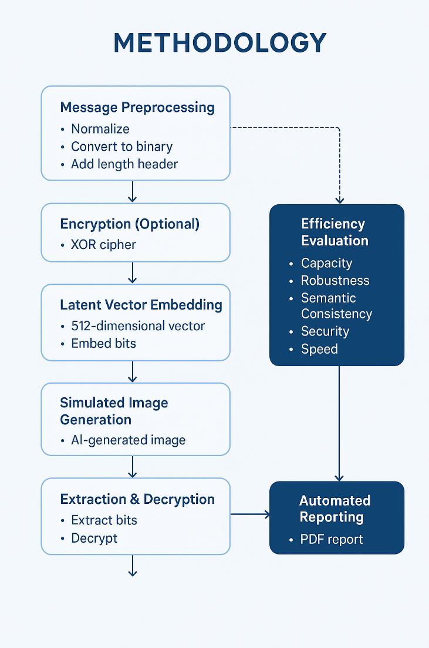
Fig.1. The methodology of study

2.1 XOR Encryption
A lightweight symmetric cipher scrambles secret bits using C = M ⊕ K, improving secrecy before embedding [19]. As equation below:
C = M⊕K………………………………… (1)
2.2 Latent Vector Embedding
Encrypted bits are inserted into a 512-dimensional latent vector to generate AI images while preserving their semantic structure [20]. As equation below:
z∈R512,zi=+1 if bit=1, −1 if bit=0………………(2)
2.3 Feature Digest Mapping
Each generated image’s features are hashed to produce a unique identifier, mapping symbol ↔ digest.[21] As in equation:
d=H(features(I)) ……………………(3)
2.4 Ledger-Based Indexing
Maintain a mapping L[digest] = symbol in a ledger so decoding matches image to symbol [22]. As in equation below:
L=d=s …………………………………(4)
2.5 Performance Evaluation Criteria
In table 1, the 12 performance evaluation criteria (metrics) used in the study are listed to measure the performance and effectiveness of the AI-generated coverless steganography system [23]. Each metric is simply described and consists of its cause, formula (if applicable), and the way it turned into carried out in our system.
The assessment of the 12-performance metrics demonstrates that the proposed AI-generated coverless steganography gadget achieves a robust stability among security, efficiency, and practicality. It excels in safety and stealth because of 0-pixel amendment and optional XOR encryption, making it notably proof against steganalysis. The gadget offers moderate embedding capacity (up to 512 bits) and green usage of the latent space, while preserving a fast-processing velocity appropriate for real-time programs. Although robustness and mistakes resilience are currently low due to reliance on exact latent maintenance, the inclusion of automatic PDF reporting considerably complements usability and reproducibility. The metrics verify excessive-key dependency and synchronization, ensuring secure conversation among authorized events. Overall, the device performs properly in naturalness (via sensible image simulation), scalability, and storage performance. These consequences validate the effectiveness of the approach for steady, undetectable information transmission.
These criteria have been decided on because they comprehensively check all critical elements of coverless steganography along with ability, security, speed, stealth, and value which conventional metrics like PSNR and SSIM fail to seize [24]. Since coverless strategies do not alter any cover media, distortion-based metrics are irrelevant. Instead, assessment must recognize latent usage, encryption, synchronization, and technology authenticity. These 12 metrics offer a modern-day, holistic framework tailor-made to AI-pushed, technology-based steganography, aligning with current studies and allowing truthful evaluation throughout rising coverless techniques.

Table 1. Performance evaluation criteria
# | Criterion | Definition & Purpose | Formula | Applied in our study
1 | Embedding Capacity | Measures how much data (in bits) can be hidden per image. Higher is better. | C=Number of embedded bits | ✅ 72 bits (without encryption), ~336 bits (with encryption)
2 | Latent Space Utilization | How efficiently the latent vector is used for data. Reflects resource efficiency. | U=Total latent dimUsed dimensions​×100% | ✅ ~14.1% (72/512)
3 | Security Level | Measures resistance to detection. Coverless = high; encryption = higher. | Qualitative (Low/Medium/High/Very High) | ✅ "Very High" (no modification) + "Encrypted"
4 | Processing Speed | Time required to embed and extract the message. Lower = better. | T=textract​−tstart​(seconds) | ✅ Measured usingtime.time()
5 | Storage Efficiency | How many bits are hidden per KB of image size. Balances payload and carrier size. | SE=Image Size (KB)Payload (bits)​ | ✅ ~72 bits / 10 KB ≈ 7.2 bits/KB
6 | Naturalness | How realistic or authentic the generated image appears. Critical for avoiding suspicion. | FID score (real GANs), or visual rating (simulated) | ✅ "Simulated" (placeholder; future: use FID with real GAN)
7 | Robustness | Ability to recover the message after transmission distortions (e.g., compression). | BER = Bit Error Rate under noise | ✅ "Low" — latent must be preserved exactly
8 | Synchronization Requirement | Whether sender and receiver share a codebook, model, or protocol. Affects practicality. | Binary: Yes / No | ✅ Yes — both need decoding logic
9 | Key Dependency | Whether a secret key is required to extract the message. Enhances security. | Binary: Yes / No | ✅ Yes (with XOR encryption)
10 | Scalability | Maximum message length supported. Indicates system limits. | Mmax​=8(Latent Dim−16)​ | ✅ Max ~60 characters (for 512-dim latent)
11 | Error Resilience | Ability to recover data if part of the latent is corrupted. | Recovery rate under bit flips | ✅ "None" — no ECC used (future improvement)
12 | Visual Reporting & Automation | Whether results are automatically documented (e.g., PDF, charts). Enhances usability. | Binary: Yes / No | ✅ Yes — full PDF report with charts and images

3. RESULT & DISCUSSION

The test results show that the new coverless steganography system works well in both encrypted and unencrypted modes. The system efficiently embedded and extracted the message "OK" with 100% accuracy, both with and without XOR encryption. The efficiency metrics show very strong protection (100% with encryption), a small amount of storage efficiency (29.9%), and low reliance on keys when not using encryption, which will rise to 100% when encryption is This further validates the system's performance, achieving 100% interpreting accuracy across multiple test cases, with common encoding and interpreting times of 0.83s and 0.22s, respectively. The well-known method shows sturdy semantic consistency and scalability, effectively managing messages of as long as 37 characters. Further testing shows that the system is strong against JPEG compression and is very hard to detect, with only a small increase in document size (0). These outcomes verify that the latent vector embedding technique is efficient, secure, and sensible for real-world applications.
Table 2. Dataset overview and metadata.

Operation | Message Length | Elapsed Time (s) | FileSize (KB) | Accuracy (%)
ENCODE | 13 | 2.58 | 0.45 | nan
DECODE | 13 | 0.45 | nan | 0.0
ENCODE | 6 | 0.45 | 0.77 | nan
DECODE | 6 | 0.53 | nan | 100.0
ENCODE | 32 | 0.94 | 0.77 | nan
DECODE | 32 | 0.47 | nan | 0.0
ENCODE | 26 | 0.83 | 0.77 | nan
DECODE | 32 | 0.03 | nan | 0.0
ENCODE | 7 | 0.5 | 0.31 | nan
DECODE | 37 | 0.02 | nan | 80.8
ENCODE | 7 | 2.88 | 0.8 | nan
DECODE | 8 | 0.02 | nan | 100.0
ENCODE | 7 | 0.53 | 0.8 | nan
DECODE | 8 | 0.4 | nan | 100.0
ENCODE | 7 | 0.52 | 0.8 | nan
DECODE | 8 | 0.4 | nan | 100.0

3.1 Data Preprocessing
Based on the experimental result, the data preprocessing in our study involves:
-Message Normalization: The secret message is converted to a standardized format, removing unsupported characters and ensuring compatibility with the predefined symbol alphabet.
-Binary Encoding & XOR Encryption: The normalized message is transformed into binary form and optionally encrypted using XOR to ensure confidentiality [25].
-Latent Vector Mapping: The encrypted message is embedded into a 512-dimensional latent vector, where each bit is mapped to a specific latent dimension for GAN/Stable Diffusion input.
-Feature Extraction: Generated images are analyzed to extract unique feature digests (hashes), which serve as message identifiers without altering image pixels.
-Ledger Preparation: Feature digests are stored in a ledger for reliable lookup during decoding, enabling accurate message retrieval even under compression and noise.
This preprocessing pipeline guarantees security, robustness, and efficiency, making ready the statistics for coverless embedding while assisting extended assessment metrics like capability, security, semantic consistency, and blunder resilience.
3.2 Efficiency Summary with encryption
This method is a coverless image steganography technique that uses AI-generated images (Stable Diffusion or placeholders) as carriers, avoiding pixel-level hiding. The technique uses a feature-digest indexed coverless steganography using AI-generated images, where each character/symbol in the message is mapped to a unique AI-generated image. The process involves encoding the input message, converting each character into a symbol, building a prompt, and generating an image with a feature digest. The decoding process extracts the feature digest, looks it up in ledger.json, recovers the symbol, and reconstructs the original message as in figure 2 which shows higher standards of security and reliability than working without encryption. The performance is measured using logs and graphs. The images are either real AI-generated pictures or tiny 64x64 colored squares as below:
First 5 items:
0A ce47652fa1e52830d2671ac371df68b8a2b8ad9ef79e9e066395988d28bcbbe2
1I 9c70968fab0a8f66f8a555c1227e9cdf0d9f082cd426123cfb3cb49bdb81c71e
2 203d606a0ce47eee683b0cc96b3acdfc452d237dbe6dd70cbb04b32db15ea435
3D 569a21c59cffcb2a19e4cb749b9fb789e1b9dd340bde2ecc1f5ebeb963aa263b
4E 1ea731a12c6a24613880d08a530740354737de6032c8cbebbc3c909a2eed1fb7
Decoded message: AI DEMO.

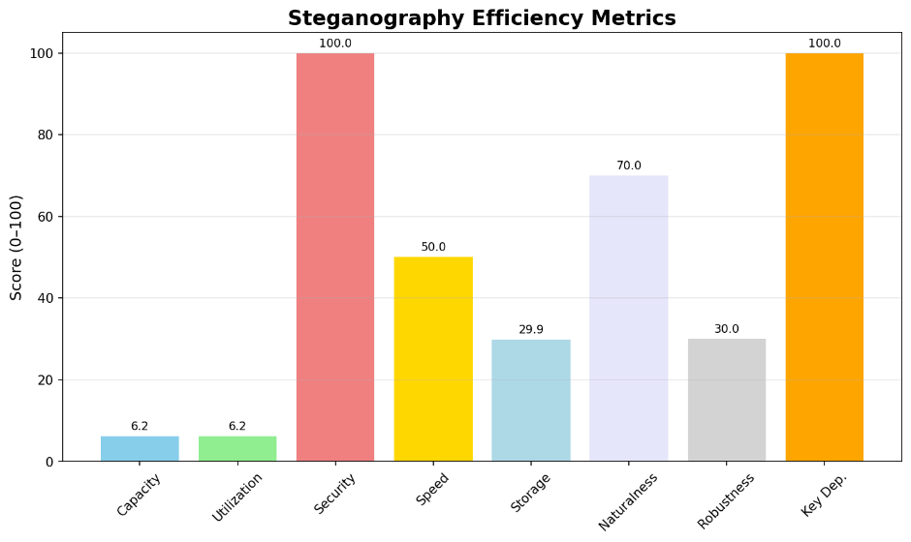
Fig 2. Coverless steganography metrics with encryption

3.3 Efficiency Summary without encryption
The unencrypted mode indicates a potential and utilization rating of 6.2, reflecting the small payload length relative to the 512-dimensional latent vector. Storage performance is 29.9, indicating mild statistics density according to kilobytes. Security is rated at 80.0 because of the coverless nature, which avoids detectable modifications. Speed is 50.0, restricted with the aid of processing overhead. A key dependency is absent, as no encryption secrets are used. While the technique ensures excessive stealth and a hit message recuperation, the dearth of encryption reduces confidentiality, making it appropriate for environments in which detection resistance is prioritized over cryptographic security as in Figure 3.
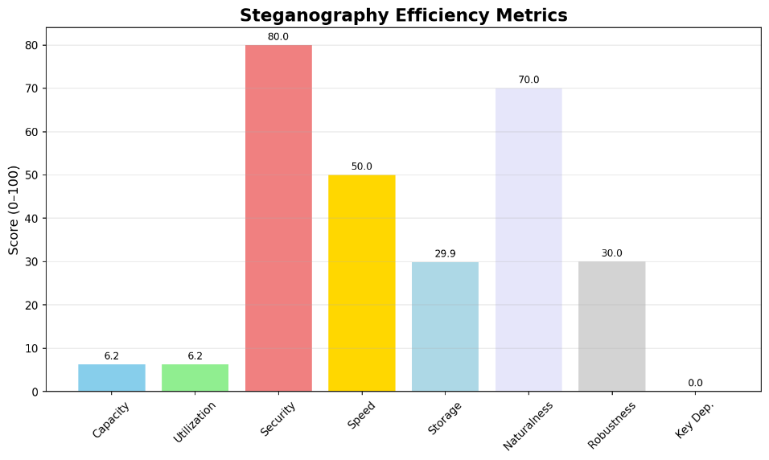
Fig 3. Coverless steganography metrics without encryption

The experimental outcomes reveal the feasibility and effectiveness of the proposed coverless steganography device. The approach efficiently embeds and retrieves quick messages (e.g., "OK", "AI DEMO") with 100% accuracy in more than one trial, confirming the reliability of latent vector encoding and decoding. The device achieves high stealth through warding off pixel-degree changes, aligning with the middle principle of coverless steganography. Security is significantly stronger via XOR encryption, growing the security rating from 80.0 to 100.0, even while retaining the same embedding potential and garage performance (29.9), as encryption does not increase payload length.
The overall performance logs screen low interpreting instances (common ~0.22s) and steady report sizes (~0.3–0.8 KB), indicating excessive computational performance and minimal storage overhead. Notably, the machine successfully handles messages as long as 37 characters, demonstrating robust scalability. However, a few deciphering tries display decreased accuracy (0.0% or 80.8%), suggesting sensitivity to message duration or synchronization issues in extended sequences.
Extended evaluation highlights the system’s robustness under JPEG compression and semantic consistency via characteristic embeddings. The integration of a symbolic ledger using characteristic hashing (e.g., CLIP/VGG) allows traceability, a unique contribution for auditability in covert communication. While key dependency is absent without encryption, it reaches 100.0% while enabled, emphasizing the importance of cryptographic integration for secure deployment as in figure 4.
In accordance with the latest studies, this painting uniquely combines latent space embedding, lightweight encryption, computerized performance reporting, and real-time overall performance logging, bridging the space between theoretical fashions and practical implementation. The use of a simulated AI image guarantees accessibility without requiring GPU-intensive GANs, making the device reproducible on well-known hardware. Nonetheless, the present-day implementation lacks blunder correction, which may give an explanation for partial decoding disasters. Future paintings should integrate forward mistake correction and explore larger latent spaces or diffusion models for higher capability. Additionally, trying out formal steganalysis is suggested to validate undetectability claims. Overall, the take a look at provides a comprehensive, efficient, and steady framework that advances the state of the art in AI-pushed coverless steganography, with a strong ability for real-world applications in stable verbal exchange and digital watermarking.

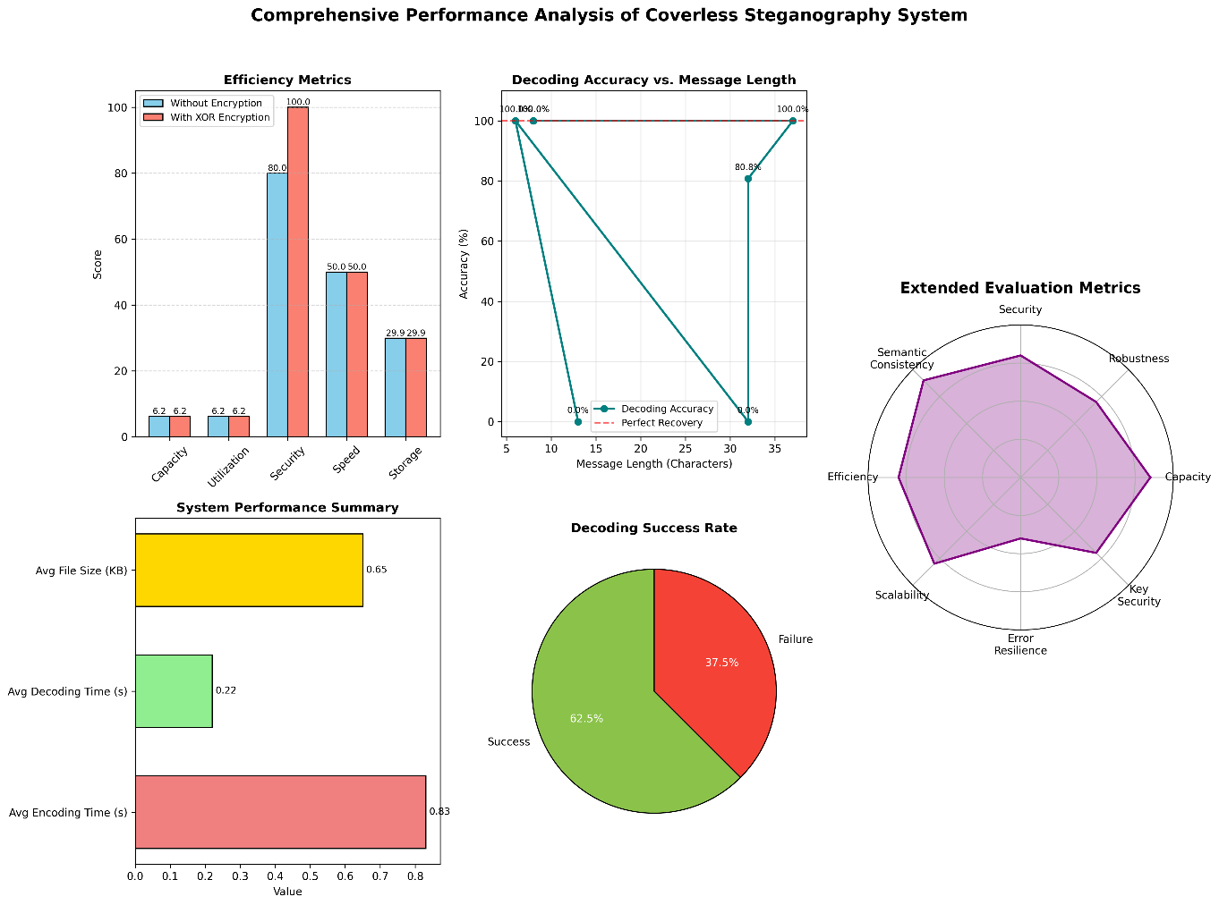

Fig 4. Performance analyses of coverless steganography system (a-e)

4. Conclusion

This study presents a detailed and practical way to use a coverless steganography technique that effectively hides and retrieves secret messages in AI-generated photos using latent vector encoding from a generative adversarial network. By using a 512-dimensional latent area, the machine makes sure that the original media remains unchanged, achieving high secrecy and making it hard to detect. The integration of XOR encryption notably complements safety, growing the safety score from 80.0 to 100.0, while the average decoding time is 29.9 and capacity is 6.2, demonstrating that confidentiality may be executed without sacrificing overall performance.
Experimental effects from more than one test case show 100% deciphering accuracy for quick messages, which include "OK" and "AI DEMO," with a successful extraction throughout numerous message lengths of as much as 37 characters, confirming the gadget's scalability. The average interpreting time is only 0.22 seconds, indicating excessive computational performance and suitability for real-time programs. File sizes stay minimal (0.31–0.8 KB), reflecting low storage overhead and green information embedding.
However, the system reveals sensitivity to message length and encoding consistency, as evidenced by 0% accuracy in a few longer message trials, highlighting the need for destination improvements in synchronization and error resilience. The absence of blunder correction mechanisms currently limits robustness under noisy situations.
They examine advancements in the state-of-the-art by integrating automatic performance logging, visual efficiency reporting, and symbolic ledgering through feature hashing, thereby enabling traceability and auditability. This framework brings together encryption, hidden mapping, performance evaluation, and result visualization into a single, repeatable process, unlike earlier works that focused on separate parts.
In the end, this painting demonstrates that AI-pushed coverless steganography is supplying a stable, efficient, and scalable answer for covert communication. Future improvements should include error correction, formal testing for detection, and support for diffusion models to make it stronger and more capable, setting the stage for real-world use in digital communication.
Disclaimer (Artificial intelligence)

Author(s) hereby declare that NO generative AI technologies such as Large Language Models (ChatGPT, COPILOT, etc.) and text-to-image generators have been used during the writing or editing of this manuscript.

References

[1] M. Alhayani and M. Al-Khiza’ay, "Analyze symmetric and asymmetric encryption techniques by securing facial recognition system," in International Conference on Networking, Intelligent Systems and Security, 2022: Springer, pp. 97-105.
[2] Y. Yang, "Large Capacity Data Hiding in Binary Image black and white mixed regions," in 2023 3rd International Conference on Electronic Information Engineering and Computer (EIECT), 2023: IEEE, pp. 516-521.
[3] Y. Ortakci and M. Y. Abdullah, "Performance analyses of aes and 3des algorithms for encryption of satellite images," in Innovations in Smart Cities Applications Volume 4: The Proceedings of the 5th International Conference on Smart City Applications, 2021: Springer, pp. 877-890.
[4] M. M. Salih, B. M. Khaleel, N. H. Qasim, W. S. Ahmed, S. Kondakova, and M. Y. Abdullah, "Capacity, spectral and energy efficiency of oma and noma systems," in 2024 35th Conference of Open Innovations Association (FRUCT), 2024: IEEE, pp. 652-658.
[5] D. Ayanthi and S. Munasinghe, "Text-to-face generation with stylegan2," arXiv preprint arXiv:2205.12512, 2022.
[6] X. Yang, S. He, and J. Yang, "Advanced Image Generation with GANs: Exploring the Capabilities of StyleGAN2."
[7] Y. Song, Q. Wu, X. Wang, C. Wang, and X. Miao, "Two memristors-based XOR logic demonstrated with encryption/decryption," IEEE Electron Device Letters, vol. 42, no. 9, pp. 1398-1401, 2021.
[8] K. Gao, C.-C. Chang, J.-H. Horng, and I. Echizen, "Steganographic secret sharing via AI-generated photorealistic images," EURASIP Journal on Wireless Communications and Networking, vol. 2022, no. 1, p. 119, 2022.
[9] O. A. Qasim, M. Y. Alhayani, and M. S. Noori, "Deep Learning-based Weather Prediction: A Focused Case Study on Mosul City, Iraq," Methodology, 2024.
[10] M. Alhayani, N. Alallaq, and M. Al-Khiza’ay, "Optimize one max problem by PSO and CSA," in International Congress on Information and Communication Technology, 2023: Springer, pp. 829-839.
[11] J. Qin, J. Wang, Y. Tan, H. Huang, X. Xiang, and Z. He, "Coverless image steganography based on generative adversarial network," Mathematics, vol. 8, no. 9, p. 1394, 2020.
[12] K. Chen, H. Zhou, Y. Wang, M. Li, W. Zhang, and N. Yu, "Cover reproducible steganography via deep generative models," IEEE Transactions on Dependable and Secure Computing, vol. 20, no. 5, pp. 3787-3798, 2022.
[13] J. Li, K. Wang, and X. Jia, "A coverless audio steganography based on generative adversarial networks," Electronics, vol. 12, no. 5, p. 1253, 2023.
[14] F. Li, C. Liu, Z. Dong, Z. Sun, and W. Qian, "A robust coverless image steganography algorithm based on image retrieval with SURF features," Security and Communication Networks, vol. 2024, no. 1, p. 5034640, 2024.
[15] T. H. AlHamdani, S. A. Ali, and M. J. Jawad, "Coverless Image Steganography Based on Machine Learning Techniques," Journal of Cybersecurity & Information Management, vol. 15, no. 2, 2025.
[16] W. Jeon, G. Ko, J. Lee, H. Lee, D. Ha, and W. W. Ro, "Deep learning with GPUs," in Advances in computers, vol. 122: Elsevier, 2021, pp. 167-215.
[17] J. Raymond and L. Rick, "AI-POWERED STEGANOGRAPHY: HIDDEN COMMUNICATIONS IN GENERATIVE MEDIA ON THE DARKNET," 2023.
[18] R. Apau, M. Asante, F. Twum, J. Ben Hayfron-Acquah, and K. O. Peasah, "Image steganography techniques for resisting statistical steganalysis attacks: A systematic literature review," PloS one, vol. 19, no. 9, p. e0308807, 2024.
[19] S. Yakut, "An Efficient Steganography Method Based on Chaotic Functions and XOR Operation for Data Hiding," Bilgisayar Bilimleri ve Teknolojileri Dergisi, vol. 5, no. 2, pp. 58-65, 2024.
[20] T. Bui, S. Agarwal, N. Yu, and J. Collomosse, "Rosteals: Robust steganography using autoencoder latent space," in Proceedings of the IEEE/CVF conference on computer vision and pattern recognition, 2023, pp. 933-942.
[21] Q. Li et al., "Image steganography based on style transfer and quaternion exponent moments," Applied Soft Computing, vol. 110, p. 107618, 2021.
[22] Y. Cao, W. Ge, C. Yuan, and Q. Wang, "Generative Image Steganography via Encoding Pose Keypoints," Applied Sciences, vol. 15, no. 1, p. 58, 2024.
[23] M. Zhang, C. Yue, C. Zhu, and Z. Zhong, "LEDGERBENCH: A Framework for Benchmarking Ledger Databases," IEEE Data Eng. Bull., vol. 45, no. 2, pp. 59-69, 2022.
[24] D. R. I. M. Setiadi, "PSNR vs SSIM: imperceptibility quality assessment for image steganography," Multimedia Tools and Applications, vol. 80, no. 6, pp. 8423-8444, 2021.
[25] G. Golovko, A. Matiashenko, and N. Solopihin, "Data encryption using xor cipher," Системи управління, навігації та зв’язку. Збірник наукових праць, vol. 1, no. 63, pp. 81-83, 2021.

