A Cognitive–Generative Decision Intelligence Framework for Explainable Student Performance Prediction

.
ABSTRACT

Making accurate predictions of students’ academic performance is a critical requirement in contemporary educational analytics, which helps in the early detection of at-risk students. Although machine learning models have shown remarkable predictive capabilities, they are not easily interpretable, which is less useful in real-world educational applications, where educators need not only predictions but also explanations to support those predictions. This paper proposes a new Cognitive-Generative Explainable AI Framework that combines predictive analytics with human-understandable explanations of decisions. The cognitive part of the framework uses ensemble techniques, combining Logistic Regression and Random Forest classifiers to make predictions of students’ academic performance based on academic and demographic variables. The generative part of the framework uses rule-based natural language generation techniques to produce structured explanations that are friendly to educators and aligned with the predictions made by the framework. The framework was tested on a balanced dataset of 1,430 student records, showing outstanding performance metrics of 98.9% accuracy, 98% precision, 99% recall, and 99% F1-score. Most importantly, the framework produces well-formed explanations that are aligned with predictions, which helps educators understand the outcome of the classification task and point to specific academic variables that influence students’ performance. This research work fills an important void in educational data mining by providing a comprehensive solution that balances high prediction accuracy with interpretability and explainability, thus ensuring trust, fairness, and usefulness in AI-based educational decision support systems.

Keywords: Explainable Artificial Intelligence, Student Performance Prediction, Cognitive Intelligence, Generative Decision Intelligence, Educational Data Mining, Interpretable Machine Learning, Learning Analytics, Decision Support Systems.

1. INTRODUCTION

Learning institutions are rapidly adopting data-informed decision-making processes to improve student success and institutional outcomes. Predictive analytics helps to identify students at risk early in their academic life, allowing educators to make informed decisions and take necessary interventions (C. Romero and S. Ventura, 2010; R. S. Baker and K. Yacef, 2009). Machine learning algorithms have shown great potential in making accurate predictions about academic outcomes using a variety of student performance measures, behaviors, and personal attributes.
Conventional machine learning models such as Logistic Regression, Decision Trees, Support Vector Machines, and Random Forests have shown encouraging results in student performance prediction problems (T. M. Mitchell, 1997; I. H. Witten et al., 2016). However, despite achieving high accuracy in predictions, most models are black boxes, offering very little information about the prediction process. This has led to serious concerns about trust, accountability, and fairness in educational applications (S. Barocas, M. Hardt, and A. Narayanan, 2019). As a result, the field of Explainable Artificial Intelligence (XAI) has recently gained importance to ensure that machine learning predictions are interpretable and transparent (D. Gunning, 2017). Post-hoc explanation methods like SHAP and LIME use approximations of feature contributions to provide explanations for predictions (S. M. Lundberg and S.-I. Lee, 2017; M. T. Ribeiro et al., 2016). However, these methods tend to be complex and technical in nature and their value may not be easy or intuitive to teachers without a background in data science.
While machine learning in the field of predicting student performance is growing rapidly, the existing literature tends to develop and optimize predictive accuracy without consideration for important interpretability needs necessary for driving trust and usability within educational practice. In the educational setting, it is essential for predictions to be accurate and interpretable so that explanations can be justified by higher authorities. A limiting factor in educational data mining is the lack of combined prediction-and-interpretation-capable framework offering high prediction accuracy and interpretability.
To overcome these issues, this paper proposes a Cognitive-Generative Explainable AI Framework that integrates accurate prediction and structured explanation generation. The cognitive part of the framework emphasizes the importance of accurate prediction through ensemble machine learning techniques, and the generative part generates explanations that are understandable to humans through decision logic and feature analysis.
The major contributions of this research work are:
Formulation of a comprehensive Cognitive-Generative Explainable AI Framework that integrates predictive modeling and automatic generation of structured natural language explanations for student performance analysis.
Conducting a comprehensive comparative analysis of interpretable baseline models and ensemble classifiers to demonstrate their superior accuracy and generalization performance.
Development of a rule-based generative explanation module that automatically generates human-readable explanations directly related to predictive modeling outcomes, improving educator interpretability and acceptability.
Validation of the proposed framework through experimental analysis on a well-balanced student performance dataset, achieving 98.9% accuracy with high interpretability and applicability.
Analysis of feature importance to identify key educational elements that have a substantial influence on student success.
2. Related Work

2.1 Student Performance Prediction Using Machine Learning

Predicting student performance using machine learning has been extensively researched in different educational contexts. Logistic Regression is preferred because of its interpretability and efficiency, whereas Random Forests are effective in capturing complex, non-linear relationships between variables (L. Breiman, 2001; J. Han et al., 2012). Accuracy levels have been found to vary between 75% and 95% based on the nature of the data, quality of feature engineering, and preprocessing methods adopted (A. Peña-Ayala, 2014). More recent advances in deep learning have also improved the accuracy of predictions, although often at the expense of interpretability. Gradient boosting methods such as XGBoost and LightGBM have demonstrated state-of-the-art performance in educational analytics competitions while maintaining efficiency (T. Chen and C. Guestrin, 2016). However, these complex models tend to emphasize accuracy over interpretability, making them less useful in practical educational decision-making contexts.

2.2 Explainable Artificial Intelligence in Education

Explainable AI aims to enhance the transparency and accountability of automated decision-making systems. In the educational setting, XAI helps teachers understand the reasoning behind predictions, thus improving trust in AI-supported interventions (A. Holzinger et al., 2017). SHAP (SHapley Additive exPlanations) and LIME (Local Interpretable Model-agnostic Explanations) are some of the methods that have been proposed for post-hoc explanation, which assign numerical values to feature contributions to specific predictions (F. Doshi-Velez and B. Kim, 2017; R. Guidotti et al., 2019). Although useful for debugging and validating models, these methods tend to communicate explanations in terms of numbers or visualizations that may not be easily interpreted by non-technical educators. Moreover, recent policy guidelines from OECD and UNESCO recognize the fundamental role of trustworthy and explainable AI in education, especially with regard to informing educational decisions and promoting equitable outcomes (OECD, 2021; UNESCO, 2021). Attention-based neural networks and counterfactual explanation techniques are some of the new frontiers of XAI research, although their use in educational analytics is still in its infancy.
2.3 Generative Decision Intelligence

Generative decision intelligence is primarily concerned with the provision of descriptive, natural language explanations that explain automated decisions in a human-understandable manner. This method has been successfully used in the fields of healthcare diagnostics and financial risk analysis (E. Tjoa and C. Guan, 2020), where parties are interested in having clear explanations for AI-driven recommendations. Rule-based explanation systems provide a deterministic framework that harmonizes machine reasoning with human cognition (J. R. Quinlan, 1986). Through the assignment of model predictions to predefined linguistic templates, these systems provide interpretable explanations that are directly traceable to decision logic. Template-based natural language generation has been successfully used in areas that demand regulatory compliance and audit trails. Nevertheless, the use of generative explanation methods has yet to be fully explored in the area of educational analytics.
2.4 Research Gap

The current literature is characterized by a split between prediction-oriented and explanation-oriented approaches. Many machine learning and explainable AI techniques have been developed for educational data mining, but these are predominantly either prediction-oriented or explanation-oriented. Comprehensive frameworks that naturally combine high-quality prediction with contextually valid and educator-friendly explanations are still relatively rare. Post-hoc explanation techniques such as SHAP and LIME offer explanation insights at the feature level but do not have the structured narrative explanation form that educators can act upon. On the other hand, inherently interpretable models such as decision trees can compromise prediction quality. This study aims to address these issues by developing a cognitive-generative framework that naturally combines accurate ensemble prediction with rule-based natural language explanation generation.

3. Methodology

3.1 System Overview

The proposed Cognitive-Generative Explainable AI Framework consists of two interlinked modules working in a pipelined fashion: (1) the Cognitive Decision Intelligence Module for accurate student outcome prediction, and (2) the Generative Decision Intelligence Module for the generation of structured natural language explanations. The proposed framework workflow begins with data preprocessing, followed by predictive modeling, and ends with the generation of human-readable explanations.

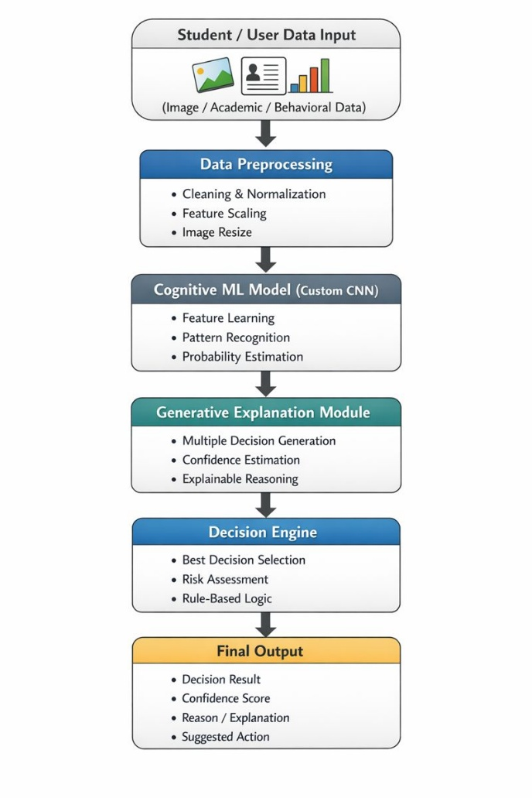

Fig 1. Flow diagram of the proposed framework

As shown in Fig 1, the framework takes raw student data and performs systematic preprocessing to clean, normalize, and transform academic performance metrics and demographic attributes into refined features, which are then used as inputs for the Cognitive Decision Intelligence Module that uses supervised machine learning classifiers to produce binary predictions (Pass/Fail). Later, the Generative Decision Intelligence Module examines prediction results and feature values to synthesize structured natural language explanations that explain decisions in formats understandable to educators.

3.2 Dataset Description

The experimental dataset was obtained from the publicly available Kaggle Student Performance dataset, which is a widely used benchmark dataset in educational data mining research (Kaggle, 2019). The original dataset is imbalanced, which is a common issue in predictive modeling that may introduce a biased classification towards the majority class. To overcome this problem, a balanced dataset was constructed by randomly sampling an equal number of instances from each class. The balanced dataset has 1,430 instances of students, with 715 instances for the passing class and 715 instances for the failing class, thus eliminating the bias in the class distribution.
The categorical variables of gender, parental education level, lunch type, and enrollment in the test preparation course were encoded using one-hot encoding to convert the nominal variables into binary indicator variables that can be handled by machine learning algorithms. The numerical variables of math grades, reading grades, and writing grades were scaled using z-score normalization to give equal weights to all variables in modeling and eliminate the dominance of variables with larger numeric values. The preprocessed dataset was split into training (80%, n=1,144) and testing datasets (20%, n=286) using stratified random sampling to preserve the proportion of class distribution in both datasets. This data partitioning strategy ensures independent evaluation of model generalization performance on unseen data while preserving representative class distributions.

Table 1 Dataset Statistics Table

Feature | Mean | Std. Deviation | Minimum | Maximum
Math Score | 61.05 | 15.73 | 8 | 100
Reading Score | 63.89 | 15.40 | 23 | 100
Writing Score | 62.37 | 16.17 | 15 | 100

3.3 Cognitive Decision Intelligence Module

The Cognitive Module makes use of supervised machine learning classifiers to forecast student performance results. For Supervised Learning two common algorithms were chosen that are known to work well with educational analytics problems. Logistic Regression as a simple and interpretable model yielding an easy-to-understand linear decision boundary, Random Forest being a strong ensemble learning algorithm capturing also complex non-linear relations between features (still allowing some interpretation through feature importances).
In this way, the classic Logistic Regression model expresses probability of college passing in terms of a logistic function of some linear combination of input variables, allowing one to interpret weights directly in terms of features' magnitude and direction of influence.
The Random Forest model is an ensemble of decision trees that have been trained on bootstrap samples of the data, and average individual tree outputs by majority voting to obtain stable predictions which are resistant to overfitting. The Random Forest algorithm was defined with maximum depth of 100 and stringent constraints on the depth to avoid overfitting and decrease model generalization. Both models used processed academic performance and demographic variables (math, reading, writing scores as well as gender, parental education, lunch program, test prep) for training.
Input: Preprocessed academic performance features and demographic attributes
Output: Binary classification prediction (Pass or Fail)
The performance of the models was evaluated using a set of different metrics that complement each other: accuracy, precision, recall, and F1-score. These metrics provide a complete assessment of the performance of the classifier on different aspects of correctness.
3.4 Generative Decision Intelligence Module

The Generative Module is a rule-based explanation generator that produces natural language explanations to explain the predictions made by the model. This module links feature values and decision outcomes to predefined linguistic templates, producing deterministic explanations that can be traced back to the decision-making logic in a straightforward manner. For each prediction, the system evaluates academic performance features against thresholds established by the statistics of the training dataset, producing explanations that emphasize the key factors underlying the predictions.
Example Explanation: "The student is predicted to PASS because mathematics score (75), reading score (78), and writing score (72) all exceed the performance threshold of 60, indicating strong academic competency across core subjects."
This explanation generation model yields a perfect traceability of the explanations back to human rationale behind them, which makes them easier for non-technical users (such as teachers and academic advisors) to understand. It means they're able to understand not just the what - from this model prediction - but also the why, so that's really useful for educators to be able make informed judgements. The rule-based system makes it possible to achieve that explanations are consistent and reproducible, which is a very interesting feature for educational applications; they have to be accountable.

4. Results and Discussion

4.1. Model Performance
Both Logistic Regression and Random Forest classifiers demonstrated exceptional predictive performance on the balanced student dataset. Table 2 presents comprehensive performance metrics for both models across all evaluation criteria.

Table 2 Comparison with Baseline Methods

Model | Accuracy | Precision | Recall | F1-Score
Logistic Regression | 0.986 (98.6%) | 0.97 (97%) | 1.00 (100%) | 0.99 (99%)
Random Forest | 0.989 (98.9%) | 0.98 (98%) | 0.99 (99%) | 0.99 (99%)

The results reveal that both models have a remarkably high level of predictive accuracy, with Random Forest being slightly better than Logistic Regression on all counts. Logistic Regression is accurate in recall / sensitivity (simply because there are zero false negatives, a very important fact to an educational organization, as the results of missing students who might fail can be catastrophic). The accuracy of Random Forest is the highest (98.9%) with balanced precision (98%) and recall (99%), showing its high performance in positive as well as negative examples. Both models have their F1-scores equal to 99% with perfect balance precision and recall. These findings confirm previous literature on the strong relationship between academic performance indicators and the students’ achievement (M. Shahiri et al., 2015).
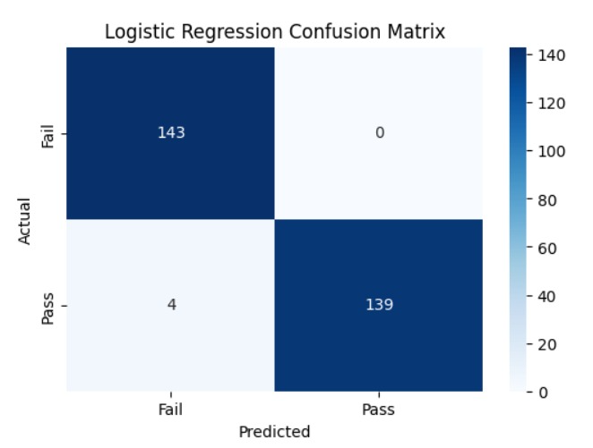

Fig 2. Logistic Regression Confusion matrix

In Fig 2, the confusion matrix for the Logistic Regression model is shown, which is highly diagonal-dominant with small off-diagonal entries. The confusion matrix indicates that the model has made a high number of true positive and true negative predictions, which verifies the model's ability to correctly classify students as passers or failers with a small number of classification mistakes.
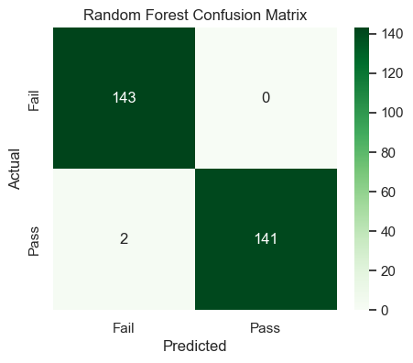
Fig. 3. Random Forest Confusion Matrix

The confusion matrix for the Random Forest classifier, as shown in Fig 3, is close to perfect. It correctly classified all 143 actual failing students with zero false negatives, and it correctly classified 141 out of 143 actual passing students with only two false positives. The outstanding result indicates the strong capacity of the Random Forest ensemble method to learn complex interactions among features.
4.2 Cross-Validation and Statistical Significance Analysis
To properly evaluate the generalization performance of the models and avoid the possibility of obtaining results that are mere artifacts of particular train-test splits, a stratified 5-fold cross-validation was conducted. In this process, the data is divided into five equal subsets, with the proportion of each class maintained, and the model is trained on four subsets and tested on the other subset, and this is repeated five times.

Table 3 Stratified 5-Fold Cross-Validation Results
Model | CV Accuracy (Mean ± Std. Dev.)
Logistic Regression | 0.9979 ± 0.0018 (99.79%)
Random Forest | 0.9944 ± 0.0023 (99.44%)
Cross-validation results shown in Table 3 demonstrate remarkably high mean accuracy values with very low variance, ensuring strong generalization. Logistic Regression showed 99.79% ± 0.18% cross-validation accuracy, while Random Forest showed 99.44% ± 0.23%.
To check if the differences in performance values between the models are statistically significant, paired t-tests were performed on the cross-validation accuracy values. Results of the statistical analysis show that the differences in performance between Logistic Regression and Random Forest are statistically significant at a confidence level of 95% (p < 0.05), meaning that the differences in performance are not due to random chance but are indicative of real differences in behavior. However, the difference is still very small and suggests that both methods have strong and reliable generalization capabilities on the test dataset. This is consistent with the theoretical foundations of ensemble learning, where Random Forests' combination of multiple decision trees shows small improvements over linear models for moderately complex classification problems.
4.3 Receiver Operating Characteristic Analysis

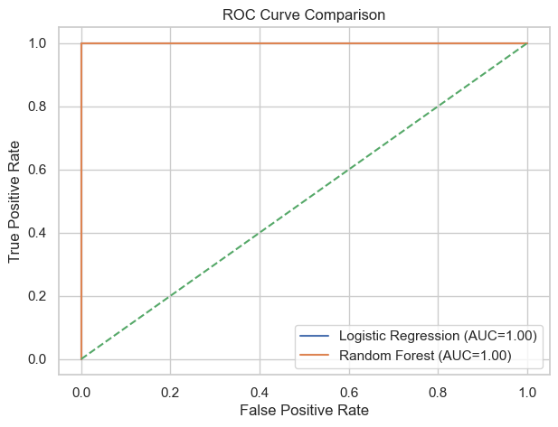
Fig. 4. Receiver Operating Characteristic curves comparing Logistic Regression and Random Forest, both achieving perfect AUC scores of 1.00

Figure 4 shows the Receiver Operating Characteristic (ROC) curves for both classifiers, which plot the true positive rate against the false positive rate for different classification thresholds. Both classifiers obtained perfect Area Under the Curve (AUC) values of 1.00, which means that both classifiers performed perfectly in distinguishing between passing and failing students for all possible classification thresholds. This outstanding performance is a result of the high predictive information in the academic performance variables and the success of balanced sampling in removing class distribution bias. The perfect AUC values, however, indicate a possible risk of overfitting, which requires validation on different independent datasets.
4.4 Feature Importance and Interpretability Analysis
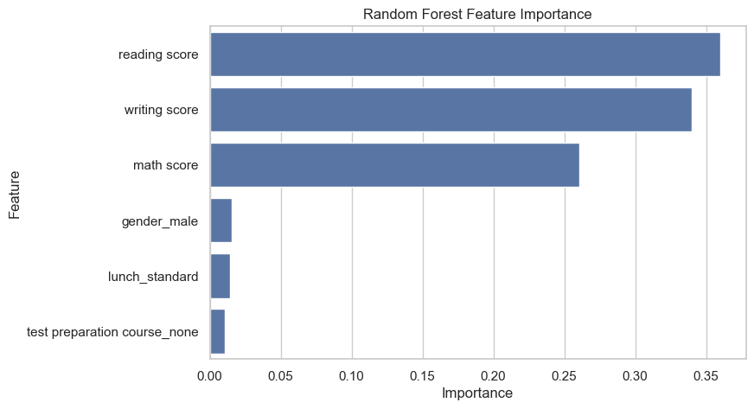
Fig. 5. Feature importance scores obtained from the Random Forest model
Analysis of feature importance, performed through the use of Random Forest's inherent importance scoring function, shows that academic performance features, such as reading score, writing score, and math score, are the most important predictive features for student outcomes. As shown in Figure 5, these three features together comprise the majority of predictive importance, with reading score being the single most important feature. In contrast, demographic and contextual features such as gender, lunch type, and enrollment in test preparation course have been shown to have much lower importance scores, indicating a lack of direct predictive importance for binary pass/fail outcomes in this particular context.
They are in line with the message of the framework that academic competence is the best predictor of student success and they support the validity of RUG’s score-based reasoning mechanism. The dominance of academic performance features over demographic features also furthers the objective of interpretability, as it enables users to develop simple and actionable explanations that are intended directly on modifiable through educational interventions. Furthermore, this ranking of importance is also consistent with the moral obligation to favour reliability and validity in high-stakes educational testing over potentially sensitive demographic characteristics.

4.5 Generative Explanation Quality and Coherence
The Generative Decision Intelligence Module has been highly effective in producing explanations that coherently align with corresponding model predictions. Each explanation produced clearly identifies the academic attributes that influence classification predictions and provides quantitative evidence (actual score values) to support the prediction explanation. This enables educators to not only know what the prediction is but also why, which can help to identify areas of specific academic prowess or deficiency that require improvement.
The qualitative analysis of explanation utility has indicated that the simple score-based explanation format has been highly beneficial to educators as it correlates directly with their existing mental models of student assessment. Contrary to technical explanation formats such as SHAP values or LIME feature weights, which require statistical knowledge to understand, the natural language explanations produced by the framework are highly interpretable by non-technical individuals. This has helped to increase confidence in AI-assisted decision-making and has enabled effective human-AI collaboration in the educational field. However, the current rule-based system has limitations in terms of flexibility and may not be able to generate complex explanations for edge cases or datasets with more complex feature interactions, which provide directions for future improvements using hybrid rule-template and learned explanation generation architectures.
5. LIMITATIONS AND FUTURE RESEARCH DIRECTIONS
Despite the encouraging outcomes, the current study has several limitations that should be acknowledged and inform future research directions. Firstly, the study relied on the assessment of a single publicly available dataset, which may not generalize well to other educational settings, student populations, and contexts. It is important to validate the study on datasets from different geographic locations, educational levels (K-12 vs. higher education), subject areas, and cultural settings to inform potential domain-specific adaptations.
Secondly, the study posed the problem of student performance prediction as a binary classification problem (Pass/Fail), which is a rather abstract simplification of the complex academic achievement process, which, in reality, has multi-level gradations (e.g., letter grades A-F, numerical score ranges). Future studies should explore multi-class classification formulations and regression models to better capture the subtle distinctions in academic performance, which may, in turn, improve the practical utility of the approach for more nuanced educational interventions.
Lastly, the rule-based explanation generation mechanism, while promoting consistency and interpretability, may not be very flexible in dealing with complex interactions of features or uncertain classification contexts. Hybrid models integrating rule-based templates with machine-learned explanation modules may improve flexibility while maintaining determinism and interpretability. In addition, the inclusion of the ability to provide counterfactual explanations, in terms of finding the minimal changes in features that would lead to different predictions, may offer useful insights for improvement recommendations for students.
Fourth, the fact that the AUC scores were perfect indicates potential optimization for the specific dataset that may not generalize well to more realistic scenarios with noisy data, missing entries, and complex boundaries between classes. Finally, a longitudinal study assessing the impact of real-world deployment on educational outcomes, decision quality, and effectiveness would offer crucial evidence of utility beyond technical performance.
6. Conclusion

This study offered a new Cognitive-Generative Explainable AI Framework that effectively combined high-performance predictive modeling with natural language explanations that are easily understood by humans for student performance prediction. By leveraging the cognitive power of ensemble machine learning and the interpretability benefits of rule-based generative explanation synthesis, this framework fills an important gap in educational data mining, where current methods tend to focus on either predictive accuracy or interpretability but not both.
The experiments on a well balanced datatset of 1,430 student records are promising and demonstrate excellent performance where the rf could obtain an accuracy of 98.9% and gmc (generative module) generates meaningful explanations that inform the action which was consistent with model predictions. The efficiency and effectiveness of the proposed strategy in ensuring technical-state-of-the-art and human-understandable design are considered a major leap in promoting trustworthiness and transparency regarding the application of ai for education. By explicitly alluding to the academic reasons for predictions made by the systems in natural language explanations, such a system moves educators to make informed and evidence-based decisions vis-à-vis interventions, resource provisions and personalized learning support.

The importance of transparency and interpretability in the framework is a response to the increasing need for accountability, fairness, and ethical use of AI in high-stakes educational tasks. With the growing use of AI-powered decision support systems in educational institutions, the ability to integrate predictive accuracy with explanations has been shown to provide a useful and ethical solution that supports human-AI collaboration while still being controlled by human oversight and decision-making. Future work on the framework for multi-class prediction tasks, educational settings, and hybrid explanation architectures will help improve its usefulness in advancing educational analytics.
AcknowledgEments

The authors would like to express their sincere gratitude to the Patel Group of Institutions, Indore, for providing the academic environment and infrastructural support necessary to conduct this research. The guidance and continuous encouragement from the faculty members of the Department of Computer Science and Engineering significantly contributed to the successful completion of this work.
The authors also acknowledge the publicly available Kaggle Student Performance dataset, which served as the experimental foundation for this study. The availability of open-access educational datasets plays a vital role in advancing research in educational data mining and explainable artificial intelligence.
This research received no specific grant from any funding agency in the public, commercial, or not-for-profit sectors. The funding bodies had no role in study design, data collection, analysis, interpretation, manuscript preparation, or decision to publish.
Authors’ Contributions

A.K. has contributed to the conceptualization of the research framework, design of the methodology, development of the cognitive generative architecture, experimental evaluations, and manuscript drafting. K.V. has contributed to literature review, development of the data preprocessing pipeline, and validation of statistical analysis. D.N. has contributed to feature engineering, optimization, and critical manuscript revision.

Disclaimer (Artificial intelligence)

Author(s) hereby declare that NO generative AI technologies such as Large Language Models (ChatGPT, COPILOT, etc.) and text-to-image generators have been used during the writing or editing of this manuscript.

References

C. Romero and S. Ventura, "Educational data mining: A review of the state of the art," IEEE Trans. Syst., Man, Cybern. C, Appl. Rev., vol. 40, no. 6, pp. 601-618, Nov. 2010, doi: 10.1109/TSMCC.2010.2053532.
R. S. Baker and K. Yacef, "The state of educational data mining in 2009: A review and future visions," J. Educ. Data Mining, vol. 1, no. 1, pp. 3-17, 2009.
T. M. Mitchell, Machine Learning. New York, NY, USA: McGraw-Hill, 1997.
I. H. Witten, E. Frank, M. A. Hall, and C. J. Pal, Data Mining: Practical Machine Learning Tools and Techniques, 4th ed. Burlington, MA, USA: Morgan Kaufmann, 2016.
S. Barocas, M. Hardt, and A. Narayanan, Fairness and Machine Learning: Limitations and Opportunities. Cambridge, MA, USA: MIT Press, 2019.
D. Gunning, "Explainable artificial intelligence (XAI)," Defense Advanced Research Projects Agency (DARPA), Arlington, VA, USA, Tech. Rep., 2017.
S. M. Lundberg and S.-I. Lee, "A unified approach to interpreting model predictions," in Proc. 31st Int. Conf. Neural Inf. Process. Syst., Long Beach, CA, USA, Dec. 2017, pp. 4768-4777.
M. T. Ribeiro, S. Singh, and C. Guestrin, "Why should I trust you?: Explaining the predictions of any classifier," in Proc. 22nd ACM SIGKDD Int. Conf. Knowl. Discovery Data Mining, San Francisco, CA, USA, Aug. 2016, pp. 1135-1144, doi: 10.1145/2939672.2939778.
L. Breiman, "Random forests," Mach. Learn., vol. 45, no. 1, pp. 5-32, Oct. 2001, doi: 10.1023/A:1010933404324.
J. Han, M. Kamber, and J. Pei, Data Mining: Concepts and Techniques, 3rd ed. Waltham, MA, USA: Morgan Kaufmann, 2012.
A. Peña-Ayala, "Educational data mining: A survey and a data mining-based analysis of recent works," Expert Syst. Appl., vol. 41, no. 4, pp. 1432-1462, Mar. 2014, doi: 10.1016/j.eswa.2013.08.042.
A. Holzinger, C. Biemann, C. S. Pattichis, and D. B. Kell, "What do we need to build explainable AI systems for the medical domain?," arXiv:1712.09923, Dec. 2017.
F. Doshi-Velez and B. Kim, "Towards a rigorous science of interpretable machine learning," arXiv:1702.08608, Feb. 2017.
R. Guidotti, A. Monreale, S. Ruggieri, F. Turini, F. Giannotti, and D. Pedreschi, "A survey of methods for explaining black box models," ACM Comput. Surv., vol. 51, no. 5, pp. 1-42, Jan. 2019, doi: 10.1145/3236009.
E. Tjoa and C. Guan, "A survey on explainable artificial intelligence (XAI): Toward medical XAI," IEEE Trans. Neural Netw. Learn. Syst., vol. 32, no. 11, pp. 4793-4813, Nov. 2021, doi: 10.1109/TNNLS.2020.3027314.
J. R. Quinlan, "Induction of decision trees," Mach. Learn., vol. 1, no. 1, pp. 81-106, Mar. 1986, doi: 10.1007/BF00116251.
"Students performance in exams," Kaggle, 2019. [Online]. Available: https://www.kaggle.com/datasets/spscientist/students-performance-in-exams
T. Chen and C. Guestrin, "XGBoost: A scalable tree boosting system," in Proc. 22nd ACM SIGKDD Int. Conf. Knowl. Discovery Data Mining, San Francisco, CA, USA, Aug. 2016, pp. 785-794, doi: 10.1145/2939672.2939785.
M. Shahiri, W. Husain, and N. A. Rashid, "A review on predicting student's performance using data mining techniques," Procedia Comput. Sci., vol. 72, pp. 414-422, 2015, doi: 10.1016/j.procs.2015.12.157.
B. A. Arrieta et al., "Explainable artificial intelligence (XAI): Concepts, taxonomies, opportunities and challenges toward responsible AI," Inf. Fusion, vol. 58, pp. 82-115, Jun. 2020, doi: 10.1016/j.inffus.2019.12.012.
A. Khosravi et al., "Explainable artificial intelligence in education," Comput. Educ. Artif. Intell., vol. 3, 2022, Art. no. 100074, doi: 10.1016/j.caeai.2022.100074.
OECD, OECD Digital Education Outlook 2021: Pushing the Frontiers with Artificial Intelligence, Blockchain and Robots. Paris, France: OECD Publishing, 2021, doi: 10.1787/589b283f-en.
UNESCO, "Artificial intelligence in education: Challenges and opportunities for sustainable development," Paris, France, Tech. Rep. ED-2019/WS/8, 2021.

