Machine learning for Hate Text Speech Detection: A comprehensive Review of Techniques, Dataset and Challenges

.
ABSTRACT

Conventional moderation practices, which rely on human reviewers to identify and remove harmful contents are often labor-intensive, subjective, and unable to cope with the massive volume of user-generated data produced daily. Hate text speech has become a pervasive challenge across digital platforms, prompting extensive research into automated detection methods capable of identifying harmful and abusive content at scale. This review provides a comprehensive synthesis of machine learning approaches for hate speech detection, examining the linguistic characteristics of hateful expressions, the evolution of datasets, and the progression of modelling techniques from traditional machine learning to deep learning and transformer-based architectures. The analysis highlights the complexity of hate speech as a sociolinguistic phenomenon, particularly in its implicit, coded, and context dependent forms, which remain difficult for automated systems to detect reliably. Significant limitations in existing datasets including annotation inconsistency, class imbalance, domain specificity, and limited multilingual coverage further constrain model performance and generalization. Across the literature, challenges related to bias and inadequate evaluation practices persist. By synthesizing current trends and identifying gaps. This review outlines key research directions focused on contextual modelling, multilingual and cross-cultural resources, implicit hate detection, fairness aware algorithms, and adaptive learning strategies. The findings underscore the need for interdisciplinary with ethically grounded approaches to develop robust and socially responsible hate speech detection systems capable of supporting safer online environments. Overall, hate speech detection remains an evolving field that requires ongoing refinement of datasets, models, and evaluation practices. By addressing current gaps and embracing innovative approaches, future systems can better support the creation of safer and more inclusive digital environments.
.

Keywords: Hate Speech, Machine Learning, Dataset Annotation, Implicit Hate Speech, Abusive language

1. INTRODUCTION

Social media platforms and websites serve as a hub of communication for individuals all around the world. People who are geographically, religiously, racially, and culturally separated from one another (such as the separation of the Indian Sub-continent into India and Pakistan) frequently engage in verbal violence against one another (Ashiq et al., 2024). The widespread adoption of digital communication platforms such as social media, messaging applications, and online forums has significantly transformed global interaction patterns, enabling fast and large-scale dissemination of information (Hu et al., 2014). Despite these benefits, the same platforms have also become conduits for harmful online behaviour, including hate speech, abusive language, harassment, and extremist content. Hate speech is a complex topic that transcends language, culture, and even social spheres. Recently, the spread of hate speech on social media sites has added a new layer of complexity to the issue of online safety and content moderation (Lavanya et al., 2023). Hate speech not only violates ethical and moral boundaries but also poses serious threats to social harmony and mental well-being. The anonymity provided by online platforms encourages users to engage in hate speech without fear of accountability, making its detection and moderation a critical challenge (Naseeb et al., 2025). Hate text-speech encompassing explicit, implicit, or coded language used to target individuals or groups based on race, religion, ethnicity, gender, nationality, or other protected attributes poses serious societal and security concerns. The increasing prevalence of such content contributes to psychological harm, with social polarisation, misinformation, and in severe cases to real-world violence (Arora et al., 2023). Hate speech detection is inherently subjective, as definitions of offensive content vary across cultures and contexts. Automated systems must be carefully designed to avoid biases, false positives, and over-censorship while ensuring fair and accurate classification. Ensuring transparency in AI-based hate speech detection models is crucial for building user trust and compliance with ethical guidelines (Mehmood et al., 2023).
Conventional moderation practices, which rely on human reviewers to identify and remove harmful contents are often labour-intensive, subjective, and unable to cope with the massive volume of user-generated data produced daily. As a result, automated detection systems have become essential for supporting scalable, consistent, and real-time identification of harmful textual content. In recent years, machine learning (ML) and natural language processing (NLP) have emerged as the core technologies driving progress in hate speech detection (Johnson, 2017). ML approaches ranging from traditional classifiers to advanced deep learning models have demonstrated promising results in identifying abusive language patterns, sentiment cues, semantic relationships, and contextual dependencies (Diaz‐Garcia & Carvalho, 2025).
However, despite technological advancements, significant challenges remain. Hate speech is highly contextual and often expressed through sarcasm, metaphor, coded language, or evolving slang, making it difficult for ML models to achieve consistent accuracy across platforms and languages (Sharma et al., 2024). The scarcity of high-quality, balanced, and representative datasets further limits model generalisation as existing corpora often exhibit annotation inconsistencies, demographic biases, and domain-specific linguistic patterns (Diaz-Garcia & Carvalho, 2025). Additionally, issues such as adversarial text manipulation, model interpretability, ethical concerns, and fairness in automated decision-making continue to impede reliable deployment in real-world environments (Alslaity & Orji, 2022).
In response to these gaps, this review aims to provide a comprehensive and structured examination of modern machine learning techniques for hate text-speech detection. The study investigates the strengths and limitations of existing ML algorithms, explores widely used datasets and their characteristics, and synthesises the methodological challenges associated with model development and deployment. Following a research question-driven approach similar to established systematic reviews, this paper addresses the following core research questions:
- What datasets are available for hate speech and abusive language detection, and how do their characteristics influence model performance and generalizability?
- What machine learning techniques among the traditional, deep learning, and hybrid have been employed in hate speech detection, and what advantages and limitations do they present?
- What challenges persist in dataset quality, linguistic diversity, model robustness, and real-world deployment of ML-based hate text-speech detection systems?
To answer these questions, this review synthesises existing literature and highlights trends, opportunities, and limitations in current detection frameworks. The remainder of this paper is structured as follows: Section 2 describes the methodology and information sources used in conducting the review. Section 3 presents a detailed literature review for the investigation of ML techniques and datasets for hate speech detection. Section 4 discusses key challenges and gaps identified in the analysed studies. Section 6 concludes the review.

2. Methodology
This review follows established guidelines for conducting systematic literature reviews in computer science to ensure comprehensive coverage and methodological rigour (Azarian et al., 2023). Consistent with the structure used in prior scholarly surveys, this section outlines the digital repositories and academic databases consulted during the review process. The study draws upon reputable and widely indexed sources that host peer-reviewed publications related to machine learning, natural language processing, social computing, and online safety. These information sources include journal databases, conference proceedings, preprint archives, and curated research indexes. The selected repositories were chosen for their broad disciplinary coverage, accessibility, and relevance to hate speech detection research, ensuring a diverse and representative set of studies for analysis.
2.1 Search Strategy
A systematic search procedure was employed to identify relevant studies focusing on machine learning techniques for hate text-speech detection. The search strategy was designed using predefined inclusion and exclusion criteria and was guided by the three research questions outlined in Section 1 above. The search was conducted iteratively to capture both foundational works and the most recent advancements in the field. The process involved scanning titles, abstracts, and keywords for relevance, followed by full-text review of shortlisted articles. Publications that examined hate speech detection, abusive language classification, toxicity identification, or ML-driven content moderation were included. Studies were excluded if they lacked empirical evaluation, did not employ ML-based methods, or were non-English sources. This systematic approach ensured that only scientifically valid, methodologically sound, and thematically aligned research articles were incorporated in the final review. The search was limited to publications available in open-access and institutionally accessible databases. Figure 1 below presents the workflow illustrating the identification, screening, eligibility assessment, and final inclusion of studies in this review.
2.2 Search Terms
To ensure broad coverage across diverse research themes and linguistic variations in hate speech detection, a combination of primary keywords, synonyms, and related concepts was used. Boolean operators were employed to refine and expand the query space. The search terms included:
- “Hate speech detection” AND (“machine learning” OR “deep learning” OR “NLP”)
- “Abusive language” AND (“text classification” OR “toxicity detection”)
- “Online harassment” AND (“natural language processing” OR “automated moderation”)
- “Cyberbullying detection” AND (“supervised learning” OR “feature extraction”)
- “Offensive language” AND (“transformers” OR “contextual embeddings”)
- “Implicit hate speech” AND (“semantic analysis” OR “context modeling”)
These terms were selected to capture a comprehensive range of studies addressing explicit, implicit, and contextual forms of hate text-speech, including those using traditional ML models, deep learning architectures, hybrid frameworks, and linguistic feature-based methods. The combination of these keywords ensured the retrieval of articles focusing on model development, dataset construction, evaluation methods, and real-world deployment challenges.

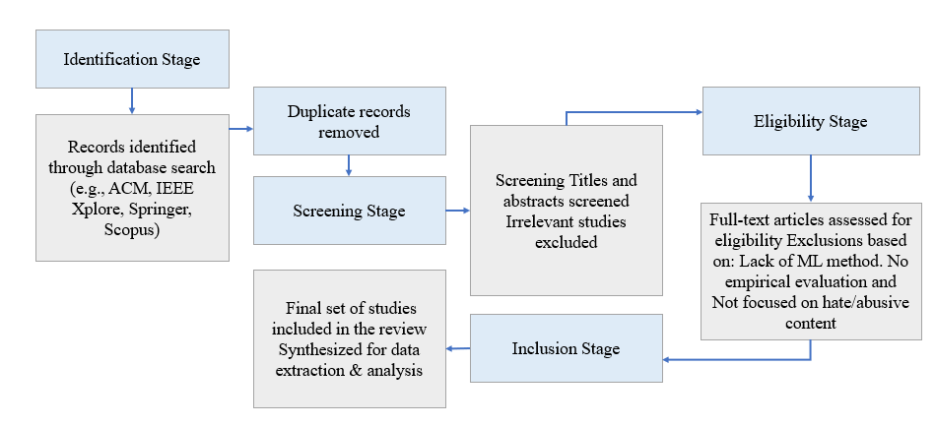 Figure. 1: The criteria for selecting relevant literatures for the study
3. Literature Review
Research on hate text-speech detection has expanded considerably in recent years in response to the growing visibility of harmful and abusive communication across digital environments. With social media platforms increasingly serving as primary spaces for public interaction, they have also become fertile environments for the rapid dissemination of hateful content, often facilitated by anonymity and high audience reach (Abdelhakim et al., 2023). This development has intensified scholarly interest in understanding the linguistic, social, and contextual characteristics of hate speech and in creating computational methods capable of detecting such language effectively (Kumar & Dhiman, 2025). As noted in recent surveys, hate speech is a multilayered phenomenon that requires insights from computational linguistics, machine learning, communication studies, sociology, and ethics, making the research landscape highly interdisciplinary (Narula & Chaudhary, 2025).
The early phase of research primarily relied on lexicon-driven or rule-based techniques that used keyword lists, profanity lexicons, or handcrafted patterns. However, as several reviews highlight, these systems performed poorly with emerging and context-dependent expressions with frequently misclassifying benign content that included reclaimed slurs or sarcasm (Dritsas & Trigka, 2025). The field progressed toward traditional machine learning models such as SVMs and logistic regression, and later toward deep learning architectures including CNNs, RNNs, and attention-based models. More recent advances center on transformer-based architectures, which provide improved contextual understanding and have become dominant in state-of-the-art detection pipelines. Across the literature, a common observation is that hate speech is not purely linguistic but socially constructed, requiring interpretation through cultural norms, speaker intent, and interactional context (Imperato & Mancini, 2025). These complexities continue to challenge automated detection systems and motivate ongoing research into models capable of deeper semantic and pragmatic reasoning.
3.1 Typology of Hate Text-Speech
Hate text-speech manifests in diverse forms, making its computational detection inherently complex. The literature identifies multiple typologies based on the explicitness of expression, the presence of targeted entities, and the degree of contextual reliance (Roiha, 2024). Explicit hate speech is the most straightforward category, typically comprising direct slurs, derogatory statements, and unambiguous expressions of hostility toward individuals or groups. Because such content contains overt linguistic markers, it is often easier for automated systems to detect (Kiritchenko et al., 2021). However, reliance on surface-level cues limits the applicability of models trained solely on explicit hate.
A considerable portion of online hateful communication takes more subtle forms, often classified as implicit hate speech. Implicit hate relies on metaphorical language, euphemisms, stereotype-based references, sarcasm, or culturally specific coded terms that may not appear hateful without contextual or world-knowledge interpretation (Montasari, 2023). Research shows that implicit hate tends to be more harmful and more difficult to detect because its meaning emerges through inference rather than direct lexical patterns. Another important category involves context-dependent hate speech, where the interpretation of a text hinges on conversational history, speaker identity, or socio-political conditions (Mane et al., 2025). For example, a phrase that appears innocuous in isolation may become hateful when viewed within a broader conversation or against the background of prior interactions.
The literature also considers related phenomena such as cyberbullying, harassment, and toxic behavior, which share linguistic and functional overlap with hate speech. While not all toxic content qualifies as hate speech, the boundaries between categories are often porous, and datasets frequently merge related behaviors under broader labels (Pellegrino & Stasi, 2024). These typologies underscore the need for detection systems that account for subtlety, context, and cultural variability rather than relying exclusively on predefined lexical indicators. They also highlight the importance of datasets that capture a wide range of expressions and the necessity of annotation guidelines that reflect the complexity of real-world communication. Figure 2 below shows a conceptual figure showing three core categories arranged from simplest to most complex, illustrating their overlaps.
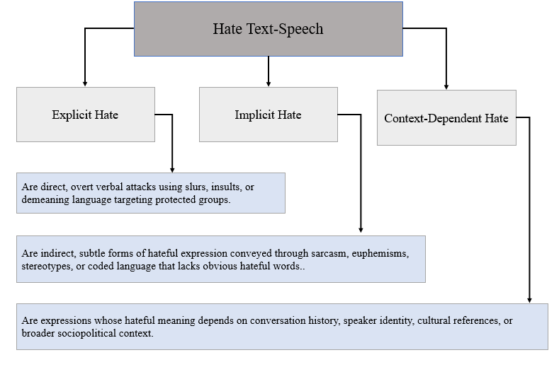
Figure 2: Typology of Hate Speech
3.2 Datasets for Hate Text-Speech Detection
Datasets constitute the empirical basis for training and evaluating hate speech detection models, and progress in the field is closely tied to improvements in dataset quality, diversity, and annotation practices (M. Luo, X. Mu 2022). As discussed in many published articles, most benchmark datasets originate from platforms such as Twitter, Reddit, YouTube, Facebook, and more extreme communities like Gab or Stormfront (A. Rodriguez 2022). Each platform reflects distinct linguistic norms, interaction styles, and user demographics, resulting in datasets that vary widely in toxicity levels, vocabulary, and contextual depth (S. Khan, et al., 2022). This heterogeneity contributes to the persistent challenge of domain dependence, wherein models trained on one source exhibit degraded performance when applied to another (H. Wu, et al., 2022).
A major concern raised across the literature is annotation subjectivity. Hate speech lacks a universally accepted definition, and annotators may interpret the same content differently depending on cultural background, experience with online communities, or understanding of coded language (M. Hong, J.J. Jung 2022). The studies reviewed in some journals demonstrate that annotation guidelines often differ considerably across datasets, not only in label granularity but even in conceptual framing. Some datasets distinguish between “hate,” “offensive,” and “neutral” speech, while others incorporate hierarchical schemes involving target identification, toxicity severity, or contextual attributes. Such discrepancies complicate cross-dataset comparisons and hinder the establishment of standardised evaluation metrics.
Class imbalance is another significant limitation. Because most online content is non-hateful, hate speech typically represents a small minority of labelled data. This imbalance biases machine learning models toward the majority class, reducing sensitivity to implicit or minority expressions of hate (A. Kumar, et al., 2022). Moreover, many datasets are constructed using keyword filtering methods that disproportionately capture explicit hate while failing to include implicit or context-dependent instances. The result is a dataset landscape skewed toward highly overt expressions, reinforcing models that overfit to explicit cues (R.M. Cruz, W.V. de Sousa 2022).
The literature also identifies a lack of linguistic and cultural diversity. English-language datasets dominate the field, even though hate speech manifests differently across sociolinguistic communities. Multilingual datasets have begun to emerge, but they face challenges with annotation consistency, cultural transferability, and differences in writing systems or orthography. Several recent reviews emphasise that effective multilingual hate speech detection requires aligned annotation frameworks and culturally grounded labeling guidelines, conditions not met by many existing resources.
Beyond linguistic diversity, dataset representativeness remains limited in other ways. Few datasets capture intersectional hate, conversational context, multimodal cues (e.g., text image combinations), or evolving coded language. Static datasets quickly become outdated as online communities generate new euphemisms or obfuscation strategies to evade detection. This phenomenon, often described as linguistic drift, reduces the long-term effectiveness of trained models. Collectively, these limitations highlight the need for comprehensive, culturally informed, and dynamically updated datasets. Table 1 provides a summary of widely used datasets, outlining their sources, annotation approaches, label schemes, and known limitations.

Table 1: Summary of Major Hate Speech Datasets
Dataset | Source / Platform | Size | Labels Provided | Annotation Method | Key Limitations
HateXplain | Twitter, Gab | 24k | Hate, Offensive, Normal + Rationales | Crowdsourced with explanations | Subjective rationales; platform-specific bias
Davidson Dataset | Twitter | 24k | Hate, Offensive, Neutral | Crowdsourced | Ambiguous label boundary; imbalance
Stormfront | Extremist forum | 10k | Hate, non-hate | Expert annotation | Highly explicit hate; poor generalization
OffensEval (SemEval) | Social media | 14k–40k | Offensive levels (binary, hierarchical) | Mixed methods | Varies by country; label inconsistency
Gab Hate Corpus | Gab | 27k | Explicit hate, non-hate | Expert-guided | Extremely toxic domain; lacks implicit cases
HASOC | Twitter, Facebook | 12 languages | Hate, Offensive, Profanity | Regional annotators | Multilingual but inconsistent per locale

3.3 Machine Learning Techniques for Hate Text-Speech Detection
Machine learning approaches to hate speech detection have evolved significantly, progressing through several methodological phases: traditional machine learning, deep learning, and transformer-based architectures. Early efforts relied on feature-engineering-driven models such as Support Vector Machines, Logistic Regression, and Naïve Bayes classifiers (Nurce, E., J. Keci, and L. Derczynski 2021). These systems used lexical, syntactic, and sentiment-based features and achieved moderate success in controlled settings. However, their dependence on handcrafted features and limited contextual awareness restricted their capacity to detect nuanced or implicit hate speech (Albadi, N., M. Kurdi, and S. Mishra 2018).
The emergence of deep learning marked a major advancement by enabling automatic feature learning from data. Convolutional Neural Networks (CNNs) demonstrated effectiveness in capturing local lexical patterns, while Recurrent Neural Networks (RNNs), particularly LSTMs and GRUs, improved the modelling of sequential dependencies in text (Suryawanshi, S., et al., 2020). These architectures offered substantial gains in performance by moving beyond simple bag-of-words representations. Their ability to capture phrase-level and sentence-level dependencies made them more suitable for analysing conversational and informal online communication (Mathuret al., 2018). Attention mechanisms further enhanced deep learning models by allowing them to prioritise linguistically salient regions of text, improving interpretability and classification accuracy, especially in cases where hateful meaning hinged on specific phrases (Bohra, A., et al., 2018).
The introduction of transformer-based language models has reshaped the field by offering unprecedented improvements in contextual understanding (Caselli, T., et al., 2020). Models such as BERT, RoBERTa, XLNet, DistilBERT, XLM-R, and domain-specific variants like HateBERT leverage self-attention to capture long-range dependencies, subtle semantic nuances, and polysemy more effectively than earlier architectures (Pavlopoulos, J., et al., 2021). The IJMIR paper highlights that transformers dominate contemporary benchmarks because of their ability to integrate surrounding context, handle multilingual inputs, and adapt to domain-specific linguistic patterns through fine-tuning (Mathew, B., et al., 2021). However, these models also introduce practical challenges, including computational demands, sensitivity to annotation bias, and vulnerability to adversarial manipulation (A. Vaswani, et al., 2017).
Hybrid and ensemble models represent another important direction. These approaches combine strengths from multiple architectures for example, integrating traditional ML classifiers with transformer embeddings or merging CNN and LSTM layers into unified pipelines (Kennedy, C.J., et al., 2020). Ensemble strategies such as stacking and boosting often yield performance improvements by reducing variance and capturing complementary linguistic cues (Grimminger, L. and R. Klinger 2021). Despite their effectiveness, these systems tend to increase computational complexity and may suffer from decreased interpretability, raising concerns regarding deployment in real-world moderation systems (L. Khan, et al., 2022). Figure 3 below presents a conceptual timeline illustrating the evolution of machine learning approaches used in hate text-speech detection from early rule-based methods to modern transformer architectures.
Across these methodological developments, a consistent theme emerges that while machine learning has achieved remarkable progress in detecting explicit hate speech, handling implicit, context-dependent, and culturally nuanced expressions remains a significant challenge (De la Pena ˜ Sarrac´en, G.L. and P. Rosso 2022). Achieving robust and fair detection requires advancements not only in modelling but also in dataset construction, annotation frameworks, and ethical evaluation metrics. Table 2 shows a comparison of strengths and limitations of major machine learning approaches in the area of hate speech.

Table 2: Comparison of strengths and limitations of major ML approaches
Technique | Input Representation | Strengths | Weaknesses
Traditional ML (SVM, NB, LR) | TF-IDF, n-grams | Fast, interpretable, low-resource | Poor context understanding; weak on implicit hate
CNN | Word embeddings | Captures local patterns; effective for short posts | Limited global context
LSTM / GRU | Word embeddings | Models sequence and context | Struggles with long contexts; slower
Attention-based DL | Embeddings + attention | Highlights key phrases; improved interpretability | Still limited on coded language
Transformers (BERT, RoBERTa, XLM-R) | Contextual embeddings | State-of-the-art contextual understanding | Computationally heavy; bias amplification
Hybrid / Ensemble | Multiple combined inputs | Improved robustness; leverages strengths of multi-models | Complex to train; harder to interpret

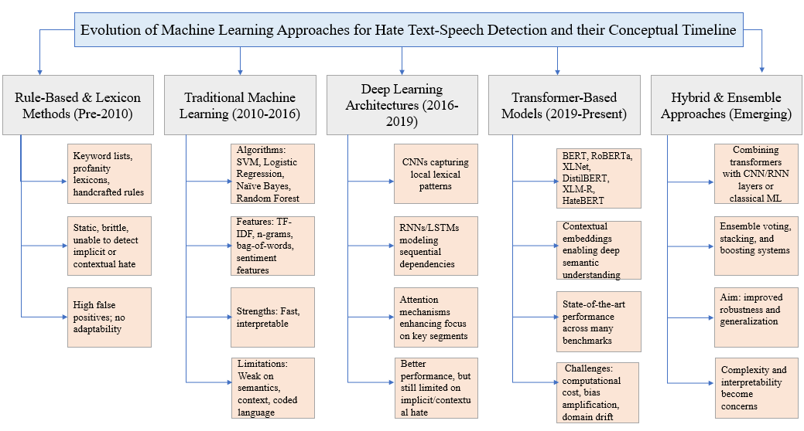
Figure 3: Evolution of Machine Learning Approaches for Hate Text-Speech Detection
4. Key Challenges Identified in the Literature
A review of current research reveals several persistent challenges that hinder the development of robust, fair, and contextually informed hate speech detection systems. These challenges span linguistic, computational, ethical, and methodological dimensions.
One of the most recurrent challenges is linguistic ambiguity, particularly in implicit or coded hate speech. Unlike explicit content, implicit hate often relies on connotations, stereotypes, or culturally specific references. Modelling such subtleties requires systems that can integrate background knowledge, capture pragmatic meaning, and infer unstated intentions, capabilities that remain limited in contemporary NLP models.
A second challenge concerns dataset limitations. The literature repeatedly emphasises class imbalance, annotation subjectivity, and cultural bias as fundamental obstacles. Many datasets overrepresent certain types of hate or target populations, leading to skewed model behaviour. Additionally, data collection methods often based on keyword filtering produce datasets biased toward explicit hate, leaving implicit forms underrepresented. The scarcity of multilingual and cross-cultural datasets restricts the development of models applicable beyond English-dominant contexts. Even where multilingual datasets exist, inconsistencies in annotation guidelines and label definitions hinder cross-lingual transfer.
A third major issue is domain shift and generalisation. Models trained on one dataset frequently suffer performance declines when tested on another, even within the same language. This instability indicates that models may be learning dataset-specific artefacts rather than generalizable linguistic patterns. Domain adaptation techniques, adversarial training, and large-scale pretraining have partially addressed this issue, but significant gaps remain.
Another critical challenge is bias and fairness. Multiple studies have shown that machine learning models can perpetuate or amplify existing societal biases, disproportionately flagging content associated with marginalized groups or dialects (e.g., African American English) as hateful. This raises serious ethical concerns, as automated moderation systems may inadvertently silence minority communities while failing to detect subtle hate directed at them. Ensuring fairness requires careful dataset curation, balanced representation of linguistic varieties, and interpretability mechanisms that highlight model reasoning.
From a computational perspective, the resource demands of transformer models pose practical deployment challenges, especially for real-time moderation on large-scale platforms. The need for continuous updating to account for evolving slang, coded expressions, and adversarial manipulation further complicates deployment.
Finally, the literature identifies evaluation challenges. Many studies rely on accuracy or F1 scores, metrics that do not adequately reflect model performance on minority classes or ambiguous cases. Few works incorporate robustness testing, bias audits, or cross-dataset evaluation, resulting in an overly optimistic picture of model performance. Without comprehensive evaluation frameworks, it remains difficult to assess the true reliability or fairness of hate speech detection systems.
Collectively, these challenges illustrate that hate speech detection is not merely a technical task but a socially embedded one requiring interdisciplinary solutions. Addressing these gaps is essential for the development of reliable, ethical, and generalizable detection systems.
4.1 Discussion
The evolution of hate speech detection research reflects the broader trajectory of natural language processing and machine learning, moving from surface-level lexical heuristics toward increasingly sophisticated context-aware models. Despite substantial progress, the literature reveals that hate speech remains an intrinsically complex phenomenon shaped by linguistic ambiguity, cultural variability, and evolving online behaviors. This complexity limits the effectiveness of computational models trained exclusively on textual features and highlights the need for deeper interdisciplinary approaches.
One central theme emerging from past studies is the tension between generalizability and domain specificity. Models trained on one dataset, often from a single platform or linguistic community tend to perform poorly when applied to different domains, underscoring the influence of platform norms, demographic variance, and differing communicative practices. This phenomenon has been consistently reported across empirical studies, showing that even state-of-the-art transformer architectures struggle when confronted with unseen domains, subtle hate forms, or culturally grounded expressions. The discussion in some papers similarly highlights that no universal model currently exists that performs consistently across platforms, languages, and hate categories, largely due to the fragmented and heterogeneous nature of existing datasets. Another important point concerns annotation inconsistencies. As the literature increasingly recognizes, hate speech is a socially constructed concept whose interpretation depends on cultural context, the annotator’s background, and the guidelines provided. Consequently, datasets often exhibit substantial disagreement, even among trained annotators. This disagreement, while sometimes dismissed as “annotation noise,” actually reflects the inherent subjectivity of the task. The variability poses challenges for supervised learning, as models trained on noisy or inconsistent labels may internalise biased patterns or make unreliable predictions in ambiguous cases.
The literature also highlights a growing shift toward recognising the role of pragmatic, conversational, and socio-historical context in shaping hateful meaning. This recognition has prompted researchers to experiment with models that incorporate contextual metadata such as user history, conversation threads, or multimodal signals. Although these approaches show promise, they also raise ethical considerations related to privacy, user profiling, and potential discrimination.
The synthesis of existing work suggests that progress in hate speech detection requires not only improved model architectures but also methodological innovations in dataset construction, annotation frameworks, evaluation metrics, and interpretability. The field is moving toward a more holistic understanding of hate speech that recognises the interplay between language, culture, and social dynamics.
5.Conclusion
This review examined the current landscape of machine learning approaches for hate text-speech detection, emphasising the interplay between linguistic complexity, dataset limitations, and methodological challenges. Although machine learning has advanced significantly from traditional classifiers to deep learning and transformer-based models, accurately detecting hateful content remains difficult, particularly when expressions are implicit, coded, or highly context-dependent. These forms require nuanced semantic and pragmatic understanding that current models only partially achieve. The review also highlighted persistent dataset issues, including annotation subjectivity, class imbalance, and limited cultural and linguistic diversity. Such limitations restrict model generalisation and contribute to biased or unreliable predictions. Additionally, challenges related to fairness, adversarial manipulation, and evaluation inconsistencies further complicate the deployment of automated moderation tools in real-world settings. Despite these obstacles, emerging research directions point toward more robust and inclusive solutions. Greater emphasis on contextual modelling, multilingual and cross-cultural datasets, implicit hate detection, fairness-aware algorithms, and dynamic learning frameworks offers promising pathways forward. Continued interdisciplinary collaboration will be essential to developing systems that are not only more accurate but also ethically responsible and socially aware. Overall, hate speech detection remains an evolving field that requires ongoing refinement of datasets, models, and evaluation practices. By addressing current gaps and embracing innovative approaches, future systems can better support the creation of safer and more inclusive digital environments.

Generative AI Statement

During the preparation of this work the author(s) used ChatGPT in order to improve readability and language. After using this tool/service, the author(s) reviewed and edited the content as needed and take(s) full responsibility for the content of the publication

COMPETING INTERESTS DISCLAIMER:
Authors have declared that they have no known competing financial interests OR non-financial interests OR personal relationships that could have appeared to influence the work reported in this paper.

References

Arora, A., Nakov, P., Hardalov, M., Sarwar, S. M., Nayak, V., Dinkov, Y., Zlatkova, D., Dent, K., Bhatawdekar, A., Bouchard, G., & Augenstein, I. (2023). Detecting Harmful Content on Online Platforms: What Platforms Need vs. Where Research Efforts Go. ACM Computing Surveys, 56(3), 1–17. DOI: 10.1145/3603399
Alslaity, A., & Orji, R. (2022). Machine learning techniques for emotion detection and sentiment analysis: current state, challenges, and future directions. Behaviour and Information Technology, 43(1), 139–164. DOI: 10.1080/0144929x.2022.2156387
Azarian, M., Yu, H., Shiferaw, A. T., & Stevik, T. K. (2023). Do we perform systematic literature review right? a scientific mapping and methodological assessment. Logistics, 7(4), 89. DOI: 10.3390/logistics7040089
Abdelhakim, M., Liu, B., & Sun, C. (2023). Ar-PuFi: A short-text dataset to identify the offensive messages towards public figures in the Arabian community. Expert Systems With Applications, 233, 120888. DOI: 10.1016/j.eswa.2023.120888
Vaswani, et al., Attention is all you need, Advances in neural information processing systems 30 (2017). DOI: 10.48550/arXiv.1706.03762
Kumar, et al., BILEAT: a highly generalized and robust approach for unified aspect-based sentiment analysis: BILEAT, Applied Intelligence 52 (12) (2022) 14025–14040. DOI: 10.1007/s10489-022-03311-y
Rodriguez, Y.-L. Chen, C. Argueta, FADOHS: framework for detection and integration of unstructured data of hate speech on facebook using sentiment and emotion analysis, IEEE Access 10 (2022) 22400–22419. DOI: 10.1109/ACCESS.2022.3151098
Albadi, N., M. Kurdi, and S. Mishra. Are they our brothers? analysis and detection of religious hate speech in the arabic twittersphere. in 2018 IEEE/ACM International Conference on Advances in Social Networks Analysis and Mining (ASONAM). 2018. IEEE. DOI: 10.1109/ASONAM.2018.8508247
Bohra, A., et al. A dataset of Hindi-English code-mixed social media text for hate speech detection. in Proceedings of the second workshop on computational modeling of people’s opinions, personality, and emotions in social media. 2018. DOI: 10.18653/v1/W18-1105

Caselli, T., et al. I feel offended, don’t be abusive! implicit/explicit messages in offensive and abusive language. in Proceedings of the Twelfth Language Resources and Evaluation Conference. 2020.
Diaz-Garcia, J. A., & Carvalho, J. P. (2025). A survey of textual cyber abuse detection using cutting-edge language models and large language models. arXiv (Cornell University). DOI: 10.48550/arXiv.2501.05443
De la Pena ˜ Sarrac´en, G.L. and P. Rosso. Unsupervised embeddings with graph auto-encoders for multi-domain and multilingual hate speech detection. In Proceedings of the Thirteenth Language Resources and Evaluation Conference. 2022.
Dritsas, E., & Trigka, M. (2025). Machine Learning and Data science in Social Sciences: Methods, applications, and future directions. IEEE Access, 13, 105334–105352. DOI: 10.1109/access.2025.3578906
Diaz‐Garcia, J. A., & Carvalho, J. P. (2025). A literature review of Textual cyber Abuse Detection using Cutting‐Edge Natural Language Processing Techniques: Language Models and Large Language Models. Wiley Interdisciplinary Reviews Data Mining and Knowledge Discovery, 15(3). DOI: 10.1002/widm.70029
Grimminger, L. and R. Klinger, Hate towards the political opponent: A Twitter corpus study of the 2020 US elections on the basis of offensive speech and stance detection. arXiv preprint arXiv:2103.01664, 2021.
Hu, X., Chu, T. H. S., Leung, V. C. M., Ngai, E. C., Kruchten, P., & Chan, H. C. B. (2014). A Survey on Mobile Social Networks: Applications, Platforms, System Architectures, and Future Research Directions. IEEE Communications Surveys & Tutorials, 17(3), 1557–1581. DOI: 10.1109/comst.2014.2371813
H. Wu, et al., Phrase dependency relational graph attention network for Aspectbased Sentiment Analysis, Knowledge-Based Systems 236 (2022), 107736. DOI: 10.1016/j.knosys.2021.107736
Imperato, C., & Mancini, T. (2025). Mapping the Landscape of Online Discrimination: An Integrated transdisciplinary approach. Human Behavior and Emerging Technologies, 2025(1). DOI: 10.1155/hbe2/6627162
Ibrohim, M.O. and I. Budi. Multi-label hate speech and abusive language detection in Indonesian Twitter. in Proceedings of the third workshop on abusive language online. 2019. DOI: 10.18653/V1/W19-3506
Johnson, B. G. (2017). Speech, Harm, and the Duties of Digital Intermediaries: Conceptualizing platform ethics. Journal of Media Ethics, 32(1), 16–27. DOI: 10.1080/23736992.2016.1258991
Kennedy, C.J., et al., Constructing interval variables via faceted rasch measurement and multitask deep learning: a hate speech application. arXiv preprint arXiv:2009.10277, 2020.
Kumar, G., & Dhiman, C. (2025). Decoding fake news fabrications and trends: A comprehensive survey. Neurocomputing, 653, 131118. DOI: 10.1016/j.neucom.2025.131118
Kiritchenko, S., Nejadgholi, I., Fraser, K. C., Kiritchenko, S., Nejadgholi, I., & Fraser, K. C. (2021). Confronting Abusive Language Online: A Survey from the Ethical and Human Rights Perspective. Journal of Artificial Intelligence Research, 71, 431–478. DOI: 10.1613/jair.1.12590
L. Khan, et al., Deep sentiment analysis using CNN-LSTM architecture of English and Roman Urdu text shared in social media, Applied Sciences 12 (5) (2022) 2694. DOI: 10.3390/app12052694
Mathew, B., et al. Hatexplain: A benchmark dataset for explainable hate speech detection. in Proceedings of the AAAI conference on artificial intelligence. 2021. DOI: 10.1609/aaai.v35i17.17745
Mathur, P., et al. Did you offend me? classification of offensive tweets in hinglish language. in Proceedings of the 2nd workshop on abusive language online (ALW2). 2018. DOI: 10.18653/v1/W18-5118
M. Luo, X. Mu, Entity sentiment analysis in the news: A case study based on negative sentiment smoothing model (nssm), International Journal of Information Management Data Insights 2 (1) (2022), 100060. DOI: 10.1016/j.jjimei.2022.100060
Montasari, R. (2023). Analysing Ethical, Legal, Technical and Operational Challenges of the Application of Machine Learning in Countering Cyber Terrorism. Advanced Sciences and Technologies for Security Applications, 159–197. DOI: 10.1007/978-3-031-50454-9_9
Mane, S., Kundu, S., & Sharma, R. (2025). A survey on Online Aggression: Content detection and Behavioral analysis on social media. ACM Computing Surveys, 57(7), 1–36. DOI: 10.1145/3711125
M. Hong, J.J. Jung, Sentiment aware tensor model for multi-criteria recommendation, Applied Intelligence 52 (13) (2022) 15006–15025. DOI: 10.1007/s10489-022-03267-z
Narula, R., & Chaudhary, P. (2025). A comprehensive review on detection of hate speech for multi-lingual data. Social Network Analysis and Mining, 14(1). DOI: 10.1007/s13278-024-01401-y
Nurce, E., J. Keci, and L. Derczynski, Detecting abusive Albanian. arXiv preprint arXiv:2107.13592, 2021.
Pellegrino, A., & Stasi, A. (2024). A bibliometric analysis of the impact of media manipulation on adolescent mental health: Policy recommendations for algorithmic transparency. Online Journal of Communication and Media Technologies, 14(4), e202453. DOI: 10.30935/ojcmt/15143
Pavlopoulos, J., et al. SemEval-2021 task 5: Toxic spans detection. in Proceedings of the 15th international workshop on semantic evaluation (SemEval-2021). 2021 DOI: 10.18653/v1/2021.semeval-1.6
Roiha, M. (2024, May 22). Beyond the screen. Digital realities and embodied harm in the experiences of gender-based online hate speech. https://hdl.handle.net/2445/216831
R.M. Cruz, W.V. de Sousa, G.D. Cavalcanti, Selecting and combining complementary feature representations and classifiers for hate speech detection, Online Social Networks and Media 28 (2022), 100194. DOI: 10.1016/j.osnem.2021.100194
Sharma, N. A., Ali, A. B. M. S., & Kabir, M. A. (2024). A review of sentiment analysis: tasks, applications, and deep learning techniques. International Journal of Data Science and Analytics, 19(3), 351–388. DOI: 10.1007/s41060-024-00594-x
Suryawanshi, S., et al. Multimodal meme dataset (MultiOFF) for identifying offensive content in image and text. in Proceedings of the second workshop on trolling, aggression and cyberbullying. 2020.
S. Khan, et al., HCovBi-caps: hate speech detection using convolutional and Bidirectional gated recurrent unit with Capsule network, IEEE Access 10 (2022) 7881–7894. DOI: 10.1109/ACCESS.2022.3143799

Ashiq, W., Kanwal, S., Rafique, A., Waqas, M., Khurshaid, T., Montero, E. C., ... & Ashraf, I. (2024). Roman urdu hate speech detection using hybrid machine learning models and hyperparameter optimization. Scientific Reports, 14(1), 28590.

Mehmood, F.; Shahzadi, R.; Ghafoor, H.; Asim, M.N.; Ghani, M.U.; Mahmood, W.; Dengel, A. ENML: Multi-label ensemble learning for Urdu text classification. ACM Trans. Asian Low-Resour. Lang. Inf. Process. 2023, 22, 1–31.

Naseeb, A., Zain, M., Hussain, N., Qasim, A., Ahmad, F., Sidorov, G., & Gelbukh, A. (2025). Machine Learning- and Deep Learning-Based Multi-Model System for Hate Speech Detection on Facebook. Algorithms, 18(6), 331. https://doi.org/10.3390/a18060331
Lavanya , J., M. Ramesh, J. Sravan Kumar, G. Rajaramesh, and Subhani Shaik. 2023. “Hate Speech Detection Using Decision Tree Algorithm”. Journal of Advances in Mathematics and Computer Science 38 (8):66-75. https://doi.org/10.9734/jamcs/2023/v38i81791.

