A Pseudotumoral Lesion of the Mitral Annulus: Diagnostic Approach and Clinical Implications

Abstract
Background:
Caseous calcification of the mitral annulus (CCMA) is a rare variant of mitral annular calcification characterized by liquefaction necrosis within chronically calcified annular tissue. Its pseudotumoral appearance may mimic cardiac tumors or infective processes, creating significant diagnostic challenges.
Case Presentation:
An 81-year-old female patient was referred for preoperative cardiac assessment in advance of elective hip arthroplasty. She was asymptomatic and classified as New York Heart Association (NYHA) functional class I. Transthoracic echocardiography demonstrated a well-circumscribed mass measuring 23 × 20 mm situated at the posterior mitral annulus, accompanied by mild mitral stenosis, with a mitral valve area of 1.9 cm² and a mean transvalvular gradient of 5 mmHg. Left ventricular systolic function was preserved. Cardiac magnetic resonance imaging demonstrated a hypointense lesion with peripheral late gadolinium enhancement, while computed tomography confirmed a hypodense mass with peripheral calcifications, consistent with caseous degeneration. Laboratory findings were unremarkable. A conservative approach was adopted. The patient underwent orthopaedic surgery without complications, and six-month follow-up echocardiography showed stable findings.
Conclusion:
CCMA should be included in the differential diagnosis of mitral annular masses in elderly individuals. The use of multimodality imaging is integral to accurate diagnosis and is essential in avoiding unwarranted surgical intervention.

Keywords
Caseous calcification; Mitral annulus; Mitral annular calcification; Cardiac mass; Multimodality imaging; Cardiac CT; Cardiac MRI; Mitral stenosis.

Introduction:
Caseous calcification of the mitral annulus (CCMA) represents an uncommon variant of mitral annular calcification (MAC), distinguished by the presence of liquefactive necrosis within chronically calcified annular tissue (1,3). Although MAC itself is a frequent finding in elderly populations, particularly among women, CCMA represents a rare subtype, with a reported prevalence ranging from 0.06% to 0.07% in patients undergoing transthoracic echocardiography and accounting for less than 1% of all MAC cases (1,2).
First described in pathological studies by Pomerance in 1970 (3), CCMA most commonly involves the posterior mitral annulus and may appear as a rounded, well-defined mass. Its pseudotumoral morphology frequently leads to diagnostic uncertainty, as it may mimic atrial myxoma, mitral annular abscess, infective endocarditis, or other primary cardiac tumors (4,5). Misinterpretation can result in unnecessary invasive investigations or surgical intervention (6).
The development of multimodality imaging has significantly improved the noninvasive characterization of such lesions. While echocardiography remains the initial diagnostic tool, cardiac magnetic resonance imaging (MRI) and computed tomography (CT) provide complementary information that enables more accurate tissue characterization and differentiation from malignant or infectious processes (4,7).
We report the case of an elderly woman in whom a pseudotumoral mitral annular lesion was incidentally discovered during preoperative assessment. This case highlights the diagnostic approach and clinical implications of CCMA, emphasizing the essential role of multimodal cardiac imaging in preventing misdiagnosis and inappropriate management.
Reporting this case is important because the pseudotumoral appearance of CCMA may lead to diagnostic confusion with cardiac tumors or infective processes. This report highlights the role of multimodality imaging in establishing the correct diagnosis and avoiding unnecessary surgical intervention.
Case report :
An 81-year-old female patient was referred to our cardiology department for preoperative cardiac assessment in advance of elective left hip arthroplasty indicated for advanced osteoarthritis. She had no prior history of hypertension, diabetes mellitus, chronic kidney disease, or established cardiovascular disease. From a cardiovascular perspective, she remained asymptomatic and was categorised as New York Heart Association (NYHA) functional class I.
On physical examination, blood pressure was 123/74 mmHg. Cardiac auscultation revealed an accentuated first heart sound at the mitral area and a low-pitched diastolic rumble at the apex. No peripheral signs of heart failure were noted. Electrocardiography showed a normal sinus rhythm without conduction abnormalities or ischemic changes.
Laboratory investigations revealed hemoglobin of 13 g/dL, leukocyte count of 6,420/mm³, and platelet count of 240,000/mm³. Renal function was preserved (urea 0.54 g/L, creatinine 80 µmol/L), and phosphocalcic balance was within normal limits. There were no biological signs of infection. Laboratory findings are summarized in Table 1.
Transthoracic echocardiography revealed a well-defined, echogenic mass arising from the posterior mitral annulus and projecting into the left atrium (Figure 1A, 1B). The lesion measured 23 × 20 mm and was non-mobile in nature. It was associated with mild mitral stenosis, characterised by a mitral valve area of 1.9 cm² determined by planimetry and a mean transmitral gradient of 5 mmHg. Left ventricular systolic function was preserved, with an ejection fraction of 55%. The estimated pulmonary artery systolic pressure was 26 mmHg. No other valvular calcifications were observed.
Given the pseudotumoral appearance of the lesion, further imaging was performed for tissue characterization.
Cardiac magnetic resonance imaging revealed a well-defined mass located at the posterior mitral annulus. On axial T1-weighted sequences, the lesion appeared hypointense (Figure 2A). Post-contrast T1-weighted imaging following gadolinium administration demonstrated peripheral enhancement consistent with a caseous necrotic core (Figure 2B). T2-weighted sequences showed low signal intensity, indicating the absence of edema and further supporting the diagnosis of caseous degeneration (Figure 2C).
Multislice cardiac computed tomography confirmed the presence of a round hypodense mass with peripheral linear calcifications at the posterior mitral annulus (Figure 3), findings highly suggestive of caseous calcification of the mitral annulus.
Discussion :
CCMA is an infrequent variant of mitral annular calcification (MAC), with a reported prevalence of approximately 0.06–0.07% among patients undergoing transthoracic echocardiography, and accounting for less than 1% of all MAC cases (1,2). First described by Pomerance in 1970, this entity is characterized by liquefaction necrosis within chronic calcified deposits of the posterior mitral annulus (3).
CCMA predominantly occurs in elderly women and has been linked to hypertension, chronic kidney disease, and disturbances in calcium–phosphate metabolism; however, these risk factors were not present in our patient (2,4).
The pathophysiological mechanisms underlying caseous calcification of the mitral annulus remain incompletely elucidated. It is considered a variant of mitral annular calcification in which longstanding calcium deposition undergoes central liquefactive necrosis (11). This process results in the formation of a toothpaste-like caseous material surrounded by a fibrotic and calcified capsule. Metabolic disturbances, chronic inflammation, and degenerative changes associated with aging may contribute to this process.
Diagnostic Challenge
The principal clinical issue is its pseudotumoral appearance. On echocardiography, CCMA typically appears as a round, well-circumscribed echodense mass located at the posterior mitral annulus (1). However, when protruding into the left atrium, it may mimic:
- Atrial myxoma
- Mitral annular abscess
- Infective endocarditis vegetation
- Primary or metastatic cardiac tumors
Several reports describe cases initially misdiagnosed as cardiac tumors, leading to unnecessary surgical exploration (5,6,10). A comparison of previously reported cases of caseous calcification of the mitral annulus is summarized in Table 2.
Cardiac magnetic resonance imaging has a pivotal role in tissue characterisation. CCMA typically exhibits low signal intensity on both T1- and T2-weighted sequences, with peripheral late gadolinium enhancement reflecting a fibrotic capsule encasing central caseous material (7).
Cardiac computed tomography is particularly useful for confirming the diagnosis. The characteristic finding is a hyperdense mass with a central hypodense area and peripheral calcifications, which strongly supports CCMA (4,8). CT is especially valuable in excluding malignant or infectious etiologies.
Clinical Implications
Although generally regarded as benign, CCMA may be associated with mitral valve dysfunction, systemic embolic events, and conduction abnormalities (2,9). In the present patient, mild mitral stenosis was identified, with a mitral valve area of 1.9 cm² and a mean gradient of 5 mmHg, in the absence of pulmonary hypertension or functional impairment, consistent with NYHA class I status.
Longitudinal data suggest that most cases remain stable over time, supporting conservative management in asymptomatic patients (2). Surgical intervention is reserved for severe symptomatic valvular dysfunction or persistent diagnostic uncertainty (6).
In the present case, accurate multimodal imaging prevented misdiagnosis and unnecessary cardiac surgery, allowing safe orthopaedic intervention and conservative follow-up.

Conclusion:
Caseous degeneration of the mitral annulus remains an uncommon but important differential diagnosis of intracardiac masses in elderly patients. Its pseudotumoral presentation may lead to diagnostic uncertainty and inappropriate therapeutic decisions if not correctly recognized.
This case underscores the pivotal role of multimodality cardiac imaging—particularly cardiac CT and MRI—in accurately characterizing mitral annular lesions and distinguishing benign degenerative processes from neoplastic or infectious etiologies.
Early recognition of typical imaging features allows for conservative management in asymptomatic patients and prevents unnecessary surgical intervention.

Consent
Written informed consent was obtained from the patient for publication of this case report and accompanying images.
Authors’ Contributions
All authors contributed to the clinical management of the patient, image interpretation, manuscript drafting, and final approval of the version to be published.
Disclaimer (Artificial intelligence)
Author(s) hereby declare that NO generative AI technologies such as Large Language Models (ChatGPT, COPILOT, etc.) and text-to-image generators have been used during the writing or editing of this manuscript.
References :
- Harpaz D, Auerbach I, Vered Z, Motro M, Tobar A, Rosenblatt S. Caseous calcification of the mitral annulus: a neglected, unrecognized diagnosis. J Am Soc Echocardiogr. 2001;14(8):825–831.
- Deluca G, Correale M, Ieva R, et al. The incidence and clinical course of caseous calcification of the mitral annulus: a prospective echocardiographic study. J Am Soc Echocardiogr. 2008;21(7):828–833.
- Pomerance A. Pathological and clinical study of calcification of the mitral valve ring. J Clin Pathol. 1970;23(4):354–361.
- Elgendy IY, Conti CR. Caseous calcification of the mitral annulus: a review. Clin Cardiol. 2013;36(10):E27–E31.
- Kronzon I, Winer HE, Cohen ML. Sterile, caseous mitral annular abscess. J Am Coll Cardiol. 1983;2(1):186–190.
- Mudd JO, McCarthy PM, Rodriguez LL, et al. Caseous calcification of the mitral annulus mimicking cardiac tumor. Ann Thorac Surg. 2007;83(5):1786–1788.
- Di Bella G, Gaeta M, Pingitore A, et al. Caseous calcification of the mitral annulus: cardiac magnetic resonance findings. J Cardiovasc Med (Hagerstown). 2008;9(8):827–829.
- Alkadhi H, Leschka S, Prêtre R, et al. Caseous calcification of the mitral annulus: computed tomography findings. J Thorac Imaging. 2010;25(2):W43–W45.
- Grigioni F, Avierinos JF, Ling LH, et al. Mitral annular calcification and cardiovascular outcomes. Circulation. 2005;111(25):3286–3292.
- Oury A, et al. Caseous calcification of the mitral annulus: case report and review of the literature. Ann Cardiol Angeiol (Paris). 2022;71(6):425-428.
- Dietl CA, Hawthorn CM. Caseous calcification of the mitral annulus: review of clinical and imaging features. J Cardiol Cases. 2020.

Figures :
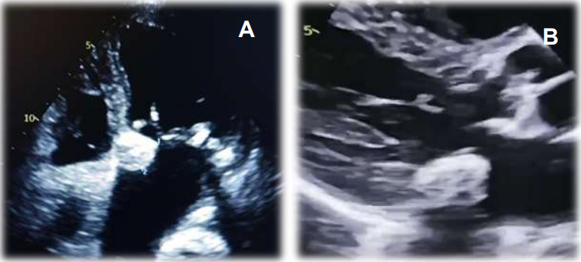
Figure 1 : Transthoracic echocardiography showing caseous calcification of the mitral annulus
A : Apical view, B : Parasternal long-axis view

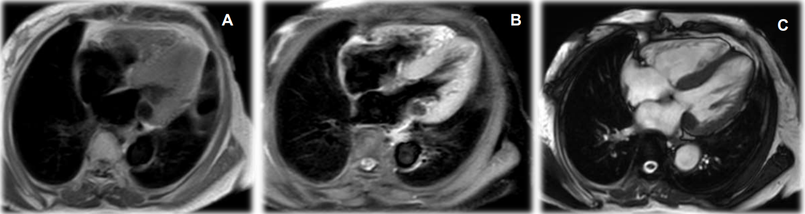
Figure 2: (A) Axial T1-weighted image showing a well-defined, hypointense mass at the posterior mitral annulus. (B) Post-contrast T1-weighted image (after gadolinium injection) demonstrating peripheral enhancement of the lesion, consistent with a caseous necrotic core. (C) T2-weighted image showing low signal intensity of the mass, indicating the absence of edema and supporting the diagnosis of caseous necrosis.
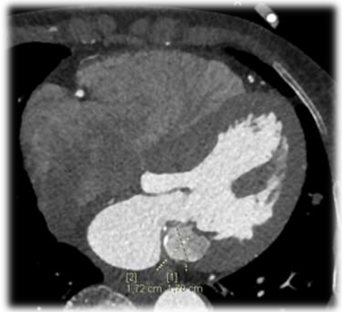
Figure 3: Cardiac CT scan showing caseous calcification of the mitral annulus.

Parameter | Result
Hemoglobin | 13 g/dL
Leukocyte count | 6,420 /mm³
Platelets | 240,000 /mm³
Urea | 0.54 g/L
Creatinine | 80 µmol/L
Table 1. Laboratory findings

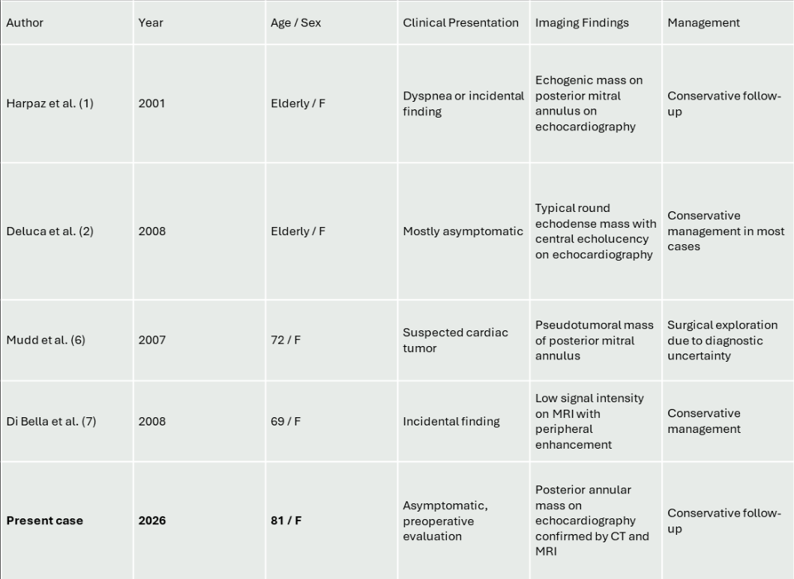
Table 2. Comparison of previously reported cases of caseous calcification of the mitral annulus (CCMA)

