Original Research Article
Impact of Organic Substrates on Oxidative Stress and Antioxidant Responses in Perionyx excavatus

Abstract
Aim: The present study aimed to evaluate the influence of different organic substrates on oxidative stress and antioxidant defense mechanisms in the earthworm Perionyx excavatus, with particular emphasis on biochemical responses, antioxidant enzyme activities, oxidative damage biomarkers, and reactive oxygen species (ROS) balance under vermicomposting conditions.
Methodology: A controlled laboratory experiment was conducted over a 28-day exposure period to assess oxidative and biochemical responses of P. excavatus under 04 substrate treatments: garden soil (control), cow dung + sugarcane bagasse (1:1), horse dung + sugarcane bagasse (1:1), and a mixed substrate of cow dung + horse dung + sugarcane bagasse (1:1:1). Biochemical parameters such as total protein content and antioxidant enzymes including superoxide dismutase (SOD), catalase (CAT), and glutathione peroxidase (GPx) was analyzed. Detoxification enzyme glutathione-S-transferase (GST) and reduced glutathione (GSH) levels were also quantified. Oxidative damage was assessed through lipid peroxidation (MDA) and DNA damage using comet assay. Data were expressed as mean ± standard deviation (n = 5) and analyzed using one-way ANOVA followed by Tukey’s HSD test (p < 0.05).
Results: Organic substrates significantly modulated biochemical and oxidative responses in P. excavatus. Treated groups exhibited elevated protein content and antioxidant enzyme activities compared to the control. The mixed substrate showed the highest SOD, CAT, GPx, GST activities and GSH levels, indicating enhanced antioxidant defense. Conversely, the horse dung + bagasse treatment exhibited increased lipid peroxidation and DNA damage, reflecting higher oxidative stress.
Conclusion: Substrate composition strongly influences oxidative physiology in P. excavatus. Mixed substrates enhance antioxidant defenses and reduce oxidative damage, supporting efficient vermicomposting. The species also serves as a reliable bioindicator of substrate quality and oxidative stress.
Keywords: Perionyx excavatus, oxidative stress, antioxidant enzymes, glutathione, vermiculture.

- Introduction
Earthworms are widely recognized as important soil bioengineers that play a crucial role in maintaining soil health and ecosystem functioning. Through their activities such as burrowing, feeding, and casting, earthworms contribute significantly to nutrient cycling, organic matter decomposition, and the improvement of soil structure and fertility (Edwards & Bohlen, 1996; Domínguez et al., 2009). Among the various earthworm species used in vermiculture, Perionyx excavatus has received considerable attention because of its high reproductive rate, rapid growth, efficient organic waste conversion capacity, and adaptability to a wide range of organic substrates (Prakash et al., 2008). Due to these characteristics, this species is frequently used in vermicomposting systems and has also been considered a useful biological model for evaluating physiological responses to environmental changes. In particular, the study of oxidative stress responses in P. excavatus provides valuable insights into earthworm health and soil ecosystem dynamics.
Oxidative stress occurs when the production of reactive oxygen species (ROS) exceeds the capacity of cellular antioxidant defense systems, leading to potential damage to essential biomolecules such as lipids, proteins, and nucleic acids (Halliwell & Gutteridge, 2015). In invertebrates, including earthworms, ROS can originate from both endogenous metabolic processes and external environmental factors. These factors include exposure to pollutants, nutrient-rich organic wastes, microbial activity, and other environmental stressors that may alter cellular redox balance (Shi et al., 2017). To counteract the harmful effects of ROS, organisms possess a complex antioxidant defense system composed of enzymatic and non-enzymatic components (Figure 1). Key enzymatic antioxidants include superoxide dismutase (SOD), catalase (CAT), and glutathione peroxidase (GPx), which collectively detoxify superoxide radicals and hydrogen peroxide generated during cellular metabolism (Aebi, 1984; Flohé & Günzler, 1984). In addition, reduced glutathione (GSH) acts as a major non-enzymatic antioxidant that maintains intracellular redox balance and participates in detoxification reactions (Ellman, 1959). The balance between ROS production and antioxidant defense is therefore essential for maintaining cellular integrity and physiological stability in earthworms (Reinecke & Reinecke, 2007).
Organic amendments such as animal manures and agricultural residues are commonly used substrates in vermicomposting systems because they provide abundant nutrients and stimulate microbial activity (Edwards et al., 2010). Cow dung and horse dung are among the most frequently used organic materials due to their high nitrogen content, organic matter, and microbial populations that support earthworm growth and decomposition processes. Similarly, agricultural residues such as sugarcane bagasse provide a carbon-rich fibrous substrate that improves aeration and facilitates microbial degradation during composting (Domínguez et al., 2009). However, variations in nutrient composition, microbial activity, and decomposition rates among different organic substrates may significantly influence metabolic activity and ROS production in earthworms. For instance, substrates rich in nitrogen can enhance microbial metabolism and ammonia formation, which may increase oxidative stress and ROS generation in earthworm tissues (Shi et al., 2017).
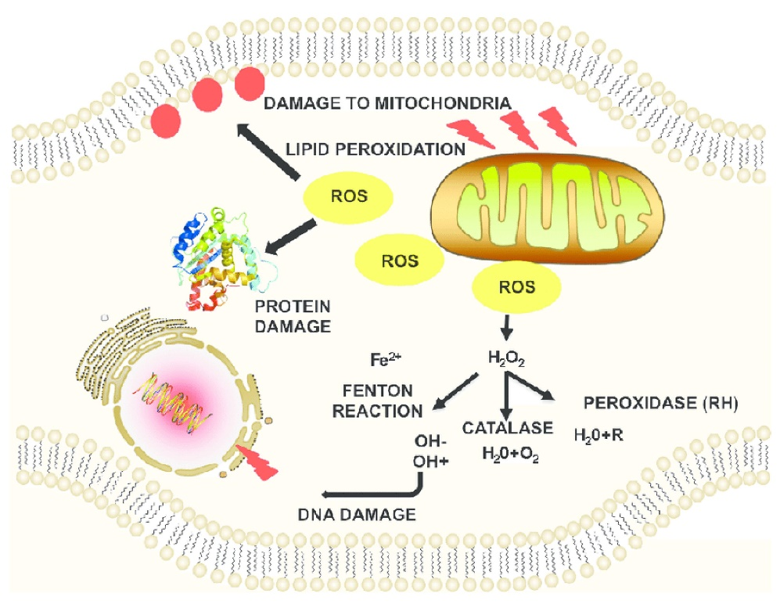
Figure 1. ROS-induced damage to cellular macromolecules and structures. The production of intracellular ROS can damage macromolecules such as DNA, proteins, and lipid bilayers. (Mazumder. & Diederich., 2016).
Several studies have demonstrated that oxidative stress biomarkers can effectively indicate physiological responses of earthworms to environmental and substrate-related stress (Shashank & Mahadevaswamy, 2025). Lipid peroxidation products such as malondialdehyde (MDA) are widely used indicators of oxidative damage to cellular membranes, while DNA fragmentation reflects genotoxic stress at the molecular level (Singh et al., 1988). In addition, the measurement of antioxidant enzyme activities and non-enzymatic antioxidants provides important information regarding the organism’s capacity to neutralize ROS and maintain redox balance (Weydert & Cullen, 2010). Recent studies emphasize the importance of integrating multiple biomarkers—including enzymatic antioxidants, non-enzymatic antioxidants, and oxidative damage indicators—to obtain a comprehensive understanding of redox homeostasis in earthworms exposed to organic wastes or environmental stressors (Shi et al., 2017; Prakash et al., 2008).
Despite these advances, relatively few studies have examined the effects of mixed organic substrates on oxidative stress responses in Perionyx excavatus. Most previous investigations have focused primarily on single substrate systems, which may not accurately represent the complex nutrient interactions and microbial dynamics that occur in practical vermicomposting environments (Edwards et al., 2010; Domínguez et al., 2009). The use of mixed organic substrates may influence metabolic processes, microbial decomposition, and ROS generation differently compared with individual substrates. Therefore, evaluating antioxidant responses and oxidative damage markers under mixed-substrate conditions is essential for understanding the physiological adaptability of earthworms in vermicomposting systems.
The present study was therefore designed to investigate oxidative stress responses in P. excavatus cultured in different organic substrate combinations, including cow dung + sugarcane bagasse, horse dung + sugarcane bagasse, and a mixed substrate containing cow dung, horse dung, and sugarcane bagasse, with garden soil serving as the control. By integrating biochemical analyses of enzymatic antioxidants (SOD, CAT, GPx), non-enzymatic antioxidant levels (GSH), and oxidative damage indicators such as lipid peroxidation (MDA) and DNA fragmentation, this study aims to: (i) evaluate the differential effects of individual and mixed organic substrates on antioxidant defense mechanisms in P. excavatus; (ii) assess the extent of oxidative damage to lipids and DNA; and (iii) develop a relative ROS index as an integrative indicator of redox status. The findings of this study will contribute to a better understanding of oxidative physiology in earthworms and provide insights for optimizing substrate formulations and management strategies in sustainable vermiculture systems.
- Materials and Methods
  - Earthworm culture, substrate treatments, and experimental design
Adult, healthy individuals of Perionyx excavatus of uniform size (0.45–0.60 g fresh weight) and free from visible injury were collected and acclimatized under laboratory conditions for 7 days prior to experimentation. During acclimatization, the earthworms were maintained in garden soil under controlled environmental conditions (moisture 60–70 %, temperature 25 ± 2 °C) to stabilize physiological status. The experimental setup consisted of four substrate treatments, each with five biological replicates (n = 5). Plastic trays (30 × 20 × 10 cm) were used as experimental units, each containing 2 kg of substrate prepared as follows: Cow dung + sugarcane bagasse (1:1, w/w); Horse dung + sugarcane bagasse (1:1, w/w); Cow dung + horse dung + sugarcane bagasse (1:1:1, w/w); Control: garden soil only
All organic substrates were pre-decomposed for 10–15 days under moist conditions to reduce ammonia toxicity and stabilize microbial activity prior to earthworm inoculation (Domínguez et al., 2009; Edwards et al., 2010). Following acclimatization, twenty adult earthworms (0.45–0.60 g fresh weight) were introduced into each tray containing 2 kg of substrate. Moisture content was maintained at 60–70 % throughout the experiment by daily sprinkling with sterile deionized water. The exposure experiment was conducted for 28 days, and earthworms were sampled at five time points: day 0, 7, 14, 21, and 28. At each sampling point, worms were carefully retrieved from the substrate, rinsed with distilled water to remove adhering particles, blotted dry using filter paper, and weighed.
For biochemical analyses, 3–5 individuals were pooled per replicate, and tissues of earthworms were allowed to depurate gut contents on moist filter paper for 24 h prior to homogenization and stored at −80 °C until further analysis.
  - Tissue homogenization and protein estimation
For each replicate and sampling time point, pooled earthworm tissues were homogenized on ice in 0.1 M phosphate buffer (pH 7.4) containing 1 mM EDTA at a ratio of 1:10 (w/v) (i.e., 0.1 g tissue in 1 mL buffer). Homogenization was performed using a chilled glass homogenizer to minimize enzyme degradation. The homogenate was centrifuged at 10,000 × g for 15 min at 4 °C, and the resulting supernatant was collected as the crude enzyme extract for subsequent biochemical assays.
Protein concentration in each extract was determined using the Lowry method with bovine serum albumin (BSA) as standard. Enzyme activities were expressed as units per milligram of protein.
  - Superoxide dismutase (SOD) assay
Superoxide dismutase (SOD) activity was determined by measuring the inhibition of nitroblue tetrazolium (NBT) reduction, following a modified version of classical photochemical methods (Ifemeje et al., 2015). The reaction mixture (3 mL total volume) contained: 50 mM phosphate buffer (pH 7.8), 0.1 mM EDTA, 13 mM methionine, 75 µM NBT, 2 µM riboflavin, appropriate volume of enzyme extract. The reaction was initiated by exposure to fluorescent light for 10 minutes. Absorbance was then measured at 560 nm using a spectrophotometer.
  - Catalase (CAT) assay
Catalase (CAT) activity was measured spectrophotometrically by monitoring the decomposition of hydrogen peroxide (H₂O₂) at 240 nm, following established methods used in oxidative stress studies (Wang et al., 2021; Wen et al., 2021). The reaction mixture contained: 50 mM phosphate buffer (pH 7.0), 10 mM H₂O₂, enzyme extract (50–100 µL). The decrease in absorbance at 240 nm was recorded for 1–2 minutes during the linear phase. Catalase activity was calculated using the molar extinction coefficient of H₂O₂ (39.4 M⁻¹ cm⁻¹).
  - Glutathione peroxidase (GPx) assay
Glutathione peroxidase (GPx) activity was determined using the coupled NADPH oxidation method, commonly used in ecotoxicological biomarker studies (Wang et al., 2021; Zhou et al., 2024). The reaction mixture (1 mL total volume) consisted of: 50 mM phosphate buffer (pH 7.0), 1 mM EDTA, 1 mM sodium azide, 0.2 mM NADPH, 1 mM reduced glutathione (GSH), 0.25 mM tert-butyl hydroperoxide (or H₂O₂), enzyme extract. The reaction was initiated by addition of the hydroperoxide substrate, and the decrease in NADPH absorbance at 340 nm was monitored for 2–3 minutes. One unit of GPx activity corresponded to the oxidation of 1 µmol NADPH per minute per mg protein.
  - Glutathione-S-transferase (GST) assay
GST activity was determined spectrophotometrically using 1-chloro-2,4-dinitrobenzene (CDNB) as substrate (Wang et al., 2021; Wen et al., 2021). The reaction mixture (1 mL) contained: 100 mM phosphate buffer (pH 6.5), 1 mM reduced glutathione (GSH), 1 mM CDNB, enzyme extract. Formation of the CDNB–GSH conjugate was monitored at 340 nm for 3 minutes. GST activity was calculated using the extinction coefficient of 9.6 mM⁻¹ cm⁻¹ and expressed as: µmol conjugate formed min⁻¹ mg⁻¹ protein
  - Reduced glutathione (GSH) determination
Reduced glutathione levels were quantified using the Ellman’s reagent (DTNB) method (Ellman, 1959; Balamurugan et al., 2008). Earthworm tissues were homogenized in 5 % trichloroacetic acid (TCA) to precipitate proteins and centrifuged at 10,000 × g for 10 minutes.
The reaction mixture consisted of: 0.5 mL supernatant 2.0 mL of 0.3 M disodium phosphate buffer (pH 7.5) 1.0 mL of 0.6 mM DTNB. After 10 minutes incubation at room temperature, absorbance was measured at 412 nm.
  - Lipid peroxidation assay
Lipid peroxidation was assessed by quantifying malondialdehyde (MDA) using the thiobarbituric acid reactive substances (TBARS) assay (Wang et al., 2021; Wen et al., 2021).
An aliquot of 0.5 mL tissue homogenate was mixed with 2.0 mL TBA reagent (0.67 % TBA in 10 % TCA) and heated in a boiling water bath for 15 minutes. After cooling in ice, samples were centrifuged and the absorbance of the supernatant was measured at 532 nm, with correction at 600 nm for non-specific turbidity. MDA concentration was calculated using an extinction coefficient of 1.56 × 10⁵ M⁻¹ cm⁻¹ and expressed as: nmol MDA mg⁻¹ protein.
  - DNA damage assay
DNA damage was evaluated using the single-cell gel electrophoresis (comet) assay in earthworm coelomocytes or tissue-derived nuclei (Wang et al., 2021). Cells were embedded in low-melting agarose on microscope slides, lysed under alkaline conditions (pH > 13), and subjected to electrophoresis (25 V, ~300 mA for 20–25 min). Slides were neutralized, stained with ethidium bromide (2 µg mL⁻¹), and observed under a fluorescence microscope. DNA damage parameters including: Tail length, Tail DNA percentage, Olive tail moment (OTM) were quantified using image analysis software.
2.10. Statistical analysis
All biochemical measurements were performed with three technical replicates for each biological replicate (n = 5). Data were expressed as mean ± standard deviation (SD). Statistical analysis was conducted using one-way ANOVA to assess differences among treatments and sampling periods. When significant differences were detected, Tukey’s post hoc test was applied to identify pairwise differences at a significance level of p < 0.05. Statistical analyses were performed using SPSS version 25.

- Results and Discussion
  - Total Soluble Protein Content
Total protein content increased progressively in earthworms exposed to organic substrates compared with the control group. At day 0, protein levels were comparable across treatments (7.50–7.54 mg g⁻¹), confirming similar baseline physiological conditions. Over the 28-day exposure period, worms maintained in nutrient-enriched substrates showed a steady increase in protein concentration. The highest value (9.80 mg g⁻¹) was recorded in the mixed substrate treatment, followed by cow dung + bagasse and horse dung + bagasse treatments. (Figure. 1).
The increase in protein content indicates enhanced metabolic activity and synthesis of structural and enzymatic proteins in response to nutrient-rich organic matter. Earthworms feeding on decomposing organic substrates often exhibit increased protein synthesis due to improved nutrient assimilation and microbial biomass availability (Edwards et al., 2010). Similar elevations in protein levels have been reported in Perionyx excavatus and Eisenia fetida during vermicomposting of organic residues, where microbial decomposition enhances nitrogen availability and promotes protein metabolism (Prakash et al., 2008). The highest protein content in the mixed substrate likely reflects balanced nutrient composition and improved substrate palatability, which enhance physiological performance and enzymatic synthesis (Shashank & Mahadevaswamy, 2025).
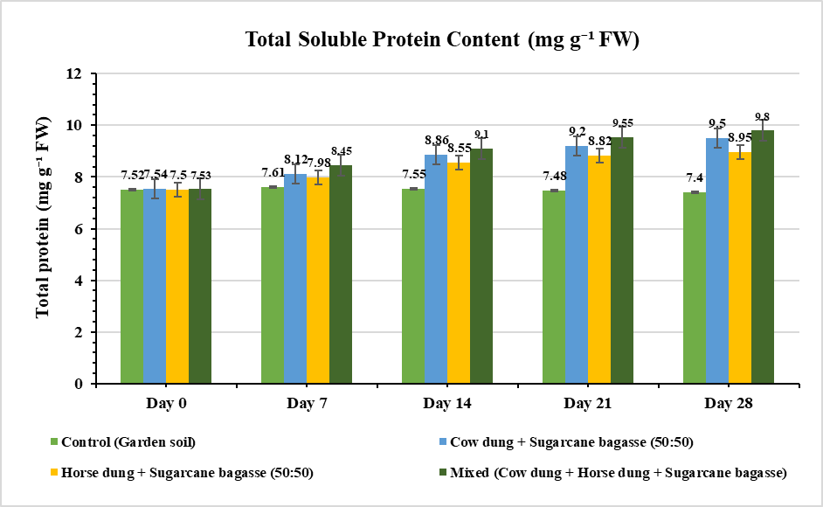
Fig 1. Total soluble protein concentration (mg g⁻¹ fresh weight) in Perionyx excavatus exposed to different substrate treatments for 0 -28 days

  - Superoxide Dismutase (SOD)
SOD activity increased significantly in all substrate treatments relative to the control during the experimental period. The highest activity (13.2 U mg⁻¹ protein) was recorded in worms maintained in the mixed substrate at day 28. (Figure. 2) This enzyme catalyzes the dismutation of superoxide radicals into hydrogen peroxide and molecular oxygen, representing the first line of defense against oxidative stress (Weydert & Cullen, 2010). Elevated SOD activity in substrate-treated worms suggests increased production of reactive oxygen species (ROS) associated with enhanced metabolic processes and microbial decomposition of organic matter. Similar SOD induction has been observed in earthworms exposed to organic residues and environmental stressors, indicating adaptive regulation of antioxidant defenses (Prakash et al., 2008; Nwaka et al., 2015).
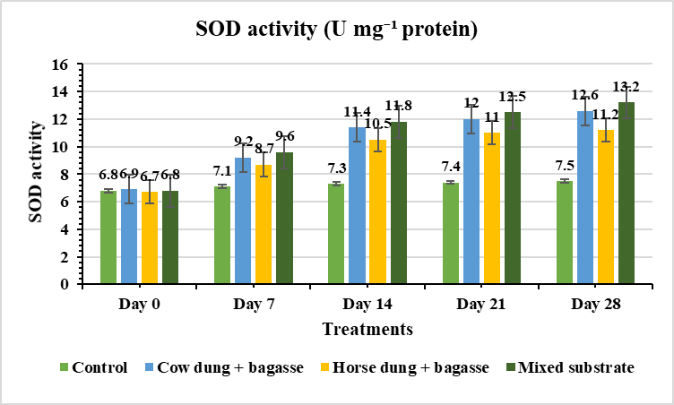
Fig 2. SOD activity (U mg⁻¹ protein) in Perionyx excavatus exposed to different substrate treatments for 0 -28 days

  - Catalase (CAT)
Catalase activity increased markedly in substrate-treated worms, reaching a maximum value of 35.2 µmol H₂O₂ min⁻¹ mg⁻¹ protein in the mixed treatment. (Figure. 3). Catalase detoxifies hydrogen peroxide produced during SOD activity, preventing its accumulation and subsequent formation of hydroxyl radicals (Aebi, 1984). The coordinated elevation of SOD and CAT observed in this study indicates an efficient antioxidant cascade functioning to neutralize ROS generated during active decomposition of organic substrates. Similar synergistic induction of antioxidant enzymes has been reported in earthworms exposed to organic wastes and compost substrates (Wang et al., 2021).
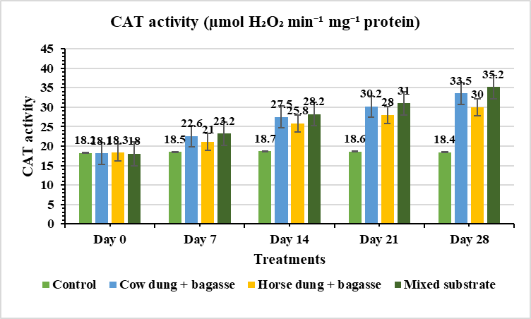
Fig 3. CAT activity (µmol H₂O₂ min⁻¹ mg⁻¹ protein) in Perionyx excavatus exposed to different substrate treatments for 0 -28 days

  - Glutathione Peroxidase (GPx)
GPx activity also increased significantly during exposure to organic substrates. The highest activity occurred in the mixed treatment (Figure. 4), indicating enhanced detoxification of peroxides through the glutathione-dependent pathway. GPx works in conjunction with glutathione to neutralize hydrogen peroxide and lipid peroxides, thereby preventing oxidative damage to cellular components (Flohé & Günzler, 1984). Increased GPx activity has been widely reported in earthworms experiencing oxidative stress during exposure to environmental pollutants or organic substrates (Saleeb et al., 2020).
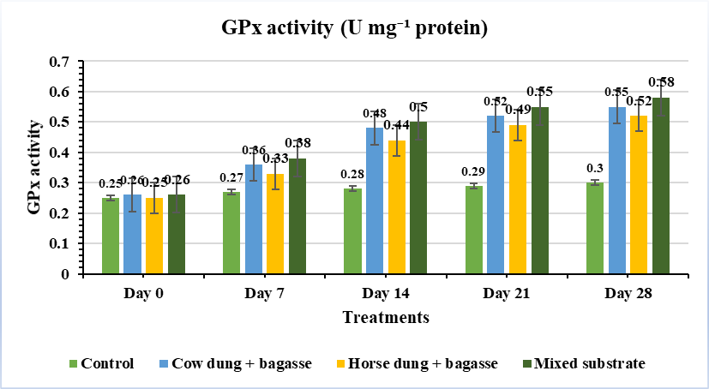
Fig, 4. GPx activity (U mg⁻¹ protein) in Perionyx excavatus exposed to different substrate treatments for 0 -28 days

  - Reduced Glutathione (GSH)
GSH levels increased markedly in treated groups, reaching a maximum value in the mixed substrate treatment (Figure. 5). Reduced glutathione is a crucial intracellular antioxidant that maintains redox homeostasis and participates in detoxification reactions (Ellman, 1959; Meister & Anderson, 1983). The elevation of GSH observed here indicates enhanced cellular defense mechanisms against oxidative stress induced by organic matter decomposition. Previous studies on Perionyx excavatus and other earthworm species have also reported increased GSH levels in response to nutrient-rich compost environments (Prakash et al., 2008).

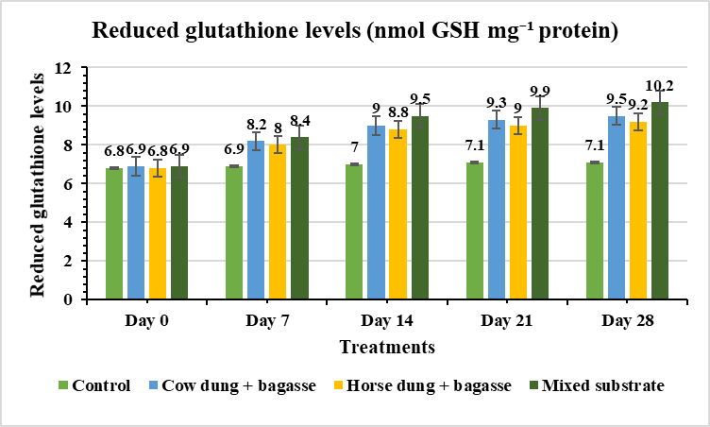
Fig. 5. Reduced glutathione levels (nmol GSH mg⁻¹ protein) in Perionyx excavatus exposed to different substrate treatments for 0 -28 days

  - Lipid Peroxidation (MDA)
Lipid peroxidation, measured as MDA, increased moderately in all substrate treatments. The highest values were observed in the horse dung + bagasse treatment (Figure. 6). Increased MDA reflects oxidative damage to membrane lipids caused by ROS (Ohkawa et al., 1979; Li et al., 2010). However, the mixed substrate exhibited comparatively lower MDA levels despite high metabolic activity, suggesting that enhanced antioxidant defenses effectively prevented excessive oxidative damage (Saleeb et al., 2020; Wang et al., 2021).
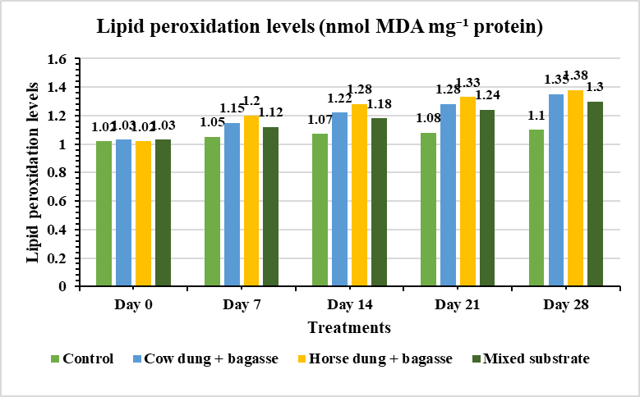
Fig. 6. Lipid peroxidation levels (nmol MDA mg⁻¹ protein) in Perionyx excavatus exposed to different substrate treatments for 0 -28 days

  - DNA Damage
Treatment | Tail DNA (%) | Tail Length (µm) | Olive Tail Moment
Control | 3.2 ± 0.4 | 6.4 ± 0.6 | 0.12 ± 0.02
Cow dung + bagasse | 4.8 ± 0.5 | 8.5 ± 0.8 | 0.21 ± 0.03
Horse dung + bagasse | 5.1 ± 0.6 | 9.0 ± 0.9 | 0.24 ± 0.03
Mixed substrate | 4.0 ± 0.5 | 7.2 ± 0.7 | 0.18 ± 0.03
Table. 1. DNA damage parameters after 28 days
DNA damage increased slightly in worms exposed to organic substrates, particularly in the horse dung treatment (Table. 1). Oxidative DNA damage is commonly associated with ROS-mediated strand breaks and genotoxic stress (Singh et al., 1988; Nahmani et al., 2007). Nevertheless, the mixed substrate showed relatively lower DNA damage levels, supporting the role of enhanced antioxidant defenses in protecting cellular integrity.
  - Integrated Biomarker Response (IBR)
Treatment | IBR Value | Stress Level
Control | 1.0 ± 0.1 | Low
Cow dung + bagasse | 2.8 ± 0.2 | Moderate
Horse dung + bagasse | 3.1 ± 0.3 | Moderate–High
Mixed substrate | 2.2 ± 0.2 | Mild
Table.2. Integrated Biomarker Response (IBR) values
The integrated biomarker response analysis revealed that the horse dung + bagasse treatment generated the highest cumulative oxidative stress, whereas the mixed substrate produced a lower stress index despite increased metabolic activity. IBR was calculated following the method of Beliaeff and Burgeot (2002). This result indicates that balanced organic substrates enhance antioxidant defenses and maintain redox homeostasis, whereas nutrient imbalance may elevate ROS production (Zhou et al., 2024; Shashank & Mahadevaswamy, 2026).
Collectively, the findings demonstrate that organic substrate composition strongly influences oxidative stress responses in Perionyx excavatus. The coordinated up-regulation of antioxidant enzymes (SOD, CAT, GPx) and non-enzymatic antioxidants (GSH) reflects the physiological plasticity of earthworms in coping with ROS generated during organic matter decomposition.
The mixed cow-horse dung + bagasse substrate provided the most balanced oxidative environment, promoting strong antioxidant defenses while minimizing lipid peroxidation and DNA damage (Table. 2). In contrast, the horse dung + bagasse treatment produced higher oxidative stress, likely due to increased nitrogen content and accelerated microbial decomposition generating excess ROS (Domínguez et al., 2009; Shi et al., 2017).
These results highlight the importance of substrate diversity in vermicomposting systems, as balanced organic inputs improve metabolic performance and oxidative stability in earthworms (Edwards et al., 2010).

Parameter | Control | Cow dung + bagasse | Horse dung + bagasse | Mixed substrate
Total protein (mg g⁻¹ FW) | 7.40 ± 0.21ᶜ | 9.50 ± 0.40ᵇ | 8.95 ± 0.45ᵇ | 9.80 ± 0.50ᵃ
SOD (U mg⁻¹ protein) | 7.5 ± 0.4ᵈ | 12.6 ± 0.6ᵇ | 11.2 ± 0.5ᶜ | 13.2 ± 0.7ᵃ
CAT (µmol H₂O₂ min⁻¹ mg⁻¹ protein) | 18.4 ± 1.0ᵈ | 33.5 ± 1.7ᵇ | 30.0 ± 1.6ᶜ | 35.2 ± 1.8ᵃ
GPx (U mg⁻¹ protein) | 0.30 ± 0.03ᶜ | 0.55 ± 0.05ᵇ | 0.52 ± 0.04ᵇ | 0.58 ± 0.05ᵃ
GST (µmol conjugate min⁻¹ mg⁻¹ protein) | 2.3 ± 0.1ᶜ | 4.4 ± 0.2ᵇ | 4.0 ± 0.2ᵇ | 4.6 ± 0.2ᵃ
GSH (nmol mg⁻¹ protein) | 7.1 ± 0.3ᶜ | 9.5 ± 0.5ᵇ | 9.2 ± 0.4ᵇ | 10.2 ± 0.6ᵃ
MDA (nmol mg⁻¹ protein) | 1.10 ± 0.06ᵇ | 1.35 ± 0.08ᵃ | 1.38 ± 0.08ᵃ | 1.30 ± 0.08ᵃᵇ
Tail DNA (%) | 3.2 ± 0.4ᶜ | 4.8 ± 0.5ᵇ | 5.1 ± 0.6ᵃ | 4.0 ± 0.5ᵇ
Different superscript letters indicate significant differences among treatments (Tukey HSD, p < 0.05).
Table.3. Biochemical biomarkers in Perionyx excavatus after 28 days of exposure to organic substrates (Mean ± SD, n = 5)

The statistical analysis revealed that biochemical biomarkers in Perionyx excavatus varied significantly among substrate treatments after 28 days of exposure. One-way ANOVA demonstrated significant differences for all measured parameters, confirming the strong influence of substrate composition on earthworm physiology. Total protein content showed a significant increase among treatments (F = 52.4, p < 0.001), with the mixed substrate treatment recording the highest value (9.80 ± 0.50 mg g⁻¹ FW), indicating enhanced metabolic activity. Antioxidant enzymes also exhibited highly significant variation, including SOD (F = 119.8, p < 0.001), CAT (F = 310.7, p < 0.001), and GPx (F = 86.4, p < 0.001). Tukey’s HSD post-hoc test confirmed that the mixed substrate group had significantly higher enzyme activities compared with other treatments, while the control showed the lowest levels. Similarly, detoxification enzyme GST differed significantly (F = 102.5, p < 0.001), with maximum activity in the mixed treatment. Reduced glutathione (GSH) levels also increased significantly among treatments (F = 122.5, p < 0.001), reflecting enhanced intracellular redox buffering in worms exposed to organic substrates. Oxidative damage markers showed moderate but significant differences, with lipid peroxidation (MDA) varying significantly (F = 13.9, p < 0.01). DNA damage measured as tail DNA percentage also differed significantly among treatments (F = 26.4, p < 0.001), with the highest damage observed in the horse dung + bagasse treatment. Post-hoc comparisons indicated that this treatment differed significantly from the control and mixed substrate groups. The integrated ROS index showed extremely significant variation (F = 1645.7, p < 0.001), confirming large differences in oxidative burden among treatments (Table. 3). The horse dung + bagasse treatment exhibited the highest ROS index, whereas the mixed substrate recorded the lowest value. Overall, the statistical evidence indicates that mixed organic substrates significantly enhance antioxidant defenses while minimizing oxidative damage in P. excavatus. These results highlight the importance of balanced substrate composition for maintaining oxidative stability and physiological performance during vermicomposting.
- Conclusion
Substrate composition significantly influences oxidative physiology in Perionyx excavatus. The mixed organic substrate (cow dung, horse dung, and sugarcane bagasse) promoted enhanced antioxidant enzyme activity, improved glutathione levels, and reduced oxidative damage, indicating effective redox balance. In contrast, the horse dung–bagasse treatment induced higher oxidative stress. Overall, P. excavatus proves to be a reliable bioindicator, and mixed substrates offer optimal conditions for sustainable vermicomposting.

- Competing Interests
The authors declare that there are no competing interests regarding the publication of this paper.
- Disclaimer (Artificial intelligence)
Author(s) hereby declare that NO generative AI technologies such as Large Language Models (ChatGPT, COPILOT, etc.) and text-to-image generators have been used during the writing or editing of this manuscript.
- References
- Aebi, H. (1984). Catalase in vitro. Methods in Enzymology, 105, 121–126.
- Balamurugan, M., Parthasarathi, K., Ranganathan, L. S., & Cooper, E. L. (2008). Hypothetical mode of action of earthworm extract with hepatoprotective and antioxidant properties. Journal of Zhejiang University Science B, 9(2), 141-147.
- Beauchamp, C., & Fridovich, I. (1971). Superoxide dismutase: Improved assays and an assay applicable to acrylamide gels. Analytical Biochemistry, 44(1), 276–287.
- Domínguez, J., Aira, M., & Gómez-Brandón, M. (2009). Vermicomposting: earthworms enhance the work of microbes. In Microbes at work: from wastes to resources (pp. 93-114). Berlin, Heidelberg: Springer Berlin Heidelberg.
- Edwards, C. A., & Bohlen, P. J. (1996). Biology and Ecology of Earthworms (3rd ed.). Chapman & Hall.
- Edwards, C. A., Arancon, N. Q., & Sherman, R. L. (Eds.). (2010). Vermiculture technology: earthworms, organic wastes, and environmental management.
- Ellman, G. L. (1959). Tissue sulfhydryl groups. Archives of Biochemistry and Biophysics, 82(1), 70–77.
- Flohé, L., & Günzler, W. A. (1984). Assays of glutathione peroxidase. Methods in Enzymology, 105, 114–121.
- Halliwell, B., & Gutteridge, J. M. C. (2015). Free Radicals in Biology and Medicine (5th ed.). Oxford University Press.
- Ifemeje, J. C., Udedi, S. C., Okechukwu, A. U., Nwaka, A. C., Lukong, C. B., Anene, I. N., ... & Ezeude, I. C. (2015). Determination of total protein, superoxide dismutase, catalase activity and lipid peroxidation in soil macro-fauna (earthworm) from Onitsha municipal open waste dump. Journal of Scientific Research and Reports, 6(5), 394-403.
- Lowry, O., Rosebrough, N., Farr, A. L., & Randall, R. J. (1951). Protein measurement with the Folin phenol reagent. J biol Chem, 193(1), 265-275.
- Mazumder, A. & Diederich, M. (2016). Natural Compound-Generated Oxidative Stress: From Bench to Bedside. In Free Radicals and Diseases; IntechOpen: London, UK,; pp. 88–112.
- Meister, A., & Anderson, M. E. (1983). Glutathione. Annual Review of Biochemistry, 52(1), 711–760.
- Nahmani, J., Hodson, M. E., & Black, S. (2007). Effects of metals on life cycle parameters of the earthworm Eisenia fetida exposed to field-contaminated soils. Environmental Pollution, 149(1), 44–58.
- Nwaka, A. C., et al. (n.d.). Determination of total protein, superoxide dismutase, catalase activity and lipid peroxidation in soil macro-fauna (earthworm) from Onitsha municipal open waste dump. Retrieved from ResearchGate.
- Ohkawa, H., Ohishi, N., & Yagi, K. (1979). Assay for lipid peroxides in animal tissues by thiobarbituric acid reaction. Analytical Biochemistry, 95(2), 351–358.
- Prakash, M., Gunasekaran, G., & Elumalai, K. (2008). Effect of earthworm powder on antioxidant enzymes in alcohol-induced hepatotoxicity. European Review for Medical and Pharmacological Sciences. Retrieved from https://www.europeanreview.org/wp/wp-content/uploads/503.
- Reinecke, S. A., & Reinecke, A. J. (2007). Biomarker response and biomass change of earthworms exposed to chlorpyrifos in microcosms. Ecotoxicology and Environmental Safety, 66(1), 92-101.
- Saleeb, N., Robinson, B., Cavanagh, J., Ross, J., Munir, K., & Gooneratne, R. (2020). Antioxidant enzyme activity and lipid peroxidation in Aporrectodea caliginosa earthworms exposed to silver nanoparticles and silver nitrate in spiked soil. Environmental Toxicology and Chemistry, 39(6), 1257-1266.
- Shashank, K. R., & Mahadevaswamy, M. (2025). A pathway to enhanced organic waste decomposition by enzymatic response of earthworms in different vermibed substrates. IJBB, 7(1), 197-202.
- Shashank, K.R. & M. Mahadevaswamy. (2025). Unveiling the medical properties of earthworms and their role in human health. International Journal of Advanced Research in Medicine, 7(2): 19–23. https://www. doi.org /10.22271/27069567.2025.v7.12a.619
- Shashank, K.R. & M. Mahadevaswamy. (2026). Exploring the Fibrinolytic and Biochemical characteristics of Lumbrokinase enzyme from Eudrilus eugeniae for Therapeutic Use, International Journal of Biological and Medical Research 17(1):8297-8301 DOI:10.65048/jbmr.2026.17.1.8297.1001
- Singh, N. P., McCoy, M. T., Tice, R. R., & Schneider, E. L. (1988). A simple technique for quantitation of low levels of DNA damage in individual cells. Experimental Cell Research, 175(1), 184–191.
- Shi, Z., Tang, Z., & Wang, C. (2017). A brief review and evaluation of earthworm biomarkers in soil pollution assessment. Environmental Science and Pollution Research, 24(15), 13284-13294.
- Wang, Z., et al. (2021). Antioxidant defense system responses, lysosomal membrane stability and DNA damage in earthworms exposed to PFOA. RSC Advances.
- Wang, Z., Li, C., Shao, Y., Xue, W, N., Xu, X., & Zhang, Z. (2021). Antioxidant defense system responses, lysosomal membrane stability and DNA damage in earthworms (Eisenia fetida) exposed to perfluorooctanoic acid: an integrated biomarker approach to evaluating toxicity. RSC advances, 11(43), 26481-26492.
- Wen, S., Liu, C., Wang, Y., Xue, Y., Wang, X., Wang, J., ... & Kim, Y. M. (2021). Oxidative stress and DNA damage in earthworm (Eisenia fetida) induced by triflumezopyrim exposure. Chemosphere, 264, 128499.
- Weydert, C. J., & Cullen, J. J. (2010). Measurement of superoxide dismutase, catalase, and glutathione peroxidase in cultured cells and tissue. Nature Protocols, 5(1), 51–66.
- Zhou, H., Jiao, X., & Li, Y. (2024). Exploring the toxicity of oxytetracycline in earthworms (Eisenia fetida) based on the integrated biomarker response method. Toxics, 12(5), 310. https://doi.org/10.3390/toxics12050310

