Effects of Azadirachta indica aqueous leaf extract on liver and kidney in high-fat diet-induced obese wistar rats

ABSTRACT
Obesity is one of the major health challenges in the globe. Azadirachta indica leaf has demonstrated various biological activities such as antioxidant, antipyretic, anti-fungal, anti-bacterial, anti-inflammatory and antimalarial activities e.t.c. This study aimed to evaluate the effect of Azadirachta indica aqueous leaf extract on liver and kidney in high-fat diet-induced obesity in albino rats.Twenty-five male and female adult wistar rats were divided into five groups. Five animals in each group. Group A served as negative control group fed with normal diet for 12 weeks. Group B were administered orally, with high-fat diet and normal diet for 12 weeks. Groups C, D and E received high-fat diet + normal diet for 6 weeks and treated with 10mg/kg.bw of lipostatin, 200mg/kg.bw and 400mg/kg.bw of Azadirachta indica extract respectively for another 6 weeks. During the treatment, abdominal circumference, body weight and body mass index were measured weekly. After treatment, animals were euthanized and liver, kidney were harvested for laboratory analysis.The result showed the body weight, body mass index, abdominal circumference were significantly decreased (p< 0.05) in the treated groups compared to high-fat diet group, while the histological examination of liver, kidney of treated groups showed clearance of lipid deposition. In conclusion, these results confirmed the effect of Azadirachta indica extract in obesity as indicated by by improvement of some anthropometrical parameters and restoration of liver and kidney abnormalties.

Keywords: Azadirachta indica, Histopathology, High-fat diet, Lipostatin, Obesity.

INTRODUCTION

Obesity is a complex multifactorial disease that accumulated excess body fat leads to negative effects on health (Janez et al., 2024; Patoulias et al., 2024; Lincoff et al., 2023; Drucker, 2024). Obesity is defined as when a person has a body mass index [BMI (kg/m2) (Jastreboff et al., 2022; Banerjee et al., 2023; Kosiborod et al., 2023), dividing a person’s weight by the square of their height] greater than or equal to 30. Overweight is defined as a BMI of 25.0-29.9 (Rangraze et al., 2024; Abraham, 2024; Apperloo et al., 2024; Muzurovic et al., 2023). The main cause of obesity is long-term energy imbalance between consumed calories and expended calories (Knop et al., 2023; Jensterle et al., 2022; Melson et al., 2024). Globally, in 2020, 22.4% of 430 million adolescents and children (5-19 years old) were affected (Linge et al., 2024; Álvarez-Martín et al., 2024). By 2035, these numbers may increase to 39.2% and 770 million (Marin et al., 2024; Noma et al., 2024; Chang-Chusan et al., 2025). In Nigeria, the prevalence of overweight individuals ranged from 20.3%–35.1%, while the prevalence of obesity ranged from 8.1%–22.2% (Smith and Weissman, 2010; Apovian et al., 2015; Ponce-Gonzalez et al., 2023). Following the success of orlistat, lorcaserin, liraglutide, phentamine-topiramate and naltrexone-bupropion as new, safer drugs approved by the Food and Drug Administration (FDA) (Nyanhanda et al., 2023; Rizvi et al., 2022; Bliddal et al., 2024). in reducing body weight, which show the satiety of the drug and a mean difference of 5% or more in weight loss between the medication and placebo group in at least one year duration pivotal trial (Yanuwski and Yanuwski, 2014; Fitch and Bays, 2022), they became one-year weight loss drug (Tan et al., 2024; Honnayya, 2024). Because of long term duration of these drugs and non-affordability due to the cost, the adverse effects of these drugs for the treatment of obesity make it difficult to treat. Azadirachta indica Azadirachta indica. A. juss has great medical benefits through its various biological properties (Abdullah et al., 2023; Anuradha and Jaganthan, 2023). The neem leaves extract has numerous biological and pharmacological activities, including antipyretic, analgesic, antifungal, etc (Anuradha et al., 2024; Luis et al., 2023; Lin et al., 2024). However, little is known about its effect on the liver and kidney in high-fat-induced obese rats. Thus, this study aimed to evaluate the effects of Azadirachta. indica aqueous leaf extract in high-fat diet induced obese rats.

MATERIALS AND METHODS
Plant Collection and Identification
The leaf of Azadiracta indica was collected on at the herbarium of the pharmaceutical department Usmanu Danfodiyo University, Sokoto.
The plant taxonomic identification and assigning of voucher number was carried out at harbarium department of Pharmacognosy, Usmanu Danfodiyo University, Sokoto with voucher number: PCG/UDUS/Meli/0003
Plant Extraction
Fresh leaf of A. indica were collected and air-dried at room temperature over a period of two weeks. Dried materials were pounded in the laboratory mortar into powder. 1000g of pounded ground Azadirachta indica extract was weighed and dissolved in 5000 mL of distilled water. The solution was stirred with the use of stirrer for two hours and left to stay over 24hours. This was filtered with muslin cloth and evaporated at 55 ̊C in water bath (Abdullah et al., 2023). The resultant powder weighed 40.5g and gave 10.1% as percentage yield.
SAMPLE SIZE DETERMINATION
The sample size of the experiment was determined by this formular: n= DF/k +1 (Luis et al., 2023). n = the number of animals used in the experiment per group. DF = the degree of freedom for the error term in an analysis of variance (ANOVA). k = the number of groups, n =? DF = 20, k = 5. Therefore, n = 20/5 + 1 = 5 animals.

Procurement of Animals
A total of number of 37 healthy wistar albino rats both male and female weighing between 175-180g was obtained from animal house of the faculty of pharmaceutical science, Ahmadu Bello University Zaria. Twenty-five were used for the experiment while twelve were used for LD50 determination. They were allowed to acclimatize for a period of 14 days. They were maintained on rat feeds and water ad libitum throughout the experimental period. They were kept in a metal cage in a well-ventilated environment at a conducive temperature and cleaned regularly at the animal house faculty of pharmaceutical science, Usmanu Danfodiyo University, Sokoto.
EXPERIMENTAL ANIMAL GROUPING AND EXPERIMENTAL DESIGN
A total number of 25 healthy albino rats were used. After the acclimatization period of two weeks, animals were divided into five groups with three rats and two rats as replicates. Group A, served as the negative control group, consisting of 5 rats, they were given water ad libitum and were fed with standard rat chow for 12 weeks of the experimental period. The group B consist of 5 rats, received water ad libitum and were administered orally with high-fat diet in the dose of 1ml daily of mixture of melted pig fat and hydrogenated vegetable oil in 4:3 ratio, respectively for 12 weeks and also fed with a standard rat chow and served as obese positive control group (OECD, 2000; Shyamala et al., 2003). The group C, also consist of five rats, served as standard control group in which they were fed orally with high fat diet in a dose of 1ml of mixture of melted pig fat and hydrogenated vegetable oil in 4:3 ratio for 6 weeks and were orally administered standard drug lipostatin of 10mg/kg body weight daily (Calderon et al., 2011) for another six weeks. While group D and group E had 5 rats each, received water and were administered orally with melted pig fat and hydrogenated vegetable oil 1ml daily for 6 weeks and standard rat chow after 6 weeks of feeding of Azadirachta indica extract in a dose of 200 mg/kgbwt and 400mg/kgbwt respectively, daily for another 6 weeks and the dose of extract chosen were based on the result of acute toxicity (LD50) study conducted. The body weight and length of the rats were recorded every week throughout the experimental period (Adekunle et al., 2016). As shown in the table 1.0

Table 1.0 Summary of Experimental Design
Experimental Groups | Intervention Given | Treatment Given | Durations | Laboratory Analysis
Group A: 5 rats (Normal control) | Distilled water + normal diet | No treatment given | 12 weeks | H&E, Sudan Black,
Group B: 5 rats (Negative control) | High-fat diet/ + normal diet | No treatment given | 12 weeks | H&E, Sudan Black,
Group C: 5 rats. (Standard control). | High-fat diet + normal diet for 6 weeks | 10mg/kgbw of lipostatin for 6 weeks | 12 weeks | H&E, Sudan Black,
Group D: 5 rats.  Test. | High-fat diet + normal diet for 6 weeks | 200mg/kgbw of A.indica leaf extract for 6 weeks | 12 weeks | H&E, Sudan Black.
Group E: 5 rats  Test. | High-fat diet + normal diet for 6 weeks | 400mg/kgbw of A. indica extract for 6 weeks | 12 weeks | H&E, Sudan Black.

INDUCTION OF OBESITY
A high-fat diet was prepared by a mixture of melted pig fat and hydrogenated vegetable oil in 4:3 ratio (OECD, 2000; Shyamala et al., 2003). Obesity was induced by a single daily oral dose of 1ml/kg.bw daily of a mixture of melted pig fat and hydrogenated vegetable oil in 4:3 ratio of high-fat diet in addition to a normal diet for 12 weeks. Treatment began at 7 weeks of diet feeding that continued for another six weeks.

Euthanisation and Collection of Samples
After six weeks of the treatment period, the animals were anaesthetized using chloroform vapour in an enclosed transparent plastic jar. The animals were then dissected by longitudinal abdominal incision with aid of surgical blade to carefully harvest the liver and kidney were removed for histopathological analysis.

LABORATORY ANALYSIS
Liver and kidney were grossed and sectioned immediately by using cryostat for Hematoxylin & Eosin staining and sudan black staining technique for histopathological analysis and examined microscopically using (Mag x400) Photomicrograph of liver and kidney were taken using light microscope and Best Scope camera and the results were presented alongside with control.

Procedure for Haematoxylin and Eosin staining Technique:
1. The sections were taken to water
2. They were stained in haematoxylin for 10minutes
3. They were rinsed in water
4. They were differentiated in 1% acid alcohol for few seconds
5. They were rinsed in water
6. They were blued in tap water for 10minutes,
7. They were counter stained in eosin, dehydrated, cleared, mounted and examined under microscope
(Avwioro, 2014).
Procedure for Sudan Black staining for Lipid Demonstration Technique
1. Frozen sections were fixed on a clean glass slide using fresh 10% formalin.
2. Frozen sections were washed with distilled water,
3. Propylene glycol was added in two changes, each of 5 minutes
4. Sudan black solution was added and left at 7 minutes for agitation
5. 85% propylene glycol was added and left for 3 minutes
6. Section was rinsed in distilled water
7. Nuclear fast red was added and left for 3 minutes
8. Section was washed in tap water twice and rinsed in distilled water
9. It was mounted with glycerin jelly and viewed under the microscope
(Avwioro, 2014).

DATA ANALYSIS

The data analysis was performed using Graph pad prism 6.0 as mean ± SD. The normal distribution of the data was evaluated through the application of the Kolmogorov-Smirnov test. The quality of the variances was verified using Levene’s test. Statistical comparison between groups was made using repeated one-way analysis of variance (ANOVA) with post hoc Bonferroni Multiple comparison Test to establish the differences in means where appropriate. P < 0.05 was taken as statistically significant. The standard analysis was performed using SPSS Statistical software version 27

RESULTS & DISCUSION
Effect of aqeous leaves extract of Azadirachta indica on Body Weight, Body Mass Index and Abdominal Circumference.

The measurements of body weight, BMI, and abdominal circumference (Table 2) before the induction and after treatment of the experimental Wistar rats is shown. There was a statistically significant difference in these measured parameters between the treated groups and the untreated group

Table 2. Body Weight, Body Mass Index and Abdominal Circumference.

Groups | Initial measurements |  |  | Measurements at 6 weeks |  |  | Measurements at 12 weeks
 | BW1(g) | BMI1(g/cm²⁾ | AC1(cm) | BW2(g) | BMI2(g/cm²) | AC2(cm) | BW3(g) | BMI3(g/cm²) | AC3(cm)
Group A | 177.67±9.29 | 0.53±0.05 | 13.67±0.58 | 209.00±1.00 | 0.62±0.03 | 14.33±0.58 ª | 221.67±1.53 | 0.66±0.04 | 15.67±0.58
Group B | 176.65  ± 1.76 | 0.52  ± 0.00 | 13.37  ± 0.32 | 342.82  ± 4.22ª | 1.00±0.04 | 19.67±0.78 ª | 451.67±7.64 ª | 1.3±0.006 ª | 19.93±0.58 ª
Group C | 184.33±3.06 | 0.55±0.03 | 14.33±0.58 | 343.67±5.51 ª | 1.02±0.82 | 18.33±0.68 ª | 215.00±5.00 ^{a,b} | 0.62±0.06 ^{a,b} | 15.67±0,58 ^{a,b}
Group D | 176.67±6.03 | 0.52±0.04 | 14.33±0.68 | 343.33±5.77 ª | 1.02±0.92 | 19.33±0.58 ª | 209.00±8.54 ^{a,b} | 0.60±0.06 ^{a,b} | 15.67±0.58 ^{a,b}
Group E | 176.67±7.51 | 0.53±0.05 | 13.33±0.48 | 330±10 ª | 1.02±0.72 | 18.67±0.78 ª | 212±3.61 ^{a,b} | 0.63±0.05 ^{a,b} | 15.32±0.58a,b
Values are presented as mean ± Standard Error of the Mean. a represents a highly significant at p<0.05 when compared to Control Group 1 while b represents highly significant at p<0.05 when compared to HFD group B
Key: BW1 = Initial Body Weight, BW2 = Body Weight after induction and BW3 = Body Weight after treatment BMI 1 = Initial Body mass Index, BMI2 = Body mass Index after induction and BMI3 = Body mass Index after treatment AC1 = Initial Abdominal circumference, AC 2 = Abdominal circumference after inductionandAC3 = Abdominal circumference after treatment.

Effect of aqueous leaf extract of Azadirachta indica on the General Tissue Architecture of Liver and Kidney using H & E Staining Technique
Figure 1: Shows effects of Azadirachta indica leaf extract on liver sections in high-fat diet induced obese wistar rats. (H & E X 400). Group A: Normal control group, hepatocyte (yellow arrow), sinusoid (blue arrow) and central vein (red arrow). When compare with group B. Group B, high-fat diet group shows irregular hepatocytes with micro-vesicular steatosis (green arrow) and macro-vesicular steatosis (red arrow), fat deposition obscure the portal triad (blue arrow) and the central vein (black arrow), at hepatocyte, a ballooning hepatocyte (yellow arrow), vacuolar degeneration (green arrow). Group C, High-fat diet +10mg/kg.b.w of lipostatin, shows no hepatic fatty deposition in hepatocyte (yellow arrow).When compared with group D. Group D, High fat diet + 200mg/kg.b.w extract, shows no hepatic fatty deposition in hepatocyte (yellow arrow), central vein (red arrow) and sinusoid (blue arrow) when compared with group B. Group E, High-fat diet +400mg/kg.b.w of lipostatin, shows no hepatic fatty deposition at hepatocyte (yellow arrow), central vein (red arrow) and sinusoid (blue arrow), when compared with Group B.

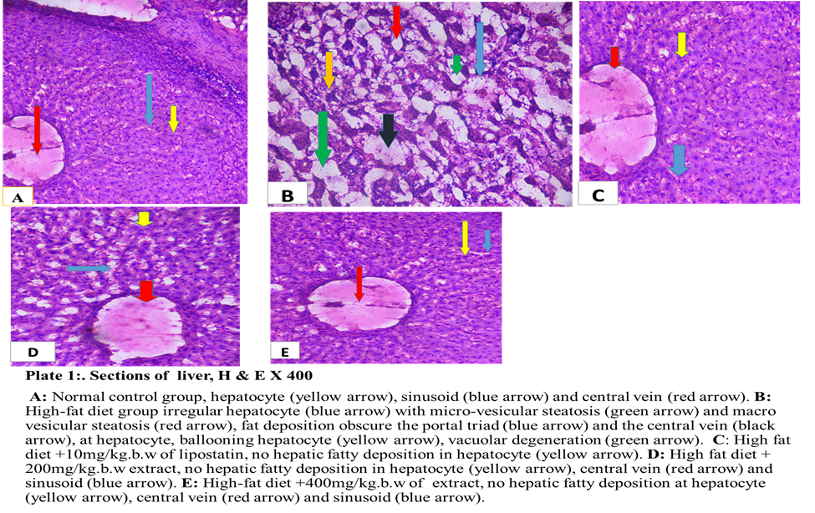
Figure 1: Sections of Liver, H & E X 400

Figure 2. Shows effects of Azadirachta indica leaf extract on liver sections in high-fat diet induced obese wistar rats (Sudan Black X 400). Group A, normal control group, normal hepatocyte (yellow arrow), central vein (red arrow) and portal triad (blue arrow) with dack background when compare with group B.Group B, High-fat diet
group,shows dark-brown of fat deposition at portal triad (red arrow), central vein (blue arrow), sinusoid (white arrow), around the vacuoles (black arrow) and hepatocyte (yellow arrow) with brown back-ground when compare with group B. Group C, High-fat diet +10mg/kg.b.w lipostatin shows dark back-ground with no hepatic fatty deposition at hepatocyte (yellow arrow), portal triad (blue arrow) and central vein( red arrow) when compare with group B. Group D, High-fat diet + 200mg/kgb.w extract, no hepatic fatty deposition in hepatocyte (yellow arrow),central vein (red arrow) when compare with group B. group E, High-fat diet + 400mg/kgb.w of lipostatin group,show no hepatic fatty deposition at hepatocyte (yellow arrow), central vein (red arrow), when compare with group B.

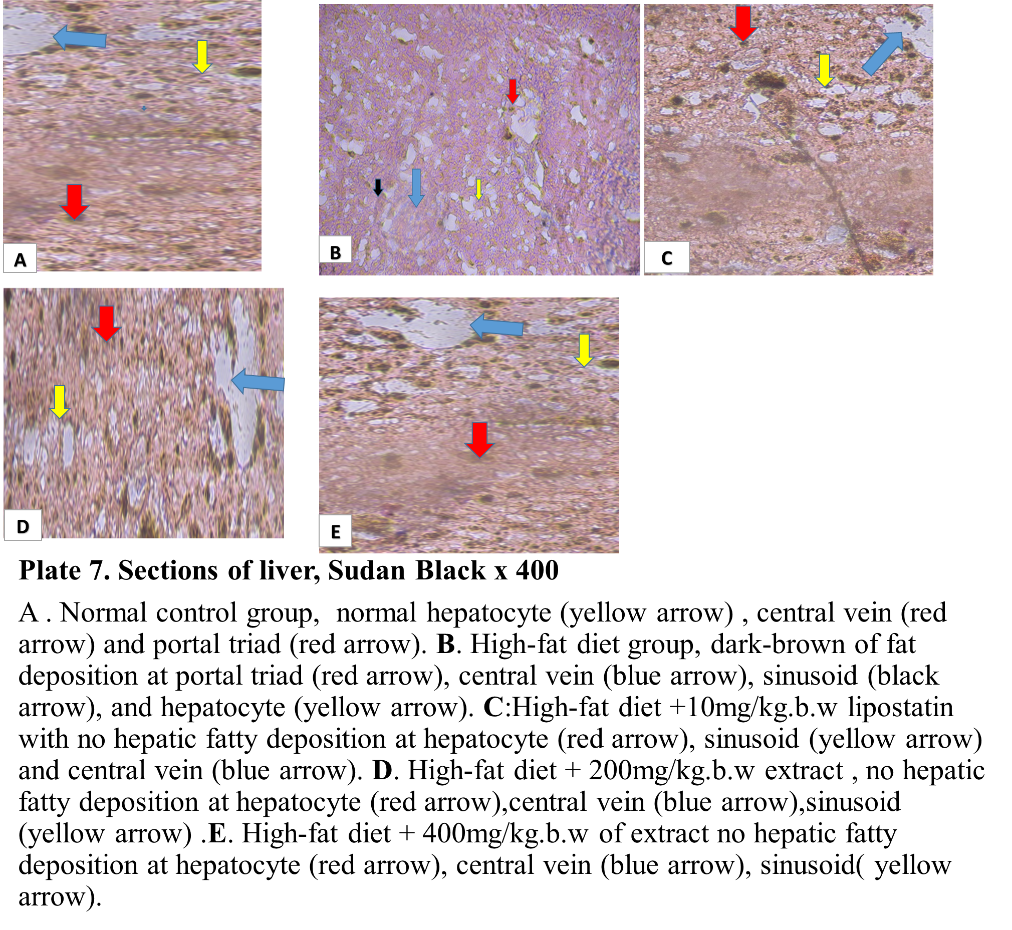
Figure 2: Sections of Liver, Sudan Black X 400

Figure 3: Shows effects of Azadirachta indica leaf extract on kidney sections in high-fat diet-induced obese wistar rats. (H & E X 400). Group A. Negative control group, normal glomerulus (yellow arrow), tubule (blue arrow), and bowman’s space (red arrow), when compare with group B: Group B, high-fat diet group, shows glomerulus (red arrow) and tubules (black arrow) have been obscured with large deposition of fats, bowman’s space is wider (yellow arrow). Marked proliferation of adipose tissue in
renal sinus (blue arrow), Accumulation of numerous and large deposition of adipose tissue in renal sinus( blue arrow), renal capsule (brown arrow), group C, high-fat diet + 10mg/kg.b.w extract group, shows no fat deposition at glomerulus (yellow arrow),tubules(blue arrow) and bowman’s space(red arrow) when compare with group B. Group D, High-fat diet + 200mg/kg.b.w extract, shows clearance of fat at tubule (blue arrow) glomerulus (yellow arrow), bowman’s space (red arrow) when compared with group B. Group E, High-fat diet+400mg/kg.b.w lipostatin group , shows clearance of fat at glomerulus (yellow arrow), tubules (blue arrow), bowman’s space (red arrow).when compared with group B.
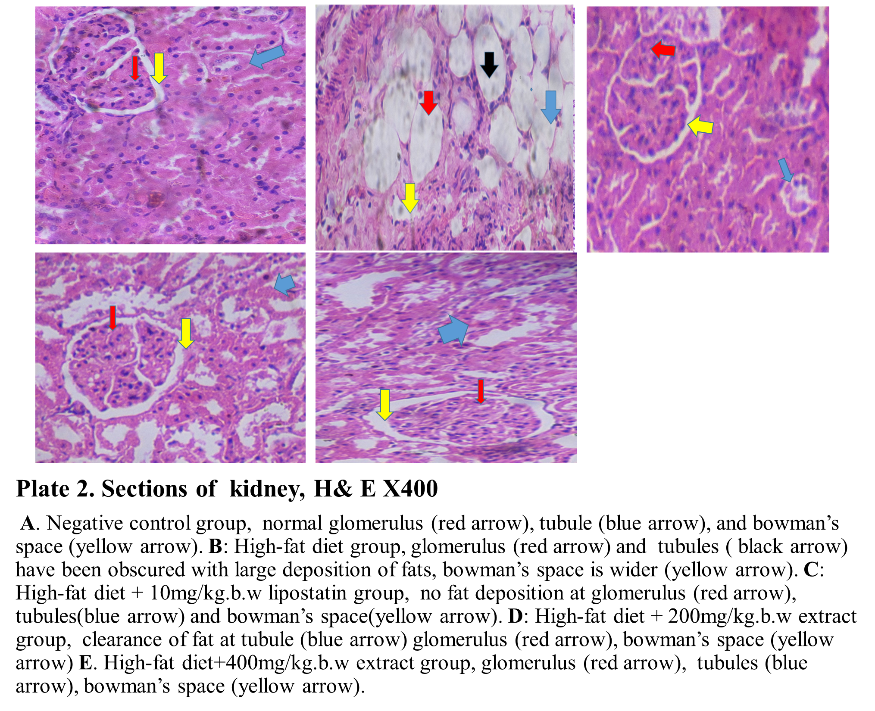
Figure 3: Sections of Kidney, H & E X 400

Figure 4 Shows effects of Azadirachta indica leaf extract on kidney sections in high-fat diet -induced obese Wistar rats (Sudan Black X 400). Group A. negative control group, shows light-brown of no fat deposit at glomerulus (blue arrow), tubules (yellow arrow), bowman’s space (black arrow) when compare with group B. Group B, Section from high-fat diet group, shows dark-brown deposit of fat at glomerulus (blue arrow), tubule (red arrow), bowman’s space (blue arrow),when compared with group B. group C, high-fat diet+10mg/kgbw lipostatin group, shows light-brown of clearance of fat at tubule (blue arrow).when compared with group B. Group D, High-fat diet + 200mg/kgb.w extract group, shows light-brown of clearance of fat at glomerulus (blue arrow). tubule (yellow arrow), bowman’s space (black arrow),when compared with group B. Group E, high-fat diet+400mg/kgb.w group, shows light-brown of clearance of fat at glomerulus (black arrow), tubule (yellow arrow), and bowman’s space (red arrow) when compared with group B.

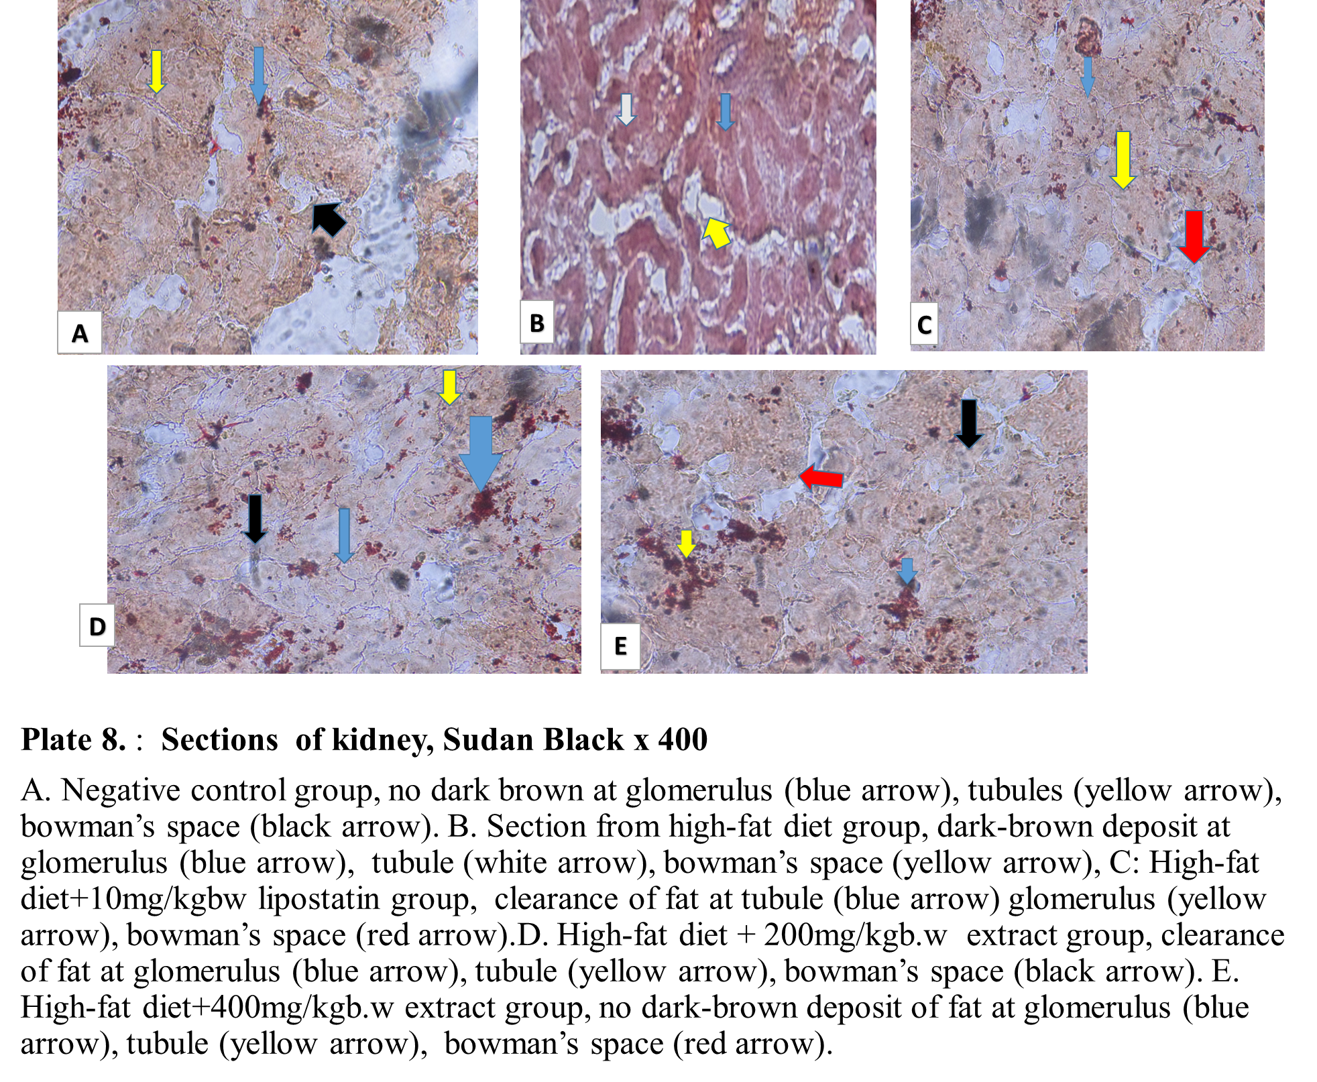
Figure 4: Sections of Kidney, Sudan Black X 400

Histological examination of liver section for Haematoxylin and Eosin staining for general tissue morphology showed normal hepatocytes with intact morphologies in
normal control, group A and the treated groups, group C, D and E.when compared with group B. Liver section of group B shows irregular hepatocyte with micro and macro vesicular steatosis, fat deposition obscure the portal triad and the central vein, at hepatocyte, ballooning hepatocyte, vacuolar degeneration. Numerou and large fat deposition in the liver and hepatic structure disorganization. The administration of A. indica reversed the formation of hepatic fatty deposition in hepatocytes at the doses of 200mg/kg body weight and 400mg/kg body weight of Azadirachta indica leaf extract. Similar observation was reported by (Xiaodong, 2024), who also observed fat droplet in the histology of liver and its amelioration after treatment with Hordeum vulgare extract. Liver section of group B shows irregular hepatocyte with micro and macro vesicular steatosis, fat deposition obscure the portal triad and the central vein, at hepatocyte, ballooning hepatocyte, vacuolar degeneration. Numerou and large fat deposition in the liver and hepatic structure disorganization. The administration of A. indica reversed the formation of hepatic fatty deposition in hepatocytes at the doses of 200mg/kg body weight and 400mg/kg body weight of A. indica leaf extract. Similar observation was reported by (Xiaodong, 2024), who also observed fat droplet in the histology of liver and its amelioration after treatment with Hordeum vulgare extract.

The histology of liver section was observed using Sudan black staining technique and showed normal portal vein, central vein, sinusoid and hepatocyte in group A, C, D and E with light brown colouration when compared with group B which showed dark-brown colouration of fat deposit at hepatocyte, sinusoid, central vein and whole area of liver architecture. A similar report was done by (Sweata et al., 2025) and (Saman et al., 2023, who demonstrated fatty deposition in liver using oil red O staining technique and clearance of fat deposition after treatment with Naringin. Histological section of kidney for Haematoxylin and Eosin staining for general tissue morphology in group A showed normal histology of renal parenchyma with normal glomerulus, proximal convoluted tubule, and bowman’s space. Also, in group B there was renal structure disorganization and renal parenchyma occupied by large and numerous fat (adipose tissue). Glomerulus and tubules have been obscured with large deposition of fats with bowman’s space wider in high-fat diet-induced obese rats. while the group C, D and E showed clearance of fat deposition in the glomerulus, tubules and adipose tissue in renal parenchyma with normal bowman’s space after the administration of Azadirachta indica aqueous leaf extract as well as standard drug administration, This in line with the finding of (Paula et al, 2020) who observed the fat deposit at renal parenchyma and its clearance after treatment with Jiangtang Tiaozhi.The histology of kidney using sudan black staining technique showed no dark brown colouration at the glomerulus, bowman’s space, and renal tubule in group A and standard drug control group C when compared with group B. However, the treated groups D and E with 200mg/kgb.w and 400mg/kgb.w respectively, showed no dark brown colouration of fat deposition after the administration of A. indica aqueous leaf extract when compared with group B. This

finding in agreement of (Sweata et al., 2025) who used Oil red O to stain lipid and clearance of lipid after treatment with Syzygium aromaticum.

CONCLUSION
The treatment with Azadirachta indica could ameliorate histopathological alterations of liver and kidney in obese rats. Thus, Azadirachta indica could be useful in the treatment of obesity and its related disorders.

Abbreviations: FDA=Drug Administration, H&E= hematoxylin and eosin, BW1 = Initial Body Weight, BW2 = Body Weight after induction and BW3 = Body Weight after treatment BMI 1 = Initial Body mass Index, BMI2 = Body mass Index after induction and BMI3 = Body mass Index after treatment AC1 = Initial Abdominal circumference, AC 2 = Abdominal circumference after inductionandAC3 = Abdominal circumference after treatment. ANOVA= Analysis of variance. HFD= high-fat diet. A. indica = Azadirachta indica
Ethical Approval
The protocol of this study was approved by Ethics and Research Committee of Department of Health and Biomedical Research Ethics Committee (HBREC) with HBREC/25/000 number, Usmanu Danfodiyo University Sokoto.

Disclaimer (Artificial intelligence)
Author(s) hereby declare that no generative Al technologies such as ChatGPT,COPILOT, Large Language Model and text-to-image generators have been used during the writing or editing of this manuscript

REFERENCES
Abdullah A., and Biswas P., Sahabuddin M., Mubasharah A., Khan D. A. and Hossain, A. (2023). Molecular Dynamics simulation and pharmacoinformatic integrated analysis of bioactive phytochemicals from Azadirachta indica (neem) to treat diabetes mellitus. Journal of Chemistry. 12(2):1–19.
Abraham, A. (2024). Genetic Evidence for Distinct Biological Mechanisms That Link Adiposity to Type-2 Diabetes. Toward Precision Medicine. Diabetes. 73(1):1012-1025.

Adekunle, A. S., Adelusi, T. I., Kamdem, J., Ishmael, A. and Akintade, B. B. (2016). Insulinomimetic, Antihyperlipidemic and Antioxidative Properties of Moringa oleifera, Possible Mechanism of Action. British Journal of Medicine and Medical Research. 17(5):1- 11.
Álvarez-Martín, C., Caballero, F. F., Iglesia, R. and Alonso-Aperte, E. (2024). Association of MC4 Rs17782313 Genotype with Energy Intake and Appetite. A Systematic Review and Meta-Analysis. Nutrition. Review. 14(3):20-40.
Anuradha D. S., Julietraja K., Jaganathan B. and Alsinai, A. (2024). Curcumin-conjugated PAMAM Dendrimers of two generations: comparative analysis of physiochemical properties using AdriaticTopological indices. ACS. Omega 9. 2(1):14558–14579.
Anuradha, D. S. and Jaganthan, B. (2023). Topological properties of boron triangular sheet for robotic finger flex motion through indices. AIP. 22(2):29-40.
Apperloo, E. M., Gorriz, J. L., Soler, M. J., Cigarran–Guldris, S., Cruzado, J. M., Puchades, M. J., Lopez-Martinez, M., Waanders, F. and Laverman, G. D. (2024). Semaglutide in patients with overweight or obesity and chronic kidney disease without diabetes: A randomized double-blind placebo-controlled clinical trial. Nature Medicine. 31(2): 278–285.
Avwioro O. G. (2014). Histochemistry and tissue pathology; principles and techniques.Third edition pp 123-425.
Banerjee, Y., Patti, A. M., Giglio, R. V., Ciaccio, M., Vichithran, S., Faisal, S., Stoian, A. P., Rizvi, A. A. and Rizzo, M. (2023). The role of atherogenic lipoproteins in diabetes: Molecular aspects and clinical signiﬁcance. Journal of Diabetes Complication. 37(4):122-130.
Bliddal, H., Bays, H., Czernichow, S., Hemmingsson, J., Hjelmesaeth, J., Morville, T., Koroleva, A., Skov-Neergaard, J., Velez –Sanchez, P. and Wharton, S. (2024). Once-Weekly Semaglutide in Persons with Obesity and Knee Osteoarthritis. The New England Journal of Medicine. 39(1):1573–1583.
Calderon, G. D. (2011). Clinical guidance on the identification .Evaluation and treatment of Overweight and obesity in adult, National instutites of health. Obese. 6(2):51-209.
Chang–Chusan, Y. A., Eneli, I., Hennessy, E, Pronk, N .P. and Economos, C. D(2025). Next steps in efforts to address the obesity pidemic. Annual Review of Public Health. 11(4):112-114.
Drucker, D. J. (2024). Efﬁcacy and Safety of GLP-1 Medicines for Type 2 Diabetes and Obesity. Diabetes Care. 47: 1873–1888.
Egbujo, E. C., Adisa, J. O. and Yahaya, A. B. (2008). A Study of the Staining Effect of Roselle (Hibiscus sabdariffa) on the Histologic Sections of the Testis. International. Journal of Morphology, 26(4): 927-930.
Fitch, A. K. and Bays, H. E. (2022). Obesity definition, diagnosis, bias, standard operating procedures (SOPs), and telehealth: An Obesity Medicine Association (OMA) Clinical Practice Statement (CPS). Obesity Pillars. 11(4):10-30.
Honnayya, R. (2024). Impact of rhizosphere on competitive effects of neem (Azadirachta indica A. Juss) on associated Pigeon pea in an agroforestry system. 47(1):132–136.
Janez, A., Muzurovic, E., Bogdanski, P., Czupryniak, L., Fabryova, L., Fras, Z., Guja, C., Haluzik, M., Kempler, P. and Lalic, N. (2024). Modern Management of Cardiometabolic Continuum: From Overweight/Obesity to Prediabetes/Type 2 Diabetes Mellitus.Recommendations from the Eastern and Southern Europe Diabetes and Obesity. Expert Group. Diabetes Therapy. 15(3):1865–1892.
Jastreboff, A. M., Aronne, L. J., Ahmad, N. N., Wharton, S., Connery, L., Alves, B., Kiyosue, A., Zhang, S. and Liu, B. and Bunck, M. C. (2022). Tirzepatide Once Weekly for the Treatment of Obesity. The New England Journal of Medicine. 38(7):205–216.
Jensterle, Μ., Rizzo, Μ., Haluzík, Μ. and Janež, A. (2022). Efficacy of GLP-1 RA Approved for Weight Management in Patients With or Without Diabetes: A Narrative Review. Advances in Therapy. 39(4):2452–2467.
Knop, F. K., Aroda, V. R. and Vale, R. D., Holst-Hansen, T., Laursen, P. N., Rosenstock, J., Rubino, D. M., Garvey, W.T. and Investigators, O. (2023). Oral semaglutide 50 mg taken once per day in adults with overweight or obesity (OASIS 1): A randomised, double-blind, placebo-controlled, phase 3 trial. Lancet. 40(2):705–719.
Kosiborod, M. N., Abildstrom, S. Z. and Borlaug, B. A. (2023). Semaglutide in patients with heart failure with preserved ejection fraction and obesity. The New England Journal of Medicine. 38(9):1069-84.
Lin, K., Mehrotra, A. and Tsai, T. C. (2024). Metabolic Bariatric Surgery in the Era of GLP-1 Receptor Agonists for Obesity Management. JAMA. 7(2):5-9.
Lincoff, A. M., Brown-Frandsen, K., Colhoun, H. M., Deanfield, J., Emerson, S. S., Esbjerg, S., Hardt-Lindberg, S., Hovingh, G. K., Kahn, S. E. and Kushner, R. F. (2023). Semaglutide and Cardiovascular Outcomes in Obesity without Diabetes. The New Engand Journal of Medicine. 38(9):2221–2232.
Linge, J., Birkenfeld, A .L. and Neeland, I. J. (2024). Muscle Mass and Glucagon-Like Peptide-1 Receptor Agonists. Adaptive or Maladaptive Response to Weight Loss? Circulation. 150(1):1288
Luis, D., Izaola, O., Primo, D. and Aller, R. (2023). Variation in PERILIPIN Gene Is a Predictor of Weight Loss and Protection against Impaired Glucose Metabolism after a Meal Replacement Diet in Postmenopausal Obese Females. European. Review. Medical. Pharmacological. Science. 22(7): 9355–9362.
Marin, A. G., Filipescu, A. and Petca, A. (2024). The role of obesity in the etiology and carcinogenesis of endometrial cancer. Cureus: 16(3):59-70.
Melson, E., Ashraf, U. and Papamargaritis, D. (2024). What is the pipeline for future medications for obesity? International. Journal of Obesity. 31(1):378–285.
Muzurovic, E., Yumuk, V. D. and Rizzo, M. (2023). GLP-1 and dual GIP/GLP-1 receptor Agonists in overweight/obese patients for atheroscle-rotic cardiovascular disease prevention: Where are we now? Journal of Diabetes Complications. 37(4):231-250.
Noma, J. R., Silva- Rodrigues, G. and Souza, V. C. O. (2024). The Influence of Serum Selenium in Differential Epigenetic and Transcriptional Regulation of CPT1B Gene in Women with Obesity. Journal of Trace Element in Medicine and Biology. 83(7):127-140.
Nyanhanda, T, Mwanri, L. and Mude, W. (2023). Double burden of malnutrition: a population levelcomparative cross-sectional study across three sub-saharan African countries-Malawi, Namibia and Zimbabwe. International Journal of Environmental Research and Public Health: 20(4):121-124.
OECD. (2000). Guidance Document on Acute Oral Toxicity. Environmental Health and Safety Monograph Series on Testing and Assessment.Third Edition, pp 24-29.
Patoulias, D., Koufakis, T., Ruza, I., El-Tanani, M. and Rizzo, M. (2024). Therapeutic Advances in Obesity: How Real-World Evidence Impacts Affordability Beyond Standard of Care. Pragmatic and. Observational Research. 15(6):139–149.
Paula, E., Rafael, R., Mariano, R., Escolastico, A. and Ignacio, L. (2020). Structural and Ultrastructural renal lesions in rats fed high fat and high- phosphorus diets. Clinical Kidney Journal. 14(3):847-854.
Ponce-Gonzalez, J.G., Martínez-Ávila, Á.., Velázquez-Díaz, D., Perez-Bey, A., Gómez-Gallego, F., Marín-Galindo, A., Corral-Pérez, J. and Casals, C. (2023). Impact of the FTO Gene Variation on Appetite and Fat Oxidation in Young Adults. Nutrients. 15(4):20-37.
Rangraze, I., Patoulias, D., Karakasis, P., El-Tanani, M. and Rizzo, M. (2024). Tirzepatide, a novel, dual glucose-dependent insulinotropic polypeptide/glucagon-like peptide-1 receptor agonist for the ongoing diabesity epidemic. The dawn of a new era? Expert Review of Clinical Pharmacology. 17(3):853–856.
Rizvi, A. A., Kathuria, A., Al Mahmeed W., Al-Rasadi K., Al-Alawi K., Banach M., Banerjee Y., Ceriello A., Cesur, M. and Cosentino, F. (2022). Post-COVID syndrome, inflammation, and diabetes. Journal of Diabetes and its Complication. 36(4):108-118.
Saman, A., Irfana, L., Najiya, A., Threem, Z., Mohsin, M. and Ayesha, M. (2023). Obesity theranostics using nanoemulsions of probiotics and local herbs. Saudi Journal of Biological Sciences. 30(5):100-122.
Shyamala, M. P., Venukumar, M. R. and Latha, M. S. (2003). Antioxidant potential of the Syzygiumaromaticum (Gaertn) Linn (Cloves) in rats fed with high fat diet. Indian Journal of Pharmacology. 35(4): 99-103.
Smith, S. R. and Weissman, N. J. (2010). Multicenter, placebo-controlled trial of lorcaserin for weight management. The England Journal of Medicine. 36(3):245-256.
Sweata, S., Sanjib, G. and Maharaj, B. (2025). Naringin ameliorates high-fat diet-induced hepatotoxicity and dyslipidemia in experimental rat model via modulation of anti-oxidant enzymes. AMPK and SERBP-1c signaling pathways. Toxicology Reports. 30(5):14-20.
Tan, S., Santolaya, J.L., Wright, T.F., Liu, Q., Fujikawa, T., Chi, S., Bergstrom, C.P., Lopez, A., Chen, Q. and Vale, G. (2024). Interaction between the Gut Microbiota and Colonic Enteroendocrine Cells Regulates Host Metabolism. Nature. Metabolism. 6(3):1076–1091.
Xiaodong, S. (2024). Highland Barley Alleviates High-Fat Diet-Induced Obesity and Liver Injury Through the IRS2/PI3K/AKT Signaling Pathway in Rats. Nutrients. 22(3):32-34.
Yanovski, S. Z and Yanovski, J. A. (2014). Long-term drug treatment for obesity: a systematic and clinical rview. The Journal of the American Medical Association. 31(1):74-86.

