Comparative Analysis of Volatile Constituents in Native Salvia Species (Lamiaceae) of Isparta, Türkiye Using HS-SPME/GC-MS

.
ABSTRACT

Aims: To comprehensively characterize the volatile metabolite profiles of thirteen Salvia taxa naturally distributed in Isparta Province (south-western Türkiye) and to evaluate their chemotaxonomic relationships based on volatile composition.
Study Design: Experimental laboratory-based phytochemical and multivariate chemotaxonomic study.
Place and Duration of Study: Plant materials were collected from naturally occurring populations in Isparta Province, south-western Türkiye, during systematic floristic surveys. Chemical analyses were conducted in the laboratory following sample collection.
Methodology: Thirteen taxa (Salvia viridis, S. bracteata, S. sclarea, S. absconditiflora, S. cadmica, S. tomentosa, S. aethiopis, S. frigida, S. argentea, S. palaestina, S. virgata, S. verticillata, and S. syriaca) were identified during field surveys. Volatile metabolites were extracted using headspace solid-phase microextraction and analyzed by gas chromatography–mass spectrometry. Identified compounds were classified into major chemical groups and quantified based on relative abundance percentages. Multivariate statistical analyses were performed to evaluate interspecific variation and chemotaxonomic differentiation among taxa.
Results: Between 40 and 49 volatile constituents were identified per taxon. Monoterpene hydrocarbons and sesquiterpene hydrocarbons represented the dominant chemical classes across species; however, their relative abundances varied markedly among taxa. Multivariate analyses demonstrated clear chemotaxonomic separation of species based on volatile profiles. Trans-caryophyllene, α-pinene, p-cymene, linalool and germacrene D were identified as major discriminatory metabolites contributing strongly to interspecific differentiation.
Conclusion: The studied Salvia taxa exhibit substantial interspecific variation in volatile composition. The results provide a comprehensive assessment of chemical diversity within the Isparta flora and establish a robust chemotaxonomic framework that may support future phytochemical, pharmacological and industrial applications.

Keywords: Salvia; Lamiaceae; HS-SPME/GC–MS; volatile organic compounds; chemotaxonomy

1. INTRODUCTION

Medicinal and aromatic plants constitute strategic biological resources due to their long-standing utilization in traditional medical systems and their increasing importance in modern industrial applications. Essential oils and aromatic extracts obtained from these plants are extensively used in the food, cosmetic, pharmaceutical, detergent and perfumery sectors as natural or semi-synthetic sources of aroma chemicals. In recent years, global consumer demand for clean-label and nature-based products has significantly increased the economic value of plant-derived volatiles (Boztaş et al., 2021; Çatak and Atalay, 2022).
Among the plant families characterized by a high diversity of volatile metabolites, Lamiaceae is particularly noteworthy because of its exceptional terpenoid richness and broad biological activity spectrum. In addition to Lamiaceae, several families including Rosaceae, Asteraceae, Rutaceae, Apiaceae, Iridaceae, Zingiberaceae, Lauraceae and Pinaceae comprise numerous aromatic taxa of high ecological and industrial relevance (Selvi et al., 2022; Turgut et al., 2023). Türkiye represents one of the primary centres of diversity for Lamiaceae within the Mediterranean basin, exhibiting remarkable species richness and endemism (Celep and Demirci, 2017).
In Türkiye, Lamiaceae is represented by approximately 45 genera, more than 560 species and over 700 taxa, reflecting the broad ecological amplitude and evolutionary success of this family (Özhatay and Kültür, 2006). Within this framework, the genera Salvia, Mentha, Origanum, Thymus, Sideritis, Phlomis and Stachys have attracted significant scientific interest due to their pronounced phytochemical diversity and pharmacological potential (Aktaş, 2001; İpek et al., 2012).
The genus Salvia derives its name from the Latin verbs salvare and salveo (“to heal” or “to make healthy”), reflecting its long-standing ethnobotanical relevance (Kayıcılar and Maral, 2026). Salvia species are rich sources of volatile secondary metabolites, particularly monoterpenes, sesquiterpenes and oxygenated terpenoids, which are closely associated with antimicrobial, antioxidant, anti-inflammatory and enzyme-inhibitory activities (Özçoban and Gediklioğlu, 202; Karadeniz and Karadeniz, 2025; Kayıcılar and Maral, 2026).
In recent years, the characterization of Salvia volatile profiles has increasingly relied on headspace solid-phase microextraction combined with gas chromatography–mass spectrometry (HS-SPME/GC–MS). This technique provides solvent-free sampling, minimizes artefact formation and allows a more realistic representation of the natural volatilome compared to conventional hydrodistillation methods (Arthur and Pawliszyn, 1990; Hatipoğlu et al., 2016). Recent comparative studies have demonstrated that HS-SPME/GC–MS yields richer and more representative terpenoid profiles than traditional extraction methods across different aromatic taxa (Gabriel et al., 2025).
Current literature emphasizes the marked chemical plasticity of Salvia species. Volatile composition is strongly influenced by taxonomic identity, geographical origin, edaphic properties, phenological stage and microclimatic conditions (Öğüt and Özek, 2025). A recent large-scale comparative study revealed that Salvia species can be grouped into distinct chemotaxonomic clusters based on their dominant terpenoid classes, underlining the value of volatilomic data for phylogenetic interpretation (Wang et al., 2024). Similarly, a comprehensive regional survey across Central Asia emphasized the importance of geographical and ecological factors in shaping Salvia essential oil chemotypes (Levaya et al., 2025).
Within this framework, the present study aims to (i) document the botanical characteristics of thirteen Salvia taxa naturally distributed in Isparta Province, Türkiye, and (ii) comparatively characterize their volatile compound profiles using HS-SPME/GC–MS in qualitative and quantitative terms. The results are expected to contribute to a more robust chemotaxonomic understanding of these taxa and to provide a scientific basis for future pharmacological and industrial applications.

This study provides a comprehensive characterization of the volatile metabolite profiles of thirteen Salvia taxa naturally distributed in Türkiye’s Isparta region. HS-SPME/GC–MS analysis revealed a broad spectrum of volatile compounds ranging from 40 to 49 compounds per taxon, indicating notable chemical diversity among the studied taxa. The detection of key discriminatory metabolites such as alpha-pinene and trans-caryophyllene further supports the chemotaxonomic interpretation of interspecific variation. These findings may contribute to future phytochemical, pharmaceutical and industrial applications, particularly in the development of nature-based products.

2. material and methods

2.1. Plant Material
Plant material consisted of naturally occurring populations of thirteen Salvia spp. collected during extensive floristic surveys carried out within the boundaries of Isparta Province, southwestern Türkiye (Figure 1). Sampling was deliberately scheduled to coincide with the peak flowering phenophases of each taxon to ensure optimal representation of volatile-producing tissues. Several field campaigns were conducted throughout the growing season, and samples were harvested prior to floral senescence.
For each taxon, healthy and undamaged leaves and flowers were collected from at least ten mature individuals. Taxonomic identification was performed using the diagnostic keys and descriptions provided in Flora of Turkey and the East Aegean Islands (Davis, 1982). Voucher specimens were prepared according to standard herbarium techniques and deposited in the Herbarium of the Department of Forest Botany, Faculty of Forestry, Isparta University of Applied Sciences (ISUBU), where they are permanently archived.
2.2. HS-SPME/GC–MS Analysis
Volatile constituents were analyzed using headspace solid-phase microextraction coupled with gas chromatography–mass spectrometry (HS-SPME/GC–MS). For each analysis, 2.0 g of sample material was placed in 10 mL crimp-sealed glass vials and incubated at 60 °C for 30 min to allow headspace equilibration.
Volatile compounds were extracted using a 75 μm Carboxen/polydimethylsiloxane (CAR/PDMS) fiber and thermally desorbed in the injection port of a Shimadzu GC-2010 Plus system equipped with a Restek Rx-5Sil MS capillary column (30 m × 0.25 mm i.d., 0.25 μm film thickness).
The oven temperature was programmed from an initial temperature of 40 °C (held for 2 min) and increased at a rate of 4 °C min⁻¹ to 250 °C. Injector and ion source temperatures were maintained at 250 °C. Mass spectrometric detection was performed in electron ionization mode (EI, 70 eV), with helium used as carrier gas at a constant flow rate of 1.61 mL min⁻¹.
Compound identification was accomplished by comparing mass spectra and retention times with those of reference spectra in the Wiley, NIST and FFNSC mass spectral libraries and published literature.
2.3. Statistical Analysis
Quantitative data were expressed as relative percentages based on peak area normalization. All analyses were carried out in triplicate, and results are presented as mean ± standard deviation.
Prior to multivariate analysis, the data matrix was autoscaled (mean-centred and divided by standard deviation) to reduce the influence of magnitude differences among variables. Principal component analysis (PCA) was performed to explore patterns of similarity and dissimilarity among taxa based on their volatile fingerprints.

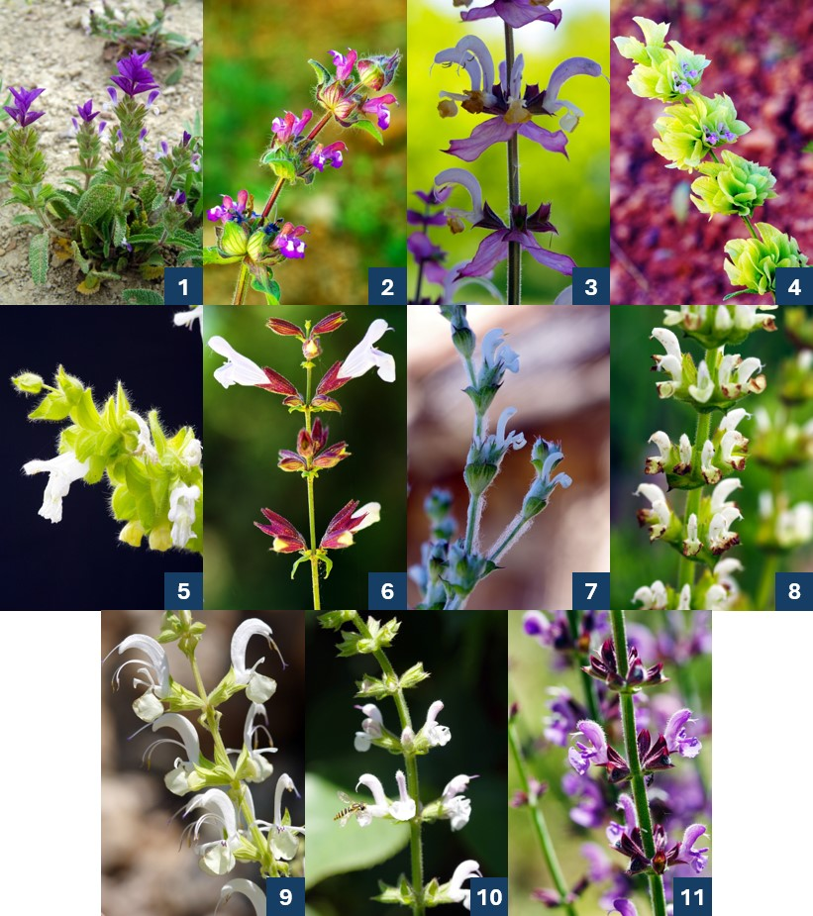
Fig. 1. Photographs of eleven Salvia species studied: (1) S. viridis (2) S. bracteata (3) S. sclarea (4) S. absconditiflora (5) S. cadmica (6) S. tomentosa (7) S. aethiopis (8) S. frigida (9) S. argentea (10) S. palaestina (11) S. virgata

3. results and discussion

Thirteen Salvia taxa were recorded from natural populations within Isparta Province: S. viridis, S. bracteata, S. sclarea, S. absconditiflora, S. cadmica, S. tomentosa, S. aethiopis, S. frigida, S. argentea, S. palaestina, S. virgata, S. verticillata and S. syriaca. HS-SPME/GC–MS analysis enabled the successful characterization of leaf and flower volatile profiles and revealed pronounced qualitative and quantitative interspecific variation (Table 1).
A total of 40–49 individual compounds were identified per species. Monoterpene hydrocarbons (MH) and sesquiterpene hydrocarbons (SH) constituted the dominant chemical classes across all taxa, although their relative proportions varied markedly (Figure 2).
In S. viridis, 48 compounds were detected, with trans-caryophyllene (14.62 %), β-pinene (10.77 %) and γ-muurolene (6.80 %) as the major constituents. S. bracteata exhibited a complex profile (49 compounds) dominated by trans-β-ocimene (9.47 %), p-cymene (9.20 %) and trans-caryophyllene (9.01 %). The volatile composition of S. sclarea was characterized by a high proportion of oxygenated monoterpenes, particularly linalyl acetate (35.77 %), followed by germacrene D (14.71 %) and trans-caryophyllene (13.14 %).
S. absconditiflora displayed a profile dominated by 1,8-cineole (20.84 %), trans-caryophyllene (15.37 %) and α-pinene (6.89 %). S. cadmica was distinguished by an unusually high abundance of low-molecular-weight oxygenated compounds, notably 2-propanone (12.10 %), p-cymene (8.89 %) and linalool (8.21 %). In contrast, S. tomentosa showed a monoterpene-rich profile dominated by α-pinene (29.08 %), limonene (14.94 %) and trans-caryophyllene (8.43 %).

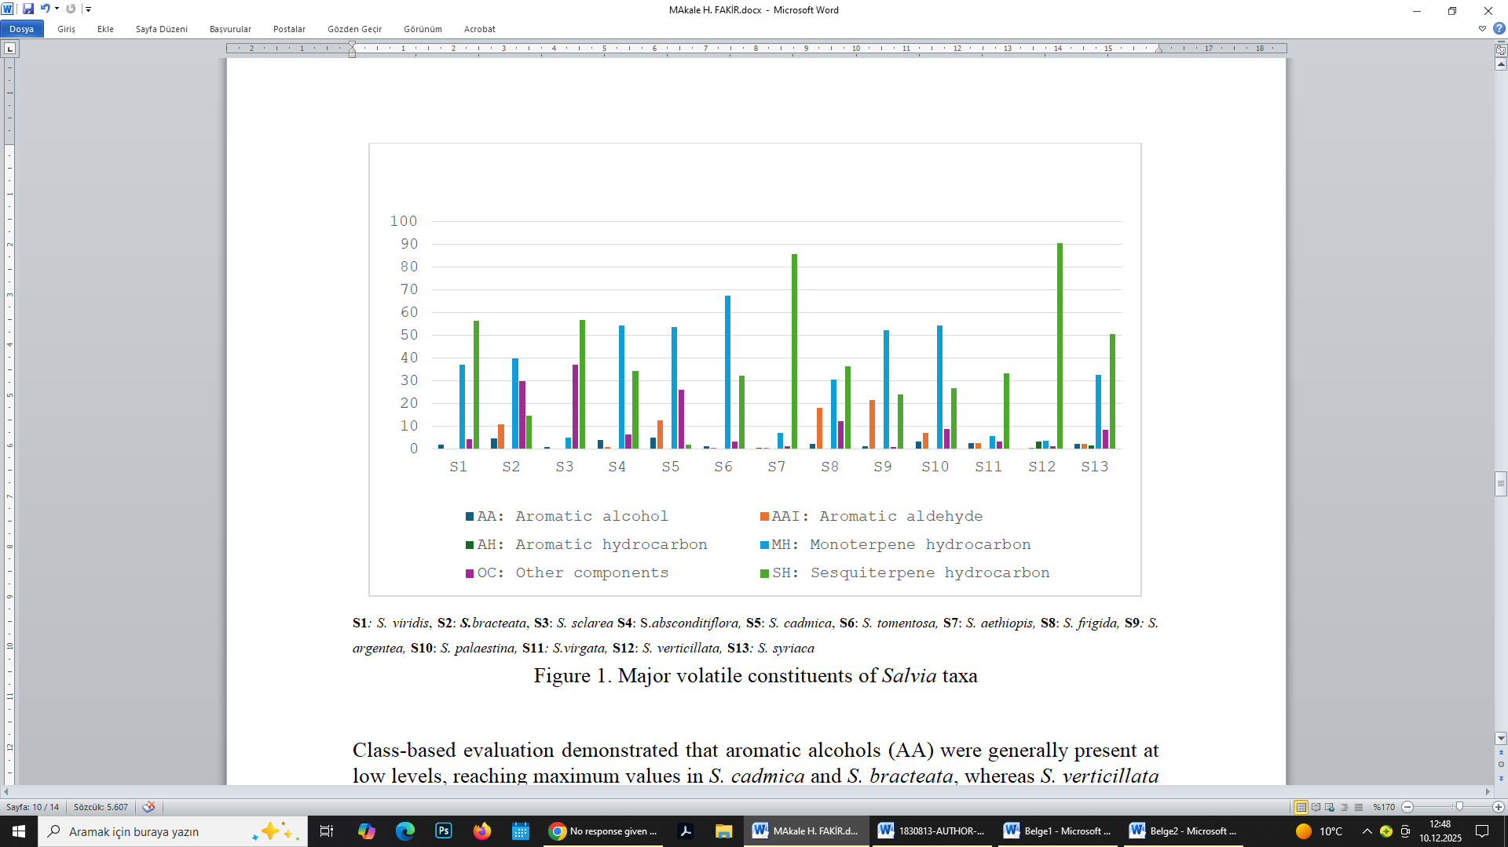
S1: S. viridis S2: S.bracteata S3: S. sclarea S4: S.absconditiflora S5: S. cadmica S6: S. tomentosa S7: S. aethiopis S8: S. frigida S9: S. argentea S10: S. palaestina S11: S.virgata S12: S. verticillata S13: S. syriaca
Fig. 2. Major volatile constituents of Salvia taxa
Sesquiterpenes were particularly abundant in S. aethiopis, in which α-copaene accounted for 33.25 % of total volatiles, followed by trans-caryophyllene (7.97 %) and δ-cadinene (7.69 %). S. frigida and S. argentea were characterized by high proportions of p-cymene (17.62 % and 20.69 %, respectively), with considerable contributions from linalool and germacrene D. In S. palaestina and S. virgata, trans-caryophyllene was the dominant compound (19.13 % and 22.09 %, respectively), accompanied by sabinene, limonene and α-pinene.
S. verticillata exhibited a distinct sesquiterpene-dominated profile with (E)-β-farnesene (17.46 %), germacrene D (16.44 %) and δ-cadinene (7.13 %) as principal constituents. Likewise, S. syriaca was characterized by high levels of trans-caryophyllene (24.79 %), α-copaene (7.53 %) and sabinene (5.99 %).

Table 1. HS-SPME/GC–MS results of Salvia taxa
RT | Compounds | S1 | S2 | S3 | S4 | S5 | S6 | S7 | S8 | S9 | S10 | S11 | S12 | S13 | Molecular Formula | Compound Class
1.357 | Ethanol | 0.44 | 1.08 | 0.39 | 0.16 | 1.48 | - | 0.42 | 1.55 | - | 1.40 | 0.68 | 0.36 | 1.71 | C₂H₆O | AA
1.424 | 2-Propanone | 0.36 | 0.63 | - | - | 12.10 | - | 0.31 | 1.19 | - | 2.25 | 1.16 | 0.30 | 2.10 | C₃H₆O | OC
1.494 | Dimethyl sulfide | - | - | - | - | - | - | - | - | - | 1.28 | 0.89 | 0.35 | 0.97 | C₂H₆S | OC
1.838 | Acetic acid | - | - | 0.48 | - | 4.51 | - | - | - | - | 1.20 | - | - | 0.50 | C₂H₄O₂ | OC
1.877 | Ethyl Acetate | 0.39 | 0.79 | 0.16 | - | 3.60 | - | 0.29 | 0.87 | - | 0.87 | 0.58 | 0.20 | - | C₄H₈O₂ | OC
2.505 | Penten-3-ol | - | - | - | - | - | - | - | - | - | 0.68 | 0.50 | - | 0.55 | C₅H₁₀O | AA
2.668 | Valeraldehyde | - | - | - | - | - | - | - | - | - | 1.39 | 0.66 | 0.18 | 0.59 | C₅H₁₀O | AAI
3.318 | 4-Methyl-2-pentanone | - | - | - | - | 0.52 | - | - | - | - | - | - | - | - | C₆H₁₂O | OC
4.241 | 3-Methyl-2-butenal | - | - | - | - | 1.61 | - | - | - | - | - | - | - | - | C₅H₈O | AAI
4.565 | Hexanal | - | - | - | - | - | - | - | 0.47 | - | 1.87 | 0.70 | - | - | C₆H₁₂O | AAI
4.947 | Butyl acetate | - | 0.45 | - | - | - | - | - | 0.44 | - | - | - | - | - | C₆H₁₂O₂ | OC
5.437 | 3-Methyl-2-butenyl formate | - | - | - | - | 0.44 | - | - | - | - | - | - | - | - | C₆H₁₀O₂ | OC
6.072 | (E)-2-Hexenal | - | - | - | - | - | - | - | - | - | - | 0.45 | 0.26 | 1.70 | C₆H₁₀O | AAI
6.610 | Hexanol | - | 0.66 | 0.17 | - | - | - | - | - | - | - | - | - | - | C₆H₁₄O | AA
7.990 | 5-Methyl-2-furfural | - | - | 0.19 | - | - | - | - | - | 0.40 | 0.42 | 0.52 | - | - | C₆H₆O₂ | AAI
8.298 | Tricyclene | - | - | - | 0.25 | - | - | - | - | - | - | - | - | - | C₁₀H₁₆ | MH
8.453 | α-Thujene | - | 0.87 | - | 0.32 | - | 0.19 | 0.40 | 3.99 | 3.07 | 4.64 | 1.26 | - | 4.21 | C₁₀H₁₆ | MH
8.690 | α-Pinene | 1.87 | 1.12 | 0.12 | 6.89 | 3.90 | 29.08 | 0.42 | 0.69 | 2.81 | 9.84 | 10.21 | 0.53 | 2.92 | C₁₀H₁₆ | MH
9.065 | 2,4(10)-thujadien | - | - | - | - | - | - | - | 1.28 | - | - | - | - | - | C₁₀H₁₆ | MH
9.068 | 1-Butoxy-2-propanol | - | - | - | - | 0.49 | - | - | - | - | - | - | - | - | C₇H₁₆O₂ | AA
9.267 | Camphene | - | 0.33 | - | 5.17 | - | 1.74 | - | - | 0.37 | 0.75 | 0.38 | 0.44 | - | C₁₀H₁₆ | MH
9.317 | 5,5-Dimethyl-2(5H)-furanone | - | - | - | - | 3.63 | - | - | - | - | - | - | - | - | C₆H₁₀O₂ | MH
9.461 | Verbenene | - | - | - | - | 1.06 | - | - | - | - | - | 0.89 | - | - | C₁₀H₁₆ | MH
10.169 | Sabinene | 0.21 | 0.61 | - | - | - | 0.15 | 1.35 | 4.48 | 5.11 | 11.41 | 4.36 | 0.26 | 5.99 | C₁₀H₁₆ | MH
10.338 | β-Pinene | 10.77 | 4.73 | - | 2.37 | - | 4.57 | - | 0.61 | 3.86 | 1.52 | 8.15 | 0.43 | 1.15 | C₁₀H₁₆ | MH
10.557 | 1-Octen-3-ol | 0.34 | - | - | 0.42 | - | - | - | - | - | 0.32 | - | - | - | C₈H₁₆O | AA
10.680 | 6-Methyl-5-hepten-2-one | - | - | - | - | - | - | 0.23 | 0.71 | - | 0.67 | - | - | - | C₈H₁₄O | OC
10.709 | 3-Octanone | 0.27 | - | - | 0.52 | - | 0.16 | - | - | - | - | - | - | - | C₈H₁₆O | OC
10.864 | β-Myrcene | 2.61 | 2.02 | 1.84 | 4.45 | - | 4.52 | 0.24 | - | 3.31 | 2.60 | 3.28 | - | 0.64 | C₁₀H₁₆ | MH
11.128 | n-Butyl n-butyrate | - | 0.60 | - | - | - | - | - | - | - | - | - | - | - | C₈H₁₆O₂ | OC
11.246 | Capronate | - | 0.48 | - | - | - | - | - | - | - | - | - | - | - | C₈H₁₆O₂ | OC
11.379 | Pseudolimonene | - | - | - | - | 1.79 | - | - | - | - | - | - | - | - | C₁₀H₁₆ | MH
11.462 | Phellandrene | - | - | - | 0.19 | - | 0.13 | - | - | - | 0.46 | - | - | 0.45 | C₁₀H₁₆ | MH
11.771 | Hexyl acetate | 1.21 | 8.23 | 0.12 | 0.16 | 2.28 | - | 0.22 | 1.214 | - | 0.61 | - | - | 0.47 | C₈H₁₆O₂ | OC
11.865 | α-Terpinene | 0.34 | 0.83 | - | 0.45 | - | 0.35 | 0.26 | 1.06 | 1.45 | 1.64 | 0.62 | - | 2.67 | C₁₀H₁₆ | MH
12.169 | p-Cymene | 0.26 | 9.20 | - | 0.89 | 8.89 | 0.55 | 0.68 | 17.62 | 20.69 | 2.88 | 2.32 | - | 2.24 | C₁₀H₁₄ | AHI
12.364 | Limonene | 5.65 | 2.15 | 0.64 | - | 2.61 | 14.94 | 0.42 | 3.19 | 2.48 | 2.84 | 14.14 | 0.95 | 2.11 | C₁₀H₁₆ | MH
12.446 | Eucalyptol | - | 0.86 | - | 20.84 | 7.54 | 4.72 | 0.23 | 0.60 | - | 8.14 | - | - | 3.01 | C₁₀H₁₈O | MH
12.694 | cis-Ocimene | 6.69 | 1.30 | 0.50 | - | - | 1.39 | - | - | 4.33 | 0.63 | 0.64 | - | - | C₁₀H₁₆ | MH
12.978 | 2-Octenol | - | - | - | - | - | - | - | 0.49 | - | - | - | - | - | C₈H₁₆O | AA
13.094 | trans-β-Ocimene | 5.80 | 9.47 | 0.83 | - | - | - | - | - | 1.15 | - | - | - | 0.95 | C₁₀H₁₆ | MH
13.105 | δ-3-Carene | - | - | - | - | - | 0.38 | - | - | - | - | - | - | - | C₁₀H₁₆ | MH
13.497 | γ-Terpinene | 0.34 | 2.43 | - | 0.80 | - | 0.74 | 0.56 | 1.84 | 11.31 | 2.88 | 1.44 | - | 4.22 | C₁₀H₁₆ | MH
13.986 | (3E,5E)-3,5-Octadien-2-one | - | - | - | - | - | - | - | - | - | 0.93 | - | - | - | C₈H₁₂O | OC
14.003 | cis-Sabinene hydrate | - | - | - | 0.19 | 0.85 | - | - | - | 0.59 | - | - | - | - | C₁₀H₁₈O | AA
14.555 | α-Terpinolen | 0.33 | 0.42 | - | 0.39 | 2.50 | 0.28 | 0.25 | - | 1.29 | 0.79 | 0.39 | - | 1.31 | C₁₀H₁₆ | MH
14.639 | α-Fenchone | - | 0.92 | - | - | - | - | - | 1.02 | - | - | - | - | 0.68 | C₁₀H₁₆O | MH
14.729 | Fencholenic aldehyde | - | - | - | - | - | - | - | - | - | - | 0.67 | - | - | C₁₀H₁₆O | MH
14.737 | 4-Isopropenyl-1-methylbenzene | - | 1.22 | - | - | 0.69 | - | - | - | 0.26 | - | - | - | - | C₁₀H₁₄ | AAI
14.806 | 2-Nonanone | - | 0.62 | - | - | 0.97 | - | - | - | - | - | - | - | - | C₉H₁₈O | OC
14.965 | Propyl hexanoate | - | 0.50 | - | - | - | - | - | - | - | - | - | - | - | C₉H₁₈O₂ | OC
15.185 | Linalool | 1.49 | 7.15 | 1.08 | 0.39 | 8.21 | 0.23 | 2.19 | 7.65 | 10.26 | 2.44 | 1.02 | 0.37 | 2.23 | C₁₀H₁₈O | MH
15.320 | Nonanal | - | - | - | - | - | - | - | 1.91 | 0.29 | 0.89 | 0.62 | 0.41 | 1.35 | C₉H₁₈O | OC
15.369 | Hexyl propanoate | - | 1.73 | - | - | - | - | - | - | - | - | - | - | - | C₉H₁₈O₂ | OC
15.382 | β-Thujone | - | - | - | - | 3.13 | - | - | - | - | - | - | - | - | C₁₀H₁₆O | MH
15.471 | Pentyl 3-methylbutanoate | - | - | - | - | - | - | - | 0.71 | - | - | - | - | - | C₁₀H₂₀O₂ | OC
15.829 | α-Thujone | - | - | - | - | 0.75 | - | - | 1.09 | - | - | - | - | - | C₁₀H₁₆O | MH
16.173 | Campholaldehyde | - | - | - | - | 1.38 | - | - | - | - | - | 2.50 | - | - | C₁₀H₁₆O | MH
16.247 | (4E,6Z)-Alloocimene | 0.56 | - | - | - | - | - | - | - | 0.41 | - | - | - | - | C₁₀H₁₆ | MH
16.305 | p-Mentha-1,5,8-triene | 0.43 | 1.05 | - | - | - | 0.24 | - | - | 0.24 | - | - | - | - | C₁₀H₁₆ | MH
16.385 | Limonene oxide <cis-> | - | - | - | - | - | - | - | - | - | - | 0.37 | - | - | C₁₀H₁₆O | MH
16.564 | Limonene oxide <trans-> | - | - | - | - | - | - | - | - | - | - | 0.47 | - | - | C₁₀H₁₆O | MH
16.691 | trans-Pinocarveol | - | - | - | - | - | - | - | - | - | - | 1.35 | - | - | C₁₀H₁₆O | MH
16.700 | Allocimene | - | 0.37 | - | - | - | - | - | - | - | - | - | - | - | C₁₀H₁₆ | MH
16.884 | Camphor | - | 0.82 | - | 4.02 | 6.18 | 1.32 | - | - | - | - | - | - | - | C₁₀H₁₆O | MH
16.914 | Verbenol | - | - | - | - | - | - | - | - | - | - | 0.40 | - | - | C₁₀H₁₆O | MH
17.041 | (2Z)-2-Pentenyl pentanoate | - | - | - | - | - | - | - | 1.02 | - | - | - | - | - | C₁₀H₁₈O₂ | OC
17.299 | Sabinaketone | - | - | - | - | - | - | - | 0.43 | - | - | - | - | - | C₁₀H₁₆O | MH
17.438 | Pinocamphone | - | - | - | 0.54 | 0.52 | - | - | - | - | - | - | - | - | C₁₀H₁₆O | MH
17.486 | Pinocarvone | - | - | - | - | - | - | - | - | - | - | 1.28 | - | - | C₁₀H₁₄O | MH
18.002 | Borneol | - | - | - | 6.68 | - | 2.30 | - | - | 0.60 | 1.74 | - | 0.85 | - | C₁₀H₁₈O | MH
18.224 | 4-Terpineol | - | 1.14 | - | 0.49 | 0.61 | 0.25 | - | 0.46 | - | - | - | - | - | C₁₀H₁₈O | MH
18.461 | Cryptone | - | - | - | - | 3.98 | - | - | - | - | - | - | - | - | C₁₀H₁₆O | MH
18.486 | Cymen-8-ol <para-> | - | - | - | - | - | - | - | - | 0.38 | - | - | - | - | C₁₀H₁₄O | AA
18.651 | Butyl caproate | 0.81 | 8.13 | - | 0.14 | - | - | - | - | - | - | - | - | - | C₁₀H₂₀O₂ | OC
18.710 | Hexyl butanoate | - | - | - | - | 0.55 | - | - | - | - | - | - | - | 0.85 | C₁₀H₂₀O₂ | OC
18.793 | α-Terpineol | 1.02 | 3.00 | 0.17 | 0.88 | 2.23 | 1.26 | - | 0.44 | 0.36 | 0.88 | 1.64 | - | - | C₁₀H₁₈O | AA
18.875 | Ethyl caprylate | - | 0.57 | - | - | - | - | - | - | - | - | - | - | - | C₁₀H₂₀O₂ | OC
19.217 | Capraldehyde | - | 0.42 | - | - | - | - | - | - | - | 0.42 | - | - | - | C₁₀H₂₀O | AAI
19.240 | Berbenone | - | - | - | - | 2.46 | - | - | - | - | - | 1.13 | - | - | C₁₀H₁₄O | MH
19.439 | Linalyl formate | - | - | 0.70 | - | - | - | - | - | - | - | - | - | - | C₁₁H₁₈O₂ | OC
20.308 | hexyl 2-methylbutanoate | 0.90 | 5.45 | - | 0.16 | - | - | 0.22 | - | - | - | - | - | 2.23 | C₁₁H₂₂O₂ | OC
20.325 | cis-3-Hexenyl isovalerate | - | - | - | - | - | 0.19 | - | 3.10 | - | - | - | - | - | C₁₁H₂₀O₂ | OC
20.388 | Pulegone | - | - | - | - | 1.12 | - | - | - | - | - | - | - | - | C₁₀H₁₆O | MH
20.520 | Butanoate | - | - | - | - | - | - | - | 1.17 | - | - | - | - | - | C₄H₈O₂ | OC
20.547 | Cumaldehyde | - | - | - | - | 1.55 | - | - | - | - | - | - | - | - | C₁₀H₁₂O | AAI
20.610 | Carvone | - | - | - | - | 0.85 | - | - | - | - | - | - | - | - | C₁₀H₁₄O | MH
20.823 | Linalyl acetate | 0.38 | - | 35.77 | 0.23 | 0.44 | - | - | - | 0.61 | - | - | - | - | C₁₂H₂₀O₂ | OC
22.102 | Bornyl acetate | - | - | - | 4.44 | 0.84 | 2.95 | - | - | - | - | - | - | - | C₁₂H₂₀O₂ | OC
22.251 | Sabinol | - | - | - | - | - | 0.14 | - | - | - | - | - | - | - | C₁₀H₁₈O | MH
22.677 | Tridecane | - | - | - | - | - | - | - | - | - | - | - | 3.40 | - | C₁₃H₂₈ | AH
22.700 | Carvacrol | - | 0.85 | - | - | 1.61 | - | 0.66 | 2.15 | 0.34 | 1.97 | 0.86 | - | - | C₁₀H₁₄O | MH
22.790 | Ascaridole | - | 0.57 | - | - | - | - | - | - | - | - | - | - | - | C₁₀H₁₆O₂ | MH
23.446 | Myrtenyl acetate | - | - | - | 0.60 | - | - | - | - | - | - | - | - | - | C₁₂H₁₈O₂ | OC
23.765 | Bicycloelemene | - | - | 0.39 | - | - | - | 0.47 | - | - | - | - | 0.48 | - | C₁₅H₂₄ | SH
23.792 | δ-Elemene | - | - | - | - | - | 0.28 | - | - | - | - | - | - | - | C₁₅H₂₄ | SH
23.845 | cis- Caryophyllene | - | - | 0.16 | - | - | - | - | - | - | - | - | 0.37 | - | C₁₅H₂₄ | SH
24.252 | α-Terpinyl acetate | - | 0.39 | - | - | - | - | 4.92 | - | - | - | - | - | - | C₁₂H₂₀O₂ | SH
24.268 | α-Cubebene | 0.99 | - | 1.25 | 0.57 | - | 0.41 | - | 1.185 | 0.53 | 1.03 | 0.52 | 1.61 | 0.75 | C₁₅H₂₄ | SH
24.693 | Neryl acetate | - | - | 0.31 | - | - | - | - | - | - | - | - | - | - | C₁₂H₂₀O₂ | SH
25.036 | α-Ylangene | 1.05 | - | 0.14 | 0.58 | - | 1.31 | - | - | - | - | - | 0.49 | - | C₁₅H₂₄ | SH
25.262 | α-Copaene | 3.59 | 0.39 | 6.59 | 1.89 | 0.43 | 1.59 | 33.25 | 3.83 | 1.15 | 1.65 | 1.09 | 4.93 | 7.53 | C₁₅H₂₄ | SH
25.350 | Geranyl acetate | 0.44 | 0.51 | 0.61 | - | - | - | - | - | - | - | - | - | - | C₁₂H₂₀O₂ | SH
25.528 | β-Bourbonene | 2.36 | - | 0.22 | 0.36 | - | 1.91 | 0.42 | 1.72 | 0.35 | 0.63 | 1.06 | 1.57 | 3.68 | C₁₅H₂₄ | SH
25.607 | Hexyl hexoate | - | 1.32 | - | - | - | - | - | - | - | - | - | - | - | C₁₂H₂₄O₂ | OC
25.670 | Butyl octanoate | - | 0.32 | - | - | - | - | - | - | - | - | - | - | - | C₁₂H₂₄O₂ | OC
25.673 | Sesquithujene | - | - | - | - | - | - | - | - | - | - | 0.61 | - | - | C₁₅H₂₄ | SH
25.750 | β-Elemene | - | - | 0.70 | - | - | - | 3.70 | - | 0.52 | 0.42 | - | 1.26 | - | C₁₅H₂₄ | SH
26.125 | Tetradecane | - | - | - | - | - | - | - | - | - | 0.54 | 0.44 | - | - | C₁₄H₃₀ | SH
26.775 | trans-Caryophyllene | 14.62 | 9.01 | 13.14 | 15.37 | - | 8.43 | 7.97 | 7.01 | 1.84 | 19.13 | 22.09 | 6.98 | 24.79 | C₁₅H₂₄ | SH
27.075 | β-Cubebene | 1.33 | - | 0.38 | 0.66 | - | 0.79 | 0.66 | 0.52 | 0.37 | - | - | 0.92 | 0.67 | C₁₅H₂₄ | SH
27.103 | Calarene | - | 1.65 | - | - | - | - | 0.33 | - | - | - | - | 0.44 | - | C₁₅H₂₄ | SH
27.178 | α-Bergamotene | - | - | - | - | - | - | - | 0.80 | - | - | - | - | - | C₁₅H₂₄ | SH
27.378 | (+)-Aromadendrene | - | - | 0.77 | - | - | - | 2.08 | - | - | - | - | 2.21 | 1.45 | C₁₅H₂₄ | SH
27.439 | Aristolene | - | - | - | - | - | - | 0.68 | - | - | - | - | 1.23 | - | C₁₅H₂₄ | SH
27.579 | Isoledene | - | - | - | - | - | - | 0.71 | - | - | - | - | - | 0.53 | C₁₅H₂₄ | SH
27.706 | Cadina-1(6) | 0.39 | - | 0.37 | 0.15 | - | 0.24 | 0.77 | - | 0.26 | - | - | 0.51 | - | C₁₅H₂₄ | SH
27.837 | β-Farnesene | - | - | - | - | - | - | - | - | - | - | 0.70 | 17.46 | - | C₁₅H₂₄ | SH
27.871 | α-Bulnesene | - | - | - | - | - | - | - | - | - | - | - | 0.26 | - | C₁₅H₂₄ | SH
27.921 | α-Humulene | 3.59 | 1.35 | 0.48 | 0.61 | - | 1.44 | 1.51 | 0.99 | - | 0.79 | 0.88 | - | 0.73 | C₁₅H₂₄ | SH
28.061 | Alloaromadendrene | 0.60 | 0.67 | 0.25 | 0.51 | - | - | 0.74 | - | 0.21 | - | - | 1.11 | - | C₁₅H₂₄ | SH
28.127 | (+)-Epi-bicyclosesquiphellandrene | 0.47 | - | 0.63 | - | - | 0.26 | 0.61 | 0.58 | 0.60 | - | - | 1.27 | 0.50 | C₁₅H₂₄ | SH
28.461 | β-Guaiene | 0.50 | - | - | - | - | - | 0.83 | - | 0.22 | - | - | 0.91 | 0.73 | C₁₅H₂₄ | SH
28.582 | γ-Muurolene | 6.80 | - | 1.48 | 1.93 | - | - | 1.56 | 1.58 | 1.24 | - | 0.43 | 3.54 | 0.82 | C₁₅H₂₄ | SH
28.705 | α-Amorphene | 0.71 | - | - | - | - | 2.33 | - | - | - | - | - | - | - | C₁₅H₂₄ | SH
28.761 | Germacrene D | 1.59 | - | 14.71 | - | - | 1.24 | 6.58 | 7.11 | 10.17 | 0.77 | 2.98 | 16.44 | 2.12 | C₁₅H₂₄ | SH
29.011 | β-Selinene | 0.93 | - | 0.31 | 4.42 | 1.30 | 1.01 | 0.49 | 1.34 | - | - | - | 0.36 | - | C₁₅H₂₄ | SH
29.121 | α-Selinene | 2.18 | - | 1.48 | 2.60 | - | 0.57 | 2.14 | - | 0.87 | - | 0.53 | 3.65 | - | C₁₅H₂₄ | SH
29.252 | Eudesma-3,7(11)-diene | 1.94 | - | - | - | - | 0.58 | - | - | - | - | - | - | - | C₁₅H₂₄ | SH
29.271 | Bicyclogermacrene | - | - | 4.32 | - | - | - | 5.76 | 0.91 | 0.40 | - | - | 6.00 | 2.16 | C₁₅H₂₄ | SH
29.331 | α-Muurolene | 1.43 | - | 0.80 | - | - | 0.51 | 0.97 | 0.59 | 0.61 | - | - | 1.80 | - | C₁₅H₂₄ | SH
29.523 | α-Farnesene | - | - | 0.44 | - | 0.40 | 0.33 | 0.92 | 0.86 | 0.39 | 0.39 | - | - | - | C₁₅H₂₄ | SH
29.791 | γ-Cadinene | 3.24 | - | 1.47 | 1.16 | - | 0.88 | 1.21 | 1.64 | 1.23 | - | 0.61 | 3.85 | 0.91 | C₁₅H₂₄ | SH
29.977 | δ-Cadinene | 6.28 | - | 3.80 | 2.80 | - | 2.23 | 7.69 | 3.71 | 2.32 | 0.66 | 1.04 | 7.13 | 2.33 | C₁₅H₂₄ | SH
30.032 | Calamenene | - | - | - | - | - | - | 1.43 | - | - | 0.33 | - | 1.01 | 0.89 | C₁₅H₁₈O | SH
30.388 | Cadina-1,4-diene | 0.30 | - | 0.41 | - | - | - | 1.37 | - | 0.26 | - | - | 0.92 | - | C₁₅H₂₄ | SH
30.522 | α-Cadinene | 0.82 | - | 0.57 | 0.18 | - | 0.23 | 0.49 | 0.48 | 0.49 | - | - | 1.52 | - | C₁₅H₂₄ | SH
30.651 | α-Calacorene | 0.38 | - | 0.24 | 0.17 | - | 0.33 | 0.39 | - | - | - | - | 0.48 | - | C₁₅H₂₄ | SH
31.800 | Spathulenol | - | - | 0.20 | - | - | - | - | - | - | - | - | - | - | C₁₅H₂₄O | AA
31.931 | Caryophyllene oxide | - | 0.62 | 0.22 | 0.39 | - | 0.33 | - | 1.68 | - | 0.41 | 0.49 | - | - | C₁₅H₂₄O | SH
32.373 | Viridiflorol | - | - | - | 2.08 | - | - | - | - | - | - | - | - | - | C₁₅H₂₆O | AA
34.154 | β-Eudesmol | - | - | - | 0.22 | - | - | - | - | - | - | - | - | - | C₁₅H₂₆O | AA
34.700 | Valeranon | - | - | - | 0.32 | - | - | - | - | - | - | - | - | - | C₅H₁₀O | OC
35.441 | Heptadecane | - | - | - | - | - | - | - | - | - | - | - | - | 0.48 | C₁₇H₃₆ | AH
38.234 | Octadecane | - | - | - | - | - | - | - | - | - | - | - | - | 0.68 | C₁₈H₃₈ | AH
40.893 | Nonadecane | - | - | - | - | - | - | - | - | - | - | - | - | 0.45 | C₁₉H₄₀ | AH
 | TOPLAM | 100 | 100 | 100 | 100 | 100 | 100 | 100 | 100 | 100 | 100 | 100 | 100 | 100
 | AA: Aromatic alcohol | 1.80 | 4.74 | 0.93 | 3.95 | 5.05 | 1.26 | 0.42 | 2.48 | 1.33 | 3.28 | 2.82 | 0.36 | 2.26
 | AAI: Aromatic aldehyde | 0.26 | 10.84 | 0.19 | 0.89 | 12.74 | 0.55 | 0.68 | 18.09 | 21.65 | 6.98 | 2.65 | 0.44 | 2.29
 | AH:Aromatic hydrocarbon | - | - | - | - | - | - | - | - | - | - | - | 3.40 | 1.61
 | MH:Monoterpene hydrocarbon | 37.09 | 40.01 | 5.01 | 54.24 | 53.83 | 67.66 | 6.98 | 30.54 | 52.39 | 54.29 | 5.81 | 3.83 | 32.54
 | OC: Others component | 4.32 | 29.82 | 37.23 | 6.57 | 26.25 | 3.30 | 1.27 | 12.33 | 0.90 | 8.70 | 3.25 | 1.26 | 8.47
 | SH:Sesquiterpene hydrocarbon | 56.53 | 14.59 | 56.64 | 34.35 | 2.13 | 32.15 | 85.73 | 36.53 | 24.03 | 26.75 | 33.47 | 90.71 | 50.59

RT: Retention Time; S1: S. viridis S2: S.bracteata S3: S. Sclarea S4: S.absconditiflora S5: S. cadmica S6: S. tomentosa S7: S. aethiopis S8: S. frigida S9: S. argentea S10: S. palaestina S11: S.virgata S12: S. verticillata S13: S. syriaca

Class-based evaluation demonstrated that aromatic alcohols (AA) were generally present at low levels, reaching maximum values in S. cadmica and S. bracteata, whereas S. verticillata contained only trace amounts. Aromatic aldehydes (AAI) exhibited marked interspecific variation and were particularly abundant in S. frigida and S. argentea. Aromatic hydrocarbons (AH) were detected only in S. verticillata and S. syriaca. Monoterpene hydrocarbons (MH) predominated in S. tomentosa, S. palaestina, S. absconditiflora and S. argentea, whereas S. sclarea, S. virgata and S. verticillata exhibited comparatively low MH proportions. Conversely, sesquiterpene hydrocarbons (SH) were dominant in S. verticillata and S. aethiopis, accounting for more than 80 % of total volatiles.
Principal component analysis (PCA) clearly discriminated the studied taxa on the basis of their volatile fingerprints (Figure 2). The first principal component (PC1) explained the greatest proportion of variance and primarily separated SH-rich taxa (e.g., S. verticillata) from species enriched in MH and aromatic aldehydes (e.g., S. cadmica and S. bracteata). The second principal component (PC2) further differentiated taxa according to their relative abundance of aromatic alcohols and minor constituents. The score plot revealed distinct chemotypic groupings, with S. sclarea clearly separated along PC2 due to its oxygenated monoterpene-rich profile, while S. tomentosa and S. argentea clustered together due to lower sesquiterpene levels. S. absconditiflora, S. palaestina, S. frigida and S. virgata formed a closely associated group, indicating strong chemical similarities.

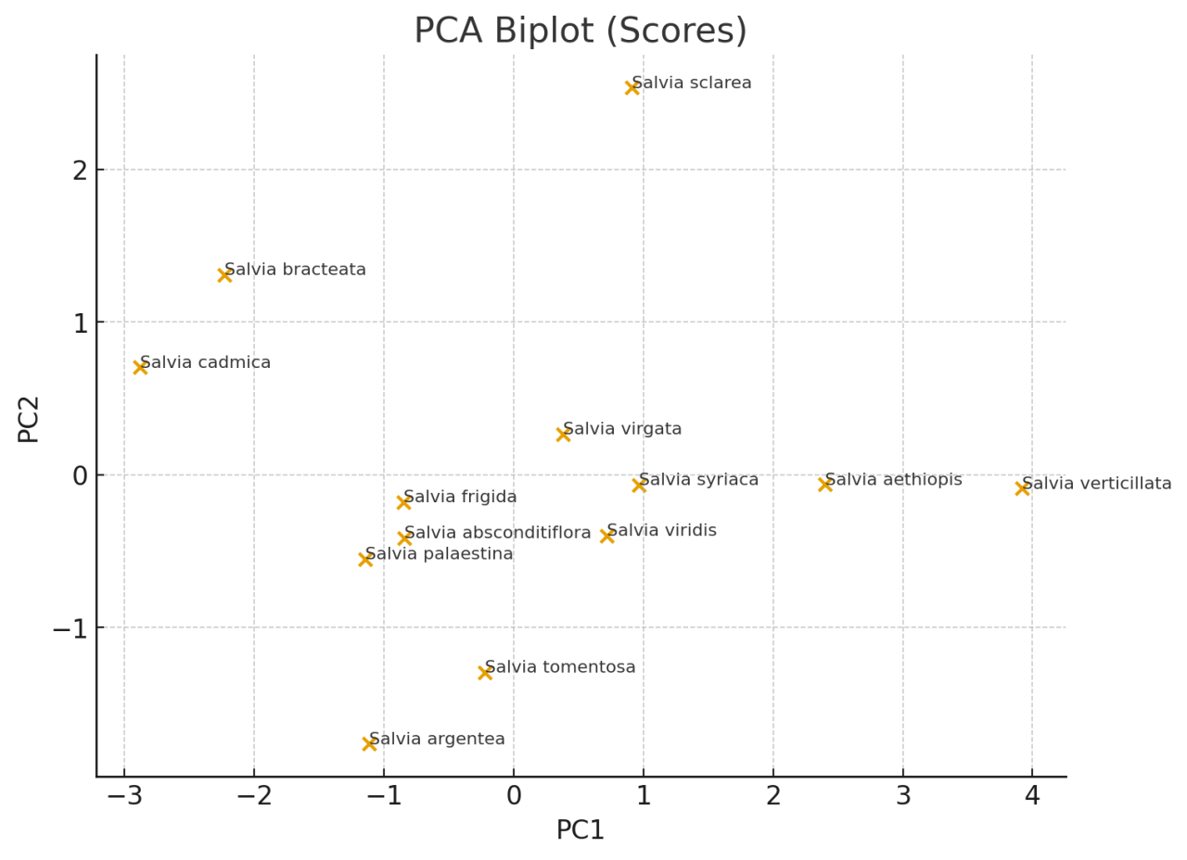

Figure 3. Principal Component Analysis (PCA) of Salvia

5. Discussion
Comparative HS-SPME/GC–MS profiling revealed pronounced interspecific diversity in the volatile signatures of the investigated Salvia taxa. Trans-caryophyllene emerged as a dominant or co-dominant component in the majority of species, supporting its proposed value as a robust chemotaxonomic marker within the genus, whereas several taxa, including S. argentea, S. cadmica and S. frigida, exhibited reduced levels of this compound accompanied by elevated proportions of linalool and related oxygenated monoterpenes. Similar trends have been documented in recent large-scale volatilomic surveys of Salvia species from different biogeographic regions (Özçoban and Gediklioğlu, 2024; Karadeniz and Karadeniz, 2025; Levaya et al., 2025).
Multivariate statistical analysis confirmed that variability in monoterpene and sesquiterpene fractions represents the principal driver of chemotaxonomic separation, in agreement with contemporary chemometric studies based on GC–MS-derived plant volatilomes (Bakó et al., 2024). The clear separation of taxa along principal components highlights the robustness and reproducibility of HS-SPME/GC–MS-based fingerprints when standardized analytical protocols are applied.
Comparisons with published data revealed both concordance and divergence in volatile composition. The predominance of oxygenated monoterpenes in taxa such as S. sclarea and S. absconditiflora appears to be relatively stable across geographical regions, supporting the concept of genetically constrained chemotypes. In contrast, the highly variable profiles observed in S. bracteata and S. syriaca are most plausibly attributed to strong environmental modulation, including edaphic properties, altitude and microclimatic conditions (Tuğlu et al., 2025).
The methodological robustness of the present findings is further supported by recent optimisation studies demonstrating the critical influence of fibre chemistry, incubation temperature and extraction duration on VOC recovery efficiency (Babič et al., 2024; Nascimento et al., 2024). The standardized protocol adopted in this study aligns with current best-practice recommendations and ensures a high degree of comparability with contemporary literature.
Collectively, the findings demonstrate that volatile chemical composition in Salvia species is governed by a complex interplay of genetic background and environmental drivers, thereby reinforcing the value of metabolomic fingerprints as reliable tools for chemotaxonomic inference, biodiversity assessment and the selection of elite germplasm for pharmaceutical and industrial applications (Karadeniz and Karadeniz, 2025).

6. Conclusion
This study provides the first comprehensive, comparative volatilomic assessment of Salvia taxa naturally distributed in the Isparta region (Türkiye) using HS-SPME/GC–MS. The pronounced interspecific variation observed among taxa highlights the strong discriminatory power of volatile fingerprints and confirms their value as robust chemotaxonomic markers within the genus.
Distinct chemotypic patterns revealed across the analyzed taxa reflect both genetic background and local ecological drivers, emphasizing the importance of integrating chemical profiling into systematic, evolutionary and biodiversity-oriented studies of Salvia. Beyond their taxonomic relevance, the documented volatile signatures establish a scientific foundation for the targeted selection of taxa with high pharmaceutical, nutraceutical and agro-industrial potential.
Future studies combining metabolomic, transcriptomic and molecular phylogenetic approaches are strongly recommended to elucidate chemotype–genotype relationships and to facilitate the rational exploitation and conservation of biochemically valuable Salvia genetic resources.
Acknowledgements and Funding
“This study is derived from the Master’s thesis entitled “Determination of Volatile Constituents of Salvia L. Taxa Growing Naturally in Isparta Province”, conducted at the Graduate Education Institute of Isparta University of Applied Sciences. The authors gratefully acknowledge all individuals who contributed to the study and the Scientific Research Projects Management Unit of Isparta University of Applied Sciences for financial support under Project No. 2023-MYL-0188.”
Disclaimer (Artificial Intelligence)
Author(s) hereby declare that NO generative AI technologies such as Large Language Models (ChatGPT, COPILOT, etc) and text to image generators have been used during writing or editing of this manuscript.
Competing Interests
Authors have declared that no competing interests exist.

References
Aktaş, K. (2001). A taxonomic study on some Lamiaceae (Labiatae) species (Master’s thesis, Celal Bayar University, Graduate School of Natural Sciences). Council of Higher Education – National Thesis Center. Retrieved from https://tez.yok.gov.tr/UlusalTezMerkezi/tezDetay.jsp?id=mkCyvXI0swaSdcBxUgaydA
Arthur, C. L., & Pawliszyn, J. (1990). Solid phase microextraction with thermal desorption using fused silica optical fibers. Analytical Chemistry, 62(19), 2145–2148. https://doi.org/10.1021/ac00218a019
Babič, K., Strojnik, L., Ćirić, A., & Ogrinc, N. (2024). Optimization and validation of an HS-SPME/GC-MS method for determining volatile organic compounds in dry-cured ham. Frontiers in Nutrition, 11, 1342417. https://doi.org/10.3389/fnut.2024.1342417
Bakó, E., Böszörményi, A., Vargáné Szabó, B., Engh, M. A., Hegyi, P., Ványolós, A., & Csupor, D. (2024). Chemometric analysis of monoterpenes and sesquiterpenes of conifers. Frontiers in Plant Science, 15, 1392539. https://doi.org/10.3389/fpls.2024.1392539
Boztas, G., Avcı, A. B., Arabacı, O., & Bayram, E. (2021). Economic status of medicinal and aromatic plants in Turkey and in the world. Theoretical and Applied Forestry, 1(1), 27-33.
Celep, F., & Dirmenci, T. (2017). Systematic and biogeographic overview of Lamiaceae in Turkey. Natural Volatiles & Essential Oils, 4(4), 14–27. https://dergipark.org.tr/en/download/article-file/526468
Çatak, E., & Atalay, A. (2022). Economic and medicinal importance of the Lamiaceae (Labiatae) family. Euroasia Journal of Mathematics, Engineering, Natural & Medical Sciences (Medical Sciences), 9(20), 150–157.
Davis, P. H. (Ed.). (1982). Flora of Turkey and the East Aegean Islands (Vol. 7). Edinburgh University Press. https://www.researchgate.net/publication/273136401_Flora_
Gabriel, M. B., Pinheiro, G. P., Hantao, L. W., & Sawaya, A. C. H. F. (2025). Comparison of Hydrodistillation and Headspace Solid-Phase Microextraction to Analyze Volatiles from Brazilian Propolis by GC-MS. Chemosensors, 13(9), 322. https://doi.org/10.3390/chemosensors13090322
Hatipoglu, S. D., Zorlu, N., Dirmenci, T., Goren, A. C., Ozturk, T., & Topcu, G. (2016). Determination of Volatile Organic Compounds in Fourty Five Salvia Species by Thermal Desorption-GC-MS Technique. Records of Natural Products, 10(6).
Kayıcılar, F. R., & Maral, H. (2026). Variability in essential oil composition and antioxidant activity of twelve wild-growing Salvia species from Türkiye. Flavour and Fragrance Journal. https://onlinelibrary.wiley.com/doi/pdf/10.1002/ffj.70056
İpek, A., Gürbüz, B., Bingöl, M. Ü., Geven, F., Akgül, G., Rezaeieh, K. A. P., & Coşge, B. (2012). Comparison of essential oil components of wild and field grown Salvia cryptantha Montbert & Aucher ex Benthan, in Turkey. Turkish Journal of Agriculture and Forestry, 36(6), 668-672. https://doi.org/10.3906/tar-1201-41
Karadeniz, Ş., & Karadeniz, B. (2025). Salvia L. Türlerinin Biyoaktiviteleri. Düzce Üniversitesi Süs Ve Tıbbi Bitkiler Botanik Bahçesi Dergisi, 4(2), 1-19. https://izlik.org/JA87YR64ME
Levaya, Y., Atazhanova, G., Gabe, V., & Badekova, K. (2025). A review of botany, phytochemistry, and biological activities of eight Salvia species widespread in Kazakhstan. Molecules, 30(5), 1142. https://doi.org/10.3390/molecules30051142
Nascimento, M. B., Amorim, L. R., Nonato, M. A., Roselino, M. N., Santana, L. R., Ferreira, A. C., ... & Soares, S. E. (2024). Optimization of HS-SPME/GC-MS method for determining volatile organic compounds and sensory profile in cocoa honey from different cocoa varieties (Theobroma cacao L.). Molecules, 29(13), 3194. https://doi.org/10.3390/molecules29133194
Öğüt, K., & Özek, T. (2025). Chemical composition of Salvia yangii BT Drew essential oil. European Journal of Life Sciences, 4(3), 169-176. https://dergipark.org.tr/en/download/article-file/5395724
Özçoban, A., & Gedikoğlu, A. (2024). Evaluation of the chemical composition, antioxidant and antimicrobial activity of Salvia officinalis L. essential oil. Adnan Menderes University Journal of Agricultural Faculty, 21(1), 89–94. https://doi.org/10.25308/aduziraat.1451479
Özhatay, N., & Kültür, Ş. (2006). Check-list of additional taxa to the Supplement Flora of Turkey III. Turkish Journal of Botany, 30(4), 281-316. https://journals.tubitak.gov.tr/cgi/viewcontent.cgi?article=2114&context=botany
Selvi, S., Polat, R., Çakilcioğlu, U., Celep, F., Dirmenci, T., & Ertuğ, Z. F. (2022). An ethnobotanical review on medicinal plants of the Lamiaceae family in Turkey. Turkish Journal of Botany, 46(4), 283-332. https://doi.org/10.25135/rnp.529.2505.3521
Tuğlu, Ü., Cessur, A., Baydar, N. G., & Baydar, H. (2025). Comparison of phenolic composition, antiradical and antioxidant activities of diploid and autotetraploid genotypes of Salvia officinalis L. South African Journal of Botany, 180, 160-170. https://doi.org/10.1016/j.sajb.2025.02.036
Turgut, K., Baydar, H., and Telci, İ. (2023). “Cultivation and breeding of medicinal and aromatic plants in Turkey,” in Medicinal and aromatic plants of Turkey. Editors Á. Máthé, and K. Turgut (Cham: Springer International Publishing), 131–167.
Wang, F., Huang, Y., Hou, Z., Chen, Y., Lou, G., Qi, Z., Zhang, X., Dennis, M., & Wei, Y. (2024). Evolution and chemical diversity of the volatile compounds in Salvia species. Phytochemical Analysis, 35(3), 493–506. https://doi.org/10.1002/pca.3306

