Short Research Article

Preference and importance of goat breeds in households in the Diffa Region, Niger

.
ABSTRACT

The Diffa Region is a livestock area par excellence in Niger, where transhumants, nomads and sedentary people raise various animal breeds. Among these breeds, only goats were concerned by this study. There are three goat breeds raised, namely the common Sahel goat, the variegated Sahel goat and the red goat of Maradi. The study will allow to better appreciate the perception of preference in goat breeds in the municipalities of the region of Diffa. To do this, 576 heads of households were interviewed in six municipalities. The collected data were analyzed with RStudio 4.4.3 software. The results from these analyses show that the population of all the municipalities prefers the common goat of the Sahel (SCG) with the number of responses varying from 10 to 93 and the variegated goat of the Sahel (SVG) from 17 to 58. Nevertheless, the breeders of Maïné-Soroa prefer the SVG breed more (min = 17 to max = 37). Significant differences were found between the preferences in CCS and SVG breeds with p-value ranging from 0.013 to 0.048. The communities prefer the CCS and SVG breeds more because they are economical. They multiply very quickly because they have twin births and they have a short interval between births. The economy is based on the breeding of goat breeds that are very popular because they have good butchering ability. The settled communities of the Diffa region have different appreciations for goat breeds depending on their agro-ecological zone. This is due to the varying potential of these breeds according to the agro-ecological zone.

Keywords: Goat, Sahel goat, economy, Diffa, Niger

1. INTRODUCTION
The world goat population is estimated by the FAO at over one billion head in 2017 an increase of about 38% since 2000 (283 million head) (FAOSTAT, 2019; Laouadi, 2019). Globally, Africa ranks second (42%) in terms of goat population after Asia (53%), followed by the Americas (4%) (FAOSTAT, 2019). Small ruminant farming, in Europe as in many tropical countries, represents a major component of agricultural systems (Cobo, 2007). According to statistics from the Ministry of Livestock on the evolution of livestock in Niger, there would be 18.1 million goats in 2020 and 29 million head of goats in 2030 (HCI3N/SOFRECO, 2022).
Indeed, goat production systems have become increasingly important in the economy of human societies (Cobo, 2007). This evolution is explained by the potential of these animals to produce meat, milk, hides and fertilizer for agroecology. Goat farming relies on the use of a rich and diverse pastoral flora, giving it a strong territorial footprint linked to meat and milk production. Demand for this product is steadily increasing, and consumers appreciate its nutritional and organoleptic qualities (Chentouf et al. 2014). Goat farming has many advantages due to its potential and multifunctionality. However, this potential remains largely untapped relative to current needs (Ahuya et al., 2005; Iñiguez, 2011), as the sector receives less technical and institutional support compared to the beef industry (Sadoud, 2020). Although the relative importance of these functions varies according to regions and systems, the function of providing food is universal since they constitute the main source of protein (Cobo, 2007). The challenges of animal production in the countries of the South are to increase productivity, preserve the environment, maintain the rural fabric, fight against poverty and promote economic integration. These points strongly commit Research to the service of the development of animal production (Sow, 2022). It brings a significant income to households. They occupy a prominent place in breeding in eastern Niger.
Furthermore, goat breeds play a role in most animal production systems. Indeed, traditional goat production systems around the Mediterranean basin are experiencing significant societal changes. Market pressure and evolving consumer demand are contributing to rapid modifications in their organization (Dubeuf et al., 2001). However, goats are becoming increasingly competitive with cattle and sheep, even in the most intensive systems, thanks to their productivity and the organoleptic and sanitary quality of their milk and meat (Jash et al., 2001). Moreover, preferences regarding goat breeds have not been developed.
However, in recent years many herder households have lost theirmeans of subsistence. The crisis linked to insecurity in eastern Niger is one of the problems that had caused many households to lose their livestock. Added to this are recurrent droughts, the consequence of which is the cachectic state of the livestock. It is then necessary to find ways and means that will allow different households to rebuild their herds in goat species. It is in this context that a study was conducted. It allows us to know the most popular goat breed by the population of the Diffa region. It is specifically to identify the most raised goat breeds in each municipality and to identify the reasons that drive the herding communities of the Diffa region to choose these breeds.

2. material and methods

2.1 Choice of site
The choice of sites focused on the municipalities of N’Guigmi, Kablewa, Maïné-Soroa, Chétimari, Diffa and Gueskérou (Figure 1). Almost all households in these populations have lost their means of existence. The majority of this community practices livestock farming.

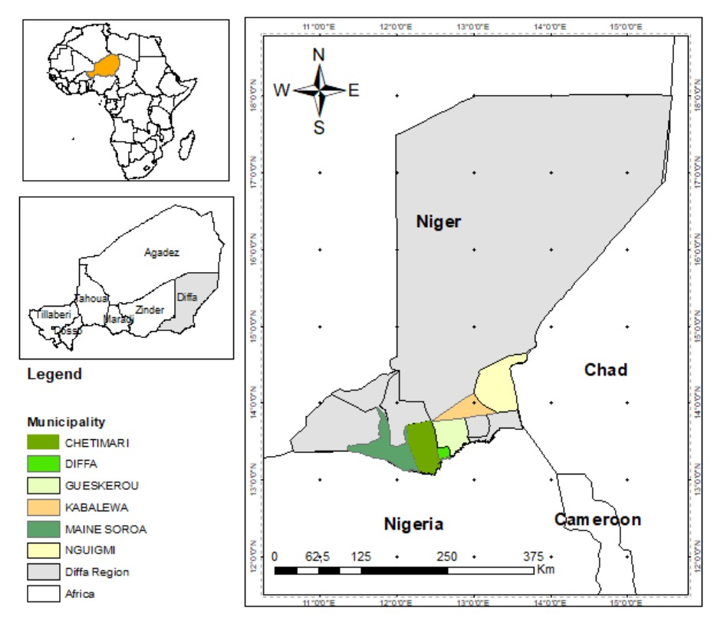
Fig. 1 : Map of the study area
2.2 Methods
2.2.1 Data collection
The Lake Chad Basin areas are the most affected by the insecurity caused by terrorist groups. This has impacted many villages and communes, including N’Guigmi, Kablewa, Gueskérou, Diffa, Chétimari, and Maïné-Soroa. These areas are prime livestock farming zones, and their livelihoods depend on livestock. It is important to collect data on livestock farming systems and the breeds these communities raise and prefer. To this end, interviews were conducted with herders who currently raise small ruminants and those who raised them before the Boko Haram security crisis. A questionnaire was also prepared on the role of goat breeds in households in the Diffa region and on preferences for goat breeds in the Diffa region.
Sample size : The municipalities of N’Guigmi, Kablewa, Gueskérou, Diffa, Chétimari and Maïné-Soroa were selected in the Diffa region to conduct this study. On each site, the surveys concerned the households of these municipalities. This sample was determined from the law of large numbers with Slovin's formula (Meyer, 2024). In total, 576 households were surveyed in all six municipalities (Table 1).
$n_{e}=\frac{N}{1+N.e²}$; $n=\frac{1562}{1+1562*({0,0331}^{2})}=576$

(with n e the sample size, N the size of the parent population; e: the risk of error of being wrong, which must be low at 3.31%).
Sampling method : Thus, the random sampling method was used to identify the households surveyed. The data collection was carried out on the basis of a household questionnaire, addressed to the heads of households or one of the wives of the head of household. This questionnaire focuses on the roles of goats in livelihood strategies and the preference of breeders for goat breeds in the Diffa region.
Table 1: Sample size of six municipalities studied in the Diffa region
Municipalities | Number of households | Samples
N'Guigmi | 433 | 123
Kablewa | 126 | 63
Maïné-Soroa | 300 | 99
Chétimari | 458 | 136
Diffa | 200 | 83
Gueskérou | 45 | 72
Total | 1562 | 576

2.2.2 Data processing and analysis
The FactoMineR and factoextra packages were used for principal component analysis nalysis (PCA) of goat breed preferences of households in 6 communes in the Diffa region. Diffa. The ggpubr and ggballoonplot packages were used to establish the factorial tables presenting the reasons for choosing goat breeds by commune (Kassambara, 2017; R Core Team, 2024). The tidyverse package associated with the ggplot2, stringr, forcats, lubridate packages compiled with R version 4.4.3 and the ggpubr, rstatix packages were used to calculate the p-values, to verify the normality and homoscedasticity tests before performing the tests parametric ANOVA with two factors or the non-parametric Kruskal-Wallis tests with 2 factors with pairwise comparison of Wilcoxon test. The Shapiro test with p.value = 0.0431, therefore less than 0.05. The Kruskal-Wallis test is recommended (Kassambara, 2019, 2019; R Core Team, 2024). The different tests made it possible to compare the preferences of each goat breed by municipality.

3. results and discussion

3.1 Goat breed preferences in the Diffa region
The representation of goat breed preferences along the axes is significant with the percentage of 92.22% on the first 2 axes (Table 2).
Table 2: Eigenvalues and percentages of cumulative variances
Dimension | eigenvalue | variance.percent | cumulative.variance.percent
Dim.1 | 5.11530778 | 85.2551296 | 85.25513
Dim.2 | 0.41820590 | 6.9700984 | 92.22523
Dim.3 | 0.24395821 | 4.0659701 | 96.29120
Dim.4 | 0.13779654 | 2.2966089 | 98.58781
Dim.5 | 0.04826577 | 0.8044294 | 99.39224
Dim.6 | 0.03646581 | 0.6077635 | 100.00000

The population of all the communes prefers the common Sahel goat (SCG) with the number of responses varying from 10 to 93 and the variegated Sahel goat (SVG) from 17 to 58. The Sahel Variegated Goat (SVG) is most valued by the settled community of Maïné-Soroa. They entrust these goats to transhumant herders during the rainy season, who graze them around the Manga basins or in the large area attached to the commune of Maïné-Soroa. The SCG, on the other hand, is more appreciated by settled households and transhumant herders in the other communes studied. These breeds are relatively slender, prolific, and produce more milk during the rainy season. They thrive in these areas, which is why the local populations value them. These households appreciate the red goat of Maradi less, the number of responses of which varies from 4 to 17 (Fig. 2). The Maradi red goat is not valued because it is not prolific and is not a good milk producer. The population of all the communes also added that it cannot withstand the climatic conditions of their locality. These climatic conditions mean that the Maradi red goat (from the south-central region of Niger) cannot reach its full potential when raised throughout the Diffa region.
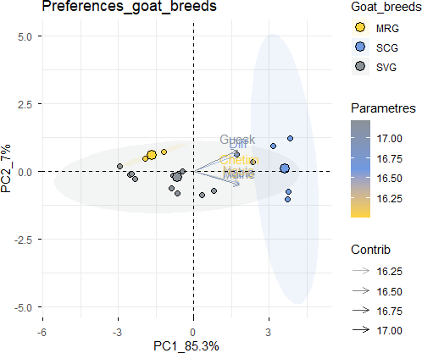
Fig. 2 : Preferences of goat breeds by households in Diffa
3.2 Importance of goat breeds in households in the Diffa region
Among the different goat breeds encountered in the communes of Diffa, the populations prefer the SCG breeds the most (min = 24 to max = 36) in all the communes, except for Maïné-Soroa. Next, the breeders prefer the SVG breed (min = 17 to max = 37). The CRM breed is not appreciated in most of the breeding households in the communes of Diffa (Fig. 3). This latter breed is not appreciated because it is not adapted to the ecological conditions of the Diffa region. It fails to externalize its potential. The communities prefer the SCG and SVG breeds more because they are economical. They multiply very quickly because they have twin births and they have a short interval between births. The economy relies on the breeding of goat breeds that are highly valued because they have good butchering ability. They generate substantial income for the breeders. In addition, there are those who prefer breeding because of the socio-religious and cultural aspect (Fig. 3).

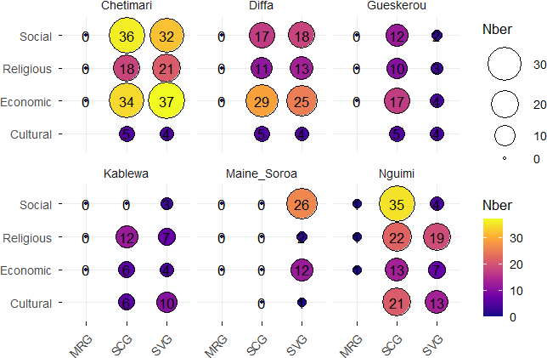
Fig. 3 : Reasons for preference of goat breeds by households in six communes of Diffa

3.3 Comparative analysis of preference in goat breeds in the Diffa region
The Kruskal-Wallis test shows a large magnitude with an effect of 0.337. Kruskal-Wallis with p-value = 0.00122, shows that there are overall significant differences in preferences for goat breeds.Some significant differences were found between the preference in SCG and SVG breeds, in all the communes, except that of Gueskerou. However, no significant differences were found between the SVG and CRM breeds, as the p-value is greater than 0.05 (Fig. 4).
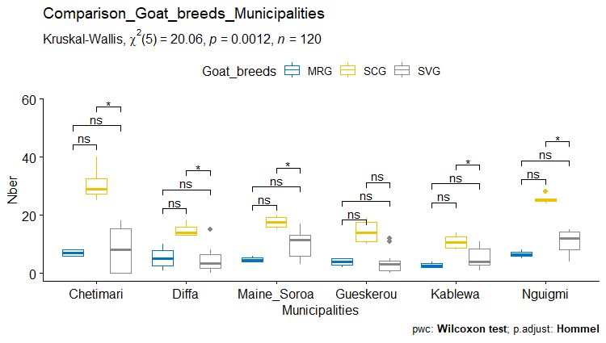
Fig. 4 : Preference comparison of goat breeds by households in six municipalities of Diffa

There are significant differences for the choice of breeds from the municipalities of Chétimari, Diffa, Gueskerou, Kablewa and Maïné-Soroa with respective p-values of 0.004; 0.024; 0.015; 0.028 and 0.011. However, there is no significant difference for the choice of SVG and CRM breeds.
Table 3: P-values from the test comparing preferences in goat breeds by municipality
Municipalities | group1 | group2 | statistic | p | p.adj | p.adj.signif
Chetimari | MRG | SCG | 0 | 0.028 | 0.057 | ns
Chetimari | MRG | SVG | 24 | 1 | 1 | ns
Chetimari | SCG | SVG | 48 | 0.004 | 0.012 | *
Diffa | MRG | SCG | 0 | 0.029 | 0.059 | ns
Diffa | MRG | SVG | 26.5 | 0.807 | 0.807 | ns
Diffa | SCG | SVG | 43 | 0.024 | 0.048 | *
Gueskerou | MRG | SCG | 0 | 0.029 | 0.059 | ns
Gueskerou | MRG | SVG | 28.5 | 0.623 | 0.623 | ns
Gueskerou | SCG | SVG | 44.5 | 0.015 | 0.044 | *
Kablewa | MRG | SCG | 0 | 0.029 | 0.059 | ns
Kablewa | MRG | SVG | 14 | 0.243 | 0.243 | ns
Kablewa | SCG | SVG | 42.5 | 0.028 | 0.056 | ns
Maine_Soroa | MRG | SCG | 0 | 0.029 | 0.059 | ns
Maine_Soroa | MRG | SVG | 9 | 0.077 | 0.077 | ns
Maine_Soroa | SCG | SVG | 45.5 | 0.011 | 0.032 | *
N’Guigmi | MRG | SCG | 0 | 0.029 | 0.059 | ns
N’Guigmi | MRG | SVG | 8.5 | 0.067 | 0.067 | ns
N’Guigmi | SCG | SVG | 48 | 0.004 | 0.013 | *

3.4 DISCUSSION
The seven West African goat breeds: Casamance Goat (Kolda, Senegal), Labé Goat (Fouta Djallon, Guinea), three Sahel Goats (including the Djoloff goat in Senegal; the red Maradi goat in Niger; the Gorgol goat from Mauritania) the Sokoto Goat (Maradi, Niger) and Guera goat (Atar, Mauritania). The relationships between the breeds analyzed correspond to their geographic distribution and, moreover, that the Labé Goat is strongly separated from the other breeds (Missohou et al., 2006). The significance of the standard deviations at the 1% threshold reveals a heterogeneity of preferences for raising Sahelian breeds and crossbred goats, etc.(Zanou et al., 2023). However, breeder-fatteners and pure fatteners prefer large-sized breeds such as Sahelian goats, Touareg goats, and especially crossbreeds (Ouedraogo, 2016). These results are close to those of this study with a distinct preference for Sahel goats (common Sahel goat, SCG for 93 households and variegated du Sahel Goats, SVG for 58 households). Goat breeds are raised according to their ability to thrive with minimal risk in a given area. Agro-climatic conditions are the primary factors that limit or hinder the breeding of specific goat breeds. If a goat breed is not in its natural environment, it cannot fully realize its zootechnical potential. This potential is primarily prolificacy and milk production. In the study areas, goat prolificacy was demonstrated by frequent twin births, and even triplet births, in the common Sahel goat (SCG) in the Diffa, Kablewa, Gueskerou, and N’Guigmi region. The same observation was made in the Maïné-Soroa commune with the Sahel variegated goat (SVG). Thus goats are integrated into complex livelihood systems, and are "multifunctional" in providing milk, meat, manure, fibers, hides, cash, savings or social status and are often valued for their social or religious uses (Miller et al., 2015). Goats are raised in areas agro-ecological and in varied systems, but it is mainly present in the most arid regions where it plays a role in subsistence and securing agricultural systems of primary importance. The breeding systems are mainly traditional to pastoral, agropastoral and sedentary and secondarily peri-urban (Missohou et al., 2016). It has also been reported that goats play an important role in the strategy of households to achieve food security (Molid Aziada et al., 2021). Goat meat is valued by consumers (Sadoud, 2020). Although relatively small, goats produce a significant amount of meat over time. This is due to their prolificacy, generally multiple births, and also to a short interval between births. Goat farmers in these study areas reported that their goats give birth twice in 12 months or twice in 14 months. The potential of goats, and in particular dairy and dual-purpose goats (producing both meat and milk), to contribute to improving the living conditions of disadvantaged populations in the most densely populated areas of Kenya was recognized in the early 1980 and remains important today (Ahuya et al., 2005). In addition, Cilentana goat farming represents an important source of income for the local communities and also preserves the territory itself guaranteeing the protection of biodiversity and the conservation of local activities that have a historical tradition, In the internal areas of Cilento, province of Salerno (Campania) (Iommelli et al., 2022).

4. CONCLUSION
The two main goat breeds of Niger are diversely appreciated according to the agro-ecological zones. Thus, the Sahel goat with these two variants common Sahel goat (SCG) and the variegated Sahel goat (SVG) are very popular in most households in the communes of Diffa. These goats are prolific in these areas and manage to externalize their potential despite the aridity of the climate. The households of the breeders of the communes of the Diffa Region prefer to raise the Common Sahel Goat more than the variegated goat. This breed is the most raised by most households in Eastern Niger. It plays an important economic role thanks to prolificity. It improves the income of households that raise them, while ensuring their food and nutritional security. It is important to continue this study in order to better identify the potential and ecological environments of these two goat breeds that are popular in the Diffa region. This will allow us to see which one will better externalize these potentialities in such and such other environments. This study identified the preferred breeds of the two Sahel goat variants: the common Sahel goat (SCG) and the variegated Sahel goat (SVG). These breeds are valued differently across the communes of Eastern Niger. The SCG is more popular in the communes of N'Guigmi, Kablewa, Chétimari, Diffa, and Gueskérou, while the SVG is more prized in the commune of Maïné-Soroa. It is important to justify this choice by examining the production parameters of these two Sahel goat breeds in the agro-ecological zones of the Lake Niger basin and the Manga River basin.

Disclaimer (Artificial intelligence)

Author(s) hereby declare that NO generative AI technologies such as Large Language Models (ChatGPT, COPILOT, etc.) and text-to-image generators have been used during the writing or editing of this manuscript.

References
- Ahuya, C. O., Okeyo, A. M., Mwangi-Njuru, & Peacock, C. (2005). Developmental challenges and opportunities in the goat industry : The Kenyan experience. Small Ruminant Research, Special Issue: Plenary Papers of the 8th International Conference on Goats, 60(1), 197‑206. https://doi.org/10.1016/j.smallrumres.2005.06.013
- Cobo, E. (2007). Feeding of small ruminants: Comparison of sheep and goats. Academic year 2006-2007 [Thesis, UM2]. CIRAD/Agritrop. https://agritrop.cirad.fr/546485/
- Dubeuf, J., Capote, J., Carrizasa-Duran, J., Castel, J. M., Gabina, D., Milan, M. R., & De Rancourt, M. (2001). Perspectives d’évolution des systèmes de production ovine et caprine laitières dans différents pays euroméditerranéens. Rencontres autour des Recherches sur les Ruminants., 8, 8.

- FAOSTAT. (2019). Statistics of the Food and Agriculture Organization of the United Nations [Statistics, CSV]. http://www.fao.org/faostat/fr/#data/QA.%20Accessed%202%20September%202019
- HCI3N/SOFRECO. (2022). Prospective analysis of the livestock and meat value chain (cattle, sheep, goats) in Niger 2021-2030. (p. 172). High Commission for Initiative 3 N. chrome-extension://efaidnbmnnnibpcajpcglclefindmkaj/https://reca-niger.org/IMG/pdf/l4-etude_betail.pdf
- Iñiguez, L. (2011). The challenges of research and development of small ruminant production in dry areas. Small Ruminant Research, Special Issue: Technological development and associative attempts to a sustainable goat production, 98(1), 12‑20. https://doi.org/10.1016/j.smallrumres.2011.03.010
- Iommelli, P., Infascelli, L., Tudisco, R., & Fabian, C. (2022). The Italian Cilentana goat breed : Productive performances and economic perspectives of goat farming in marginal areas. Tropical Animal Health and Production, 54(304). https://doi.org/10.1007/s11250-022-03292-7
- Jash, S., Singh, C., & Gupta, A. K. (2001). Effect of enhanced pre-partum concentrate feeding on kidding and lactation performance of stallfed crossbred goats. Indian Journal of Small Ruminants, 7(1), 15.
- Kassambara, A. (2017). Practical Guide to Principal Component Methods in R. PCA, (M)CA, FAMD, MFA, HCPC, factoextra. Multivariate Analysis II. (1st ed.). http://www.sthda.com
- Kassambara, A. (2019). Comparison of Groups: Numerical Variables Edition 1. datanovia.com Summarize, Visualize, Verify Hypotheses, Run Tests, Interpret, Report. (1st ed.). Datanovia. https://www.datanovia.com/en
- Laouadi, M. (2019). Characterization and management of the main local goat genetic resources in Algeria: Case of the Laghouat Region. [Doctor of Science in Veterinary Sciences, National Higher Veterinary School]. chrome-extension://efaidnbmnnnibpcajpcglclefindmkaj/https://depot.ensv.dz:8443/jspui/bitstream/123456789/249/3/Caract%C3%A9risation%20et%20gestion%20des%20principales%20ressources%20g%C3%A9n%C3%A9tiques%20caprines%20locales%20en%20Alg%C3%A9rie%20%3A%20cas%20de%20la%20r%C3%A9gion%20de%20Laghouat.pdf
- Meyer, C. par J. (2024). How to calculate sample size: 14 steps. wikiHow. https://fr.wikihow.com/calculer-la-taille-de-l%27%C3%A9chantillon
- Miller, B. A., Dubeuf, J.-P., Lugginbuhl, J.-M., & Capote, J. (2015). Large-scale goat development programs for smallholder farmers in the context of poverty reduction. (Report based on knowledge acquired by the IGA/IFAD Project, 2011-2012 Report, IGA-International Goat Association; p. 31). IGA/IFAD. http://www.iga-goatworld.com/uploads/6/1/6/2/6162024/scaling-up_successful_practices_%28full%29.pdf.
- Missohou, A., Nahimana, G., Ayssiwede, S. B., & Sembene, M. (2016). Goat farming in West Africa: A synthesis. Revue d’élevage et de médecine vétérinaire des pays tropicaux, 69(1), 3–18. https://doi.org/10.19182/remvt.31167.
- Missohou, A., Talaki, E., & Maman Laminou, I. (2006). Diversity and Genetic Relationships among Seven West African Goat Breeds. Asian-Aust. J. Anim. Sci., 16(9), 7. https://doi.org/www.ajas.info
- Molid Aziada, M., Mahaman M., Mouctari, O., Issa, S., & Chaibou, M. (2021). Practices and constraints of Maradi Red goat farming in rural Niger. Int. J. Biol. Chem. Sci., 15(3), 936–949. https://dx.doi.org/10.4314/ijbcs.v15i3.8
- Ouedraogo, M. (2016). Contribution to the knowledge of the characteristics and pathological constraints of small ruminant livestock in the rural commune of Thiou/Yatenga Province [Master's thesis, Bobo-Dioulasso Polytechnic University (UPB)]. Bobo-Dioulasso Polytechnic University (UPB). Ministry of Secondary and Higher Education (MESS).
- R Core Team. (2024). _R: A Language and Environment for Statistical Computing_. R Foundation for Statistical Computing, Vienna, Austria., 4.4.1. https://www.R-project.org/
- Sadoud, M. (2020). Consumer perception of goat meat in the Chlef region of Algeria. An overview of Algerian consumer preferences for goat meat in a region with a strong tradition of goat farming. La revue scientifique Viandes & Produits Carnés., 3635(3‑5), 12.
- Sow, F. (2022). Characteristics of Goat Farming and Digestive Utilization Efficiency of Forages in Two Local (Sahelian) and Imported (Majorera) Goat Breeds in the Fatick Region (Senegal)—ProQuest. https://www.proquest.com/openview/20298841422af414c1e4033f59b44b9d/1?pq-origsite=gscholar&cbl=2026366&diss=y
- Zanou, M. A. M., Zannou, A., Aoudji, A. K. N., Houinato, M. R. B., & Dossa, L. H. (2023). Heterogeneity of preferences and breeders’ willingness to pay for improved livestock system in Benin, West Africa. Heliyon, 9(8), 13. https://doi.org/10.1016/j.heliyon.2023.e19172

