Trends and Seasonal Variability of Dust Activity in Iraq (1992–2022)

Abstract
Dust activity constitutes a major environmental stressor in Iraq; however, its long-term assessment is challenged by sparse station coverage, reporting gaps, and strong interannual variability. These limitations introduce potential observational bias, particularly when analyses rely on short records, linear assumptions, or spatial aggregation. This study examines spatiotemporal variability in dust activity across 11 meteorological stations in Iraq using long-term meteorological observations (1992-2022), with a focus on spring–summer conditions when dust occurrence is most frequent. Non-parametric methods (Mann–Kendall test and Sen’s slope estimator) were used to find trends in the data because they are less sensitive to outliers, non-normal distributions, and data gaps. We used descriptive statistics to describe the mean conditions, variability, and extremes. We also linked station-level results to administrative governorates to look for spatial patterns without forcing artificial spatial smoothing. The analysis shows that there are big differences between regions, with higher dust activity during spring and summer in southern Iraq. Trend results show a mix of trends that are going up, down, and not significant across stations, more than half of the stations exhibited statistically non-significant trends, indicating dominant interannual variability rather than systematic long-term change. This means that the changes we see are mostly due to short-term variability and localized processes, not a clear trend across the whole country. The presence of opposing trends underscores the potential bias in interpretations of dust evolution in data-sparse regions due to aggregation and incomplete records. These results show that to accurately measure dust trends in Iraq; we need methods that take into account observational bias and variability. These findings have implications for regional climate variability assessment and dust management strategies in Iraq. They also give us a statistically consistent starting point for future studies that look at atmospheric circulation and source attribution.

Keywords: Dust Storms, Bias, Mann-Kendall, environmental features

1. Introduction
Dust-related events are some of the most noticeable environmental features of dry and semi-arid areas(Lian et al., 2025). This is because mineral dust from dry surfaces often interacts with the atmosphere(Kok et al., 2023). These things happen in different ways, from strong but short-lived dust storms to more stable background conditions like rising dust(Ofremu et al., 2025). In large part, they make up atmospheric mineral dust and have a big impact on air quality, visibility, and the state of the environment(Kok et al., 2023). The Middle East is one of the dustiest places on Earth(Al-Dousari et al., 2022). Dust storms happen often there because of the dry ground, sparse vegetation, and good weather(Maji & Sonwani, 2022). Iraq is in the middle of this area and is often affected by both locally generated and advected dust(Awadh, 2023). Dust activity in Iraq varies greatly from place to place and from season to season(Fattahi & Rezazadeh, 2022). This is because the northern, central, and southern parts of the country have different climates, topography, and land surface characteristics(Al-Hussein, Hamed, Al-Ozeer, Gentilucci, & Bouri, 2024).
In Iraq, dust is often seen in two different but related ways: as dust storms and as rising dust. Dust storms are not very common, but when they do happen, they are usually very strong and cause a lot of visibility loss(Awadh, 2023). On the other hand, rising dust happens more often and is caused by moderate winds and local surface conditions that cause background dust to move(Awadh, 2023; Khidher, 2024). Even though these events happen at different times and with different levels of intensity, they have often been treated the same in past studies. This could hide important differences in how they behave over time and how they change over time. A lot of research has been done on dust activity over Iraq and nearby areas using station observations, satellite data, and reanalysis datasets(Attiya, 2020; Attiya & Jones, 2020; Noori, 2024). These studies have helped us learn more about the geography and climate of dust events, but their conclusions about long-term trends are still not clear. Even in small areas, reported trends can be going up, down, or not at all, or they can be statistically insignificant. Some of these differences are due to different sources of data and ways of analyzing it, but they also show how hard it is to find strong trends in dust records that have a lot of yearly variation and occasional extremes.
A lot of previous assessments have a common flaw: they only look at things on an annual scale. Dust activity in Iraq is very seasonal, with the most common and intense dust storms happening in the spring and summer(Al-Dabbas, Ayad Abbas, & Al-Khafaji, 2012; Khidher, 2024). Putting dust records together into yearly values may hide changes that only happen at certain times of the year and create a temporal aggregation bias(Albani et al., 2015; Karl et al., 1989), where signals that are opposite or uneven in time cancel each other out. Because of this, analyses that only look at annual data may not show important changes in how dust behaves. From a methodological point of view, time series related to dust are even harder to deal with(Krasnov, Katra, & Friger, 2016). Observational records often have distributions that aren't normal, lots of zeros, outliers that happen during extreme events, and gaps in the data because stations close or reports are delayed. If this is the case, parametric trend detection methods that assume linearity and normality may not be the best choice(Lewis, 2014). The Mann–Kendall test with Sen's slope estimation is an example of a non-parametric method that works better for looking at environmental data that has gaps and changes that happen only sometimes(Abdullahi, Mohammad, Oweseni, Ijimdiya, & Sulaiman, 2023). We use a non-parametric trend analysis framework to look at how dust activity changes over time and seasonally at certain meteorological stations in Iraq. The study's goal is to find out if changes in dust activity are due to long-term patterns or if they are mostly due to short-term changes and differences between regions. To do this, it looks at both annual and seasonal trends and makes a clear distinction between dust storms and rising dust. Finding seasonally resolved trends that might be hidden by annual aggregation is a top priority.
Despite the relevance of dust activity for environmental and socio-economic systems in Iraq, long-term trend detection remains inherently challenging due to sparse observational networks, heterogeneous record lengths, and the episodic nature of dust events. Consequently, reported trends may be sensitive to methodological choices, temporal aggregation, and station selection. This study explicitly addresses these challenges by emphasizing seasonal resolution, distinguishing between dust storm and rising dust events, and employing non-parametric statistical techniques designed for data-deficient and non-normally distributed records. By doing so, the analysis aims to reduce interpretational bias and provide a more robust characterization of dust variability rather than over-interpreting weak or spatially inconsistent trends. Unlike many previous studies that focused primarily on annual aggregates or did not distinguish between dust storm and rising dust events, this study explicitly emphasizes seasonal resolution and event differentiation to reduce aggregation bias and improve interpretation of trend behavior.
2. Methodology
2.1 Data Source
This study is based on long-term records of dust events, covering the period 1992–2022. that were observed at 11 weather stations in Iraq. The study looks at two dust indicators: dust storms and rising dust, which are measured in days per year and per season. We chose the stations based on how much data was available, how long the records were, and how well they could represent the northern, central, and southern parts of the country. The dataset covers many decades, but there are gaps in the data at some stations because they were closed or had operational problems. These gaps are most obvious in years when there was war or damage to infrastructure. In order to keep the original observations intact, no artificial gap-filling or interpolation was used. Instead, the analysis uses statistical methods that can handle missing values and records that aren't continuous.
Data from each month were combined to make annual and seasonal scales. The usual climatological definition of seasons is: winter (December to February), spring (March to May), summer (June to August), and fall (September to November).

2.2 Methodology for detecting trends
We used the non-parametric Mann–Kendall (MK) test on annual and seasonal time series from each station to look at changes in dust activity over time. We use the MK test because it doesn't require assumptions of normality or linearity and is less affected by outliers and extreme values. These traits are especially important for dust-related records because they are often affected by short-term extremes and change a lot from year to year. Sen's slope estimator was used to measure the size of the trends that were found. This estimator gives a strong estimate of the median rate of change over time. We looked at trend significance at normal confidence levels and looked at the results in terms of both statistical significance and how consistent they were across stations and seasons.
2.3 The framework and reasoning behind the analysis
Because dust events are very seasonal and happen in short bursts, trend analysis was done on both an annual and seasonal scales. We used this dual-scale method to lower the risk of temporal aggregation bias, which can happen when seasonal changes are hidden by annual averages. The analysis focuses on the direction and consistency of change rather than fitting parametric models to time series that are very variable. This is because it explicitly resolves seasonal behavior. We used standard scientific computing tools for all of the statistical analyses and visualizations. Station-based time series plots and seasonal trend figures show the results in a way that makes it easy to compare stations and seasons directly.
3. Study Area
Iraq is in the global dust belt, which runs from North Africa to Southwest and Central Asia. Dust-related events happen there all the time(Awadh, 2023). The country has very different climates and landscapes that have a big effect on how dust is made and moved(Griffin, Kellogg, & Shinn, 2001). The main way these gradients show up is along a north-south line, which shows differences in land cover, topography, precipitation, and surface moisture conditions(Wang, Wang, Fu, Yang, & Li, 2017). Northern Iraq has higher elevations and more rain each year, especially in the winter and spring(Al-Ansari, 2021). In general, these conditions make it harder for dust to get out into the air than in other parts of the country. Central Iraq is a transition zone that is affected by both the cooler weather in the north and the drier weather in the south(Muslih & Abbas, 2024). It often gets dust from both the north and the south, as well as from events that happen there(Sissakian, Al-Ansari, & Knutsson, 2013). Southern Iraq is mostly dry to semi-arid, with a lot of flat land, little vegetation, and being close to big dust source areas. This makes it very likely that dust will be present there often(Moridnejad, Karimi, & Ariya, 2015).
The meteorological stations chosen for this study were chosen because they had enough data, had long records, and could show these big differences between regions. The stations cover all of Iraq, from the north to the south, so researchers can look at how dust-related events change over time and space. There aren't many stations, but their locations cover the main climatic gradients that affect how dust moves around the country.These stations have recorded dust storms and rising dust, which are reported as the number of days per month and then combined into yearly and seasonal totals for analysis. There are times when the records are missing data, which is due to station closures and operational problems. The analysis makes it clear that these gaps exist and keeps them there to avoid adding fake signals. This regional framework gives the geographic and climatic background needed to understand the differences in dust activity across space and time that are shown in the next sections.
4. Results
Trend analysis was conducted using observations from all available stations; however, results are presented in detail for four representative meteorological stations selected to characterize dust activity across Iraq. These stations reflect the main regional contrasts between northern, central, and southern Iraq, while results from the remaining stations are used to assess the overall spatial consistency of the identified patterns.
4.1 How often dust storms happen
The number of dust storms that happen each year varies greatly from year to year at all of the stations that were looked at (Fig. 1). A few stations keep track of years with no or very few dust storm days, which shows how rare these events are. The Mann-Kendall trend analysis shows that most stations do not have statistically significant monotonic trends in the number of dust storms that happen each year. When trends are found, their direction and importance are different at different stations. Some trends are getting stronger, some are getting weaker, and some are not significant at all (Fig1).
The limited magnitude of detected trends reflects the rarity of dust storms and their dominance by episodic extreme events rather than gradual long-term change.
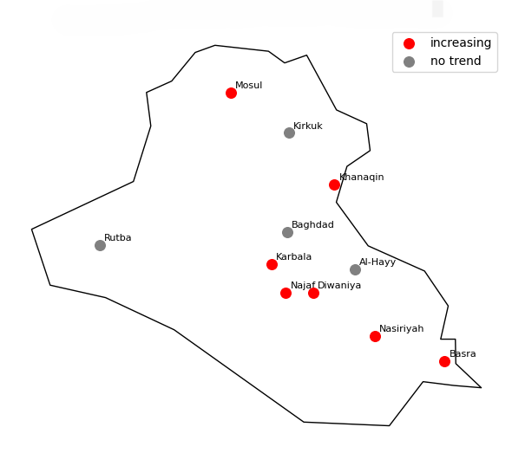

Fig1. Spatial distribution of Spring-Summer dust storm trends for (1992-2022) in Iraq

Sen's slope estimates show that the amount of change in the number of dust storms is usually small (Fig. 2), even at stations where the trends are statistically significant.
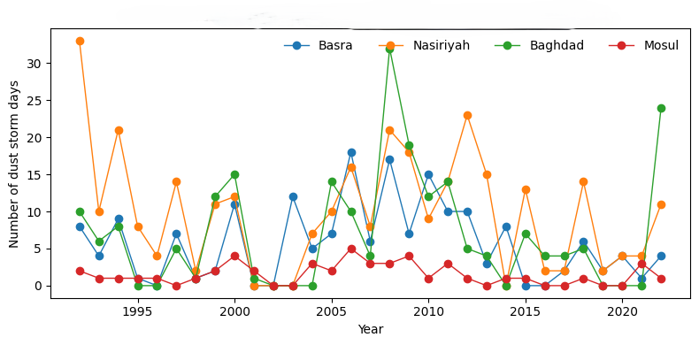

Fig2. Annual frequency of dust storms at representative Iraqi stations
4.2 Dust levels that rise every year
Rising dust events happen much more often than dust storms and have a clearer time structure. The annual Mann-Kendall analysis shows that stations have different trends in different places (Fig. 3). Southern stations show statistically significant trends of decreasing rising dust frequency, while central and northern stations mostly show weak or no trends.
The Sen's slope values that go along with this show that there are moderate rates of decline at stations with significant trends (Fig. 3). This means that the rising dust occurrence is changing slowly instead of suddenly.
Compared to dust storms, rising dust events exhibit more stable temporal behavior, making them more suitable indicators for assessing long-term variability in dust activity.
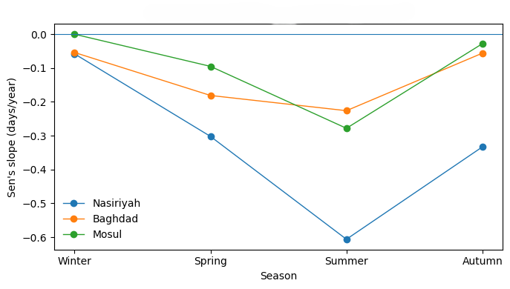

Fig. 3 Seasonal trends of rising dust of three stations across Iraq for (1992-2022)

4.3 Dust levels that go up and down with the seasons
Seasonal analysis shows that trends over the course of a year hide a lot of seasonal variation in rising dust activity (Fig. 4). There are statistically significant trends that show a decrease mostly in the spring and summer at a number of stations (Figs. 4-b and c). These times of year are when dust activity is at its highest in Iraq.
On the other hand, winter rising dust trends are mostly not significant at any of the stations (Fig.4-d). Autumn, on the other hand, shows mixed behavior, with some stations showing weak trends and others showing statistically significant trends (Fig.4-a). Seasonal Sen's slope estimates also show that the strongest negative slopes are in the spring and summer, while the winter slopes stay close to zero at most places.
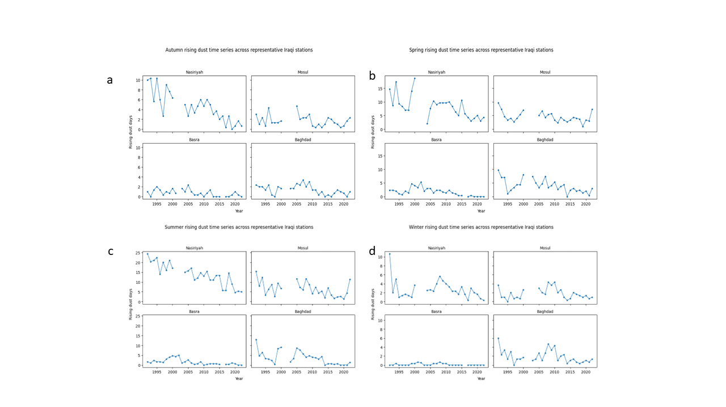

Fig.4: Variations of rising dust over (Nasiriyah, Mosul, Basra and Baghdad) stations for a-Autumn, b- Spring c- Summer d- Winter during the study period (1992-2022)

4.4 Spatial Variability
Comparing northern, central, and southern stations shows clear differences in the amount
and seasonal behavior of rising dust (Fig.4). Southern stations always have more dust days and stronger seasonal signals, while northern stations have fewer dust days and weaker trends. Central stations act in a way that is somewhere between the two regions, showing characteristics that are in between the two.
The fact that some stations show rising, falling, and not significant trends at the same time (Fig.1; Fig.4) shows that dust dynamics in Iraq are very different in different places. The representative stations shown in the figures serve as regional proxies, and the identified spatial contrasts are consistent with patterns observed across the broader station network.
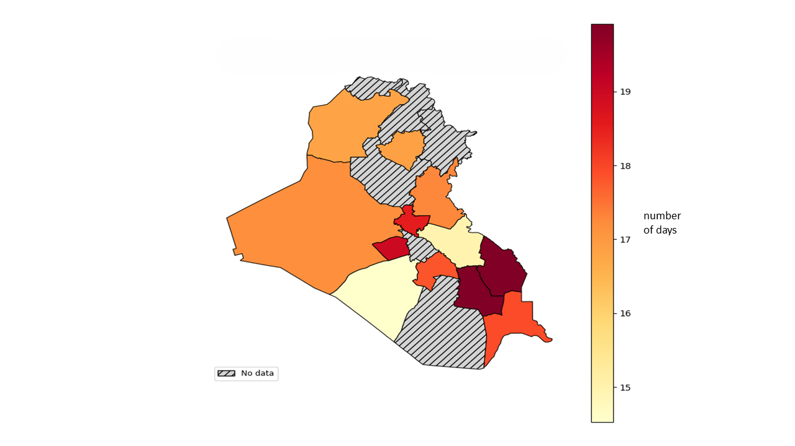

Fig. 5 Spatial distribution of rising dust across Iraq for (1992-2022)

5. Discussion
This study shows how dust activity changes with the seasons in Iraq. It also shows how hard it is to find dust trends in places where there aren’t much data and things are always changing. There are a few important things that come out of the results that need to be thought about carefully. The absence of long-term spatially coherent trends across stations indicates that dust activity in Iraq is not governed by a singular national-scale force. The presence of rising, falling, and insignificant trends indicates that localized surface conditions, short-term variability, and episodic meteorological drivers are the predominant factors. This finding aligns with the significant interannual variability observed in both dust storm and rising dust records(Salman, Al-Jumaily, & AL-Salihi, 2022). It also says not to draw conclusions based on national averages or spatial aggregation. These findings are broadly consistent with previous regional studies(Attiya, 2020; Khidher, 2024), which also reported substantial interannual variability and spatial heterogeneity in Iraqi dust activity.
Second, the seasonal breakdown shows that spring and summer have the most effect on the dust signal, especially when the dust is rising. It can be hard to see this behavior if you only look at yearly data, and you might draw the wrong conclusions because of temporal aggregation bias. The fact that statistically significant trends were mostly found in the warm season shows that dust activity changes with the seasons and isn't the same all year. This supports the decision to examine seasonal metrics rather than solely annual ones.
Third, it's important to know the difference between dust storms and dust that is rising. Dust storms don't happen very often, and when they do, they're usually in very bad weather, so they aren't very good at showing strong trends. However, rising dust has a higher frequency and more stable statistical behavior, which makes it a better long-term measure of how dust changes over time. Some earlier studies looked at these two things as the same, but that could mix up two very different physical processes. One significant outcome from the results is observational bias. The trend outcomes vary based on the selected stations and their coverage duration due to inconsistent record lengths, limited station coverage, and absent data. The presence of contradictory trends among nearby stations illustrates how incomplete records and aggregation can mislead interpretations of dust evolution. This makes it even more important to use non-parametric methods that focus on strength rather than strict assumptions about distributions. Linking station-based results to administrative governorates in space gives a general picture of dust activity in the area without making it look better than it really is. But the analysis doesn't look for continuous spatial gradients because it knows that observations at the station level can't fully explain differences within a sub-governorate. As a result, the spatial patterns should be seen as suggestive rather than complete, showing how regions are different from each other rather than how they are exactly distributed.

6. Conclusion
This study examined long-term trends and seasonal variability of dust storms and rising dust across 11 meteorological stations in Iraq during 1992–2022 using non-parametric statistical methods. The results reveal strong spatial and seasonal variability, with southern Iraq experiencing higher dust activity, particularly during spring and summer. Most stations showed non-significant long-term trends, suggesting that interannual variability and localized processes dominate dust behavior rather than coherent national-scale change. The distinction between dust storms and rising dust proved important, as rising dust provided more stable indicators of variability. Despite data limitations and sparse station coverage, the applied methodology provides a robust framework for trend detection in data-constrained environments. Future research should integrate circulation diagnostics and remote sensing to better understand the drivers of dust variability in Iraq.

Limitations and uncertainties
Several limitations should be acknowledged when interpreting the results of this study. Although the statistical analysis incorporates observations from 11 stations, the detailed presentation and discussion focus on four representative sites, which may not capture all local-scale variability. In addition, spatial coverage remains sparse, record lengths vary among stations, and observations rely on synoptic reports that may involve subjective classification. These limitations reinforce the interpretation of the results as indicators of variability rather than definitive long-term trends. In general, the results show that the recent changes in dust activity over Iraq are more like variability than trends. This has a big impact on research that looks at what causes climate change and research that looks at its effects. Changes that seem to happen quickly may just be normal fluctuations and not long-term changes. In the future, it would be useful to combine tools for diagnosing based on circulation and tools for figuring out where changes come from. This would help link changes that are seen to large-scale atmospheric drivers and surface conditions.
Future research should integrate circulation-based diagnostics, land surface indicators, and satellite-derived products to improve attribution of observed dust variability to atmospheric and surface drivers.

Disclaimer (Artificial intelligence)

Author(s) hereby declare that NO generative AI technologies such as Large Language Models (ChatGPT, COPILOT, etc.) and text-to-image generators have been used during the writing or editing of this manuscript.

References

- Abdullahi, N. I., Mohammad, S., Oweseni, Y., Ijimdiya, S., & Sulaiman, K. (2023). A Non-Parametric Mann-Kendall and Sen’s Slope Estimate as a Method for Detecting Trend Within Hydro-Meteorological Time Series: a Review. Academy Journal of Science and Engineering, 17(1), 119-122.
- Al-Ansari, N. (2021). Topography and climate of Iraq. Journal of Earth Sciences and Geotechnical Engineering, 11(2), 1-13.
- Al-Dabbas, M. A., Ayad Abbas, M., & Al-Khafaji, R. M. (2012). Dust storms loads analyses—Iraq. Arabian Journal of Geosciences, 5(1), 121-131.
- Al-Dousari, A., Omar, A., Al-Hemoud, A., Aba, A., Alrashedi, M., Alrawi, M., . . . Al-Dousari, N. (2022). A success story in controlling sand and dust storms hotspots in the Middle East. Atmosphere, 13(8), 1335.
- Al-Hussein, A. A., Hamed, Y., Al-Ozeer, A. Z., Gentilucci, M., & Bouri, S. (2024). Impact of climatic changes on surface water in Middle East, Northern Iraq. Environmental Earth Sciences, 83(2), 48.
- Albani, S., Mahowald, N., Winckler, G., Anderson, R., Bradtmiller, L., Delmonte, B., . . . Hesse, P. (2015). Twelve thousand years of dust: the Holocene global dust cycle constrained by natural archives. Climate of the Past, 11(6), 869-903.
- Attiya, A. A. (2020). Assessment of dust events above Iraq using remote sensing of the atmosphere and Arc GIS techniques. University of Wollongong,
- Attiya, A. A., & Jones, B. G. (2020). Climatology of Iraqi dust events during 1980–2015. SN Applied Sciences, 2(5), 845.
- Awadh, S. M. (2023). Impact of North African sand and dust storms on the Middle East using Iraq as an example: Causes, sources, and mitigation. Atmosphere, 14(1), 180.
- Fattahi, M. P., & Rezazadeh, M. (2022). Spatio-temporal distribution of various types of dust events in the Middle East during the period 1996-2015.
- Griffin, D. W., Kellogg, C. A., & Shinn, E. A. (2001). Dust in the wind: long range transport of dust in the atmosphere and its implications for global public and ecosystem health. Global Change and Human Health, 2(1), 20-33.
- Karl, T. R., Tarpley, J. D., Quayle, R. G., Diaz, H. F., Robinson, D. A., & Bradley, R. S. (1989). The recent climate record: What it can and cannot tell us. Reviews of Geophysics, 27(3), 405-430.
- Khidher, S. A. (2024). Dust storms in Iraq: Past and present. Theoretical and Applied Climatology, 155(6), 4721-4735.
- Kok, J. F., Storelvmo, T., Karydis, V. A., Adebiyi, A. A., Mahowald, N. M., Evan, A. T., . . . Leung, D. M. (2023). Mineral dust aerosol impacts on global climate and climate change. Nature Reviews Earth & Environment, 4(2), 71-86.
- Krasnov, H., Katra, I., & Friger, M. (2016). Increase in dust storm related PM10 concentrations: A time series analysis of 2001–2015. Environmental Pollution, 213, 36-42.
- Lewis, T. (2014). Book of Extremes (Vol. 112): Springer.
- Lian, L., Huang, J., Chen, S., Du, S., Zhang, L., & Yang, J. (2025). A Comprehensive Review of Dust Events: Characteristics, Climate Feedbacks, and Public Health Risks. Current Pollution Reports, 11(1), 1-19.
- Maji, S., & Sonwani, S. (2022). Nature of Sand and Dust Storm in South Asian Region: extremities and environmental impacts. In Extremes in Atmospheric Processes and Phenomenon: Assessment, Impacts and Mitigation (pp. 113-139): Springer.
- Moridnejad, A., Karimi, N., & Ariya, P. A. (2015). Newly desertified regions in Iraq and its surrounding areas: Significant novel sources of global dust particles. Journal of Arid Environments, 116, 1-10.
- Muslih, K. D., & Abbas, A. M. (2024). Climate of Iraq. In The Geography of Iraq (pp. 19-47): Springer.
- Noori, F. J. (2024). Dust Storms Monitoring in Iraq using The Low Resolution Satellite Images. University of Baghdad,
- Ofremu, G. O., Raimi, B. Y., Yusuf, S. O., Dziwornu, B. A., Nnabuife, S. G., Eze, A. M., & Nnajiofor, C. A. (2025). Exploring the relationship between climate change, air pollutants and human health: impacts, adaptation, and mitigation strategies. Green Energy and Resources, 3(2), 100074.
- Salman, A. D., Al-Jumaily, K. J., & AL-Salihi, A. M. (2022). Patterns of aerosols-clouds interactions over Iraq using MODIS satellite data during (2008-2017). Paper presented at the AIP Conference Proceedings.
- Sissakian, V., Al-Ansari, N., & Knutsson, S. (2013). Sand and dust storm events in Iraq. Journal of Natural Science, 5(10), 1084-1094.
- Wang, C., Wang, S., Fu, B., Yang, L., & Li, Z. (2017). Soil moisture variations with land use along the precipitation gradient in the north–south transect of the Loess Plateau. Land Degradation & Development, 28(3), 926-935.

