Application of Machine Learning Techniques in Hernia Classification

Abstract
Machine learning is a branch of artificial intelligence (AI) concerned with designing systems that can learn from data and make predictions or decisions without explicit programming. The rapid progress in machine learning in recent years has been attributed to advances in computing capacity, the growth of large-scale datasets, and the development of novel algorithms. A hernia is a medical condition that occurs when an organ or tissue pushes through a weak spot in the surrounding muscle or connective tissue. Hernia develop due to a combination of muscle weakness and strain. Some common causes include congenital weakness, where some individuals are born with weak abdominal muscles, making them more prone to hernias. Accurate and early classification of hernia is crucial for effective treatment planning and management. Machine learning (ML) techniques have been increasingly applied in medical diagnosis due to their ability to identify complex patterns in clinical data. However, existing studies on hernia classification have been limited in their methodological approaches, that is, most studies have utilized the k-Nearest Neighbors (KNN) algorithm for hernia classification leaving other robust classification algorithms. The study used publicly available secondary data obtained from the University of California Irvine (UCI) machine learning data repository with the sample size of n=310 observations. The objective was achieved by applying K- nearest neighbor, the artificial neural networks, the support vector machines, random forest and the naïve bayes algorithms to the hernia data obtain from the UCI machine learning repository. For each method, data was splitted in the ratio 70: 30, that is, 70% of the data was used for training while 30% of the data was used for testing. KNN was optimized when k=6, while the random forest technique outperformed all the algorithms. This study recommends that the supervised random forest algorithm should be used while classifying hernia conditions because of its high accuracy, sensitivity, specificity and kappa values for proper medical diagnostics and treatment. Using the hybrid machine learning models such as RF-SVM, ANN-SVM, RF-NBC and deep learning methods could be possible future research areas.
Keywords: Hernia Classification, artificial intelligence, complex computing work, Machine learning classification, learning patterns
Introduction
Machine learning is a branch of artificial intelligence (AI) concerned with designing systems that can learn from data and make predictions or decisions without explicit programming (Mitchell, 1997). The rapid progress in machine learning in recent years has been attributed to advances in computing capacity, technology, the growth of large scale datasets, and the development of novel algorithms. Machine learning allows computers to autonomously handle complex computing work and models or algorithms by discovering patterns and relationships within data. It is commonly classified into three main categories (Alpaydin, 2020): supervised learning, which includes tasks such as classification and regression; unsupervised learning, which involves techniques like clustering and anomaly detection; and reinforcement learning, which is applied in areas such as robotics and autonomous decision-making systems. Machine learning is widely applied across various sectors. In healthcare, it supports disease detection and personalized treatment strategies (Estava et al., 2017). In finance, it is used for fraud prevention and risk evaluation (Lessmann et al., 2015). Additionally, fields such as marketing, supply chain optimization, and cybersecurity employ ML to enhance automation and data-driven decision-making.
Machine learning classification is a type of supervised learning whereby models or algorithms are trained to categorize input data into predefined categories or classes by learning patterns from labeled data (Geron, 2019). The main aim of classification is to predict categorical outcomes, such as distinguishing spam from non-spam emails, identifying the presence or absence of a disease in epidemiology, or determining customer churn in business. Classification tasks can be further put into several types depending on the nature of the response variable. Binary classification deals with problems in which the response variable has two possible classes only, for example in fraud detection, where transactions are labeled as either fraudulent or legitimate (Hastie et al., 2009; Bolton & Hand, 2002). Multiclass classification applies when there are three or more possible classes or groups in a response variable, such as assigning animals to categories like dogs, cats, or birds. Multilabel classification, on the other hand, allows a single instance to be associated with multiple groups at the same time, such as detecting several objects within a single image.
There are wide range of algorithms that are available for solving classification problems in machine learning, each with specific or different assumptions and strengths. Logistic regression is a widely used algorithm for binary classification that models the relationship between independent variables and a categorical outcome by estimating class probabilities through the logistic (sigmoid) function (Sevvanthi et al., 2023). In spite of its simplicity, it performs well when the relationship between variables is approximately linear. Decision trees are intuitive, tree-structured models that recursively partition data based on feature values to create homogeneous subsets, making them easy to interpret. However, individual decision trees are prone to overfitting. To overcome this limitation, ensemble methods such as random forests combine multiple decision trees trained on different subsets of the data, thereby improving predictive performance, enhancing robustness, and reducing variance (Breiman, 2001). Support Vector Machines (SVMs) are powerful classifiers that aim to identify an optimal separating hyperplane between classes, maximizing the margin between them. SVMs are particularly effective in high-dimensional spaces and can handle nonlinear classification through the use of kernel functions. Naïve Bayes is a probabilistic classification technique grounded in Bayes’ Theorem and the assumption of conditional independence among features (Bafjaish, 2020). Owing to its computational efficiency, it is frequently applied in text mining and document classification tasks. The k-Nearest Neighbors (k-NN) algorithm is a non-parametric and instance-based method that assigns class labels to observations based on the most common class among their k closest neighbors in the feature space (Zhang et al., 2017). While simple to implement, its performance depends heavily on the choice of distance metric and the value of k. Neural networks, especially deep learning architectures, are highly effective in dealing with complex, nonlinear associations within large and high-dimensional settings (Soni and Shnan, 2023). These models consist of multiple interconnected layers that enable them to learn hierarchical feature representations, making them particularly suitable for applications such as image recognition, speech processing, and natural language understanding.
A hernia is a medical condition that occurs when an organ or tissue pushes through a weak spot in the surrounding muscle or connective tissue (Nasef et al., 2025). Hernias commonly develop in the abdominal wall but can also occur in the groin, diaphragm, or other parts of the body. The most common types of hernias include inguinal (groin), umbilical (belly button), hiatal (upper stomach), and incisional (resulting from surgical wounds). Hernia develop due to a combination of muscle weakness and strain. Some common causes include congenital weakness, where some individuals are born with weak abdominal muscles, making them more prone to hernias. Heavy lifting without proper technique can strain the muscles and lead to hernia formation. Persistent coughing or sneezing from chronic respiratory conditions can increase abdominal pressure, resulting in hernias. Other causes include obesity, which puts additional strain on abdominal muscles, and pregnancy, where the expansion of the abdomen can weaken muscles, increasing the risk of hernia. Straining during bowel movements due to chronic constipation can also cause excessive strain on abdominal muscles, leading to hernias. The spine consists of a series of vertebrae stacked on top of each other, providing support and flexibility to the body. A normal spine maintains proper alignment and allows smooth movement. However, spondylolisthesis is a spinal disorder in which one vertebra slips forward over the one below it, potentially leading to pain and mobility issues. Several studies have been using numerous supervised machine learning methods in epidemiology ranging from classification, regression and prediction. Aljahdali & Hussain, (2013) used the support vector machines and the random forest techniques to classify liver and cancer where the two algorithms gave similar results in terms of performance. Kaur et al.,(2023) used ANN, SVM, KNN and random forest to classifier Alzheimer’s disease, random forest gave higher accuracy and sensitivity of 86..24% and 69.32% respectively among all algorithms. Handayani, (2019).
Hernia is a medical condition characterized by the protrusion of an organ or tissue through an abnormal opening in the surrounding muscle or tissue. Accurate and early classification of hernia is very important for effective treatment planning and management. Machine learning (ML) methods have been increasingly used in medical diagnosis due to their ability to identify complex patterns in clinical data. However, existing research on hernia classification have been limited in their methodological approaches. A study by Handayani, (2019) used only the k-Nearest Neighbors (KNN) algorithm for hernia classification. While KNN is a popular supervised classification learning method due to its simplicity and effectiveness, relying solely on one ML model limits the potential for achieving optimal classification performance. Different supervised learning models, such as Support Vector Machines (SVM), Random Forest, Naïve Bayes, and deep learning techniques, offer varying levels of accuracy, precision, and robustness depending on the dataset and feature selection process. By restricting the analysis to only KNN, Handayani (2019) may have overlooked potentially powerful models that could enhance classification accuracy and reliability. Therefore, there is a critical need to explore the application of a wider range of supervised ML models in hernia classification to determine the most effective technique. A comparative analysis of multiple ML algorithms can provide insights into the strengths and weaknesses of each approach, ultimately leading to improved diagnostic performance. Therefor this study aimed to fill this research gap by evaluating various supervised ML models for hernia classification, optimizing model parameters, and identifying the best-performing approach. The findings will contribute to the advancement of ML applications in medical diagnosis and support healthcare professionals in making informed decisions.
Objective
To apply the supervised machine learning algorithms in hernia classification
Methodology
Data Source and Variables
The study utilized the cross sectional research design and used publicly available secondary data obtained from the University of California Irvine (UCI) machine learning data repository. The sample size was n=310 observations and the target variable was the class of the medical condition which was categorical in nature with three categories namely; class hernia, class spondylolisthesis and class normal. These classes were classified according to six explanatory variables namely;
1. Pelvic Incidence (PI)-angle between the perpendicular line between the sacral plates and a line connecting the midpoint of the sacral plate to the bicoxofemoral axis.
2. Pelvic Tilt (PT)- pelvic orientation which connects the femur with other body parts. PT can be moved forward, backward, as well as other directions.
3. Lumbar lordosis angle (LA)-is the characteristic of the human spine and the reference of human posture to see whether the posture is good or bad.
4. Sacral slope (SS)-slope located between the sacral plate and the horizontal plane.
5. Pelvic radius (PR)-value that affects the development of large lumbar lordosis.
6. Degree spondylolisthesis (DG)- measurement that states the degree of how much of the lower body part is slipping forward.

K-Nearest Neighbor (KNN)
“K-Nearest Neighbor (K-NN) is a simple algorithm that stores all available cases and classifies new cases based on a similarity measure such as distance functions. A case is classified by a majority vote of its neighbors, with the case being assigned to the class most common amongst its K nearest neighbors measured by a distance function. If K = 1, then the case is simply assigned to the class of its nearest neighbor” (Poornima et al., 2013). For instance the test sample (green dot) should be classified either to blue squares or to red triangles. If k = 3 (solid line circle) it is assigned to the red triangles because there are 2 triangles and only 1 square inside the inner circle. If k = 5 (dashed line circle) it is assigned to the blue squares (3 squares vs. 2 triangles inside the outer circle).
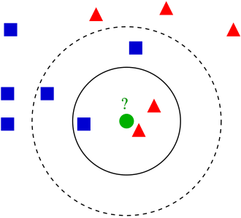
Figure 1: K-NN illustration
“Numerical variables should be standardized to values between 0 and 1 when there is a mixture of categorical and numerical features in the dataset. Choosing the optimal value for K is best done by first inspecting the dataset. In general, a large K value is more precise as it reduces the overall noise but there is no guarantee. Cross-validation is another way to retrospectively determine a good K value by using an independent dataset to validate the K value. Historically, the optimal K for most datasets has been proposed to be any value between 3 and 10” (Grignaffini et al., 2022). That produces much better results than 1- NN. One can also use Confusion matrix to optimize on K. The distance between new data point and the k neighbor is usually computed using the Euclidean distance given by;
Distance=$\sqrt{\sum_{i=1}^{k}{{\left(x_{n}-x_{i}\right)}^{2}}}$
A short distance between the new data point $x_{n}$ and a training point $x_{i}$ suggests that the two points are close in the feature space implying that the new point likely shares similar characteristics with the K neighbor/training point. A long distance between new data point $x_{n}$ and a training point $x_{i}$​ suggests that the two points are farther apart in the feature space implying that the new point and the training point are less similar in terms of their features. The K-NN working can be explained on the basis of the below algorithm:
Step-1: Select the number K of the neighbors
Step-2: Calculate the Euclidean distance of K number of neighbors
Step-3: Take the K nearest neighbors as per according to Euclidean distance.
Step-4: Among these k neighbors, count the number of the data points in each category.
Step-5: Assign the new data points to that class for which the number of the neighbor is maximum.

Support Vector Machines (SVM)
“Support vector machine (SVM) is a supervised learning classification algorithm which builds hyper planes as decision surface thereby classifying input data to a high dimensional feature space” (Omondiagbe et al.,2019). “The hyper plane built distinguishes between the different categories examples and maximizes the separation margin. SVM model shows instances as set of point, mapped so that the instances of the different classes are separated by a unique line. The set of points are mapped and classified into classes according to the side of the line they belong to”. For a given training set ${\{x_{i},y_{i}\}}_{i=1}^{n}$with the input data as $x_{i}ϵR^{m}$ and the corresponding class labels are given as $y_{i}ϵ$ $\left\{-1,,1\right\}$. The classifier model with hyper plane to split the two classes is given as (Omondiagbe et al., 2019).
$y=\left[W^{T}ϕ\left(x\right)+b\right]$ (1)
Where x is the feature vector, W denotes the weight vector perpendicular to the hyperplanes, b is the bias value, $ϕ$ is the non-linear function and y is the class label. Nonlinear function ∅ (.) is the feature map which helps to transfer the input data to a high dimensional feature space. Maximizing the margin (M) gives the weight vector and the bias value. This is defined by:
m=$\frac{2}{|W|}$ (2)
And the minimization is defined as;
$\frac{|W^{2}|}{2}$=$\frac{1}{2}W^{T}W$ (3)
The features of the input data are split accordingly, and the features are mapped to the output class ($y_{i}$=+1) if:
$W^{T}ϕ$($x_{i}$) +b $≥$+1 (4)
Also the features are mapped to the output class ($y_{i}$=-1) if;
$W^{T}ϕ$($x_{i}$) +b $≤$-1 (5)
Where i=1, 2, 3,…, n
These two sets of inequalities, Eqn. (4) and Eqn. (5) are combined into one giving Eqn. (6):
y ($W^{T}ϕ$($x_{i}$)+b) $≥$+1 (6)
The constrained optimization problem which is also known as primal problem can be formulated when Eqn. (3) and Eqn. (6) are combined. This is shown in Eqn. (7)
${MinJ}_{primal}\left(W,λ\right)=\frac{1}{2}W^{T}$W + C$\sum_{i=1}^{n}{λ_{i}} (7)$
Subject to;
y($W^{T}ϕ$($x_{i}$)+b) $≥$+1- $λ_{i}$ (8)
Where $λ_{i}$ $≥$0($λ_{i}$ is a slack variable for data point I and C is a regularization
parameter). $λ_{i}$ is used so that misclassification can be allowed on the training data so as to avoid overfitting the data. Choice of C determines the balance between maximizing and minimizing the margin and classification error respectively. To solve the constrained optimization problem, the Lagrange function is constructed as shown in Eqn. (9);
L$\left(W,b,α,λ,β\right)=\frac{1}{2}W^{T}\text{W + C}\sum_{i=1}^{n}{λ_{i}}$+$\sum_{i=1}^{n}{α_{i}}\left\{y_{i}\left[W^{T}ϕ\text{(}x_{i}\text{)+b}\right]-1+λ_{i}\right\}$ + $\sum_{i=1}^{n}{βλ_{i}}$ (9)
Where $α$ $≥$0,$β≥$0, $α$ and $β$ are the Langrange multipliers. The quadratic optimization problem or dual problem which corresponds to the primal problem is given in Eqn. (10);
${MaxJ}_{dual}\left(α\right)$= $\sum_{i=1}^{n}{α_{i}} -\frac{1}{2}\sum_{i,j=1}^{n}{α_{i}}α_{j}y_{i}y_{j}$K($x_{i}x_{j}$) (10)
Subject to 0 $≤$ $α$ $≤$ C and $\sum_{i,j=1}^{n}{α_{i}}y_{i}$=0, where x=feature vector $α$ is Langrange multiplier, K is the kernel function used and it maps the input features to a high dimensional feature space. The classifier for the linear SVM is then represented by:
f(x)=$W^{T}\left(x\right)+b (11)$
Where f in eqn 11 is the linear function, x is the feature vector, b is the bias and W is the classifier weight which is computed as;
W=$\sum_{α>0}{α_{i}}y_{i}x_{i}$ (12)
f(x)=$\sum_{α>0}{α_{i}}y_{i}{(x}_{i}$,x) + b (13)
The Non-linear SVM can be derived by mapping the input data x into the feature space and the SVM is trained for the mapped features $ϕ$($x_{i}$). For the non-linear SVM, kernel trick is used by replacing the inner product in eqn 13 with kernel K($x_{i},x_{j}$) that corresponds to it. The kernel function maps the input reduced feature space and the goal is to find a separation between the data. The Classifier for the non-linear SVM is;
f$\left(x\right)=\sum_{α>0}{α_{i}}y_{i}$K($x_{i}$,x)+b (14)

Artificial Neural Networks (ANN)
An artificial neural network (ANN) is a parallel connection of a set of nodes called neurons. From the statistical viewpoint, it represents a function of explanatory variables which is composed of simple building blocks and which may be used to provide an approximation of conditional expectations or, in particular, probabilities in regression or classification. ANN contains intermediary layers between its input and output layer referred to as hidden layers and they have hidden nodes embedded in them. The output received from the input layer will be passed to the output layer after it must have been processed and computed in the hidden layer. Feed forward neural networks are trained with the standard back propagation (BP) algorithm and are broadly used for pattern classification because they learn to convert input data into results that are favorable. The back propagation of errors from the output layer to the hidden layer is the main idea of this algorithm. A back propagation neural network represents a neuron and adjacent layers that are connected by weights.

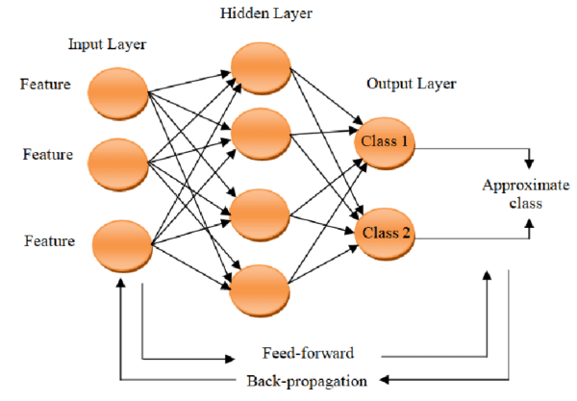
Figure 2: Artificial Neural Network Architecture (Source: Researchgate.net)
The number of neurodes, H, in the hidden layer can be determined as in Looney, (1996) by a rule of thumb:
H=|1.7*$\log_{2}(n)$|+1
A lot of computations takes place in the hidden layer,
$I_{j}=\sum_{i}{W_{ji}x_{i}+a_{j}}$ (15)
$Y_{j}=f_{j}(I_{j})$ (16)
Where, $f_{j} is$activation function, $a_{j}$ is the bias associated at each connection link between the input layer and hidden layer, $x_{i}$ input at nodes in input layer, $I_{j}$ is the summation of weight inputs added with bias, $Y_{j}$ is the output of activation function at hidden layer. The principle of output layer can be deduced using Eqn. (17) and Eqn. (18);
$I_{n}=\sum_{j}{W_{nj}x_{j}+b_{n }}(17)$
$Y_{n}=f_{n}(I_{n})$ (18)
Where; $f_{n}$ is the activation function, $W_{nj}$ is the weight associated at the connection link between nodes in hidden layer j and nodes in output layer n, $b_{n}$ is the the bias associated at each connection link between the hidden layer and output layer, $x_{j}$ input at nodes in hidden layer, $I_{n}$ is the summation of weighted inputs added to the bias, $Y_{n}$ is the final output at the output layer.

Naïve Bayes Classifier (NBC)
This classifier makes use of the Bayes rule which assumes independence among predictors. NBC postulates that the presence of an attribute in a class is not related to the presence of any other attribute. The Bayes rule calculates conditional probability as;
P$\left(Y|X\right)=\left(\frac{P\left(X | Y\right)P(Y)}{P(X)}\right)$ (19)
Where; P (Y|X)=posterior probability of class Y given predictor (X), P (Y)=prior probability of class, P (X|Y)=likelihood and P (X)=normalizing constant. By using this technique, all the features are presumed independent according to Bayes theorem which means there is no dependency among the attribute value on a given class and the other attributes. The Bayes theorem enables us to express the posterior probability in terms of the prior probability P(Y), the class-conditional probability P (X|Y), and the evidence, P(X) as shown in Eqn. (19). The NBC works by estimating the class-conditional probability. By so doing, it assumes that the attributes are conditionally independent, given the class label y.
The mathematical expression of the conditional independence assumption is given as:
P$\left(X|Y=y\right)=\prod_{i=1}^{d}{P\left(X_{i}|Y=y\right)} (20)$
In Eqn. (20), each attribute set X: {$X_{1}$, $X_{2},$ …., $X_{d}$} consist of d attribute features. To classify a test dataset, NBC works by calculating the posterior probability of each class Y using Eqn. (21).
P$\left(Y|X\right)=\frac{P(Y)\prod_{i=1}^{d}{P(X_{i}|Y=y)}}{P(X)}$ (21)
In Eqn. (21), P(X) is static for every Y, hence the class that maximizes the expression $P\left(Y\right)\prod_{i=1}^{d}{P\left(X_{i} | Y=y\right)}is chosen.$

Random Forest (RF)
Random Forest algorithm is a powerful tree learning technique in Machine Learning. It works by creating a number of decision trees during the training phase. Each tree is constructed using a random subset of the data set to measure a random subset of features in each partition. This randomness introduces variability among individual trees, reducing the risk of overfitting and improving overall prediction performance. In prediction, the algorithm aggregates the results of all trees, either by voting (for classification tasks) or by averaging (for regression tasks). This collaborative decision-making process, supported by multiple trees with their insights, provides an example stable and precise results.

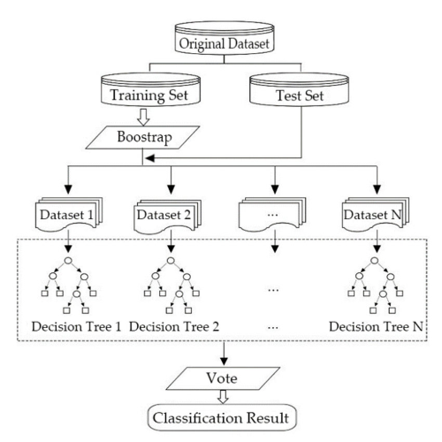
Figure 3: Random Forest Architecture (Source: Researchgate.net)
Model Evaluation
Confusion matrix is a N by N matrix used to know the performance of a machine learning classification. It gives a comparison between the actual and the predicted values. A confusion matrix is a visualization tool that helps in understanding the performance of a classification models. N by N implies that N is the number of classes or outputs. Confusion matrix has four components namely:
True positive(TP)-actual and predicted values are the same.
False Negative(FN)-Actual value is positive while the predicted is negative.
False Positive(FP)-The actual value is negative.
True Negative(TN)-Actual and predicted values are the same.
For 2 classes, we get a 2 by 2 confusion matrix while for 3 classes, we get a 3 by 3 confusion matrix. The evaluation metrics derived from confusion matrix include;
Accuracy – Measures the proportion of correctly classified cases from the total number of objects in the dataset;
Accuracy=$\frac{Correct Predictions}{All Predictions}$
=$\frac{TP+TN}{TP+TN+FP+FN}$ (For Binary Classification)
=$\frac{Sum of the elements in the leading diagonal}{sum of all elements in the confusion matrix}$ (For Multi-Classification)
A model with higher accuracy value is the best model.
The Cohen`s Kappa statistic(k) - It is the statistical measure that evaluates the level of agreement between two raters or between the predicted and actual values(or a model and ground truth) on categorical data (Landis & Koch, 1977);
k =$\frac{p_{o }-{ p}_{e}}{1 -{ p}_{e}}=\frac{total accuracy - random accuracy}{1 - random accuracy}$
$p_{o }$=observed accuracy(proportion of instances where raters agree)
$p_{o }$ =$\frac{correct predictions}{all predictions}$
$p_{e}$= Expected agreement by chance(proportion of agreement that is expected if raters are assigning categories randomly)
${ p}_{e}$ = $\sum_{i=1}^{n}{\left(\frac{R_{i}}{N}*\frac{C_{i}}{N}\right)}$ where $R_{i}$ is row total, $C_{i}$ is column total.
The threshold for Kappa statistic according to Landis & Koch.(1977);
K < 0 = there is poor agreement between predicted & actual values.
0.10 – 0.20 = slight agreement between predicted & actual values.
0.21 – 0.40 = fair agreement between predicted and actual values.
0.41 – 0.60 = moderate agreement between predicted and actual values.
0.61 – 0.80 = substantial agreement between predicted and actual values.
0.81 – 1.00 = almost perfect agreement.
It provides a more detailed evaluation of agreement compared to raw accuracy, especially in situations with class imbalance. It ensures that high agreement scores are not inflated due to chance.
Sensitivity (True Positive Rate) - measures the proportion of true positives (instances correctly identified as belonging to a specific class) out of all actual instances of that class.
sensitivity = $\frac{TP}{TP + FN} (For Binary Classification)$.
For multi class classification, sensitivity is computed for each class.
${sensitivity}_{1}$ = $\frac{{TP}_{1}}{{TP}_{1}+{FN}_{1}}$ (For class 1)
${ sensitivity}_{2}$ = $\frac{{TP}_{2}}{{TP}_{2}+{FN}_{2}}$ (For class 2)
${sensitivity}_{n}$ = $\frac{{TP}_{n}}{{TP}_{n}+{FN}_{n}}$ (For class n)
Specificity - Specificity measures the proportion of true negatives (instances correctly identified as not belonging to a specific class) out of all actual instances that do not belong to that class.
specificity = $\frac{TN}{TN + FP} (For Binary Classification)$.
For multi class classification, sensitivity is computed for each class.
${\text{specificity}}_{1}$ = $\frac{{TN}_{1}}{{TN}_{1}+{FP}_{1}}$ (For class 1)
${\text{specificity}}_{2}$ = $\frac{{TN}_{2}}{{TN}_{2}+{FP}_{2}}$ (For class 2)
${\text{specificity}}_{n}$ = $\frac{{TN}_{n}}{{TN}_{n}+{FP}_{n}}$ (For class n)

Results and Discussions
Exploratory Data Analysis
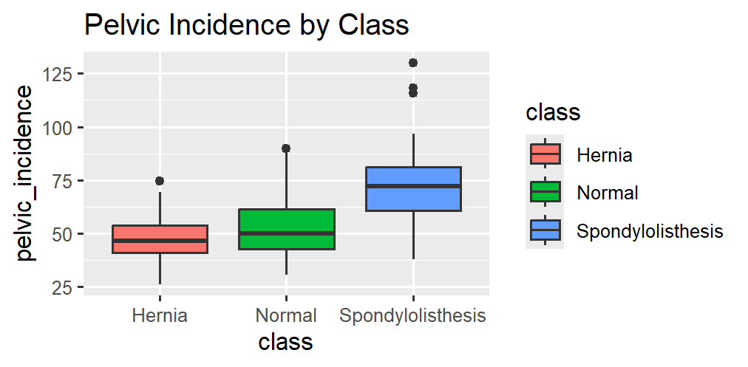
Figure 4: Boxplot showing summary statistics for pelvic incidence per class
From Figure 4, the median pelvic incidence for class hernia is approximately 46.4 degrees with minimum and maximum of about 26.1 and 74.4 degrees respectively, the first and third quartiles are approximately 41.0 and 53.9 degrees respectively. For class Normal, the median pelvic incidence is approximately 50.1 degrees with minimum and maximum of about 30.7 and 89.8 degrees respectively, the first and third quartiles are approximately 42.8 and 61.5 degrees respectively. For the class Spondylolisthesis, the median pelvic incidence is approximately 72.1 degrees with minimum and maximum of about 37.9 and 130.0 degrees respectively, the first and third quartiles are approximately 60.7 and 81.1 degrees respectively.
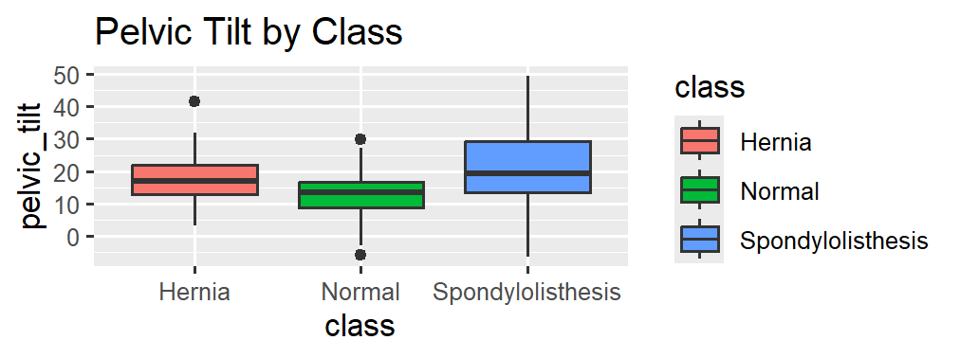
Figure 5: Boxplot showing summary statistics for pelvic tilt per class
From Figure 5, the median pelvic tilt for class Hernia is approximately 16.9 with minimum and maximum of about 3.1 and 41.5 respectively, the first and third quartiles are approximately 12.9 and 22.0 respectively. For class Normal, the median pelvic tilt is approximately 13.5 with minimum and maximum of about -5.8 and 29.0 respectively, the first and third quartiles are approximately 8.8 and 16.8 respectively. For the class Spondylolisthesis, the median pelvic tilt is approximately 19.3 with minimum and maximum of about -6.5 and 49 respectively, the first and third quartiles are approximately 13.5 and 29.2 respectively.
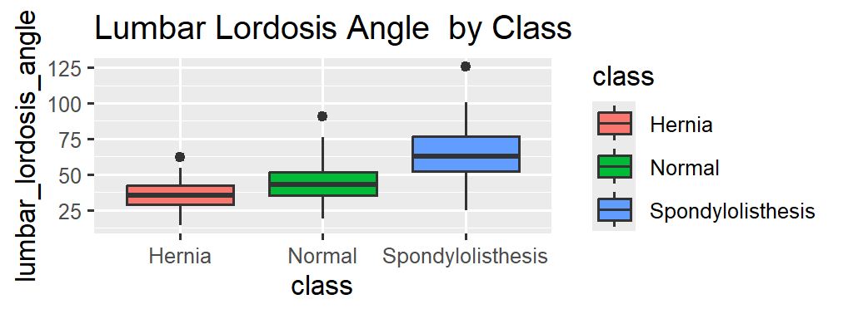
Figure 6: Boxplot showing summary statistics for lumbar lordosis angle by per class
From Figure 6, the median lumbar lordosis angle for class hernia is approximately 35.1 degrees with minimum and maximum of about 14.0 and 62.0 degrees respectively, the first and third quartiles are approximately 29.0 and 42.0 degrees respectively. For class Normal, the median lumbar lordosis angle is approximately 42.5 degrees with minimum and maximum of about 19.0 and 90.5 degrees respectively, the first and third quartiles are approximately 35.0 and 51.5 degrees respectively. For the class Spondylolisthesis, the median lumbar lordosis angle is approximately 62.5 degrees with minimum and maximum of about 24.5 and 126.0 degrees respectively, the first and third quartiles are approximately 52.0 and 77.0 degrees respectively.
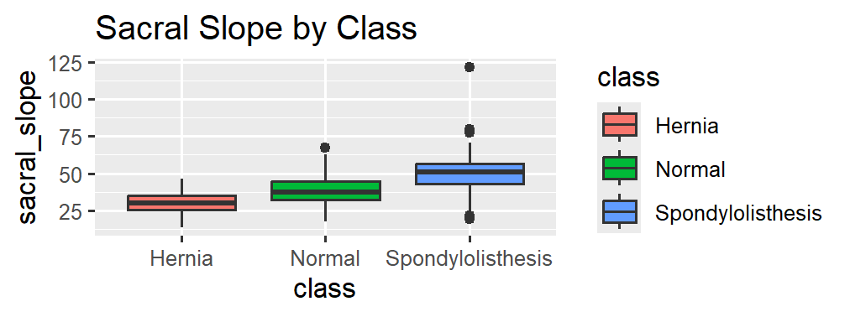
Figure 7: Boxplot showing summary statistics for sacral slope by per class
From Figure 7, the median sacral slope for class hernia is approximately 30.0 degrees with minimum and maximum of about 13.0 and 46.5 degrees respectively, the first and third quartiles are approximately 25.0 and 35.0 degrees respectively. For class Normal, the median sacral slope is approximately 37.0 degrees with minimum and maximum of about 17.5 and 67.0 degrees respectively, the first and third quartiles are approximately 32.0 and 44.5 degrees respectively. For the class Spondylolisthesis, the median sacral slope is approximately 50.9 degrees with minimum and maximum of about 19.0 and 121.0 degrees respectively, the first and third quartiles are approximately 43.0 and 56.5 degrees respectively.
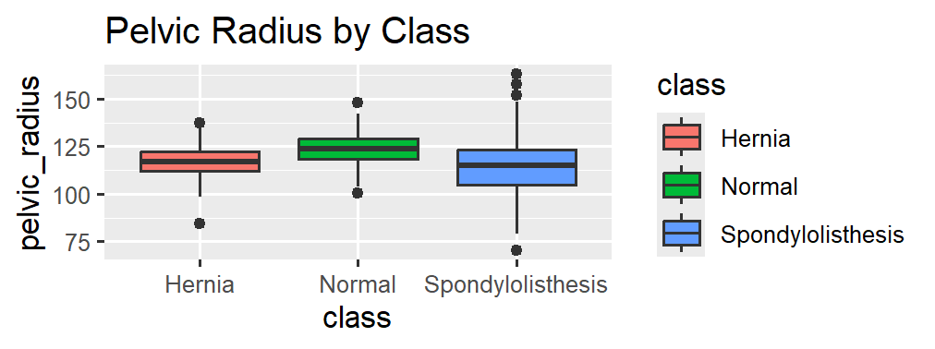
Figure 8: Boxplot showing summary statistics for pelvic radius by per class
From Figure 8, the median pelvic radius for class hernia is approximately 117 units with minimum and maximum of about 84 and 138 units respectively, the first and third quartiles are approximately 112 and 122 units respectively. For class Normal, the median pelvic radius is approximately 124 units with minimum and maximum of about 101 and 148 units respectively, the first and third quartiles are approximately 118 and 129 units respectively. For the class Spondylolisthesis, the median pelvic radius is approximately 115 units with minimum and maximum of about 70 and 163 units respectively, the first and third quartiles are approximately 105 and 123 units respectively.
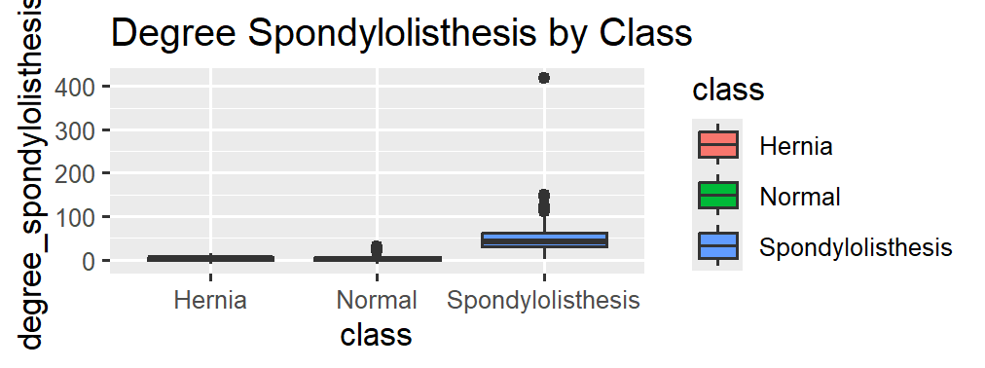
Figure 9: Boxplot showing summary statistics for degree spondylolisthesis by per class
From Figure 9, the median degree spondylolisthesis for class Hernia is approximately 2.5 with minimum and maximum of about -10.0 and 16.0 respectively, the first and third quartiles are approximately -1.0 and 6.0 respectively. For class Normal, the median degree spondylolisthesis is approximately 1.0 with minimum and maximum of about -10.0 and 31.0respectively, the first and third quartiles are approximately -1.5 and 5.0 respectively. For the class Spondylolisthesis, the median degree spondylolisthesis is approximately 42.0 with minimum and maximum of about 1.0 and 100 respectively, the first and third quartiles are approximately 30.5 and 70.0 respectively.

Application of Supervised Machine Learning Classifiers
For all supervised machine learning algorithms considered in this study, the dataset was first divided into two sets: a training set and a testing set. Specifically, 70% of the data was allocated to the training set and used for model fitting and parameter estimation, while the remaining 30% was partitioned as the testing set and used for model evaluation and validation. This data-splitting approach was used to ensure that the model performance was assessed on previously unseen observations, thereby giving an unbiased estimate of the models’ generalization ability and reducing the problem of overfitting. The same partitioning was applied consistently across all the supervised machine learning models to allow for fair and comparable assessment of predictive performance. The supervised machine learning models considered were; K-Nearest Neighbor (KNN), the Artificial Neural Network (ANN), Support Vector Machine (SVM), Random Forest (RF), and the Naïve Bayes Classifiers
KNN optimization
KNN model was optimized based on Overall accuracy and Kappa values for k neighbors where k=6 gave optimum results among all k neighbors (K=1,2,3,…,10).
Table 1: K-NN optimization
K | Overall Accuracy | Kappa-values
1 | 0.7670 | 0.6413
2 | 0.8447 | 0.7582
3 | 0.7864 | 0.6672
4 | 0.8252 | 0.7273
5 | 0.8252 | 0.7248
6 | 0.8544 | 0.7717
7 | 0.8252 | 0.7268
8 | 0.8447 | 0.7575
9 | 0.8447 | 0.7571
10 | 0.8252 | 0.7255

The model was optimized when k=6, that is, the overall accuracy at k=6 was the highest amongst all other K values (0.8544). It is very apparent furthermore that the overall accuracy can be same for different values of k, this is exhibited vividly by the set of ties when is 4, 5, 7 and 10(82.52%) and also when k is 2, 8 and 9(84.47%).

Artificial Neural Network

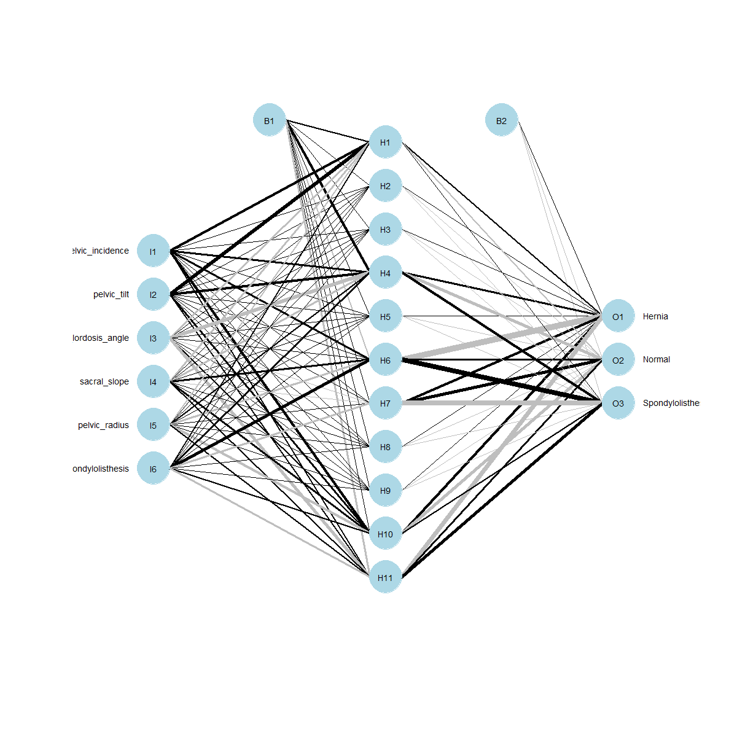
Figure 10: ANN output
Figure 10 shows the output of the artificial neural netwoks with six input variables, 11 hidden nodes and the three outputs, B1 and B2 are the biases associated with the hidden and the output layers respectively. The number of hidden nodes were determined according to Looney, (1996).
Model Evaluation
Table 2: Performance evaluation
Model | Sensitivity | Specificity | Accuracy | Cohen`s Kappa Value
K-NN | 0.8262 | 0.9313 | 0.8544 | 0.7714
ANN | 0.6888 | 0.8828 | 0.7532 | 0.6063
SVM | 0.8264 | 0.9317 | 0.8571 | 0.7724
RF | 0.8266 | 0.9341 | 0.8701 | 0.7901
NBC | 0.7332 | 0.8897 | 0.7792 | 0.6454

From Table 2, it is clear that the Random forest is the best machine learning based classification model hernia classification. This contradicts Handayani, (2019) which only used and conclude KNN as the best classifier for hernia condition. Random Forest had higher accuracy (87.01%), sensitivity (82.66%), specificity (93.41%), and kappa value (79.01%) compared to other machine learning algorithms. It produced an overall accuracy of 87.01%, which implies that it correctly classified approximately 87 out of every 100 cases in the dataset. The sensitivity of 82.66% indicates that the model was able to correctly identify about 83% of the actual positive cases while the specificity of 93.41% shows that it accurately recognized over 93% of the actual negative cases. Also, the Cohen’s kappa value of 79.01% reflects substantial agreement between the predicted and true class labels beyond what would be expected by chance, showcasing the reliability and robustness of the model. This was followed closely by Support Vector Machine, accuracy (85.71%), sensitivity (82.64%), specificity (93.17%), and kappa value (77.24%). Artificial Neural Network had the poorest performance among all the algorithms, accuracy (75.32%), sensitivity (68.88%), specificity (88.28%), and kappa value (60.63%). Furthermore, the support vector machines also gave higher accuracy compared to the KNN method. The study also is in line with various studies that have shown random forest outperforming other methods in disease classifications for example Kaur et al, (2023) which found that random forest is the best machine learning classifier in Alzheimers`s disease classification.
Conclusions
The main aim of this study was to apply the supervised machine learning methods in classification of hernia. This was achieved by applying K- nearest neighbor, the artificial neural networks, the support vector machines, random forest and the naïve bayes algorithms to the hernia data obtain from the UCI machine learning repository. For each method, data was splitted in the ratio 70: 30, that is, 70% of the data was used for training while 30% of the data was used for testing. KNN was optimized when k=6, while the random forest technique outperformed all the algorithms. This study shows that evaluating various machine learning algorithms is very crucial in health and clinical studies.
Recommendations
This study recommends that the supervised random forest algorithm should be used while classifying hernia conditions because of its high accuracy, sensitivity, specificity and kappa values for proper medical diagnostics and treatment. Future Studies should consider feature-based machine learning classification methods in hernia classification such as artificial neural networks-recursive feature elimination, artificial neural networks-principal component analysis, artificial neural networks-linear discriminant analysis and the combination of other algorithms with these feature selection methods. In addition, using the hybrid machine learning models such as RF-SVM, ANN-SVM, RF-NBC, could be possible future research areas. Also future work should consider additional deep learning machine learning algorithms.
Disclaimer (Artificial intelligence)
Author(s) hereby declare that NO generative AI technologies such as Large Language Models (ChatGPT, COPILOT, etc.) and text-to-image generators have been used during the writing or editing of this manuscript.
References
Aljahdali, S., & Hussain, S. N. (2013). Comparative prediction performance with support vector machine and random forest classification techniques. International journal of computer applications, 69(11).
Alpaydin, E. (2020). Introduction to machine learning (4th ed). MIT Press.
Bafjaish, S. S. (2020). Comparative analysis of Naive Bayesian techniques in health-related for classification task. Journal of Soft Computing and Data Mining, 1(2), 1-10.
Bolton, R. J., & Hand, D. J. (2002). Statistical fraud detection: A review. Statistical Science, 17(3), 235–255. https://doi.org/10.1214/ss/1042727940
Breiman, L. (2001). Random forests. Machine Learning, 45(1), 5–32. https://doi.org/10.1023/A:1010933404324
Esteva, A., Kuprel, B., Novoa, R. A., Ko, J., Swetter, S. M., Blau, H. M., & Thrun, S. (2017). Dermatologist-level classification of skin cancer with deep neural networks. Nature, 542(7639), 115–118. https://doi.org/10.1038/nature21056
Géron, A. (2019). Hands-on machine learning with Scikit-Learn, Keras, and TensorFlow (2nd ed.). O’Reilly Media.
Grignaffini, F., Barbuto, F., Piazzo, L., Troiano, M., Simeoni, P., Mangini, F., ... & Frezza, F. (2022). Machine learning approaches for skin cancer classification from dermoscopic images: a systematic review. Algorithms, 15(11), 438.
Handayani, I. (2019). Application of K-nearest neighbor algorithm on classification of disk hernia and spondylolisthesis in vertebral column. Indonesian Journal of Information Systems, 2(1), 57-66.
Hastie, T., Tibshirani, R., & Friedman, J. (2009). The elements of statistical learning: Data mining, inference, and prediction (2nd ed). Springer.
Kaur, C., Panda, T., Panda, S., Al Ansari, A. R. M., Nivetha, M., & Bala, B. K. (2023, February). Utilizing the Random Forest Algorithm to Enhance Alzheimer’s disease Diagnosis. In 2023 Third International Conference on Artificial Intelligence and Smart Energy (ICAIS) (pp. 1662-1667). IEEE.
Kremic, E., & Subasi, A. (2016). Performance of random forest and SVM in face recognition. Int. Arab J. Inf. Technol., 13(2), 287-293.
Lessmann, S., Baesens, B., Seow, H.-V., & Thomas, L. C. (2015). Benchmarking state-of-the-art classification algorithms for credit scoring. European Journal of Operational Research, 247(1), 124–136. https://doi.org/10.1016/j.ejor.2015.05.030
Looney, C. G. (1996). Advances in feedforward neural networks: demystifying knowledge acquiring black boxes. IEEE Transactions on Knowledge and Data Engineering, 8(2), 211-226.
Mitchell, T. M. (1997). Machine learning. New York, NY: McGraw-Hill.
Mohammad Abood Kadhim & Abdulkareem Merhej Radhi2. heart disease classification using optimized machine learning algorithms. DOI: https://doi.org/10.52866/ijcsm.2023.02.02.004
Nasef, D., Nasef, D., Sawiris, V., Girgis, P., & Toma, M. (2025). Machine-Learning-Based Biomechanical Feature Analysis for Orthopedic Patient Classification with Disc Hernia and Spondylolisthesis. BioMedInformatics, 5(1), 3.
Omondiagbe, D. A., Veeramani, S., & Sidhu, A. S. (2019, June). Machine learning classification techniques for breast cancer diagnosis. In IOP conference series: materials science and engineering (Vol. 495, p. 012033). IOP Publishing.
Poornima, K. M., Danti, A., & Narasimhamurthy, S. K. (2013). Wavelet Based Face Recognition using ROIs and k-NN. International Journal of Innovations in Engineering and Technology (IJIET), 3(2), 2319-1058.
Sevvanthi, K., Ganapathy, S., Penumadu, P., & Harichandrakumar, K. T. (2023). Comparing the predictive performance of a decision tree with logistic regression for oral cavity cancer mortality: A retrospective study. Cancer Research, Statistics, and Treatment, 6(1), 103-110.
Soni, M., & Shnan, M. A. (2023). Scalable neural network algorithms for high dimensional data. Mesopotamian Journal of Big Data, 2023, 1-11.
S. Ghumbre, C. Patil, and A. Ghatol, “Heart disease diagnosis using support vector machine,” in International conference on computer science and information technology. Pattaya, Thailand: Planetary Scientific Research Centre, 2011, pp. 84–88.
S. Palaniappan and R. Awang, “Intelligent heart disease prediction system using data mining techniques,” in IEEE/ACS International Conference on Computer Systems and Applications. Doha, Qatar, March 2008, pp. 108–115.
Yamaguchi, N., Morioka, D., Izumisawa, Y., Toyoda, J., Yamaguchi, K., Horii, N., ... & Endo, I. (2021). A classification system specific for recurrent inguinal hernia following open hernia surgery. in vivo, 35(6), 3501-3508.
Zhang, S., Li, X., Zong, M., Zhu, X., & Cheng, D. (2017). Learning k for knn classification. ACM Transactions on Intelligent Systems and Technology (TIST), 8(3), 1-19.

