A Signal for Caution: Eight Cases of Neurological Injury After Spinal Manipulation and Implications for Future Surveillance

.
ABSTRACT

Aims: We present a two-year, single-center retrospective case series on spine-related complications caused by unregulated spinal manipulation.
Study design: This is a retrospective case series.
Place and Duration of Study: A tertiary hospital from 1 January 2024 to 31 December 2025 (24 months). This study included adults aged 18–65 who presented with spine-related injuries secondary to spinal manipulation.
Methodology: A search was conducted in the hospital records. Patients’ data were tabulated and analyzed using descriptive statistics for variables including demographics, diagnosis, American Spinal Injury Association (ASIA) Impairment Scale, and treatment outcomes.
Results: Eight patients (seven male, one female), aged 18 to 57 years (mean = 39.1), were included. There were six cervical injuries and two thoracic injuries, including one case of cervical metastasis and one of thoracic ossification of the ligamentum flavum (yellow ligament). Four cervical patients had pre-existing cervical spondylosis. One cervical and one thoracic patient had no predisposition. In the cervical region, five patients suffered ASIA C and D injuries, while one patient suffered an ASIA A injury from massaging and abdominal bracing. In the thoracic region, one patient suffered an ASIA A injury from a practitioner standing on the thoracic spine, and another suffered an ASIA D injury from spinal rotation. Two cervical patients underwent operative treatment and showed improvement, while those receiving conservative treatment showed no worsening. The ASIA A patients succumbed to subacute complications of their injuries.
Conclusion: Accurate diagnosis and the exclusion of serious pathology are mandatory prerequisites to any treatment. Aggressive maneuvers should be avoided, while ensuring judicious and controlled application of force, with heightened caution in the cervical region, particularly when untrained manipulation is involved. Prognostically, the initial severity of the injury remains the most critical factor; however, in cases of incomplete neurological deficits, timely surgical decompression may significantly improve functional outcomes.

Keywords: [Spinal Manipulation, Spinal Cord Injury, Cervical Spine, Patient Safety)

1. INTRODUCTION

Spinal manipulative therapy is a high-velocity low-amplitude thrust technique applied to the spine to achieve pain relief¹. This is one of the physiotherapeutic modalities for conservative treatment of cervical spondylosis, lumbar spondylosis, and chronic pain syndromes and has proven efficacy. Spinal manipulation may be indicated in the treatment of low back pain, neck pain, headache, and hypomobility of spinal joints³. Contraindications include, but are not limited to severe osteoporosis, nerve or spinal cord compression, bleeding or vascular conditions, acute herniated nucleus pulposus, hypermobility disorders, pregnancy, and in the paediatric population. Common side effects can be temporary and mild, characterized by soreness, fatigue, and headache⁴. Serious side effects are rare and include vertebral artery dissection and stroke⁵. While serious side effects are rare, these reports are based on regulated practice within the physiotherapy community.

With the advent of social media, complementary treatment of common musculoskeletal conditions has become widely popular, often involving dramatic spinal manipulation accompanied by loud popping noises performed by untrained personnel. This has led to many members of the public seeking treatment without first ruling out contraindications to spinal manipulation with a trained medical professional.

There is limited evidence in the literature related to spinal injury from passive spinal manipulation. This information is important for educating the public on the safety and risks of untrained and unsupervised spinal manipulation. Hence, it is essential to provide reliable and strong evidence when counseling patients seeking treatment for spinal conditions. We present a retrospective case series of spine-related complications due to mechanisms related to spinal manipulation in the community, which presented to our center over a period of 24 months.

2. Materials and methods

This study is a retrospective observational case series of spinal injuries secondary to spinal manipulation therapy. Patient data were collected from a regional tertiary center. The study included patients who presented within a 24-month period, from 1 January 2023 to 31 December 2024.

Inclusion criteria were: (i) adult patients aged between 18 and 65 years, (ii) spine-related injury secondary to manipulation of the spinal column, and (iii) spinal manipulation performed by untrained personnel or the patients themselves.

Data were collected and analyzed using descriptive statistics for the following variables: (i) demographics, (ii) diagnosis, (iii) neurologic status on presentation and post-treatment, (iv) mechanism of manipulation, (v) treatment received, and (vi) underlying spinal conditions.

The neurological status of all patients was graded according to the American Spinal Injury Association (ASIA) Impairment Scale, following the International Standards for Neurological Classification of Spinal Cord Injury (ISNCSCI) protocol⁶.

Data tabulation was performed using Google Sheets, and analysis was conducted using descriptive statistics.

3. results and discussion

The study cohort comprised eight patients (seven males and one female) with a mean age of 39.1 years (range: 18–57 years). Anatomically, six patients (75.0%) sustained injuries in the cervical region, while two (25.0%) involved the thoracic spine. Neurological severity at presentation, according to the American Spinal Injury Association (ASIA) Impairment Scale, was primarily ASIA D (n=5, 62.5%), followed by ASIA A (n=2, 25.0%) and ASIA C (n=1, 12.5%).

Pre-existing spinal pathology was present in 75.0% of the cohort (n=6). Among the cervical group (n=6), conditions included degenerative spinal stenosis (n=3), spinal metastasis (n=1), and unstable os odontoideum (n=1). In the thoracic group, one patient had ossification of the yellow ligament (OYL), while the other had a normal spinal profile.

The relationship between the massage technique and neurological outcomes varied by region. In the cervical region, massage-related maneuvers resulted in three ASIA D injuries and one ASIA C injury. Notably, the single case of complete neurology (ASIA A) occurred in a patient with underlying spinal metastasis. In the thoracic region, one patient with OYL sustained an ASIA D injury following thoracolumbar rotation. The second thoracic case resulted in an ASIA A injury in a previously normal spine after the masseuse stood directly on the patient's back.

Surgical intervention (decompression and stabilization) was performed in four patients with cervical injuries, while the remaining four patients were managed conservatively.

At the three-month follow-up, 50% (n=2) of the surgically treated group showed neurological recovery, improving from ASIA C to ASIA D. Conversely, all patients managed conservatively for incomplete injuries (cervical and thoracic) showed no change in their neurological status. Mortality was 25.0% (n=2), involving both patients who initially presented with ASIA A injuries (Patient 6 and Patient 8), both of whom passed away during the subacute period.

Table 1 summarizes the clinical presentation, mechanism of injury, and neurological severity for all patients.

Table 1: Summary of patient presentation, diagnosis, treatment and outcome.

No | Age | Mechanism | Underlying Disorder | Diagnosis | Neurologic Status on Presentation | Treatment | Neurologic Outcome
1 | 57 | Direct massaging of the neck | Cervical spondylosis | C6 Incomplete spinal cord injury with c5-c6 prolapse intervertebral disc | C | Combined anterior cervical discectomy and fusion c5/6 and posterior cervical decompression and fusion c5-c7 | ASIA D
2 | 32 | Direct massaging of the neck | Cervical spondylosis | C6 Incomplete spinal cord injury with c5-c6 prolapse intervertebral disc | D | Trial of conservative | ASIA D
3 | 33 | Voluntary bracing with isometric contraction of the neck and muscles. | Nil | C6 central cord syndrome 2’ to c5-c6 prolapsed intervertebral disc. | D | Anterior cervical discectomy and fusion c5-c6 | ASIA E
4 | 55 | Direct massaging | Degenerative stenosis | C5 central cord | D | Conservative | ASIA D
5 | 18 | Direct massage | Unstable os odontoideum | Incomplete cord injury | D | Decompression and c0 fusion | ASIA D
6 | 43 | Direct massage | Spinal metastasis | Complete cord injury | A | Conservative | ASIA A
7 | 35 | Rotation | Ossification of Yellow Ligament thoracic | T10, 11, 12 OYL with Thoracic myelopathy | D | Conservative | ASIA A
8 | 40 | Standing on the back | Nil | Thoracic chance fracture | A | Posterior Instrumentation and fusion with decompression | ASIA A
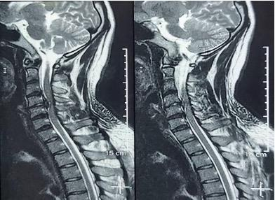
Fig. 1. Demonstrate traumatic cervical prolapsed intervertebral disc as a result of neck manipulation.

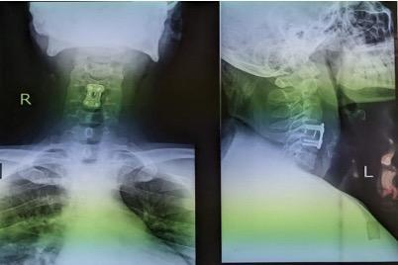
Fig. 2. Postoperative radiograph after anterior cervical discectomy and fusion. This patient had a favourable outcome.

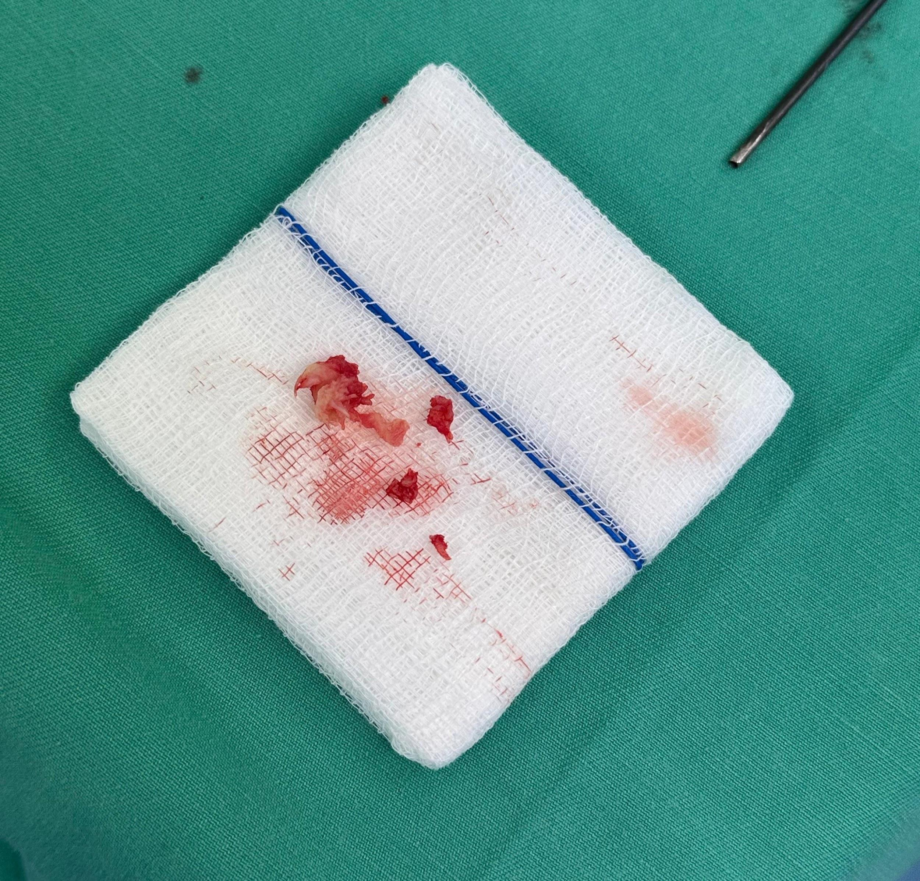
Fig. 3. Intervertebral disc material evacuated during operation.

3.1 Discussion

Spinal manipulative therapy involves a high-velocity, low-amplitude thrust technique applied to the spine to achieve pain relief and is one of physiotherapeutic approaches to conservative treatment of cervical spondylosis, lumbar spondylosis and chronic pain syndromes^{7,8}. Pain relief is achieved via forceful stretching, which is postulated to induce relaxation mechanisms and disrupting pain-spasm-pain cycle independent from spinal lesion⁹. Persistent effect may result from neural plastic changes and alteration in motor neuron excitability with associated increase in cortical drive¹⁰.

In our case series, the application of manipulation ranges from massaging and standing on the thoracic spine. Clearly, forces applied were beyond what was safe for the spine, resulting in varying degrees of neurologic injury. Pre-existing conditions also alter the biomechanics of the spine predisposing to injury.

Common side effects reported in the literature are temporary and mild, such as soreness, fatigue and headache¹¹. Ernst reported in a 2007 review of 32 case reports, 200 serious adverse events were reported with 30-61% mild events, while serious side effects were vertebral artery dissection and stroke¹². Spinal manipulation can be applied for chronic low back pain, neck pain, headache, and hypomobility of spinal joint¹³.

While the underlying basic science of spinal manipulation has its basis in the literature, bonesetters and laymen in the community have no training in safe application of the maneuvers. Severe osteoporosis, nerve or spinal cord compression, bleeding or vascular conditions, acute herniated nucleus pulposus, hypermobility disorder, pregnancy and paediatric population are contraindicated; these populations might predispose themselves to danger when the spine is being thrusted by untrained personnel. In our case series, pre-existing conditions range from degenerative stenotic disorder, upper cervical congenital instability, spinal metastasis and ankylosing spine.

Mechanism of injury ranges from low energy mechanism by massaging of the neck to standing on the thoracic spine. In our patients, direct massage of the neck resulted in spinal cord injury. We also recorded a thoracic injury due to standing on the spine, which reflects injudicious use of force on the weakened spine. Due to these mechanisms employed by bonesetters, the safety of these maneuvers are not known.

A case report by Chung in 2002, a case of acute tetraplegia which was confirmed by MRI cord edema, resolved with conservative treatment and methylprednisolone after 6 months¹⁴. Chu et al studied the incidence and severity of adverse events across 30 chiropractic clinics in Hong Kong from 2017 to 2022. They graded into 5 grades of severity and reported 0.21 per 100,000 SMT sessions of grade ≥ 3 injuries, severe, life-threatening or death. In their report, no grade 4 or grade 5 cases were reported¹⁵.

In our series of patients, operative treatment yielded favourable neurologic outcomes. These are mainly in patients with cervical region injury with incomplete spinal cord injury. 6 patients suffered injury in the cervical region while 2 in the thoracic region. This could be due to mobility of the cervical spine compared to other regions of the spine¹⁶.

Preexisting conditions can predispose the spinal cord to injury as a result of displacement of the spinal motion segment due to manipulation. Kirnaz et al showed in a review a decrease in normal compressive modulus of the disc from 20 to 5 MPa and 700 to 1800 Nmm/8 as a result of degenerative process¹⁷. Alteration in spine stiffness and viscoelasticity coupled with resultant stenosis may lead to widening of elastic or narrowing of neutral zone kinematics, predisposing the neural elements to injury from manipulation¹⁸. Destructive disease processes like tumors may also destroy the polyaxial columnar stability of the spine¹⁹. The mechanisms involved in these patients are low energy. One patient with spinal metastasis and another with thoracic fracture with complete cord injury died during the subacute period of the injury.

From this series of cases, the lessons that we would like to put forward are;
- Aggressive techniques such as standing on the thoracic spine or aggressive neck massaging represent injudicious force that exceeds the physiological tolerance of the spinal column.
- "Low-energy" maneuvers, such as injudicious neck massage, can cause permanent spinal cord injury when applied to a vulnerable region like the neck. The cervical spine is more vulnerable to manipulation-induced injury (6 out of 8 cases) due to its high mobility compared to the thoracic region.
- Pre-existing pathology alters spine biomechanics and predisposes the spine and the neural elements to injury when manipulated. The relationship between the spectrum of spinal manipulation and spinal tolerance is non-linear when different pathologies are present, making intuitive predictions unreliable. For example, a stiff spine as a result of ankylosing spondylitis, is more vulnerable to bending manipulation and may lead to catastrophic injury in the stiff thoracic region. In contrast, lytic pathology will render the stiffest region unstable.
- Surgical Benefit: Operative treatment shows favorable neurologic outcomes for incomplete cervical cord injuries.
- Mortality Risks: Patients with spinal tumours or complete thoracic injuries face high mortality rates in the subacute period.

Based on this, 3 elements interact to determine the severity of injury.
- Force applied
- Spine tolerance
- Spinal pathology

The prognosis is primarily dictated by the severity of the initial injury and the type of treatment administered.

While spinal injury due to spinal manipulation is rare within regulated healthcare settings, this may not be the case outside of the regulated physiotherapy community. Serious spinal injury is a significant risk in the hands of untrained and unregulated individuals. Thoroughly ruling out serious spinal conditions is imperative before employing any form of spinal manipulation to ensure patient safety.

This study has several limitations. First, it is a retrospective case series that inherently limits the ability to establish causality. Second, the small sample size from a single center may affect the statistical power and generalizability of our findings. Consequently, these results should be interpreted as preliminary and require validation in larger, prospective, multi-center studies.

We hope that this information can be used to provide evidence during consultation for patients seeking spinal manipulation for the treatment of their spinal condition as well as protecting the general public from potential harm. Further prospective epidemiological studies looking into the spine-related side effects of spinal manipulation will provide more robust evidence and assist in comprehensive counselling and patient education.

4. Conclusion

The primary "take-home message" is that accurate diagnosis and the exclusion of serious pathology are mandatory prerequisites to any treatment. Aggressive maneuvers should be avoided, while ensuring judicious and controlled application of force, with heightened caution in the cervical region, particularly when untrained manipulation is involved. Prognostically, the initial severity of the injury remains the most critical factor; however, in cases of incomplete neurological deficits, timely surgical decompression may significantly improve functional outcomes.

Acknowledgements

A brief acknowledgement section may be given after the conclusion section just before the references. The acknowledgments of people who provided assistance in manuscript preparation, funding for research, etc. should be listed in this section. All sources of funding should be declared as an acknowledgement. Authors should declare the role of funding agency, if any, in the study design, collection, analysis and interpretation of data; in the writing of the manuscript. If the study sponsors had no such involvement, the authors should so state.

Competing interests

We declare that no competing interests exist.

Authors’ Contributions

Author Dr Ahmad Ikhwan bin Mohd Sharfuddin designed the study, performed the statistical analysis, wrote the protocol, and wrote the first draft of the manuscript. Dr Harkeerat and Dr Kishanraj assisted in designing the study, data collection and contributed to the analyses of the study. Author Dr Harkeerat assisted in collecting data and data analysis. All authors read and approved the final manuscript.

Consent

All authors declare that ‘written informed consent was obtained from the patient (or other approved parties) for publication of this case report and accompanying images. A copy of the written consent is available for review by the Editorial office/Chief Editor/Editorial Board members of this journal.

Ethical approval

All authors hereby declare that all experiments have been examined and approved by the appropriate ethics committee and have therefore been performed in accordance with the ethical standards laid down in the 1964 Declaration of Helsinki.

Disclaimer (Artificial intelligence)
Author(s) hereby declare that NO generative AI technologies such as Large Language Models (ChatGPT, COPILOT, etc.) and text-to-image generators have been used during the writing or editing of this manuscript.
References
- Nugraha. (2025). Safety and therapeutic outcomes of cervical high-velocity low-amplitude manipulation in clinical practice: A review. Bulletin of Rehabilitation Medicine. https://journals.eco-vector.com/2078-1962/article/view/667401.
- Effectiveness of musculoskeletal manipulations in patients with neck pain: a systematic review and network meta-analysis. (2026). BMJ Open, 15(10), e098682. https://doi.org/10.1136/bmjopen-2024-098682.
- Qaseem, A., et al. (2017). Noninvasive Treatments for Acute, Subacute, and Chronic Low Back Pain: A Clinical Practice Guideline From the American College of Physicians. Annals of Internal Medicine.
- Whedon, J. M., Mackenzie, T. A., Phillips, R. B., & Lurie, J. D. (2015). Risk of traumatic injury associated with chiropractic spinal manipulation in Medicare Part B beneficiaries aged 66–99. Spine, 40(4), 264–270. https://doi.org/10.1097/brs.0000000000000725.
- Cassidy, J. D., Boyle, E., Côté, P., He, Y., Hogg-Johnson, S., Silver, F. L., & Bondy, S. J. (2008). Risk of vertebrobasilar stroke and chiropractic care: results of a population-based case-control and case-crossover study. Spine, 33(4 Suppl), S176–S183. https://doi.org/10.1097/BRS.0b013e3181644600.
- Rupp R, Biering-Sørensen F, Burns SP, et al. International Standards for Neurological Classification of Spinal Cord Injury: Revised 2019. Top Spinal Cord Inj Rehabil. 2021;27(2):1–22. doi:10.46292/sci2702-1.

- 7Langenfeld A, Baechler M, Swanenburg J, Mühlemann M, Nyirö L, Streuli D, et al. (2025). Systematic review on biomechanical effects of high-velocity, low amplitude spinal manipulation. PLoS One, 20(7), e0328048.
- 8Sharma A, Alahmari K & Ahmed I. (2015). Efficacy of manual therapy versus conventional physical therapy in chronic low back pain due to lumbar spondylosis. A pilot study. Medical Sciences, 3(3), 55-63.
- 9Maigne JY, & Vautravers P. (2003). Mechanism of action of spinal manipulative therapy. Joint bone spine, 70(5), 336-341.
- 10Gyer G, Michael J, Inklebarger J, & Tedla JS. (2019). Spinal manipulation therapy: Is it all about the brain? A current review of the neurophysiological effects of manipulation. Journal of integrative medicine, 17(5), 328-337.
- 11Puentedura EJ, March J, Anders J, Perez A, Lander MR, Wallmann HW, et al. (2012). Safety of cervical spine manipulation: are adverse events preventable and are manipulations being performed appropriately? A review of 134 case reports. Journal of Manual & Manipulative Therapy, 20(2), 66-74.
- 12Ernst E. Adverse effects of spinal manipulation: a systematic review. Journal of the Royal Society of Medicine. 2007;100(7):330-338. doi:10.1177/014107680710000716
- 13Bronfort G, Haas M, Evans R, Kawchuk G, Dagenais, S. (2008). Evidence-informed management of chronic low back pain with spinal manipulation and mobilization. The Spine Journal, 8(1), 213-225.
- 14Chung OM. (2002). MRI confirmed cervical cord injury caused by spinal manipulation in a Chinese patient. Spinal Cord, 40(4), 196-199.
- 15Chu ECP, Trager RJ, Lee LYK, & Niazi IK. (2023). A retrospective analysis of the incidence of severe adverse events among recipients of chiropractic spinal manipulative therapy. Scientific reports, 13(1), 1254.
- 16Wilke HJ, Kienle A, Werner K, Liebsch C. (2025). Range of motion and neutral zone of all human spinal motion segments: A data collection of 30 years of in vitro experiments performed under standardized testing conditions. JOR spine, 8(1), e70052.
- 17Kirnaz S, Capadona C, Lintz M, Kim B, Yerden R, Goldberg JL, et al. (2021). Pathomechanism and biomechanics of degenerative disc disease: features of healthy and degenerated discs. International journal of spine surgery, 15(s1), 10-25.
- 18D’Aprile P, Tarantino A. (2021). Biomechanics of the Spine. In MRI of Degenerative Disease of the Spine: A Case-Based Atlas (pp. 3-9). Cham: Springer International Publishing.
- 19Xia G, Yu H, Jiang S, Peng X, Fu X, Chen Q, et al. (2024). Biomechanical characteristics of thoracic T10 bone tumor metastasis at different locations: three-dimensional finite element analysis. Chinese Journal of Tissue Engineering Research, 28(36), 5759.

