Case Report

COMBINED PONTE AND PEDICLE SUBTRACTION OSTEOTOMIES FOR SEVERE THORACOLUMBAR KYPHOTIC DEFORMITY IN ANKYLOSING SPONDYLITIS: A CASE REPORT

.
ABSTRACT

Introduction and Importance: Ankylosing spondylitis (AS) is an immune-mediated inflammatory disease of the axial skeleton that may progress to spinal rigidity and fixed kyphotic deformity with marked sagittal imbalance, in selected cases requiring corrective osteotomy.
Case Presentation: A 25-year-old male with a three-year history of inflammatory back pain was diagnosed with AS based on HLA-B27 positivity, elevated inflammatory markers, and characteristic imaging findings. Although inflammatory symptoms improved after subcutaneous etanercept, the patient developed progressive rigid thoracolumbar kyphosis with clinically significant sagittal imbalance. Considering the rigidity of deformity and the magnitude of sagittal malalignment, we performed posterior instrumented fusion with combined Ponte osteotomy (PO) and pedicle subtraction osteotomy (PSO) to achieve adequate correction and restoration of sagittal alignment. Estimated blood loss was 3000 mL, and the patient received 2 units of packed red blood cells (PRBCs) perioperatively/intraoperatively. Deformity correction was conducted under intraoperative neurophysiological monitoring (IONM) using somatosensory-evoked potentials (SSEPs) and motor-evoked potentials (MEPs), with no significant signal changes. Postoperative radiographic assessment demonstrated substantial improvement in sagittal alignment.
Clinical Discussion: AS management requires a multidisciplinary approach integrating medical therapy and orthopedic correction when deformity causes functional limitation. Despite controlled inflammatory activity on biologic therapy, surgery was required to address fixed kyphosis and restore global sagittal balance. The patient showed meaningful improvements in pain, posture, and functional capacity, supported by improved BASDAI and ASDAS-CRP scores and radiographic alignment.
Conclusion: Combined Ponte osteotomy and pedicle subtraction osteotomy can effectively correct severe rigid thoracolumbar kyphotic deformity with sagittal imbalance in AS, improving sagittal alignment and quality of life.
Keywords: ankylosing spondylitis, kyphotic deformity, intraoperative monitoring, pedicle subtraction osteotomy, Ponte osteotomy, case report

1. INTRODUCTION
Ankylosing spondylitis (AS) is a chronic immune-mediated inflammatory disease primarily affecting the spine and sacroiliac joints, leading to pain, stiffness, and progressive limitation of function.¹ Long-standing AS is associated with osteoporosis and vertebral fractures, with a higher fracture risk than the general population, particularly in the thoracolumbar region.^{2,3} Progressive ectopic bone formation may result in spinal rigidity (“bamboo spine”), deformity, and increased skeletal fragility. AS is strongly associated with HLA-B27, present in >90% of patients, although only 1–5% of HLA-B27–positive individuals develop the disease, suggesting additional contributing factors.⁴ Radiographic sacroiliitis remains an important diagnostic indicator. Kyphotic deformity can be assessed using the Cobb angle and chin-brow vertical angle (CBVA).⁵ Severe kyphotic deformities are managed with corrective osteotomies, including Ponte osteotomy (PO) and pedicle subtraction osteotomy (PSO).⁶ PSO provides substantial sagittal correction without anterior column lengthening but is technically demanding and carries risks such as major blood loss, neurological deficits, pseudoarthrosis, implant failure, and loss of correction.^{7,8} Therefore, restoring stable alignment is essential. This case report presents an AS patient with thoracolumbar kyphotic deformity treated with combined PSO and PO, reported according to the SCARE 2020 criteria.⁹

2. CASE REPORT

2.1. Case presentation

We report a case of ankylosing spondylitis (AS) treated using a combined pedicle subtraction osteotomy (PSO) and Ponte osteotomy (PO). A 25-year-old male (villa guardian) presented to the orthopedic outpatient clinic with a 3-year history of progressive low back pain. The pain worsened with position changes, prolonged sitting, standing upright, and lying flat, and was relieved by forward bending and resting. There was no radiating pain to the buttocks or lower limbs. The patient reported intermittent paresthesia over the right small toe and plantar area. No motor weakness, bowel or bladder dysfunction, or gait disturbance was noted, and he remained independent in daily activities without walking aids. He had previously been diagnosed with arthritis by an internist and received anti-inflammatory treatment for one year. There was no family history of AS. The clinical appearance is shown in Fig. 1. Physical examination revealed a thoracolumbar kyphotic deformity without swelling or bruising. Mild tenderness was noted at L5–S1, with preserved sensation and no anesthesia. Motor strength was 5/5 in all extremities with normal reflexes. The Schober test was positive. BASDAI was 6 and ASDAS-CRP was 3.5. Laboratory tests showed elevated erythrocyte sedimentation rate (ESR) and C-reactive protein (CRP). HLA-B27 was positive by PCR. Thoracolumbar radiographs demonstrated kyphotic deformity at the thoracolumbar junction and sacroiliac joint abnormalities (Fig. 2). MRI and myelography confirmed thoracolumbar kyphosis without spinal cord compression (Fig. 3). Based on clinical, laboratory, and radiological findings, the patient was diagnosed with AS.

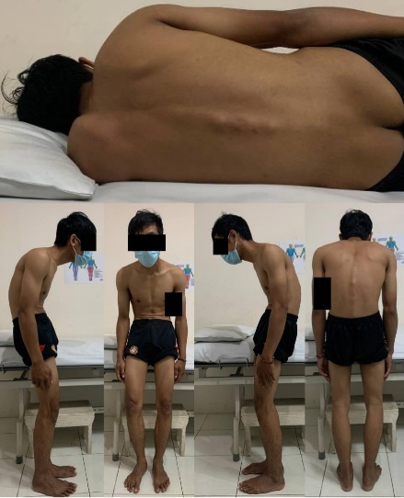

Fig. 1. The initial clinical assessment of the patients (Source: internal documentation)

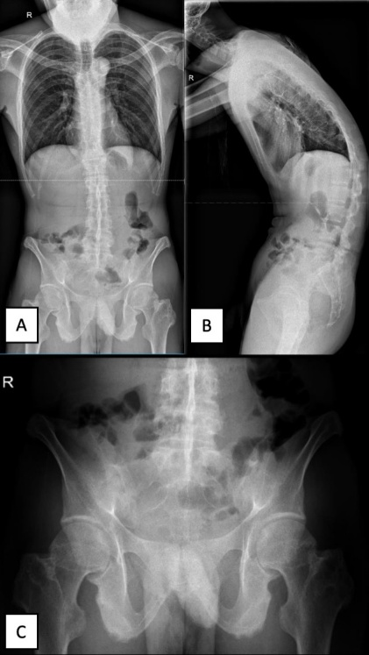

Fig. 2. Preoperative radiological examination of thoracolumbar vertebra X-ray in (A) AP and (B) lateral view; (C) pelvis X-ray in AP (Source: internal documentation)

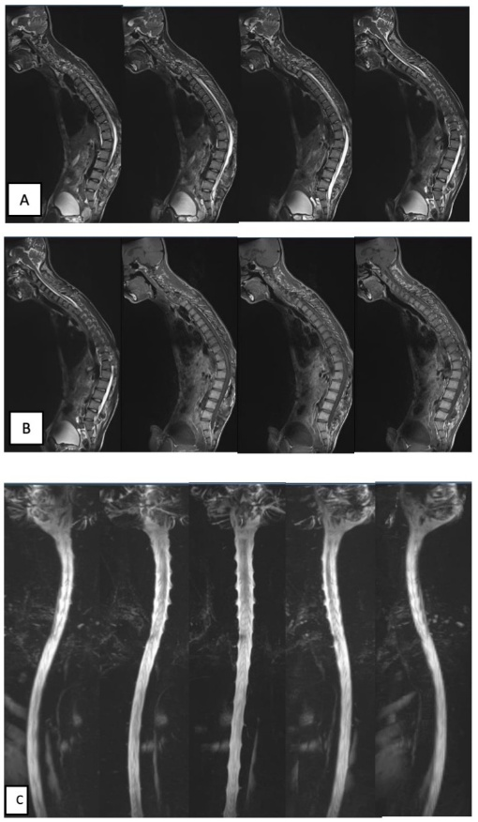

Fig. 3. Preoperative radiological examination of whole spine vertebra MRI (A) T2 weighted; (B) T1 weighted, and myelography (Source: internal documentation)

2.2. Surgical Procedure

The patient underwent planned posterior corrective surgery under general anesthesia in the prone position. A midline posterior incision was made over T11–L3, followed by subperiosteal exposure to the transverse processes and facet joints. Given the rigidity and severity of the thoracolumbar deformity and the need for substantial sagittal correction, a combined Ponte osteotomy (PO) and pedicle subtraction osteotomy (PSO) strategy was selected to increase correction potential beyond posterior column release alone. Long-arm pedicle screws were inserted bilaterally at T10, T11, L1, L3, and L4, with monoaxial long-arm screws at T12. Ponte osteotomy was performed at T11–T12, followed by L1–L3 laminectomy and pedicle subtraction osteotomy at L2. Deformity correction was achieved under intraoperative neurophysiological monitoring (SSEPs and MEPs). Two 250-mm rods with a 42-mm crosslink were applied, and implant position was confirmed using fluoroscopy. Synthetic bone graft was added, and a drain was placed before closure. Estimated blood loss was 3000 mL, requiring 2 units of PRBCs. No intraoperative complications occurred. The surgical technique is shown in Fig. 4.

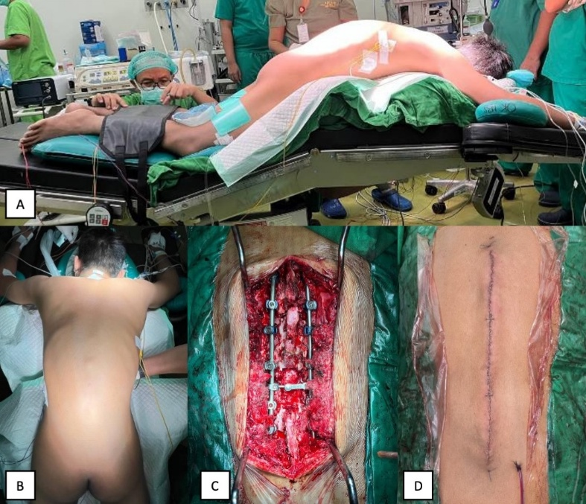
Fig. 4. Clinical pictures of intraoperative: (A) positioning; (B) surgical site; (C) after PSO and PO osteotomy and posterior fusion; (D) skin closure. (Source: internal documentation)

2.3. Postoperative
Postoperatively, a thoracic-lumbo-sacral orthosis (TLSO) brace was applied on day 1. The patient received intravenous NSAIDs for five days combined with methylprednisolone 125 mg for pain control. Sitting mobilization was initiated once pain was tolerable and continued until day 3, when the drain was removed based on output. Rehabilitation progressed to standing and ambulation on postoperative days 4–5. The patient was discharged after a 5-day hospital stay with a TLSO brace to be worn for three months. No additional pharmacological therapy for ankylosing spondylitis was given during this period.

2.4. Follow-up Evaluation
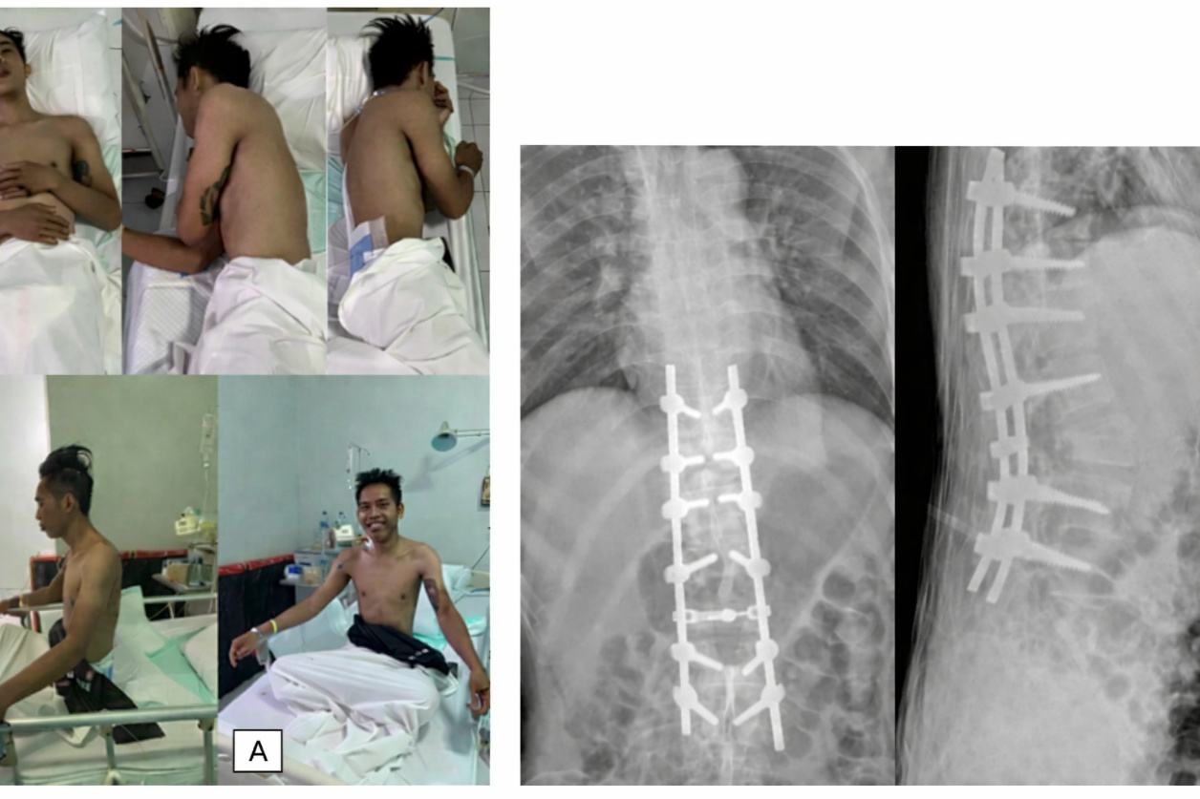
On postoperative day 5, the patient was able to perform basic movements comfortably, including lying supine, rolling side to side, and sitting on the bed (Fig. 5 (A)). On postoperative day 6, the patient was able to stand upright and begin ambulation. At the final follow-up, motor and sensory examinations showed improvement, supported by radiological evaluation. BASDAI decreased to 1, and ASDAS-CRP improved to 1.3. Follow-up anteroposterior and lateral thoracolumbar radiographs are shown in Fig. 5 (B). Formal spinopelvic alignment parameters (C2–C7 SVA, global SVA, Cobb angle, T1 slope, CBVA, PI/PT/SS, and PI–LL mismatch) were not quantitatively recorded at the time of imaging acquisition, representing a limitation of this report.

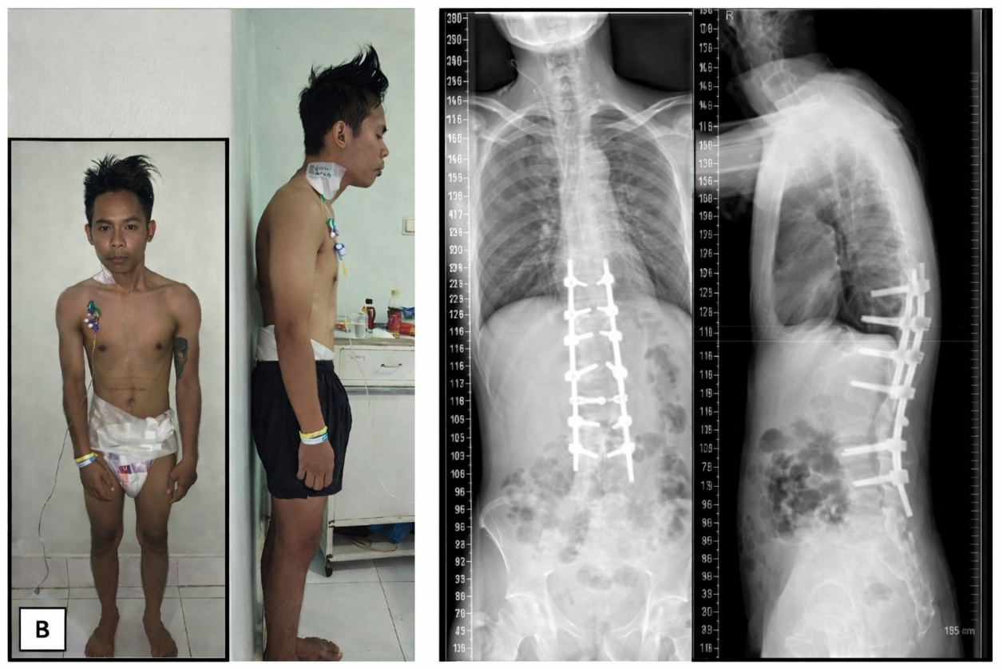
Fig. 5. The postoperative follow-up: (A) clinical evaluation and radiographic thoracolumbar X-ray evaluation of AP and lateral view. The sixth day of postoperative follow-up: (B) clinical evaluation and radiographic thoracolumbar X-ray evaluation of AP and lateral view. (Source: internal documentation).
3. discussion
Ankylosing spondylitis (AS) is an immune-mediated inflammatory disease primarily affecting the spine and sacroiliac joints; in advanced stages, inflammation may progress to fibrosis and calcification, resulting in spinal rigidity and fusion (“bamboo spine”) with clinical features such as inflammatory back pain, progressive stiffness, and possible peripheral joint involvement.^{10,11,12} AS is strongly associated with HLA-B27, although the etiology remains multifactorial. In this case, HLA-B27 testing was performed and was positive by PCR; however, additional HLA-B27 subtyping/allele characterization was not performed because it was not required for clinical diagnosis and management. Corrective surgery is indicated when severe deformity causes significant functional limitation, and comprehensive preoperative assessment is essential, including evaluation of pulmonary function, cardiovascular status, renal function related to long-term NSAID use, and cervical spine rigidity for safe airway management.^{13,14} Osteotomy selection depends on deformity severity and correction goals: pedicle subtraction osteotomy (PSO) provides major sagittal correction (typically 30°–40°) without anterior column lengthening but is technically demanding, and recent evidence continues to support its effectiveness for rigid AS deformity while emphasizing substantial risks (notably major blood loss and mechanical complications), thereby highlighting the importance of robust fixation and careful follow-up.^{15,16} Ponte osteotomy (PO) is generally simpler and safer but offers more limited sagittal correction and may risk coronal imbalance.¹⁷ Intraoperative neurophysiological monitoring (IONM) using SSEPs/MEPs is widely utilized in complex deformity correction to enhance neural safety, with contemporary reviews supporting its adjunctive role in high-risk reconstructive procedures. Postoperatively, BASDAI and ASDAS-CRP scores improved markedly in our patient, supporting clinical benefit, although limitations include the single-case design and the absence of quantified radiographic parameters (e.g., KA and CBVA measurements), and larger prospective studies are needed. Although Cobb angle and CBVA are commonly used to quantify kyphosis severity, these measurements were not available in our case because they were not recorded at the time of imaging acquisition.

4. Conclusion
Corrective surgery in ankylosed spines is technically demanding; however, in selected patients with fixed severe deformity and sagittal imbalance, combined Ponte osteotomy and pedicle subtraction osteotomy with rigid posterior fixation can restore alignment and meaningfully improve function and quality of life.

DATA AVAILABILITY

This study relied on research article data that can be requested from the corresponding author.

CONSENT

Written informed consent was obtained from the patient for publication of this case report and accompanying images.

ETHICAL APPROVAL

Ethical approval was waived by the author’s institution due to observational studies and multi-centre authors.

Disclaimer (Artificial intelligence)
Author(s) hereby declare that NO generative AI technologies such as Large Language Models (ChatGPT, COPILOT, etc.) and text-to-image generators have been used during the writing or editing of this manuscript.

REFERENCES
1. Liang Z, Fu C, Zhang Q, et al. Effects of water therapy on disease activity, functional capacity, spinal mobility and severity of pain in patients with ankylosing spondylitis: a systematic review and meta-analysis. Disabil Rehabil. 2021;43(7):895-902. doi:10.1080/09638288.2019.1645218.
2. Sharif K, Watad A, Amital H, et al. Osteoporosis in ankylosing spondylitis. Med Clin (Barc). 2023;160:373–378.
3. Yan Y, Xu J, Xia Y, et al. Bone mineral density and fracture risk in ankylosing spondylitis: a systematic review and meta-analysis. Osteoporos Int. 2024;35:1–13.
4. Ebrahimiadib N, Berijani S, Ghahari M, Pahlaviani FG. Ankylosing spondylitis. J Ophthalmic Vis Res. 2021;16(3):462-469. doi:10.18502/jovr.v16i3.9440.
5. Bittar M, Deodhar A. Axial Spondyloarthritis: A Review. JAMA. 2025;333(5):408–420. doi:10.1001/jama.2024.20917.
6. Khan MA. HLA-B*27 and Ankylosing Spondylitis: 50 Years of Insights and Discoveries. Curr Rheumatol Rep. 2023;25:327–340. doi:10.1007/s11926-023-01118-5.
7. Luan H, Liu K, Kahaer A, et al. Pedicle subtraction osteotomy for the corrective surgery of ankylosing spondylitis with thoracolumbar kyphosis: experience with 38 patients. BMC Musculoskelet Disord. 2022;23(1):1-9. doi:10.1186/s12891-022-05693-z.
8. Burkhard MD, Suter D, Sigrist B, Fuernstahl P, Farshad M, Spirig JM. Pedicle subtraction osteotomy with patient-specific instruments. North Am Spine Soc J. 2021;7(August):100075. doi:10.1016/j.xnsj.2021.100075.
9. Agha RA, Franchi T, Sohrabi C, et al. The SCARE 2020 Guideline: Updating Consensus Surgical CAse REport (SCARE) Guidelines. Int J Surg. 2020;84:226-230. doi:10.1016/j.ijsu.2020.10.034.
10. Luan H, Liu K, Kahaer A, et al. Pedicle subtraction osteotomy for the corrective surgery of ankylosing spondylitis with thoracolumbar kyphosis: experience with 38 patients. BMC Musculoskelet Disord. 2022;23: (artikel). doi:10.1186/s12891-022-05693-z.
11. Zhao SZ, Qian BP, Huang JC, Qiao M, Wang B, Qiu Y. Failure patterns and related risk factors of sagittal reconstruction following pedicle subtraction osteotomy in patients with ankylosing spondylitis and thoracolumbar kyphosis. Neurosurg Focus. 2021;51(4):E7.
12. Luo JZ, Wu TL, Yang ZL, Duan CG, Tao HR. An effective strategy for treatment of severe kyphosis secondary to ankylosing spondylitis: one-level modified osteotomy combined with shoulders lifting correction method. J Orthop Surg Res. 2024;19:536.
13. Hu Z, Zhong R, Zhao D, et al. Staged osteotomy in lateral position for the treatment of severe kyphotic deformity secondary to ankylosing spondylitis: a retrospective study. J Orthop Surg Res. 2023;18: (artikel). doi:10.1186/s13018-023-03884-5.
14. Mortezazadeh M, Vahedifard F, Ahmadi-Renani S, Salimzadeh A. A woman with a bamboo spine in the thoracic vertebra and normal sacroiliac joint; a 5-years undiagnosed ankylosing spondylitis: Case report and literature review. Rheumatol Res. 2020;5(1):32-37. doi:10.22631/rr.2020.69997.1088.
15. Bourghli A, Boissiere L, Obeid I. Lumbar pedicle subtraction osteotomy: techniques and outcomes. North Am Spine Soc J (NASSJ). 2024;19:100516. doi:10.1016/j.xnsj.2024.100516.
16. Burkhard MD, Suter D, Sigrist B, Fuernstahl P, Farshad M, Spirig JM. Pedicle subtraction osteotomy with patient-specific instruments. North Am Spine Soc J (NASSJ). 2021;7:100075. doi:10.1016/j.xnsj.2021.100075.
17. Hu Z, Zhong R, Zhao D, et al. Staged osteotomy in lateral position for the treatment of severe kyphotic deformity secondary to ankylosing spondylitis: a retrospective study. J Orthop Surg Res. 2023;18(1):1-10. doi:10.1186/s13018-023-03884-5.

