Molecular Evaluation of Oligodendrogliomas Using Next Generation Sequencing: The GCRI Experience

.
ABSTRACT

Introduction: Oligodendroglioma is a rare, slow-growing glioma originating from oligodendrocytic cells and primarily affects adults. According to the 5th edition of the World Health Organization Classification of Tumors of the Central Nervous System , a definitive diagnosis requires the presence of an Isocitrate Dehydrogenase (IDH) gene mutation and co-deletion of chromosome arms 1p and 19q. Histopathology, immunohistochemistry (IHC), and molecular genetic analyses form the diagnostic foundation. However, the accuracy of IHC alone in distinguishing oligodendrogliomas from astrocytomas remains questionable.
Methods: Based on IHC findings, 11 cases were initially diagnosed as oligodendroglioma, they all were found positive for IDH1 R132H mutation and retained ATRX protein expression and were subjected to further molecular testing. Next Generation Sequencing (NGS) was used to identify the single nucleotide variations (SNVs), fusions and copy number variations (CNVs). The gold standard technique Fluorescence In-Situ Hybridization (FISH) technique was used to identify 1p/19q co-deletion detection along with CNVs.
Results: Our NGS results demonstrated that out of 11 patients who were positive for IDH mutation by IHC, 4 patients had IDH wild-type glioma tumors. In another result, we found that 1 patient had 1p/19q co-deletion by FISH and had IDH mutation alongwith ATRX retained by IHC, however, by NGS, it showed presence of ATRX mutation and no co-deletion in CNVs. Rest 5 samples showed concordance findings with FISH results proving to be negative for oligodendrogliomas.
Conclusion: Based on our findings with limited sample size, we conclude that for Oligodendroglioma tumor classification, IHC alone is insufficient for definitive diagnosis, while FISH remains the diagnostic gold standard. However, NGS offers broader molecular profiling by offering higher throughput, with limited biopsy material, enabling precise sub-typing even in challenging cases aligning with WHO CNS5. Although, assessment in higher number of patients is warranted.

Keywords: Oligodendroglioma, Next-Generation Sequencing (NGS), 1p/19q Co-deletion, Immunohistochemistry (IHC), Fluorescence in Situ Hybridization

- Introduction
Oligodendroglioma represents a rare, distinct subtype of primary central nervous system (CNS) tumors originating from Oligodendrocyte, the glial cells responsible for myelinating axons in the brain and spinal cord (Bale et al., 2022). Oligodendrogliomas make up 3% to 4% of all brain tumours and 5% to 15% of all gliomas. Approximately 24,000 individuals worldwide receive a diagnosis of oligodendroglioma tumour each year. They usually occur in frontal lobe, with people having age from 40 years to 50 years. (Jiang et al., 2025). The WHO 2021 CNS5 classification stratifies oligodendroglioma into grade 2 (low-grade, slow-growing, seizure-prone tumors with minimal mitotic activity) and grade 3 (anaplastic variants showing elevated mitotic activity, increased cellularity, microvascular proliferation, and aggressive recurrence risk) tumors (Guo et al., 2023).

Molecularly, oligodendroglioma tumors are defined by mandatory co-deletion of chromosomal arms 1p/19q, occurring in ~70–90% of cases. (Mandaliya et at., 2023) Nearly all (>95%) carry IDH1 (most commonly R132H) or IDH2 (R172K) mutations. This IDH-mutant, 1p/19q-codeleted molecular profile is pathognomonic for oligodendrogliomas and distinguishes them from astrocytomas, which typically lack 1p/19q loss and instead demonstrate TP53 mutations and ATRX loss, whereas oligodendrogliomas show ATRX retention and wild-type TP53 (Higuchi et al., 2024) . TERT promoter mutations co-occur in 70–80% of oligodendrogliomas, activating telomerase and enhancing diagnostic specificity when combined with IDH/1p19q status. (Arita et al., 2022)

The fluorescence in situ hybridization (FISH) has been regarded valuable for targeted 1p/19q confirmation with >95% specificity. (Brandner et al., 2022). However, advances in molecular diagnostics have transformed oligodendroglioma classification from histology-dependent to molecularly-driven precision. NGS stands out for detecting IDH mutations, 1p/19q co-deletion, TP53, ATRX, and TERT alterations, simultaneously and provides comprehensive genomic insights, including variant allele frequencies, CNVs via read-depth analysis, and fusion detection-critical for distinguishing oligodendrogliomas from histological mimics like IDH-mutant astrocytomas. (Tirro et al., 2022). This comprehensive molecular profiling approach provides objective, quantitative, and highly reproducible results that are fully aligned with the WHO CNS5 classification framework. Thus, by capturing the complete molecular landscape, NGS allows accurate and confident distinction between oligodendroglioma and astrocytoma, even in diagnostically challenging cases.

For oligodendroglioma tumors, apart from classical known genes, other genes such as ARID1A, MAGOH, and ERCC2 reflect chromatin regulation, RNA processing, and DNA repair alterations. (Dand et al., 2023) Also, MTOR, AKT2, NRAS, and JAK1 converge on PI3K-AKT-mTOR, MAPK, and cytokine signaling pathways, highlighting oncogenic growth and survival mechanisms. (Wu et al., 2022) MYCL and CCNE1 drive transcriptional activation and cell-cycle progression (Li HL et at., 2023), while NOTCH2 and AXL influence differentiation and invasiveness. (Abdallah 2023) PPP2R1A modulates phosphatase-mediated signaling control. Collectively, these genes define molecular pathways useful for oligodendroglioma classification, prognostication, and therapeutic targeting (Peris-Martínez et al., 2023). Based on these information, in the current study, we investigated oligodendroglioma tumor samples on NGS platform.

- Materials and Methods
After collecting consent form and taking ethical approval from “Institutional Ethics Committee”, in the current study, histologically confirmed 11 oligodendrogliomas tumors were analysed for comprehensive molecular profiling. DNA and RNA were extracted from fresh-frozen tissues using the QIAamp DNA & RNA kits, respectively.

Nucleic acid concentrations were quantified via Qubit 4 Fluorometer (Thermo Fisher Scientific, Waltham, MA, USA) with dsDNA HS and RNA HS assay kits. Quality assessment involved spectrophotometric analysis on the Varioskan LUX multimode microplate reader, evaluating 260/280 nm (1.8–2.0) and 260/230 nm (>1.8) ratios to confirm minimal contamination or degradation.

Further for the NGS, 25 µL sample with the concentration of 5 ng/µL DNA and RNA respectively were loaded in the Ion Torrent Genexus Integrated Sequencer (Thermo Fisher Scientific) and analysed using the Oncomine Comprehensive Assay v3 (OCAv3) panel. This multiplex assay enables simultaneous detection of SNVs, CNVs, and gene fusions critical to glioma biology, including IDH1/IDH2 hotspots and 1p/19q co-deletions.

- Results
- Clinicopathological Features
The clinicopathological characteristics of the oligodendroglioma were identified in age, gender, grade, tumor location, MGMT status & therapies. 6 males and 5 females were enrolled in our study. Further grade based analysis showed that 6 patients were of grade 2 and 5 patients with grade 3. Regarding tumor location, frontal lobe involvement was most common followed by parietal lobe tumors. 9 out of 11 patients lacked MGMT methylation. 54.55% Patients received combined surgery, chemotherapy, and radiotherapy followed by received surgery with chemotherapy surgery with radiotherapy 19.11%, and surgery alone 9.09%. Overall, the figure illustrates demographic trends, molecular features, and treatment patterns characteristic of oligodendroglioma management.
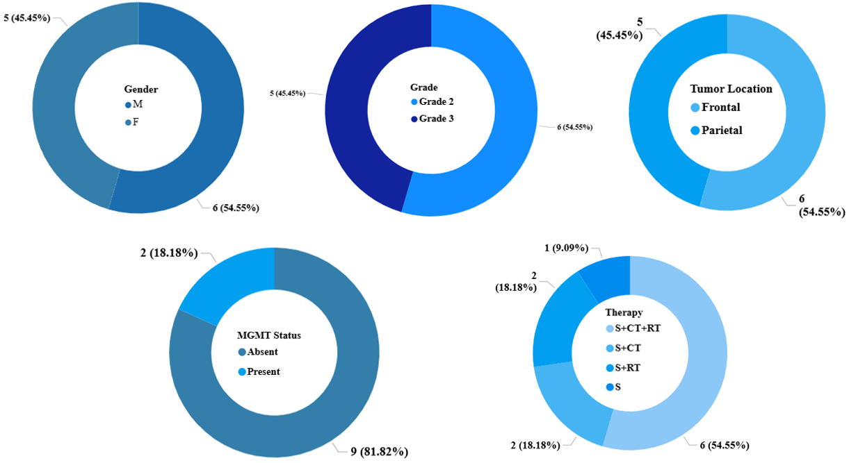
Fig 1:- Distribution of Clinicopathological parameters among 11 patients studied

- Immunohistochemistry Marker Analysis
Across all 11 tumor samples, IDH mutations were uniformly detected by IHC, confirming an IDH-mutant status in the entire cohort. TP53 mutations were identified in three samples. ATRX expression was retained in all tumors, with one sample showing focal, patchy partial positivity. TERT promoter mutations could not be evaluated using IHC. Collectively, these IIHC findings are consistent with the molecular profile of IDH-mutant oligodendrogliomas.

- Florescent In-Situ Hybridization (FISH)
For 1p/19q co-deletion, all samples evaluated by FISH. Out of 11 samples, 10 cases were negative, indicating absence of whole-arm 1p and 19q loss. Only one sample demonstrated a positive result, confirming true 1p/19q co-deletion and supporting a definitive oligodendroglioma diagnosis in that case.

- Single Nucleotide Variants
On NGS platform, we detected total 40 SNVs in 14 glioma-associated genes. The highest mutation frequencies observed in IDH1 (26.7%) followed by TERT (20%), TP53 (10%), NOTCH1 (6.7%), PIK3CA (6.7%), and a spectrum of lower-frequency alterations in ATRX, FBXW7, MTOR, PDGFRA, PIK3R1, POLE, PTEN, ROS1, and SLX4 (each 3.3%). This mutational landscape reflects canonical glioma biology, where the co-occurrence of IDH1 with TP53 and/or ATRX is more characteristic of IDH-mutant astrocytoma, whereas isolated TERT promoter mutations are more often associated with oligodendroglioma, although they are not dominant in this cohort. Overall, the profile highlights convergent disruption of DNA repair and PI3K–AKT–mTOR signaling pathways, supporting the role of panel-based molecular profiling in refining integrated histomolecular diagnosis and improving clinicopathological stratification.
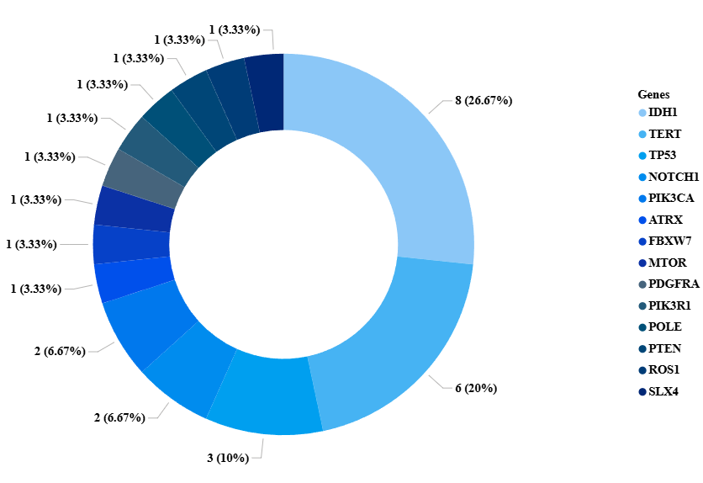
Fig 2:- Distribution of various SNVs found across 11 Patients from the study cohort

SNV analysis by NGS identified IDH-wild-type status in four of eleven samples, which supports a diagnosis of IDH-wild-type astrocytoma over oligodendroglioma.

One sample was IDH-mutant by both NGS and IHC and exhibited 1p/19q co-deletion by FISH. However, NGS additionally detected ATRX mutations despite ATRX appearing retained on IHC. This discordance illustrates that NGS can reveal clinically relevant alterations that may be limited by IHC and FISH. While IHC and FISH remain traditional and gold standard techniques in routine practice, NGS provides more sensitive detection for a subset of alterations, highlighting the limitations of IHC and FISH in certain contexts.

The reason behind the discordant findings of FISH and NGS could be that the FISH technique cannot distinguish partial from whole-arm 1p/19q co-deletion. This could may misinterpret such as False Positive even though, there is partial arm deletion of 1p/19q, especially in glioma subtypes (Ball et al., 2020). In contrast, NGS evaluates genome-wide copy number changes using read depth, accurately distinguishing true whole-arm loss from segmental deletions However, further studies should be incorporated for orthogonal validation.

Table 1:- Genetic alterations and protein expression of various oligodendroglioma specific genes
Sample 5 By NGS
Gene | AA Change | Type | Call
IDH1 | p.Arg132His | snp | PRESENT (HETEROZYGOUS)
TP53 | p.Arg273Cys | snp | PRESENT (HETEROZYGOUS)
ATRX | p.Gln2194Leu | snp | PRESENT (HETEROZYGOUS)

- Detection of Fusions in NGS
NGS identified nine fusion events spanning four fusion types. The most frequent, PTPRZ1–MET, is a recognized astrocytoma hallmark, driving MET activation and aggressive tumor behaviour (Rodriguez et al., 2025). C11orf95–RELA characterizes astrocytic tumors through NF-κB pathway activation (Kardian et al., 2024). EGFR–DYRK1A supports oncogenic EGFR signaling, predominantly in astrocytoma (Liao et al., 2025). EML4–ALK, though rare in gliomas, is reported more often in astrocytic lineages and carries potential therapeutic relevance (Blandin et al., 2023).

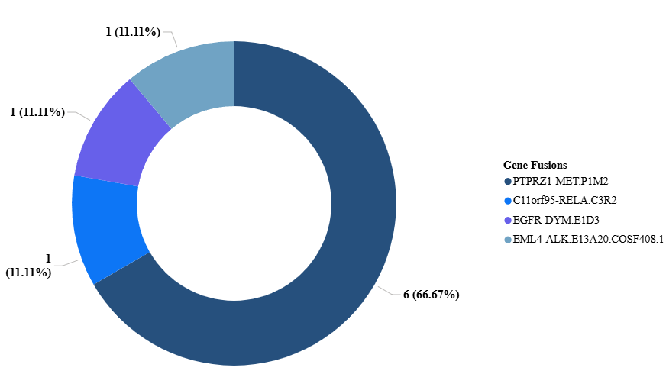
Figure 3:- Gene fusion spectrum detected by NGS across 11 patients

- Analysis Using Copy Number Variation
The remaining 6 genes that showed IDH mutation and ATRX retention, were analysed using another parameter- CNV, which has 12 specific genes for oligodendrogliomas; out of which 7 genes namely ARID1A, JAK1, MAGOH, MTOR, MYCL, NOTCH2 and NRAS are located on p-arm of chromosome 1 and rest 5 genes namely AKT2, AXL, CCNE1, ERCC2 and PP2RIA are located on q-arm of chromosome 19. Using Torrent Suite™ and Ion Reporter™ software, CNV analyses were classified as "definite" or "probable" based on confidence intervals of p-values, amplicon coverage, and the coefficient of variation metrics, respectively where A gene is considered DEFINITE if any P-value < 0.05, Valid CNV amplicons > 10 and 95% CNV confidence < 2, otherwise the gene is classified as PROBABLE (Ali et al., 2020)

Sample 1:- Although 7 out of 12 genes on both arms, showed significant p-values, only 2 genes - specifically on 19q arm showed definite loss, eliminating the probability of sample to be classified as oligodendroglioma.

Table 2:- Identification of co-deletion of 1p/19q arm specific genes using CNV-NGS analysis
Variant ID | Locus | Call | P-Value | CNV Confidence | Valid CNV Amplicons | Loss | Arm
ARID1A | chr1:27022977 | ABSENT | 0 | 5%:0, 95%:0.3 | 95 | Probable | p
JAK1 | chr1:65310460 | ABSENT | 0.03493 | 5%:0, 95%:1.53 | 3 | Probable | p
MAGOH | chr1:53692719 | ABSENT | 0.5071 | 5%:0, 95%:4.46 | 1 | Probable | p
MTOR | chr1:11168315 | ABSENT | 1.10E-04 | 5%:0, 95%:0.97 | 13 | Probable | p
MYCL | chr1:40362966 | ABSENT | 2.83E-04 | 5%:0, 95%:0.9 | 9 | Probable | p
NOTCH2 | chr1:120457924 | ABSENT | 0 | 5%:0.09, 95%:0.44 | 111 | Probable | p
NRAS | chr1:115252191 | ABSENT | 0.05443 | 5%:0, 95%:1.69 | 3 | Probable | p
AKT2 | chr19:40739755 | ABSENT | 0.00196 | 5%:0, 95%:1.23 | 11 | Definite | q
AXL | chr19:41725295 | ABSENT | 0.002916 | 5%:0.03, 95%:1.29 | 11 | Definite | q
CCNE1 | chr19:30303882 | ABSENT | 3.03E-06 | 5%:0, 95%:0.5 | 10 | Probable | q
ERCC2 | chr19:45855711 | ABSENT | 0.02773 | 5%:0, 95%:1.55 | 5 | Probable | q
PPP2R1A | chr19:52715952 | ABSENT | 0.07519 | 5%:0, 95%:1.81 | 2 | Probable | q
Sample 2:- Although 4 out of 12 genes on both arms, showed significant p-values, only 1 gene - specifically on 1p arm showed definite loss, ruling out the sample to be classified as oligodendroglioma.

Table 3:- Understanding co-deletion of 1p/19q arm specific genes using CNV-NGS analysis
Variant ID | Locus | Call | P-Value | CNV Confidence | Valid CNV Amplicons | Loss | Arm
ARID1A | chr1:27022977 | ABSENT | 0 | 5%:0.36, 95%:0.69 | 95 | Probable | p
JAK1 | chr1:65310460 | ABSENT | 0.137 | 5%:0, 95%:2.16 | 3 | Probable | p
MAGOH | chr1:53692719 | ABSENT | 0.543 | 5%:0, 95%:4.01 | 1 | Probable | p
MTOR | chr1:11168315 | ABSENT | 3.25E-04 | 5%:0.26, 95%:1.23 | 13 | Definite | p
MYCL | chr1:40362966 | NO CALL | . |  | 9 | Probable | p
NOTCH2 | chr1:120457924 | ABSENT | 0 | 5%:0.44, 95%:0.77 | 110 | Probable | p
NRAS | chr1:115252191 | ABSENT | 0.101 | 5%:0, 95%:2.02 | 3 | Probable | p
AKT2 | chr19:40739755 | ABSENT | 0.007218 | 5%:0.38, 95%:1.53 | 11 | Probable | q
AXL | chr19:41725295 | ABSENT | 0.007695 | 5%:0.4, 95%:1.55 | 11 | Probable | q
CCNE1 | chr19:30303882 | ABSENT | 2.90E-05 | 5%:0, 95%:0.92 | 10 | Probable | q
ERCC2 | chr19:45855711 | ABSENT | 0.08453 | 5%:0.21, 95%:1.96 | 5 | Probable | q
PPP2R1A | chr19:52715952 | ABSENT | 0.0575 | 5%:0, 95%:1.73 | 2 | Probable | q
Sample 4:- Out of 12 genes, only 1 gene on 1p arm showed definite loss and statistically significant P-value. Thus, this sample cannot be classified as oligodendroglioma

Table 4:- Interpreting co-deletion of 1p/19q arm specific genes using CNV-NGS analysis
Variant ID | Locus | Call | P-Value | CNV Confidence | Valid CNV Amplicons | Loss | Arm
ARID1A | chr1:27022977 | ABSENT | 0.6259 | 5%:1.67, 95%:2.19 | 95 | Probable | p
JAK1 | chr1:65310460 | ABSENT | 0.1641 | 5%:1.78, 95%:5.94 | 3 | Probable | p
MAGOH | chr1:53692719 | ABSENT | 0.5149 | 5%:0.72, 95%:7.8 | 1 | Probable | p
MTOR | chr1:11168315 | ABSENT | 0.8975 | 5%:1.4, 95%:2.85 | 13 | Probable | p
MYCL | chr1:40362966 | NO CALL | . |  | 9 | Probable | p
NOTCH2 | chr1:120457924 | ABSENT | 1.76E-9 | 5%:2.76, 95%:3.38 | 111 | Definite | p
NRAS | chr1:115252191 | ABSENT | 0.3327 | 5%:1.44, 95%:5.21 | 3 | Probable | p
AKT2 | chr19:40739755 | ABSENT | 0.3666 | 5%:1.66, 95%:3.39 | 11 | Probable | q
AXL | chr19:41725295 | ABSENT | 0.9679 | 5%:1.28, 95%:2.83 | 11 | Probable | q
CCNE1 | chr19:30303882 | ABSENT | 0.2195 | 5%:0.81, 95%:2.21 | 10 | Probable | q
ERCC2 | chr19:45855711 | ABSENT | 0.9437 | 5%:1.03, 95%:3.38 | 5 | Probable | q
PPP2R1A | chr19:52715952 | ABSENT | 0.7828 | 5%:0.35, 95%:3.82 | 2 | Probable | q
Sample 3:- Although partial molecular evidence of 1p/19q loss was observed, definitive deletion was confirmed in only three of twelve genes. As complete whole-arm 1p/19q co-deletion was not demonstrated by FISH, the tumor did not fulfill WHO 2021 diagnostic criteria for oligodendroglioma.

Table 5:- Analysing co-deletion of 1p/19q arm specific genes using CNV-NGS analysis
Variant ID | Locus | Call | P-Value | CNV Confidence | Valid CNV Amplicons | Loss | Arm
ARID1A | chr1:27022977 | ABSENT | 0 | 5%:0, 95%:0.19 | 95 | Probable | p
JAK1 | chr1:65310460 | ABSENT | 0.09483 | 5%:0, 95%:1.97 | 3 | Probable | p
MAGOH | chr1:53692719 | ABSENT | 0.3232 | 5%:0, 95%:3.31 | 1 | Probable | p
MTOR | chr1:11168315 | ABSENT | 1.084E-07 | 5%:0, 95%:0.58 | 13 | Definite | p
MYCL | chr1:40362966 | ABSENT | 0.00000032 | 5%:0, 95%:0.43 | 9 | Probable | p
NOTCH2 | chr1:120457924 | ABSENT | 0 | 5%:0.38, 95%:0.72 | 111 | Probable | p
NRAS | chr1:115252191 | ABSENT | 0.0268 | 5%:0, 95%:1.49 | 3 | Probable | p
AKT2 | chr19:40739755 | ABSENT | 0.00002239 | 5%:0, 95%:0.87 | 11 | Definite | q
AXL | chr19:41725295 | ABSENT | 6.183E-07 | 5%:0, 95%:0.6 | 11 | Definite | q
CCNE1 | chr19:30303882 | ABSENT | 8.23E-10 | 5%:0, 95%:0.18 | 10 | Probable | q
ERCC2 | chr19:45855711 | ABSENT | 0.003783 | 5%:0, 95%:1.15 | 5 | Probable | q
PPP2R1A | chr19:52715952 | ABSENT | 0.01116 | 5%:0, 95%:1.06 | 2 | Probable | q
Sample 8:- Three genes out of twelve showed definite loss on 1p/19q arm, making sample partial positive for oligodendroglioma; but complete 1p/19q co-deletion was not demonstrated by FISH in the sample and thus the tumor did not fulfill WHO 2021 diagnostic criteria for oligodendroglioma.

Table 6:- Evaluating co-deletion of 1p/19q arm specific genes using CNV-NGS analysis
Variant ID | Locus | Call | P-Value | CNV Confidence | Valid CNV Amplicons | Loss | Arm
ARID1A | chr1:27022977 | ABSENT | 0 | 5%:0.28, 95%:0.61 | 95 | Probable | p
JAK1 | chr1:65310460 | ABSENT | 0.1161 | 5%:0, 95%:2.06 | 3 | Probable | p
MAGOH | chr1:53692719 | ABSENT | 0.5676 | 5%:0, 95%:4.13 | 1 | Probable | p
MTOR | chr1:11168315 | ABSENT | 6.77E-07 | 5%:0.15, 95%:1.09 | 13 | Definite | p
MYCL | chr1:40362966 | NO CALL | . |  | 9 | Probable | p
NOTCH2 | chr1:120457924 | ABSENT | 0 | 5%:0.46, 95%:0.79 | 110 | Probable | p
NRAS | chr1:115252191 | ABSENT | 0.07484 | 5%:0, 95%:1.88 | 3 | Probable | p
AKT2 | chr19:40739755 | ABSENT | 0.001744 | 5%:0.25, 95%:1.34 | 11 | Definite | q
AXL | chr19:41725295 | ABSENT | 0.001064 | 5%:0.22, 95%:1.29 | 11 | Definite | q
ERCC2 | chr19:45855711 | ABSENT | 0.02812 | 5%:0.01, 95%:1.62 | 5 | Probable | q
CCNE1 | chr19:30303882 | ABSENT | 6.25E-07 | 5%:0, 95%:0.78 | 10 | Probable | q
PPP2R1A | chr19:52715952 | ABSENT | 0.03477 | 5%:0, 95%:1.5 | 2 | Probable | q
Sample 9:- Definite loss of three out of twelve genes on the 1p/19q arms rendered the sample partially positive for oligodendroglioma; however, complete whole-arm 1p/19q co-deletion was not demonstrated by FISH. Consequently, the tumor did not meet the WHO 2021 diagnostic criteria for oligodendroglioma.

Table 7:- Assessment of 1p/19q arm–specific gene co-deletion using CNV-NGS analysis
Variant ID | Locus | Call | P-Value | CNV Confidence | Valid CNV Amplicons | Loss | Arm
ARID1A | chr1:27022977 | ABSENT | 0 | 5%:0.04, 95%:0.37 | 95 | Probable | p
JAK1 | chr1:65310460 | ABSENT | 0.2353 | 5%:0, 95%:2.5 | 3 | Probable | p
MAGOH | chr1:53692719 | ABSENT | 0.7233 | 5%:0, 95%:5.06 | 1 | Probable | p
MTOR | chr1:11168315 | ABSENT | 3.72E-07 | 5%:0, 95%:0.96 | 13 | Definite | p
MYCL | chr1:40362966 | NO CALL | . |  | 9 | Probable | p
NOTCH2 | chr1:120457924 | ABSENT | 0 | 5%:0.35, 95%:0.7 | 111 | Probable | p
NRAS | chr1:115252191 | ABSENT | 0.03028 | 5%:0, 95%:1.5 | 3 | Probable | p
AKT2 | chr19:40739755 | ABSENT | 7.76E-08 | 5%:0, 95%:0.94 | 11 | Definite | q
AXL | chr19:41725295 | ABSENT | 9.98E-08 | 5%:0, 95%:0.96 | 11 | Definite | q
ERCC2 | chr19:45855711 | ABSENT | 0.0004424 | 5%:0, 95%:0.77 | 5 | Probable | q
CCNE1 | chr19:30303882 | ABSENT | 2.433E-07 | 5%:0, 95%:0.44 | 10 | Probable | q
PPP2R1A | chr19:52715952 | ABSENT | 0.01855 | 5%:0, 95%:1.21 | 2 | Probable | q

In CNV analysis by NGS, a “Call: ABSENT” across all six samples indicates the absence of statistically significant CNVs (deletions or amplifications) at the assessed loci relative to a diploid reference. Although these tumors were IDH-mutant and ATRX-retained, the consistent absence of CNV calls across the 1p/19q regions precludes classification as oligodendroglioma, as WHO 2021 criteria require complete whole-arm 1p/19q co-deletion for this diagnosis( Sejda et al., 2023).

Discussion
The 5th edition of the World Health Organization Classification of Tumors of the Central Nervous System (WHO CNS5) has fundamentally shifted glioma diagnostics toward an integrated molecular framework. Oligodendroglioma is now strictly defined by the presence of an IDH mutation and complete whole-arm 1p/19q co-deletion, independent of histological morphology. This molecular requirement has significantly reduced the subjectivity historically associated with morphologic interpretation and has improved diagnostic reproducibility across institutions (Reuss, 2023; Sahm et al., 2023). Within this context, accurate determination of IDH status and 1p/19q codeletion is essential for appropriate tumor classification, prognostic stratification, and therapeutic planning.

In our institutional cohort, all 11 tumors were initially suspected to represent oligodendroglioma based on histomorphology and IHC findings, including IDH1 R132H positivity and retained ATRX expression. However, further molecular characterization using NGS and FISH revealed discordances in several cases. Four tumors demonstrated IDH-wild-type status on NGS analysis, which excludes oligodendroglioma under WHO CNS5 criteria. Additionally, the majority of tumors lacked definitive whole-arm 1p/19q co-deletion when evaluated by FISH and CNV analysis.

These findings highlight the complexity of glioma classification and the potential for diagnostic refinement when multiple modalities are integrated. Importantly, our observations should not be interpreted as evidence of inadequacy of IHC. Immunohistochemistry remains an essential, rapid, and cost-effective screening tool, particularly for detecting the common IDH1 R132H mutation and assessing ATRX expression. However, IHC does not detect non-canonical IDH variants, cannot evaluate IDH2 mutations, and does not directly assess chromosomal arm-level deletions. Therefore, discrepancies between IHC and NGS may reflect methodological scope rather than methodological failure.

The identification of TP53 and ATRX alterations in several tumors further supported astrocytic molecular signatures in a subset of cases. In large genomic datasets, particularly those generated by The Cancer Genome Atlas (TCGA), the co-occurrence of TP53 and ATRX mutations has been shown to strongly associate with IDH-mutant astrocytomas, whereas oligodendrogliomas typically demonstrate IDH mutation, 1p/19q co-deletion, and TERT promoter mutation without ATRX loss (Cancer Genome Atlas Research Network, 2015). While our findings align with these established molecular patterns, the small sample size limits definitive conclusions regarding frequency or predictive value in our population.

With respect to 1p/19q evaluation, FISH confirmed co-deletion in only one tumor. NGS-based CNV analysis identified partial chromosomal losses in multiple cases; however, complete whole-arm deletion was not consistently demonstrated. It is recognized that FISH interrogates specific probe loci and may occasionally be influenced by segmental deletions or chromosomal imbalance, whereas NGS estimates copy number changes through read-depth distribution across multiple genomic regions. Differences between these techniques may therefore reflect analytical resolution and interpretative criteria rather than clear diagnostic hierarchy. However, our study was not designed to compare sensitivity or specificity between platforms, and caution should be exercised in extrapolating comparative performance conclusions.

Fusion analysis identified rearrangements such as PTPRZ1–MET and EML4–ALK in select tumors. These alterations have been more frequently described in astrocytic tumors and may carry potential therapeutic relevance. In our series, their detection provided additional genomic context but should be interpreted as descriptive findings rather than lineage-defining events without orthogonal validation or functional correlation.

Collectively, our results illustrate how comprehensive genomic profiling may classify integrated glioma diagnosis in select cases. Rather than replacing established techniques, NGS appears to function as a complementary modality that expands the molecular landscape beyond predefined markers. In diagnostically challenging cases, particularly when histology and IHC findings are ambiguous, broader genomic assessment may provide additional information to support classification within the WHO CNS5 framework.

Nevertheless, several limitations must be acknowledged. This was a small, single-center observational study with only 11 cases. The limited sample size restricts statistical generalizability and prevents formal performance comparison between diagnostic modalities. In addition, orthogonal validation of discordant findings was not performed in all cases. Therefore, our observations should be interpreted as exploratory and hypothesis-generating rather than definitive evidence of diagnostic performance differences.

Future multicenter studies with larger cohorts and standardized comparative methodologies will be necessary to determine the optimal integration of IHC, FISH, and NGS in routine diagnostic algorithms for diffuse gliomas.

Conclusion

In a series of Oligodendroglioma patients, using integrated molecular analysis, we identified discrepancies between initial IHC-based classification and comprehensive molecular profiling. It is infact underscoring the importance of confirming both, IDH mutation status and whole-arm 1p/19q co-deletion in accordance with WHO CNS5 criteria. While FISH remains an established method for assessing 1p/19q status and IHC serves as an important screening tool. In our cohort, NGS contributed additional molecular information that aided in refining tumor classification. However, this study was not designed to establish diagnostic superiority of any single modality.

Also, the smaller sample size would always remains challenging to interpret the data. Therefore, study in a larger subset of patients is warranted to further evaluate the complementary roles of IHC, FISH, and NGS in the molecular diagnosis of Oligodensroglioma tumors.

Consent

As per international standards or university standards, patient(s) written consent has been collected and preserved by the author(s).

Ethical approval
“All authors hereby declare that all experiments have been examined and approved by the appropriate ethics committee and have therefore been performed in accordance with the ethical standards laid down in the 1964 Declaration of Helsinki.”

Disclaimer (Artificial intelligence)
Author(s) hereby declare that NO generative AI technologies such as Large Language Models (ChatGPT, COPILOT, etc.) and text-to-image generators have been used during the writing or editing of this manuscript.

- References
- Bale, Tejus A., and Marc K. Rosenblum. "The 2021 WHO classification of tumors of the central nervous system: an update on pediatric low‐grade gliomas and glioneuronal tumors." Brain Pathology 32.4 (2022): e13060.
- Jiang, K., Kalluri, A., Odonkor, M., Heinemann, D. M., Weber-Levine, C., Raj, D., ... & Rincon-Torroella, J. (2025). Trends in the Management of Oligodendrogliomas: A Multinational and Multidisciplinary Survey Study. World neurosurgery, 196, 123716.
- Guo, X., Shi, Y., Liu, D., Li, Y., Chen, W., Wang, Y., ... & Ma, W. (2023). Clinical updates on gliomas and implications of the 5th edition of the WHO classification of central nervous system tumors. Frontiers in Oncology, 13, 1131642.
- Mandaliya, N., Trivedi, P., Patel, D. M., Kazi, M., & Trivedi, P. (2023). Significance Of Molecular Markers and Deletion Of 1p/19q In Oligodendroglioma Patients by Fluorescence in Situ Hybridization Technique: An Institutional Study. Clinical Reviews and Case Reports, 2(5).
- Higuchi, F., Uzuka, T., Matsuda, H., Sumi, T., Iwata, K., Namatame, T., ... & Ueki, K. (2024). Rise of oligodendroglioma hypermutator phenotype from a subclone harboring TP53 mutation after TMZ treatment. Brain Tumor Pathology, 41(2), 80-84.
- Arita, H., & Ichimura, K. (2022). Prognostic significance of TERT promoter mutations in adult-type diffuse gliomas. Brain Tumor Pathology, 39(3), 121-129.
- Brandner, S., McAleenan, A., Jones, H. E., Kernohan, A., Robinson, T., Schmidt, L., ... & Kurian, K. M. (2022). Diagnostic accuracy of 1p/19q codeletion tests in oligodendroglioma: A comprehensive meta‐analysis based on a Cochrane systematic review. Neuropathology and applied neurobiology, 48(4), e12790.
- Tirrò, E., Massimino, M., Broggi, G., Romano, C., Minasi, S., Gianno, F., ... & Vigneri, P. (2022). A custom DNA-based NGS panel for the molecular characterization of patients with diffuse gliomas: diagnostic and therapeutic applications. Frontiers in Oncology, 12, 861078.
- Dang, D. D., Rosenblum, J. S., Shah, A. H., Zhuang, Z., & Doucet-O’Hare, T. T. (2023). Epigenetic regulation in primary CNS tumors: an opportunity to bridge old and new WHO classifications. Cancers, 15(9), 2511.
- Wu, H., Wei, M., Li, Y., Ma, Q., & Zhang, H. (2022). Research progress on the regulation mechanism of key signal pathways affecting the prognosis of glioma. Frontiers in Molecular Neuroscience, 15, 910543.
- Li, H. L., Dong, L. L., Jin, M. J., Li, Q. Y., Wang, X., Jia, M. Q., ... & Yuan, S. (2023). A review of the regulatory mechanisms of N-myc on cell cycle. Molecules, 28(3), 1141.
- Abdallah, A. S. (2023). Investigation of the Initiation, Progression and Treatment of Pediatric Gliomas (Doctoral dissertation, Northwestern University).
- Peris-Martínez, I., Romero-Murillo, S., Vicente, C., Narla, G., & Odero, M. D. (2023). Regulation and role of the PP2A-B56 holoenzyme family in cancer.
- Ball, M. K., Kollmeyer, T. M., Praska, C. E., McKenna, M. L., Giannini, C., Raghunathan, A., ... & Ida, C. M. (2020). Frequency of false-positive FISH 1p/19q codeletion in adult diffuse astrocytic gliomas. Neuro-oncology advances, 2(1), vdaa109.
- Rodriguez, A., Dixit, K., O’Hara Jr, R. M., & Vojnic, M. (2025). Efficacy of tepotinib in patients with high-grade glioma with MET alterations: A case series. Neuro-Oncology Practice, npaf130.
- Kardian, A. S., & Mack, S. (2024). The intersection of epigenetic alterations and developmental state in pediatric ependymomas. Developmental Neuroscience, 46(6), 365-372.
- Liao, C., Wang, Q., & Xie, Z. (2025). Kinase Inhibitors for the Treatment of Brain Diseases. Trends in CNS Drug Discovery, 311-352.
- Blandin, A. F., Giglio, R., Graham, M. S., Garcia, G., Malinowski, S., Woods, J. K., ... & Ligon, K. L. (2023). ALK amplification and rearrangements are recurrent targetable events in congenital and adult glioblastoma. Clinical Cancer Research, 29(14), 2651-2667.
- Ali, R. H., Alateeqi, M., Jama, H., Alrumaidhi, N., Alqallaf, A., Mohammed, E. M., ... & Bahzad, S. (2023). Evaluation of the Oncomine Comprehensive Assay v3 panel for the detection of 1p/19q codeletion in oligodendroglial tumours. Journal of Clinical Pathology, 76(2), 103-110.
- Sejda, A., Grajkowska, W., Trubicka, J., Szutowicz, E., Wojdacz, T., Kloc, W., & Iżycka-Świeszewska, E. (2022). WHO CNS5 2021 classification of gliomas: A practical review and road signs for diagnosing pathologists and proper patho-clinical and neuro-oncological cooperation. Folia neuropathologica, 60(2), 137-152.
- Reuss, D. E. (2023). Updates on the WHO diagnosis of IDH-mutant glioma. Journal of Neuro-oncology, 162(3), 461-469.
- Kessler, T., Ito, J., Wick, W., & Wick, A. (2023). Conventional and emerging treatments of astrocytomas and oligodendrogliomas. Journal of Neuro-oncology, 162(3), 471-478.
- Guarnaccia, M., Guarnaccia, L., La Cognata, V., Navone, S. E., Campanella, R., Ampollini, A., ... & Cavallaro, S. (2022). A targeted next-generation sequencing panel to genotype gliomas. Life, 12(7), 956.
- Houssaini, A. S., Lamrabet, S., Senhaji, N., Sekal, M., Nshizirungu, J. P., Mahfoudi, H., ... & Bennis, S. (2024). Prognostic value of ATRX and p53 status in high-grade glioma patients in Morocco. Cureus, 16(3).
- Mohamed, E., Kumar, A., Zhang, Y., Wang, A. S., Chen, K., Lim, Y., ... & Phillips, J. J. (2022). PI3K/AKT/mTOR signaling pathway activity in IDH-mutant diffuse glioma and clinical implications. Neuro-oncology, 24(9), 1471-1481.
- D’Amico, M., & De Amicis, F. (2022). Aberrant Notch signaling in gliomas: A potential landscape of actionable converging targets for combination approach in therapies resistance. Cancer Drug Resistance, 5(4), 939.
- Davalan, W., & Alkins, R. (2025). Prognostic and predictive determinants in high-grade gliomas: integrating tumor-intrinsic biology with patient and system-level factors. Frontiers in Neurology, 16, 1664458.
- Lowe, B. R., Maxham, L. A., Hamey, J. J., Wilkins, M. R., & Partridge, J. F. (2019). Histone H3 mutations: an updated view of their role in chromatin deregulation and cancer. Cancers, 11(5), 660.
- Payliss, B. J., Patel, A., Sheppard, A. C., & Wyatt, H. D. (2021). Exploring the structures and functions of macromolecular SLX4-nuclease complexes in genome stability. Frontiers in Genetics, 12, 784167.
- Masui, K., Onizuka, H., Muragaki, Y., Kawamata, T., Kurata, A., & Komori, T. (2025). Progression of long-term “untreated” oligodendroglioma cases: Possible contribution of genomic instability. Brain Tumor Pathology, 42(2), 43-47.
- Ball, Matthew K., Thomas M. Kollmeyer, Corinne E. Praska, Michelle L. McKenna, Caterina Giannini, Aditya Raghunathan, Mark E. Jentoft et al. "Frequency of false-positive FISH 1p/19q codeletion in adult diffuse astrocytic gliomas." Neuro-oncology advances 2, no. 1 (2020): vdaa109.
- Sina, M. (2023). Identification and interpretation of pathogenic variants following Next Generation Sequencing (NGS) analysis in human Mendelian disorders.
- Sahm, F., Brandner, S., Bertero, L., Capper, D., French, P. J., Figarella-Branger, D., ... & Wesseling, P. (2023). Molecular diagnostic tools for the World Health Organization (WHO) 2021 classification of gliomas, glioneuronal and neuronal tumors; an EANO guideline. Neuro-oncology, 25(10), 1731-1749.
- Polivka, J., Svajdler, M., Priban, V., Mracek, J., Kasik, P., Martinek, P., ... & Topolcan, O. (2022). Oncogenic fusions in gliomas: an institutional experience. Anticancer Research, 42(4), 1933-1939.
- Yang, W., Zhao, X., Zheng, A., Liu, Z., Ma, J., Zhang, X., ... & Liu, Q. (2023). Identification of MET fusions in solid tumors: a multicenter, large scale study in China. International journal of cancer, 152(6), 1259-1268.
- Malgulwar, P. B., Nambirajan, A., Pathak, P., Faruq, M., Rajeshwari, M., Singh, M., ... & Sharma, M. C. (2018). C11orf95-RELA fusions and upregulated NF-KB signalling characterise a subset of aggressive supratentorial ependymomas that express L1CAM and nestin. Journal of neuro-oncology, 138(1), 29-39.
- Zuckermann, M., He, C., Andrews, J., Bagchi, A., Sloan-Henry, R., Bianski, B., ... & Baker, S. J. (2024). Capmatinib is an effective treatment for MET-fusion driven pediatric high-grade glioma and synergizes with radiotherapy. Molecular cancer, 23(1), 123.
- Chen, H., Zhang, M., Bai, L., Niu, Y., Wang, X., Jiang, R., ... & Zhong, D. (2024). Coexistence of a novel SV2B-ALK, EML4-ALK double-fusion in a lung poorly differentiated adenocarcinoma patient and response to alectinib: a case report and literature review. Frontiers in Oncology, 14, 1453259.
- Vashisht, V., Vashisht, A., Mondal, A. K., Woodall, J., & Kolhe, R. (2024). From genomic exploration to personalized treatment: next-generation sequencing in oncology. Current Issues in Molecular Biology, 46(11), 12527-12549.
- Wong, D. (2025). A Review of Molecular Techniques and Biomarkers for the Diagnosis of Tumors of the Central Nervous System. Advances in Molecular Pathology.
- Gargallo, P., Molero, M., Bilbao, C., Stuckey, R., Carrillo-Cruz, E., Hermosín, L., ... & Calabria, I. (2022). Next-generation DNA sequencing-based gene panel for diagnosis and genetic risk stratification in onco-hematology. Cancers, 14(8), 1986.
- Cancer Genome Atlas Research Network. Comprehensive, integrative genomic analysis of diffuse lower-grade gliomas. New England Journal of Medicine. 2015;372(26):2481–2498.

