Comprehensive Study of Substrate Materials for Rectangular Microstrip Patch Antenna At 3.5 GHz

Abstract
5G communication demands compact, efficient antennas capable of operating in key bands like 3.5 GHz to support high data rates and reliable connectivity. Among various types, antenna design focuses on balancing performance, size, and integration for modern wireless applications. This study presents a comprehensive evaluation of ten different substrate materials for a rectangular microstrip patch antenna (RMPA) designed for 3.5 GHz 5G applications. The substrates investigated include FR-4, RO4730JXR, Teflon, E-glass, Taconic RF-35, Polystyrene, Form, Plexiglass, Fused Quartz, and TMM4. Key antenna performance parameters such as bandwidth, return loss, voltage standing wave ratio (VSWR), impedance matching, and radiation characteristics were analyzed using MATLAB R2024b-based electromagnetic modelling. Results indicate that the Plexiglass substrate achieved the best impedance matching with a return loss of −20.7726 dB and VSWR of 1.0043, while the Form substrate provided the widest bandwidth of 6.39 % with a good return loss of −17.84488 dB. The study emphasises the critical influence of substrate dielectric properties on antenna efficiency, bandwidth, and radiation behavior. Findings provide valuable guidance for material selection in sub-6 GHz 5G antenna design and contribute to the advancement of compact, high-performance wireless communication systems.
Keywords: Rectangular microstrip patch antenna, substrate materials, 5G communication, return loss, VSWR.
1.0 Introduction
The rapid deployment of fifth-generation (5G) wireless communication systems has significantly increased the demand for high-performance antennas capable of supporting advanced wireless technologies. Unlike previous generations of mobile communication, 5G networks are designed to deliver enhanced mobile broadband, ultra-reliable low-latency communication, and massive machine-type connectivity. These features require antenna systems that are compact, efficient, and capable of operating across designated frequency bands. One of the most widely adopted frequency ranges for 5G is the sub-6 GHz band, particularly the 3.5 GHz spectrum, which offers a suitable balance between wide coverage, signal penetration, and high data transmission rates [1]. As a result, designing antennas that can effectively operate at this frequency has become an important area of research in modern wireless communication engineering.
Antennas are essential components in any wireless communication system, as they function as transducers that convert electrical signals into electromagnetic waves for transmission and receive electromagnetic waves, which are then converted back into electrical signals for processing. Various antenna types have been developed over the years to meet the diverse requirements of communication systems. Common examples include monopole antennas, Yagi–Uda antennas, parabolic reflector antennas, log-periodic antennas, and microstrip patch antennas, each of which is designed for specific applications and performance requirements [2]. While some antenna structures offer high gain and long-distance transmission capabilities, others are preferred for their compactness and ease of integration into modern electronic devices.
Among these antenna types, the microstrip patch antenna (MPA) has gained considerable attention due to its simple structure, low cost, and compatibility with planar circuit technology. Microstrip antennas are typically constructed by printing a metallic radiating patch on one side of a dielectric substrate, while the other side is covered with a ground plane. This planar configuration makes them highly suitable for integration with printed circuit boards and other microwave circuits. In addition, microstrip patch antennas are available in various geometrical shapes such as rectangular, circular, triangular, and slotted configurations, allowing designers to modify antenna characteristics according to application requirements.
Among the various geometries, the rectangular microstrip patch antenna (RMPA) is the most widely used due to its simplicity and predictable radiation characteristics. The RMPA offers several advantages that make it attractive for 5G communication systems. First, it has a low-profile and lightweight configuration, which is ideal for compact wireless devices and base station modules. Second, it offers ease of fabrication and integration with planar circuits, since it can be manufactured using standard printed circuit board (PCB) techniques. Third, the rectangular geometry is highly compatible with antenna arrays and multiple-input multiple-output (MIMO) systems, which are essential technologies in modern 5G networks for improving data capacity, reliability, and spectral efficiency [3].
Despite these advantages, the performance of a microstrip patch antenna is strongly influenced by several design parameters, among which the substrate material plays a crucial role. The electrical and physical properties of the substrate directly affect the electromagnetic behavior of the antenna. Key substrate parameters such as dielectric constant (εr), loss tangent (tan δ), and substrate thickness (h) significantly influence important antenna characteristics, including resonant frequency stability, bandwidth, radiation efficiency, and impedance matching [5]. For instance, substrates with lower dielectric constants generally provide improved radiation efficiency and wider bandwidth, while substrates with lower loss tangent reduce dielectric losses and enhance overall antenna performance.
Therefore, selecting an appropriate substrate material is essential for optimising antenna performance in 5G applications. Different dielectric materials possess varying electrical characteristics that can either improve or degrade antenna performance depending on the application requirements. Consequently, a systematic evaluation of substrate materials is necessary to identify those that can provide optimal performance at the 3.5 GHz operating frequency.
In this work, a comparative and comprehensive investigation of ten different substrate materials is carried out to determine their suitability for rectangular microstrip patch antennas designed for 3.5 GHz 5G applications. The study evaluates key performance parameters such as return loss, bandwidth, voltage standing wave ratio (VSWR), impedance matching, and radiation characteristics. By comparing the electromagnetic performance of antennas fabricated with different substrates, this research aims to provide valuable insights into substrate selection for the design of efficient and reliable 5G antenna systems.
The substrate material plays a fundamental role in determining the overall performance of a rectangular microstrip patch antenna, particularly for 3.5 GHz 5G applications. In a microstrip antenna structure, the radiating patch is placed on a dielectric substrate above a ground plane, making the electrical and physical characteristics of the substrate critical to antenna behavior. Parameters such as dielectric constant, loss tangent, and substrate thickness directly affect key antenna characteristics, including impedance matching, bandwidth, radiation efficiency, gain, and resonant frequency stability. Therefore, careful selection of substrate materials is essential to achieve optimal antenna performance in modern wireless communication systems.
One of the most important substrate parameters is the dielectric constant (εr) [6]. The dielectric constant determines how electromagnetic waves propagate within the substrate and influences the distribution of fringing fields around the patch edges. Substrates with a low dielectric constant generally allow stronger fringing fields, which improves radiation efficiency and increase the achievable bandwidth. This characteristic is particularly beneficial for high-frequency applications such as 5G communication, where wide bandwidth and efficient radiation are essential for reliable signal transmission.
In addition, a lower dielectric constant allows more electromagnetic energy to radiate into free space rather than being confined within the substrate, thereby improving overall antenna efficiency. However, one limitation of low dielectric substrates is that they often lead to slightly larger antenna dimensions, since the effective wavelength inside the substrate increases [7]. Nevertheless, for 5G systems operating at 3.5 GHz, this trade-off is generally acceptable because improved bandwidth and radiation efficiency are more critical than minimal antenna size. Consequently, selecting an appropriate substrate material with suitable dielectric properties remains a key factor in optimizing antenna performance for next-generation wireless communication systems [8].
2.0 Influence of Substrate Material
The substrate material plays a fundamental role in determining the overall performance of a rectangular microstrip patch antenna, particularly for 3.5 GHz 5G applications. In a microstrip antenna structure, the radiating patch is placed on a dielectric substrate above a ground plane, making the electrical and physical characteristics of the substrate critical to antenna behaviour. Parameters such as dielectric constant, loss tangent, and substrate thickness directly affect key antenna characteristics, including impedance matching, bandwidth, radiation efficiency, gain, and resonant frequency stability. Therefore, careful selection of substrate materials is essential to achieve optimal antenna performance in modern wireless communication systems.
One of the most important substrate parameters is the dielectric constant (εr) [6]. The dielectric constant determines how electromagnetic waves propagate within the substrate and influences the distribution of fringing fields around the patch edges. Substrates with a low dielectric constant generally allow stronger fringing fields, which improves radiation efficiency and increase the achievable bandwidth. This characteristic is particularly beneficial for high-frequency applications such as 5G communication, where wide bandwidth and efficient radiation are essential for reliable signal transmission.
In addition, a lower dielectric constant allows more electromagnetic energy to radiate into free space rather than being confined within the substrate, thereby improving overall antenna efficiency. However, one limitation of low dielectric substrates is that they often lead to slightly larger antenna dimensions, since the effective wavelength inside the substrate increases [7]. Nevertheless, for 5G systems operating at 3.5 GHz, this trade-off is generally acceptable because improved bandwidth and radiation efficiency are more critical than minimal antenna size. Consequently, selecting an appropriate substrate material with suitable dielectric properties remains a key factor in optimising antenna performance for next-generation wireless communication systems [8].
3.0 Materials and Methodology
3.1 Investigated Substrate Materials
The following ten dielectric substrates were evaluated: FR-4, RO4730JXR, Teflon, E-glass, Taconic RF-35, Polystyrene, Form, Plexiglass, Fused Quartz, and TMM4. Each material differs in dielectric constant.

3.2 Antenna Design Parameters
The antenna was designed as shown in figure 1 to operate at a target frequency of 3.5 GHz, suitable for sub-6 GHz 5G applications. A rectangular patch geometry was selected due to its simple structure, ease of analysis, and efficient radiation characteristics [9]. The antenna was excited using a microstrip line feed, chosen for its planar configuration and ease of impedance matching [10]. All electromagnetic analyses and performance evaluations were carried out using MATLAB R2024b, enabling accurate computation of return loss, bandwidth, VSWR, and radiation characteristics.
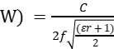 (1)
The patch width
Where c is the velocity of light, ‘w is the width of the patch for the frequency fr of operation, and dielectric constant Ɛr [11][12][13].

The patch length, (2)

The ground plane's length (L_{g}) and Substrate length (Ls)
L_{g} = Ls = L + 6h (3)
The ground plane's width (W_{g}) and Substrate Width (Ws)
W_{g} =Ws = w + 6h (4)
Where L and w, are the length and the width of the patch antenna respectively.

The Length extension, 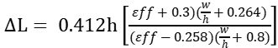 (5)
Where_{ff} = the effective dielectric constant of the substrate, L = the patch length extension, h and w = the height and width of the patch respectively [114][15].

The effective length of the patch, 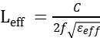 (6)
The effective dielectric constant, _{eff} 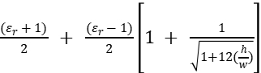 (7)

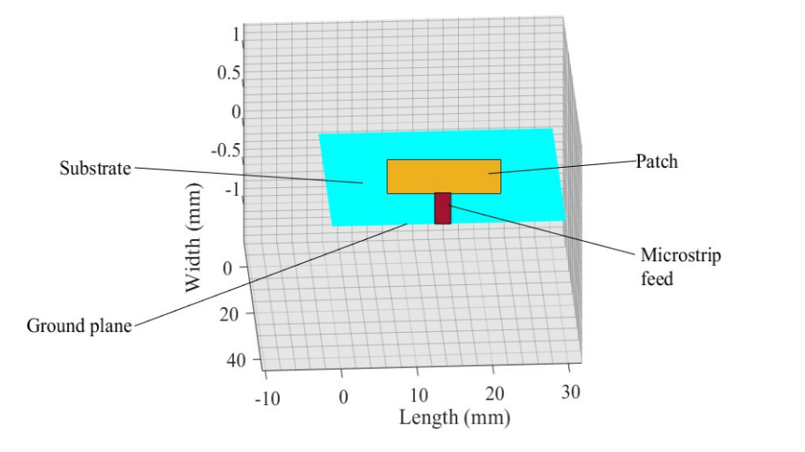
Figure 1: Design of rectangular patch antenna

3.3 Simulation Procedure
Antenna dimensions shown in table 1 for each substrate were calculated using standard RMPA formulas. The electromagnetic response was simulated over the 3–4 GHz range using MATLABR24b software. Key performance metrics, including return loss, bandwidth, VSWR, and radiation pattern, were extracted and compared. Based on these results, the best-performing substrates were identified for optimal 5G antenna operation.

Table 1: Design Dimension of Rectangular MPA with ten different Substrates
Substrates | Patch (mm) |  | Substrate and ground plane (mm) |  | Spacing  (mm) | Dielectric constant  Er | Height/ Thickness  (mm) | Feed Offset  (mm)
Substrates | Length  Lp | Width  Wp | Length  Lg | Width  Wg
FR 4 | 19.53 | 24.4 | 39.09 | 39.09 | 24.49 | 4.8 | 0.39 | 4.11
RO4730JXR | 24.70 | 30.91 | 49.45 | 49.45 | 24.49 | 3.0 | 0.49 | 5.20
Teflon | 29.53 | 36.94 | 59.11 | 59.11 | 24.49 | 2.1 | 0.59 | 6.21
E-Glass | 17.15 | 21.06 | 39.09 | 39.09 | 24.49 | 6.2 | 0.34 | 3.61
Taconic RF-35 | 22.87 | 28.62 | 45.79 | 45.79 | 24.49 | 3.5 | 0.45 | 4.82
Polystyrene | 26.79 | 33.53 | 53.64 | 53.64 | 24.49 | 2.6 | 0.53 | 5.64
Foam | 42.16 | 52.74 | 84.39 | 84.39 | 24.49 | 1.0 | 0.84 | 8.87
Plexiglass | 26.58 | 33.26 | 53.22 | 53.22 | 24.49 | 2.6 | 5.32 | 5.59
Fused Quartz | 22.01 | 27.54 | 44.06 | 44.06 | 24.49 | 3.8 | 0.44 | 4.63
TMM 4 | 19.71 | 24.62 | 39.53 | 39.53 | 24.49 | 4.7 | 0.39 | 4.22

4.0 Results and Discussion
The simulation results reveal that the performance of the rectangular microstrip patch antenna is strongly influenced by the electrical properties of the substrate material. Among the ten substrates investigated, the Plexiglass substrate demonstrated the best impedance matching performance as shown in figure 2. It achieved the lowest return loss of −20.7726 dB as shown in Figure 3 and an excellent voltage standing wave ratio (VSWR) of 1.0043 in Figure 4, indicating near-perfect impedance matching between the antenna and the transmission line. A lower return loss implies that very little power is reflected back toward the source, ensuring efficient transmission of electromagnetic energy. The VSWR value being very close to unity further confirms that the antenna system is well-matched and capable of delivering maximum power to the radiating structure.
Other low-loss substrates such as Teflon and Taconic RF-35 also demonstrated acceptable impedance matching characteristics as indicated in Figures 5 and 6, respectively. These materials have relatively low dielectric loss tangents, which reduce energy dissipation within the substrate and allow more power to be radiated. Although their performance was slightly inferior to that of Plexiglass, they still maintained good return loss and stable impedance behaviour within the operating frequency range. In contrast, the FR-4 substrate exhibited comparatively higher losses and poorer return loss performance as shown in Figure 7. This observation confirms the well-known limitation of FR-4 for microwave and high-frequency applications, where dielectric losses become significant and reduce antenna efficiency.
In terms of bandwidth characteristics, the Foam substrate provided the widest bandwidth of 6.39 %, making it highly suitable for broadband 5G applications. A wider bandwidth allows the antenna to operate efficiently over a broader frequency range, which is essential for modern communication systems that require reliable signal transmission under varying channel conditions. The improved bandwidth observed with the Foam substrate can be attributed to its very low dielectric constant, which enhances fringing fields around the patch edges and promotes better radiation characteristics.
The results also show that low-loss substrates generally provide more stable and wider bandwidth performance compared to substrates with higher dielectric losses. Materials with low loss tangent values minimize internal energy dissipation and support stronger electromagnetic radiation, thereby improving both bandwidth and radiation efficiency.
Furthermore, the radiation pattern analysis revealed that all substrates produced broadside radiation patterns, which are typical of rectangular microstrip patch antennas. This confirms that the fundamental radiation mechanism of the antenna remains consistent regardless of substrate type. However, the radiation efficiency and gain varied depending on the dielectric properties of the substrate. Substrates with lower dielectric losses produced stronger radiation and higher gain, while high-loss materials reduced overall antenna performance by dissipating part of the radiated energy within the substrate.
Overall, these results as shown in Table 2, highlight the importance of substrate selection in optimising antenna performance for 3.5 GHz 5G applications. Low-loss dielectric materials such as Plexiglass, Teflon, Taconic RF-35, and Foam provide improved impedance matching, wider bandwidth, and better radiation efficiency compared to conventional substrates like FR-4.
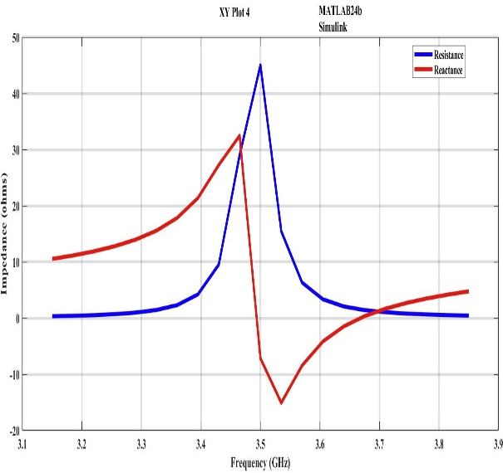
Figure 2: Impedance matching of Polystyrene
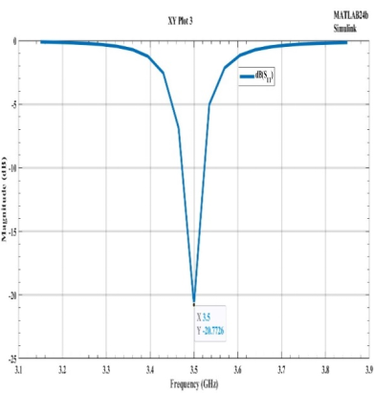
Figure 3: Return loss of Plexiglas
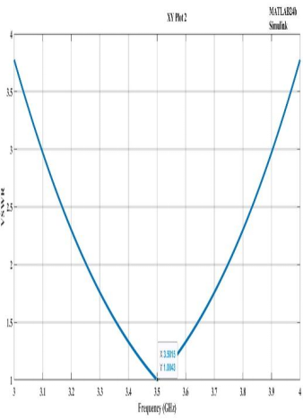
Figure 4: VSWR of Plexiglas

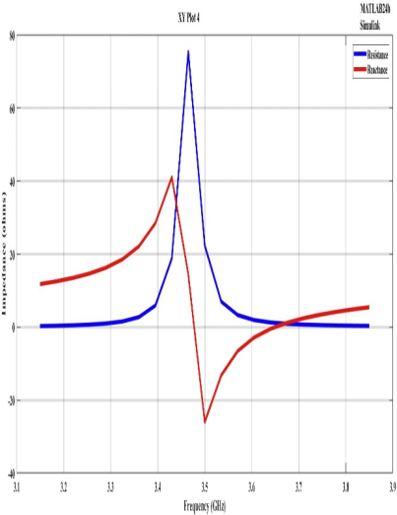
Figure 5: Impedance matching of Teflon
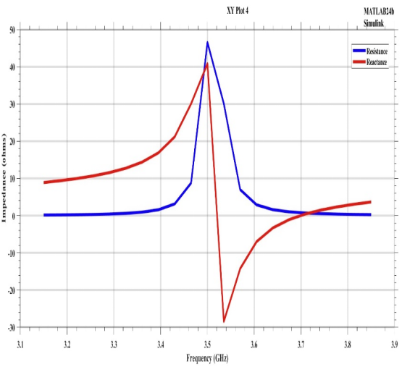
Figure 6: Impedance matching of Taconic RF-35
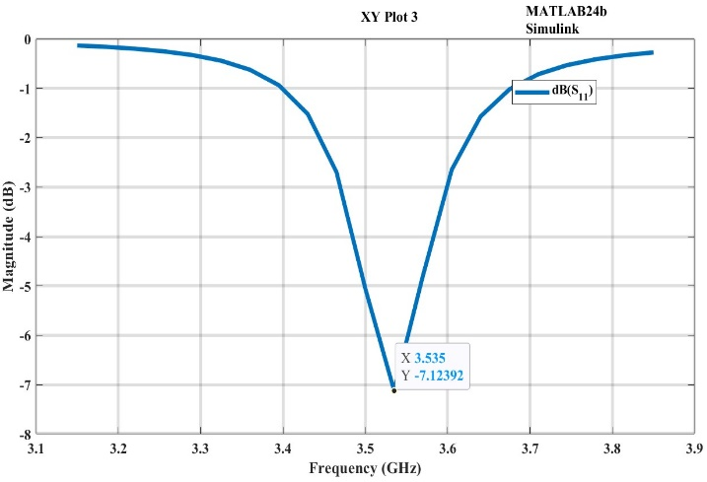
Figure 7: Return loss of FR4
Table 2: Comparison of Simulation Output for Different Substrates of RMPA Performance at 3.5 GHz
Substrate materials | Return Loss (dB) | Bandwidth (%) | VSWR | Impedance Matching (Ohms) | Gain (dBi) | HPBW (degree) | F/B Ratio (dB)
FR4 | -5.0587 | 5.405 | 1.01006 | 19 + j16 | 0.429 | 90 | 28.6
RO4730JXR | -13.8501 | 1.23 | 1.00718 | 66 + j35 | 6.36 | 90 | 27.5
Teflon | -6.1303 | 1.745 | 1.01006 | 72 + j40 | 7.86 | 85 | 0
E-glass | -15.996 | 8.57 | 1.01006 | 69 + j30 | 5.86 | 90 | 24.5
Taconic RF-35 | -8.16012 | 0.944 | 1.00143 | 47 + j40 | 6.3 | 90 | 28.5
Polystyrene | -11.8845 | 2.63 | 1.00143 | 58 + j45 | 7.48 | 90 | 26.8
Foam | -17.8488 | 6.39 | 1.00143 | 67 + j47 | 9.25 | 70 | 20.8
Plexiglass | -20.7726 | 2.32 | 1.0043 | 47 + j33 | 5.448 | 70 | 0
Fused Quartz | -5.47992 | 5.09 | 1.00718 | 37 + j48 | 6.99 | 70 | 29
TMM4 | -15.1029 | 2.66 | 1.00718 | 64 + j36 | 5.92 | 80 | 17.5

5.0 Conclusion
This study presented a comparative analysis of ten different substrate materials for a 3.5 GHz rectangular microstrip patch antenna (RMPA) designed for 5G applications. The results clearly demonstrate that the electrical properties of the substrate, particularly dielectric constant and loss tangent, have a significant impact on antenna performance parameters such as return loss, VSWR, bandwidth, and radiation efficiency. Among the substrates investigated, Plexiglass exhibited the best impedance matching performance, achieving the lowest return loss of −20.7726 dB and an excellent VSWR of 1.0043, which indicates minimal signal reflection and efficient power transfer. Substrates such as Teflon and Taconic RF-35 also showed acceptable impedance matching due to their low dielectric losses and stable electromagnetic characteristics.
In terms of bandwidth performance, the Foam substrate produced the widest bandwidth of 6.39 %, making it particularly suitable for broadband 5G communication systems that require stable operation over a wider frequency range. Although all the investigated substrates produced broadside radiation patterns, which are typical for rectangular microstrip patch antennas, their overall radiation efficiency varied depending on the dielectric properties of the material. Low-loss substrates generally improved radiation efficiency and antenna gain, while higher-loss materials such as FR-4 showed reduced performance at microwave frequencies. Overall, the findings of this study highlight the importance of careful substrate selection in the design of microstrip patch antennas for 5G applications. By choosing appropriate dielectric materials, antenna designers can significantly enhance impedance matching, bandwidth, and radiation efficiency. Consequently, optimised substrate materials are essential for developing compact, efficient, and high-performance antennas capable of supporting modern 5G wireless communication systems.
Disclaimer (Artificial intelligence)
Author(s) hereby declare that NO generative AI technologies such as Large Language Models (ChatGPT, COPILOT, etc.) and text-to-image generators have been used during the writing or editing of this manuscript.

REFERENCES
[1] Olabisi O, Ebisemiju A.G, and Eleyele D.E (2025): Design and optimization of rectangular microstrip patch antenna using duroid substrate for 5G application in Nigeria. Iconic Research and Engineering Journals. 8(7): 426-430.
[2] Olabisi O., Adeniran A.O., Ajao O.S., and Adegboyega O. (2018): Design and implementation of 4 elements Circular patch antenna with gain 3.0 GHz application. International Journal of Trend in Scientific Research and Development, (IJTSRD). 2(2): 996-999.
[3] Olabisi O., Adewumi A.S., Ajao O.S and Adeniran A. O (2019): Bow-Tie Microstrip Patch Antenna-Design and Implementation for Dual Band WLAN Applications. International Journal of Trend in Scientific Research and Development, 3(4): 1136 – 1140.
[4] Elechi, P., & John, P. O. (2022). Improved multiband rectangular microstrip patch antenna for 5G application. Journal of Telecommunication, Electronic and Computer Engineering, 14(2), 7–14.
[5] Kartikasari, G., Praja, M. P. K., & Romadhona, S. (2023). Design of rectangular patch microstrip antenna with defected ground structure method at 3.5 GHz frequency for 5G technology. Journal of Information Technology and Its Utilization, 6(2).
[6] Kumar, P. (2023). Impedance matching techniques for microstrip patch antennas. IEEE Transactions on Antennas and Propagation, 71(3), 1234–1243.

[7] Hussain, M., Khan, S., & Ahmad, F. (2024). Enhanced performance of microstrip antenna fabricated on a composite dielectric substrate coupled with multiple dielectric superstrates. Optical and Quantum Electronics.
[8] Abubakar, M. A. Y., & Ali, M. H. (2025). Design and simulation of a high-gain dual-band microstrip patch antenna array for 26/28 GHz 5G applications. FUDMA Journal of Sciences.
[9] Olabisi O, Aremu O.A, Ajeigbe O.A, Ajao O.S, Areo S.O and Adebisi S.S. (2024). “Performance Evaluation of Rectangular Microstrip Patch Antenna Using Different Substrate Materials for 5G Applications”. International Journal of Research Publication and Reviews, 5 (8); 3108-3116.
[10] Djouimaa, A., & Bencherif, K. (2024). Design of a compact circular microstrip patch antenna for 5G applications. Engineering, Technology & Applied Science Research, 14(4), 16020–16024.
[11] Singh, R., Gupta, A., and Kumar, A. (2022). Design and analysis of microstrip antennas. Journal of Electromagnetic Waves and Applications, 36(1), 1–12.
[12] Kumar, C., Raghuwanshi, S. K., & Kumar, V. (2022). Graphene-based microstrip patch antenna on photonic crystal substrate for 5G application. Frontiers in Materials, 9, 1079588.
[14] Falih, H. (2024). A high-gain slotted rectangular microstrip patch antenna for 5G millimeter-wave applications. Sumer Journal for Pure Science.
·
[14] Olabisi O, Adeniran A.O., Ajao O.S, Areo S. O and Olatunde I.D (2019) “Design and Performance Analysis of Printed Square Log Periodic Array Microstrip Patch Antenna at 2.5 and 3.5 GHz”,Journal of Advancement in Communication System (JACS), http//hbrppublication.com, JACS, 2(3): 1 – 7.
[15] Olabisi O, Adeniran A.O., Ajao O.S and Areo S. O (2019): Comparative Analysis of Measured and Simulated Performance of Printed Excited Rectangular Log Periodic Array Microstrip Patch. Journal of Advancement in Communication System (JACS), ,2(3): 1 – 7. http//hbrppublication.com, JACS.

