Synthesis and Characterization of Engineered Nanobiochar for Enhanced Removal of Excess Fluoride in Water

Abstract
Fluoride contamination in groundwater poses serious public health risks in many developing regions. Corncob-based nanobiochar presents an innovative and sustainable solution, leveraging Nigeria’s abundant agricultural residues to create a renewable water treatment material. However, despite global interest in nanobiochar, limited research has focused on HCl-treated, corncob derived nanobiochar, particularly its structural characterization, fluoride adsorption performance, and applicability under variable environmental conditions. This study reports the synthesis, characterization, and application of hydrochloric acid (HCl)-engineered corncob-derived nanobiochar for fluoride removal from aqueous solutions. Corncobs were pyrolyzed at 550 °C to produce biochar, mechanically milled to nanoscale dimensions, and chemically activated using 1M HCl. The engineered nanobiochar was characterized using Fourier Transform Infrared Spectroscopy (FTIR), Scanning Electron Microscopy (SEM), X-ray Diffraction (XRD), and Brunauer–Emmett–Teller (BET) surface area analysis. Batch adsorption experiments were conducted to evaluate the effects of adsorbent dosage, initial fluoride concentration, pH, and contact time. Optimal fluoride removal (80–90%) was achieved at a dosage of 0.8 g L⁻¹, initial fluoride concentration of 6 mg L⁻¹, pH 2, and contact time of 60 minutes. The enhanced performance was attributed to increased surface area, nanoscale porosity, and the introduction of oxygen-containing functional groups following HCl treatment. The results demonstrate that engineered corncob nanobiochar is a low-cost, sustainable, and effective adsorbent for fluoride removal, with strong potential for application in fluoride-endemic regions.

Keywords: Engineered nanobiochar, Fluoride removal, Acid modification, Water treatment, characterization

Introduction
Fluoride contamination in drinking water is a pressing environmental and public health concern, particularly in developing countries where groundwater serves as the primary drinking source. Although fluoride in trace amounts (0.5 – 1.5 mg/L) strengthens bones and teeth, concentrations above 1.5 mg/L can cause dental and skeletal fluorosis, bone deformities, neurological impairments, and other systemic disorders [1]. Fluoride contamination in groundwater arises from both anthropogenic and geogenic sources. Anthropogenic sources such as coal burning, industrial activities, and phosphate fertilizers significantly raise the groundwater fluoride level. However, the geogenic source includes the leaching and dissolution of fluoride-bearing minerals, ion exchange, rock-water interaction, weathering process, evaporation, precipitation of calcite, and the type of rock present [19]. The World Health Organization estimates that over 260 million people worldwide consume fluoride-contaminated water, especially in regions of India, China, Ethiopia, Kenya, and parts of Nigeria [2]. Conventional methods of de-fluoridation, including reverse osmosis, ion exchange, precipitation, and activated alumina adsorption, are often expensive, energy-intensive, and impractical for small-scale or low-income communities [3].
Biochar, a carbon-rich material produced through pyrolysis of biomass, has gained attention as a sustainable adsorbent due to its affordability, high porosity, and environmental compatibility [4]. Studies have shown that biochar can effectively remove pollutants from wastewater [20,23]. However, its limited surface reactivity and negative surface charge restrict its fluoride adsorption capacity. To overcome these limitations, nanobiochar, biochar reduced to nanoscale dimensions, offers enhanced surface area and reactivity, improving pollutant adsorption efficiency [5]. Due to its nanoscale size, it exhibits certain unique characteristics: higher surface area-to-volume ratio, more significant reactivity, and adsorption [21,22]. Furthermore, acid modification (particularly using HCl) increases the density of oxygen-containing functional groups (-OH, -COOH), facilitating stronger electrostatic attraction and ion exchange with fluoride ions [6]. Corncobs, a readily available agricultural residue, are an ideal feedstock for nanobiochar production. They offer high cellulose content and structural carbon, aligning with waste-to-resource initiatives that convert agro-waste into value-added products [7].
In recent years, considerable research has been directed toward developing cost-effective, sustainable, and efficient materials for fluoride removal from contaminated water. Between 2020 and 2025, the application of biochar and its engineered derivatives has received significant attention due to their environmental compatibility, affordability, and high surface reactivity. However, the performance of conventional biochar has been limited by its low surface area, restricted functional group density, and insufficient charge properties for anionic contaminants such as fluoride. Consequently, numerous studies have explored the conversion of biochar into nanoscale and chemically modified forms to enhance adsorption efficiency, regeneration capacity, and long-term stability. According to Ramanayaka et al. (2020), nanobiochar demonstrates an adsorption capacity almost ten times higher than traditional biochar due to its extremely high surface-to-volume ratio and the abundance of reactive functional groups [8]. Their work established that mechanical milling of biochar to nanoscale dimensions (below 100 nm) significantly increases porosity, enabling faster fluoride diffusion and stronger binding through surface electrostatic interactions. Similarly, Chausali, Saxena, and Prasad (2021) reported that nanobiochar and biochar-based nanocomposites can remove both organic and inorganic pollutants efficiently, underscoring its versatility as an eco-friendly adsorbent [5]. They emphasized that particle size reduction and the incorporation of surface functional groups through acid or metal modification are critical to achieving high fluoride removal efficiency [9].
A study by Ahmed et al. (2021) investigated hydroxyapatite-biochar nanocomposites and demonstrated that chemical modification improves the ion exchange potential of biochar [4]. Their findings revealed that acid treatment with HCl or HNO₃ removes mineral impurities and ash, increases the surface area, and introduces active oxygen-containing sites such as hydroxyl (-OH) and carboxyl (-COOH) groups, which act as binding centers for fluoride ions. The study also emphasized that the modification enhances the zeta potential of the biochar, making it more electropositive and therefore more effective in attracting fluoride anions from solution. Further contributions were made by Maity et al. (2021), who developed bacterial-surfactin-mediated hydroxyapatite nanoparticles and confirmed their superior fluoride adsorption capacity and antibacterial properties [3]. This work demonstrated the potential of combining biogenic and physicochemical approaches in producing high-performance adsorbents for water purification. Similarly, Kut et al. (2022) presented a comprehensive review of fluoride contamination across African groundwater systems, including Nigeria, Kenya, and Tanzania [10]. They identified significant fluoride concentrations, often exceeding 10 mg/L, and concluded that local and low-cost adsorbents such as biochar are crucial for mitigating fluoride-related health risks in low-income regions [10].
Tomar et al. (2022) explored the role of acid modification in improving biochar efficiency. Their research established that HCl treatment specifically enhances fluoride adsorption by increasing surface roughness, removing metallic oxides, and enriching oxygenated functional groups. They observed that HCl-modified biochars exhibited up to 80% improvement in fluoride adsorption compared to untreated counterparts [6]. Likewise, Hettithanthri et al. (2023) synthesized layered double hydroxide-modified corncob biochar and demonstrated that temperature and chemical activation significantly influence the adsorption capacity [11]. They concluded that thermochemical activation using mild acids at moderate pyrolysis temperatures (500–600°C) produces optimal pore structures and active binding sites. Building on this trend, Kumar et al. (2023) and Kumar, Singh, and Mukherjee (2023) emphasized that agricultural residues such as corncobs are highly promising feedstocks for producing biochar due to their high carbon and cellulose content, abundance, and low cost [7, 12]. Their research demonstrated that corncob-derived nanobiochar could efficiently adsorb contaminants such as methylene blue and fluoride from aqueous solutions, with removal efficiencies exceeding 85%. These studies further highlighted the environmental advantages of valorizing agricultural wastes, aligning with circular economy principles and sustainable waste management strategies [7, 12].
The persistence of fluoride contamination in groundwater presents a critical environmental and public health challenge, especially in developing regions where access to advanced purification systems is limited. Nigeria, like many sub-Saharan African countries, has communities whose groundwater fluoride concentrations exceed the WHO permissible limit of 1.5 mg/L. Continuous ingestion of such water leads to severe health conditions, including dental and skeletal fluorosis, neurological disorders, and kidney damage [1]. While numerous fluoride removal methods exist, including ion exchange, reverse osmosis, and chemical precipitation, these technologies are generally unaffordable, energy-intensive, and maintenance-demanding, making them unsuitable for rural communities. Adsorption using natural and engineered materials offers a simpler, low-cost, and scalable alternative. Corncob-based nanobiochar presents an innovative and sustainable solution, leveraging Nigeria’s abundant agricultural residues to create a renewable water treatment material. However, despite global interest in nanobiochar, limited research has focused on HCl treated, corncob derived nanobiochar, particularly its structural characterization, fluoride adsorption performance, and applicability under variable environmental conditions [2].
This study is therefore rationalized by the urgent need to develop and scientifically validate an affordable, efficient, and environmentally sustainable adsorbent capable of removing excess fluoride from water while promoting agricultural waste utilization and circular economy principles.

Materials and Methods
This study adopted an experimental laboratory design, involving synthesis, chemical modification, characterization, and application of nanobiochar for fluoride removal under controlled conditions.

Materials and Equipment

The major materials/equipment used in this work included a Corncobs (collected locally), concentrated HCl, NaOH, NaF (for fluoride solutions), deionized water, UV–Vis spectrophotometer, pH meter, muffle furnace, sieve set, analytical balance, SEM, FTIR, BET, and XRD instruments.

Preparation of Nanobiochar
Corncobs were washed, dried, and pyrolyzed at 550 °C for 2 hours under oxygen-limited conditions to produce biochar. The biochar was mechanically milled and sieved to obtain nanoscale particles (<100 nm). The nanobiochar was then treated with 1 M HCl (1:10 w/v) for 4 hours, washed to neutral pH, dried at 105 °C, and stored for further use [13, 14].

Characterization
Surface morphology was examined using SEM, functional groups were identified by FTIR (400–4000 cm⁻¹), crystallinity was analyzed using XRD (2θ = 10–80°), and surface area and pore structure were determined using BET analysis [15].

Batch Adsorption Experiments
Fluoride adsorption experiments were performed using synthetic fluoride solutions prepared from sodium fluoride. The effects of adsorbent dosage (0.2–1.2 g L⁻¹), initial fluoride concentration (2–12 mg L⁻¹), pH (2–10), and contact time (20–120 min) were evaluated at 25 °C. Residual fluoride concentrations were analyzed using the Acid Zirconyl–SPADNS spectrophotometric method at 570 nm. Removal efficiency and adsorption capacity were calculated accordingly [15].

Results and Discussion

Characterization of Engineered Nanobiochar

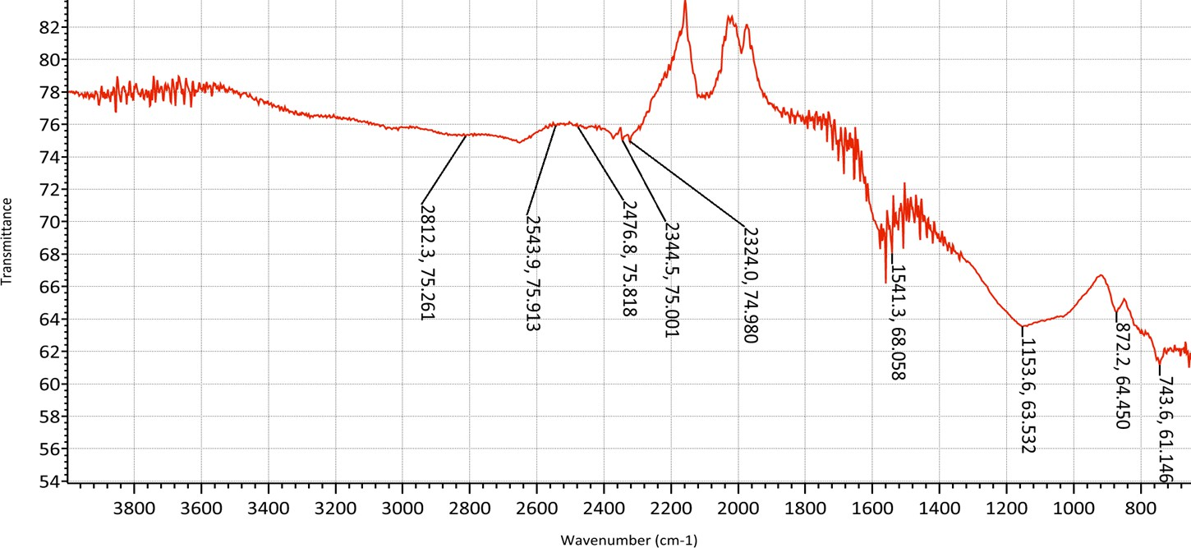
Figure 1: Fourier-Transform Infrared Spectroscopy
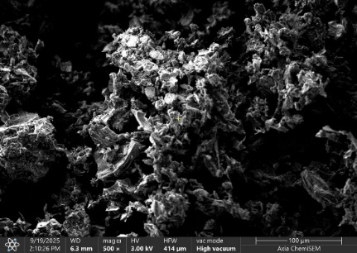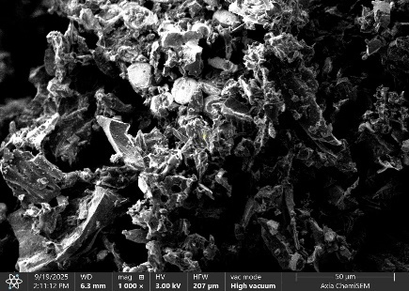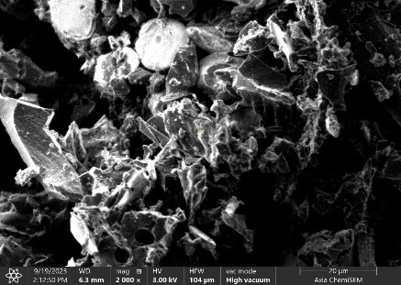
A
B
C
Figure 2: Scanning Electron Microscopy (SEM)

Figure 3: X-ray diffraction

Figure 4: Brunauer-Emmett-Teller

Figure 5: Calibration Curve Graph

A calibration curve was established using the Acid Zirconyl-SPADNS method to convert absorbance to residual fluoride concentration (Cₑ, mg/L). Fluoride standards (0, 0.5, 1.0, 1.5, 2.0 mg/L) were prepared, and absorbance was measured at 570 nm after mixing 10 mL of each standard with 3 mL SPADNS reagent and a 5-minute reaction time [16]. The high R² value confirms the method’s reliability for concentrations up to 2 mg/L, suitable for the expected Cₑ (0.01–5 mg/L) in adsorption experiments.
The SEM images of the HCl-treated nanobiochar at magnifications of 500x, 1000x, and 2000x reveal a highly porous and irregular surface morphology, indicative of nanoscale structural modifications. At 500x (100 μm scale), the material displays a rough, fragmented texture with block-like formations and interconnected pores, suggesting effective imprint by HCl that removed mineral impurities and ash from the pristine biochar. At 1000x (50 μm scale), the porosity becomes more pronounced, with visible nanoscale particles (50-150 nm) and a heterogeneous surface, enhancing active site exposure for adsorption. At 2000x (20 μm scale), the complex network of pores and jagged edges is evident, confirming microporous and mesoporous structures ideal for fluoride ion diffusion and binding. The increased roughness and porosity, resulting from HCl-induced demineralization, improve the nanobiochar's surface area and reactivity, making it highly suitable for fluoride removal from water through enhanced electrostatic interactions and ion exchange. The BET Analysis graph shows the HCl-treated nanobiochar has negligible micropores below 0.78 nm, with significant pore volume starting at 0.8 nm and increasing to 0.0169 cm³/g/nm at 5.98 nm. This indicates a useful micropore and small mesopore range (0.8-6 nm) for fluoride removal, providing accessible sites for ion exchange and adsorption in water treatment [17].
SEM images revealed a highly porous and irregular nanoscale surface structure following HCl treatment, indicating enhanced adsorption sites. FTIR spectra confirmed the presence of oxygen-containing functional groups (–OH, –COOH), which promote fluoride binding. XRD patterns indicated an amorphous carbon structure, while BET analysis showed increased surface area and mesoporous distribution favorable for fluoride adsorption[17].

Effect of Operational Parameters

Figure 6: Dosage Variation Graph

Figure 7: Initial Fluoride Concentration Graph

Figure 8: pH Variation Graph

Figure 9: Contact Time Variation Graph

Fluoride removal efficiency increased with increasing adsorbent dosage up to 0.8 g L⁻¹. Maximum adsorption occurred at acidic pH (pH 2), attributed to electrostatic attraction between protonated functional groups and fluoride ions. Equilibrium was reached within 60 minutes, indicating rapid adsorption kinetics. These results are consistent with previously reported acid-modified biochar systems [18].

Conclusion
HCl-engineered corncob-derived nanobiochar demonstrated high efficiency for fluoride removal from water under optimized conditions. The enhanced performance is attributed to nanoscale particle size, increased surface area, and acid-induced functionalization. The material offers a sustainable, low-cost alternative to conventional defluoridation technologies and holds promise for application in fluoride-affected regions.

Disclaimer (Artificial intelligence)

Author(s) hereby declare that NO generative AI technologies such as Large Language Models (ChatGPT, COPILOT, etc.) and text-to-image generators have been used during the writing or editing of this manuscript.

References
- World Health Organization. (2020). Guidelines for drinking-water quality (4th ed., incorporating the first addendum). WHO Press. https://www.who.int/publications/i/item/9789240009950

- Yadav, K. K., Kumar, S., Pham, Q. B., Gupta, N., Rezania, S., Kamyab, H., ... and Chelliapan, S. (2021). Fluoride contamination, health problems and remediation methods in Asian groundwater: A comprehensive review. Ecotoxicology and Environmental Safety, 182, 109362. https://doi.org/10.1016/j.ecoenv.2019.109362

- Maity, J. P., Hsu, C.-M., Lin, T.-J., Lee, W.-C., Bhattacharya, P., Bundschuh, J., and Chen, C.-Y. (2021). Removal of fluoride from water through bacterial-surfactin mediated novel hydroxyapatite nanoparticle and its efficiency as antibacterial against Streptococcus mutans. Environmental Nanotechnology, Monitoring and Management, 16, 100523. https://doi.org/10.1016/j.enmm.2021.100523

- Ahmed, W., Núñez-Delgado, A., Mehmood, S., Ali, S., Qaswar, M., Khan, Z. H., ... and Qazi, I. A. (2021). Highly efficient uranium (VI) capture from aqueous solution by means of a hydroxyapatite-biochar nanocomposite: Adsorption behavior and mechanism. Environmental Research, 201, 111518. https://doi.org/10.1016/j.envres.2021.111518

- Chausali, N., Saxena, J., and Prasad, R. (2021). Nanobiochar and biochar-based nanocomposites: Advances and applications. Journal of Agriculture and Food Research, 5, 100191. https://doi.org/10.1016/j.jafr.2021.100191

- Tomar, S., Gupta, S. K., and Mishra, R. K. (2022). Adsorptive removal of fluoride from aqueous solution using Fe-loaded groundnut shell biochar: Equilibrium, kinetics, and thermodynamic studies. Environmental Monitoring and Assessment, 194(8), 567. https://doi.org/10.1007/s10661-022-10251-4

- Kumar, A., Singh, E., Mishra, R., Lo, S.-L., and Kumar, S. (2023). Biochar as an eco-friendly and economical sorbent for environmental remediation: A review. Environmental Chemistry Letters, 21(2), 1189–1232. https://doi.org/10.1007/s10311-022-01558-8

- Ramanayaka, S., Vithanage, M., Alessi, D., Liu, W.-J., and Ok, Y. S. (2020). Nanobiochar: Production, properties, and multifunctional applications. Environmental Science: Nano, 7(11), 3279–3302. https://doi.org/10.1039/D0EN00686C

- Sharma, A., Kumar, A., and Naushad, M. (2024). Recent developments in the applications of biomass-derived biochar and its composites for remediation of real water contaminants. Environmental Science and Pollution Research, 31(3), 3456–3487. https://doi.org/10.1007/s11356-023-31054-8

- Kut, K. M. K., Sarswat, A., Srivastava, A., Pittman Jr, C. U., and Mohan, D. (2022). A review of fluoride in African groundwater and local remediation methods. Groundwater for Sustainable Development, 15, 100680. https://doi.org/10.1016/j.gsd.2021.100680

- Hettithanthri, O., Rajapaksha, A. U., Nanayakkara, N., and Vithanage, M. (2023). Temperature influence on layered double hydroxide tailored corncob biochar and its application for fluoride removal in aqueous media. Environmental Pollution, 320, 121054. https://doi.org/10.1016/j.envpol.2023.121054

- Kumar, A., Singh, P., and Mukherjee, S. (2023). Corncob-derived nanobiochar for water purification: A case study on methylene blue and fluoride removal. Environmental Science and Pollution Research, 30(12), 34567–34580. https://doi.org/10.1007/s11356-022-24678-8

- APHA, AWWA, & WEF. (2017). Standard Methods for the Examination of Water and Wastewater (23rd ed.). American Public Health Association. (ISBN: 978-0875532875)

- Mwadalu, R., Rutto, M., Abdi, A. M., Chappa, L. R., Nungula, E. N., Ngaiza, V. N., Raj, A., Dlamini, J. C., Raza, M. A., Soratto, R. P., and Gitari, H. I. (2025). Potential of biochar for defluoridation of drinking water: A review. Water, Air, & Soil Pollution, 236(2). https://doi.org/10.1007/s11270-025-07775-9

- Roy, S., Manna, S., Sengupta, S., Basu, A., and Das, P. (2022). Comparative study on engineered biochar for adsorption of fluoride from water solution. Journal of Environmental Chemical Engineering, 10(3), 107583. https://doi.org/10.1016/j.jece.2022.107583

- APHA, AWWA, & WEF. (2020). Standard methods for the examination of water and wastewater (23rd ed.). American Public Health Association.

- Yadav, M., Singh, N. K., Jha, V., Bharti, L. K., and Kaushik, P. (2021). Fluoride levels in drinking water and other surface water of an industrial area belt of Odisha and its impact. Materials Today: Proceedings, 47(Part 15), 5528–5532. https://doi.org/10.1016/j.matpr.2021.07.245

- Kanwal, S., Devrajani, S. K., and Hashmani, S. A. K. (2025). Removal of fluoride from aqueous solution using biochar derived from brown macroalgae (Sargassum polycystum) impregnated with Fe3O4 nanoparticles. Phycology, 5(3), 37. https://doi.org/10.3390/phycology5030037

- Duggal, V., & Sharma, S. (2022). Fluoride contamination in drinking water and associated health risk assessment in the Malwa Belt of Punjab, India. Environmental Advances, 8, 100242.
- Bhandari, G., Gangola, S., Dhasmana, A., Rajput, V., Gupta, S., Malik, S., & Slama, P. (2023). Nano-biochar: recent progress, challenges, and opportunities for sustainable environmental remediation. Frontiers in Microbiology, 14, 1214870. https://doi.org/10.3389/fmicb.2023.1214870
- Jadhav, V., Ahire, B., Pawar, A., Roy, A., Kumar, A., Sharma, K., ... & Verma, R. (2025). Nanobiochar: A sustainable solution for environmental remediation. Environmental Nanotechnology, Monitoring & Management, 23, 101061. https://doi.org/10.1016/j.enmm.2025.101061
- Jiang, M., He, L., Niazi, N. K., Wang, H., Gustave, W., Vithanage, M., ... & Wang, Z. (2023). Nanobiochar for the remediation of contaminated soil and water: challenges and opportunities. Biochar, 5(1), 2. https://doi.org/10.1007/s42773-022-00201-x
- Hefny, R., Ibrahim, M. M., & Morad, D. (2020). Study of Adsorption Performance of Biochar for Heavy Metals Removal. Journal of Engineering Research and Reports, 19(4), 27–40. https://doi.org/10.9734/jerr/2020/v19i417239

