Phytochemical Analysis and Antimicrobial Activities of Successive Extracts of Diodia scandens Aerial Parts Collected from Ogbomoso, Nigeria

ABSTRACT

Diodia scandens is known to be used in traditional medicine; however, the antimicrobial activity is not well studied. The present study aimed to evaluate the phytoconstituents and antimicrobial activity of the successive solvent extracts of the aerial parts of D. scandens. Dried and powdered aerial parts were used for successive maceration with n-hexane, ethyl acetate, and ethanol solvents. Phytoconstituents were analyzed both qualitatively and quantitatively, while the antimicrobial activity was tested against the pathogens Staphylococcus aureus, Escherichia coli, Candida albicans, and Aspergillus niger. The minimum inhibitory concentration (MIC) and MMC were also tested for the extracts. Phytoconstituents identified in the extracts included alkaloids, tannins, flavonoids, and coumarins. The ethyl acetate extract showed the highest antimicrobial potency, with a minimum inhibitory concentration (MIC) of 3.125 mg/mL against S. aureus and 1.56 mg/mL against C. albicans. In contrast, the ethanol extract showed limited antimicrobial activity (MIC > 50 mg/mL). These findings suggest that the ethyl acetate extract of D. scandens exhibits broad-spectrum antimicrobial potential. Further research is needed to isolate and characterize the bioactive compounds responsible for these effects, which could contribute to the development of new therapeutic agents.
Keywords: Diodia scandens; phytochemical screening; solvent extraction; antimicrobial activity
1. Introduction
Infectious diseases continue to pose a significant public health challenge, as their therapeutic management is increasingly jeopardized by the swift emergence of antibiotic resistance (Podolsky, 2023). Drug-resistant pathogens are now appearing more quickly than new antibiotics can be found and used, which is making the treatment gap bigger. This is especially important in low- and middle-income countries where access, affordability, and drug safety monitoring may not be adequate (Muteeb et al., 2023). Recent research continues to show that the global antibiotic pipeline is getting smaller while resistance mechanisms are expanding. This makes it even more important to find new and better ways to get antimicrobial medicines, such as bioactive natural compounds (Ahmed et al., 2024). Medicinal plants are still very important, not only because they have been used in traditional medicine for a long time, but also because they are a chemically varied source of secondary metabolites that can work through many different antimicrobial mechanisms (Angelini, 2024). Recent studies demonstrate that plant extracts can impede bacteria growth by disrupting membranes, inhibiting enzymes, interfering with nucleic acid activities, and facilitating resistance-modifying interactions that may augment the efficiency of current antibiotics (Abdallah et al., 2023; Angelini, 2024; Podolsky, 2023). It is crucial to note that extraction conditions and solvent polarity affect the phytochemical profile obtained, and consequently, the antimicrobial efficacy. This necessitates comparative solvent-based studies for evidence-based validation and subsequent drug development significance.
Phytochemicals such as alkaloids, phenolics, flavonoids, tannins, terpenoids, and coumarins are significantly associated with antimicrobial action and have recently garnered fresh interest as potential agents against resistant diseases (Schultz et al., 2020a). Plant-derived drugs are increasingly regarded as “resistance-aware” options due to their multitarget mechanisms and potential synergy with conventional therapies (Schultz et al., 2020b). Consequently, comprehensive antimicrobial screening of medicinal plants, in conjunction with phytochemical profiling, provides an effective methodology to discover extracts with consistent action, validate traditional assertions, and prioritize extracts for subsequent purification and mechanistic investigations. In this context, the genus Diodia (family Rubiaceae) is particularly noteworthy due to its ethnomedicinal significance and insufficiently investigated phytochemical diversity (Ojo et al., 2024). Diodia scandens is utilized in West African traditional medicine for ailments frequently associated with infectious or inflammatory processes, such as diarrhoea/dysentery, dermatological and soft-tissue disorders, wound management, and various other conditions addressed with phytotherapeutic interventions (Sadiq Wada et al., 2022). These customary applications reinforce the justification for scientific assessment of its antibacterial properties and for correlating observed efficacy with phytochemical composition across various solvent extracts. Consequently, this study employs a comparative methodology to assess Diodia scandens through (i) phytochemical screening across solvents of differing polarity and (ii) antimicrobial evaluation. The study also seeks to identify the most bioactive extract systems and substantiate the ethnomedicinal significance of the plant, while aiding ongoing initiatives to discover plant-derived antimicrobial candidates in an era constrained by antimicrobial resistance.
2. Materials and Methods
2.1 Plant collection and identification
The aerial parts of Diodia scandens were collected from cultivated land in Ladoke Akintola University of Technology (LAUTECH), Ogbomoso, Oyo State, Nigeria (approximately 8.1800°N, 4.2636°E). Prof. A. T. J. Ogunkunle of the Department of Pure and Applied Biology at LAUTECH did the botanical authentication. A voucher specimen was deposited in the institution herbarium with the number LHO 964.
2.2 Extraction of plant material
The freshly collected plant sample was washed with distilled water, air dried for 35 days and pulverized using Electric blender. The extraction followed the procedures described by Ojo et al. (2017) with modification. Successive maceration was performed using n-hexane, ethyl acetate and ethanol. 200 g of the powdered sample was soaked in 2.5 L of each solvent for 72 hours with intermittent shaking, followed by filtration with Whatman No. 1 paper. Each filtrate was collected as its respective extract, and the residue was rewashed before proceeding to the next solvent. All extracts were concentrated using a rotary evaporator at 40–50 °C and stored at 4 °C until analysis. The percentage yield of extracts was calculated by dividing the weight of the dried crude extract obtained after solvent removal by the initial weight of the dry plant material used for extraction and multiplying the result by 100 (El Mannoubi, 2023).
2.3 Phytochemicals screening
2.3.1 Qualitative phytochemicals screening
Standard qualitative test methods were used to check the crude extracts for the presence or absence of major phytochemical groups (Adepoju et al., 2024). Screening encompassed terpenoids, saponins, phenols, coumarins, steroids, cardiac glycosides, alkaloids, tannins, flavonoids, quinones, glycosides, anthocyanins, and anthraquinones, adhering to established protocols.
2.3.2 Quantitative Phytochemical Screening
2.3.2.1 Determination of Total Alkaloid Content
A standard precipitation-based method was used to measure the total alkaloid content. The sample was soaked in 200 mL of 10% acetic acid made with ethanol and left to sit for 4 hours. A water bath (Bio Techno Lab Serological Water Bath, Model BTL-10, India) was used to concentrate the filtrate until it was about one-fourth of the original volume. Then, concentrated ammonium hydroxide was added slowly to help the alkaloids come out of solution. The precipitate was washed with diluted ammonium hydroxide, filtered, dried, and weighed on an analytical balance (Mettler Toledo XPR205, Switzerland). The final mass was used to determine the quantity of alkaloid in it (Van Tan, 2018).
2.3.2.2 Determination of Total Saponin Content
An ethanol extraction and partitioning method was used to measure the amount of saponin. 20 g of the sample was mixed with 100 cm³ of 20% aqueous ethanol. It was then kept it in a water bath (Bio Techno Lab Serological Water Bath, Model BTL-10, India) at 55°C for 4 hours. After filtering, the residue was re-extracted with 200 mL of the same solvent. The two filtrates were then heated to 90°C and reduced to 40 mL. To get rid of impurities, 20 mL of diethyl ether was added, and the water phase was kept. The water layer was rinsed twice with 10 mL of a 5% sodium chloride solution. The rest of the solution was heated until it reached a constant mass, then it was weighed using an analytical balance (Mettler Toledo XPR205, Switzerland) to determine the saponin content in it (Adepoju et al. 2024).
2.3.2.3 Determination of Total Phenolic Content
The Folin–Ciocalteu colorimetric technique was used to find out how much total phenolic content. 1 mL of extract was combined with 1 mL of Folin–Ciocalteu reagent and 9 mL of distilled water in a 25 mL volumetric flask. After five minutes, 10 mL of 7% sodium carbonate was added to make the colour stronger. Thesame procedure was repeated for gallic acid standard solutions (20–100 μg/mL). After sitting at room temperature for 90 minutes, a UV/Visible spectrophotometer (LAMBDA 1050+; PerkinElmer, USA) was used to measure measured the absorbance at 550 nm. The results were expressed as mg gallic acid equivalent (GAE) per g of extract (Siddiqui et al. 2017).

2.3.2.4 Determination of Total Tannin Content
Folin–Ciocalteu-based method was used to find out how much tannin was in the sample. In a 10 mL volumetric flask, 0.1 mL of extract, 7.5 mL of distilled water, 0.5 mL of Folin–Ciocalteu reagent, and 1 mL of 35% sodium carbonate were mixed together. The mixture was shaken and then left for 30 minutes to let the color fully develop. Gallic acid standards (20–100 μg/mL) was made the same way. UV/Visible spectrophotometer (LAMBDA 1050+; PerkinElmer, USA) was used to measure absorbance at 725 nm. The results were given in mg GAE per g of extract (Adepoju et al. 2024).
2.3.2.5 Determination of Total Flavonoid Content
Aluminum chloride colorimetric method was used to determine how much flavonoid was in the sample. One milliliter of the extract was mixed with four milliliters of distilled water in a 10 mL volumetric flask. After five minutes, 0.3 mL of 5% sodium nitrite and 0.3 mL of 10% aluminum chloride were added. After 5 more minutes, 2 mL of 1 M sodium hydroxide was added, and distilled water was used to fill the mixture to the right level. Quercetin standards (20–100 μg/mL) were made and processed in the same way. A UV/Visible spectrophotometer (LAMBDA 1050+; PerkinElmer, USA) was used to read the absorbance at 510 nm against a reagent blank. The amount of flavonoids was given in mg quercetin equivalent (QE) per g of extract (Shraim et al. 2021).

2.4 Antimicrobial Susceptibility Test
Agar diffusion and broth dilution methods were used to test the antimicrobial activity of the extracts of Diodia scandens against selected pathogenic bacteria and fungi: Staphylococcus aureus, Escherichia coli, Candida albicans, and Aspergillus niger. All antimicrobial tests were performed in triplicates to ensure the reliability and reproducibility of the data. All antimicrobial tests were done in a laminar airflow cabinet under sterile conditions to prevent contamination. Before use, the cabinet was cleaned and ultraviolet light was turned on for 30 minutes. The microbial strains used in this study were ATCC 25923 (Staphylococcus aureus), ATCC 25922 (Escherichia coli), ATCC 10231 (Candida albicans), and ATCC 16404 (Aspergillus niger). Mueller–Hinton agar was prepared according to the manufacturer's instructions, sterilized at 121 °C for 15 minutes, and cooled before being poured into sterile Petri dishes. 0.1 mL of standardized microbial inoculum was added to the solidified agar plates, using a sterile swab to spread the inoculum evenly over the agar surface. Then, using a sterile cork borer, wells with a diameter of 6 mm were bored aseptically. To make each crude extract solution, 10 mg of the extract was dissolved in 1 mL of dimethyl sulfoxide (DMSO) to create a solution with a concentration of 10 mg/mL. A pure DMSO control was added to separate wells on the same plate to prove the solvent itself was not responsible for the inhibition. Ciprofloxacin was used as a control for S. aureus and E. coli, and Ketoconazole for C. albicans and A. niger. They are the gold standards for these specific pathogens. The agar well diffusion method was used by adding 0.1 mL of the extract solution to the wells of the agar plates that had already been inoculated. The plates were left at room temperature to pre-diffuse, and then placed in an incubator at 37 °C for 24 hours for bacterial isolates and at 28°C for 48–72 hours for fungal isolates. A clear ruler was used to measure the zones of inhibition around the wells in millimeters after the incubation period (Gajic et al., 2022). The concentration range of 25–100 mg/mL was selected based on preliminary trials and literature recommendations. This range was found to provide measurable inhibition against the tested pathogens while ensuring the extracts were used within their effective concentrations
2.4.1 Determination of Minimum Microbicidal Concentration (MMC) and Minimum Inhibitory Concentration (MIC)
Following the Clinical and Laboratory Standards Institute (CLSI) guidelines, the broth dilution method was used to determine the Minimum Inhibitory Concentration (MIC) of the extracts. Mueller–Hinton broth was made, sterilized, and then kept in sterile test tubes. The microbial suspensions were changed to 0.5 McFarland standard, which is about 1.5 × 10⁸ CFU/mL. To get concentrations of 5 mg/mL, 2.5 mg/mL, 1.25 mg/mL, and 0.62 mg/mL, the extract stock solution was diluted in a series. 0.1 mL of the standardized microbial suspension was added in each tube and allowed to grow at 37 °C for 24 hours. The MIC was noted as the lowest amount of extracts that doesn't make the solution cloudy.
The Minimum Microbicidal Concentration (MMC) was measured by taking samples from MIC tubes that did not show any visible growth, putting them on freshly made Mueller–Hinton agar plates. The plates were kept at 37 °C for 24 hours. The MMC was the lowest concentration of extract that doesn't cause any visible microbial growth on the agar plates (Gajic et al., 2022).
3. Results and discussion
3.1 The extraction yield
The extraction yield (%) of the successive extracts of the aerial parts of Diodia scandens is presented in Figure 1. The yields for n-hexane, ethyl acetate, and ethanol were 2.95%, 4.04%, and 4.06%, respectively. The yield generally increased from the non-polar (n-hexane) extract to the more polar ethyl acetate and ethanol extracts. This pattern suggests that a larger part of the plant's extractable parts are semi-polar to polar. This fits with the knowledge that more polar solvents often get a wider range of secondary metabolites. The ethyl acetate and ethanol extracts yields are relatively close, which imply that semi-polar to polar solvents can get higher secondary metabolites out of Diodia scandens. The lower yield of n-hexane (2.95%) indicates that the aerial parts of Diodia scandens contain fewer non-polar extractives, such as waxes and non-polar terpenes. The yield obtained in this study is similar to that of Akpuaka et al., (2018) who reported 3.58% (ethyl acetate) and 1.59% (n-hexane) as the extraction yield D. scandens extracts.

Figure 1: Percentage yield of Diodia scandens extracts

3.2 Phytochemical Composition of the Successive Extracts of Diodia scandens
3.2.1 Qualitative phytochemical composition
Preliminary phytochemical screening of the Diodia scandens aerial part showed the presence of alkaloids, tannins, flavonoids, and coumarins across all extracts (Figure 2). The solvent-dependence observed for phenolic constituents detected only in the ethyl acetate and ethanol extracts but not in the n-hexane extract is consistent with the general principle that extraction efficiency is strongly governed by solvent polarity and “like dissolves like,” with less-polar solvents typically recovering fewer phenolic compounds than more polar/semi-polar systems (Altemimi et al., 2017). In line with this polarity effect, terpenoids were observed only in the ethyl acetate extract, suggesting that a semi-polar extraction system is better suited for concentrating intermediate-polarity metabolites in D. scandens. Comparable solvent-dependent selectivity has been reported in the literature: Akpuaka et al. (2018) found that D. scandens extracts contains glycosides, steroids, saponins, and alkaloids in the n-hexane extract while the ethyl acetate extract contained mainly steroids and saponins. Quinones, glycosides, cardiac glycosides, steroids, anthraquinones, and anthocyanins were not detected in any of the present extracts. The consistent non-detection of anthraquinones aligns with earlier pharmacognostic work on D. scandens leaf material that similarly reported anthraquinones as absent in the screened extract (Essiett et al., 2010). Overall, the ethyl acetate extract exhibited the widest qualitative phytochemical range in the present study, including terpenoids and phenolic constituents in addition to the core metabolite groups detected across extracts. These classes are widely associated with antimicrobial and antioxidant bioactivity.

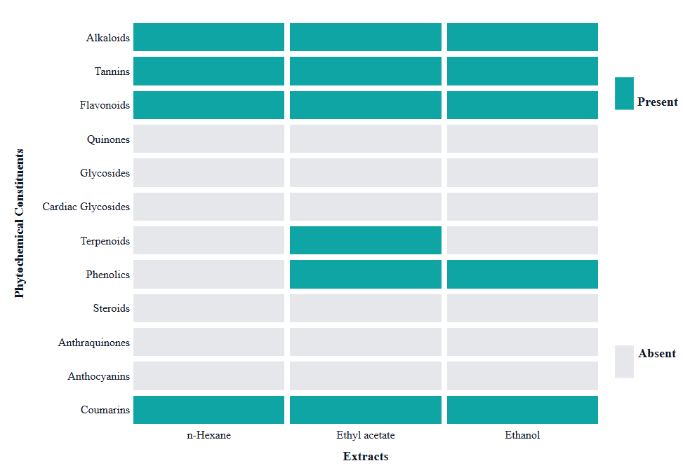
Figure 2: Preliminary phytochemical composition of successive extracts of Diodia scandens

3.2.2 Quantitative phytochemical analysis
Quantitative phytochemical analysis revealed clear solvent-driven differences in metabolite abundance between the ethyl acetate and ethanol extracts (Figure 3). Overall, the ethanol extract contained higher levels of saponins, alkaloids, flavonoids, and tannins, whereas the ethyl acetate extract showed higher total phenolic content. This pattern is consistent with established solvent–solute relationships in phytochemical extraction, where polar solvents (ethanol) typically recover a broader range of polar and glycosylated constituents, while semi-polar solvents (ethyl acetate) can preferentially concentrate moderately polar fractions depending on the phenolic subtypes present (Abubakar and Haque, 2020). Saponins were significantly higher in the ethanol extract (3.74 ± 0.10%) than in ethyl acetate (1.48 ± 0.17%), supporting improved recovery of amphiphilic glycosides in the more polar fraction. This direction agrees with prior D. scandens quantitative profiling using ethanol extraction: Ojo (2017) reported measurable saponin content in D. scandens (6.58%), alongside other phytonutrients linked to antibacterial activity. Biologically, the elevated saponin content is relevant to antimicrobial outcomes because saponins are widely reported to exert membrane-active effects, including disruption of lipid organization and permeability changes that can compromise microbial viability and enhance entry of other bioactives (Li and Monje-Galvan, 2023).
Alkaloids quantities were higher in ethanol (13.63 ± 0.14%) than in ethyl acetate (3.87 ± 0.23%), indicating that alkaloid constituents of D. scandens concentrated more strongly in the polar fraction. This aligns with earlier D. scandens quantitative data showing substantial alkaloid abundance in ethanol extracts (10.53%) (Ojo et al., 2017). Since alkaloids are frequently implicated in antimicrobial activity through interference with essential cellular processes (including enzyme-linked pathways), their enrichment in ethanol provides a mechanistic basis for expecting measurable inhibition in downstream antimicrobial assays. Both extracts were flavonoid-rich, with ethanol (65.387 ± 0.14 QE mg/g) exceeding ethyl acetate (55.292 ± 0.19 QE mg/g), indicating strong representation of flavonoids across both polar and semi-polar fractions. Because flavonoids are repeatedly associated with antimicrobial effects reported mechanisms include alteration of membrane permeability, enzyme interactions, and broader disruption of bacterial physiology, including biofilm-related processes these high values support the likelihood of observable antimicrobial responses (do Nascimento and da Costa, 2025). Total phenolics were higher in ethyl acetate (77.345 ± 0.58 GAE mg/g) than in ethanol (62.054 ± 0.58 GAE mg/g), suggesting that a sizeable portion of phenolic constituents in the aerial parts may be moderately polar and therefore concentrate more effectively in a semi-polar extraction system. From a biological standpoint, phenolics are widely linked with antimicrobial potential through interactions such as protein binding and enzyme-related inhibition, so the phenolic enrichment of the ethyl acetate fraction supports the possibility that this extract contributes meaningfully to antimicrobial performance (Nguyen et al., 2021). Tannins were substantially higher in ethanol (31.963 ± 0.31 GAE mg/g) than ethyl acetate (12.331 ± 0.31 GAE mg/g). Given that many tannins are strongly polar, high-molecular-weight polyphenols, preferential recovery in polar solvents is expected, and this polarity-matching rationale is consistently emphasized in extraction literature (Kamarudin et al., 2021).

Figure 3: Quantitative phytochemical constituents of the polar extracts of Diodia scandens

3.3 Antimicrobial activity of the polar extracts
The antimicrobial activity of the ethanol and ethyl acetate extracts was evaluated against Staphylococcus aureus, Escherichia coli, Candida albicans, and Aspergillus niger using agar well diffusion (25–100 mg/mL), with MIC and MMC also determined (Table 1; Figure 4). The ethyl acetate extract consistently exhibited superior activity relative to ethanol, as shown by larger inhibition zones at equivalent doses and lower MMC values, indicating that the most active antimicrobial constituents were more effectively concentrated in the semi-polar fraction under the extraction conditions used. This solvent-linked variation in antimicrobial performance is consistent with earlier D. scandens reports showing that activity differs meaningfully with extraction solvent and assay format (Ojo et al., 2024).
Against S. aureus, the ethyl acetate extract produced strong, concentration-dependent inhibition (13 mm at 25 mg/mL; 18 mm at 50 mg/mL; 22 mm at 100 mg/mL), exceeding the ciprofloxacin control zone (19 mm). This diffusion-based performance aligned with the comparatively low MIC (3.125 mg/mL) and MMC (12.5 mg/mL), supporting robust growth suppression and bactericidal activity at higher concentrations. The high activity of the ethyl acetate extract against S. aureus (22 mm zone) and C. albicans (23 mm zone) provides a scientific basis for its traditional use in treating infected wounds and skin conditions Comparable inhibition magnitudes for D. scandens have been reported in the literature: Ojo et al. (2013) observed measurable zones for D. scandens ethanol extracts against multidrug-resistant staphylococci (reported range 6–20 mm, depending on concentration and isolate), confirming that D. scandens can generate clinically relevant diffusion-assay inhibition against staphylococci.
For E. coli, the ethanol extract showed weak inhibition (10 mm only at 100 mg/mL; none at 25–50 mg/mL), consistent with MIC/MMC values >100 mg/mL, suggesting limited Gram-negative efficacy for that fraction under the current assay conditions. In contrast, ethyl acetate inhibited E. coli across all concentrations tested (8–16 mm from 25–100 mg/mL) with MIC/MMC = 25/25 mg/mL, indicating bactericidal activity occurring at the inhibitory threshold (MMC/MIC = 1). Prior work evaluating D. scandens against mixed clinical isolates (including E. coli and S. aureus) similarly supports susceptibility differences by concentration and methodology: Ojo et al., (2010) reported that D. scandens extracts inhibited at least one test organism, with the largest inhibition zone observed at 200 mg/mL (26.7 ± 2.89 mm) and reported MIC ≈ 50 mg/mL and MMC ≈ 200 mg/mL (across their extracts and organisms). Although the MIC/MMC values in that study are higher than those observed in this study, This can be as a result of differences in geographic location of the plant.
Ethyl acetate again outperformed ethanol against the fungal isolates. C. albicans showed large, dose-responsive inhibition zones with ethyl acetate (18, 20, and 23 mm at 25, 50, and 100 mg/mL, respectively), comparable to ketoconazole (20 mm), and supported by a very low MIC (1.5625 mg/mL) and MMC/MMC (6.25 mg/mL) suggesting strong inhibitory activity with fungicidal action at higher concentrations. Ethanol exhibited minimal anti-Candida activity (0–10 mm) with much higher MIC/MMC (>50 mg/mL). For A. niger, ethyl acetate produced moderate inhibition (12 mm at 25–50 mg/mL; 16 mm at 100 mg/mL) with MIC/MMC = 6.25/12.5 mg/mL, whereas ethanol was negligible (10 mm only at 100 mg/mL; MIC/MMC >100 mg/mL). Taken together, the diffusion assay and MIC/MMC indices indicate that the ethyl acetate extract has broader and consistently stronger antimicrobial activity than the ethanol extract across the bacteria and fungi tested, most notably against C. albicans (MIC 1.5625 mg/mL) and S. aureus (MIC 3.125 mg/mL). This pattern is consistent with evidence that bioactive antimicrobial constituents of D. scandens can be preferentially captured in specific solvent fractions: for example, Ojo et al. (2024) demonstrated antibacterial activity on direct bioautographic plates using D. scandens ethyl acetate and n-hexane extracts, with ethyl acetate extract producing inhibition zones in the ~14–21 mm range against S. aureus and coagulase-negative staphylococci, underscoring that different solvent can concentrate antibacterial principles into distinct extract pools. While the ethanol extract contained higher concentrations of alkaloids, flavonoids, and saponins, its antimicrobial activity was weaker compared to the ethyl acetate extract. This discrepancy could be attributed to the differential solubility of compounds in the respective solvents, which affects their bioavailability and ability to interact with microbial cells. It is possible that certain compounds in the ethanol extract are less bioavailable or do not exhibit antimicrobial effects as strongly as those in the ethyl acetate extract. The antimicrobial activity observed in the ethyl acetate extract may be primarily attributed to bioactive compounds such as alkaloids and flavonoids. Alkaloids, for example, can interfere with microbial enzyme systems, while flavonoids are known to disrupt cell membrane integrity. Additionally, the presence of phenolic compounds in the ethyl acetate extract may enhance antimicrobial effects through protein binding and enzyme inhibition, further supporting its superior antimicrobial activity

Table 1: Antimicrobial activity of the successive extracts of Diodia scandens

Concentration (mg/mL)
Organisms | Ethanol |  |  | Ethyl acetate |  |  | Control
 | 100 | 50 | 25 | 100 | 50 | 25 | Ciprofloxacin | Ketoconazole
Staphylococcus aureus (mm) | 12 | 10 | 0 | 22 | 18 | 13 | 19 | NA
Escherichia coli (mm) | 10 | 0 | 0 | 16 | 14 | 8 | 12 | NA
Candida albicans (mm) | 10 | 8 | 0 | 23 | 20 | 18 | NA | 20
Aspergillus niger (mm) | 10 | 0 | 0 | 16 | 12 | 12 | NA | 14

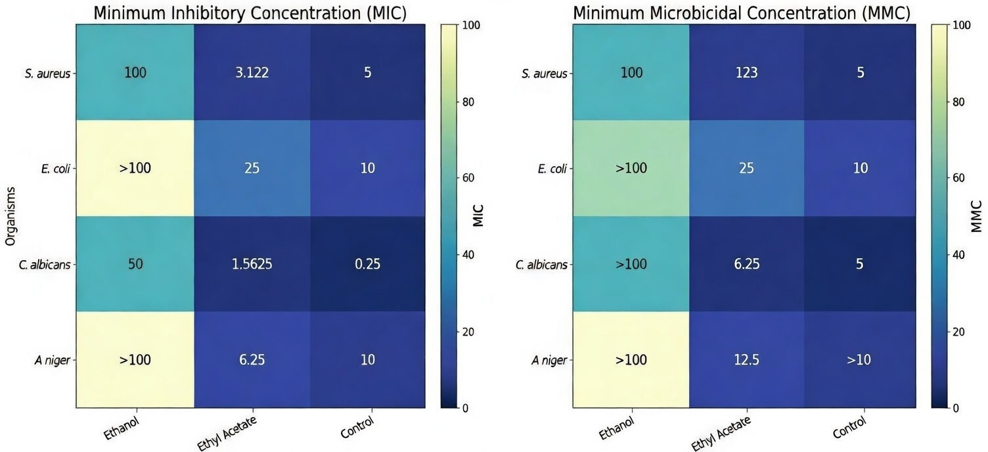

Figure 4: MIC and MMC of the polar extracts of Diodia scandens

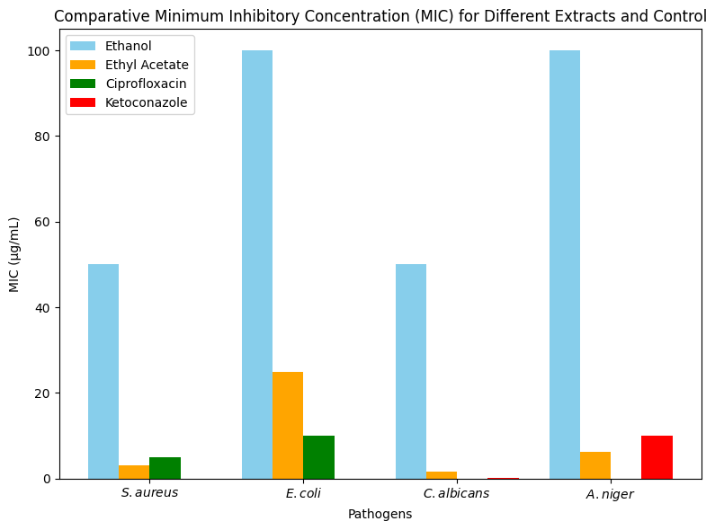
Figure 5: Comparative Minimum Inhibitory Concentration (MIC) of the polar extracts of Diodia scandens and controls
Conclusion
This study evaluated the aerial parts of Diodia scandens using successive solvent extraction, phytochemical screening, and in vitro antimicrobial assays. Qualitative screening confirmed a broad repertoire of secondary metabolites, with alkaloids, tannins, flavonoids, and coumarins consistently detected across extracts, while the distribution of phenolics and terpenoids showed clear solvent dependence. Quantitative findings further demonstrated differential enrichment: the ethanol extract concentrated relatively higher levels of saponins, alkaloids, flavonoids, and tannins, whereas the ethyl acetate fraction exhibited the greatest total phenolic content, indicating preferential partitioning of moderately polar phenolic constituents into a semi-polar solvent system. Biological evaluation against Staphylococcus aureus, Escherichia coli, Candida albicans, and Aspergillus niger showed that the ethyl acetate extract consistently outperformed the ethanol extract at comparable concentrations, producing larger inhibition zones and markedly lower MIC and MMC values. In contrast, the ethanol extract displayed weaker and less reproducible activity, particularly against E. coli and A. niger, consistent with its comparatively higher MIC/MMC thresholds. Collectively, these results indicate that the dominant antimicrobial principles of D. scandens are selectively enriched in the ethyl acetate fraction under the conditions employed. The findings reinforce the ethnomedicinal relevance of D. scandens.
Limitations
This study did not include a preliminary cytotoxicity test. The antimicrobial activity was also assessed using only four pathogens, and further studies with a broader range of microbes are recommended. Additionally, the study only utilized three solvents for extraction, and further solvent-based studies may reveal additional bioactive compounds

Disclaimer (Artificial intelligence)
Author(s) hereby declare that NO generative AI technologies such as Large Language Models (ChatGPT, COPILOT, etc.) and text-to-image generators have been used during the writing or editing of this manuscript.

References

- Abdallah, E. M., Alhatlani, B. Y., de Paula Menezes, R., & Martins, C. H. G. (2023). Back to nature: Medicinal plants as promising sources for antibacterial drugs in the post-antibiotic era. Plants, 12, Article 3077.

- Abubakar, A. R., & Haque, M. (2020). Preparation of medicinal plants: Basic extraction and fractionation procedures for experimental purposes. Journal of Pharmacy and Bioallied Sciences, 12(1), 1–10.

- Adepoju, A. J., Esan, A. O., Olawoore, I. T., Ibikunle, G. J., & Adepoju, V. O. (2024). Nauclea latifolia Stem Bark Extracts: Potentially Effective Source of Antibacterial, Antioxidant, Antidiabetic and Anti-Inflammatory Compounds. Journal of Applied Science and Environmental Management, 28(1), 49–59. https://doi.org/10.4314/jasem.v28i1.6

- Ahmed, S. K., Hussein, S., Qurbani, K., Ibrahim, R. H., Fareeq, A., Mahmood, K. A., & Mohamed, M. G. (2024). Antimicrobial resistance: Impacts, challenges, and future prospects. Journal of Medicine Surgery and Public Health, 2, 100081. https://doi.org/10.1016/j.glmedi.2024.100081

- Akpuaka, M. U., Chime, J. C., & Igoli, J. O. (2018). Phytochemical Analysis of n- Hexane and Ethylacetate Extracts of Diodia scandens Sw and Spectroscopic Identification of an Omega- 6 Fatty Acid and a Glyceryl Trilinoleoate. Physical Science International Journal, 19(3), 1–9. https://doi.org/10.9734/psij/2018/42782

- Altemimi, A., Lakhssassi, N., Baharlouei, A., Watson, D. G., & Lightfoot, D. A. (2017). Phytochemicals: Extraction, isolation, and identification of bioactive compounds from plant extracts. Plants, 6(4), 42.

- Angelini, P. (2024). Plant-derived antimicrobials and their crucial role in combating antimicrobial resistance. Antibiotics, 13(8), 746.

- do Nascimento, J. B., & da Costa, J. G. M. (2025). Flavonoids: A review of antibacterial activity against Gram-negative bacteria. International Journal of Microbiology, 2025(1), Article 9961121.

- Gajić, I., Kabić, J., Kekić, D., Jovićević, M., Milenković, M., Mitić Ćulafić, D., … Opavski, N. (2022). Antimicrobial susceptibility testing: A comprehensive review of currently used methods. Antibiotics, 11(4), Article 427.

- Kamarudin, N. A., Muhamad, N., Salleh, N. N. H. N., & Tan, S. C. (2021). Impact of solvent selection on phytochemical content, recovery of tannin and antioxidant activity of Quercus infectoria galls. Pharmacognosy Journal, 13(5), 1195–1204. https://doi.org/10.5530/pj.2021.13.153

- Kavita, S., Singh, N., & Sharma, O. P. (2022). Medicinal plants and their roles in healthy life. World Journal of Pharmaceutical and Medical Research, 8(9), 197–199.

- Li, J., & Monje-Galvan, V. (2023). In vitro and in silico studies of antimicrobial saponins: A review. Processes, 11(10), Article 2856.

- Muteeb, G., Rehman, M. T., Shahwan, M., & Aatif, M. (2023). Origin of antibiotics and antibiotic resistance, and their impacts on drug development: A narrative review. Pharmaceuticals, 16, Article 1615.

- Nguyen, N., Duong, N., Nguyen, K. H., Bui, N., Pham, T., Nguyen, K., Le, P., Kim, K., Dahibhate, N., Kumar, D., Kumar, K., Bibi, S., Gokhan, Z., Rajesh, J., Mahomoodally, M., Siddhuraju, P., Becker, K., Kchaou, W., Abbes, F., . . . Iamtham, S. (2021). Effect of extraction solvent on total phenol, flavonoid content, and antioxidant activity of Avicennia officinalis. Biointerface Research in Applied Chemistry, 12(2), 2678–2690. https://doi.org/10.33263/briac122.26782690

- O’Neill, J. (2016). Tackling drug-resistant infections globally: final report and recommendations. . https://apo.org.au/sites/default/files/resource-files/2016-05/apo-nid63983.pdf

- Ojo, S. K. S., Awokoya, O. O., Aliu, K. T., Jeje, T. O., Balogun, D. M., Offrire, V. O., Atitebi, C. O., & Awokoya, O. O. (2024). Prophylactic and combination study on Phyllanthus amarus and Diodia scandens bioactive fractions against antibiotic-resistant staphylococci. Nigerian Journal of Microbiology, 38(1), 7075–7084.

- Ojo, S. K. S., Idemudia, A. J., Alikwe, P. C. N., & Awokoya, O. O. (2010). Antimicrobial potency of Diodia scandens and Phyllanthus amarus on some clinical isolates. International Journal of Pharmaceutical Research and Development, 2(2), 1–7.

- Ojo, S. K., Esumeh, F. I., Osanyinlusi, S. A., & Jeje, T. O. (2017). Phytochemical and antibacterial properties of <i>Diodia scandens</i> and <i>Phyllanthus amarus</i> on staphylococci isolated from patients in tertiary hospitals in Nigeria. Journal of Medicinal Plants for Economic Development, 1(1). https://doi.org/10.4102/jomped.v1i1.7

- Ojo, S., Esumeh, F., & Uyoh, A. (2013). Antimicrobial Effect of Diodia scandens and Phyllanthus amarus on Multi-drug Resistance Pattern of Staphylococci from Clinical Sources of Surgical Unit of a Tertiary Hospital. American Journal of Drug Discovery and Development, 3(4), 271–278. https://doi.org/10.3923/ajdd.2013.271.278

- Podolsky, S. H. (2018). The evolving response to antibiotic resistance (1945–2018). Palgrave Communications, 4(1). https://doi.org/10.1057/s41599-018-0181-x

- Sam, S. (2019). Importance and effectiveness of herbal medicines. Journal of Pharmacognosy and Phytochemistry, 8(2), 354–357. https://www.phytojournal.com/archives/2019/vol8issue2/PartF/8-4-205-517.pdf

- Schultz, F., Anywar, G., Tang, H., Chassagne, F., Lyles, J. T., Garbe, L., & Quave, C. L. (2020a). Targeting ESKAPE pathogens with anti-infective medicinal plants from the Greater Mpigi region in Uganda. Scientific Reports, 10(1), 11935. https://doi.org/10.1038/s41598-020-67572-8

- Schultz, F., Anywar, G., Wack, B., Quave, C. L., & Garbe, L. (2020b). Ethnobotanical study of selected medicinal plants traditionally used in the rural Greater Mpigi region of Uganda. Journal of Ethnopharmacology, 256, 112742. https://doi.org/10.1016/j.jep.2020.112742

- Sadiq Wada, A. S., Julde, S. M., Borodo, S. B., Ahmad, M. H., Malami, S., & Yaro, A. H. (2022). Phytochemistry, ethnomedicinal uses and pharmacological activity of Diodia scandens: A review of current scientific literature. Egyptian Journal of Basic and Applied Sciences, 9(1), 533–541. https://doi.org/10.1080/2314808X.2022.2098462

