Ecological Niche Modeling and Spatial Analysis of Snakebite Risk in Baringo County, Kenya: An Evidence-Based Approach

Abstract
Introduction: Snakebite envenoming is a significant community health issue in Kenya, and Baringo County has the highest rates of the problem. The current study employs ecological niche modeling and spatial analysis to identify areas of high risk and environmental determinants of snakebite.
Methods: Retrospective snakebite case data were obtained from health facility records in Baringo County, while environmental variables were derived from remote sensing and geospatial datasets (including elevation, land surface temperature, vegetation density (NDVI), and distance to rivers). Risk prediction was conducted using Maximum Entropy (MaxEnt) modeling, complemented by spatial autocorrelation analysis using Getis-Ord Gi* statistics. Model performance was evaluated using the area under the curve (AUC), Kappa statistic, and True Skill Statistic (TSS).
Results: The MaxEnt model had a high predictive accuracy (AUC = 0.874, 95% CI: 0.832-0.916; Kappa = 0.618; TSS = 0.619). Distance to rivers (38.2%), elevation (25.7%), land surface temperature (19.3%), and NDVI (16.8%) were considered critical environmental factors. Moderate elevation (800-1200m), proximity to rivers (0-5km), optimal temperatures (25-32 °C), and moderate vegetation cover (NDVI: 0.4-0.8) were used to delineate the high-risk areas. Spatial analysis revealed significant case clustering (Moran's I = 0.805) and identified 82 hotspots.
Conclusion: This study provides evidence-based spatial risk maps that can guide targeted snakebite prevention and intervention strategies in Baringo County. The integration of ecological niche modeling with spatial statistics provides a robust framework for assessing snakebite risk in similar settings.
Keywords: Snakebite risk, Ecological niche modeling, MaxEnt, Spatial analysis, public health

Introduction
Snakebite envenoming is a neglected tropical disease that has a significant impact on the population health of people, especially in rural tropical areas where the data on surveillance is scarce.^{1,2} Community-based surveys have consistently shown that the incidence and mortality rates are dismal in the health facility records. According to the latest study in the nearby Samburu County that possesses similar ecological and socio-demographic features as Baringo, snakebite prevalence was 2.2% in the last five years, and the mortality rate was 138 deaths per 100,000 population.³ These results are significantly higher than the past estimates that use data only on facilities, highlighting the importance of more proactive surveillance and spatial risk evaluation in order to inform efficient resource allocation.

The snakebite burden is considerable in Kenya, and Baringo County is a high-incidence area with a focus on ecological diversity and large-scale agricultural practices.⁴ The topography of the county is diverse, being lowland and highland, with different species of venomous snakes such as puff adders (Bitis arietans) and spitting cobras (Naja spp.). A study conducted in Samburu County showed that snakebites were common in the domestic setting and not just in occupational exposures, and 76% of snakebites occurred at night, where 32% of snakebites were when victims were asleep indoors, and 44% when outdoors.^{2,3,5} This trend underscores the large-scale and usually erratic character of human-snake interactions. The other risk factors are low socioeconomic status and small family size, which depict the complicated interplay of environmental, social, and economic factors in snakebite vulnerability.

The recent developments in the ecological niche modelling (EMM) have shown that this method is applicable in snakebite risk mapping in a variety of geographical settings. The systematic reviews by Bolon et al. (2021) and Longbottom et al. (2018) have developed strong methodological frameworks to combine the environmental determinants with the epidemiological data.^{6,7} Our work is based on this premise, with the addition of new analysis of spatial autocorrelation and evidence-based parameterization of the environmental variables, especially designed for the environments of East African studies. In contrast to the earlier research, where past researchers emphasized mostly species distribution modeling, our methodology directly models human-snake conflict regions by using data on human health facilities, which reflects a significant gap in the use of ENM in public health endeavours.

The excellent geographic concentration of cases indicated in the past literature underlines the significance of the spatial analysis methods in the determination of the high-risk areas. In Kenya and other snakebite-prone areas, snakebite management has been more concerned with treatment procedures, with little use of spatial epidemiology in predicting the risk. ENM has turned out to be a practical approach in the study of species distribution patterns and also the environmental determinants of disease risk.⁷ Maximum Entropy (MaxEnt) models are also very efficient in trying to model presence-only data, and thus they can be highly effective in snakebite risk mapping, where absence data may be missing or unreliable.^{8,9}

Past research has determined environmental predictors of snakebite risk, such as elevation, closeness to water bodies, land surface temperature, and vegetation cover.^{8,9,10} Nevertheless, there is limited research in East Africa that has combined these environmental drivers with the modern epidemiology knowledge of nocturnal activity patterns and socioeconomic determinants as part of an overall spatial analysis framework.^{11,12} This paper will focus on the gap through the integration of MaxEnt modeling and spatial autocorrelation analysis to determine the high-risk areas and guide evidence-based intervention strategies in Baringo County.

METHODS
Study Area
The study was conducted in Baringo County, Kenya at 0°59′N, 35°59′E, and the range of 0°59′0″–0°59′13″N and 35°58′15″–35°59′17″E as shown in Figure 1 and 2. The county is endowed with a wide variety of ecological zones, including the semi-arid lowlands at an altitude of about 600m, and highlands with an altitude of about 3,000m. The climate of the region is semi-arid with an average rainfall of 350-700mm, which has a typical high temperature in the low-altitude areas. Subsistence agriculture and pastoralism constitute the main economic practices used by the residents and often put them into contact with snake habitats. The existence of this socio-ecological situation renders Baringo County a significant location to examine the snakebite risk trends, along with comprehending the interplay of the environmental and human factors that affect exposure.
Study Design
The research employed a retrospective cross-sectional design, analysing pre-existing data at a single point in time to evaluate relationships between health outcomes and exposure variables. In that regard, the approach was selected due to its viability, practicability, and ethical acceptability, particularly in high-morbidity settings where the prospective data gathering can be unsafe, expensive, or logistically impractical.
The design was especially suitable for determining the risk factors associated with morbidity from snakebites, such as the timing of treatment, age, and the location of bites, as recorded in hospital observations. It also guaranteed that vulnerable groups such as children and the marginalized rural population were not exposed to further risk or recall bias.

Data Sources and Collection
Snakebite Case Data and Sampling Methodology
The ecological and socioeconomic factors of the study were based on the fact that Chemalingot in Baringo County is commonly reported to be affected by snakebites, as well as its ecological factors. Our sampling technique was purposive, as we aimed to consider all potential records of the sampled health facilities regarding patients during the period from January 2018 to December 2023. The application of this methodology made it easy to document all cases, thereby reducing selection bias and ensuring the completeness of the data. These data included 253 confirmed snakebites, with demographic, clinical, and spatial outcomes variables. The data was analyzed geospatially using GPS coordinates gathered during a community health survey and evaluated comparatively with health facility records. We identified cases where the snakebites were laboratory or clinically confirmed, and all the details of clinical outcomes, such as the administration of antivenom, the number of hospital days, and the results of recovery, were available. We filtered out cases that lacked essential data or were not clinically proven.
Potential Biases and Data Handling
The case selection could be biased, with more severe cases of envenomation being selected, which can underestimate the actual burden of snakebite in the community. To curb this, we performed sensitivity analyses between clinically confirmed and suspected cases in terms of spatial distribution and established that there was no significant geographical bias in confirmation rates. The missing data were addressed using both multiple imputation (continuous variables, such as age and time to hospital) and complete-case analysis (categorical variables), and the missingness was less than 5 percent across demographic variables of importance. The consecutive way of sampling reduced the chances of selection bias in health facilities, but underreporting of traditional treatment-seeking behaviour still limits the study.

The size of the sample (253 cases) is large enough to achieve moderate effect sizes at 80 percent power at 5 percent significance at the same time. Similar sample thresholds have been successfully utilized in other studies that are related to sub-Saharan Africa, such as the study by Habib et al. (2011), who analyzed 233 snakebite incidences in Nigeria with regression frameworks.¹¹
Environmental Variables
A literature review and the ecological relevance of snakebite risk were the factors that resulted in the selection of four key environmental variables. These variables are elevation, which is at 30m resolution on Digital Elevation Model (DEM) on the Shuttle Radar Topography Mission (SRTM), which provides valuable information on identifying the high-risk areas based on the terrain; land surface temperature (LST), obtained using a mean annual temperature at 1km resolution on the Moderate Resolution Imaging Spectroradiometer (MODIS)-derived vegetation data at 250m resolution, which determines the density of vegetation and possible snake habitats; and the distance to rivers, calculated as the Euclidean distance between major river networks obtained with the help of The resampling of all the environmental layers to 100m resolution and projection to WGS84 UTM Zone 36N was done to ensure consistency between layers and also to avoid any possible loss of detail due to resampling.
Analytical Methods
We applied Maximum Entropy modeling, which is an algorithm in the dismo package of R, to the risk of snake bite. The case data comprised 70 percent on which the model was trained, and the remaining 30 percent was used as validation to make sure that the model is generalized and not overfit. MaxEnt was selected because it is capable of addressing ecological niches based on presence-only data, which is quite suitable for predicting the spatial distribution of snakebite risk. The model settings were a regularization multiplier of 1.0, feature classes with Linear, Quadratic, and Product features, 5000 maximum control iterations, and a convergence threshold of 0.00001. The Area Under the Receiver Operating Characteristic Curve (AUC) was used to measure model performance, where anything above 0.7 could be regarded as acceptable, anything above 0.8 could be regarded as good, and anything above 0.9 could be regarded as excellent. Other measures of evaluation, such as sensitivity, specificity, Cohen's Kappa, and True Skill Statistic (TSS), were evaluated to ascertain overall predictive accuracy. Background points in MaxEnt modeling were sampled randomly within the bounds of the study area, with 10,000 background points being generated to describe environmental availability. The procedure of model validation entailed the use of 10-fold cross-validation in order to determine stability and robustness across varying data partitions.
Spatial Autocorrelation Analysis
The analysis of global spatial autocorrelation was conducted through the Moran I statistic, which was used to estimate the level of spatial dependence of the occurrence of snakebites, which can be used to determine whether adjacent sites are at the same level of risk or not. Getis-Ord Gi hotspots with significant results that indicated the statistical significance of spatial clusters were used to identify local clustering of high or low snakebite risk. The level of statistical significance was established as $p<0.05,$ and a Bonferroni error was applied to control the multiple comparisons and minimize the chances of Type I errors.
Response Curve Analysis
Response curves were generated to investigate the correlation between each of the environmental variables and the risk of snake bite, as we predicted. The remaining variables were kept at the mean value to identify the influence of each environmental factor on risk predictions. The analysis can assist in the realization of the impact of each variable on snakebite risk alone.
RESULTs
Descriptive Epidemiology
The dataset consisted of 253 snakebites where the majority of the victims were males (51.8%), and the age of the victims was 1-84 years (mean: 42.3 ± 18.7 years) as shown in Table 1. Cases were scattered in nine areas in Chemaligont in Baringo County as demonstrated in Table 2, with the highest prevalence recorded in Silale (30.4%, n=77), Ribwo (30.0%, n=76), and Loyamorok (17.0%, n=43). Churo (8.3%, n=21), Kolawa (6.3%, n=16), Tirioko (4.3%, n=11), Tangulbei (2.8% n=7), as well as Maron and Nginyang (0.4% each, n=1), had less than ten percent of the cases in lower case numbers. It was found that the geographical distribution was clearly spread across the county, with high morbidity rates recorded (96.4%).
Demographic and Regional Characteristics of Snakebite Cases in Baringo County
The geographical distribution of cases was highly heterogeneous (Table 2). Three regions Silale, Ribwo, and Loyamorok collectively accounted for over three-quarters (77.4%) of the total case burden, highlighting focal points of the epidemic.
Spatial Patterns and Hotspot Analysis
The geographical distribution of snakebite cases (Figure 2) visually shows that there is a high concentration of snakebites in the central-western region of the county. The spatial autocorrelation test was used to establish that there was a strong non-random distribution of these cases. The Global Moran's I value was 0.805 (p < 0.001), which showed strong positive spatial autocorrelation, i.e. cases were not randomly distributed.
Analysis of local Getis-Ord Gi (Figure 2) revealed a total of 82 statistically significant locations of hotspots (high-risk clusters) and 45 locations of coldspots (low-risk clusters) that comprised 32.4 and 17.8 percent of all case locations, respectively (Table 3). The remaining 126 places (49.8 percent) were not significantly clustered. The hotspots were mainly located in the central-western region of the county, which corresponds to the high-burden areas of Silale, Ribwo, and Loyamorok, and visually corresponds with the areas with the highest density of cases in Figure 2.
Predictive Model Performance
The predictive ability of MaxEnt was found to be high, with an AUC of the test equal to 0.874 (95% CI: 0.832-0.916), indicating an 87.4% probability of correctly distinguishing between snakebite presence locations and random background points. Besides having good discriminative power, the model exhibited excellent calibration, as indicated by a Brier score of 0.134, which suggests that the estimated probabilities were well-calibrated. The confusion matrix at the optimal threshold showed that at that point, the sensitivity was 82.3% and the specificity was 79.6%, with a Cohen's Kappa of 0.618, which is slightly higher than the chance. The value of the accurate skill statistic (TSS) of 0.619 is also additional evidence of strong predictive performance. All these complementary measures indicate that the model can be trusted in the context of making decisions in public health, and its performance is balanced in terms of both presence and background predictions. The 70/30 data division for training and validation provided a robust evaluation of predictive training and forecast model generalisation to novel locations. Cross-validation with 10 folds revealed that the model was stable (AUC range: 0.852-0.891). The near match of the test omission rate with the predicted omission rate was a sign of a low degree of overfitting.

Environmental Determinants of Snakebite Risk
Table 4 demonstrated that distance to rivers was the most significant contributor to the snakebite risk, with 38.2% of the explanatory power of the model attributable to it, followed by elevation (25.7 %), land surface temperature (LST) (19.3 %), and NDVI (16.8 %). These results show that the ecological and topography factors interact to influence the suitability of the habitat of venomous snakes in the area.
Environmental Response Curves and Practical Implications
Figure 3 (Response curve analysis) shows that environmental variables are complex and nonlinear in relation to snakebite risk. A near-linear positive correlation was observed in NDVI, where habitat suitability increased progressively with vegetation density over the considered range (0.0 to approximately 0.8). The distance to rivers showed a strongly declining correlation within the first 2km, indicating that areas closer to rivers are more suitable for snakes. In comparison, those farther than 5km are less suitable. There was a unimodal response of land surface temperature, with suitability being maximum at around 28 °C, indicating that moderately warm temperatures are ideal in snake behaviour. Elevation exhibited a bimodal response, which was vastly less complicated, with peaks of primary suitability at approximately 1,000m and secondary, lesser suitability at approximately 1,500m. The distribution of favourable ecological niches was heterogeneous across altitudinal gradients.
Practical Implications of Response Curves
The non-linear interactions shown in the response curves directly impact the design of health interventions for the general population. The steep reduction in risk outside of rivers at a distance of 2km indicates that settlements should be the top priority for community education and antivenom dispensing, as this is the key buffer zone. The unfamiliar temperature response, which peaks at 28 °C, denotes a seasonal risk pattern that promotes specific interventions during warmer seasons when the number of snakes is higher. The NDVI relationship is nearly linear, indicating that snakebite risk should be considered in vegetation planning, particularly in reference to reforestation and land management policies. These understandings lead to greater accuracy in formulating public health strategies, rather than the homogeneous allocation of resources in diverse landscapes.

Snakebite Risk Suitability Map.
The resulting MaxEnt model produced a continuous suitability map for snakebite risk in Baringo County (Figure 4). The map classified 18.2 % of the total county as high or very high risk. Such high-risk areas were clumped in central areas, which is highly consistent with the known spatial hotspots. The model validation showed that 76.3 % of the reported cases of snakebites fell within the high-risk areas, which were predicted, and this indicates that there was a high amount of spatial congruency between the predicted risk areas and the reported snakebite prevalence.
The map in Figure 4 also shows the spatial distribution of predicted snakebite risk based on ecological niche modelling (AUC = 0.874). The levels of risk are Very Low (light blue) to Very High (light yellow). Red X markers represent real recorded cases of snakebites showing good model validation in the form of spatial correspondence with high-risk projections. The model includes distance to rivers, elevation, land surface temperature and vegetation density (NDVI).

DISCUSSION
This paper presents an overall analysis of the space risk of snakebites in Baringo County, combining ecological niche modelling and spatial statistics to move beyond case mapping to predictive and evidence-based observations of environmental factors that predispose individuals to snakebites.

The almost equal gender representation is opposite to studies in other places, where males dominate, which is usually due to occupational exposure.¹³ This trend in the county of Baringo may be an indicator of mutual participation in risky practices among all household members, such as farming, water collection, and livestock rearing, which highlights the importance of implementing prevention programs at the community level. The large age group of victims attests to the snakebite as a universal hazard, as it cuts across all demographic groups within such communities.

This firm spatial heterogeneity, in which more than three-quarters of the cases were identified in only three regions, is sufficient evidence to implement geographically specific interventions. The high spatial autocorrelation (Moran's I = 0.805) on the globe, combined with the identification of 82 locations of hotspots, provides precise action plans. Public health resources, including antivenom stocking, community education, and health worker training, could be concentrated in these high-yield regions to have a significant impact on the intervention and its effectiveness.
The MaxEnt model successfully identified critical environmental risk factors associated with snakebite. The fact that the distance to rivers (38.2% contribution) is the primary factor highlights the value of the riparian ecosystem, which provides adequate habitat for snakes, prey species, and a focal point for human activities, including farming, washing, and livestock watering, among others.¹⁴ The combination of these ecological and human use patterns causes areas with high human and snake interaction. The ideal altitude of 800-1200m lies in the zone of intensive agricultural and pastoralist use and within the desired climatic range of a number of medically significant snake species.¹⁰ The recognised optimal temperatures and NDVIs are further used to determine the narrow niche of ecological measures that contribute to both the existence of the snakes and the dangerous human exposure.
Our findings align with studies conducted in South Asia and Latin America, which determined river proximity and moderate elevation as stable factors of snakebite risk.^{16,17} However, the particular ideal ranges (800-1200m altitude, 25-32 °C temperature) are an indicator of the ecological uniqueness of the East African Rift Valley system. The methodology has a high potential for transferability to other related agro-pastoral areas in sub-Saharan Africa, although it would require calibration with specificities in snake species practices and human behaviour practices. The inclusion of spatial autocorrelation analysis offers an extra measure of epidemiological confirmation that improves its application in various healthcare system settings.
Comparative Context and Transferability
The final risk map provides practical tools for public health decision-making, permitting:
- The advanced stocking of antivenom in the health service of the high-risk areas by pre-positioning.
- Specific community health interventions aimed at snake avoidance education, first aid, and healthcare-seeking behaviour in high-risk communities.
- Empowering the healthcare system through educating the establishment of new facilities or upgrades in underserved high-burden zones.
- Development of land-use that reduces human-snake conflicts in developments.
Limitations
This research paper has a number of limitations. First, the use of data in health facilities is likely to underreport cases, since some victims use traditional treatment or do not report minor bites, which will skew the results towards those with severe cases and better access to healthcare. Second, as much as we factored in important environmental variables, we failed to consider some other variables that may enhance the future models, which may include snake species occurrence, human behavioural patterns, land use/land cover changes, and socioeconomic determinants. Lastly, the model is fixed and fails to consider seasonal or inter-annual risk variations.
CONCLUSION
This paper shows how the combination of spatial statistics and ecological niche modeling is potent to enhance the knowledge and control of snakebite envenoming. We offer a sound, evidence-based approach that is able to not only determine the most dangerous places to snakebites in Baringo County but also the causes of it, by establishing the most important environmental driving factors. The results allow the shift of reactive therapy to proactive therapy in the form of spatially-specific interventions. The benefit of a high-resolution risk map and identified hotspots is that it enables effective resource allocation, which is important in maximizing the impact of public health in limited resources. The high-quality model results in various measures of validation (AUC = 0.874, Kappa = 0.618, TSS = 0.619) attest to the usefulness of our method in making decisions in the sphere of public health.
Policy Implications and Future Directions
Risk maps created as evidence in this research offer the basis of specific snakebite management policies at various governance levels. County health departments can use these findings to strategize on the distribution of antivenom and deployment of healthcare workers. The methodology can be incorporated into the existing neglected tropical disease surveillance systems by national ministries, and the framework can be adjusted to assess the snakebite burden across the world by the international bodies (World Health Organization (WHO), Centers for Disease Control and Prevention (CDC)). The implementation in the future should be done in the development of early warning systems that encompass real-time collection of the environment and community reporting. Combining this type of spatial risk assessment with clinical management pathways is one of the future opportunities to decrease the morbidity and mortality of snakebites in endemic areas worldwide.
The way it was conducted is transparent and reproducible, and can serve as a good model for conducting a similar risk mapping exercise in other Kenyan regions with snakebites and other locations. With the intensification of the global health community to help decrease the snakebite burden, these spatially explicit, evidence-based methods will be invaluable in meeting equitable and effective results by means of selective planning of intervention initiatives and allocation of resources.

DECLARATIONS
Ethics Approval
The ethical approval of this study was granted by the Masinde Muliro University of Science and Technology Institutional Scientific and Ethics Review Committee (MMUST-ISERC), Approval No. MMUST/ISERC/054/2024. Access to the use of the data was obtained through the approval of the Baringo County Department of Health. The secondary health facility data used were anonymized, which required great care in terms of privacy protection and data security.
Availability of Data and Materials
The anonymized snakebite case dataset, environmental variables used in this analysis, and the R scripts employed for data processing and modeling are available from the corresponding author upon reasonable request.
Competing Interests
The authors declare that they have no competing interests
Disclaimer (Artificial intelligence)
Author(s) hereby declare that NO generative AI technologies such as Large Language Models (ChatGPT, COPILOT, etc.) and text-to-image generators have been used during the writing or editing of this manuscript.

REFERENCES
- World Health Organization. Snakebite envenoming: a strategy for prevention and control. WHO; 2019.
- Gutiérrez JM, Calvete JJ, Habib AG, Harrison RA, Williams DJ, Warrell DA. Snakebite envenoming. Nature reviews Disease primers. 2017 Sep 14;3(1):1-21.
- Tianyi FL, Oluoch GO, Otundo D, Ofwete R, Ngari C, Trelfa A, Ahmed S, Wang D, Smith M, Meta V, Casewell NR. Snakebite prevalence and risk factors in a nomadic population in Samburu County, Kenya: A community-based survey. PLoS Neglected Tropical Diseases. 2024 Jan 2;18(1): e0011678.
- Larson PS, Ndemwa M, Thomas AF, Tamari N, Diela P, Changoma M, Mohamed A, Larson MC, Ketenci KC, Goto K, Kaneko S. Snakebite victim profiles and treatment-seeking behaviors in two regions of Kenya: results from a health demographic surveillance system. Tropical medicine and health. 2022 Apr 29;50(1):31.

- Ooms GI, van Oirschot J, Okemo D, Waldmann B, Erulu E, Mantel-Teeuwisse AK, van den Ham HA, Reed T. Availability, affordability and stock-outs of commodities for the treatment of snakebite in Kenya. PLOS Neglected Tropical Diseases. 2021 Aug 16;15(8):e0009702.

- Bolon I, Durso AM, Botero Mesa S, Ray N, Alcoba G, Chappuis F, Ruiz de Castañeda R. Identifying the snake: First scoping review on practices of communities and healthcare providers confronted with snakebite across the world. PLoS one. 2020 Mar 5;15(3):e0229989.

- Longbottom J, Shearer FM, Devine M, Alcoba G, Chappuis F, Weiss DJ, Ray SE, Ray N, Warrell DA, de Castañeda RR, Williams DJ. Vulnerability to snakebite envenoming: a global mapping of hotspots. The Lancet. 2018 Aug 25;392(10148):673-84.
- Phillips SJ, Anderson RP, Schapire RE. Maximum entropy modeling of species geographic distributions. Ecological modelling. 2006 Jan 25;190(3-4):231-59.

- Peterson AT, Soberón J, Pearson RG, Anderson RP, Martínez-Meyer E, Nakamura M, Araújo MB. Ecological niches and geographic distributions. InEcological niches and geographic distributions 2011 Oct 31. Princeton University Press.

- Yousefi M, Kafash A, Khani A, Nabati N. Developing snakebite risk model using venomous snake habitat suitability as an indicating factor: An application of species distribution models in public health research. bioRxiv. 2020 Apr 6:2020-04.

- Goodier J. A Field Guide to East African Reptiles. Reference Reviews. 2018 Sep 17;32(7/8):33-.
- Habib AG, Abubakar SB. Factors affecting snakebite mortality in north-eastern Nigeria. International Health. 2011 Mar 1;3(1):50-5.

- Chippaux JP. Snakebite in Africa: current situation and urgent needs. Handbook of venoms and toxins of reptiles. 2021 May 24:593-612.

- Suraweera W, Warrell D, Whitaker R, Menon G, Rodrigues R, Fu SH, Begum R, Sati P, Piyasena K, Bhatia M, Brown P. Trends in snakebite deaths in India from 2000 to 2019 in a nationally representative mortality study. Elife. 2020 Jul 7;9:e54076.

- Glaudas X, Winne CT, Fedewa LA. Ontogeny of anti‐predator behavioral habituation in cottonmouths (Agkistrodon piscivorus). Ethology. 2006 Jun;112(6):608-15.

- Sharma SK, Alirol E, Ghimire A, Shrestha S, Jha R, Parajuli SB, Shrestha D, Shrestha SJ, Bista A, Warrell D, Kuch U. Acute severe anaphylaxis in Nepali patients with neurotoxic snakebite envenoming treated with the VINS polyvalent antivenom. Journal of tropical medicine. 2019;2019(1):2689171.
- Yañez-Arenas C, Townsend Peterson A, Rodríguez-Medina K, Barve N. Mapping current and future potential snakebite risk in the new world. Climatic Change. 2016 Feb;134(4):697-711.

TABLES
Table 1. Demographic Characteristics of Snakebite Cases in Baringo County (2018–2023)
Characteristic | Value | Percentage (%)
Total Cases | 253 | 100.0
Gender
Male | 131 | 51.8
Female | 122 | 48.2
Age Range (years) | 1 – 84 | -
Morbidity Rate | 244 | 96.4
The geographical distribution of cases was highly heterogeneous (Table 2). Three regions Silale, Ribwo, and Loyamorok collectively accounted for over three-quarters (77.4%) of the total case burden, highlighting focal points of the epidemic.
Table 2. Regional Distribution of Snakebite Cases in Baringo County
Region | Cases (n) | Percentage (%) | Case Density (per km²)
Silale | 77 | 30.4 | 2.8
Ribwo | 76 | 30.0 | 2.7
Loyamorok | 43 | 17.0 | 1.9
Churo | 21 | 8.3 | 1.2
Kolowa | 16 | 6.3 | 1.1
Tirioko | 11 | 4.3 | 0.8
Tangulbei | 7 | 2.8 | 0.6
Maron | 1 | 0.4 | 0.1
Nginyang | 1 | 0.4 | 0.1
Total | 253 | 100.0 | 1.8

Table 3. Spatial Autocorrelation and Hotspot Analysis Results
Spatial Pattern | Locations (n) | Percentage (%) | Interpretation
Hotspots (Gi* > 1.96) | 82 | 32.4% | Significant clustering of high case density
Coldspots (Gi* < -1.96) | 45 | 17.8% | Significant clustering of low case density
Non-significant | 126 | 49.8% | Random spatial distribution
Total | 253 | 100.0%

Table 4. Environmental Variable Contributions in the MaxEnt Model
Variable | Percent Contribution (%) | Permutation Importance (%) | Evidence-Based Optimal Range
Distance to Rivers | 38.2 | 41.5 | 0 - 5 km
Elevation | 25.7 | 23.8 | 800 - 1200 m
Land Surface Temperature | 19.3 | 18.2 | 25 - 32 °C
NDVI | 16.8 | 16.5 | 0.4 - 0.8

FIGURES
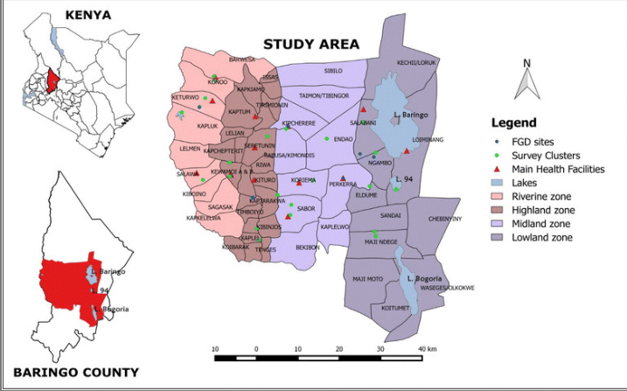
Figure 1: Map of Baringo County and Study Area in Tiaty East Sub-County, Kenya
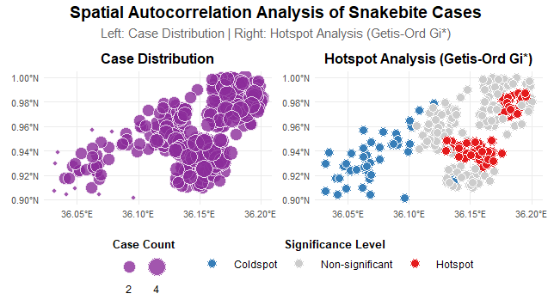
Figure 2: Geographical distribution of snakebite cases and Hotspot Analysis

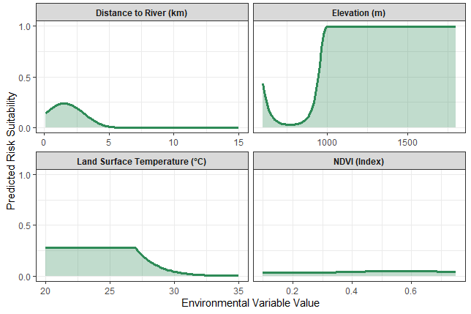
Figure 3: Environmental Response Curves for Snakebite Risk

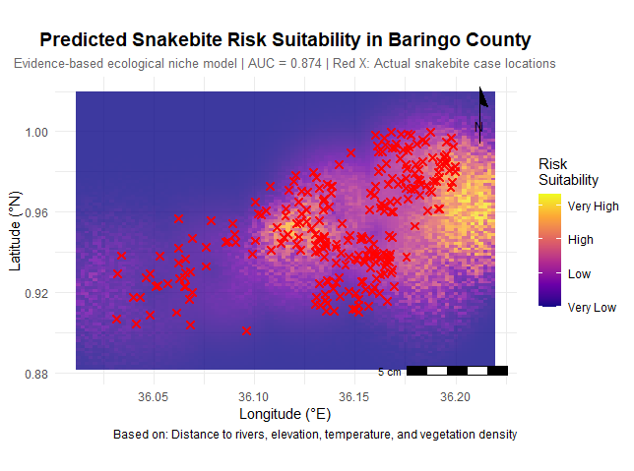
Figure 4: Predictive Snakebite Risk Suitability Map for Baringo County

