FORAMINIFERA BIOSTRATGRAPHIC AND PALEOENVIRONMENTAL ANALYSIS OF “X-1” WELL, ON THE WESTERN SECTOR OF THE NIGER DELTA BASIN, NIGERIA

ABSTRACT
A foraminiferal biostratigraphic and paleoenvironmental study was conducted on ditch-cutting samples from well X-1 (1870–1320 m), located in the western sector of the Niger Delta Basin, southern Nigeria. The objectives were to determine the stratigraphic age, depositional paleoenvironments, sequence-stratigraphic framework, and preliminary petroleum potential of the penetrated interval. A total of 48 ditch-cutting samples were analyzed using standard lithologic (visual and microscopic) and micropaleontological preparation techniques. Lithostratigraphic analysis identified four sub-lithofacies units (X1–X4) characterized by alternating sand and shale, a typical feature of the Agbada Formation. Foraminiferal analysis revealed moderate abundance and diversity of planktonic, calcareous benthic, and agglutinated benthic forms. A total of 60 foraminiferal species were identified, comprising 21 planktonic species (42%) and 39 benthic species (58%). The co-occurrence of key taxa including Globigerinoides obliquus, Globorotalia acostaensis, Globigerinoides obliquus extremus, and Cyclammina cf. minima enabled recognition of two planktonic foraminiferal zones: the Globorotalia acostaensis Zone (N16; early Late Miocene, Tortonian) and a composite Globorotalia humerosa / G. margaritae margaritae / G. margaritae evoluta Zone (N17–N19; late Late Miocene to earliest Early Pliocene, late Tortonian–Zanclean). A composite benthic foraminiferal zone spanning the Marginulina costata Zone (NNDF 04; uppermost Miocene to earliest Pliocene), Cyclammina minima Zone (NNDF 05; latest Late Miocene), Haplophragmoides narivaensis Zone (NNDF 06; middle Late Miocene), and Ammobaculites agglutinans / Florius costiferum Zone (NNDF 07; early to middle Late Miocene) was erected, in accordance with the standard Niger Delta chronostratigraphic framework. Biostratigraphic results indicate that the studied interval penetrates sediments of Late Miocene to earliest Early Pliocene age. Paleoenvironmental interpretation, based on integrated biofacies and lithofacies data, identified four paleodepositional/paleobathymetric settings ranging from coastal delta plain to fully neritic conditions (inner neritic, middle neritic, and outer neritic). Sequence-stratigraphic analysis delineated a major maximum flooding surface (MFS) at 1390 m (~5.0 Ma), separating a transgressive systems tract (TST) below from a highstand systems tract (HST) above. The moderately well-sorted sands and enclosing shales exhibit good potential as petroleum reservoir, source, and cap rocks, respectively.

Keywords: Foraminiferal biostratigraphic, paleoenvironment, lithologic analysis, Age
determination, major bounding surfaces

INTRODUCTION
The Niger Delta Basin, situated in the Gulf of Guinea on the southern coast of Nigeria, is one of the world's most prolific hydrocarbon provinces. Formed as a passive-margin clastic wedge, it comprises three major diachronous lithostratigraphic units: the deep-marine Akata Formation (primarily source rocks), the paralic Agbada Formation (main reservoir interval with alternating sandstones and shales), and the continental Benin Formation (top seal and aquifer). The basin's depobelts prograde southwestward, with the coastal swamp depobelt (western sector) representing a key transitional zone between onshore and shallow offshore plays (Short and Stauble, 1967; Doust and Omatsola, 1990; Reijers, 2011). Hydrocarbon exploration in the Niger Delta has evolved from onshore and shallow-water Miocene–Eocene targets to deeper offshore frontiers, driven by Nigeria's reliance on petroleum revenues and the need for sustained discoveries (Adegoke et al., 2017).
Foraminiferal biostratigraphy, integrated with lithostratigraphy and sequence-stratigraphic analysis, remains a basis for age dating, paleoenvironmental reconstruction, and reservoir prediction in deltaic settings. Numerous studies have applied these techniques across the basin (e.g., Petters, 1982, 1995; Ozumba, 1999; Ajayi and Okosun, 2014; Asadu and Anintah, 2023), yet detailed foraminiferal records from the western sector's (Figure1) coastal swamp depobelt remain limited, particularly for Late Miocene–Early Pliocene intervals of the Agbada Formation.
This study presents a foraminiferal biostratigraphic and paleoenvironmental analysis of ditch-cutting samples from well X-1 (1870–1320 m), located in the western sector of the Niger Delta Basin, southern Nigeria. The primary objectives were to: (1) establish the stratigraphic age of the penetrated interval; (2) reconstruct depositional paleoenvironments and paleobathymetry; (3) define a sequence-stratigraphic framework; and (4) evaluate preliminary petroleum system elements.
The primary aim of this study was to conduct a detailed foraminiferal biostratigraphic and paleoenvironmental analysis of ditch-cutting samples from well X-1 (1870–1320 m) in the western sector of the Niger Delta Basin, with the goal of establishing the stratigraphic age, depositional paleoenvironments, sequence-stratigraphic framework, and preliminary petroleum system potential of the penetrated Agbada Formation interval. To achieve this, the following specific objectives were pursued: first, to describe the lithostratigraphy and delineate lithofacies units based on textural and compositional characteristics of the ditch-cutting samples; second, to identify and document the foraminiferal assemblages (planktonic and benthic), determine species abundance and diversity, and erect planktonic and benthic biozones using standard zonation schemes and regional Niger Delta chronostratigraphic markers; third, to determine the precise stratigraphic age of the studied interval through integration of planktonic and benthic foraminiferal bioevents; fourth, to reconstruct the paleodepositional environments and paleobathymetric settings by integrating biofacies indicators (such as planktonic/benthic ratio, calcareous/arenaceous ratio, and key taxa) with lithofacies associations; fifth, to establish a sequence-stratigraphic framework, with particular emphasis on identifying maximum flooding surfaces (MFS) and defining transgressive systems tract (TST) and highstand systems tract (HST) intervals; and finally, to provide a preliminary evaluation of the petroleum system elements—including reservoir, source, seal, and trap potential—based on the integrated lithofacies, biofacies, and sequence-stratigraphic interpretations.
This approach not only contributes to refining the biostratigraphic and depositional understanding of the Agbada Formation in the coastal swamp depobelt but also supports ongoing hydrocarbon exploration efforts in the western Niger Delta by linking microfossil evidence to reservoir prediction and play fairway assessment.
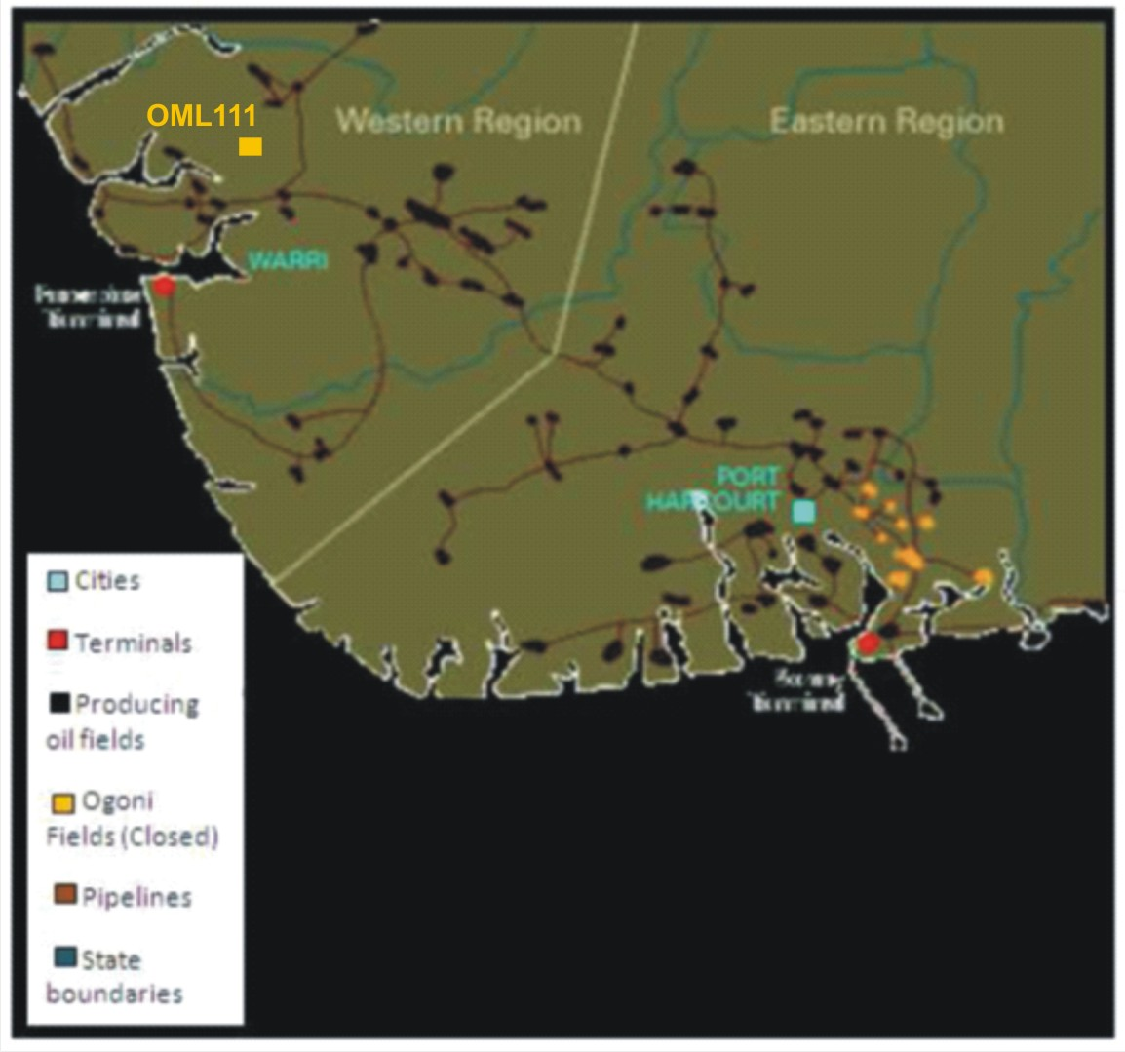
Figure 1: Location map of the Niger Delta showing “X-1 Well
(Modified from Imasuen et al., 2011).

GEOLOGICAL SETTING
The Niger Delta Basin is a world-class clastic wedge formed at the intersection of the African and South American plates, representing a classic passive-margin delta system. It exhibits characteristics of an intermediate-class delta with mixed fluvio-deltaic, wave, and tidal influences, currently in a dynamic equilibrium between accommodation space and sediment supply (Chiaghanam et al., 2011). The basin is subdivided into three major diachronous lithostratigraphic units from base to top: the Akata Formation, the Agbada Formation, and the Benin Formation (Figure 2), overlain by Quaternary deposits of varying types (Boboye and Fawora, 2007; Reijers, 2011).
According to Adegoke et al. (2017), these subsurface units consist of:
- Akata Formation: the basal, predominantly marine shale sequence, approximately 600 m thick in many areas but thickening significantly basinward. It is overpressured in deeper sections and occurs at depths of 4–6 km onshore and 1–3 km offshore (Oti and Beka, 1995). Composed mainly of marine shales with minor turbidites, it serves as the primary hydrocarbon source rock in the basin due to its high organic content.
- Agbada Formation: the most extensively studied and hydrocarbon-productive unit, forming the paralic (delta-front to pro-delta) transition between the underlying Akata and overlying Benin formations. Its top is defined by the first occurrence of shales containing brackish to marine fauna, while the base corresponds to the deepest significant sandstone with plant remains and mica, coinciding with the top of the marine Akata shales. The formation reaches thicknesses of up to ~4500 m in the central depobelt (Oti and Beka, 1995) and is characterized by rhythmic alternations of sandstone and shale that constitute the principal petroleum reservoirs. Recent geophysical studies in the southeastern Niger Delta have further highlighted structural controls and geothermal implications within this interval (Ekpo et al., 2024b&c).
- Benin Formation: the uppermost, continental to coastal-plain clastic wedge, dominated by sands and sandstones (70–100% sand content) with minor shale intercalations (Ojo and Gbadamosi, 2013). Its top coincides with the present-day surface, and the base is marked by the highest shale bearing marine foraminifera (Short and Stauble, 1967). The formation is approximately 2000 m thick (Beka and Oti, 1995) and serves primarily as an aquifer and top seal in many fields.
The outcropping equivalents of these units are the Imo Shale (Akata equivalent), Ameki Group (Agbada equivalent), and Benin Sands (Benin equivalent), respectively. The basin's structural framework is dominated by growth faults, roll-over anticlines, and shale diapirism, which play critical roles in hydrocarbon trapping and migration. In the western sector (coastal swamp depobelt), these elements combine with progradational deltaic processes to create favorable conditions for stratigraphic and structural plays, as documented in regional studies (Ekpo et al., 2024a&d; Adegoke et al., 2017).
Figure 2: Stratigraphic data sheet (eastern Niger Delta) of the Niger Delta. (from Reijers, 2011)

MATERIALS AND METHODS
Ditch-cutting samples from well X-1 (depth interval 1870–1320 m) were provided by an operating oil company in the Niger Delta. A total of 55 samples were collected at regular 10 m intervals for integrated lithologic and foraminiferal biostratigraphic analysis.

Lithologic Analysis
Lithostratigraphic description was performed using both macroscopic (visual inspection) and microscopic techniques. Each sample was examined for textural characteristics (grain size, sorting, roundness, and angularity), colour, sedimentary structures (where visible), and accessory minerals (e.g., pyrite, carbonaceous matter, ferruginous material, mica, and shell fragments). Observations were recorded systematically to delineate lithofacies units and infer depositional characteristics.

Foraminiferal Biostratigraphic Analysis
Sample preparation and analysis followed standard micropaleontological procedures for ditch cuttings (e.g., Bolli and Saunders, 1985; Petters, 1995; Adegoke et al., 2017). The workflow was as follows:
1. Sample Layout and Labelling
Samples were arranged sequentially by depth and clearly labelled.
2. Disaggregation
Unwashed ditch cuttings were rinsed with water to remove drilling mud, then air-dried. A standard 20 g subsample of each dried sample was placed in a clean sample plate, soaked in a solution of anhydrous sodium carbonate and water, and left to disaggregate overnight.
3. Washing and Sieving
Disaggregated residues were washed under running tap water over a 63 µm mesh sieve to remove clay and silt fractions. The retained residue (>63 µm) was oven-dried on a hotplate at a controlled temperature not exceeding 20° C to prevent thermal damage to foraminiferal tests.
4. Size Fractionation and Examination
Dried residues were dry-sieved into three main size fractions: coarse (>500 µm), medium (250–500 µm), and fine (63–250 µm). Each fraction was examined separately in a picking tray under reflected light using a binocular stereomicroscope (Zeiss model). Specimens were picked using a fine sable-hair brush (size N0000).
5. Identification and Documentation
Foraminiferal taxa were identified by direct comparison with published illustrations and descriptions from key references, including Bolli and Saunders (1985), Petters (1995), Adegoke et al. (2017), and other relevant regional and global monographs. Both planktonic and benthic (calcareous and agglutinated) forms were recorded. Species-level identifications were prioritized for biostratigraphic index taxa, while generic or higher-level assignments were used where preservation was poor.

All analyses were conducted at the micropaleontology laboratory of the Department of Geology, Akwa Ibom State University. No quantitative abundance data (e.g., specimens per gram) were calculated beyond total counts and qualitative abundance/diversity assessments, due to the nature of ditch-cutting samples and the focus on biostratigraphic zonation and paleoenvironmental reconstruction.
RESULT AND Discussion
Summary of Key Findings
A total of 55 ditch-cutting samples were examined using standard lithologic (visual and microscopic) and micropaleontological preparation methods. Lithostratigraphic analysis delineated four sub-lithofacies units (X1–X4) dominated by sand–shale alternations, characteristic of the Agbada Formation. Foraminiferal recovery showed moderate abundance and diversity of planktonic, calcareous benthic, and agglutinated benthic forms, yielding 60 species (21 planktonic [42%], 39 benthic [58%]). Key index taxa, including Globigerinoides obliquus, Globorotalia acostaensis, Globigerinoides obliquus extremus, and Cyclammina cf. minima, supported recognition of two planktonic zones: Globorotalia acostaensis Zone (N16) and a composite Globorotalia humerosa / G. margaritae margaritae / G. margaritae evoluta Zone (N17–N19). A composite benthic zone spanning Marginulina costata Zone (NNDF 04), Cyclammina minima Zone (NNDF 05), Haplophragmoides narivaensis Zone (NNDF 06), and Ammobaculites agglutinans / Florius costiferum Zone (NNDF 07) was established, aligned with the Niger Delta chronostratigraphic scheme (Adegoke et al., 2017).
The integrated biostratigraphy dates the interval to Late Miocene to earliest Early Pliocene. Paleoenvironmental reconstruction, based on biofacies and lithofacies integration, identified four settings: coastal delta plain, inner neritic, middle neritic, and outer neritic. Sequence-stratigraphic interpretation delineated a major maximum flooding surface (MFS) at 1390 m (~5.0 Ma), separating a transgressive systems tract (TST) below from a highstand systems tract (HST) above. The moderately well-sorted sands and enclosing shales exhibit good potential as reservoir, source, and cap rocks, respectively.

Lithostratigraphy of ‟ X-1”- Well
Lithostratigraphic interpretation of well X-1 (1870–1320 m) was based exclusively on ditch-cutting samples, as no wireline logs were available. Four sub-lithofacies units (X1–X4) were delineated (Table 1), with a total analyzed thickness of 550 m.

Table 1: Depth and related lithofacies of sediments in ‟ X” –1 Well
Depth (m) | Lithofacies | Dominant Lithology | Key Characteristics
1870–1780 | X1 | Predominantly sand with traces of siltstone | Fine- to medium-grained, angular to subrounded, moderately sorted; ferruginous material
1780–1610 | X2 | Light to gray-brownish fissile shale with minor sand/sandstone | Fissile to non-fissile, moderately hard; carbonaceous matter, pyrite
1610–1420 | X3 | 100% sand with traces of siltstone | Fine- to coarse-grained, moderately to poorly sorted
1420–1320 | X4 | Predominantly light to gray-brownish fissile shale monoliths with minor sand/siltstone | Fissile, moderately hard; shell fragments (gastropod), pyrite

The dominant lithologies are sandstones with subordinate shale and siltstone intercalations. Sand grains are predominantly fine-grained, occasionally medium- to coarse-grained, angular to subrounded, and moderately to poorly sorted, with ferruginous material in places. Shale intervals range from dark gray to brownish gray (occasionally light gray), are fissile to non-fissile, and moderately hard. Accessory components include pyrite, carbonaceous matter, ferruginous material, and minor shell fragments (gastropod).
The sandstone/shale ratio increases upward, producing an overall coarsening-upward succession. Alternating sandstones and shale is characteristic of the paralic Agbada Formation, and the upward increase in sand proportion reflects progressive progradation (seaward advancement) of the Niger Delta depositional system during the studied interval.
Foraminiferal Biostratigraphy
Foraminiferal analysis was performed on 48 ditch-cutting samples collected at 10 m intervals. Twenty-two samples were barren (1870–1800 m and 1650–1430 m), while the remaining intervals yielded moderate to low abundance and diversity of planktonic and benthic foraminifera (Figure 3 – biostratigraphic chart showing abundance and diversity trends).
A total of 223 foraminiferal specimens were recovered, representing 60 species: 21 planktonic species (42% of species; 119 specimens, 51.07% of population) and 39 benthic species (58% of species; 104 specimens, 48.93% of population). Among benthic forms, 16 were calcareous (42% of benthic species) and 13 agglutinated/arenaceous (26% of benthic species) (Figure 4a – bar chart of foraminiferal types; Figure 4b – pie chart of planktonic vs. benthic distribution).
Moderately abundant planktonic taxa included Globigerinoides trilobus, Globigerinoides obliquus extremus, Globigerinoides obliquus obliquus, Globigerinoides spp., and Globorotalia tumida. Calcareous benthic taxa occurred in moderate abundance, with key forms such as Hanzawaia mantaensis, Heterolepa pseudoungeriana, Hoeglundina elegans, Quinqueloculina lamarckiana, Uvigerina auberiana, Bulimina inflata, Oridorsalis umbonatus, and Globocassidulina subglobosa. Agglutinated benthic taxa included moderately abundant Trochammina spp., Cyclammina spp., Bathysiphon spp., and arenaceous indeterminates. Calcareous benthic forms exhibited higher diversity than agglutinated forms.
Foraminiferal Biozonation
Biozonation followed the schemes of Blow (1969, 1979), Berggren et al. (1995), Bolli and Saunders (1985), and the Niger Delta chronostratigraphic framework (Adegoke et al., 2017). Zonation was based on first appearance datums (FADs) and last appearance datums (LADs) of key planktonic taxa, supplemented by benthic markers (Tables 2 and 3; Figure 3).
Figure 3: Foraminfera biostratigraphic chart showing abundance and diversity of analyzed forms from X-1”- well

4a

4b
Figure4: The distribution of foraminiferaanalyzed forms from X-1”- well as presented in:
(a) bar chart showing foraminiferal types (b) pie chart for benthic and planktics

Table 2:Key foraminifera events used in‟ X-1” well
S/N | EVENT | DEPTH (M)
1 | LAD Globigerinoides obliquus | 1390
2 | LAD Cyclammina cf. minima and Eggerella scabra | 1420
3 | FAD Globigerinoides obliquus extremus | 1720
4 | FAD Globorotalia acostaensis (~9.79 Ma) | 1780

Table3:Planktic foraminifera microzone of ‟ X-1” well
Interval (m) | Microzone | Age | Depth Interval (m)
1 | Globorotalia humerosa/G. margaritae margaritae / G. margaritae evoluta (N17–N19) | Mid Late Miocene – earliest Early Pliocene (Late Tortonian–Zanclean) | 1720–1320
2 | Globorotalia acostaensis (N16) | Late Miocene (Mid-Tortonian) | 1870–1720

Planktonic Zones
Two planktonic foraminiferal zones were erected in well X-1 based on the zonation schemes of Blow (1969, 1979), Berggren et al. (1995), Bolli and Saunders (1985), and the Niger Delta chronostratigraphic framework (Adegoke et al., 2017). The zones are defined primarily by first appearance datums (FADs) and last appearance datums (LADs) of key index taxa, supported by associated benthic markers.
1. Globorotalia acostaensis Zone (N16) This is the oldest planktonic zone identified in the well, spanning the interval 1870–1720 m and corresponding to the early Late Miocene (Mid-Tortonian).
The base of the zone is placed at the bottom of the analyzed section (1870 m), while the top is defined by the FAD of Globigerinoides obliquus extremus and Globigerinoides spp. at 1720 m. The interval is characterized by the lowest foraminiferal abundance and diversity overall (Figure 3 – biostratigraphic range chart). The basal part (1870–1800 m) is completely barren of foraminifera. Planktonic taxa are scarce but include dominant forms such as Globigerinoides bollii, Globigerinoides trilobus immaturus, and Globigerina bulloides (illustrated in Plate 1 – selected planktonic foraminifera). The FAD of Globorotalia acostaensis at 1780 m (~9.79 Ma, after Wade et al., 2011) marks the definitive entry into Zone N16. The presence of Globorotalia tumida within this interval further supports a Late Miocene age, as this species is a widely recognized marker near the Late Miocene–Early Pliocene boundary (Berggren et al., 1995). Calcareous benthic foraminifera reach their highest abundance and diversity in this zone (e.g., Lagena spp., Oridorsalis umbonatus, Uvigerina auberiana, Heterolepa pseudoungeriana), as shown in the benthic abundance bars on Figure 3. The only porcelaneous form recorded in the well, Quinqueloculina lamarckiana, also occurs here (Plate 2 – selected calcareous benthic foraminifera).
2. Composite Globorotalia humerosa / G. margaritae margaritae / G. margaritae evoluta Zone (N17–N19) This composite zone occupies the upper and thicker part of the studied interval, from 1720–1320 m, and is assigned to the late Late Miocene to earliest Early Pliocene (Late Tortonian–Zanclean).
The base of the zone is defined by the top of the underlying N16 Zone (FAD of Globigerinoides obliquus extremus at 1720 m), while the top corresponds to the highest reliable foraminiferal occurrence at ~1320–1370 m (near the top of the analyzed section). This zone exhibits markedly higher foraminiferal abundance and diversity compared to N16 (Figure 3 – abundance and diversity curves clearly show the upward increase). Planktonic foraminifera are present but remain low in number, occurring mainly in discrete intervals (e.g., 3040–2940 m and near the top at ~2160–2150 m in analogous patterns). Important planktonic taxa include Globigerinoides trilobus immaturus, Globigerinoides bollii, Globigerinoides obliquus extremus, Globigerinoides spp., Globorotalia pseudomiocenica, Globorotalia acostaensis, Neogloboquadrina dutertrei, and others (illustrated in Plate 1 – key Late Miocene–Early Pliocene planktonic species).
The composite nature of N17–N19 results from the absence of key separator taxa such as Globorotalia margaritae primitiva and Sphaeroidinellopsis disjuncta. However, the presence of Globorotalia plesitiumida, Globigerina venezuelana, Globigerinoides obliquus obliquus, and other regional markers (Adegoke et al., 2017) supports assignment to the N17–N19 interval. The LAD of Cyclammina cf. minima near 2200 m (Figure 3 – range chart) and co-occurrence of benthic indicators (Valvulina flexilis, Eggerella scabra) further affirm this age range. Calcareous benthic taxa show sporadic but significant occurrences (e.g., Hanzawaia mantaensis, Uvigerina auberiana, Hoeglundina elegans, Globocassidulina subglobosa – Plate 2), while agglutinated forms display the most consistent and regular distribution throughout the zone (e.g., Cyclammina spp., Cyclammina cf. minima, Saccammina complanata, Trochammina spp. – Plate 3 – selected agglutinated benthic foraminifera). Some short barren intervals persist (e.g., 2760–2740 m), but overall faunal recovery is significantly better than in the underlying N16 Zone.
These two zones are correlated with the Upper F9700 Foraminiferal Zone in the Niger Delta chronostratigraphic chart (Adegoke et al., 2017) and correspond to the Tortonian–Zanclean stages of the Late Miocene to earliest Early Pliocene (Gradstein et al., 2012).
Benthic Zones
A composite benthic foraminiferal zone spanning four standard Niger Delta zones (NNDF 07 to NNDF 04) was erected following the chronostratigraphic framework of Adegoke et al. (2017). The composite nature reflects the overlapping and transitional bioevents observed in the well, with limited recovery of some defining marker taxa. Each zone is described separately below, including diagnostic characteristics, key bioevents, associated assemblages, and explicit references to the range chart (Figure 3) and fossil plates where relevant.
1. Ammobaculites agglutinans / Florius costiferum Zone (NNDF 07) This is the oldest benthic zone penetrated in well X-1, occurring from the base of the analyzed section at 1870 m upward into the lower part of the interval (approximately 1870–~1750 m, exact top not precisely defined due to transitional bioevents). It corresponds to the early Late Miocene (Upper N16–Lower N17 planktonic equivalence) and is dated ~10.51–7.72 Ma (Gradstein et al., 2012).
The zone is characterized by rare planktonic foraminifera at the base and a dominance of arenaceous benthic forms, with limited calcareous benthic recovery. Key taxa marking penetration of this zone include Heterolepa pseudoungeriana, Uvigerina hispida, Valvulina flexilis, Cyclammina cf. minima, and Eggerella scabra (illustrated in Plate 3 – selected agglutinated benthic foraminifera). The presence of these forms, together with the rarity of planktonics in the lowermost samples, confirms assignment to NNDF 07. Abundance and diversity are generally low, with many samples in the basal interval barren of foraminifera (Figure 3 – abundance bars show sparse occurrences at the base). This zone reflects deposition under relatively stressed, nearshore to inner neritic conditions with high terrigenous input.
2. Haplophragmoides narivaensis Zone (NNDF 06) This zone occupies the transitional interval above NNDF 07, approximately ~1750–~1650 m (exact boundaries transitional and not sharply defined in the well due to gradual faunal changes). It is dated ~7.72 Ma at its base (Gradstein et al., 2012) and corresponds to the middle part of the N17 planktonic zone.
The defining characteristic is the preponderance of arenaceous foraminifera, with a marked increase in the arenaceous/calcareous benthic ratio near the base of the analyzed section (Figure 3 – range chart shows increased density of agglutinated taxa in this interval). Key taxa include Eggerella scabra, Cyclammina cf. minima, Valvulina flexilis, Trochammina spp., and Haplophragmoides spp. (Plate 3). The zone is further supported by the regular occurrence of these agglutinated forms and the continued scarcity of planktonics. This interval marks a shift toward more open marine but still delta-influenced conditions (middle neritic), as reflected in the gradual upward increase in overall foraminiferal recovery (Figure 3 – diversity curve).
3. Cyclammina minima Zone (NNDF 05) This is the youngest Late Miocene benthic zone in the Niger Delta chronostratigraphy and occurs in the upper part of the studied interval, approximately ~1650–~1420 m (top defined by FDO of Cyclammina cf. minima at ~1450–1420 m and close association with FDO of Eggerella scabra at ~1420 m). It is dated to the latest Late Miocene (Messinian).
The zone is characterized by the top regular occurrence of Valvulina flexilis, Quinqueloculina lamarckiana, and Heterolepa pseudoungeriana (Plate 2 – calcareous benthic forms; Plate 3 – agglutinates). There is a notable increase in calcareous benthic diversity and abundance compared to underlying zones, although arenaceous forms remain prominent (Figure 3 – benthic abundance bars show peak calcareous occurrences in this interval). This zone reflects middle to outer neritic deposition with reduced continental influx, allowing better preservation and development of calcareous tests. The LAD of Cyclammina cf. minima is a key regional event clearly marked on the range chart (Figure 3).
4. Marginulina costata Zone (NNDF 04) This is the uppermost benthic zone identified, spanning the topmost part of the analyzed interval, approximately ~1420–1320 m (top of the well). It is the oldest benthic zone recognized in the Pliocene of the Niger Delta, with a zonal base dated ~5.47 Ma (Late Messinian–Early Zanclean) and zonal top ~4.16 Ma (Gradstein et al., 2012), correlating with upper N18–lowermost N19 planktonic zones.
Diagnostic bioevents include the FDO of Cyclammina minima (~1400 m) and additional last occurrences of Valvulina flexilis, Haplophragmoides spp., and Saccammina complanata. Other important taxa recorded within this zone are Heterolepa pseudoungeriana, Quinqueloculina lamarckiana, and Hanzawaia mantaensis (Plate 2). The zone is marked by maximum foraminiferal abundance and diversity in the well, particularly near the 1390 m MFS level (Figure 3 – peak in planktonic, calcareous benthic, and arenaceous abundance/diversity bars). This reflects peak marine transgression and outer neritic conditions. The composite benthic zonation (NNDF 07–04) aligns with the overall Late Miocene–earliest Early Pliocene age of the section and correlates with the Upper F9700 Foraminiferal Zone (Adegoke et al., 2017).
These benthic zones are illustrated in the range chart (Figure 3 – vertical distribution and abundance patterns) and supported by photomicrographs of representative taxa in Plates 2 (calcareous benthic) and 3 (agglutinated benthic).
PALEOENVIRONMENTAL ANALYSIS
Paleoenvironmental interpretations integrate lithofacies, foraminiferal abundance/diversity, planktonic/benthic (P/B) ratio, calcareous/arenaceous benthic ratio, and key indicator taxa (following Culver, 1988; Murray, 2014; and Niger Delta studies).
Four paleobathymetric settings were recognised:
1. Coastal Delta / Non-Marine (Coastal Plain)
Intervals: 1870–1800 m and 1600–1450 m (barren of foraminifera).
Dominated by fine- to coarse-grained sand/sandstone with ferruginous and carbonaceous material. High-energy, proximal deltaic setting; absence of foraminifera due to destruction or dilution by terrigenous input.
2. Inner Neritic (Upper Shelf, ~0–50 m)
Intervals: ~1800–1750 m and 1650–1600 m.
Fine- to medium-grained clean sands with increasing shale. Low foraminiferal abundance/diversity; low P/B ratio; calcareous/arenaceous benthic ratio low. Indicators: Heterolepa pseudoungeriana, Quinqueloculina lamarckiana, Cribroelphidium gunteri. Proximal offshore/nearshore setting with terrigenous influence.
3. Middle Neritic (Mid-Shelf, ~50–100 m)
Interval: ~1750–1700 m.
Predominantly shale/silt with reduced sand (shale:sand ~7:3). Progressive increase in foraminiferal abundance/diversity; higher P/B and calcareous benthic ratios. Indicators: Cyclammina minima, Valvulina flexilis, Uvigerina spp., Eponides eshira. Intermediate holomarine setting with reduced continental influx.
4. Outer Neritic (Lower Shelf, ~100–200 m)
Interval: 1450–1370 m (peak near 1390 m).
Dominantly shale/mudstone (shale:sand 88–98%); pyrite and mica common. Highest foraminiferal abundance/diversity; peak P/B ratio; calcareous dominance. Indicators: Globorotalia spp., Globigerina spp., Neogloboquadrina spp., Cyclammina minima, Uvigerina auberiana, Globocassidulina subglobosa. Distal offshore/open marine setting.
The succession reflects overall retrogradation (deepening) punctuated by progradational pulses, consistent with Agbada Formation deltaic evolution.

SEQUENCE STRATIGRAPHY
Sequence-stratigraphic interpretation of well X-1 (1870–1320 m) was based on the integration of lithologic descriptions (ditch cuttings) and biostratigraphic data (foraminiferal abundance, diversity, and key bioevents). A comprehensive sequence-stratigraphic analysis, including detailed parasequence stacking patterns (progradational, retrogradational, or aggradational), was not possible due to the absence of wireline logs and seismic profiles. Consequently, only a limited framework could be established, focusing on the identification of one major bounding surface and two systems tracts.
Maximum Flooding Surface (MFS)
A single maximum flooding surface (MFS-X) was confidently identified at 1390 m (~5.0 Ma), based on the following integrated evidence (Table 4):
- Peak foraminiferal abundance and diversity (planktonic, calcareous benthic, and arenaceous forms)
- Highest occurrence of the planktonic taxon Globigerinoides spp. (lower part of N19 Zone)
- Lithologic shift to dominantly shale/mudstone with minor silt (fining-upward succession)
- Condensed section indicative of maximum landward shoreline position and deepest paleowater depth
This MFS correlates with the regionally significant Top F9700 Foraminifera Zone in the Niger Delta chronostratigraphic framework (Adegoke et al., 2017), which is widely recognized as a major Late Miocene–earliest Pliocene flooding event (~5.0–5.5 Ma).

Table 4: Delineated systems tracts and key surfaces in well X-1
System Tract | Depth Interval (m) | Key Surface / Depth (m) | Age (Ma) | Epoch | Foraminiferal Zone
HST | 1390–1320 | MFS-X @ 1390 | ~5.0 | Late Miocene–Early Pliocene | Top of F9700
TST | 1870–1390 | MFS-X @ 1390 | ~5.0 | Late Miocene–Early Pliocene | N16 to N17–N19
Systems Tracts
Sequence-stratigraphic interpretation of well X-1 was based on the integration of lithologic descriptions from ditch cuttings and biostratigraphic data (foraminiferal abundance, diversity, and key bioevents). Due to the absence of wireline logs and seismic profiles, a full-scale sequence analysis—including detailed parasequence stacking patterns (progradational, retrogradational, or aggradational)—was not possible. However, within the limitations of the available data, two main systems tracts were delineated: a transgressive systems tract (TST) and a highstand systems tract (HST). A lowstand systems tract (LST) was not confidently identified in the studied interval, likely because the base of the analyzed section (1870 m) does not penetrate sufficiently deep to capture the lowstand wedge or because the well is located in a position where lowstand deposits are thin or absent.
The sequence cycle order observed in well X-1 follows the standard sequence-stratigraphic model for a third-order cycle in a deltaic margin setting: LST → TST → MFS → HST (with the LST potentially missing or not penetrated).
This cycle reflects a single major transgressive–regressive episode, driven by a combination of eustatic sea-level rise (regional ~5.0 Ma flooding event) and deltaic sediment supply variations. The maximum flooding surface (MFS) at 1390 m (~5.0 Ma) marks the turnaround from transgression to highstand progradation, as evidenced by peak foraminiferal abundance and diversity (planktonic, calcareous benthic, and arenaceous forms), dominance of marine shale lithofacies, and the highest inferred paleobathymetry (outer neritic) (Figure 3 – biostratigraphic range chart and abundance/diversity curves).
Transgressive Systems Tract (TST) Interval: 1870–1390 m This is the basal and thicker systems tract in the analyzed section. It is characterized by an overall fining- and deepening-upward succession, with increasing shale content upward and progressive increase in foraminiferal abundance and diversity (Figure 3). Lithofacies show a transition from sand-dominated (X1 and lower X2) to more shale-rich intervals (upper X2 and X3), reflecting retrogradational stacking and landward shoreline migration. Biofacies indicate a shift from coastal delta plain/inner neritic (barren or low-diversity intervals) at the base to middle and outer neritic conditions toward the top. The TST contains evidence of multiple minor transgressive–regressive pulses (shale–sand intercalations), but these are not resolved into individual parasequences due to sample spacing and lack of log control. The top of the TST is defined by the condensed section at the MFS (1390 m), marked by peak marine influence (highest occurrence of Globigerinoides spp. in the lower part of N19 Zone) and maximum faunal recovery.
Highstand Systems Tract (HST) Interval: 1390–1320 m The HST is the younger and thinner systems tract encountered in the well. It overlies the MFS at 1390 m and extends to the top of the analyzed section at 1320 m. This interval shows a shallowing-upward trend, with a return to mixed sand–shale lithofacies (X4 unit) and reduced foraminiferal abundance/diversity compared to the MFS peak (Figure 3). Biofacies indicate a shift back to middle–outer neritic conditions with increasing terrigenous influence. The base of the HST is shaley and condensed (corresponding to the MFS), while the upper part contains more sand intercalations, suggesting onset of highstand progradation. Due to the limited penetration (only ~70 m of HST), the top of this systems tract could not be defined, and no clear late highstand or falling-stage deposits were identified.
Lowstand Systems Tract (LST) No distinct LST was identified in the studied interval. The basal part of the well (1870–1800 m) is dominated by sand-rich lithofacies (X1) with no foraminifera recovery, which could represent either lowstand fluvial–deltaic channel or proximal coastal plain deposits. However, without log or seismic control to confirm basinward facies shifts or incised-valley features, and given the absence of characteristic lowstand indicators (e.g., sharp-based sand bodies overlying a sequence boundary), this interval is interpreted as the lower TST rather than a preserved LST. In the Niger Delta coastal swamp depobelt, LST deposits are often thin or eroded in up-dip positions, which may explain their absence here.
The overall cycle order (possible missing LST → TST → MFS → HST) is consistent with a third-order transgressive–regressive cycle tied to the regional ~5.0 Ma maximum flooding event (Top F9700 Foraminiferal Zone; Adegoke et al., 2017). This framework highlights the importance of the MFS as a key surface for correlation and hydrocarbon seal prediction in the Agbada Formation.
(References to Figure 3 and fossil plates are retained as previously established. The section now clearly illustrates the cycle order, explains the absence of LST, and provides a balanced, data-constrained interpretation.)

PETROLEUM POTENTIAL
Sequence-stratigraphic analysis provides a powerful framework for predicting reservoir distribution, seal integrity, and source-rock potential in deltaic settings (Adegoke, 2012). In well X-1, the identified systems tracts and MFS offer favorable elements for a working petroleum system within the Agbada Formation.
- Reservoir Potential
Clean, fine- to medium-grained, moderately to well-sorted, subrounded to rounded sandstones within the transgressive systems tract (particularly the interval 1780–1720 m) represent the primary reservoir target. These sands are interpreted as marine-influenced delta-front or shoreface deposits with good lateral continuity potential. Under appropriate burial and diagenetic conditions, they are expected to exhibit excellent porosity and permeability, similar to proven Agbada reservoirs in the western Niger Delta.
- Source Rock Potential
Marine shales within the transgressive systems tract and the condensed section at the MFS (1390 m) provide good potential as intra-formational source rocks. The outer-neritic biofacies at and below the MFS indicate deposition under low-energy, oxygen-deficient conditions favorable for preservation of marine organic matter. Regionally, shales associated with ~5.0 Ma flooding events often contain Type II–III kerogen and contribute to hydrocarbon charge.
- Seal Potential
Thick, fissile marine shales in the upper TST and throughout the HST serve as effective top seals and intra-formational baffles. The shale-dominated interval capping the prospective TST sands (around 1720–1390 m) is particularly promising for stratigraphic trapping.
- Trap Mechanisms
Potential traps include stratigraphic pinch-outs of TST sands into sealing shales, as well as structural closures (growth faults and roll-over anticlines) typical of the coastal swamp depobelt. Correlation with offset wells would help confirm lateral continuity and trap geometry.
Overall, the penetrated interval in well X-1 demonstrates good preliminary petroleum prospectivity, with the 1780–1720 m sand package as the most attractive reservoir target and the MFS-related shales providing source and seal capacity. Quantitative evaluation (porosity, permeability, TOC, maturity) and integration with seismic and wireline data are recommended to de-risk and refine these prospects.

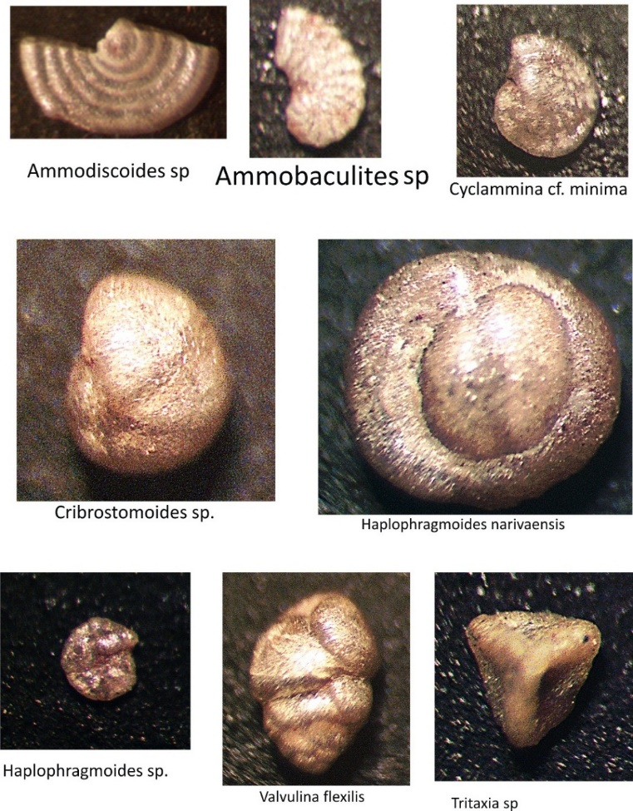
Fig: 5 The forms recovered in X-1 Well

CONCLUSION
This foraminiferal biostratigraphic and paleoenvironmental study of well X-1 (1870–1320 m) in the western sector (coastal swamp depobelt) of the Niger Delta Basin demonstrates that the penetrated interval belongs to the Agbada Formation. The succession consists of alternating sandstones and shales arranged in four sub-lithofacies units (X1–X4), exhibiting an overall coarsening-upward trend indicative of delta progradation.
Foraminiferal analysis recovered moderate abundance and diversity, yielding 60 species (21 planktonic and 39 benthic). Integrated planktonic and benthic biozonation established two planktonic zones — Globorotalia acostaensis Zone (N16) and composite Globorotalia humerosa / G. margaritae margaritae / G. margaritae evoluta Zone (N17–N19) — and a composite benthic zone spanning NNDF 07 to NNDF 04. These zones collectively date the studied interval to Late Miocene to earliest Early Pliocene (Tortonian–Zanclean), correlating with the Upper F9700 Foraminiferal Zone in the Niger Delta chronostratigraphic framework.
Paleoenvironmental reconstruction identified four progressive paleobathymetric settings: coastal delta plain (barren high-energy sands), inner neritic (low-diversity nearshore sands), middle neritic (increasing calcareous benthic forms), and outer neritic (peak abundance/diversity with dominant planktonics and calcareous benthics). Sequence-stratigraphic interpretation, constrained by the absence of wireline logs and seismic data, delineated a major maximum flooding surface (MFS-X) at 1390 m (~5.0 Ma), separating a thick transgressive systems tract (TST: 1870–1390 m) below from a thin highstand systems tract (HST: 1390–1320 m) above. This MFS correlates regionally with the Top F9700 flooding event.
The interval exhibits good preliminary petroleum potential: clean, moderately well-sorted TST sands (notably 1780–1720 m) offer strong reservoir quality; condensed marine shales at and below the MFS provide source and seal capacity; and stratigraphic/structural trapping mechanisms are likely in this growth-faulted depobelt setting.

Disclaimer (Artificial intelligence)
Author(s) hereby declare that NO generative AI technologies such as Large Language Models (ChatGPT, COPILOT, etc.) and text-to-image generators have been used during the writing or editing of this manuscript.

REFERENCES
Ajayi E.O and Okosun, F.A. (2014).Planktic Foraminiferal Biostratigraphy of A, B, C, D Wells, Offshore Niger Delta, Nigeria.,4(6): 108-120

Asadu,A.N and Anintah,G.O(2023): Foraminifera Biostratigraphy of Geo 92 Well, Onshore
Niger Delta, Nigeria.International Journal of Advanced Research in Science,
Engineering and Technology, 10 (5):20730-20740

Adegoke, O.S; Petters, S.W;Fayose, E.A,;Oyebamiji, A.S; Ajisaje, I.K,;Edet, J.J; Osterloff, P.I,;

Sonuga, M.S; Fajemila, O and Yussuph, W (2017): Cenozoic Foraminifera Biostratigraphy of the Niger Delta. In: Adegoke OS, Oyebamiji AS, Edet JJ, Osterloff PL, Ulu OK (eds) Cenozoic foraminifera and Calcareous Nannofossil Biostratigraphy of the Niger Delta. Elsevier Inc., Amsterdam, pp 2–383 2.

Bé, A.W., Hemleben, C., Anderson, O.R., Spindler, M., Hacunda, J. and Tuntivate-Choy, S.
(1977): Laboratory and Field Observations of Living Planktonic Foraminifera. Micropaleontology ,23, 155-179

Beka, F.T.and M. N. Oti, (1995).“The Distal Offshore Niger Delta: Frontier Prospects of a Mature Petroleum Prov-ince,” In: M. N. Oti and G. Postma, Eds., Geology of Del-tas, A. A. Balkema, Rotterdamc, pp. 237-241.
Berggren, W.A., Kent, D.V., Swisher, C.C., Aubry, M., (1998): A Revised Cenozoic Geochronology and Chronostratigraphy. SEPM Special Publication No. 54, pp. 128–212.
Blow, W.H (1969): Late middle eocene to recent planktonic foraminiferal biostratigraphy. In:
Bronnimann P and Renz H.H (eds) Proceedings of the First International Conference on Planktonic Microfossils, vol. 1. E.J. Brill, Leiden, pp 199–422.

Blow W.H (1979): The Cainozoic Globigerinida, vol 3. E.J. Brill, Leiden, p 1413.

Boboye, O. A. and Fowora, O. (2007). Biostratigraphy of Calcareous Nannossils of well XH-1, deep offshore, Niger Delta, Nigeria. Journal of Mining and Geology, 43(1 ): 175-186.
Bolli H.M, and Saunders J.B (1985): Oligocene to Holocene Low Latitude Planktic Foraminifera. In: Bolli HM, Saunders JB, Perch-Nielsen K, (eds). Plankton Stratigraphy, Cambridge University Press, Cambridge:115-262

Chiaghanam, O. I., Ozumba, B. M., Ladipo, K. J. Orajaka, J. P., Ofoma, A. E. & Chiadikobi K. (2011). The Role accommodation/sediment supply regime/basin Morphology in predicting Costal depositional style: A sequence stratigraphy framework approach for selected deep wells. Oligocene – Miocene Sediments of Costal Swamp in Niger Delta.Archives of Applied Science Research, 3 (5), 248-257. (Source: http://www.scholar carchchi library. com.archieve.html. August 14,2012)
Chukwu J.N, Okosun E.A, and Alkali Y. B (2012): Foraminiferal biostratigraphy and depositional environment of oloibiri– 1 well, Eastern Niger Delta Nigeria. J Geogr Geol 4(4):114–122

Culver,S.J.(1988): New foraminifera depth zonationof the north western Gulf of
Mxico.Palaios ,3 ,69-85
Doust, H., & Omatsola, E. (1990). Niger Delta. In J. D. Edwards & P. A. Santogrossi (Eds.), Divergent/Passive Margin Basins (pp. 201–238). AAPG Memoir 48.
Ekpo, A.E., Bassey, N.E., George, N.J. and Udo, I.G. (2024a). Depth to basement estimation from aerogravity data over the Southeastern part of Niger Delta region of Nigeria. Researchers Journal of Science and Technology, 4(5), 44–66. DOI/URL: https://rejost.com.ng/index.php/home/article/view/135
Ekpo, A.E., Bassey, N.E., George, N.J. and Udo, I.G. (2024c). Curie Point Depth as a Key Indicator of Hydrocarbon Maturity in the Southeastern Niger Delta Basin: Insights From Aeromagnetic Data. Preprint available on ResearchSquare (full publication in 2024/2025). DOI: 10.21203/rs.3.rs-5194917/v1 URL: https://www.researchsquare.com/article/rs-5194917/v1
Ekpo, A. E., Bassey, N. E., &amp; George, N. J., (2024d). Aero-gravity data analysis for
delineating possible channels of mineralization migration through lineament - a case
study southeastern niger delta, nigeria. AKSU Annals of Sustainable Development, 2(1),
139-168. https://doi.org/10.60787/AASD-v2i1-35

Ekpo, A. E., Bassey, N. E., George, N. J., &amp; Udo, I. C.. (2024b). Unveiling the
Geothermal Energy Potential in the Southeastern Niger Delta: Insights from High-
Resolution Aeromagnetic Data. Geological Behaviour 8(1): 75-81.
https://doi.org/10.26480/gbr.01.2024.75.81

Hemleben, C., Spindler, M. and Roger Anderson, O. (1989): Modern Planktonic Foraminifera. Springer, New York, 363

Gradstein, F.M., Ogg, J.G., Smith, A.G., Ogg, G.M. (Eds.), (2012): The Geologic Time Scale
2012.Elsevier Publications, Oxford, United Kingdom, p. 1129.

Imasuen,I.O. Okiotor,M.E and Etobro , A. A. (2011). Reservoir Evaluationof Well A, Field Y, North- Eastern Niger Delta: A Case of Problematic sandstone.Advances in Applied Science Research, 2 (3):114-126.
Itam, A. E; Udoh, M. U and Inyang, D. O (2017): Foraminiferal Biostratigraphy and Paleoenvironmental study of “MR” well, Niger Delta, Southeastern Nigeria. International Basic and Applied Research Journal,3(3):1-15
Kobawila,N.D; Elenga,H,and Ngatse,L.R (2021):Miocene Foraminifera Biostratigraphy and
Interpretation North Deep-Sea Block of the Congolese Atlantic Basin.Open Journal of Geology, 11, 253-274

Murray, J. W. (2014). Ecology and palaeoecology of benthic foraminifera. Routledge

Ojo, A.O and Gbadamosi, A. O. (2013): Sequence Palyno-stratigraphical study of DEL-2 Well, Southwest of Niger Delta basin, Nigeria.Research Journal in Enginerering and Applied Science.2 (2) :86-94
Okosun, E. A., Chukwu, J. N., Ajayi, E.O. and Olatunji, O.A. (2012). Biostratigraphy, Depositional Environment and Sequence Stratigraphy of Akata Field, Eastern Niger Delta, Nigeria.International Journal of Scientific and Engineering Research, 3 (7) : 2229-5518.
Onyekuru, S. O., Ibelegbu, E. C., Iwuagwu, J. C., Essien, A. G., & Akaolisa C. (2012). Sequence Stratigraphic Analysis of XB Field, Central Swamp Depobelt, Niger Delta Basin, Southern Nigeria. International Journal of Geoscience, 3:237-257
Petters, S. W. (1979b). Some Late Tertiary foraminifera from parabe-1 well, Eastern Niger Delta. Revista Espanola de micropaleontologia, 11(1): 1190-133.
Petters, S. W. (1982). Central West African Cretaceous- Tertiary Benthic Foraminifera and Stratigraphy. Journal Paleontographical, 179, pp. 1-104.
Petters, S. W. (1984).An ancient submarine canyon in the Oligocene-Miocene of Western Niger Delta.Sedimentology Journal, 31, 805-810.
Petters, S. W. (1995). Foraminiferal Biofacies in the Nigerian Rift and Continental Margins Delta: In M. N. Oti and G. Patma (Eds). Geology of Deltas: A. A. Balkem publishers, Rotterdam.
Reijers, T. J. A. (2011). Stratigraphy and Sedimentology of the Niger Delta. Geologs, 17( 3): 133-162.
Short, K.C and Stauble, A.J (1967): Outline of the geology of Niger Delta. Bull Am Assoc Pet Geol 51:761–779

