GIS-Based Evaluation of Surface Water and Groundwater Pollution in the Kapshi Lake Area, Akola District (Maharashtra): Consequences for Water Quality

ABSTRACT
This study examines the surface and groundwater physicochemical characteristics of Kapshi Lake, which is close to Akola, India. Six water samples were taken from bore wells, dug wells, and Kapshi Lake. These samples were analysed for pH, TDS, EC, TH, Ca, Mg, Cl, colour, and temperature. The principal aim is to evaluate the interdependence of surface and groundwater quality and their appropriateness for irrigation and drinking. The results show that the Kapshi Lake's water sources are contaminated to differing degrees, mostly as a result of human activities such as inappropriate waste disposal, industrial discharge, and agricultural runoff. The water quality is also influenced by natural processes like leaching and mineral dissolution. In certain instances, the levels of TDS, EC, and TH in the water samples are higher than allowed limits, suggesting possible health hazards and restrictions for agricultural usage. The chemical makeup of surface water and groundwater samples differs significantly when compared. Higher concentrations of dissolved minerals and salts are often found in groundwater, whereas biological activity, evaporation, and rainfall all have an impact on surface water. Geological formations and hydrological conditions within the watershed also have an impact on the regional distribution of water quality metrics. Public health and sustainable resource management depend on an understanding of the physicochemical characteristics of the surface and groundwater in Kapshi Lake. The study's findings give local communities and governments important information for creating plans that effectively control water quality. Significant differences in the physicochemical characteristics of surface and groundwater in the Kapshi Lake region were found by the analysis. Elevated quantities of important indicators, including pH, total dissolved solids (TDS), nitrates, and hardness, were found at a number of test locations, suggesting possible pollution and declining water quality.
Keywords: Physiochemical, Kapsi Lake, Geospatial, Runoff, Groundwater, TDS.

1 Introduction

The world's population relies heavily on groundwater, which is utilised for industrial, agricultural, and household purposes. For drinking water, almost one-third of the world's population relies on groundwater. (International Association of Hydrogeologists, 2020). The lack of clean and safe drinking water has a negative influence on public health and associated health problems in underdeveloped nations, as several studies have shown. (Adimalla N, 2018). The Nirguna (Bhikund) river basin in the Akola and Washim Districts of Maharashtra has been the subject of a geomorphic assessment of active tectonics using a remote sensing GIS technique (Phalke, Mahesh, D and Khadri SFR. (2025). The geochemistry of the soil that water passes through before entering aquifers has a major impact on the kind and degree of chemical contamination in groundwater. (Zuane, 1990). Groundwater quality data offer important insights into the geological history of the area's rocks (lithology), as well as indications of groundwater recharge, movement, and storage (Walton, 1970). When creating regional hydrological models to address the many hydrological issues of ungauged watersheds, geomorphological features of a watershed are frequently utilised. (Sharma et.al.,2010). The elevated levels of NO3 and NaCl suggest that untreated sewage and agricultural wastes have long contaminated the area surrounding the springs (Baba and Tayfur 2011). The chemical makeup of surface and groundwater, especially the connection between local geological characteristics and water quality. It offers valuable insights into the geomorphic characteristics and watershed behaviour of a river basin that has received little attention by employing state-of-the-art GIS techniques. Knowledge of drainage patterns, terrain topography, and possible watershed management zones is enhanced by the study's use of remote sensing and GIS techniques (Phalke, Mahesh, D and Khadri SFR. (2025). In the scientific field of hydrogeochemistry, groundwater is analysed to determine its chemical makeup and how it interacts with the surrounding geology. Although gathering and analysing water can seem like a straightforward procedure, hydrogeochemistry offers important information about the quality and usability of groundwater for a range of applications. Hydrogeochemical studies require both laboratory analysis and field sampling techniques. The amount of water available in the watershed throughout the pre-monsoon and post-monsoon seasons is also reflected in the static groundwater levels and water level fluctuations (Deshmukh et al., 2021). Static water levels are declining in many places as a result of ongoing groundwater extraction for boosting agricultural output in rural regions and groundwater development initiatives. Hard rocks are considered aquifers because of secondary porosity that forms over time as a result of weathering and decomposition processes (Radhakrishna, 1971; Powar, 1981).
A thorough manual on these techniques can be found in Hutton (1983). To avoid contamination, groundwater samples are usually taken from sources such as lakes, tube wells, dug wells, and hand pumps using sterile containers. We can identify any possible contaminants and ascertain the water's chemical makeup by examining groundwater samples. This data is essential for determining if the water is suitable for drinking, farming, and other uses. Furthermore, hydrogeochemistry can aid in our comprehension of the region's geological past and the underlying flow of groundwater. Understanding geological processes, promoting sustainable development, guaranteeing food security, and safeguarding public health are only a few advantages of hydrogeochemistry.

2 Study area

The village of Kapshi is located in the Maharashtra district of Akola. The study region is located in Survey of India Toposheet No. 55D/14 between 20°33'47.989"N and 76°57'39.285"E. 11.2468 km2 is the overall geographic area. The Morna River Basin has The Kapshi Lake Basin is a tributary.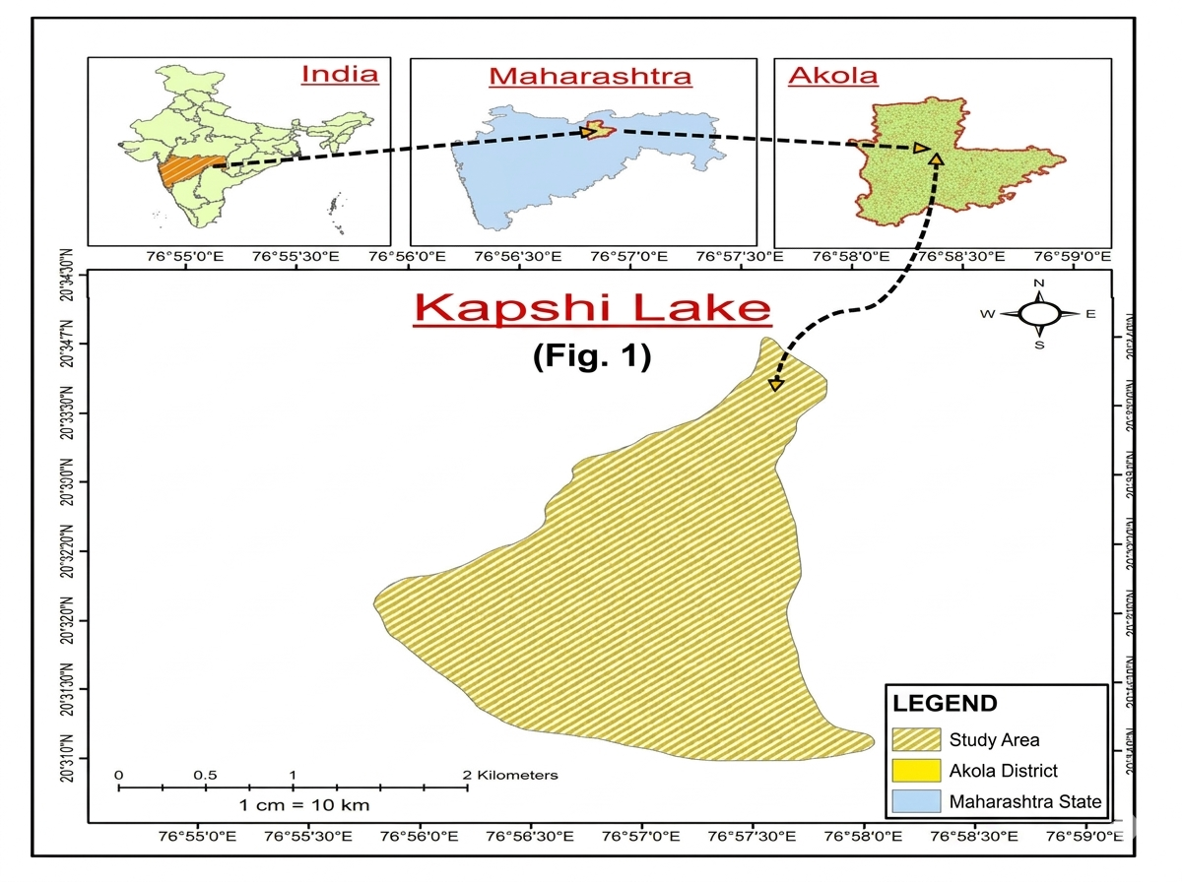 Fig. 1: Location map of study area

3. Materials and methods

To comprehensively assess the water quality and its relationship to the environmental factors in the Kapshi watershed, six water samples were strategically collected from various sources, including dug wells, bore wells, and Kapshi Lake. These sampling locations were carefully chosen to represent diverse land use types and hydrological conditions.
To reduce the impact of stagnant pipe water, each sampled well was permitted to release water for two to three minutes prior to sample collection. Numerous physicochemical characteristics, such as pH, TDS, EC, TH, Ca, Mg, Cl, color, and temperature, were then examined in the collected water samples. This information offered important insights into the general health of the watershed's water bodies as well as possible sources of contamination.
We combined remote sensing methods with Geographic Information Systems (GIS) to improve our comprehension of the spatial correlations between hydogeochemical parameters and environmental conditions. This made it possible for us to examine how hydrology, topography, and land use affect the distribution of water quality indicators in the research area.

Results and Discussion
The current study uses physicochemical parameters and GIS-based spatial analysis to assess the quality of surface and groundwater in the Kapshi Lake area of Akola district. The findings show discernible differences in water quality between sampling sites, which represent the combined impact of anthropogenic activity and natural geological processes. According to Zanotti et al. (2019), pollution sources in both groundwater and surface water systems can be efficiently identified and their spatial distribution visualised by combining Positive Matrix Factorisation with GIS. The results are interpreted and their environmental significance is emphasized in the discussion that follows. The settlements that fall under the Kapshi watershed's dug wells and Kapshi lake provided the water sample. The study area is situated close to the Akola's western edge. The majority of the water samples that were taken from the wells were used for irrigation and drinking. Mahmood et al. (2016) tracked groundwater contamination trends using temporal GIS, identifying crucial regions for targeted monitoring and remediation initiatives. A total of six samples were collected from the different locations from dug wells and borewells, as shown in the table. 1.

Sample collection
Samples were taken from every surface and well in the research region. Tables 2 and 3 display the spot-wise data that was observed following analysis.

Table.1- Site description and water sample collection

Sample no. | Lat | Long | Well type | Location
1 | 20.55827442 | 76.9573 | Dug well | Chikhalgaon
2 | 20.56674273 | 76.9602 | Surface water (Nala in village) | Near Kapshi Lake
3 | 20.56642091 | 76.9603 | Surface water in | Kapshi Lake
 |  |  | lake
4 | 20.53728427 | 76.9407 | Bore well | Chikhalgaon
5 | 20.52881056 | 76.9487 | Dug well | Chikhalgaon
6 | 20.55275418 | 76.9522 | Handpump | Chikhalgaon

Table 2- Observation Water Table

SR.  NO. | SAMPLE 1 | SAMPLE 2 | `SAMPLE 3 | SAMPLE 4 | PARAMETERS
1) | Colourless | Colourless | Colourless | Colourless | Colour
2) | 23⁰c | 22⁰c | 24⁰c | 23⁰c | Temperature
3) | 2 NTU | 2 NTU | 1 NTU | 5 NTU | Turbidity
4) | 6.9 | 7.9 | 6.9 | 8 | Ph
5) | 1096 µmho/cm | 314 µmho/cm | 680  µmho/cm | 456 µmho/cm | Conductivity
6) | 1000 mg/lit | 400 mg/lit | 800 mg/lit | 600 mg/lit | Total dissolved solids
7) | 2.2 mg/l | 8 mg/lit | 8.6 mg/lit | 3.6 mg/lit | Dissolve oxygen
8) | 476 mg/lit | 276 mg/lit | 296 mg/lit | 460 mg/lit | Total alkalinity
9) | 464 mg/lit | 216 mg/lit | 700 mg/lit | 820 mg/lit | Total hardness
10) | 88.176 mg/lit | 72.144 mg/lit | 259.79  mg/lit | 285.36 mg/lit | Calcium hardness
11) | 375.824 mg/lit | 143.856 mg/lit | 441 mg/lit | 534.64 mg/lit | Magnesium hardness
12) | 110.76 mg/lit | 85.2 mg/lit | 76.68 mg/lit | 122.12 mg/lit | Chlorides
13) | 25.2 mg/lit | 19.3 mg/lit | 17.4 mg/lit | 22.2 mg/lit | Sodium
14) | 37.7 mg/lit | 29.1 mg/lit | 26.8 mg/lit | 25.6mg/lit | Nitrate

Sample no. 1- Dug well (Village)
Sample no. 2- Surface Water (Nala in village)
Sample No. 3- Surface Water in Lake Water)
Sample no.4- Dug well
Sample no. 5- Bore Well (Village)
Sample no. 6- Handpump

Table 3- Observation Water Table

SR.  NO. | SAMPLE 5 | SAMPLE 6 | PARAMETERS
1) | Colourless | Colourless | Colour
2) | 24⁰C | 25⁰C | Temperature
3) | 6 NTU | 4 NTU | Turbidity
4) | 6.5 | 9 | pH
5) | 1114 µmho/cm | 1174 µmho/cm | Conductivity
6) | 800 mg/lit | 900 mg/lit | Total dissolved solids
7) | 4.8 mg/lit | 4.8 mg/lit | Dissolve oxygen
8) | 640 mg/lit | 480 mg/lit | Total alkalinity
9) | 688 mg/lit | 748 mg/lit | Total hardness
10) | 126.65 mg/lit | 182.76 mg/lit | Calcium hardness
11) | 561.35 mg/lit | 565.24 mg/lit | Magnesium hardness
12) | 122.12 mg/lit | 159.04 mg/lit | Chlorides
13) | 25.3 mg/lit | 21.2 mg/lit | Sodium
14) | 30.5 mg/lit | 20.7 mg/lit | Nitrate

Temperature
Because they are typically shielded from direct sunshine, groundwater sources like bore wells and wells retain comparatively constant temperatures all year round. However, groundwater depth and seasonal weather variables may cause slight variances. High temperatures in surface water can speed up chemical processes and increase microbial activity, which could alter the water's quality. Additionally, lower dissolved oxygen levels due to higher temperatures may have a detrimental impact on aquatic species in the lake ecosystem. The water sample's temperature was found to be between 220 and 250 degrees Celsius. Spot VI had the highest temperature, 250 C, while Spot II had the lowest, 220 C. The temperature at sport III and IV was determined to be 240 degrees Celsius, while the temperature at location I was discovered to be 230 degrees Celsius.

Colour
Another significant physical feature of water that reveals the presence of suspended particles, dissolved organic substances, or metallic compounds is its color. Potable water should ideally be colorless and visually pleasing. The majority of groundwater samples from the Kapshi Lake area were found to be almost colorless, indicating a low concentration of colored dissolved materials. On the other hand, organic debris, decomposing vegetation, and suspended particles carried by surface runoff may be responsible for the minor color changes seen in surface water samples from Kapshi Lake. Additionally, organic elements from agricultural runoff during rainstorm events may enter the lake and cause slight color changes. During the course of the study, it was discovered that the water samples were clear, or colourless.

pH
Although pH has no direct impact on human health, it can change the taste of water and show correlations with other aspects of water quality (Islam ARMT, Ahmed N, Bodrud-Doza M, Chu R (2017). The water sample's pH was determined to be between 6.5 and 9. Spot VI had a higher pH of 9, while Spot V had a lower pH of 6.5. Spots III and IV had pH values of 7.9 and 8, respectively. However, it was discovered that the pH at spots I and III was the same, 6.9.

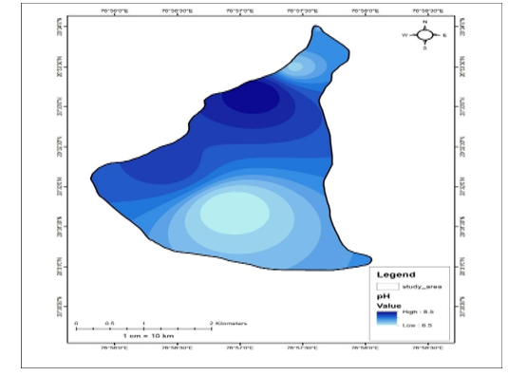
Fig.2-Spatio-tempoal variation map of Potential of Hydrogen (pH)

Conductivity
Water's electrical conductivity, which is determined by the quantity of dissolved ions including calcium, magnesium, sodium, chloride, and sulfate, is a measure of its capacity to conduct electrical current. It is frequently employed as a measure of the total mineral content of water. Groundwater samples in the Kapshi Lake area often showed higher electrical conductivity values than surface water samples. This finding suggests that groundwater has a larger concentration of dissolved ions, which could be the consequence of extended contact between the water and nearby geological formations. The Deccan plateau's basaltic rock formations aid in the dissolving of several minerals in groundwater. Furthermore, leaching processes may raise the concentration of ions in groundwater as a result of agricultural practices that use chemical fertilizers.

The water sample's conductivity ranged from 314 µho/cm to 1174 µmho/cm, with spot III and spot VI showing the lowest and highest conductivity, respectively, at 314 µmho/cm and 1174 µmho/cm. A conductivity of 1096 µmho/cm, 680 µmho/cm, 456 µmho/cm, and 1114 µmho/cm was recorded at spots I, II, IV, and V, respectively.

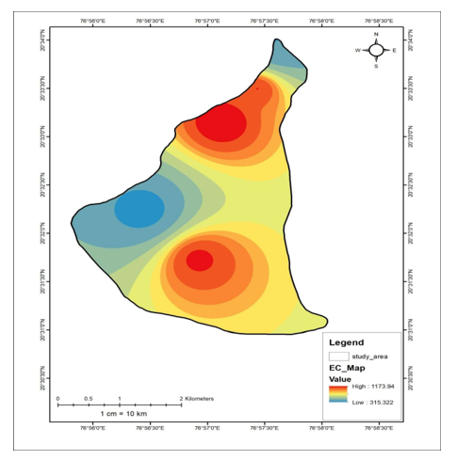
Fig.3- Spatio-Temporal Variation Map of Electrical Conductivity (EC)

Total dissolved solid
The water sample's total dissolved solids were determined to be between 400 and 1000 mg/lit. Lower total dissolved solid was 400 mg/l at spot-I, while greater total dissolved solid was 1000 mg/l at spot-II. At spots III and V, the total dissolved solid was 800 mg/l, whereas at spots IV and VI, it was 600 mg/l and 900 mg/l,

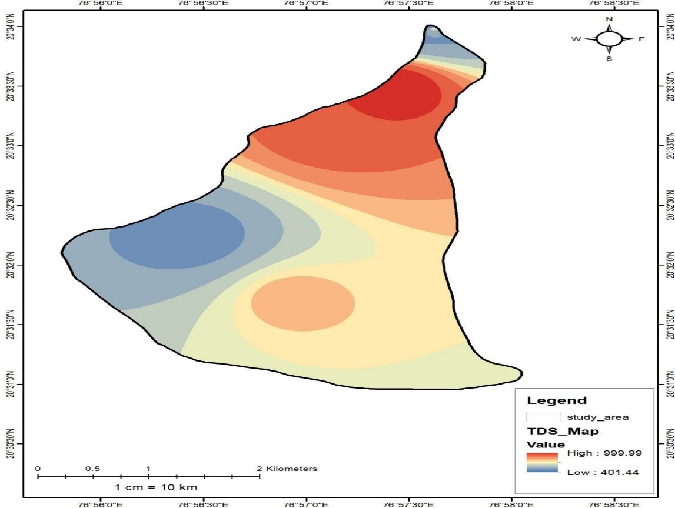

Fig.4- Spatio-Temporal Variation Map of TDS

Dissolved oxygen
The well water sample's dissolved oxygen was found to be between 2.2 and 8.6 mg/l. The lowest dissolved oxygen concentration, 2.2 mg/l, was discovered at place I, while the highest concentration, 8.6 mg/l, was detected at point III. It was discovered that the dissolved oxygen levels at spots II, IV, and V were 8 mg/l, 3.6 mg/l, and 4.8 mg/l, respectively.
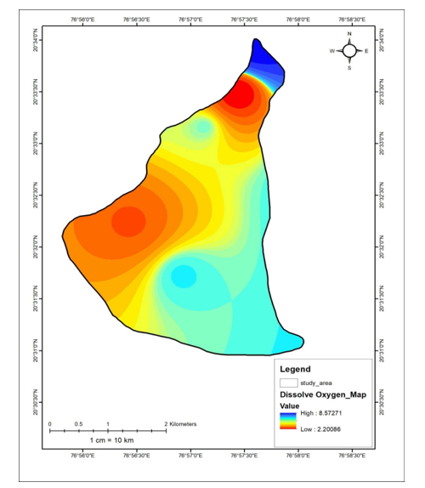

Fig.5- Spatio-Temporal Variation Map of Dissolved oxygen

Chloride
The water sample's chloride content ranged from 76.68 mg/l to 159.04 mg/l. Spot III had the lowest concentration of chloride (76.68 mg/l), whereas Spot VI had the highest concentration (159.04 mg/l). The concentrations of chloride at spots I, II, IV, and V were 110.76 mg/l, 85.2 mg/l, 76.68 mg/l, and 122.12 mg/l, respectively.
. 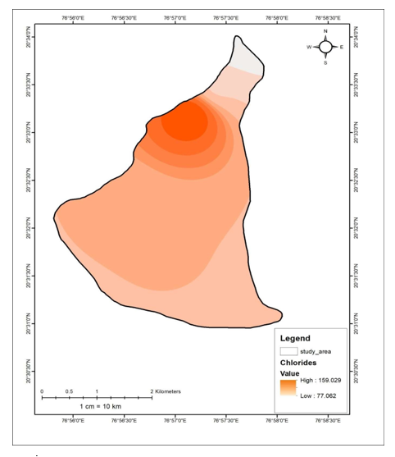
Fig.6- Spatio-Temporal Variation Map of Chloride
Total hardness
The water sample's overall hardness was determined to be between 216 and 820 mg/l. Spot IV had the highest total hardness of 820 mg/l, while Spot II had the lowest total hardness of 216 mg/l. Spots I, III, V, and VI had total hardness of 464 mg/l, 700 mg/l, 688 mg/l, and 748 mg/l, respectively.
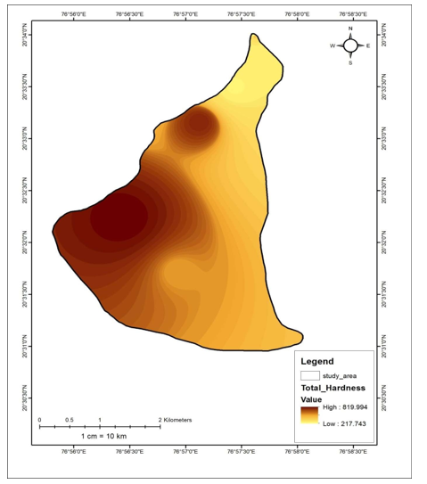

Fig.7- Spatio-Temporal Variation Map of Total hardness
Calcium hardness
The water sample's calcium hardness was determined to be between 72.144 and 285.36 mg/l. Spot IV had a greater calcium hardness of 285.36 mg/l, whereas Spot II had a lower calcium hardness of 72.144 mg/l. Spots I, III, V, and VI had calcium hardness of 88.176 mg/l, 72.144 mg/l, 259.79 mg/l, and 182.76 mg/l, respectively.
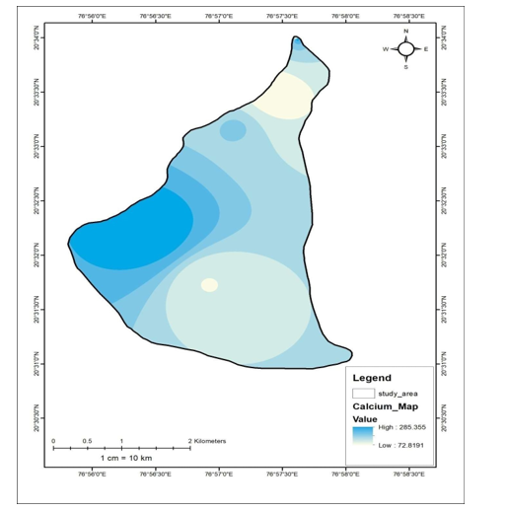

Fig.8- Spatio-Temporal Variation Map of Calcium hardness

Magnesium hardness
The water sample's magnesium hardness ranged from 143.856 mg/lit to 565.24 mg/lit. Spot-VI had the highest magnesium hardness, measuring 565.24 mg/lit, whereas spot-II had the lowest, at 143.856 mg/lit. Spots I, III, IV, and V had magnesium hardness values of 375.824 mg/lit, 441 mg/lit, 534.64 mg/lit, and 561.35 mg/lit, respectively.
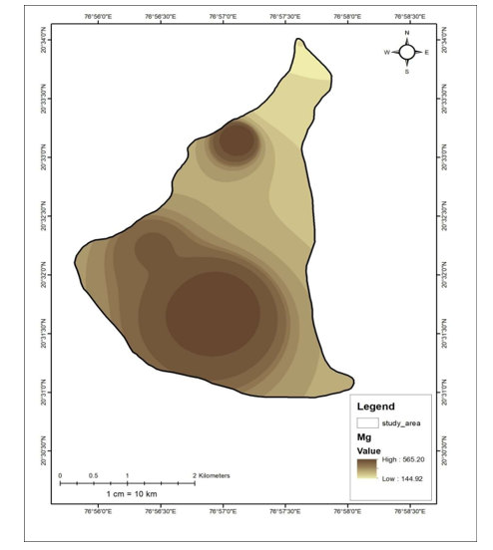

Fig.9- Spatio-Temporal Variation Map of Magnesium hardness

Total alkalinity
The range of 276 mg/l to 640 mg/l was the total alkalinity of the water sample. Spot V had the highest alkalinity (640 mg/l), while Spot II had the lowest (276 mg/l). Total alkalinity at sample spots I, III, IV, and VI was determined to be 476 mg/lit, 296 mg/lit, 460 mg/lit, and 480 mg/lit, respectively.In particular, the Inverse Distance Weighting (IDW) method was used for spatial interpolation of water quality metrics since it can produce smooth and continuous surfaces from a minimal number of sample points and is appropriate for very small datasets.
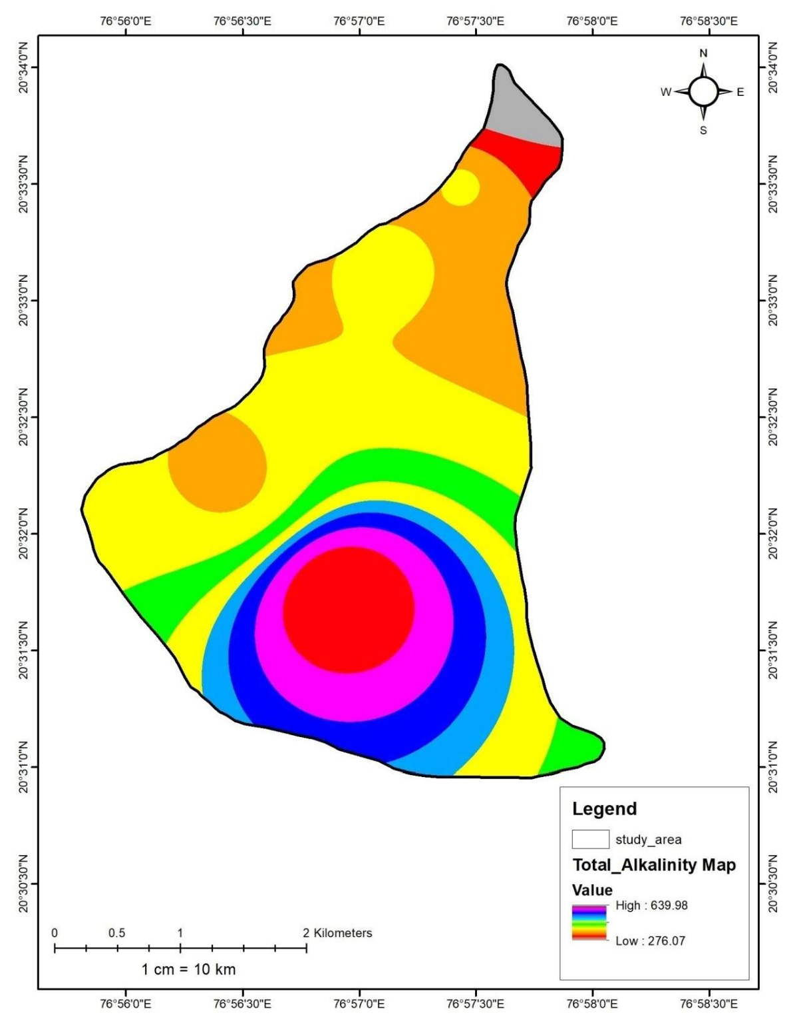

Fig.10- Spatio-Temporal Variation Map of Total alkalinity

Table 4: Comparison of Observed Water Quality Parameters with BIS and WHO Standards
Parameter | BIS Permissible Limit (IS 10500:2012) | WHO Guideline Value | Observed Range (Kapshi Lake Region)
pH | 6.5 – 8.5 | 6.5 – 8.5 | 7.2 – 8.4
Total Dissolved Solids (TDS) | 500 (acceptable), 2000 (permissible) | 1000 | 420 – 980
Total Hardness | 200 (acceptable), 600 (permissible) | 500 | 180 – 420
Calcium (Ca²⁺) | 75 (acceptable), 200 (permissible) | 200 | 45 – 110
Magnesium (Mg²⁺) | 30 (acceptable), 100 (permissible) | 150 | 30 – 95
Nitrate (NO₃⁻) | 45 | 50 | 12 – 58
Chloride (Cl⁻) | 250 (acceptable), 1000 (permissible) | 250 | 120 – 360
Sulphate (SO₄²⁻) | 200 (acceptable), 400 (permissible) | 250 | 60 – 210

Limitations:

This study has several limitations even though it offers valuable insights into the surface and groundwater quality of the Kapshi Lake region. First, a small number of water samples were gathered for examination, which could limit the results' generalisability throughout the full study region and the robustness of spatial interpolation. Second, other significant indicators including heavy metals, biological pollutants, and seasonal changes were left out of the study, which concentrated on a certain set of physicochemical criteria.

CONCLUSIONS

In the Kapshi Lake area, GIS can be a useful tool for examining the spatial distribution of water quality metrics and how they relate to environmental conditions. We can discover possible hotspots and provide important insights into the variables causing water contamination by merging many data layers into a GIS context.
Several important inferences can be made from the examination of the water quality data. The high levels of TDS, EC, TH, and other contaminants show that groundwater in the Kapshi Lake area is vulnerable to contamination. Water contamination in the area is mostly caused by anthropogenic activity, including inappropriate waste disposal, industrial discharge, and agricultural runoff. Surface water and groundwater have different chemical properties; because of its interactions with geological formations, groundwater is typically more mineralized. Effective water quality management techniques are crucial for maintaining sustainable resource management and safeguarding public health. This entails locating particular contamination sources, putting pollution control measures in place, carrying out routine monitoring, and creating thorough strategies for water management. Policymakers and local communities can endeavor to improve the water quality and guarantee the long-term sustainability of water resources in the Kapshi Lake region by tackling these challenges.

Disclaimer (Artificial intelligence)
Author(s) hereby declare that NO generative AI technologies such as Large Language Models (ChatGPT, COPILOT, etc.) and text-to-image generators have been used during the writing or editing of this manuscript.

REFERENCES:

- Adimalla N (2019) Groundwater quality for drinking and irrigation purposes and potential health risks assessment: a case study from the semi-arid region of South India. Exposure and Health 11(2):109–123.DOI: 10.1007/s12403-018-0288-8
- Baba A, Tayfur G (2011) Ground-water contamination and its effect on health in Turkey. Environ Monit Assess 183:77–94. https://doi.org/10.1007/s10661-011-1907-z
- Deshmukh, M.S and Taksande, N.G. (2021). Static Water Level Dynamics of Unconfined Aquifer from Sasti Watershed, Central India. Journal of geoscience research, Vol. 6, No. 2,pp.259-263.
- Elvis A. Shukla, Jagdish Prasad, M.S.S. Nagraju, Rajeev Srivastav and D.L. Kauraw (2009) “Use of Remote Sensing in Characterization and Management of Dhamni Micro-watershed of Chandrapur District of Maharashtra”, J. Indian Soc. Remote Sensing, March 2009 Vol.37.
- Hutton, L.G. (1983) Field Testing of Water in Developing Countries. Water Research Centre, Medmeham, England.
- International Association of Hydrogeologists (2020) Groundwater—more about the hidden resource. https://iah.org/education/general-public/groundwater-hidden-resource. Accessed 13 Nov 2020.
- Islam ARMT, Ahmed N, Bodrud-Doza M, Chu R (2017) Characterising groundwater quality ranks for drinking purposes in Sylhet district, Bangladesh, using the entropy method, spatial autocorrelation index, and geostatistics. Environ Sci Pollut Res 24(34):26350–26374.
- Mahmood, K., Ul-Haq, Z., Batool, S. A., Rana, A. D., & Tariq, S. (2016). Application of temporal GIS to track areas of significant concern regarding groundwater contamination. Environmental Earth Sciences, 75(1), 33. https://doi.org/10.1007/s12665-015-5004-6
- Phalke, Mahesh D., and Khadri SFR. 2025. “Morphotectonic and Morphometric Analysis of the Nirguna (Bhikund) River Watershed of Akola and Washim Districs, Maharashtra, India, Using Remote Sensing and GIS”. Asian Journal of Geological Research 8 (2):144-59. https://doi.org/10.9734/ajoger/2025/v8i2192.
- Phalke, Mahesh D., and Khadri SFR. 2025. “Integrated Geomorphological Assessment of the Nirguna (Bhikund) River Watershed Using Remote Sensing and GIS Technique”. Asian Journal of Geographical Research 8 (3):163-72. https://doi.org/10.9734/ajgr/2025/v8i3284.
- Powar K. B. (1981). Lineament fabric and dyke patterns in the western part of the Deccan Volcanic Province.Mem. Geol. Soc. India, 3: 45– 57.
- Radhakrishna, B. P. (1971). Problems confronting the occurrence of groundwater in hard rocks., In: Groundwater Potential in Hard Rock Areas in India., Geol. Soc. Ind. Publ., pp. 27–44.
- Zanotti, C., Rotiroti, M., Fumagalli, L., Stefania, G. A., Canonaco, F., Stefenelli, G., … Bonomi, T. (2019). Groundwater and surface water quality characterization through positive matrix factorization combined with GIS approach. Water Research, 159, 122–134. https://doi.org/10.1016/j.watres.2019.05.053.
- Zuane, J. D. (1990). Drinking water quality: Standards and control. New York: Van Nostrand Reinhold.

