Syenitic magmatism and crust–mantle interaction during late Pan-African tectonism in southwestern Nigeria

Abstract
Syeinite intrusions within the Igarra Schist Belt of southwestern Nigeria constitute an important yet understudied component of late Pan-African magmatism in the Nigerian Basement Complex. This study integrates petrographic observations with whole-rock major, trace, and rare earth element (REE) geochemistry to constrain the petrogenesis and tectonic significance of these syenites. Petrographic data indicate crystallization from an alkali-rich, moderately evolved magma dominated by alkali feldspar, with subordinate plagioclase and mafic phases, consistent with metaluminous, high-K compositions. Major-element geochemistry supports emplacement at shallow to mid-crustal levels during the waning stages of regional deformation. Trace-element characteristics and tectonic discrimination diagrams indicate a transitional syn- to post-collisional magmatic affinity. Chondrite-normalized REE patterns are strongly fractionated, showing pronounced light REE enrichment relative to heavy REE and coherent inter-sample trends. The subdued heavy REE segment and absence of a significant Eu anomaly suggest partial melting of an enriched lithospheric mantle source at relatively shallow depths, with limited residual garnet and minimal pre-emplacement feldspar fractionation. These features point to magma generation during lithospheric relaxation and crust–mantle interaction following continental collision. The results indicate that the Igarra syenites record late-orogenic syenitic magmatism linked to Pan-African tectonic reorganization in southwestern Nigeria. This study highlights the role of enriched mantle inputs in generating syenitic magmas during orogenic collapse and contributes to a broader understanding of crust–mantle processes associated with the terminal stages of the Pan-African orogeny.
Keywords: Syenite; Petrography; Whole-rock geochemistry; Pan-African orogeny; Igarra Schist Belt; Nigerian Basement Complex; Tectonic setting; Magmatic differentiation

1. Introduction
Syenites are silica-saturated to silica-undersaturated intermediate plutonic rocks dominated by alkali feldspar, with subordinate plagioclase and ferromagnesian minerals, and little or no quartz. They occur in a wide range of tectonomagmatic environments, including continental rifts, post-collisional settings, and volcanic arcs, where they commonly form stocks, batholiths, sills, dykes, and lensoid intrusions within older crustal rocks (Brooks, 2024; Bolhar et al., 2025). Texturally, syenites vary from fine- to coarse-grained, porphyritic, and locally pegmatitic, reflecting differences in emplacement depth, magma evolution, and cooling history (Wang et al., 2021).
Beyond their petrogenetic significance, syenitic rocks are increasingly recognized for their economic and metallogenic importance. Syenite complexes worldwide host a variety of mineral commodities, including gemstones (sapphire-bearing syenites in Slovakia and Russia (Sorokina et al., 2021)), precious metals (syenite-hosted gold deposits in Canada (Mathieu et al., 2025, Dubé, & Mercier-Langevin, 2020), uranium-thorium-rare earth element (U–Th–REE) mineralization in agpaitic nepheline syenites, and bauxite derived from syenitic protoliths (Damdinov et al., 2022; Sorokina et al., 2021). Consequently, syenites provide valuable insights into crust–mantle interactions, magma differentiation processes, and the metallogenic evolution of continental crust.
Within the Nigerian Basement Complex, syenitic rocks occur sparingly compared to granites, gneisses, and schists, a distribution pattern that mirrors their global rarity (Igonor et al., 2023; Vorontsov et al., 2021). Nigerian syenites are restricted to two contrasting petrographic and tectonic settings: those associated with the Pan-African Older Granites and those related to the Younger Granite complexes (Belts et al., 2024). The Older Granite–related syenites are typically enriched in CaO, MgO, and K₂O, with K₂O commonly exceeding Na₂O, whereas syenites of the Younger Granite province display broader compositional variability and Na₂O/K₂O ratios approaching unity (Province et al., 2024). These geochemical contrasts reflect differences in magma sources, degrees of crustal contamination, and tectonic evolution during emplacement. (Fig.1)
The Nigerian Basement Complex forms part of the Pan-African mobile belt, situated between the West African Craton and the Congo Craton, and south of the Tuareg Shield (Ominigbo, 2022). It records a polycyclic tectonic history involving multiple orogenic episodes, notably the Liberian (~2.7 Ga), Eburnean (~2.0 Ga), Kibaran (~1.1 Ga), and Pan-African (~600 Ma) events (Adamu et al., 2024; Adeoti, & Okonkwo, 2016; Obaje, 2009). These events produced a complex assemblage of gneiss-migmatite-quartzite complexes, schist belts, syn- to post-tectonic granitoids, and minor felsic and mafic intrusives. The Pan-African orogeny, in particular, was responsible for extensive crustal reworking, granitization, and emplacement of the Older Granites and associated syenitic bodies.
The Igarra Schist Belt, located along the southeastern margin of the western Nigerian Basement Complex, represents one of the prominent low- to medium-grade metamorphic belts formed during this tectonic evolution. It comprises pelitic to semi-pelitic schists, marbles, calc-silicate gneisses, quartzites, and polymictic metaconglomerates, intruded by Pan-African granitoids and minor felsic to mafic bodies, including syenites (Udı et al., 2023; Adepoju et al, 2021). Structural studies indicate that the belt was affected by at least two major compressional stress regimes during the Pan-African event, with E–W-trending structures being particularly dominant (Udimwen, 2017).
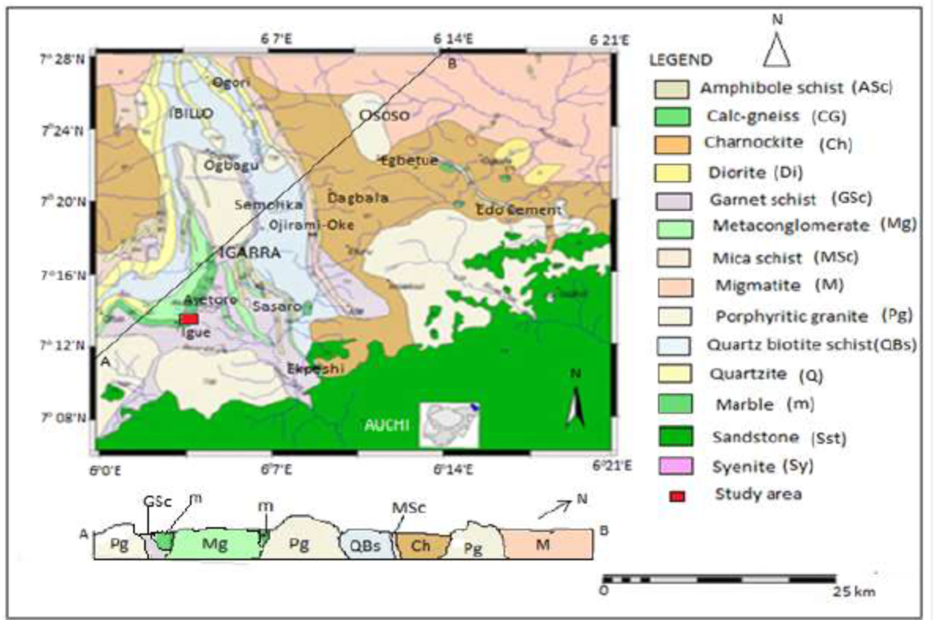
Figure 1. Geological map of Igarra area (modified after Oyewole and Ofuyah, 2017)

Syenitic intrusions within the Igarra Schist Belt, notably around the Sassaro and adjacent areas, intrude marble, calc-silicate gneiss, and mica schist units and are considered relatively younger than the regional pegmatites (Ogbe et al., 2018). Despite their geological significance, previous studies on the Igarra syenites have largely emphasized field relationships, petrography, and geotechnical properties, with limited attention given to their whole-rock geochemistry, tectonic affinity, and trace-element characteristics (Ugbe et al., 2023; Agoha et al., 2022; Oyebamiji et al., 2024).
This study addresses this gap by presenting a comprehensive mineralogical and geochemical investigation of Syenite rocks within the Igarra Schist Belt, southwestern Nigeria. Using major- and trace-element geochemistry, CIPW normative calculations, and established tectonic discrimination diagrams, the study aims to constrain the petrogenesis, aluminium saturation state, and tectonic setting of the syenitic bodies. The results contribute to a better understanding of Pan-African magmatism in the Nigerian Basement Complex and provide baseline geochemical data relevant to regional crustal evolution and mineral resource assessment.

2. Materials and methods
Geological field investigations were carried out within the Igarra Schist Belt, located in southwestern Nigeria, with particular emphasis on exposed syenitic intrusions. Detailed field observations were made to characterise lithology, texture, mineral assemblages, and structural features, while orientation measurements were obtained using a compass–clinometer. Sampling locations were precisely recorded with a handheld GPS receiver to ensure spatial accuracy. A total of ten fresh and representative syenite rock samples were systematically collected across the intrusion, providing adequate spatial coverage and minimising the influence of surface weathering. These samples form the basis for subsequent petrographic, geochemical, and structural analyses aimed at understanding the petrogenesis and emplacement characteristics of the syenitic bodies.
Petrographic analyses were performed on standard thin sections prepared from selected samples. Mineral identification and textural characterization were carried out using a polarizing light microscope under plane- and cross-polarized light.
For geochemical analysis, approximately 1 kg of each sample was crushed and pulverized to <425 µm. Whole-rock major- and trace-element analyses were conducted at Bureau Veritas Laboratories (Vancouver, Canada). Major elements were determined following lithium metaborate/tetraborate fusion, while trace elements were analyzed after partial digestion using modified Aqua Regia. Elemental concentrations were measured by Inductively Coupled Plasma–Mass Spectrometry (ICP–MS), with analytical quality control ensured through blanks, certified reference materials, and replicate analyses. CIPW normative calculations and established geochemical discrimination diagrams were employed for data interpretation.

3. Results
3.1 Field occurrence and petrography
The syenitic rocks in the Igarra area occur as stock-like intrusions forming prominent hills, locally associated with narrow dykes. In hand specimen, the rocks are dark-coloured and predominantly medium-grained. Megascopic examination reveals feldspar and biotite as the dominant mineral constituents.
Petrographic analysis shows that the syenites are composed mainly of alkali feldspar (orthoclase and microcline), plagioclase, quartz, and biotite, with minor opaque minerals (figs 2 and 3). Biotite occurs as brown, platy grains exhibiting strong pleochroism from brown to greenish-brown. The grains commonly display preferred orientation and form intergrowths with quartz. Alkali feldspar occurs as tabular, idiomorphic to sub-idiomorphic crystals, locally exhibiting cross-hatched twinning and containing quartz and biotite inclusions. Plagioclase occurs in subordinate proportions, while opaque minerals, including ilmenite and hematite, occur as accessory phases, collectively constituting approximately 10% of the rock volume.
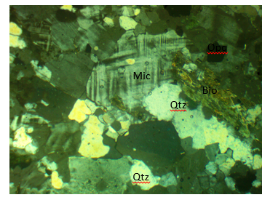
Fig. 2 Photomicrograph of syenite comprising biotite (bio), microcline (mic), Quartz (qtz). Bar Scale: 3µm (xpl).
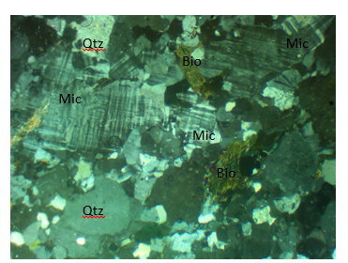
Fig.3 Photomicrograph of syenitic rock comprising biotite (bio), Quartz (qtz). Bar Scale: 3µm

3.2 CIPW normative mineralogy
CIPW normative calculations (Table 1) indicate that the syenitic rocks are dominated by biotite (10.8–22.9%), orthoclase (20.7–27.7%), albite (17.9–20.7%), and quartz (7.4–12.7%). Plagioclase is represented by variable proportions of albite and anorthite, with anorthite contents ranging from 0.7 to 4.3%. Minor normative phases include wollastonite (6.5–9.3%), hematite (7.5–9.6%), apatite (2.4–3.1%), ilmenite (0.1–0.2%), and pyrite (≤0.1%). The total normative mineral sums range from 97.5 to 99.7 wt%.

3.3 Major element geochemistry
The syenitic rocks display relatively narrow compositional ranges in major oxides (Table 2). SiO₂ contents vary from 53.23 to 55.71 wt%, while Al₂O₃ ranges from 11.39 to 12.53 wt%. Total iron (Fe₂O₃) varies between 7.50 and 9.62 wt%, MgO between 5.80 and 6.93 wt%, and CaO between 5.29 and 6.47 wt%. Alkali contents show Na₂O values of 2.11–2.45 wt% and K₂O values of 6.16–6.98 wt%. TiO₂ contents range from 0.70 to 0.78 wt%, P₂O₅ from 1.02 to 1.28 wt%, MnO from 0.05 to 0.13 wt%, and Cr₂O₃ from 0.009 to 0.034 wt%. Loss on ignition (LOI) values range from 0.3 to 1.2 wt%, and analytical totals are consistently close to 100 wt%.

3.4 Trace element geochemistry
The syenitic rocks contain variable concentrations of trace elements (Table 3). Copper shows relatively elevated values (43.22–122.45 ppm), while chromium ranges from 80.9 to 149.3 ppm. Barium displays high absolute concentrations (2711–3222 ppm). Strontium contents range from 755 to 979 ppm, whereas zirconium varies from 101 to 194 ppm. Vanadium contents range from 72 to 102 ppm, and nickel from 47 to 57 ppm.
Rare earth and high-field-strength elements show moderate abundances, with lanthanum ranging from 22.6 to 32.6 ppm, yttrium from 18 to 20 ppm, and niobium from 10 to 13 ppm. Thorium values range from 2.1 to 3.9 ppm, and uranium from 0.6 to 0.81 ppm. Precious and volatile-associated elements, including Au (0.5–2.34 ppb), Ag (29–112 ppb), Hg (3–5 ppm), and Tl (0.59–0.86 ppm), are present in variable but generally low concentrations.
3.5 Rare Earth Element (REE) geochemistry
The syenitic rocks display variable but generally elevated concentrations of rare earth elements (REEs) (Table 4). Light Rare Earth Elements (LREEs) are strongly enriched, with La ranging from 25 to 163 ppm, Ce from 80 to 942 ppm, Pr from 13 to 312 ppm, Nd from 27 to 645 ppm, and Sm from 6 to 121 ppm. Europium contents range from 1.7 to 13 ppm. Heavy rare earth elements (HREEs) occur at comparatively lower concentrations, with Gd ranging from 9 to 45 ppm, Tb from 1 to 3.5 ppm, Dy from 7 to 22 ppm, Ho from 1 to 2.8 ppm, Er from 2 to 10 ppm, Tm from 0.4 to 1.8 ppm, Yb from 2 to 7.5 ppm, and Lu from 0.3 to 1.6 ppm.
The REE distributions are characterized by a pronounced enrichment of LREEs relative to HREEs, reflected in the large absolute differences between La–Sm and Gd–Lu concentrations. Europium contents are moderate relative to adjacent REEs. Total REE concentrations are high, largely driven by elevated LREE abundances.
In addition to REEs, tantalum (Ta) concentrations range from 1 to 3.5 ppm, indicating low to moderate enrichment of high-field-strength elements.

Table 1: CIPW norm result of Syenite from study area
Sample code/ minerals | S1 | S2 | S3 | S4 | S5 | S6 | S7 | S8 | S9 | S10
Quartz | 11.4 | 11.9 | 9.3 | 10.4 | 10.1 | 12.7 | 9.7 | 9.0 | 9.9 | 7.4
Orthoclase | 20.7 | 24.8 | 27.7 | 25.7 | 24.1 | 22.9 | 25.2 | 27.3 | 25.1 | 25.3
Albite | 18.7 | 19.4 | 20.2 | 19.1 | 18.6 | 17.9 | 20.2 | 20.2 | 20.7 | 19.3
Anorthite | 4.3 | 4.3 | 2.7 | 4.1 | 3.3 | 3.4 | 2.8 | 1.1 | 0.7 | 2.4
Wollastonite | 8.3 | 6.5 | 6.9 | 7.4 | 8.3 | 8.7 | 8.1 | 8.9 | 9.3 | 9.3
Ilmenite | 0.2 | 0.2 | 0.1 | 0.2 | 0.2 | 0.2 | 0.2 | 0.2 | 0.1 | 0.2
Hematite | 9.1 | 7.5 | 8.7 | 7.8 | 7.9 | 9.6 | 7.6 | 8.7 | 8.8 | 8.9
Apatite | 2.9 | 2.8 | 2.5 | 2.7 | 2.9 | 2.9 | 3.1 | 2.4 | 2.7 | 2.5
Pyrite | 0.03 | 0.03 | 0.1 | 0.03 | 0.03 | 0.1 | 0.1 | 0.1 | 0.1 | 0.1
Biotite | 22.6 | 20.6 | 19.2 | 20.7 | 22.9 | 19.2 | 20.9 | 10.8 | 22.3 | 22.8
SUM | 98.1 | 97.9 | 97.5 | 97.9 | 98.5 | 97.6 | 97.7 | 97.6 | 99.7 | 98.3

Table 2: Major Oxides (wt %) composition of Syenite rock.
Sample No | SiO₂ | TiO₂ | Al₂O₃ | Fe₂O₃ | MnO | MgO | CaO | Na₂O | K₂O | P₂O₅ | Cr₂O₃ | LOI | SUM
S1 | 53.95 | 0.7 | 11.89 | 9.02 | 0.13 | 6.83 | 6.47 | 2.21 | 6.16 | 1.21 | 0.027 | 0.7 | 99.81
S2 | 55.71 | 0.78 | 12.5 | 7.5 | 0.11 | 6.22 | 5.53 | 2.29 | 6.62 | 1.18 | 0.034 | 0.9 | 99.82
S3 | 54.6 | 0.77 | 12.44 | 8.68 | 0.12 | 5.8 | 5.29 | 2.39 | 6.95 | 1.06 | 0.027 | 1.2 | 99.78
S4 | 55.03 | 0.73 | 12.53 | 7.76 | 0.12 | 6.26 | 5.91 | 2.25 | 6.78 | 1.14 | 0.025 | 0.8 | 99.78
S5 | 54.53 | 0.72 | 12.17 | 7.97 | 0.13 | 6.93 | 6.32 | 2.2 | 6.78 | 1.24 | 0.031 | 0.3 | 99.79
S6 | 54.52 | 0.72 | 11.39 | 9.62 | 0.05 | 5.83 | 6.47 | 2.11 | 6.16 | 1.21 | 0.009 | 0.8 | 99.81
S7 | 54.69 | 0.77 | 12.25 | 7.58 | 0.05 | 6.32 | 6.13 | 2.39 | 6.72 | 1.28 | 0.012 | 0.8 | 99.82
S8 | 54.6 | 0.77 | 11.84 | 8.66 | 0.11 | 5.98 | 5.89 | 2.39 | 6.95 | 1.21 | 0.029 | 0.9 | 99.78
S9 | 55.55 | 0.74 | 11.74 | 8.76 | 0.11 | 6.76 | 6.11 | 2.45 | 6.88 | 1.28 | 0.033 | 1.1 | 99.78
S10 | 53.23 | 0.72 | 12.17 | 8.97 | 0.13 | 6.93 | 6.35 | 2.28 | 6.98 | 1.02 | 0.025 | 0.6 | 99.79

Table 3. Average abundance of element in Earth crust, ranges and average content of the element in Syenite (all values in ppm, Ag and Au in ppb) after Levinson (1974) and Rose et.al (1991)
Element | Average Crustal abundance | Syenitic rock
Element | Average Crustal abundance | Average | Range
Mo | 1.5 | 1.624 | 0.92-2.28
Cu | 55 | 87.279 | 43.22-122.45
Pb | 12.5 | 5.566 | 1.68-15.77
Zn | 70 | 40.53 | 32-45.35
Ag | 70 | 65 | 29-112
Ni | 75 | 33.09 | 47-57
Co | 25 | 16.53 | 12.4-19.1
Mn | 1000 | 345 | 253-487
As | 1.8 | 1.14 | 0.79-1.6
U | 2.7 | 0.7 | 0.6-0.81
Au | 4 | 1.68 | 0.5-2.34
Th | 10 | 3.3 | 2.1-3.9
Sr | 375 | 88.87 | 755-979
Cd | 0.13 | 0.02 | 0.01-0.03
Sb | 0.2 | 0.063 | 0.05-0.08
Bi | 0.17 | 0.09 | 0.03-0.21
V | 135 | 91.3 | 72-102
La | 30 | 27.37 | 22.6-32.6
Cr | 100 | 120.11 | 80.9-149.3
Ba | 640 | 310.31 | 2711-3222
W | 1.5 | 0.35 | 0.2-0.6
Sc | 18 | 2.44 | 1.3-3.3
Tl | 0.45 | 0.67 | 0.59-0.86
Ga | 15 | 5.49 | 4-6.4
Zr | 165 | 162 | 101-194
Y | 33 | 19.3 | 18-20
Nb | 20 | 13.5 | 10-13
B | 10 | 17.9 | 16-19
Hg | 0.08 | 3.8 | 3-5
Se | 0.05 | 0.15 | 0.1-0.2
Te | 0.005 | 0.023 | 0.02-0.03

Table 4. Rare Earth Element concentrations and chondrite-normalized values for the Igarra syenites (Chondrite values after Boynton, 1984)
Element | Range (ppm) | Chondrite value | Normalized range (CN)
La | 25 – 163 | 0.234 | 107 – 697
Ce | 80 – 942 | 0.613 | 131 – 1537
Pr | 13 – 312 | 0.092 | 141 – 3391
Nd | 27 – 645 | 0.457 | 59 – 1411
Sm | 6 – 121 | 0.153 | 39 – 791
Eu | 1.7 – 13 | 0.058 | 29 – 224
Gd | 9 – 45 | 0.199 | 45 – 226
Tb | 1 – 3.5 | 0.036 | 28 – 97
Dy | 7 – 22 | 0.249 | 28 – 88
Ho | 1 – 2.8 | 0.056 | 18 – 50
Er | 2 – 10 | 0.165 | 12 – 61
Tm | 0.4 – 1.8 | 0.025 | 16 – 72
Yb | 2 – 7.5 | 0.161 | 12 – 47
Lu | 0.3 – 1.6 | 0.024 | 13 – 67

4. Discussion
4.1 Petrographic characteristics and magmatic evolution
The petrographic features of the Igarra syenites provide important constraints on their crystallization history and magmatic evolution. The dominance of alkali feldspar, with subordinate plagioclase and biotite, is consistent with syenite compositions derived from evolved intermediate magmas. The presence of both orthoclase and microcline, locally exhibiting perthitic and cross-hatched twinning, suggests slow cooling under plutonic conditions, allowing subsolidus re-equilibration of alkali feldspars (Salazar-Naranjo, & Vlach, 2018). Myrmekitic intergrowths between quartz and feldspar further indicate late-stage crystallization processes and localized silica saturation during magma solidification.
Biotite occurs as the principal ferromagnesian phase, displaying strong pleochroism and preferred orientation, which may reflect magmatic flow alignment prior to complete crystallization. The scarcity of mafic minerals such as amphibole or pyroxene suggests that the magma underwent significant fractionation before emplacement (Keshavarzi, et al., 2014). Accessory opaque minerals, including ilmenite and hematite, indicate relatively oxidizing magmatic conditions, consistent with the presence of Fe³⁺-rich phases and the observed total iron contents (Aulbach et al., 2022).
4.2 Major element geochemistry and magmatic affinity
Major-element compositions confirm the syenitic affinity of the studied rocks and are consistent with petrographic observations. SiO₂ contents between 53 and 56 wt% place the rocks within the intermediate compositional range, while elevated K₂O contents (6.16–6.98 wt%) relative to Na₂O indicate a potassic character. Such high K₂O values are characteristic of syenites associated with post-orogenic and late-to-post-collisional tectonic environments within continental crust (Li et al., 2024; Akpan et al., 2023).
The relatively narrow range of Al₂O₃ contents (11.39–12.53 wt%) and Aluminium Saturation Indices indicate predominantly metaluminous compositions. This suggests that feldspar crystallization occurred without significant excess aluminium, and that the magma source was not strongly peraluminous or sediment-derived. The metaluminous nature is consistent with derivation from mantle-influenced magmas or lower crustal sources modified by fractional crystallization rather than extensive crustal anataxis (Chappell, & Wyborn, 2024).
The TAS plots of Cox et al. (1979) and Middlemost (1994) (figs. 4 and 5) and R1–R2 multicationic classifications (fig. 6), places the samples across syenite, syenodiorite, and monzonite fields, reflecting slight compositional heterogeneity within the intrusion. This variability likely reflects internal magmatic differentiation, possibly through fractional crystallization of plagioclase and ferromagnesian minerals during magma ascent or emplacement. Aluminium saturation indices indicate that the rocks are predominantly metaluminous, as shown by A/CNK–A/NK (fig.7) and B–A (fig.8) plots.
On the Frost and Frost (2008) granitoid discrimination diagram, the syenite samples plot within the magnesian field (Figure 9), indicating an oxidized magma series typical of orogenic environments. Magnesian granitoids are widely associated with subduction-related, syn-collisional, and post-collisional tectonic regimes, in contrast to ferroan granitoids characteristic of within-plate anorogenic settings. The positioning of the Igarra syenites therefore supports an orogenic affinity consistent with Pan-African tectonism.
Further constraints on magmatic affinity are provided by the Miyashiro (1974) FeO*/MgO discrimination plot, where the samples fall dominantly within the calc-alkaline field (Figure 10). This calc-alkaline signature reflects suppression of iron enrichment during magma evolution, commonly attributed to early crystallization of Fe–Ti oxides under oxidizing conditions. Such characteristics are typical of magmas generated in convergent margin or collisional settings and further argue against a tholeiitic or within-plate origin (Marxer et al., 2025; Tang et al., 2021).
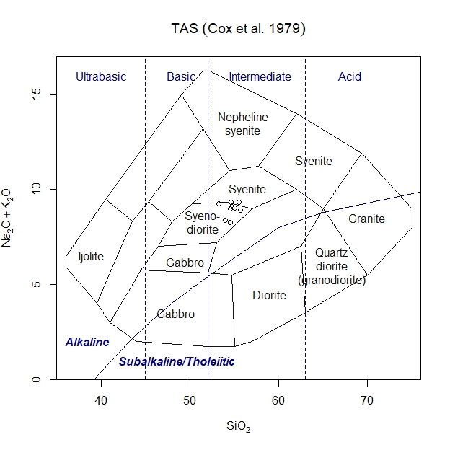
Figure 4: SiO₂ vs Na₂O + K₂O (TAS) diagram after Cox et. al., (1979)

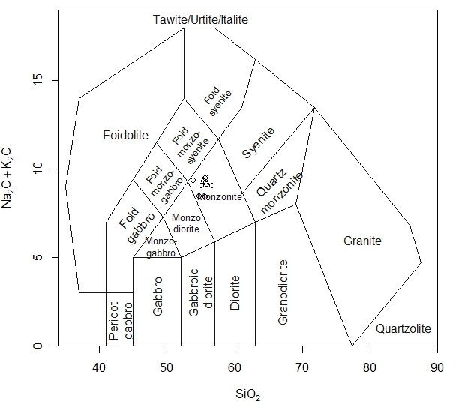
Figure 5: Total Alkali Silica (TAS) diagram classification (after Middlemost, 1994)
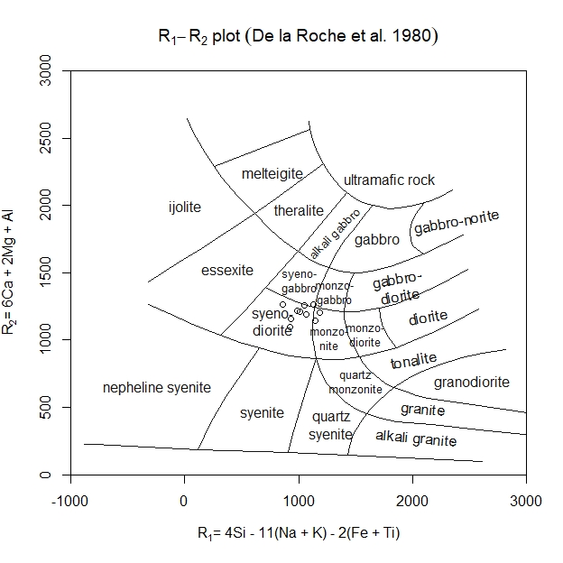
Figure 6: R1-R2 diagram of De La Roche et al., (1980)
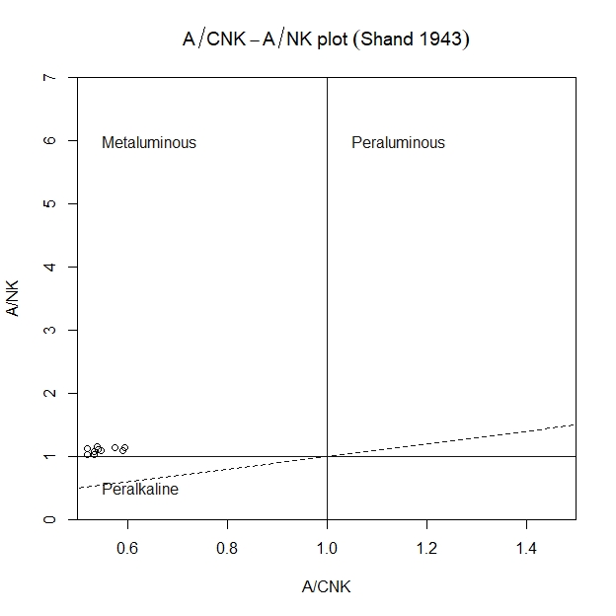
Figure 7: A/CNK vs A/NK plot of Shand (1943) discriminating metaluminous, peraluminous and peralkaline composition.

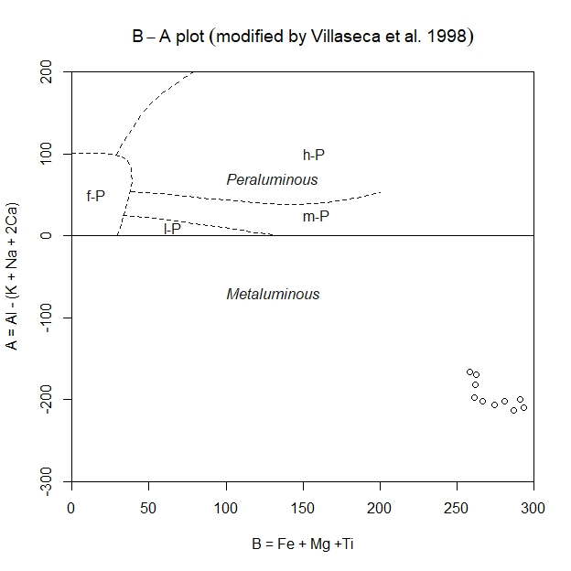

Figure 8: B-A diagram after Villaseca et. al., (1998)
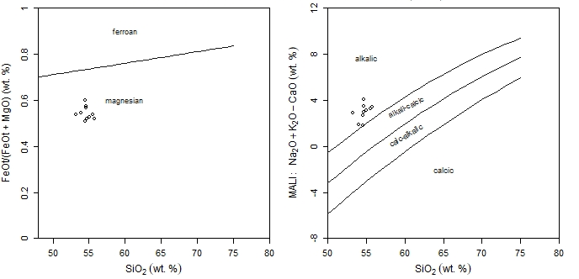

Figure 9 and 10: Granite tectonic discrimination diagram after Frost and Frost (2008)

4.3 CIPW normative mineralogy and magma chemistry
CIPW normative mineralogy further reinforces the syenitic character of the rocks and provides quantitative insight into magma chemistry (Table 1). High normative orthoclase and albite contents reflect the alkali-rich nature of the magma, while moderate quartz norms (7.4–12.7%) indicate silica saturation to slight oversaturation. The presence of normative quartz aligns with petrographic evidence of interstitial quartz and suggests that the magma evolved toward silica saturation during late crystallization stages.
Low anorthite contents (≤4.3%) indicate limited calcic plagioclase, supporting the inference of advanced fractionation prior to emplacement. Normative wollastonite and hematite suggest contributions from Ca- and Fe-rich components, consistent with observed CaO and Fe₂O₃ concentrations. The occurrence of normative apatite corresponds with elevated P₂O₅ contents, implying early saturation of phosphorus and potential enrichment of incompatible elements during magmatic evolution.
4.4 Trace element characteristics and source implications
Trace-element abundances provide critical constraints on magma source characteristics and tectonic setting. The high concentrations of large-ion lithophile elements (LILE) such as Ba (up to >3200 ppm) and Sr (up to ~980 ppm) are indicative of enrichment processes commonly associated with subduction-modified mantle sources or metasomatized lithospheric mantle (Wang et al., 2025). These elements are readily mobilized by fluids and melts, suggesting a mantle source that experienced prior enrichment rather than a depleted asthenospheric source.
On the Co–Th discrimination diagram of Hastie et al. (2007), the samples plot within the volcanic-arc field (Figure 11), reflecting relative enrichment in Th compared to Co. Thorium enrichment is commonly associated with slab-derived fluids or melts that metasomatize the mantle wedge during subduction. This signature indicates a subduction-modified mantle source, even though the syenites were emplaced during the later stages of orogenesis.
The Pearce et al. (1984) trace-element discrimination diagrams further constrain the tectonic setting. On the Nb–Y and Rb–(Y+Nb) plots, the syenite samples cluster predominantly within the volcanic-arc granite (VAG) and syn-collisional granite (syn-COLG) fields, with minor overlap toward the within-plate granite (WPG) field (Figure 12). The suppression of Nb relative to Y and Rb is a hallmark of subduction-related magmas and reflects retention of Nb in residual phases during slab melting or mantle metasomatism. The limited dispersion toward WPG fields likely reflects late-stage differentiation rather than a true intraplate origin.
Elevated concentrations of compatible elements such as Cr, Ni, and V are notable for rocks of syenitic composition and may reflect limited early removal of mafic phases or minor assimilation of mafic lower crustal material. Conversely, moderate abundances of high-field-strength elements (HFSE) such as Nb, Zr, and Y suggest a source that was not strongly depleted, but also not typical of within-plate alkaline magmatism, which commonly exhibits higher HFSE enrichment.
The low to moderate Th and U contents further support a mantle-dominated source with limited involvement of highly radiogenic upper crustal materials (Aulbach et al., 2022). The trace-element signature as a whole is consistent with magmas generated in tectonic settings transitional between subduction-related and post-collisional environments.
The REE characteristics of the Igarra syenites provide important constraints on magma source composition and evolutionary processes. The strong enrichment in light rare earth elements relative to heavy rare earth elements indicates derivation from an enriched magma source, rather than a depleted mantle (Sun et al., 2025) (Fig 13). Such LREE-enriched patterns are typical of magmas generated from metasomatized lithospheric mantle or mantle sources influenced by subduction-related fluids and melts. The comparatively lower concentrations of HREEs suggest limited involvement of residual garnet in the source region or partial melting at relatively shallow mantle depths. This inference is consistent with generation of the magma within the lithospheric mantle or lower crust, rather than deep asthenospheric sources (Alpaslan et al., 2025). The overall REE distribution implies significant incompatibility controlled enrichment during partial melting and subsequent magmatic differentiation.
Moderate europium contents indicate that Eu behaved neither as a strongly compatible nor incompatible element during magma evolution. This suggests limited plagioclase fractionation prior to or during emplacement, consistent with the metaluminous nature of the rocks and the dominance of alkali feldspar over calcic plagioclase observed petrographically. The absence of extreme Eu depletion further supports crystallization from a magma that had not undergone extensive feldspar removal at depth (Li et at., 2022).
The low to moderate Ta concentrations are characteristic of magmas generated in orogenic tectonic settings, where high-field-strength elements are typically depleted relative to within-plate alkaline magmas. This behavior is consistent with the volcanic-arc to syn- and post-collisional affinities indicated by tectonic discrimination diagrams and supports derivation from a subduction-modified mantle source (Verplanck & Hitzman, 2025). Thus, the trace-element and REE signatures of the Igarra syenites are consistent with late- to post-collisional Pan-African magmatism, involving partial melting of an enriched mantle source followed by internal magmatic differentiation and limited crustal contamination.

4.5 Geotectonic setting and Pan-African context
The multicationic R1–R2 tectonic discrimination diagram (Batchelor and Bowden, 1985) places the Igarra syenites mainly within the post-collisional granite field, with minor overlap into the syn-collisional domain (Figure 14). This distribution reflects the transitional tectonic environment prevailing during the late stages of the Pan-African orogeny in southwestern Nigeria. Following continental collision, lithospheric delamination, slab break-off, or asthenospheric upwelling may have facilitated partial melting of enriched mantle sources, producing potassic to high-K magmas.
The emplacement of syenitic intrusions within the Igarra Schist Belt is therefore interpreted as part of late-to-post-orogenic magmatism associated with crustal relaxation and tectonic reorganization after peak Pan-African deformation. This interpretation is consistent with regional geological evidence indicating widespread granitoid and minor syenitic intrusions emplaced during the waning stages of Pan-African tectonism.
Comparable syenitic bodies elsewhere in the Nigerian Basement Complex (Bolarinwa, 2023; Lawal et al., 2025; Yelwa, & Shuaibu, 2024) have been similarly interpreted as products of post-collisional magmatism, reflecting a shift from compressional to extensional regimes and renewed mantle input into the crust.
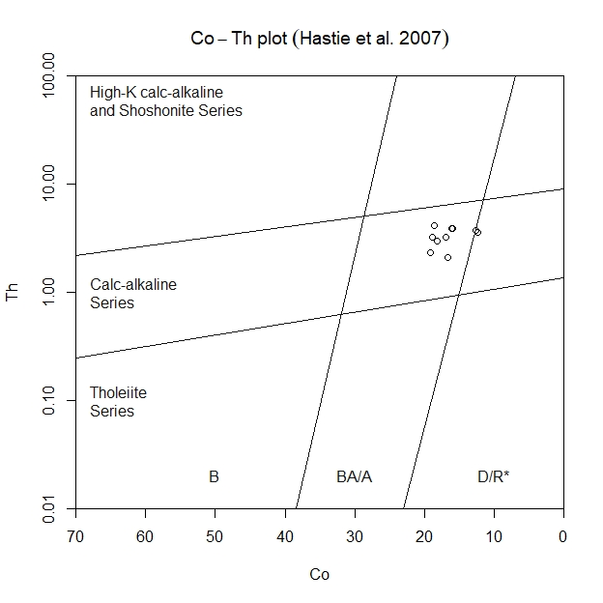
Figure 11: Samples showing the Co-Th plot of syenite analyses (Hastie et al.2007)
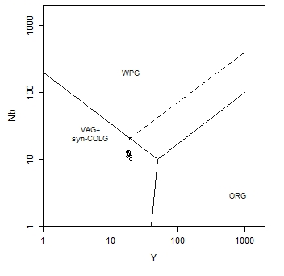
Figure 12: Trace-element discrimination diagrams (after Pearce et al., 1984) for granites derived from melts parental to REE-enriched syenite. VAG: volcanic-arc granites, ORG: ocean-ridge granites, syn-COLG: syncollisional granites, WPG: within-plate granites.

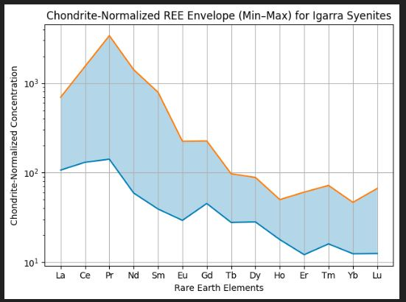
Figure 13. Chondrite-normalized rare earth element (REE) envelope (minimum–maximum values) for syenitic rocks from the Igarra Schist Belt, southwestern Nigeria. Normalization values are after Boynton (1984). The shaded field highlights strong LREE enrichment relative to HREEs and limited dispersion in the HREE segment.
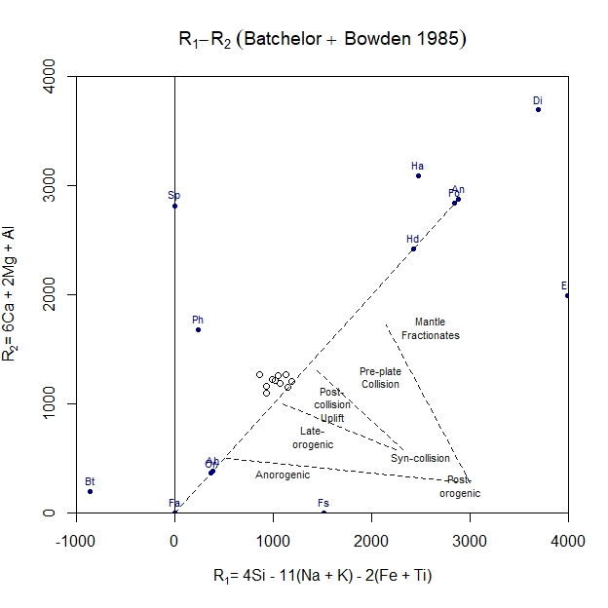
Figure 14: Tectonic Setting Discrimination diagram of R1-R2 (after Batchelor and Bowden, 1985)

4.6 Regional and economic implications
The geochemical characteristics of the Igarra syenites bear implications for regional crustal evolution and mineralization potential. Elevated Ba, Sr, P, and moderate HFSE contents suggest that these rocks may act as fertile hosts for incompatible element enrichment. Although no direct economic mineralization was identified in this study, syenites worldwide are known to host or be spatially associated with REE, U–Th, and gemstone mineralization (Verplanck, & Hitzman, 2025; Benali, & Cherfi, 2024; Watts, & Miller, 2024).
From a regional perspective, the Igarra syenites provide valuable constraints on the nature of Pan-African magmatism in southwestern Nigeria, highlighting the role of enriched mantle sources and late-stage tectonic processes in crustal growth and modification.

5. Conclusions
Syenitic magmatism within the Igarra Schist Belt represents a discrete phase of intermediate, alkali-rich plutonism linked to the terminal stages of the Pan-African orogeny in southwestern Nigeria. Petrographic characteristics and major-element chemistry indicate crystallization from a differentiated, metaluminous, high-K magma emplaced at shallow to mid-crustal levels following regional deformation. These features distinguish the Igarra syenites from syn-tectonic granitoids and align them with late-orogenic intrusive suites developed during post-collisional lithospheric reorganization.
Rare earth element systematics provide critical constraints on magma generation and evolution. The consistently fractionated chondrite-normalized REE patterns, marked by strong LREE enrichment and subdued HREE abundances, indicate partial melting of an enriched lithospheric mantle source at relatively shallow depths, where residual garnet was insignificant. The coherent REE envelopes across samples imply a common source and melting regime, while the absence of a pronounced Eu anomaly suggests that feldspar fractionation was limited prior to emplacement and that differentiation occurred largely during late-stage crystallization within the crust.
When integrated with trace-element tectonic discrimination results, the REE characteristics confirm that the Igarra syenites were not products of anorogenic or within-plate magmatism, but rather formed in a transitional syn- to post-collisional setting associated with the waning stages of Pan-African convergence. These syenites thus record an important episode of enriched mantle input and crust–mantle interaction during orogenic collapse, contributing to a more complete understanding of late Pan-African magmatism and its geodynamic significance within the Nigerian Basement Complex.

Disclaimer (Artificial intelligence)
Author(s) hereby declare that NO generative AI technologies such as Large Language Models (ChatGPT, COPILOT, etc.) and text-to-image generators have been used during the writing or editing of this manuscript.

References
Adamu, L. M., Lekdukun, M. O., Adesina, D. A., Emmanuel, A. U., Ibrah, S. O., & Adamu, N. (2024). Geology, Petrology and Geochemistry of the Basement Rocks around Ihima, Southwestern Basement Complex, Nigeria. World Scientific News, 190(2), 70-100.
Adeoti, B., & Okonkwo, C. T. (2016). Structural geology of the basement complex rocks in Iwaraja Area, Southwestern Nigeria. International Letters of Natural Sciences, (58).
Adepoju, M. O., Odeyemi, I. B., & Akinluyi, F. O. (2021). Landsat-8 lineament analysis for detection of epigenetic mineralization zones in parts of Igarra Schist Belt, Southwestern Nigeria. Remote Sensing in Earth Systems Sciences, 4(1), 76-86.
Agoha, C. C., Adejuwon, B. B., Mgbeojedo, T. I., Onwubuariri, C. N., Akiang, F. B., Ibeneme, S. I., ... & Njoku, J. O. (2022). Natural radioactivity assessment and geophysical interpretation of parts of Igarra area, Southern Nigeria. Environmental Monitoring and Assessment, 194(6), 438.
Akpan, A. E., Ekwueme, B. N., & Ephraim, B. E. (2023). Tectonic setting of the syenite around Igarra, southwestern Nigeria: Constraints from geochemistry. Journal of the Nigerian Society of Physical Sciences, 5(1), 999. https://doi.org/10.46481/jnsps.2023.999
Alpaslan, M., Guezou, J.-C., Boztuğ, D., & Temel, A. (2025). Geochemical and Pb-Sr-Nd isotopic constraints indicating an enriched-mantle source for Late Cretaceous to Early Tertiary volcanism, Central Anatolia, Turkey. International Geology Review, 67(3), 1025–1042. https://doi.org/10.1080/00206814.2025.2381090
Aulbach, S., Marras, G., Stagno, V., & Mikhailenko, D. S. (2022). Fe³⁺ distribution and Fe³⁺/ΣFe-oxygen fugacity variations in kimberlite-borne eclogite xenoliths, with comments on clinopyroxene-garnet oxy-thermobarometry. Journal of Petrology, 63(8), egac076. https://doi.org/10.1093/petrology/egac076
Aulbach, S., Marras, G., Stagno, V., & Mikhailenko, D. S. (2022). Fe³⁺ distribution and Fe³⁺/ΣFe-oxygen fugacity variations in kimberlite-borne eclogite xenoliths, with comments on clinopyroxene-garnet oxy-thermobarometry. Journal of Petrology, 63(8), egac076. https://doi.org/10.1093/petrology/egac076
Batchelor, R.A. and Bowden, P. (1985) Petrogenetic Interpretation of Granitoid Rock Series Using Multicationic Parameters. Chemical Geology, 48, 43-55. http://dx.doi.org/10.1016/0009-2541(85) 90034-8
Belts, S., Nigeria, N., Oluyede, K., Garba, I., Danbatta, U., Ogunleye, P., & Klötzli, U. (2024). Origin and Geological Setting. Geology and Natural Resources of Nigeria, 124.
Benali, H., & Cherfi, Y. (2024). Syenite hosted-REE mineralization in the Ediacaran Tioueine granitoid ring-complex, western Hoggar (Tuareg shield), southern Algeria. Journal of African Earth Sciences, 212, 105-121. https://doi.org/10.1016/j.jafrearsci.2024.105121
Bolarinwa, A. T. (2023). Geochemistry of weathered profiles over syenite and younger granite in Pankshin area, north central Nigeria. Earth Science Research, 12(1). https://doi.org/10.5539/esr.v12n1p1
Bolhar, R., Maghdour-Mashhour, R., Milani, L., Mondal, S., O'Sullivan, G. J., Klemd, R., & Chang, Q. (2025). Petrogenesis of syenites at Phalaborwa, Kaapvaal Craton:(isotope) geochemical, modelling and age constraints. Chemical Geology, 123202.
Brooks, K. (2024). Syenites. Geology Today, 40(2), 72-78.
Chappell, B. W., & Wyborn, D. (2024). Origin of I-type and S-type granites: A review of 50 years of the I-S classification. Australian Journal of Earth Sciences, 71(2), 145–168. https://doi.org/10.1080/08120099.2023.2245678
Cox, K. G., Bell, J. D., Pankhurst, R. J. (1979). The Interpretation of Igneous Rocks. Allen and Unwin, London, 450 p. http://dx.doi.org/10.1007/978-94-017-3373-1
Damdinov, B. B., Damdinova, L. B., & Tugutova, S. Z. (2022). Rare Earth–Uranium–Thorium Mineralization in the Molybdenum Ores of the Buluktaevskoe Mo–W Deposit (Western Transbaikalia, Russia). Geology of Ore Deposits, 64(5), 300-312.
De la Roche, H., Leterrier, J., Grandclaude, P. and Marchal, M. (1980) A Classification of Volcanic and Plutonic Rocks Using R1-R2 Diagrams and Major Element Analyses—Its Relationships with Current Nomenclature. Chemical Geology, 29, 183-210. http://dx.doi.org/10.1016/0009-2541(80)90020-0
Dubé, B., & Mercier-Langevin, P. (2020). Gold deposits of the Archean Abitibi greenstone belt, Canada.
Frost, B.R. and Frost, C.D. (2008) A Geochemical Classification for Feldspathic Igneous Rocks. Journal of Petrology, 49, 1955-1969. http://dx.doi.org/10.1093/petrology/egn054
Hastie, A.R., Kerr, A.C., Pearce, J.A. and Mitchell, S.F. (2007) Classification of Altered Volcanic Island Arc Rocks using Immobile Trace Elements: Development of the Th-Co Discrimination Diagram. Journal of Petrology, 48, 2341-2357. https://doi.org/10.1093/petrology/egm062
Igonor, E. E., Daramola, S.O. and Oladipupo, K.J, (2023). Petrogenetic characterisation of Pan-African Granitoids within FUTA, southwest Nigeria: Mesoscopical, Mineralogical and Geochemical evaluation, Journ. Earth and Atm. Sci. 6(1), 43-60.
Keshavarzi, R. , Esmaili, D. , Kahkhaei, M. , Mokhtari, M. and Kordlou, M. (2014) Mineral Chemistry and Magmatic Differentiation Evidences in the Neshveh Intrusion (NW Saveh, Central Iran). Open Journal of Geology, 4, 262-288. doi: 10.4236/ojg.2014.46020.
Lawal, M., Mohammed, M. A., & Alalade, K. A. (2025). Geology of basement complex rocks in Kabo area, Kano, northwestern Nigeria: Insights into the trends of mineralization in the region. International Journal of Science for Global Sustainability, 11(1).
Li, X., Wang, Q., Zhang, C., & Dan, W. (2022). Identifying crystal accumulation and melt extraction during formation of high-silica granite. Geology, 50(2), 216–220. https://doi.org/10.1130/G49424.1
Li, J., Zhang, H., & Wang, C. (2024). Mineral textures and chemistry trace the origin and transcrustal evolution of the Sanyuangou syenite in southern North China Craton. Journal of Petrology, 65(6), egae056. https://doi.org/10.1093/petrology/egae056
Marxer, K., Ulmer, P., & Müntener, O. (2025). The role of oxygen fugacity in hydrous basaltic phase equilibria: Experimental constraints at 0.2 and 0.8 GPa. Contributions to Mineralogy and Petrology, 180(11), Article 82. https://doi.org/10.1007/s00410-025-02189-x
Mathieu, L., Estrade, G., Miranda, M., Laurent, O., & Grégoire, M. (2025). Crystallization conditions and magmatic–hydrothermal evolution of syenite dykes spatially associated with gold mineralization: the example of the Dolodau syenite–carbonatite complex, Abitibi greenstone belt. Canadian journal of earth sciences, 62(6), 1062-1087.
Middlemost, E.A.K. (1994) Naming Materials in the Magma/Igneous Rock System. Earth-Science Reviews, 37, 215-224.
Miyashiro, A. (1974) Volcanic Rock Series in Island Arcs and Active Continental Margins. American Journal of Science, 274, 321-355. https://doi.org/10.2475/ajs.274.4.321
Obaje, N. G. (2009). The basement complex. In Geology and Mineral Resources of Nigeria (pp. 13-30). Berlin, Heidelberg: Springer Berlin Heidelberg.
Ogbe, O. B., Olobaniyi, S. B., Ejeh, O. I., Omo-Irabor, O. O., Osokpor, J., Ocheli, A., & Overare, B. (2018). Petrological and structural investigation of rocks around Igarra, Southwestern Nigeria. Ife Journal of Science, 20(3), 663-677.
Ominigbo, O. E. (2022). Evolution of the Nigerian basement complex: current status and suggestions for future research. Journal of mining and Geology, 58(1), 229-236.
Oyebamiji, A., Akinola, O., Olaolorun, O., Abdu-Raheem, Y., Adeoye, A., & Oguntuase, M. (2024). Geochemistry, petrogenesis and geological implication of granitic rocks in Igarra area, southwestern Nigeria. Applied Earth Science, 133(3), 174-189.
Pearce, J.A., Harris, N.B.W. and Tindle, A.G. (1984) Trace Element Discrimination Diagrams for the Tectonic Interpretation of Granitic Rocks. Journal of Petrology, 25, 956-983. http://dx.doi.org/10.1093/petrology/25.4.956
Province, G., Ashano, E. C., & Olasehinde, A. (2024). The Nigerian Younger. Geology and Natural Resources of Nigeria, 80.
Salazar-Naranjo, A. F., & Vlach, S. R. F. (2018). On the crystallization conditions of the Neoproterozoic, high-K calc-alkaline, Bragança Paulista-type magmatism, southern Brasília Orogen, SE Brazil. Brazilian Journal of Geology, 48, 631-650.
Shand, S.J. (1943) Eruptive Rocks. Their Genesis Composition. Classification, and Their Relation to Ore-Deposits with a Chapter on Meteorite. John Wiley & Sons, New York.
Sorokina, E. S., Botcharnikov, R. E., Kostitsyn, Y. A., Rösel, D., Häger, T., Rassomakhin, M. A., ... & Hofmeister, W. (2021). Sapphire-bearing magmatic rocks trace the boundary between paleo-continents: A case study of Ilmenogorsky alkaline complex, Uralian collision zone of Russia. Gondwana research, 92, 239-252.
Sun, J., Liu, C.-Z., Dick, H. J. B., & Zhang, C. (2025). The mantle source of REE-rich alkaline silicate magmas can be enriched by continent-derived sediment subduction. Nature Communications, 16(1), Article 11191. https://doi.org/10.1038/s41467-025-54321-x
Tang, M., Chu, X., Hao, J., & Shen, B. (2021). Orogenic iron cycle and the evolution of atmospheric oxygen. Proceedings of the National Academy of Sciences (PNAS), 118(13), e2017297118. https://doi.org/10.1073/pnas.2017297118
Udı, E. M., Imasuen, O. I., Avwenagha, E. O., & Odokuma-Alonge, O. I. (2023). Examination of the Pan–African Orogeny: Implications on the Architecture of Basement Rocks in Igarra, Southwestern Nigeria. International Journal of Earth Sciences Knowledge and Applications, 5(1), 92-102.
Udimwen, E., (2017) “Paleostress configuration of Pan-African orogeny: evidence from Igarra Schist Belt, SW Nigeria”, Iranian Journal of Earth Sciences 9, 85.
Ugbe, F. C., Ominigbo, O. E., & Akano, A. O. (2023). Tectonic Setting of the Syenite Around Igarra, Southwestern Nigeria: Constraints from Geochemistry. Journal of the Nigerian Society of Physical Sciences, 999-999.
Verplanck, P. L., & Hitzman, M. W. (2025). Rare earth mineralization in igneous rocks: Sources and processes. Journal of Geochemical Exploration, 264, 107-128. https://doi.org/10.1016/j.gexplo.2024.107128
Villaseca, C., Barbero, L. and Herreros, V. (1998) A Re-Examination of the Typology of Peraluminous Granite Types in Intracontinental Orogenic Belts. Transactions of the Royal Society of Edinburgh. Earth Sciences, 89, 113-119.
Wang, H., Tang, Y., Xu, Y. S., Zhang, H., Lv, Z. H., Qin, S. X., & Song, Y. W. (2021). Textures and Chemical Compositions of Nb-Bearing Minerals and Nb Mineralization in the Shuangshan Nepheline Syenite Pluton, East Qinling, China. Minerals, 11(11), 1163.
Wang, P., Yang, G., Zhuang, Y., & Li, H. (2025). Petrogenesis of Late Miocene high Ba–Sr granitoids in Eastern Pamir, Northwest Tibetan Plateau: Insights into lithospheric mantle evolution and geodynamic processes during India–Asia bidirectional subduction. Journal of Petrology, 66(4), egad091. https://doi.org/10.1093/petrology/egad091
Watts, K. E., & Miller, J. S. (2024). Mafic alkaline magmatism and rare earth element mineralization in the Mojave Desert, California: The Bobcat Hills connection to Mountain Pass. Geochemistry, Geophysics, Geosystems, 25(2), e2023GC011253. https://doi.org/10.1029/2023GC011253
Yelwa, N. A., & Shuaibu, A. M. (2024). Geology and geochemical characterization of basement rocks around Burumburum area, North Central Basement Complex, Nigeria. Science World Journal, 19(1), 142–155.

