Review Paper

Review on Role of Fluorinated Scaffolds in Pharmaceutical Chemistry: Enhancing Drug Properties through Strategic Fluorination

.
ABSTRACT

Fluorine ions have transformed the manufacturing of modern medications and continue to dramatically change the physical, pharmacokinetic, and pharmacodynamic properties of drugs. The physical properties of carbon-fluorine bonds are unique due to the very high bond dissociation energy of this bond, and the fact that fluorine is a highly electronegative atom with minimal steric interference from bonding to a carbon atom, provide chemists with an opportunity to precisely modify the molecular properties of drugs without changing the overall framework of the molecule. Based on the above characteristics of C-F bonds, strategic fluorine incorporation into many biologically active molecules increases the molecules' lipophilicity, membrane permeability, metabolic stability, and resistance to enzymatic degradation, and therefore increases the bioavailability and half-life duration in vivo of those molecules. There is also a significant body of knowledge that demonstrates substituting fluorine atoms in drug molecules impacts the electronic distribution, conformation, and intermolecular interactions of those molecules, resulting in increased affinity and selectivity towards their intended targets. This review presents and discusses the influence of fluorine in drug design and highlights the influence of fluorine on molecular action via structural activity relationships as well as the method of synthesizing fluorinated drug molecules. Representative patient-indicated and commercially available fluorinated drug examples that have been clinically approved include fluoroquinolone antibiotics and fluorinated steroids used in the treatment of cancer, neurological, infectious, and cardiovascular diseases.
The review additionally provides a discussion of emerging methodologies that utilize novel electrophilic and nucleophilic fluorination reagents, late stage fluorination strategies, and the incorporation of trifluoromethyl or perfluoroalkyl groups into drug structures for optimization of pharmacokinetic propertiesIn summary, this review illustrates how the strategic fluorination is a key component of the expanded utility of chemical compounds to develop new drugs.
Keywords: Intermolecular interactions, strategic fluorine incorporation, pharmacokinetic properties, electronegativity

1. INTRODUCTION
1.1.Importance of fluorine in medicinal chemistry
Fluorine's distinct physicochemical characteristics have made it a particularly important element in contemporary medicinal chemistry. Drug compounds' biological behaviour can be drastically changed by adding fluorine atoms or fluorinated groups without appreciably altering the size or shape of the molecule. Fluorine substitution frequently improves membrane permeability and lipophilicity, which makes it easier for pharmaceuticals to pass across cellular membranes and even the blood–brain barrier. This is especially crucial for medications that affect the central nervous system (CNS) ^{1-2.}Fluorine also plays a crucial role in enhancing the medication molecules' metabolic stability. Fluorine substitution prolongs half-life, lowers dose frequency, and improves bioavailability by shielding critical molecular locations from oxidative degradation, particularly by cytochrome P450 enzymes ^{3,4}. Furthermore, fluorine's strong electronegativity affects molecule structure and increases binding affinity to target proteins, which raises potency and selectivity ⁵.
1.2.Brief history of fluorinated drugs
A relatively recent but significant advancement in medicinal chemistry is the incorporation of fluorine into medicines. 5-fluorouracil (5-FU), an anticancer drug created in the 1950s, was the first significant breakthrough. The idea behind its construction was to substitute fluorine for a hydrogen atom in uracil, which would prevent thymidylate synthase from working and interfere with DNA synthesis. Today, 5-FU is still often used in oncology ⁶⁻⁷. Fluorine-containing medications gained importance after this. The addition of fluorine in the 1960s and 1970s resulted in the creation of fluorinated corticosteroids, including dexamethasone and fluticasone, which demonstrated improved anti-inflammatory properties with fewer systemic adverse effects ⁸. Another significant development was the antidepressant fluoxetine, which was first made available in the late 1980s and showed how fluorination can enhance serotonin transporter selectivity and blood–brain barrier penetration ⁹.
2. Chemical Properties of Fluorine Relevant to Drug Design
Incorporating fluorine is a well-known method for improving medication prospects. High electronegativity and a strong carbon–fluorine bond can affect molecular dipoles, modify electrical effects, and increase receptor binding affinity. Fluorinated analogues are extremely helpful in contemporary medicinal chemistry because of these characteristics¹⁰.
2.1.Electronegativity and Bond Strength
Compared to C–H (≈ 410 kJ/mol) and C–Cl (≈ 340 kJ/mol), fluorine forms one of the strongest single bonds with carbon (C–F bond energy = 485 kJ/mol). Because fluorinated sites are resistant to oxidative processing by cytochrome P450 enzymes, this high bond strength promotes chemical and metabolic stability ¹¹. Additionally, fluorine's electronegativity removes electron density, modifying the reactivity and acidity/basicity of nearby groups.
2.2.Lipophilicity and Membrane Permeability
Fluorine has a double influence on lipophilicityFluorine substitution for hydrogen in aromatic systems may boost lipophilicity, enhancing medication penetration through lipid membranes and the blood-brain barrier, as seen with CNS-active medicines i.e fluoxetine¹².When integrated into aliphatic chains, fluorine may lower lipophilicity due to its polar character¹³.
2.3.Effects on pKa, Metabolism, and Hydrogen Bonding
The pKa of adjacent functional groups is significantly impacted by fluorine substitution. For instance, a carboxylic acid's pKa is lowered when a hydrogen atom is swapped out for a fluorine atom next to it, improving ionisation and solubility. Likewise, amines' basicity is decreased by fluorine at the α-position, which can enhance medication selectivity and lessen off-target interactions. By preventing oxidative hot spots and extending half-life and oral bioavailability, fluorination also regulates medication metabolism. Moreover, fluorine indirectly contributes to hydrogen bonding. Despite being a weaker hydrogen-bond acceptor than oxygen or nitrogen, fluorine has substantial inductive effects that affect the strength and geometry of nearby hydrogen bonds, frequently maintaining drug molecules' bioactive conformations¹⁴.
3.Elucidating the Key Biological Impacts of Fluorination
The unique chemical properties of fluorine translate directly into profound and strategic advantages in a biological context. By strategically placing fluorine, medicinal chemists can fundamentally alter a drug's behaviour in the body, primarily by influencing its metabolic stability, membrane permeability, and binding interactions.
3.1. Enhancing Metabolic Stability (The "Metabolic Shield")
One of the most significant advantages of fluorination is the enhancement of metabolic stability. Drug metabolism, particularly oxidation by cytochrome P450 (CYP450) enzymes, is a primary cause of drug clearance. Chemists can "shield" a metabolically vulnerable C-H bond by replacing the hydrogen with a makes it highly resistant to oxidative cleavage by CYP450 enzymes. This "metabolic block" prevents the drug from being broken down at that site, which can lead to: Longer half-life ,Improved bioavailability and Reduced dosage frequency.
3.2. Modulating Lipophilicity and Permeability
Fluorine has a "dual-influence" on lipophilicity, which is critical for a drug's ability to pass through cellular membranes.Increased Lipophilicity: When substituted on aromatic rings, fluorine often increases the molecule's overall lipophilicity. This enhancement is crucial for drugs that need to cross lipid membranes. Decreased Lipophilicity: In contrast, when fluorine is integrated into aliphatic chains, its polar character may lower lipophilicity.This ability to precisely "tune" a molecule's lipophilicity allows for optimisation of its absorption, distribution, metabolism, and excretion (ADME) profile.
3.3. Optimizing Binding Affinity and Potency
Fluorine substitution can directly influence a drug's binding affinity and selectivity for its biological target. It achieves this through several mechanisms:

Fig 1 : Mechanisms of Drug's Binding Affinity

4. Common Fluorinated Functional Groups in Pharmaceuticals
4.1.Fluoroalkanes
A class of organic compounds known as fluoro alkanes is made up of fluorine atoms joined to carbon atoms in an alkane chain. These substances are also referred to as perfluoroalkanes or fluorinated alkanes. Fluoroalkanes are distinguished by their special qualities, which include minimal reactivity, chemical inertness, and great thermal stability ^{15–16}. Because of the special qualities of fluorine atoms, fluor alkanes are important in medication design. Fluorine can be added to medicinal compounds to improve their lipophilicity¹⁷, metabolic stability, and biological activity. Fluoroalkanes are important in medication design for the following reasons. F- substituents can improve a drug's bioavailability and metabolic stability¹⁸. Fluorinated substances frequently have increased membrane permeability, which facilitates better distribution and absorption inside the body¹⁹. Enhanced Lipophilicity can be obtained by Fluoro-arenes in particular have the capacity to boost lipophilicity, which may improve a drug's capacity to interact with target proteins and pass through cell membranes²⁰. Drugs containing fluorine have been authorized for use in a number of therapeutic domains, such as Oncology for example sotorasib for non-small cell lung cancer. Antimicrobial drugs that work against a variety of bacteria, such as fluoroquinolones, are effective in infectious diseases²¹⁻²².. Examples include, fluoro methane (CH₃F), fluoro ethane (CH₃CH₂F), tetrafluoroethylene (C₂F₄).
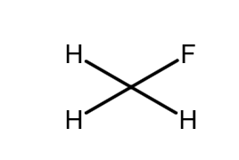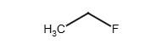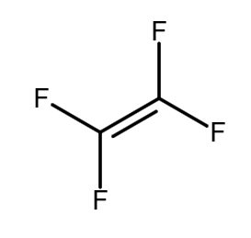
Fluoromethane 1-Fluoroethane 1,1,2,2-Tetrafluoroethene
Scheme 1 : Structure of Fluoromethane, 1-Fluoroethane, 1 ,1 ,2,2-Tetrafluoroethene

4.2.Aromatic fluorination
An Aromatic fluorination can greatly increase a drug's efficacy and safety can be greatly increased by fluorine's special qualities, which include increased lipophilicity, metabolic stability, and binding affinity²³.When designing drugs, fluorinated aromatics are employed to improve potency, stability, and bioavailability²⁴. Examples include fluorobenzene, difluorobenzene, trifluoro benzene, tetrafluoro benzenes, pentafluoro benzene, and hexafluoro benzene.
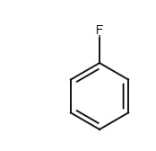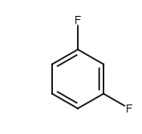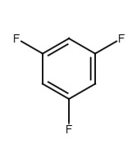
Fluorobenzene 1,3 di fluorobenzene 1,3,5 tri fluorobenzene
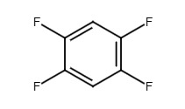
2,3,5,6-tetrafluorobenzene
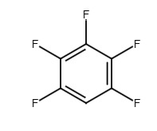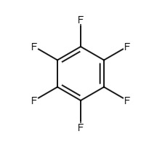
1,2,3,5,6 pentafluoro benzene 1,2,3,4,5,6 hexafluoro benzene
Scheme 2: Structure of Fluorobenzene, 1,3 di fluorobenzene, 1,3,5 tri fluorobenzene, 2,3,5,6-tetrafluorobenzene, 1 ,2,3,5,6 pentafluoro benzene, 1 ,2,3,4,5,6 hexafluoro benzene

4.3.Asymmetric and Enantioselective Fluorination Strategies
In medicinal chemistry, chirality the non-superimposable mirror image nature of a molecule is often the difference between a potent drug and an inactive or toxic compound. Since nearly all biological targets (receptors, enzymes) are chiral, enantiopure fluorinated molecules are required. Therefore, the development of highly selective asymmetric fluorination methods, which create a C–F bond while simultaneously controlling the stereocenter, is a crucial area of research. The primary goal is to use a chiral element (a catalyst or an auxiliary) to direct the fluorine atom to one specific face of the substrate, achieving a high enantiomeric excess .
4.3.1 Chiral-Catalyzed Electrophilic Fluorination
This approach is the most successful for creating new fluorinated stereocenters. It involves combining a prochiral substrate (one that can become chiral) with an electrophilic fluorine source (F⁺)and a small amount of a complex chiral catalyst . The catalyst acts as a template, forcing the fluorine reagent to approach only one face of the molecule.
Example: Asymmetric Fluorination of β-Keto Esters
β-Keto esters are essential building blocks for many drug structures. Direct fluorination of the α-carbon using a reagent like Selectfluor F–N(SO₂Ph)₂,typically yields a racemic (50:50) mixture of enantiomers. However, when a chiral organocatalyst (such as a chiral phosphoric acid) is introduced, the reaction becomes highly selective. The chiral catalyst forms a transient, rigid complex with the substrate, directing the F attack to only one side. This is often used to synthesize α-fluoro β-keto esters, which are valuable intermediates for anti-inflammatory agents and enzyme inhibitors. A prochiral substrate, when reacted with Selectfluor in the presence of a chiral catalyst (such as a chiral phosphate), produces an enantiopure fluorinated product with high enantiomeric excess.
4.3.2 Enantioselective Fluoroalkylation
This method focuses on the asymmetric introduction of fluorinated alkyl groups, particularly the biologically relevant trifluoromethyl (CF3)and difluoromethyl (CHF2)groups, to form new C-C bonds.
Example: Asymmetric Trifluoromethylation
The addition of the CF₃group to prochiral carbonyl compounds (like aldehydes) must be controlled. Researchers have developed protocols using electrophilic CF₃ reagents (e.g., derivatives of Togni's reagent) in conjunction with chiral copper or nickel complexes. The chiral metal complex coordinates to both the aldehyde and the CF₃ reagent, positioning them perfectly for the addition to occur on only one side of the aldehyde's double bond, resulting in the desired single enantiomer of the CF₃ containing alcohol.
4.3.3 Biocatalytic Fluorination
For ultimate control, biocatalysis represents a promising, highly selective, and green strategy. Enzymes are inherently chiral and evolved to differentiate between mirror-image forms. The enzyme fluorinase is capable of catalyzing the formation of the C-F bond in certain substrates with perfect chemo- and stereoselectivity under mild, physiological conditions. While the scope is currently limited, the use of engineered enzymes holds the key to developing new, scalable asymmetric fluorination routes in the future.

4.4.Difluoro methylene and fluorinated heterocycles
4.4.1. Difluoro methylene
Because of its lipophilicity and hydrogen bonding properties, the difluoromethyl group (CF2H) can improve therapeutic target affinity and specificity. Other fluorinated functionalities, such as difluoromethylene (CF2), are also useful building blocks for drug creation. In drug design, the difluoromethyl group (CF2H) is a flexible building block. EXAMPLES Lubiprostone: Used to treat constipation.
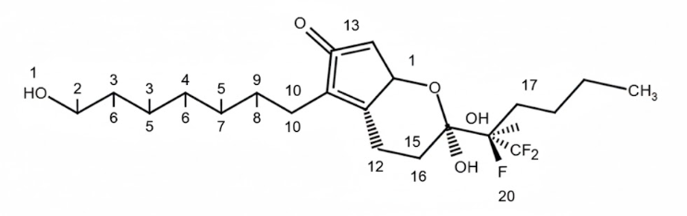
Scheme 3 : 7-[(2R,4aR,5R,7aR)-2-(1,1-difluoropentyl)-2-hydroxy-6-oxo-3,4,4a,5,7,7a-hexahydrocyclopenta[e]pyran-5-yl]heptanoic acid
4.4.2.Fluorinated heterocycles
Heterocyclic compounds with fluorine atoms are known as fluorinated heterocycles. These substances are used in many applications and possess special properties. Because of their improved stability, lipophilicity, and bioavailability, fluorinated heterocycles have applications in materials science, agrochemicals, and medicines. Heterocycles' reactivity, stability, and biological activity can all be greatly impacted by the addition of fluorine atoms. Some examples of fluorinated heterocycles include—fluorinated pyridines, Fluorinated quinolines, Fluorinated indoles²⁵.
4.5. Fluorinated Building Blocks
The difluoromethyl CHF₂ group offers a more nuanced set of properties, often acting as a bioisostere for hydroxyl OH, thiol SH, or amine NH groups. The critical difference lies in the single hydrogen atom H adjacent to the two fluorine atoms. The powerful electron-withdrawing effect of the two fluorines makes the C–H bond in CHF₂acidic enough to act as a lipophilic hydrogen bond donor. This unique characteristic allows the CHF₂ group to establish specific hydrogen-bonding interactions within a protein's binding site, which can be essential for high affinity and specificity. It is often referred to as a lipophilic hydrogen bond donor.
Replacing a methyl CH₃ group with CHF₂ offers an opportunity to subtly modulate physicochemical properties. It provides a smaller increase in lipophilicity compared to CF₃ while simultaneously introducing a new hydrogen bond donating capability. This flexibility makes CHF₂ an invaluable building block for fine-tuning the balance between metabolic stability, membrane permeability, and receptor binding—a balance exemplified by drugs like Lubiprostone and Maraviroc that successfully incorporate this moiety.
4.5.1.Trifluoromethoxy OCF₃ Group
The OCF₃ group is essentially a OCF₃ group connected to the rest of the molecule via an oxygen atom.
Role: It is used to modulate properties beyond what CF₃alone can achieve. It retains the CF₃unit's strong electron-withdrawing character and high metabolic stability, but the intervening oxygen allows for slightly different molecular interactions and polarity.
Properties: The OCF₃ group is often more lipophilic than the CF₃group, which can further enhance membrane permeability and absorption in certain drug scaffolds. It is an effective tool for fine-tuning the balance between lipophilicity and metabolic stability, particularly when greater membrane penetration is required.
4.5.2.Pentafluorosulfanyl SF₅ Group
The SF5 group, consisting of a sulfur atom bonded to five fluorine atoms, is a recent but rapidly evolving functional group in medicinal chemistry.5 It is often dubbed the super-trifluoromethyl group.
Role: It is used when an extreme electronic effect is needed, typically to create an analogue with superior pharmacological properties to a known CF₃-containing drug.
Properties: The SF₅group is considered one of the most electron-withdrawing substituents known. It is also bulkier and more lipophilic than the CF₃group. Its high chemical and thermal stability make it exceptionally resistant to metabolic degradation. Due to this unique combination of properties, it is frequently explored as a bioisostere for CF₃, tert-butyl, or nitro NO₂ groups, often leading to compounds with higher potency and longer half-lives.
5.Synthetic Strategies for Fluorinated Scaffolds
A key component of contemporary drug design is the inclusion of fluorine into bioactive compounds. Because of fluorine's strong C–F bond, high electronegativity, and special physicochemical characteristics, synthetic chemists have created a variety of techniques for adding fluorine atoms or fluorinated groups to scaffolds that are pertinent to medicines ²⁵. These tactics include the use of specific fluorinating reagents, conventional electrophilic and nucleophilic fluorination, and more recent developments in photo redox catalysis, flow chemistry, and C–H activation^{26-27.}
5.1.Electrophilic and nucleophilic fluorination
The two main categories of classical fluorination techniques are electrophilic and nucleophilic fluorination, each operating through distinct reactive fluorine species and reaction pathways. Electrophilic fluorination involves the transfer of a positively polarized fluorine atom (F⁺) to electron-rich substrates. Common reagents include molecular fluorine (F₂), XeF₂, and N–F reagents such as Selectfluor, N-fluorobenzenesulfonimide (NFSI), and N-fluor pyridinium salts. Due to their ability to functionalize C–H, C=C, aromatic systems, and heteroatoms under relatively mild conditions, these reagents are widely used for late-stage fluorination of complex bioactive molecules, enabling structural modification without disrupting sensitive functional groups. Although electrophilic fluorination typically offers excellent reactivity and synthetic flexibility, challenges include over-fluorination, harsh reaction control (especially with F₂ gas), and regioselectivity issues, which are often addressed using milder and more selective N–F reagents.In contrast, nucleophilic fluorination operates through nucleophilic fluoride sources (F⁻) that attack electrophilic carbon centers via SN2 or SNAr mechanisms, displacing suitable leaving groups to form stable C–F bonds. Commonly used nucleophilic fluorinating agents include alkali metal fluorides such as KF and CsF, silver(I) fluoride (AgF), and phase-transfer or organic-soluble fluoride sources such as tetrabutylammonium fluoride (TBAF) and [18F] fluoride. This strategy is particularly crucial in radiopharmaceutical chemistry, where ¹⁸F⁻ is incorporated into small molecules using Kryptofix/K₂CO₃ activation systems to generate PET imaging tracers. Advantages of nucleophilic fluorination include high bond-forming efficiency, predictable reaction pathways, and compatibility with radiolabeling workflows. However, its limitations include poor reactivity with sp² and sterically hindered centers, low solubility of inorganic fluorides in organic solvents, and moisture sensitivity, which are often mitigated using polar aprotic solvents (e.g., MeCN, DMSO), crown ethers, or phase-transfer catalysts.
Together, electrophilic and nucleophilic fluorination provide complementary synthetic platforms, enabling chemists to strategically introduce fluorine across a wide range of molecular architectures with applications spanning pharmaceutical development, agrochemicals, materials science, and PET imaging agents^{28,29}.
5.2.Use of fluorinating agents (Selectfluor, DAST, Deoxo-Fluor)
Fluorinating agents are chemicals used to introduce fluorine atoms into organic or inorganic molecules. In medicinal chemistry, materials science, and agrochemicals, they are crucial because fluorine substitution can drastically change a compound’s properties — improving metabolic stability, lipophilicity.
5.2.1.Selectfluor
Selectfluor (chemical name:1-chloromethyl-4-fluoro-1,4-diazoniabicyclo[2.2.2]octane bis(tetrafluoroborate)) is a bench-stable, crystalline, and highly efficient electrophilic fluorinating reagent that delivers positively polarized fluorine (F⁺). It functions as a safer and easier-to-handle alternative to molecular fluorine (F₂), offering superior safety, thermal stability, and reaction control. Due to the strong polarity of its N–F bond, Selectfluor enables controlled and selective fluorine transfer under mild reaction conditions, making it one of the most widely adopted reagents in synthetic and medicinal chemistry. It is particularly valuable for late-stage fluorination of complex bioactive molecules, including C–H, C=C, heteroatom (N, S, P), and activated aromatic systems, while maintaining compatibility with sensitive functional groups such as esters, amides, carbonyls, and heterocycles. The strategic introduction of fluorine using Selectfluor can significantly enhance metabolic stability, improve lipophilicity and membrane permeability, increase receptor affinity, and reduce oxidative degradation, leading to improved pharmacokinetic and pharmacodynamic properties—making it an important tool in structure–activity relationship (SAR) studies and lead optimization. Beyond acting as a fluorine transfer reagent, Selectfluor also serves as an oxidant, radical initiator, and catalytic mediator in reactions where fluorine is not ultimately incorporated into the final product. It is widely used in C–H functionalization, oxidative cyclization, dehydrogenation, halogenation, Baeyer–Villiger-type oxidation, and radical-driven C–C and C–heteroatom bond formation. Additionally, in photo redox and transition-metal catalysis, Selectfluor participates in single-electron transfer (SET) processes, generating reactive radical intermediates and enabling diverse synthetic transformations. Although highly advantageous, it can exhibit limited regioselectivity in certain substrates, may promote over-oxidation if not carefully controlled, and typically requires polar solvents such as MeCN, acetone, or MeOH for optimal reactivity. Despite these limitations, its reliability, broad functional group tolerance, operational simplicity, and scalability for industrial applications have established Selectfluor as a gold-standard reagent in both academic research and pharmaceutical process development. ³⁰

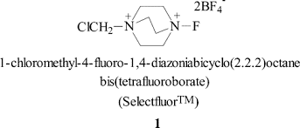
Scheme 4 : 1-chloromethyl-4-fluoro-1 ,4-diazoniabicyclo[2.2.2]octane bis(tetrafluoroborate)

5.2.2.DAST- (diethylaminosulfur trifluoride)
dAST (Diethylaminosulfur trifluoride, (CH₃CH₂)₂NSF₃) is a widely used nucleophilic deoxofluorinating reagent known for its ability to replace oxygen-containing functional groups with fluorine under relatively mild conditions. As a liquid reagent with strong sulfur–fluorine bonds, DAST efficiently converts alcohols, aldehydes, ketones, carboxylic acids, and carbonyl-containing substrates into their corresponding alkyl fluorides, gem-difluorides, and acyl fluorides through Nucleophilic fluorination pathways (commonly via S_N2 or sulfur-mediated activation mechanisms). One of its major advantages is the ability to introduce fluorine without requiring harsh conditions or metal catalysts, making it highly valuable for synthesising fluorinated building blocks, intermediates, and bioactive scaffolds. Its transformations are particularly important in medicinal and agrochemical chemistry, where fluorination can dramatically enhance metabolic stability, lipophilicity, membrane permeability, binding affinity, and resistance to enzymatic degradation.DAST is extensively applied in the manufacture of fluorinated pharmaceuticals, agrochemicals, and specialty materials, including the synthesis of key intermediates for fluoroalkyl groups, gem-difluoromethylene motifs, and heterocyclic fluorinated derivatives. Despite its broad applicability, DAST requires cautious handling due to its moisture sensitivity, thermal instability at higher temperatures, and potential to form hazardous by-products (e.g., HF or sulfinyl fluoride species) when decomposed. Side reactions such as elimination, rearrangement, and over-fluorination can occur depending on substrate structure, reaction temperature, and solvent choice, commonly necessitating low-temperature conditions (e.g., 0 °C or below) and aprotic solvents such as dichloromethane for optimal results. Nevertheless, due to its high fluorination efficiency, operational simplicity, and crucial role in assembling fluorinated molecular frameworks, DAST remains a cornerstone reagent in both academic research and industrial fluorine chemistry.
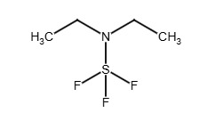
Scheme 5: Diethylaminosulfur trifluoride
5.2.3.Deoxo-Fluor
chemically known as Bis(2-methoxyethyl)amino sulfur trifluoride (BAST), is a highly efficient nucleophilic deoxofluorinating reagent widely used in synthetic organic and medicinal chemistry. It converts oxygen-containing functional groups into fluorinated derivatives, including alcohols to alkyl fluorides, aldehydes and ketones to gem-difluorides, and carboxylic acids to acyl fluorides, through sulfur-mediated activation followed by fluoride transfer. Compared to earlier sulfur-based reagents such as DAST, Deoxo-Fluor offers enhanced thermal and chemical stability, minimizing unwanted decomposition and hazardous by-products, which significantly improves reaction safety and reproducibility. It is particularly valued in fluorine-rich drug and agrochemical synthesis, where fluorination plays a critical role in improving lipophilicity, metabolic stability, receptor affinity, membrane permeability, and resistance to enzymatic breakdown. A key advantage of Deoxo-Fluor is its ability to operate at broader temperature ranges, including moderately elevated temperatures, without undergoing rapid degradation, making it more suitable for scalable and industrial processes. It shows good compatibility with a variety of functional groups and is typically used in aprotic solvents such as dichloromethane or toluene, often under controlled temperatures to avoid side reactions. While it provides cleaner reactions than DAST, caution is still required, as HF release, over-fluorination, elimination, or rearrangement reactions may occur depending on the substrate. Despite these challenges, its improved stability, operational safety, and high fluorination efficiency make Deoxo-Fluor a preferred reagent for constructing fluorinated pharmaceuticals, advanced intermediates, and bioactive molecules in both laboratory and industrial settings³¹.
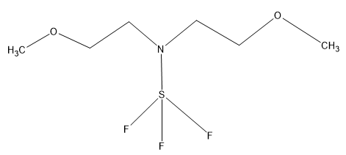
Scheme 6 : Bis(2-methoxyethyl)amino sulfur trifluoride
5.3.Modern techniques: Photo redox, flow chemistry, C–H activation
5.3.1.Photoredox techniques
Photo redox catalysis is a light-driven redox activation strategy that employs a photocatalyst—typically Ru, Ir metal complexes or organic dyes—to generate reactive radical or ionic intermediates under visible light irradiation. This approach has revolutionized modern synthetic chemistry by enabling fluorination reactions under exceptionally mild conditions, avoiding the harsh reagents, extreme temperatures, or strong oxidants associated with traditional fluorination methods. In medicinal chemistry, photo redox catalysis offers a sustainable and highly selective platform for introducing fluorine, trifluoromethyl (–CF₃), difluoromethyl (–CF₂H), or other fluorinated moieties into complex drug scaffolds with excellent functional-group tolerance. The method supports both direct C–H fluorination and cross-coupling strategies (e.g., photo redox-Ni dual catalysis) to construct C–CF₃, C–F, and C–CF₂H bonds with controlled regio- and chemo selectivity. These transformations are crucial in drug discovery, as fluorine incorporation can significantly modulate lipophilicity, membrane permeability, metabolic stability, protein–ligand binding, and bioavailability without introducing steric bulk. Additionally, photo redox systems use visible light as a clean energy source, align with green chemistry principles, reduce by-product formation, and permit late-stage fluorination of bioactive compounds, enabling rapid diversification of lead molecules. Because of these advantages, photo redox fluorination has emerged as a vital tool for designing next-generation fluorinated pharmaceuticals with improved pharmacokinetic and pharmacodynamic profiles³² .
5.3.2. Flow chemistry
Flow chemistry techniques offer substantial advantages for the synthesis of fluorinated scaffolds, especially when handling highly reactive, toxic, or thermally unstable fluorinating reagents such as DAST (diethylaminosulfur trifluoride), Selectfluor, Deoxo-Fluor, and anhydrous HF. Unlike traditional batch reactions, continuous flow systems minimize direct human exposure to hazardous chemicals, enhance heat and mass transfer, and allow precise control over reaction parameters such as temperature, pressure, reagent stoichiometry, and residence time. This level of control significantly reduces side reactions—including elimination, over-fluorination, or thermal decomposition—that are commonly associated with fluorination reactions. Flow setups also enable efficient handling of gas–liquid fluorination processes, rapid quenching of unstable intermediates, and safe scaling of exothermic reactions, all while maintaining consistent product quality. Furthermore, micro-reactor and tubular flow designs improve reaction kinetics, increase fluorine-atom incorporation efficiency, and support late-stage fluorination of complex drug molecules with high reproducibility. The inherent scalability, automation potential, reduced waste generation, and enhanced safety profile make flow chemistry an indispensable platform in modern medicinal and process chemistry, particularly for the efficient, reproducible, and industrially viable production of fluorinated pharmaceuticals and advanced fluorinated building blocks. ³³.
5.3.3.C–H activation
C–H activation in fluorinated scaffolds refers to the direct functionalization of inert carbon–hydrogen (C–H) bonds in molecules that already contain fluorine atoms or fluorinated groups, enabling selective incorporation of new substituents without requiring pre-functionalized starting materials. This strategy has emerged as a powerful tool in modern synthetic and medicinal chemistry because it streamlines synthetic steps, improves atom economy, and allows late-stage diversification of complex fluorinated molecules—an essential advantage in drug discovery, agrochemical development, and advanced materials design. Fluorine’s strong electronegativity and inductive effects significantly influence the bond dissociation energy and reactivity of nearby C–H bonds, often enabling regioselective activation when paired with suitable catalysts such as Pd, Ir, Rh, Ru, or earth-abundant metals like Fe, Co, and Ni. Additionally, directing groups, transient auxiliaries, and ligand-controlled catalysis further enhance site-selectivity, even in structurally dense fluorinated scaffolds. C–H activation enables transformations such as C–H fluorination, alkylation, arylation, amination, heteroatom coupling, and cross-dehydrogenative coupling, providing rapid access to chemically diverse fluorinated motifs with improved lipophilicity, metabolic stability, membrane permeability, and binding affinity. The method is also compatible with photo redox, electrochemical, and dual catalytic platforms, allowing milder reaction conditions and minimising degradation of sensitive C–F bonds. Overall, C–H activation has become a transformative approach for constructing and modifying fluorinated architectures with high precision, synthetic efficiency, and industrial relevance²⁶⁻³².
6.Role of Fluorine in Drug Development
Since fluorination greatly improves the pharmacological characteristics of medicinal medicines, it has emerged as a key component of contemporary drug development. Medicinal chemists can modify a drug's behaviour to increase its efficacy, stability, and selectivity by adding fluorine atoms to organic compounds³⁴.

Fig 2: Role of Fluorine in drug discovery and development

.6.1. As CNS drugs
When designing drugs for the central nervous system (CNS), fluorine is essential. particularly in facilitating the passage of chemicals across the blood-brain barrier. Despite being extremely electronegative, fluorine frequently makes a medication more lipophilic when added to aromatic rings or alkyl groups. Because the blood-brain barrier is so lipophilic, more lipophilic medications can pass through it more easily. BBB penetration is reduced by hydrogen bonds (diffusion is slowed down by hydrophilic contacts). Hydrogen-bond donor capacity is decreased by fluorine substitution (polarity is decreased when –OH, –NH are substituted with –F)³⁵. instances: Fluorine enhances lipophilicity and BBB penetration in fluoxetine, an SSRI antidepressant³⁶. Flutemetamol (Alzheimer's disease PET imaging): Fluorine increases brain uptake³⁷. Haloperidol (fluorinated analogues of antipsychotics) Enhancement of CNS bioavailability ³⁸.
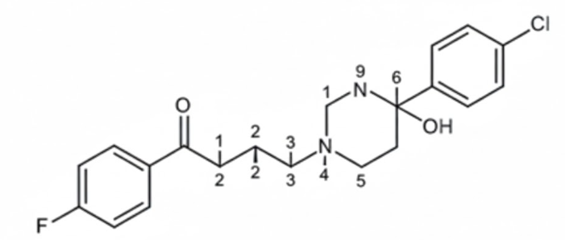

Scheme 7 : 4-[4-(4-chlorophenyl)-4-hydroxypiperidin-1-yl]-1-(4-fluorophenyl) butan-1-one
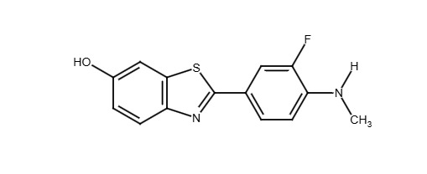
Scheme 8 : 5-(4-fluorophenyl)-3-(1-methyl-1H-indol-3-yl)-2-benzothiophen-1-ol
6.2. As Anticancer
In oncology drug design, fluorine substitution is frequently utilized to improve potency, selectivity, and metabolic stability³⁹. Enhanced Potency: The high electronegativity of fluorine modifies the distribution of electrons in pharmacological molecules. This can increase the affinity for interaction with oncogenic targets, such as kinases, enzymes, and receptors⁴⁰. Improved Metabolic Stability: CYP450 enzymes oxidatively metabolize a large number of cancer medications. Metabolically labile locations, such as aromatic or benzylic hydrogens, are shielded from hydroxylation by fluorine atoms. It leads to improved patient compliance, a longer half-life, and a reduced dose frequency⁴¹. Unwanted oxidation or hydrolysis can be prevented by substituting fluorine close to a cleavage point. This guarantees longer circulation and a greater effective concentration at tumor locations for cytotoxic medicines⁴². Fluorine promotes medication uptake by cancer cells by increasing lipophilicity. Examples include Gefitinib (EGFR inhibitor), Sorafenib (multi-kinase inhibitor)⁴⁴⁻⁴⁶.
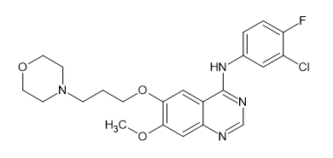
Scheme 9 : N-(3-chloro-4-fluorophenyl)-7-methoxy-6-(3-morpholin-4-ylpropoxy)quinazolin-4-amine
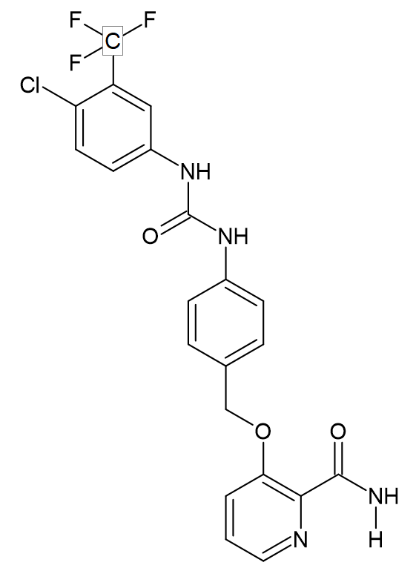
Scheme10: 4-[4-({[4-chloro-3-(trifluoromethyl)phenyl]carbamoyl}amino)phenoxy]-N-methylpyridine-2-carboxamide
6.3. As Anti-inflammatory
Anti-inflammatory medications commonly contain fluorine to improve their efficacy, absorption, and metabolic stability⁴⁷. Fluorine is a useful tool in drug design because of its special qualities, which include its size, electron-withdrawing nature, and capacity to stabilize bonds. This makes it possible to create anti-inflammatory drugs that are more focused and efficient. A drug's binding affinity to its target can be increased by fluorine, giving it a stronger anti-inflammatory action. Fluorine helps reduce undesirable side effects, like gastrointestinal problems, that come with conventional anti-inflammatory medications⁴⁸.
6.4 As Antiviral
Because fluorine can change a drug's characteristics and increase its efficacy, it is important in the creation of antiviral medications. Fluorine can enhance pharmacokinetic characteristics, metabolic stability, and lipophilicity, which will ultimately result in increased antiviral activity and longer-lasting effects ⁴⁹. Antiviral drugs that contain fluorine have the ability to block viral enzymes such neuraminidases, reverse transcriptases, and proteases. By focusing on particular stages of the viral life cycle, fluorine-containing antiviral drugs can impede viral replication. Examples include Efavirenz (Sustiva), Oseltamivir (Tamiflu), and Sofosbuvir (Sovaldi) ⁵⁰.
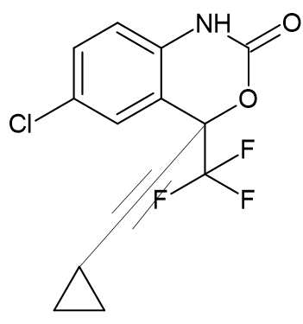

Scheme 1 1 : (4S)-6-chloro-4-(2-cyclopropylethynyl)-4-(trifluoromethyl)-1,4-dihydro-2H-3,1-benzoxazin-2-one
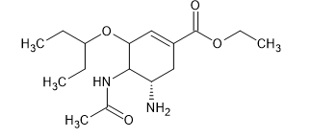
Scheme 1 2 : (3R,4R,5S)-4-acetamido-5-amino-3-(1-ethylpropoxy)-1-cyclohexene-1-carboxylic acid ethyl ester
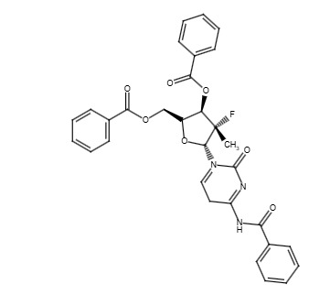
Scheme 1 3 :Isopropyl(2S)-2-[[[(2R,3R,4R,5R)-5-(2,4-dioxopyrimidin-1-yl)-4-fluoro-3-hydroxy-4-methyltetrahydrofuran-2-yl]methoxy-phenoxy phosphoryl] amino] propanoate
6.5.Volatile Anesthetics
This class includes compounds used for general anesthesia, such as isoflurane, sevoflurane, and desflurane. Their inclusion in medicinal chemistry is a classic example of metabolic engineering through halogenation. The strong C–F bond (high bond dissociation energy) is resistant to oxidative cleavage by liver enzymes (cytochrome P450). This prevents the metabolism of the anaesthetic into potentially toxic, organ-damaging metabolites (e.g., trifluoroacetic acid, a hepatotoxin associated with older agents like halothane). By remaining metabolically stable, the drugs are rapidly excreted unchanged through the lungs.
6.6. Fluorinated Steroids (Corticosteroids)
This class comprises potent anti-inflammatory and immunosuppressive agents, such as dexamethasone and fluticasone. These drugs exert their effects by binding to the glucocorticoid receptor (GR) in the cytoplasm, triggering gene expression changes that suppress the inflammatory cascade. The fluorine atom, typically placed at the C-6 or C-9 position on the steroid ring, acts as an electron-withdrawing group. This electronic effect alters the distribution of charge across the molecule, optimising its conformation and enhancing van der Waals interactions with the active site of the glucocorticoid receptor. Enhanced Lipophilicity/Potency may be due to the strategic substitution, which increases the drug’s lipophilicity, which is crucial for enhanced membrane permeability and distribution into target tissues. The combined electronic and lipophilic effects result in a dramatic increase in anti-inflammatory potency and therapeutic index compared to non-fluorinated analogues like hydrocortisone.
6.7. Radiopharmaceuticals (PET Imaging Agents)
This class is primarily utilized for non-invasive diagnostic imaging, with 18F Fluorodeoxyglucose 18FFDG being the most famous example. These compounds are designed to mimic endogenous biological molecules (like glucose or thymidine). By carrying a positron-emitting isotope, they can be tracked in the body to visualize biochemical functions (metabolism, perfusion, proliferation). Theoretical Role of Fluorine is Nuclear Medicine Tagging i.e the fluorine atom is replaced by its radioactive isotope, 18F. 18F is favored in Positron Emission Tomography (PET) because it has an ideal half-life (109.8 minutes), long enough for synthesis and patient transport, but short enough to minimize patient radiation exposure. The 18F atom is a close mimic to a hydroxyl group or a hydrogen atom in terms of size and volume. This minimal steric effect means the radiopharmaceutical can be transported and processed by the body's native enzymes and transporters (e.g., glucose transporters for 18F FDG) almost identically to the natural molecule, allowing for accurate visualization of biological processes.
7.Case studies of fluorinated analogs improving drug profiles
7.1 Fluorine substitution
In medicinal chemistry, fluorine substitution is a calculated change. The C–F bond alters how medications interact with enzymes, receptors, and membranes because it is tiny, strong, and extremely electronegative. The potency, stability, bioavailability, and selectivity⁵¹ of a medication can all be significantly increased in this way. Increasing Target Affinity and Potency. Mechanism: Stronger π-stacking and dipolar interactions with protein residues⁵² are made possible by fluorine's modification of electronic distribution. For instance, the addition of F at C-6 to fluoroquinolones (like ciprofloxacin) improves DNA gyrase binding and broadens the range of antibacterial action. Fluorine improves BBB permeability and lipophilicity, which facilitates the CNS penetration mechanism. For instance, fluoxetine (Prozac, CF₃ group) has significant SSRI activity and increased CNS penetration. FQ, or ciprofloxacin At C-6,5-Uracil F at C-5 Fluorouracil Antimetabolite and anticancer properties^{53.}
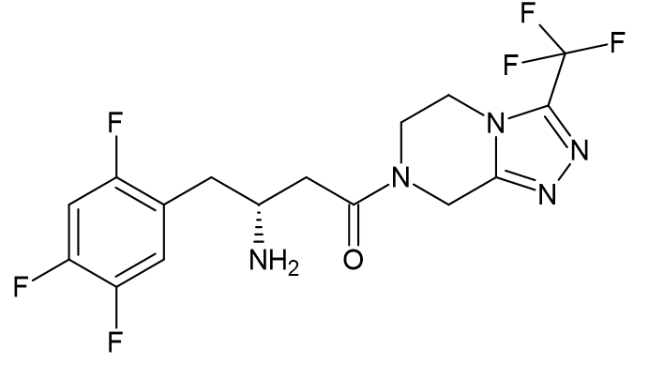
Scheme 1 4 : (RS)-N-methyl-3-phenyl-3-[4-(trifluoromethyl)phenoxy]propan-1-amine
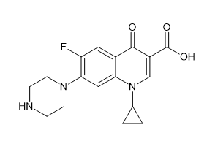
Scheme 1 5 :1-cyclopropyl-6-fluoro-4-oxo-7-(piperazin-1-yl)-1,4-dihydroquinoline-3-carboxylic acid
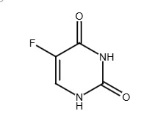
Scheme 1 6 :5-fluoro-1H-pyrimidine-2,4-dione
7.2 Influence on Solubility
The function of fluorine: Although not very hydrophilic, single fluorine atoms can be polarised. Lipophilicity (logP) is usually increased by CF₃ groups. It may lessen solubility in water. Crystal packing may be disturbed by strategic fluorination. It enhances solid-state solubility, which is beneficial for formulation ⁵¹. Illustrations: Trifluoro phenyl group sitagliptin: Careful fluorination balanced hydrophilic substituents, improving oral bioavailability and solubility despite being lipophilic⁵².
7.3 Influence on Metabolic Stability
The function of fluorine: Fluorinated carbons are resistant to oxidative metabolism due to their strong C–F bond (~485 kJ/mol). CYP450 oxidation is prevented by positioning F in metabolically labile sites (benzylic, allylic, and aromatic positions). Although they are resistant to oxidation, CF₃ groups function as bioisosteres for methyl groups ^{51.}Propionate fluticasone to aromatic F atoms prolong lung residence with minimal systemic exposure by preventing oxidative deactivation ⁵³.
8. Approved Fluorinated Drugs and Clinical Relevance⁵⁴⁻⁵⁸

SI.No | Drug Name | IUPAC Name | Structure | MOA | Uses | Adverse Effects
1 | Sitagliptin | (R)-4-oxo-4-[3-(trifluoromethyl)-5,6-dihydro[1,2,4]triazolo[4,3-a]pyrazin-7(8H)-yl]-1-(2,4,5-trifluorophenyl)butan-2-amine |  | Sitagliptin  inhibits the DPP-4 enzyme reversibly.  stops the incretin hormones GLP-1 and GIP from degrading  This causes a decrease in glucagon and an increase in glucose-dependent insulin production. | - It is used as oral antidiabetic medication.  - Used alone in patients with type 2 diabetes when diet and exercise are not enough.  - Used to treat the Type 2 Diabetes Mellitus. | Upper respiratory infections, headache, nasopharyngitis  Rare: pancreatitis, arthralgia, bullous pemphigoid elease.
2 | Efavirenz | (4S)-6-chloro-4-(2-cyclopropylethynyl)-4-(trifluoromethyl)-2,4-dihydro-1H-3,1-benzoxazin-2-one |  | At the NNRTI binding pocket, efavirenz binds to the HIV-1 reverse transcriptase (RT) enzyme non-competitively, causing a conformational shift that prevents the enzyme from functioning. This stops viral RNA from being converted into DNA, which is an essential stage in the HIV reproduction cycle. | - It is an antiretroviral drug.  - Used in the Treatment of HIV-1 infection. | vivid dreams, dizziness, and neuropsychiatric symptoms
3 | Sorafenib | 4-[4-[[6-(4-chlorophenyl)-1H-pyridin-2-yl]carbamoylamino]phenoxy]-N-methylpyridine-2-carboxamide |  | By blocking multiple important kinases involved in tumor cell proliferation and angiogenesis, sorafenib, a multi-target kinase inhibitor, prevents these processes. | - Used in the treatment of advanced hepatocellular carcinoma .  - Used in thr renal cell carcinoma  - Used in differentiated thyroid carcinoma. | Fatigue, diarrhea, rash, alopecia, hand-foot skin reaction, hypertension
4 | Fluticasone | S-(fluoromethyl) 6α,9-difluoro-11β-hydroxy-16α-methyl-3-oxo-17α-propionyloxy-androsta-1,4-diene-17β-carbothioate | 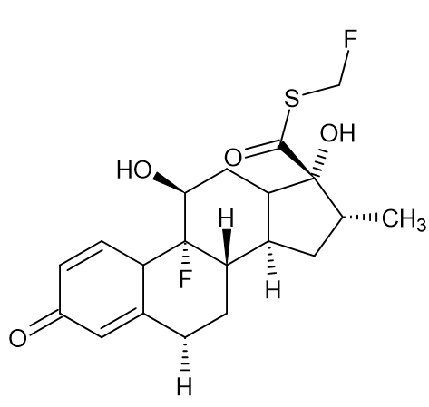 | A synthetic corticosteroid called fluticasone works by attaching itself to glucocorticoid receptors in target cells' cytoplasm. As a result, pro-inflammatory mediators such histamines, leukotrienes, and cytokines are suppressed, which lowers inflammation and immunological function.  . | - Used to treat Asthma.  - Used to treat Chronic Obstructive Pulmonary Disease (COPD).  - Used to treat Allergic Rhinitis (Nasal Spray).  - Used to Treats inflammatory skin diseases like eczema, psoriasis, and dermatitis. | Adrenal suppression, growth suppression in children, osteoporosis, glaucoma, cataracts.Oral thrush, hoarseness, nasal irritation, headache, cough.
5 | Capecitabine |  | 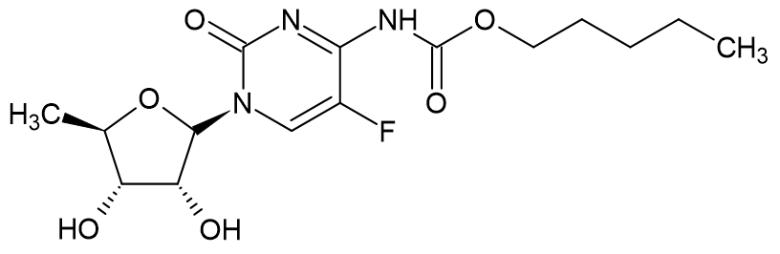 | Capecitabine is a prodrug that is converted by an enzyme in three steps: 1. Carboxylesterase in the liver converted it to 5′-deoxy-5-fluorocytidine (5′-DFCR). 2. Cytidine deaminase in the liver again converted it to 5′-deoxy-5-fluorouridine (5′-DFUR). 3. Tumor tissue: The enzyme thymidine phosphorylase, which is more prevalent in tumor tissues than in normal tissues, transforms tumor tissue into the active medication 5-FU. | - Used to treat Colorectal Cancer.  - Used to treat the metastatic breast cancer.  - Used to treat Gastric Cancer. | Redness, swelling, and pain on the palms of the hands or soles of the feet,Diarrhea,Nausea,vomting,fatigue,mouth sores

8.2.Success stories and market impact:
8.2.1.Success stories
Old medications:
The first licensed fluorinated medication was fludrocortisone (Florinef, 1954). 9α-fluorine corticosteroid that has strong mineralocorticoid action, improved metabolic stability, and longer therapeutic duration. 5. Fluorouracil (1957): An innovative antimetabolite that fights cancer. Targeted chemotherapy has entered a new age thanks to the fluorine at C-5, which permits suicide inhibition of thymidylate synthase. One of the first popular SSRIs with a trifluoromethyl group was fluoxetine (Prozac, 1986). Its pharmacokinetic profile, potency, and CNS penetration were all enhanced by fluorination. A powerful member of the statin class, lipitor (atorvastatin) has fluorinated aromatic rings. One of the most successful medications in history, Lipitor, demonstrates how fluorine optimization has contributed to both clinical and commercial success ⁵⁸.
New drugs:
According to a recent analysis, the U.S. FDA approved 58 fluorinated small molecules in a variety of therapeutic categories, including about 30 in oncology, 12 antivirals/infectious illnesses, 11 CNS disorders, and others. For HIV treatment, use oteseconazole .⁵⁵⁻⁵⁸
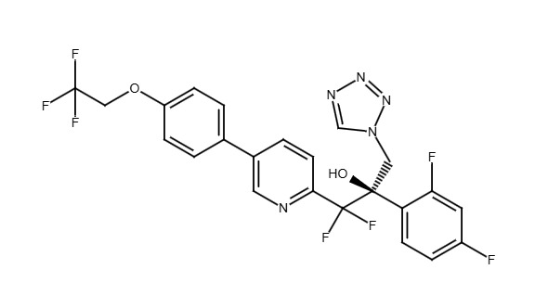
Scheme 1 7 : (2R)-2-(2,4-difluorophenyl)-1,1-difluoro-3-(1H-1,2,3,4-tetrazol-1-yl)-1-{5-[4-(2,2,2-trifluoroethoxy)phenyl]pyridin-2-yl}propan-2-ol
The benefits of fluorinated medicines, including improved pharmacokinetics, therapeutic specificity, and strategic drug discovery avenues, are expected to drive the market's robust growth at about 6.5% per year. The expanding need for fluorinated fine chemicals and building blocks highlights the vital role fluorine plays in pharmaceutical innovation, and Asia-Pacific is becoming a prominent hub. Globally, there are more than 300 licensed fluorinated medications, including well-known brands like Lipitor, fluoroquinolones, and fludrocortisone. The market for fluorinated medications was estimated to be worth USD 182.64 billion in 2024. Growing at a compound annual growth rate (CAGR) of 6.5%, it is projected to reach USD 268.19 billion by 2032 from USD 195.12 billion in 2025 ⁵⁸⁻⁵⁹.
9.Challenges and Limitations
9.1.Toxicity concerns
9.1.1. Metabolic Stability and Bioaccumulation
Strong fluorine–carbon bonds prevent metabolic breakdown. Certain fluorinated medications or their metabolites may bioaccumulate as a result in tissues, particularly the liver and kidney. PFOS and PFOA are examples of persistent perfluorinated chemicals, which are recognized environmental contaminants having harmful and endocrine-disrupting qualities. example Fluoxetine (Prozac)\, Efavirenz ⁶⁰⁻⁶¹.
9.1.2. Fluoride Release
Fluoride ions are released when certain fluorinated medications go through metabolic defluorination; an excess of these ions can lead to neurotoxicity, bone and joint problems, and fluorosis. For instance: Renal toxicity can result from prolonged exposure to fluorinated anesthetics, such as halothane, which can create inorganic fluoride ⁶¹⁻⁶².
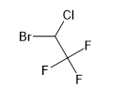
Scheme 1 8 : 2-bromo-2-chloro-1,1,1-trifluoroethane
9.1.3. Hepatotoxicity
Because fluorinated scaffolds produce reactive intermediates during metabolism, they can harm the liver. For instance, CYP450-mediated bioactivation of certain fluorinated aromatics produces hepatotoxic reactive oxygen species (ROS) example Efavirenz. ⁵⁸.
9.1.4. Neurotoxicity
Concerns regarding CNS adverse effects are raised by the possibility that certain fluorinated chemicals may more readily penetrate the blood–brain barrier (BBB). Prolonged exposure can cause oxidative damage or disrupt neural signalling. Examples are Ciprofloxacin, Efavirenz(.⁶¹⁻⁶³.
9.1.5. Endocrine and Reproductive Toxicity
Persistent fluorinated chemicals (PFAS-related structures) like fluorine acetate can be harmful to development and reproduction and disrupt hormone balance. They may interfere with the balance of steroid hormones and thyroid function⁶⁰.
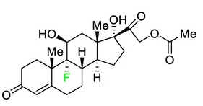
Scheme 1 9 :9-fluoro-11,17,21-trihydroxypregn-4-ene-3,20-dione 21-acetate.
9.1.6. Carcinogenic Potential
Due to receptor-mediated effects (e.g., PPAR-α activation), DNA damage, or chronic ROS production, some perfluorinated scaffolds like Halothane have genotoxic and carcinogenic tendencies ^{61-63.}
9.1.7. Off-target Binding
Increased lipophilicity from fluorination might result in non-specific binding to proteins and membranes, changing pharmacodynamics and increasing the possibility of negative consequences, examples like Fluoxetine, Efavirenz ^{64-65.}
10.Future Perspectives
The future development of PROTACs that have fluorine atoms is anticipated to incorporate fluorine strategically and with high accuracy to maximize the degradation efficiency, and minimize toxicity. To identify optimal positions for fluorine in the developing PROTACs, structure-based design of the compounds will benefit from cryo-EM modeling of the ternary PROTAC-E3-ligase complex, and molecular dynamics simulations of the three components of the ternary complex.
Next-generation cereblon-based PROTACs will likely be optimized to improve affinity to cereblon, based on the design of new and improved analogues of 4-F-Thalidomide, while minimizing unwanted immunosuppressive effects at off-target sites. By developing fluorinated motifs across multiple E3 ligases (i.e., VHL, MDM2, and IAP) will also increase the number of potentially degradable targets within the human proteome, and will address potential mechanisms of resistance observed with existing (non-fluorinated) PROTACs⁶⁶⁻⁶⁸.

By integrating artificial intelligence/machine learning platforms with quantum chemical modelling methods and real-world pharmacokinetic data, predictive fluorination strategies can be developed that optimize simultaneously the potency, ability to cross the blood-brain barrier, and safety of the designed compounds. Incorporating automated retrosynthetic planning and "green chemistry" metrics into the developing processes will enable selection of the most sustainable process using safe reagents (for example, N-fluorobenzenesulfonimide and Selectfluor), mechanochemical methods, and recyclable catalytic systems⁶⁹⁻⁷⁰.

Furthermore, future research needs to be conducted with environmental conservation in mind, minimising the use of highly persistent polyfluorinated by-products, increasing degradability of compounds, and assessing the life-cycle assessment of the drug development process. Overall, the combination of new discovery methods in fluorine chemistry, protein degradation technology, computer-based artificial intelligence, and sustainable synthesis will enable the development of the next-generation of PROTACs⁷¹⁻⁷².

Conclusion

The innovative field of medicinal chemistry utilises fluorination as an incredibly important component in designing medicines today. Fluorine enhances all aspects of developing a drug (which includes, but not limited to: interactions between a drug's molecules with other molecules; pharmacologic activity; pharmacokinetics; and efficaciousness of a drug). Fluorine improves target selectivity through increasing the affinity for binding sites and stability of a bioactive form by influencing molecular interactions via electrostatics/halogen bonding or through substituting carbon–hydrogen bonds (C–H) with stronger carbon–fluorine bonds (C–F). Fluorine protects against oxidative metabolic degradation, particularly CYP450-mediated metabolic processes thus allowing for longer drug clearance and extended half-life. By optimizing lipophilicity, fluorination increases permeability across membranes (enters tissues easily), increases oral bioavailability (can be absorbed easily in gastrointestinal tract after oral administration), and enhances the ability of a drug to get across the blood–brain barrier (required for drugs used to treat diseases of the brain) when used as a treatment for neurodegenerative diseases and psychiatric disorders. Therefore, through the ability to maintain approximately the same molecular weight of a drug while balancing its lipophilicity versus aqueous solubility, fluorinated compounds can have very good ADME properties. The significance of many fluorinated substances is illustrated by the fact that around 50% of all drug prescriptions contain fluorinated substances; examples include atorvastatin (Lipitor), fluticasone (Flonase), and fluoxetine (Prozac). Fluorinated compounds are important in the treatment of many diseases found in several drug classes, including infectious, inflammatory, and oncology/CNS. Medicinal chemists may be able to develop future medicines with fluorinated compounds when they utilise 'design strategies'. Fluorinated substances will continue to be significant in medicinal chemistry through this exercise.

Disclaimer (Artificial intelligence)
Author(s) hereby declare that NO generative AI technologies such as Large Language Models (ChatGPT, COPILOT, etc.) and text-to-image generators have been used during the writing or editing of this manuscript.

AcknowledgEments
The authors are sincerely acknowledge the support and encouragement provided by the Principal Dr. Y .Prapurna Chandra sir, Vice Principal Dr. P. Venugopalaiah sir of Ratnam Institute of Pharmacy, Nellore, for facilitating the completion of this work. We express our gratitude to colleagues, faculty and my fellow Ms. Praveena for their valuable discussions, technical assistance, and academic guidance.
No specific external funding was received for this work.

Authors’ Contributions
Dr. M. Suchitra designed the study, wrote the protocol, and wrote the first draft of the manuscript. Ms. Poojitha compiled the work. All authors approved the final manuscript.

References
- Shabir, G., Saeed, A., Zahid, W., Naseer, F., Riaz, Z., Khalil, N., Muneeba, & Albericio, F. (2023). Chemistry and pharmacology of fluorinated drugs approved by the FDA (2016–2022). Pharmaceuticals, 16(8), 1162.
- Gillis, E. P., Eastman, K. J., Hill, M. D., Donnelly, D. J., & Meanwell, N. A. (2015). Applications of fluorine in medicinal chemistry. Journal of Medicinal Chemistry, 58(21), 8315–8359.
- Britton, R., Gouverneur, V., Lin, J. H., Meanwell, N. A., Ni, C., Pupo, G., et al. (2021). Contemporary synthetic strategies in organofluorine chemistry. Nature Reviews Chemistry, 5.
- Wang, J., Sánchez-Roselló, M., Aceña, J. L., del Pozo, C., Sorochinsky, A. E., Fustero, S., et al. (2014). Fluorine in pharmaceutical industry: Fluorine-containing drugs introduced to the market in the last decade (2001–2011). Chemical Reviews, 114(4), 2432–2506.
- Zhou, Y., Wang, J., Gu, Z., Wang, S., Zhu, W., Aceña, J. L., et al. (2016). Next generation of fluorine-containing pharmaceuticals: Compounds currently in phase II–III clinical trials of major pharmaceutical companies. Chemical Reviews, 116(2), 422–518.
- Vodenkova, S., Buchler, T., Cervena, K., Veskrnova, V., Vodicka, P., & Vymetalkova, V. (2022). 5-Fluorouracil resistance, mechanisms of action, and biomarkers of response in colorectal cancer treatment. Pharmacology & Therapeutics, 237, 108168.
- Longley, D. B., Harkin, D. P., & Johnston, P. G. (2003). 5-Fluorouracil: Mechanisms of action and clinical strategies. Nature Reviews Cancer, 3(5), 330–338.
- Isanbor, C., & O’Hagan, D. (2006). Fluorine in medicinal chemistry: A review of anti-cancer agents. Journal of Fluorine Chemistry, 127(3), 303–319.
- Wong, D. T., Bymaster, F. P., & Engleman, E. A. (1995). Prozac (fluoxetine, Lilly 110140), the first selective serotonin uptake inhibitor and an antidepressant drug: Twenty years since its first publication. Life Sciences, 57(5), 411–441.
- Filler, R., & Saha, R. (2009). Fluorine in medicinal chemistry: A century of progress and a 60-year retrospective of selected highlights. Future Medicinal Chemistry, 1(5), 777–791.
- Böhm, H. J., Banner, D., Bendels, S., Kansy, M., Kuhn, B., Müller, K., et al. (2004). Fluorine in medicinal chemistry. ChemBioChem, 5(5), 637–643.
- Park, B. K., Kitteringham, N. R., & O’Neill, P. M. (2001). Metabolism of fluorine-containing drugs. Annual Review of Pharmacology and Toxicology, 41, 443–470.
- Shabir, G., Saeed, A., Zahid, W., Naseer, F., Riaz, Z., Khalil, N., et al. (2023). Chemistry and pharmacology of fluorinated drugs approved by the FDA (2016–2022). Pharmaceuticals (Basel), 16(8), 1162.
- Zhou, Y., Zhi, H., & Wang, J. (2021). Fluorine-containing drugs approved by the FDA in the past two decades (2000–2020): Where are we now? European Journal of Medicinal Chemistry, 224, 113735.
- Kirk, K. L. (2006). Fluorine in medicinal chemistry: Recent therapeutic applications of fluorinated small molecules. Journal of Fluorine Chemistry, 127(8), 1013–1029.
- Hiyama, T. (2000). Organofluorine compounds: Chemistry and applications. Springer.
- Banks, R. E., Smart, B. E., & Tatlow, J. C. (1994). Organofluorine chemistry: Principles and commercial applications. Springer.
- Meanwell, N. A. (2018). Fluorine and fluorinated motifs in the design and application of bioisosteres for drug design. Journal of Medicinal Chemistry, 61(14), 5822–6061.
- Johnson, B. N., Pal, S., Shet, S., et al. (2023). Fluorine—a small ‘magic bullet’ atom in drug development: Blocking metabolically labile sites to boost pharmacokinetics. Applied Organometallic Chemistry, 37(12), e6985.
- Zhou, Y., Wang, J., Gu, Z., Wang, S., Zhu, W., Aceña, J. L., et al. (2016). Next generation of fluorine-containing pharmaceuticals: New structural trends and therapeutic areas. Chemical Reviews, 116(2), 422–518.
- Müller, K., Faeh, C., & Diederich, F. (2007). Fluorine in pharmaceuticals: Looking beyond intuition. Science, 317(5846), 1881–1886.
- Wikipedia contributors. (2025). Quinolone antibiotic. In Wikipedia.
- Yerien, D. E., Bonesi, S., & Postigo, A. (2016). Fluorination methods in drug discovery. Organic & Biomolecular Chemistry, 14(36), 7578–7590.
- Inoue, M., Sumii, Y., & Shibata, N. (2020). Contribution of organofluorine compounds to pharmaceuticals. ACS Omega, 5(19), 10633–10640.
- Nandeshwarappa, B. P., Manjunatha, S. K., Ramesh, D. K., Suchitra, M., & Sadashiv, S. O. (2020). Synthesis and antimicrobial activity of 3-(2-(substituted 1,3,4-thiadiazol-2-ylamino)acetyl)-4-hydroxy-1-methyl/phenylquinolin-2(1H)-ones. RGUHS Journal of Pharmaceutical Sciences, 10(4), 33–38.
- Campbell, M. G., & Ritter, T. (2014). Late-stage fluorination: From fundamentals to application. Organic Process Research & Development, 18(3), 474–480.
- O’Hagan, D. (2008). Understanding organofluorine chemistry: An introduction to the C–F bond. Chemical Society Reviews, 37(2), 308–319.
- Shibata, N., Mizuta, S., & Kawai, H. (2008). Recent advances in enantioselective fluorination and trifluoromethylation reactions. Tetrahedron: Asymmetry, 19(18), 2633–2648.
- Preshlock, S., Tredwell, M., & Gouverneur, V. (2016). 18F-labeling of arenes and heteroarenes for applications in positron emission tomography. Chemical Reviews, 116(2), 719–766.
- Nyffeler, P. T., Durón, S. G., Burkart, M. D., Vincent, S. P., & Wong, C. H. (2005). Selectfluor: Mechanistic insight and applications. Angewandte Chemie International Edition, 44(13), 192–212.
- Singh, R. P., & Shreeve, J. M. (2004). Recent advances in nucleophilic fluorination reactions. Accounts of Chemical Research, 37(1), 31–44.
- Bloom, S., McCann, M., & Lectka, T. (2019). Photoredox methods for fluorination in organic synthesis. Organic & Biomolecular Chemistry, 17(17), 3973–3987.
- Roberge, D. M., Zimmermann, B., Rainone, F., Gottsponer, M., Eyholzer, M., & Kockmann, N. (2008). Microreactor technology and continuous processes in the pharmaceutical industry: Is the revolution underway? Organic Process Research & Development, 12(5), 905–913.
- Sharmeen, S., Azad, M. A. K., Rahman, A. F. M. S., Ahmed, S., Reza, H. M., & Alam, M. A. (2022). Fluorine in drug design: A versatile player in medicinal chemistry. Pharmaceuticals (Basel), 15(4), 460.
- O’Hagan, D. (2008). Understanding organofluorine chemistry: An introduction to the C–F bond. Chemical Society Reviews, 37(2), 308–319.
- Wang, J., Sánchez-Roselló, M., Aceña, J. L., del Pozo, C., Sorochinsky, A. E., et al. (2020). Fluorination in drug design: A medicinal chemistry perspective. Journal of Medicinal Chemistry, 63(12), 6543–6563.
- Nelissen, N., Van Laere, K., Thurfjell, L., Owenius, R., Vandenbulcke, M., Koole, M., et al. (2009). Phase 1 study of the Pittsburgh compound B derivative [18F]flutemetamol in healthy volunteers and patients with probable Alzheimer’s disease. Journal of Nuclear Medicine, 50(8), 1251–1259.
- Baldessarini, R. J., & Tarazi, F. I. (2011). Pharmacotherapy of psychosis and mania. In L. L. Brunton, B. A. Chabner, & B. C. Knollmann (Eds.), Goodman & Gilman’s The Pharmacological Basis of Therapeutics (12th ed., pp. 461–500). McGraw-Hill.
- Shah, P., & Westwell, A. D. (2007). The role of fluorine in medicinal chemistry. Journal of Enzyme Inhibition and Medicinal Chemistry, 22(5), 527–540.
- Gupta, S. P. (2019). Roles of fluorine in drug design and drug action. Letters in Drug Design & Discovery, 16(10), 1089–1109.
- Zhou, Y., Wang, J., Gu, Z., Wang, S., Zhu, W., Aceña, J. L., et al. (2016). Next generation of fluorine-containing pharmaceuticals: Compounds currently in phase II–III clinical trials of major pharmaceutical companies. Journal of Fluorine Chemistry, 188, 190–199.
- Jeschke, P. (2004). The unique role of fluorine in the design of active ingredients for modern crop protection. ChemBioChem, 5(5), 570–589.
- Parker, W. B. (2009). Enzymology of purine and pyrimidine antimetabolites used in the treatment of cancer. Chemical Reviews, 109(7), 2880–2893.
- Shields, A. F., Grierson, J. R., Dohmen, B. M., Machulla, H. J., Stayanoff, J. C., Lawhorn-Crews, J. M., et al. (1998). Imaging proliferation in vivo with [F-18]FLT and positron emission tomography. Nature Medicine, 4(11), 1334–1336.
- Wilhelm, S. M., Carter, C., Tang, L., Wilkie, D., McNabola, A., Rong, H., et al. (2004). BAY 43-9006 exhibits broad spectrum oral antitumor activity and targets the RAF/MEK/ERK pathway and receptor tyrosine kinases involved in tumor progression and angiogenesis. Cancer Research, 64(19), 7099–7109.
- Barker, A. J., Gibson, K. H., Grundy, W., Godfrey, A. A., Barlow, J. J., Healy, M. P., et al. (2001). Studies leading to the identification of ZD1839 (IRESSA): An orally active, selective epidermal growth factor receptor tyrosine kinase inhibitor targeted to the treatment of cancer. Bioorganic & Medicinal Chemistry Letters, 11(14), 1911–1914.
- Kirk, K. L. (2006). Fluorine in medicinal chemistry: Recent therapeutic applications of fluorinated small molecules. Journal of Fluorine Chemistry, 127(8), 1013–1029.
- Daley-Yates, P. T. (2015). Inhaled corticosteroids: Potency, dose equivalence and therapeutic index. British Journal of Clinical Pharmacology, 80(3), 372–380.
- Zhu, W., Wang, J., Wang, S., et al. (2018). Design, synthesis, and antiviral activity of fluorine-containing compounds. Journal of Medicinal Chemistry, 61(14), 5874–5895.
- Kim, C. U., Lew, W., Williams, M. A., Liu, H., Zhang, L., Swaminathan, S., et al. (1997). Influenza neuraminidase inhibitors possessing a novel hydrophobic interaction in the enzyme active site: Design, synthesis, and structural analysis of carbocyclic sialic acid analogs with potent anti-influenza activity. Journal of the American Chemical Society, 119(4), 681–690.
- Gillis, E. P., Eastman, K. J., Hill, M. D., Donnelly, D. J., & Meanwell, N. A. (2015). Applications of fluorine in medicinal chemistry. Journal of Medicinal Chemistry, 58(21), 8315–8369.
- Kumar, R., Ignjatović, M. M., Peterson, K., Olsson, M., Leffler, H., Ryde, U., et al. (2019). Structure and energetics of ligand–fluorine interactions with galectin-3 backbone and side-chain amides: Insight into solvation effects and multipolar interactions. ChemMedChem, 14(16), 1528–1536.
- Böhm, H. J., Banner, D., Bendels, S., et al. (2004). Fluorine in medicinal chemistry: When and how to introduce fluorine into a molecule. ChemBioChem, 5(5), 637–643.
- Herman, G. A., Stevens, C., Van Dyck, K., Bergman, A., Yi, B., De Smet, M., et al. (2005). Pharmacokinetics and pharmacodynamics of sitagliptin, an inhibitor of dipeptidyl peptidase IV, in healthy subjects: Results from two randomized, double-blind, placebo-controlled studies with single oral doses. Clinical Pharmacology & Therapeutics, 78(6), 675–688.
- Scott, L. J. (2017). Sitagliptin: A review in type 2 diabetes. Drugs, 77(2), 209–224.
- Food and Drug Administration. (2005). Sustiva (efavirenz) capsules and tablets: Prescribing information. FDA.
- Kenedi, C. A., & Goforth, H. W. (2015). Efavirenz and the central nervous system: What we already know. Journal of Antimicrobial Chemotherapy, 70(10), 2693–2702.
- Zhou, Y., Wang, J., Gu, Z., et al. (2022). Next-generation fluorinated drugs: Clinical significance and market trends. Future Medicinal Chemistry, 14, 1811–1830.
- Grand View Research. (2024). Fluorinated drugs market size, share & trends analysis report.
- Lau, C., Anitole, K., Hodes, C., Lai, D., Pfahles-Hutchens, A., & Seed, J. (2007). Perfluoroalkyl acids: A review of monitoring and toxicological findings. Toxicological Sciences, 99(2), 366–394.
- Wang, Z., DeWitt, J. C., Higgins, C. P., & Cousins, I. T. (2017). A never-ending story of per- and polyfluoroalkyl substances (PFASs)? Environmental Science & Technology, 51, 2508–2518.
- Wang, J., Sánchez-Roselló, M., Aceña, J. L., del Pozo, C., Sorochinsky, A. E., et al. (2020). Fluorination in drug design: A medicinal chemistry perspective. Journal of Medicinal Chemistry, 63(12), 6543–6563.
- Sunderland, E. M., Hu, X. C., Dassuncao, C., Tokranov, A. K., Wagner, C. C., & Allen, J. G. (2019). A review of the pathways of human exposure to poly- and perfluoroalkyl substances (PFASs) and present understanding of health effects. Journal of Exposure Science & Environmental Epidemiology, 29, 131–147.
- Fier, P. S., & Hartwig, J. F. (2013). Selective C–H fluorination of pyridines and diazines inspired by drug design. Science, 342(6160), 956–960.
- Kirsch, P. (2013). Modern fluoroorganic chemistry: Synthesis, reactivity, applications. Wiley-VCH.
- Bond, M. J., Kleinman, M. E., & Ciulli, A. (2022). Targeted protein degradation by PROTACs: Current advances and future perspectives. Nature Reviews Drug Discovery, 21, 99–117.
- Cromm, P. M., & Crews, C. M. (2017). Proteolysis-targeting chimeras (PROTACs) in chemical biology and drug discovery. Cell Chemical Biology, 24, 1181–1190.
- Testa, B., Todorovski, T., & Kaiser, A. (2021). Fluorinated PROTACs: Opportunities and challenges. ChemMedChem, 16, 2229–2243.
- Chen, H., Engkvist, O., Wang, Y., Olivecrona, M., & Blaschke, T. (2018). The rise of deep learning in drug discovery. Drug Discovery Today, 23, 1241–1250.
- Yerien, D. E., Barata-Vallejo, S., & Postigo, A. (2016). Fluorination methods in medicinal chemistry. Chemical Society Reviews, 45, 1445–1470.
- Shimizu, M., & Hiyama, T. (2005). Modern synthetic methods for fluorine-containing compounds. Angewandte Chemie International Edition, 44, 214–231.
- Haufe, G., & Kirsch, P. (2011). Green fluorination strategies: Concepts and applications. Synthesis, 2011, 3007–3033.
- Inoue, M., Sumii, Y., & Shibata, N. (2020). Contribution of organofluorine compounds to pharmaceuticals. ACS Omega, 5(19), 10633–10640.
- Meanwell, N. A. (2018). Fluorine and fluorinated motifs in the design and application of bioisosteres for drug design. Journal of Medicinal Chemistry, 61, 5822–5880.
- Gandhi, R. T., Malani, P. N., & del Rio, C. (2022). COVID-19 therapeutics for nonhospitalized patients. JAMA, 327(7), 617–618.
- Filler, R., & Kobayashi, Y. (1993). Biomedicinal aspects of fluorine chemistry. Elsevier.
- Fluorination methods for drug discovery and development. (2016). Expert Opinion on Drug Discovery, 11(10), 983–999.

