Original Research Article

An Ethnobotanical Survey of Exotic Medicinal Plant Species in Vaishali District, Bihar, India

Abstract
Background: The Vaishali district of Bihar, India, exhibits rich biodiversity, characterized by a variety of exotic plant species introduced through human activities and natural dispersal. Little research was conducted in this specific area. Aim: The present study documents the ethnomedicinal uses of some exotic (non-native) plant species. Objective: To study the exotic plant species utilized for traditional medicinal applications in the Vaishali district. Methods: Plant specimens were collected through field survey, interviews with botanist, local community, folk medicine practitioners and literature review. Semi structured and snowball sampling technique is applied in survey methodology. Result: A total of 33 exotic plant species from 15 families and 33 genera were explored to be commonly used by local communities in ethnomedicine for conditions like respiratory infection, skin diseases, stomach issues and other ailment. Conclusion: This research paper highlights the significance of exotic plants in traditional healthcare system and their therapeutic use. Some Exotic plants have adapted to local environment and are used in ethnomedicine by native people for their antioxidant and antimicrobial properties as well as for healthcare services. These plants need to be conservation.
Keywords: ethnomedicine, exotic plants, traditional medicinal, non-native

1. Introduction
Ethnomedicine is the study of traditional communities that use plants and natural materials for healing purposes (Fabricant & Farnsworth, 2001).Alien plans, also referred to as exotic or non- native plant that have introduced in local community from outside their natural geographical range by human mediated transport, whether intentionally or accidently (Richardson et al., 2000). In the Vaishali district of Bihar, these herbal remedies were a main source of healthcare because modern clinics are often hard to reach for the rural population. Exploration of ethnomedicinal practices had done from ancient time Vedas, Ramayana and Mahabharata period. Interestingly, local healers adopted many non-native plants into their practices. Vaishali flora had been documented in different botanical survey and ethnomedicinal studies of Bihar. Traditional knowledge of medicinal plant species is valuable source of information for healthcare, across the world (Farnsworth et al., 1985). Past researches indicates that local communities used both native and non-native (exotic) plant species for curing diseases from digestive issue to skin problems. The systematic documentation and utilization of exotic species in Vaishali district are limited. This gap need for compressive and focused research. This research includes the exotic plant species used in Vaishali district, their local names, preparation techniques, and their medicinal benefits. Recently the plant species are increasingly threatened with extinction due to habitat loss, climate change, urbanization and encroachment of forest land (MoEFCC, 2018). Conservation and sustainable use of biological resource are essential to protect biodiversity and preserve traditional knowledge (NBA, 2021).
  - Study area
Vaishali district is located in Northern Bihar between 25.41°N, 85.13°E and 25.68° N, 85.22°E. This district bordered by the Gandak river in the north and Ganga river to the south. The climate of this district is subtropical and the soil is alluvial, which support a wide variety of plant species.
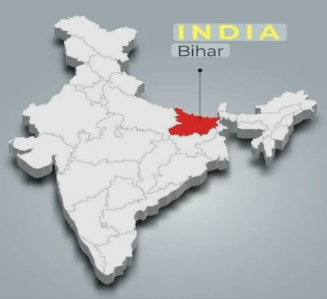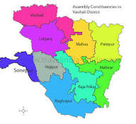
Figure 1.Map of India showing Bihar Figure-2. Vaishali district Block Map
2. Materials and Methods
Field survey was conducted in 16 block of vaishali district from 2021 to 2025 in all season of whole the year. The snowball sampling technique as described by Heckathorn (2011), was used for finding, selecting and inviting participants, who were knowledgeable about medicinal plants. Structured and semi-structured interview were conducted to gather information. The majority of the plants were collected in their natural habitats and all details from the collection site which is essential character for identification was recorded. Collections were made at several times by visiting the study area. The specimens were collected during the stages of flowering and fruiting. In order to collect data of medicinal plants growing in the rural areas, these areas were surveyed comprehensively. Local practitioners (vaidyas) disclosed that all the parts of plants such as roots, leaves, stem, seed and inflorescence of these plants are used for the treatment of different diseases. In addition voucher specimens of the reported plants were collected for accurate identification by plant taxonomists. The voucher specimens were dried, poisoned, mounted and labeled on herbarium sheet. The plant specimens were identified with the help of keys and botanical description. The descriptions of regional floras are describing on the basis of different book, research article and botanist such as Haines (1921), and Singh. A. et al., (2017). Ethnomedicinal uses were compared and cross checked with standard Indian literatures (Ambasta, 1986; Anonymous, 1948-1976; Jain, S. K. 1991). Vaidyas, referred to as “Doctors of herbs” are traditional aurvedic healers to use plant parts to make medicinal recipes like kadha (herbal tea), churna (powder), pills, asava, aristha and taila (oils). These practioners are knowledgeable about the types of plants, seasonal collection time and formulation methods for particular diseases. They often crushing the plant parts using stones or wooden tools to make juice, paste, decoctions, powders or ointment applied orally or topically.
3. Results
A total number of 33 species of exotic plants recorded belonged to 15 family and 33 genera, which were being used by the villagers of this district for the treatment of various diseases. The recorded invasive alien exotic plant species serve as the valuable resource for the indigenous people. Herbs and shrubs were the primary sources of herbal medicines used in vaishali district. The majority of remedies are made in the form of juice from freshly harvested plants parts.Asteraceae is the dominant family because Asteracea plants are fast growing and rich in secondary metabolites. Other dominant family is Fabaceae, Malvaceae, Amaranthaceae and Apocynaceae. Most remedies are prepared as juice extracted from fresh plant part. Several Ethnomedicinal remedies are formulated from dried ingredients. Prepared remedy is also taken by mixing with other medicinal plant part. Ethnic people primarily use traditional medicines to treat cough, cold and skin infections, as well as to heal cuts and wound with further applications for diabetes, jaundice and dysentery. Traditional medicinal knowledge is mostly limited to the elders, while modern generations have little interest about the importance of the medicinal resources. Botanical names are arranged alphabetically followed by common name, family, origin, plant parts and ethnomedicinal uses. Lists are mentioned below.

3.1 List 1: List of Exotic (Non-Native) Ethnomedicinal Plants Used in Vaishali district, Bihar, India.
Botanical Name | Common name | Family | Origin  (non-native place) | Plant Part Used | Ethno-medicinal Use
 | Century plant | Asparagaceae |  |  | Skin infection and wounds
  Agave americana
  Mexico
  Leaves
Ageratum conyzoides | Billy goat weed | Asteraceae | Tropical America | Leaves whole plant | Expectorant, wound healing
Alternathera sessile | Joyweed | Amaranthaceae | Central  America | Leaf paste | Wound healing, inflammation
Acacia arabica | Babul | Mimosaceae  (Fabaceae) | Africa | All parts | Treats weakness and general debility
Argemone mexicana | Mexican prickly poppy | Papaveraceae | Mexico | Seeds, latex | Skin diseases, scabies
 | Bougainvillea | Nyctaginaceae | Brazil | Leaves | Cough remedy
  Bougainvillea
  spectabilis
Blumea  lacera | Wing stem | Asteraceae | Africa | Leaf juice | Stomach disorder, skin ailment
Calotropis procera | Akwan | Apocynaceae | Africa | Latex, roots | Anti-inflammatory, pustules
Cassia alata | Ringworm shrub | Fabaceae | Tropical America | Leaves, flowers | Antifunga,ringworm
Cassia tora | Chakunda | Fabaceae | Africa | Seeds, leaves | Anthelmintic, laxative
Catharanthus roseus | Periwinkle | Apocynaceae | Medagascar | Leaves,  root | Treat diabetes, high BP, cancer treatment
Chenopodi  umambrosioides | Mexican tea | Amaranthaceae | Central America | Leaves | Remove intestinal worms
Celosia argentea | Silver cockscomb | Amaranthacea | Tropical America | Leaves,  seed | Diarrhoea,  digestion
Chromolaenaodorata | Siam weed | Asteraceae | Tropical America | leaves | Antiseptic, burns, skin problems
Emilia sonchifolia | Lilac tasselflower | Asteraceae | Africa | Whole plant | Eye disease, skin ailments
Euphorbia hirta | Asthma weed | Euphorbiaceae | Trop. America | Stem, leaves | Asthma, cough remedies
Eupatorium odoratum | Siam weed | Asteraceae | America | Leaves, stems | Wound healing, in fever
  Grevillea
  robusta
  Silk oak
  Proteaceae
  Australia
  Leaves
  minor skin
  infections
Hyptis  suaveolens | Bush mint | Lamiaceae | America | Leaves, stem | Antispasmodic,fever
Ipomoea batatas | Morning glory | Convolvulacea | Trop. America | Root | Digestive tonic
Lantana camara | Lantana | Verbanaceae | Trop. America | Leaves | Skin, poultice
Mikania micrantha | Bitter vine | Asteracea | America | Fresh leaves | Antibacterial, wound healing
Merremia  aegyptia | Climbing morning glory | Convolvulaceae | Africa/Arabian region | Leaves, roots | Skin ailments
Portulaca  oleracea | Purslane | Portulacacea | Meditarranean | Whole plant | Cooling, digestion
Prosopis juliflora | Mesquite | Fabaceae | America | Bark, pods | Antimicrobial
 | Coffee senna | Fabaceae | Tropical America |  | laxative and fever remedy
  Senna
  occidentalis
  leaves
 | Candle bush | Fabaceae | Trop. America | Leaves | Ringworm infection
  Senna alata
Sida acuta | Wireweed | Malvaceae | Tropical America | Leaves, roots | Wound healing, analgesic
Solanum torvum | Turkey berry | Solanaceae | Americas/Africa | Fruits, leaves | Antimicrobial
Tagetes  erecta | African marigold | Asteraceae | Mexico | Flower | Digestive remedies, skin problem
Tridax  procumbens | Coat buttons | Asteraceae | Trop. America | Leaves | Wound healing
Urena  lonata | Caesar weed | Malvaceae | Africa | Roots, leaves | Rheumatism, diarrhea
Xanthium strumarium | Cocklebur | Asteraceae | Mexio | Fruits | Allergy, insect bite.

3.2 Data Distribution category and Analysis

3.2.1 Family Distribution (Top 5 lists)
Family | Frequency | Percentage
Asteraceae | 8 | 24 %
Fabaceae | 5 | 15 %
Amaranthaceae | 3 | 9 %
Apocynaceae | 2 | 6 %
Convolvulaceae | 2 | 6 %

The Asteraceae family is common with eight species. These families of plants are widely use medicine and highly represented in the study area The Fabaceae family is the second most common with five species. People often use Fabaceae plants to make medicine because they have qualities that help with things, like inflammation and stomach problems. The Apocynaceae family and the Convolvulaceae family each have two speciest. The Amaranthaceae family has three species. The Apocynaceae family, the Convolvulaceae family and the Amaranthaceae family have a lot of potential to be used as medicine as their adaptability and accessibility.

3.2.2 Plant Parts Used (Top 5 list)
Plant Part | Frequency | Percentage
Leaves | 19 | 57 %
Whole plant | 3 | 9 %
Roots | 3 | 9 %
Seeds | 2 | 6 %
Flowers | 2 | 6 %
Leaves are the most commonly used plant parts with 19 instances according to the analysis of plant parts used. This is because leaves are easy to get and they have variety of bioactive compounds present. Leaves can also be picked without hurting the plant, so people like to use them. The whole plant and the roots are used in some cases three times each. This means that some medicines need the whole plant or the parts under the ground to work properly. People use flowers and seeds too. These parts are often used for medicines that help with infections or stomach problems
3.2.3 Geographic Origin (Top 5 lists)
Region | Species | Percentage
Tropical America | 14 | 42 %
Africa | 7 | 21 %
Mexico | 4 | 13 %
Central America | 3 | 10 %
Mediterranean | 1 | 4 %

The geographic origin data shows that Tropical America accounts for the greatest percentage of species.This implies that a large number of the medicinal plants that are currently utilized in the region are successfully adapted to tropical climates.Africa is the second most important origin of region, with seven species. These plants are probably in this region because people used to trade and grow them a time ago. These findings show that the medicinal plants used in this area come from, around the world, which is because of people bringing in new plants and them adapting to the new environment.

3.2.4 Ethnomedicinal Used (Top 5 lists)
Category | Frequency | Percentage
Skin diseases& wound healing | 13 | 39 %
Digestive disorders | 6 | 18%
Respiratory ailments | 4 | 12 %
Antimicrobial | 4 | 12 %
Anti-inflammatory | 2 | 6 %

Research shows that individuals utilize plants for self-healing indicates that skin issues and wound healing are the reasons behind the use of these plants, accompanied by 13 examples. This indicates that individuals frequently utilize medical treatments for addressing skin infections, injuries, and various skin issues. These plants are also utilized for respiratory conditions and antimicrobial purposes. These results highlight the significance of Exotic plants value for health care and traditional healing methods.

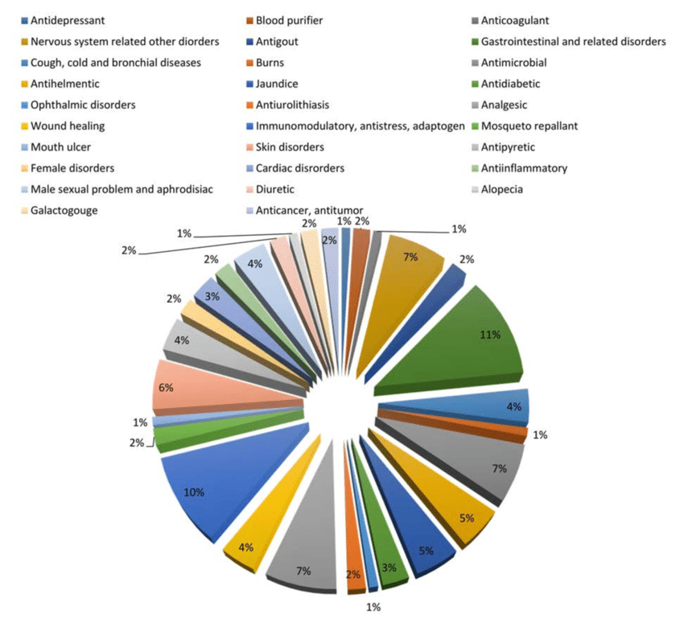
Figure 3. Diseases distribution summary data
Discussion

The findings suggest that the ethnomedicinal uses of exotic plant species in Vaishali district reveals the rich traditional knowledge saved by local communities to treat common health problems. One of the notable feature observed is that diverse use of exotic plant for treating respiratory disease, digestive and skin disorder. Point shows the medicinal properties are well characterized by ethnic people. These exotic plants are not native to the area. They have been integrated into local medicinal practices and passed down orally through generations. This integration is driven by synthesis of ecological shifts and cultural exchange. People have found ways to use them for human well being to feel better. This shows native people are in adapting new healing option to their needs. Especially in rural areas where modern healthcare facility is not easily available, these plants play an important role in daily health care practices. It is important to document and study these practices, so that this valuable knowledge is not lost in the future. It is essential to preserve such ethnomedicinal plant and indigenous knowledge both with the co-operation of local communities, researchers and policymakers. Currently, there is a lack of research gap regarding pharmacological validation, safety testing, toxicity and dosages of these remedies. Future studies are necessary to explore these areas. Overall, the use of exotic plants in Vaishali district keeps traditional healing methods to alive and offer exciting possibilities for developing new natural remedies.

4. Summary
The study covered 15 families, with the Asteracea family making up about one fourth (24%) of all species surveyed other major family recorded as Fabaceae, Amaranthaceae, Apocynaceae and Convolvulaceae. Leaves 57% were widely used plant part, followed by stem 12%, seed 6%, roots 9%, whole plant 9% and rest in other parts. These plants have traditionally been used for skin and wound problem 39%, digestion disorder 18%, treating respiratory issues 12% and addressing other conditions like fever, inflammation and infections 18%, rest of others. This highlights their important role in traditional plant based treatments. Around 42% of these plants come from Tropical America, while African species make up 21%, showing that widely distributed plant and ecologically adapted species are most commonly used in traditional medicine. The statistical data analysis highlights the rich ethnomedicinal diversity and therapeutic applicability of the documented plant species.
5. Conclusion
The ethnomedicinal plants of Vaishali district show that many naturalized exotic species, particularly those originating from Tropical America are mostly used in traditional health care. Local people often use plant leaves to treat skin diseases and wound. The recorded exotic invasive plants act as the valuable resources for the native people. The study shows that the local community has enriched healing knowledge by embracing exotic and weedy plants. Due to less interest of young generation about traditional knowledge, urbanization and over exploitation of natural forest, these valuable knowledge as well as plant species are getting destroyed leading to their extinction. Future research should focus on analyzing plant chemicals, testing their effectiveness and find the way to protect biodiversity and traditional knowledge.
Disclaimer (Artificial intelligence)
Author(s) hereby declare that NO generative AI technologies such as Large Language Models (ChatGPT, COPILOT, etc.) and text-to-image generators have been used during the writing or editing of this manuscript.

References
Ambasta, S. P. (Ed.). (1986). The useful plants of India (pp. 918-pp).
Anonymous. (1948–1976). The wealth of India: Raw materials (Vols. 1–11). Council of Scientific and Industrial Research (CSIR), New Delhi, India.
Balakrishnan, N. P., Chakrabarty, T., Sanjappa, M., Lakshminarsimhan, P., & Singh, P. (2012). Flora of India (Vol. 23, pp. 193-194). Kolkata: Botanical survey of India.
Behera, G., Nayak, N. R., Bhatta, B., Padhan, J., Joshi, N., Majhi, R., ... & Sahu, A. R. (2024). A checklist of invasive alien plants of Kalahandi district: one of the famous historical and ancient places of Odisha, India.
Bhat, P., Hegde, G. R., Hegde, G., &Mulgund, G. S. (2014). Ethnomedicinal plants to cure skin diseases—an account of the traditional knowledge in the coastal parts of Central Western Ghats, Karnataka, India. Journal of ethnopharmacology, 151(1), 493-502.
Bhattacharya, R., & Sarkar, A. (1998). Flora of West Bengal. Botanical Survey of India.
Branco, S., Irimia, R. E., & Montesinos, D. (2023). The introduction of an invasive weed was not followed by the introduction of ethnobotanical knowledge: a review on the ethnobotany of Centaurea solstitialis L.(Asteraceae). PeerJ, 11, e15489.
Chavre, B. W., & Patil, R. K. (2023). Invasive plant species of Maharashtra state: a review. Sustainability, Agri, Food and Environmental Research-DISCONTINUED, 11.
Divakara BN, Prasad S. Ethnomedicinal importance of invasive alien flora of Latehar and Hazaribagh districts: Jharkhand. Indian Forester. 2015; 141(11): 1172-1175
Fabricant, D. S., & Farnsworth, N. R. (2001). The value of plants used in traditional medicine for drug discovery. Environmental Health Perspectives, 109 (Suppl 1), 69–75.
Farnsworth, N. R., Akerele, O., Bingel, A. S., Soejarto, D. D., & Guo, Z. (1985). Medicinal plants in therapy. Bulletin of the World Health Organization, 63(6), 965.
Haines, H.H. (1921-1925). The Botany o f Bihar and Orissa. Adlard & Son Co. Ltd., London.
Heckathorn D. D. (2011). SNOWBALL VERSUS RESPONDENT-DRIVEN SAMPLING. Sociological methodology, 41(1), 355–366. https://doi.org/10.1111/j.1467-9531.2011.01244.x
Jain, S. K. (1991). Dictionary of Indian folk medicine and ethnobotany. Deep Publications.
Jain, S.K. and Rao, R.R. (1977). A handbook of field and Herbarium Methods, Today & Tomorrow, Printers and Publishers, New Delhi, pp.33-58
Khoja, A. A., Waheed, M., Haq, S. M., & Bussmann, R. W. (2024). The role of plants in traditional medicine and current therapy: A case study from North part of Kashmir Himalaya. Ethnobotany Research and Applications, 27, 1-23.
Khoja, A. A., Waheed, M., Haq, S. M., & Bussmann, R. W. (2024). The role of plants in traditional medicine and current therapy: A case study from North part of Kashmir Himalaya. Ethnobotany Research and Applications, 27, 1-23.
Ministry of Environment, Forest and Climate Change.(MoEFCC., 2018). State of India’s forests 2017 (Forest Survey of India report). Government of India. https://fsi.nic.in
National Biodiversity Authority. (NBA., 2021). Annual report 2020–21. Ministry of Environment, Forest and Climate Change, Government of India. https://nbaindia.org
Palai, S., Priyadarshini, A., & Patil, S. J. (2025). 11 Nonnative Medicinal Plants of Asia. Herbal Wealth Adhikari, P., Acharya, S., Sigdel, S., & Kandel, G. (2022). Ethno-medicinal Usage of Invasive Plants in Traditional Health Care Practices: A Review. INTERNATIONAL JOURNAL OF APPLIED, 6(2), 65-78.of the Asia-Pacific: Genomics, Medicinal Uses, and Conservation, 117.
Pathak, D. K., Bargali, K., Khatri, K., & Bargali, S. S. (2025). Distribution pattern, ecological status and ethnomedicinal uses of medicinal plants along an altitudinal gradient among Jaunsar tribes of Western himalaya. Journal of Herbs, Spices & Medicinal Plants, 31(1), 1-25.
Pysek, P., & Richardson, D. M. (2007). Traits associated with invasiveness in alien plants: where do we stand?. Biological invasions, 97-125.
Rai, P. K., & Singh, J. S. (2024). Ecological insights and environmental threats of invasive alien plant Chromolaena odorata: Prospects for sustainable management. Weed Biology and Management, 24(1), 15-37.
Richardson, D. M., Pysek, P., Rejmanek, M., Barbour, M. G., Panetta, F. D., & West, C. J. (2000). Naturalization and invasion of alien plants: concepts and definitions. Diversity and distributions, 6(2), 93-107
Sahu, A. R., & Raal, A. (2024). Usage of exotic plant species by native people in the Bargarh district of Western Odisha, India: an ethnobotanical study. Genetic Resources and Crop Evolution, 71(8), 4483-4498
Sandilyan, S., & van’t Klooster, C. I. (2016). The other sides of invasive alien plants of India—With special reference to medicinal values. Journal for nature conservation, 31, 16-21.
Singh, A., Nautiyal, M. C., Kunwar, R. M., & Bussmann, R. W. (2017). Ethnomedicinal plants used by local inhabitants of Jakholi block, Rudraprayag district, western Himalaya, India. Journal of ethnobiology and ethnomedicine, 13(1), 49.
Singh, M. S., Tripathi, O. P., Yadav, H. S., Singha, L. B., & Basumatary, D. (2024). Assessment of non-woody alien and invasive plant species along the altitudinal gradients of Indo-Burma biodiversity hotspot in Manipur, India. Vegetos, 37(5), 2075-2094.
Singh. H., M. Mishra & P. A. Dhole (2020Ethnomedicinal Plants Used by the Tribal Communities of West Champaran District of Bihar, India Pla. Sci. 2020; Vol. 03 Iss.04:38-44.
Suman, V., & Singh, C. B. (2022). Catalogue and Ethnobotany of Invasive Alien Grasses of Bhagalpur District (Bihar), India.
Zargar, S. A., Malik, R. A., Khuroo, A. A., Ganie, A. H., & Reshi, Z. A. (2025). Alien flora of the Himalayan highlands: naturalised and invasive plants in the Trans-Himalayan region of Ladakh, India. Biological Invasions, 27(4), 113.

