Molecular confirmation of Lissachatina fulica from Kanwar Lake using DNA barcoding: A Ramsar wetland in Bihar, India

Abstrac
The giant African land snail Lissachatina fulica is one of the most invasive land snails in the world, with far-reaching ecological, agricultural as well as human health effects. It originated in the East African region and has dispersed within the tropical and subtropical parts of the world due to human mediated dispersal. It has taken advantage of environmental factors to establish and displace ecosystems in the areas where it invades due to its wide host range, high reproductive output and flexibility. Morphology based identification on a single specimen collected from Kanwar Lake, Begusarai, Bihar on 2nd March 2025 along with mitochondrial markers like COI (NCBI Accession No: PX716854.1, 584 bp) have been used in genetic studies to give knowledge on identity confirmation and invasion by data deposition in the NCBI GenBank through barcoding. This article offers first confirmed record of L. fulica, its DNA barcoding based identity confirmation in Kanwar Lake, a Ramsar Wetland, Bihar.
Keywords: Lissachatina fulica, African Snail, Morphology, invasive species, COI, DNA barcoding, Kanwar Lake, Ramsar Wetland.

Introduction
Lissachatina fulica (Ferussac, 1821) is also know as giant African land snail and pulmonate gastropod native to East Africa and other islands of the Indian Ocean [1]. Traditionally, human beings have commonly translocated it to various parts of the world by way of food, pets, and by accident when transporting cargo, making it established in Asia, the Pacific, the Caribbean, the Americas and in portions of Europe [2][3]. According to IUCN criteria, it has been listed as one of the 100 worst invading alien species in the world and causes agricultural losses to the tune of feeding on a large range of crops and native vegetation, causing biodiversity loss and economic expenses [4]. Besides agricultural effects, L. fulica has also been used as an intermediate host to medically significant parasites, including Angiostrongylus cantonensis, the rat lungworm, which causes eosinophilic meningitis in humans [5][6].
The correct identification strategies are essential to detect the existence of invasive species at the time of its early development, as morphological characteristics may not be a reliable way to distinguish it correctly in this context [7]. As a result of this, morpho-taxonomic methods are not always effective with the specimen of juvenile as the most important diagnostic features do not have a major development. The DNA barcoding provides the practical molecular identification system, with the universal COI gene region, which allows the quick and exact identification of the species at all developmental stages [8].
The morphological methods of identification also face challenges at early stages of life and in cryptic species complexes that have minimal morphological differentiation [9]. As a molecular method to identify species, DNA barcoding involves the identification of species using a 655 base pair fragment of the mitochondrial cytochrome c oxidase subunit I (COI) gene [10]. This method has proven to be a useful tool in the measurement of biodiversity and helped to uncover unknown species and enhanced species dispensation among various taxonomic categories [11].
Molecular techniques, in particular DNA barcoding of mitochondrial genes (e.g., 16S rRNA, cytochrome oxidase I - COI) have been used to identify species, estimate genetic diversity, and learn more about the history of invasions [11]. Using DNA barcoding, it is possible to assign or compare species from various parts of the world with reference calibrated sequences in publicly available databases like NCBI GenBank [12][13]. This paper document morphological and DNA barcoding results on L. fulica, with identity confirmation by molecular tools.
2. material and methods
The specimens of land snails was collected from Kanwar Lake, Begusarai, Bihar (FRH, KLBS, 25.5934⁰ N, 86.1625⁰ E) on 2nd March 2025 by sterile hand-picking. The flesh tissue samples was separately collected and kept in molecular grade ethanol 99.9% at 20°C until extraction, sequencing, and molecular analysis of the DNA were done. The entire specimens containing the shells were also preserved in ethanol to be used in future studies and deposited in the National Zoological Collections of ZSI, GPRC, Patna with NZC. Reg. No. IV- 6737.

2.1. Genomic DNA Isolation
Genomic DNA was extracted by using NucleoSpin® Tissue Kit (Macherey-Nagel) by following the manufactures protocols. The tissues were placed in a 1.5 ml microcentrifuge tube by adding 180 µl of T1 buffer together with 25 µl of proteinase K for an incubation at 56ºC in a water bath until the tissue was fully lysed. The RNase A solution (5 µl of 100 mg/ml concentration) was added to the lysed mixture followed by a 5-minute incubation at room temperature. Subsequently, 200 µl of B3 buffer was added and heated at 70ºC for 10 minutes. Then, 210 µl of 100% ethanol was added while thoroughly vortexing the mixture. The mixture was pipetted into NucleoSpin® Tissue column placed in a 2 ml collection tube and centrifuged at 11000 x g for 1 minute. The NucleoSpin® Tissue column was transferred to a new 2ml tube and washed with 500 µl of BW buffer. Wash step was repeated using 600 µl of B5 buffer. After washing the NucleoSpin® Tissue column was placed in a clean 1.5 ml tube and DNA was eluted out using 50 µl of BE buffer.
2.2. PCR & Sequencing using BigDye Terminator v3.1
The PCR amplification was carried out in a PCR thermal cycler (GeneAmp PCR System 9700, Applied Biosystems) and the COI gene was amplified using universal primers LCO1490 and HCO2198 [14] with the BigDye Terminator v3.1 Cycle sequencing Kit (Applied Biosystems, USA) following manufactures protocol and sequenced in ABI 3500 DNA Analyzer (Applied Biosystems). The sequence quality was checked using Sequence Scanner Software v1 (Applied Biosystems). Sequence alignment and required editing of the obtained sequences were carried out using Geneious Pro v5.1 (Drummond et al., 2010). (Part of the above work was carried out at Rajiv Gandhi Centre for Biotechnology (RGCB), Ministry of Science and Technology (Department of Biotechnology), Government of India, Thiruvananthapuram, Kerala).
3. results

3.1. Morphological identification
The giant African land snail, L. fulica is mostly morphologically identified by well-developed shell characters and other anatomic characteristics distinguishing it among the gastropods of the genus Achatinidae. The studied specimen has a huge, dextral, elongated-conical shell whose length of shell is about 89 mm and its shell is containing 7-9 convex whorls and having a sharply-pointed spire and comparatively small, ovate aperture, similarly reported by [15] [16]. It has high longitudinal growth striations and irregular brown to reddish-brown vertical banding on a light background and distinctive features commonly applied in the identification in the field and for taxonomic evaluation [15] [17]. The collected shell of the specimen (Figure.1).
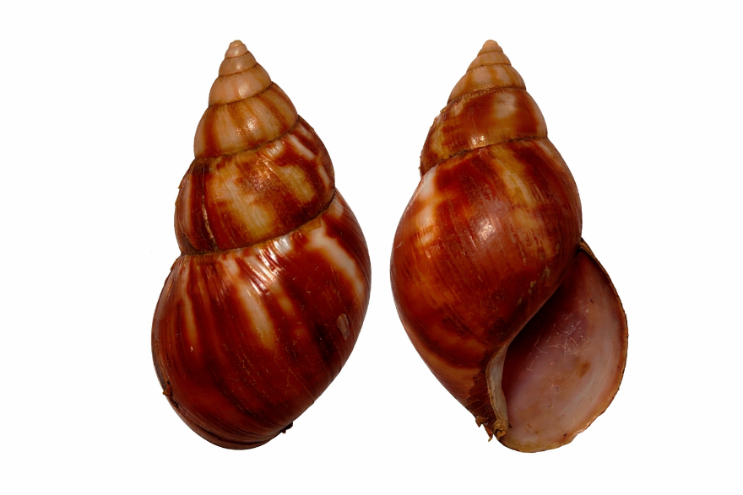

Figure. 1. Photograph of Lissachatina fulica shell from the collected specimen, Kanwar Lake
Vernier calipers are regularly used to measure quantitative morphometric parameters, such as shell height, shell width, aperture height, aperture width, spire height, and body whorl length, and calculated ratios, such as shell height/shell width, are used to measure intraspecific variation [16][18][21]. The columella is almost straight and distinctly truncated at the base which is a diagnostic feature separating L. fulica and closely related species like Achatina reticulata which vary in shell strength and columellar structure [16] [18]. The morphometric measurements were taken for the taxonomical identification of the species and the diagram was adapted and modified from [20]. (Figure.2).

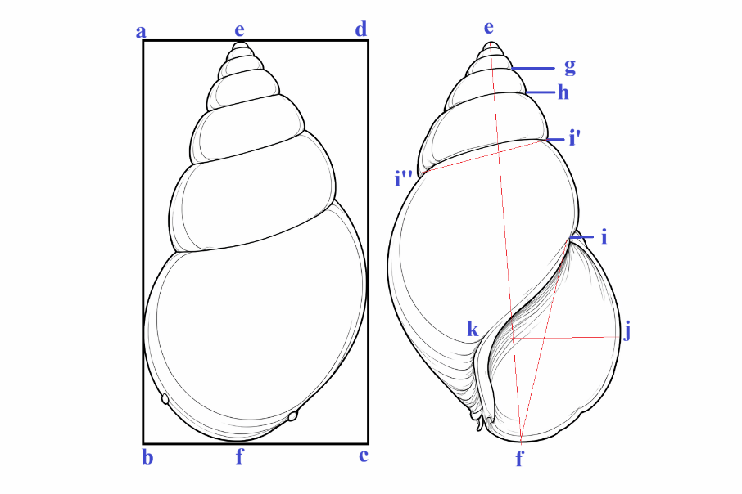

Figure 2. Morphometric parameters: shell length (SL: e-f: 89mm), shell width (SW: b-c: 47mm), aperture length (AL: f-i: 43mm), aperture width (AW: k-j: 29mm), body whorl length (BWL: i″-f: 67mm), penultimate whorl length (PWL: i′-h: 20mm), maximum penultimate whorl width (PWW: i″-I‴: 21mm), and spire height (SpL: i′-d: 33mm).

Beyond linear measurements, geometric morphometric approaches have demonstrated that shell shape undergoes ontogenetic modification, becoming more elongated with advancing developmental and reproductive stages, thereby linking shell morphology to life-history traits and improving demographic classification in ecological investigations [21]. In addition to shell features, reproductive anatomy, particularly genital structures, has been described as taxonomically informative within Achatinidae and is useful when shell characters show phenotypic plasticity due to environmental influences [15]. Although morphological parameters remain foundational for species recognition in both native and invasive ranges, increasing recognition of phenotypic variability has encouraged complementary use of molecular tools to strengthen taxonomic resolution [16] [18]. Therefore, morphology based identification along with mitochondrial markers like COI have been used in genetic studies to give knowledge on identity confirmation and invasion by data deposition in the NCBI GenBank through barcoding.

3.2. DNA polymorphism analysis
The sequences were aligned along with additional mitochondrial COI sequences retrieved from the NCBI, GenBank, and the sequence generated from the present study with latest Chromas version and MEGA [22]. Based on similarity search the generated COI sequences showed similarity Lissachatina fulica and were then deposited in NCBI GenBank database and accession number was obtained (PX716854.1, 548 bp). The identification of species was confirmed by using the BLAST program, NCBI [23] [24]. The sequence was then used for polymorphism studies and further analysis with the COI sequences deposited from other countries etc., based on the geographical distribution and also as per available sequences from the NCBI nucleotide database.
The analysis of L. fulica sequence used the Neighbor-Joining method to study the mitochondrial cytochrome c oxidase I (COI) gene which occurs frequently in DNA barcoding studies. Phylogenetic trees built using the Neighbor-Joining approach as one of the prevalent techniques allowed researchers to extract evolutionary relations from sequence genetic distances. The phylogenetic research demonstrated that L. fulica belongs to the Achatinidae family with confirmed genetic proximity to other Lissachatina species (Figure.3). Phylogenetic relationships of the query sequence were inferred using the Neighbor-Joining method based on mitochondrial COI sequences. Genetic distances were calculated using the Kimura 2-parameter (K2P) model. The robustness of the inferred tree topology was assessed using bootstrap analysis with 1000 replicates, and values ≥70% were considered significant. The phylogenetic tree obtained through this analysis displayed strong branches that exhibited proper clustering of sequences from L. fulica together with their most related taxa. DNA barcoding studies supported by mitochondrial COI gene sequences proved effective in determining evolutionary relationships of the giant African land snail as well as its taxonomic identification.
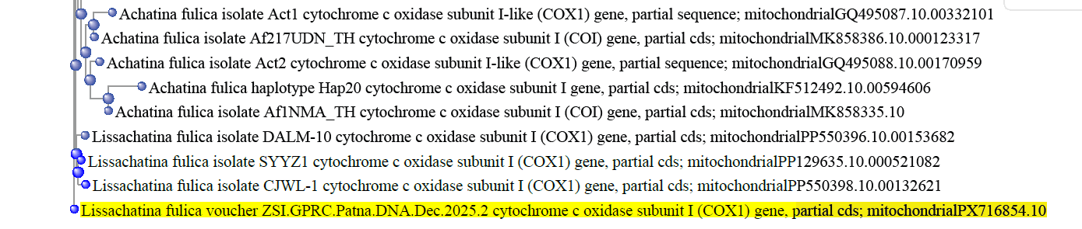
Figure.3. Molecular Phylogenetic analysis by Neighbour Joining method using mitochondrial cytochrome c oxidase 1 gene of Giant African snail (Lissachatina fulica) through DNA Barcoding.
Additionally, NCBI MSA Viewer 1.25.0 is a powerful tool for analyzing multiple sequence alignments, facilitating detailed comparative analysis of genetic sequences. In the present study, the Giant African snail sequence was identified using the BLAST (Basic Local Alignment Search Tool) algorithm, which compares the queried sequence against a database of known sequences to find regions of similarity. The MSA Viewer (Figure.4) was then employed to visualize and interpret the multiple sequence alignment results. This tool employs to align the query sequence of Giant African snail through DNA Barcoding with those of other related species, highlighting conserved regions, identifying genetic variations, and inferring evolutionary relationships. The visual representation provided by the MSA Viewer aids in the clear identification of sequence homologies and differences, making it an essential resource for molecular biologists studying the genetic makeup and evolutionary history of the Giant African snail.
Molecular analysis confirmed that the specimen belonged to the species L. fulica, with a similarity of 100% in GenBank, as we had hypothesized by morphological classification. The sample clustered in the phylogenetic tree with sequences belonging to L. fulica.
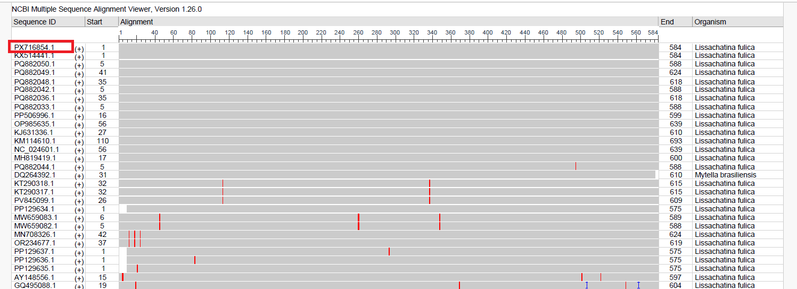
Figure.4. NCBI Multiple Sequence Alignment Viewer 1.25.0 results showing query (PX716854.1) from the present study with the database of known sequences regions of similarity.

4. DISCUSSION
4.1. DNA Barcoding: A Molecular Complement to Traditional Taxonomy
In order to avoid the basic drawbacks of morphology-based taxonomy, especially those associated with phenotypic plasticity, cryptic diversity, or ontogenetic variation in groups, DNA barcoding has become an effective and widely used tool in identifying gastropod species and systematic research. DNA barcoding uses a short standardized fragment of a gene located in the mitochondrial cytochrome c oxidase subunit I (COI) gene, to affix specimens to species-level entities or Molecular Operational Taxonomic Units (MOTUs) depending on sequence divergence limits and phylogenetic procession [13] [14]. DNA barcoding has been especially useful in gastropods, where environment-sensitive shell morphology can be imposed during convergent evolution. As an example, most recently in a large-scale study DNA Barcode Identification was used for Gastropod and Bivalve Species in Coastal Bays and Islands of Vietnam [29]. The paper has shown that the barcode information has not only supported the established taxonomy but also discovered some new or mis-recognized taxa, which confirmed the integrative capacity of the molecular method in biodiversity evaluation.
In a similar case, in Bangladesh, Morphological and Molecular Characterization of Several Neogastropod Species (Mollusca: Gastropoda) was carried out from Coastal Waters of Bangladesh [30]. The agreement between molecular clades and species boundaries supported the value of multilocus barcoding systems in areas where there is little baseline taxonomic information and morphological plasticity is high. Latest in 2026 [35] parallel research has applied molecular approaches to genetically characterize giant African land snails (Achatinidae) on Hainan Island, tropical China, by using COI.
All these studies agree that DNA barcoding can be a strong supplementary technique to traditional taxonomy in gastropods. Barcoding has allowed precise species definition, cryptic lineage detection, building regional reference libraries, and improved biodiversity lists by generating standardized molecular information. Combined with morphological and ecological information, DNA barcoding enhances systematic classifications and helps to conduct more accurate conservation and biogeographic analyses.
4.2. Limitations of Morphological and Anatomical Classification of Gastropods
Historical studies of gastropods (class Gastropoda) including snails and slugs of the marine, freshwater, and terrestrial worlds have been based on morphological and anatomical characters such as the shape of shells, the internal structure, and other external characters (e.g. Taxonomy of the Gastropoda [25]. Nonetheless, such characters tend to exhibit very high levels of variability and plasticity, and overlap of unrelated lineages, making determination of the correct species limits difficult when using morphological evidence alone. The morphological classification of gastropods by their morphological and anatomical features is not always trusted [26]. One of the most identifiable families is the Achatinidae has classification issues caused by considerable intraspecific morphological range. As such, the subfamilies and genera have been extensively revised based on molecular analysis [27].
Morphological identification may fail in gastropods due to a number of reasons. The shape of the shell and other morphological characters may vary continuously within species and can have a large overlap amongst closely related species making them unreliable as diagnostic characters. To illustrate, in the freshwater snail genus Radix, morphmetric analysis established that shell shape change was mainly continuous and not appropriate to define homogenous units of taxonomy, to generate various phenotypes in various ecological conditions, results in morphological overlap that can obscure actual species limits. Morphology keys also have difficulties with the juvenile forms, cryptic species complexes and diagnostic characters, which are sensitive to ecological or developmental factors. The gastropod larvae and the adults can be of varied morphological characteristics, which complicates the classification process of the gastropod using its exterior characteristics only [26].
4.3. Implications for Conservation and Management of Lissachatina fulica in Indian Wetlands
L. fulica has evolved to be one of the most infamous invasive molluscs throughout the world. Due to its wide ecological effects, the species was listed under the 100 of the World’s Worst Invasive Alien Species list by the International Union of Conserve Nature. L. fulica has managed to become an established species in tropical and subtropical areas of Asia, the Pacific Islands and the Americas through deliberate and unintentional anthropogenic releases [31]. The species has become common in India and currently inhabits various habitats such as urban areas, farmlands, forest edges, and damp microhabitat, where its location is enabled by a high level of ecological plasticity and human-mediated dispersal pathways [32] [33].
A significant ecological issue related to L. fulica is its wide trophic range and the resulting impact that it has on plant communities and local biota. The snail is a very polyphagous herbivore that can eat hundreds of plant taxa, such as agricultural crops, ornamental species, and native vegetation [32]. This type of feeding behaviour leads to great decline in plant biomass and possibly changes primary productivity and vegetation structure especially in humid environments where the growth of plants is rich. Wetlands are particularly susceptible since in many cases they have their own specialized assemblage of flora with a very narrow ecological spectrum; invasive snails can thus destroy the structure of the plant assemblages and ecological equilibrium [33].
The invasiveness of L. fulica is further reinforced by its life-history characteristics. It is a simultaneous hermaphrodite, which can cross-fertilize and self-fertilize, and individuals bear huge clutches of eggs several times in a favourable environment. In this way, a small population of introduced individuals can most effectively use this type of reproductive strategy, resulting in a rapid increase in population and subsequent colonization and maintenance in new environments [31]. As soon as they are formed, large populations could multiply rapidly in their nearby locations such as wetlands and other environments characterized by moisture to increase their survival and procreation.
From a conservation perspective, the spread of L. fulica can impact significantly on native molluscan assemblages through resource competition and competitive exclusion. In a number of invaded areas, the abundance of giant African snail has been linked with the reduction of native gastropods, implying that native species in the same ecological groups have been replaced [32]. The native freshwater and terrestrial snails play a significant role in the functioning of ecosystems by both detritus processing and nutrient cycling and by being prey in food webs; therefore, the ecological impact of invasion or suppression of native taxa by invasive snails may have a cascading impact.
Besides environmental effects, L. fulica is also associated with serious ecological and public-health risks because of its capacity to serve as an intermediate host of parasitic nematodes of medical and veterinary significance. Metastrongyloid nematodes including Angiostrongylus spp. and other species have been known to infect the species and cause eosinophilic meningitis in humans and other animals and pets [31]. Given that in wetland areas where people, animal habitats and domestic animals often share space, the occurrence of infected snail populations exacerbates the chances of the dissemination of the parasite, and therefore, integrated ecological and public-health management approaches are necessary. Based on such risks, L. fulica invasions need quick detection and response mechanisms. Invasive fronts, especially in fragmented wetland landscapes, linked to tourism, agriculture, and growing urban settlements, can be monitored to enhance the success of identifying nascent populations before they become densely populated and eradication becomes impractical [33]. It is hence important to intervene at an early stage so that the species will not be able to take root in the ecologically sensitive sites.
The scientific literature has reported various control methods such as manual collection, trapping and physical exclusion. These approaches may be effective but they are frequently labour intensive and work best when the snail population is not too large and the area is small in size. Trapping experiments based on trapping techniques have also shown that the use of baited traps is capable of trapping both adults and juveniles, thus resulting in the suppression of populations once they are part of a coordinated eradication effort [34]. Nevertheless, these strategies are only successful with the help of maintenance, correct choice of bait, and adjustment to ecological conditions of a given area. The community involvement is also important in the management of invasive species. The perception and awareness by the population plays a critical role in determining the effectiveness of control measures especially in urban and peri-urban environment where human-mediated dispersal is quite prevalent. It has been demonstrated that communities that possess a higher level of invasive species awareness tend to endorse monitoring and elimination initiatives on L. fulica [21]. The inclusion of environmental education in the wetland conservation efforts can thus increase the reporting of snail incidences by the populace and boost their involvement in the control efforts.
In general, the control of the ecological effects of L. fulica in Indian wetlands needs a complex and unified management system. The most efficient strategies ought to incorporate ecological monitoring, habitat protection, public awareness and specific control interventions that would be consistent with the local environmental conditions. Given the high reproductive capacity and adaptiveness of the species, inter- administrative and ecological management of the species will be crucial in curbing its expansion and protecting biodiversity and ecological processes of wetlands.
4. Conclusion
This article offers molecular validation on the presence of the giant African snail, Lissachatina fulica, in the Kanwar Lake which is a Ramsar wetland in the state of Bihar. With DNA barcoding a dependable molecular identification methodology being in use globally for the last more than two decades, the study indicates how successful genetic methods are in identifying invasive alien species even at an early stage when morphological recognition might be challenging as a result of variability in development or similarity with native groups. DNA barcoding can also allow quick and accurate identification of species, whilst traditional morpho-taxonomic methods can only easily allow accurate determination in well-developed adult specimens. The molecular data produced in this research indicates the increasing ecological threat of biological invasions in vulnerable wetland ecosystem and the significance of enabling molecular diagnostics and traditional ecological survey in monitoring biodiversity.
Management wise, successful management of invasive alien species is based on four basic approaches, namely: prevention, early detection, eradication and control, of which prevention is the most important one. Given the reproductive capacity and ecological flexibility of L. fulica, the existence of a single individual is just enough to report and implement management measures. Consequently, a series of monitoring programmes are needed at the Kanwar Lake and the landscapes within the area to determine the distribution and ecological effects of this invasive gastropod.
Moreover, combining citizen science programs with scientific surveillance might contribute greatly to the early-warning system by raising people awareness and involvement in the reporting of the cases of invasive species. These collaborative measures, together with molecular surveillance technologies, will be crucial to the ecological integrity protection of Ramsar wetlands and improvements of long-term effects of the invasive alien species in India.

Disclaimer (Artificial intelligence)
Author(s) hereby declare that NO generative AI technologies such as Large Language Models (ChatGPT, COPILOT, etc.) and text-to-image generators have been used during the writing or editing of this manuscript.

References
- Lissachatina fulica (Férussac, 1821) in GBIF Secretariat (2023). GBIF Backbone Taxonomy. Checklist dataset https://doi.org/10.15468/39omei (Accessed via GBIF.org on 2026-02-15).
- Ayyagari, V. S., & Sreerama, K. (2017). Evaluation of haplotype diversity of Achatina fulica (Lissachatina) [Bowdich] from Indian sub-continent by means of 16S rDNA sequence and its phylogenetic relationships with other global populations. Biotech, 7(4), 252. https://doi.org/10.1007/s13205-017-0877-4.
- Mahjabin, Mysha & Tasnim, Zerin & Datta, Sujan Kumar & Haque, Wahida & Ahmed, Md Sagir. (2023). DNA Barcoding and Phylogenetic Analysis of Some Gastropod Molluscs (Class-gastropoda) from Three Ecological Habitats of Bangladesh. Bioresearch Communications. 9. 1305-1309. 10.3329/brc.v9i2.67082.
- Ohimain, E.I., Oyedeji, A.A. & Ologidi, C.G. (2025). Nuisance of Lissachatina fulica introduced beyond Africa: lessons from their native range—a review. JoBAZ 86, 90 https://doi.org/10.1186/s41936-025-00513-x.
- Lima, M. G., Augusto, R. C., Pinheiro, J., & Thiengo, S. C. (2020). Physiology and immunity of the invasive giant African snail, Achatina (Lissachatina) fulica, intermediate host of Angiostrongylus cantonensis. Developmental and comparative immunology, 105, 103579. https://doi.org/10.1016/j.dci.2019.103579.
- Silva, G. M., Thiengo, S. C., Sierpe Jeraldo, V. L., Rego, M. I. F., Silva, A. B. P., Rodrigues, P. S., & Gomes, S. R. (2022). The invasive giant African land snail, Achatina fulica (Gastropoda: Pulmonata): global geographical distribution of this species as host of nematodes of medical and veterinary importance. Journal of Helminthology, 96, e86. doi:10.1017/S0022149X22000761.
- Uh-Navarrete, Adrián Emmanuel, Carmen Amelia Villegas-Sánchez, José Angel Cohuo-Colli, Ángel Omar Ortíz-Moreno, and Martha Valdez-Moreno. (2021). Identifying Early Stages of Freshwater Fish with DNA Barcodes in Several Sinkholes and Lagoons from the East of Yucatan Peninsula, Mexico. Diversity 13, no. 11: 513. https://doi.org/10.3390/d13110513.
- Ward, R. D., Zemlak, T. S., Innes, B. H., Last, P. R., & Hebert, P. D. (2005). DNA barcoding Australia's fish species. Philosophical transactions of the Royal Society of London. Series B, Biological sciences, 360(1462), 1847-1857. https://doi.org/10.1098/rstb.2005.1716.
- Pfenninger, M., & Schwenk, K. (2007). Cryptic animal species are homogeneously distributed among taxa and biogeographical regions. BMC Evolutionary Biology, 7(1), 121.
- Hebert, P. D. N., Cywinska, A., Ball, S. L., & deWaard, J. R. (2003). Biological identifications through DNA barcodes. Proceedings of the Royal Society of London. Series B: Biological Sciences, 270(1512), 313–321.
- Hajibabaei, M., Singer, G. A. C., Hebert, P. D. N., & Hickey, D. A. (2007). DNA barcoding: how it complements taxonomy, molecular phylogenetics and population genetics. Trends in Genetics, 23(4), 167–172.
- Hebert, P. D. N., Ratnasingham, S., & deWaard, J. R. (2003b). Barcoding animal life: cytochrome c oxidase subunit 1 divergences among closely related species. Proceedings of the Royal Society B: Biological Sciences, 270(Suppl. 1), S96–S99.
- Paul D. N. Hebert, Alina Cywinska, Shelley L. Ball, Jeremy R. deWaard (2003). Biological identifications through DNA barcodes. Proc Biol Sci 1 February; 270 (1512): 313–321. https://doi.org/10.1098/rspb.2002.2218.
- Folmer, O., Black, M., Hoeh, W., Lutz, R., & Vrijenhoek, R. (1994). DNA primers for amplification of mitochondrial cytochrome c oxidase subunit I from diverse metazoan invertebrates. Molecular Marine Biology and Biotechnology, 3(5), 294-299.
- Mead, A. R. (1961). The giant African snail: A problem in economic malacology. University of Chicago Press, Chicago.
- Raut, S. K., & Barker, G. M. (2002). Achatina fulica Bowdich and other Achatinidae as pests in tropical agriculture. In G. M. Barker (Ed.), Molluscs as Crop Pests (pp. 55–114). CABI Publishing, Wallingford.
- Odaibo, A. B., Olayinka, S. O., & Oso, O. G. (2025). Shell morphology and radula structures of giant African land snail species, Achatina fulica Bowdich, 1822 and Achatina reticulata Pfeiffer 1845 (Gastropoda: Achatinidae) in Southwest Nigeria. The Zoologist, 26, 37–42.
- Gabetti, A., Maganza, A., Prearo, M., Riina, M. V., Nodari, S., Rizzioli, B., Mangini, V., Di Tizio, L., Acutis, P., Dondo, A., Esposito, G., & Pastorino, P. (2023). First Report of Giant African Snail (Lissachatina fulica) in a Protected Area of the Cottian Alps, Northwest Italy. Sustainability, 15(11), 8633. https://doi.org/10.3390/su15118633.
- Gajera, N., Vakani, B. and Kundu, R. (2022). Radular morphology and relationship between shell size and radula size of few dominating intertidal gastropod molluscs of Veraval Coast, Gujarat. Frontiers in Marine Science, 9: 657124. DOI: https://doi.org/10.3389/fmars.2022.657124
- Afiademanyo, K.M.; Awaga, K.L.; Ouro-Sama, K.; Solitoke, H.D. (2021). Morphometric Differentiation between Two Closely Related Achatinid Snails (Gastropoda: Achatinidae) of West Africa and Implications for the Conservation of Achatina togoensis (Bequaert & Clench, 1934). Open J. Anim. Sci., 11, 559–579.
- Patiño-Montoya A, Marins G, Nomiyama TS, Tidon R. (2025). Perceptions and awareness of invasive species in the Brazilian Federal District: implications for controlling the giant African snail (Lissachatina fulica). NeoBiota. 103:325–337. https://doi.org/10.3897/neobiota.103.156013
- Koichiro Tamura, Glen Stecher, Sudhir Kumar (2021). MEGA11 Molecular Evolutionary Genetics Analysis Version 11. Molecular Biology and Evolution, 38(7), 3022–3027. https://doi.org/10.1093/molbev/msab120
- Zheng Zhang, Scott Schwartz, Lukas Wagner, and Webb Miller (2000), "A greedy algorithm for aligning DNA sequences", J Comput Biol; 7(1-2):203-14.
- Aleksandr Morgulis, George Coulouris, Yan Raytselis, Thomas L. Madden, Richa Agarwala, Alejandro A. Schäffer. (2008). Database Indexing for Production MegaBLAST Searches, Bioinformatics 24:1757-1764.
- Ponder W. & Lindberg D. R. (1997). Towards a phylogeny of gastropod molluscs: an analysis using morphological characters. Zoological Journal of the Linnean Society 119(2): 83-265. doi:10.1111/j.1096-3642.1997.tb00137.x.
- Venkatesan, V.; Mohamed, K.S. (2015). Gastropod classification and taxonomy. Recent Adv. Mar. Biodivers. Conserv. Manag. 38, 38–41.
- Nick Dawnay, Rob Ogden, Ross McEwing, Gary R. Carvalho, Roger S. Thorpe., (2007). Validation of the barcoding gene COI for use in forensic genetic species identification, Forensic Science International, 173, Issue 1, Pages 1-6, ISSN 0379-0738, https://doi.org/10.1016/j.forsciint.2006.09.013.
- Ratnasingham, S., & Hebert, P. D. N. (2007). BOLD: The Barcode of Life Data System (http://www.barcodinglife.org). Molecular Ecology Notes, 7(3), 355–364.
- Mai, N. C., Hoe, P. T., Trung, L. Q., Van, N. T., Hoa, L. X., Chieu, H. D., Thung, D. C., Tuan, B. M., Nho, P. T. D., Lien, L. Q., & Linh, T. M. (2025). DNA Barcode Identification for Gastropod and Bivalve Species in Coastal Bays and Islands of Vietnam. Diversity, 17(12), 863. https://doi.org/10.3390/d17120863
- Sultana, KS, PS Brishti, S. M. S. Ahmed, MB Billah and Kazi Ahsan Habib. Morphological and Molecular Characterization of Several Neogastropod Species (Mollusca: Gastropoda) From Coastal Waters of Bangladesh With One New Record. Journal of Bio-Science (2021): n. pag. DOI:10.3329/jbs.v29i0.54824.
- Silva, G. M., Thiengo, S. C., Sierpe Jeraldo, V. L., Rego, M. I. F., Silva, A. B. P., Rodrigues, P. S., & Gomes, S. R. (2022). The invasive giant African land snail, Achatina fulica (Gastropoda: Pulmonata): global geographical distribution of this species as host of nematodes of medical and veterinary importance. Journal of helminthology, 96, e86. https://doi.org/10.1017/S0022149X22000761
- Rasal V, Dhakad M, Khandal D. (2022). Ecological invasion of the giant African snail Lissachatina fulica (Bowdich, 1822) in a semi-arid forest of western India. Biodiversity Observations. 12:60–64. https://doi.org/10.15641/bo.876
- Celis-Ramírez M, Quintero-Ángel M, Varela-M RE. (2022). Control of invasive alien species: The giant African snail (Lissachatina fulica)-a difficult urban public management challenge. Journal of Environmental Management. 322:116159. https://doi.org/10.1016/j.jenvman.2022.116159
- Roda A, Cong MY, Donner B, et al. (2018). Designing a trapping strategy to aid Giant African Snail (Lissachatina fulica) eradication programs. PLoS ONE. 13:e0203572. https://doi.org/10.1371/journal.pone.0203572.
- Feng, X., Wang, Y., Xu, Y., & Lu, Y. (2026). DNA barcoding and genetic characterisation of giant African land snails (Achatinidae) on Hainan Island, tropical China, by using COI. Molluscan Research, 46(1), 76–83. https://doi.org/10.1080/13235818.2025.2600688

