Composition and Diversity of Anopheles Species and Their Feeding Patterns in Nasarawa: Implications for Malaria Vector Control
.
ASTRACT:

Background: Anopheles mosquitoes transmit malaria and are major global disease vectors. Their varied feeding and resting behaviors make malaria control difficult and influence disease transmission.

Aims: To investigate composition, abundance and feeding pattern of Anopheles species in Nasarawa State, Nigeria.

Study design: Three houses each were randomly selected in two communities for hourly collection of Anopheles species
Place and Duration of Study: This study was conducted between March 2023 and April 2024 in two Local Government Areas of Nasarawa State, Nigeria.
Methodology: Adult female Anopheles species were caught indoor and outdoor hourly from 6:00pm to 6:00am for three consecutive nights in each month in each of the three houses per sites using CDC light traps. Anopheles mosquitoes were morphologically identified using dissecting microscope. Species composition and abundance were compared using descriptive statistics and chi-square (χ²) tests at P<0.01, while feeding behaviour was assessed using Durbin Watson regression and t-tests
Results: Out of 3,826 female Anopheles species caught, 3,017(78.9%) were Anopheles gambiae s.l., 570(14.9%) Anopheles coustani, 154(4%) Anopheles funestus, and 85(2.2%) Anopheles pharoensis. An. gambiae was significantly (P<.01) more in Keffi, whereas An. coustani significantly (P<.01) predominated in Obi. No difference (P>.01) in An. funestus and An. pharoensis abundance in the two localities. An. gambiae’s abundance peaked during the wet season (July–September) and lowest in February. Anopheles species in the study areas were both exophagic and endophagic, biting late evening and early morning. Peak biting period of the four Anopheles species in the study areas was between 11:00 pm to 2:00 am. An. coustani significantly (P=.05) bit outdoor while An. funestus and An. pharoensis significantly (P=.05) bit indoor. An. gambiae though bite more indoor but not significantly different (P=.05) with outdoor biting.
Conclusion: Localised abundance and high outdoor biting activities of these Anopheles species underscores the importance of locality-specific vector control strategies that also address outdoor and peak biting hours because plasticity in mosquitoes’ behaviour reduces indoor-based control efficacy thereby sustaining malaria transmission despite conventional interventions
.
Keywords: Anopheles, Abundance, Feeding, Malaria, indoor, outdoor, Keffi, Obi.

1. INTRODUCTION
Mosquitoes are one the most important vectors of infectious disease-causing agents that tremendously affect global health, with over half of the global human population at risk of exposure to malaria, mosquito-transmitted infections (Damilare, 2018). Anopheles species are important public health insect due to bloodsucking habits of the females and transmission of important human diseases like malaria (Ukubuiwe et al 2021). Malaria is majorly transmitted through the bites of infected female Anopheles mosquitoes, though blood transfusion and contaminated needles may transmit it (Djihinto et al 2022). Malaria risk in an area depends on the Anopheles fauna and bionomics of the important species including those composed of complexes because of vast diversity of Anopheles vector species (Lelisa et al 2017). There are over 400 species of Anopheles mosquito which around 30 are vectors of malaria (WHO, (2019). Main Malaria Vectors that are widely distributed are An. gambiae sl and An funestus, while An nili, An mela and An. Moucheti, though main malaria vectors, but are localized. An. pharoensis, An. Coustani, An. hancocki and An. Longipalpis are secondary malaria vectors that are in various ecological zones across most parts of sub-Saharan Africa (Coetzee, 2022)
Anopheles mosquitoes, though behave differently, are mostly nocturnal feeders, biting from dusk to dawn (Costa-Neta et al 2023; Damilare, 2018). Feeding in primary malaria vectors is influenced by host seeking behavior (Orsborne, et al 2020) and other environmental drivers (Meshach, et al 2025). Malaria vector species locate their host from a distance majorly through carbon dioxide (CO₂) or body odours, heat and moisture emitted by hosts (Liu, et al 2020). Some Anopheles species prefer feeding indoor (endophagic) others feed primarily outdoors (exophagic) (Narcisse, et al 2022) while some species rest indoor (endophilic) others rest outdoor (exophilic) after feeding (Kaiseret, et al 2021). Anopheles species are not exclusively exophagic or endophagic, exophilic or endophilic, but exhibit a mixture of these extremes of behavior; a challenge for malaria vector control strategies.
Vector control can dramatically reduce malaria transmission (Muslime, et al 2019) and remains a primary malaria control measure (WHO, 2019) which can dramatically reduce malaria transmission . The distributions, abundances, and relative proportions of Anopheles species vary with period and locations (Ombugadu, et al 2025a). Malaria vector control could be nearly impossible without knowledge of the composition dynamics of the vectors because optimal control measures may be different for different species of malarial vector.
2. material and methods
2.1 Study Area
This study was carried out in Nasarawa State, North-Central Nigeria (Figure 1). Nasarawa state has tropical climate with distinct rainy and dry seasons; rainy (wet) season span from April to October and the dry season span from November to March (Sufiyan, et al 2020) and the main economy activities is agriculture (Sylvester & Danjuma, 2021). This study was conducted in Angwan Alheri, Rimi ward, and Gwadenye ward in Zhemigili district of Keffi and Obi local government areas respectively (Figure 1). Keffi in western and Obi in Southern parts of the State are within geographic coordinate of 8.3500°N 8.6000°E and 8.8480° N and 7.8730°E respectively.

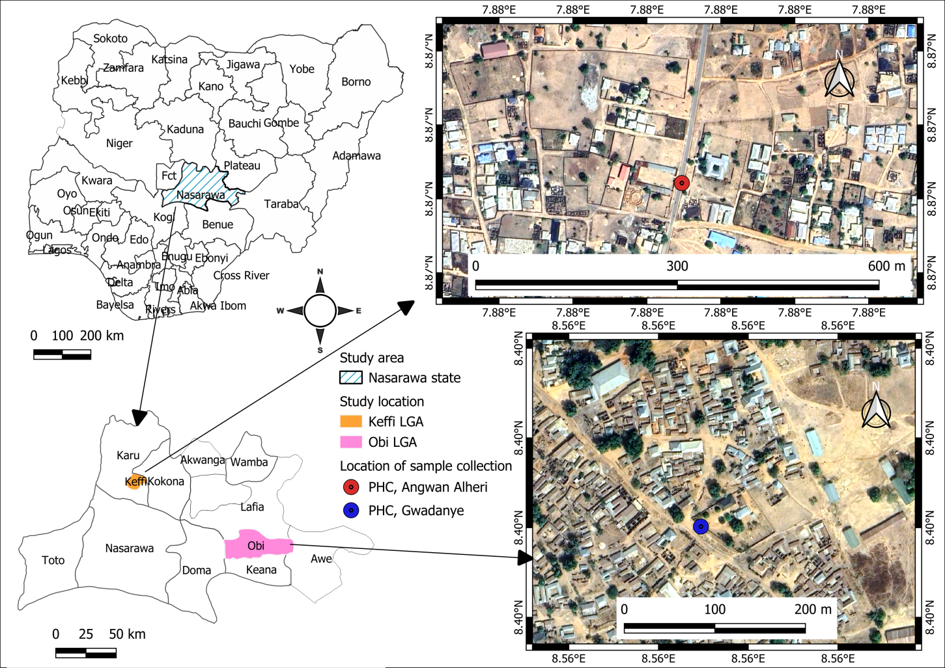
Figure 1. Map of Nasarawa State Indicating Study Areas.
2.2 Advocacy:
Advocacy visits to the communities were made and verbal consent was sought from household owners to set CDC light traps.
2.3: Sample Collection:
Adult female Anopheles mosquitoes were sampled using standard CDC light traps (Model: John W. Hock CDC Light trap 512, USA) following CDC protocol (CDC, 2010). In each of the two study areas, three (3) houses were randomly selected and at each sampling night, three light traps were placed indoors and three outdoors at 1.5 m height above human bait in an untreated bed nets. Trapped mosquitoes, attracted by light, were separately picked hourly from 6:00pm to 6:00am from both indoor and outdoor in all the traps with aspirator into paper cups labeled as either indoor/outdoor according to hour of collection. Each paper cup was gauze with nets with an opening plugged with cotton wool. Anopheles species were morphologically using morphological features (Coetzee, 2020)
2.4: Data Analysis:
Composition and abundance of mosquito species in the study areas were analysed using descriptive statistics and chi-square (χ2) test at P<0.01 level of significance. Indoor and outdoor feeding behaviour across species in the study months were compared using Durbin Watson Regression and T-test and feeding hours were analysed using descriptive statistics.
3. results
3.1: Composition and Abundance of Anopheles Species.
Obi and Keffi study areas were composed of Anopheles gambiae sl (78.9%), Anopheles funestus (4.0%), Anopheles pharoensis (2.2%) and Anopheles coustani (14.9%) (table 1). Anopheles coustani was present and significantly P=.01) common in Obi while An. gambiae, though present in both study areas, was significantly (P=.01) more common in Keffi (95.5%) than Obi (66.4%) (table 1).

Table 1. Composition of Anopheles species in Obi and Keffi
Anopheles Species | Site
Anopheles Species | Obi (%) | Keffi (%) | Total (%)
An. Gambiae | 1454 (66.4) | 1563 (95.5) | 3017 (78.9)
An. Coustani | 570 (26.0) | 0 (0) | 570 (14.9)
An. Funestus | 96 (4.4) | 58 (3.5) | 154 (4.0)
An. Pharoensis | 70 (3.2) | 15 (0.9) | 85 (2.2)
Total | 2190 (57.2) | 1636 (42.8) | 3826
An.=Anopheles, P=.01

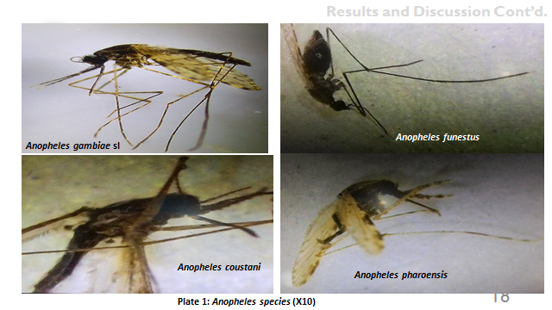
Plate 1. Anopheles species.
Anopheles gambiae sl was the most abundant species across all months and most in the month of July, followed by Anopheles coustani which occurred most in in the month of Augustin Obi (Figure 2a). Anopheles funestus, appeared most within the months of June to September while Anopheles pharoensis, the least abundant species, was most found in August(figure 2a) in Obi. Anopheles gambiae and Anopheles funestus appeared most in the month of September while Anopheles pharoensis occured most in the months of June and August in Keffi (Figure 2b).

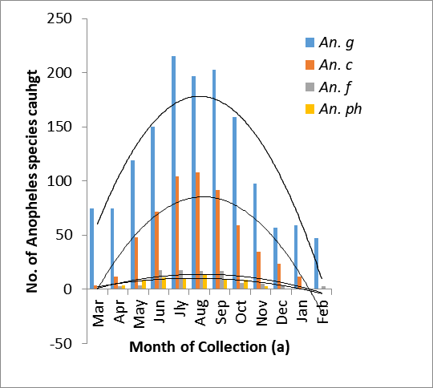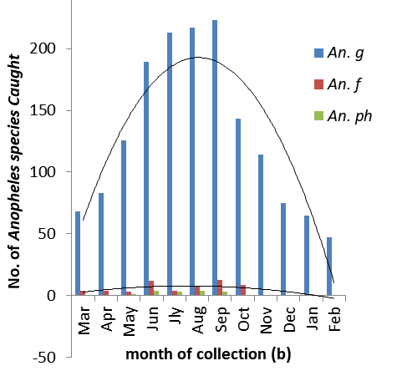 An.=Anopheles, g=gambiae, c = coustani, f = funestus and ph = pharoensis Figure 2. Monthly abundance of Anopheles species in Obi (a) and Keffi (b). 3.2: Feeding Patter of Anopheles spp In Obi, Anopheles gambiae sl bites mostly indoor except months of March and April, Anopheles funestus also bite more indoor than outdoor except in the months of September, November and December and Anopheles pharoensis mostly bite indoor too except in the month of May and June while Anopheles coustani bite more outdoors than indoors in all the months (Figure 3). Like in Obi, Anopheles gambiae sl, Anopheles funestus and Anopheles pharoensis bite more indoor than outdoor in Keffi (Figure 4).
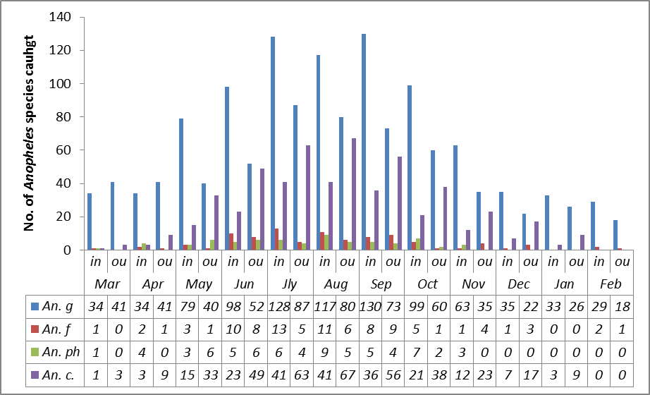
An. =Anophele, g=gambiae, f = funestus, ph = pharoensis, c = coustani,. In= Indoor biting, Ou = Outdoor biting.
Figure. 3. Indoor and Outdoor Biting Preference of Anopheles Species in Obi.

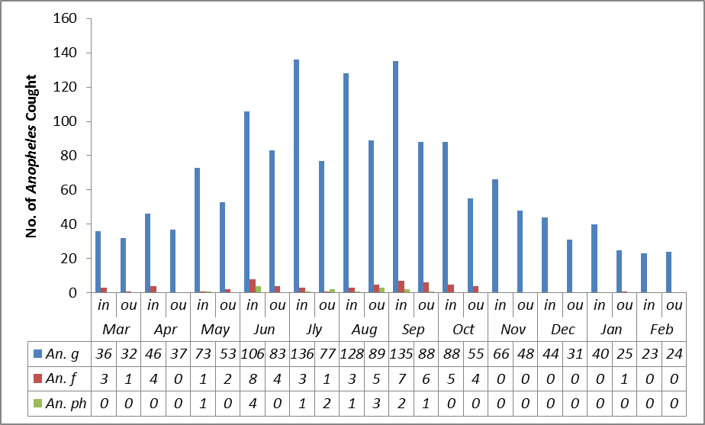 An.=Anopheles, g= gambiae, f = funestus, ph = pharoensis. In= Indoor biting, Ou = Outdoor biting. Figure 4. Indoor and Outdoor Biting Preference of Anopheles Species in Keffi.

Anopheles gambiae sl mostly bite early evening (9:00pm; 8:00pm) to early morning (4:00; 5:00am) in Obi and Keffi respectively and peaked between 1-2am in both study locations (Figure 5 & 6). Anopheles funestus mostly bite between late evening (11:00pm) to early morning (4:00am) and peaked between 11:00pm to 1:00am in both study locations (Figures 5&6). Peak biting period of Anopheles pharoensis was between 9-11pm and 1-2am in Obi and Keffi respectively (Figure 5&6). Anopheles coustani mostly bite between 11:00pm to 4:00am but peaked between 12-1am (Figure 5). There is significance difference (P=.05) between indoor and outdoor biting behavior of Anopheles coustani, Anopheles funestus and Anophels pharoensis and no significance difference (P=.05) between indoor/outdoor biting of Anopheles gambiae sl.

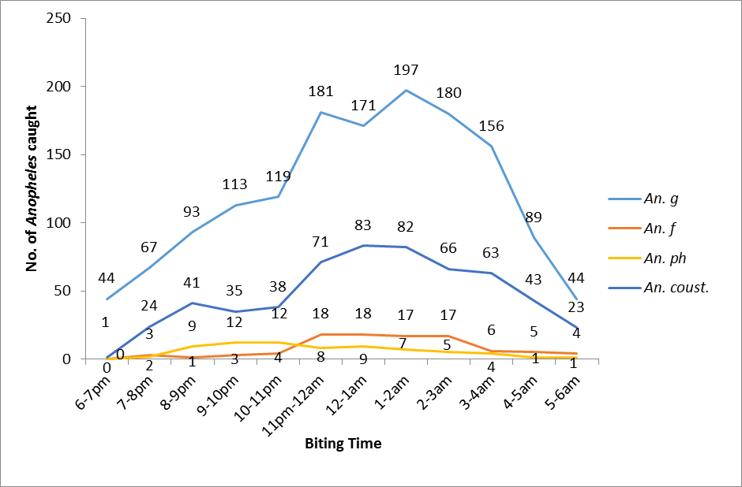 An.= Anophele, g=gambiae, f = funestus ph = pharoensis, c = coustani.
Figure 5. Peak Biting Time of Anopheles Species in Obi.

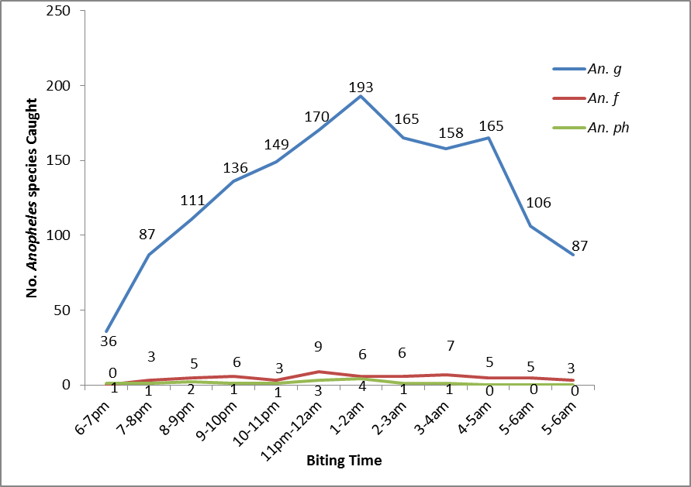
An. = Anopheles, g=gambiae, f = funestus, ph = pharoensis
Figure 6. Peak Biting Time of Anopheles Species in Keffi.

4. DISCUSSION
4.1 Abundance and Composition of Anopheles species in the study Areas
A total of three thousand eight hundred and twenty six (3826) Anopheles mosquitoes caught in the study areas were composed of four different species. Out of the total number of mosquitoes caught, the most abundant was Anopheles gambiae sl (3017) (78.9%), followed by Anopheles coustani (570) (14.9%), Anopheles funestus (154) (4%) and Anopheles pharoensis (85) (2.2%). Anopheles mosquitoes species were caught more in Obi (2190 (57.2%)) than in Keffi (1636 (42.8%)) and while Anopheles gambiae was significantly (P=.01) more common in Keffi, An. coustani was significantly (p=.01) more common in Obi. There was no significance difference (P=.01) in the composition of Anopheles funestus and Anopheles pharoensis in either sites of the study area. In both Obi and Keffi, Anopheles gambiae sl was the most abundant species (67 and 96%) respectively. Anopheles coustani was only found in Obi and the second most abundant species (26%) followed by Anopheles funestus (4%) and the least abundant species was Anopheles pharoensis (3%). In Keffi, the second most abundant species was Anopheles funestus (3%) and the least was Anopheles pharoensis (1%). Related findings of Anopheles gambiae as the most widespread of malaria vector was reported in Nigeria across all ecological zones, from the humid forests in the south to the Sahel savannah in the north (Adamu, et al 2023; Thabet, et al 2022; Oduola, et al 2021). However, the overall abundance (78.9%) of Anopheles gambiae s.l, in this study was higher compare to some studies in Nigeria (Ezenwaka & Ailogie, 2023; Ogbuefi & Aribodor, 2023)) and lower (Ombugadu, et al 2025b; Okeke, et al 2024) compare to the result of this studies. Similarly, Anopheles coustani found in this study was reported as an incidental malaria vectors in various ecological zones across most parts of sub-Saharan Africa (Coetzee, 2022; Ombugadu, et al 2020). The composition and distribution of these Anopheles species could be influenced by a variety in micro-ecological and climatic factors (Noboru, et al 2002) and human factors which can impact availability of breeding sites, development of mosquitoes species and variability in malaria transmission intensity across different regions (Babale, et al 2023).
Anopheles gambiae sl, though less abundant during the dry season months (November - March) than the rainy season months (April - October), the mosquito was abundant in all the months in both Obi and Keffi study areas. Anopheles coustani was found in all the months except the month of February and most abundant in the month of August and with highly reduced number within dry than rainy season months. Anopheles funestus and Anopheles pharoensis though not found in all the months in the study areas, the mosquitoes were more abundant in the months of rainy than dry seasons too. The abundance of different Anopheles species in this study follows Nigeria’s distinct wet and dry seasons which could be due to impact of rainfall, temperature, and humidity on the breeding and survival rate of mosquitoes (Thabet, et al 2022). Lower humidity and higher temperatures in the dry season are less favourable for mosquito survival (Agyekum, et al 2021) and responsible for less abundant of mosquitoes during the dry than wet seasons (Olorunniyi, 2021; Adamu, et al 2023). Higher abundance of Anopheles mosquitos during the rainy season could also be as a result of increased vegetation growth which provides more resting and hiding places for adult mosquitoes and protect them from predators and environmental stresses (Sauer, et al 2021) and availability of food especially nectar from flowers which increases Plasmodium gametogenesis and vector competence (Ernest, et al 2021).

4.2 Feeding Behaviour of Anopheles Species in the Study Areas.
4.2.1 Endophagic/Exophagic Feeding Preference of Anopheles Species
Anopheles gambiae sl feed more indoor (endophagic) than outdoor (exophagic) in all the months except in March and April in Obi and February in Keffi study areas. The mosquito fed most in month of September/July and July/August indoor and outdoor in Obi and Keffi respectively and least in the month of February. Anopheles funestus also fed more indoor than outdoor in all the months except in September/November/December in Obi and May/August/January in Keffi. Anopheles pharoensis also fed more indoor than outdoor. Indoor and outdoor biting behaviour of Anopheles funestus and pharoensis was significantly difference (P=.05) but no significance difference (P=.05) in indoor and outdoor biting behaviour of Anopheles gambiae. Nzioki, et al (2023) similarly reported endophagic behavior of Anopheles gambiae and funestus. Contrastingly, Salomé, et al (2023) and Narcisse, et al (2022) reported that, these mosquitoes species were more exophagous than endophagous in their feeding behavior. Endophagic behaiour of these Anopheles species could be due to their proximity to human hosts; they have evolved to exploit human environments and behaviour where people typically sleep indoors during the night (Adugna, et al 2021), host seeking behavior (Orsborne, et al 2020) and environmental drivers such as temperature and relative humidity (Meshach, et al 2025). Anopheles coustani significantly (P=.05) fed more outdoor than indoor in all the months. Exophagic activity of this mosquito occurred most in August and least in March while endophagic behaviour was most in July and August and least in January. This is similar to the findings of Gebhardt, et al (2022) who reported that An. coustani seek hosts more outdoors than indoors but also have high tendency of indoor than outdoor feeding behavior (Nzioki, et al 2023). Exophagic behaviour of An. coustani could be due to its zoophilic tendencies, natural habitat preferences, and adaptations to outdoor environments (Zemene et al 2021). This behavior allows it to exploit animal hosts, avoid indoor control measures, and survive in natural settings with less competition and predation influencing its role in malaria transmission in areas where it is abundant.
4.2.2. Biting Cycle of Anopheles Species
Anopheles mosquito bit all night (6:00pm-6:00am) in the study areas and more between late evening (9:00pm-10:00pm) to early morning (3:00am – 4:00am) periods in Obi and 8:00pm – 5:00am in keffi. Anopheles gambiae sl, Anopheles coustani, Anopheles funestus and Anopheles pharoensis generally bite most between 1:00am-2:00am, 12–1:00am, 11:00pm–1:00am and 12:00am-:1:0am respectively in Obi but in Keffi, Anopheles gambiae and Anopheles pharoensis bite most between 1-2:00am while Anopheles funestus bite most between 11:00pm-12:00am. There was no bite of Anopheles funestus and An. pharoensis between the hours of 6-7:00pm in both study areas. Biting activities of these Anopheles mosquitoes shortly after sunset in this study agrees with the findings of Dambach, et al (2018) who reported that An. species bite shortly after sunset coinciding with the activities of people; going indoors in preparation for night rest, which could be significant to malaria transmission risk because it increases chances of bites before bed net. The late evening biting of these mosquito species could also be as a result of outdoor activities such as socializing, cooking, or relaxing of human host (Degafe, et al 2021).
Late evening and early morning peak biting time of the Anopheles species in this study is akin with the findings of Ombugadu, et al (2025b) who reported that peak biting activities of most Anopheles species occur between these hours. However, Costa-Neta et al (2023) reported a slight difference of peak biting activity of these Anopheles species between midnight and early morning. This could be due to evolutionary adaptation to exploit human behaviour (Orsborne, et al 2020); time most people are asleep, making them more vulnerable to mosquito bites, especially in the absence of bed nets or other protective measures (Lawal, et al 2020). Biting during peak sleeping times enhance the chances of an infected mosquito in transmitting disease causing agent like plasmodium species to human, sustaining the cycle of transmission. The shift in the biting times and points of these Anopheles mosquitoes could be behavioral response to the widespread use of Insecticides Treated Nets (ITNs) (Degafe, et al 2021).and can make standard interventions less effective over time (Akuoko et al 2024).
5. CONCLUSION
Two localities in Obi and Kefffi Local Government Areas of Nasarawa State were composed of four species of Anopheles mosquitoes, Anopheles gambiae sl, Anopheles coustani, Anopheles funestus, and Anopheles pharoensis with Anopheles gambiae sl being the most abundant species. Anopheles coustani was not found in Keffi at the time of this study but was second most abundant in Obi while the third and the least abundant species were An. funestus and An. pharoensis respectively. Anopheles species in the study areas bite both indoor and outdoor and were more abundant in the months of rainy season, especially between June and October, than dry season. Anopheles gambiae sl bite more indoor but was not significantly different (P=.05) from outdoor biting. Anopheles funestus and Anophels pharoensis bite more indoor too while Anopheles coustani significantly (P=.05) bite more outdoor than indoor. The four Anopheles species bite throughout nights, from dusk to dawn, and were most active during the late evening to early morning periods which coincides with resting period of human host, making human more vulnerable to mosquito bites. This behaviour and outdoor biting habit of these Anopheles species are capable of complicatin control efforts because standard traditional control methods like Insecticides Treated Nets (ITNs) and Indoor Residual Spray (IRS) which are indoor-based may not be adequate because these times and places are less covered by these standard interventions. To compliment current control intervention of Anopheles species, additional control tools that target late-evening and outdoor biting are required to control residual transmission and ultimately achieve malaria elimination.
Disclaimer (Artificial intelligence)
Author(s) hereby declare that NO generative AI technologies such as Large Language Models (ChatGPT, COPILOT, etc.) and text-to-image generators have been used during the writing or editing of this manuscript.

References

Adamu, Y., Hassan, S. & Amuga, G. (2023). Molecular Characterisation of Anopheles Species Collected from Two Area Councils of the Federal Capital Territory, Abuja, Nigeria. European Modern Studies Journal, 7(4). doi.10.59573/emsj.7(4).2023.30.
Adugna, T., Yewhelew, D. & Getu, E. (2021). Bloodmeal sources and feeding behavior of anopheline mosquitoes in Bure district, northwestern Ethiopia. Parasites and Vectors, 14. doi.10.1186/s13071-021-04669-7.
Agyekum, T., Botwe, P., Arko-Mensah, J., Issah, I., Acquah, A., Hogarh, J., et al. (2021). A Systematic Review of the Effects of Temperature on Anopheles Mosquito Development and Survival: Implications for Malaria Control in a Future Warmer Climate. International Journal of Environmental Research and Public Health, 18. doi.10.3390/ijerph18147255.

Akuoko, O.K., Shittu, B.D., Isaac, A.H., Abdul, R.M., Christopher, M. O., Yaw A. A.., et al (2024). Biting behaviour, spatio-temporal dynamics, and the insecticide resistance status of malaria vectors in different ecological zones in Ghana. Parasites and Vectors 17(16). doi.org/10.1186/s13071-023-06065-

Babale, S., Salim, H., Yakudima, I., Kabir, B., Mamman, R., Chiroma, U. & Ibrahim, S. (2023). Seasonal assessment of pupal habitat productivity of malaria vector: Anopheles gambiae s.l as influence by physico-chemical conditions at selected breeding habitats in Niger, Nigeria. EUREKA: Life Sciences. doi.10.21303/2504- 5695.2023.002841

Centre for Disease Control and Prevention (CDC) (2010). Guideline for evaluating insecticide resistance in arthropod vectors using the CDC bottle bioassay. Centers for Disease Control and Prevention, Atlanta, GA.
Coetzee, M. (2020). Key to the females of Afrotropical Anopheles mosquitoes (Diptera: Culicidae). Malaria Journal. doi.10.1186/s12936-020-3144-9.

Coetzee, M. (2022). Literature review of the systematics, biology and role in malaria transmission of species in the Afrotropical Anopheles subgenus Anopheles (Diptera: Culicidae). Zootaxa, 5133 (2), 182-200.

Costa-Neta, B., Silva, d., Carvalho, d., da, C., Brito, J. & Silva, F. (2023). The evening crepuscular host-seeking activity of Anopheles mosquitoes in northeast Brazil. Journal of Medical Entomology, 60, 1008-1015.

Dambach, P., Schleicher, M., Korir, P., Ouedraogo, S., Dambach, J., Sié, A., et al. (2018). Nightly Biting Cycles of Anopheles Species in Rural Northwestern Burkina Faso.Journal of Medical Entomology, 55, 1027-1034.

Damilare, O.F. (2018). Mosquitoes and the Lymphatic Filarial Parasites: Research Trends and Budding Roadmaps to Future Disease Eradication. Journal of Tropical Medicine and Infectious Disease. doi:10.3390/tropicalmed3010004
Degefa, T., Andrew, K. G., Ming-Chieh, L., Guiyun, Y., & Delenasaw, Y. (2021). Patterns of human exposure to early evening and outdoor biting mosquitoes and residual malaria transmission in Ethiopia. Acta Tropica. doi.org/10.1016/j.actatropica.2021.105837

Djihinto, O., Medjigbodo, A., Gangbadja, A., Saizonou, H., Lagnika, H., Nanmede, D., et al (2022). Malaria-Transmitting Vectors Microbiota: Overview and Interactions With Anopheles Mosquito Biology. Frontiers in Microbiology Doi.10.3389/fmicb.2022.891573.

Ernest, M., Silva, T. & Vega-Rodríguez, J. (2021). The best sugar in town for malaria transmission. Trends in parasitology, 37(9),775-776.

Ezenwaka, C. O. & Ailogie, T. E. (2023). Distribution and abundance of mosquito species in Otuoke, Ogbia Local Government Area, Bayelsa State, Nigeria. The Zoologist, 22, 9-13.
Gebhardt, M., Searle, K., Kobayashi, T., Shields, T., Hamapumbu, H., Simubali, L., (2022). Understudied Anophelines Contribute to Malaria Transmission in a Low- Transmission Setting in the Choma District, Southern Province, Zambia. The American Journal of Tropical Medicine and Hygiene, 106, 1406-1413.

Kaiseret, M., Wood, O., Damiens, D., Brooke, B., Koekemoer, L. & Munhenga, G. (2021). Estimates of the population size and dispersal range of Anopheles arabiensis in Northern KwaZulu-Natal, South Africa: implications for a planned pilot programme to release sterile male mosquitoes. Parasites and Vectors, 14. doi.10.1186/s13071-021-04674.

Lawal, N., Idoko, A.S., Abdullahi, H. & Imam, A.A. (2020). Circadian Biting patterns of Major Lymphatic Filariasis Vectors from Northwest Nigeria. Public Health Open Access. doi.10.23880/phoa-16000158.

Lelisa, K., Abebe, A., Taye, B., Emana, D. & Yewhalaw, D. (2017). Anopheline mosquitoes’ behaviour and entomological monitoring in Southwestern Ethiopia. Journal of Vector–borne disease, 54(3), 240-248.
Liu, F., Ye, Z., Baker, A., Sun, H. & Zwiebel, L. (2020). Gene editing reveals obligate and modulatory components of the CO₂ receptor complex in the malaria vector mosquito, Anopheles coluzzii. Insect biochemistry and molecular biology. doi.10.1016/j.ibmb.2020.103470.
Meshach, L., Richard, O'.R., Nicholas, J.C., Tamsyn, U.W., & Konstans W. (2025). Diversity and Plasticity in Mosquito Feeding Patterns:A Meta-Analysisof ‘Universal’ DNA Diet Studies. Global Ecology and Biogeography, doi.org/10.1111/geb.70077.
Musiime, A. K., Smith, D. L., Kilama, M., Rek, J., Arinaitwe, E., Nankabirwa, J. I. et al 2019). Impact of vector control interventions on malaria transmission intensity, outdoor vector biting rates and Anopheles mosquito species composition in Tororo, Uganda. Malaria journal, 18(1), 445.
Narcisse, B., Ngbolua, J., Eric, M., Mawunu, M., Irish, S., Basimike, M. & Jonas, N. (2022). Study of the Behavior and Entomological Parameters of Anopheles in Two Health Zones of The North-Ubangi Province, Democratic Republic of Congo. Egyptian Academic Journal of Biological Sciences, Medical Entomology and Parasitology, 14(2), 57-63.
Noboru, M., George, S., Motoyoshi, M., Andrew, G. & Guiyun, Y. (2002). The Effects of Climatic Factors on the Distribution and Abundance of Malaria Vectors in Kenya. Journal of Medical Entomology. 39(6), 833-841.
Nzioki, I., Machani, M., Onyango, S., Kabui, K., Githeko, A., Ochomo, E., et al. (2023). Current observations on shifts in malaria vector biting behavior and changing vulnerability to malaria transmission in contrasting ecosystems in Western Kenya. Research Square. doi.10.21203/rs.3.rs-2772202/v1

Oduola, A.O., Obembe, A., Lateef, S.A., Abdulbaki, M.K., Kehinde, E.A., Adelaja, O.J., et al (2021). Species Composition and Plasmodium falciparum Infection Rates of Anopheles gambiae s.l. Mosquitoes in Six Localities of Kwara State, North Central, Nigeria. Journal of Apply Sciences and Environmental Management, 25 (10), 1801-1806
Ogbuefi, E.O. & Aribodor, D.N. (2023). Mosquitoes population dynamics and its implication for control in some selected local government areas of Anambra State, Nigeria. Animal Research International, 20(2), 4924–4939

Okeke, O.A., Muoghalu, C.V., Udeh, N.P., Nnatuanya, I.O., Nwadike, C.C., Afoemezie, P.I., et al (2024). Mosquito species composition, diversity and relative abundance in Science Village, Nnamdi Azikiwe University, Awka, Anambra State, Nigeria. Journal of Current Biology, 4(3),1647-1662

Olorunniyi, O. (2021). Relationship of Climatic Variables with Abundance of Indoor Mosquito Genera in Six Communities in Ekiti State, Nigeria. Journal of Advances in Biology and Biotechnology. doi.10.9734/jabb/2021/v24i830233.

Ombugadu, A., Ekawu, R.A., Pam, V.A., Odey, S.A., Igboanugo, S.I., Luka J., et al (2020). Feeding Behaviour of Mosquito Species in Mararraba-Akunza, Lafia Local Government Area, Nasarawa State, Nigeria. Biomedical Journal of scientific and technical research, 25 (1), 18742- 18752

Ombugadu, A., Kasimu, H., L., Raphael, A., James, I.M., Joshua A. I., Innocent A.P., et al (2025b) Jeremiah, I., (2025b). Mosquitoes Composition and Plasmodium Infection Status in Malaria Vectors in an Urban Community in Lafia Metropolis, Nasarawa State, Nigeria. International Journal of Current Research in Science, Engineering and Technology.8(2),309-313.

Ombugadu, A., Nanvyat, N. & Georgina, S.M. (2025a). Population dynamics of the major anopheline vector in Nasarawa State, Central Nigeria, using the Novel Prokopack Aspirator and an existing protocol. Zoological and Entomological Letters, 4(2), 28-33
Orsborne, J., Mohammed, A., Jeffries, C., Kristan, M., Afrane, Y., Walker, T., & Yakob, L. (2020). Evidence of extrinsic factors dominating intrinsic blood host preferences of major African malaria vectors. Scientific Reports. doi.10.1038/s41598- 020-57732-1.
Salomé, G., Riddin, M. & Braack, L. (2023). Species Composition, Seasonal Abundance and Biting Behavior of Malaria Vectors in Rural Conhane Village, Southern Mozambique. International Journal of Environmental Research and Public Health, doi.10.3390/ijerph20043597.
Sauer, F., Grave, J., Lühken, R. & Kiel, E. (2021). Habitat and microclimate affect the resting site selection of mosquitoes. Medical and Veterinary Entomology, 35, 379-388.

Sufiyan, I., Mohammed, K., Bello, D. & Zaharadeen, I. (2020). Impact of harmattan season on human health in Keffi, Nasarawa State, Nigeria. Matrix Science Medica, 4, 44-50.

Sylvester, U. & Danjuma, N. (2021). Sustainable Development Strategies for Rural Area in Nasarawa State, Nigeria. African Journal for economy and sustainable development, 4(1), 63-80.

Thabet, H., Tageldin, R., Fahmy, N., Diclaro, J., Alaribe, A., Ezedinachi, E., et al (2022) Spatial Distribution of PCR-Identified Species of Anopheles gambiae senus lato (Diptera: Culicidae) Across Three Eco- Vegetational Zones in Cross River State, Nigeria. Journal of Medical Entomology, 59, 576-584.

Ukubuiwe A.C., Olayemi I.K.,Ukubuiwe, C.C. & Ugbede, B.S. (2021). Environmental Manipulation: A Potential Tool for Mosquito Vector Control. doi.org/10.5772/intechopen.95924.

WHO, (2019). World Malaria Report. Accessed March, 2020 from https://www.who.int/malaria/puplications/world-malaria-report-2019/en/WHO
Zemene, E., Belay, D., Tiruneh, A., Lee, M., Yewhalaw, D. & Yan, G. (2021). Malaria vector dynamics and utilization of insecticide-treated nets in low-transmission setting in Southwest Ethiopia: implications for residual transmission. BMC Infectious Diseases, 21. doi.10.1186/s12879-021-06592-9.

