Diversity and Ecological Distribution of Woody Macrofungi in the Sal (Shorea robusta) Forest Region of Bangladesh

Abstract
This study documented the diversity and ecological characteristics of woody macrofungi occurring in the Sal (Shorea robusta) forest region of Bangladesh. A total of 21 wood-inhabiting species belonging to multiple families were recorded across six study sites. The dominant genera included Ganoderma, Trametes, Bondarzewia, and Phellinus. These species colonized fallen logs, stumps, branches, decaying trunks, and standing dead trees of Shorea robusta, Mangifera indica, Artocarpus heterophyllus, Albizia lebbeck, Acacia auriculiformis, and Tectona grandis. G. lucidum, T. versicolor, D. concentrica, and T. gibbosa were the most frequently encountered taxa, indicating rich lignocellulosic substrate availability in the forest. Diversity analysis revealed that Potka (East), Sreepur exhibited the highest fungal diversity with Simpson’s Diversity Index (D.I.) of 0.917, while Rajendrapur and Modhupur showed comparatively lower diversity (D.I. = 0.833). The findings highlight the major macrofungal species responsible for wood decay and tree-rotting processes in the Salforest region and provide essential baseline information for assessing fungal biodiversity, forest health, and ecosystem functioning.
Keywords:
Fungal diversity; Forest ecosystem; Lignicolous fungi; Salforest; Shorea robusta; Tree-rotting macrofungi; Wood-decay fungi; Woody macrofungi.
1. Introduction
Woody macrofungi are essential components of forest ecosystems, acting as primary agents of wood decay, nutrient recycling, and ecological balance. Among them, ligninolytic and lignocellulolytic fungi play a particularly critical role in the rotting of large forest trees, initiating and accelerating the decomposition of trunks, branches, and root systems. In Bangladesh, many surveys had been occurred. Ganoderma applanatum was found in National Botanical Garden, Dhanmondi Lake and in National Zoo [1, 2]. Four species of G. were found during collection time such as- G. tsugae, G. applanatum, G. boninense and G. sp. from Sylhet division [3]. G. lucidum was previously reported from Rangamati Hill tracts area under tropical evergreen and semi-evergreen forest region of Bangladesh [4]. G. applanatum was found with the frequency of its presence was 85.72% and density was 14.28%. It was associated with Shorea robusta. Previously it was found in Kalai, Jaipurhat in an association with Acacia auriculiformis [5]. Later then, it was recorded on the bark of Mehogani [6, 7, 8], on Sissoo [9] and also on sal tree in Gajni forest [10, 11]. In the Salforest of Bangladesh, dominated by Shorea robusta, these fungi thrive due to the abundance of mature trees, dense vegetation cover, high organic matter content, and continuous deposition of woody substrates. Such conditions create ideal microhabitats for the establishment and proliferation of fungi capable of causing white rot, brown rot, soft rot, and heartwood decay. Recent investigations have demonstrated that macrofungi are rich sources of bioactive secondary metabolites, particularly polyphenols, flavonoids, terpenoids, sterols, and polysaccharides, which contribute to their antioxidant, antimicrobial, and anti-inflammatory properties [27]. These compounds not only play important ecological roles in fungal defense and competition but also hold significant pharmaceutical and nutraceutical potential. Similarly, contemporary studies on fungal secondary metabolites have revealed that diverse taxa produce structurally complex compounds such as polyketides, terpenoids, alkaloids, and phenolic derivatives with wide-ranging biological activities [28]. The expanding research on fungal phytochemistry highlights the importance of documenting macrofungal diversity, as unexplored forest ecosystems may harbor species with valuable biochemical profiles. Despite the profound influence of these organisms on forest structure, tree longevity, and ecosystem stability, the wood-decaying fungal community of the Salforest has remained largely unexplored.
This study focuses exclusively on the wood-inhabiting and tree-rotting macrofungi recorded across different ranges of the Salforest. It aims to document their diversity, substrate associations, distribution patterns, and ecological impacts based on detailed field observations. Special emphasis has been placed on fungi known to cause major structural decay in large forest trees, including species of Ganoderma., Phellinus, Bondarzewia, and T.. By identifying these taxa and understanding their roles in advanced wood decomposition, this study provides essential insights into the processes driving tree mortality, forest turnover, and nutrient cycling. The findings offer a foundational resource for fungal biodiversity assessment, forest health monitoring, and the development of conservation strategies for the Salforest ecosystem in Bangladesh.

2. Materials and Methods
2.1. Experimental site and duration: The experiment was conducted in selected survey areas and in the Plant Pathology Laboratory, Department of Plant Pathology, Sher-e-Bangla Agricultural University, Dhaka-1207.The experiment was conducted from July 2022 to June 2024.
2.2. Survey area: Survey was conducted in different Salforest regions of Bangladesh, namely Rajendrapur, Gazipur Salforest, Potka (East) Salforest, Sreepur; Potka (West) Salforest, Sreepur; Uthulia range, Akhaliya, Angergara, Valuka, Mymensingh Salforest, Sontoshpur Rubber Orchard, Fulbariya, Mymensingh forest region, and Modhupur Salforest region.

2.3. Macro Fungi Collection: The fungal survey depends on the timing and location of observation. Necessary materials and equipment, such as an isolation kit, slants, petridishes containing medium, an isolation chamber, a typed data sheet, a digital camera for photography, digging equipment, a heat convector card board, and a collection of samples were made during day time, and the ecological characteristics of mushrooms were recorded in the data sheet.
  - Time of collection: The survey study was conducted from July 2022 to March 2024. Collected samples were preserved as dried specimens in the Sher-e-Bangla Agricultural University Herbarium of Macro Fungi (SHMF).
  - Photography: The photograph was taken in their natural habitat. Each sample was wrapped with the necessary information, tagging as date of collection, sample no., location name, and host name.
2.6. Drying and Storing: Then the specimens were dried in a hot air dryer at 40-50°C and stored in air-tight containers with some silica gel for further microscopic studies. The samples were preserved at 4°C before starting the in vitro study.
2.7. Diversity Analysis: A standard procedure and pre-designed data analysis procedures were followed. The frequency and density of different species had been determined by the following formulas [12].

Frequency of fungal species (%) = (Number of sites in which the species is present/ Total number of sites) × 100
Density (%) = (Total number of individuals of a particular species/ Total number of species) × 100
To calculate the Simpson Index (D) and Simpson’s Diversity Index (D.I.) for the six locations of Salforest regions, we need the number of species and their relative abundance (proportion of each species at the site).

Calculation of Simpson Index and Simpson’s Diversity Index
To calculate the Simpson Index (D) and Simpson’s Diversity Index (D.I.), we need the number of species and their relative abundance i.e. proportion of each species at the site = n_{i}/N. Then Simpson Index (D) will be calculated by using the following formula:
$$D=\sum_{i=1}^{S}{{\left(\frac{n_{i}}{N}\right)}^{2}}$$
Where:
- $n_{i}$= Number of individuals of species i
- $N$= Total number of individuals
- $D=Simpson Index$
- D.I.= Simpson’s Diversity Index
Then Simpson’s Diversity Index (D.I.) will be:
$$D.I.=1-D$$

3. Results
Name | Fruiting body of the collected specimen
Bondarzewia barkeleyi | 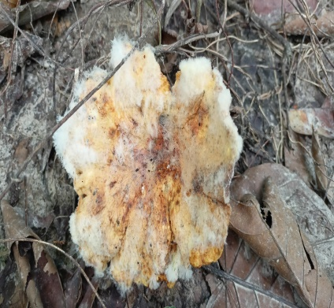 | 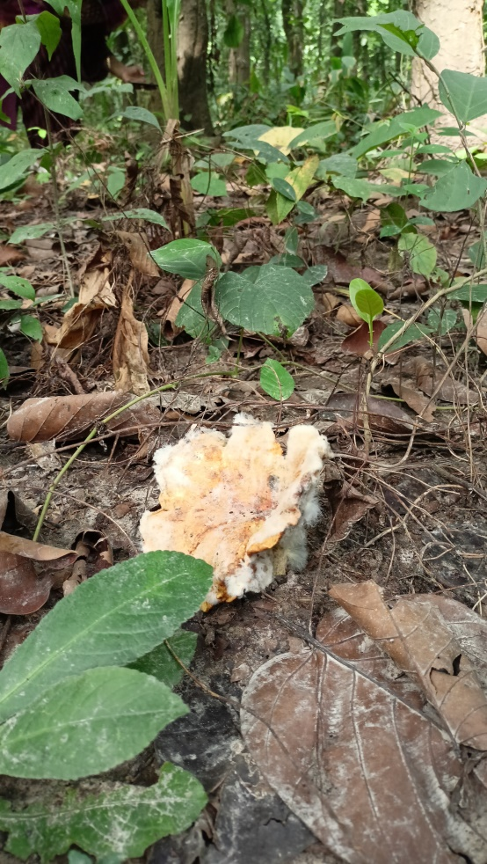
Lentinus sajorkaju | 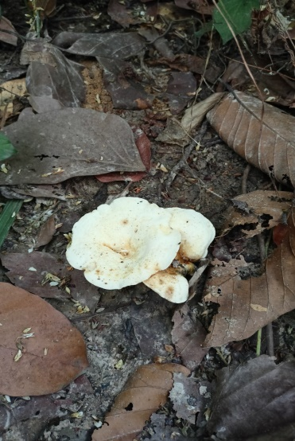 | 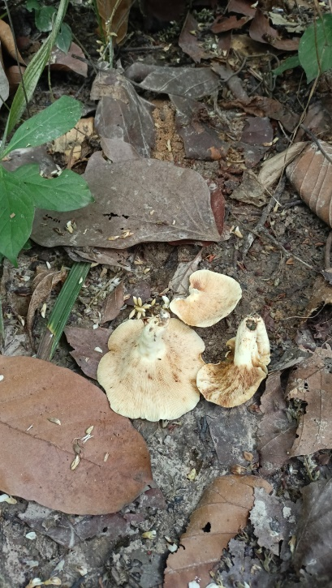
Leucopaxillus giganteus | 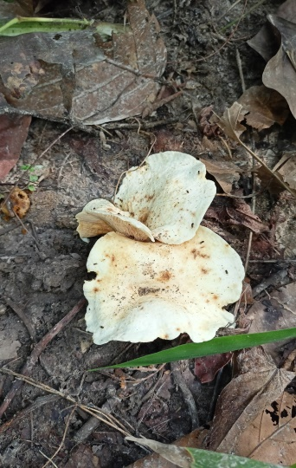 | 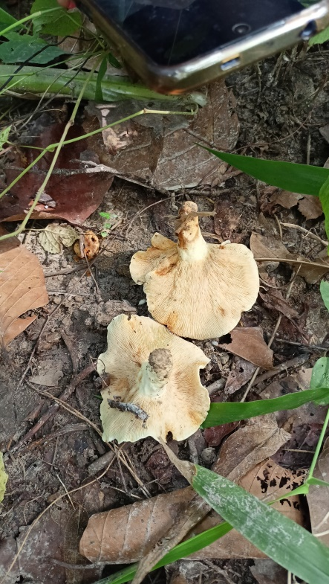
Lactarius citriolens | 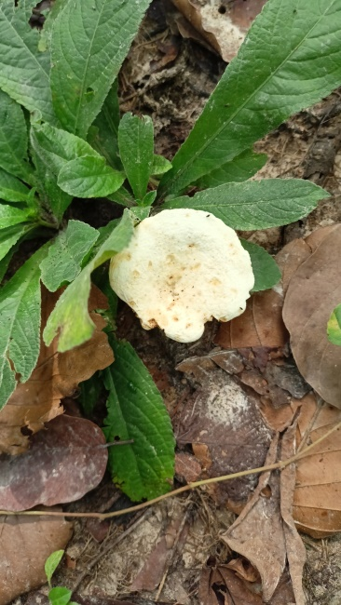 | 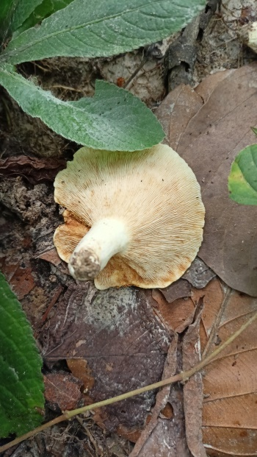
T. gibbosa | 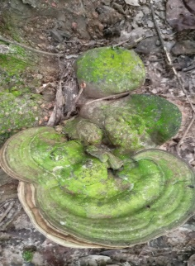 | 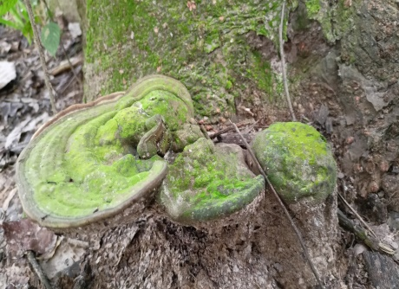

Plate 1. Woody Macrofungi collected from the selected Salforest regions of Bangladesh

Name | Fruiting body of the collected specimen
A. ovinus | 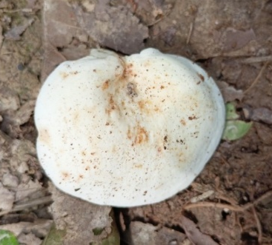 | 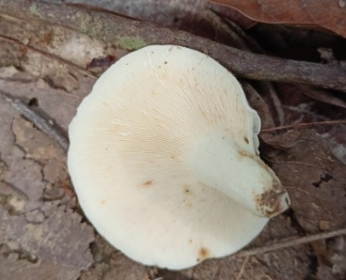
G. curtisii | 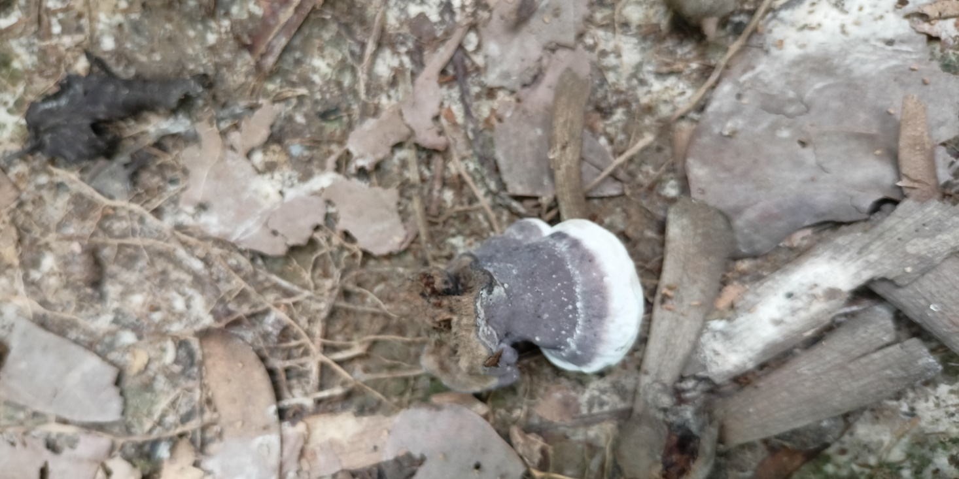 | 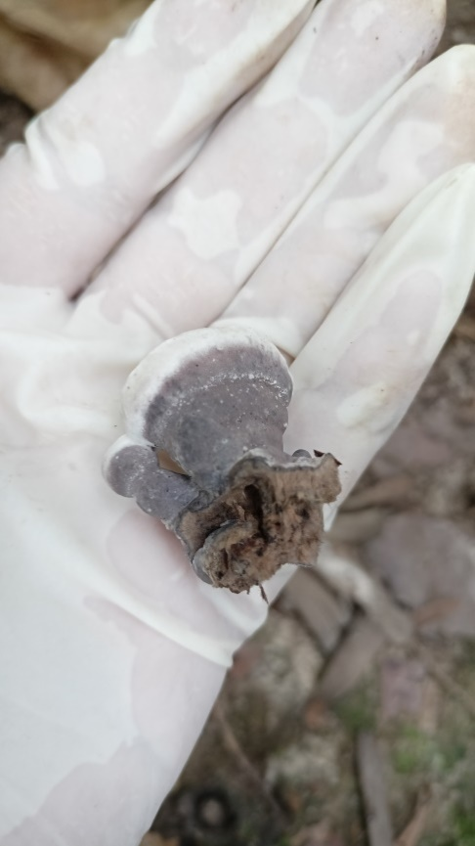
G. sp. | 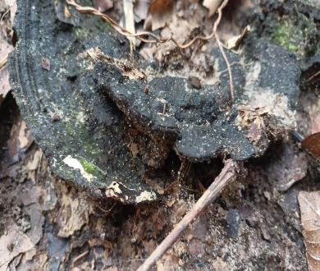 | 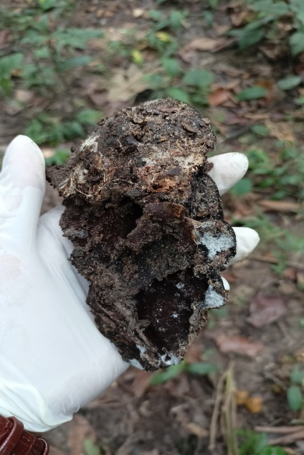
Cordyceps sp. | 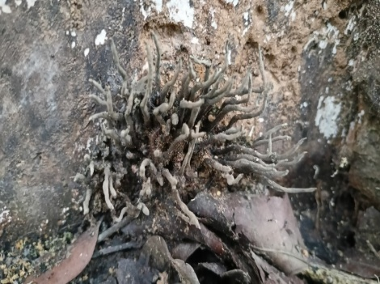 | 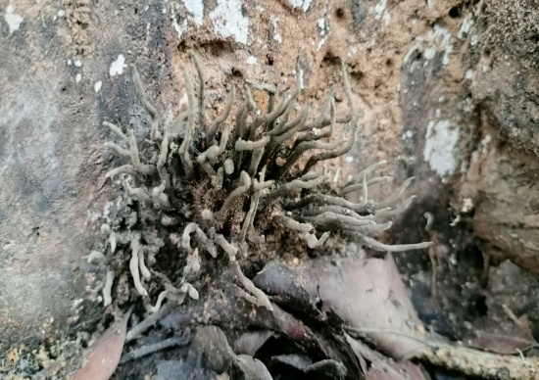
Plate 2. Woody Macrofungi collected from the selected Salforest regions of Bangladesh

Name | Fruiting body of the collected specimen
Cerioporus squamosus | 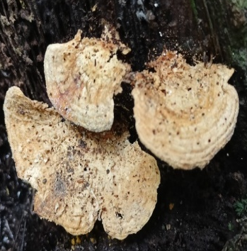 | 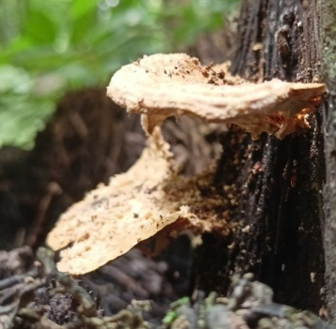 | 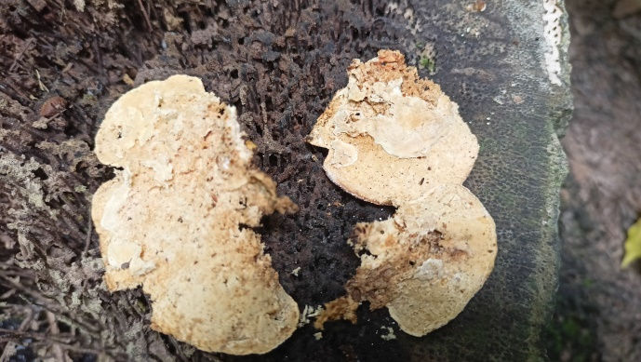
Gloeporus dichrous | 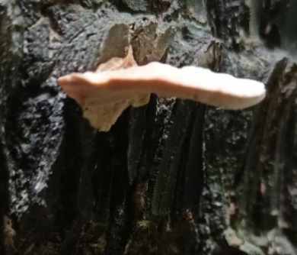 | 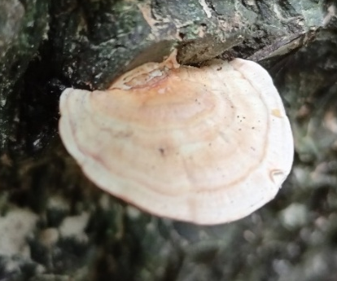 | 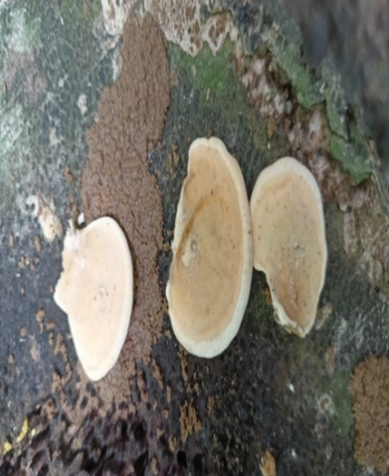
H. compactum | 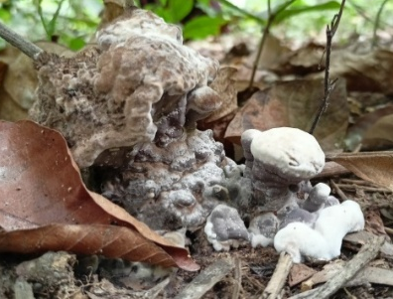 | 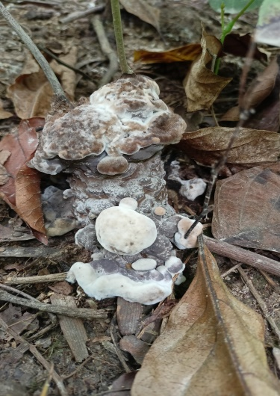 | 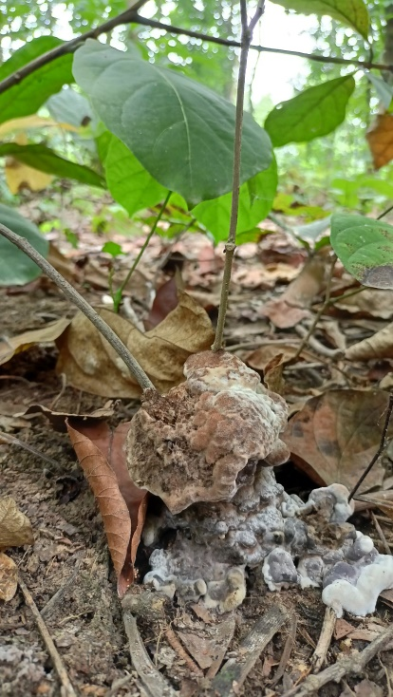
Daedaleopsis confragosa | 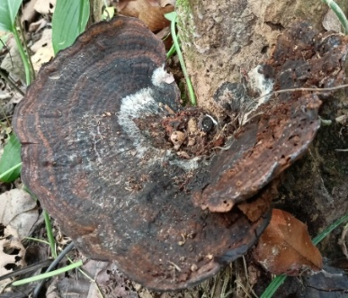 | 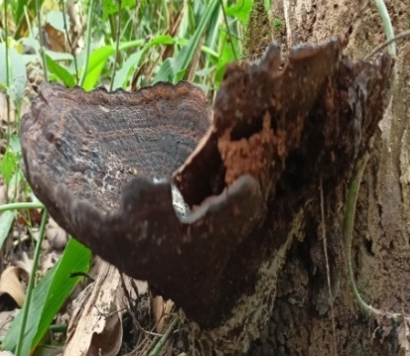 | 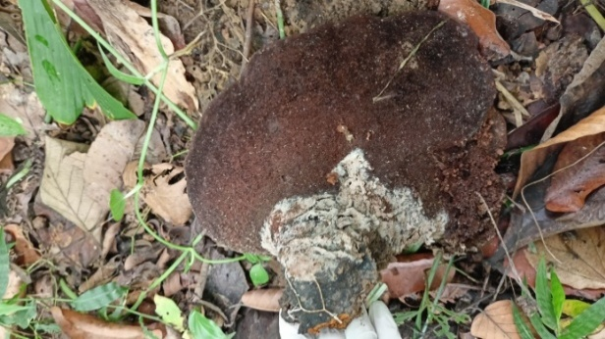
Plate 3. Woody Macrofungi collected from the selected Salforest regions of Bangladesh

Name | Fruiting body of the collected specimen
Xylobolus subpileatus | 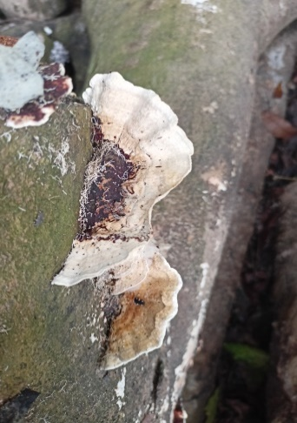 | 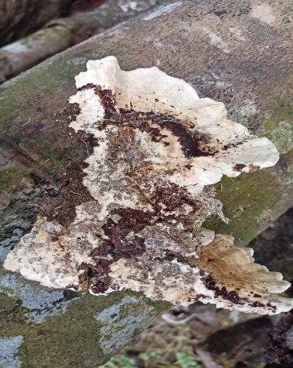 | 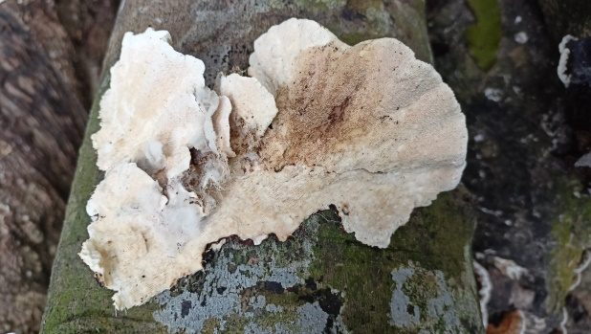
G. applanatum | 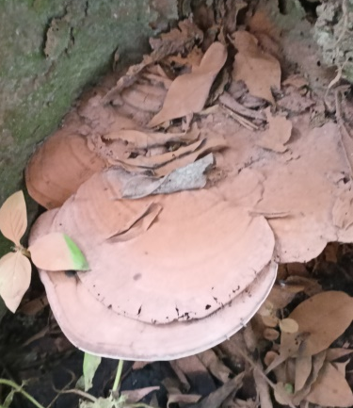 | 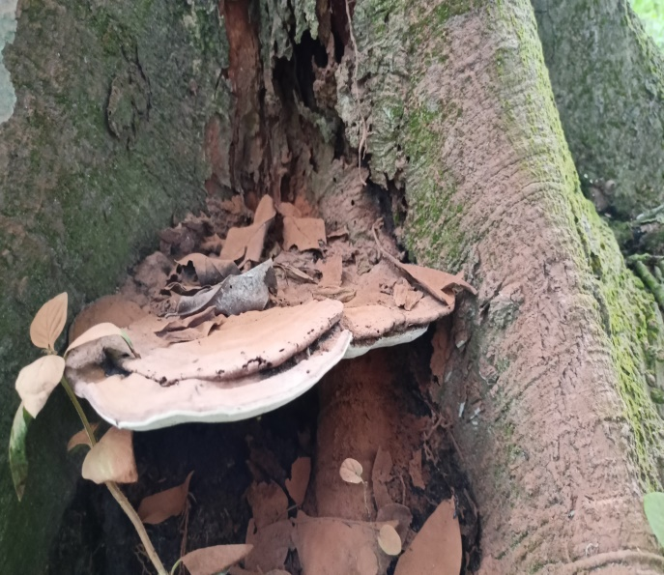 | 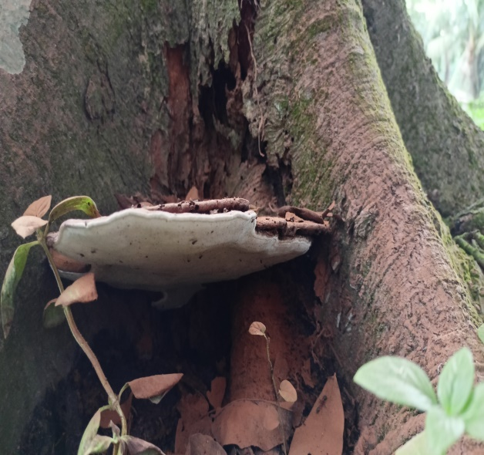
Inonotus obliquus | 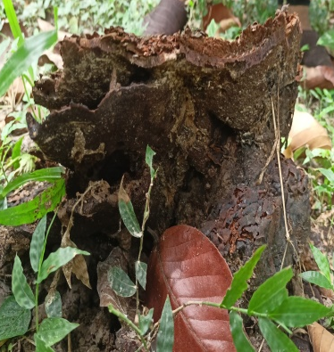 | 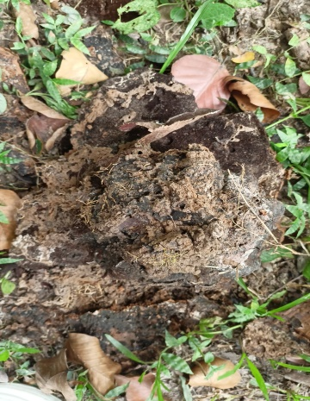 | 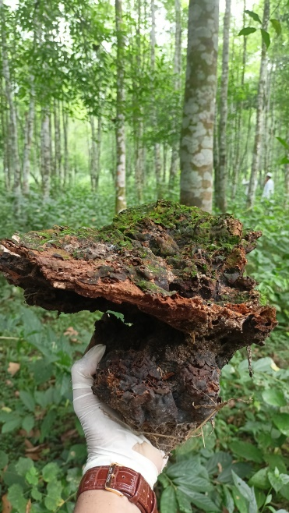
Plate 4. Woody Macrofungi collected from the selected Salforest regions of Bangladesh

Name | Fruiting body of the collected specimen
G. lucidum | 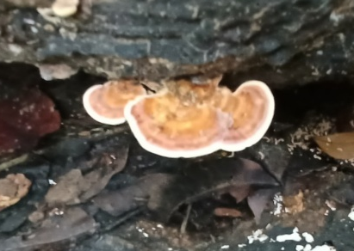 | 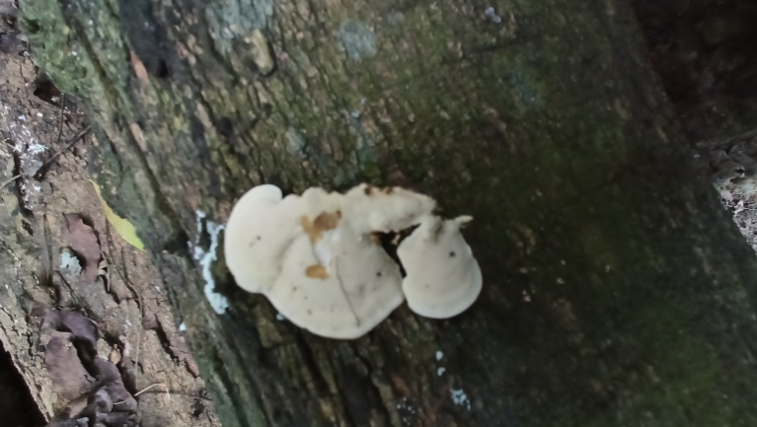
Phellinus hartigii | 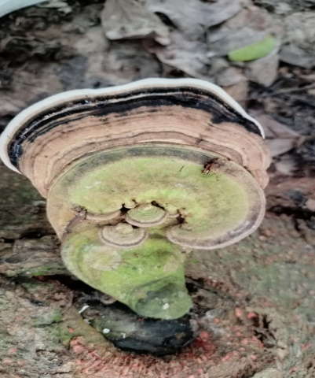 | 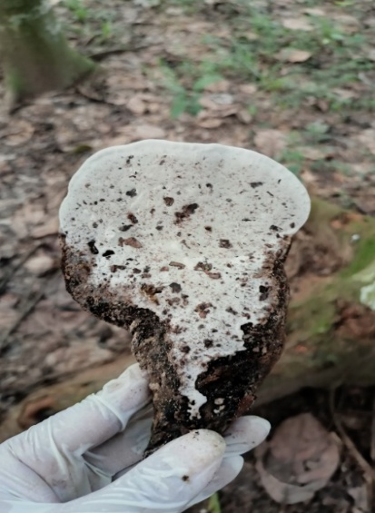
T. versicolor | 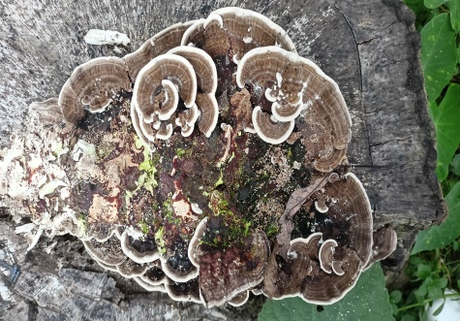 | 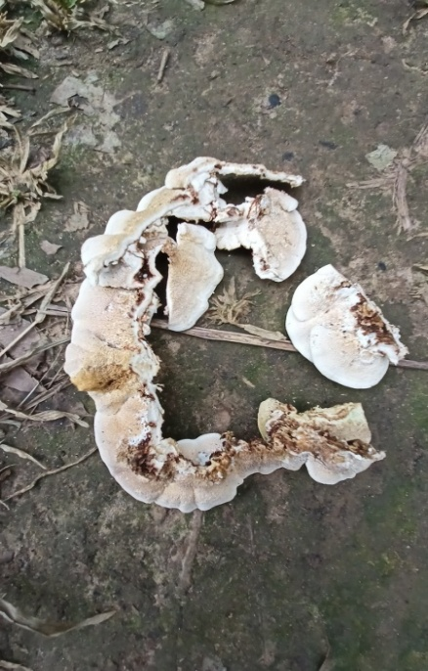
F. fomentarius | 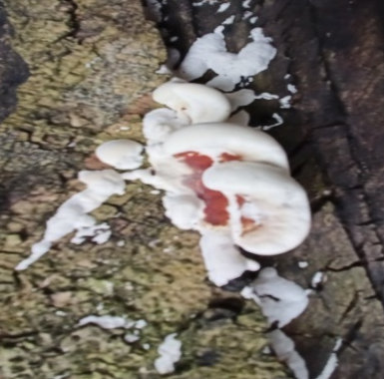 | 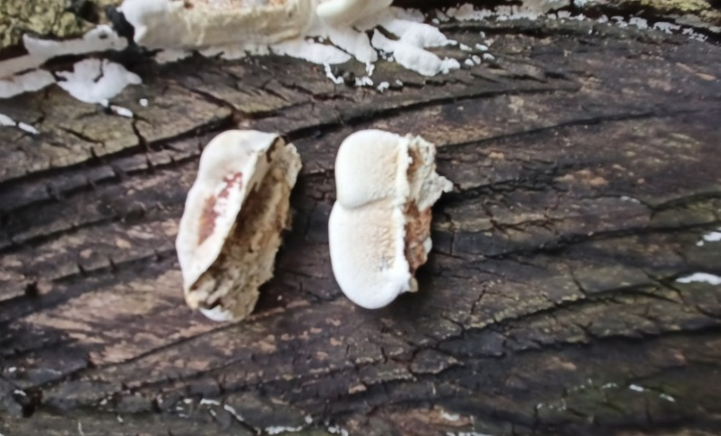
D. concentrica | 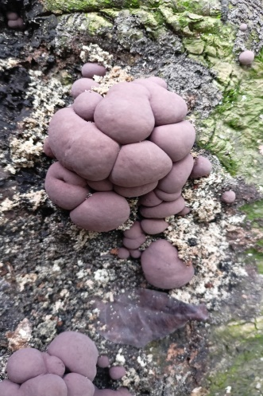 | 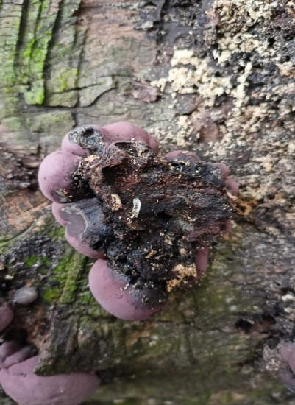
Plate 5. Woody Macrofungi collected from the selected Salforest regions of Bangladesh
Table 1. Year-wise Distribution (2022–2024) of Recorded Woody Macrofungi Species collected from Salforest regions of Bangladesh
Species | 2022 | 2023 | 2024
B. barkeleyi
Lentinus sajor-caju
Leucopaxillus giganteus
Lactarius citrolens
T. gibbosa
Lentinellus sp.
D. concentrica
A. ovinus
H. compactum
Daedaleopsis confragosa
G. curtisii
G. lucidum.
M. ramealis
G. sp.
Cerioporus squmosus
Gloeporus dichrous
Xylobolus subpileatus
G. applanatum
Phellinus hartigii
T. versicolor
F. fomentarius

The Table 1. lists mushroom species recorded across 2022, 2023, and 2024, showing clear year-to-year variation in species occurrence. Several species appeared only in a single year, indicating temporal or seasonal specificity, while some taxa such as Russula heterophylla, Daedaleopsis confragosa, F. fomentarius, and Cordyceps sp., occurred in more than one year, suggesting their consistent presence in the study area. A few species, including Coprinellus disseminatus and G. lucidum, were recorded only in 2022, whereas others, such as Tricholoma album, Russula delica, and Termitomyces sp. appeared only in 2023. Many wood-decaying species, such as Grifola frondosa, Neolentinus schaefferi, G. applanatum, and Phellinus hartigii, were unique to 2024, reflecting habitat differences or environmental dependency.

Table 2. Diversity analysis of woody macrofungi across different locations of the Salforest of Bangladesh
Sl. No. | Location | Number of Woody Macrofungi species (S) | Simpson index (D= 1/S) | Simpson’s Diversity Index (D.I.= 1-D)
1 | Rajendrapur Salforest, Gazipur | 6 | 0.167 | 0.833
2 | Potka (East) Salforest, Sreepur | 12 | 0.083 | 0.917
3 | Potka (West) Salforest, Sreepur | 10 | 0.100 | 0.900
4 | Uthulia range, Mymensingh | 9 | 0.111 | 0.889
5 | Sontoshpur Rubber Orchard, Mymensingh | 11 | 0.091 | 0.909
6 | Modhupur Salforest, Tangail | 6 | 0.167 | 0.833

The diversity of mushroom species across six surveyed locations in the Salforest region and the surrounding areas of Mymensingh and Gazipur was evaluated using Simpson’s Index (D) and Simpson’s Diversity Index (D.I.) (Table 2). Among the sites, Potka (East), Sreepur exhibited the highest diversity, with 12 recorded species, resulting in the lowest Simpson index (D = 0.083) and the highest Simpson’s Diversity Index (D.I. = 0.917), indicating a rich and evenly distributed fungal assemblage. Similarly, Sontoshpur Rubber Orchard and Potka (West), Sreepur demonstrated high diversity, with 11 and 10 species, corresponding to D values of 0.091 and 0.100 and D.I. values of 0.909 and 0.900, respectively. The Uthulia range recorded nine species, with moderately high diversity (D = 0.111; D.I. = 0.889). In contrast, Rajendrapur and Modhupur presented the lowest species richness, with six species each, yielding the highest Simpson index (D = 0.167) and the lowest Simpson’s Diversity Index (D.I. = 0.833), reflecting comparatively lower diversity and dominance of a few species.

Figure 1. Macrofungi species found in Rajendrapur Salforest, Gazipur, Bangladesh
The Doughnut chart (Figure 1) showed the relative distribution of mushroom species recorded from Rajendrapur, Gazipur. G. sp. and Russula delica had the highest occurrence (22% each), indicating their ecological dominance in the area. Coprinellus disseminatus followed with 17%, while Lactarius resimus and Auricularia auricula-judae each contributed 10%. Russula heterophylla accounted for 12%, and A. ovinus showed the lowest proportion at 7%.

Figure 2. Macrofungi species collected from Potka (East), Salforest, Sreepur, Bangladesh
The horizontal bar chart (Figure 2) represented the relative abundance of different wild mushroom species recorded from Potka (East), Sreepur. A total of twelve species were recorded. Lepiota sp. exhibited the highest abundance followed by M. ramealis and Lactarius controversus. Cordyceps sp. displayed the lowest frequency among all species.
Figure 3. Macrofungi species recorded from Potka (West) Salforest, Sripur, Bangladesh
The next bar graph (Figure 3) presented the frequency of mushroom species collected from Potka (West), Sreepur. Among the documented species, G. applanatum exhibited the highest frequency with 8 records, followed by D. concentrica (7), Russula emetica (6), Russula delica (5), and Termitomyces sp. The least abundant species in this site were Lactarius controversus and Inocybe geophylla, each recorded only 2 times.

Figure 4. Macrofungi species collected from Uthulia range Salforest, Valuka, Mymensingh, Bangladesh
The Pie of pie chart (Figure 4) showed the proportional abundance of nine macrofungal species recorded from the Uthulia range, Valuka, Mymensingh. Auricularia cornea had the highest proportion (16%), indicating strong ecological presence. G. lucidum, Macrolepiota albuminosa, and Russula delica followed with 14% and 12%, reflecting moderate, consistent occurrence. Clitocybe costata and Inocybe rimosa also contributed 12%. In contrast, Lentinus sajor-caju accounted for 8%, while Lentinellus sp. and G. curtisii each represented 6%, making them the least abundant.
Figure 5. Macrofungi species collected from Sontoshpur Rubber orchard, Bangladesh
The vertical bar graph (Figure 5) presented the comparative abundance of twelve macrofungal species recorded in the study area, revealing distinct variations in their distribution patterns. Daedaleopsis confragosa exhibited the highest abundance with a value of 8, indicating its strong ecological presence and successful establishment across the surveyed sites. This was followed by Amanita verna (6) and Cerioporus squomosus (5), both of which showed moderately high occurrences. The species with the minimum abundance (value 2) were F. fomentarius and Russula delica.

Figure 6. Macrofungi species found in Modhupur Salforest region of Bangladesh
The Pie of pie chart (Figure 6) showed notable variation in the relative abundance of six macrofungal species. T. versicolor was the most dominant, contributing 28%, followed by Russula delica at 24%. Lactarius citrolens and Gloeoporus dichrous each accounted for 14%, indicating moderate occurrence. The lowest proportions were recorded for Lactifluus vellereus and H. compactum, each contributing 10%.

Figure 7. Relative abundance of common woody macrofungi species recorded in the Salforest region of Bangladesh
In contrast, Lepiota, Termitomyces, and Coprinellus each contribute 9% of the total records. The pie chart (Figure 7) showed the proportional distribution of common fungal genera in the Salforest. G. dominated the records, contributing 37% and reflecting its strong ecological adaptability. Amanita and T. each accounted for 18%, representing the next highest proportions. In contrast, Lepiota, Termitomyces, and Coprinellus each contributed 9% of the total occurrences.

Figure 8. Families of woody macrofungi species collected from the Salforest region of Bangladesh
The bar chart (Figure 8) showed a distinctly uneven distribution of macrofungal species among the recorded families. Russulaceae exhibited the highest richness with 11 species, indicating its strong ecological adaptability in the Salforest. Polyporaceae followed with 6 species, reflecting its major role in wood decomposition. Marasmiaceae contributed 4 species, representing moderate prevalence. Tricholomataceae and Meripilaceae each recorded 3 species. Several families—including Inocybaceae, Agaricaceae, Amanitaceae, Lyophyllaceae, Stereaceae, and Auriculariaceae—were represented by 2 species each. In contrast, many families such as Auriscalpiaceae, Gloeophyllaceae, Entolomataceae, Albatrellaceae, Bankeraceae, G.taceae, Hygrophoraceae, Meruliaceae, Hymenochaetaceae, Hypoxylaceae, Cordycipitaceae, and Psathyrellaceae were represented by only one species.

Figure 9. Hosts of woody macrofungi recorded in the Salforest region of Bangladesh
The Bar of pie chart (Figure 9) showed the proportional distribution of host tree species associated with macrofungal occurrence. Shorea robusta had the highest share (26%), confirming its role as the primary substrate in the Salforest. Artocarpus heterophyllus and the “Others” group each contributed 17%, while Terminalia arjuna and Ficus benghalensis each accounted for 12%. Mangifera indica represented 11%, and Ficus religiosa had the lowest proportion at 5%, indicating minimal fungal association.

Table 3. Site-wise Variation in Sample Number, Fungal Morphotypes, Genera, and Species of woody macrofungi collected from Salforest region of Bangladesh
Sl. No. | Samples | Rjendrapur, Gazipur | Potka (East), Sreepur | Potka (West), Sreepur | Uthulia range, Valuka, Mymensingh | Sontoshpur rubber orchard, Fulbaria, Mymensingh | Modhupur | Total
1 | No. of samples | 7 | 12 | 10 | 9 | 11 | 6 | 55
2 | No. of fleshy samples | 4 | 7 | 7 | 7 | 5 | 4 | 34
3 | No. of woody samples | 3 | 5 | 3 | 2 | 6 | 2 | 21
4 | No. of genera | 6 | 11 | 8 | 8 | 11 | 6 | 50
5 | No. of species | 7 | 12 | 10 | 9 | 11 | 6 | 55

Table 3 summarizes the distribution of mushroom samples collected from six locations, showing clear variation in abundance, morphology, and taxonomic richness. Potka (East), Sreepur recorded the highest number of samples (12), followed by Sontoshpur rubber orchard (11) and Potka (West) (10), while Modhupur had the lowest (6). Fleshy samples were most abundant in Potka (East) and Potka (West) (7 each), whereas Modhupur produced only four. Woody samples were highest in Sontoshpur rubber orchard (6) and lowest in Uthulia and Modhupur (2 each). Genus-level richness was greatest in Potka (East) and Sontoshpur (11 genera each), while Rajendrapur and Modhupur recorded only six. Species richness showed a similar trend, with Potka (East) documenting the highest number (12) and Modhupur the lowest (6). In total, 55 samples (34 fleshy and 21 woody) representing 50 genera and 55 species were collected across all sites. Overall, the Sripur and Fulbaria regions supported higher macrofungal diversity compared with Modhupur and Rajendrapur.

Table 4. Morphological Characteristics of Woody Macrofungi recorded from the Salforest region of Bangladesh
Scientific Name | Basidiocarp Characteristics
Bondarzewia berkeleyi | Large rosette-like clustered caps; underside poroid; thick fibrous and corky flesh; saprotrophic at tree bases.
Lentinus sajor-caju | Semicircular to fan-shaped leathery cap; decurrent gills; tough fibrous context; eccentric or absent stipe; wood-decaying.
Leucopaxillus giganteus | Very large fleshy to fibrous cap; thick decurrent gills; stout stipe; tough context; usually on soil near woody debris.
Lactarius citrolens | Whitish cap with crowded decurrent gills exuding white latex; brittle flesh; often near woody roots; mycorrhizal.
Trametes gibbosa | Thick semicircular bracket; pale zonate surface; poroid underside; corky tough context; sessile on hardwood.
Lentinellus sp. | Small fan-shaped woody caps with serrated gill edges; hairy surface; tough fibrous flesh; wood saprotroph.
Daldinia concentrica | Cushion-shaped black stromata with concentric inner rings; hard charcoal-like texture; on dead hardwood.
Albatrellus ovinus | Fleshy polypore with pores beneath cap; soft to firm context; short central stipe; usually soil-associated near wood.
Hydnellum compactum | Irregular brown cap with tooth-like spines below; corky woody flesh; ectomycorrhizal, often near woody litter.
Daedaleopsis confragosa | Bracket-shaped fruit body with maze-like elongated pores; thin woody context; sessile on dead hardwood.
Ganoderma curtisii | Varnished reddish-brown kidney-shaped bracket; fine pores; hard woody context; lateral stipe; hardwood parasite/saprotroph.
Ganoderma lucidum | Shiny laccate reddish-brown cap with lighter margin; minute pores; corky-woody flesh; lateral to central stipe.
Marasmiellus ramealis | Very small brown cap; thin wiry stipe; tough leathery flesh; on twigs and woody debris.
Ganoderma sp. | Bracket-like varnished zonate cap; poroid underside; corky to woody context; lateral or central stipe.
Cerioporus squamosus | Large fan-shaped scaly cap; large round pores; thick eccentric stipe; firm then tough flesh; hardwood saprotroph.
Gloeporus dichrous | Small gelatinous-corky bracket; smooth moist surface; fine pores below; sessile on decaying wood.
Xylobolus subpileatus | Resupinate to small bracket form; smooth orange-brown surface; corky tough context; wood-inhabiting.
Ganoderma applanatum | Hoof-shaped dull brown perennial conk; small pores; very hard woody flesh; sessile on hardwoods.
Phellinus hartigii | Dark perennial woody bracket; minute pores; extremely hard context; sessile on living or dead wood.
Trametes versicolor | Thin multicolored zonate fan-shaped brackets; velvety surface; tiny pores; thin corky context; dead wood.
Fomes fomentarius | Large perennial hoof-shaped grey conk; concentric ridges; very hard woody interior; stipe absent.

Table 4. presented a concise summary of 21 woody macrofungi species, describing their key basidiocarp characteristics and ecological associations. It highlighted important diagnostic features such as cap shape and texture, hymenophore type, including gills, pores, or spines, stipe position, and the nature of the context, ranging from fleshy to corky or woody. Most species were bracket-forming polypores with poroid undersurfaces and tough perennial fruiting bodies growing on hardwood as saprotrophs or parasites. At the same time, a few were gilled or toothed forms associated with soil or woody litter. This table presents a concise summary of 21 woody macrofungi species, describing their key basidiocarp characteristics and ecological associations. It highlighted important diagnostic features such as cap shape and texture, hymenophore type, including gills, pores, or spines, stipe position, and the nature of the context, ranging from fleshy to corky or woody. Most species were bracket-forming polypores with poroid undersurfaces and tough perennial fruiting bodies growing on hardwood as saprotrophs or parasites. At the same time, a few were gilled or toothed forms associated with soil or woody litter.

4. Discussion
The diversity of woody macrofungi recorded in the Salforest demonstrated the ecological richness and complexity of this forest ecosystem, which provided abundant lignified substrates, stable humidity, and shaded microclimates essential for fungal colonization [13]. The presence of numerous lignicolous species across multiple families indicated a well-established decomposer community that actively broke down woody materials [1]. The continuous supply of fallen branches, decaying trunks, stumps, and standing dead trees — particularly of Shorea robusta, Mangifera indica, Artocarpus heterophyllus, Albizia lebbeck, Acacia auriculiformis, and Tectona grandis — supported a thriving assemblage of saproxylic fungi, as similar forests in Bangladesh yielded abundant wood-decay fungi such as members of the genus G. on mixed-species trees [8]. Auricularia auricula-judae, a gelatinous, ear-shaped wood-decaying basidiomycete of the family Auriculariaceae, was recorded from the tropical moist deciduous forest regions in Bangladesh, growing on dead or decaying hardwoods, including elder (Sambucus), mango (Mangifera), and jackfruit (Artocarpus) [24]. Its occurrence reflects a preference for humid, shaded microenvironments with abundant decaying wood, which supports its saprotrophic growth [26]. In Bangladesh, Lentinellus was recorded from Mymensingh [25], and Sylhet [3], typically fruiting during the monsoon on decaying logs and stumps in shaded, humid forest floors.
Species such as G. lucidum and T. versicolor were dominant and widely distributed across all sites, reflecting their broad ecological amplitude and competitive ability to colonize diverse host trees. Their occurrence on both freshly fallen and heavily decayed wood suggested their role across multiple stages of decomposition. G. lucidum, with its capacity to cause white rot, was frequently collected on decaying wood and showed the highest density among G. species in tropical moist deciduous forests of Bangladesh [8]. Similarly, G. lucidum was observed fruiting on decaying wood in deciduous forests of Odisha, India, highlighting its natural occurrence in mixed-wood forests [14]. T. versicolor and other white-rot polypores were documented across a range of forest types in Southeast Xizang, China, demonstrating their widespread role in lignin and cellulose degradation [15]. More broadly, polypore fungi, including G. and T., contributed significantly to nutrient cycling and wood decomposition in tropical forest ecosystems [16].
The detection of D. concentrica, Bondarzewia barkeleyi, and Phellinus species indicated the presence of advanced wood-decay stages, as these taxa typically developed on heavily degraded or long-standing deadwood. Their occurrence highlighted active nutrient turnover and demonstrated that the Salforest supported fungi specialized in the later phases of decomposition. For instance, D. concentrica has been reported to produce phenol-oxidase activity and degrade angiosperm wood extensively [17], while species of Xylariaceae, including Xylaria, were able to cause type I and type II soft-rot degradation with significant biomass loss, indicating their ecological role in nutrient cycling [18]. These species also signaled the presence of microhabitats with stable moisture and shade, which are essential for their fruiting.
Family-level patterns further supported these ecological observations. Polyporaceae, G.taceae, and Xylariaceae were the most represented families, aligning with their global dominance in tropical wood-decay processes. White-rot polypores, in particular, preferentially colonize angiosperm wood due to its relatively oxidizable lignin, contributing to lignocellulosic breakdown [19]. In older and more decomposed wood, white-rot and brown-rot fungi were observed to dominate advanced decomposition stages, underscoring their roles in carbon cycling and soil enrichment [20]. The consistent presence of such families across multiple sites suggested that the Salforest hosted a functionally important decomposer guild.
Site-wise variation in species richness and frequency reflected differences in microhabitat structure, canopy density, substrate diversity, and human disturbance. For example, it was found in unmanaged forests that “overall species richness increased as the forest naturalness increased, both at the site and log levels” [21]. Sites such as Potka-1, Potka-2, and Sontoshpur likely supported higher fungal diversity due to abundant coarse woody debris and minimal anthropogenic interference. In contrast, in managed or disturbed forests, fungal species richness tended to decline: wood-decaying basidiomycete richness was significantly lower in plots with reduced deadwood and frequent tree-fall disturbance [22]. Thus, Madhupur’s comparatively lower diversity may be tied to reduced deadwood, selective logging, grazing pressure, or forest fragmentation — conditions that, as shown in several studies, limit substrate availability and stable microhabitats crucial for wood decay fungi. [23].
5. Conclusion
This study recorded 21 species of woody macrofungi from the Salforest region of Bangladesh, representing ecologically important lignicolous taxa. Dominant species included G. lucidum, T. versicolor, D. concentrica, and T. gibbosa. Their distribution patterns reflect substrate availability, habitat characteristics, and decomposition stages. The findings highlight the essential role of woody macrofungi in maintaining forest health and provide baseline information for future taxonomic and ecological research.
Acknowledgement
This research was financially supported by Sher-e-Bangla Agricultural University Research System (SAURES) (2022-2023), Bangladesh. We thank the anonymous local people who helped during sampling in the forest.

Disclaimer (Artificial intelligence)
Author(s) hereby declare that NO generative AI technologies such as Large Language Models (ChatGPT, COPILOT, etc.) and text-to-image generators have been used during the writing or editing of this manuscript.

References
1. Tanni, J. F., Aminuzzaman, F. M., Ahmed, M. and Rahaman, M. (2020). Diversity and distribution of macro fungi in some selected parks and gardens of Dhaka city, Bangladesh. Asian Journal of Biology. 9(1): 23–43. journalajob.com
2. Rubina, H., Aminuzzaman, F. M., Chowdhury, M. S. M. and Das, K. (2017). Morphological characterization of macro fungi associated with forest tree of National Botanical Garden, Dhaka. Journal of Advances in Biology & Biotechnology. 11(4): 1–18. Journal Jabb
3. Tanjim, A., Aminuzzaman, F. M., Rahaman, M. and Tanni, J. F. (2019). Biodiversity, distribution and morphological characterization of macrofungi in Sylhet and Moulvibazar under tropical evergreen and semi-evergreen forest regions of Bangladesh. International Journal of Advanced Research. 7(11): 567–589.
4. Marzana, A., Aminuzzaman, F. M., Chowdhury, M. S. M., Mohsin, S. M. and Das, K. (2018). Diversity and ecology of macrofungi in Rangamati of Chittagong Hill Tracts under tropical evergreen and semi-evergreen forest of Bangladesh. Advances in Research. 13(5): 1–17.
5. Rumainul, M. I., Aminuzzaman, F. M. and Chowdhury, M. S. M. (2015). Biodiversity and morphological characterization of mushrooms at the tropical moist deciduous forest region of Bangladesh. Journal of Experimental Agriculture International. 8(4): 235–252.
6. Rashid, S. N., Aminuzzaman, F. M., Islam, M. R., Rahaman, M. and Rumainul, M. I. (2016). Biodiversity and distribution of wild mushrooms in the southern region of Bangladesh. Advances in Biology & Biotechnology. 9(1): 1–25. Journal Jabb
7. Das, K. and Aminuzzaman, F. M. (2017). Diversity of fleshy macro fungi in mangrove forest regions of Bangladesh. Journal of Biology and Nature. 6(4): 218–241. ikprress.org
8. Mafia, M. I., Aminuzzaman, F. M., Chowdhury, M. S. M. and Tanni, J. F. (2020). Occurrence, diversity and morphology of poroid wood decay by Ganoderma spp. from tropical moist deciduous forest region of Bangladesh. Journal of Agriculture and Natural Resources. 3(2): 16.
9. Aminuzzaman, F. M. and Das, K. (2017). Morphological characterization of polypore macro fungi associated with Dalbergia sissoo collected from Bogra district under social forest region of Bangladesh. Journal of Biology and Nature. 6(4): 199–212. ikprress.org
10. Joty, A. A., Aminuzzaman, F. M., Sultana, N., Tanjina, A., Sonchita, D. R. B. and Islam, M. N. (2020). Diversity, distribution and morphology of wild mushrooms collected from Gajni Forest of Bangladesh. International Journal of Environment. 9(2): 234–255.
11. Sonchita, D. R. B., Aminuzzaman, F. M., Joty, A. A., Tanni, J. F., Islam, M. N. and Rahaman, M. (2020). Diversity, distribution and morphological characterization of wild macro fungi from Gajni Forest. Asian Journal of Biology. 9(2): 19–32. journalajob.com
12. Zoberi, M. H. (1973). Some edible mushrooms from Nigeria. Nigerian Field. 38: 81–90.
13. Baral, S., Thapa-Magar, K., Karki, G., Devkota, S., & Shrestha, B. B. (2015). Macrofungal diversity in community-managed Sal (Shorea robusta) forests in central Nepal. Mycology, 6(3-4), 151–157.
14. Singh, S., & Das, K. (2019). A study on genus Ganoderma from deciduous forests of Odisha, India. Journal of Biology and Medicine, 5(1), 12–20.
15. Zhang, Y., Li, X., Wang, H., & Chen, J. (2024). Diversity of wood-decay basidiomycetes in southeast Xizang: Occurrence across different forest types. Mycology, 15(1), 45–58.
16. Liu, W., Zhao, L., & Xu, Y. (2024). Polypore fungi in tropical forests: Roles in nutrient cycling and wood decomposition. Forest Ecology and Management, 556, 120632.
17. Ju, Y. M., & Rogers, J. D. (2002). Daldania and its allied genera. Mycologia, 94(3), 547–574.
18. Zhang, Y., Li, X., Wang, H., & Chen, J. (2023). Diversity of Xylariaceae in tropical forests and their wood-decay capabilities. Fungal Ecology, 61, 101–112.
19. Bari, E., Nazarnezhad, N., Kazemi, S. M., Tajick Ghanbary, M. A., Mohebby, B., Schmidt, O., & Clausen, C. A. (2015). Comparison between degradation capabilities of the white-rot fungi Pleurotus ostreatus and Trametes versicolor in beech wood. International Biodeterioration & Biodegradation, 103, 1–9.
20. Loyd, A. L., Barnes, C. W., Held, B. W., Schink, M. J., & Smith, M. E. (2018). Elucidating wood decomposition by four species of white-rot fungi. Fungal Ecology, 36, 70–78.
21. Siitonen, J., Kuusinen, M., & Renvall, P. (2021). Wood-inhabiting fungal responses to forest naturalness vary among morpho-groups. Scientific Reports, 11, 12345.
22. ISCA. (2015). Decomposition of wood by polypore fungi in tropical forests: A case study. International Research Journal of Agricultural and Forestry Sciences, 3(8), 45–52.
23. Forest Management Review. (2020). How does forest management affect fungal diversity and community composition? Forest Ecology and Management, 465, 118076.
24. Rumainul, M. I. & Aminuzzaman, F. M. (2016). Macro fungi biodiversity at the central and northern biosphere reserved areas of tropical moist deciduous forest region of Bangladesh. Journal of Agriculture and Ecology Research International, 5(4), 1–11. journaljaeri.com
25. Das, K., Aminuzzaman, F. M. & Akhtar, N. (2020). Diversity, distribution and morphology of wild mushrooms collected from Gajni Forest of Bangladesh. International Journal of Environment, 9(2), 234–255. Nepjol
26. Fei, Y., Zhang, J., Yuan, S., Liu, Y., Wang, X., Wang, M., Zhao, H., & Liu, Q. (2025). Ameliorating potential of Auricularia auricula-judae polysaccharides in mitigating behavioral disorders through gut microbiota regulation. Frontiers in Nutrition, 12(1), 1585778.
27. Fogarasi, M., Nemes, S. A., Fărcaş, A., Socaciu, C., Semeniuc, C. A., Socaciu, M. & Socaci, S. (2024). Bioactive secondary metabolites in mushrooms: A focus on polyphenols, their health benefits and applications. Food Bioscience, 62, 105166.
28. Amuzu, P., Pan, X., Hou, X., Sun, J., Jakada, M. A., Odigie, E., Xu, D. & Lai, D. (2024). Recent updates on the secondary metabolites from Fusarium fungi and their biological activities. Journal of Fungi, 10(11), 778.

