Soxhlet Extraction and Quantification of Gallic Acid and Quercetin from Moringa oleifera Leaves by HPLC

Abstract
Moringa oleifera is a nutritionally and medicinally important plant widely recognized for its rich phytochemical composition, particularly phenolic acids and flavonoids. The present study aimed to evaluate extraction efficiency and quantify major antioxidant markers, gallic acid and quercetin, in methanolic and aqueous leaf extracts. Soxhlet extraction was carried out using methanol and distilled water, and both solvents yielded measurable extractable fractions. The total phenolic content (TPC), determined using the Folin–Ciocalteu method, was higher in the methanolic extract compared to the aqueous extract. Similarly, the total flavonoid content (TFC), measured by the aluminum chloride assay, was also greater in the methanolic extract than in the aqueous extract. High-Performance Liquid Chromatography (HPLC) analysis confirmed the presence of gallic acid and quercetin in both extracts. The methanolic extract exhibited higher concentrations of these compounds compared to the aqueous extract. Retention times showed close agreement with standard references, confirming chromatographic accuracy and specificity. Overall, the findings demonstrate that methanolic extraction is more efficient than aqueous extraction for isolating phenolic and flavonoid compounds from Moringa oleifera leaves. These results highlight the strong antioxidant potential of Moringa oleifera, supporting its application in nutraceutical, herbal, and pharmaceutical formulations.
Keywords: Moringa oleifera; Soxhlet extraction; Total phenolic content; Total flavonoid content; Gallic acid; Quercetin; HPLC analysis; Antioxidants; Phytochemicals; Methanolic extracts.

1. Introduction
Moringa oleifera Lam., commonly known as the drumstick tree, is a nutritionally and medicinally important plant belonging to the family Moringaceae. It is widely distributed in tropical and subtropical regions, particularly across South Asia, Africa, and parts of South America. In India, especially in the Hathwa region of Bihar, located in South Asia on the Asian continent, Moringa oleifera is commonly cultivated and traditionally used for nutritional and therapeutic purposes due to its rich phytochemical composition and accessibility in rural healthcare systems (Alia et al., 2022). Medicinal plants used in the Hathwa region of Bihar, India, possess significant ethnopharmacological value, as local populations depend heavily on plant-based remedies for treating infections, inflammation, and metabolic disorders. This reinforces the importance of Moringa oleifera leaves as a natural and sustainable source of therapeutic phytochemicals (Ahmad et al., 2020; Shea, 2023). Among various plant parts, the leaves of Moringa oleifera contain the highest concentration of bioactive compounds, including phenolic acids, flavonoids, vitamins, carotenoids, essential amino acids, and minerals. These phytochemicals contribute significantly to its antioxidant capacity and therapeutic potential (Saini et al., 2021; Moyano et al., 2021). Recent studies have demonstrated that Moringa oleifera leaf extracts exhibit diverse pharmacological activities such as antioxidant, anti-inflammatory, antimicrobial, antidiabetic, and antihyperlipidemic effects, supporting their application in both traditional and modern medicine (Alia et al., 2022). Ethnomedicinal surveys conducted in Bihar, India (Asia), have reported that several leafy medicinal plants, including Moringa oleifera, are traditionally used for wound healing and treatment of skin infections. These therapeutic effects are largely attributed to their phenolic and flavonoid content, which play an important role in reducing oxidative stress and inhibiting microbial growth (Ahmad et al., 2020).
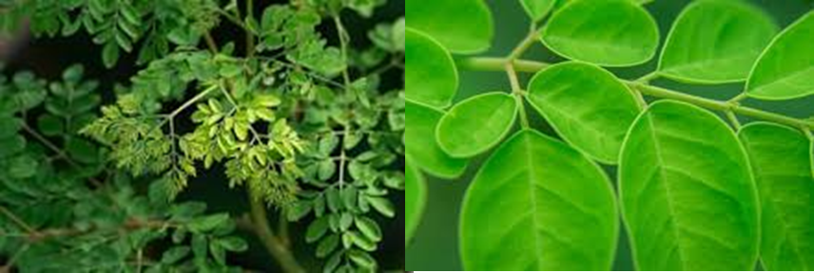
Fig. 1. Moringa oleifera leaves
Phenolic and flavonoid compounds such as gallic acid and quercetin are recognized as important antioxidant markers due to their strong free radical scavenging activity and protective effects against oxidative stress-related disorders. These compounds contribute significantly to the antioxidant and pharmacological properties of medicinal plants, including Moringa oleifera (Sharma et al., 2023; Mukherjee et al., 2024). The accumulation of phenolic compounds in plants is influenced by several factors, including solvent polarity, extraction method, and environmental conditions such as soil composition, moisture content, and climatic factors. These environmental and methodological variations may significantly affect the phytochemical profile and therapeutic potential of plant extracts (Sharma et al., 2023).
Efficient extraction techniques are essential for isolating bioactive phytochemicals from plant materials. Soxhlet extraction remains one of the most effective conventional extraction methods due to its ability to ensure continuous solvent circulation and efficient recovery of phenolic compounds. Methanol, due to its intermediate polarity, has been reported to be particularly effective in extracting phenolic and flavonoid compounds compared to aqueous solvents (Saini et al., 2021). For accurate identification and quantification of phenolic markers such as gallic acid and quercetin, High-Performance Liquid Chromatography (HPLC) is considered a gold-standard analytical technique due to its high sensitivity, specificity, and reproducibility. HPLC enables precise identification of compounds based on their characteristic retention times and peak profiles, ensuring reliable phytochemical characterization of medicinal plants (Srivastava et al., 2024; Sharma et al., 2023).
Although several studies have reported the medicinal importance of Moringa oleifera, limited research has focused on comparative evaluation of phenolic and flavonoid content and chromatographic profiling of Moringa oleifera leaves collected from the Hathwa region of Bihar, India (Asia), where environmental and ecological factors may influence phytochemical composition.
Therefore, the objective of the present study was to evaluate and compare the total phenolic content (TPC), total flavonoid content (TFC), and HPLC-based quantification of key antioxidant markers, gallic acid and quercetin, in methanolic and aqueous extracts of Moringa oleifera leaves collected from Hathwa, Bihar, India (Asia). The study also aimed to assess the influence of solvent polarity on extraction efficiency and phytochemical recovery. The findings of this study will contribute to scientific validation of the traditional medicinal use of Moringa oleifera and support its potential application in pharmaceutical and nutraceutical development.

2. Materials and Methods
2.1 Plant Material Collection and Preparation
Fresh leaves of Moringa oleifera were collected from local cultivation sites and thoroughly washed to remove surface impurities (Ahmad, 2016). The leaves were shade-dried at room temperature to preserve heat-sensitive phytochemicals and then ground into a fine powder using a sterile mechanical grinder. The powdered material was stored in airtight containers until extraction (Rodríguez et al., 2015)
2.2 Soxhlet Extraction
The shade-dried leaf powder (5 g) of Moringa oleifera was subjected to Soxhlet extraction using two different solvents, methanol and distilled water, to ensure efficient solubilization of phytoconstituents (Zhao & Zhang, 2013). Each extraction was performed for 6 hours, followed by concentration of the solvent fractions using a rotary evaporator under reduced pressure, after which the extracts were dried to a constant weight (Baitha & Ahmad, 2019). The percentage extraction yield for both solvent systems was determined gravimetrically using the formula:
% yield = (weight of extract after dry / dry weight of the sample) × 100
.
Methanol primarily extracts moderately polar bioactive compounds such as phenolics and flavonoids, whereas water dissolves a broader spectrum of hydrophilic constituents including polysaccharides, tannins, proteins, and water-soluble phenolics (Zou et al., 2024). Due to this difference in solvent polarity, aqueous extracts generally show higher extraction yields, while methanolic extracts often contain a more concentrated profile of pharmacologically active metabolites. The yields obtained from both methanolic and aqueous extracts were recorded and utilized for subsequent determination of Total Phenolic Content (TPC), Total Flavonoid Content (TFC), and HPLC-based quantification of gallic acid and quercetin. Sequential solvent extraction enhances the recovery of moderately polar phytochemicals, especially phenolics and flavonoids. This observation supports the superior extraction efficiency of methanol found in the present Moringa study (Kumari & Singh, 2020).
2.3 Determination of Total Phenolic Content (TPC)
The Total Phenolic Content (TPC) of Moringa oleifera leaf extracts was determined using the widely accepted Folin–Ciocalteu colorimetric method, following the protocol described by Hossain et al., (2017). For the analysis, 0.1 mL of the extract (1 mg/mL) was mixed with Folin–Ciocalteu reagent, followed by the addition of sodium carbonate solution to initiate the color development reaction. The mixture was incubated for 1.5 hours in the dark to allow complete formation of the chromophore complex. The absorbance was measured at 765 nm using a UV–Visible spectrophotometer. A standard calibration curve was prepared using gallic acid at different concentrations, and the phenolic content of each extract was quantified based on this curve. Final results were expressed as milligrams of Gallic Acid Equivalent per gram of extract (mg GAE/g), indicating the total concentration of phenolic compounds present in the sample.
2.4 Determination of Total Flavonoid Content (TFC)
The Total Flavonoid Content (TFC) of Moringa oleifera leaf extracts was determined using the AlCl₃ colorimetric method, a widely used procedure for flavonoid quantification in plant extracts (Chang et al., 2002). For the assay, 1 mg/mL of the extract was mixed with methanol, followed by the addition of 10% aluminum chloride (AlCl₃), 1 M potassium acetate, and distilled water. The reaction mixture was allowed to incubate at room temperature for 30 minutes, enabling the formation of a stable flavonoid–AlCl₃ complex. After incubation, absorbance was measured at 415 nm using a UV–Visible spectrophotometer. A calibration curve was prepared using quercetin as the standard flavonoid, and the flavonoid content of each extract was calculated accordingly. Final results were expressed as milligrams of Quercetin Equivalent per gram of extract (mg QE/g), reflecting the total flavonoid concentration in the sample.

2.5 Determination of Gallic Acid in the Moringa oleifera Extracts

2.5.1 Preparation of Mobile Phase
For the quantification of gallic acid in Moringa oleifera extracts, a mobile phase consisting of Water: Acetonitrile (80:20, v/v) was used. The pH was adjusted to 3.00 using O-phosphoric acid. The prepared mobile phase was degassed in an ultrasonicator for 15 minutes prior to use to remove dissolved gases and ensure stable chromatographic performance.

2.5.2 Preparation of Standard Stock Solution
A standard stock solution of gallic acid was prepared by dissolving 1 mg of the reference standard in 1 mL of methanol. Working standard solutions were prepared through appropriate serial dilutions to obtain concentrations of 40 μg/mL, 20 μg/mL, and 10 μg/mL. These standards were used to generate a calibration curve for quantification (Sawant et al., 2010).

2.5.3 Preparation of Sample Extract
The dried methanolic and aqueous extracts of Moringa oleifera were dissolved in methanol to obtain a 1 mg/mL stock solution. From this, a 100 μg/mL working concentration was prepared using methanol. The solutions were sonicated for 10 minutes to ensure complete solubilization and subsequently filtered through a 0.2 μm, 13 mm nylon membrane filter before injection into the HPLC system.

2.5.4 Chromatographic Conditions
Table 1. Chromatographic Conditions for the Quantification of Gallic Acid Using Agilent TC-C18(2)® HPLC Column.
S. No. | Parameter | Condition
1 | Stationary phase | Agilent TC-C18(2), 4.6 × 250 mm, 5 μm
2 | Mobile phase | Water : ACN (80:20); pH 3.00 adjusted with O-phosphoric acid
3 | Detection wavelength | 272 nm
4 | Flow rate | 1 mL/min
5 | Injection volume | 10 μL
6 | Temperature | Ambient
7 | LC system | Agilent HPLC system with OpenLab CDS 2 software

2.7 Determination of Quercetin in the Moringa oleifera Extracts

2.7.1 Preparation of Mobile Phase
For the quantification of quercetin in Moringa oleifera extracts, a mobile phase consisting of Acetonitrile: Methanol (40:60, v/v) was prepared. The mobile phase was degassed in an ultrasonicator for 15 minutes to eliminate air bubbles and ensure stable baseline performance during chromatographic analysis.

2.7.2 Preparation of Standard Stock Solution
A standard stock solution of quercetin was prepared by dissolving 1 mg of the quercetin standard in 1 mL of methanol. From this stock, working standard solutions were prepared by appropriate dilution to obtain concentrations of 20 μg/mL, 10 μg/mL, and 5 μg/mL, which were used to construct the calibration curve for quantification (Guideline 2005).

2.7.3 Preparation of Sample Extract
The concentrated methanolic and aqueous extracts of Moringa oleifera leaves were dissolved in methanol to form a 1 mg/mL stock solution. A working solution of 100 μg/mL was prepared from this stock. The sample solutions were sonicated for 10 minutes to ensure complete dissolution and filtered through a 0.2 μm, 13 mm nylon membrane filter prior to HPLC injection.

2.7.4 Chromatographic Conditions
Table 2. Chromatographic Conditions for the Quantification of Quercetin Using Agilent TC-C18(2)® HPLC Column.
S. No. | Parameter | Condition
1 | Stationary phase | Agilent TC-C18(2), 4.6 × 250 mm, 5 μm
2 | Mobile phase | ACN : Methanol (40:60)
3 | Detection wavelength | 317 nm
4 | Flow rate | 1 mL/min
5 | Injection volume | 10 μL
6 | Temperature | Ambient
7 | LC system | Agilent HPLC system with OpenLab CDS 2 software

2.7 Statistical Analysis
All experiments were performed in triplicate, and results were expressed as mean ± standard deviation (SD). Statistical analysis was carried out using standard statistical software. Calibration curves for gallic acid and quercetin were constructed using linear regression analysis. Differences between methanolic and aqueous extracts were evaluated using appropriate statistical methods, and significance was considered at p < 0.05 (Sharma et al., 2023).
3. Results
3.1 Extractive Yield (%)
The extractive yield of Moringa oleifera leaves was calculated based on the dried weight of the methanolic and aqueous extracts obtained after Soxhlet extraction. The extraction results showed that the methanolic extract (MO-M) produced a higher yield (12.56%) compared to the aqueous extract (MO-A) (10.21%). Methanol is an effective solvent for extracting moderately polar phytoconstituents such as phenolics, flavonoids, and other bioactive compounds, which may contribute to its comparatively higher extraction efficiency. In contrast, the aqueous extract yielded slightly less material, as water primarily dissolves highly hydrophilic constituents such as tannins, sugars, proteins, and organic acids.

Table 3. Yield obtained from samples after extraction.
S. No. | Sample Code | Yield Content (%)
1 | MO-M | 12.56
2 | MO-A | 10.21

These results clearly indicate that methanolic extraction produced a higher yield than aqueous extraction, which aligns with previously reported findings for many plant leaf extractions where alcohol-based solvents often enhance extraction efficiency.

3.2 Total Phenolic Content (TPC)
The Total Phenolic Content (TPC) of Moringa oleifera leaf extracts was determined using the Folin–Ciocalteu method, and results were expressed as milligrams of Gallic Acid Equivalent per gram of extract (mg GAE/g). The methanolic extract (MO-M) exhibited a higher phenolic concentration compared to the aqueous extract (MO-A). This is consistent with previous findings indicating that methanol, due to its intermediate polarity, is more efficient in extracting phenolic compounds from plant matrices. Phenolics are major contributors to antioxidant activity because of their strong hydrogen-donating ability and free radical–scavenging potential. Polyphenols exhibit potent antioxidant activity by donating hydrogen atoms and neutralizing free radicals, thereby preventing oxidative cellular damage. Such mechanisms explain the high DPPH and FRAP activity exhibited by Moringa methanolic extracts (Alhakmani et al., 2020). The higher TPC value observed in MO-M suggests that methanol selectively extracts more antioxidant-rich secondary metabolites, whereas water extracts a broader but less phenolic-dense profile of hydrophilic components.

Table 4. Total Phenolic Content of Moringa oleifera Extracts.
S. No. | Sample Code | TPC (mg GAE/g)
1 | MO-M | 25.85 ± 0.62
2 | MO-A | 17.21 ± 0.55
These results indicate that the methanolic extract contains significantly higher phenolic content than the aqueous extract, confirming its suitability for further antioxidant and HPLC-based analyses.
3.3 Total Flavonoid Content (TFC)
The Total Flavonoid Content (TFC) of Moringa oleifera leaf extracts was determined using the AlCl₃ colorimetric method, and the values were expressed as milligrams of Quercetin Equivalent per gram of extract (mg QE/g). Similar to the phenolic content, the methanolic extract (MO-M) demonstrated a higher flavonoid concentration compared to the aqueous extract (MO-A). This can be attributed to the enhanced solubility of flavonoids in methanol due to its intermediate polarity, which facilitates greater extraction of quercetin-type and other polyhydroxylated flavonoid structures. Flavonoids are known for their strong antioxidant capacity, metal-chelating behavior, and free radical–neutralizing potential. Therefore, the higher TFC value obtained in the methanolic extract suggests that methanol is more effective in isolating flavonoid-rich phytoconstituents essential for antioxidant and pharmacological activity.

Table 5. Total Flavonoid Content of Moringa oleifera Extracts.
S. No. | Sample Code | TFC (mg QE/g)
1 | MO-M | 6.47 ± 0.43
2 | MO-A | 3.85 ± 0.22
These findings confirm that the methanolic extract contains a significantly higher flavonoid content than the aqueous extract, supporting the use of methanol for extracting antioxidant-rich compounds from Moringa oleifera leaves.

3.4 Quantification of Gallic Acid

Table 6. HPLC Determination of Gallic Acid Content in Methanolic and Aqueous Extracts of Moringa oleifera.
S. No | Sample Code | RT (min) | Concentration
S. No | Sample Code | RT (min) | (µg/mL)
1 | MO-A | 3.25 | 1.3
2 | MO-M | 3.25 | 2.4

The HPLC chromatographic analysis of Moringa oleifera extracts confirmed the presence of gallic acid in both the aqueous (MO-A) and methanolic (MO-M) fractions. Sharp and well-resolved peaks were recorded at a retention time of 3.250 minutes, matching the reference gallic acid standard and confirming compound identity.
Quantitative analysis revealed that the methanolic extract (MO-M) contained a higher concentration of gallic acid (2.4 µg/mL) compared to the aqueous extract (MO-A) (1.3 µg/mL). The increased gallic acid content in MO-M highlights the superior extraction efficiency of methanol for phenolic acids owing to its intermediate polarity and greater solvation capacity. These findings are consistent with previously reported studies indicating enhanced phenolic recovery using methanol-based extraction systems.
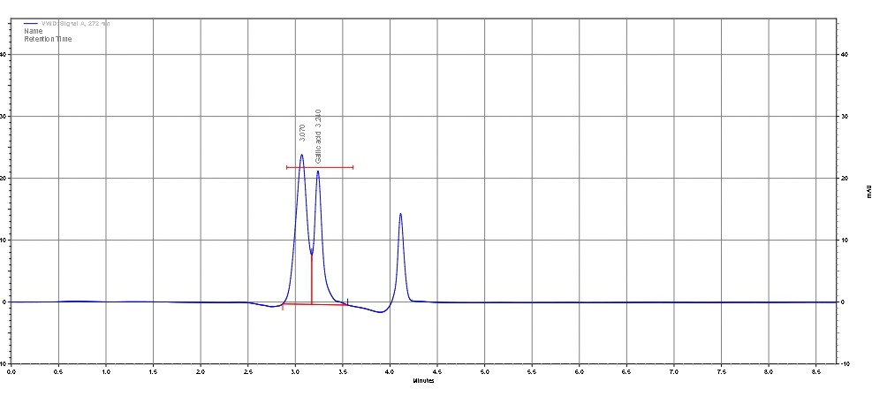
Fig. 2. HPLC chromatogram showing the gallic acid standard peak.
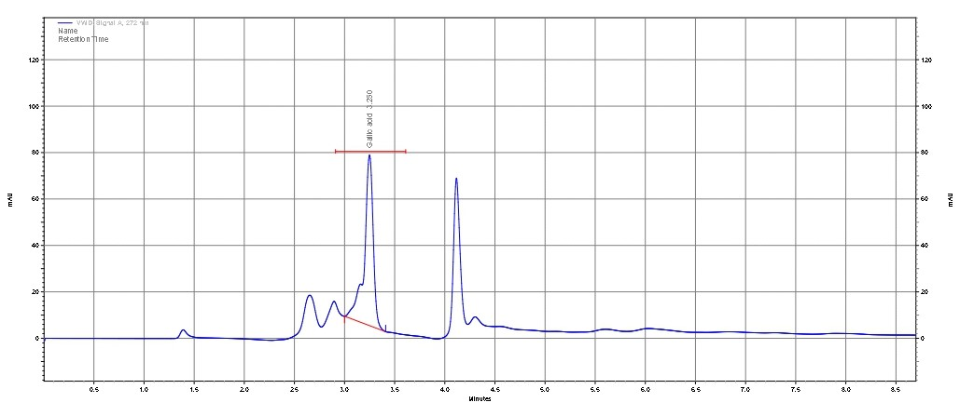
Fig. 3. HPLC chromatogram showing the gallic acid peak in MO-A.
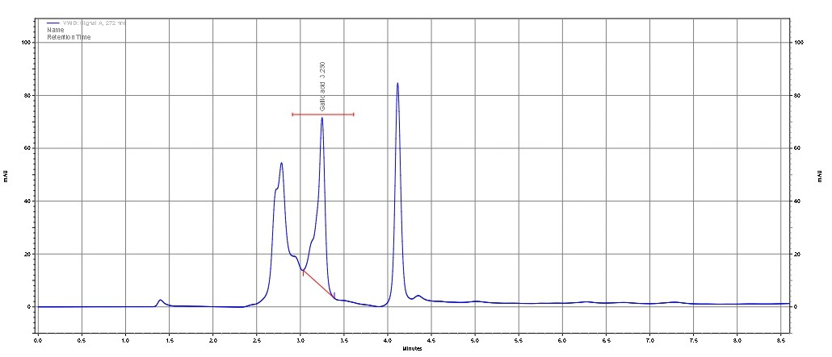
Fig. 4. HPLC chromatogram showing the gallic acid peak in MO-M.
After examining the chromatograms (Figures 2–4), the retention time of gallic acid in both extracts showed perfect alignment with the standard, confirming chromatographic specificity and identity. The higher gallic acid content in the methanolic extract further supports the well-established advantage of methanol for phenolic compound extraction from plant materials.

3.5 Quantification of Quercetin

Table 7. HPLC Determination of Quercetin Content in Methanolic and Aqueous Extracts of Moringa oleifera.
S. No | Sample Code | RT (min) | Concentration(µg/mL)
1 | MO-A | 3.103 | 0.48
2 | MO-M | 3.1 | 1.4
The quantification of quercetin in the methanolic (MO-M) and aqueous (MO-A) extracts of Moringa oleifera was performed using High-Performance Liquid Chromatography (HPLC). Chromatographic separation was achieved on a C18 reverse-phase column (4.6 × 250 mm, 5 μm) using a mobile phase of acetonitrile:methanol (40:60, v/v), which provided sharp and well-resolved peaks for quercetin. Detection was carried out at 317 nm, the characteristic absorption maximum of quercetin.
Distinct and well-defined quercetin peaks were observed in both extracts at retention times of 3.103 minutes (MO-A) and 3.100 minutes (MO-M), closely matching the retention time of the quercetin standard and confirming the compound’s identity. Quantitative results showed that the methanolic extract contained a higher quercetin concentration (1.4 µg/mL) compared to the aqueous extract (0.48 µg/mL). This difference reflects the enhanced solubility of quercetin in methanol and corresponds with the higher Total Flavonoid Content (TFC) previously recorded for the methanolic fraction.
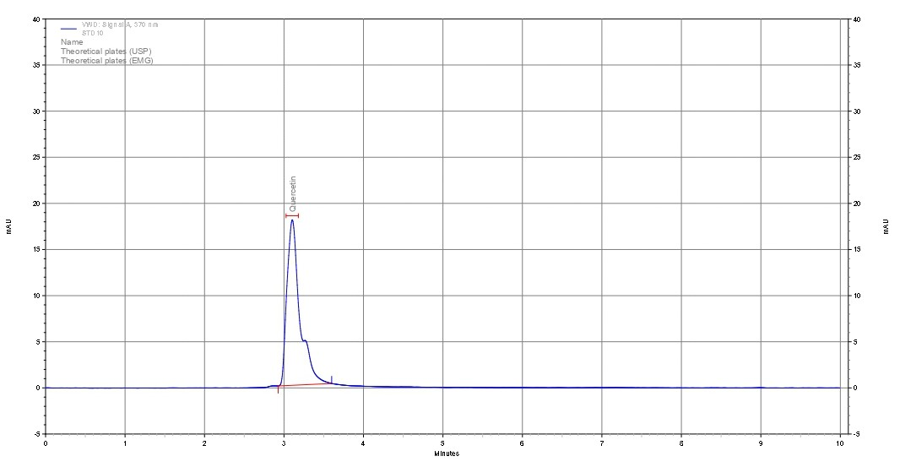
Fig. 5. HPLC chromatogram showing the quercetin standard peak.
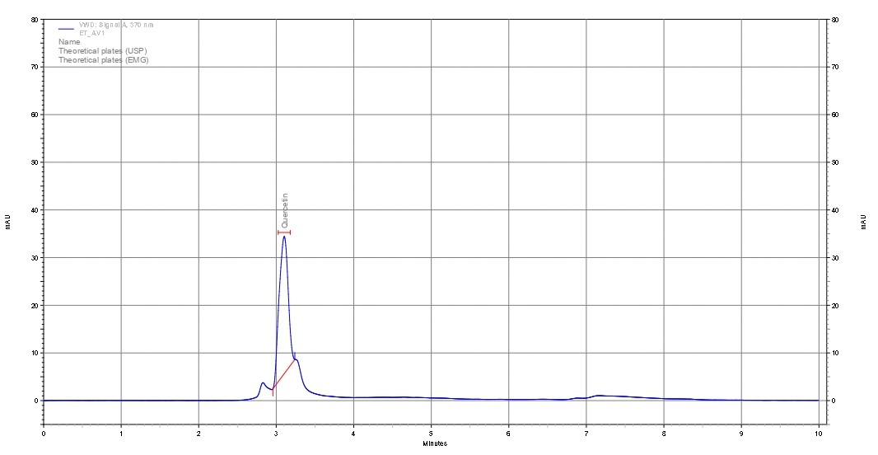
Fig. 6. HPLC chromatogram showing the quercetin peak in MO-A.
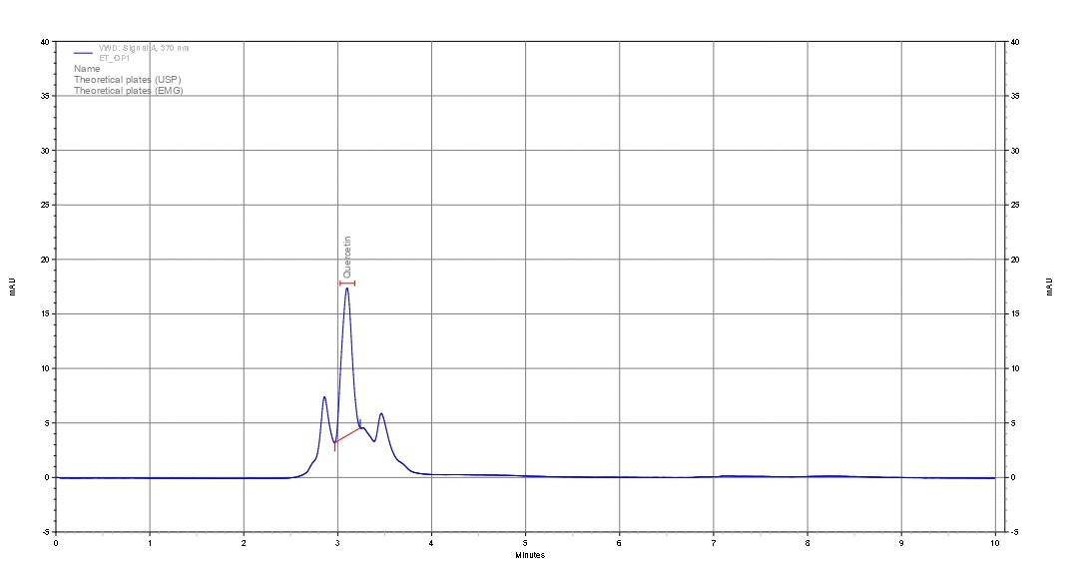
Fig. 7. HPLC chromatogram showing the quercetin peak in MO-M
After reviewing the chromatograms (Figures 5–7), the retention time of quercetin in both extracts showed excellent alignment with the standard peak, confirming chromatographic specificity and accurate identification. The higher quercetin concentration in the methanolic extract reinforces the superior extraction ability of methanol for flavonoid compounds. This is attributed to the intermediate polarity of methanol, which enhances the solubility of polyhydroxylated flavonoids such as quercetin. These findings are consistent with earlier phytochemical reports that methanol is one of the most efficient solvents for flavonoid extraction from plant matrices.

4. Discussion
The present study evaluated the influence of solvent polarity on the extraction efficiency and phytochemical composition of Moringa oleifera leaves collected from the Hathwa region of Bihar, India (Asia), with particular emphasis on the quantification of key antioxidant markers, gallic acid and quercetin. The findings demonstrate that methanol is a more effective solvent than water for extracting phenolic and flavonoid compounds. This difference is primarily attributed to the intermediate polarity of methanol, which enhances the solubility and extraction of moderately polar secondary metabolites, including phenolic acids and flavonoids (Sharma et al., 2023).
The extractive yield showed a slight advantage for the methanolic extract compared to the aqueous extract. Although aqueous solvents often extract higher amounts of hydrophilic compounds such as sugars, proteins, and polysaccharides, methanol preferentially extracts biologically active secondary metabolites rather than bulk hydrophilic constituents. Similar findings have been reported in recent phytochemical studies, where methanolic extraction yielded higher concentrations of phenolic compounds due to its superior penetration into plant tissues and ability to disrupt plant cell walls (Saini et al., 2021).
The Total Phenolic Content (TPC) and Total Flavonoid Content (TFC) results further confirmed the enhanced extraction efficiency of methanol. Phenolic and flavonoid compounds are known to exhibit higher solubility in organic solvents with intermediate polarity, which facilitates their efficient recovery. Previous studies on medicinal plants have consistently reported higher phenolic and flavonoid concentrations in methanolic extracts compared to aqueous extracts (Sharma et al., 2023). Furthermore, increased phenolic and flavonoid content is strongly associated with enhanced antioxidant activity, as these compounds play a critical role in neutralizing free radicals and preventing oxidative damage (Badhe et al., 2025). The elevated TPC and TFC observed in the methanolic extract of Moringa oleifera therefore indicate its greater antioxidant potential.
High-Performance Liquid Chromatography (HPLC) analysis confirmed the presence of gallic acid and quercetin in both methanolic and aqueous extracts, with retention times matching those of standard reference compounds. This confirms the specificity, accuracy, and reliability of the chromatographic method used in the study. Quantitative analysis revealed higher concentrations of gallic acid and quercetin in the methanolic extract compared to the aqueous extract, which is consistent with the TPC and TFC findings. These results are in agreement with previous studies demonstrating that methanol enhances the extraction of phenolic antioxidants from medicinal plants due to its ability to dissolve both polar and moderately non-polar compounds (Sawant et al., 2010).
Gallic acid and quercetin are well-established antioxidant compounds known for their strong free radical scavenging activity and pharmacological properties, including anti-inflammatory, antimicrobial, and cardioprotective effects. The higher concentrations of these compounds in the methanolic extract suggest greater antioxidant and therapeutic potential. Additionally, methanolic extracts of medicinal plants have been reported to exhibit stronger antimicrobial activity compared to aqueous extracts, which is attributed to their higher phenolic and flavonoid content (Rao et al., 2021; Sharma et al., 2023). These findings further support the effectiveness of methanol as an extraction solvent for recovering bioactive phytochemicals from plant materials.
Environmental factors such as soil composition, climatic conditions, and geographical location may also influence phytochemical accumulation in plants. The Hathwa region of Bihar, India, is characterized by subtropical climatic conditions and fertile alluvial soil, which may contribute to enhanced biosynthesis of secondary metabolites in Moringa oleifera. Such regional variations in phytochemical content have been reported in several medicinal plant studies (Sharma et al., 2023).
Overall, the present study clearly demonstrates the significant influence of solvent polarity on the extraction efficiency and phytochemical composition of Moringa oleifera leaves. Methanol proved to be a more effective solvent for extracting phenolic and flavonoid compounds, including gallic acid and quercetin. The combined TPC, TFC, and HPLC findings confirm that Moringa oleifera leaves are a rich source of antioxidant phytochemicals and support their potential application in nutraceutical, pharmaceutical, and functional food industries.

5. Conclusion
This study demonstrates that solvent polarity plays an important role in the efficient extraction of phenolic and flavonoid compounds from Moringa oleifera leaves collected from the Hathwa region of Bihar, India (Asia). Methanol was identified as a more effective solvent compared to water for the recovery of key antioxidant phytochemicals such as gallic acid and quercetin. The results highlight the importance of solvent selection in maximizing phytochemical extraction efficiency. High-Performance Liquid Chromatography (HPLC) proved to be a reliable and precise analytical technique for the identification and quantification of phenolic markers. The chromatographic method ensured accurate detection and confirmed the presence of bioactive compounds in the extracts. This study also provides scientific validation for the traditional medicinal use of Moringa oleifera leaves in rural healthcare systems. The presence of antioxidant phytochemicals supports its therapeutic relevance in managing oxidative stress–related conditions. The findings emphasize the phytochemical richness of Moringa oleifera leaves from this geographical region. Environmental and regional factors may contribute to variations in phytochemical composition. The study contributes valuable information for the phytochemical standardization of medicinal plants. It also highlights the potential of Moringa oleifera as a natural source of antioxidant compounds. These findings support its application in nutraceutical and pharmaceutical formulations. The study establishes a reliable analytical approach for future phytochemical investigations. It also provides a useful reference for quality evaluation of plant-based products. Overall, Moringa oleifera represents a promising plant resource for therapeutic and industrial applications.
Disclaimer (Artificial intelligence)
Author(s) hereby declare that NO generative AI technologies such as Large Language Models (ChatGPT, COPILOT, etc.) and text-to-image generators have been used during the writing or editing of this manuscript

Reference
- Ahmad, L., Ullah, F., Semotiuk, A. J., Rashid, W., Khan, I., Jan, H. A., ... & Ahmad, I. (2020). Traditional knowledge and economic significance of Berberis lycium Royle in the Lower Dir District, Pakistan. Ethnobotany Research and Applications, 20, 1-12.
- Ahmad, M. S. (2016). Documentation and folklore use of medicinal plants of Hathwa (Gopalganj), Bihar. The Biobrio, 3(1–2), 153–160.
- Alhakmani, F., Kumar, S., & Khan, S. A. (2020). Antioxidant activity of fresh and dry leaf extracts of selected medicinal plants. Antioxidants, 9(7), 785.
- Alia, F., Putri, M., Anggraeni, N., & Syamsunarno, M. R. A. A. (2022). The potency of Moringa oleifera Lam. as protective agent in cardiac damage and vascular dysfunction. Frontiers in Pharmacology, 12, 724439.
- Anwar, F., Latif, S., Ashraf, M., & Gilani, A. H. (2007). Moringa oleifera: A food plant with multiple medicinal uses. Phytotherapy Research, 21(1), 17–25.
- Badhe, P., & Badhe, A. (2025). Moringa oleifera in Breast Cancer: Targeting ROS, p53, and VEGF Pathways through Phytochemical Synergy. Biopress Journal of Computational Life Sciences (BJCLS), 1(07), 90-105.
- Baitha, R. R., & Ahmad, M. S. (2019). Study of few climbers and twiners used to cure inflammatory diseases of District West Champaran. The Biobrio, 6(1–2), 370–377.
- Chang, C., Yang, M., Wen, H., & Chern, J. (2002). Estimation of total flavonoid content in propolis by two complementary colorimetric methods. Journal of Food and Drug Analysis, 10, 178–182.
- Guideline, I. H. T. (2005). Validation of analytical procedures: text and methodology. Q2 (R1), 1(20), 05.
- Hossain, A., Khatun, M. A., Islam, M., & Huque, R. (2017). Enhancement of antioxidant quality of green leafy vegetables upon different cooking method. Preventive Nutrition and Food Science, 22(3), 216–222.
- Kumari, S., & Singh, R. (2020). Assessment of bioactive potential in selected medicinal plant extracts. Journal of Medicinal Plants Research, 14(3), 112–118.
- Leone, A., Spada, A., Battezzati, A., Schiraldi, A., Aristil, J., & Bertoli, S. (2015). Cultivation, genetic, ethnopharmacology, phytochemistry and pharmacology of Moringa oleifera. International Journal of Molecular Sciences, 16(6), 12791–12835.
- Moyano, C. A. E., Suástegui, J. M. M., Vivenes, E. Z., Ganadara, J. S., & Seijo, C. L. (2021). Análisis del perfil lipídico y aminoacídico de hojas deshidratadas de Moringa oleifera (L.) y su potencial como suplemento dietético en acuicultura de moluscos. La Técnica. Revista de las Agrociencias. ISSN 2477-8982.
- Mukherjee, S., Mudalkar, S., Singh, G., & Kumar, S. (2024). MEDICO BIOWEALTH OF INDIA. Ambika Prasad Research Foundation, Odisha, India. DOI: https://doi. org/10.5281/zenodo, 13924509.
- Rao, P., Mishra, S., & Nayak, V. (2021). Antibacterial activity of different solvent extracts of medicinal plant leaves. International Journal of Phytomedicine, 13(2), 150–158.
- Rodríguez-Pérez, C., Quirantes-Piné, R., Fernández-Gutiérrez, A., & Segura-Carretero, A. (2015). Optimization of extraction method to obtain a phenolic compounds-rich extract from Moringa oleifera Lam leaves. Industrial Crops and Products, 66, 246-254.
- Saini, R. K., Prasad, P., Sreedhar, R. V., Akhilender Naidu, K., Shang, X., & Keum, Y. S. (2021). Omega− 3 polyunsaturated fatty acids (PUFAs): Emerging plant and microbial sources, oxidative stability, bioavailability, and health benefits—A review. Antioxidants, 10(10), 1627.
- Sawant L, Prabhakar B, Pandita N (2010) Quantitative HPLC Analysis of Ascorbic Acid and Gallic Acid in Phyllanthus Emblica. J Anal Bioanal Tech 1:111.
- Sharma, R. K., Jha, A. K., Siddiquee, A., & Ahmad, M. S. (2023). Assessment of physico-chemical parameters of wetland soils in relation to agricultural productivity. The Biobrio, 10(3-4), 1017–1022.
- Shea, I. M. K. (2024). EVALUATION OF THE MORINGA OLEIFERA LEAF MEAL EFFECTS ON. University of Namibia.
- Siddiquee, A., & Ahmad, M. S. (2021). Study of few exotic/alien plant species of dicot families and their economic importance. The Biobrio, 8(3–4), 676–687.
- Sreelatha, S., & Padma, P. R. (2009). Antioxidant activity and total phenolic content of Moringa oleifera leaves in two stages of maturity. Plant Foods for Human Nutrition, 64(4), 303–311.
- Srivastava, M. L., Siddiquee, A., Baitha, R. R., & Ahmad, M. S. (2024). Somatic embryogenesis and quantification of L-Dopa in Mucuna pruriens. Indian Journal of Applied & Pure Biology, 39(2), 1057–1064.
- Zhao, S., & Zhang, D. (2013). Supercritical fluid extraction and characterisation of Moringa oleifera leaves oil. Separation and Purification Technology, 118, 497-502.
- Zou, C., Zhang, X., Xu, Y. and Yin, J., 2024. Recent advances regarding polyphenol oxidase in camellia sinensis: Extraction, purification, characterization, and application. Foods, 13(4), p.545.

