MOLECULAR IDENTIFICATION AND ANTIMICROBIAL RESISTANCE DETERMINANT OF Klebsiella pneumoniae ISOLATE FROM DIABETIC FOOT WOUNDS IN BENUE STATE, NIGERIA

ABSTRACT
Diabetic foot wounds (DFWs) represent one of the most serious complications of diabetes mellitus and are frequently associated with bacterial infections that complicate treatment and increase the risk of amputation. Among the bacterial pathogens implicated in these infections, Klebsiella pneumoniae has emerged as a major opportunistic pathogen due to its increasing multidrug resistance and ability to acquire virulence determinants. This study investigated the molecular characteristics and antimicrobial resistance determinants of Klebsiella pneumoniae isolated from diabetic foot wounds in selected tertiary health facilities in Benue State, Nigeria. A total of 57 K. pneumoniae isolates were subjected to phenotypic screening for extended-spectrum β-lactamase (ESBL) production using the double-disc synergy test and confirmatory combination disk method. Molecular detection of resistance genes including blaCTX-M, blaNDM, and blaKPC was performed using polymerase chain reaction (PCR). The results showed that 12 (21.1%) isolates were ESBL producers while 45 (78.9%) were non-producers. The distribution of ESBL isolates across the three senatorial zones showed that Zone B had the highest prevalence (58.3%), followed by Zone A (25.0%) and Zone C (16.7%). Molecular analysis revealed the presence of the blaCTX-M gene, confirming ESBL production in several isolates, while the NDM gene was detected in two isolates. No isolates were found to carry the KPC gene. The findings highlight the growing burden of ESBL-producing K. pneumoniae in diabetic foot infections and underscore the need for continuous molecular surveillance, antimicrobial stewardship, and improved infection control strategies in healthcare facilities in Nigeria.
Keywords: ESBL, blaCTX-M, blaNDM, Molecular Detection, PCR, Antimicrobial Resistance.

- INTRODUCTION
Molecular identification methods, such as polymerase chain reaction (PCR) and sequencing of conserved genetic markers like the 16S rRNA gene or species-specific genes (e.g., rpoB, ureD), have become the gold standards for detecting K. pneumoniae with high specificity and sensitivity (Chen et al., 2023). These techniques overcome the limitations of traditional culture-based methods, which are often time-consuming, less sensitive, and prone to misidentification. Molecular characterization also enables the detection of virulence genes and antimicrobial resistance determinants, offering valuable information for clinical management and infection control (Peirano and Pitout, 2022; Gital et al., 2024).
Nigeria is currently experiencing an increasing prevalence of diabetes mellitus alongside a growing burden of antimicrobial resistance. In many healthcare facilities across the country, antimicrobial stewardship programs are still developing, and the misuse or overuse of antibiotics remains a significant challenge. These factors create favorable conditions for the emergence and spread of multidrug-resistant bacterial pathogens, including ESBL-producing K. pneumoniae (Ayeni et al., 2025; Esmail et al., 2019; Ajigbewu et al., 2025).
Despite the clinical importance of K. pneumoniae in diabetic foot infections, molecular epidemiological data from Nigeria remain limited, particularly at the regional level. Benue State hosts several tertiary health facilities that manage a large number of diabetic patients presenting with foot complications. However, routine microbial surveillance in these facilities is often based on conventional culture techniques, and molecular characterization of pathogens is rarely performed (Nwosu et al., 2025).
Therefore, conducting a molecular investigation of K. pneumoniae isolates from diabetic foot wounds in tertiary health facilities in Benue State is essential for understanding the prevalence of ESBL-producing strains and the distribution of important antimicrobial resistance genes such as blaCTX-M, blaNDM, and blaKPC. Such information will help improve diagnostic accuracy, guide appropriate antibiotic therapy, and contribute to the development of effective infection control strategies aimed at reducing the burden of multidrug-resistant infections among diabetic patients.
2. MATERIALS AND METHODS
Detection of Extended spectrum beta-lactamases (ESBLs)
Double Disc Synergy Test was used to detect K. pneumoniae . K. pneumoniae isolates were spread onto a Muller-Hinton agar plate. The antibiotic discs used were Ceftriaxone (30 µg), Cefotaxime (30 µg), Ceftazidime (30 µg), and Amoxicillin/Clavulanic acid (20/10 µg). The three antibiotics were placed at distances of 30 mm from the clavulanate disc that was placed in the middle of the plate. After 24 hours of incubation, an enhanced zone of inhibition between either of the cephalosporin antibiotics or the amoxicillin/clavulanic acid disc occurred, and the test was considered positive. This indicated synergistic activity with clavulanic acid and the presence of an ESBL.
Phenotypic Confirmatory
Ceftazidime (30 µg) disk was used alone and in combination with Clavulanic acid (30 µg/10µg) for phenotypic confirmation of the presence of ESBLs. The antibiotics were placed within 20mm of the surface of the plate and incubated for 24 hours at 37°C. The K. pneumoniae were considered ESBL producers due to a ≥ 5 mm increase in zone diameter for either of the Ceftazidime discs or their respective Ceftazidime/Clavulanate discs.
DNA Extraction
Genomic DNA was extracted from overnight bacterial cultures using the boiling method. Briefly, 2-3 colonies were suspended in 200 µL of sterile distilled water and heated at 95 °C for 10 minutes, followed by centrifugation at 13,000 rpm for 5 minutes. The supernatant containing DNA was stored at -20 °C until use.
Polymerase Chain Reaction (PCR) for Species Confirmation
Molecular confirmation of K. pneumoniae was carried out using PCR targeting rpoB genes. The PCR reactions were performed in 25 µL volumes containing 12.5 µL of Master Mix, 1 µL each of forward and reverse primers, 2 µL of DNA template, and 8.5 µL of nuclease-free water. Thermocycling conditions were optimized for each primer set based on manufacturer protocols.
PCR products were electrophoresed on 1.5 % agarose gel stained with ethidium bromide and visualized under UV illumination (Peirano and Pitout, 2022)
Detection of Antibiotic Resistance Genes
PCR assays were used to detect selected resistance genes including blaCTX-M, blaKPC, and blaNDM. Primer sequences and PCR conditions were adopted from previously validated protocols (Peirano and Pitout, 2022; Logan and Weinstein, 2023). Positive and negative controls were included in all reactions.
- RESULTS
.Phenotypic Detection of ESβL-Producing Isolates
Phenotypic confirmation of extended-spectrum β-lactamase (ESβL) production using the ceftazidime and ceftazidime–clavulanic acid combination disk test showed that 12 out of the 57 isolates (21.1 %) were ESβL producers, while 45 isolates (78.9%) were non-producers as shown in table 1.

Distribution of ESBL Across the Three Senatorial Zones
Distribution of Extended Spectrum Beta-Lactamase (ESBL) producing isolates across the three senatorial zones. A total of 12 ESBL-producing isolates were identified in the study. Zone B recorded the highest number of ESBL isolates, with 7 cases (58.3%). Zone A had 3 cases (25.0%). Zone C recorded the lowest number, with 2 cases (16.7%) as shown in table 2.
Agarose Gel Electrophoresis of PCR Products
The image displays the results of an agarose gel electrophoresis used to separate DNA fragments by size. M lane contains a DNA marker (ladder) with fragments of known base pair (bp) lengths, used to estimate the size of DNA fragments in other lanes. The marker shows bands at 3000, 2000, 1500, 1000, 600, 500, and 200 bp. The negative control lane designated as -ve showed no DNA bands. The positive control lane (+ve), showed a band at approximately 593 bp, confirming the amplification of the target gene.

Table 1: Phenotypic confirmation of ESβL K. pneumoniae producers
Antibiotic | K. pneumoniae isolates n=57
 | ESβL producers (%) | Non ESβL producers (%)
Ceftazidime (30 μg)
+
Ceftazidime/clavulanic | 12(21.1) | 45(78.9)

χ² = 19.12

Table 2: Distribution of ESBL across the Three Senatorial Zones.
Zones | NO of ESBL | (%)
A | 3 | 25.0
B | 7 | 58.3
C | 2 | 16.7
Total | 12 | 100
χ² = 3.50

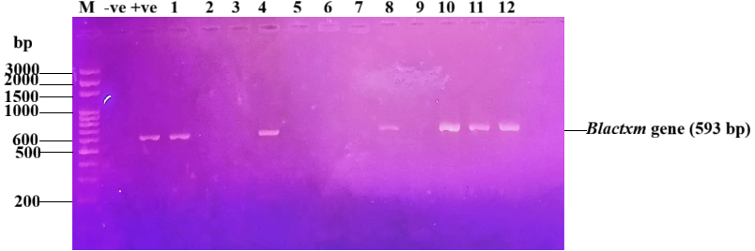
Plate 1: Agarose gel electrophoresis of PCR products for the Blactxm gene (593 bp). M = Maker, -ve = Negative control, +ve = Positive control

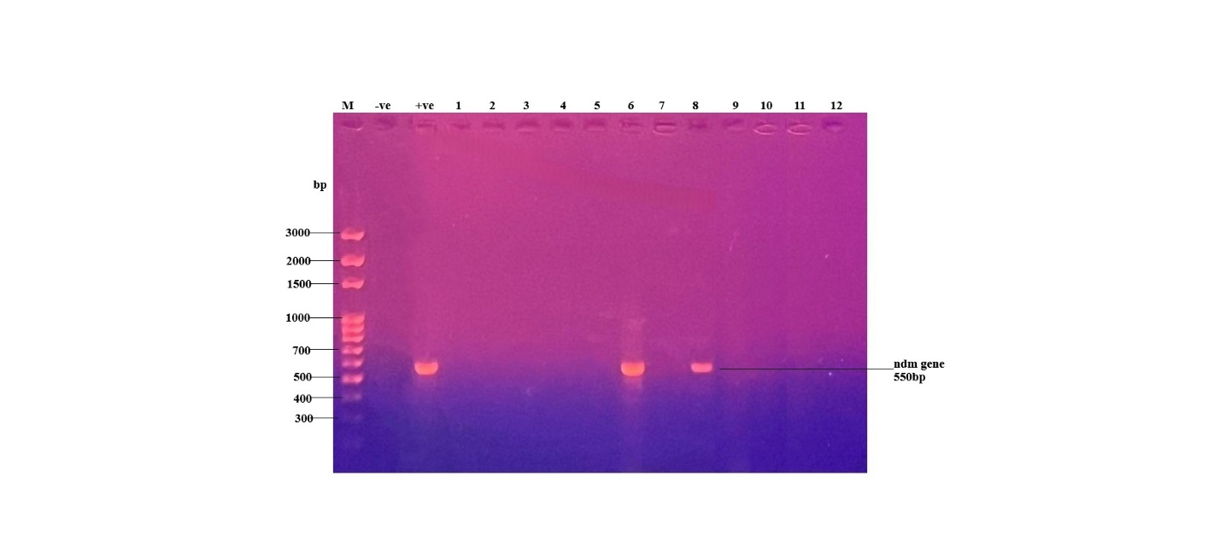Plate 2: Agarose gel electrophoresis showing the amplification of the ndm gene (550 bp). This figure displays the results of a polymerase chain reaction (PCR) to detect the ndm gene.

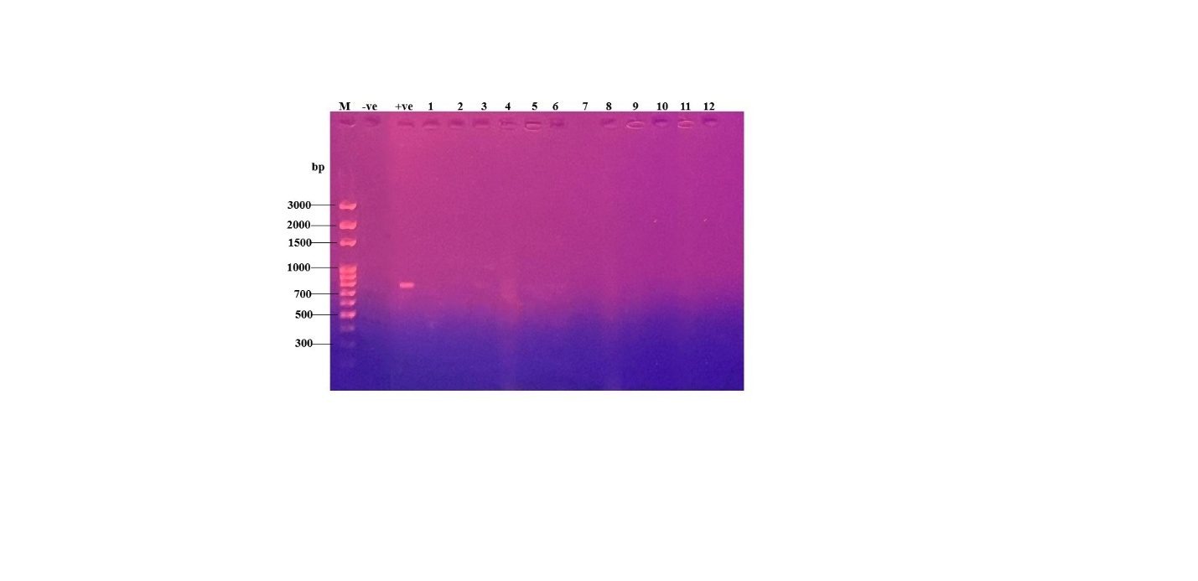
Plate 3: Agarose gel electrophoresis showing the absence of kpc gene. Lane M is a 100 bp DNA ladder. Lane +ve and -ve represent the positive and negative controls, respectively. Lanes 1-12 contain the tested samples.

- DISCUSSION

The current study examined the molecular and phenotypic traits of Klebsiella pneumoniae isolates from diabetic foot wounds in a few Benue State tertiary medical facilities. The results showed that 21.1% of the isolates produced ESBL, suggesting a significant level of antibiotic resistance in the bacterial community linked to diabetic wound infections. This incidence is in line with data from other developing nations where chronic wound infections have been linked to an increasing number of ESBL-producing Enterobacteriaceae isolates (Bush and Bradford, 2020).

The blaCTX-M gene detected in several isolates is epidemiologically important because CTX-M enzymes represent the most globally widespread family of extended-spectrum β-lactamases (ESBLs). Their presence confirms the phenotypic ESBL results and suggests that a significant proportion of the isolates carry mobile genetic elements capable of conferring high-level resistance to third-generation cephalosporins. From an epidemiological standpoint, this indicates ongoing selection pressure in the clinical environment and the potential for horizontal transfer of ESBL determinants among Enterobacteriaceae circulating within hospital settings (Ezeh et al., 2024; Ayeni et al., 2025).
Notably, only two isolates (lanes 6 and 8) carried the ndm gene, which encodes New Delhi metallo-β-lactamase. Although the prevalence was low, the detection of even a small number of NDM-positive strains has serious implications. NDM-producing bacteria are associated with rapid dissemination, substantial treatment failure, and outbreaks in healthcare facilities. Their presence may indicate early infiltration of carbapenemase producers into the local microbial population, creating an epidemiological warning signal requiring urgent surveillance and containment efforts (Chukwu et al., 2022).
Interestingly, the KPC gene was not detected in any of the isolates. This observation suggests that KPC-mediated carbapenem resistance may not yet be widespread in the study area. Similar findings have been reported in some regions of sub-Saharan Africa where NDM and other metallo-β-lactamases appear to be more prevalent than KPC enzymes (Chukwu et al., 2022). Nevertheless, continuous monitoring remains essential to detect the possible introduction of KPC-producing strains into the local bacterial population
Molecular epidemiology studies have shown that certain clonal lineages of K. pneumoniae are responsible for the global dissemination of antimicrobial resistance genes. Continuous molecular surveillance is therefore essential for monitoring the emergence of high-risk clones. Epidemiological surveillance should integrate phenotypic susceptibility data with molecular typing (e.g., MLST, whole-genome sequencing) to distinguish between endemic transmission and sporadic introductions information that directly informs infection control and outbreak response. (Wyres and Holt, 2018; World Health Organization, 2024).

Overall, the findings of this study highlight the growing importance of molecular diagnostic techniques in the surveillance of antimicrobial resistance. Molecular detection provides rapid and accurate identification of resistance genes, enabling clinicians to make more informed decisions regarding antimicrobial therapy. The results also emphasize the need for strengthened antimicrobial stewardship programs, routine molecular surveillance, and improved infection control practices in healthcare facilities.
- CONCLUSION
This study demonstrated the presence of extended-spectrum β-lactamase producing Klebsiella pneumoniae among isolates obtained from diabetic foot wounds in tertiary health facilities in Benue State. The detection of ESBL production in 21.1% of the isolates indicates a considerable level of antimicrobial resistance among the bacterial population associated with diabetic wound infections. Molecular analysis confirmed the presence of the blaCTX-M gene in several isolates, while the NDM gene was detected in a small number of samples, indicating the potential emergence of carbapenem-resistant strains. The absence of the KPC gene suggests that KPC-mediated resistance may not yet be widespread in the study area.
Disclaimer (Artificial intelligence)
Author(s) hereby declare that NO generative AI technologies such as Large Language Models (ChatGPT, COPILOT, etc.) and text-to-image generators have been used during the writing or editing of this manuscript.

REFERENCES
Armstrong, D.G., Boulton, A.J.M. and Bus, S.A. (2020). Diabetic foot ulcers and their recurrence. New England Journal of Medicine, 376(24), 2367–2375.
Ayeni, F.A., Ezeh, A.I. and Yusuf, I. (2025). Antimicrobial resistance patterns among Enterobacteriaceae in Nigerian hospitals. African Journal of Clinical Microbiology, 26(2), 85–95.
Bush, K. and Bradford, P.A. (2020). Epidemiology of β-lactamase-producing pathogens. Clinical Microbiology Reviews, 33(2), e00047-19.
Chen, X., Zhang, W. and Li, Y. (2023). Molecular identification and characterization of Klebsiella pneumoniae using rpoB gene sequencing. Journal of Clinical Microbiology, 61(4), e01562-22.
Chukwu, M.O., Nworie, O. and Okechukwu, O. (2022). Carbapenem-resistant Enterobacteriaceae in sub-Saharan Africa: epidemiology and public health implications. Infectious Diseases Reports, 14(3), 365–374.
Lipsky, B.A., Senneville, E., Abbas, Z.G., et al. (2020). Guidelines on the diagnosis and treatment of diabetic foot infections. International Working Group on the Diabetic Foot, 1–42.
Logan, L.K. and Weinstein, R.A. (2023). The epidemiology of carbapenem-resistant Enterobacteriaceae. Clinical Infectious Diseases, 76(3), 483–490.
Paczosa, M.K. and Mecsas, J. (2016). Klebsiella pneumoniae: Going on the offense with a strong defense. Microbiology and Molecular Biology Reviews, 80(3), 629–661.
Peirano, G. and Pitout, J.D.D. (2022). Extended-spectrum β-lactamase-producing Enterobacteriaceae: update on molecular epidemiology and treatment options. Drugs, 82, 1353–1370.
Podschun, R. and Ullmann, U. (1998). Klebsiella spp. as nosocomial pathogens: epidemiology, taxonomy, typing methods, and pathogenicity factors. Clinical Microbiology Reviews, 11(4), 589–603.
Gital, N. S., Umar, A. F., Lambu, Z. N., & Muhammad, Y. A. (2024). Molecular Characterization and Antibiotic Susceptibility Pattern of Commonly Encountered Bacteria from Wound Infection in Diabetic Patients Attending Specialist Hospital, Bauchi, Bauchi State. International Journal of Research and Innovation in Applied Science, 9(5), 264-275.
Nwosu, P. C., Egwuatu, E. C., Wright, A. K. A., Ebiala, F. I., Yaro, G. O., Sone, P. E., ... & Olokede, E. U. (2025). Diabetic foot ulcers in Africa: A systematic review of microbial profiles and clinical outcomes in the context of multidrug resistance. Epidemiology and Health Data Insights, 1(6), ehdi022.
Esmail, M. A. M., Abdulghany, H. M., & Khairy, R. M. (2019). Prevalence of multidrug-resistant Enterococcus faecalis in hospital-acquired surgical wound infections and bacteremia: concomitant analysis of antimicrobial resistance genes. Infectious Diseases: Research and Treatment, 12, 1178633719882929.
Ajigbewu, O. H., Adeyemi, F. M., Wahab, A. A., Oyedara, O. O., Yusuf-Omoloye, N. A., & Ajigbewu, F. A. (2025). Occurrence of extremely drug-resistant Klebsiella and multidrug-resistant Enterobacter species in chronic wound patients. Microbes and Infectious Diseases, 6(1), 342-354.

