Correlation between Research Self-Efficacy, Student Engagement, and Research Mentoring, and the Writing Skills of College Students on Non-Board Courses

.
ABSTRACT
Aims: To determine the significance of the relationship between research self-efficacy, student engagement, and research mentoring, and the writing skills.
Study design: This study employed correlation design.
Place and Duration of Study: The study was conducted at Samal Island City College, a recognized higher education institution.
Methodology: The study was participated by 218 respondents selected through simple random sampling. Statistical tools, including mean, and Pearson-r, were employed to analayze the data.
Results: Results revealed no link between determinants and criterion variables.
Conclusion: Bandura’s Social Cognitive Theory describing human functioning as the interaction of environmental, behavioral, and personal cognitive factors, emphasizing the roles of observational learning, self-efficacy, and self-regulation in shaping behavior, is completely denied. Thus, future research may be explored using other variables not covered in this study to further examine Social Cognitive Theory. Mixed-method or exploratory study may be undertaken to generate themes that may be utilized as variables intended to the above mentioned recommendations. Institutions may consider redirecting or modifying the focus on the aforementioned variables within school programs to develop more effective resources and strategies for improving students’ writing skills.

Keywords: Research-self-efficacy, student engagement, research mentoring, writing skills, college students, non-board courses

1. INTRODUCTION

1.1. The Problem and Its Scope
Poor writing skills remain a global concern in education. Wang and Troia (2023) reported that students often submit work lacking clarity, structure, and overall quality. Similarly, Davis (2023) found persistent difficulties in producing accurate and organized written outputs, while Elstad and Eriksen (2024) emphasized that this issue continues to attract attention in educational research and classroom practice.
International evidence confirms this challenge across contexts. In Norway, students struggled with logically structured texts (Elstad & Eriksen, 2024). In the United States, national assessments showed many learners perform below proficiency in academic writing (Wang & Troia, 2023). In Japan, university students consistently demonstrated weaknesses in written composition (Davis, 2023). These findings highlight the widespread nature of poor writing skills.
The Philippines reflects similar concerns. Vacalares et al. (2023) reported tertiary students often produce outputs lacking grammatical accuracy and logical flow. Salvador (2024) observed low performance in structured essay writing among first-year students, while Cabrera (2022) noted public school learners in Davao City struggle to meet writing benchmarks. These studies confirm that poor writing skills persist across academic levels.
Poor writing skills can lead to several academic and cognitive consequences, particularly in students’ ability to communicate ideas effectively and construct coherent arguments. In the study of Hermida (2024), it was highlighted that weak writing ability affects clarity of communication, academic performance, and students’ motivation and confidence. It is on this urgency that this study was pursued.

1.2.Significance of the Study
This study is significant in addressing students’ writing difficulties, which affect clarity of communication, academic performance, and the ability to construct coherent arguments. Improving writing competence supports the goals of Sustainable Development Goal 4: Quality Education, which promotes inclusive and equitable quality education and the development of essential literacy skills necessary for lifelong learning. By examining the issue of poor writing skills, this research contributes to enhancing students’ academic outcomes and strengthening their ability to effectively express ideas in academic and professional contexts.
Furthermore, the study aligns with the educational priorities of the Department of Education (Philippines) and the institutional mission of Holy Cross of Davao College. The findings may provide insights for educators and academic institutions in developing strategies to improve students’ writing proficiency, thereby supporting the national goal of producing competent and literate learners while reinforcing the college’s commitment to academic excellence and holistic student development.

1.3.Research Objectives
This study aimed to determine the significance of the correlation between research self-efficacy, student engagement, and research mentoring, and the writing skills of college students enrolled in non-board courses. Specifically, it aimed to achieve the following objectives:
- To determine the levels of research self-efficacy in terms of problem identification, literature survey, approach to writing, findings and analysis, and writing up; student engagement in terms of academic challenge, active learning, student-staff interaction, enriching educational experiences, work-integrated learning, time on task, and participation in educational practices; research mentoring in terms of mentoring relationship structure, guidance and support system, the rules, responsibilities and program expectations, the communication and interaction environment, and the work environment and resource support; and writing skills of students.
- To determine the significance of the correlation between research self-efficacy, student engagement, and research mentoring, and the writing skills of students.

1.4.Hypotheses
The null hypotheses were tested at a 0.05 level of significance.

Ho1: The correlation between research self-efficacy and writing skills of students is not significant.
Ho2: The correlation between student engagement and writing skills of students is not significant.
Ho3: The correlation between research mentoring and writing skills of students is not significant.

1.5.Theoretical and Conceptual Framework
This study is anchored on Bandura’s Social Cognitive Theory (SCT) which describes human functioning as the interaction of environmental, behavioral, and personal cognitive factors, emphasizing the roles of observational learning, self-efficacy, self-regulation in shaping behavior (Bandura, 1986). In the context of writing, this perspective views the act of composing not merely as a product of linguistic knowledge, but as a complex process influenced by cognitive, affective, and social context (Flower, 1994).
In this study, research self-efficacy variables indicated by problem identification, literature survey, approach to writing, findings and analysis, and writing up stands for personal cognitive factors. The student engagement variable indicated by academic challenge, active learning, student-staff interaction, enriching educational experiences, work-integrated learning, time on task, and participation in educational practices is associated with behavioural matter mentioned in the theory. Moreover, the research mentoring variable indicated by mentoring relationship structure, guidance and support system, the rules, responsibilities and program expectations, the communication and interaction environment, and the work environment and resource support speaks for environmental factors. Lastly, the writing skills variable is associated with human functioning matter stressed in the theory.
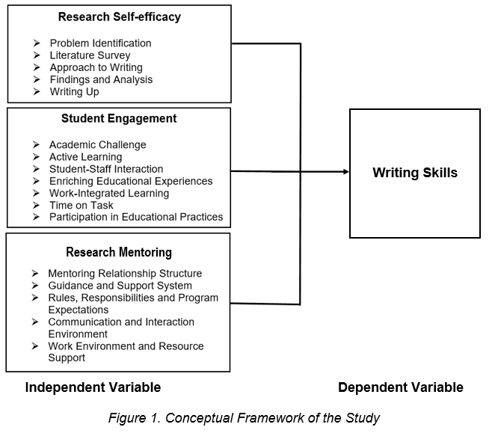
2. material and methods

2.1.Research Design
This study employed a descriptive-correlational approach to examine the link between research self-efficacy, student engagement, and research mentoring, and the students’ writing skills. A descriptive–correlational research design is a quantitative research approach used to describe existing conditions and examine the relationship between two or more variables without manipulating them (Hash et al., 2023). This design is appropriate for the study because it provides measurable evidence of how the independent variable as mentioned relates with the dependent variable.

2.2.Locale of the Study
The study was conducted at Samal Island City College, a recognized higher education institution. Samal Island City College serves as one of the higher education institutions in the area, providing tertiary education to students from the island and nearby communities. Its location supports access to higher education for local residents. The institution is located in the Island Garden City of Samal, an island city situated in the Davao Gulf, and is accessible from Davao City by ferry. Moreover, Samal Island hosts several educational institutions, including three colleges and numerous primary and secondary schools that serve learners across the island. These institutions play an important role in providing accessible education and supporting the academic development of students in the local community.

2.3.Sample and Sampling Technique
The respondents of this study were first-year College students of four non-board programs, namely, Bachelor of Public Administration, Bachelor of Tourism Management, Bachelor of Science in Entrepreneurship, and Bachelor of Science in Agri-business. They are duly enrolled in the Academic Year 2025–2026.
The respondents were selected through simple random sampling, giving each student an equal chance of participation. This method minimizes bias and ensures that the sample accurately represents the population. As Thomas (2023) emphasized, random sampling provides fairness and reliability in participant selection, strengthening the validity of the study’s findings. From a total population of 500, a representative sample of 218 students was determined using the Raosoft formula, ensuring accuracy at a 95% confidence level and a 5% margin of error. Online calculators such as Raosoft are widely recognized for providing reliable estimates efficiently (ClinCalc, 2022).

2.4.Data Gathering Technique
The study utilized survey questionnaire technique in gathering data. The survey data gathering technique is a quantitative method used to collect information from a group of respondents through structured questionnaires or surveys. Surveys are commonly administered through printed questionnaires, online forms, or interviews to obtain responses that can be analyzed statistically (Creswell & Creswell, 2023).
In this study, the research instruments were printed and distributed to the identified respondents. The questionnaire used to measure research self-efficacy was adapted from the Research Self-Efficacy Scale (RSS) by Sener et al. (2011), yielding a reliability coefficient of 0.917. The questionnaire used to measure student engagement was adapted from the Australasian Survey of Student Engagement (AUSSE) (Coates & Hillman, 2008), with a coefficient of 0.953. The questionnaire used to measure research mentoring was adapted from the Mentor-Mentee Research Relations Questionnaire, producing a coefficient of 0.944. Each section contained multiple items, ensuring comprehensiveness while remaining manageable. The quality and validity of the instrument were ensured through the validation panel of experts and research specialists. A pilot test was then conducted on thirty (30) students who were not part of the actual respondents to determine the clarity and usability of the items, and confirmed excellent reliability and internal consistency.
On the other hand, students’ writing skills were measured through an actual writing task, separate from the questionnaire. Written outputs were evaluated using Artificial Intelligence (AI) tools, specifically Gemini and Copilot, ensuring consistent scoring and minimizing personal bias. Respondents completed the task independently, and AI raters assessed outputs objectively. Evaluation was based on six criteria, content, organization, word choice, voice and tone, sentence structure, and conventions, adapted from Saddler and Andrade (2004).

2.5.Data Analysis Technique
In analyzing and interpreting the results of this study, the researcher employed statistical tools:
2.5.1.Descriptive statistical analysis using mean and standard deviation were utilized to determine the levels of students’ research self-efficacy, student engagement, and research mentoring, and writing skills. These measures summarize responses and describe overall tendencies in each variable (Creswell & Creswell, 2021). Computed values identified whether students exhibited high, moderate, or low levels of these factors and skills.
In the following section, the matrix containing the scale, descriptive level, and corresponding interpretation assigned to each variable in this study is presented. This measure is specifically used to describe the levels of research self-efficacy, student engagement, research mentoring, and the writing skills.

List 1. Determination of the levels of students’ research self-efficacy, student engagement, and research mentoring

Scale | Level | Research Self-efficacy | Student Engagement | Research Mentoring
3.25-4.00 | Very High | Very good | Very good | Very good
2.50-3.24 | High | Good | Good | Good
1.75-2.49 | Low | Poor | Poor | Poor
1.00-1.74 | Very Low | Very Poor | Very Poor | Very Poor

List 2. Interpretation of the Writing Performance of Students

Percentage Range (%) | Performance Level | Interpretation of Writing Performance
90-100% | Very High | Writing demonstrates very good mastery of content, organization, grammar, punctuation, and mechanics. The work is sophisticated, coherent, and requires minimal to no revision.
80-89% | High | Writing shows good competence, meeting key criteria effectively with only minor errors. The student demonstrates clear understanding of writing concepts and produces well-developed work.
60-79% | Low | Writing meets basic expectations but contains noticeable poor grammar, organization, or clarity. The student struggles with consistency and requires moderate instructional support.
50-59% | Very Low | Writing is very poor, with serious deficiencies across most areas. The student shows limited grasp of writing skills and requires extensive support and remediation.

For the interpretation of standard deviation, the following percentage standard by Sergent et al. (2024) was followed:

% of Scores Covered Interpretation Basis
≈ 68% Scores are highly consistent.
≈ 95% Scores are moderately dispersed.
≈ 99.7% Scores are highly dispersed.

2.5.2.Correlation analysis using Pearson Product-Moment Correlation Coefficient (Pearson-r) was applied to examine significant correlation between research self-efficacy, student engagement, and research mentoring, and writing skills. This statistical tool measures the strength and direction of associations between variables (Field, 2021). In this study, it revealed whether students’ personal attitudes, behavioral practices, and environmental conditions were positively or negatively related to writing performance.

For the interpretation scale of r-value, the following scheme as proposed by Guilford (1956) was used:

Computed r Descriptive Interpretation
+/- 1.00 Perfect correlation
Between +/- 0.75 – +/- 0.99 High correlation
Between +/- 0.51 – +/- 0.74 Moderately high correlation
Between +/- 0.31 – +/- 0.50 Moderately low correlation
Between +/- 0.01 – +/- 0.30 Low correlation
0.00 No correlation

2.6.Ethical Consideration
The study strictly adhered to ethical guidelines in conducting research involving students. Informed consent was obtained from all respondents prior to data collection to ensure voluntary participation and the confidentiality of their responses. The research instruments underwent validation and reliability testing to ensure the accuracy and credibility of the data gathered. Furthermore, formal permission was secured from the participating educational institution before the conduct of the study. The research was also reviewed and approved by the Society of Moral Integrity and Legal Ethics (SMILE) to ensure compliance with established ethical and legal standards.

3. results and discussion

3.1.Descriptive Results
Table 1 presents the descriptive statistics for the variables examined in this study, including research self-efficacy, student engagement, research mentoring, and their respective indicators, and the writing skills. It contains the number of samples, standard deviation, mean and corresponding descriptive level.
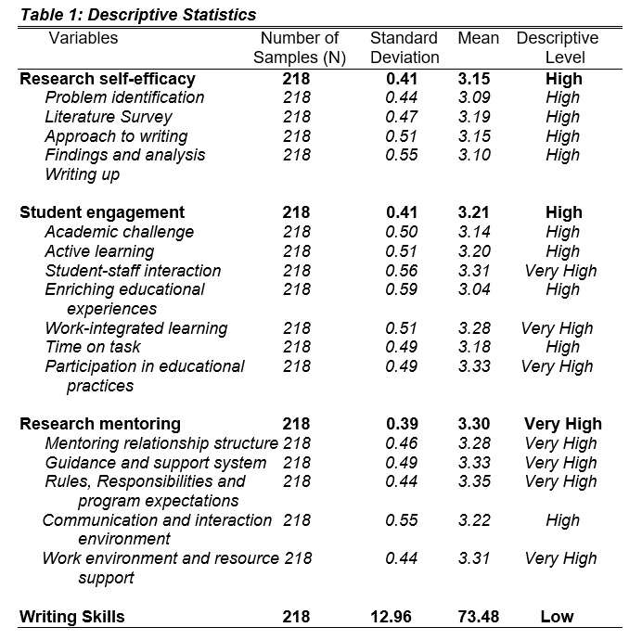
Specifically, the table shows that research self-efficacy obtained a mean of 3.15, described as high. It indicates that research self-efficacy of the respondents is good. It also shows the standard deviation of 0.41, describing that the responses are highly consistent. All of its indicators are described as high. Moreover, the student engagement variable obtained a mean of 3.21, described as high. It denotes that student engagement is good. The standard deviation of 0.41 manifests that the respondents’ responses are highly consistent. Among its indicators, only three are described as very high, and the other four are high. Furthermore, the table shows that research mentoring obtained a mean of 3.30, described as very high. It indicates that research mentoring is very good. It also presents the standard deviation of 0.39 denoting that the responses of the respondents are highly consistent. Among its indicators there are four rated very high, and the remaining one indicator is high. Finally, the writing skills of the participants obtained a mean of 73.48, interpreted as low. It describes that the writing skills of the respondents is poor. The result showing the standard deviation of 12.96 explains that the respondents’ responses are highly consistent.

3.2.Correlation Results

Table 2 is the correlation table. It contains the independent and criterion variables. It also contains the r-value, p-value, decision on null hypothesis, and the corresponding interpretation.
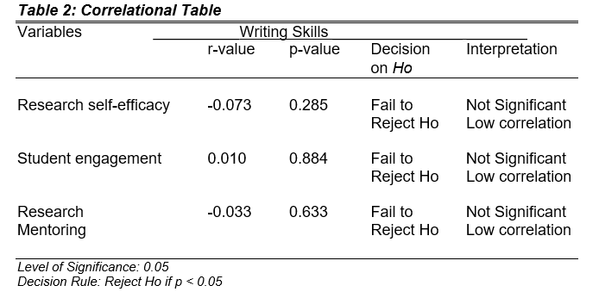
Specifically, the table shows that the research self-efficacy (p=0.285, r=-0.073), student engagement (p=0.884, r=0.010), and research mentoring (p=0.633, r=-0.033) variables obtained respective p-value which are less than 0.05 degree of confidence. Hence, all their hypotheses are not rejected. It indicates that all the determinant variables are not significantly correlated with the criterion.

3.3.Summary of Findings
- Research self-efficacy and writing skills of students is not significantly correlated.
- Student engagement and writing skills of students is not significantly correlated.
- Research mentoring and writing skills of students is not significantly correlated.

3.4.No link between research self-efficacy and student writing skills
In this study, research self-efficacy did not significantly correlate with students’ writing skills. This finding supports Jiang (2025), who noted that self-efficacy alone may not guarantee improved writing outcomes unless it is supported by appropriate instructional strategies. Moreover, this current finding affirms the assertion of Fadillah and Dari (2025), who found a very weak and non-significant relationship between writing self-efficacy and students’ writing performance, suggesting that confidence in writing does not necessarily translate into higher writing achievement. Finally, the absence of link between self-efficacy and writing skills aligns the study of Setyowati et al. (2024), who observed no significant correlation between students’ writing self-efficacy and essay writing performance, indicating that other factors such as instruction, practice, and feedback may play a more critical role in improving writing skills.
In contrast, the absence of a significant relationship between research self-efficacy and students’ writing skills in the present study contradicts Sophia et al. (2024), whose study involving 120 secondary school students found a significant positive correlation between students’ self-efficacy and descriptive writing performance, indicating that learners with stronger confidence in their writing abilities tend to achieve better writing outcomes. Sophia’s study has a lesser number of respondents as compared to the 218 samples employed in the current study.

3.5.No link between student engagement and student writing skills
Student engagement also showed no significant relationship with writing skills in the present study. This finding affirms the results of Suscano et al. (2025), who indicated that engagement tends to correlate more strongly with overall academic performance rather than specific skills such as writing. Additionally, this current study supports the assertion of Feng (2025), who noted that although students may demonstrate high levels of engagement in writing activities, such as interacting with feedback or participating in writing tasks, this engagement does not necessarily translate into measurable improvements in writing performance without effective instructional guidance and structured feedback.
The absence of a significant relationship between student engagement and students’ writing skills in the present study opposes the study of Fredricks et al. (2023) involving only 96 undergraduate students, much less than the samples employed in the current study. Contrary to the current finding, Fredricks asserted that a positive relationship between student engagement and writing performance.

3.6.No link between research mentoring and student writing skills
Research mentoring was not significantly related to writing skills in the present study. This finding affirms the study of Kedrowicz (2025), who found that mentoring programs often enhance students’ overall research competencies rather than specific writing proficiency. The result of the current study supports Hernandez et al. (2023), who reported that research mentoring primarily improves only in writing ability depending more on targeted writing instruction and structured feedback. Similarly, it is affirmed in the study of Byars-Winston et al. (2024) who emphasized that mentoring relationships contribute significantly to students’ professional development and research engagement, but their direct impact on specific academic skills such as writing is often indirect and mediated by other learning supports.
The findings of the present study contradicts the findings of Becker et al. (2025) involving only 84 undergraduate students, much less the samples employed in the current study. Contradicting to the current study, Becker reported that mentoring programs explicitly tailored to academic writing showed a positive correlation with students’ writing development.

4. Conclusion
Based on the findings, the study revealed no significant correlations between research self-efficacy, student engagement, research mentoring, and the students’ writing skills. Thus, Bandura’s Social Cognitive Theory describing human functioning as the interaction of environmental, behavioral, and personal cognitive factors, emphasizing the roles of observational learning, self-efficacy, and self-regulation in shaping behavior, is completely denied.

References

Bandura, A. (1986). Social Cognitive Theory. https://www.sciencedirect.com/topics/social-sciences/social-cognitive-theory.
Becker, L., Smith, J., & Anderson, P. (2025). Academic mentoring and writing development among undergraduate students. Journal of Academic Writing, 15(1), 45–62.
Byars-Winston, A., Womack, V. Y., Butz, A. R., McGee, R., Quinn, S. C., & Thomas, S. B. (2024). Pilot study of an intervention to increase cultural awareness in research mentoring: Implications for mentoring effectiveness. CBE—Life Sciences Education, 23(1), ar10. https://doi.org/10.1187/cbe.23-02-0020
Cabrera, J. M. (2022). Assessment of students’ writing proficiency in selected public secondary schools in Davao City. Philippine Journal of Education Studies, 95(2), 45–58. https://doi.org/10.7828/pjes.v95i2.1584
ClinCalc. (2022). Sample size calculators: ClinCalc and Raosoft compared. Retrieved from https://clincalc.com
Coates, H., & Hillman, K. (2008). Australasian Survey of Student Engagement: 2007 institution report. https://research.acer.edu.au/ausse/19/.
Creswell, J. W., & Creswell, J. D. (2021). Research design: Qualitative, quantitative, and mixed methods approaches (5th ed.). SAGE Publications. https://doi.org/10.1177/0011000020926564
Creswell, J. W., & Creswell, J. D. (2023). Research design: Qualitative, quantitative, and mixed methods approaches (6th ed.). SAGE Publications.
Davis, M. (2023). Academic writing standards in East Asian higher education: A comparative perspective. Journal of Global Education Research, 14(1), 25–39. https://doi.org/10.1080/25741292.2023.1938752
Elstad, E., & Eriksen, I. M. (2024). Norwegian students’ challenges in academic writing: An empirical investigation. Scandinavian Journal of Educational Research, 68(3), 421–437. https://doi.org/10.1080/00313831.2023.2204567
Fadillah, M. R., & Dari, R. W. (2025). The correlation between EFL undergraduate students’ self-efficacy beliefs in essay writing and writing performance. J-SHMIC: Journal of English for Academic Purposes, 12(2). https://doi.org/10.25299/jshmic.2025.vol12(2).21155
Feng, Y. (2025). Research on EFL learners’ engagement with feedback in English writing. Frontiers in Educational Research, 8(4). https://doi.org/10.25236/FER.2025.080419
Field, A. (2021). Discovering statistics using IBM SPSS statistics (5th ed.). SAGE Publications. https://doi.org/10.1177/09593543211069161
Flower, L. (1994). The construction of negotiated meaning: A social cognitive theory of writing. Southern Illinois University Press. https://doi.org/10.2307/358881
Fredricks, J. A., Wang, M. T., & Ye, F. (2023). Student engagement and academic outcomes: The role of behavioral and cognitive engagement in writing performance. Educational Psychology Review, 35(2), 521–540. https://doi.org/10.1007/s10648-022-09672-2
Guilford, J. P. (1956). Fundamental statistics in psychology and education. McGraw-Hill.
Hash, P. M., Hodges, D. A., & Parker, E. C. (2023). Quantitative descriptive and correlational research. In Music education research: An introduction. Oxford University Press. https://doi.org/10.1093/oso/9780197639757.003.0012
Hermida, R. (2024). Student challenges in academic paragraph writing: A study in Aceh, Indonesia. Accentia: Journal of English Language and Education, 4(2). https://ejournal.unmuha.ac.id/index.php/accentia/article/view/2270
Hernandez, P. R., Woodcock, A., Estrada, M., & Schultz, P. W. (2023). Mentoring and persistence in research careers: The role of mentoring in developing research identity and competence. Journal of Educational Psychology, 115(6), 1021–1035. https://doi.org/10.1037/edu0000762
Jiang, H. (2025). Enhancing college English writing through self-efficacy-based instruction. Frontiers in Psychology, 16, 1668324. https://doi.org/10.3389/fpsyg.2025.1668324
Kedrowicz, A. (2025). The impact of a research mentoring program on graduate trainees’ perceptions of mentoring competencies. Discover Education, 4, 118. https://doi.org/10.1007/s44217-025-00118-9
Mentor-Mentee Research Relations Questionnaire. https://grad.ucdavis.edu/sites/g/files/dgvnsk9301/files/inline-files/questionnaire_aligning_expectations_in_mentoring_relationships_2018-05-1._.pdf.
Saddler, B., & Andrade, H. (2004). The writing rubric. Educational Leadership, 62(2), 48-52.
Salvador, R. A. (2024). Written composition performance of first-year college students: An institutional assessment. Asian Journal of Education and Human Development, 12(1), 72–85. https://doi.org/10.7828/aje.v12i1.1784
Sener, N., Karabeyoglu, A., & Ozturk, C. (2011). The development of the Research Self-Efficacy Scale for university students. Procedia - Social and Behavioral Sciences, 15, 1649–1653. https://doi.org/10.1016/j.sbspro.2011.03.347
Sergent, S. R., & Varacallo, M. (2024). Standard deviation. StatPearls. https://www.ncbi.nlm.nih.gov/books/NBK574574/
Setyowati, L., Sukmawan, S., Karmina, S., & Mabaroh, B. (2024). The correlation between students’ writing self-efficacy and essay writing performance. Journal of Languages and Language Teaching, 12(1), 72–87. https://doi.org/10.33394/jollt.v12i1.12345
Sophia, B., Patty, J., & Jamil, A. (2024). Self-efficacy as a predictor of writing performance: A correlational study of Indonesian secondary school students. J-Shelves of Indragiri (JSI), 6(2), 129–148. https://doi.org/10.61672/jsi.v6i2.2853
Suscano, S. E., Mahilum, I. B., Quipse, J. T., Andung, L. J. C., Aya-ay, R. C., Marani, R. W., Palomares, C. J. V., Bais, R. L., & Esperat, H. P. (2025). The role of student engagement in shaping academic performance. Psychology and Education: A Multidisciplinary Journal, 31(5), 520–525. https://doi.org/10.5281/zenodo.14772893
Thomas, L. (2023). Simple random sampling | Definition, steps & examples. Scribbr. Retrieved August 16, 2025, from https://www.scribbr.com/methodology/simple-random-sampling/
Vacalares, J. R., Gomez, M. C., & Reyes, P. F. (2023). Writing performance of tertiary students: A Philippine context. International Journal of Language and Education, 7(4), 59–73. https://doi.org/10.26858/ijole.v7i4.24567
Wang, Z., & Troia, G. A. (2023). The state of writing instruction and achievement: Insights from national and international data. Reading and Writing Quarterly, 39(2), 101–120. https://doi.org/10.1080/10573569.2023.2165305

Disclaimer: I, the author, declare NO generative AI technologies such as Large Language Models (ChatGPT, COPILOT, etc.) and text-to-image generators have been used during the writing or editing of this manuscript.

