SOURCES OF STRESS, SELF-EFFICACY AND TURNOVER INTENTION AMONG ENGLISH LANGUAGE TEACHERS: A CORRELATION ANALYSIS

.
ABSTRACT

Aims: This study aimed to determine the relationship between sources of stress, self-efficacy, and the turnover intention among English language teachers.
Study design: Quantitative descriptive–correlational research design was employed.
Place and Duration of Study: The study was conducted among English language teachers of selected schools in Davao City during the 2025 academic year.
Methodology: A total of 215 English language teachers were selected through simple random sampling. Standardized survey questionnaires were used to measure sources of stress, self-efficacy, and turnover intention. Descriptive statistics were used to determine the levels of the variables, while Pearson correlation analysis was employed to examine the relationships among them.
Results: The findings revealed that teachers experienced a high level of stress, a very high level of self-efficacy, and a low level of turnover intention. Correlation analysis indicated that sources of stress and self-efficacy were not significantly related to teachers’ turnover intention (p > .05), showing very weak relationships among the variables.
Conclusion: Sources of stress and self-efficacy do not significantly correlate with turnover intention among the respondents. The findings do not fully support the assumptions of Social Cognitive Theory in this context, suggesting that other factors may better explain teachers’ turnover intention. Further studies are recommended to explore other predictors.

Keywords: sources of stress, self-efficacy, turnover intention, English language teachers, correlational analysis

1. INTRODUCTION

1.1 The Problem and Its Scope
Teacher turnover intention is increasingly acknowledged as a pressing global issue, with research studies revealing consistent patterns of this concern across diverse education systems (Qin, 2021). In many parts of the world, a growing number of educators are expressing uncertainty about remaining in the profession, highlighting a systemic issue that demands urgent attention to safeguard the long-term viability of education systems (Royalty et al., 2022; OECD, 2021). Meta-analytic findings further validate the widespread and persistent nature of this problem across various school contexts and national settings (Farahmandpour & Voelkel, 2025). The growing trend of teacher turnover intention makes it difficult for schools to keep skilled teachers and provide consistent, high-quality education.
Across multiple countries, the intention of teachers to leave the profession is similarly widespread and increasingly documented in recent research. In China, a recent study reports a rising number of teachers expressing intentions to exit the profession (Qin & Liu, 2023). In Australia, research has shown consistent patterns of teachers considering early departure from their roles (Bottrell et al., 2024). In Latvia and Lithuania, high proportions of educators have reported intentions to leave their positions, particularly in both primary and secondary education sectors (Cavioni et al., 2023). In Rwanda, annual data reflect an alarming rate of teacher exits from the system, with many more educators reportedly considering resignation (Zeitlin, 2020). Similarly, university faculty in China has been found to express increasing intention to leave teaching due to sustained work-related challenges (Duan et al., 2024). These international cases collectively emphasize a growing global trend of teachers’ declining commitment to remain in the profession.
In the Philippine context, the intention of teachers to leave the profession has likewise become a critical and escalating concern. Recent local studies have reported elevated levels of turn over intention among teachers in both public and private school sectors (Lazarus et al., 2023). Empirical studies within the country point to growing tendencies among teachers to resign, change careers, or migrate abroad in search of alternative employment opportunities (Oberes & Tan, 2022; Sahito & Väisänen, 2024).
Teachers’ turnover intention has become a persistent concern in education systems worldwide, creating serious challenges for schools, learners, and the teachers themselves. When more teachers consider leaving the profession, schools experience unstable staffing, reduced motivation, and weaker instructional delivery, which threaten the provision of consistent, high-quality education and may ultimately affect students’ long-term outcomes. Although many studies focus on teacher attrition or actual departure, fewer examine turnover intention as an early indicator of leaving. As a result, the extent, trends, and system-level implications of teachers’ plans to exit remain underexplored. This gap underscores the need to investigate teachers’ turnover intention across contexts to support the development of informed and proactive policies that promote a stable and committed teaching workforce.

1.2 Significance of the Study
This study, by examining teacher turnover intention and related factors, contributes to sustaining teacher well-being, ensuring a motivated and stable workforce, and safeguarding the quality of education for current and future learners. It also strengthens teacher support systems in the Philippines and promotes a supportive, humane, and high-quality educational environment. Furthermore, the study aligns with United Nations Sustainable Development Goal 4 (SDG 4), which seeks inclusive, equitable, and high-quality education and lifelong learning opportunities for all. Finally, it supports the Vision, Mission and Goals of Holy Cross of Davao College to provide Christ-centered, quality Catholic education that nurtures holistic formation, promotes excellence, and prepares individuals to become compassionate and effective agents of social transformation.

1.3 Statement of the Problem
This study aimed to determine the significance of the correlation between sources of stress and self-efficacy, and the turnover intention of English language teachers. Specifically, it aimed to achieve the following objectives:
- To determine the levels of teachers’ sources of stress in terms of inadequate school-based support and teaching-related demands; self-efficacy in terms of instructional strategies, classroom management, and student engagement; and the turnover intention in terms of thinking of quitting, intention to search, and intention to quit or stay.
- To determine the significance of the correlation between sources of stress, self-efficacy, and the turnover intention.

Hypothesis:
Ho1: Teachers’ sources of stress and turnover intention do not significantly correlate with self-efficacy.

1.4 Theoretical and Conceptual Framework
This study is anchored on Albert Bandura’s Social Cognitive Theory SCT (1986), which emphasizes that an individual's behavior, their environment, and their personal factors are not independent but are in a constant, dynamic interplay (Schunk & Pajares, 2010).
In this study, sources of stress variable indicated by inadequate school-based support and teaching-related demands serves as the environmental factor (Chen et al., 2022). Turnover intention variable which is indicated by thoughts of quitting, intention to leave, and job search behavior stands for behavioral factor (Walsh, Ashford, & Hill, 1985; Tett & Meyer, 1993; Bothma & Roodt, 2013). Lastly, teacher self-efficacy as indicated by instructional strategies, managing classrooms, and engaging students is associated with personal factor (Akbari & Abednia, 2010).
In the context of this study, self-efficacy reflects how English language teachers perceive and manage the sources of stress in their profession, which may relate to their turnover intention or desire to leave the teaching profession. Teachers with higher self-efficacy tend to approach challenges with confidence, viewing stressful situations as manageable rather than overwhelming. Consequently, while stress from various sources may influence turnover intention, teachers’ levels of self-efficacy may shape how they experience and respond to these stressors.

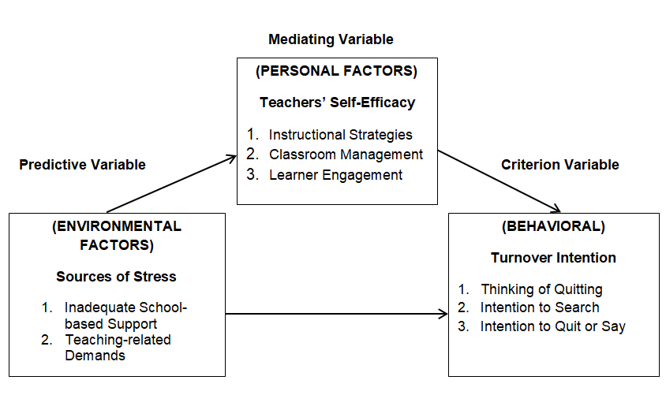

Fig 1. Impact of Teachers’ Self-efficacy on Source of Stress and Turnover Intention

2. METHODOLOGY
The research design, locale of the study, the sample and sampling technique, data gathering technique, data analysis technique, and the ethical considerations are explained in this section.

2.1 Research Design
This study employed a quantitative descriptive-correlation research design. A descriptive-correlational approach is particularly appropriate as it investigates associations between variables without manipulating them, thereby providing insights into naturally occurring relationships (Bhandari, 2021).

2.2 Locale of the Study
This study was conducted in public secondary schools within Clusters I, XIII, and XIV of the Schools Division of Davao City. Davao City is a highly urbanized city in the Davao Region of the Philippines. Situated in the South eastern part of Mindanao, the city has a large population and a diverse public education system.

2.3 Sample and Sampling Technique
The population comprised 485 junior and senior high school English language teachers across Clusters I, XIII, and XIV of the Davao City Division. These selected clusters serve densely populated areas with large student enrolments and varied teacher profiles, providing a suitable context for examining teachers’ stress, self-efficacy, and turnover intention.
In the selection of clusters, purposive sampling was used to select groups based on characteristics relevant to the study, ensuring information-rich data from participants most suitable for the research objectives (Campbell et al., 2020; Ames et al., 2023). Within these clusters, simple random sampling technique was employed to select the respondents. Simple random sampling is a probability sampling technique in which every member of the population has an equal chance of being selected, thereby minimizing selection bias and ensuring that the sample represents the larger population (Noor et al., 2022; Lakhre & Mishra, 2024). In this study, respondents were randomly selected from the total number of teachers within each cluster to ensure fairness and unbiased representation. Out of the total population of teachers across the selected clusters, a total of 215 teachers participated in the study.

2.4 Data Gathering Technique
The survey technique was utilized in this study to collect quantitative data from respondents through a structured questionnaire, enabling the researcher to gather standardized information about the variables being investigated (Creswell & Creswell, 2022).
The first part measured teachers’ sources of stress using the Teacher Stress Scale (TSS) adapted from Chen et al. (2022), focusing on indicators such as inadequate school-based support and teaching-related demands. The second part assessed teachers’ self-efficacy using the Second Language Teaching Efficacy Scale (SLTES) developed by Akbari and Abednia (2010), which consists of 34 items across three subscales: Instructional Strategies (12 items), Classroom Management (10 items), and Student Engagement (12 items). Although originally using a nine-point Likert scale, it was modified into a four-point scale for this study. The final part measured turnover intention using the modified Ordinal Turnover Intention Scale adapted from Bertolini and Marcatto (2025), with additional items from Roodt (2004). It assessed teachers’ withdrawal intentions through three components: Thinking of Quitting, Intention to Search, and Intention to Quit or Stay, using a four-point Likert scale.
All instruments were adapted and modified from established scales and underwent pilot testing with 30 respondents similar to the target participants, who were excluded from the final data collection. The questionnaire demonstrated high reliability, with an overall Cronbach’s alpha of 0.95.

2.5 Data Analysis
To analyze the data gathered in this study, descriptive and correlational analyses were employed; descriptive research summarizes characteristics of variables and addresses “what” is happening, and correlational research examines how variables are related without manipulating them (Miksza et al., 2023). The weighted mean was used to determine overall levels of stress, self‑efficacy, and turnover intention, and Pearson’s r assessed the significance of relationships among these variables.
The table below presented the matrix of scale ranges, descriptive levels, and corresponding interpretations assigned to each variable in the study. This measure was used to describe the levels of perceived stress, self-efficacy, and turnover intention.

Table 1. The matrix of scale ranges
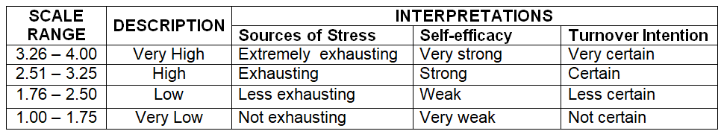

Moreover, the standard deviation was used to determine the degree of variation or dispersion of the respondents’ answers. It shows how consistent or varied the responses are in relation to the mean. The table below was used to describe the standard deviation:

Table 2. Determination of the degree of variation or dispersion of the respondents’ answers
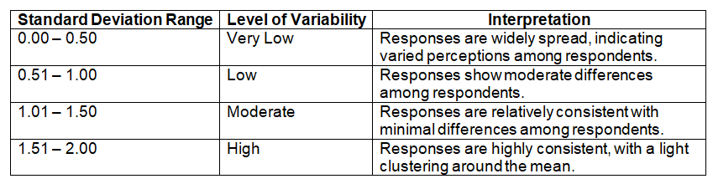

For the interpretation of the r‑value, this study used the scheme proposed by Guilford
(1956):

Computed r Descriptive Interpretation
+/- 1.00 Perfect correlation
Between +/- 0.75 – +/- 0.99 High correlation
Between +/- 0.51 – +/- 0.74 Moderately high correlation
Between +/- 0.31 – +/- 0.50 Moderately low correlation
Between +/- 0.01 – +/- 0.30 Low correlation
0.00 No correlation

Table 3. r‑value Estimated

3. results and discussion
This chapter presents the results of the descriptive and correlation analysis along with their corresponding interpretation. It concludes with a summary of findings.

3.1 Descriptive Analysis
Table 4 presented the descriptive statistics of the study. Contained in the table are the variables namely sources of stress, self-efficacy, and teachers’ turnover intention with their respective indicators. The table also included the number of respondents, computed means, standard deviation (SD), and the corresponding descriptive levels.
Specifically, the table shows that the sources of stress variable obtained a mean of 2.64 (SD = 0.386), described as high. This indicates that the respondents’ sources of stress are exhausting. All its indicators are high. Based on the standard deviation obtained, the responses are widely spread, indicating varied perceptions among respondents. In terms of self-efficacy, the respondents reported a very high level, with a mean of 3.34 (SD = 0.125), indicating that teachers demonstrated a very strong self-efficacy, with all three indicators rated very high. The standard deviation obtained a very low variability indicating that the responses are widely spread, showing varied perceptions among respondents. Finally, the turnover intention variable obtained a mean of 1.86 (SD=0.322), indicating low level. It indicates that the respondents have less certainty in their turnover intention. All its indicators are described as low. Standard deviation result shows that the responses are widely spread, indicating varied perceptions among respondents.

Table 4. Descriptive Table
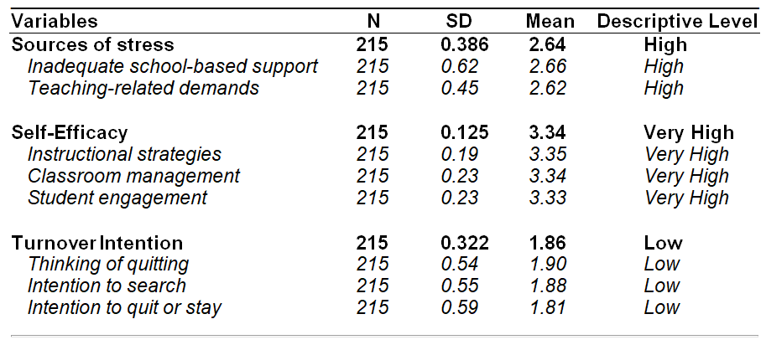

The findings indicate that teachers experience a high level of stress from various sources, while demonstrating a very strong sense of self-efficacy in performing their roles. Despite the presence of stress, teachers show a low level of turnover intention.

3.2 Correlation Analysis
Table 5 showed the correlation analysis of the determinant and criterion variables. The table included the r-values, p-values, and the corresponding decisions on the null hypotheses.

Table 5: Correlational Table
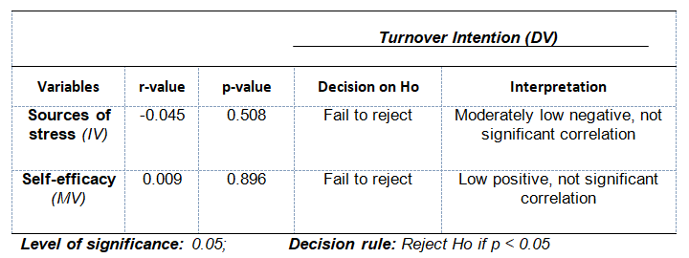

The correlation between sources of stress and the turnover intention of English language teachers yielded a p-value of 0.508, which is higher than the 0.05 level of significance. Hence, the null hypothesis was not rejected. It indicates that the correlation is not significant. With an r-value of -0.045, such a correlation is described as moderately low.
The correlation between self-efficacy and the criterion yielded a p-value of 0.896, which is higher than the 0.05 level of significance. Hence, the null hypothesis was not rejected. It indicates that the two variables mentioned are not significantly correlated. With an r-value of 0.009, the strength of the correlation is low.
The findings reveal that neither sources of stress nor self-efficacy show a significant relationship with teachers’ turnover intention. Both variables demonstrate very weak.

3.3 Summary of Findings
- The sources of stress and self-efficacy variables are statistically not significantly correlated with turnover intention of English language teachers.

4. DISCUSSION

4.1 The sources of stress and turnover intention of English language teachers are not significantly correlated.
The correlation analysis of this study shows that sources of stress are significantly correlated with turnover intention. This finding affirms the study of Xiaorong Chen and Xingjiang Tian (2023), which findings revealed that some work-related pressures did not directly predict turnover intention, emphasizing that psychological resources and support mechanisms may weaken the influence of stress on teachers’ intention to leave. Similarly, this current finding supports the study of Muhammad Iqbal, Shamim Ullah, and Rizwan Ahmad (2023) asserting that certain work-related conditions among teachers were not significantly associated with turnover intention, suggesting that educators may remain in their profession despite facing different sources of stress.

However, the present study contradicts Yang (2023), who reported a significant positive relationship between work stress and teachers’ turnover intention. The present study may be more reliable, as it focused specifically on English language teachers in basic education settings, where professional commitment and contextual factors differ from the vocational college teachers examined by Yang. These differences in respondent characteristics, context, and analytical approach likely explain the non-significant correlation found here.

4.2 No link between self-efficacy and turnover intention of English language teachers
The self-efficacy variables and turnover intention of English language teachers were not significantly correlated. This finding aligns with several recent empirical studies indicating that teacher self-efficacy alone may not be a strong direct predictor of turnover intentions. In many educational settings, self-efficacy appears to influence turnover indirectly rather than acting as a stand-alone determinant of leaving the profession. This recent view supports Nkwatsibwe et al. (2025) and Costan et al. (2022), who suggested that when multiple predictors are considered, the isolated effect of self-efficacy on turnover intention often diminishes in significance.
In contrast, Zhao et al. (2022) who found that teaching efficacy significantly influenced turnover intention in contexts where workplace conditions and job satisfaction strongly interacted, such as rural or highly specialized schools, is contradicted by the current study.

5. Conclusion
Based on findings, it is concluded that sources of stress and self-efficacy are not significantly correlated with turnover intention. Hence, the social cognitive theory which emphasizes that an individual's behavior, their environment, and their personal factors are not independent but are in a constant, dynamic interplay is denied.

6. RECOMMENDATIONS
Based on the conclusion, the following are recommended:
- Replicate the study using other variables not covered in the study to examine the assertion of Social Cognitive Theory.
- Conduct qualitative or mixed-methods research to explore other contextual and personal factors that may be correlated with teachers’ turnover intention.

Disclaimer (Artificial intelligence)

Author(s) hereby declare that NO generative AI technologies such as Large Language Models (ChatGPT, COPILOT, etc.) and text-to-image generators have been used during the writing or editing of this manuscript.

REFERENCES

- Akbari, R., & Abednia, A. (2010). Second language teachers’ sense of self-efficacy: A construct validation. Teaching English Language and Literature (TELL), 4(1), 69–101.
- Ames, H., Glenton, C., & Lewin, S. (2023). Purposive sampling in a qualitative evidence synthesis: A worked example from a synthesis on parental perceptions of vaccination communication. BMC Medical Research Methodology, 23, 16. https://doi.org/10.1186/s12874-023-01884-9
- Bandura, A. (2006). Guide for constructing self-efficacy scales.
- Bertolini, D., & Marcatto, F. (2025). Introducing the ordinal turnover intention scale (OTIS): A cross-sectional validation in Italian employees and foundation for longitudinal research. Journal of Health and Social Sciences, 42–55. https://doi.org/10.19204/2025/NTRD4
- Bothma, C. F. C., & Roodt, G. (2013). The validation of the turnover intention scale. SA Journal of Human Resource Management, 11(1), 1–12. https://doi.org/10.4102/sajhrm.v11i1.507
- Bottrell, D., Riddle, S., & Li, M. (2024). Emotional labor and teachers’ intentions to leave: A longitudinal study of Australian educators. The Australian Educational Researcher. https://doi.org/10.1007/s13384-024-00794-1
- Campbell, S., Greenwood, M., Prior, S., Shearer, T., Walkem, K., Young, S., Bywaters, D., & Walker, K. (2020). Purposive sampling: Complex or simple? Research case examples. Journal of Research in Nursing, 25(8), 652–661. https://doi.org/10.1177/1744987120927206
- Cavioni, V., Grazzani, I., & Rappuoli, S. (2023). Teacher burnout and turnover intentions: A cross-national study in Latvia and Lithuania. International Journal of Environmental Research and Public Health, 20(3), 2431. https://doi.org/10.3390/ijerph20032431
- Chen, J. J., Li, Z., Rodrigues, W., & Kaufman, S. (2022). Teacher stress scale (TSS) [Database record]. APA PsycTests. https://doi.org/10.1037/t85552-000
- Chen, X., & Tian, X. (2023). Emotional labor and turnover intention among teachers: The mediating role of self-efficacy and moderating effect of social support. International Journal of Educational Research, 117, 102115. https://doi.org/10.1016/j.ijer.2023.102115
- Costan, F., Gonzales, G., Gonzales, R., Valle, L., Dela Cruz, J., Alcantara, G., & Ocampo, L. (2022). Teachers’ turnover intentions in view of implementing a flexible learning system: An extended theory of planned behavior. Sustainability, 14(20), 13009. https://doi.org/10.3390/su142013009
- Creswell, J. W., & Creswell, J. D. (2022). Research design: Qualitative, quantitative, and mixed methods approaches (6th ed.). SAGE Publications.
- Duan, M., Zhou, Y., & Zhang, X. (2024). The impact of multiple job demands on Chinese university teachers’ turnover intentions. Asia-Pacific Education Researcher, 33, 1351–1361. https://doi.org/10.1007/s40299-023-00809-y
- Farahmandpour, Z., & Voelkel, R. H. (2025). Teacher turnover factors and school-level influences: A meta-analysis of the literature. Education Sciences, 15(2), 219. https://doi.org/10.3390/educsci15020219
- Febyana, N. S., Emilisa, N., Ramadini, S. S., & Prayogi, R. (2024). The effect of self-efficacy and emotional intelligence on turnover intention mediated by work engagement among Gen Z employees. Innovative: Journal of Social Science Research, 4(3). https://doi.org/10.31004/innovative.v4i3.12101
- Guilford, J. P. (1956). The structure of intellect. Psychological Bulletin, 53(4), 267–293. https://doi.org/10.1037/h0040755
- Iqbal, M., Ullah, S., & Ahmad, R. (2023). Teachers’ workplace conditions and turnover intention: Evidence from Pakistan. Journal of Educational Research, 126(3), 345–358. https://doi.org/10.1080/00220671.2023.2189472
- Lazarus, C., Gutierrez, A., & Baguio, K. (2023). Effect of organizational commitment on turnover intention of senior high private school teachers in Cebu City, Philippines. International Journal of Management, Technology, and Social Sciences, 8(1), 19–32. https://doi.org/10.5281/zenodo.7504129
- Miksza, P., Shaw, J. T., Richerme, L. K., Hash, P. M., Hodges, D. A., & Parker, E. C. (2023). Quantitative descriptive and correlational research. In Music education research (pp. 241–262). Oxford University Press. https://doi.org/10.1093/oso/9780197639757.003.0012
- Nkwatsibwe, I., Rukundo, A., & Balimuttajjo, S. (2025). Relationships between job stress, job satisfaction, self-efficacy, and turnover intentions among teachers. East African Journal of Education Studies, 8(2), 150–167. https://doi.org/10.37284/eajes.8.2.2876
- Noor, S., Tajik, O., & Golzar, J. (2022). Simple random sampling in scientific research. International Journal of Education & Language Studies, 1(2), 79–80.
- Oberes, M. V., & Tan, T. A. (2022). Organizational commitment and turnover intention among senior high school teachers. The Normal Lights, 16(1). https://doi.org/10.56278/tnl.v16i1.1714
- OECD. (2021). Education at a glance 2021: OECD indicators. OECD Publishing.
- Qin, L. (2021). Country effects on teacher turnover intention: A multilevel, cross-national analysis. Educational Research for Policy and Practice, 20(1), 79–105.
- Qin, L., & Liu, H. (2023). Teachers’ perceived status and turnover intentions: Evidence from Chinese K–12 schools. Educational Psychology, 43(2), 195–211. https://doi.org/10.1080/01443410.2022.2079353
- Royalty, H., Feng, L., & Baek, J. (2022). What predicts teachers’ turnover intention? A meta-analysis. Educational Research Review, 37, 100477. https://doi.org/10.1016/j.edurev.2022.100477
- Sahito, Z., & Väisänen, P. (2024). Examining teacher retention through job satisfaction and commitment. International Journal of Learning, Teaching and Educational Research, 23(4), 42–58. https://doi.org/10.26803/ijlter.23.4.3
- Schunk, D. H., & Pajares, F. (2010). Self-efficacy beliefs. In International encyclopedia of education (pp. 668–672). Elsevier.
- Tett, R. P., & Meyer, J. P. (1993). Job satisfaction, organizational commitment, turnover intention, and turnover. Personnel Psychology, 46(2), 259–293. https://doi.org/10.1111/j.1744-6570.1993.tb00874.x
- Walsh, J. P., Ashford, S. J., & Hill, T. E. (1985). Feedback obstruction and turnover intentions. Human Relations, 38(1), 23–46. https://doi.org/10.1177/001872678503800102
- Yang, W. (2023). Work stress and turnover intention among vocational college teachers. Asian Journal of Educational Research, 11(2), 56–67. https://doi.org/10.5430/ajer.v11n2p56
- Zeitlin, A. (2020). Teacher turnover in Rwanda: Incidence and consequences. arXiv. https://arxiv.org/abs/2009.13091
- Zhao, Y., Lu, Z., Cheng, X., & Li, J. (2022). Organizational trust and turnover intention of rural kindergarten teachers. International Journal of Environmental Research and Public Health, 19(19), 12403. https://doi.org/10.3390/ijerph191912403

