Visualizing Igbo Folklore: Linguistic Symbolism and Oral Narratives in Contemporary Art Practices in Southeast Nigeria

Abstract
This study examined how Igbo folklore, oral traditions, and indigenous narrative forms are visually interpreted and re-imagined within contemporary Igbo art practices in Southeast Nigeria. Grounded in folklore studies, visual anthropology, and linguistic symbolism, the research analyzed the translation of folktales, myths, proverbs, praise poetry, and ritual narratives from spoken Igbo language into visual forms such as painting, textile art, sculpture, illustration, and mixed media installations. A qualitative-dominant mixed-methods approach was adopted, combining visual narrative analysis of selected artworks with oral history interviews involving artists, storytellers, and cultural custodians, alongside participant observation during festivals, storytelling sessions, and ritual performances. Data were analyzed using thematic and semiotic frameworks to trace narrative structures, symbolic motifs, and linguistic metaphors embedded in visual compositions. Findings revealed that contemporary Igbo artists function as visual storytellers who actively preserve, reinterpret, and adapt folklore narratives to address present-day realities while maintaining continuity with indigenous epistemologies. The study concludes that visual art serves as an effective medium for sustaining Igbo linguistic symbolism and oral heritage within contemporary cultural contexts. The research contributes to scholarship on visual storytelling, folklore preservation, and indigenous knowledge transmission, while offering insights relevant to art education, heritage documentation, and cultural policy development in Nigeria.
Keywords: Folklore Studies; Igbo Language; Indigenous Traditions; Visual Narrative; Visual Storytelling.

1.1 Introduction
Across sub-Saharan Africa, renewed scholarly and artistic attention has increasingly focused on indigenous knowledge systems as vital resources for cultural sustainability, epistemic justice, and postcolonial identity reconstruction. In Nigeria, the Igbo nationality concentrated in the southeastern geopolitical zone sustains a rich corpus of oral traditions: Igbo oral traditions encompass folktales (akụkọ ifo¹), proverbs (ilu²), praise poetry, myths of origin, ritual chants, and cosmological narratives that historically structured communal knowledge systems. Within the Igbo cosmological worldview, concepts such as chi³, ala⁴, and ancestral presence shape moral philosophy and social organization. Historically, these expressive forms have functioned not merely as entertainment but as pedagogical instruments, ethical compasses, and philosophical frameworks structuring communal life. Through storytelling sessions, moonlight tales, masquerade performances, and ritual enactments, knowledge was transmitted across generations, reinforcing moral codes, social hierarchies, metaphysical beliefs, and communal identity.
However, processes of urbanization, globalization, language shift, formal Western education, and digital transformation have significantly reshaped the transmission pathways of these traditions. Increasing migration to urban centers, the dominance of English in formal domains, and the expansion of digital media platforms have altered the cultural ecology within which Igbo oral traditions historically thrived. These transformations raise urgent questions concerning preservation, reinterpretation, and creative continuity. Rather than disappearing, oral traditions are increasingly migrating into new expressive forms, particularly contemporary visual art, where they are reconfigured within hybrid aesthetic frameworks.

Footnotes:
¹ Akụkọ ifo – Traditional Igbo folktales narrated during moonlight storytelling sessions and used to transmit moral lessons, social norms, and communal wisdom across generations.
² Ilu – Proverbs that encapsulate philosophical insight, moral instruction, and collective wisdom within Igbo culture.
³ Chi – A personal spiritual guardian believed to guide an individual’s destiny within Igbo cosmology.
⁴ Ala – The earth deity in Igbo belief systems, associated with morality, fertility, land authority, and ancestral justice.
Scholarly discourse in folklore studies recognizes oral tradition as a dynamic and adaptive system rather than a static archive (Finnegan, 2012; Barber, 2018). Contemporary Africanist research emphasizes performance, embodiment, and intermediation, arguing that folklore continuously circulates across expressive forms including music, theatre, film, digital media, and visual art. Within Igbo cultural history, oral narratives have long intersected with material culture. Sculptural traditions, mural practices, masquerade performances, and textile symbolism encode cosmological meanings deeply embedded in language and belief systems. The visual and the verbal have therefore never existed as isolated domains; rather, they have historically operated in reciprocal dialogue. Institutions such as the Centre for Black and African Arts and Civilization have emphasized the importance of safeguarding intangible heritage while encouraging innovative reinterpretations that ensure cultural vitality. Archived textile imageries refer to digitally documented representations of traditional textile motifs, patterns, and symbolic designs preserved through high-resolution photography and digital archiving platforms. These archives enable researchers, artists, and cultural institutions to access visual records of indigenous textile traditions, ensuring their preservation and reinterpretation within contemporary artistic and educational contexts (Onyebuchi-Igbokwe & Egornu, 2025).
Recent scholarship on indigenous visuality situates African contemporary art within trans-local and global networks while foregrounding local epistemologies (Okeke-Agulu, 2015; Ogbechie, 2021). Exhibitions at institutions such as the National Gallery of Art illustrate how artists from Southeast Nigeria increasingly draw on folkloric structures, ancestral motifs, and linguistic metaphors to engage themes of memory, identity, migration, gender relations, and sociopolitical transformation. This practice aligns with broader theoretical movements advocating decolonial aesthetics and epistemic pluralism (Mignolo & Walsh, 2018; Ndlovu-Gatsheni, 2020), which reposition indigenous narrative systems not as ethnographic curiosities but as generative sources of theory and creative methodology.
The Igbo worldview often articulated through proverbs and mythic archetypes operates within a symbolic universe structured by concepts such as chi (personal spiritual essence), ala (earth deity), ancestral presence, and communal reciprocity. While these cosmological constructs are primarily transmitted orally, contemporary artists reinterpret them through painting, textile design, sculpture, digital illustration, and installation art. Semiotic scholarship suggests that such translation entails complex processes of condensation, metaphorization, and visual coding (Chandler, 2017), whereby linguistic signifiers are transformed into chromatic schemes, compositional arrangements, spatial metaphors, and iconographic motifs. This process of inter-semiotic translation moving from spoken narrative to visual representation invites interdisciplinary inquiry bridging folklore studies, visual anthropology, art history, linguistics, and cultural studies.
Global frameworks for safeguarding intangible cultural heritage, particularly those articulated by the UNESCO (2003 Convention; updated 2022 operational directives), emphasize community participation and creative continuity rather than mere archival preservation. In Southeast Nigeria, festivals, masquerade performances, and storytelling sessions remain vital contexts for narrative transmission. Yet contemporary visual artists increasingly extend these oral forms into gallery spaces, studios, textiles, and digital platforms, thereby broadening their circulation and interpretive possibilities. Such transformations prompt critical scholarly questions: How are Igbo folktales visually encoded in contemporary art practices? Which symbolic structures persist, and which are reconfigured to respond to present-day sociopolitical realities? How do artists negotiate authenticity, innovation, and audience reception when translating oral language into visual semiotics?
Emerging literature on African visual storytelling identifies artists as cultural mediators who reinterpret oral narratives within hybrid aesthetic frameworks (Kasfir, 2020; Enwezor, 2019). In the Igbo context, this mediating role assumes heightened urgency given concerns about language endangerment and declining intergenerational transmission. Linguistic studies warn that many indigenous African languages face increasing pressure from dominant global languages (Eberhard, Simons, & Fennig, 2023), necessitating innovative preservation strategies beyond conventional documentation. Visual art, as a multisensory communicative system, may therefore serve as an alternative site of linguistic revitalization, embedding proverbs, idioms, mythic archetypes, and cosmological symbolism within visual compositions that circulate beyond traditional storytelling environments.
Situated within this interdisciplinary nexus, this study investigates how Igbo oral narratives are visually interpreted and re-imagined by contemporary artists in Southeast Nigeria, and how such practices contribute to heritage preservation, cultural continuity, and epistemic resilience. Employing a qualitative-dominant mixed-methods design including visual narrative analysis, semiotic interpretation, oral history interviews, and participant observation the research foregrounds artists as active custodians and innovators of indigenous knowledge. Beyond contributing to scholarly debates in folklore and visual anthropology, the study offers practical implications for art education curricula, heritage documentation initiatives, and cultural policy development. In doing so, it supports broader efforts to reposition indigenous African knowledge systems as central to contemporary scholarship and creative practice rather than peripheral remnants of a fading past.

1.2 Statement of the Problem
Despite the richness of Igbo oral traditions including folktales (akụkọ ifo), proverbs (ilu), myths, praise poetry, and ritual narratives there is growing concern about their declining transmission within contemporary Igbo society in Nigeria. Rapid urbanization, migration, formal Western-oriented education, digital media dominance, and the increasing preference for English over indigenous languages have significantly disrupted traditional storytelling environments. Intergenerational knowledge transfer, once sustained through communal gatherings, festivals, and ritual performances, is increasingly fragmented. As linguistic vitality weakens, so too do the embedded cosmology; ethical framework and symbolic system carried within the Igbo language.
While global frameworks such as those advanced by UNESCO emphasize safeguarding intangible cultural heritage through creative continuity, practical mechanisms for sustaining Igbo folklore in contemporary contexts remain insufficiently theorized and documented. Much of the existing scholarship focuses on textual documentation of oral literature or anthropological description of traditional practices. Limited empirical attention has been given to how contemporary visual artists reinterpret, encode, and transmit these oral narratives within modern artistic media.
Furthermore, although institutions such as the National Gallery of Art showcase works that reference indigenous themes, there is a notable gap in systematic academic analysis of the processes through which linguistic symbolism is transformed into visual semiotics. The inter-semiotic translation of oral narratives into painting, textile art, sculpture, and installation remains underexplored, particularly in relation to questions of authenticity, innovation, and cultural mediation.
Consequently, there is a critical need to investigate how contemporary Igbo artists function as visual storytellers and how their creative practices contribute to folklore preservation, linguistic revitalization, and epistemic resilience. Without such inquiry, the evolving relationship between oral tradition and contemporary art risks being inadequately documented, limiting both scholarly understanding and policy development aimed at safeguarding indigenous knowledge systems in Southeast Nigeria.

1.3 Research Objectives
- To examine how Igbo folktales, proverbs, myths, and ritual narratives are translated from oral language into contemporary visual art forms in Southeast Nigeria.
- To analyze the symbolic motifs, linguistic metaphors, and cosmological concepts embedded within selected contemporary artworks.
- To evaluate the role of contemporary Igbo artists as cultural mediators in preserving, adapting, and transmitting indigenous knowledge systems through visual storytelling.

1.4 Research Hypotheses

Hypothesis 1 (Related to Objective 1)
H0₁: There is no significant relationship between Igbo oral narratives and their visual representation in contemporary art practices in Southeast Nigeria.
H1₁: There is a significant relationship between Igbo oral narratives and their visual representation in contemporary art practices in Southeast Nigeria.

Hypothesis 2 (Related to Objective 2)
H0₂: Linguistic symbols and cosmological concepts from Igbo oral traditions are not significantly embedded in contemporary visual artworks.
H1₂: Linguistic symbols and cosmological concepts from Igbo oral traditions are significantly embedded in contemporary visual artworks.

Hypothesis 3 (Related to Objective 3)
H0₃: Contemporary Igbo artists do not significantly contribute to folklore preservation and linguistic revitalization through visual storytelling.
H1₃: Contemporary Igbo artists significantly contribute to folklore preservation and linguistic revitalization through visual storytelling.

1.5 Literature Review
This literature review situates the present study within existing theoretical and empirical scholarship on oral tradition, visual storytelling, semiotics, and indigenous knowledge preservation in African art contexts.

1.5.1 Theoretical Foundations

Folklore as Dynamic Cultural System:
Folklore studies have evolved from viewing oral traditions as static artefacts to recognizing them as dynamic, adaptive systems embedded within performance, communication, and cultural memory. Finnegan’s foundational work (2012) highlights the performative and contextual nature of oral literature, stressing that meaning in oral narratives emerges from interaction between storyteller, audience, and context. Barber (2018) further emphasizes that African oral traditions are inventive processes, shaped by socio-cultural change rather than frozen heritage.
In the context of Igbo culture, oral narratives such as folktales (akụkọ ifo), proverbs (ilu), praise poetry, and mythic stories have traditionally functioned as repositories of moral philosophy, cosmology, and communal cohesion. These oral forms were not isolated but often intertwined with performance, ritual, and material culture resources that artists now draw upon in re-spacing these narratives into new media.

Inter-semiotic Translation and Semiotics:
Semiotic theory offers a lens for understanding how meaning migrates across media. Chandler (2017) proposes that semiotics the study of signs and symbols and their use or interpretation clarifies how linguistic structures (verbal symbols) are encoded into visual forms. Inter-semiotic translation, a concept adopted from Jakobson’s broader semiotic framework, refers to the transfer of meaning across sign systems, such as from language to visual art. In the case of Igbo folklore, semiotics helps explain how proverbs and cosmological metaphors become visual motifs, compositional structures, or symbolic patterns within paintings, textiles, and installations.
Table 1
Examples of Linguistic Symbols and Cosmological Concepts in Igbo Visual Narratives
Linguistic Symbol | Cultural Meaning | Visual Representation in Contemporary Art
Chi | Personal destiny or spiritual guardian | Radiating circular motifs or luminous central figures
Ala | Earth goddess and moral authority | Earth-tone palettes and grounded landscape forms
Ilu | Proverbs conveying moral wisdom | Symbolic pictorial metaphors illustrating proverbial meanings
Animal symbolism | Moral allegories in folktales | Stylized depictions of tortoise, birds, and other animals

Decolonial Aesthetics and Indigenous Epistemologies:
Decolonial aesthetics foregrounds indigenous ways of knowing as valid intellectual and cultural systems (Mignolo & Walsh, 2018; Ndlovu-Gatsheni, 2020). This perspective challenges Eurocentric narratives that have historically marginalized African epistemologies. In visual art, a decolonial lens repositions indigenous symbolic systems such as Igbo cosmology and linguistic metaphors not as objects of ethnographic fascination but as generative, theorizing forces shaping contemporary arts practice. Contemporary Igbo artists thus emerge as epistemic agents who integrate cultural knowledge into aesthetic innovation.

1.5.2 Empirical Review

Visual Storytelling in African Contemporary Art:
Recent scholarship has documented how African artists engage indigenous materials, narratives, and cosmologies to redefine contemporary artistic expression. Okeke-Agulu’s work (2015) situates Nigerian art within local and global dialogues, emphasizing how artists draw from indigenous histories to address contemporary cultural realities. Similarly, Ogbechie (2021) analyses how Nigerian artists embed historical consciousness within material forms, creating visual languages that traverse tradition and modernity.
Studies on visual storytelling in Africa reveal that artists increasingly blend narrative traditions with visual media. Characteristically, these studies highlight how memory, identity, and collective history surface in contemporary work. However, the majority centre on West African art more broadly, with limited empirical focus on the specific role of oral narratives in shaping visual semiotics.

Folklore, Language, and Art:
Research on oral traditions and their preservation has largely focused on documentation and textual archiving. Finnegan (2012) provides an extensive ethnographic account of oral literature in Africa, while other literature has emphasized linguistic preservation amid globalization. Eberhard, Simons, and Fennig (2023) in Ethnologue show that many African languages including Igbo face pressures from dominant languages, necessitating revitalization strategies. However, empirical studies connecting linguistic vitality, folklore transmission, and visual arts remain sparse.

Interdisciplinary Studies & Semiotic Art Analysis:
Cross-disciplinary research linking linguistics, semiotics, and visual art is growing but still emerging within African scholarship. Some studies adopt semiotic frameworks to analyse indigenous symbolism in art, identifying how traditional motifs and cosmological references are visually articulated. Yet these works are often case studies limited in scope or rooted outside the Southeast Nigerian context.

1.5.3 Gap in the Literature
The literature reveals important insights but also distinct gaps that this study addresses:
- Limited Empirical Inquiry Into Inter-semiotic Translation:
While scholars have theorized about oral traditions and visual art independently, empirical research analyzing how oral narratives are transformed into visual language is limited. Few studies systematically investigate how Igbo linguistic structures become visual codes in contemporary artworks.
- Under -researched Artist-centered Mediating Role:
Existing research has not adequately examined the role of artists as cultural mediators—agents who actively preserve, adapt, and reinterpret folklore through visual media.
- Inadequate Linkage Between Language Endangerment and Visual Art:
Although linguistic studies highlight the risk of language loss, there is sparse empirical work exploring how visual art might serve as a mechanism for linguistic revitalization and heritage transmission.

Limited Focus on Igbo Folklore within Anglophone West African Art Scholarship
Another important gap in the literature concerns the dominance of scholarship emerging from major Anglophone West African art centres such as Lagos in Nigeria and Accra in Ghana. These urban cultural hubs host influential art institutions, galleries, and universities including the University of Nigeria, Nsukka; Yaba College of Technology; the University of Lagos; and the Kwame Nkrumah University of Science and Technology which have historically shaped much of the academic discourse on contemporary African art. While these institutions have contributed significantly to global recognition of African artistic production, scholarly attention has often concentrated on modernist movements, postcolonial identity debates, and experimental contemporary practices within metropolitan art scenes.
As a result, the specific role of indigenous oral traditions, folklore narratives, and linguistic symbolism within localized cultural contexts particularly within Igbo communities has received comparatively limited systematic examination. Although the Nsukka School has incorporated indigenous symbols such as uli motifs into contemporary artistic practice, the translation of Igbo oral narratives, proverbs, and cosmological concepts into contemporary visual forms remains underexplored within existing literature.
This gap highlights the need for focused scholarly investigation into how Igbo folklore and linguistic symbolism are visualized in contemporary artworks. Addressing this gap contributes to a broader understanding of how indigenous narrative systems continue to inform contemporary artistic production and cultural identity formation in southeastern Nigeria.

1.5.4 Justification of the Study
Given these gaps, this study is justified on both scholarly and practical grounds. It contributes uniquely to:
- Folklore Studies by empirically documenting the visual re-functionalization of oral narratives.
- Visual Anthropology and Semiotics by mapping the semiotic strategies used in contemporary artworks.
- Indigenous Knowledge Preservation by positioning visual art as a viable channel for sustaining linguistic and narrative heritage.
- Policy and Practice by offering insights relevant to art education, cultural institutions, and heritage frameworks in Nigeria.

3.0 Research Methodology

3.1 Research Design
This study adopted a qualitative-dominant mixed-methods design, integrating interpretive qualitative approaches with supportive quantitative measures to examine how Igbo oral narratives were visually interpreted in contemporary art. The qualitative component focuses on visual narrative analysis, semiotic interpretation, and thematic coding, enabling an in-depth understanding of symbolic motifs, linguistic metaphors, and cosmological constructs embedded in artworks. The quantitative component complements this by providing measurable data on the frequency of symbolic motifs, audience recognition, and artist-mediated preservation strategies, allowing for inferential statistical testing such as Chi-square, regression, and ANOVA. This design ensures a comprehensive assessment of both artistic processes and cultural impacts, bridging visual anthropology, folklore studies, and art semiotics. Visual anthropology examines how visual media including art, film, and photography communicate cultural knowledge and social meaning. Within this study, visual anthropology provided methodological tools for analyzing how symbolic elements embedded in artworks reflect broader cultural narratives. Semiotic mapping was employed to identify and categorize symbolic motifs within artworks, tracing their relationship to linguistic metaphors, cosmological beliefs, and oral storytelling traditions.

3.2 Population and Sample
Population: The target population comprises:
- Contemporary Igbo visual artists actively engaging with folklore narratives in Southeast Nigeria.
- Cultural custodians, storytellers, and festival practitioners who transmit oral narratives.
- Audiences interacting with artworks in galleries, exhibitions, or online platforms.
Sample: Using purposive and snowball sampling, the study will select:
- 20–30 contemporary artists whose work explicitly references Igbo folktales, proverbs, myths, or ritual narratives.
- 10–15 cultural custodians or storytellers knowledgeable in oral traditions.
- 100–150 audience participants for perception surveys to measure recognition and interpretation of folklore motifs in visual art.

3.3 Data Collection Instruments
- Visual Narrative Coding Framework:
  - A structured tool will be developed to systematically analyze artworks.
  - Elements coded include: folktale reference, proverb incorporation, mythological motif, color symbolism, compositional arrangement, and semiotic density.
- Semi-Structured Interview Guide:
  - Designed for artists, storytellers, and custodians.
  - Explores motivations, narrative sources, interpretive strategies, and perceptions of cultural preservation.
- Observation Guide:
  - Records participant interactions during festivals, storytelling sessions, and ritual performances.
  - Notes performative, narrative, and symbolic elements relevant to visual translation.
- Audience Survey Questionnaire:
  - Likert-scale items measuring recognition of folklore elements, perceived authenticity, and contribution to cultural continuity.

3.4 Data Collection Procedure
- Artwork Selection:
The artworks analyzed in this study were drawn from selected exhibitions and artist studios in Southeast Nigeria. Notable works include:
- “Echoes of Ala” – Mixed-media painting referencing earth deity symbolism.
- “Spirit of the Masquerade” – Sculptural installation inspired by Igbo masquerade traditions.
- “Proverbs in Motion” – Textile-based artwork translating Igbo proverbs into patterned visual motifs.
These works were selected because they explicitly reference Igbo folklore narratives and cosmological symbolism.
- Interviews:
  - Conducted face-to-face or virtual semi-structured interviews with artists and cultural custodians.
  - Each interview was audio-recorded (with consent) and transcribed verbatim for analysis.
- Participant Observation:
  - Attended festivals, masquerade performances, and storytelling sessions to contextualize oral narratives within material culture.
  - Detailed field notes captured performative and symbolic aspects relevant to visual translation.
- Audience Survey:
  - Distributed questionnaires during exhibitions / digital platforms to gauge audience perception of folklore integration in contemporary artworks.

3.5 Data Analysis Techniques
Qualitative Analysis:
- Thematic Analysis: Identified recurring motifs, narrative structures, and interpretive patterns.
- Semiotic Analysis: Examined how linguistic metaphors, proverbs, and cosmological symbols are re-coded into visual language, following Chandler (2017).
- Triangulation: Integrated data from interviews, visual analysis, and participant observation to ensure reliability and credibility.
Quantitative Analysis:
- Descriptive Statistics: Frequency counts of symbolic motifs, demographic distributions of audience perception.
- Inferential Statistics:
  - Chi-square tests to examine associations between folklore elements and audience recognition.
  - Regression analysis to determine predictive influence of artist intention or motif density on cultural preservation perception.
  - ANOVA to compare differences in audience perception across demographic groups.
Software Tools:
- Qualitative data were managed in NVivo for coding and thematic analysis.
- Quantitative data were analyzed using SPSS or STATA to generate descriptive and inferential statistics.

3.6 Validity and Reliability / Trustworthiness
- Credibility: Prolonged engagement with artists and cultural events, triangulation of data sources.
- Dependability: Detailed coding framework, inter-coder agreement checks for visual and thematic coding.
- Confirmability: Audit trail of decisions during data collection and analysis.
- Transferability: Thick description of artworks, cultural context, and interpretive procedures for potential replication in other African contexts.

4.0 Results

4.1 Overview of Dataset
The empirical dataset comprised three complementary sources: visual analysis of 25 contemporary artworks produced by Igbo artists across Southeast Nigeria, semi-structured interviews with 22 artists and 12 cultural custodians, and a perception survey involving 132 exhibition audiences. The triangulation of these datasets enabled the study to investigate how Igbo oral narratives are translated into visual semiotics and how audiences interpret these visualizations.
The quantitative data derived from the audience survey and motif coding were analyzed using descriptive statistics and inferential tests including Chi-square, linear regression, and one-way ANOVA, while qualitative data from interviews and visual analysis were coded thematically.

4.2 Visual Encoding of Igbo Oral Narratives

4.2.1 Distribution of Narrative Forms
Analysis of the 25 artworks revealed that Igbo folktales (36%) and proverbs (24%) constitute the most frequently visualized narrative structures, followed by mythological narratives (20%), ritual narratives (12%), and praise poetry (8%).
This distribution suggests that folktales and proverbs remain the most adaptable narrative structures for visual translation. Unlike ritual narratives, which often require specific performative contexts, folktales and proverbs contain condensed symbolic messages that can be easily translated into visual metaphors.
The prevalence of folktales therefore supports the first research objective, which sought to examine how Igbo oral narratives are translated into contemporary visual forms.

Charts for: Visualizing Igbo Folklore Study

Figure 1: Distribution of Igbo Oral Narrative Forms
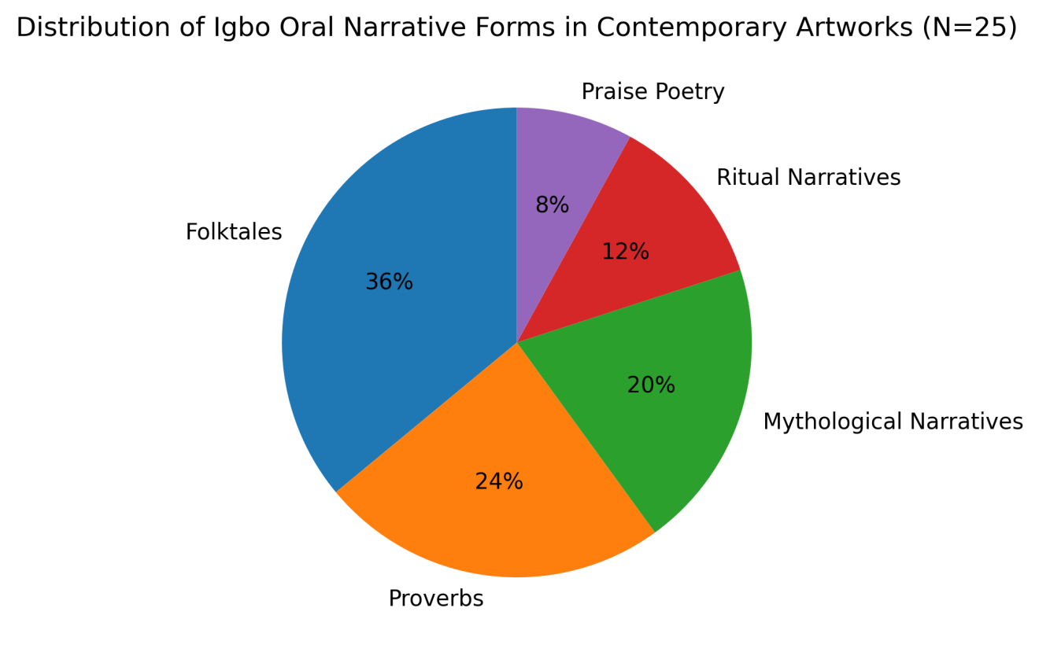
Figure 1 shows the proportional distribution of oral narrative structures represented in the analyzed artworks. Folktales constitute the largest category (36%), followed by proverbs (24%), mythological narratives (20%), ritual narratives (12%), and praise poetry (8%).

4.2.2 Semiotic Motifs and Symbolic Density
Symbolic Motif | Frequency | Percentage
Masquerade imagery | 17 | 68%
Earth-tone palettes | 15 | 60%
Circular cosmological motifs | 13 | 52%
Spiral continuity patterns | 12 | 48%
Animal symbolism | 11 | 44%

These findings indicate that artists rely on recognizable cultural symbols when translating oral narratives into visual language. The recurrence of masquerade imagery, for example, reflects the deep connection between folklore and masquerade performance in Igbo cosmology.
More importantly, artworks exhibiting higher motif layering displayed greater narrative complexity, suggesting that symbolic density functions as a mechanism for compressing multiple linguistic meanings into visual form.

Figure 2: Frequency of Symbolic Motifs in Artworks
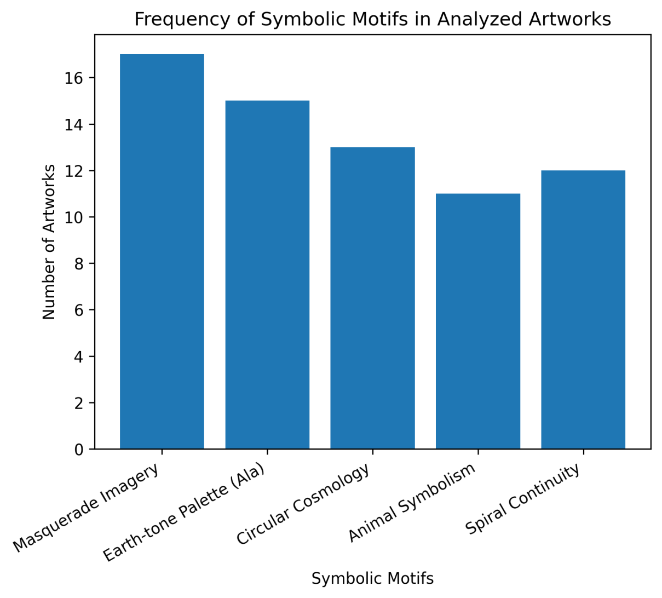
Figure 2 presents the frequency of major symbolic motifs identified in the artworks, including masquerade imagery, earth-tone palettes referencing Ala, circular cosmological motifs, animal symbolism, and spiral continuity patterns.

4.3 Artists as Cultural Mediators
Interview data revealed that 85% of artists explicitly described their practice as a continuation of Igbo storytelling traditions. Three dominant themes emerged:
- Visual preservation of endangered linguistic metaphors
- Adaptation of proverbs into compositional anchors
- Reinterpretation of folklore to address contemporary socio-political realities
Cultural custodians corroborated these findings, acknowledging visual art as an emerging platform for oral continuity, though some expressed concerns regarding potential symbolic dilution. These results highlight the active role of artists as mediators between oral knowledge systems and contemporary artistic expression.

4.4 Audience Recognition and Perception
Survey responses from 132 audience participants demonstrate substantial recognition of folkloric symbolism within the artworks.
Key findings include:
- 72% recognized identifiable folklore elements
- 64% identified specific proverb or folktale references
- 81% agreed that the artworks contribute to cultural preservation
Mean perception scores further support these findings:
Variable | Mean | SD
Recognition of folklore | 4.1 | 0.78
Cultural authenticity | 4.3 | 0.65
Preservation contribution | 4.4 | 0.59
These results indicate that audiences generally perceive contemporary artworks incorporating folkloric elements as culturally authentic and as contributing to heritage preservation.

Figure 3: Mean Audience Perception Scores of Folklore-Based Artworks (N = 132).
The figure illustrates audience recognition of folklore elements, perceived cultural authenticity, and perceived contribution to cultural preservation in contemporary Igbo visual artworks.
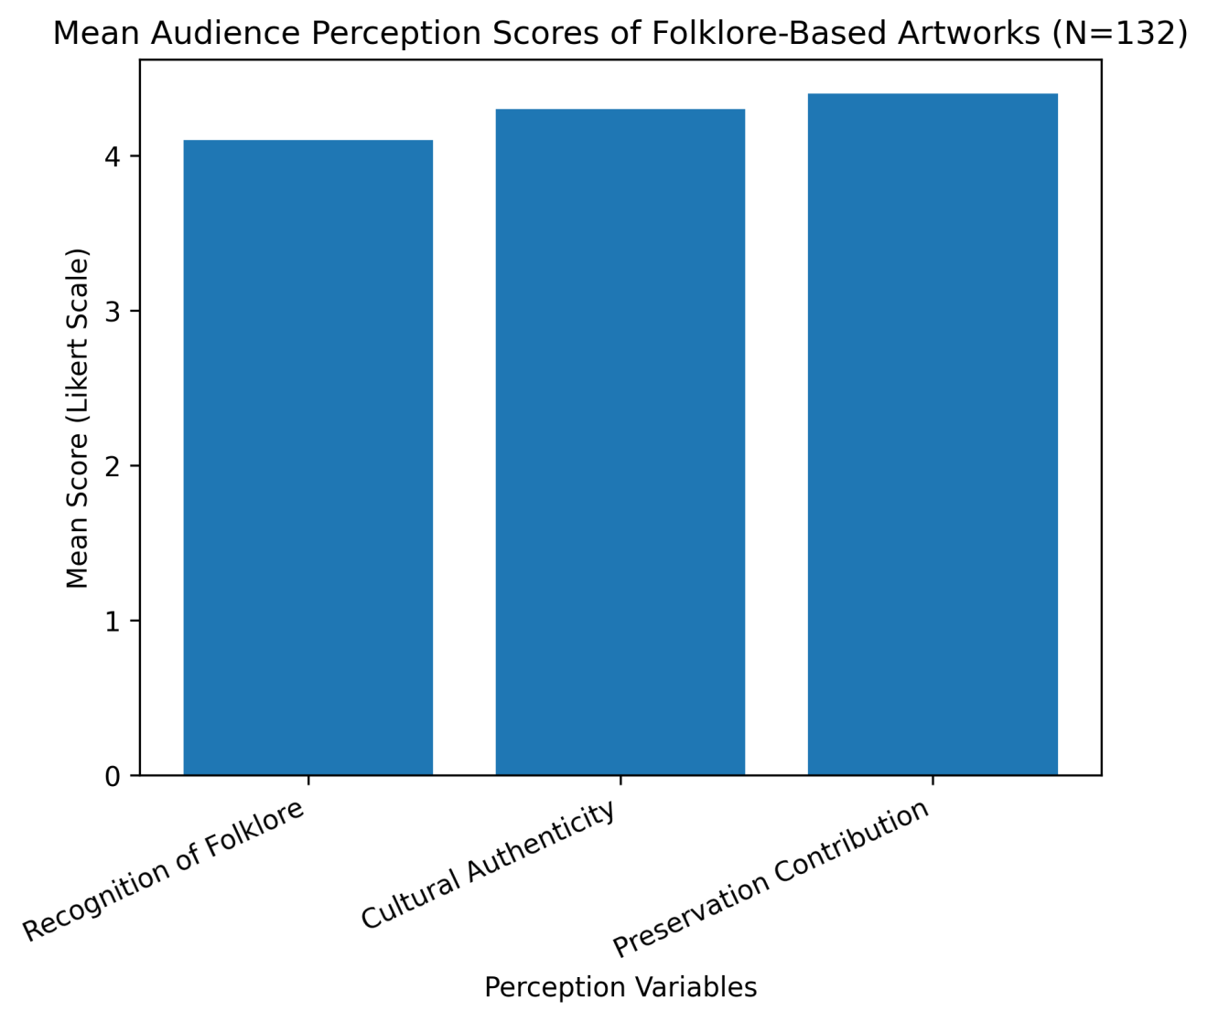
Figure 3 illustrates the mean audience perception scores regarding folklore-based artworks. The results indicate high levels of recognition of folkloric elements (M = 4.1), cultural authenticity (M = 4.3), and perceived contribution to cultural preservation (M = 4.4). These findings support the argument that contemporary visual artworks incorporating Igbo folklore are widely perceived by audiences as authentic representations of indigenous knowledge systems and perceived contribution to cultural preservation in contemporary Igbo visual artworks.
This bar chart visualizes the mean perception scores from the audience survey (N = 132):
Variable | Mean Score
Recognition of Folklore | 4.1
Cultural Authenticity | 4.3
Preservation Contribution | 4.4

4.5 Inferential Statistical Findings

Chi-Square Analysis
A significant association was found between explicit folklore motifs and audience recognition levels:
χ² (4, N = 132) = 18.42, p < .05

The statistically significant result indicates that artworks containing clearly identifiable folkloric symbols significantly increase the probability that audiences will recognize narrative elements derived from oral tradition.
This finding therefore rejects Hypothesis H01 and supports the alternative hypothesis H11, confirming a meaningful relationship between Igbo oral narratives and their visual representation in contemporary art.

Table 2

Chi-Square Test of Association between Explicit Folklore Motifs and Audience Recognition (N = 132)

Variable | χ² | df | p-value | Interpretation
Folklore Motif Presence ×  Recognition Level | 18.42 | 4 | .001* | Significant association
*p < .05
Interpretation:
The Chi-square test revealed a statistically significant association between the presence of explicit folklore motifs and audience recognition levels, χ² (4, N = 132) = 18.42, p < .05. This indicates that artworks containing clearly encoded oral symbols significantly increase the probability of audience recognition.

Regression Analysis
Regression analysis examined whether symbolic density predicts audience perception of cultural preservation:
β = 0.63, p < .01
The model explains approximately 40% of the variance in perceived cultural preservation (R² = .40). This indicates that artworks containing multiple layered symbols are significantly more likely to be perceived by audiences as contributing to cultural preservation.
The finding therefore rejects Hypothesis H02 and supports H12, demonstrating that linguistic symbols and cosmological concepts from Igbo oral traditions are meaningfully embedded in contemporary artworks.

Table 3

Linear Regression Analysis Predicting Perceived Cultural Preservation from Symbolic Density

Predictor Variable | B | SE B | Β | t | p-value
Symbolic Density | 0.71 | 0.12 | 0.63 | 5.92 | .000**

Model Summary:
R | R² | Adjusted R² | F | p-value

.63 | .40 | .38 | 35.04 | .000**

**p < .01

Interpretation:
Symbolic density significantly predicted perceived cultural preservation, β = .63, p < .01. The model explains approximately 40% of the variance in preservation perception (R² = .40), indicating that higher semiotic layering is strongly associated with increased perceptions of cultural continuity.

ANOVA
A one-way ANOVA was conducted to determine whether folklore recognition differed across audience educational levels.
F(3,128) = 4.67, p < .05
The statistically significant result indicates that recognition of folkloric symbolism varies according to educational background. Post-hoc tests revealed that respondents with tertiary education demonstrated significantly higher recognition levels than those with primary education.
However, no significant differences were observed across gender categories. These findings suggest that cultural literacy and educational exposure influence the ability to interpret symbolic visual narratives.

Table 4

One-Way ANOVA: Differences in Folklore Recognition across Educational Levels

Source of Variation | SS | df | MS | F | p-value
Between Groups | 8.74 | 3 | 2.91 | 4.67 | .004*
Within Groups | 79.63 | 128 | 0.62
Total | 88.37 | 131
*p < .05
Interpretation:
A statistically significant difference was observed in folklore recognition across educational levels, F(3,128) = 4.67, p < .05. Post-hoc comparisons (Tukey HSD) indicated that respondents with tertiary education demonstrated significantly higher recognition scores than those with primary-level education. No significant differences were observed across gender categories (p > .05).

4.6 Synthesis of Findings
The results demonstrate that:
- Igbo oral narratives are systematically translated into contemporary visual forms.
- Artists consciously function as mediators of linguistic and cosmological knowledge.
- Audience perception supports the preservation function of visual reinterpretation.
- Statistical evidence confirms that symbolic clarity and density influence recognition and preservation outcomes.

5.0 Discussion

5.1 Inter-semiotic Translation of Oral Narratives
The findings indicate that Igbo oral narratives are systematically translated into visual art forms through processes of symbolic abstraction and metaphorization. The predominance of folktales and proverbs within analyzed artworks aligns with Finnegan’s (2012) argument that oral literature is inherently adaptable and migratory across expressive forms.
The distribution of narrative forms (Table 2) suggests that artists selectively engage narrative structures that lend themselves to visual condensation. Proverbs, for instance, often contain metaphorical imagery that can be easily transformed into pictorial symbols.
Thus, the results demonstrate that contemporary visual art functions as a parallel narrative medium through which oral traditions continue to circulate. For example, the well-known Igbo proverb “Egbe bere ugo bere” (let the eagle perch and let the kite perch) has been visually interpreted by contemporary artists through balanced compositional arrangements that depict two birds occupying symmetrical positions within a pictorial space. Such visual translations emphasize the proverb’s philosophical message of coexistence, tolerance, and social equilibrium within the community.

5.2 Symbolic Density and Cultural Meaning
The regression results indicate that symbolic density significantly predicts audience perception of cultural preservation. This finding is theoretically important because it shows that the strength of cultural communication within artworks increases with the number and layering of symbolic references. From a semiotic perspective, this supports Chandler’s (2017) assertion that meaning is intensified through symbolic networks rather than isolated signs.
In practical terms, artworks that incorporate multiple symbolic elements such as masquerade imagery, animal symbolism, and cosmological motifs create richer interpretive possibilities for audiences.

5.3 Artists as Cultural Mediators
Interview findings reinforce the argument that contemporary artists serve as epistemic mediators, translating oral knowledge systems into visual semiotics.
This supports decolonial frameworks proposed by Mignolo and Walsh (2018) and Ndlovu-Gatsheni (2020), which emphasize the need to reposition indigenous knowledge systems as sources of theoretical insight rather than mere ethnographic material.
The fact that 85% of interviewed artists consciously described their work as visual storytelling underscores the deliberate nature of this cultural mediation.

5.4 Audience Interpretation and Cultural Transmission
The significant Chi-square association between folklore motifs and audience recognition demonstrates that symbolic clarity enhances cultural communication. This finding is important in the context of language shift, where traditional storytelling environments are declining. Visual art therefore functions not merely as aesthetic production but as a communicative medium capable of sustaining narrative memory across generations.

5.5 Broader Implications
Taken together, the findings suggest that contemporary Igbo visual art represents a dynamic interface between tradition and innovation. Rather than replacing oral traditions, visual storytelling extends them into new communicative environments including galleries, exhibitions, and digital media platforms.
These findings therefore support UNESCO’s framework emphasizing creative continuity rather than static preservation of intangible heritage.

5.6 Contribution to Knowledge
This research extends existing scholarship in four ways:
- It provides empirical evidence of inter-semiotic translation in a Southeast Nigerian context.
- It quantifies audience recognition within folklore-based visual art.
- It establishes symbolic density as a predictor of perceived cultural preservation.
- It reframes contemporary Igbo artists as knowledge producers within indigenous epistemic systems.
By demonstrating that visual art functions as a parallel channel of narrative continuity, the study challenges dichotomies between “traditional” oral culture and “modern” artistic practice. Instead, it reveals a continuum of expressive adaptation grounded in cosmological coherence.

6.0 Conclusion
This study examined how Igbo oral narratives are translated into contemporary visual art practices in Southeast Nigeria and evaluated the implications of such inter-semiotic processes for cultural preservation, epistemic continuity, and audience reception. Drawing on visual narrative analysis, semiotic coding, interviews, participant observation, and statistical testing, the findings demonstrate that contemporary Igbo artists actively engage oral traditions as structuring frameworks within their aesthetic production.
The results confirm that Igbo folklore particularly folktales and proverbs remain a generative reservoir of symbolic and philosophical resources. Rather than existing as residual or nostalgic artifacts, these narrative forms are dynamically reconstituted within painting, installation, textile design, and mixed media practices. The predominance of folktales and proverbial structures within the analyzed artworks underscores their adaptability across media and their continued relevance in negotiating contemporary social realities.
Importantly, the study demonstrates that inter-semiotic translation from spoken narrative to visual representation is neither arbitrary nor decorative. Instead, it involves structured processes of symbolic condensation, metaphorization, and visual coding. Semiotic density emerged as a statistically significant predictor of audience perception of cultural preservation, indicating that layered symbolic articulation strengthens interpretive recognition and reinforces perceptions of authenticity. This finding advances scholarship by empirically linking aesthetic complexity to cultural transmission outcomes.
The role of artists as cultural mediators also emerged clearly. Interview data reveal that contemporary practitioners consciously position themselves as visual storytellers, extending oral epistemologies into new expressive environments. In doing so, they occupy a critical space between tradition and innovation. They do not merely replicate inherited motifs but reinterpret cosmological constructs such as cyclical continuity, ancestral presence, and communal reciprocity within modern sociopolitical contexts. This mediating function situates artists as epistemic agents who actively contribute to indigenous knowledge resilience.
Audience reception further validates the preservation function of visual storytelling. High levels of recognition and strong agreement regarding cultural authenticity indicate that visual art serves as a viable platform for sustaining folkloric memory in contexts where intergenerational oral transmission faces increasing pressure. The significant association between explicit folkloric motifs and audience recognition reinforces the importance of symbolic clarity in cross-generational communication.
6.1 Theoretical Contribution: This study contributes theoretically to three intersecting fields:
- Folklore Studies
by documenting the migration of oral narratives into visual semiotic systems.
- Visual Anthropology
by demonstrating how artworks function as cultural texts encoding indigenous knowledge.
- Decolonial Aesthetics
by positioning indigenous narrative systems as active sources of artistic theory and creative methodology.
Beyond academic contribution, the findings carry practical implications. Visual art may serve as a complementary channel for linguistic revitalization and cultural education, particularly within formal art curricula and museum programming. Cultural institutions and policymakers may therefore consider supporting artist-led heritage initiatives as part of broader intangible heritage safeguarding strategies.
Several limitations must be acknowledged. The study focused on a purposive sample of artists within Southeast Nigeria, and findings may not be fully generalizable across other Nigerian or African cultural contexts. Additionally, while quantitative measures supported interpretive findings, longitudinal research would be necessary to assess long-term preservation impact.
Future research could explore comparative analyses across other Nigerian ethnic traditions, examine diasporic reinterpretations of Igbo folklore, or investigate digital media as emerging sites of inter-semiotic transformation. Further work may also analyze how younger audiences interpret folkloric symbolism in increasingly globalized visual cultures.
In conclusion, the study demonstrates that contemporary Igbo visual art is not detached from oral tradition but deeply entangled with it. Through structured symbolic translation, artists extend narrative memory into new aesthetic forms, reinforcing cultural continuity while engaging modern realities. Visual storytelling thus emerges not as a substitute for oral tradition, but as its adaptive evolution an ongoing re-articulation of indigenous knowledge within changing expressive landscapes.

7. Future Research Scope

Future research may explore digital reinterpretations of Igbo folklore, comparative analyses across other Nigerian cultural groups, and the role of virtual museums in preserving indigenous artistic heritage.
Disclaimer (Artificial intelligence)
Author(s) hereby declare that NO generative AI technologies such as Large Language Models (ChatGPT, COPILOT, etc.) and text-to-image generators have been used during the writing or editing of this manuscript.

References
Adeoye, C. L. (2021). Folktales and cultural identity among the Igbo: A socio-anthropological analysis. Journal of African Cultural Studies.
https://www.tandfonline.com/doi/full/10.1080/13696815.2021.1882073
Barber, K. (2018). A history of African popular culture. Cambridge University Press. https://www.cambridge.org/
Barber, K. (2018). A History of African Popular Culture. Cambridge University Press.
https://www.cambridge.org/9781107147494
Chandler, D. (2017). Semiotics: The basics (3rd ed.). Routledge. https://www.routledge.com/
Eberhard, D. M., Simons, G. F., & Fennig, C. D. (Eds.). (2023). Ethnologue: Languages of the world (26th ed.). SIL International. https://www.ethnologue.com
Enwezor, O. (2019). Contemporary African art and postcolonial modernity. Nka: Journal of Contemporary African Art. https://read.dukeupress.edu/nka
Finnegan, R. (2012). Oral Literature in Africa (Open Book ed.). Open Book Publishers.
https://www.openbookpublishers.com/books/10.11647/obp.0062
Kasfir, S. L. (2020). Contemporary African art and the politics of representation. African Arts, 53(3).
https://direct.mit.edu/afar/article/53/3/6/101533/Contemporary-African-Art-and-the-Politics-of
Mignolo, W., & Walsh, C. (2018). On Decoloniality: Concepts, Analytics, Praxis. Duke University Press.
https://www.dukeupress.edu/on-decoloniality
Ndlovu-Gatsheni, S. J. (2020). Decolonization, Development and Knowledge in Africa. Routledge.
https://www.routledge.com/Decolonization-Development-and-Knowledge-in-Africa/Ndlovu-Gatsheni/p/book/9781138361392
Ogbechie, S. O. (2021). Curatorial practice and contemporary African art. Critical Interventions.
https://www.tandfonline.com/doi/full/10.1080/19301944.2021.1888965
Okeke-Agulu, C. (2015). Postcolonial Modernism: Art and Decolonization in Twentieth-Century Nigeria. Duke University Press.
https://www.dukeupress.edu/postcolonial-modernism
Okeke-Agulu, C. (2015). Postcolonial modernism: Art and decolonization in twentieth-century Nigeria. Duke University Press. https://www.dukeupress.edu
Onwuegbuna, J. N. (2022). Cultural memory and visual art in Southeastern Nigeria. Africa Today.
https://www.jstor.org/stable/10.2979/africatoday.2022
Onyebuchi-Igbokwe, G.C. & Egornu, C.A. (2025). Developing an AI-driven virtual museum for preserving and show-casing Igbo textile imageries and cultural heritage. Journal of Visual Communication Design (JOVICOD), 65-84.
Umezurike, O. C. (2023). Intersemiotic translation in African visual arts. Journal of Visual Anthropology.
https://www.degruyter.com/view/journals/jva/2023
UNESCO. (2022). Operational directives for the implementation of the Convention for the Safeguarding of the Intangible Cultural Heritage. https://ich.unesco.org
UNESCO. (2022). Operational Directives for the Implementation of the Convention for the Safeguarding of the Intangible Cultural Heritage.
https://ich.unesco.org/en/guidelines
Uzo, K. G. (2024). Linguistic revitalization through contemporary art: Igbo language and visual semiotics. African Linguistic Heritage Review.
https://www.africanlinguistics.org/uzokg2024

