Original Research Article

Including Learner’s Culture in English Language Teaching: an Experimental Study

.
ABSTRACT

Including the culture of the learner in English language teaching may create interest among the learners to learn any other language. English is not the mother tongue of the learners of our Indian context. The English language is recognized as a global language, and the demand for it is remarkable in the present market. As many MNCs are administered using the English language. The employees of any company are expected to have excellent communication skills in English. Therefore it has become compulsory for everyone to have good communication skills in English. Rural background learners may have performance variation in English speaking, compared to urban background learners. To build the gap between rural and urban learners, the teaching approaches and methods have to be changed by the teacher to make his/her teaching more effective. The aim of the present study is to know the benefits of a learner's culture in English language teaching: with a specific focus on learning problems of engineering graduates in rural Telangana. To carry out this study the researcher conducted an experimental study by including learners’ culture in teaching English language and communication skills. The tools used for this study are student questionnaire, materials related to learners culture for intervention the results of the study are analyzed and discussed. This empirical study provides some implication to enhance learners communication skills by using learners culture.

Keywords: English communication skills, culture in language teaching, rural background, learning English problems.

1. INTRODUCTION
In the contemporary era of globalization, English has evolved from a colonial legacy into a fundamental tool for socio-economic mobility. In the Indian context, particularly within the rural landscapes of Telangana, English proficiency is often viewed as a "passport" to higher education and modern employment. However, for many students in these regions, the language remains a distant and intimidating entity. This difficulty stems largely from a pedagogical disconnect: the English taught in classrooms is frequently divorced from the sociocultural realities of the learners (Kachru, 1986). Language and culture are inextricably linked; one cannot be mastered effectively without the context of the other. For a learner in a remote village in Telangana, standard ELT materials often feature urban or Westernized scenarios—such as navigating a subway or discussing autumn—that find no resonance in their daily lives. According to Ladson-Billings (1995), pedagogical practices must be culturally relevant to foster academic success. When rural learners encounter content that ignores their agricultural heritage, local festivals like Bathukamma, or the oral traditions of their communities, they experience "cultural alienation," which significantly hinders the acquisition process. The concept of Culturally Responsive Teaching (CRT) posits that using students' cultural knowledge, prior experiences, and frames of reference makes learning more encounter-oriented and effective (Gay, 2010). In the context of rural Telangana, integrating the learner's "funds of knowledge"—the skills and information essential to their household and community functioning—can serve as a powerful bridge to the target language (Moll et al., 1992). By utilizing familiar contexts, the cognitive load is reduced. Instead of struggling to understand both a new concept and a new language, the student can focus on the linguistic aspect because the conceptual framework is already familiar.
Importance of the English language in communication
It has been accepted that the English language plays an important and vital role in communication. As the majority of people around the world speak English. So, the demand for the English language has increased rapidly since it started in countries like India from the initial stage. As a result, every educational institution is focusing on teaching the English language along with communication skills. Employers from industries expect and look for persons who are good at communicating in English. Therefore each individual should have good communication skills. So, we can say that the demand for English and the respect the person who speaks English gets in society can be the reason for increasing its demand.
The English language empowers young minds not only in passing examinations but in demonstrating their intelligence before the world. Technical institutions have understood the significance of communicating in English in response to the increasing needs of the job market. Since the world has gone global, the need to compete in it without English efficiency is difficult. Many organizations/companies have started training their employees in English proficiency. Most people fail to express themselves clearly because of a lack of communication skills in English.
Communication can be said to be a central activity of human life. We also witnessing the emergence of an advanced economy based on information and knowledge. Probably the most important skill for knowledge workers in the new environment is the ability to communicate in English. This means being able to listen and to express one’s ideas effectively in writing a speech and so on. In order to achieve desired goals and success every professional needs to assess and respond to communication situations that occur always.
  - Teaching and learning problems in English in rural areas
Teaching and learning in Telangana may not be reaching what we expect of the rural students even though the government of Telangana implemented English medium schools in Telangana state. The materials teachers use may not be related to the learner’s background; this can be the reason behind lacking in English communication skills. The cultural familiarity of the text would definitely help the learner to get motivated towards learning a language because they may be curious to know the culture of his/her own in the form of text.
It has been observed in much research that the teaching environment also plays an important role in the teaching and learning process. Teaching environments in urban, rural, and tribal areas have a lot of differences with reference to infrastructural facilities, and availability of teaching-learning materials. The role of the teacher also plays a major role in teaching English. The use of authentic materials can be useful in the teaching and learning process to make teaching more meaningful. The use of culturally related materials in teaching English could be the best idea to teach English in rural and tribal areas because it relates to the learners’ background.
  - Background of the study
Rural learners from engineering undergraduate face problems in getting employment in MNCs. The reason for rejection can be a Lack of communication skills in English. If the learners of rural areas are provided with suitable materials and adapting opted teaching methods may help them to create a comfortable learning environment. The teacher’s approach to teaching English plays a very important role in the teaching and learning process. The inclusion of local or learner’s culture to teach English to rural engineering students would help them to enhance their English communication skills and to become effective communicators.
  - Literature review
Many studies have been conducted in the field of using culturally related texts in teaching English communication skills, and the inclusion of culture in English language teaching helps in improving the learner's communication skills. The studies have been reviewed and discussed in detail to understand how culture can help a teacher in making his or her language teaching fruitful. The studies can be a great source to carry out present experiments.
Culture is a concept referring to ways of acting, believing, valuing, and thinking which are shared by members of a community (social group) and which are transmitted to the next generation. Culture is dynamic and open to change as a result of a change in living conditions or through contact with other cultures. (Crozet, 2000)
(Sun, 2013)carried out a study “Culture Teaching in Foreign Language Teaching” in China and observed that to teach any language the learners must be taught the culture of the targeted language which would help them to adopt the culture of the target language to have effective communication skills. She also emphasized the importance of knowing the culture of the target language before learning it. The expressions in native and foreign language vary in many ways. She suggests that learning the culture of the target language makes it easy to learn the language.
An experiment was conducted (Wang, 2011) to know how cultural differences occur in language teaching. He suggests that the inclusion of an updated and upgraded culture of the learn makes and creates interest among the learners. The learners get motivated by the inclusion of their culture in English language teaching. He also explained the cultural differences between native language and foreign language with suitable and elaborative examples.
(Brown & Park, 2020) conducted a study titled “Culture in language learning and teaching” in Turkey with ELT students and stated that the knowledge of culture plays a vital role in learning any language. They also declared that the cultural knowledge of the learner plays the role of facilitator in learning a new language. They suggested that the curriculum should include culture in the teaching-learning process.
(Devrim, D. Y., & Bayyurt, Y., 2010). ”Students’ understandings and preferences of the role and place of ‘culture’ in English Language Teaching: A focus in an EFL context” and investigated using Kachru’s three circle model and found that the learners preferences in using language based on its demand was found and they were aware and able to use the language based on their requirements in different contexts. The study focused in English as foreign language context. The learners do have awareness of language usage and use it based on their needs and requirement.
(Mahmoud, 2015) carried out a study “Culture and English language teaching in the Arab world” in an Arabic setting. The study proved that the culture of the target language should be taught. The learner’s culture should include teaching the target language. The researchers finally recommended that the learner’s culture should be included in teaching English.
(Kostikova, L., Prishvina, V., Ilyushina, A., Fedotova, O., & Belogurov, A., 2018, March) carried a study titled “Culture in teaching English as a foreign language” to know learners readiness in learning English language trough learning culture of the target language. The analysis of the data presents that learners were ready to learn English language and believed that the orientation of the culture helps in learning foreign language. Therefore this research can help the researcher to carry the present study to include learners culture in English language teaching.
(Genc, B., & Bada, E., 2005). A study “Culture in language learning and teaching” was conducted to know the impact of culture in learning English language. The results of the study suggest that learning culture helps the learners in learning the target language the study also highlights that the inclusion of culture class may have impact on learning English language. Culture class incorporates some of the language skills among the learners.
(Yadav, 2014) conducted a study titled “Role of Mother Tongue in Second Language Learning” and suggested that the native language of the learner can be used in teaching the target language. He emphasized that the use of the mother tongue in teaching the target language plays a major role to make the teaching-learning process more effective. He also advised students to include the learner's native language in teaching a second language. He suggested using the learner's native culture like songs, stories and other literary forms in teaching English.
(Savithri, J., & Kamala, E. E., 2016). Conducted a study titled “The Effect of Culture-Specific Syllabus on English Language Learners in Engineering Colleges”. The study strongly suggest that the inclusion of specific culture of the learners improves communication skills of the learners. The findings of the study recommends specific native culture inclusion in English language teaching.
(Hossain, K. I., 2024). In his review article titled “Reviewing the role of culture in English language learning: Challenges and opportunities for educators” discusses the importance of integration of native culture along with adaptation of advanced technology in language teaching can help the learner to enhance his/her communication skills. The reviewer also focuses on transformation of teaching methodologies in language teaching accelerates students learning. Integration of local culture and teaching methodologies play vital role in teaching and learning of English.
(Holliday, A., 1994). Article titled “Student culture and English language education: An international perspective.” Finds that the regional culture of the learner and institution fosters the leaner to adopt the international culture. As the regional culture of learners and institution maintains the international cultural trait, it helps the learner to cope with the international culture and to enhance his/her communication skills.
An extension to the above studies reviewed the present study focuses on inclusion of learner’s culture in English language teaching to enhance their communication skills particularly engineering graduates of rural engineering college learners.
Significance of the study
The present experiment is carried out to enhance students’ communication skills in English by using culturally related texts. As, it is expected by every recruiters of software companies that the aspirants must possess good communication skills in English. Therefore, as part of teaching the researcher noticed that engineering undergraduates from rural areas lack communication skills in English. It is the most important responsibility of an English teacher to focus on learners’ communication skills in English. The problem of the learners makes the researcher to think where the problem exists. Many researchers conducted studies on the same problem and the results of those studies discussed various issues related to learners’ communication skills in English. It is stated by many researchers that the cultural familiarity of the texts helps the learners to enhance their communication skills in targeted language.
Therefore, the conduction of this study is significant to help the rural learners to enhance their communication skills in English by using culturally familiar texts.
  - Objectives of the study
This experiment has been conducted with the following objectives:
- To know the barriers to English communications skills among rural learners
- To motivate rural learners to communicate in English
- To apply suitable strategies to improve communication skills of rural learners in English
- To enhance English communication skills by using learner’s culturally related texts
  - Hypothesis
The research has been carried designed to examine the following hypothesis:
- Culturally related texts may help rural learners to enhance their English communication skills.
- Mother tongue influence may be one of the barriers to English communication skills.
  - Research questions
- Why do rural area undergraduate engineering students lack English communication skills?
- How can culturally related texts help rural students to enhance their English communication skills?
- What are the teaching strategies a teacher can apply to motivate learners to learn English?
- METHODS
  - Research Methodology
The present study is an experimental study in its nature. The researcher selects 44 rural background students from engineering college. The student questionnaire was administered to collect data from students related to their socio-economic background, learning problems and difficulties in communicating English.
Culturally related texts (learner’s native culture) were used during the intervention to teach English communication skills. The performances of the learners were recorded and analyzed to suggest some implications. The activities were designed to target enhancement of students’ basic language skills in English (LSRW). The texts which were used to enhance their communication skills are purely from the learners’ culture. Some familiar situations were created and students were given a chance to take part in the classroom activities.
  - Tools
2.2.1. Student Questionnaire: A student questionnaire was used to collect data regarding students’ opinions and problems in learning and communicating in English. The questionnaire was designed using five point Likert scale.
2.2.2. Interaction with Students: Interaction with students helped the researcher to understand students' learning problems with regards to English communication skills. It helps the researcher to collect authentic data.
2.2.3. Interventions: The researcher conducted some intervention classes by using culturally related texts of students to improve their communication skills. The basic language skills listening, speaking, reading and writing were included in intervention design. The texts were analyzed and graded for learning complexity. The results of the intervention is analyzed qualitatively to conclude the study.
2.2.4. Student Feedback: The researcher received feedback from students regarding their learning experience on including culturally related texts in teaching-learning to enhance their English communication skills.
3. DATA ANALYSIS
Collected data by using student questionnaire, interaction, intervention and feedback is analyzed quantitatively and qualitatively to indicate factors of learning problems of rural learners. The quantitate data analysis of the student questionnaire provides accurate information. The data collected by administering questionnaire was analyzed quantitatively. Whereas, the data collected by other tools was analyzed qualitatively.
3.1. Quantitative data Analysis
The below graphical and statistical representation of the data provides the information regarding students opinion on top activities incorporated culture in teaching, frequency of cultural opportunities in the class, initiation of cultural inclusion in teaching, reason for hesitation of learners to use English language, overall experience of cultural inclusion in teaching-learning, percentage of student agreement with benefits of using culture in teaching-learning. The data collected by administering student questionnaire.

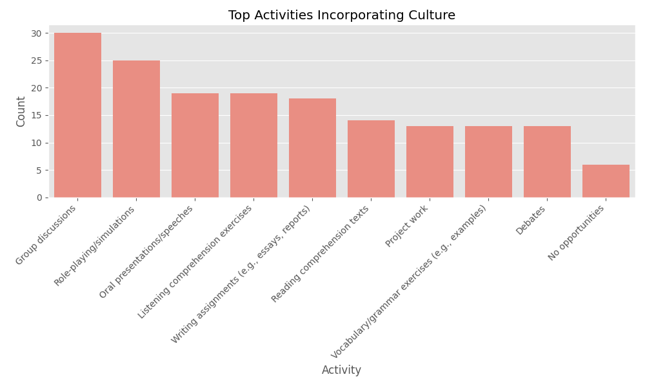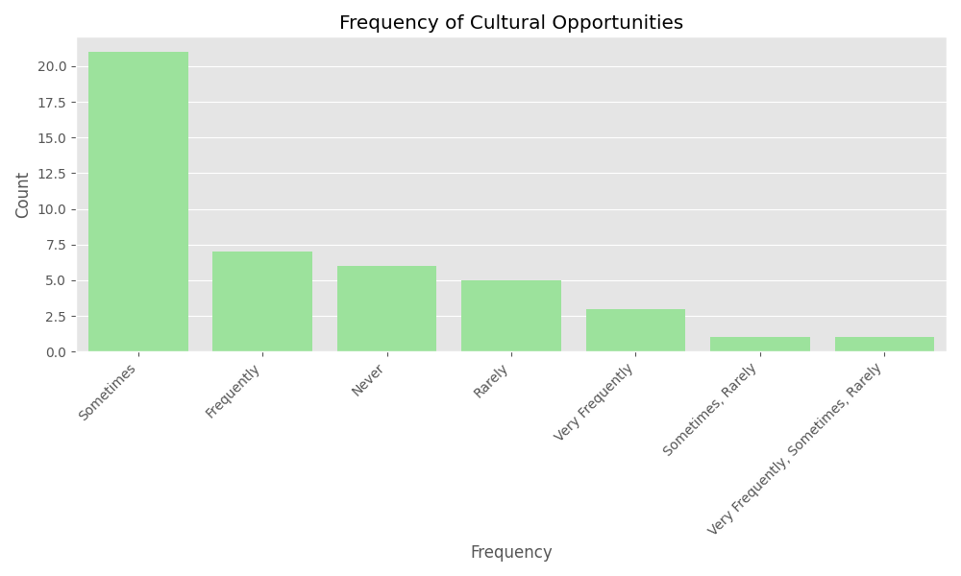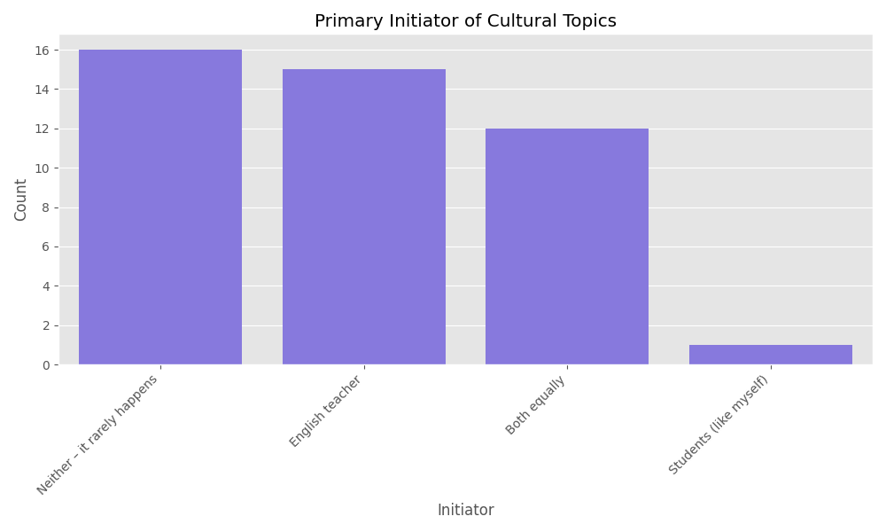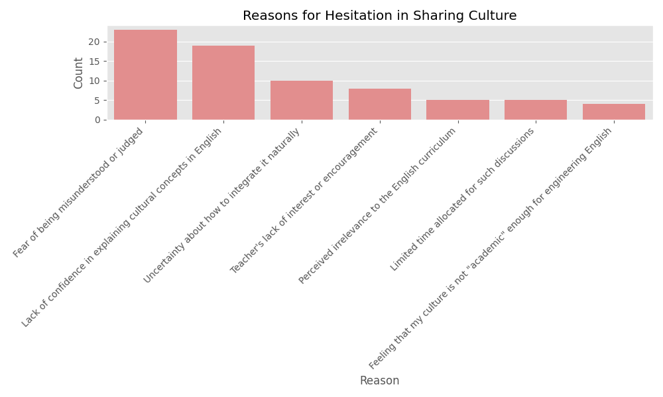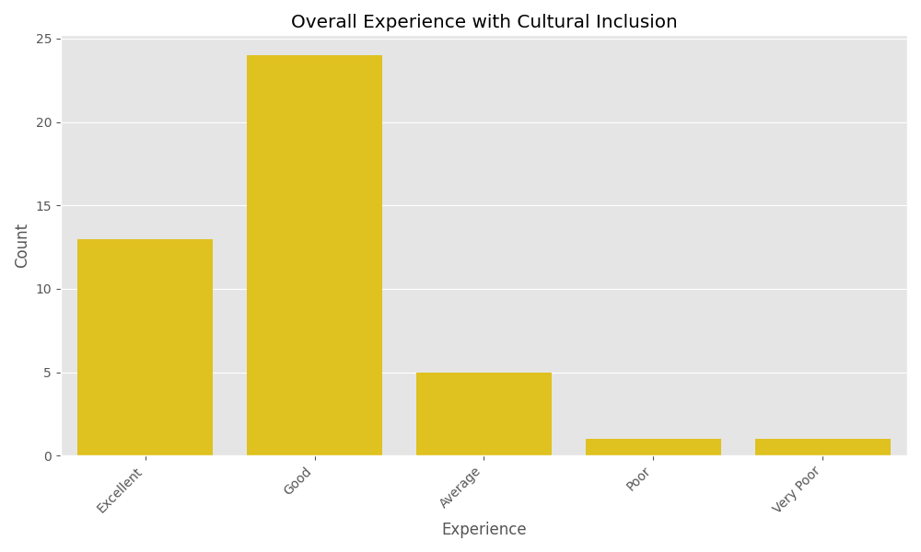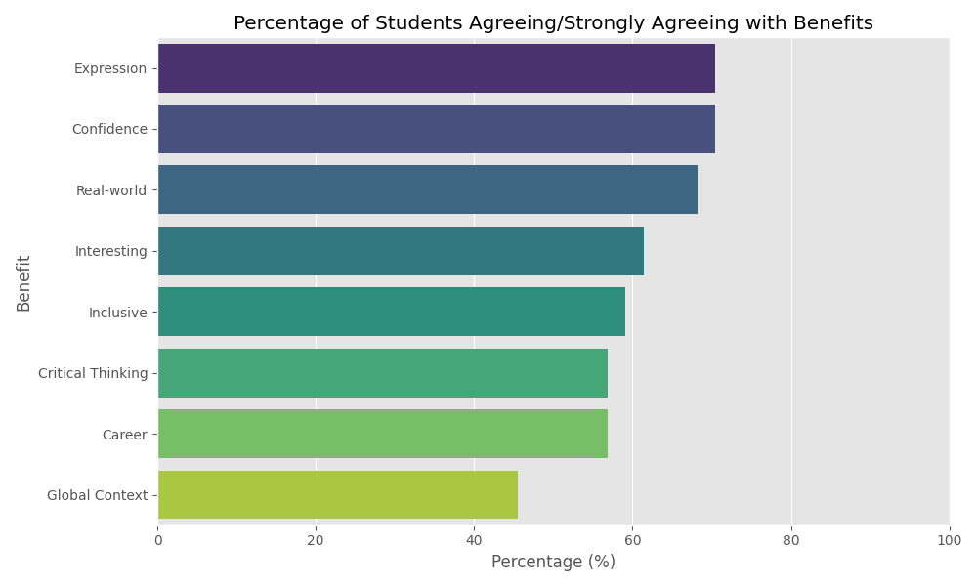

The analysis of the "Cultural Inclusion" survey responses from engineering students provides a comprehensive view of how cultural integration is perceived and practiced in English language classes. Below is the summarized analysis based on the data provided by 44 respondents.
3.2. Frequency and Initiation of Cultural Inclusion
How Often: Most students experience cultural inclusion "Sometimes" (47.7%), while a significant portion experiences it "Frequently" or "Very Frequently". However, about 13.6% report "Never" having such opportunities.
Who Initiates: The English teacher (43.2%) is the primary initiator of cultural topics, followed by a collaborative approach where both teacher and students initiate discussions (34.1%).

3.3. Key Activities & Contexts
Cultural elements are most frequently integrated into:
- Group Discussions (30 mentions)
- Role-playing/Simulations (25 mentions)
- Oral Presentations/Speeches (19 mentions)
- Listening Comprehension Exercises (19 mentions)
3.4. Perceived Benefits
Students strongly believe that incorporating culture into English learning yields significant benefits:
Expression & Confidence: Over 70% of students agree that it helps them express ideas more effectively and boosts their confidence in speaking.
Engagement: 61.4% feel it makes learning English more interesting.
Relevance: 68.2% believe it helps connect language learning to real-world experiences.

3.5. Barriers and Hesitations
Despite the benefits, many students feel hesitant to share their culture. The primary reasons include:
Fear of Judgment: 52.3% (23 respondents) fear being misunderstood or judged.
Language Barrier: 43.2% (19 respondents) cite a lack of confidence in explaining cultural concepts in English.
Integration Issues: Uncertainty about how to naturally integrate culture into the technical curriculum.
3.6. Support and Materials
Teacher Support: The environment is generally positive, with 70.4% of students rating their English teacher as "Supportive" or "Very Supportive."
Teaching Materials: There is room for improvement in textbooks; while 31.8% feel materials represent diverse cultures well, 43.2% feel they only "Somewhat" represent them, and 25% feel they do not represent them adequately.

3.7. Overall Student Experience
The overall experience of cultural inclusion at the engineering college is rated as "Good" or "Excellent" by the vast majority of respondents. Suggestions for improvement focused on more student-led activities, friendly interactions, and making the curriculum more inclusive of diverse backgrounds.
The statistical analysis of response variation provides insights into the level of consensus and diversity of opinion among the 44 respondents.
3.8. Summary of Response Variation
The table below summarizes the spread of responses across a scale of 1 to 5 (1 = Very Low/Strongly Disagree, 5 = Very High/Strongly Agree).
Metric | Mean | Std Dev (σ) | Coeff. of Variation (CV) | Skewness
Frequency of Opportunities | 2.95 | 1.10 | 37.19% | -0.13
Teacher Support | 3.95 | 0.94 | 23.74% | -0.79
Overall Experience | 4.07 | 0.85 | 20.80% | -1.34
Benefit: Expression | 3.80 | 0.76 | 20.15% | -0.94
Benefit: Global Context | 3.34 | 0.96 | 28.83% | -0.42

3.9. Key Statistical Observations
Highest Variation (Frequency): The Frequency of Opportunities ($CV = 37.19\%$) shows the most significant disagreement among students. While the average is near "Sometimes" (3.0), the high standard deviation indicates that some students feel opportunities are abundant while others feel they are non-existent.
Strongest Consensus (Expression & Critical Thinking): Students were most unified in their belief that cultural inclusion helps them express ideas ($CV = 20.15\%$). This low variation suggests a near-universal agreement on the pedagogical value of cultural context for communication.
Negative Skewness (Satisfaction): The Overall Experience and Teacher Support both show significant negative skewness ($-1.34$ and $-0.79$). This indicates that while the "average" is high, the distribution is heavily weighted toward the positive end, with only a small number of "outlier" students reporting very poor experiences.
Divided Opinion (Global Context): The Global Context benefit has the lowest mean ($3.34$) and a relatively high spread ($CV = 28.83\%$), indicating that students are less certain or more divided on whether cultural sharing helps them understand the global nuances of English.
3.10. Visual Analysis of Spread
Boxplots: Reveal that "Overall Experience" and "Teacher Support" have the tightest clusters at the top (4.0-5.0 range), though a few outliers exist at the very bottom (rating of 1.0).
Violin Plots: Show a "bulge" at 4.0 for most benefits, indicating a modal response of "Agree," but a much flatter distribution for "Frequency of Opportunities," confirming the wide variety of classroom experiences.
4. Findings and Discussion of the Study
In the analysis of the results, interaction with students, administering questionnaires and intervention by using culturally related texts the researcher found many findings from the data. The findings of the research are discussed. Major basic skills of the English language (LSRW) were tested. This study is mainly focused to enhance the English communication skills of the learners.
4.1. Impact of learner’s culture in enhancing the following skills:
Listening: The learners were curious to listen to their native culture-related content as the researcher narrated some stories which were related to their culture. The researcher could witness the interest of the learners trough observation. Learners were surprised to listen stories from their culture in English language. The interest of the learners makes them to learn the target language.
Speaking: Learners were happy to speak about their culture like festivals, leaders of Telangana, and great personalities they know from their culture. Initially learners struggled to find words in English language with the help of the researcher they could learn meanings of unknown words. Teachers assistance can help the learners in getting confidence of speaking English.
Reading: The learners were given texts to read. The researcher intended to test their interest in reading native culture. The passages were given to test their comprehension skills in reading. The performance of the students was good. Learners were interested in reading the text. All the reading strategies were introduced by the researcher with practical experience. The learners were able to apply reading strategies like, skimming, scanning etc…
Writing: Learners were given a task to check their writing skills. The tasks were given based on their culture like writing how they celebrate festivals at their home and asking them to write about their favorite persons from the Telangana movement. They were also asked to write about rituals they performed in their village/town etc.
4.2. Implications of the study
The implication of the study deals with the detailed explanation to overcome the learners' problems with regard to English communication skills. The teachers of English can follow the implications which were suggested by the researcher.
❖ Learners should be focused inside and outside the class to listen to some stories which are related to their culture in English. So that the learners can get some content to speak in public and it would give them some boost in learning or having good communication skills in English.
❖ Teacher should conduct some activities in the English class to enhance their English speaking skills. The learners should be encouraged by providing a learning environment along with contextualizing English language teaching using the learner’s culture.
❖ Reading comprehension passages can be prepared based on the learner's culture which would encourage them to know and feel comfort in reading their own culture. The researcher used all the activities by contextualizing teaching including the culture of the learner.
❖ Writing is one of the productive skills which learners need to master in any language. The known native culture of the learner creates interest among them to learn any language.
5. CONCLUSION
The present experiment was conducted to know the role of the learner's native culture in teaching English communication skills. The findings of the study strongly support that the native culture of the learner plays an important role in motivating learners to learn any other language. The experiment was conducted to improve English communication skills of rural engineering graduates from Telangana, by using their native culture. Quantitative and qualitative data analysis from various sources strongly supports the hypothesis formulated by the researcher. This kind of study can be carried out in any other area, as this study limits to rural areas of Telangana. The implications can be considered by the teachers of English from rural areas to make his/her teaching more effective to improve learners’ communication skills in English.

Consent and Ethical approval

The study follows ethical standards and consents that the research has been done involving human participants. Participation was voluntary, and handwritten informed consent was obtained prior to the participation. Anonymity and confidentiality codes and ensured by assigning identification codes and securing all data in password-protected devices. The institutional ethics committee approved the study, and all procedures complied with the Data Privacy Act of 2012.
DISCLAIMER (ARTIFICIAL INTELLIGENCE)
Author hereby declare that NO generative AI technologies such as Large Language Models (ChatGPT, COPILOT, etc) and text-to-image generators have been used during the writing or editing of this manuscript. The data of the study has been analyzed qualitatively.

References
- Brown, L., & Park, M. Y. (2020). Culture in language learning and teaching. In Teaching Korean as a Foreign Language: Theories and Practices (pp. 81–108). https://doi.org/10.4324/9780429244384-5
- Crozet, C., & Liddicoat, A. J. (2000). Teaching culture as an integrated part of language: implications for the aims, approaches and pedagogies of language teaching. In C. Crozet & A. J. Liddicoat (Eds.), Teaching languages, Teaching Cultures (pp. 1-18). Language Australia.
- Devrim, D. Y., & Bayyurt, Y. (2010). Students' understandings and preferences of the role and place of 'culture' in English Language Teaching: A focus in an EFL context. TESOL Journal, 2(1), 4-23. https://tesol-internationaljournal.com/wp-content/uploads/2013/11/A2V2_TESOL.pdf
- Gay, G. (2010). Culturally responsive teaching: Theory, research, and practice. Teachers College Press.
- Genc, B., & Bada, E. (2005). Culture in language learning and teaching. The reading matrix, 5(1). https://www.readingmatrix.com/archives/vol_5_no_1/genc_bada.pdf
- Holliday, A. (1994). Student culture and English language education: An international perspective. Language, Culture and Curriculum, 7(2), 125-143.
- Hossain, K. I. (2024). Reviewing the role of culture in English language learning: Challenges and opportunities for educators. Social Sciences & Humanities Open, 9, 100781.
- Kachru, B. B. (1986). The alchemy of English: The spread, functions, and models of non-native Englishes. University of Illinois Press.
- Kostikova, L., Prishvina, V., Ilyushina, A., Fedotova, O., & Belogurov, A. (2018). Culture in teaching English as a foreign language. In Proceedings of the 2nd International Conference on Culture, Education and Economic Development of Modern Society (ICCESE 2018) (pp. 13-17). Atlantis Press. https://doi.org/10.2991/iccese-18.2018.4
- Ladson-Billings, G. (1995). But that's just good teaching! The case for culturally relevant pedagogy. Theory Into Practice, 34(3), 159–165.
- Mahmoud, M. M. A. W. (2015). Culture and English Language Teaching in the Arab World. Adult Learning, 26(2), 66–72. https://doi.org/10.1177/1045159515573020
- Moll, L. C., Amanti, C., Neff, D., & Gonzalez, N. (1992). Funds of knowledge for teaching: Using a qualitative approach to connect homes and classrooms. Theory Into Practice, 31(2), 132–141.
- Savithri, J., & Kamala, E. E. (2016). The Effect of Culture-Specific Syllabus on English Language Learners in Engineering Colleges. Language in India, 16(1), 54-63. http://www.languageinindia.com/jan2016/elizabethculturespecificsyllabusfinal.pdf
- Sun, L. (2013). Culture teaching in foreign language teaching. Theory and Practice in Language Studies, 3(2), 371–375 https://doi.org/10.4304/tpls.3.2.371-375
- Wang, J. (2011). Culture Differences and English Teaching. English Language Teaching, 4(2), 223. https://doi.org/10.5539/elt.v4n2p223
- Yadav, M. K. (2014). Role of Mother Tongue in Second Language Learning. *International Journal of Research (IJR)*, *1*(11), 572–582. https://journals.pen2print.org/index.php/ijr/

