Original Research Article

Immunoinformatics-Based Multi-Epitope Vaccine Design Against Cryptococcus neoformans Causing Cryptococcal Meningitis

ABSTRACT

Aims: To develop a multi-epitope vaccine against Cryptococcus neoformans using computational immunoinformatics approaches for the prevention of cryptococcal meningitis.
Study design: Computational in silico vaccine design study.
Place and Duration of Study: The study was performed using publicly available protein sequence databases and bioinformatics tools during the project period.
Methodology: Four immunogenic proteins—Mp88, Hsp70, Chitin Deacetylase 2, and a GPI-anchored cell wall protein—were selected as vaccine targets. Cytotoxic T-cell, Helper T-cell, and B-cell epitopes were predicted and screened for antigenicity, immunogenicity, allergenicity, and toxicity. Selected epitopes were linked with suitable linkers and adjuvants to design a multi-epitope vaccine construct. Physicochemical properties, structural modelling, molecular docking with immune receptors, molecular dynamics simulations, codon optimization, and in silico cloning were performed.
Results: The final vaccine construct showed favorable physicochemical properties, structural stability, and strong interaction with immune receptor targets. Molecular dynamics simulations confirmed stability of the vaccine–receptor complex. Codon optimization and in silico cloning indicated efficient expression potential in a suitable host system.
Conclusion: The proposed multi-epitope vaccine construct demonstrated favorable physicochemical properties, structural stability, and strong interaction with immune receptors in computational analyses. These findings highlight the potential of immunoinformatics-driven approaches for antifungal vaccine discovery and provide a promising candidate for future experimental validation against cryptococcal meningitis.

Keywords: Cryptococcus neoformans; cryptococcal meningitis; multi-epitope vaccine; immunoinformatics

INTRODUCTION

Cryptococcus neoformans is the primary cause of cryptococcal meningitis, a potentially lethal infection that primarily affects immunocompromised individuals, particularly those living with HIV/AIDS [1, 2, 3]. Approximately 180,000 people worldwide succumb to cryptococcal meningitis annually, with a disproportionate burden in low- and middle-income countries where diagnostic and treatment resources are limited [4, 5]. Despite advancements in antifungal therapy, current treatment approaches remain largely reactive, relying on prolonged courses of medications that are often toxic, expensive, and difficult to access [6, 7]. Furthermore, the emergence of antifungal resistance and the risk of immune reconstitution inflammatory syndrome (IRIS) remain significant clinical concerns [8, 9]. Currently, there is no approved vaccine for cryptococcal disease, leaving a critical gap in preventive measures against this fatal infection [2, 10].
Recent progress in genomics and computational biology has facilitated the rise of reverse vaccinology. This approach utilizes immunoinformatics tools and genome-derived protein sequences to identify potential vaccine candidates without the requirement for pathogen cultivation, significantly accelerating vaccine discovery pipelines [11,12,58].Reverse vaccinology represents a logical and cost-effective strategy for vaccine design, especially for complex fungal pathogens where traditional methods may fail.
To minimize safety risks while eliciting robust humoral and cellular immune responses, multi-epitope vaccine design has emerged as an advanced subunit vaccine strategy that integrates multiple B-cell and T-cell epitopes into a single construct [9,59].This method involves predicting and combining specific B-cell and T-cell epitopes into a single synthetic construct [10, 9].
Recent in silico studies have demonstrated the potential of immunoinformatics-driven vaccine constructs as promising preventive strategies against various pathogens, including C. neoformans [11, 9]. In this study, four proteins were selected based on their immunogenic potential: Mp88, Hsp70, Chitin Deacetylase 2 (Cda2), and GPI-anchored cell wall protein. The FASTA sequences for these targets were retrieved from the UniProtKB database for further analysis.

Therefore, this study aimed to design a multi-epitope vaccine candidate against Cryptococcus neoformans using an integrated immunoinformatics workflow that included epitope prediction, vaccine construct design, structural modelling, molecular docking with immune receptors, molecular dynamics simulations, and in silico cloning for expression feasibility.

- Materials and Methods

  - Target protein selection
To identify the most effective vaccine candidates, four specific proteins were selected based on their high immunogenic potential and their critical roles in the pathogen's lifecycle. These included MP88 [17], HSP70 [16], chitin deacetylase 2 (CDA2) [15], and a GPI-anchored cell wall protein [14]. These targets were chosen because of their known ability to trigger a robust immune response and their accessibility on the fungal cell surface.
The primary amino acid sequences for each of these targets were retrieved in FASTA format from the UniProtKB database [13]. This ensured that the most accurate, manually curated, and up-to-date sequences were used as the foundation for all subsequent computational modeling and epitope mapping.

  - Epitope prediction and screening
Cytotoxic T lymphocyte (MHC-I), helper T lymphocyte (MHC-II), and B-cell epitopes were predicted using the IEDB and NetMHCpan servers. VaxiJen [20], AllerTOP [21], ToxinPred [22], and IFNepitope [23] screened for antigenicity, allergenicity, toxicity, and
IFN-γ induction respectively. The Population coverage analysis [24] ensured global applicability.

  - Vaccine construct design
The assembly of the multi-epitope vaccine was strategically engineered to ensure both structural stability and high processing efficiency. To prevent the formation of "junctional epitopes" and to facilitate proper proteasomal cleavage, the selected epitopes were merged using specialized AAY, GPGPG, and KK linkers [20]. These linkers act as physical spacers that allow each epitope to be presented effectively to the immune system without structural interference.
To further boost the vaccine's potency, alpha-defensin adjuvant was incorporated at the N-terminus, alongside a PADRE sequence, both of which serve to significantly enhance the overall immunogenicity of the construct [21]. These elements are vital for stimulating both innate and adaptive immune pathways. The final vaccine sequence, which attained a total length of 360 amino acids, was also appended with a 6xHis tag at the C-terminus to facilitate future downstream protein purification and detection. Throughout the design process, careful consideration was given to the role of post-translational modifications, as these factors are often decisive in determining the ultimate stability and biological efficacy of the vaccine within a host system [22].

  - Physicochemical analysis
ProtParam is an ExPASy tool that computes crucial physicochemical parameters—such as molecular weight, theoretical pI, amino acid composition, instability index, and hydropathicity (GRAVY)—from a protein's primary sequence to predict its stability and behavior. ProtParam analysis confirmed the vaccine to be [25]Stable (Instability Index: 25.81), Hydrophilic (GRAVY: -0.138), Thermostable (Aliphatic Index: 73.11).

  - Structure modeling and validation
The tertiary structure of the protein was predicted via AlphaFold which gives high-accuracy structural predictions. [26] To optimize local geometry and eliminate potential steric clashes, the raw model generated by AlphaFold was processed through GalaxyRefine server. [27] Post refining it was assessed through the validation tools PROCHECK [28], ERRAT [29], and ProSA-web [30] to ensure residues were within the favorable regions of the Ramachandran plot.

  - Molecular docking & dynamics
Docking with TLR4 via HADDOCK [31] yielded a strong binding score (-89.8). The interaction maps confirmed receptor engagement via PDBsum [32].
Molecular dynamics (MD) simulation in GROMACS, being a standard protocol for studying protein-ligand complexes, it provides enough time to observe protein stability, binding site dynamics, and conformational changes over the time of 100ns. GROMACS simulation (100 ns) [33] showed structural stability (RMSD ~1.0 nm, stable Rg and SASA).

  - Expression analysis
Codon optimization via Java Codon Adaptation Tool (JCat) [34]: This process yielded a Codon Adaptation Index (CAI) of 1.0, GC content of 51.67% indicating an ideal match with the host’s tRNA availability and stable mRNA formation.
Following the optimization, the sequence was computationally inserted into the pET28a(+) expression vector. The successful orientation of the construct was then verified and visualized using SnapGene [35].

- results

  - Sequence retrieval from NCBI:
The primary amino acid sequence of the target protein was successfully retrieved in FASTA format from the UniProtKB database [13]. This step was essential to ensure the use of a high-quality, manually curated sequence that is cross-referenced with existing experimental data. By sourcing the sequence from this comprehensive repository, a reliable foundation was established for all subsequent computational modeling and structural analysis.

  - Screening of epitopes:
Candidate epitopes were screened based on antigenicity, allergenicity, toxicity, and immunogenicity to ensure the selection of safe and potent peptide candidates for the final vaccine construct.

    - Screening of CTL and HTL epitopes:
Using the IEDB server, both CTL (MHCI) and HTL (MHC-II) epitopes were predicted from selected Cryptococcus neoformans proteins. These epitopes were screened for antigenicity, non-toxicity, non-allergenicity, and IFN-γ induction potential using tools like VaxiJen, ToxinPred, AllerTOP, and IFNepitope. Based on this analysis, 6 CTL and 7 HTL epitopes were shortlisted for the final vaccine construct due to their strong immunogenic profiles and safety characteristics (Table 1a and Table 1b)
Table 1a. Screened MHC-I epitopes.
Protein | Peptide | Allele | Toxicity | Allergenicity | Antigenicity | Immunogenicity
Mp88 | AMAGVISVV | HLA-A*02:03 | Non-Toxin | Non-Allergen | Antigen | Positive
 | STSTFQQRY | HLA-A*30:02 | Non-Toxin | Non-Allergen | Antigen | Positive
 | SAYPPGWYI | HLA-A*68:02 | Non-Toxin | Non-Allergen | Antigen | Positive
 | TAMAGVISV | HLA-A*68:02 | Non-Toxin | Non-Allergen | Antigen | Positive
 | TAMAGVISV | HLA-A*02:06 | Non-Toxin | Non-Allergen | Antigen | Positive
CDA 2 | VTEQDVTDNY | HLA-B*44:02 | Non-Toxin | Non-Allergen | Antigen | Positive
 | TEIASSFPTI | HLA-B*40:01 | Non-Toxin | Non-Allergen | Antigen | Positive
 | EIASSFPTI | HLA-A*26:01 | Non-Toxin | Non-Allergen | Antigen | Positive
 | YTMSVMTMF | HLA-B*58:01 | Non-Toxin | Non-Allergen | Antigen | Positive
HSP70 | EAAAATVQAK | HLA-A*68:01 | Non-Toxin | Non-Allergen | Antigen | Positive
 | VANPIMTKF | HLA-B*35:01 | Non-Toxin | Non-Allergen | Antigen | Positive
 | EAVANPIMTK | HLA-A*11:01 | Non-Toxin | Non-Allergen | Antigen | Positive
 | EEISSMVLI | HLA-B*40:01 | Non-Toxin | Non-Allergen | Antigen | Positive
 | KAVVTVPAY | HLA-B*58:01 | Non-Toxin | Non-Allergen | Antigen | Positive
 | KAVVTVPAY | HLA-B*57:01 | Non-Toxin | Non-Allergen | Antigen | Positive
GPI | APGTGAYTL | HLA-B*07:02 | Non-Toxin | Non-Allergen | Antigen | Positive
 | YTLSLSSLRR | HLA-A*68:01 | Non-Toxin | Non-Allergen | Antigen | Positive
 | KHTQVQDFDW | HLA-B*57:01 | Non-Toxin | Non-Allergen | Antigen | Positive
 | LAFGAYPSF | HLA-B*57:01 | Non-Toxin | Non-Allergen | Antigen | Positive
 | ELAPGTGAY | HLA-B*35:01 | Non-Toxin | Non-Allergen | Antigen | Positive

Table 1b: Screened MHC-II epitopes.
Protein | Peptide | Allele | Toxicity | Allergenicity | Antigenicity | Immunogenicity
Mp88 | GSGSAAAGSTAAASS | HLA-DQA105:01/DQB102:01 | Non-Toxin | Non-Allergen | Antigen | Positive
 | GSGSAAAGSTAAASS | HLA-DQA101:02/DQB106:02 | Non-Toxin | Non-Allergen | Antigen | Positive
 | NQTSYARLLSLNAID | HLA-DRB1*01:01 | Non-Toxin | Non-Allergen | Antigen | Positive
 | GNPVGGNVTTNATGS | HLA-DQA105:01/DQB103:01 | Non-Toxin | Non-Allergen | Antigen | Positive
 | ARVIPDGVLTAVHFV | HLA-DRB1*03:01 | Non-Toxin | Non-Allergen | Antigen | Positive
CDA 2 | TDEASAAASTDVNTE | HLA-DQA103:01/DQB103:02 | Non-Toxin | Non-Allergen | Antigen | Positive
 | GQQLFATINSTLNTK | HLA-DRB1*04:05 | Non-Toxin | Non-Allergen | Antigen | Positive
 | SSGSGSAAGSASTS | HLA-DQA105:01/DQB102:01 | Non-Toxin | Non-Allergen | Antigen | Positive
 | AALLTLTAGVALAHP | HLA-DRB1*07:01 | Non-Toxin | Non-Allergen | Antigen | Positive
 | AGYAPVTEIASSFP | HLA-DRB1*08:02 | Non-Toxin | Non-Allergen | Antigen | Positive
HSP 70 | GRKFEDAAVQADMKM | HLA-DQA103:01/DQB103:02 | Non-Toxin | Non-Allergen | Antigen | Positive
 | PDEAVAYGAAVQAAI | HLA-DQA105:01/DQB103:01 | Non-Toxin | Non-Allergen | Antigen | Positive
 | PLIKRNITVPTKKSE | HLA-DRB3*02:02 | Non-Toxin | Non-Allergen | Antigen | Positive
 | AVAYGAAVQAAILT G | HLA-DRB1*09:01 | Non-Toxin | Non-Allergen | Antigen | Positive
 | AEAYLGGTVSKAVVT | HLA-DQA105:01/DQB103:01 | Non-Toxin | Non-Allergen | Antigen | Positive
GPI | RGRYASQITELESKV | HLA-DRB1*04:05 | Non-Toxin | Non-Allergen | Antigen | Positive
 | RGRYASQITELESKV | HLA-DQA105:01/DQB102:01 | Non-Toxin | Non-Allergen | Antigen | Positive
 | RGRYASQITELESKV | HLA-DQA103:01/DQB103:02 | Non-Toxin | Non-Allergen | Antigen | Positive
 | TQEMASRLYQYNSPR | HLA-DPA101:03/DPB104:01 | Non-Toxin | Non-Allergen | Antigen | Positive
 | FTQEMASRLYQYNSP | HLA-DPA101:03/DPB102:01 | Non-Toxin | Non-Allergen | Antigen | Positive
 | RGRYASQITELESKV | HLA-DPA102:01/DPB101:01 | Non-Toxin | Non-Allergen | Antigen | Positive
 | HATPNISSITASSSS | HLA-DQA101:02/DQB106:02 | Non-Toxin | Non-Allergen | Antigen | Positive
 | QQFRIHSSTNTKVLL | HLA-DRB1*07:01 | Non-Toxin | Non-Allergen | Antigen | Positive
 | PKSRFAFTKPKSSPL | HLA-DPA102:01/DPB101:01 | Non-Toxin | Non-Allergen | Antigen | Positive

    - Screening of b Epitopes:
Linear B-cell epitopes were identified using the BepiPred 2.0 tool to ensure their ability to elicit a humoral immune response. Predicted epitopes were further assessed for their immunological suitability based on key criteria including antigenicity (VaxiJen v2.0), allergenicity (AllerTOP v2.0), and toxicity (ToxinPred). Following this screening, four non-toxic, non-allergenic, and antigenic B-cell epitopes were selected for integration into the final vaccine construct, supporting its potential to stimulate effective antibody-mediated immunity. (Table 2). The list of epitopes selected for final vaccine construct is listed (Table 3).

Table 2: Screened B Cell epitopes.

Protein | Peptide | Toxicity | Allergenicity | Antigenicity
Mp88 | GSDVSYEEWMNYMAYD | Non-Toxin | Non-Allergen | Antigen
CDA 2 | TPTGDWTGVNYNSSDP | Non-Toxin | Non-Allergen | Antigen
HSP70 | AVGIDLGTTYSVAVW | Non-Toxin | Non-Allergen | Antigen
GPI | TSTSTHTHV SCLADTL | Non-Toxin | Non-Allergen | Antigen

Table 3: Final Epitopes selected for Vaccine Construct.

Category | Epitope Sequence
CTL Epitope | TAMAGVISVAAY
CTL Epitope | VANPIMTKFAAY
CTL Epitope | APGTGAYTLAAY
HTL Epitope | NQTSYARLLSLNAIDGPGPG
HTL Epitope | AALLTLTAGVALAHPGPGPG
HTL Epitope | AEAYLGGTVSKAVVTGPGPG
HTL Epitope | TQEMASRLYQYNSPR
B Cell Epitope | TSTSTHTVSCLADTLKK
B Cell Epitope | AVGIDLGTTYSVAVW

    - Population coverage by CTL and HTL epitopes:
The population coverage of the selected CTL and HTL epitopes was analyzed using the IEDB population coverage tool. The results indicated broad global population coverage, suggesting that the selected epitopes could potentially stimulate immune responses across diverse human populations with different HLA allele distributions (Figure 1).

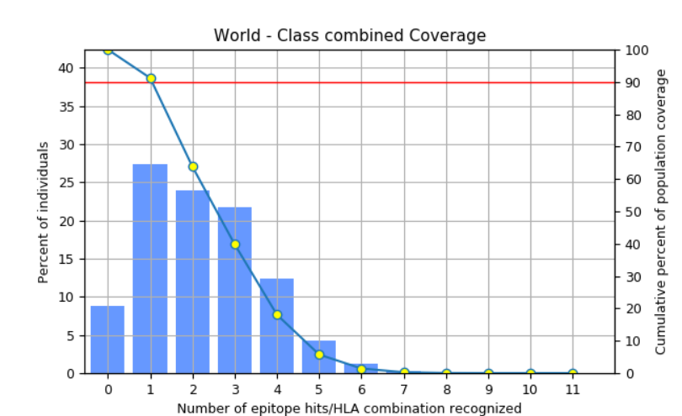

Figure 1: Global population coverage of predicted MHC-I and MHC-II epitopes calculated using the IEDB population coverage tool.
  - Vaccine construct design:
The final multi-epitope vaccine construct was designed by integrating selected CTL HTL, and B-cell epitopes, linked with immune-enhancing components to ensure optimal processing and presentation. (Figure 2)
The schematic diagram illustrates the final arrangement of CTL, HTL, and B-cell epitopes linked through appropriate spacers along with the β-defensin adjuvant and PADRE sequence. This organization facilitates efficient antigen processing and presentation by the host immune system (Figure 2).
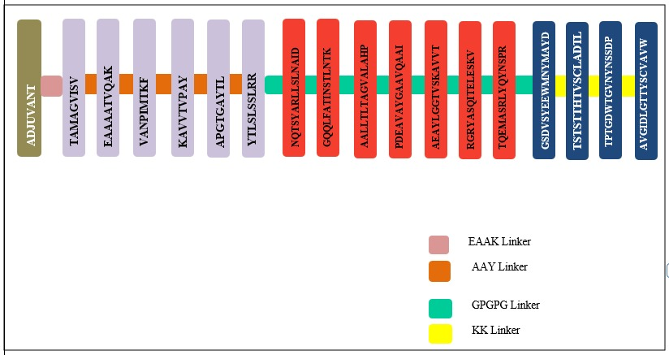

Figure 2: Schematic representation of the multi-epitope vaccine construct showing the arrangement of CTL, HTL, and B-cell epitopes with linkers, β-defensin adjuvant, and PADRE sequence
    - Immunological and physicochemical properties:
ProtParam analysis revealed that the vaccine construct contains 360 amino acids with a molecular weight of 37.39 kDa and a pI of 9.25. It is predicted to be stable (instability index: 25.81), thermostable (aliphatic index: 73.11), and hydrophilic (GRAVY: –0.138). The construct shows high solubility and favorable half-life predictions across mammalian, yeast, and E. coli systems, supporting its potential for expression and stability. (Table 4).

Table 4: Physicochemical properties of Vaccine Construct

Property | Value
Number of amino acids | 360
Molecular weight | 37,398.42 Da
Theoretical pI (Isoelectric Point) | 9.25
Total number of atoms | 5237
Molecular formula | C₁₆₅₄H₂₆₀₈N₄₅₄O₅₀₈S₁₃
Negatively charged residues (Asp + Glu) | 23
Positively charged residues (Arg + Lys) | 36
Instability index (II) | 25.81 (Stable)
Aliphatic index | 73.11
GRAVY (Hydropathicity index) | –0.138 (Hydrophilic)
Extinction coefficient (Cys oxidized) | 58260 M⁻¹cm⁻¹
Extinction coefficient (Cys reduced) | 57760 M⁻¹cm⁻¹
Abs 0.1% (Cys oxidized) | 1.558
Abs 0.1% (Cys reduced) | 1.544
Estimated half-life in mammalian cells | 30 hours (in vitro)
Estimated half-life in yeast | >20 hours (in vivo)
Estimated half-life in E. coli | >10 hours (in vivo)

    - Solubility of vaccine construct:

The solubility of the designed vaccine construct was predicted using the SOLUprot server to evaluate its expression feasibility in Escherichia coli. The construct achieved a solubility probability score of 0.856, which is significantly higher than the default threshold of 0.5, indicating a high likelihood of soluble expression in the bacterial host system. This result suggests that the vaccine construct is suitable for recombinant protein expression and downstream purification processes (Figure 3).
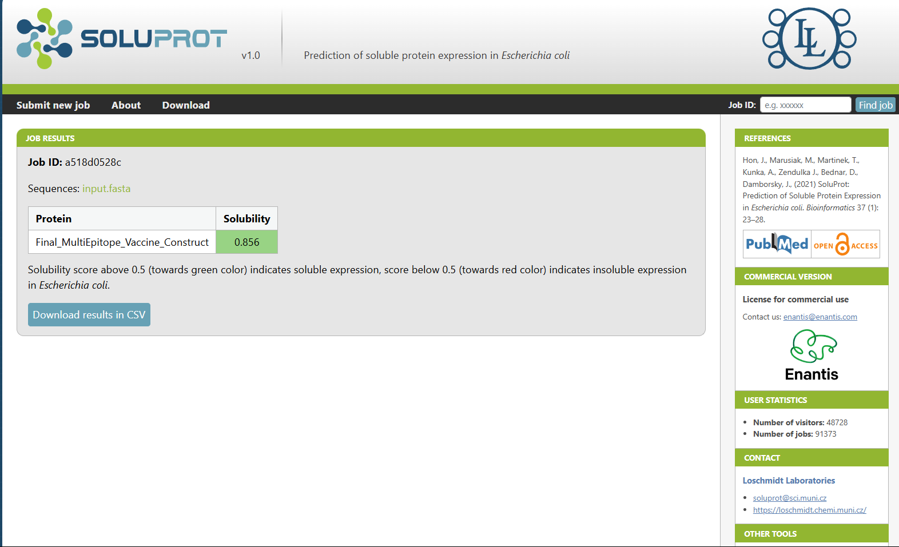

Figure 3: Predicted solubility score of the vaccine construct in Escherichia coli using the SOLUprot server.

  - Secondary Structure Prediction
The secondary structure of the final vaccine construct was analyzed using the PSIPRED server. The prediction revealed a balanced composition of α-helices, β-strands, and random coils, indicating a structurally stable protein with appropriate folding characteristics. The presence of random coils may contribute to structural flexibility, which is beneficial for epitope accessibility and immune recognition (Figure 4a).

The cartoon representation further illustrates the spatial arrangement of secondary structural elements within the vaccine construct, highlighting the distribution of helices, strands, and coil regions that contribute to the overall structural organization of the protein (Figure 4b).

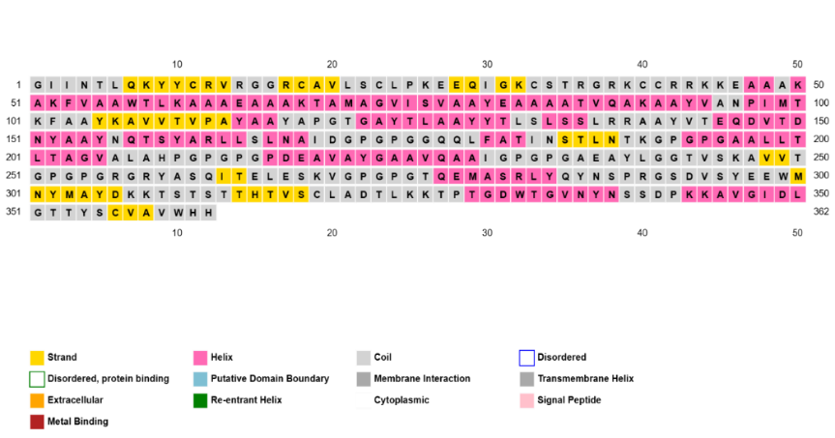
Figure 4a: Secondary structure prediction of the vaccine construct generated using the PSIPRED server.

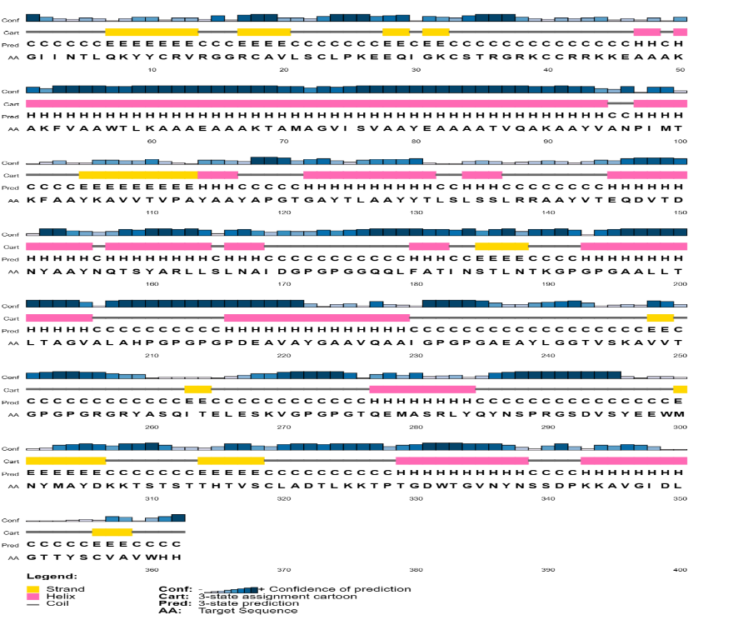
Figure 4b: Cartoon representation of the predicted secondary structure elements of the vaccine construct generated using PSIPRED.

  - 3D Structure Modelling and Validation:

    - 3D Structre Modelling.
The three-dimensional structure of the final multi-epitope vaccine construct was initially predicted using AlphaFold, which provided a high-confidence structural model. To enhance the quality of the predicted structure, it was refined using the GalaxyRefine server, which improves side-chain conformations and overall structural packing. (Figure 5a, Figure 5b)
The three-dimensional structure predicted by AlphaFold provides a preliminary structural model of the vaccine construct, enabling visualization of the spatial arrangement of epitopes and structural elements (Figure 5a).
.
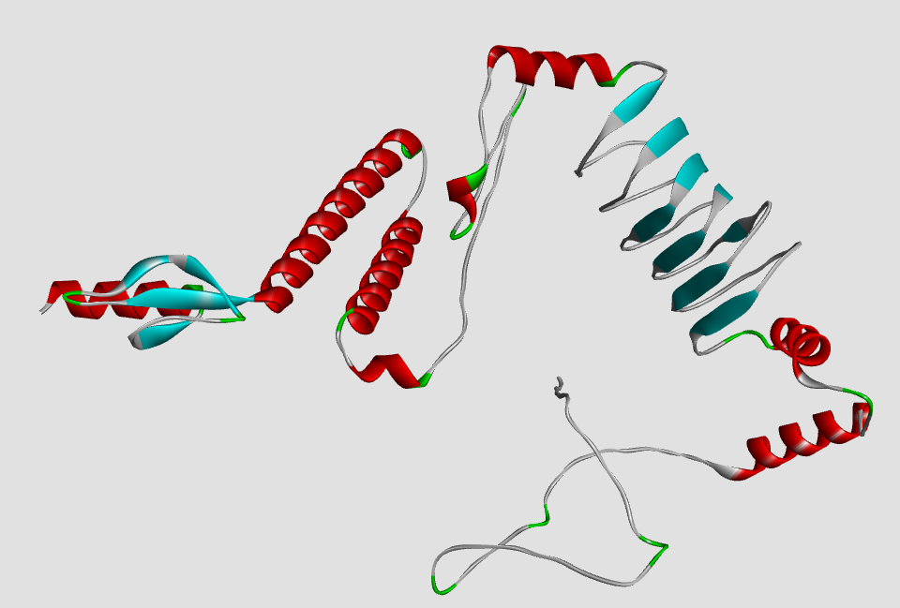
Figure 5a: Three-dimensional structural model of the vaccine construct predicted using AlphaFold.

Structural refinement using the GalaxyRefine server improved side-chain conformations and overall structural packing, resulting in a more energetically favorable model suitable for downstream validation and docking studies (Figure 5b).

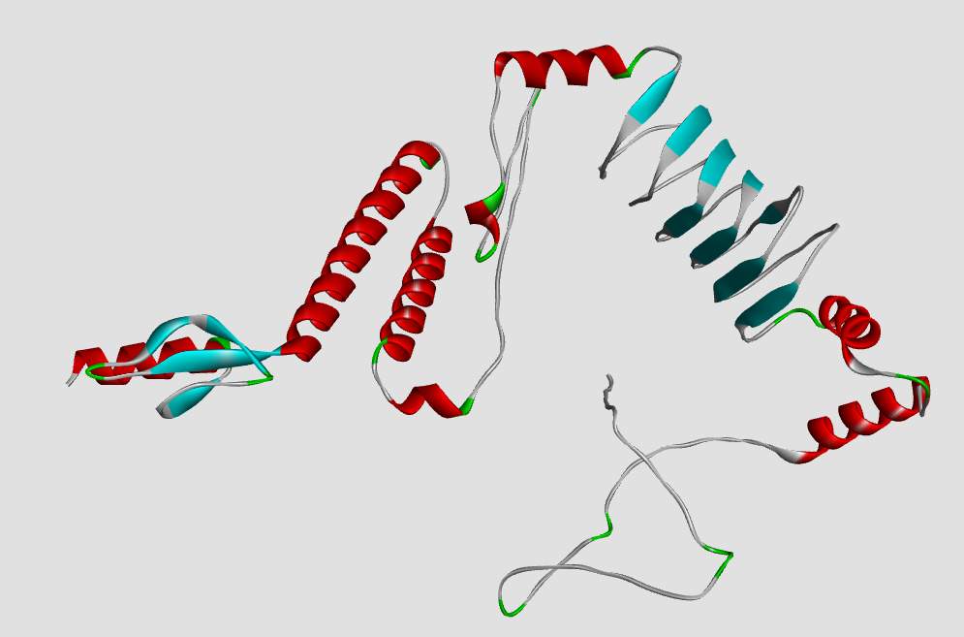
Figure 5b: Refined three-dimensional structure of the vaccine construct generated using the GalaxyRefine server.

    - 3D Structure Validation:
The refined model was evaluated using multiple structural validation tools:
PROCHECK (Ramachandran Plot):
Structural validation using PROCHECK indicated that 87.7% of residues were located in the most favored regions of the Ramachandran plot, confirming acceptable stereochemical quality.
ProSA-web:
The model achieved a Z-score of –3.54, which falls within the acceptable range for native protein structures, confirming the overall correctness of the model. (Figure 5c)
ERRAT:
The model scored an overall quality factor of 86.76, suggesting reliable non-bonded atomic interactions and a well-resolved structure. (Figure 5d)
The ERRAT analysis generated an overall quality factor of 86.76, indicating reliable non-bonded atomic interactions and confirming the structural integrity of the refined model (Figure 5d).

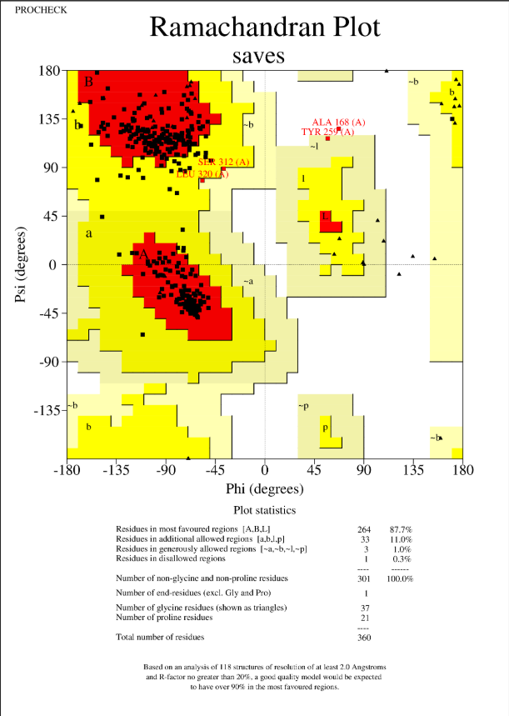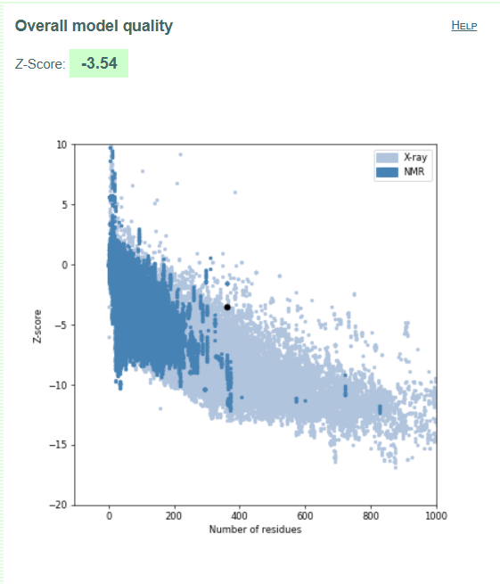
Figure 5c: Structural validation of the refined vaccine model using PROCHECK (Ramachandran plot) and ProSA-web

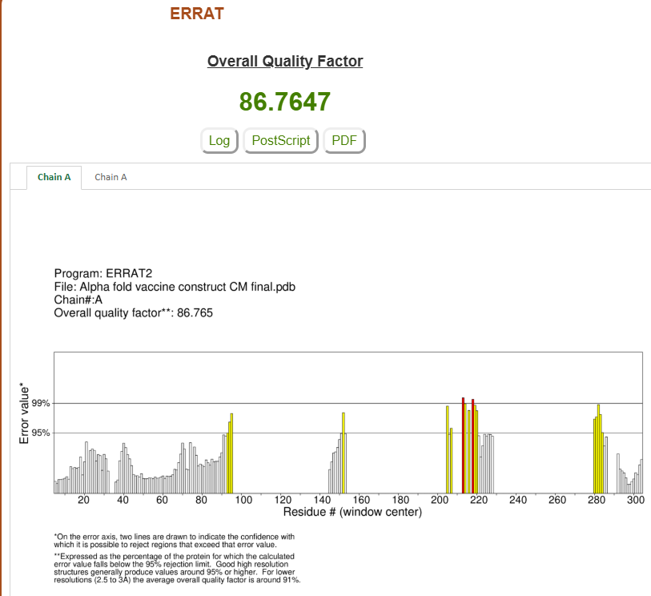
Figure 5d: ERRAT analysis showing the overall quality factor of the refined vaccine structure.

  - Molecular Docking:
Molecular docking of the refined vaccine construct with the TLR4 immune receptor was performed using the HADDOCK 2.4 server (Figure 6). Among the generated clusters, the best docking solution was selected based on key interaction parameters.
The selected cluster exhibited a HADDOCK score of –89.8 ± 2.9, indicating a strong and stable interaction (well below the –60 threshold). The interaction was supported by a high electrostatic energy (–375.4 ± 55.8) and favorable van der Waals energy (–32.9 ± 6.1), reflecting good shape complementarity and polar interactions. (Table 5)
The buried surface area of 1789.9 Å² further supported strong complex formation. Although the restraints violation was relatively high (191.9 ± 30.8), the overall Z-score of –1.4 confirmed the reliability of the docking pose.

Table 5: Best Cluster Properties of Docked Proteins by HADDOCK

Metric | Value | Interpretation
HADDOCK Score | –89.8 ± 2.9 | Very good. Well below the –60 threshold typically considered strong binding.
Electrostatic Energy | –375.4 ± 55.8 | Strong electrostatic interactions (critical for immunogenic proteins).
van der Waals Energy | –32.9 ± 6.1 | Acceptable; good shape complementarity.
Desolvation Energy | –1.1 ± 4.3 | Slightly low; acceptable but might reflect limited hydrophobic burial.
Restraints Violation | 191.9 ± 30.8 | On the higher side — could mean moderate violation of distance restraints.
Buried Surface Area | 1789.9 Å² ± 94.9 | Very good — above 1400 Å² is typically favourable for protein–protein docking.
Z-Score | –1.4 | Solid — the more negative, the better (Z < –1 is considered meaningful).

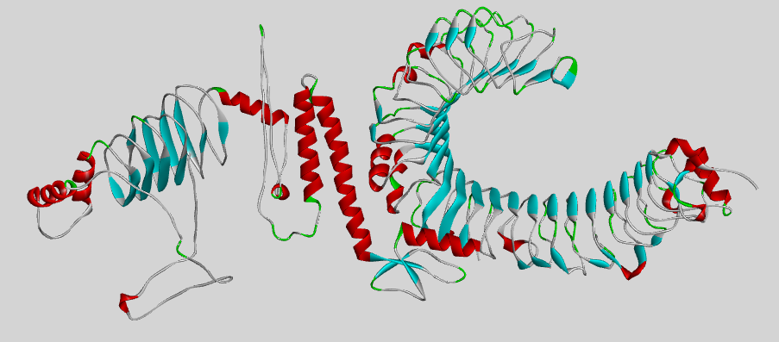
Figure 6: Docked complex of the multi-epitope vaccine (MEV) and TLR4 receptor visualized using Discovery Studio.
  - Protein- Protein Interactions:
To gain deeper insight into the molecular interactions between the multi-epitope vaccine (MEV) and TLR4, the PDBsum server was used to analyze the docked complex.
The interaction interface revealed several hydrogen bonds, salt bridges, and non-bonded contacts between the MEV and TLR4, suggesting strong molecular recognition and stability of the complex. The PDBsum interaction map provided a detailed schematic of contacting residues, highlighting the binding hotspots essential for receptor engagement. (Figure 7). This interaction analysis supports the docking results and confirms that the MEV construct has a strong binding affinity for the TLR4 immune receptor, which is critical for initiating an effective innate immune response.
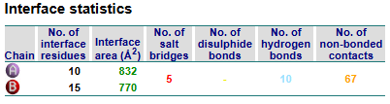
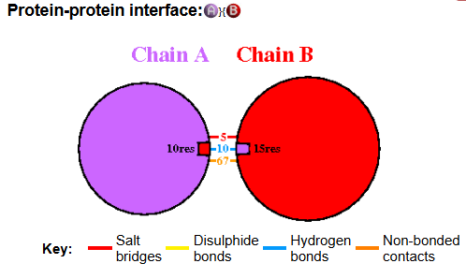
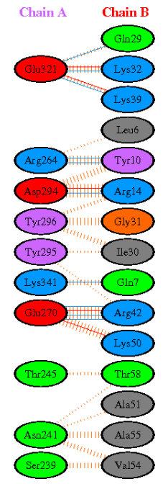
Figure 7: Protein–protein interaction map between the multi-epitope vaccine construct and TLR4 generated using the PDBsum server.

  - MD Simulations Analysis:

A 100 ns molecular dynamics simulation was performed to evaluate the stability, flexibility, and compactness of the MEV–TLR4 complex.
- RMSD analysis showed initial adjustment followed by stabilization around 1.0 nm, indicating conformational stability. (Figure 8a).
- RMSF revealed moderate fluctuations across residues, with minor peaks above 1.5 nm, typically at loop or terminal regions — suggesting localized flexibility. (Figure 8b)
- The Radius of Gyration (Rg) remained consistent between 4.2–4.4 nm, confirming structural compactness throughout the simulation. (Figure 8c)
- Solvent Accessible Surface Area values gradually decreased from ~550 nm² to ~470 nm², indicating reduced solvent exposure and tighter molecular packing. (Figure 8d).
These findings demonstrate that the vaccine construct maintains a stable and compact conformation, with sufficient flexibility in accessible regions — favorable for immune recognition and receptor binding.
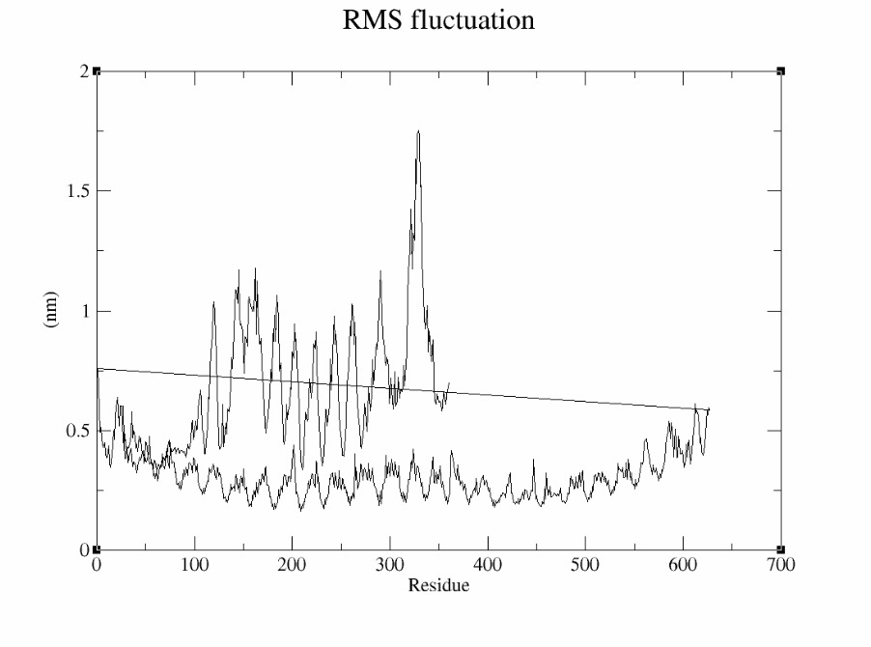
Figure 8a: Root mean square fluctuation (RMSF) profile showing residue flexibility during the 100 ns molecular dynamics simulation.
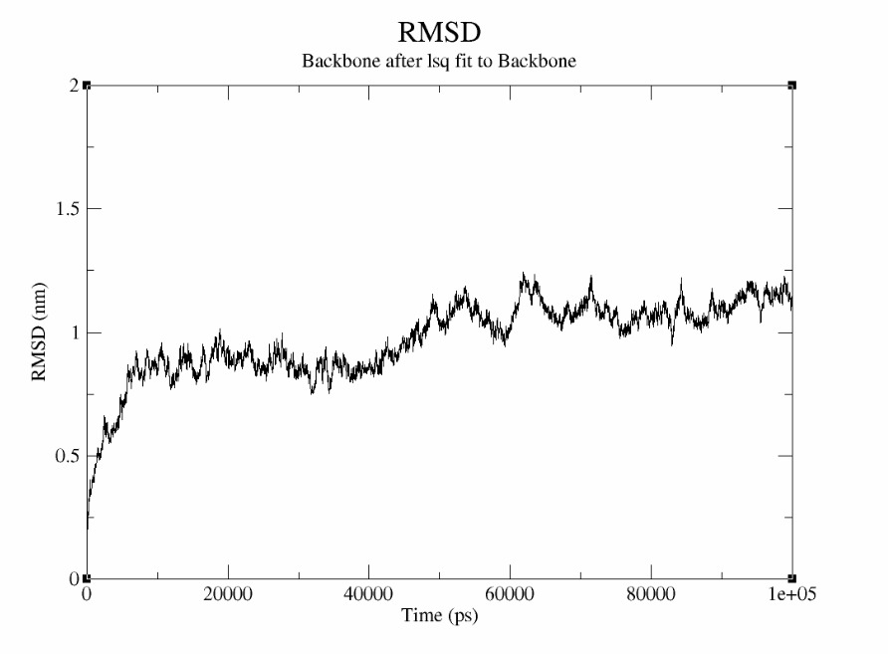
Figure 8b: Backbone root mean square deviation (RMSD) indicating structural stability of the MEV–TLR4 complex during the simulation.

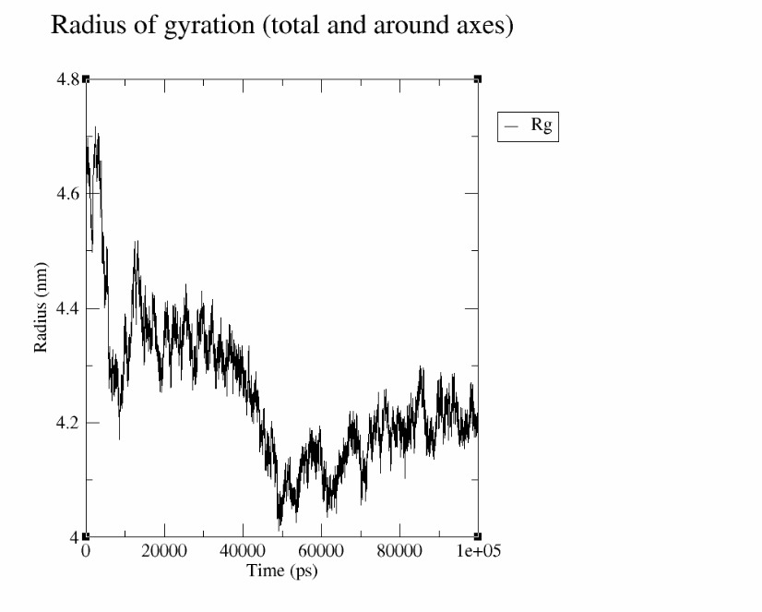
Figure 8c: Radius of gyration (Rg) plot showing structural compactness of the MEV–TLR4 complex during the simulation.

  - Codon Optimization and In Silico Cloning:
To enhance expression efficiency in Escherichia coli (strain K12), the codon sequence of the final vaccine construct was optimized using the JCAT server. The optimized sequence achieved a Codon Adaptation Index (CAI) of 1.0 and a GC content of 51.67%, both of which fall within the ideal range for efficient transcription and translation in E. coli. The relative adaptiveness plot confirmed uniform codon usage, indicating successful adaptation (Figure 9a).
The optimized nucleotide sequence was then cloned in silico into the pET28a (+) expression vector using SnapGene software (Figure 9b), positioned between NdeI and XhoI restriction sites. This construct is suitable for high-level recombinant expression and purification in bacterial systems.

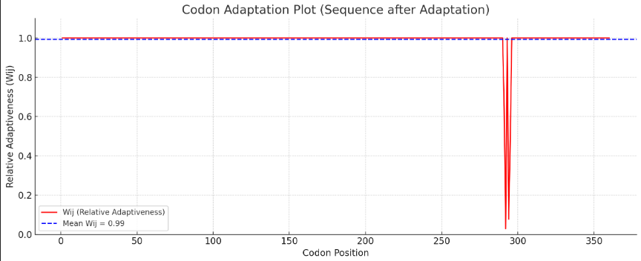
Figure 9a: Codon optimization of the vaccine construct for E. coli (strain K12) performed using the JCat server.
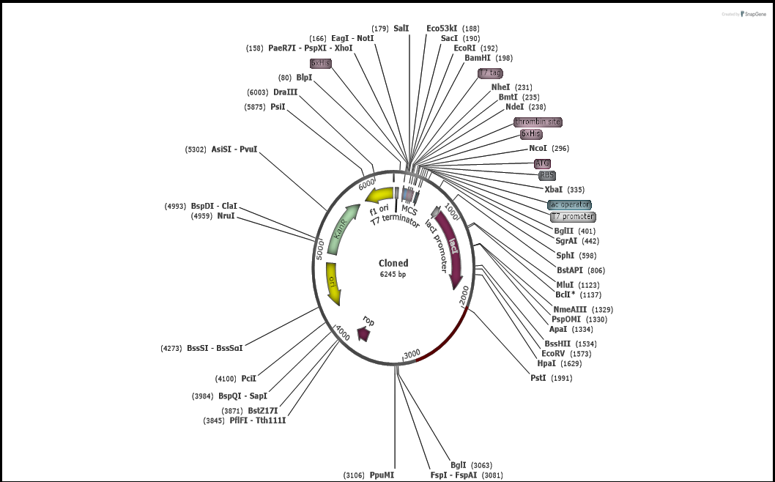
Figure 9b: In silico cloning of the optimized vaccine gene into the pET28a(+) expression vector.

- discussion
Cryptococcal meningitis is primarily caused by Cryptococcus neoformans and represents a life-threatening opportunistic fungal infection, particularly among immunocompromised populations worldwide [36,38,39]. Despite the availability of antifungal therapies, treatment is often complicated by drug toxicity, pharmacokinetic interactions, prolonged treatment duration, and high mortality rates, highlighting the need for improved preventive strategies [40,41,42]. Vaccine development against C. neoformans has therefore been proposed as a promising approach, and recent advances in reverse vaccinology and immunoinformatics provide powerful tools for identifying vaccine antigens and designing epitope-based vaccine constructs against fungal pathogens [43–46,60].
In the present study, a multi-epitope subunit vaccine candidate was designed using several immunodominant proteins of C. neoformans. Proteins such as mannoprotein MP88 and other cell-wall-associated proteins known to stimulate host immune responses were selected based on previous literature and their antigenic properties [48,49,50]. Epitope prediction for B-cells, cytotoxic T lymphocytes (CTLs), and helper T lymphocytes (HTLs) was performed using established immunoinformatics tools including IEDB, which are widely used in epitope-based vaccine design [52–54]. The predicted epitopes were further screened for antigenicity, allergenicity, toxicity, and cytokine-induction potential to improve the safety and immunogenicity profile of the final vaccine construct.
A total of six CTL epitopes, seven HTL epitopes, and four B-cell epitopes were shortlisted and assembled into a 360-amino-acid multi-epitope vaccine construct using suitable linkers (AAY, GPGPG, and KK) and an immunostimulatory β-defensin adjuvant. In addition, the PADRE sequence was incorporated to overcome HLA-DR polymorphism limitations, a strategy commonly applied in multi-epitope vaccine design [56,57]. Physicochemical analysis suggested that the designed construct is stable, soluble, and hydrophilic, indicating potential suitability for recombinant expression in bacterial systems.
Structural modelling was performed using AlphaFold [26], followed by refinement with GalaxyRefine [27]. Structural validation using PROCHECK [28], ERRAT [29], and ProSA [30] indicated acceptable stereochemical quality and favorable folding characteristics. Toll-like receptor 4 (TLR4) was selected as the immune receptor for docking analysis because of its established role in recognizing pathogen-associated molecular patterns (PAMPs) from microbial pathogens, including fungi. Activation of TLR-mediated signaling pathways contributes to the initiation of innate immune responses and the subsequent activation of adaptive immunity. Previous studies have shown that Toll-like receptors such as TLR2 and TLR4 participate in the recognition of fungal pathogens, including Cryptococcus neoformans, leading to cytokine production and immune activation [62,63]. Therefore, evaluating the interaction between the designed multi-epitope vaccine construct and TLR4 provides insight into the vaccine’s potential ability to stimulate innate immune recognition.
Molecular docking using the HADDOCK server [31] suggested a strong binding affinity between the vaccine construct and TLR4, supported by favorable electrostatic and van der Waals interaction energies as well as substantial buried surface area. Molecular dynamics simulations using GROMACS [33] further demonstrated the dynamic stability of the MEV–TLR4 complex, with RMSD, RMSF, radius of gyration, and SASA analyses indicating overall structural stability and controlled flexibility. Codon optimization using JCat [34] produced a codon adaptation index (CAI) of 1.0 and a GC content of 51.67%, suggesting efficient expression potential in Escherichia coli. Furthermore, in silico cloning of the optimized gene sequence into the pET28a(+) expression vector using SnapGene [35] demonstrated the feasibility of recombinant production of the designed vaccine construct.
Overall, the present study demonstrates an immunoinformatics-based pipeline for designing a potentially safe, stable, and immunogenic vaccine construct against cryptococcal meningitis. These findings support ongoing efforts toward fungal vaccine development and highlight the feasibility of computational vaccine discovery strategies targeting Cryptococcus species [61].
Although the selected epitopes demonstrated favorable antigenicity, immunogenicity, and population coverage, the present study did not include a comprehensive epitope conservancy analysis across multiple strains of Cryptococcus neoformans. Such analysis would further strengthen predictions regarding vaccine effectiveness against genetically diverse strains of the pathogen. Future studies incorporating large-scale genomic datasets and epitope conservancy analysis will be important for validating the broader applicability of the proposed multi-epitope vaccine construct.
- Conclusion

This project highlights the effective application of immunoinformatics in designing a safe and immunogenic multi-epitope vaccine candidate against Cryptococcus neoformans. The construct integrates epitopes capable of stimulating both cellular and humoral immunity, supported by favorable docking and simulation results.

The designed construct not only satisfies all key physicochemical and immunological parameters but also demonstrates robust receptor binding and stability under dynamic conditions. The inclusion of a β-defensin adjuvant, PADRE sequence, and epitope linkers improves immune accessibility and presentation. Structural validations confirm that the model is suitable for downstream experimental and clinical testing. Furthermore, codon optimization and in silico cloning show that the construct is well-suited for bacterial expression systems such as E. coli, enhancing its viability for production and testing.

Overall, this study proposes a computationally validated multi-epitope vaccine candidate targeting key immunogenic proteins of Cryptococcus neoformans. The integration of epitope prediction, structural modelling, molecular docking, and molecular dynamics simulations highlights the potential of immunoinformatics-driven approaches in the rational design of vaccines against fungal pathogens. Although the findings are encouraging, further experimental validation through both in vitro and in vivo studies is necessary to confirm the immunogenicity, safety, and protective efficacy of the proposed vaccine construct.

DATA AVAILABILITY STATEMENT
The datasets used and analyzed during the current study are available from the corresponding author on reasonable request.
Disclaimer (Artificial intelligence)
The authors acknowledge the use of generative artificial intelligence tools for limited language editing and grammar improvement during the preparation of this manuscript. All scientific content, data interpretation, analysis, and conclusions were developed and verified solely by the authors.
- References

[1]. Rodrigues, M. L., Alviano, C. S., & Travassos, L. R.—1999—Pathogenicity of: virulence factors and immunological mechanisms—https://doi.org/10.1016/s1286-4579(99)80025-2
[2]. Rathore, S. S., Sathiyamoorthy, J., Lalitha, C., & Ramakrishnan, J.—2022—A holistic review on Cryptococcus neoformans https://doi.org/10.1016/j.micpath.2022.105521
[3]. Perfect JR, Dismukes WE, Dromer F, Goldman DL, Graybill JR, Hamill RJ, Harrison TS, Larsen RA, Lortholary O, Nguyen MH, Pappas PG, Powderly WG, Singh N, Sobel JD, Sorrell TC. Clinical practice guidelines for the management of cryptococcal disease. Clinical Infectious Diseases. 2010;50(3):291–322. https://doi.org/10.1086/649858
[4]. Rajasingham R, Smith RM, Park BJ, Jarvis JN, Govender NP, Chiller TM, Denning DW, Loyse A, Boulware DR. Global burden of disease of HIV-associated cryptococcal meningitis: an updated analysis. Lancet Infectious Diseases. 2017;17(8):873–881. https://doi.org/10.1016/S1473-3099(17)30243-8
[5]. Abassi, M., Boulware, D. R., & Rhein, J.—2015—Cryptococcal Meningitis: Diagnosis and Management Update—https://doi.org/10.1007/s40475-015-0046-y
[6]. Sugar, A. M., Stem, J. J., & Dupont, B.—1990—Overview: Treatment of Cryptococcal Meningitis—https://doi.org/10.1093/clinids/12.supplement_3.s338
[7]. Badali H, Alian S, Fakhim H, Falahatinejad M, Moradi A, Davoudi MM, Hagen F, Meis JF. Cryptococcal meningitis due to Cryptococcus neoformans genotype AFLP1/VNI in Iran: a review of the literature. Mycoses. 2015;58(12):689–693. https://doi.org/10.1111/myc.12415
[8]. Haddow LJ, Colebunders R, Meintjes G, Lawn SD, Elliott JH, Manabe YC, Bohjanen PR, Sungkanuparph S, Easterbrook PJ, French MA. Cryptococcal immune reconstitution inflammatory syndrome in HIV-1 infected individuals: proposed clinical case definitions. Lancet Infectious Diseases. 2010;10(11):791–802. https://doi.org/10.1016/S1473-3099(10)70170-5
[9]. Kumar Pandey, R., Ojha, R., Mishra, A., & Kumar Prajapati, V.—2018—Designing B- and T-cell multi-epitope-based subunit vaccine using immunoinformatics approach to control Zika virus infection—https://doi.org/10.1002/jcb.27110
[10]. Yurina, V., & Adianingsih, O. R.—2022—Predicting epitopes for vaccine development using bioinformaticstools—https://doi.org/10.1177/25151355221100218
[11]. Zhu, F., Qin, R., Ma, S., Zhou, Z., Tan, C., Tree, H., Zhang, P., Xu, Y., Luo, Y., Chen, J., & Pan, P.—2025—Designing a multi-epitope vaccine against Pseudomonas aeruginosa via integrating reverse vaccinology with immunoinformatics approaches—https://doi.org/10.1038/s41598-025-90226-6
[12]. Mugunthan, S. P., & Mani Chandra, H.—2021—A Computational Reverse Vaccinology Approach for the Design and Development of Multi-Epitopic Vaccine Against Avian Pathogen Mycoplasma gallisepticum—https://doi.org/10.3389/fvets.2021.721061
[13]. The UniProt Consortium – 2023 – UniProt: the Universal Protein Knowledgebase in 2023 – https://academic.oup.com/nar/article/51/D1/D523/6835119
[14]. Metzner, C., et al. – 2016 – Biomedical applications of glycosylphosphatidylinositol-anchored proteins – https://www.jlr.org/article/S0022-2275(20)32371-3/fulltext
[15]. Biondo, C., et al. – 2002 – Identification and cloning of a cryptococcal deacetylase that produces protective immune responses – https://journals.asm.org/doi/10.1128/iai.70.5.2383-2391.2002
[16]. Borges, T. J., et al. – 2012 – The anti-inflammatory mechanisms of Hsp70 – https://www.frontiersin.org/journals/immunology/articles/10.3389/fimmu.2012.00095/full
[17]. Huang, C., et al. – 2002 – Purification and characterization of a second immunoreactive mannoprotein from Cryptococcus neoformans that stimulates T-Cell responses – https://journals.asm.org/doi/10.1128/iai.70.10.5485-5493.2002
[18]. Vita, R., et al. – 2019 – The Immune Epitope Database (IEDB): 2018 update – https://academic.oup.com/nar/article/47/D1/D339/5144151
[19]. Reynisson B, Alvarez B, Paul S, Peters B, Nielsen M. NetMHCpan-4.1 and NetMHCIIpan-4.0: improved predictions of MHC antigen presentation by concurrent motif deconvolution and integration of MS MHC eluted ligand data. Nucleic Acids Research. 2020;48(W1):W449–W454. https://doi.org/10.1093/nar/gkaa379
[20]. Doytchinova, I. A., et al. – 2007 – VaxiJen: a server for prediction of protective antigens, tumour antigens and subunit vaccines – https://bmcbioinformatics.biomedcentral.com/articles/10.1186/1471-2105-8-4
[21]. Dimitrov, I., et al. – 2014 – AllerTOP v.2 — a server for in silico prediction of allergens – https://pubmed.ncbi.nlm.nih.gov/24878803/
[22]. Gupta, S., et al. – 2013 – In Silico Approach for Predicting Toxicity of Peptides and Proteins – https://journals.plos.org/plosone/article?id=10.1371/journal.pone.0073957
[23]. Dhanda, S. K., et al. – 2013 – Designing of interferon-gamma inducing MHC class-II binders – https://pmc.ncbi.nlm.nih.gov/articles/PMC4235049/
[24]. Bui, H. H., et al. – 2006 – Predicting population coverage of T-cell epitope-based diagnostics and vaccines – https://pmc.ncbi.nlm.nih.gov/articles/PMC1513259/
[25]. Gasteiger, E., et al. – 2005 – Protein Identification and Analysis Tools on the ExPASy Server – https://link.springer.com/protocol/10.1385/1-59259-890-0:571
[26]. Jumper, J., et al. – 2021 – Highly accurate protein structure prediction with AlphaFold – https://www.nature.com/articles/s41586-021-03819-2
[27]. Heo, L., et al. – 2013 – GalaxyRefine: Protein structure refinement driven by side-chain repacking – https://academic.oup.com/nar/article/41/W1/W384/1108398
[28]. Laskowski, R. A., et al. – 1993 – PROCHECK: a program to check the stereochemical quality of protein structures – http://onlinelibrary.wiley.com/doi/abs/10.1107/s0021889892009944
[29]. Colovos, C. & Yeates, T. O. – 1993 – Verification of protein structures: patterns of nonbonded atomic interactions – https://pubmed.ncbi.nlm.nih.gov/8401235/
[30]. Wiederstein, M. & Sippl, M. J. – 2007 – ProSA-web: interactive web service for the recognition of errors in three-dimensional structures of proteins – https://academic.oup.com/nar/article/35/suppl_2/W407/2920938
[31]. van Zundert, G. C. P., et al. – 2016 – The HADDOCK2.2 Web Server: User-Friendly Integrative Modeling of Biomolecular Complexes – https://pubmed.ncbi.nlm.nih.gov/26410586/
[32]. Laskowski, R. A., et al. – 2018 – PDBsum: Structural summaries of PDB entries – https://onlinelibrary.wiley.com/doi/full/10.1002/pro.3289
[33]. Abraham, M. J., et al. – 2015 – GROMACS: High performance molecular simulations through multi-level parallelism from laptops to supercomputers – https://www.sciencedirect.com/science/article/pii/S2352711015000059
[34]. Grote A, Hiller K, Scheer M, Münch R, Nörtemann B, Hempel DC, Jahn D. JCat: a novel tool to adapt codon usage of a target gene to its potential expression host. Nucleic Acids Research. 2005;33(Web Server issue):W526–W531. https://doi.org/10.1093/nar/gki376
[35]. SnapGene Software – 2026 – SnapGene: Molecular Biology Software for Cloning and Sequence Visualization – https://www.snapgene.com/
[36]. Maziarz, E. K. & Perfect, J. R. – 2016 – Cryptococcosis – https://pubmed.ncbi.nlm.nih.gov/26897061/
[37]. May, R. C., et al. – 2016 – Cryptococcus: from environmental saprophyte to global pathogen – https://www.nature.com/articles/nrmicro.2015.6
[38]. Molloy, S. F., et al. – 2017 – Cryptococcal meningitis: A neglected NTD? – https://journals.plos.org/plosntds/article?id=10.1371/journal.pntd.0005575
[39]. Sloan, D. J. & Parris, V. – 2014 – Cryptococcal meningitis: epidemiology and therapeutic options – https://www.ncbi.nlm.nih.gov/pmc/articles/PMC4026566/
[40]. Loyse A, Thangaraj H, Easterbrook P, Ford N, Roy M, Chiller T, Govender NP, Harrison TS, Boulware DR. Cryptococcal meningitis: improving access to essential antifungal medicines in resource-poor countries. Lancet Infectious Diseases. 2013;13(7):629–637. https://doi.org/10.1016/S1473-3099(13)70078-1
[41]. Spernovasilis, N. & Kofteridis, D. P. – 2018 – Pre-existing liver disease and toxicity of antifungals – https://www.mdpi.com/2309-608X/4/4/133
[42]. Nandy, A. & Basak, S. C. – 2016 – A brief review of computer-assisted approaches to rational design of peptide vaccines – https://www.mdpi.com/1422-0067/17/5/666
[43]. Alsowayeh, N., et al. – 2022 – Reverse vaccinology and immunoinformatic assisted designing of a multi-epitopes-based vaccine against nosocomial Burkholderia cepacia – https://www.frontiersin.org/articles/10.3389/fmicb.2022.929400/full
[44]. Jalal, K., et al. – 2022 – Reverse vaccinology approach for multi-epitope centered vaccine design against delta variant of SARS-CoV-2 – https://link.springer.com/article/10.1007/s11356-021-17793-z
[45]. Poland, G. A., et al. – 2013 – Vaccinomics, adversomics, and the immune response network theory – https://www.sciencedirect.com/science/article/pii/S104453231300010X
[46]. Leopold Wager, C. M. & Wormley, F. L. Jr. – 2015 – Is development of a vaccine against Cryptococcus neoformans feasible? – https://journals.plos.org/plospathogens/article?id=10.1371/journal.ppat.1004843
[47]. Zaragoza O, Nielsen K. Titan cells in Cryptococcus neoformans: cells with a giant impact. Current Opinion in Microbiology. 2013;16(4):409–413. https://doi.org/10.1016/j.mib.2013.03.006
[48]. Pietrella, D., et al. – 2001 – Role of mannoprotein in induction and regulation of immunity to Cryptococcus neoformans – https://journals.asm.org/doi/10.1128/IAI.69.5.2808-2814.2001
[49]. Levitz SM, Specht CA. The molecular basis for the immunogenicity of Cryptococcus neoformans mannoproteins. FEMS Yeast Res. 2006 Jun;6(4):513-24. doi: 10.1111/j.1567-1364.2006.00071.x. PMID: 16696647.
[50]. Rizzo J, Rodrigues ML, Janbon G. Extracellular vesicles in fungi: past, present, and future perspectives. Frontiers in Cellular and Infection Microbiology. 2020;10:346. https://doi.org/10.3389/fcimb.2020.00346
[51]. Bui, H. H., et al. – 2007 – Development of an epitope conservancy analysis tool to facilitate the design of epitope-based diagnostics and vaccines – https://bmcbioinformatics.biomedcentral.com/articles/10.1186/1471-2105-8-361
[52]. Larsen JEP, Lund O, Nielsen M. Improved method for predicting linear B-cell epitopes. Immunome Research. 2006;2:2. https://doi.org/10.1186/1745-7580-2-2
[53]. Lundegaard, C., et al. – 2008 – NetMHC-3.0: accurate web accessible predictions of MHC class I affinities – https://academic.oup.com/nar/article/36/suppl_2/W509/2505678
[54]. Fleri, W., et al. – 2017 – The immune epitope database and analysis resource in epitope discovery – https://www.frontiersin.org/articles/10.3389/fimmu.2017.00278/full
[55].Patronov, A. & Doytchinova, I. – 2013 – T-cell epitope vaccine design by immunoinformatics – https://royalsocietypublishing.org/doi/10.1098/rsob.120139
[56]. Li, W., et al. – 2014 – Peptide vaccine: progress and challenges – https://www.mdpi.com/2076-393X/2/3/515
[57]. De Groot AS, Moise L, McMurry JA, Wambre E, Van Overtvelt L, Moingeon P, Scott DW, Martin W. Activation of natural regulatory T cells by IgG Fc-derived peptide “Tregitopes”. Blood. 2008;112(8):3303–3311. https://doi.org/10.1182/blood-2008-02-138073

[58] Rawat SS, Keshri AK, Kaur R, Prasad A. Immunoinformatics approaches for vaccine design: a fast and secure strategy for successful vaccine development. Vaccines. 2023;11(2):221. https://doi.org/10.3390/vaccines11020221
[59] Waqas M, et al. Immunoinformatics design of a multi-epitope vaccine candidate using reverse vaccinology approaches. Frontiers in Immunology. 2023;14:1091941. https://doi.org/10.3389/fimmu.2023.1091941
[60] Zhou Z, Zhu F, Ma S, Tan C, Yang H, Zhang P, Xu Y, Qin R, Luo Y, Chen J, Pan P. Design of Cryptococcus neoformans multi-epitope vaccine based on immunoinformatics method. Med Mycol. 2024 Aug 2;62(8):myae080. doi: 10.1093/mmy/myae080. PMID: 39122658.
[61] Moses M, et al. Advances in fungal vaccine development: progress in the face of emerging challenges. iScience. 2025. https://doi.org/10.1016/j.isci.2025.114091
[62] Netea MG, Gow NA, Munro CA, Bates S, Collins C, Ferwerda G, Hobson RP, Bertram G, Hughes HB, Jansen T, Jacobs L, Buurman ET, Gijzen K, Williams DL, Torensma R, McKinnon A, MacCallum DM, Odds FC, Van der Meer JW, Brown AJ, Kullberg BJ. Immune sensing of Candida albicans requires cooperative recognition of mannans and glucans by lectin and Toll-like receptors. J Clin Invest. 2006 Jun;116(6):1642-50. doi: 10.1172/JCI27114. Epub 2006 May 18. PMID: 16710478; PMCID: PMC1462942.
[63] Campuzano A, Wormley FL Jr. Innate immunity against Cryptococcus, from recognition to elimination. Journal of Fungi. 2018;4(1):33. https://doi.org/10.3390/jof4010033

