Immunoinformatics-Guided Design and Comprehensive In Silico Evaluation of a Multi-Epitope Norovirus Vaccine Candidate

ABSTRACT

Background: Norovirus, a non-enveloped, positive-sense single-stranded RNA virus belonging to the Caliciviridae family, is a leading cause of acute gastroenteritis (AGE) globally, accounting for approximately 19–21 million cases annually in the United States alone. The rapid emergence of genetically diverse variants, including GII.17, poses significant challenges to conventional vaccine development. Therefore, alternative strategies capable of inducing broad and effective immune responses are urgently needed.
Aim: The present study aimed to explore the Immunoinformatics-Driven Design and In Silico Validation of a Multi-Epitope Subunit Vaccine Targeting Norovirus.
Methods: An immunoinformatics-driven approach was employed to design a multi-epitope subunit vaccine candidate against Norovirus. Three viral proteins—capsid protein (A7YK10), small protein (A7YK11), and polyprotein (A7YK09)—were selected for epitope prediction using the Immune Epitope Database (IEDB). Predicted B-cell and T-cell epitopes were screened for antigenicity (VaxiJen), allergenicity (AllerTOP), toxicity (ToxinPred), and global population coverage. The finalized construct was evaluated for physicochemical properties (ProtParam), structural integrity (secondary and tertiary structure prediction, Ramachandran analysis, QMEAN scoring), molecular docking interactions with MHC class I, MHC class II, and Toll-like receptor 4 (TLR4), molecular dynamics stability, immune response simulation, and codon optimization for expression feasibility.
Results: A 433-amino-acid multi-epitope construct incorporating six B-cell, six cytotoxic T lymphocyte (CTL), and nine helper T lymphocyte (HTL) epitopes was generated. The construct demonstrated high predicted antigenicity and broad global population coverage (98.96%). Structural validation indicated favorable stereochemical quality, with 88.9% residues in the most favored regions of the Ramachandran plot and a QMEAN Z-score of −0.97. Docking analysis revealed strong binding affinity, particularly with TLR4 (HADDOCK score −103.9 ± 11.0), and molecular dynamics simulation confirmed stability of the vaccine–TLR4 complex over 100 ns.

Conclusion: The designed multi-epitope vaccine construct exhibits promising immunogenic, structural, and interaction profiles in silico, supporting its potential as a candidate for further experimental validation in vitro and in vivo.

Keywords: Norovirus, acute gastroenteritis, multi-epitope vaccine, immunoinformatics, molecular docking, immunogenicity

1. INTRODUCTION

Norovirus (NoV) is a non-enveloped, positive-sense single-stranded RNA virus belonging to the Caliciviridae family and is recognized as the leading cause of non-bacterial acute gastroenteritis (AGE) worldwide. It affects individuals of all age groups and contributes significantly to the global burden of gastrointestinal disease and mortality (Lanata et al., 2013). Clinical symptoms typically include abdominal pain, watery diarrhoea, nausea, and vomiting, with transmission occurring primarily through the fecal–oral route (Lew et al., 2012). In the United States alone, Norovirus is responsible for an estimated 19–21 million cases each year. Its high transmissibility and environmental stability make it particularly dangerous for vulnerable populations such as infants and the elderly (Ahmed et al., 2014; Pires et al., 2015). A major public health challenge arises from the virus’s rapid genetic evolution. Considerable diversity exists within genogroups GI and GII, with the GII.4 genotype being the most prevalent and virulent. Emerging variants, including GII.17, have been associated with increased outbreak activity across multiple countries (Afgan et al., 2018). This continuous antigenic drift reduces the long-term effectiveness of strain-specific vaccines and complicates traditional vaccine development strategies. Despite extensive global efforts, no licensed Norovirus vaccine or specific antiviral therapy is currently available (Tanaka et al., 2013). Vaccine development is further slowed by technical limitations, including the lack of efficient in vitro culture systems and suitable animal models, which restrict experimental evaluation (Das et al., 2014). These constraints support the need for multivalent or broad-spectrum vaccine strategies that target conserved viral regions across strains (Chen et al., 2022). In this context, computational vaccinology and immunoinformatics have emerged as promising and cost-effective approaches for multi-epitope vaccine design (Atmar et al., 2020). These methods use bioinformatics tools to identify conserved sequences across viral variants and to predict epitope antigenicity, immunogenicity, allergenicity, toxicity, and structural stability. Widely used platforms include IEDB for epitope prediction and tools such as ProtParam, PSIPRED, and molecular docking frameworks for structural and functional evaluation. This reverse vaccinology pipeline enables rational vaccine design and accelerates early-stage candidate selection compared with purely empirical approaches (Bartsch et al., 2018). However, while in silico predictions provide a strong foundation, experimental validation remains essential to confirm real-world protective efficacy against circulating and emerging variants (Somana et al., 2020).

2. materialS and methods

2.1 Target Protein Sequence Retrieval and Selection
Norovirus protein sequences were retrieved through a systematic database search. The National Center for Biotechnology Information (NCBI) database (https://www.ncbi.nlm.nih.gov/) was used to identify relevant Norovirus genomic information. Based on an extensive literature review and antigenic relevance, three viral proteins were selected for vaccine design: the capsid protein, small protein, and polyprotein. Protein sequences corresponding to the Norovirus GV/WU24/2005/USA strain (OX = 463715) were obtained in FASTA format from the UniProt database (https://www.uniprot.org/). The selected proteins and their respective UniProt identifiers were A7YK10 (capsid protein), A7YK11 (small protein), and A7YK09 (polyprotein).
2.2 Overall Workflow for Epitope-Based Vaccine Design
The selected Norovirus protein sequences were subjected to a comprehensive immunoinformatics pipeline involving epitope prediction, screening, vaccine construct design, structural modeling, molecular docking, immune simulation, and codon optimization. A schematic representation of the overall workflow is shown in Figure 1.
2.3 B-Cell Epitope Prediction
Linear B-cell epitopes were predicted from the selected protein sequences using the Immune Epitope Database (IEDB) resource. Predicted epitopes were evaluated for their antigenic potential and suitability for inclusion in the vaccine construct.
2.4 Cytotoxic T Lymphocyte (CTL) Epitope Prediction
CTL epitopes binding to MHC class I molecules were predicted using the IEDB MHC-I binding tool (http://tools.iedb.org/mhci/). Predictions were based on peptide binding affinity, proteasomal C-terminal cleavage efficiency, and transporter associated with antigen processing (TAP) transport potential. Epitopes demonstrating strong binding affinity and favorable processing characteristics were selected for further analysis.

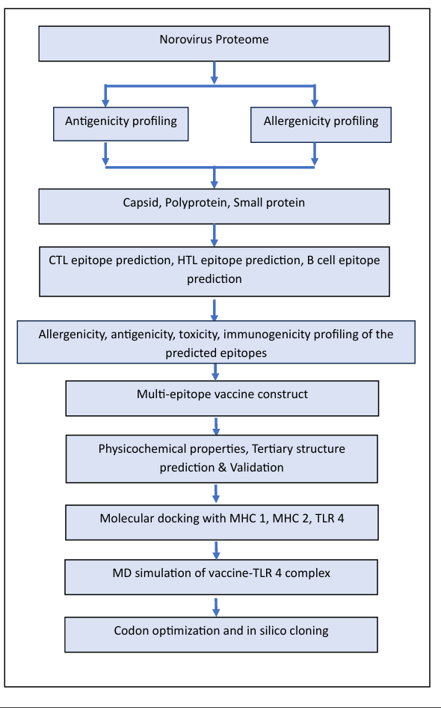
Figure 1. Schematic representation of the steps involved in epitope-based vaccine designing.

2.5 Helper T Lymphocyte (HTL) Epitope Prediction
Helper T lymphocyte (HTL) epitopes were predicted using the IEDB MHC-II binding tool (http://tools.iedb.org/mhcii/). Epitopes with strong binding affinity to commonly occurring human leukocyte antigen (HLA) class II alleles were prioritized to enhance CD4⁺ T-cell–mediated immune responses.
2.6 Population Coverage Analysis
Population coverage analysis was conducted using the IEDB-AR v2.22 population coverage tool to evaluate the global applicability of the selected CTL and HTL epitopes. This analysis estimates the proportion of individuals likely to mount an immune response based on the distribution of associated HLA class I and II alleles across different ethnic and geographical populations.
2.7 Vaccine Construct Design
A multi-epitope subunit vaccine (MEV) construct was designed by assembling the selected CTL and HTL epitopes using appropriate linker sequences. Epitope selection was based on high antigenicity, non-allergenicity, non-toxicity, conservation across strains, strong HLA binding affinity, and broad population coverage. The construct was designed to optimize immunogenicity, stability, and safety.
2.8 Physicochemical Property Analysis
The physicochemical properties of the designed vaccine construct, including molecular weight, theoretical isoelectric point (pI), instability index, aliphatic index, and grand average of hydropathicity (GRAVY), were evaluated using the ProtParam tool.
2.9 Antigenicity and Solubility Prediction
Antigenicity of the vaccine construct was assessed using the VaxiJen v2.0 server with a threshold value of 0.4. Protein solubility upon recombinant expression in Escherichia coli was predicted using the SOLUPROT web server to assess feasibility for downstream expression and purification.
2.10 Secondary Structure Prediction
Secondary structure prediction of the vaccine construct was performed using the PSIPRED server. The predicted proportions of alpha helices, beta strands, and random coils were analyzed to evaluate structural features relevant to protein stability and epitope presentation.
2.11 Tertiary Structure Prediction and Validation
Due to the chimeric nature of the multi-epitope vaccine construct and the absence of suitable homologous templates for conventional homology modeling, tertiary structure prediction was performed using the Robetta web server. Among the generated models, Model 1 was selected based on structural quality parameters and further refined using the GalaxyRefine server to improve stereochemical properties. Structural validation of the refined model was conducted using PROCHECK via the SAVES v6.0 server. Ramachandran plot analysis was performed to assess the stereochemical quality of backbone dihedral angles. Overall model quality was further evaluated using QMEAN Z-score and QMEANDisCo global score. Additionally, ERRAT analysis was performed to assess the non-bonded atomic interactions and overall structural reliability of the predicted model.
2.12 Molecular Docking Analysis
Molecular docking was performed to evaluate interactions between the vaccine construct and key immune receptors, including Toll-like receptor 4 (TLR4), MHC class I, and MHC class II molecules. Docking simulations were carried out using the HADDOCK v2.2 web server. The resulting complexes were visualized using UCSF Chimera, and detailed interaction analysis was performed using the PDBsum database.
2.13 In Silico Immune Simulation
In silico immune simulation was performed using the C-ImmSim server (http://150.146.2.1/C-IMMSIM/index.php) to predict immune responses elicited by the vaccine construct. Simulations were conducted at time steps 1, 84, and 168, corresponding to three vaccine doses administered at four-week intervals.
2.14 Codon Optimization and In Silico Cloning
Codon optimization of the vaccine construct was performed using the Java Codon Adaptation Tool (JCAT) to enhance expression efficiency in E. coli. The optimized nucleotide sequence was subsequently cloned in silico into the pET-28a(+) expression vector using SnapGene software.
3. results

3.1 Protein Sequence Retrieval
The target Norovirus protein sequences were successfully retrieved from the UniProt database. Three proteins were selected for epitope prediction and vaccine design: the capsid protein (UniProt ID: A7YK10), small protein (UniProt ID: A7YK11), and polyprotein (UniProt ID: A7YK09). These sequences formed the basis for subsequent epitope prediction and screening analyses.

3.2 Epitope Screening and Selection
The capsid protein, small protein, and polyprotein sequences were submitted to the Immune Epitope Database (IEDB) server for the prediction of B-cell, cytotoxic T lymphocyte (CTL), and helper T lymphocyte (HTL) epitopes. Predicted epitopes were systematically screened based on multiple immunological and safety parameters, including antigenicity (VaxiJen), immunogenicity (IEDB tools), allergenicity (AllerTOP v2.0), toxicity (ToxinPred), and interferon-gamma (IFN-γ) induction potential (IFNepitope server). Following this comprehensive screening, a total of six B-cell epitopes, six MHC class I (CTL) epitopes, and nine MHC class II (HTL) epitopes were selected for inclusion in the final multi-epitope vaccine construct. All selected epitopes demonstrated antigenicity scores above the recommended threshold (VaxiJen > 0.4), were predicted to be non-toxic and non-allergenic, and showed favorable immunogenic profiles. Additionally, the selected T-cell epitopes were predicted to induce IFN-γ, indicating their potential to elicit robust antiviral cell-mediated immune responses.

Tables 1–3 summarize the selected B-cell, MHC class I, and MHC class II epitopes along with their respective immunological properties.
Table 1. Selected B-cell epitopes
SEQUENCE | TOXICITY | ALLERGENICITY | ANTIGENICITY | VAXIGEN SCORE
HVNGTLLGTTPVSGSWVS | NON- TOXIN | NON-ALLERGEN | ANTIGEN | 0.5223
PLDLVDGRVRAVPRSVYFFQDVLPEYNDGLL | NON- TOXIN | NON-ALLERGEN | ANTIGEN | 0.6936
SEDEVNPALL | NON- TOXIN | NON-ALLERGEN | ANTIGEN | 0.8404
DELVPKQDEKYQK | NON- TOXIN | NON-ALLERGEN | ANTIGEN | 0.5609
TKGPHPGKPELTPLGA | NON- TOXIN | NON-ALLERGEN | ANTIGEN | 1.1375
FGTMDAEPTQERSA | NON- TOXIN | NON-ALLERGEN | ANTIGEN | 0.9676

Table 2. Selected MHC class I (CTL) epitopes
SEQUENCE | TOXICITY | IFN GAMMA | ALLERGENICITY | ANTIGENICITY | VAXIJEN SCORE
AVDWSGTRYY | NON-TOXIN | POSITIVE | NON-ALLERGEN | ANTIGEN | 0.4291
LPSLRGGSW | NON-TOXIN | POSITIVE | NON-ALLERGEN | ANTIGEN | 1.0971
SWVPRLFQL | NON- TOXIN | POSITIVE | NON-ALLERGEN | ANTIGEN | 0.5009
SEDPVPALL | NON-TOXIN | POSITIVE | NON-ALLERGEN | ANTIGEN | 0.4575
ETLPGHAQR | NON- TOXIN | POSITIVE | NON-ALLERGEN | ANTIGEN | 0.4575
SESEDEVNY | NON- TOXIN | POSITIVE | NON-ALLERGEN | ANTIGEN | 0.5439

Table 3. Selected MHC class II (HTL) epitopes
SEQUENCE | TOXICITY | IFN GAMMA | ALLERGENICITY | ANTIGENICITY | VAXIGEN SCORE
DIEMLGAQVQAQAQA | NON-TOXIN | POSITIVE | NON-ALLERGEN | ANTIGEN | 0.9669
LGAQVQAQAQAQENA | NON-TOXIN | POSITIVE | NON-ALLERGEN | ANTIGEN | 0.9256
KHDIEMLGAQVQAQA | NON-TOXIN | POSITIVE | NON-ALLERGEN | ANTIGEN | 0.7088
DQAPYQGKVYASLAA | NON-TOXIN | POSITIVE | NON-ALLERGEN | ANTIGEN | 0.4022
DFNFVYLTPPIERTV | NON-TOXIN | POSITIVE | NON-ALLERGEN | ANTIGEN | 1.3365
AQDWNVDPQPFIPS | NON-TOXIN | POSITIVE | NON-ALLERGEN | ANTIGEN | 1.0250
LKRYGLLPTRADKEE | NON-TOXIN | POSITIVE | NON-ALLERGEN | ANTIGEN | 0.9887
VTAFKAMAADAGIPW | NON-TOXIN | POSITIVE | NON-ALLERGEN | ANTIGEN | 0.4609
KRYGLLPTRADKEEG | NON-TOXIN | POSITIVE | NON-ALLERGEN | ANTIGEN | 1.2715

3.3 Population Coverage Analysis
Population coverage analysis was performed using the IEDB Population Coverage Tool to evaluate the global distribution of the selected CTL and HTL epitopes in association with their corresponding HLA alleles. The combined set of six CTL and nine HTL epitopes demonstrated an overall worldwide population coverage of 98.96%, indicating that the selected epitopes have the potential to elicit immune responses in a large proportion of the global population. This high coverage supports the suitability of the selected epitopes for inclusion in a broadly applicable multi-epitope vaccine construct.
3.4 Vaccine Construct Design
The final multi-epitope vaccine construct was designed by assembling the six selected CTL epitopes and nine HTL epitopes. β-defensin 3, a Toll-like receptor 4 (TLR4) agonist, was incorporated at the N-terminal region as an adjuvant to enhance immune stimulation. The adjuvant was linked to the first CTL epitope using an EAAAK linker to ensure structural rigidity and functional separation.
CTL epitopes were joined using AAY linkers, while HTL epitopes were connected using GPGPG linkers. These linkers were selected to facilitate efficient antigen processing and presentation while minimizing the formation of junctional (neo-) epitopes. The final construct comprised 433 amino acids and included a C-terminal 6×His tag to facilitate protein purification. The design strategy supports efficient recombinant expression and purification in Escherichia coli using standard expression systems.

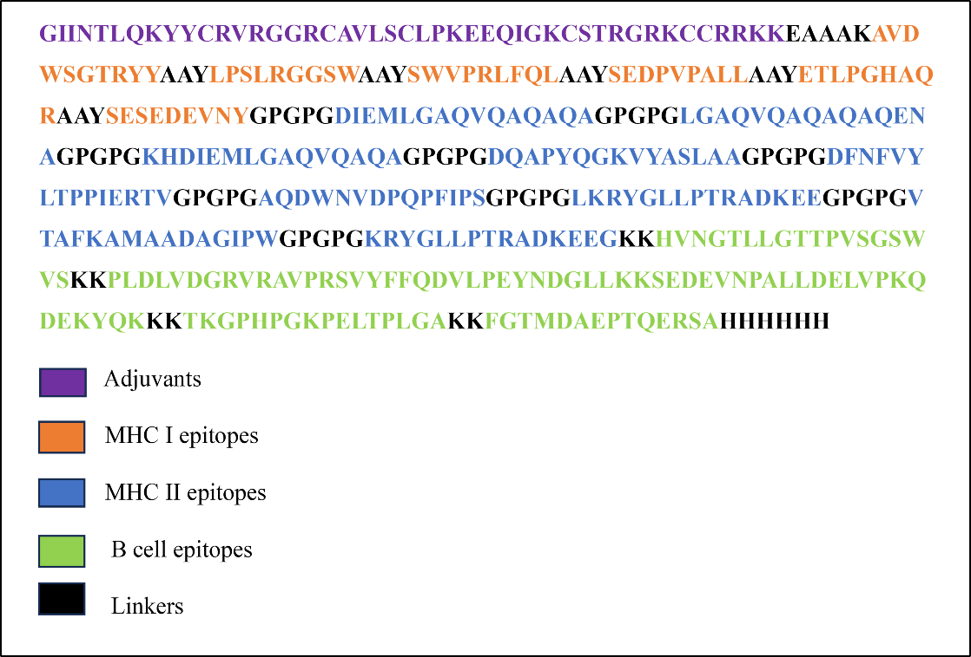
Figure 2. Schematic representation of the designed multi-epitope vaccine construct. The construct comprises β-defensin 3 adjuvant at the N-terminal region linked via an EAAAK linker, followed by selected CTL epitopes joined using AAY linkers and HTL epitopes connected using GPGPG linkers. A 6×His tag was incorporated at the C-terminal region to facilitate purification. Different colored blocks represent individual epitopes and functional domains.

3.5 Physicochemical Properties and Solubility
The physicochemical properties of the final vaccine construct were analyzed using the ProtParam tool. The construct consisted of 433 amino acids with a molecular weight of 46,095.07 Da and a theoretical isoelectric point (pI) of 8.88. It contained 51 positively charged residues (Arg + Lys) and 44 negatively charged residues (Asp + Glu). The instability index was calculated to be 29.20, which is below the threshold value of 40, indicating that the protein is predicted to be stable. The aliphatic index was 65.68, suggesting moderate thermostability. The GRAVY score was −0.576, indicating a hydrophilic nature favorable for solubility and aqueous interactions. The extinction coefficient was estimated to be 65,695 M⁻¹ cm⁻¹ (oxidized form) and 65,320 M⁻¹ cm⁻¹ (reduced form). The predicted half-life was 30 hours in mammalian reticulocytes (in vitro), >20 hours in yeast (in vivo), and >10 hours in E. coli (in vivo). Protein solubility analysis using the SOLUproT server yielded a solubility score of 0.894, indicating that the construct is highly soluble and suitable for recombinant expression and purification in E. coli. Collectively, these results support the stability and practical feasibility of the designed vaccine construct.
3.6 Secondary Structure Prediction
Secondary structure analysis of the vaccine construct was performed using the PSIPRED server. The results showed that 71 amino acids (16.40%) formed alpha helices, while 60 amino acids (13.86%) contributed to beta strands. The majority of the sequence comprised random coils (302 amino acids; 69.7%), suggesting structural flexibility that may facilitate effective epitope presentation.
3.7 Tertiary Structure Prediction and Validation

The tertiary structure of the vaccine construct was predicted using the Robetta server, which generated five initial models. Model 1 was selected and refined using the GalaxyRefine server. Structural validation revealed that 88.9% of residues were located in the most favored regions of the Ramachandran plot, with 9.9% in additionally allowed regions and 0.6% in generously allowed regions, indicating excellent stereochemical quality.
The refined model achieved a MolProbity score of 1.55 and a QMEAN Z-score of −0.97, suggesting compatibility with experimentally determined protein structures of similar size. The global QMEANDisCo score was 0.47 ± 0.05, indicating moderate-to-good local structural reliability. ERRAT analysis yielded a quality score of 90.148, further supporting the robustness of the predicted structure.

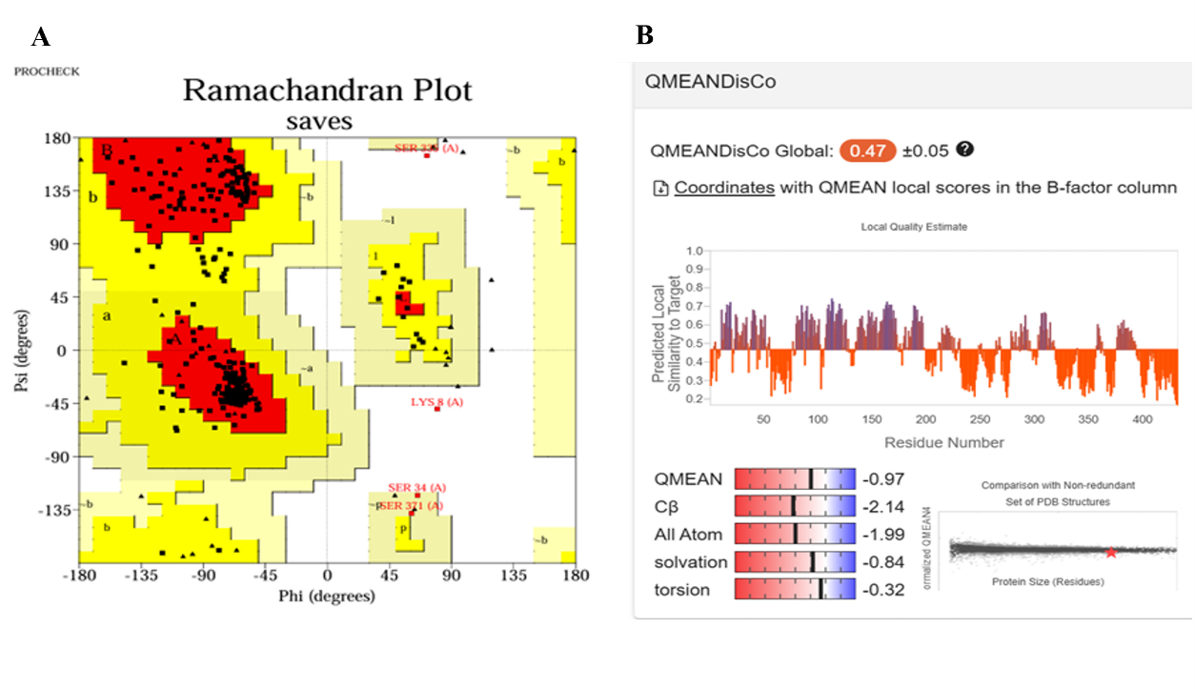
Figure 3. Structural validation of the refined 3D vaccine model. (A) Ramachandran plot analysis showing 88.9% of residues in the most favored regions, 9.9% in additionally allowed regions, 0.6% in generously allowed regions, and 0.6% in disallowed regions. (B) QMEAN Z-score (−0.97) and QMEANDisCo global score (0.47 ± 0.05), indicating acceptable structural quality of the predicted model.

3.8 Molecular Docking and Protein–Protein Interactions
Protein–protein docking analysis was conducted to evaluate interactions between the vaccine construct and key immune receptors, including TLR4, MHC class I, and MHC class II molecules, using the HADDOCK v2.2 server. The vaccine–TLR4 complex exhibited the most favorable interaction, with a HADDOCK score of −103.9 ± 11.0. The vaccine–MHC-I and vaccine–MHC-II complexes yielded HADDOCK scores of −91.4 ± 8.1 and −76.3 ± 25.5, respectively. Detailed interaction analysis revealed extensive non-bonded contacts, hydrogen bonds, and salt bridges in all docked complexes. For the vaccine–MHC-I complex, 178 non-bonded contacts, seven hydrogen bonds, and four salt bridges were observed. The vaccine–MHC-II complex exhibited 225 non-bonded contacts, 17 hydrogen bonds, and eight salt bridges. The vaccine–TLR4 complex showed 211 non-bonded contacts, 18 hydrogen bonds, and two salt bridges. These interactions suggest stable and specific binding, supporting the immunogenic potential of the vaccine construct.

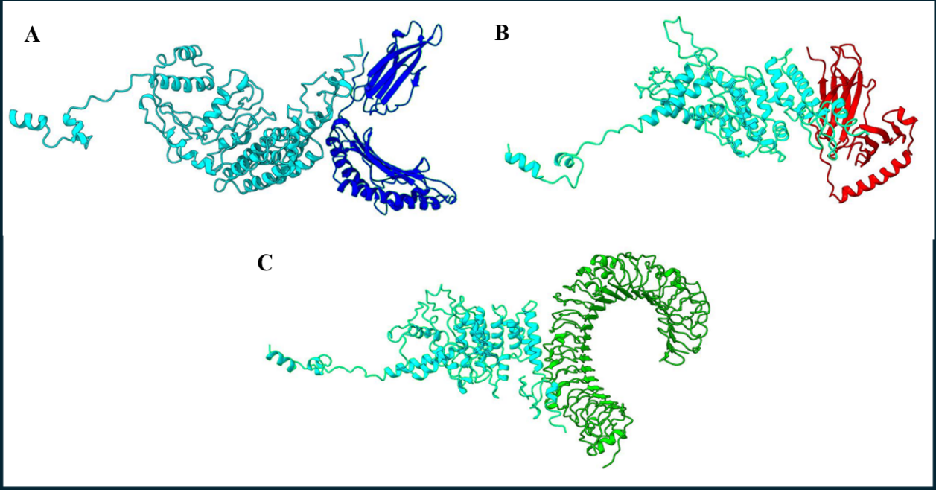
Figure 4. Molecular docking complexes of the vaccine construct with immune receptors. (A) Docked complex with MHC class I, (B) MHC class II, and (C) Toll-like receptor 4 (TLR4).

3.9 In Silico Immune Simulation Analysis
Immune simulation using the C-ImmSim server predicted robust immune responses following administration of the vaccine construct. The simulation demonstrated a substantial increase in antibody levels, particularly IgG1+IgM and IgG+IgM, indicating a strong humoral immune response. Additionally, increased populations of active B cells, helper T cells, and cytotoxic T cells were observed, suggesting the development of immune memory and effective secondary immune responses.
The simulation also predicted elevated levels of key cytokines, including IFN-γ, IL-23, IL-10, and IFN-β, which are critical for antiviral immunity. Increased dendritic cell and macrophage populations indicated efficient antigen presentation. These results support the functional immunogenic potential of the vaccine construct in a simulated immune environment.
3.10 Molecular Dynamics Simulation
Molecular dynamics (MD) simulation was performed to assess the stability of the vaccine–TLR4 complex over a 100 ns simulation period. The root mean square deviation (RMSD) values remained stable within the range of 1–1.5 Å, indicating structural stability of the complex. Root mean square fluctuation (RMSF) analysis showed that most residues exhibited acceptable fluctuation, with higher flexibility observed in surface-exposed regions, which is typical for protein complexes. These results suggest that the vaccine–TLR4 complex maintains dynamic stability, supporting sustained receptor engagement and downstream immune signaling.
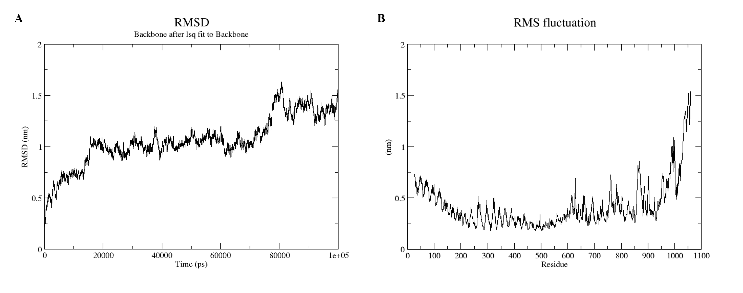
Figure 5. (A) Molecular dynamics simulation of the receptor-vaccine complex. The graph shows the RMSD of the complex (X-axis = Time in ps and Y-axis = RMSD)
(B)The second graph shows the RMSF of the complex (X-axis = Time in residue and Y-axis = RMSF.
3.11 Codon Optimization
Codon optimization of the vaccine construct was performed using the JCAT server to enhance expression efficiency in E. coli strain K12. The optimized nucleotide sequence comprised 1395 nucleotides, with a GC content of 56.99% and a codon adaptation index (CAI) of 1.0, indicating a high likelihood of efficient expression.
3.12 In Silico Cloning
The optimized vaccine gene was cloned in silico into the pET-28a(+) expression vector between the XhoI and NdeI restriction sites using SnapGene software. This step confirmed the feasibility of downstream cloning and recombinant expression in E. coli, providing an experimentally ready construct for future wet-lab validation.
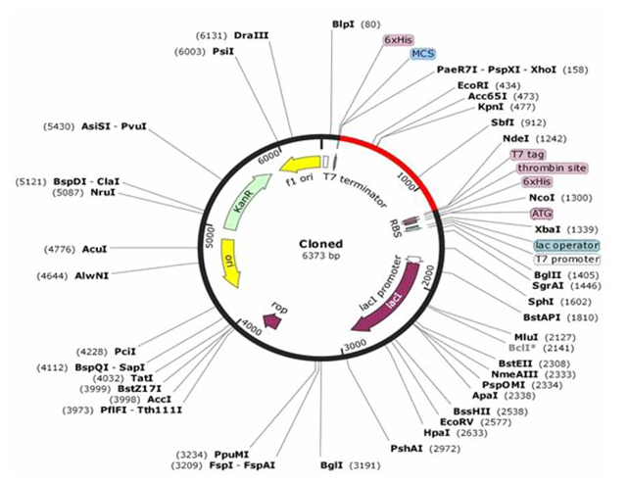
Figure 6. In silico restriction cloning of the final vaccine construct into pET28a(+) expression vector where red part representing the vaccine insert and black circle showing the vector.

4. DISCUSSION
The increasing global burden of Norovirus infections, coupled with the continued absence of a licensed vaccine, underscores the urgent need for alternative and efficient vaccine development strategies (Atmar & Estes, 2020; Patel et al., 2009). In this study, an immunoinformatics-driven framework was employed to design and evaluate a multi-epitope subunit vaccine candidate targeting Norovirus. By integrating conserved antigenic regions from the capsid protein (A7YK10), small protein (A7YK11), and polyprotein (A7YK09), the design strategy aimed to address the extensive genetic diversity and antigenic variability characteristic of Norovirus, which is a major obstacle in conventional vaccine development (Cannon & Vinjé, 2020; Chhabra et al., 2019).
The epitope selection process was guided by stringent immunological and safety criteria, including antigenicity, non-allergenicity, non-toxicity, IFN-γ induction potential, and broad HLA population coverage. The identification of B-cell, CTL, and HTL epitopes with high predicted binding affinities to multiple MHC class I and II alleles suggests the potential to elicit both humoral and cell-mediated immune responses (Vita et al., 2019; Azim et al., 2020). This prediction is further supported by the high global population coverage of 98.96%, indicating that the selected epitopes may be immunologically relevant across diverse ethnic and geographical populations. Such broad coverage is particularly important for Norovirus, given its global circulation and frequent emergence of new variants (Lo et al., 2023; Chen et al., 2024).
Physicochemical characterization of the vaccine construct revealed favorable properties for stability and expression. The predicted instability index (29.20), aliphatic index (65.68), and hydrophilic GRAVY score (−0.576) indicate a stable and soluble protein, which is essential for downstream recombinant expression and formulation (Gasteiger et al., 2005). Consistent with these findings, solubility prediction using SOLproT suggested a high likelihood of successful expression in Escherichia coli (Magnan et al., 2009). These properties support the practical feasibility of producing the vaccine construct using conventional bacterial expression systems.
Structural analysis further reinforced the robustness of the designed construct. Secondary structure prediction indicated a predominance of flexible coil regions, which may facilitate effective epitope exposure and immune recognition (Jones, 1999). Tertiary structure modelling and validation demonstrated acceptable stereochemical quality, with 88.9% of residues located in the most favored regions of the Ramachandran plot and a high ERRAT quality score, consistent with structurally reliable vaccine candidates reported in similar immunoinformatics-based studies (Ahmad et al., 2020; Ahmed & Abid, 2022). Maintenance of correct epitope conformation is critical for immune recognition, and the predicted structural integrity of the construct supports its potential immunogenicity.
Molecular docking and molecular dynamics simulations provided mechanistic insights into the interaction between the vaccine construct and key immune receptors. Favorable HADDOCK scores and stable interaction profiles were observed for complexes with TLR4, MHC class I, and MHC class II molecules, particularly the vaccine–TLR4 complex. These interactions are essential for efficient antigen presentation and activation of innate and adaptive immune responses (van Zundert et al., 2016; Tan & Jiang, 2014). The observed stability of the vaccine–TLR4 complex during molecular dynamics simulations further supports the likelihood of sustained immune signalling.
The in silico immune simulation results complemented the structural and docking analyses by predicting robust humoral and cellular immune responses, including memory B-cell and T-cell formation and the production of key antiviral cytokines such as IFN-γ. Similar immune response patterns have been reported in previous computational vaccine studies targeting Norovirus and other enteric viruses (Ahmad et al., 2020; Matos et al., 2023). Together, these findings suggest that the designed multi-epitope construct has the capacity to elicit coordinated immune responses in a simulated biological environment.
Despite these promising results, it is important to acknowledge the limitations inherent to computational studies. In silico predictions cannot fully replicate the complexity of host immune responses or account for factors such as post-translational modifications, protein folding dynamics in vivo, and immunoregulatory mechanisms (Das et al., 2021). Therefore, experimental validation remains essential. Future studies should focus on in vitro expression and purification of the vaccine construct, followed by immunogenicity assessment using assays such as ELISA, ELISpot, and flow cytometry. In vivo evaluation in suitable animal models will be critical to assess safety, immunogenicity, and protective efficacy (Atmar & Estes, 2020). Additionally, testing the construct against a broader range of Norovirus genotypes and exploring alternative adjuvants or delivery platforms may further enhance its protective potential.

4. Conclusion

In this study, an immunoinformatics and reverse vaccinology approach was successfully applied to design a rational multi-epitope subunit vaccine candidate against Norovirus. Conserved epitopes derived from the capsid protein, small protein, and polyprotein were systematically identified and assembled into a single construct designed to elicit both humoral and cellular immune responses, addressing the challenge posed by Norovirus genetic diversity (Patel et al., 2009; Chhabra et al., 2019).
Comprehensive in silico analyses demonstrated that the final vaccine construct possesses favorable physicochemical properties, structural stability, and strong interactions with key immune receptors, including MHC class I, MHC class II, and TLR4, consistent with findings from previously reported computational vaccine studies (Ahmad et al., 2020; Ahmed & Abid, 2022). Immune simulation further supported its potential to induce robust and long-lasting immune responses. Codon optimization and in silico cloning confirmed the feasibility of recombinant expression in Escherichia coli, supporting the construct’s scalability for experimental production (Grote et al., 2005).
Overall, these findings suggest that the designed multi-epitope vaccine construct represents a promising computational candidate for Norovirus vaccine development. While the results are encouraging, further experimental validation through in vitro and in vivo studies is required to confirm the safety, immunogenicity, and protective efficacy of the construct prior to clinical translation (Atmar & Estes, 2020; Chen et al., 2024).

AcknowledgEments

The authors sincerely thank Garden City University for providing the necessary academic support and research infrastructure to carry out this study. The authors also acknowledge Dr. Chemmu Mugil, Dr. Bhuvaneshwari, and Mr. Raghuveer Reddy for their valuable support and encouragement during the course of this work. The authors declare that no external funding was received for this study. The funding bodies had no role in the study design, data collection, analysis, interpretation of data, or preparation of the manuscript.

Competing interests

No potential conflict of interest was reported by the authors.
Authors’ Contributions

Nitish Kumar R conceptualized and designed the study, performed the immunoinformatics analyses, conducted molecular docking and molecular dynamics simulations, interpreted the data, and drafted the original manuscript. Parvana Nair assisted in epitope screening, data analysis, and preparation of tables and figures. Kesiya Joy, Ramachandra Prasad L A, and Shanmuga Priya V G supervised the study, contributed to study design refinement, provided critical revisions for important intellectual content, and approved the final manuscript. All authors read and approved the final version of the manuscript.

DATA AVAILABILITY STATEMENT
The datasets used and analyzed during the current study are available from the corresponding author on reasonable request.
Disclaimer for preprint
This paper is an extended version of a preprint /repository/ Thesis document of the same author.
The preprint document is available in this link: https://assets-eu.researchsquare.com/files/rs-8606904/v1/138615fa-89f6-42ef-b239-2c2edce36e77.pdf?c=1768572905
[As per journal policy, preprint /repository article can be published as a journal article, provided it is not published in any other journal]
DISCLAIMER (ARTIFICIAL INTELLIGENCE)

The authors declare that generative artificial intelligence (AI) tools were used solely for language refinement and structural editing of the manuscript. All scientific content, data analysis, interpretation of results, and conclusions were independently performed and verified by the authors. The authors take full responsibility for the accuracy and integrity of the work.

References

- Afgan e, baker d, batut b, van den beek m, bouvier d, goecks j, et al. The galaxy platform for accessible, reproducible and collaborative biomedical analyses: 2018 update. Nucleic acids res. 2018;46(w1):w537–44. Doi:10.1093/nar/gky379.
- Ahmad i, ali ss, zafar b, hashmi hf, shah i, khan s, et al. Development of multi-epitope subunit vaccine for protection against norovirus infections based on computational vaccinology. J biomol struct dyn. 2020. Doi:10.1080/07391102.2020.1845799.
- Ahmed sr, abid m. Structural vaccinology and immunoinformatics approach for designing a multi-epitope vaccine against norovirus. Mol immunol. 2022;148:116–26. Doi:10.1016/j.molimm.2022.09.006.
- Atmar rl, estes mk. Norovirus vaccine development: next steps. Expert rev vaccines. 2020;19(4):289–93. Doi:10.1080/14760584.2020.1740492.
- Azim kf, hasan m, hossain mn, somana sr, hoque sf, bappy mni, et al. Immunoinformatics approaches for designing a novel multi-epitope peptide vaccine
against human norovirus. Inform med unlocked. 2020;21:100459. Doi:10.1016/j.imu.2020.100459.
- Bartsch sm, o’shea kj, lee by. The clinical and economic burden of norovirus gastroenteritis in the united states. J infect dis. 2018;217(7):1207–14. Doi:10.1093/infdis/jix640.
- Cannon jl, vinjé j. Evolution and genetic classification of noroviruses. In: noroviruses: molecular and cellular virology. Asm press; 2020. P. 1–34. Doi:10.1128/microbiolspec.ve-0001-2014.
- Chen j, liu y, cheng z, qian l, wang h. Advances in human norovirus research: vaccines, genotype distribution and antiviral strategies. Comput biol med. 2024;159:106941. Doi:10.1016/j.compbiomed.2024.106941.
- Chhabra p, de graaf m, parra gi, chan mcw, green k, martella v, et al. Updated classification of norovirus genogroups and genotypes. J gen virol. 2019;100(10):1393–406. Doi:10.1099/jgv.0.001318.
- Das s, banerjee s, bose s. Limitations and challenges in computational vaccine design. Brief bioinform. 2021;22(4):bbaa370. Doi:10.1093/bib/bbaa370.
- Doytchinova ia, flower dr. Vaxijen: a server for prediction of protective antigens, tumour antigens and subunit vaccines. Bmc bioinformatics. 2007;8:4. Doi:10.1186/1471-2105-8-4.
- Gasteiger e, hoogland c, gattiker a, duvaud s, wilkins mr, appel rd, et al. Protein identification and analysis tools on the expasy server. In: the proteomics protocols handbook. Humana press; 2005. P. 571–607. Doi:10.1385/1-59259-890-0:571.
- Grote a, hiller k, scheer m, münch r, nörtemann b, hempel dc, et al. Jcat: a novel tool to adapt codon usage of a target gene to its potential expression host. Nucleic acids res. 2005;33(web server issue):w526–31. Doi:10.1093/nar/gki376.
- Jones dt. Protein secondary structure prediction based on position-specific scoring matrices. J mol biol. 1999;292(2):195–202. Doi:10.1006/jmbi.1999.3091.
- Lo yc, chen ch, lee yt, lee yc. The changing landscape of norovirus genotypes: a 10-year molecular surveillance study. J med virol. 2023;95(1):e28598. Doi:10.1002/jmv.28598.
- Magnan cn, randall a, baldi p. Solpro: accurate sequence-based prediction of protein solubility. Bioinformatics. 2009;25(17):2200–7. Doi:10.1093/bioinformatics/btp386.
- Matos ao, rodrigues tcv, dantas phs, tiwari s, sartori gr, azevedo vac, et al. Immunoinformatics-guided design of a multi-valent vaccine against rotavirus and norovirus. Comput biol med. 2023;164:107393. Doi:10.1016/j.compbiomed.2023.107393.
- Patel mm, hall aj, vinjé j, parashar ud. Noroviruses: a comprehensive review. J clin virol. 2009;44(1):1–8. Doi:10.1016/j.jcv.2008.10.009.
- Tan m, jiang x. Histo-blood group antigens: a common niche for norovirus and rotavirus. Expert rev mol med. 2014;16:e5. Doi:10.1017/erm.2014.6.
- Van zundert gcp, rodrigues jpglm, trellet m, schmitz c, kastritis pl, karaca e, et al. The haddock2.2 web server: user-friendly integrative modeling of biomolecular complexes. J mol biol. 2016;428(4):720–5. Doi:10.1016/j.jmb.2015.09.014.
- Vita r, mahajan s, overton ja, dhanda sk, martini s, cantrell jr, et al. The immune epitope database (iedb): 2018 update. Nucleic acids res. 2019;47(d1):d339–43. Doi:10.1093/nar/gky1006.
- Das s, banerjee s, bose s. Computational vaccine design: current progress and challenges. Brief bioinform. 2021;22(4):bbaa370. Doi:10.1093/bib/bbaa370.
- Ahmed sr, abid m. Structural vaccinology and immunoinformatics approach for designing a multi-epitope vaccine against norovirus. Mol immunol. 2022;148:116–26. Doi:10.1016/j.molimm.2022.09.006.
- Matos ao, rodrigues tcv, dantas phs, tiwari s, sartori gr, azevedo vac, et al. Immunoinformatics-guided design of a multivalent vaccine against rotavirus and norovirus. Comput biol med. 2023;164:107393. Doi:10.1016/j.compbiomed.2023.107393.
- Chen j, liu y, cheng z, qian l, wang h. Advances in human norovirus research: vaccines, genotype distribution and antiviral strategies. Comput biol med. 2024;159:106941. Doi:10.1016/j.compbiomed.2024.106941.
- Khan s, zafar b, hashmi hf, shah i, khan s, et al. Recent advances in multi-epitope vaccine design using immunoinformatics approaches. Front immunol. 2022;13:856765. Doi:10.3389/fimmu.2022.856765.

https://assets-eu.researchsquare.com/files/rs-8606904/v1/138615fa-89f6-42ef-b239-2c2edce36e77.pdf?c=1768572905

