Pathways to Conservation: Addressing Threats and Vulnerabilities of Olive Ridley Turtle (Lepidochelys olivacea) at Kolavipalam, Kozhikode, Kerala, India

ABSTRACT
Olive Ridley Turtle (Lepidochelys olivacea) are encountering substantial threats and vulnerabilities at their nesting site in Kolavipalam, Kozhikode, Kerala, India. This study seeks to evaluate the current status of Olive Ridley turtle, identify principal threats, and propose appropriate conservation measures. Data obtained from the local NGO, Theeram Prakriti Samrakshana Samiti, indicate a declining trend in the number of nesting turtles and hatching success rates over the past 24 years. The Garret ranking method was utilized to rank the primary factors contributing to the decline, with sand mining identified as the most significant threat, followed by coastal erosion, sea wall construction, climate change, incidental catch in trawl nets, tourism activities, and pollution. The study underscores the urgent need for a comprehensive conservation model that integrates community-based approaches with stringent law enforcement and habitat protection. The proposed framework emphasizes inclusive, locally-driven efforts involving primary stakeholders such as local communities, fishermen, with support from NGOs, environmentalists and researchers, alongside institutional bodies like the Forest Department, Department of Tourism, and municipalities. Key components of the framework include capacity building, conservation actions, sustainable eco-tourism initiatives, research and monitoring, and policy and institutional support. The ultimate objective is to ensure sustainable development and biodiversity protection through science-backed and community-centred conservation of Olive Ridley turtles. Future research should focus on analysing the effects of rising temperatures on nesting and hatchling ratios using advanced technologies, developing innovative solutions for reducing pollution and human impacts, and ensuring the long-term sustainability of conservation efforts through combined efforts of government and NGOs.
Keywords: Olive Ridley Turtle (ORT), Conservation, Habitat destruction, Sand mining, Coastal erosion, Community-based approaches

1. Introduction
The Olive Ridley Turtle (Lepidochelys olivacea) is considered to be one of the smallest and most abundant of all seven turtle species of the world. Yet, it is threatened and endangered in many areas, with smaller populations in the western Pacific displaying some of the most dramatic declines (Abreu,2008,shanker,2011). Knowledge about the habitats of Olive Ridley Sea Turtles (ORT) (Lepidochelys olivacea) remains limited (Carpena-Catoira et al., 2022) Known for its spectacular mass nesting behaviour (Bramha et al., 2011). This species of turtle is limited to waters at or above the 20 ◦C isotherm in the tropical regions and nests only if certain criteria are met, such as low salinity, narrow beaches with mild slope, and optimum grain size of sand (Barik et al., 2014). The abundance of their preferred food, like jellyfish and crustaceans, is also an important factor in determining this turtle’s nesting site (Baliarsingh et al., 2015). Olive Ridley turtle is amongst the most vulnerable of sea turtles due to anthropogenic threats such as ghost nets, poaching, and shrinking of suitable nesting conditions (IUCN Red List, 2011; Jensen et al., 2013;). Over the last two decades, the population of nesting females has decreased by 28 to 32% globally (Panigrahi, 2019). Currently, sea turtle habitats are being altered by climate change and human activities, with habitat loss posing an urgent threat to Indian sea turtles (Misra,2024). Olive ridleys show a great behavioural plasticity across the world. They can migrate through oceanic waters and feed on surface fauna, or remain in shallow coastal waters where they feed on invertebrates (plot,2015). The mass nesting of ORT, a phenomenon of significant ecological interest, is increasingly influenced by various factors, including extreme climatic events, severe cyclonic storms (Mishra et al., 2023b), artificial lighting (Karnad et al., 2009; Pradhan et al., 2022), and physical alterations in their nesting The nomadic behaviour of many olive ridley turtle populations represent a successful biological strategy for the opportunistic search for prey, which is patchily distributed. This flexibility might allow them to cope with unpredictable changes in dynamic ecosystems, and could help explain why olive ridleys are the most abundant of all sea turtles [Shanker,2015,Plotkin,2013)].
However, because of their slow intrinsic growth rate and anthropogenic pressures, olive ridley turtles are vulnerable, and many populations have decreased Coastal development and commercial fishing activities continue to degrade, change, and destroy natural conditions at nesting and feeding grounds, endangering the long-term existence of many olive ridley rookeries worldwide (Abreu,2008). Beautiful coast of Kerala is blessed with specialized ecosystems and it provides nesting sites for a variety of marine species including sea turtles. Olive Ridleys (Lepidochelys olivacca), one of the vulnerable turtle species according to the IUCN.
Olive Ridley turtles are particularly important for coastal and marine ecosystems. They contribute to the stability of the food web by regulating prey populations and transferring nutrients from feeding areas to coastal habitats. Additionally, their shells serve as a habitat for various epibionts, which provide food for fish and shrimp, thereby supporting a diverse range of marine species (Bjorndal & Jackson, 2003).
Several scholars have studied different aspects of olive ridley turtle. Habitat destruction, direct exploitation, and fisheries interactions have caused a decline in most sea turtle populations worldwide (Lutcavage et al. 1997; Rees et al. 2016). With the implementation of measures to protect eggs and adult females on nesting beaches, however, and regulations to reduce fisheries bycatch of turtles in the ocean, the recovery of some depleted populations has been possible, and results are encouraging (Rees et al. 2016; Mazaris et al. 2017). A previous study compiled trends of sea turtle species worldwide based on Regional Management Units (RMUs) and indicated that 12 RMUs exhibit upward trends against five RMUs with downward trend (Mazaris et al. 2017). Many authors have described the nest of L. olivacea from the east coast of India and in the Andaman Islands by (Namboothri et al.2015). However, our knowledge on the nesting of this species along the west coast of India is scanty. Rajagopalan et al. (1986), olive ridley nests both in the east and west coast of India. Though the nesting grounds along the west coast of India are diffused and the breeding populations of these areas are not as extensive as those of the east coast, the study of this population, as well as the breeding biology of these turtles, is important for developing conservation strategies.
One of the largest threats to the viability of sea turtle populations around the world is the indirect and direct effects of climate change (Varela et al., 2019). Sea turtle nesting grounds will—if they have not already—be affected by multiple climatic processes such as temperature increases, enhanced storm frequencies, and sea level rise (Fuentes et al., 2011). These processes will affect all areas of the world, but they are especially influential in the tropics and subtropics, where sea turtles reside, because of the high variability in climatic conditions between seasons (Rivas et al., 2018).
One of the most influential factors affecting all sea turtle species is human activity through egg harvesting, egg predation by domesticated animals, beach degradation by coastal development, and turtle hunting (Oliver de la Esperanza et al., 2017). Coastal development is one anthropogenic activity that is directly affecting the reproductive success of sea turtles all over the world (Oliver de la Esperanza et al., 2017). Not only does it limit the potential nesting areas on beaches, but it also contributes to beach erosion, direct tourism pressure, and increases the amount of light pollution on the beach and shoreline (Oliver de la Esperanza et al., 2017).
. This study aims to assess the current status of the Olive Ridley turtle, with particular emphasis on identifying its major threats and vulnerabilities. It further seeks to propose appropriate conservation measures and management strategies to ensure the protection of the species in Kolavipalam, focusing on safeguarding the breeding population, nesting habitats, nests, eggs, and hatchlings.
2. Study area
Kolavipalam, also referred to as Kottakadappuram, is situated in the Kolavipalam area (Figure 1), encompassing the region from Tikkoti (11°29'38.634'' N and 75°36'54.316'' E) to the Kottapuzha estuary (11°34'12.151'' N and 75°35'26.754'' E), spanning approximately 8 km width, in Kozhikode, Kerala. It is located within the Iringal village of Payyoli Municipality in the Quilandy taluk of Kozhikode district (11°32'N; 75°45'E). This 8 km stretch of coastal village is bordered by the Arabian Sea to the west and the Kottapuzha River to the east. The beach is situated south of the Murad River, approximately 30 km north of Calicut. Kolavipalam is a small fishing hamlet near Payyoli in the Kozhikode District of northern Kerala. This community-conserved area extends over an eight-kilometre stretch of coastal village, from the Kottapuzha River mouth in the north to Payyoli in the south. Kolavipalam has gained recognition due to the efforts of local conservators in protecting the fragile coastal ecosystem.
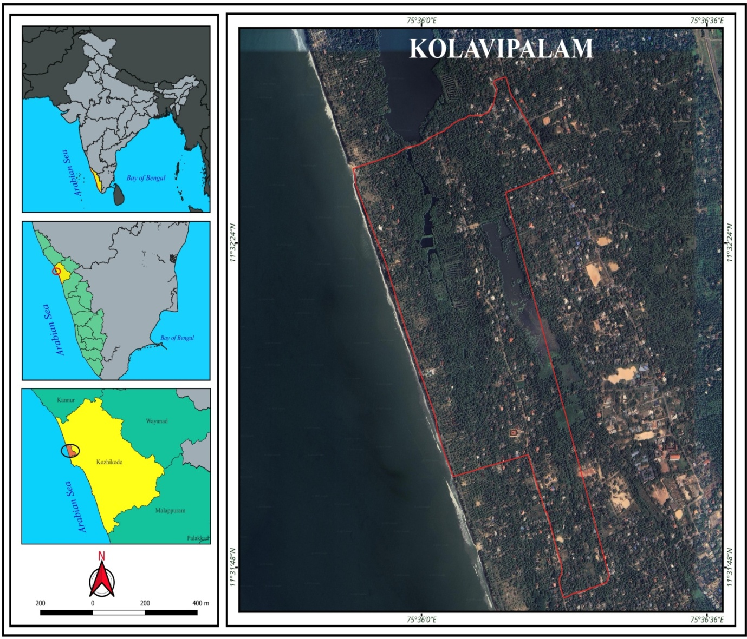
Figure1: Study area
3. Materials & methods
The study employed a mixed-methods approach to comprehensively assess the threats and vulnerabilities faced by Olive Ridley turtles at Kolavipalam, Kozhikode, and Kerala. A combination of field surveys and interviews with local stakeholders was utilized to gather qualitative and quantitative data .A thorough review of existing literature was conducted to establish a foundational understanding of Olive Ridley turtle conservation efforts globally and locally. The study involved local fishermen, conservationists, and community members who have been directly or indirectly involved with the Olive Ridley turtle habitat. Participants who have resided in the Kolavipalam area for at least five years and have been actively engaged in turtle conservation were included in the study. Individuals with no direct involvement or knowledge of Olive Ridley turtle conservation practices were excluded from the study. Data were collected through structured interviews, field observations, and the examination of relevant environmental records. Qualitative data were analysed using thematic analysis, while quantitative data were subjected to statistical evaluation to identify significant patterns and trends. Descriptive and inferential statistics were employed to analyse the quantitative data, ensuring robust and reliable results.
Present study tries to find out the threats and vulnerabilities of ORT of Kolavipalam through people’s perceptions. A micro level analysis for evaluating the threats and the status of ORT through the visual perception and opinions of respondents is carried out with the help of a questionnaire survey. The sample survey with a sample size of 310 from the study area is used for the present analysis. In the last decades, large areas of our planet have been subjected to a very intense anthropogenic influence in terms of landscape transformation. Landform and landscape changes, transformations with conversions, encroachments are resulting various pressures on ecosystems and have been progressing largely in concern with human settlements (Sreepadi, S, 2023). This study examines the significance of community based- conservation strategies for ORT. The collection of necessary information and data for the study, we depended on both qualitative and quantitative data from both the primary and secondary sources. For this study, many data collection methods have been used. For direct interviews, questions have been prepared and discussed with individuals and groups of people based on the focus of the study. The informal, direct interviews were conducted with men and women from different groups throughout the research process Sreepadi.S 2023)however, some of the conversations were noted and recorded. The direct interview methods have been used to gather primary information while selection of individual and group interviewees has been based on criteria such as rural, urban backgrounds, fishermen, and people from coastal zone and those with knowledge relevant in the field of coastal ecosystem.
For this study, secondary data were collected from the Theeram (“Theeram Prakriti Samrakshana Samithy”) turtle hatchery located at Kolavipalam (11°30.897′ N, 75°35.772′ E), with the support of the State Forest Department. The hatchery, managed by a local conservation movement, has been actively involved in turtle protection efforts for the past two decades.
This study incorporates the inputs from of the study area in order to understand their approaches to turtle conservation. The current study involves some crucial steps (Fig. 3) At the beginning, with the help of intensive field survey, collected details regarding the threats and vulnerabilities of ORT. After that, the data has been collected and analysed through the following the steps (Fig. 3) using Garrett ranking method. Garret ranking have been used in by Christy (2014) to analyse constraints of various clinical bovine mastitis control in Villupuram district of Tamil Nadu. Same technique has been used by Zalkuwi et al (2015) to study a comparative analysis of influencing sorghum farmers of India and Nigeria R Eventually, relying on the garret ranking method findings and priority ranking done .and the reports from NGO helped to assess and monitor the status of ORT from 1999-2025. This article incorporates current study involves some steps, first of all collected the data from the records of Theeram, NGO, Kolavipalam.and through the people’s perception, and Garret ranking method, adopted for the study.
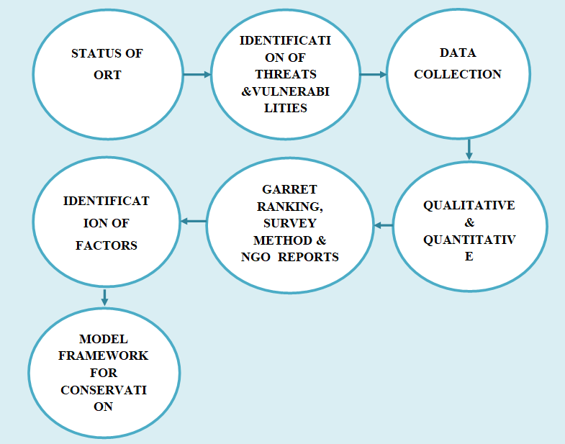
Figure2 Conceptual framework
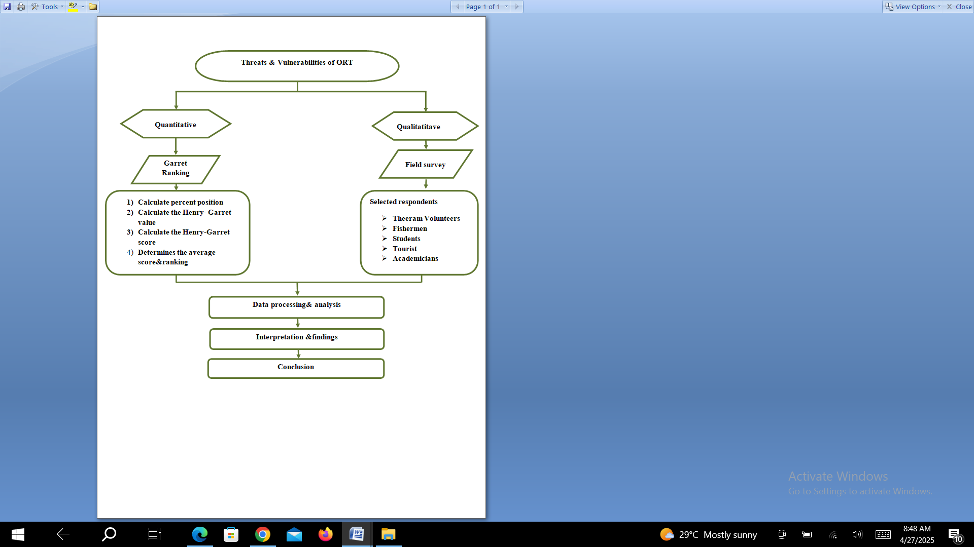
Figure3. Flowchart depicting the methodology adopted for the study.
4. Result
4.1 Nesting status of Kolavipalam beach
There has been no systematic documentation of the nesting of Olive Ridley Turtle during the nesting season in the past. Theeram, country’s first community-based initiative in turtle conservation the TheeramPrakritiSamrakshanaSamiti;a local NGO at Kolavipalam it has been operational since 1992 and is led by a group of fishermen and local people. The effort was prompted by news clipping in ‘The Hindu’ on sea turtle conservation. The community-driven conservation effort known as Theeram Prakriti Samrakshana Samithi (TPSS) was introduced by residents to safeguard Olive Ridley turtles during their nesting season dates back to 1998, initiated through collaboration between local communities, the Kerala Forest Department, and WWF. A resident of Kolavipalam, Mr. Suresh Babu played a pivotal role in its establishment, prompted by the annual migration of Olive Ridley turtles, Lepidochelys olivacea, to his home town. They organized monitoring and educational initiatives involving local communities and coastal students to raise awareness about the significance of conserving turtles and mangroves. Additionally, they engaged in rehabilitating injured turtles caught by local fishermen. The Kerala State Forest Department oversees this program, aiming to establish a sustainable local turtle conservation effort and contribute to regional conservation strategies ( NASJA.N.P,2025)
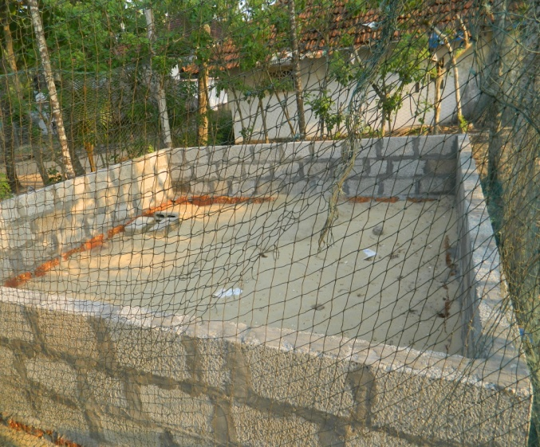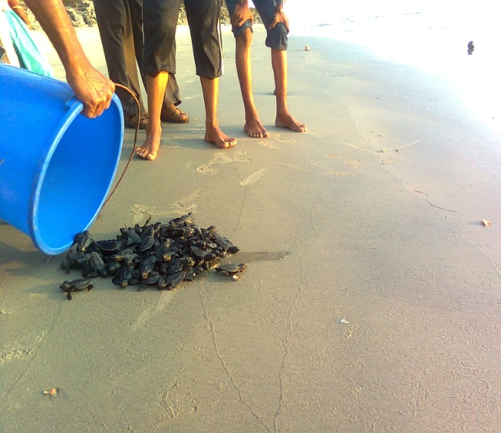
2
1
Figure 4. 1)Turtle hatchery in Kolavipalam 2) Releasing turtle babies in to the sea in presence of local people
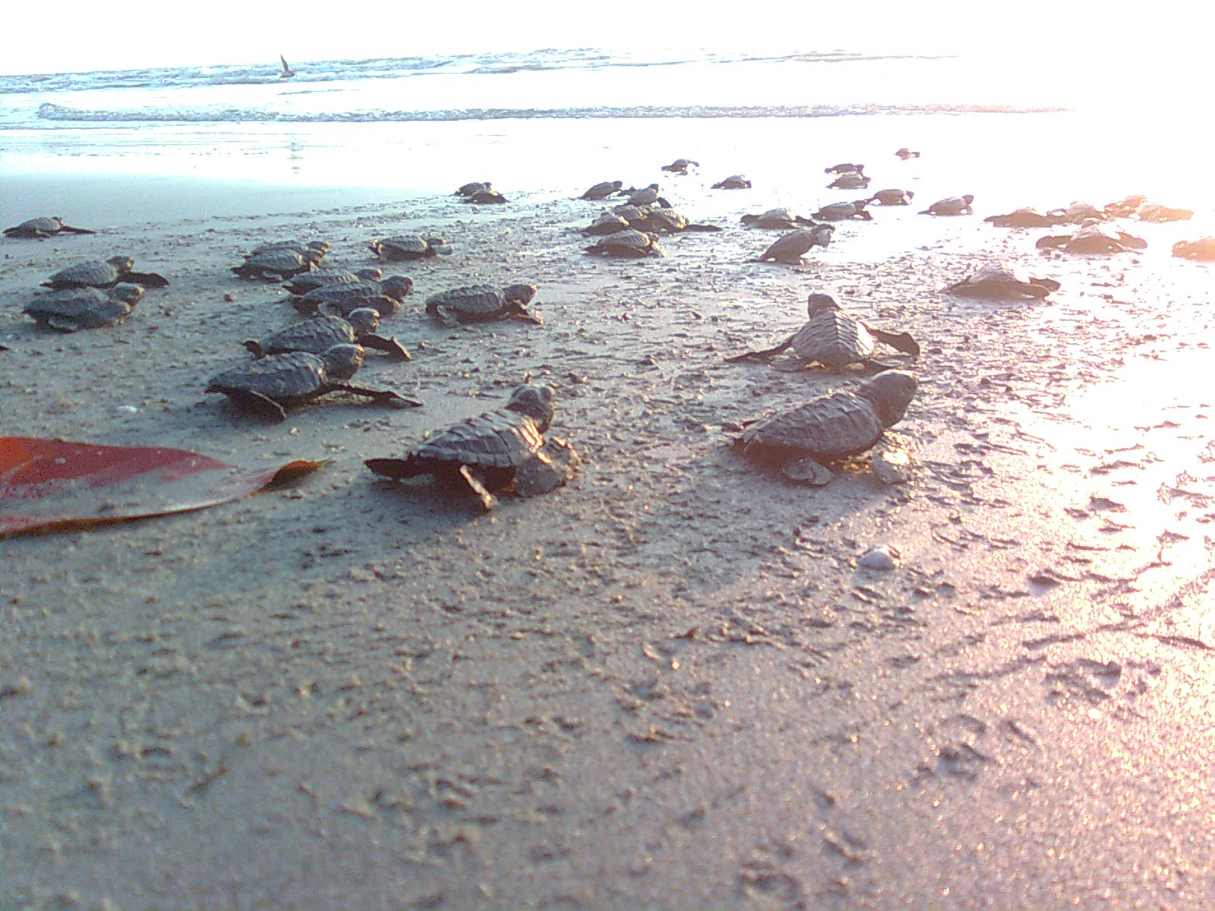Figure 5 Turtle hatchlings crawling towards the sea
3
Now the serene beautiful fishing hamlet of Kolavipalam has been in the news for a grassroots level effort to protect the highly endangered Olive Ridley turtles. For the last one decade, the villagers have been burning the midnight oil to ensure the survival of the turtles. During the nesting season, spread over five winter months, from November to March Theeram volunteers patrolled the beach at night and early morning looking for turtle nests. Safety of eggs is in the hands of a group of youngsters. Some of the group includes fishermen; shop keepers, auto drivers’ etc. Two or three groups go in different directions along eight kilometres of the beach searching for eggs. The State Forest Department has financed to construct a hatchery to protect them from being eaten by dogs and prevent them from inundated by seawater. Normally the female turtles lay eggs on the sand dunes beyond the high tide line. So, freshly laid eggs were carefully dug out from their original nests and re-buried immediately in a make-shift hatchery. Fifty days later when the hatchlings struggled to the surface, they were gently released into the sea either in the early morning or late evening, more literally, towards their mothers. Now this community effort is concentrating for total environmental protection of the area.
4.2 Kolavipalam Turtle Conservation
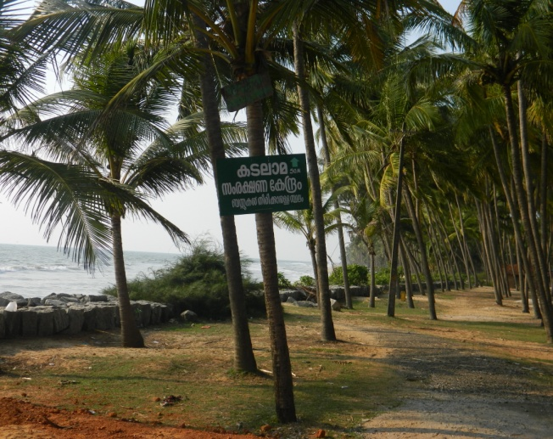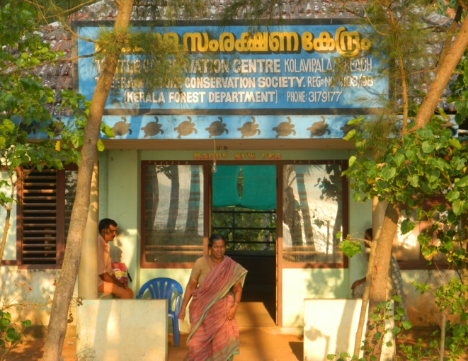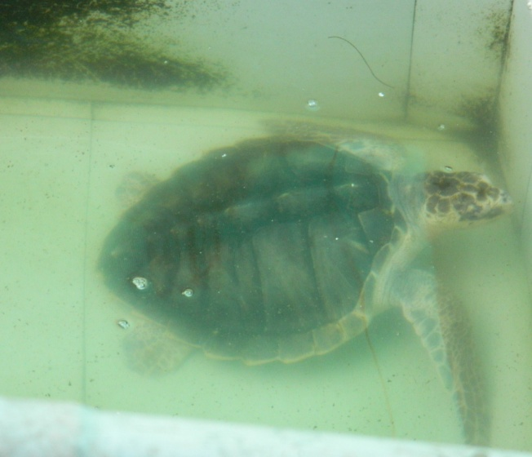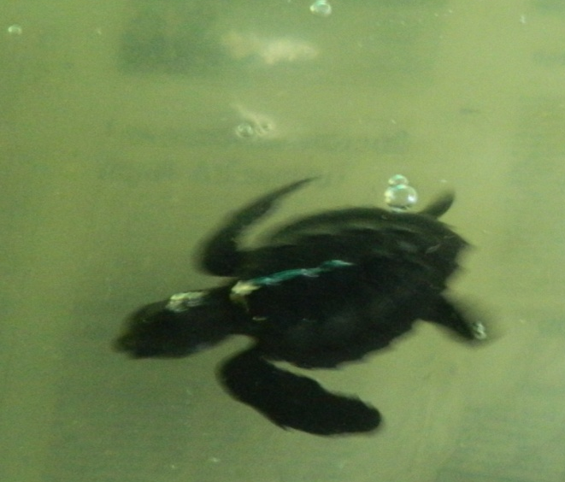
4
3
2
1
Figure 6 1)Olive ridley conservation site, Kolavipalam 2) Theeram Prakrithi Samrakshana Samithi office 3) Turtle hatchery in Kolavipalam 4) Injured turtle in the Theeram
Kolavipalam Beach also acknowledged as the ‘Turtle Beach’, is located south of the Murad River about 30km north of Calicut. The turtles that frequent the beach are not common turtles; they are the famous Olive Ridley turtles (Lepidochelys olivacea) that are endangered by sand mining and anthropogenic activities. The turtle gets its name from the olive-green color of its heart-shaped shell. The species is among the smallest of the world’s sea turtles and is found mainly in the tropical regions of the Pacific, Indian, and Atlantic oceans. According to NOAA, the number of olive ridleys are greatly reduced from historical estimates (for example, 10 million olive ridleys in the Pacific Ocean), due to over exploitation for turtle meat and eggs. By catch in fishing gear and the direct harvest of turtles and eggs is the biggest threat facing olive ridley.
Major threats of olive ridley turtle are characterized by catch in fishing gear, climate change, direct harvest of turtles and eggs, loss and degradation of nesting and foraging habitat, ocean pollution/marine debris, predation of eggs and hatchlings, and vessel strikes. Human induced causes are adopted for the present investigation. Detailed field investigation revealed the major threats to the turtles. Kolavipalam is one among the nesting site, which is a lengthy sandy beach. And the particular species always prefer sandy beaches for their mass nesting.
Now the fishing hamlet of Kolavipalam has been in the news for a grass roots level effort to protect the critically endangered Olive Ridley turtles. For a decade, the villagers have been burning the midnight oil to ensure the survival of the turtles. During the nesting season, spread over five winter months, from November to March, Theeram volunteers patrolled the beach at night and early morning looking for turtle nests. The safety of the eggs is in the hands of a group of youngsters. Some of the group includes fishermen, shop keepers, auto drivers, etc. Two or three groups walk in different directions along the eight kilometres of the beach looking for eggs. The State Forest Department has financed the construction of a hatchery to protect them from being eaten by animals and prevent them from inundated by seawater. Normally the female turtles lay eggs on the sand dunes beyond the high tide line. Hence, freshly laid eggs were carefully dug out of their original nests and immediately reburied in a makeshift hatchery. Fifty days later, when the hatchlings struggled to the surface, they were gently released into the sea, either in the early morning or late evening, more literally, towards their mothers. Now this community effort is contributing towards the overall environmental protection of the area. Recent records show a declining trend in the number of turtles on the Kerala coast. Following table (Table 1) shows the nesting status of Olive Ridley along Kolavipalam coast, collected by Theeram volunteers.
Table 1 Nesting status of ORT in Kolavipalam coast
Year | No. of turtles | Total eggs | Total hatched eggs
1998-1999 | 51 | 4501 | 3328
1999-2000 | 65 | 5843 | 4900
2000-2001 | 65 | 6264 | 5508
2001-2002 | 51 | 5605 | 4646
2002-2003 | 48 | 5255 | 4692
2003-2004 | 26 | 3171 | 2846
2004-2005 | 8 | 894 | 740
2005-2006 | 8 | 738 | 544
2006-2007 | 23 | 2040 | 1766
2007-2008 | 9 | 944 | 733
2008-2009 | 6 | 820 | 710
2009-2010 | 11 | 1214 | 947
2010-2011 | 7 | 707 | 406
2011-2012 | 10 | 1054 | 760
2012-2013 | 5 | 527 | 439
2013-2014 | 6 | 645 | 475
2014-2015 | 6 | 770 | 254
2015-2016 | 4 | 322 | 248
2016-2017 | 3 | 292 | 176
2017-2018 | 2 | 173 | 36
2018-2019 | 2 | 184 | 67
2019-2020 | 3 | 363 | 136
2020-2021 | 0 | 0 | 0
2021-2022 | 1 | 126 | 45
2022-2023 | 1 | 101 | 23
2023-2024 | 0 | 0 | 0
2024-2025 | 2 | 152 | 52
Source: Prepared by the Researcher

Number of olive ridley turtles
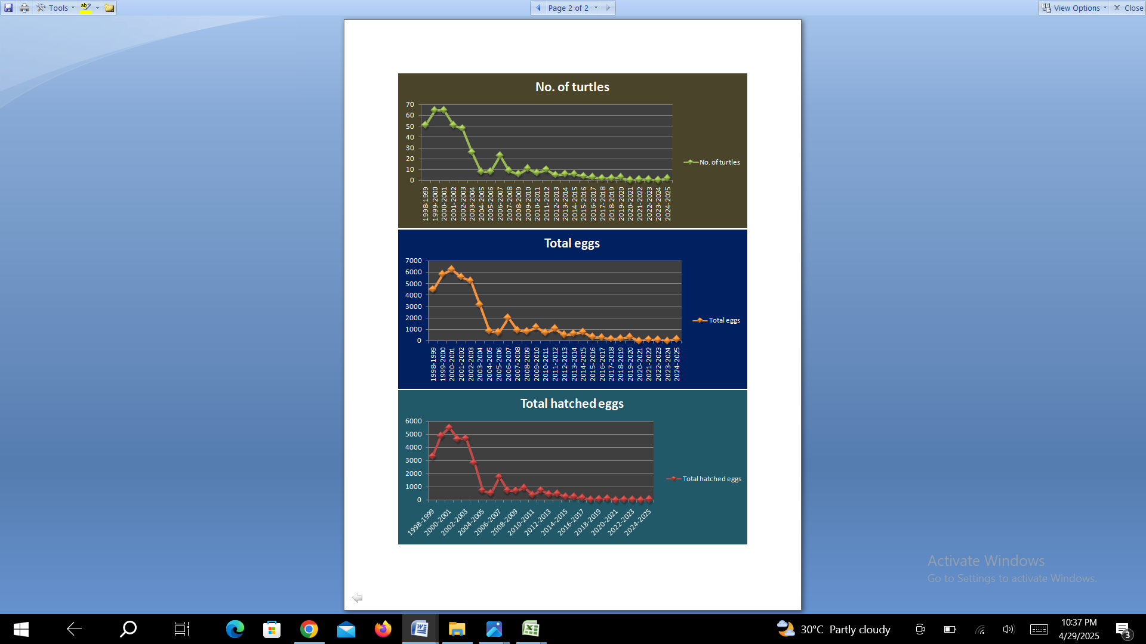
Figure 7: Nesting status of Olive Ridley Turtles
As per the (Table 1 and Figure 7) shows, the data from Theeram NGO, the turtle numbers have declined significantly over the past 24 years. Turtles were high in numbers during the period from 1998 to 2003, which was around 50 to 60.
Data from Theeram NGO shows that turtle numbers have declined significantly over the past 24 years. Turtles were high in numbers during the period from 1998 to 2003, which was around 50 to 60. Whereas after 2003, the number of turtles has declined sharply and recently after 2016, only 2 to 3 turtles were found laying eggs on the beach .Similarly, there has also been a sharp drop observed in the number of eggs hatched, corresponding to the number of eggs lay. Until 2017, the percentage of eggs hatched in relation to the total number of eggs laid was more than 70%, whereas it decreased to 60% by 2017 and after 2017 it is only less than 40%. According to the respondents, illegal sand mining around the estuary and the accumulation of plastic waste also pose serious threats to the turtles.
Olive ridley turtles crawl through these openings to nest on open, sandy beaches, and they also nest on the narrow sandy stretches between the sea wall and the sea. Human habitation is present very close to the shoreline along this beach, and private coconut plantations occupy the space between these habitations and the sea wall. The buildings are mostly of the traditional style of mud and wattle houses with tiled roofing. Around 140 families (ninety-seven per cent Hindus and the rest Muslims), with a population of approximately 840, inhabit this area. The Kottapuzha Estuary is roughly in the shape of a cross, with its mouth facing west. The Kottapuzha River forms the eastern arm, and the Arabian Sea lies to the west. The tidal waters of the estuary flow back in either a north or south direction up to a distance of roughly six kilometres. Kolavipalam is located near the southern portion of the brackish water arm , and mangroves grow in the brackish estuarine regions.
Identification of threats and vulnerabilities
On the basis of above-mentioned statistics regarding the declining trend of ORT It is clear that a visible modification of landscape has been experienced and occurred in the coastal zone of Kolavipalam. In order to identify the role of basic factors which are responsible for the above-mentioned modifications are to be ranked on the basis of field verifications and local survey. The researcher used Henry Garret ranking(1969) method for identifying the major drivers of threats and vulnerabilities of olive riddle turtles of Kolavipalam.
Garrett’s Ranking Technique was applied to study the preference, change of orders of constraints and advantages into numerical scores. The prime advantage of this technique over simple frequency distribution is that the constraints are arranged based on their severity from the point of view of respondents. Hence, the same number of respondents on two or more constraints may have given different ranks. The prime advantage of this technique over simple frequency distribution is that the constraints are arranged based on their severity from the point of view of respondents (Zalkuwi et. al 2015)In the present analysis Henry Garret Ranking Method is used to rank the major factors of threats and vulnerabilities of olive ridley turtles of Kolavipalam. It is used to find out the most significant factor which influences the status of olive ridley. Based on this method respondents have been asked to assign the rank for major factors and the result of such ranking have been converted into score values with the help of following formula:
Percent Position = 100(Rij – 0.5)/Nj, Where
Rij = Rank given for the ith variable by jth
Nj = Number of variables ranked by jth respondents

By using Garrett’s Table, the percent position estimated is converted into scores by referring to the table given by Garret and Woodworth (1969). For each factor, the scores of each individual are added and total value of scores and its mean values were calculated. The factors having highest mean value is considered to be the most significant factor.
The following table shows the representation of the major factors, preferences and ranking of threats and vulnerabilities in the coastal zone Kolavipalam and it is a random categorization of the problems obtained during the personal interview through questionnaire and field investigations.
Table 2: Drivers and Ranking Orders
Sl no | Factors | Ranks given by the respondents
Sl no | Factors | 1 | 2 | 3 | 4 | 5 | 6
1 | Sand mining | 96 | 66 | 53 | 31 | 27 | 24
2 | Climate change | 64 | 71 | 71 | 58 | 23 | 19
3 | Accidental catch | 47 | 61 | 79 | 83 | 19 | 13
4 | Coastal erosion sea wall construction | 41 | 35 | 47 | 68 | 41 | 44
5 | Pollution | 27 | 46 | 21 | 24 | 66 | 14
6 | Tourism | 20 | 23 | 31 | 39 | 57 | 26
Source: Compiled by the author, based on Filed Survey (2019-2024)
The Percent Positions and Garret Values
The Garret ranks were calculated by using Garret Ranking formula and the garret value was calculated. The respective formula is expressed below,
Percent position =100(Rij – 0.5)/Nj

The Garret tables and scores of each problem in the above table 2, and multiplied to
Source: compiled by the author, based on filed survey (2019-2024)
The Percent Positions and Garret Values
The Garret ranks were calculated by using Garret Ranking formula and the garret value was calculated. The respective formula is expressed below,
The Garret tables and scores of each problem in the above table 2, and multiplied to record scores in following table , finally by adding each row, the total Garret score were obtained.
The following table (4) describes the calculated value and Garret value of the threats and vulnerabilities of ORT of the coastal zone of Kolavipalam.
Table 3 Garret value of preferences
Sl no | 100*(rij-0.5)/6 | Calculated value | Garret value
1 | 100*(1-0.5)/6 | 8.3333 | 77
2 | 100*(2-0.5)/6 | 25 | 63
3 | 100*(3-0.5)/6 | 41.6667 | 54
4 | 100*(4-0.5)/6 | 58.3333 | 46
5 | 100*(5-0.5)/6 | 75 | 37
6 | 100*(6-0.5)/6 | 91.6667 | 23
Source: Computed by the Researcher
Table 4 Ranking of Garret value
Factors | Number Of Preference |  |  |  |  |  | Garret Score | Average | Garret Rank
Factors | 1 | 2 | 3 | 4 | 5 | 6 | Garret Score | Average | Garret Rank
Sand mining | 7392 | 1650 | 2208.34 | 1808.33 | 2025 | 2200 | 17283.67 | 56.12 | 1
Climate change | 4928 | 1775 | 2958.34 | 3383.33 | 1725 | 1741.67 | 16511.33 | 53.61 | 3
Accidental catch | 3619 | 1525 | 3291.67 | 4841.66 | 1425 | 1191.67 | 15894 | 51.60 | 4
Coastal erosion & sea wall construction | 3157 | 875 | 1958.33 | 3966.66 | 3075 | 4033.33 | 17065.33 | 55.41 | 2
Pollution | 2079 | 1150 | 875.00 | 1400.00 | 4950 | 1283.33 | 11737.33 | 38.11 | 6
Tourism | 1540 | 575 | 1291.67 | 2275.00 | 4275 | 2383.33 | 12340 | 40.06 | 5
Source: Calculated by the Researcher
The above mentioned table4 showing the Garret ranks on the basis of calculations.
From the human interference point of view, the main factors that influence the declining status of Turtles are sand mining, coastal erosion and sea wall construction, climate change, incidental catch while using trawl nets etc, tourism activities and pollution.
With the help of Garret value conversion table 4, the percent position value is converted into scores. Subsequently multiplication of the Garret value with its respective ranks and finally the total value of scores and mean values of score were calculated. The factor having highest average value is to be considered as the most significant factor. As per the ranking, the first rank has given to the sand mining followed by coastal erosion &seawall construction. Based on the Garret ranking technique, it was revealed that ‘sand mining ’ is the major driving force with a highest Garret score of 17283.66 and an average score of 56.11. Accordingly, sea wall construction & coastal erosion with average scores of 55.40and garret scores of 17065.33is represented second position. Climate change is another factor influencing the ORT and this factor place in the third position as per the people’s preferences. Accidental catch through trawling nets is also play a role in determining the changes and it plays fourth position. And followed by, tourism activities these activities having a Garret value of 1234.00 Finally, the ‘ pollution ‘with the average score of 38.10with Garret score of 11737.33 is the least rank as per people’s preferences.
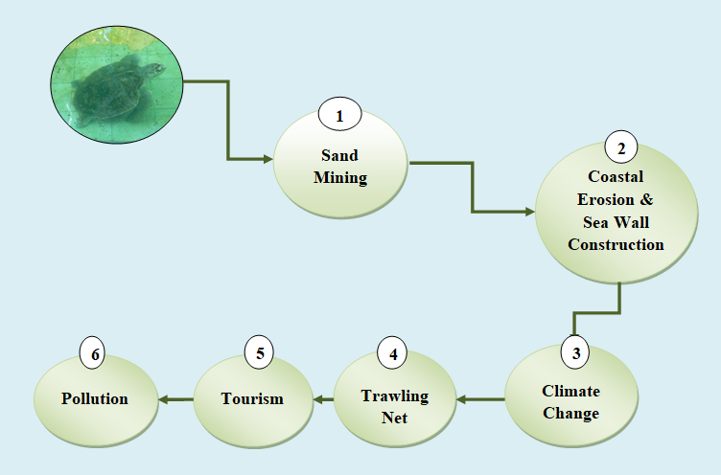
Figure 8 Factors influencing the status of nesting of ORT
Figure 8 illustrates that the nesting status of Olive Ridley turtles (ORTs) is shaped by a range of natural and anthropogenic factors that affect the suitability and stability of coastal habitats. Sand mining has emerged as a significant threat, causing habitat degradation and the loss of nesting beaches. In addition, coastal erosion and seawall construction alter natural beach dynamics, reducing available nesting space and affecting sand characteristics. Climate change further intensifies these impacts through rising temperatures, sea-level rise, and increased storm frequency. Fishing activities, particularly the use of trawl nets, pose risks of accidental capture and mortality, while tourism and coastal pollution contribute to habitat disturbance and reduced nesting success. Together, these factors collectively influence the reproductive viability of Olive Ridley turtles in the region.

1) Sand mining:
Habitat destruction of the Olive Ridley Turtle is caused by a number of factors. From the field survey it was observed that the nesting ground of Kolavipalam is under serious threat due to illegal sand mining activity in Kottapuzha Estuary drained by the Kottapuzha River, north of Kolavipalam. The basic requirements for a good nesting beach are easy accessibility from the sea and moist and fine beach sand that excessive slippage while the nest is being built sand mining can lead to a decline in the number of suitable nesting. Because of the demand of sand for different construction purposes in the study area ,exhausted sand major sand reserves in the district. Eventhoughlocalconservation groups have raised their concern to authorities’ lawsuits have been filed in court; these illegal activities persists. Study shows that the nature of sand is one of the major reasons behind the selection of this site where Olive Ridleys’ inhabit. Due to the intensive sandmining, the beach in Kolavipalam has shrunk to a great extent. It is evident from the data that the number of Olive Ridley Turtles is declining at an alarming rate here, largely due to these illegal sand mining activities. A study conducted by the Zoological Survey of India categorically states that the sand mining activity along with the illegal coastal construction poses a very serious threat to the turtle nesting habitat at Kolavipalam. Satish Babu, a key person in “Theeram” of Kolavipalam beach said, 'unbridled’ sandmining around the estuary has led to a drop in the number of turtles that used to flock the beach.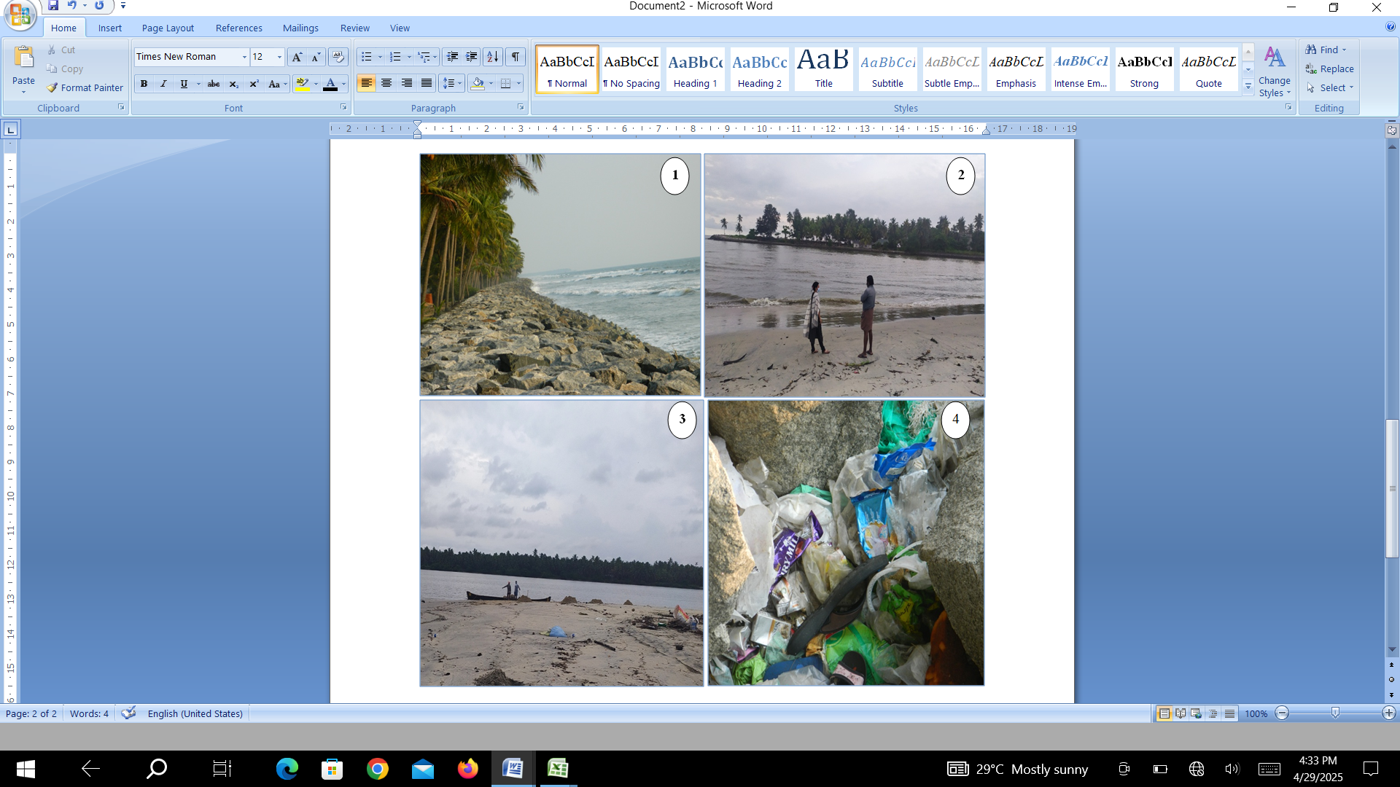

Figure9 1.Seawall along Kolavipalalm coast 2)Interview with Theeram volunteer in Kottapuzha estuary 3) view from Kottapuzha estuary 4) plastic waste found near seawall in Kolavipalam beach
From the field investigation it is clear that all such kinds of declination showing the trend. The beach at Kolavipalam was over a kilometre wide not many years ago. Today it has been reduced to a narrow strip, rapidly shrinking. The village which is nesting ground of the turtles as well as the home for some 600 people faces a grave threat from the illegal sand mining activities in the nearby Kottappuzha Estuary. Due to the indiscriminate quarrying of sand from the coast the sea erosion rate has reached at an alarming level. Tons of fine sand is excavated from the sandbank every day to be used for construction work, land-filling, and so on. The sea, in turn, carries sand away from elsewhere and re-deposits in the sandbank.
2) Coastal erosion& Sea wall construction: In order to reduce coastal erosion, shore protection structures have been built along the Kolavipalam coast. Construction of sea walls is one of them. Seawalls force waves back to the ocean; these waves take the sand in front of the sea wall and deposit it far away from land. Coastal erosion can lead to the loss of proper nesting site, reducing the availability of suitable areas for nesting. Erosion can alter the topography of the beach ,making it less suitable for ORT nesting and increasing the risks of nest loss. in order to reduce coastal erosion, shore protection structures made along the Kolavipalam coast. Construction of sea walls is one among them.
3) Climate change
Another dominant factor influence the ORT is the increase the rising sea levels. that directly influences the nesting success. sand temperature affecting the hatchling sex ratios and incubation periods. changes in the temperature and precipitation patterns can disturb the ORT nesting cycles. The declining trend of hatching success rates will reveal some interesting facts. Local fishermen also shared their knowledge regarding the success rate of hatching in each season, which is purely depended on the sand temperature.
4) Trawl nets: The use of trawl nets is the important human induced activity creates stress on the Olive ridley turtles. Incidental capture of turtles occurs in trawl fisheries is quite common in these areas. Mortality rate of adult sea turtle is another serious concern. But now a day’s Turtle Excluded Device (TED) is using to avoid the entanglement of sea turtles.
5) Tourism
Tourism activities can have both positive and negative impacts on ORT.to a great extent tourism can raise awareness about ORT and promote conservation efforts and different kind of tourism activities in the Kolavipallm area, which is also known as “ Mini Goa”,can generate income for local communities. while discussing the negative impact, artificial lighting can disturb the nesting activities of ORT to some extent and tourism activities can lead to increased human activity in the coast ,that will definitely influence the nesting activities of ORT. By adopting the sustainable tourism practices we can minimize the negative impacts of tourism on ORT.
6) Pollution
While analysing the ranking method, pollution is also a threat to ORT especially plastic pollution like microplastics, bags, other plastic wastes. Pollution can degrade ORT habitats reducing the quality of nesting site.
All these reasons showed that the anthropogenic activities exert a certain amount of pressure on a particular part on the surrounding environment causing a change in its nature in varying degrees. The outcome of this process is an environmental impact, which usually results in certain responses by society. The humankind and their surrounding environment are interdependent in the planet earth. Anthropogenic activities played a vital role by altering the environmental processes along the coastal zones. Olive ridley turtles crawl through these openings to nest on open, sandy beaches, and they also nest on the narrow sandy stretches between the sea wall and the sea. Human habitation is present very close to the shoreline along this beach, and private coconut plantations occupy the space between these habitations and the sea wall. Blending of both quantitative and qualitative assessments helped to provide useful information to form strategies to mitigate management plans.
Kolavipalalm is a notable nesting site for ORT in south India. Local community especially Theeram volunteers actively engaged in protecting their species .being in the vulnerable list by IUCN, it is necessary to make smooth pathways for conservation. Protecting and restoring the nesting sites from the above-mentioned threats is inevitable. Conducting research and monitoring to inform the proper conservation strategies and can track the populations. Natural lovers, scientists, academicians, environmentalist can a play a vital role in the conservation of ORT with the support of Govt,by providing enough financial support to implement the successful projects. And NGOs can make a significant impact on protecting our environment for future generations. By exploring these dimensions, we can enrich our understanding of ORT threats and develop effective conservation strategies tom protect these incredible creatures.

Model Framework for Community-Based Conservation of Olive Ridley Turtles (ORT):
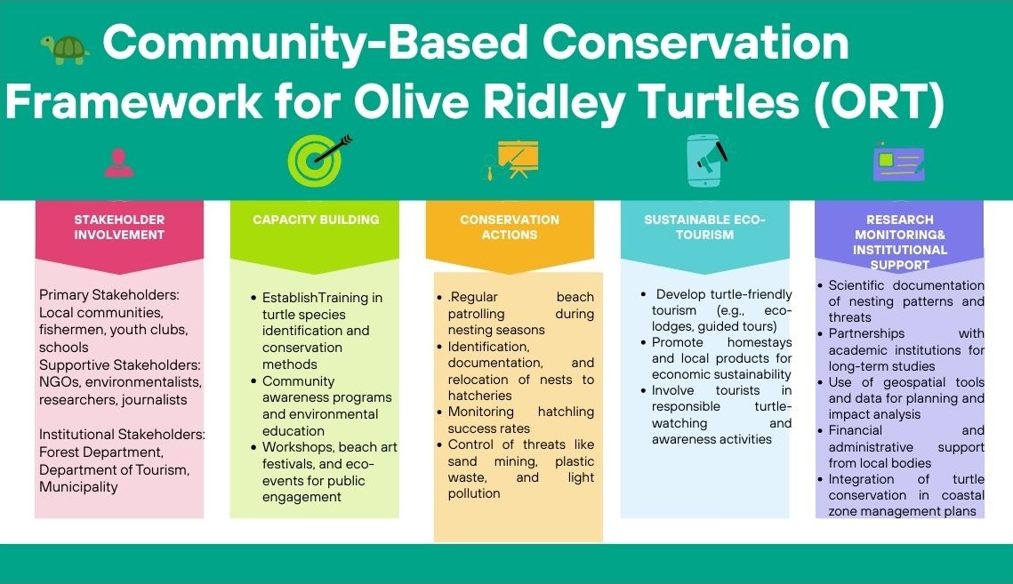
Figure 10: Model framework for conservation of ORT
Source: prepared by the researcher
Figure 10 explains the Community-Based Conservation Framework for Olive Ridley Turtles (ORT) emphasizes inclusive, locally-driven efforts involving primary stakeholders such as local communities, fishermen, youth clubs, and schools, with support from NGOs, environmentalists, researchers, and journalists, alongside institutional bodies like the Forest Department, Department of Tourism, and municipalities. The framework focuses on five key components: (1) Capacity Building through training in species identification, conservation methods, and public awareness programs; (2) Conservation Actions like beach patrolling, nest relocation, hatchling monitoring, and mitigation of threats such as sand mining and plastic waste; (3) Sustainable Eco-Tourism initiatives that promote eco-lodges, homestays, and responsible turtle-watching; (4) Research and Monitoring supported by academic partnerships and geospatial tools; and (5) Policy and Institutional Support through coastal zone integration, regulation enforcement, and local administrative backing. The ultimate goal is to ensure sustainable development and biodiversity protection through science-backed and community-centred conservation of Olive Ridley Turtles.
Discussion
The primary aim of this study was to investigate the threats and vulnerabilities faced by Olive Ridley turtles at Kolavipalam, Kozhikode, Kerala, and propose potential conservation strategies. Our observations revealed a significant decline in nesting activities, likely due to increased human interference and habitat degradation. Previous studies have highlighted the critical status of Olive Ridley turtles globally, with various factors contributing to their vulnerability. Understanding the specific challenges faced by Olive Ridley turtles in this region is crucial for developing targeted conservation efforts. Compared to other nesting sites along the Indian coastline, Kolavipalam presents unique challenges due to its geographical and socio-economic context. Contrary to earlier reports suggesting stable populations, our findings indicate a concerning decline in the number of nesting turtles. Our data supports the hypothesis that increased pollution levels have a direct impact on the nesting success of Olive Ridley turtles. This study provides valuable insights that can inform policymakers and conservationists in formulating effective strategies for turtle conservation. The implications of our findings suggest that immediate intervention is necessary to mitigate the adverse effects of human activities on turtle habitats. While our study offers critical insights, caution must be exercised in generalizing the results to other regions without further investigation. The novelty of this research lies in its comprehensive analysis of both environmental and anthropogenic factors affecting Olive Ridley turtles at a localized level.
Theeram, the country’s first community-based turtle conservation initiative, is run by Theeram Prakriti Samrakshana Samiti, a local NGO based in Kolavipalam. Established in 1992, it is led by a dedicated group of fishermen and local residents committed to protecting marine life and coastal ecosystems. The Theeram initiative in Kolavipalam represents a successful model of community-based sea turtle conservation, aligning with growing evidence that engaging local communities can be highly effective for wildlife protection. This approach leverages cultural and social traditions, which have been shown to enhance conservation efforts in various contexts (Alexander et al., 2017). Community-based conservation programs like Theeram often integrate economic incentives with local customs and knowledge. This multi-faceted approach can be more effective than relying solely on government regulations or economic motivations (Alexander et al., 2017; Gjertsen & Niesten, 2010). The involvement of fishermen and local residents in Theeram is particularly noteworthy, as it demonstrates the potential for synergy between traditional practices and conservation goals. In conclusion, Theeram's community-led model exemplifies a promising trend in sea turtle conservation. By combining local ecological knowledge, traditional practices, and community engagement, such initiatives can achieve significant results while fostering sustainable relationships between coastal communities and marine ecosystems (Braga & Schiavetti, 2013). This approach aligns with the growing recognition that effective conservation strategies must integrate cultural and social traditions of local communities with management activities (Alexander et al., 2017).
Data from Theeram NGO shows that turtle numbers have declined significantly over the past 24 years. Turtles were high in numbers during the period from 1998 to 2003, which was around 50 to 60. Whereas after 2003, the number of turtles has declined sharply and recently after 2016, only 2 to 3 turtles were found laying eggs on the beach .Similarly, there has also been a sharp drop observed in the number of eggs hatched, corresponding to the number of eggs lay. Until 2017, the percentage of eggs hatched in relation to the total number of eggs laid was more than 70%, whereas it decreased to 60% by 2017 and after 2017 it is only less than 40%.illegal sand mining around the estuary and the accumulation of plastic waste create much stress to the turtles.
The data from Theeram NGO indicates a significant decline in turtle numbers and hatching success over the past 24 years, which aligns with trends observed in several other sea turtle populations globally. The sharp decline in nesting turtles from 50-60 in 1998-2003 to only 2-3 after 2016 is concerning and mirrors declines seen in other locations. For example, loggerhead turtle nests on Masirah Island, Oman declined by 79% over a similar timeframe (Willson et al., 2020). Leatherback nests on index beaches in Mexico also showed a declining trend from 1982 to 2004 (Martínez et al., 2007). However, not all populations are declining - olive ridley nests in Brazil increased 10-fold from 1991 to 2003 (Da Silva et al., 2007). The decrease in hatching success from over 70% to less than 40% after 2017 is also troubling. While some variation in hatching success between years is normal (Brost et al., 2015) reported 38.8-65% emergence success for loggerheads), such a large sustained drop suggests underlying problems. Potential causes could include beach erosion, nest predation, or changes in incubation conditions (Brost et al., 2015; Standing et al., 1999). The decline in both nesting numbers and hatching success indicates this population is facing multiple threats. In conclusion, while the severe decline reported by Theeram NGO is alarming, it is not unprecedented. Long-term monitoring and targeted conservation efforts, as demonstrated in several of the cited studies, can help reverse such declines. Identifying and addressing key threats, both on nesting beaches and in foraging areas, will be critical for the recovery of this turtle population.
Sand mining poses a significant threat to olive ridley turtles (ORTs), particularly during their nesting periods. The destruction of nesting habitats through beach shrinkage and erosion directly impacts the turtles' ability to reproduce successfully (Fish et al., 2005). Studies have shown that up to 32% of current beach area could be lost with a 0.5-m rise in sea level, with lower, narrower beaches being the most vulnerable (Fish et al., 2005). This loss of nesting habitat has important implications for turtle populations in the region. Interestingly, while sand mining is a major threat, other anthropogenic factors also play a crucial role in the decline of ORT populations. These include fisheries interactions, pollution, climate change, and illegal trade (Cáceres-Farias et al., 2022). For instance, satellite tracking studies have revealed that ORT foraging areas often overlap with existing trawl fisheries and oil and gas exploration sites, increasing the risk of bycatch and habitat degradation (Whiting et al., 2007). In conclusion, while sand mining is indeed a top-ranked threat to ORTs, it is part of a complex web of anthropogenic pressures affecting these endangered species. Conservation efforts must address multiple threats simultaneously, including habitat protection, fisheries management, and climate change mitigation, to ensure the long-term survival of olive ridley turtles (Cáceres-Farias et al., 2022; Dawson et al., 2017).
Garret ranking highlights sand mining as the most severe threat to Olive Ridley Turtles, followed by coastal erosion and sea wall construction. Climate change, accidental catch in trawl nets, tourism, and pollution also pose risks, with plastic pollution ranked least severe based on public perception and threat score analysis.
Coastal erosion, sea wall construction, and climate change pose significant threats to sea turtle nesting habitats, particularly for olive ridley turtles. Sea walls disrupt natural sand movement and restrict turtle nesting access, exacerbating erosion and limiting available nesting areas (Rizkalla & Savage, 2011). This impact is likely to increase as coastal armoring multiplies in response to rising sea levels and more frequent storms. Interestingly, the effects of sea walls on turtle nesting can vary depending on their placement. Walls located further from the shoreline may only delay the impact on nesting turtles by a few years (Rizkalla & Savage, 2011). Additionally, density-dependent effects on hatching success have been observed in olive ridley arribadas, with higher nest densities leading to lower oxygen levels and higher carbon dioxide levels, potentially contributing to population declines (Honarvar et al., 2008). Climate change impacts, particularly rising sea levels and increasing temperatures, further threaten sea turtle nesting success. Higher sand temperatures can skew hatchling sex ratios towards females and reduce hatching success (Öz et al., 2004; Santos et al., 2015). Sea level rise is expected to inundate and flood nesting beaches, with projections suggesting up to 38% of available nesting area may be lost across some rookeries (Fuentes et al., 2009). These combined factors highlight the urgent need for conservation efforts to protect and manage sea turtle nesting habitats in the face of ongoing environmental changes
Olive ridley sea turtles (Lepidochelys olivacea) face significant threats from trawl nets and bycatch, with over 50,000 capture events and likely over 10,000 deaths estimated to occur in Italian waters alone (Lucchetti et al., 2019). Bycatch is considered the largest threat to this species, with fisheries interactions posing a major risk to their conservation (Dawson et al., 2017). Interestingly, as populations of protected species like olive ridleys increase, so does bycatch, creating a complex management challenge. For instance, in the eastern United States, despite extensive regulations to limit sea turtle bycatch in coastal gillnet fisheries, the catch per trip of Kemp's ridley has increased by more than 300% and green turtles by more than 650% between 2001 and 2016 (Putman et al., 2020). This highlights the need for balanced management approaches that consider both turtle population growth and fishing opportunities. To mitigate the impact of fishing gear on sea turtles, various Bycatch Reducer Devices (BRDs) have been developed and tested. These include hard and flexible Turtle Excluder Devices (TEDs) for bottom trawling and visual deterrents like ultraviolet LEDs for set nets (Lucchetti et al., 2019). The implementation of TEDs has shown promise in reducing turtle bycatch without significantly affecting commercial catch. However, fishermen's reluctance to change traditional gear remains a challenge, emphasizing the need for optimal gear configurations that minimize commercial loss while reducing bycatch (Lewison et al., 2003; Lucchetti et al., 2019). Continued research, enforcement of regulations, and global efforts to introduce BRDs in different areas and fisheries of the Mediterranean are crucial for the conservation of olive ridley turtles and other sea turtle species.
However, the papers do highlight several significant threats to this species: Anthropogenic activities, including habitat degradation, pollution, bycatch, and climate change, are identified as major threats to olive ridley populations (Cáceres-Farias et al., 2022). Plastic pollution is a significant concern, with 82% of olive ridleys ingesting anthropogenic debris, primarily plastics (Wedemeyer-Strombel et al., 2015). This contradicts the statement that plastic pollution is ranked least severe. Climate change poses a serious threat to sea turtle populations, including olive ridleys, by potentially skewing sex ratios towards females and exposing eggs to lethal temperatures (Fuentes et al., 2009). This aligns with the mention of climate change as a risk factor in the question. Fisheries interactions, particularly with longline and trawl fisheries, are a significant threat to olive ridleys (Dawson et al., 2017; Pikesley et al., 2013; Whiting et al., 2007). This supports the mention of accidental catch in trawl nets as a risk factor. In conclusion, while the context does not provide a Garret ranking of threats, it does highlight multiple severe threats to olive ridley turtles, including plastic pollution, climate change, and fisheries interactions. The information provided does not support sand mining as the most severe threat, nor does it rank plastic pollution as the least severe based on public perception and threat score analysis.
Community-based conservation models have shown promising results for marine turtle protection, including olive ridley turtles. These approaches emphasize collaboration among various stakeholders and empower local communities to participate in conservation efforts. Successful examples of community-based conservation include the Brazilian Amazon initiative, which led to large-scale population recovery of giant South American turtles and other freshwater species (Campos-Silva et al., 2018). Similarly, the Ostional egg harvesting project in Costa Rica demonstrated that community participation and control were key to local support for marine turtle conservation (Campbell, 1998). These models can be adapted for olive ridley conservation, incorporating elements such as awareness campaigns, involvement of educational institutions, and sustainable tourism. Strict enforcement of existing environmental laws and fishing regulations is crucial for olive ridley conservation. The use of Turtle Excluder Devices (TEDs) in shrimping vessels has been shown to significantly reduce sea turtle strandings when properly implemented (Lewison et al., 2003). Banning shoreline fishing during nesting seasons and limiting sand mining and coastal construction are also important measures to protect nesting habitats. In conclusion, a comprehensive conservation model for olive ridley turtles should integrate community-based approaches with strict law enforcement and habitat protection. Regular monitoring through annual surveys is essential to assess the effectiveness of conservation efforts. By combining traditional knowledge with scientific research and involving local communities, universities, and government agencies, a more resilient and sustainable conservation program can be developed (Alexander et al., 2017; Vierros, 2013).
Future scope of the research
Building on the findings of this study, future research can focus on several critical areas to enhance the conservation of Olive Ridley turtles at Kolavipalam and similar nesting sites. Detailed studies on the impacts of climate change, particularly rising sand and sea surface temperatures, on nesting success, hatchling sex ratios, and hatchling survival rates are urgently needed. Experimental and longitudinal research can help predict future trends and inform adaptive conservation strategies.
In addition, future work can explore innovative, eco-friendly solutions to mitigate key threats such as sand mining, coastal erosion, and pollution, possibly through technological interventions and community-led environmental stewardship programs. Socio-economic studies on the effectiveness of community participation models and the integration of sustainable eco-tourism practices into conservation frameworks can also be valuable.
Moreover, comprehensive policy analysis and the development of action-oriented policy recommendations, including incentives for local communities and stricter regulation of harmful activities, are crucial. Long-term monitoring programs utilizing GIS-based habitat mapping and population modeling can further aid in tracking changes over time and refining conservation strategies. Collaborative research involving NGOs, government bodies, academic institutions, and local stakeholders will be essential for ensuring the long-term success and sustainability of Olive Ridley conservation initiatives.
Conclusion
The study assessed the status, threats, and vulnerabilities of Olive Ridley turtles (Lepidochelys olivacea) at Kolavipalam, Kozhikode, Kerala, India. Data from the local NGO, Theeram Prakriti Samrakshana Samiti, showed a declining trend in the number of nesting turtles and hatching success rates over the past 24 years. The Garret ranking method identified sand mining as the most significant threat, followed by coastal erosion, sea wall construction, climate change, incidental catch in trawl nets, tourism activities, and pollution. The study emphasizes the need for a comprehensive conservation model integrating community-based approaches with strict law enforcement and habitat protection. The proposed framework involves local communities, NGOs, researchers, and government agencies, focusing on capacity building, conservation actions, sustainable eco-tourism, research and monitoring, and policy support. Future research should analyse the effects of rising temperatures on nesting and hatchling ratios, develop innovative solutions for reducing pollution and human impacts, and ensure long-term sustainability of conservation efforts through combined efforts of government and NGOs.
Disclaimer (Artificial intelligence)
Author(s) hereby declare that NO generative AI technologies such as Large Language Models (ChatGPT, COPILOT, etc.) and text-to-image generators have been used during the writing or editing of this manuscript.

Reference
Abreu-Grobois, A.; Plotkin, P.; IUCN SSC Marine Turtle Specialist Group. Lepidochelys olivacea. In IUCN Red List of Threatened Species; Version 2012.2; IUCN: Cambridge, UK, 2008.
Alexander, L., Allman, P., & Agyekumhene, A. (2017). The Role of Taboos in the Protection and Recovery of Sea Turtles. Frontiers in Marine Science, 4. https://doi.org/10.3389/fmars.2017.00237
Braga, H. D. O., & Schiavetti, A. (2013). Attitudes and local ecological knowledge of experts fishermen in relation to conservation and bycatch of sea turtles (reptilia: testudines), Southern Bahia, Brazil.Journal of Ethnobiology and Ethnomedicine, 9(1). https://doi.org/10.1186/1746-4269-9-15
Brost, B., Bagley, D., Leone, E., Witherington, B., Meylan, A., & Ehrhart, L. (2015). Sea turtle hatchling production from Florida (USA) beaches, 2002-2012, with recommendations for analyzing hatching success. Endangered Species Research, 27(1), 53–68. https://doi.org/10.3354/esr00653
Cáceres-Farias, L., Fernández-Sanz, H., Reséndiz, E., Alfaro-Núñez, A., & Espinoza, J. (2022). Threats and Vulnerabilities for the Globally Distributed Olive Ridley (Lepidochelys olivacea) Sea Turtle: A Historical and Current Status Evaluation. Animals, 12(14), 1837. https://doi.org/10.3390/ani12141837
Campbell, L. M. (1998). Use them or lose them? Conservation and the consumptive use of marine turtle eggs at Ostional, Costa Rica. Environmental Conservation, 25(4), 305–319. https://doi.org/10.1017/s0376892998000393
Campos-Silva, J. V., Hawes, J. E., Andrade, P. C. M., & Peres, C. A. (2018). Unintended multispecies co-benefits of an Amazonian community-based conservation programme. Nature Sustainability, 1(11), 650–656. https://doi.org/10.1038/s41893-018-0170-5
Baliarsingh, S.K., Srichandan, S., Sahu, K.C., Lotliker, A.A., 2015. Occurrence of a new species of toxic cnidaria (Pelagia noctiluca Forskål, 1775) from estuarine waters of Rushikulya river, Western Bay of Bengal. Indian J. Geo-Mar. Sci. 44 (4), 580–582.
Barik, S.K., Mohanty, P.K., Kar, P.K., Behera, B., Patra, S.K., 2014. Environmental cues for mass nesting of sea turtles. Ocean Coast. Manag. 95, 233–240. https://doi.org/ 10.1016/j.ocecoaman.2014.04.018.
Behera, S., Tripathy, B., Sivakumar, K., Choudhury, B., 2016. Beach dynamics and impact of armouring on olive ridley sea turtle (Lepidochelys olivacea) nesting at gahirmatha rookery of Odisha coast, India. Indian J. Geo-Mar. Sci. 45 (02), 233–238.
Behera, S.K., 2014. Impacts of the Super Cyclone Philine on Sea Turtle Nesting Habitats at the. Poult. Fish. Wildl. Sci. 2, 1–5. https://doi.org/10.4172/pfw.1000114.
Behera, S.K., Mohanta, R., 2014. Impacts of the super cyclone philine on sea turtle nesting habitats at the rushikulya rookery, Ganjam coast, India. Poult. Fish. Wildl. Sci. 2 (2), 1–5. https://doi.org/10.4172/2375-446x.1000114.
Bjorndal, K. A., & Jackson, J. B. C. (2003). Roles of sea turtles in marine ecosystems: Reconstructing the past. In P. L. Lutz, J. A. Musick, & J. Wyneken (Eds.), The biology of sea turtles (Vol. II, pp. 259–273). Boca Raton, FL: CRC Press.
Christy, R. H. (2014). Garrett's Ranking Analysis of Various Clinical Bovine Mastitis Control Constraints in Villupuram District of Tamil Nadu. Journal of Agriculture and Veterinary Science,Volume7.
Da Silva, A. C. C. D., Lopez, G. G., Barata, P. C. R., & De Castilhos, J. C. (2007). Nesting biology and conservation of the olive ridley sea turtle (Lepidochelys olivacea) in Brazil, 1991/1992 to 2002/2003. Journal of the Marine Biological Association of the United Kingdom, 87(4), 1047–1056. https://doi.org/10.1017/s0025315407056378
Dawson, T. M., Tilley, D., Formia, A., Maxwell, S. M., Metcalfe, K., Doherty, P. D., Chartrain, E., Fay, J. M., Witt, M. J., Lambert, F., Boussamba, F., Minton, G., Ndanga, I., Nzegoue, J., Cardiec, F., Godley, B. J., Du Plessis, P., Asseko, G., Oliwina, C., … Mabert, B. (2017). Informing Marine Protected Area Designation and Management for Nesting Olive Ridley Sea Turtles Using Satellite Tracking. Frontiers in Marine Science, 4. https://doi.org/10.3389/fmars.2017.00312
Fish, M. R., Watkinson, A. R., Renshoff, S., Côté, I. M., Gill, J. A., & Jones, A. P. (2005). Predicting the Impact of Sea‐Level Rise on Caribbean Sea Turtle Nesting Habitat. Conservation Biology, 19(2), 482–491. https://doi.org/10.1111/j.1523-1739.2005.00146.x
Fuentes, M., Dawson, J., Hamann, M., & Limpus, C. (2009). Potential impacts of projected sea‐level rise on sea turtle rookeries. Aquatic Conservation: Marine and Freshwater Ecosystems, 20(2), 132–139. https://doi.org/10.1002/aqc.1088
Fuentes, M. m. p. b., Limpus, C. j., & Hamann, M. (2011). Vulnerability of sea turtle nesting grounds to climate change. Global Change Biology, 17(1), 140–153. https://doi.org/10.1111/j.1365-2486.2010.02192.x
Fuentes, M., Hamann, M., Maynard, J., Guinea, M., Bell, I., & Werdell, P. (2009). Proxy indicators of sand temperature help project impacts of global warming on sea turtles in northern Australia. Endangered Species Research, 9(1), 33–40. https://doi.org/10.3354/esr00224
Honarvar, S., Spotila, J. R., & O’Connor, M. P. (2008). Density-dependent effects on hatching success of the olive ridley turtle, Lepidochelys olivacea. Oecologia, 157(2), 221–230.https://doi.org/10.1007/s00442-008-1065-3
Lewison, R. L., Crowder, L. B., & Shaver, D. J. (2003). The Impact of Turtle Excluder Devices and Fisheries Closures on Loggerhead and Kemp’s Ridley Strandings in the Western Gulf of Mexico. Conservation Biology, 17(4), 1089–1097. https://doi.org/10.1046/j.1523-1739.2003.02057.x
Lucchetti, A., Vasapollo, C., Virgili, M., Bargione, G., & Petetta, A. (2019). Reducing Sea Turtle Bycatch in the Mediterranean Mixed Demersal Fisheries. Frontiers in Marine Science, 6.https://doi.org/10.3389/fmars.2019.00387
Martínez, L. S., Huerta, P., Barragán, A. R., Vargas, F., García, N., & Muñoz, D. G. (2007). Conservation and Biology of the Leatherback Turtle in the Mexican Pacific. Chelonian Conservation and Biology, 6(1), 70–78. https://doi.org/10.2744/1071-8443(2007)6[70:cabotl]2.0.co;2
Garret HE, Woodworth RS. Statisticsin Psychology and Education. Vakils, Feffer and Simons Pvt. Ltd., Bombay; c1969. p. 329.
IUCN Red list,2011
Jensen, M.P., Limpus, C.J., Whiting, S.D., Guinea, M., Prince, R.I.T., Dethmers, K.E.M., Adnyana, I.B.W., Kennett, R., FitzSimmons, N.N., 2013. Defining olive ridley turtle Lepidochelys olivacea management units in Australia and assessing the potential impact of mortality in ghost nets. Endanger. Species Res. 21 (3), 241–253. https:// doi.org/10.3354/esr00521.
Karnad, D., Isvaran, K., Kar, C.S., Shanker, K., 2009. Lighting the way: towards reducing misorientation of olive ridley hatchlings due to artificial lighting at Rushikulya. India. Biological Conservation 142 (10), 2083–2088. https://doi.org/10.1016/j. biocon.2009.04.004
Lutcavage, M.E., P. Plotkin, B. Witherington, and P.L. Lutz. 1997. Human impacts on sea turtle survival. Pp. 387–409 In The Biology of Sea Turtles. Lutz, P.L., and J.A. Musick (Eds.). CRC Press, Boca Raton, Florida, USA
Mazaris, D., G. Schofield, C. Gkazinou, V. Almpanidou, and G.C. Hays. 2017. Global sea turtle conservation successes. Science Advances 3, 9: https://www. science.org/doi/10.1126/sciadv.1600730.
Mishra, M., Acharyya, T., Halder, B., Santos, C.A.G., Da Silva, R.M., Rout, N.R., Bhattacharyya, D., 2023a. Impact assessment of Cyclone Yaas on the mangrove forest area in the Bhitarkanika National Park (India). J. Mar. Syst. 242, 103947.
Mishra, M., Acharyya, T., Santos, C. A. G., Silva, R. M. da, Kar, P. K., Mohanty, P. K., Rout, N. R., Beja, S. K., Bhattacharyya, D., Behera, B., Barik, S., & Mahapatra, S. (2023b). Impact assessment of severe cyclonic storm Asani on the nesting grounds of Olive Ridley turtle, Rushikulya Estuary and spit in Odisha state, India. Ocean and Coastal Management, 238. doi:https://doi.org/10.1016/j.ocecoaman.2023.106572.
Mishra, M., Guria, R., Paul, S., Baraj, B., Santos, C.A.G., Dos Santos, C.A.C., Silva, R.M.D., 2024. Geo-ecological, shoreline dynamic, and flooding impacts of Cyclonic Storm Mocha: A geospatial analysis. Sci. Total Environ. 917, 170230 https://doi.org/ 10.1016/j.scitotenv.2024.170230.
Mishra, R.K., Naik, S., Mishra, S., Mahapatro, D., Khadanga, M.K., 2022. Mass nesting of sea turtles along the east coast of India: a sustainable environmental management approach. Eco. Inform. 69, 101648 https://doi.org/10.1016/j.ecoinf.2022.101648.

Misra,Dynamic shoreline alterations and their impacts on Olive Ridley Turtle (Lepidochelys olivacea) nesting sites in Gahirmatha Marine Wildlife Sanctuary, Odisha (India),2024
Namboothri N, Swaminathan A & Shanker K (2015) Olive ridley mass nesting at Cuthbert Bay Wildlife Sanctuary, Middle Andaman Island. Indian Ocean Turtle Newsletter, 21: 7-9.
Nasja. M. P a , Dinesh Babu b and Abdul Razak. I. P(2025) Conservation Challenges for Olive Ridley Sea Turtles in North Kerala: A Case Study of Kolavipalam Beach, Uttar Pradesh Journal of Zoology Volume 46, Issue 1, Page 129-139, 2025; Article no.UPJOZ.4393 ISSN: 0256-971X
Oliver de la Esperanza, A., Arenas Martínez, A., Tzeek Tuz, M., & Pérez-Collazos, E. (2017). Are anthropogenic factors affecting nesting habitat of sea turtles? The case of Kanzul beach, Riviera Maya-Tulum (Mexico). Journal of Coastal Conservation, 21(1), 85–93. https://doi.org/10.1007/s11852-016-0473-5
Panigrahi, D., 2019. Olive Ridley - a call for environmental stress and ecological challenge. J. Gujarat Res. Soc. 21 (4), 230–245.
Plot, V.; de Thoisy, B.; Georges, J.Y. Dispersal and dive patterns during the post-nesting migration of olive ridley turtles from French Guiana. Endanger. Species Res. 2015, 26, 221–234. [CrossRef]
Plotkin, P.T. Nomadic behaviour of the highly migratory olive ridley sea turtle Lepidochelys olivacea in the eastern tropical Pacific Ocean. Endanger. Species Res. 2010, 13, 33–40. [CrossRef]
Pradhan, B., Das, M., Pradhan, C., 2022. A systematic approach to environmental sensitivity index mapping along Odisha coast, India. Thalassas 38, 1213–1232. https://doi.org/10.1007/s41208-022-00471-z.24, e01339 https://doi.org/10.1016/ j.gecco.2020.e01339.
Putman, N. F., Hawkins, J., & Gallaway, B. J. (2020). Managing fisheries in a world with more sea turtles. Proceedings of the Royal Society B: Biological Sciences, 287(1930), 20200220.https://doi.org/10.1098/rspb.2020.0220
Rajagopalan M, Vivekanandan E, Pillai SK, Srinath M & Fernando AB (1986) Incidental catches of sea turtles in India. Mar. Fish. Infor. Serv., T and E ser., No.143: 8-16. Rajagoplan M, Vivekanandan E, Balan K and Kupup KN (2002) Incidental catch of Sea turtles along the Indian Coast. The fifth Indian Fisheries forum proceedings. (Eds.) Ayyappan, S., J. K. Jena & M. M. Joseph. Published by AFSIB, Mangalore and AoA, Bhubaneswar, India.
Rees, A.F., J. Alfaro-Shigueto, P.C. Barata, K.A. Bjorndal, A.B. Bolten, J. Bourjea, A.C. Broderick, L.M. Campbell, L. Cardona, C. Carreras, and P. Casale. 2016. Are we working towards global research priorities for management and conservation of sea turtles? Endangered Species Research 31:337–82.
Rizkalla, C. E., & Savage, A. (2011). Impact of Seawalls on Loggerhead Sea Turtle (Caretta caretta) Nesting and Hatching Success. Journal of Coastal Research, 27(1), 166–173. https://doi.org/10.2112/jcoastres-d-10-00081.1
Rivas, M. L., Spínola, M., Arrieta, H., & Faife-Cabrera, M. (2018). Effect of extreme climatic events resulting in prolonged precipitation on the reproductive output of sea turtles. Animal Conservation, 21(5), 387–395. https://doi.org/10.1111/acv.12404
Shanker, K.; Abreu-Grobois, A.; Bezy, V.; Briseño, R.; Colman, L.; Girard, A.; Girondot, M.; Jensen, M.; Manoharakrishnan, M.; Rguez-Baron, J.M.; et al. Olive ridleys: The Quirky Turtles that Conquered the World. In State of the World’s Sea Turtles Report (SWOT); Western Pacific Regional Fishery Management Council: Honolulu, HI, USA. Available online: http://www. SeaTurtleStatus.org (accessed on 21 September 2021)
Sreepadi, s, 2023, An analysis of landscape and land use changes in the coastal zone of Kozhikode district, Kerala, unpublished PhD thesis
Varela, M. R., Patrício, A. R., Anderson, K., Broderick, A. C., DeBell, L., Hawkes, L. A., Tilley, D., Snape, R. T. E., Westoby, M. J., & Godley, B. J. (2019). Assessing climate change associated sea-level rise impacts on sea turtle nesting beaches using drones, photogrammetry and a novel GPS system. Global Change Biology, 25(2), 753–762. https://doi.org/10.1111/gcb.14526
Wedemeyer-Strombel, K. R., Plotkin, P. T., Balazs, G. H., Johnson, J. B., Peterson, T. D., & Wicksten, M. K. (2015). High frequency of occurrence of anthropogenic debris ingestion by sea turtles in the North Pacific Ocean. Marine Biology, 162(10), 2079–2091. https://doi.org/10.1007/s00227-015-2738-1
Whiting, S., Coyne, M., & Long, J. (2007). Migration routes and foraging behaviour of olive ridley turtlesLepidochelys olivaceain northern Australia. Endangered Species Research, 3(1), 1–9.https://doi.org/10.3354/esr003001
Willson, A., Al Kiyumi, A., Tiwari, M., Schroeder, B., Witherington, B., Al Farsi, G., Possardt, E., Daar, L. A., Ross, J. P., Al Harthi, S., Al Sariri, T., Al Humaidy, J., Al Araimi, J., Al Bulushi, A., Baldwin, R., & Willson, M. S. (2020). Evaluating the Long-Term Trend and Management of a Globally Importa Important Loggerhead Population Nesting on Masirah Island, Sultanate of Oman. Frontiers in Marine Science, 7. https://doi.org/10.3389/fmars.2020.00666
Zalkuwi, J., Singh, R., Bhattarai, M., & Rao, O. S. (2015). Analysis Of Constraints Influencing Sorghum Farmers Using Garrett's Ranking Technique; A Comparative Study Of India And Nigeria. International Journal of Scientific Research and Management (IJSRM), 3(3), 2435-2440.

