Original Research Article
Economic Vulnerability of Women: A Study of Nalian and Kalabogi Villages in Sutarkhali Union, Dacope, Khulna, Bangladesh

Abstract
Bangladesh’s southwestern coastal region is highly vulnerable to climate change, facing frequent cyclones, floods, and salinity intrusion. This study investigates two villages in Dacope Upazila of Khulna District, characterised by agrarian, fishing, and resource extraction-related unsustainable economic activities. Compounded by constrained market integration, diminished adaptive capacities, and deficient infrastructural development, these vulnerabilities disproportionately affect female populations in Nalian and Kalabogi, where gender influenced socioeconomic disparities are closely associated with heightened disaster-related economic precarity. The study introduces the Economic Vulnerability of Women Index (EVWI), a composite metric operationalising five empirically grounded dimensions of vulnerability: Disaster Preparedness, Education, Income, Financial Accessibility, and Demography – each scored using a Likert Scale from 1 to 5 on a severity scale. Employing a mixed-methods approach, primary data were collected through semi-structured household surveys (n=52) and two participatory focus group discussions to illustrate individual and community economic vulnerability. The EVWI demonstrated acceptable internal consistency with a Cronbach’s Alpha of 0.61. The analysis yielded mean EVWI scores of 3.41 for Kalabogi and 3.06 for Nalian, indicating a ‘Moderate to High’ level of vulnerability in both villages. The 11.5% higher vulnerability in Kalabogi is primarily driven by lower secondary income sources and substandard infrastructure. Findings also highlight critical financial exclusion – with 78.85% lacking formal bank accounts – which prolongs recovery phases. These results demonstrate the EVWI’s capacity to delineate fine-grained vulnerability patterns, advocating for the institutionalization of gendered socioeconomic metrics within disaster risk reduction plans to enhance economic resilience in the Global South’s marginalized coastal geographies.

Keywords: Coastal Livelihood, Economic Vulnerability, Climate Change, EVWI, Dacope.

- Introduction
Coastal communities in underdeveloped countries are increasingly susceptible to a range of environmental and economic disturbances. Bangladesh, with a score of 27.29, ranked ninth on the World Risk Index in 2023, which was markedly very high on the index. Among five indicators, Bangladesh was in a very high-risk zone in four of them, namely exposure, vulnerability, susceptibility, and lack of coping capacities (BEH, 2023). Especially vulnerable is the low-lying coastal area of Bangladesh, which covers 47,201 square kilometres (Ahmad, 2019). The coastal area is home to about 43.8 million people, which is approximately 27% of the national population, with the district of Khulna having about 2.613 million people (BBS, 2022). Coastal regions in underdeveloped countries face significant threats from natural hazards such as storms, salinity and erosion, impacting their physical, economic, and social systems (Zacarias, 2018). Although the Bay of Bengal accounts for only 5-6% of the cyclones forming worldwide, these cyclones are the most fatal, responsible for 80-90% of global losses in both life and property (Paul, 2009).
The impacts of natural disasters are set to only increase as the climate changes (Wood et al., 2021). At the forefront of climate change are the rural poor facing direct endangerment to their economic livelihoods from coastal hazards and indirect impacts through the degradation of vital ecosystems (Barbier, 2015). The increasing population density in coastal regions further compounds the challenge, placing more individuals and assets in harm's way, particularly with the heightened potential for storm-surge flooding (Moser et al., 2014). As climate change impacts are unevenly distributed, understanding the specific vulnerabilities at local scales becomes crucial (Dolan and Walker, 2006).
Vulnerabilities in coastal communities arise from the geographical location and pattern of settlement, inappropriate land management systems, means of livelihood and lack of infrastructure, late responses to warnings and complex decision-making process (Alam and Collins, 2010). Although coastal communities face multifaceted risks – social, economic, physical, and environmental – the most vulnerable groups during disasters are women, children, and the elderly (Hoque et al., 2021). Economic dependence on specific industries or sectors can increase vulnerability to economic fluctuations (Crespo et al., 2023). It is difficult to understand the vulnerability of an economy qualitatively, hence one of the most common ways of exploring this vulnerability is through the construction of an index (Noy and Yonson, 2018), as this can help us understand the structure of economic vulnerability of an area (Guillaumont, 2008).
Women are integral parts of societies with established rules and responsibilities, and disasters have an impact on women globally (Wiest, Mocellin and Motsis, 1994; Gokhale, 2008). Within these vulnerable coastal communities, women often experience a disproportionate burden compared to men due to existing gender inequalities and deeply rooted sociocultural norms which shape their different experiences of social life and economic activities (Ariyabandu, 2009). Women play crucial roles in sectors like fisheries, yet their contributions often lack formal or social recognition, and they face limited access to economic resources and support (Ariyabandu, 2009). Gendered roles frequently increase women's vulnerability, adding to their mental health challenges, water insecurity, and caregiving responsibilities (Anjum and Aziz, 2025). Their roles, priorities, and interests in sectors like fisheries and tourism are frequently overlooked in policy and management (Ashraf and Azad, 2015). It is further seen that the needs of women are generally ignored or silent in the literature regarding the role of women in natural disaster and its recovery phases (Fothergill, 1996; Enarson, 2012; Ashraf and Azad, 2015).
Economic vulnerability arises from the exposure of the economy to damaging exogenous shocks (Briguglio et al., 2012; Guillaumont, 2008), and among the women in Bangladesh this vulnerability is significantly influenced by their restricted access to economic resources and public spaces, especially during and after disasters like cyclones (Sultana, 2022). In Bangladesh, women typically have less access to education, financial capital, and land, and they often face sociocultural barriers that restrict their mobility and limit their adaptive capacity, as they own less share of land and get a lesser portion of the aid (Ahmed, 2024; Alston and Akhter, 2016). Limited access to education, healthcare, and economic opportunities further heightens the vulnerability of women in coastal areas of Bangladesh to climate change impacts (Shamsuddoha et al., 2024). On a broader scale, global frameworks, such as the UNDRR Global Assessment Report (2024), emphasize that disaster risks are increasingly interconnected with gendered socio-economic disparities. Recent studies on gender-responsive climate adaptation highlight the necessity of including women’s specific economic needs in national policy frameworks to ensure long-term resilience (UN Women, 2024; Ahmed, 2024). There is a significant gender imbalance and potential financial strain in coastal regions of Bangladesh (Ashraf and Azad, 2015). Gender inequality within the blue economy also leads to women suffering disproportionately from climate change's adverse effects (UN Women, 2022). Women's labour in this sector is often undocumented and unequally compensated (Solano et al., 2021), for example in Bangladesh 70% of the total labour engaged in the shrimp processing are women, and they often work under minimal regulations (Nuruzzaman, 2014). Women entrepreneurs are instrumental in generating employment opportunities and fostering both economic expansion and social advancement on a global scale (Bullough, 2021), but they face severe difficulties in recovery as there are socio-economic barriers to essential financial aid in underdeveloped and developing countries (Manolova, 2020; Mashapure et al., 2022; Gannon, 2022). Mortality rates in the coastal region due to cyclones have decreased but the long-lasting economic impact of cyclones on women has had no improvement (Sultana, 2022). Economic vulnerability is higher as many women in the coastal region of Bangladesh turn to livelihoods such as agriculture, fishing, small businesses, handicrafts, and weaving, sectors that are inherently unsustainable and highly susceptible to disasters. Variations in organizational performance between genders are driven less by the owner's sex and more by contextual factors—such as how integrated the business or entrepreneur is within its environment and the geographic location (Thornton, 1999; Mirchandani, 1999; Bruin, 2007).
In climate-affected areas, women face time poverty due to water scarcity and increased care work, and they are disproportionately impacted in sectors like agriculture (UN Women, 2024). Due to climate change, women experience uneven hunger burdens and longer distances to travel for drinking water (Chowdhury, 2021), and the salinity in the coastal region leads to increased workloads, health problems and financial precarity of women (Khanam et al., 2023). Women in the most climate vulnerable districts carry out 98.5 percent of household care work (BBS and UN Women, 2022). Gender emerges as a critical determinant of vulnerability to the mental health impacts of disasters, with women in Bangladesh enduring heightened levels of physical, sexual, emotional, and domestic abuse—forms of violence that tend to escalate (Enarson, 1999) during and after such events (Rezwana, 2020). It is essential to address cultural, non-economic drivers of gender inequality so that women can access safe shelter without fear of stigma or harassment and avoid falling into poverty and increased vulnerability when widowed or divorced (Cannon, 2002). Enarson and Fordham (2001) argue that women's fundamental human right to life, economic and housing security is violated in disasters when gender subordination leads to unnecessary and disproportionate female mortality. In male-dominated households and societies, decision-making constraints often result in men managing assets, household repairs, and purchases, thereby reinforcing gender subordination during disasters (Sultana, 2010). The females are more likely to experience increased mortality, health challenges, and significant economic losses to their livelihoods due to climate-related disasters such as cyclones (Sommer and Mosely, 1972; Ikeda, 1995; UNDP, 2013). In Bangladesh, the intersection of gender issues and disaster vulnerability is especially pronounced, as the nation simultaneously confronts entrenched gender disparities and a continual series of natural catastrophes (Juran and Trivedi, 2015).
Dacope, located in the Khulna district of Bangladesh, stands out as a particularly vulnerable coastal Upazila (sub-district). This Upazila surrounded by water emerging at the confluence of Shibsha and Pashur rivers (the other two big rivers are Vodra and Dhaki which torn Dacope into three parts), is prone to cyclones, salinity intrusion, erosion, and flooding, all of which significantly impact the lives and livelihoods of its inhabitants. Studies have specifically highlighted the cyclone vulnerability and flood risk in Dacope, indicating high levels of economic vulnerability within the region (Jadid and Moniruzzaman, 2024). In the recent past, this area has been struck by quite a few severe cyclonic storm surges by Sidr (2007), Aila (2009) and Remal (2024), and this has intermittently eroded the local livelihoods of the area. The socioeconomic characteristics of Dacope, often intertwined with reliance on agriculture and fisheries around the Sundarbans protected areas, leave its population, particularly women, facing numerous disadvantages, including limited literacy and financial management skills (Islam et al., 2020). In Dacope Upazila, there is a significant educational disparity: women aged 15 and above have a 12.1% lower participation rate compared to men (BBS, 2022). The people of Dacope are mostly rural with about 71.5% living in villages (BBS, 2022).
Although considerable research has examined vulnerability in the coastal area of Bangladesh, documenting the region’s susceptibility to cyclones and floods and exploring women’s economic fragility at a national scale, there is a marked shortage of studies that focus specifically on the financial hardships experienced by women in Dacope, Khulna.

The construction of the Economic Vulnerability of Women Index (EVWI) in this study is theoretically grounded in seminal economic frameworks to ensure its robustness. The dimensions of income and financial accessibility align with Amartya Sen’s (1983) Entitlement Approach, which posits that vulnerability stems not merely from a lack of resources but from the failure of 'entitlements'—the social and legal ability to command essential goods. Furthermore, the inclusion of educational and skill-based scoring reflects Gary Becker’s (1964) Human Capital Theory, acknowledging that limited investments in women's education directly diminish their market productivity and long-term economic resilience. Finally, the analysis of financial exclusion and resource control is informed by Stefan Dercon’s (2006) research on rural vulnerability, which highlights how the absence of formal insurance and credit markets in disaster-prone regions forces marginalized households into suboptimal coping mechanisms.
Given this context, there is a pressing need for a detailed understanding of the economic vulnerabilities faced by women in Dacope, Khulna, within the broader framework of climate change and socioeconomic challenges prevalent in underdeveloped coastal regions. This study aims to provide a comprehensive analysis of the economic vulnerability of women by constructing an index based on primary data collected by a semi-structured questionnaire survey. The objectives include:
- Identifying economic vulnerability of women in Nalian and Kalabogi villages
- Exploring how the Gender intersects with economic vulnerability
- Identifying key interventions to alleviate economic vulnerability
This study dives into the complexities of economic vulnerability experienced by women in Dacope and similar settings, aiming to inform future research, policy interventions, and development practices aimed at enhancing their resilience.

- METHODOLOGY
  - Study Area
Dacope Upazila is located within the Khulna District in the southwestern coastal region of Bangladesh. Geographically, it lies approximately between 22°24' and 22°40' north latitudes and 89°24' and 89°35' east longitudes. Sutarkhali union is the southernmost union in Dacope (Figure 1). The union has an area of approximately 50 square kilometres. Nalian and Kalabogi villages are located at the southern end of the union. Hence, there is heightened disaster risk in these areas.
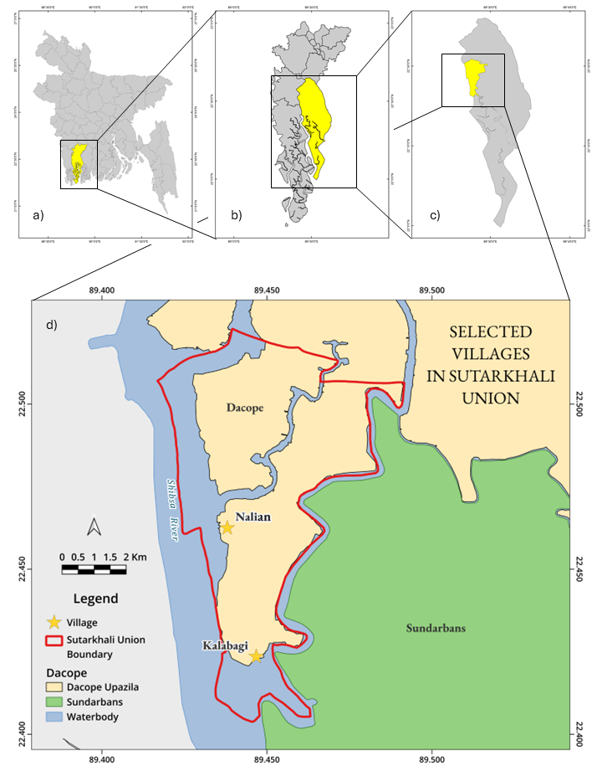

Figure 1 Map of the Study Area at Different Administrative Levels; a) Khulna in Bangladesh, b) Dacope in Khulna, c) Sutarkhali in Dacope, and d) Selected villages in Sutarkhali Union. (Ahmed et al., 2026)

  - Data Source and Collection
Primary data were gathered through two semi-structured questionnaire: a household questionnaire to capture individual economic vulnerability and a focus-group discussion (FGD) to assess community-level economic vulnerability. FGDs comprised 7-8 community representatives each, both included local residents, political representatives, and members of NGOs, facilitating in-depth discussion of economic coping strategies, gaps in life-saving infrastructure and communal resilience factors.
The total population of these two villages is approximately 23,800: 9600 in Nalian and 14,200 in Kalabogi. There is a total of 4,249 households in the two villages according to the Union Parishad. A proportional random sampling strategy was employed for the household survey, ensuring that respondents were selected in proportion to the population size of the study sites. Sampling continued until thematic saturation was observed—where subsequent interviews yielded redundant information and no new themes emerged. Consequently, the final sample size of 52 households (19 in Nalian and 33 in Kalabogi) was deemed sufficient. To provide a statistical basis for this sample size, Cochran’s Formula (1977) for a finite population was employed to verify its adequacy:
$$n=\frac{n_{0}}{1+\frac{n_{0}- 1}{N}}$$
Where, $n_{0}= \frac{z^{2}*p*q}{e^{2}}$. In this study, N represents the total household population (4,249), Z is the Z-score for an 85% confidence level (1.44), e is the margin of error (10% or 0.10), and p is the estimated proportion (0.5). Under these parameters, the formula yields a required sample size of approximately 52.
While this sample size represents a targeted exploratory cohort, it is statistically sufficient for village-level micro-analyses where the population is relatively homogenous in its socio-economic activities. Furthermore, this was complemented by thematic saturation, where subsequent interviews yielded redundant information, ensuring a representative snapshot of the local community's characteristics.
  - Selection of Dimensions
The conceptual framework of this study is built on the intersectionality of climate-induced hazards and gendered economic roles. It posits that a woman’s vulnerability is not merely a product of disaster exposure, but a composite result of her human capital (Education), household burden (Demography), and structural barriers (Financial Accessibility and Income). Based on this framework and a review of reviewing pre-existing literature, it is clear that there are many indices at present which explore coastal risk and vulnerability. Each of these indices explored the general vulnerability of people using a broad spectrum of indicators. Because this study is focused on women and their vulnerabilities, the indices were chosen to reflect them strongly. In developing the Economic Vulnerability of Women Index (EVWI), five core dimensions: Disaster Preparedness, Education, Income, Financial Accessibility, and Demography were selected based on robust theoretical underpinnings and empirical evidence from gendered vulnerability research. It should be noted that all dimensions pertain exclusively to individual attributes of women’s vulnerability and deliberately exclude external systemic factors, such as, institutional inefficiencies – such as government shortcomings in road or polder maintenance – were not addressed in the questionnaire.
Disaster Preparedness captures women’s differential exposure and adaptive capacity by measuring frequency of disasters, access to early warning systems, evacuation planning, received training, and community resource networks, thereby addressing mobility constraints and socio-cultural norms that often limit women’s disaster readiness. Education encompasses literacy rates and vocational training attainment, reflecting substantial evidence that enhanced human capital directly facilitates livelihood diversification and informed risk-reduction strategies among women. The Income dimension disaggregates individual earnings stability and diversity to highlight informal and seasonal work dependencies that exacerbate vulnerability in coastal settings, are often invisible in macro-economic data. Financial Accessibility probes real access to formal credit, savings, and insurance mechanisms, drawing on microfinance case studies in coastal Bangladesh that demonstrate the pivotal role of inclusive financial services in post-disaster economic recovery. Finally, Demography incorporates dependency ratios, life-course status, and unpaid care burdens to account for care responsibilities and household composition constraints that critically shape women’s economic agency.
The semi-structured questionnaire was meticulously designed by translating each identified factor and its associated effect into targeted items that capture the economic vulnerability of women. Each item was carefully phrased to ensure clarity, cultural relevance and alignment with the five core dimensions of the index. Below Table 1 elucidating how these factors are relevant in studying the economic vulnerability of women in the study area.
Table 1: Gender Specific Factors Exacerbating Economic Vulnerability of Women in Coastal Areas of Bangladesh
Factor | Effect on Economic Vulnerability
Limited land ownership and property rights | Restricts access to collateral for loans, limits control over productive assets and can lead to greater economic insecurity.
Unpaid care work | Limits time and opportunities for women to engage in income-generating activities and pursue education or training.
Restrictions on mobility and access to public spaces | Hinders women's ability to access markets, financial services, information, and support networks.
Lower levels of education and skills training | Limits women's employment opportunities to lower-paying and more precarious jobs, making them more vulnerable to economic shocks.
Lack of representation in decision-making processes | Leads to policies and programs that may not adequately address women's specific needs and vulnerabilities.
Gender-based violence and insecurity | Can lead to physical and mental health issues, displacement, and reduced ability to participate in economic activities.
Social and cultural norms prioritizing male household members | Can result in women having less access to household resources, including food and healthcare, and less say in financial decisions.
Greater reliance on climate-sensitive livelihoods | Women are often concentrated in sectors like agriculture and fisheries, which are directly impacted by climate change, leading to income instability.
These factors were identified from pre-existing literature by various authors working in this field.
  - Weighting and Scoring Methodology
From household questionnaires, key variables were scored on a 1–5 Likert scale ($s_{i}$), where 1 denotes lowest vulnerability and 5 the highest. Each variable $i$ received a fixed weight $w_{i}$(0<$w_{i}$ <1) ranked by relative importance. For each dimension $k$ (with $n_{k}$variables), the dimension score $D_{k}$ was calculated as:
$$D_{k}=\frac{\sum_{i=1}^{n_{k}}{w_{i}s_{i}}}{n_{k}}$$
Dimension scores were then aggregated into a composite index $EVoWI_{D}$ by assigning each dimension $k$ its own weight $W_{k}$(0<$W_{k}$<1) and averaging across the total number of dimensions $m$:
$$EVoWI_{D}=\frac{\sum_{k=1}^{m}{W_{k}D_{k}}}{m}$$
Below is an example of how the responses were ranked and how weights were acquired. No duplication of rank was allowed. Higher rank means more importance. Since, the focus of the study is on the economic vulnerability, financial accessibility and income dimensions were ranked higher.
Chart 1: Disaster Preparedness and Financial Accessibility

Dimension | Disaster Preparedness | Education | Income | Financial Accessibility | Demography
Rank | 3 | 2 | 4 | 5 | 1

$$Weight ofDimension,W_{k}=\frac{Rank of the Dimension}{\sum{Sum of all the Ranks}}$$

So, in this case the sum of the ranks is 15, and weight for $D_{FinancialAccessibility}= \frac{5}{15} or 0.33$ unit. All other weights were calculated following the same procedure as shown in the following table:
Chart 2: Dimension and Weight Calculation
Dimension | Rank (R_{k}) | Weight Calculation (R_{k}/15) | Weight (W_{k})
Financial Accessibility | 5 | 5/15 | 0.33
Income | 4 | 4/15 | 0.27
Disaster Preparedness | 3 | 3/15 | 0.20
Education | 2 | 2/15 | 0.13
Demography | 1 | 1/15 | 0.07
Total | sum = 15 |  | 1.00

  - Analysis and Validation of the Data
All survey data were collated and analysed in Microsoft Excel, where initial data cleaning and computation of descriptive statistics for each of the variables were undertaken. To assess internal consistency, a Cronbach’s alpha test was performed on the five-item (the items being the dimensions) scale, yielding α = 0.61. According to established guidelines, scales comprising fewer than ten items require a minimum alpha of 0.50 to be deemed acceptable. Since the obtained alpha exceeds this threshold, the index demonstrates moderate reliability, and the dataset may be considered fit for the intended analytical purposes.

  - Geospatial Analysis
Spatial visualisation of the composite Economic Vulnerability of Women Index was performed using QGIS. Composite index scores for the villages of Nalian and Kalabogi were imported as attribute tables and displayed with graduated colour symbology, enabling clear identification of spatial patterns in women’s economic vulnerability across the two study sites.
- RESULTS
Economic Vulnerability of Women Index (EVWI) assesses the vulnerability of women across five key dimensions: Disaster Preparedness, Education, Income, Financial Accessibility, and Demography. The index ranges from 1 (Least Vulnerable) to 5 (Most Vulnerable) vulnerability and is widely used in researching climate-induced disasters, including cyclones, floods, and river erosion. The coastal communities in Nalian and Kalabogi in Sutarkhali are acutely exposed to these recurring disasters, which have dissuaded investment from any government or private sector consequently stalling the economic growth. As a result, most of the residents rely on traditional livelihoods that are increasingly imperilled by the threat of climate change, which has slowly pushed many residents into deep poverty.
  - Sample Profile
    - Demography of the Respondents
The respondents were selected randomly, with preference given to older women as they were old enough to remember Sidr and Aila more vividly. Respondents were classified in the age range of 18 and more than 45. The mean age of the respondents was approximately 41 (40.92) years, and the most represented group was those aged between 35 and 44 years. All respondents were females in the household surveys. The age cohorts and the number of respondents in each of the brackets are shown in Table 2:
Table 2 Age Cohorts of the Study and Their Grouping at Different Stages of Adulthood
Variable | Group | Age Cohort | Count
Age (Years) | Late teens and early adulthood | 18-24 | 2
Age (Years) | Young adulthood | 25-34 | 14
Age (Years) | Middle adulthood | 35-44 | 22
Age (Years) | Older adulthood | Above 45 | 14
 |  | Total | 52
Age cohorts were stratified to analyse variations in awareness and preparedness across demographic groups, with younger cohorts demonstrating significantly higher familiarity with early warning systems, due to targeted training through school-based workshops and disaster preparedness programs compared to older adult populations. This was also meant to capture different levels of education qualifications.

The Figure 2 illustrates this distribution of age cohorts and the number of respondents:

Figure 2 Chart Showing the Variations in the Age of the Respondents

The ages of the participants of the FGDs were not recorded as it does not make much difference in community-level economic vulnerability of the women.
    - Educational Qualification of the Respondents
The study considered the various experiences women in remote rural areas have in attaining education and hence, a broad spectrum of qualifications was considered for the household level questionnaire. The educational qualification of the respondents is shown in Figure 3.

Figure 3. Education Qualification of the Respondents, the most represented group had no formal education. *Higher degrees refer to qualifications attained from tertiary education institutions.
All respondents with higher degrees were from Nalian, indicating women being more empowered in that village.
    - Family Size and Dependency Ratio
Household size and dependency composition (e.g., the presence of elderly individuals and children) were found to disproportionately burden women in the study communities with caregiving responsibilities, limiting their engagement in income-generating activities. The mean household size in the study area was 4.34, marginally lower than the Sutarkhali union average of 4.62 members per household (Figure 4).
Figure 4. Size of Families in the Studied Villages. Most people had a household size of 4 members.

Analysis of dependency structures revealed that a majority of sampled households (n=20) averaged two dependents. The mean dependency ratio (dependents per working-age adult) stood at 0.917, indicating that most households exhibited a moderate dependency burden relative to working-age members (i.e., below parity at 1.0).
  - Economic Vulnerability of Women Index (EVWI)
There are marked variations in the EVWI between the women of Nalian and Kalabogi villages. This is apparent in every dimension of the index (Figure 5).

Figure 5. Variability of Scores among the different dimensions of the EVW Index
Substantial heterogeneity in individual-level vulnerability scores was observed across the dimensions, with inter-individual variability suggesting consistently elevated average vulnerability indices. The financial dimension exhibited comparatively lower vulnerability, attributable to the proliferation of NGO-led microcredit initiatives providing conditional small-scale loans to women, thereby partially mitigating financial vulnerability. Conversely, all other dimensions demonstrated pronounced vulnerability, peaking in disaster preparedness and educational access.

The mean aggregate score of EVWI, when considering women from both study sites, is 3.28 (Figure 6). So, on average the vulnerability of women is high. There is an outlier in all this data, where a woman in Nalian showed very low vulnerability due to her social status and safety nets. The overall average vulnerability scores across all dimensions shown in Figure 7.
Figure 6. Aggregate score of economic vulnerability of women index

Figure 7. Radar chart of the economic vulnerability of women along the different dimensions of EVWI

The overall vulnerability score is the aggregate of all variables under each of those dimensions. Both of these communities are hit by disaster every year and sometimes twice a year. Hence, the overall vulnerability in disaster preparedness dimension is the highest.
    - Comparing the EVWI of Nalian and Kalabogi Villages
There are some differences in the economic vulnerability of women between Nalian and Kalabogi villages, mostly arising from the composite of all the different variables.

Figure 8. Average economic vulnerability of women in the two studied villages

It is clear that the women residing in Nalian are less vulnerable to economic shocks than the women living in Kalabogi (Figure 8). According to EVWI women in Nalian got an average score of 3.06, while the women of Kalabogi got an average score of 3.41. So, the women of Kalabogi are 11.5% more economically vulnerable than women in Nalian (Figure 9).
Figure 9 Locational variations of the dimensions of economic vulnerability of women

A comparative analysis reveals significantly lower economic vulnerability among women in Nalian, attributable to infrastructural advantages including superior road connectivity, proximity to other administrative areas (e.g., Koyra Upazila), and resilient housing materials. Conversely, women in Kalabogi exhibit heightened vulnerability due to inadequate infrastructure, reliance on climate-sensitive livelihoods (e.g., shrimp/crab farming), and substandard housing. Compounding these disparities, many of the Kalabogi households reside outside protective embankments—structures prone to failure during cyclonic events, as evidenced by river erosion destroying 102 homes about six months prior to data collection.
Dimension | Nalian, N | Kalabogi, K | Difference, |N-K| | Percentage of Difference
Disaster Preparedness | 3.640 | 3.982 | 0.342 | 9.4%
Education | 3.368 | 3.803 | 0.435 | 12.9%
Financial Accessibility | 2.253 | 2.484 | 0.231 | 10.3%
Income | 3.424 | 3.830 | 0.406 | 11.9%
Demography | 2.716 | 2.826 | 0.11 | 4.1%
Table 3 Comparison between economic vulnerability scores of women in Nalian and Kalabogi across individual dimensions

It is clear from Table 3 that there is some deviation in the vulnerability score in every dimension, and the women of Nalian get higher index scores in all dimensions.

    - Comparing the EVWI of Hindu and Muslim Women in the Study Area
The study area is highly diverse in terms of religion. Sutarkhali Union has 7,227 Hindu individuals and 22,339 Muslim individuals according to the Population and Housing Census of 2022. So, it is important to capture data on how religion might affect the economic vulnerability of women in the study area.
Figure 10. Average economic vulnerability of women in terms of their religion

It is clearly visible that the Muslim women in the study area are less economically vulnerable compared to the Hindu women. However, this data may be misrepresentative of the actual vulnerability as no responses were available from a Hindu woman living in Nalian. Meaning the location has some impact on the difference in this vulnerability. However, this is hard to determine as there is no data on how the communities dwell and what type of pattern emerge in their settlements. Looking at the Figure 11 it is seen that Muslim women on average got a score of 3.26 and Hindu women got a score of 3.35, meaning that there is a difference of 2.8% in the vulnerability score.

Figure 11. Religious variations of the dimensions of economic vulnerability of women
It has been observed that there is quite some gap between Hindu and Muslim women in terms of education and financial accessibility (Table 4). The Hindu women, however, get lower vulnerability score in the demography dimension, meaning more Hindu women are on the younger side of the age cohort, or has less dependency ratio.
Table 4 Comparison between economic vulnerability scores between Hindu and Muslim women across individual dimensions
Dimension | Hindu, H | Muslim, M | Difference,  |H-M| | Percentage
Disaster Preparedness | 3.88 | 3.85 | 0.04 | 0.93
Education | 4.00 | 3.54 | 0.46 | 13.07
Financial Accessibility | 2.60 | 2.33 | 0.27 | 11.48
Income | 3.78 | 3.65 | 0.12 | 3.32
Demography | 2.76 | 2.79 | 0.03 | 1.19

There is no apparent pattern that can be observed in this table. It is difficult to make any conclusive remarks on it without figuring out how many Hindu and Muslim women live in Nalian and Kalabogi villages.

  - Mapping the Economic Vulnerability of Women in the Study Area
Individual EVWI scores were appended to GPS data which was collected during the household level questionnaire survey. This enables the opportunity to explore how the vulnerability is spread across the two studied villages. The scores were classified into five classes: Very Low, Low, Moderate, High, and Very High. The criteria for classifying the aggregate EVWI score is shown in Table 5.
Table 5. Classification of aggregate EVWI scores
Class of Vulnerability | Aggregate EVWI Score
Very Low | 1.0-2.3
Low | 2.31-2.95
Moderate | 2.96-3.54
High | 3.55-4.1
Very High | Above 4.1

    - Individual Economic Vulnerability of Women in Nalian
The aggregate EVWI scores, when mapped, shows an interesting pattern (Figure 12). In Nalian where the average is 3.06, it can be seen that most women have moderate to high economic vulnerability but there are places with low and very low vulnerability which brings down the average quite substantially.
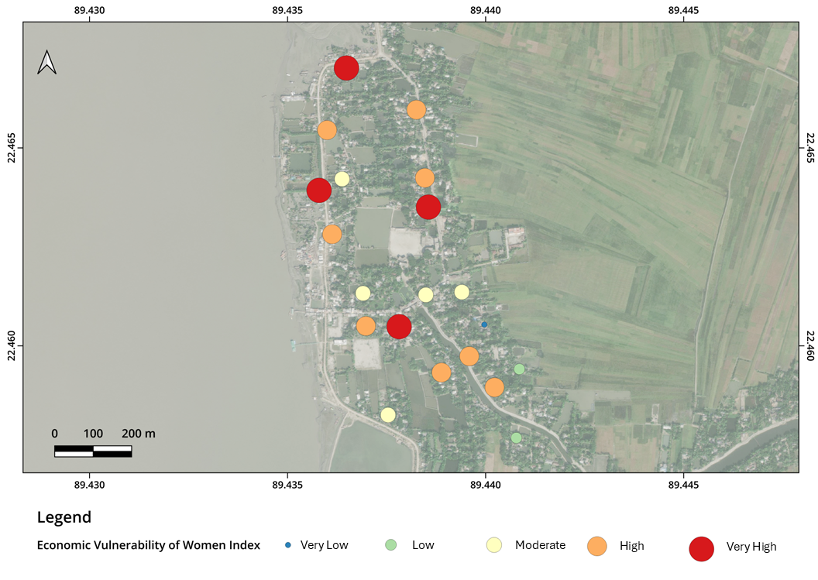
Figure 12. Distribution of economic vulnerabilities of women in Nalian

The people closer to the river have significant higher vulnerability as they feel like their assets are always under threat of being destroyed by natural disasters. However, there is no correlation between distance from riverbank and economic vulnerability due to social variables.
    - Individual Economic Vulnerability of Women in Kalabogi
When the individual aggregate EVWI scores were spatially mapped in Kalabogi, the mean vulnerability across all surveyed households was 3.41, indicating a generally high level of economic risk (Figure 13). However, several neighbourhood clusters exhibited markedly elevated scores (exceeding 4.1), signalling extreme economic vulnerability. These high-risk pockets correspond to areas where residents possess minimal formal savings and have limited or no access to banking services, rendering them unable to buffer against income disruptions. Some of these families have recently lost their homes and migrated inland, and this has increased their financial precarity.
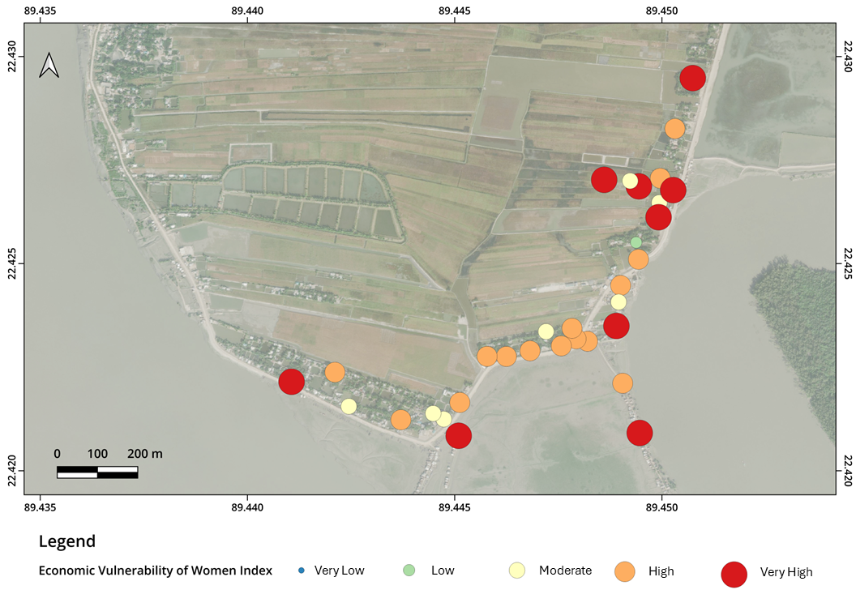
Figure 13. Distribution of economic vulnerabilities of women in Kalabogi

In this area, economic vulnerability does not exhibit a clear spatial pattern. The majority of residents recorded high vulnerability scores, whereas the pronounced cluster of very high vulnerability in the northern sector corresponds to households recently displaced from southern settlements following home loss several months earlier.

- Discussion
The Economic Vulnerability of Women Index (EVWI) provides a multidimensional assessment of women’s economic susceptibility, with particular emphasis on the financial accessibility and income. The financial accessibility dimension evaluates women’s autonomy in household fiscal decision-making, the extent of their engagement with financial institutions—capturing loan frequency, outstanding debt at the time of interview, loan amounts and purposes—and their inclusion in formal financial systems, as indicated by bank account ownership. The income dimension primarily examined respondents’ main livelihood sources and the stability of those earnings, while also identifying any supplementary income-generating activities that could buffer against disaster-related disruptions.
  - Loans and EVWI
A pronounced association emerged between loans and financial vulnerability as measured by the EVWI (Figure 14). The empirical data from the surveys strongly align with the high EVWI scores in the financial accessibility dimension. The lack of bank accounts among 78.85% of respondents is a significant factor linked to women being trapped in a cycle of high-interest informal loans, which corresponds with an elevated overall economic vulnerability score. Field observations further substantiated this relationship, revealing that households routinely resort to credit to stabilise consumption and manage routine expenditures, thereby coinciding with their overall financial fragility.

Figure 14. Correlation between Financial Vulnerability and Loan

The financial vulnerability of women is a primary component of their economic vulnerability. If a woman can manage her own money and make decisions on what to do with it, she is less prone to suffering from economic shocks. There are certain barriers to loans in the study area where the woman has to have a minimum of 81.76 USD(As on: 02-03-2026) in a savings account with the institution to take out loans, and even then, she has to bring a man as her guarantor. This results in lesser control of financial decisions. Another key issue in loans is that the instalments have to be paid on a weekly basis, and missing an instalment increases the rate of interest exponentially. Added to this is the fact that women face verbal abuse from the people employed by these financial organisations if they fail to comply to the repayment plan. This is why some women prefer to take loans from family members instead, and so there is a relatively low number of women who have bank accounts. This conceptual association between financial exclusion and vulnerability is consistent with the findings of Duflo (2012), who highlights that limited access to formal credit and a lack of bargaining power within households often compel women in developing economies to rely on risky informal financial networks during environmental crises.

Figure 15 Variables of financial vulnerability in the Financia Accessibility Dimension
The BBS data indicates that 24.81% of the people have a bank account in Sutarkhali union. From the study it is seen that only 21.15% of the respondents have a bank account. It is lower in Kalabogi compared to Nalian.
Table 6 Responses of the different variables which measures the financial vulnerability
Bank Account | Number of Respondent
Yes | 11 (21.15%)
No | 41 (78.85%)
Loan Frequency | Number of Respondent
Frequently | 12 (23.08%)
Once a month | 8 (15.38%)
Once every 3 months | 11 (21.15%)
Once a year | 17 (32.69%)
Never | 4 (7.69%)
Control over Finances | Number of Respondent
Yes | 39 (75%)
No | 13 (25%)
Safety of Asset | Number of Respondent
Not safe at all | 28 (53.85%)
Slightly secure | 11 (21.15%)
Moderately secure | 4 (7.69%)
Well secure | 9 (17.31%)
Very secure | 0 (0.00%)
So, it is clear that the women of Nalian and Kalabogi stand at a very precarious position when it comes to their finances.
  - Income Source and EVWI
Many women have to do domestic work and also participate in economic activities to support their household. Most women do not have a secondary source of income. Among those that have a secondary source of income, only two are from Kalabogi, the other 13 are from Nalian (Figure 16). Furthermore, the correlation between income instability and EVWI is evident in the fact that only two women in Kalabogi had a secondary income source. This lack of diversification, found during the primary data collection, provides a concrete reason for Kalabogi’s higher vulnerability score (3.41) compared to Nalian (3.06).

Figure 16 Number of respondents with a source of secondary income
Such lack of secondary income source correlates with increased vulnerability during the post‐disaster recovery phase, as disruption of their primary income source precludes engagement in alternative economic activities and thereby prolongs the duration required to regain financial stability. Notably, 55.77 % of respondents said their primary income source is unstable, with a further 11.54 % deeming it highly unstable.
The susceptibility of coastal women to these environmental hazards is fundamentally linked to the theory of economic shocks. As discussed by Dell, Jones, and Olken (2014), weather-induced shocks—such as the cyclones and salinity intrusion frequent in Dacope—do not merely cause temporary physical damage but lead to persistent economic contractions by reducing labor productivity and destroying localized assets. This ‘climate-economy’ interaction explains why women in Kalabogi and Nalian struggle to regain financial stability; the recurring shocks deplete their meager resources and lack of secondary income buffers, forcing them into a state of chronic vulnerability as described in the micro-perspective of Dercon (2006).
  - Socio-Demographic Observations and EVWI
The study also explored the intersectionality of religious identity and economic vulnerability. While the analysis observed certain variations in vulnerability scores across different religious groups, these findings are presented with necessary academic caution. Due to the uneven distribution of religious groups in the sampled population, these results are treated as cautious observations rather than definitive conclusions. These associative patterns suggest a need for further research with a more balanced, stratified sample to confirm if religious identity significantly intersects with economic vulnerability in this region. Consequently, this study maintains its primary focus on the broader structural and environmental factors—such as income instability and financial exclusion—that affect the collective resilience of all women in these coastal geographies.
  - Access to Digital Technology
Access to technology presents a significant potential for enhancing women's economic resilience. It can bolster awareness regarding pertinent economic factors and facilitate entry into digital financial services, including mobile banking, which subsequently enables access to formal credit systems. Furthermore, technology can function as a conduit for disseminating information about female entrepreneurship initiatives in other regions of Bangladesh, potentially serving as a source of inspiration. The survey inspected how many households have a television at home, how many people have basic phone (phones without smart capabilities), smartphones (phones that have built-in internet services), and access to internet. According to BBS (2022), 42.25% women in Sutarkhali union have access to mobile phone for personal use. However, the study revealed that only 30.77% women had a phone (basic and smartphone) for personal and family use. This deviation suggests a strong link between limited technology access and information gaps among the women of Nalian and Kalabogi. In the same BBS (2022) report, 7.98% women in Sutarkhali union were internet users, however from the survey it was seen that only 5.77% of the women had access to the internet. The ownership of a television was also very low in the study area with only 9.62% of the households owning one (Figure 17).

Figure 17. Proportion of women with access to digital technologies

- Conclusion and Recommendations
The women in Dacope particularly in Sutarkhali union face a lot of economic hardships due to natural disasters and dynamic socio-economic stresses. A multi-faceted approach is essential to improve the lives of women in this area. Based on the economic vulnerability of women index and focused group discussions, the authors suggest the following intervention strategies that can remedy these vulnerabilities in the local context:
I. Expand access to inclusive financial services
Facilitating women's access to formal financial services—such as savings accounts, microcredit, and insurance—can reduce reliance on high-interest informal loans. Tailored financial products that consider women's specific needs and constraints can promote financial independence and stability. The women should have a ROSCA (Rotating Savings and Credit Association) within them, which does not require advanced accountancy but can increase resilience to sudden economic shocks, or it can be used to get credit for entrepreneurial endeavours of women.
II. Strengthen women's collective action and cooperatives
There is not one committee of women who work for the women of the communities in the study. Encouraging the formation of women-led cooperatives and support groups can enhance access to resources, information, and markets. These collectives can serve as platforms for capacity-building, mutual support, and collective bargaining, thereby increasing women's agency and resilience.
III. Promote climate-resilient livelihoods and skill development
Providing training in climate-smart agriculture, sustainable fisheries, and alternative livelihoods can diversify income sources and reduce vulnerability to climate shocks. Skill development programs should be accessible, considering local literacy levels are low and time constraints. This can be done by engaging the schools to develop non-credit (extracurricular) activities for the students which help raise awareness in them so that they can inform the other members of their family. Adult education programmes can be established as well based on the wards. There are 5 wards in total: 2 in Nalian and 3 in Kalabogi, so some knowledge can be passed onto the communities in the individual wards that can help them develop more sustainable livelihoods.
IV. Integrate gender perspectives into policy and planning
Incorporating gender considerations into local and national climate adaptation policies can ensure that women's specific vulnerabilities and capacities are addressed. Engaging women in decision-making processes can lead to more effective and equitable resilience strategies. Implementing these strategies requires collaboration among government agencies, non-governmental organizations, and community stakeholders to create an enabling environment that supports women's economic empowerment and resilience in the face of climate change.
V. Improving physical infrastructure
The physical infrastructure in the study area is notably inadequate, with conditions in Kalabogi village being particularly dire. A significant shortage of healthcare professionals exists, as clinics often operate without on-duty doctors, leading to the deterioration of facilities such as the health centre in Nalian. This scarcity of medical personnel exacerbates women's limited access to healthcare services, thereby increasing their economic vulnerability. Expectant mothers are frequently compelled to travel to Chalna, the upazila town located several kilometres north, for healthcare. Although a water ambulance service previously facilitated such transport, its discontinuation has left women facing prolonged and risky journeys during emergencies.​ To address these challenges, the establishment of well-equipped health centres, in collaboration with non-governmental organisations (NGOs), is imperative. Training school students in basic first aid and providing specialised education to women to serve as midwives during emergencies can enhance community-based healthcare capacity. Furthermore, the area's poorly constructed roads, which become impassable during the rainy season, necessitate improvement, preferably through asphalt paving, to ensure reliable access to healthcare facilities.
The EVWI identifies a strong association between heightened economic risks and factors such as unstable income sources, limited financial autonomy, and inadequate infrastructure. Addressing these challenges necessitates targeted interventions in education, healthcare, infrastructure, and community-led initiatives to enhance resilience and adaptive capacity. Integrating gender-sensitive strategies into local and national policies is crucial for fostering sustainable economic empowerment in individuals and communities.
6. Limitations of the Study
Despite its empirical contributions, this study acknowledges several limitations that warrant caution in interpretation. First, the small sample size (n=52) and the cross-sectional design provide a localized snapshot of vulnerability rather than a longitudinal analysis of how these conditions evolve over time. Second, the religious data gap, stemming from an uneven distribution of participants across different faiths, limits the generalizability of intersectional religious findings; thus, these results are treated as associative rather than definitive. Third, while the Equal Weighting (EW) method was employed for the EVWI to maintain methodological neutrality and avoid subjective bias, it may not account for the varying relative importance of specific dimensions in different geographical contexts. Finally, as the study focuses specifically on two villages in Dacope, Khulna, the findings represent the unique socio-economic realities of these coastal communities and may not be fully representative of the broader southwestern coastal belt of Bangladesh. Future research with a larger, stratified sample and longitudinal data is recommended to further validate the EVWI’s scalability.
Disclaimer (Artificial Intelligence)
Author(s) hereby declare that NO generative AI technologies such as Large Language Models (ChatGPT, COPILOT, etc.) and text-to-image generators have been used during the writing or editing of this manuscript.
Acknowledgement
We sincerely thank all the respondents and participants from Nalian and Kalabogi villages for their generous commitment of time and dedication in sharing the information that forms the empirical basis of this study. Our profound gratitude is extended to the research assistants for their diligent efforts during the data collection phase. We also acknowledge the insightful contributions of our colleagues during the data analysis. Furthermore, we are grateful to the local representatives for their logistical support and assistance throughout the field study.
Funding
This research did not receive any specific grant from funding agencies in the public, commercial, or not-for-profit sectors.
Declaration of competing interest
The authors declare the following financial interests/personal relationships, which may be considered as potential competing interests: Md. Faruk Hossain and Md. Tanhir Hossain report that financial support, administrative support, and travel associated with this research were provided by Md. Imran Ahmed.
Consent
Informed consent was obtained from all individual participants included in the study. For participants who were unable to read with full comprehension, the consent statement was communicated verbally in the local dialect by a local guide to ensure full understanding. For participants under the age of 18, informed consent was obtained from their legal guardians (parents).
Ethical Approval
The study followed strict ethical guidelines for research involving human subjects. As the research was part of an academic pursuit, the survey protocol and methodology were reviewed and validated for statistical rigor and ethical compliance by the academic supervisors and faculty members of the Department of Geography and Environment at the University of Dhaka (DU) and the Bangladesh University of Professionals (BUP) during the research design phase.
Data availability
The datasets generated and analyzed during the current study are available from the corresponding author on reasonable request.
CRediT Authorship Contribution Statement
Md. Imran Ahmed: Conceptualization, Methodology, Investigation, Data curation, Formal analysis, Writing – original draft, Writing – review and editing. Md. Faruk Hossain: Conceptualization, Writing – original draft, Writing – review and editing, Supervision. Md. Tanhir Hossain: Conceptualization, Methodology, Investigation, Data curation, Formal analysis, Writing – original draft, Writing – review and editing.
References
Ahmad, H. (2019). Bangladesh Coastal Zone Management Status and Future Trends. Journal of Coastal Zone Management, 22, 1-7.
Ahmed, M. I, Hossain, M. F., & Hossain, M.T. (2026). Disaster-Induced Social Vulnerability of Women: A Study of Nalian and Kalabogi Villages in Sutarkhali Union, Dacope, Khulna, Bangladesh. Available at SSRN. https://ssrn.com/abstract=6137646 or http://dx.doi.org/10.2139/ssrn.6137646
Ahmed, S. (2024). Unequal Power Relations at the Center of Social Vulnerability to Climate Change: Empirical Insights from Coastal Bangladesh. PS: Political Science & Politics, 57(4), 540–544. https://doi.org/10.1017/S1049096524000568
Alam, E., & Collins, A. E. (2010). Cyclone disaster vulnerability and response experiences in coastal Bangladesh. Disasters, 34(4), 931–954. https://doi.org/10.1111/j.1467-7717.2010.01176.x
Alston, M., & Akhter, B. (2016). Gender and food security in Bangladesh: the impact of climate change. Gender, Place & Culture, 23(10), 1450–1464. https://doi.org/10.1080/0966369X.2016.1204997
Anjum, G., & Aziz, M. (2025). Climate change and gendered vulnerability: A systematic review of women's health. Women's Health, 21, 1–22. https://doi.org/10.1177/17455057251323645
Ara, M. G., Roy, T., Jahan, Md. S., & Islam, Md. M. (2022). Adaptive Strategies of Coastal People in Response to Climate Change: Experiences from Two Villages of Dacope Upazila in Bangladesh. Environment & Ecosystem Science, 6(1), 17–28.
Ariyabandu, M. M. (2009). Sex, gender and gender relations in disasters. In Women, gender and disaster: Global issues and initiatives (pp. 5-17). SAGE Publications India Pvt Ltd.
Ashraf, M. A., & Azad, M. A. K. (2015). Gender issues in disaster: Understanding the relationships of vulnerability, preparedness and capacity. Environment and Ecology Research, 3(5), 136–142. https://doi.org/10.13189/eer.2015.030504
Bangladesh Bureau of Statistics (BBS). (2022). Population and Housing Census 2022: Preliminary Report. Statistics and Informatics Division, Ministry of Planning, Government of the People’s Republic of Bangladesh, Dhaka.
Bangladesh Bureau of Statistics. (2023). Population and housing census 2022: District report: Khulna. Bangladesh Bureau of Statistics (BBS). Retrieved from https://nsds.bbs.gov.bd/storage/files/1/Publications/PHCensus/Khulna/District%20Report%20khulna.pdf
Barbier, E. B. (2015). Climate change impacts on rural poverty in low-elevation coastal zones, Policy Research Working Paper No. 7475. World Bank. https://doi.org/10.1596/1813-9450-7475
Bari, A. B. M. M., Intesar, A., Mamun, A. A., Debnath, B., Islam, A. R. M. T., Alam, G. M. M., & Parvez, M. S. (2024). Gender-based vulnerability and adaptive capacity in the disaster-prone coastal areas from an intersectionality perspective. Climate Risk Management, 43, Article 100581. https://doi.org/10.1016/j.crm.2023.100581
Becker, G. S. (1964). Human Capital: A Theoretical and Empirical Analysis, with Special Reference to Education. National Bureau of Economic Research, New York.
Briguglio, L., & Piccinino, S. (2012). Growth with resilience in East Asia and the 2008–2009 global recession. Asian Development Review, 29(02), 183-206.
Bruine de Bruin, Wändi & Parker, Andrew & Fischhoff, Baruch. (2007). Individual Differences in Adult Decision Making Competence. Journal of personality and social psychology. 92. 938-56. 10.1037/0022-3514.92.5.938.
Bullough, A., Guelich, U., Manolova, T., & Schjoedt, L. (2021). Women’s entrepreneurship and culture: Gender role expectations and identities, societal culture, and the entrepreneurial environment. Small Business Economics, 58(3), 985–996. https://doi.org/10.1007/s11187-020-00429-6
Bündnis Entwicklung Hilft & Institute for International Law of Peace and Armed Conflict. (2023). World Risk Report 2023: Focus – Diversity. Berlin, Germany: Bündnis Entwicklung Hilft (BEH). Retrieved April 23, 2025, from https://www.preventionweb.net/publication/world-risk-report-2023-focus-diversity
Bussière, M., & Mulder, C. (2000). Political Instability and Economic Vulnerability. International Journal of Finance and Economics, 5, 309–330.
Cannon, T. (2002). Gender and climate hazards in Bangladesh. Gender & Development, 10(2), 45-50.
Chowdhury, Z. H. (2021). The women on Bangladesh’s climate front lines. The New Humanitarian. Retrieve from https://www.thenewhumanitarian.org/photo-feature/2021/11/10/women-coastal-Bangladesh-climate-change-front-lines
Crespo, N. F., Crespo, C. F., & Calado, M. (2023). Strategic responses of the family businesses in accommodation industry: Lessons for overcoming crises. Journal of Family Business Management, 13(1), 118–145. https://doi.org/10.1108/JFBM-03-2022-0045
Dell, M., Jones, B. F., & Olken, B. A. (2014). What do we learn from the weather? The new climate-economy literature. Journal of Economic literature, 52(3), 740-798
Dercon S. (2006). Vulnerability, a Microperspective. In F. Bourguignon, B. Plescovic, & J. Van de Groog (Eds.), Securing Development in an Unstable World (pp. 117-147). The World Bank.
Dolan, A. H., & Walker, I. J. (2006). Understanding vulnerability of coastal communities to climate change related risks. Journal of Coastal Research, 1316-1323.
Duflo, E. (2012). Women Empowerment and Economic Development. Journal of Economic Literature 50 (4): 1051–79. DOI: 10.1257/jel.50.4.1051
Enarson, E. (1999). Violence against women in disasters: A study of domestic violence programs in the United States and Canada. Violence Against Women, 5(7), 742-768.
Enarson, E. (2012). Women confronting natural disaster: From vulnerability to resilience. Lynne Rienner Publishers.
Enarson, E., & Fordham, M. (2001). From women's needs to women's rights in disasters. Global Environmental Change Part B: Environmental Hazards, 3(3), 133-136.
Fothergill, A. (1996). Gender, risk, and disaster. International Journal of Mass Emergencies & Disasters, 14(1), 33-56.
Gannon, K. E., Castellano, E., Eskander, S., Agol, D., Diop, M., Conway, D., & Sprout, E. (2022). The triple differential vulnerability of female entrepreneurs to climate risk in sub‐Saharan Africa: Gendered barriers and enablers to private sector adaptation. Wiley Interdisciplinary Reviews: Climate Change, 13(5), e793.
Gokhale, V. (2008). Role of Women in Disaster Management: An Analytical Study with Reference to Indian Society [Paper presentation]. 14th World Conference on Earthquake Engineering, Beijing, China.
Guillaumont, P. (2008). An economic vulnerability index: Its design and use for international development policy (WIDER Research Paper No. 2008/99). The United Nations University World Institute for Development Economics Research (UNU-WIDER). https://hdl.handle.net/10419/45132
Hoque, M. A. A., Pradhan, B., Ahmed, N., Ahmed, B., & Alamri, A. M. (2021). Cyclone vulnerability assessment of the western coast of Bangladesh. Geomatics, Natural Hazards and Risk, 12(1), 198-221.
Ikeda, K. (1995). Gender differences in human loss and vulnerability in natural disasters: a case study from Bangladesh. Indian Journal of Gender Studies, 2(2), 171-193.
Islam, M. B., Hossain, M. N., Islam, M. K., Nayeem, A. R., & Akter, M. N. (2020). Effect of financial entrepreneurship and literacy program on women empowerment: A case study in Khulna District. International Journal of Scientific & Technology Research, 9(6), 803–810. Retrieved from https://www.ijstr.org/final-print/jun2020/Effect-Of-Financial-Entrepreneurship-And-Literacy-Program-On-Women-Empowerment-A-Case-Study-In-Khulna-District.pdf
Jadid, J. H., & Moniruzzaman, S. M. (2024). A Study on Cyclone Vulnerability Assessment in Dacope Upazila of Khulna. Proceedings of the 1st International Conference on Recent Innovation of Civil Engineering & Architecture for Sustainable Development (IICASD-2024) 7~9 November 2024, DUET, Gazipur, Bangladesh
Juran, L., & Trivedi, J. (2015). Women, gender norms, and natural disasters in Bangladesh. Geographical Review, 105(4), 601-611.
Khanam, D., Kabir, Z., Dina, S. A., & Islam, A. R. M. T. (2023). Experiencing the impacts of climate change-induced salinity by women in coastal region of Bangladesh. Journal of Climate Action, Research, and Policy, 1, Article 2450001. https://doi.org/10.1142/S2972312424500012
Manolova, T. S., Brush, C. G., Edelman, L. F., & Elam, A. (2020). Pivoting to stay the course: How women entrepreneurs take advantage of opportunities created by the COVID-19 pandemic. International Small Business Journal, 38(6), 481-491. https://doi.org/10.1177/0266242620949136
Mashapure, R., Nyagadza, B., Chikazhe, L., Msipa, N., Ngorora, G. K. P., & Gwiza, A. (2022). Challenges hindering women entrepreneurship sustainability in rural livelihoods: Case of Manicaland province. Cogent Social Sciences, 8(1). https://doi.org/10.1080/23311886.2022.2132675
Mirchandani, K. (1999). Feminist insight on gendered work: New directions in research on women and entrepreneurship. Gender, Work & Organization, 6(4), 224–235. https://doi.org/10.1111/1468-0432.00085
Moser, S. C., M. A. Davidson, P. Kirshen, P. Mulvaney, J. F. Murley, J. E. Neumann, L. Petes, and D. Reed. (2014). “Coastal zone development and ecosystems.” In Chap. 25 in Climate change impacts in the United States: The third national climate assessment, edited by J. M. Melillo, Terese (T.C.) Richmond, and G. W. Yohe, 579–618. Washington, DC: US Global Change Research Program. https://doi.org/10.7930/J0MS3QNW.
Noy, I., & Yonson, R. (2018). Economic vulnerability and resilience to natural hazards: A survey of concepts and measurements. Sustainability, 10(8), 2850.
Nuruzzaman, M., Selim, S. U. M., & Miah, M. H. (2014). Rights, benefits and social justice: Status of women workers engaged in the shrimp processing industries of Bangladesh. Asian Fisheries Science, 27S (Special Issue), 151–163.
Paul, B. K. (2009). Why relatively fewer people died? The case of Bangladesh’s Cyclone Sidr. Natural Hazards, 50, 289-304.
Rezwana, Nahid & Pain, Rachel. (2020). Gender‐based violence before, during and after cyclones: slow violence and layered disasters. Disasters. 45. https://doi.org/10.1111/disa.12441.
Sen, A. (1983). Poverty and Famines: An Essay on Entitlement and Deprivation. Oxford University Press, Oxford. https://doi.org/10.1093/0198284632.001.0001
Shaibur, M. R., Parvin, S., Ahmmed, I., Rahaman, M. H., Das, T. K., & Sarwar, S. (2021). Gradients of salinity in water sources of Batiaghata, Dacope and Koyra Upazila of coastal Khulna district, Bangladesh. Environmental Challenges, 4, 100152. https://doi.org/10.1016/j.envc.2021.100152
Shamsuddoha, M., Jabed, M. A., Islam, M. S., Sultana, N., Imran, A., Rabbi, S. N. A., Jenat, T. U., Shams, S., & Sharif, M. M. (2024). Impacts of climate change-induced natural hazards on women and their human rights implications: A study in the southwest coast of Bangladesh. Journal of Migration and Health, 9, 100221. https://doi.org/10.1016/j.jmh.2024.100221
Solano, N., Lopez-Ercilla, I., Fernandez-Rivera Melo, F. J., & Torre, J. (2021). Unveiling women’s roles and inclusion in Mexican small-scale fisheries (SSF). Frontiers in Marine Science, 7, 617965.
Sommer, A., & Mosley, W. H. (1972). East Bengal cyclone of November, 1970. Epidemiological approach to disaster assessment. Lancet, 1(7759), 1029–1036.
Sultana, A. M. (2010). Patriarchy and women’s gender ideology: A socio-cultural perspective. Journal of Social Sciences, 6(1), 123-126.
Sultana, N. (2022). Understanding the economic dimensions of women's vulnerability during cyclones: The Bangladesh perspective. International Journal of Disaster Risk Reduction, 70, 102730.
Thornton, P. H. (1999). The sociology of entrepreneurship. Annual Review of Sociology, 25(1), 19-46.
UN Women. (2022). State of gender equality and climate change in Bangladesh. Retrieved from https://asiapacific.unwomen.org/en/digital-library/publications/2022/09/state-of-gender-equality-and-climatechange-in-bangladesh
UN Women. (2024). Gender-based climate financing policy brief: Priorities for gender-responsive climate actions in Bangladesh. Developed in consultation with the Ministry of Environment, Forest and Climate Change and part of the Empower – Women for Resilient Societies programme.
UNDRR. (2024). Global Assessment Report on Disaster Risk Reduction (GAR 2024): Forensic Insights for Future Resilience – Learning from Past Disasters. United Nations Office for Disaster Risk Reduction (UNDRR).
United Nations Development Programme (2010). Human Development Reports (website), Gender Inequality Index (GII): Table 5 Statistical Annex, http://hdr.undp.org/en/content/gender-inequality-index-gii
Weist, R., J. Mocellin and T. Motsis. (1994). The needs of women in disasters and emergencies. UNDP and Office of United Nations Disaster Relief Coordinator, Winnipeg.
Wood, R. R., Lehner, F., Pendergrass, A. G., & Schlunegger, S. (2021). Changes in precipitation variability across time scales in multiple global climate model large ensembles. Environmental Research Letters, 16(8), 084022.
Zacarias, D. A. (2018). Understanding community vulnerability to climate change and variability at a coastal municipality in southern Mozambique. International Journal of Climate Change Strategies and Management, 11(1), 154–176. https://doi.org/10.1108/IJCCSM-07-2017-0145

