Original Research Article

Standardized Fenugreek Seed Extract (Trigonella foenum-graecum) enhances activation of Endothelial Nitric Oxide Synthase (eNOS) in HUVECs: An In Vitro Study

.
ABSTRACT

Introduction: Plant-derived functional foods are increasingly recognized for their role in managing different health-related risk factors. Despite the known traditional uses of fenugreek seed, its potential and influence on nitric oxide production require further scientific validation.
Aim: To investigate the role of Standardized fenugreek seed extract (Testosurge® and FLG) in enhancing eNOS phosphorylation and nitric oxide production to support endothelial function under in vitro conditions.
Study Design: In vitro experimental study using a Human Umbilical Vein Endothelial Cell (HUVEC) model to evaluate dose-dependent enzymatic signaling and bioactive efficacy.
Study location: BioTeSys GmbH, Schelzorstrasse 54-56, 73728 Esslingen, Germany, from November 2023 to January 2024.
Methodology: HUVECs were treated with varying concentrations of Standardized fenugreek seed extract. Extracts underwent simulated gastrointestinal digestion prior to treatment of HUVECs. The activity of eNOS was quantified using an indirect immunofluorescence assay specifically targeting phosphorylation at the Serine (S1176) residue. Subsequent enzymatic activation was measured to correlate nitric oxide production with functional output. Significances were calculated using Student’s t-test or One-way ANOVA and Dunnett’s post test.
Results: The extract demonstrated a clear dose-dependent increase in eNOS phosphorylation at S1176. This upregulation may lead to a significant increase in NO production compared to the control groups. The data confirms that the phytochemicals within the extract (flavonoids, alkaloids, and saponins) directly stimulate the eNOS signaling pathway. Testosurge® resulted in a 117% activation at 5 minutes compared to vehicle control.
Conclusion: Standardized fenugreek seed extracts may support endothelial function which leads to improved vascular tone and blood flow. Further in vivo and clinical studies are required to confirm these findings.

Keywords: Fenugreek seed extract, Testosurge®, eNOS activation, NO production, Cardiovascular health, Blood pressure

1. INTRODUCTION

One of the main issues brought on by today's unhealthy lifestyle is cardiovascular disease (CVD), which is the leading cause of death globally. In general, CVD is the state in which the heart's and blood vessels' functions change, potentially resulting in cardiac arrest, heart attack, chest discomfort, etc. A vital component of CVD prevention is lifestyle. The risk of CVD is decreased by a healthy diet high in natural fruits and vegetables, frequent exercise, etc. Risk factors for the development of atherosclerosis and CVD include diabetes mellitus, high blood pressure, and dyslipidemia, all of which can be decreased by altering lifestyle patterns [1,2].
Nitric oxide (NO) is a crucial element in the human body, playing a role in the widening of blood vessels, hormone release stimulation, signaling, and the management of neurotransmission. Nitric oxide is produced through both nitric-oxide-synthase-dependent and -independent mechanisms. Supplementing nitric oxide can enhance heart health, boost exercise performance, lower high blood pressure during pregnancy, alleviate erectile dysfunction, and aid in healing processes and respiratory function [3].
Besides its vasodilating effects, endothelial Nitric Oxide possesses various vasoprotective and likely anti-atherosclerotic characteristics. Nitric Oxide that is released into the vascular lumen effectively inhibits platelet aggregation and their adhesion to the vascular wall. In addition to safeguarding against thrombosis, this also stops the release of growth factors derived from platelets that promote the proliferation of smooth muscle [4,5].Endothelial NOS (eNOS) is produced by the NOS3 gene, located in the 7q35-7q36 area of chromosome 7 in humans. The eNOS enzyme safeguards the cardiovascular system, owing to its capability to generate a vital neurotransmitter/neuromodulator in a balanced quantity that is physiologically advantageous to the cardiovascular system [6].
The induction of Nitric Oxide synthesis by flavonoid-containing compounds has received widespread attention, as their effects appear to positively impact CVD [7]. Flavonoids exert complex actions on the synthesis and bioavailability of Nitric Oxide which may result in enhanced Nitric Oxide levels: (1) in cell free systems, under conditions of oxidative stress, flavonoids protect Nitric Oxide from superoxide-driven inactivation. (2) in intact healthy tissues, some flavonoids increase eNOS activity in endothelial cells [8]. Several characterization studies show the presence of flavonoids which may support eNOS activation[9].
There are some studies and evidence which show that cardio protective benefits are exhibited by certain seeds, fruits and vegetables, such as grapes[10,11] and intake of food items that are rich in flavonoids and polyphenol reduces the risk of CVD[12]. We hypothesized that fenugreek seed promotes Nitric Oxide production due to its specific bioactive markers extracted by specific technique[13]. Therefore, to explore the in vitro mechanism of action of Standardized fenugreek seed extracts, we conducted studies on eNOS activation, which has been noted for numerous plant-derived products [14]. Based on previous research indicating that certain plant components need to be transformed into an active metabolite during digestion [15], we examined the effects of fenugreek seed extract in vitro, utilizing fenugreek seed extract in powdered form, as well as following an in vitro simulation of digestive processes occurring in the human stomach and small intestine.

2. material and methods

2.1 Reagents and Cells
Endothelial Cell Growth Medium was supplied by Promocell (Heidelberg, Germany). Chemical reagents for in vitro study were purchased from Merck Life Sciences (Darmstadt, Germany). Primary Human Umbilical Vein Endothelial Cells (HUVEC) were acquired by Promocell (Heidelberg, Germany).
CytoFluor eNOS (Phospho-Ser1176) detection kit was procured from Assay biotech (Fremont, USA).

2.2 Test product
The two Standardized fenugreek seed extracts: Testosurge® and FLG were provided by INDUS BIOTECH, PUNE. Testosurge® with specification of Total Glycosides not less than 80%, containing Flavonoid Glycosides not less than 15%. And FLG with total Glycosides not less than 95%, contains Flavonoid glycosides not less than 50%. The Flavonoid glycoside family includes molecules like vitexin, iso-vitexin, vitexin 2-O-rhamnoside,vicenin 1, vicenin 2, vicenin 3, schaftoside, iso-schaftoside, orientin, iso-orientin [9].

2.3 In vitro Studies
2.3.1 In vitro Test System
As cellular in vitro test system Human Umbilical Vein Endothelial Cells (HUVECs) (Promocell Cat. No. C-12203; Lot No. 479Z016) were used.
The cells were cultured according to the manufacturer’s instructions.
2.3.2 Simulated In Vitro Gastric and Intestinal Digestion
Fenugreek seed extract contains a variety of phytochemicals. The physicochemical characteristics of the substance class are altered in the gastrointestinal tract as a result of biotransformation [16]. To consider these impact factors, the experiments were conducted using both the pure extract and the digested solution.
The in vitro model “artificial digest” replicates the enzymatic and pH conditions that occur during the gastrointestinal passage. The subsequent experiments will take into account the metabolic alterations of the active ingredients in the test products brought about by these conditions.
The in vitro digestion of the test items was carried out in a two-step procedure, mimicking both stomach and intestinal environments. The process started with the setup of the gastric digestion phase. Every test product was first dissolved in a mucin/pepsin mixture, containing 150 mg of the test product for every 120 mL of the mucin/pepsin mixture. The pH of this solution was precisely modified to 2.0 with hydrochloric acid (HCl) to replicate stomach's acidic conditions. The mixture was subsequently incubated at 37°C for 2 hours with continuous stirring to ensure complete mixing and to replicate the stomach's churning action.
After the gastric phase, the digestion in the intestine began. Pancreatin, trypsin, and bile extracts were included in the solution to mimic the enzymatic and emulsifying functions of the small intestine. The pH was then modified to 7.5 to establish the ideal conditions for intestinal enzyme function. The mixture was subsequently incubated for another 4 hours at 37°C, with continuous stirring. This two-phase approach enables a thorough assessment of the digestive behavior of the tested products in conditions that resemble the human gastrointestinal system closely.
2.3.3 HUVEC Viability Assay
This assay sought to identify the highest non-cytotoxic dose of a compound for a following eNOS activation assay. The MTT (3-(4,5-dimethylthiazol-2-yl)-2,5-diphenyltetrazolium bromide) viability assay was employed to evaluate the impact of the compound on Human Umbilical Vein Endothelial Cells (HUVECs).
2.3.3.1 Cell Culture and Treatment
HUVECs were placed at a density of 5,000 cells per well in a 96-well microtiter plate and permitted to attach and grow overnight in a humidified incubator at 37°C with 5% CO2. Following 24 hours, the culture medium was removed and substituted with a new supplementation medium that included the test compound at seven varying concentrations. Every concentration, along with the vehicle control, was assessed in six replicate wells (n=6). The plates were subsequently incubated for a 4-hour treatment duration under identical conditions. This time frame was selected to replicate the intended eNOS activation assay, confirming that the viability data were pertinent to the experimental circumstances.
2.3.3.2 MTT Cell Viability Assay
After the 4-hour treatment, the supplementation medium was meticulously taken out from each well. A MTT solution (5 mg/mL in phosphate-buffered saline, PBS) was subsequently introduced to each well at a 1:10 dilution in fresh medium, leading to a final MTT concentration of 0.5 mg/mL. The plates were placed back in the incubator for another 3 hours. Throughout this time, the mitochondrial succinate dehydrogenase in the active cells breaks down the yellow MTT tetrazolium ring, resulting in an insoluble purple formazan compound. This process directly reflects cellular metabolic activity and, consequently, cell viability. Following the incubation, the medium was taken out, and the formazan crystals were dissolved by introducing an adequate amount of a solubilization buffer (such as DMSO or a combination of isopropanol and hydrochloric acid). The absorbance of the obtained purple solution was recorded at a wavelength of 570 nm with a microplate reader. The absorbance readings, directly related to the count of viable cells, were utilized to create a dose-response curve and identify the concentration at which the compound initiates cytotoxic effects.
The concentrations of digest solutions in the medium that were applied for dose estimation were as follows.
Table 1: Dose estimation concentrations
Concentration level | Concentration (%)
C1 | 10
C2 | 5
C3 | 2
C4 | 1
C5 | 0.5
C6 | 0.2
C7 | 0.1

2.3.4 Activation of eNOS
2.3.4.1 Cell Culture and Treatment
HUVECs were plated into a 96-well plate at a density appropriate for later treatments and evaluations. The cells were grown overnight in a cell incubator kept at 37°C with 5% CO2 in a humid environment. The regular culture medium, generally containing vital nutrients and growth factors, was taken out and substituted with a serum-free or low-serum medium augmented with the test substances. Three distinct concentrations of the test compound were formulated, and each concentration was assessed in a set of six replicate wells (n=6). A control group that only received the supplementation medium, excluding the test compound, was also included for comparison. The plates were subsequently incubated for two different time intervals: 5 minutes and 4 hours, in order to evaluate both the acute and chronic impacts of the treatment.
2.3.4.2 Cell Fixation and Immunocytochemistry
After the treatment phase, the supplementation medium was meticulously aspirated from every well. The cells were subsequently preserved with a formaldehyde solution. Formaldehyde is a widely used fixative in cell biology for maintaining cell structure and immobilizing proteins and other cellular elements through cross-linking. This phase is vital for preserving the structural stability of the cells ahead of the antibody staining procedure. After fixation, the cells were ready for immunocytochemistry, a method that employs antibodies to identify proteins in cells.
2.3.4.3 Protein Labelling and Fluorescence Detection
The fixed cells were labeled with antibodies to specifically identify the protein eNOS. Two distinct primary antibodies were employed: one aimed at the phosphorylated variant of eNOS (P-eNOS) and the other at the total, non-phosphorylated eNOS. The phosphorylation status of eNOS is essential since it controls the activity of the eNOS to produce nitric oxide. The antibodies were created to attach selectively to their corresponding protein targets. Afterward, secondary antibodies tagged with fluorophores were introduced. These antibodies attach to the main antibodies, and their fluorescent markers enable visualization and quantification. To confirm that the results were not influenced by differences in cell number or overall protein content, the samples were standardized using an antibody targeting glyceraldehyde 3-phosphate dehydrogenase (GAPDH), a typical housekeeping protein maintained at a steady level in the majority of cells. Once the staining procedure was finished, the fluorescence intensity in every well was quantified with a plate reader. Fluorescence signals for P-eNOS, total eNOS, and GAPDH were recorded, and the ratio of p-eNOS to total eNOS was computed and adjusted to GAPDH levels to evaluate the treatment's impact on eNOS phosphorylation.
3. OBJECTIVES
• To assess the ability of extracts to stimulate eNOS in vitro, utilizing HUVECs as a model system. This will aid in evaluating their impact on cardiovascular health, blood flow, and blood pressure management.
• To subject the extracts to a simulated gastrointestinal digestion and replicate the metabolic alterations they would experience in the human body. This guarantees that the assessed active components are in their relevant physiological forms.
• To gather and process the fenugreek seed extract solutions that need to be subjected to simulated digestion for later in vitro testing.
• To provide HUVECs, an essential part of blood vessels, with the prepared solutions to examine the cellular reaction.
• To quantitatively assess the amount of phosphorylated eNOS in the HUVECs following fenugreek seed extract supplementation. This measurement will act as the main signal of eNOS activation.
• To examine the data to comprehend the connection between the treated fenugreek seed extracts and the resultant eNOS activation, thus evaluating their capacity to support cardiovascular health and control blood pressure.

3.1 Criteria for Objective measurements
3.1.1 Quantitative Measurements
The main goal of measurement is the quantification of phosphorylated eNOS (P-eNOS). This will be assessed in HUVECs utilizing methods such as Western blotting, ELISA (Enzyme-Linked Immunosorbent Assay), or Indirect immunofluorescence. The outcomes should be presented as a ratio of P-eNOS to total eNOS or a control digest, to guarantee normalization for differences in cell loading. This ratio serves as an accurate measure of eNOS activation.
3.1.2 Data Normalization & Controls
The data should be normalized in comparison to a control group of HUVECs that haven't been treated with fenugreek seed extracts. This establishes a standard for evaluation. Positive controls, like SDS, Vascular Endothelial Growth Factor (VEGF), or acetylcholine, recognized for activating eNOS, must also be added to confirm the validity of the experimental system. Every measurement must be conducted in triplicate to guarantee reliability and statistical importance.
3.1.3 Preparation of Extracts
The preparation of fenugreek seeds extract will follow a measurable procedure. The levels of the extracts, prior to and following the simulated gastrointestinal passage, must be measured utilizing techniques such as spectrophotometry or HPLC (High-Performance Liquid Chromatography). This facilitates the calculation of the mass balance of the extracts and guarantees uniform dosing of the HUVECs.

3.2 Safety
All experiments take place in a BSL-2 (Biosafety Level 2) laboratory to ensure the safe handling of HUVECs. Standard microbiological procedures, which involve wearing personal protective equipment (PPE) like lab coats, gloves, and safety eyewear, are consistently required. All cell culture activities were conducted in a laminar flow hood to ensure a sterile environment and avoid contamination.
The substances utilized for cell culture, including bovine serum albumin (BSA), trypsin, and phosphate-buffered saline (PBS), are managed in accordance with their corresponding Safety Data Sheets (SDS). Appropriate methods for disposing of all biohazardous and chemical waste are adhered. All contaminated sharp objects, such as needles and scalpels, are thrown away in specific sharps containers.
The cautious execution of the experimental protocol for the simulated gastrointestinal passage was carried out. Although the extracts and enzymes are harmless, proper laboratory hygiene is upheld to avoid any unintentional consumption or skin exposure. Any operations that required dealing with potentially dangerous materials were carried out under a fume hood.

3.3 Statistical Analysis
The gathered data will undergo thorough statistical analysis. This involves employing techniques such as ANOVA (Analysis of Variance) to evaluate the means of the various treatment groups (control, positive control, and different concentrations of fenugreek seed extracts). A p-value below 0.05 will be deemed statistically significant. The findings must be displayed as mean ± standard deviation (SD) to indicate the variation within each group.

4. results

4.1 In vitro Studies
4.1.1 Simulated In Vitro Gastric and Intestinal Digestion
The research commenced with an in vitro digestion simulation to replicate the physiological environment of the human gastrointestinal system, as illustrated in Figure 1. Three solutions were created to illustrate different phases of digestion: an initial solution, a middle solution that simulates stomach conditions, and a concluding solution that mimics intestinal conditions. At the start of the simulation, the original solutions were created and displayed a unique appearance prior to the digestion process.
After the initial setup, the solutions were incubated for two hours under conditions that simulate the stomach, particularly at a pH of 2. This phase aimed to simulate the highly acidic conditions of the stomach and to examine the initial impacts of gastric digestion on the dissolved materials. The incubation phase ended with a visual evaluation of the solutions.
Following the gastric phase, the solutions were moved to an uncontaminated setting that replicated the small intestine. They were incubated for another 4 hours at a pH of 7.5. This stage was essential for examining the impact of intestinal enzymes and the neutral-to-alkaline conditions on the materials. After finishing the complete 6-hour digestion simulation (2 hours in the stomach and 4 hours in the intestine), all initial materials had entirely dissolved.
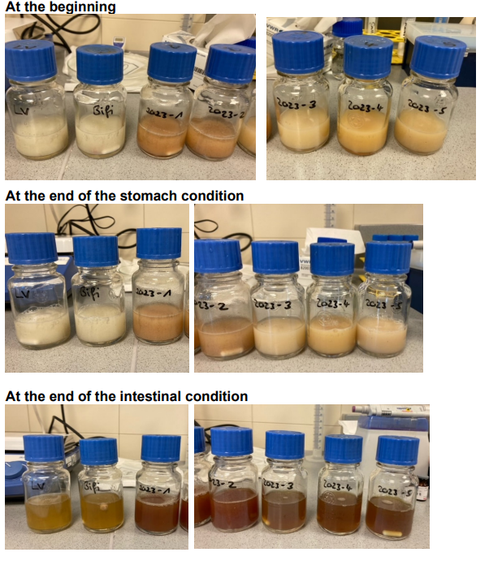
Figure 1: In vitro digest simulation solutions for each test substances. LV= digest without test product; Bifi= digest control; 2023-1 to 2023-5 = test products.
This complete dissolution resulted in a clear solution, which was then utilized in subsequent experiments at the specified concentrations. This final product represented the fully digested state of the substances, ready for absorption and further analysis.
4.1.2 HUVEC Viability Assay
Before the eNOS activation assay, a dose-finding experiment was performed to identify the highest non-cytotoxic concentrations of the test products along with their respective vehicle. The MTT viability assay was employed to evaluate the toxic effects of the digest solutions on the cells. Cell viability was assessed as a percentage of the control medium, using a cutoff of 75% of the medium control to determine cytotoxicity.
The vehicle, comprising the digest solution without the test substances, was evaluated to determine its impact on cell viability. Findings, illustrated in Figure 2, revealed that the vehicle showed no cytotoxic effects at concentrations of up to 5%. Given that the maximum intended concentration for the eNOS activation assay was 2%, it was determined that the vehicle would not affect cell viability at the specified concentrations.
Cytotoxicity was evaluated for both Standardized fenugreek extracts. Figure 2 demonstrates that the product did not lower cell viability beneath the 75% threshold at the concentrations tested. Consequently, extracts of fenugreek seeds and their corresponding digestion solutions are appropriate for implementation in the eNOS activation assay. The concentrations of 2.0%, 0.5%, and 0.2% are defined according to the viability assay.
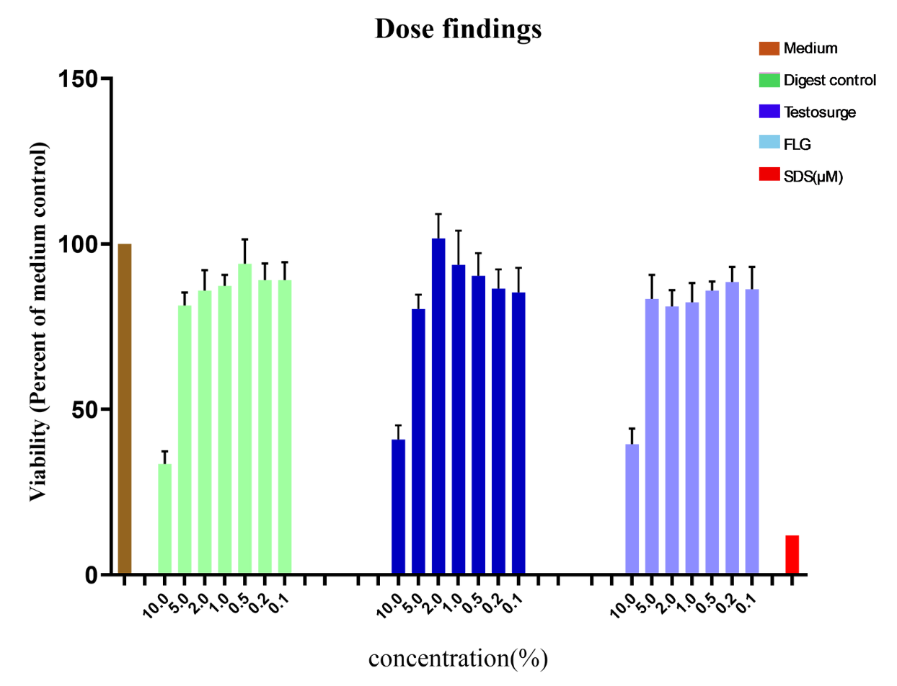
Figure 2: Dose finding for vehicle (= digest solution without product) and Standardized fenugreek seed digest solutions in HUVEC. Viability data in percentage to medium control. Values given as mean ± SD, n=6. SDS (500 µM) as positive control.
4.1.3 Activation of eNOS
The activation of eNOS was evaluated by analyzing the phosphorylation of the enzyme at serine 1176 (S1176). HUVECs were exposed to the test product digest solutions at three varying concentrations: 2.0%, 0.5%, and 0.2%. The eNOS activation was assessed at two intervals: a brief exposure of 5 minutes and an extended exposure of 4 hours. The proportion of phosphorylated eNOS (P-eNOS) to total eNOS was measured directly to assess eNOS activation.
Table 2 shows the ratio of phosphorylated eNOS to total eNOS following a 5-minute incubation with different test product solutions. This initial time point was selected to assess the immediate cellular reaction to the treatments. The information from this table shows the immediate effect of the digest solutions on eNOS phosphorylation, establishing a reference for comparison with the extended incubation duration. Additional examination of the findings will identify which concentrations and products trigger a notable early phase of eNOS activation.
Table 2: Relative amount of P-eNOS/eNOS at 5 minutes
Test substance | Concentrations | Relative amount
Medium |  | 1.24
VEGF | 20 ng/mL | 1.35
Digest Control | 2.0% | 1.35
Digest Control | 0.5% | 1.35
Digest Control | 0.2% | 1.20
Standardized fenugreek seed extract (Testosurge®) | 2.0% | 1.03
Standardized fenugreek seed extract (Testosurge®) | 0.5% | 0.97
Standardized fenugreek seed extract (Testosurge®) | 0.2% | 1.41
Standardized fenugreek seed extract (FLG) | 2.0% | 1.38
Standardized fenugreek seed extract (FLG) | 0.5% | 1.33
Standardized fenugreek seed extract (FLG) | 0.2% | 1.45

To enhance the comparison of the impacts of the test substances, eNOS activation was represented as a percentage in relation to their corresponding vehicle controls, which were standardized to 100%. As illustrated in Figure 3, digest solutions of fenugreek seed extract exhibited a notable rise in eNOS activation following a 5-minute incubation. In particular, the 0.2% concentration of the Testosurge ® solution resulted in a 117% activation of eNOS when compared to the vehicle controls and 0.2% concentration of FLG resulted in 120% activation. This implies that the best concentration for brief eNOS activation is approximately 0.2%. Both Testosurge® and FLG showed instant activation of eNOS.
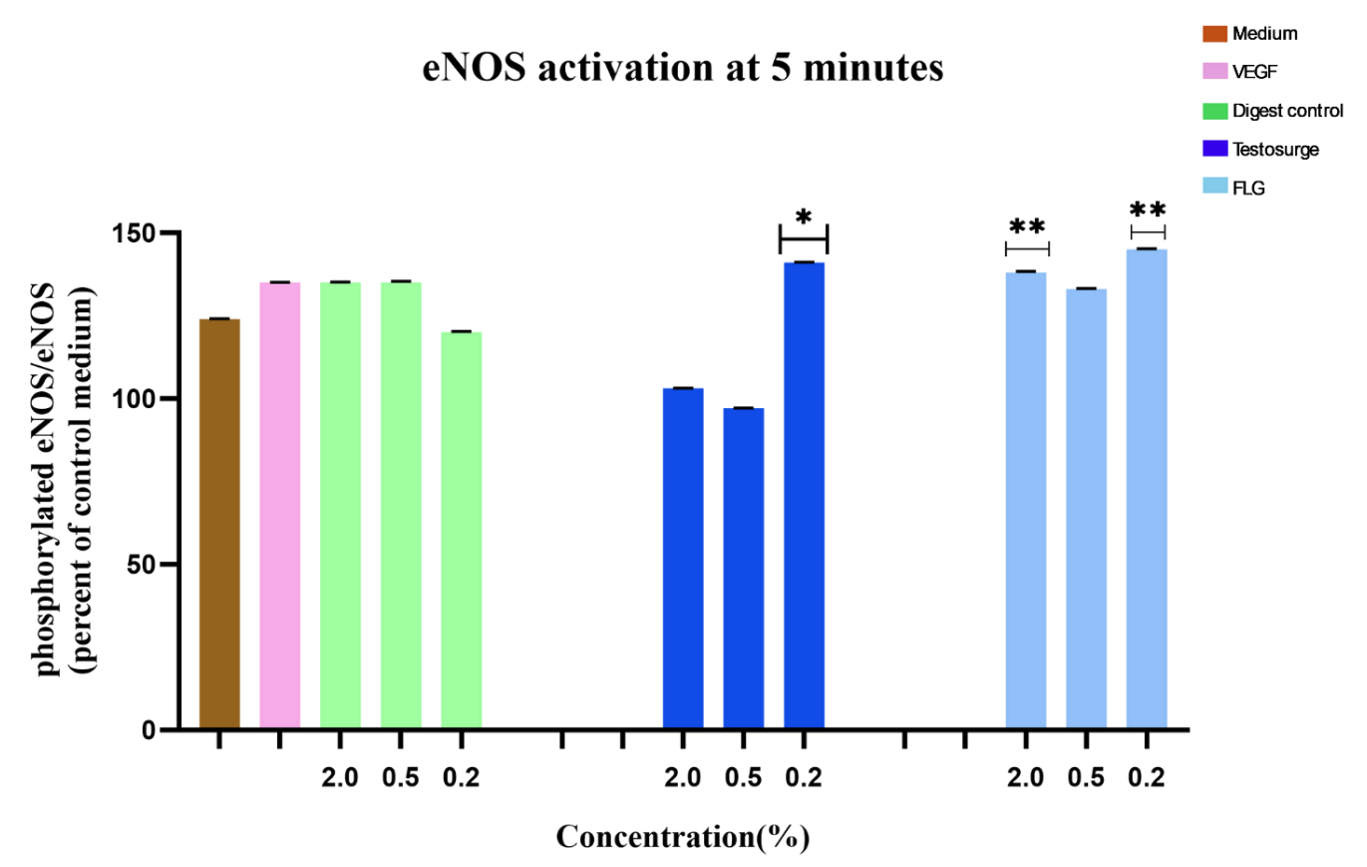
Figure 3: eNOS activation. Relation of P-eNOS/eNOS after 5 minutes supplementation with Standardized fenugreek seed digest solutions in HUVEC. Data given as percentage to respective vehicle control. Values given as mean ± SD, n=6. VEGF (20 ng/mL in medium) as positive control. Significances were calculated using Student’s t-test (medium vs. VEGF) or One-way ANOVA and Dunnett’s post test (Digest control vs. test substances). Significances are indicated as *=p<0.05 for Testosurge® and **=p<0.05 for FLG.

Table 3 summarizes the results for eNOS activation over the long term after 4 hours of incubation. This information offers an understanding of the lasting impacts of the test products on eNOS phosphorylation, facilitating a thorough comparison with the short-term findings and enhancing the comprehension of the time-sensitive cellular reaction.
Table 3: Relative amounts of P-eNOS/eNOS at 4 hours
Test substance | Concentrations | Relative amount
Medium |  | 0.64
VEGF | 20 ng/mL | 0.67
Digest Control | 2.0% | 0.88
Digest Control | 0.5% | 0.75
Digest Control | 0.2% | 0.65
Standardized fenugreek seed extract (Testosurge®) | 2.0% | 0.52
Standardized fenugreek seed extract (Testosurge®) | 0.5% | 0.57
Standardized fenugreek seed extract (Testosurge®) | 0.2% | 0.64
Standardized fenugreek seed extract (FLG) | 2.0% | 0.54
Standardized fenugreek seed extract (FLG) | 0.5% | 0.88
Standardized fenugreek seed extract (FLG) | 0.2% | 0.87

Following a 4-hour incubation period, the impact of the Standardized fenugreek seed digest solutions on eNOS activation was noted. The 0.2% concentration of FLG solution resulted in a 133% activation of eNOS when compared to the vehicle controls and Testosurge® does not show any significant activation. This implies that a temporary rise in activation was noted, which was maintained throughout the extended incubation time, and the ideal concentration for prolonged eNOS activation is also approximately 0.2%. Nevertheless, the elevated concentration of 2.0% altered the ratio in favor of the non-phosphorylated eNOS.
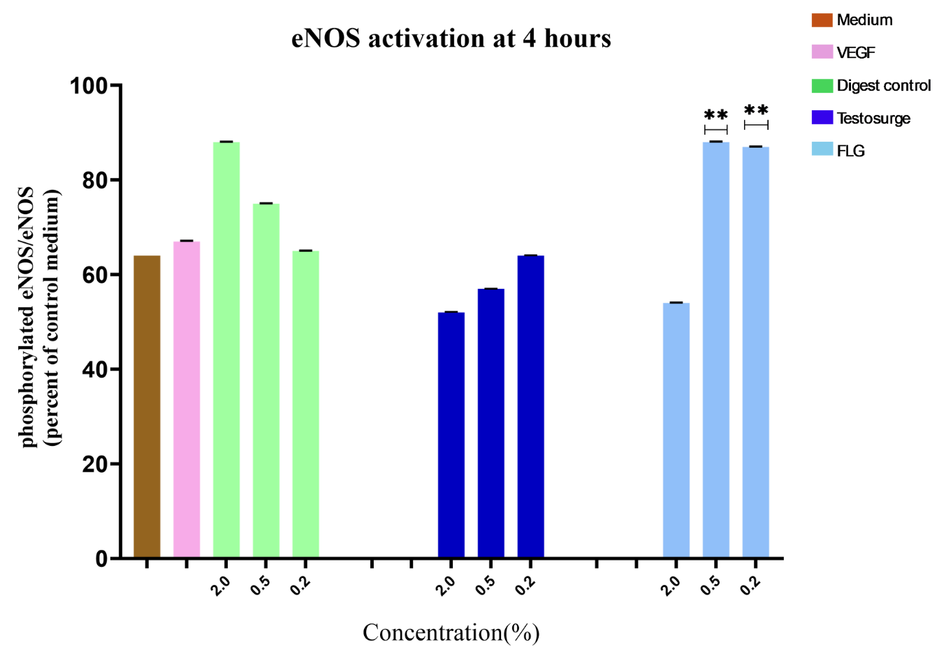
Figure 4: eNOS activation. Relation of P-eNOS/eNOS after 4 hours supplementation with Standardized fenugreek seed digest solutions in HUVEC. Data given as percentage to respective vehicle control. Values given as mean ± SD, n=6. VEGF (20 ng/mL in medium) as positive control. Significances were calculated using Student’s t-test (medium vs. VEGF) or One-way ANOVA and Dunnett’s post test (Digest control vs. test substances). Significances are indicated as *=p<0.05 for Testosurge® and **=p<0.05 for FLG.

5. DISCUSSION
Hypertension is linked to 7.5 million fatalities annually [17,18], it is a critical health issue that requires substantial attention. Reports indicate that over millions of individuals are impacted by hypertension, with an expected rise of 15% to 20% by 2025 [18]. Anti-hypertensive treatments are utilized to avoid complications stemming from chronic hypertension, which can result in severe cardiovascular issues like heart attacks and ischemia, or cardiovascular diseases like strokes or paralysis. Alongside a pharmacological strategy, particularly in prevention and during the initial stages of the illness, natural products may serve as a significant means to hinder disease advancement [19]. Numerous reports highlight the beneficial properties of fenugreek seed extracts, including antioxidant, anti-inflammatory, neuro-protective, and free radical scavenging capabilities, as well as their roles as anti-proliferative agents or in mitigating cellular toxicity caused by chemotherapeutic agents, in addition to their therapeutic effects in managing metabolic syndromes [20] and cardiovascular disease[21], where vasodilating and cardioprotective effects are evident [22,23].
Our results support the initial hypothesis that Standardized fenugreek seed extract enhances NO production by demonstrating a significant, dose-dependent increase in phosphorylation. Results show that a 0.2% concentration of both Standardized fenugreek seed extract stimulates eNOS in HUVECs. This activation occurred rapidly, reaching a peak at 5 minutes and remaining sustained for 4 hours. These findings indicate that the effect of the standardized fenugreek seed extract on eNOS is rapid and sustained. A reduced concentration of 0.2% fenugreek seed extract triggers a reaction. We observed that the elevated concentration of 2% may have caused overlapping cytotoxic effects that could have disrupted the detected eNOS activation, emphasizing the necessity for a careful balance between therapeutic advantage and possible cellular damage.
Our findings indicate that both Standardized fenugreek seed extract can enhance the function of eNOS. Given that eNOS activation is directly associated with heightened Nitric Oxide production, our results indicate that it elevates Nitric Oxide levels in cells. Considering that Nitric Oxide is an essential signaling molecule that induces vasodilation and supports cardiovascular well-being, this temporary activation might yield beneficial, though brief, impacts on blood pressure control and overall vascular performance [24].
Subsequent studies ought to concentrate on multiple essential aspects. Initially, in vivo research is necessary to validate these results in a biological system and to evaluate the prolonged impacts of fenugreek seed extracts both standardized to 80% and 95% Glycosides (Flavonoid and Steroidal Glycosides) respectively, on blood flow, blood pressure and endothelial function. Additionally, a dose-response investigation encompassing a broader spectrum of concentrations is required to more precisely define the threshold for eNOS activation and to evaluate potential cytotoxic effects with greater accuracy. Third, mechanistic investigations are needed to pinpoint the particular molecular targets of fenugreek seed extract responsible for eNOS activation. Ultimately, isolating and analyzing specific phytochemicals in the fenugreek seed extract may assist in identifying the active compounds linked to the noticed effects.

6. Conclusion

In summary, the strong evidence shown in this study highlights that both Standardized fenugreek seed extracts (Testosurge® and FLG), especially abundant in phytochemicals such as flavonoids, steroids provides cardiovascular and antioxidant benefits. The direct stimulation of eNOS, indicated by increased phosphorylation at S1176 and subsequent Nitric Oxide synthesis, is a crucial molecular process through which Standardized fenugreek seed extract alleviates endothelial dysfunction. This dual function of safeguarding against oxidative stress and enhancing Nitric Oxide bioavailability makes Standardized fenugreek seed extract a valuable natural supplement for preventing and managing cardiovascular diseases by directly targeting an essential early aspect of their development. These findings were observed in vitro set-up and additional studies are necessary to convert these results into clinical uses, confirming Standardized fenugreek seed extract’s effectiveness as a supportive treatment for preserving vascular health and managing blood pressure.

Disclaimer (Artificial intelligence)
Author(s) hereby declare that NO generative AI technologies such as Large Language Models (ChatGPT, COPILOT, etc.) and text-to-image generators have been used during the writing or editing of this manuscript.

References

[1] Masana L, Ros E, Sudano I et al (2017) Is there a role for lifestyle changes in cardiovascular prevention? What, when and how. Atheroscler Suppl 26:2–15. https://doi.org/10.1016/S1567- 5688(17)30020-X.
2] Wang Z, Yang Y, Wang Q, Wang L, Zhao Y, Qian X, Feng R, Qian J. Pathological mechanisms and clinical research progress of endothelial dysfunction. Front Cardiovasc Med. 2026 Feb 4;13:1749548. doi: 10.3389/fcvm.2026.1749548. PMID: 41717580; PMCID: PMC12913529.
[3] Kiani AK, Bonetti G, Medori MC, Caruso P, Manganotti P, Fioretti F, Nodari S, Connelly ST, Bertelli M. Dietary supplements for improving nitric-oxide synthesis. J Prev Med Hyg. 2022 Oct 17;63(2 Suppl 3): E239-E245. doi: 10.15167/2421-4248/jpmh2022.63.2S3.2766. PMID: 36479475; PMCID: PMC9710401.
[4] Radomski MW, Palmer RM, Moncada S. The anti-aggregating properties of vascular endothelium: interactions between prostacyclin and nitric oxide. Br J Pharmacol 1987; 92: 639–646.
[5] Alheid U, Frölich JC, Förstermann U. Endothelium-derived relaxing factor from cultured human endothelial cells inhibits aggregation of human platelets. Thromb Res 1987; 47: 561–571.
[6] Tran N, Garcia T, Aniqa M, Ali S, Ally A, Nauli SM. Endothelial Nitric Oxide Synthase (eNOS) and the Cardiovascular System: in Physiology and in Disease States. Am J Biomed Sci Res. 2022;15(2):153-177. Epub 2022 Jan 4. PMID: 35072089; PMCID: PMC8774925.
[7] Corti R, Flammer AJ, Hollenberg NK, Lüscher TF. Cocoa and cardiovascular health. Circulation. 2009; 119: 1433–1441.
[8] Duarte, J., Francisco, V., & Perez-Vizcaino, F. (2014). Modulation of nitric oxide by flavonoids. Food & function, 5(8), 1653–1668. https://doi.org/10.1039/c4fo00144c
[9] Thakurdesai PA, Deshpande PO, Pore MP. Characterization, Preclinical Efficacy and Toxicity Evaluations of Flavonoids Glycosides based Standardized Fenugreek Seed Extract (FEFLG). Pharmacognosy Journal. 2023;15(1):90-105.
[10] Feng, Zhe, et al. "Grape seed extract enhances eNOS expression and NO production through regulating calcium‐mediated AKT phosphorylation in H2O2‐treated endothelium." Cell biology international 34.10 (2010): 1055-1061.
[11] Iqbal I, Wilairatana P, Saqib F, Nasir B, Wahid M, Latif MF, Iqbal A, Naz R, Mubarak MS. Plant Polyphenols and Their Potential Benefits on Cardiovascular Health: A Review. Molecules. 2023 Sep 1;28(17):6403. doi: 10.3390/molecules28176403. PMID: 37687232; PMCID: PMC10490098.
[12] Edirisinghe, Indika, Britt Burton-Freeman, and C. Tissa Kappagoda. "Mechanism of the endothelium-dependent relaxation evoked by a grape seed extract." Clinical science 114.4 (2008): 331-337.
[13] Sun S, Yu Y, Jo Y, Han JH, Xue Y, Cho M, Bae SJ, Ryu D, Park W, Ha KT, Zhuang S. Impact of extraction techniques on phytochemical composition and bioactivity of natural product mixtures. Front Pharmacol. 2025 Jul 30;16:1615338. doi: 10.3389/fphar.2025.1615338. PMID: 40808686; PMCID: PMC12343529.
[14] Schmitt, C.A.; Dirsch, V.M. Modulation of endothelial nitric oxide by plant-derived products. Nitric. Oxide 2009, 21, 77–91.
[15] Gerstgrasser, A.; Röchter, S.; Dressler, D.; Schön, C.; Reule, C.; Buchwald-Werner, S. In Vitro Activation of eNOS by Mangifera indica (Careless™) and Determination of an Effective Dosage in a Randomized, Double-Blind, Human Pilot Study on Microcirculation. Planta Medica 2015, 82, 298–304.
[16] Wojtunik-Kulesza, K.; Oniszczuk, A.; Oniszczuk, T.; Combrzy ´nski, M.; Nowakowska, D.; Matwijczuk, A. Influence of In Vitro Digestion on Composition, Bioaccessibility and Antioxidant Activity of Food Polyphenols-A Non-Systematic Review. Nutrients 2020, 12, 1401.
[17] Mills KT, Stefanescu A, He J. The global epidemiology of hypertension. Nat Rev Nephrol. 2020 Apr;16(4):223-237. doi: 10.1038/s41581-019-0244-2. Epub 2020 Feb 5. PMID: 32024986; PMCID: PMC7998524.
[18] Paul G. Hunter, Fiona A. Chapman, Neeraj Dhaun,Hypertension: Current trends and future perspectives. BJCP 2021 March. https://doi.org/10.1111/bcp.14825
[19] Wani-Parekh, P.; Blanco-Garcia, C.; Mendez, M.; Mukherjee, D. Guide of Hypertensive Crisis Pharmacotherapy. Cardiovasc. Hematol. Disord. Drug Targets 2017, 17, 52–57.
[20] Szabó K, Gesztelyi R, Lampé N, Kiss R, Remenyik J, Pesti-Asbóth G, Priksz D, Szilvássy Z, Juhász B. Fenugreek (Trigonella Foenum-Graecum) Seed Flour and Diosgenin Preserve Endothelium-Dependent Arterial Relaxation in a Rat Model of Early-Stage Metabolic Syndrome. Int J Mol Sci. 2018 Mar 10;19(3):798. doi: 10.3390/ijms19030798. PMID: 29534453; PMCID: PMC5877659.
[21] Faisal Z, Irfan R, Akram N, Manzoor HMI, Aabdi MA, Anwar MJ, Khawar S, Saif A, Shah YA, Afzaal M, Desta DT. The multifaceted potential of fenugreek seeds: From health benefits to food and nanotechnology applications. Food Sci Nutr. 2024 Jan 10;12(4):2294-2310. doi: 10.1002/fsn3.3959. PMID: 38628211; PMCID: PMC11016425.
[22] Olaiya, Charles Ojo, and Kehinde Olugboyega Soetan. "A review of the health benefits of fenugreek (Trigonella foenum-graecum L.): Nutritional, Biochemical and pharmaceutical perspectives." Am. J. Soc. Issues Humanit 4 (2014): 3-12.
[23] Naidu MM Shyamala BN Naik JP Sulochanamma G and Srinivas P. Chemical composition and antioxidant activity of the husk and endosperm of fenugreek seeds. LWTFood Sci and Technol. 2011; 44: 451-456.
[24] Pryor, W. A., & Squadrito, G. L. (1995). The chemistry of peroxynitrite: a product from the reaction of nitric oxide with superoxide. American Journal of Physiology-Lung Cellular and Molecular Physiology, 268(5), L699-L722.

