Original Research Article
Dietary Supplement Use and Determinants Among
Physically Active Young Adults Aged 18-35 Years

Abstract:
The growing emphasis on fitness and body consciousness has contributed to increased dietary supplement use among physically active young adults. This cross-sectional analytical study aimed to assess the prevalence of dietary supplement consumption and examine demographic and exercise related determinants among physically active individuals aged 18–35 years in Lucknow, Uttar Pradesh. A total of 100 participants (75 males and 25 females) engaged in structured exercise at least three times per week for a minimum of three months were selected using convenience sampling. Data were collected through a structured self-administered questionnaire covering sociodemographic characteristics, anthropometric profile, exercise patterns, supplement use, motivations and risk perception. Body Mass Index was calculated using standard criteria and data were analyzed using SPSS. Findings revealed that 32% of participants reported regular supplement use and 9% reported occasional use, while 59% did not consume supplements. Whey protein was the most commonly consumed supplement. The primary motivations for use were muscle recovery and muscle growth. Supplement consumption was more prevalent among individuals engaged in strength training and those exercising more than five times per week. A statistically significant association was observed between gender and supplement use, with males demonstrating higher consumption compared to females (χ² = 11.677, p = .003). The findings indicate that supplement use is influenced by both physiological demands and sociocultural factors, with notable variability in perceptions regarding its necessity. These results highlight the need for targeted awareness and professional nutritional guidance to promote safe, rational, and evidence-based supplement use among physically active young adults.
Keywords: dietary supplement, athletes, muscle recovery, exercise behavior, nutrition practices, exercise.
Introduction:
In recent years, the increasing emphasis on health, fitness and body consciousness has markedly influenced the lifestyle choices of young adults, particularly those who engage in regular physical activity. Participation in gym activities, recreational sports and structured workout routines has become increasingly prevalent. Simultaneously, the use of dietary supplements has become almost routine within many fitness communities (Knapik et al., 2016; Garthe & Maughan, 2018). For numerous physically active young adults, supplements are no longer perceived as optional additions but as essential components for achieving fitness, aesthetic or performance-related objectives (Backhouse et al., 2013; Aljaloud et al., 2013). Dietary supplements encompassing vitamins and minerals, protein powders, amino acids, ergogenic aids and herbal preparations are widely accessible in convenient forms such as tablets, capsules and powders. While their original purpose was to address nutrient deficiencies or support specific health needs, they are now frequently marketed as tools for muscle gain, fat loss, enhanced endurance and expedited recovery (Maughan et al., 2018; Verma et al., 2024). What was once predominantly associated with elite athletes has now become deeply integrated into the everyday routines of recreationally active individuals (Bianco et al., 2011; Froiland et al., 2004).
Research conducted across various countries consistently indicates that individuals who engage in physical activity are more likely to utilize supplements compared to the general population (Burnett et al., 2017; Knapik et al., 2016), although the extent and patterns of usage differ across contexts (Baltazar-Martins et al., 2019; Huang et al., 2006). Young adults involved in resistance training and high-intensity workouts frequently report elevated consumption of protein-based and performance-enhancing products (Bianco et al., 2011; Giannopoulou et al., 2013).
However, quantifying the number of individuals using supplements only partially addresses the issue. It is equally crucial to investigate the underlying reasons for their use and the factors influencing these decisions. Supplement consumption is influenced by a combination of demographic characteristics, lifestyle behaviors and psychosocial factors (Backhouse et al., 2013; Wiens et al., 2014). Gender differences are commonly observed, with men showing a greater propensity for muscle-building or ergogenic products, while women are more inclined towards micronutrients or weight management supplements (Sharma, 2020; Darvishi et al., 2013). Factors such as educational attainment, type and intensity of exercise, health awareness and exposure to fitness-related content also play significant roles (Froiland et al., 2004; Wiens et al., 2014). Motivations often extend beyond medical necessity, encompassing aspirations for improved physique, enhanced performance, expedited recovery and overall well-being (Baltazar-Martins et al., 2019; Joseph et al., 2018). Peer influence, guidance from trainers and exposure to social media platforms further contribute to shaping beliefs regarding the necessity and efficacy of these products (Backhouse et al., 2013; Sankar & Khan, 2024).
Although certain dietary supplements, when consumed judiciously and supported by robust scientific evidence, may confer physiological benefits (Maughan et al., 2018), their unsupervised or excessive use presents significant public health concerns. Potential risks include micronutrient overconsumption, product adulteration or contamination, adverse metabolic or gastrointestinal effects and the inadvertent substitution of supplements for nutritionally adequate diets (Knapik et al., 2016; Sobal & Marquart, 1994). The rapid commercialization and aggressive marketing of these products often surpass the dissemination of evidence-based guidance, thereby influencing young adults to rely on non-professional sources of information (Froiland et al., 2004; Joseph et al., 2018).
The usage of dietary supplements varies significantly across different types of physical activities and exhibits distinct gender-wise patterns. In resistance training and bodybuilding, protein powders, amino acids, and ergogenic aids are predominantly favored, particularly among men aiming for muscle hypertrophy and strength enhancement ( Mazzilli et al., 2021). Conversely, endurance athletes often prioritize supplements such as electrolytes, vitamins, and minerals to support sustained performance and recovery (Maughan et al., 2018; Garthe & Maughan, 2018). Gender differences manifest in supplement preferences and motivations; men typically lean toward muscle-building and performance-enhancing products, while women more frequently use micronutrient supplements, weight management aids, and general health boosters (Wiens et al., 2014; Baltazar-Martins et al., 2019). These variations are influenced by physiological demands of specific activities, sociocultural expectations, and targeted marketing strategies (Knapik et al., 2016; Garthe & Maughan, 2018). Understanding these nuanced patterns requires examining the intersection of exercise modality, gender-specific goals, and behavioral factors shaping supplement consumption.
Despite growing scholarly attention, existing research has predominantly centered on elite athletic populations (Maughan et al., 2018; Baltazar-Martins et al., 2019), resulting in comparatively limited evidence regarding recreationally active young adults. Furthermore, much of the literature remains descriptive, focusing primarily on prevalence estimates without sufficiently examining the sociocultural, behavioral and demographic determinants that shape supplement use practices (Garthe & Maughan, 2018; Chandana et al., 2023). This gap restricts a comprehensive understanding of the contextual drivers influencing consumption patterns. Accordingly, there is a need for analytically comprehensive investigations that move beyond prevalence to explore the multifactorial determinants of supplement use within this population. Generating such evidence is critical to informing targeted educational strategies, strengthening risk communication frameworks and guiding policy initiatives aimed at promoting safe, evidence-based and rational supplement practices among physically active young adults.

Materials and Methods
Study Design
A cross-sectional analytical study was conducted among physically active young adults in BBAU Lucknow, Uttar Pradesh. The study aimed to estimate the prevalence of dietary supplement use and identify demographic, anthropometric and exercise-related determinants associated with supplementation behavior. Data were collected from fitness centers and recreational exercise facilities over a defined study period.
Study Population
The study population comprised men and women aged 18–35 years who were engaged in structured physical activity at least three times per week for the preceding three months. Physically active individuals were targeted to ensure relevance to supplement consumption practices commonly associated with exercise participation.
Study Period:
The time taken for the study was 8 months that is from October 2024 to May 2025.

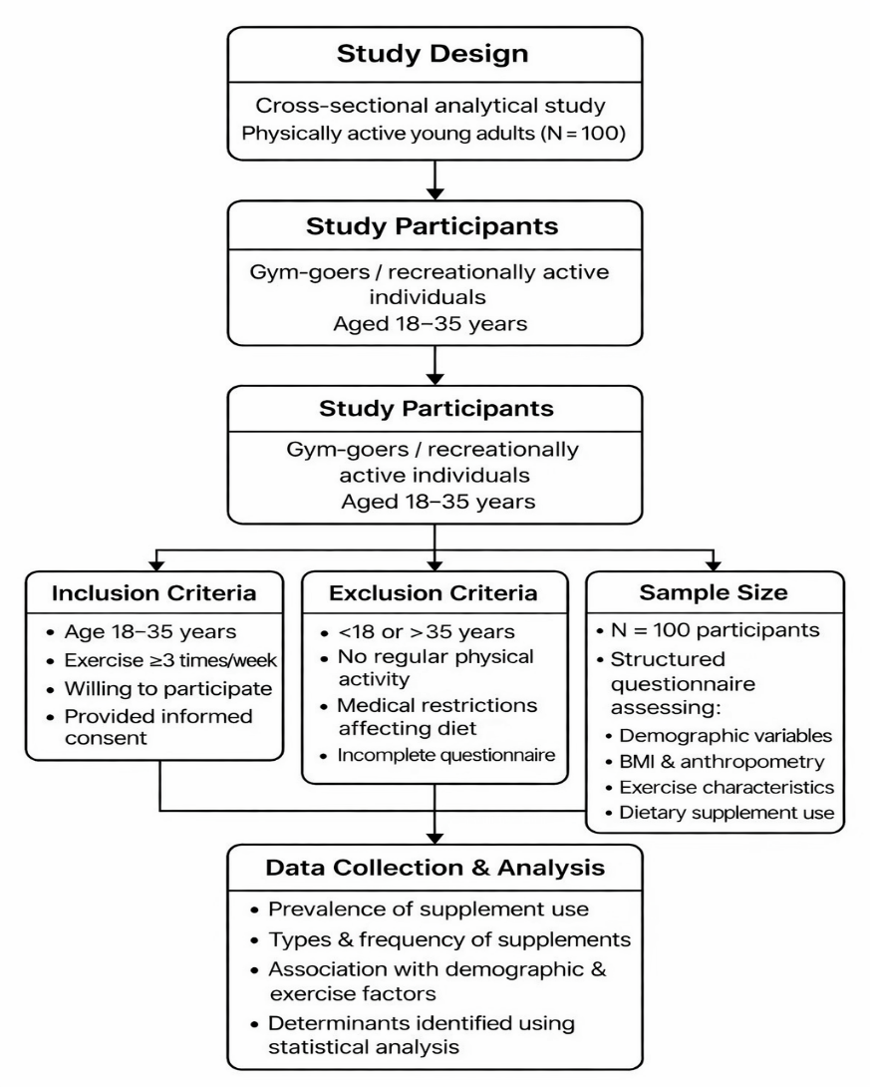
Sample Size and Sampling
A total of 100 participants (75 males and 25 females) were included in the analysis. Participants were recruited using a non-probability convenience sampling approach from gymnasiums and exercise settings. The sample size was considered adequate to estimate supplement use prevalence and explore associated factors within the study population.
Table 1. Inclusion and Exclusion Criteria
Inclusion Criteria  (Participants were eligible if they) | Exclusion Criteria  (Participants were excluded if they)
- Were aged 18–35 years. | - Were <18 or >35 years.
- Engaged in regular structured exercise (≥3 sessions per week). | - Did not participate in regular physical activity.
- Had maintained physical activity for at least three months. | - Had medical conditions limiting diet or exercise.
- Completed the questionnaire in full. | - Submitted incomplete questionnaires.

Data Collection
Data were collected using a structured questionnaire developed following a review of literature on dietary supplement use among physically active populations. The instrument consisted of five domains:
1. Sociodemographic and Socioeconomic Characteristics
Information on age, gender, educational attainment, residential status and socioeconomic category (lower, middle, upper) was obtained.
2. Anthropometric Assessment
Participants self-reported height and weight. Body Mass Index (BMI) was calculated using the Quetelet formula (kg/m²) and categorized according to World Health Organization criteria as underweight (<18.5), normal weight (18.5–24.9), overweight (25.0–29.9), and obese (≥30.0).
3. Physical Activity Profile
Data regarding exercise frequency, duration per session, type of training (e.g., resistance, aerobic, mixed) and primary fitness goals were recorded.
4. Dietary Supplement Use
Participants were asked about:
- Current or recent supplement use.
- Types of supplements consumed.
- Frequency and duration of use.
- Motivations for supplementation
Dietary supplement use was operationally defined as the consumption of any product intended to enhance performance, recovery or general health beyond habitual dietary intake.
5. Knowledge and Risk Perception
Selected items assessed awareness regarding appropriate use, potential benefits and possible risks associated with supplementation.
Data Collection Procedure
Eligible participants were informed about the study objectives and procedures. After obtaining written informed consent, questionnaires were administered in person. Participation was voluntary and confidentiality of responses was maintained throughout the study.
Statistical Analysis
Data were entered into Microsoft Excel and analyzed using SPSS.
Results and Discussion:
The following section presents the distribution and patterns of dietary supplement use among physically active young adults. It outlines the overall prevalence, commonly consumed supplement types and key motivations for use. Additionally, associations between supplement consumption and variables such as type of exercise, gender, and training frequency are examined to understand behavioral trends within the study population.
Prevalence of Dietary Supplement Use
This shows that (Fig.1) most participants (59%) reported that they do not consume dietary supplements, while 32% indicated regular use and 9% reported occasional use. This suggests that although supplementation is present among a considerable portion of the sample, it is not a universal practice. The findings reflect a mixed behavioral pattern, where a significant group integrates supplements into their routine, while the majority rely primarily on their regular diet and training practices without consistent supplementation.

Figure 1. Prevalence of Dietary Supplement Use
Categories of Dietary Supplements Consumed Among Study Participants
This (Fig.2) illustrates the distribution of supplement types among participants. The majority reported not using any supplement, while whey protein emerged as the most commonly consumed supplement among users. Creatine and combination use (protein with creatine) were reported by a smaller proportion, whereas casein protein and other supplements were least preferred. This pattern suggests that protein-based supplementation, particularly whey protein, dominates supplement choices among active individuals, while specialized or alternative supplements are comparatively less utilized.
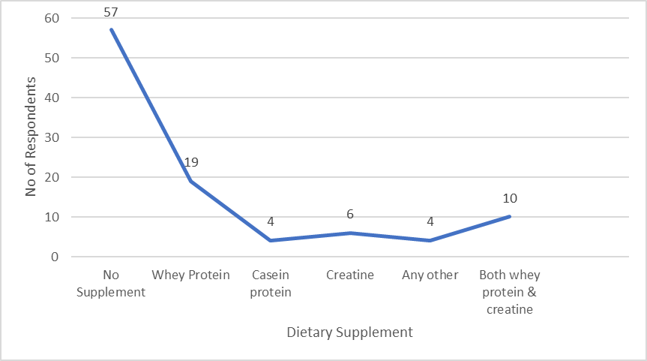
Figure 2. Categories of Dietary Supplements Consumed Among Study Participants
Motivations for Supplement Use
This illustrates (Fig.3) that muscle recovery is the most commonly reported benefit (highest frequency, around 35 respondents), followed by muscle growth (around 20 respondents). Other benefits such as both muscle recovery & muscle growth, weight loss/fat burning and refueling glycogen stores were reported by a moderate number of participants. Very few respondents selected hydration, any other or gave no response.
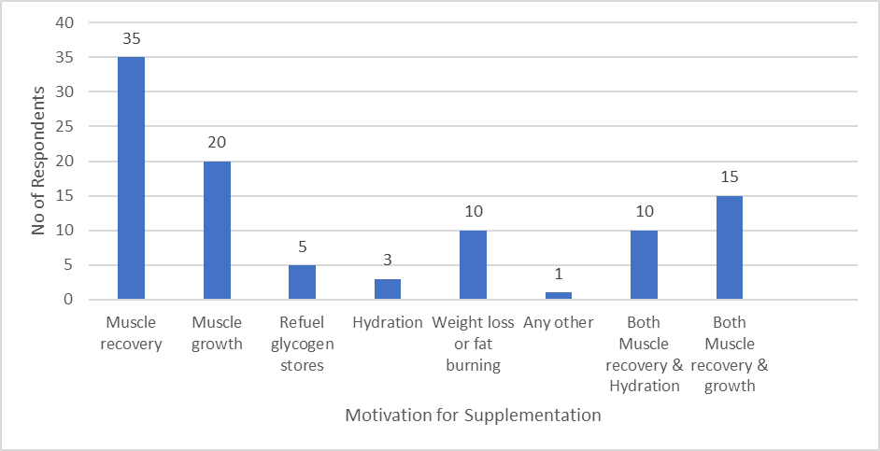Figure 3. Motivations for Supplement Use
Supplement Use Across Type of Exercise
The findings (Table 2) indicate that strength training participants reported the highest consumption of supplements, particularly protein powders, compared to other exercise groups. A considerable number of individuals engaged in cardio activities also reported supplement use, though to a lesser extent participants involved in sports, yoga/pilates and mixed exercise types showed comparatively lower and more varied supplement consumption patterns. A small proportion of respondents did not specify their exercise type. Overall, the data suggest that supplement consumption is more common among individuals engaged in strength-based training, possibly reflecting their focus on muscle recovery and growth.
Table 2 Supplement Use Across Type of Exercise
 |  | Consumption of Supplement (e.g. protein powder)
 |  | Yes | No | Sometimes
Type of exercise primarily engaged in. | 1.Cardio (running, cycling etc.) | 6 | 10 | 1
Type of exercise primarily engaged in. | 2.Strength training | 14 | 26 | 6
Type of exercise primarily engaged in. | 3.Sports | 4 | 8 | 0
Type of exercise primarily engaged in. | 4.Yoga/Pilates | 1 | 4 | 1
Type of exercise primarily engaged in. | Any Other | 1 | 6 | 1
Type of exercise primarily engaged in. | Both 1 & 3 | 1 | 1 | 0
Type of exercise primarily engaged in. | Both 2 & 4 | 1 | 1 | 0
Type of exercise primarily engaged in. | Both 2 & 3 | 1 | 1 | 0
Type of exercise primarily engaged in. | Both 1& 2 | 3 | 1 | 0
Supplement Use Across Gender
A Chi-square test of independence (Table 3 & 3.1) was conducted to examine the association between gender and supplement consumption. The results revealed a statistically significant association between the two variables (χ² = 11.677, df = 2, p = .003). Male participants were more likely to report consuming supplements compared to female participants. While a considerable proportion of males reported regular or occasional use, the majority of females indicated that they did not consume supplements. These findings suggest that gender plays a significant role in influencing supplementation behavior among physically active young adults.
Table 3 Supplement Use Across Gender
 |  | Supplement Consumption |  |  | Total
 |  | Yes | No | Sometimes | Total
Gender | Male | 30 | 37 | 8 | 75
Gender | Female | 2 | 22 | 1 | 25
Total |  | 32 | 59 | 9 | 100

Table 3.1 Chi-Square Test
 | Value | df | p value
Pearson Chi- Square | 11.677ª | 2 | .003

Supplement Use Across Training Frequency
This indicates (Table 4) most participants (59%) did not consume supplements, while 32% reported use and 9% used them occasionally. Supplement use was relatively higher among those training more than five times per week (16 out of 46) and 3-4 times per week (9 out of 28). In contrast, fewer participants who exercised less frequently or never exercised reported lesser supplement use. Overall, non-consumption was common across all training frequencies.
Table 4 Supplement Use Across Training Frequency
 |  | Supplement Consumption |  |  | Total
 |  | Yes | No | Sometimes | Total
Frequency of Training Per Week | 1-2 times | 4 | 5 | 1 | 10
Frequency of Training Per Week | 3-4 times | 9 | 16 | 3 | 28
Frequency of Training Per Week | More than 5 times | 16 | 27 | 3 | 46
Frequency of Training Per Week | I do exercise regularly | 2 | 9 | 2 | 13
Frequency of Training Per Week | Never | 1 | 2 | 0 | 3
Total |  | 32 | 59 | 9 | 100

Discussion
The present study investigated dietary supplement consumption among physically active young adults and found that while supplementation was practiced by a substantial proportion of participants, it was not universally adopted. Approximately one-third of participants reported regular supplement use, while a smaller proportion reported occasional use and the majority did not consume supplements. This pattern is consistent with previous cross-sectional studies among gym users and fitness practitioners, which reported that supplement consumption, although common, varies considerably across individuals depending on training intensity, awareness and personal fitness goals (Jawadi et al., 2017; Mazzilli et al., 2021). Similarly, Joseph et al. (2018) reported that not all physically active individuals in Indian populations use supplements, indicating selective adoption rather than universal dependence. However, the proportion of supplement users observed in the present study appears slightly lower than that reported in some international athlete populations, where supplement use prevalence exceeded 50%, possibly due to differences in competitive level, training demands and exposure to nutritional guidance (Knapik et al., 2016). This comparison suggests that supplementation practices may be more prevalent among competitive athletes than recreationally active individuals.
Protein-based supplements, particularly whey protein, emerged as the most commonly consumed supplements in the present study. This finding is consistent with previous studies reporting protein supplements as the most frequently used ergogenic aids among athletes, fitness practitioners and university students (Ficarra et al., 2022; Qudah et al., 2025). Similarly, Jovanov et al. (2019) and Moradi et al. (2024) reported that protein supplements were preferred due to their established role in enhancing muscle recovery, muscle protein synthesis and performance adaptation. These findings align with physiological evidence highlighting the importance of protein intake in supporting muscle hypertrophy and recovery among individuals engaged in resistance training. In comparison, creatine and combination supplements were less frequently used in the present study, which is consistent with previous reports indicating that although creatine is an effective ergogenic aid, its use is generally lower than protein supplementation due to limited awareness, safety concerns or specific training objectives (De Zan et al., 2025).
Exercise characteristics were also significantly associated with supplementation behavior. Participants engaged in strength-based training reported higher supplement use compared to those involved in cardio-based exercise, sports or yoga. This finding is consistent with previous research demonstrating that individuals engaged in resistance training are more likely to consume protein and ergogenic supplements due to increased muscle repair and adaptation demands (Mazzilli et al., 2021; Moradi et al., 2024). Similarly, participants exercising more than five times per week demonstrated greater supplement use, which aligns with findings reported by Čaušević et al. (2025) and Gimbar et al. (2025), who observed that increased training frequency was positively associated with supplement consumption. However, the present study also identified supplement use among individuals with lower training frequency, which is comparable to findings by Jagim et al. (2023), suggesting that supplementation behavior is influenced not only by physiological demands but also by psychological factors, marketing exposure and perceived performance benefits.
A statistically significant association between gender and supplement use was observed, with males demonstrating higher supplement consumption compared to females. This finding is consistent with previous systematic reviews and cross-sectional studies reporting greater supplement use among male athletes and fitness participants (Knapik et al., 2016; Mazzilli et al., 2021). Similarly, Moradi et al. (2024) and Jovanov et al. (2019) reported that males were more likely to consume protein and performance-enhancing supplements due to greater emphasis on muscle hypertrophy and strength development. Comparable gender differences have also been reported in Indian populations, where male participants demonstrated higher supplement consumption compared to females (Joseph et al., 2018). These gender differences may be attributed to sociocultural influences, differing fitness goals and targeted marketing strategies that promote muscle-building supplements primarily toward male consumers.
Overall, the findings of the present study are consistent with existing literature demonstrating that dietary supplement use among physically active individuals is influenced by training characteristics, gender and performance-related motivations. However, compared to studies involving competitive athletes, the overall supplement use observed in the present study was relatively moderate, possibly reflecting differences in athletic level, access to professional nutritional guidance and awareness. These findings support previous evidence indicating that supplementation behavior is multifactorial and influenced by physiological demands, fitness goals, knowledge and sociocultural factors (De Zan et al., 2025; Jagim et al., 2023). The present study contributes to the existing literature by providing further evidence on supplement consumption patterns among physically active young adults and highlights the need for evidence-based nutritional education to promote safe and appropriate supplement use.

Conclusion
This study assessed the prevalence of dietary supplement use and examined demographic and exercise-related determinants among physically active young adults aged 18–35 years. The findings revealed that dietary supplement consumption was present in a considerable proportion of participants, with approximately one-third reporting regular use, while the majority did not consume supplements. Protein supplements, particularly whey protein, were the most commonly used products, primarily motivated by muscle recovery and muscle growth. Supplement use was significantly associated with gender, with male participants demonstrating higher consumption compared to females. Higher prevalence was also observed among individuals engaged in strength training and those exercising more frequently, indicating that exercise modality and training intensity influence supplementation behavior. These findings confirm that supplement use is shaped by a combination of physiological demands, fitness goals and behavioral factors.
Overall, the study highlights the need for evidence-based nutrition education and professional guidance to promote safe, rational, and informed supplement use among physically active young adults. Such interventions are essential to ensure that supplementation practices complement balanced dietary intake rather than substitute for adequate nutrition.
Competing Interests: None
Disclaimer (Artificial intelligence)
Author(s) hereby declare that NO generative AI technologies such as Large Language Models (ChatGPT, COPILOT, etc.) and text-to-image generators have been used during the writing or editing of this manuscript.

Reference
Aljaloud, S. O., & Ibrahim, S. A. (2013). Use of dietary supplements among professional athletes in Saudi Arabia. Journal of nutrition and metabolism, 2013(1), 245349.
Backhouse, S. H., Whitaker, L., & Petróczi, A. (2013). Gateway to doping? Supplement use in the context of preferred competitive situations, doping attitude, beliefs, and norms. Scandinavian journal of medicine & science in sports, 23(2), 244-252.
Baltazar-Martins, G., Brito de Souza, D., Aguilar-Navarro, M., Muñoz-Guerra, J., Plata, M. D. M., & Del Coso, J. (2019). Prevalence and patterns of dietary supplement use in elite Spanish athletes. Journal of the International Society of Sports Nutrition, 16(1), 30.
Bianco, A., Mammina, C., Paoli, A., Bellafiore, M., Battaglia, G., Caramazza, G., ... & Jemni, M. (2011). Protein supplementation in strength and conditioning adepts: knowledge, dietary behavior and practice in Palermo, Italy. Journal of the International Society of Sports Nutrition, 8(1), 25.
Burnett, A. J., Livingstone, K. M., Woods, J. L., & McNaughton, S. A. (2017). Dietary supplement use among Australian adults: Findings from the 2011–2012 national nutrition and physical activity survey. Nutrients, 9(11), 1248.
Čaušević, D., Alexe, C. I., Čović, N., Panaet, E. A., Abazović, E., Todor, R. M., ... & Alexe, D. I. (2025). Supplement use among athletes: Insights from gyms in Sarajevo. Applied Sciences, 15(9), 4747.
Chandana, K. N., Syeda, F. S., Pallavi, R., & Veena, B. M. (2023). Comparative study on nutrition knowledge and consumption of dietary supplements among athletes and fitness practitioners. International Journal of Health & Allied Sciences, 12(1), 16-21.
Darvishi, L., Askari, G., Hariri, M., Bahreynian, M., Ghiasvand, R., Ehsani, S., ... & Khorvash, F. (2013). The use of nutritional supplements among male collegiate athletes. International journal of preventive medicine, 4(Suppl 1), S68.
De Zan, D., Eletti, F., Fiore, G., Di Girolamo, E., Bozzini, G. G. M., Perico, V., ... & Verduci, E. (2025). Use of Nutritional Strategies, Bioactive Compounds, and Dietary Supplements in Young Athletes: From Evidence to Potential Risks—A Narrative Review. Nutrients, 17(13), 2194.
Ficarra, G., Rottura, M., Irrera, P., Bitto, A., Trimarchi, F., & Di Mauro, D. (2022). Use of drugs and dietary supplements in university students of sports science: results of a survey-based cross-sectional study. Nutrients, 14(20), 4267.
Froiland, K., Koszewski, W., Hingst, J., & Kopecky, L. (2004). Nutritional supplement use among college athletes and their sources of information. International journal of sport nutrition and exercise metabolism, 14(1), 104-120.
Garthe, I., & Maughan, R. J. (2018). Athletes and supplements: prevalence and perspectives. International journal of sport nutrition and exercise metabolism, 28(2), 126-138.
Giannopoulou, I., Noutsos, K., Apostolidis, N., Bayios, I., & Nassis, G. P. (2013). Performance level affects the dietary supplement intake of both individual and team sports athletes. Journal of sports science & medicine, 12(1), 190.
Gimbar, M., Samavat, H., Hamilton, K. P., Ziegler, J., Wardenaar, F., Esopenko, C., & Byham-Gray, L. (2025). Predictors of third-party tested nutritional supplementation use among DI and DIII student-athletes at a northeast university. Journal of Dietary Supplements, 22(2), 310-328.
Huang, S. H. S., Johnson, K., & Pipe, A. L. (2006). The use of dietary supplements and medications by Canadian athletes at the Atlanta and Sydney Olympic Games. Clinical Journal of Sport Medicine, 16(1), 27-33.
Jagim, A. R., Harty, P. S., Erickson, J. L., Tinsley, G. M., Garner, D., & Galpin, A. J. (2023). Prevalence of adulteration in dietary supplements and recommendations for safe supplement practices in sport. Frontiers in Sports and Active Living, 5, 1239121.
Jawadi, A. H., Addar, A. M., Alazzam, A. S., Alrabieah, F. O., Al Alsheikh, A. S., Amer, R. R., ... & Badri, M. (2017). Prevalence of dietary supplements use among gymnasium users. Journal of nutrition and metabolism, 2017(1), 9219361.
Joseph, N., Kumar, A., Singh, H., Shaheen, M., Das, K., & Shrivastava, A. (2018). Nutritional supplement and functional food use among medical students in India. Journal of Dietary Supplements, 15(6), 951-964.
Jovanov P, et al. (2019). Prevalence, knowledge and attitudes towards sports supplements among young athletes. Journal of the International Society of Sports Nutrition.
(Supports protein supplements as most common)
Knapik, J. J., Steelman, R. A., Hoedebecke, S. S., Austin, K. G., Farina, E. K., & Lieberman, H. R. (2016). Prevalence of dietary supplement use by athletes: systematic review and meta-analysis. Sports Medicine, 46(1), 103-123.
Maughan, R. J., Burke, L. M., Dvorak, J., Larson-Meyer, D. E., Peeling, P., Phillips, S. M., ... & Engebretsen, L. (2018). IOC consensus statement: dietary supplements and the high-performance athlete. International journal of sport nutrition and exercise metabolism, 28(2), 104-125.
Mazzilli, M., Macaluso, F., Zambelli, S., Picerno, P., & Iuliano, E. (2021). The use of dietary supplements in fitness practitioners: A cross-sectional observation study. International journal of environmental research and public health, 18(9), 5005.
Moradi, F., Yazdani, A., Nematolahi, F., Hosseini-Roknabadi, S. M., & Sharifi, N. (2024). Prevalence of supplement usage and related attitudes and reasons among fitness athletes in the gyms of Kashan and its relationship with feeding behavior: a cross-sectional study. BMC Sports Science, Medicine and Rehabilitation, 16(1), 150.
Qudah, T., Iqbal, S., Absi, H. A., Sanal, S., Elkoumi, A., Fino, L., & Abumweis, S. (2025). Assessment of the University Students’ Knowledge, Attitudes, and Use of Protein Supplements: A Cross‐Sectional Study From the United Arab Emirates. Journal of Nutrition and Metabolism, 2025(1), 5582105.
Sankar, K. K., & Khan, M. A. (2024). IJCM_166A: A cross sectional study to assess knowledge, attitude and practices about dietary supplements among gym going medical students. Indian Journal of Community Medicine, 49(Suppl 1), S48-S49.
SHARMA, D. (2020). STUDIES ON QUALITY ASSESSMENT OF SPORTS NUTRITION FORMULARY (Doctoral dissertation, CHAUDHARY SARWAN KUMAR HIMACHAL PRADESH KRISHI VISHVAVIDYALAYA).
Sobal, J., & Marquart, L. F. (1994). Vitamin/mineral supplement use among athletes: a review of the literature. International Journal of Sport Nutrition and Exercise Metabolism, 4(4), 320-334.
Verma, N. K., Singh, A. K., Rao, P. K., Singh, S., Mishra, S., & Singh, J. (2024). Dietary Supplements and Its Health Benefits: An Overview. Sch Acad J Pharm, 5, 181-188.
Wiens, K., Erdman, K. A., Stadnyk, M., & Parnell, J. A. (2014). Dietary supplement usage, motivation, and education in young Canadian athletes. International journal of sport nutrition and exercise metabolism, 24(6), 613-622.

