Original Research article

NEW DISTRIBUTIONAL RECORD OF THE FRESHWATER PHYLACTOLAEMATE BRYOZOAN RUMARCANELLA HIMALAYANA ANNANDALE, 1911 FROM SATHYAMANGALAM TIGER RESERVE, ERODE DISTRICT, TAMIL NADU, INDIA.

.
ABSTRACT
.
A new distributional record of the of Phylactolaemate Bryozoan Rumarcanella himalayana Annandale, 1911is described from the Sathyamangalam Tiger Reserve of Western Ghats of Tamil Nadu, India. The zooplankton samples were collected by extensive survey undertaken by the scientific team of Zoological Survey of India, Southern Regional Centre, Chennai, Tamil Nadu from the various waterbodies of Sathyamangalam Tiger Reserve, Erode district, Tamil Nadu during the year 2023 as a part of the Annual Programme of Research Work. The family Plumatellidae Allman, 1856 is poorly studied in India and is represented by four genera viz. Plumatella Lamarck, 1816, Hyalinella Jullien, 1885, Rumarcanella Hirose and Mawatari, 2011 and Swarupella Shrivastava, 1981. The genus Rumarcanella Hirose and Mawatari, 2011 is represented by five species from India viz. Rumarcanella vorstmani (Toriumi, 1952) Rumarcanella indica Annandale, 1909 which were later synonimysed as Rumarcanella himalayana (Annandale, 1911), Rumarcanella gusuku Hirose & Mawatari, 2011 and Rumarcanella yanbaruensis Hirose & Mawatari, 2011. There are only few studies on the freshwater bryozoans from the state of Tamil Nadu. The present study reports for the first time one species of bryozoan from the Western Ghats of Tamil Nadu especially from the Western Ghats. The presence of the floatoblasts in the zooplankton samples from Sathyamangalam Tiger Reserve represents a significant contribution by extending the geographical distribution range of Rumarcanella himalayana, a freshwater bryozoan previously unrecorded in the Western Ghats of India. The present discovery of this species in the Sathyamangalam Tiger Reserve adds valuable data to the biodiversity of the ecologically rich Western Ghats and also provides information into the role of these organisms as bioindicators in freshwater ecosystems. Furthermore, the present report highlights the need for further exploration and taxonomic studies on freshwater bryozoa which remains underexplored in Western Ghats of India, will paves the way for future investigations into their ecological and environmental significance.

Keywords: Bryozoa, Rumarcanella, Sathyamangalam Tiger Reserve, Western Ghats of Tamil Nadu, India.

- INTRODUCTION

The Ectoprocta (Bryozoa) are minute, sessile, colonial unsegmented coelomate animals. They inhabits every type of freshwater habitats such as ponds, lakes, rivers and estuaries (Okland & Okland 2005; Massard & Geimer, 2008). Bryozoans have a great potential for spreading, mainly because of the ability to produce statoblasts. Statoblasts are very small and numerous dormant asexual bodies (Wood & Okamura, 2005) that are highly resistant to unfavourable environmental conditions. The systematic studies of freshwater Bryozoa from India have been studied in detail only from few areas. The freshwater Bryozoans are common in India which occurs among the aquatic vegetation and algal mats and few are planktonic. Studies on the family Plumatellidae, and freshwater bryozoans (Phylactolaemata) in general, are notably scarce in India despite high potential biodiversity. They are the ignored fauna as they are non-charismatic. As the colonies look similar, the accurate identification is mainly based on the morphology of Statoblasts which can be done through advanced techniques such as SEM and molecular techniques which are limitedly available for freshwater studies and the scarcity of literature are some of the reasons for the lack of studies on the family Plumatellidae in India. The taxonomists who are working in this group are become rare and most of the earlier workers are superannuated. These are the reasons for the lack of studies on the family Plumatellidae in India. The study provides a new finding among zooplankton samples in India and is also a new distributional record of the species Rumarcanella himalayana (Annandale, 1911) in Western Ghats of India. This study suggests the possibility of more unexplored species within freshwater ecosystem of Western Ghats of Tamil Nadu, India.

Bryozoa are sessile although young colonies have a capacity for a slight movement over the substratum. The growth habit distinguishes most of the freshwater genera. Bryozoan colonies consist of more or less elongate individuals called zooids which are small and numerous. Statoblasts are of much more regular shape and are produced by phylactolameta. Their shape may vary from a circular to an elliptical disc. Conspicuous spine are present on statoblasts of Pectinetella, Crystaella, Lophopodella, and Lophopus but in some forms the spines are absent. Sessoblasts are often called resting or attached statoblasts because they remain cemented to the zooecial tube or to the substratum. They are thick and elliptical and some are provided on the free face with a thin chitinous rim, the vestigial annules. Floatoblasts are generally called floating or free because they are produced on the funiculus in great numbers and are first released to float freely in the zooids body and then released from the zooid tubes to the surrounding water. A disc shaped, dark reddish-brown chitin covered central capsule containing germinal tissue from which new zooids will develop is the characteristic of both sessoblasts and floatoblasts. A light amber coloured gas filled float or annulus or ‘air cell’ is characteristics of floatoblasts. Sometimes it is possible to identify a species from only a single floatoblast. The statoblast may tide the species over periods of draught or winter long after the parent colonies have disintegrated or disappeared. The Statoblasts that are freely released into the water are called “floatoblasts” and those which are attached to a substratum are called ‘Sessoblasts”. Both types are having taxonomic value (Wood, 2005). Piptoblasts which are not attached to the substrate surface stay inside the colony and they are found only in Fredericella species (Wood & Okamura, 2005). Because of their distinctive appearance the Statoblasts are used for species identification (Reynolds, 2000; Wood et al., 2006; Masard & Geimer, 2008; Satkauskiene et al., 2018).

Bryozoan dispersal from one place to another may be by various means such as water animals (Birds & Mammals) and wind (Brown, 1933). Ducks, some amphibians, and some reptiles feeding on the water surface are known to ingest floatoblasts, which can remain viable and germinate after passing through the digestive tract (Brown 1933; Charalambi-dou et al. 2003; Figuerola et. al., 2005; Green et.al., 2008). They live in freshwaters of varying PH range 5.3 to 8.0 and upto elevations of 3950 meters and occur at various depths of shoreline level to 214 m. They grow on submerged materials of many kinds such as plant leaves and stem, mussel, snail shells, rocks etc. and are also in close association with sponges. They are of much economic importance. They feed on microscopic organisms both plant & animal and are being eaten by fishes, snails and possibly by other animals (Rogick, 1956). They are used as indicators in bioassay studies, water quality monitoring, paleolimnological research, for controlling their fouling growth and to identify their changes in community composition over time (Swami et.al., 2014).
The Plumatellids are active filter feeders thus they improve water clarity and play a crucial role in nutrient cycle, effectively acting as natural water purifiers in lentic and lotic ecosystems. They are sensitive to pollutants and habitat degradation thus they act as bioindicators. Their colonies act as habitats, shelter and food source for various other invertebrates and microorganisms. They play a key role in carbon cycling and biomass production of the ecosystem. The members of Plumatellidae acts as Biofouling agents. The highly resistant dormant bodies called statoblasts (floatoblasts and sessoblasts) helps to withstand harsh and changing conditions. These floatoblasts helps in efficient dispersal mechanisms by water currents or by adhering to the feathers of migratory waterfowl, thus enabling rapid colonization of new habitats.
While studying the zooplankton samples collected from the Sathyamangalam Tiger Reserve, Erode district, Tamil Nadu the first author come across the interesting floatoblasts of bryozoans and were subjected for detailed taxonomic studies and it revealed a new distributional record of freshwater Bryozoan Rumarcanella himalayana Annandale, 1911 belonging to the genus Rumarcanella Hirose & Mawatari, 2011. The present study reports for the first time one species of bryozoan from the Western Ghats of Tamil Nadu. The presence of the floatoblasts in the zooplankton samples from Sathyamangalam Tiger Reserve represents a significant contribution by extending the geographical distribution range of Rumarcanella himalayana, a freshwater bryozoan previously unrecorded in the Western Ghats of India. The present discovery of this species in the Sathyamangalam Tiger Reserve adds valuable data to the biodiversity of the ecologically rich Western Ghats and also provides information into the role of these organisms as bioindicators in freshwater ecosystems. Furthermore, the present report highlights the need for further exploration and taxonomic studies on freshwater bryozoa which remains underexplored in Western Ghats of India, and future investigations which will reveal a greater number of species and this will pave their way into ecological and environmental significance.

- material and methods

The Sathyamangalam Tiger Reserve is situated in Erode District of Sathyamangalam Taluk and parts of Erode Forest Circle of Tamil Nadu state. Fig. 1 shows the location map of Sathyamangalam Tiger Reserve and Photographs 1 & 2 Shows the photos of collection locality, Gunderipallam dam of Sathyamangalam Tiger Reserve, Erode district. Table 1. Shows the co-ordinates as well as the details of the collection locality.

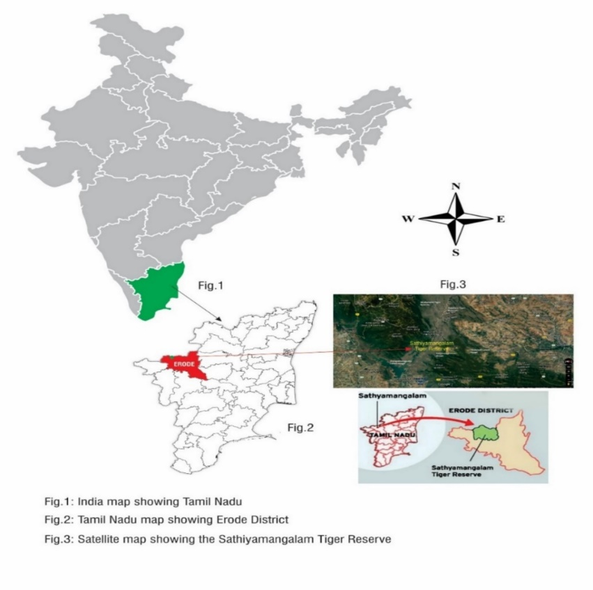
Fig. 1 Showing the location map of Sathyamangalam Tiger Reserve.

Table-1 DETAILS OF SAMPLE COLLECTION LOCALITY

Locality | District | Date | St. No | Lot No. | Co- ordinates |  | Altitude  (M) | No of zooplankton lots  collected | Collected by
 |  |  |  |  | Latitude  (N) | Longitude  (E) | Altitude  (M) | No of zooplankton lots  collected | Collected by
Gunderipallam Dam, TN Palayam Range, Kongarpalayam beat, Sathyamangalam, Tamil Nadu. | Erode | 28.07.2023 | 1 | 5 | N 11. 56358° | E 077.36888° | 381.9M | 1 | Dr. J. Thilak  & Party

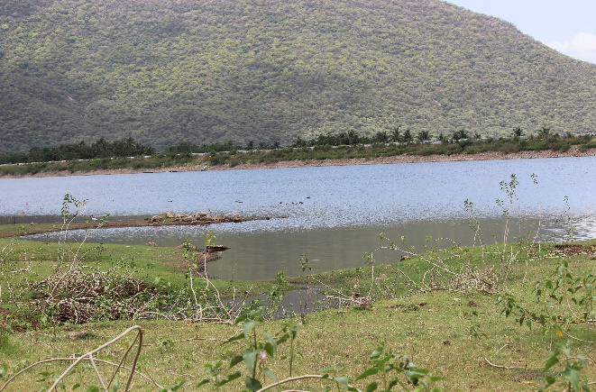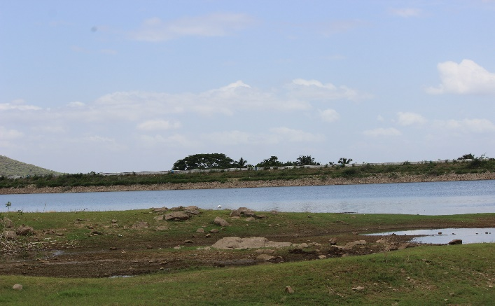
Photograph- 1 Photograph - 2

Photographs 1 & 2: Showing the photos of collection locality, Gunderipallam dam
of Sathyamangalam Tiger Reserve, Erode district.

2.1 DETAILED METHODOLOGY

The plankton samples were collected by sweeping the plankton net made of bolting silk of mesh size 63µm through water among weeds and also by filtering 50 liters of water through the plankton net. The samples were preserved in 5% neutral formaldehyde, labeled and subjected for identification later. All the samples were deposited in National Zoological Collections of SRC/ZSI/Chennai. Temporary mounts of samples were prepared in the laboratory and the photographs of specimens were taken with Nikon 80i sterio zoom microscope with different magnifications such as 10x, 20x, 40x and 100x and the photographs of Bryozoan statoblasts were confirmed with experts in the relevant field. Table. 1 Shows the coordinates of the Gunderipallam Dam in TN Palayam Range, Kongarpalayam beat, Sathyamangalam Tiger Reserve, Tamil Nadu from where the zooplankton sample in which the bryozoan floatoblasts were collected, observed and studied. The photographs 1 & 2 shows the photos of the localities of Gunderipallam Dam from where the zooplankton samples were collected.

The standard references were followed for species identification viz. Edmondson (1959), Geimer & Massard (1986), Rao (1992) Reynolds, (2000) and Wood & Okamura (2005). Later the floatoblasts photographs were confirmed by the experts in relevant field.
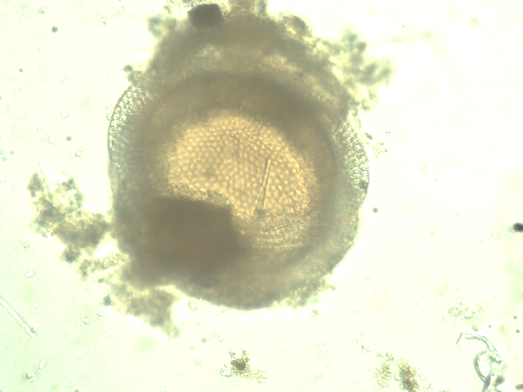 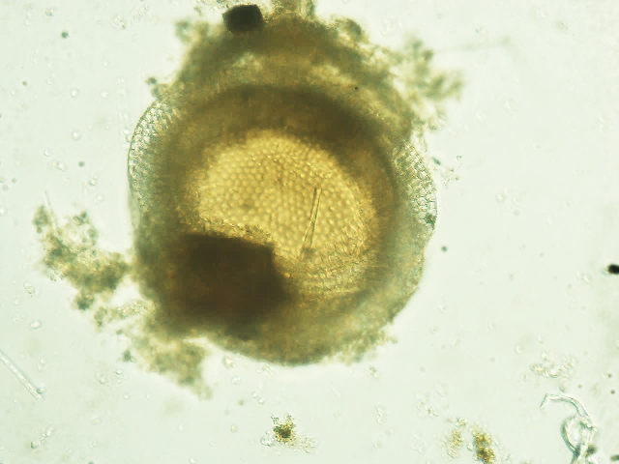 Fig-1 Fig-2

Fig.1: Photograph of the floatoblast of Rumarcanella himalayana Annandale, 1911.
Fig-2: Photograph of the floatoblasts ventral valve with inset showing tubercles on the annulus.
Fig-3: Photograph of sessoblast with inset showing tubercles on annulus.

Fig-3

2.1.1 ORIGINAL DESCRIPTIONS

Stolella himalayana Annandale, 1911: p. 246, fig. 49; Annandale & Kemp 1912: p. 143. Type material. No. ZEV 4813/7 (holotype), collected May, 1911 at Malwa Tal, Kumaun, W. Himalayas (3,600 feet) by S.W. Kemp.

      - CLASSIFICATION

Phylum Ectoprocta (Bryozoa) Ehrenberg, 1831
Class Phylactolaemata Allman 1856
Order Plumatellida Allman, 1856
Family Plumatellidae Allman 1856
Genus Rumarcanella Hirose & Mawatari, 2011
Rumarcanella himalayana Annandale, 1911

3. RESULTS AND DISCUSSION
While working among the Zooplankton samples from Sathyamangalam Tiger Reserve the first author come across the flotoblasts of Bryozoans and were photographed with higher magnification of 80i Nikon microscope and were confirmed by Prof. Wood on the basis of flatboats morphology.

3.1 DIAGNOSIS:

Among phylactolaemate bryozoans floatoblasts have been found to carry the most reliable characters for species identification. In this species, the floatoblast features are quite distinctive: small size, fenestrae similar in size and shape, roughened suture, and hypertubercles. It is generally understood that among plumatellid bryozoans the sessoblast annulus is homologous to the gas-filled annulus of floatoblasts (Mukai 1982). The small floatoblast size is another distinguishing feature of Rumarcanella himalayana Annandale, 1911. Hypertubercles appear mostly on the ventral valve and are not expressed on every tubercle. The sample consists of about numerous floatoblasts.

Similar studies based on floatoblasts were conducted by Swami et.al., (2016) from Kagzipura Lake, Aurangabad, Maharashtra, India and they reported Rumarcanella vorstmani (Toriumi, 1952), Swarupella divina Wood 2006, Plumatella casmiana Oka 1907, Laphodella carteri Hyatt 1968. These studies were also based on floatoblasts which were collected by plankton net. The genus Rumarcanella is the first ever to be based primarily on a single feature of the statoblast: the presence of hypertubercles. A hypertubercle may be defined as a small tubercle that sits atop a larger tubercle, generally seen on the floatoblast fenestra, but occasionally also found on the sessoblast frontal valve. Other characteristics of the genus include a colony “entirely adherent, composed of narrow, branching tubes, weakly chitinized; ectocyst thin, transparent, with almost no encrustation” (Hirose & Mawatari 2011). Hypertubercles were first noticed in R. vorstmani (Toriumi, 1952) and R. minuta (Toriumi, 1941), now synonymized under R. himalayana. The list was later expanded to include two new species, R. gusuku Hirose & Mawatari, 2011 and R. yanbaruensis Hirose & Mawatari, 2011.

The genus Rumarcanella is considered problematic due to the likelihood that hypertubercles may not be a reliable unifying feature. For example, the floatoblasts of Plumatella raoi also have hypertubercles, but the colony features free branches, not the “entirely adherent branches specified in the genus description. Therefore, we must either broaden the genus definition, or else recognize that hypertubercles do not occur exclusively in this genus. In fact, they may commonly occur in any species where the statoblast tubercles are especially prominent. Hirose & Mawatari (2011) provided genetic evidence that four Rumarcanella species with hypertubercles can grouped in a single clade be within a field that includes common plumatellids and fredericellids. This is useful information. However, it is possible that other species with similar features but lacking statoblast hypertubercles, may also fall within the clade. Here again molecular studies could prove very useful. In time the definition of genus Rumarcanella may be modified in ways that place less reliance on hypertubercles. Until then it should remain as an interesting concept, but one that allows certain species with hypertubercles not to be included.

Studies on the family Plumatellidae, and freshwater bryozoans (Phylactolaemata) in general, are notably scarce in India despite high potential biodiversity. They are the ignored fauna as they are non-charismatic. As the colonies look similar, the accurate identification is mainly based on the morphology of Statoblasts which can be done through advanced techniques such as SEM and molecular techniques which are limitedly available for freshwater studies and the scarcity of literature are some of the reasons for the lack of studies on the family Plumatellidae in India. The taxonomists who are working in this group are become rare and most of the earlier workers are superannuated. These are the reasons for the lack of studies on the family Plumatellidae in India. Our study provides a new finding among zooplankton samples in India and is also a new distributional record of the species Rumarcanella himalayana (Annandale, 1911) in Western Ghats of India. This study suggests the possibility of more unexplored species within freshwater ecosystem of Western Ghats of Tamil Nadu, India. The Phylactolaemate bryozoans available at the Zoological Survey of India , Kolkata was studied Wood (2022) and seven species were synonimysed such as species viz. F. indica from the northern temperate zones; the latter species name is now changed to Fredericella borealis; (2) Plumatella bigemmis Annandale, 1919 is a junior synonym of Plumatella fungosa Pallas, 1768; (3) Plumatellia persica Annandale, 1919 is a junior synonym of Plumatella casmiana Oka, 1907; (4) Plumatella (Afrindella) testudinicola Annandale, 1912 combines two previously known species: Plumatella bombayensis Annandale, 1908 and Plumatella casmiana Oka, 1907; (5) Rumarcanella minuta (Toriumi, 1941) is a junior synonym of Stolella himalayana Annandale, 1911 which now becomes Rumarcanella himalayana based on statoblast hypertubercles; (6) Plumatella longigemmis Annandale, 1915 and Hyalinella (Australella) indica Annandale, 1915 are both junior synonyms of Hyalinella lendenfeldi (Ridley, 1886); (7) Stolella indica Annandale, 1909, Swarupella andamanensis Rao, 1961 and Swarupella kasetsartensis Wood, 2006. The species Plumatella bombayensis is confirmed, and its holotype is re-described. In addition to this Fredericella borealis four new species are presented viz. Plumatella crispa, P. dhritiae, P. paltensis and P. raoi and the validity is rejected for the genera Afrindella, Australella, Stolella, and Swarupella. He also suggested that genera Rumarcanella and Varunella require refinement and documentation. A taxonomic key to Indian Phylactolaemata was also provided.

The floatoblasts plays an important role in the species identification and our study is mainly based on the structure of floatoblast. The dorsal & ventral fenestra of the floatoblast of Rumarcanella vorstmani differ in size. But in Rumarcanella minuta the floatoblast annulus is uniformly narrow and its dorsal and ventral fenestra are with similar convexity. The floatoblast annulus is wider than sides at both ends and ventral fenestra strongly convex in Rumarcanella gusuku. The floatoblasts of Rumarcanella yanbaruensis both the valves nearly flat, nearly symmetrical in lateral and transverse views; fenestra of ventral valve convex, floatoblast suture finely denticulate, annulus wider at both ends and the sculpture comprising a coarse pavement of circular elements. Whereas in Rumarcanella himalayana floatoblasts are small and broadly oval, its fenestrae is large and very similar on both valves and the dorsal fenestra width at least 80% of floatoblast width, both valves with faint tubercles and some tubercles bearing hypertubercles suture with irregular knots and spikes giving a serrated appearance in frontal view. In the case of the floatoblasts from Sathyamangalam Tiger Reserve, it resembles Rumarcanella himalayana in size, shape, width and size of fenestra and the presence of hypertubercles with irregular knots and spikes giving a serrated appearance in frontal view.

The Plumatellids are active filter feeders thus they improve water clarity and play a crucial role in nutrient cycle, effectively acting as natural water purifiers in lentic and lotic ecosystems. They are sensitive to pollutants and habitat degradation thus they act as bioindicators. Their colonies act as habitats, shelter and food source for various other invertebrates and microorganisms. They play a key role in carbon cycling and biomass production of the ecosystem. The members of Plumatellidae acts as Biofouling agents. The highly resistant dormant bodies called statoblasts (floatoblasts and sessoblasts) helps to withstand harsh and changing conditions. These statoblasts helps in efficient dispersal mechanisms.

3.1.1 DISTRIBUTION. India: India the species was first collected at Malwa Tal, a small village near Nainital in the foothills of the Himalaya Range, State of Uttarakhand, about 230 km northeast of New Delhi. Other sites include Kolkata (ZSI No. P1388/1) and the State of Maharashtra (Swami et al. 2016). Elsewhere: Beyond India the species has been reported from Australia (Mitra et al. 2013), Japan (Hirose & Mawatari 2011), Korea (Toriumi 1941), Thailand (Wood et al. 2006), and Taiwan (Toriumi 1942). ZSI No. P1388/1 collected 25 December 1958 at Dhakuria Lake, Kolkata by K.S. Rao and S.N. Paul.

4. CONCLUSION

Study on diversity of fresh water bryozoans may help to understand its role in food chain of freshwater ecosystem. Bryozoans are important in water quality monitoring and paleolimnological research and for controlling their growth as fowlers. The present study will contribute to the knowledge on the distribution and diversity of Bryozoa in Tamil Nadu. especially from the Western Ghats of India. Fresh water bryozoans are poorly studied in many parts of India and the information on their distribution is limited. The present record expands the known geographical distribution of this species and contributed to the understanding of freshwater bryozoan biodiversity in India. Such distributional studies are important for contributing aquatic biodiversity and supporting future ecological and taxonomic investigations. More detailed studies will reveal a greater number of species from this area.

Disclaimer (Artificial intelligence)

Author(s) hereby declare that NO generative AI technologies such as Large Language Models (ChatGPT, COPILOT, etc.) and text-to-image generators have been used during the writing or editing of this manuscript.

References

- ANNANDALE, N. (1911) THE FAUNA OF BRITISH INDIA, INCLUDING CEYLON AND BURMA. FRESH-WATER SPONGES, HYDROIDS AND POLYZOA. TAYLOR & FRANCIS, LONDON, 251 PP.

- Annandale, N. & Kemp, S. (1912) Observations on the invertebrate fauna of the Kumaon Lakes, with special reference to the sponges and Polyzoa. Records of the Indian Museum, 7: 129–45. https://doi.org/10.5962/bhl.part.28229
- Brown, C.J.D. (1933) A limnological study of certain fresh-water Polyzoa with special reference to their statoblasts. Transactions of the American Microscopical Society, 52: 271–314.
- Charalambidou, I., Santamaria, L. & Figuerola, J. (2003) How far can the freshwater bryozoan Cristatella mucedo disperse in duck guts? Archiv fur Hydrobiologie, 157: 547–554.
- Figuerola, J., Green, A.J. & Michot, T.C. (2005) Invertebrate eggs can fly: Evidence of waterfowl mediated gene flow in aquatic invertebrates. American Naturalist, 165: 274–280.
- Green, A.J., Jenkins, K.M., Bell, D., Morris, P.J. & Kingsford, R.T. (2008) The potential role of water birds in dispersing invertebrates and plants in arid Australia. Freshwater Biology, 53: 380–392.
- Geimer, G. & Massard, J. A., 1986: Les bryozoaires du Grand-Duché de Luxembourg et des regions limitrophes. Travaux Scientifiques Musée D’Histoire Naturelle de Luxembourg 7, 1-188.
- Hirose, M. & Mawatari, S.F. (2011) Freshwater Bryozoa of Okinawa, Japan, with descriptions of Rumarcanella gen. nov. INDIAN PHYLACTOLAEMATA (Phylactolaemata: Plumatellidae and two new species. Zootaxa, 2732(1): 1–19. https://doi.org/10.11646/zootaxa.2732.1.1
- Massard, J.A. and G. Geimer (2008). Global diversity of bryozoans (Bryozoa or Ectoprocta) in freshwater. Hydrobiologia: 93–99. 5.
- Mukai, H. 1982. Development of freshwater bryozoans (Phylactolaernata). In Developmental biology of freshwater invertebrates. Edited by F.W. Harrison and R.R. Cowden. Alan R. Liss, Inc., New York. pp. 535-576.
- Reynolds, K. T., 2000: Taxonomically important features on the surface of floatoblasts in Plumatella (Bryozoa). Microscopy and Microanalysis 6, 202-210.
- Okland, J. & Okland, K. A., 2005: Freshwater bryozoans (Bryozoa) Of Norway V: review and comparative discussion of the distribution and ecology of the 10 species recorded. Hydrobiologia 534, 31-55.
- Rao, K.S. (1992) Fresh-water Ecology (Bryozoa). Anmol Publications, New Dehli, 308 pp.
- Rogick M. (1956) Bryozoa. In Edmondson W. T. Editor. Freshwater Biology. Wiley, New York, 495-507.
- Satkauskiene, I., Wood, T., Rutkauskaite-Suciliene, J., MildaZiene, V. & TuCkute, S., 2018: Freshwater bryozoans of Lithuania (Bryozoa). ZooKeys 774, 53-75.
- Swami, P.S., Mokashe, S.S. & Harkal, A.D. (2014). Records of freshwater Bryozoa in Mula Dam of Ahmednagar District, Maharashtra, India. Journal of Entomology and Zoology Studies. 2 (6): 99-101.
- SWAMI PS, HARKAL AD AND MOKASHE SS. (2016) AN ASSESSMENT OF BRYOZOAN (PHYLACTOLAEMATA) FAUNA OF KAGZIPURA LAKE, AURANGABAD, MAHARASHTRA, INDIA. J. THREATENED TAXA 8(3): 8611-8614.

- TORIUMI, M. 1941 STUDIES ON FRESHWATER BRYOZOA OF JAPAN 2. FRESHWATER BRYOZOA OF TYOSEN (KOREA). THE SCIENCE REPORTS OF THE TOHOKU IMPERIAL UNIVERSITY, SER. 4, 16, 413–425.

- Toriumi, M. (1942) Studies on freshwater Bryozoa of Japan 4. Freshwater Bryozoa of Taiwan (Formosa). The Science Reports of the Tohoku Imperial University, ser. 4, 17: 207–214.
- Wood, T. S., 2005: Study methods for freshwater bryozoans. Denisia 16, zugleich Kataloge der OÖ. Landesmuseen Neue Serie 28, 103-110.
- WOOD, T. S. AND OKAMURA, B. 2005. A NEW KEY TO THE FRESHWATER BRYOZOANS OF BRITAIN, IRELAND, AND CONTINENTAL EUROPE. FRESHWATER BIOLOGICAL ASSOCIATION, SCIENTIFIC PUBLICATION NO. 63, AMBLESIDE, UK. 113 PP.

- Wood, T.S., Anurakpongsatorn, P. & Mahujchariyawong, J. (2006) Freshwater bryozoans of Thailand (Ectoprocta and Ento-procta). The Natural History Journal of Chulalongkorn University, 6: 81–117.
- Wood T.S. 2022. Phylactolaemate bryozoans at the Zoological Survey of India and a taxonomic key to Indian Phylactolaemata. Zootaxa 5200 (5): 401–435. https://doi.org/10.11646/zootaxa.5200.5.1

***********************************

