Original Research Article

Size Structure and Growth Pattern of Octopus cyanea in East Lombok Waters, Indonesia

.
ABSTRACT

The waters surrounding Seruni Mumbul Village, East Lombok Regency are a region with potential for the stone octopus (Octopus cyanea) fishery. This study aimed to analyze the distribution of dorsal mantle length (DML), body weight, and growth patterns of Octopus cyanea. Research was conducted from April to August 2025 at two main landing sites: Segare Harapan Jaya Cooperative and the collector in Dusun Kampung Mandar, Seruni Mumbul Village, Pringgabaya Subdistrict, East Lombok Regency, NTB Province. Data were collected daily in situ using a total landing census method, in which all landed individuals were measured without selection to obtain morphometric data, including dorsal mantle length (DML), body weight, and sex determination. Data analysis included the distribution of mantle length, body weight, and the length–weight relationship. A total of 467 individuals were recorded during the study period. The population was generally dominated by small to medium-sized individuals, indicating ongoing recruitment and active growth. The length–weight relationship showed negative allometric growth in both sexes, suggesting that mantle length increased proportionally faster than body weight. These findings provide baseline biological information that can support sustainable fishery management, including the formulation of minimum catch size regulations and local conservation strategies.

Keywords: Octopus cyanea; growth pattern; dorsal mantle length; length–weight relationship; East Lombok; reef octopus

1. INTRODUCTION

The Province of West Nusa Tenggara (NTB) encompasses 29,159.04 km² of marine waters with high habitat complexity, including 76,420 ha of coral reef ecosystems that provide ecological niches crucial for the survival and reproduction of various benthic organisms, including Octopus cyanea (Taqwa, 2024). From a bio-ecological perspective, octopuses are semelparous organisms with short life cycles, occupying an important position in the food web as both predators and prey (Linung et al., 2024). They utilize crevices and hard substrates as dens for shelter and reproduction (Taqwa, 2024). However, as intertidal to subtidal organisms, Octopus cyanea populations are vulnerable to anthropogenic pressures. Intensive resource extraction not only reduces population abundance but also has the potential to alter size structure and disrupt trophic balance within marine ecosystems (Tarigan & Simbolon, 2020).
In several regions, such as Simeulue Regency, octopus is a high-value commodity that contributes significantly to the economic welfare of coastal communities, particularly octopus fishers (Putri & Zuraidah, 2022). Over the past decade, octopus has become an important export commodity, offering higher income potential compared to other species such as tuna, grouper, and snapper. High export demand and competitive market prices have led many fishers to target octopus as either a primary or secondary catch (Alim et al., 2023). This trend is reflected in production data from NTB, where octopus production reached 520.7 tons in 2022, up from 227.9 tons in 2020 and 329.9 tons in 2021 (Dislutkan NTB, 2023), indicating significant exploitation pressure on local populations.
Understanding biological aspects, particularly growth patterns, is fundamental in marine science to explain how organisms respond to environmental conditions. The growth of Octopus cyanea is influenced by oceanographic variables and food availability in its habitat (Amir et al., 2021). The length–weight relationship is commonly used to estimate condition factors and describe growth trends of individuals within a population (Omar et al., 2020 in Kartini, 2023). Growth parameters also reflect habitat suitability and the adaptive capacity of octopus to environmental variability (Ahmed et al., 2021). Differences in physicochemical characteristics of waters can trigger morphometric variations as forms of phenotypic adaptation (Semmens et al., 2004; Diniariwisan et al., 2023).
The waters surrounding Seruni Mumbul Village, East Lombok Regency, represent a specific habitat for Octopus cyanea in NTB. Although Mulyani et al. (2024) reported the dominance of this species in the Alas Strait, data on local population growth dynamics around Seruni Mumbul remain limited. This constitutes a critical research gap, given that Octopus cyanea exhibits rapid growth with a lifespan of less than one year (Linung et al., 2024), during which male and female reproductive phases occur within a short period (Rufiati et al., 2024). The absence of baseline biological data at the local level may hinder conservation efforts and understanding of environmental carrying capacity. Considering that octopus distribution is influenced by local factors, this study is essential to analyze the growth patterns of Octopus cyanea, providing biological data for understanding population dynamics in the waters surrounding Seruni Mumbul Village.

2. material and methods

2.1 Study Area

This study was conducted over a five-month period, from April to August 2025. Data collection focused on the catch from fishers operating in the waters surrounding Seruni Mumbul Village, East Lombok Regency, geographically located along the Alas Strait coast (Figure 1). These waters are characterized by coral reef and seagrass habitats, which serve as the main fishing grounds for local fishers. The fishing gear employed was a modified hand line designed to resemble a conch.

Data were collected in situ at two main landing sites representing the catches from the area: Segare Harapan Jaya Cooperative (-8.510614, 116.664169) and the collector in Dusun Kampung Mandar (-8.500976, 116.674004). All Octopus cyanea individuals were recorded immediately after landing to ensure accuracy of morphometric measurements. A total of 467 individuals were measured in this study.
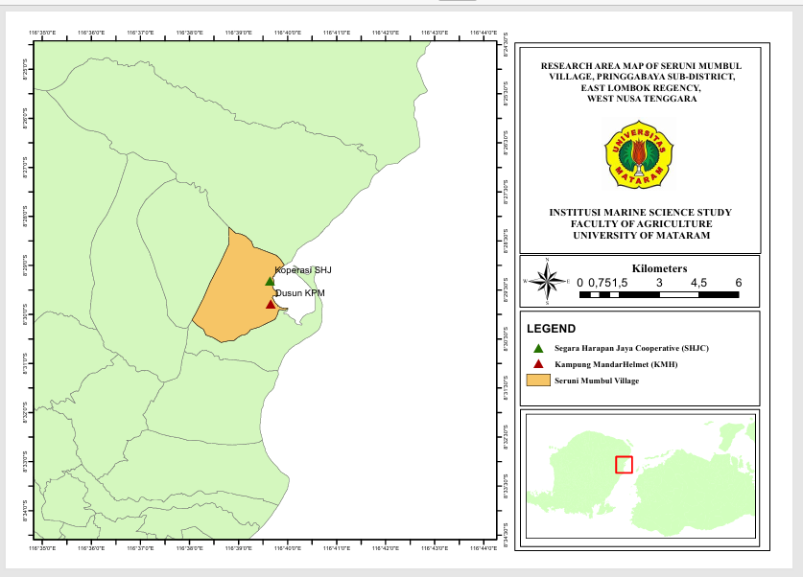
Figure 1. Study Area Map
2.2 Data Collection
The data used in this study consisted of primary and secondary data. Primary data were obtained through direct measurements of all Octopus cyanea individuals landed at two sites: Segare Harapan Jaya Cooperative and the collector in Dusun Kampung Mandar. The measured parameters included dorsal mantle length (DML), body weight, sex, total length (TL), arm length (AL), head width, and sucker diameter. DML was used as the primary parameter for assessing gonadal maturity, as it is more stable and less affected by arm flexibility or regeneration compared to total length.
Species identification was conducted based on morphological characteristics. Octopus cyanea has a relatively large body, with arms 4–6 times the mantle length. Mantle length can reach approximately 160 mm, while total length may exceed 1 m. In males, the third right arm is modified into a hectocotylus, measuring approximately 70–90% of the length of the adjacent arm. The tip of the hectocotylus features a small triangular ligula measuring about 1–2% of arm length, and a small, blunt calamus measuring 35–40% of the ligula length (Norman et al., 2016). Another distinguishing feature is the presence of an ocellus (false eye spot) located above the eyes (Omar et al., 2020).
Following species identification, morphometric measurements were performed. DML was measured as the distance from the posterior end of the mantle to the anterior edge of the mantle (between the eyes). Individuals were placed on a flat measuring board to ensure consistency and accuracy, as octopus bodies are soft and flexible, with the posterior mantle end positioned against the back edge of the board (Figure 2). Each measured individual was documented with a camera and recorded in data sheets. Mantle length was measured using a centimeter-scale measuring board, while body weight was determined with a digital scale with 0.1 g precision.
Sex determination was conducted by examining the reproductive organs, specifically identifying the presence of the hectocotylus on the third arm. The hectocotylus is a sexual dimorphic feature distinguishing males from females, as it is absent in females (Omar et al., 2020).
Data collection was conducted daily from April to August 2025, except on days when fishers did not go to sea due to adverse weather conditions or when no catch was available. A total landing census method was used, in which all individuals landed at both sites were measured without selection, including those with damaged or missing arms. Samples from both landing sites were then combined for analysis. Secondary data were obtained from books, scientific journals, and other relevant documents pertaining to octopus biology.
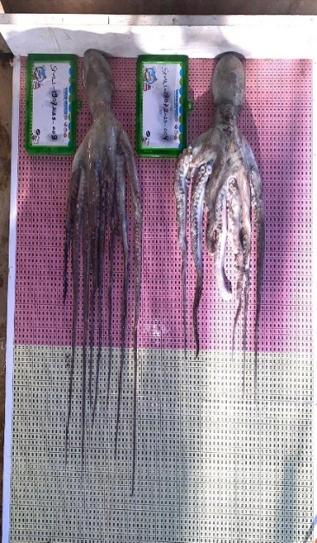
Figure 2. Morphometric measurements of Octopus cyanea
2.3 Data Analysis

2.3.1 Dorsal Mantle Length and Body Weight Distribution

The distribution of dorsal mantle length (DML) and body weight of Octopus cyanea was analyzed using histograms. Analyses were conducted separately for each sex (male and female) to evaluate differences in the distribution of mantle length and body weight between sexes. The number of classes and class intervals for the histograms were determined using Sturges’ formula, allowing the size distribution to proportionally reflect the population structure of Octopus cyanea at the study sites. The results of the mantle length and body weight distribution were subsequently compared with gonadal maturity sizes by sex, following Omar et al. (2020): mantle length ≥12.9 cm for males and ≥15.5 cm for females, and body weight 750 g for males and 900 g for females. This comparison aimed to determine the proportion of individuals that had reached gonadal maturity and were considered suitable for capture.
Sturges’ formula used is as follows (Yunita et al., 2016):
$$K=1+\left(3,32×\log{(n}\right)$$
$$i=\frac{X_{\text{max}}-X_{\text{min}}}{K}$$
Where:
K | = Number of classes
n | = Sample size
i | = Class width
$$X_{\text{max}}$$ | = Maximum value
$$X_{\text{min}}$$ | = Minimum value

2.3.2 Growth Pattern Analysis

Dorsal Length and weight data can describe growth patterns and the influence of environmental factors on the growth of organisms (Ahmed et al., 2021). The relationship between length and weight was analyzed using the formula proposed by Le Cren (1951 in Lempoy et al., 2020)
$$W=aL^{b}$$
Where:
W | = Total body weight (g)
L | = Dorsal mantle length (cm)
a & b | = Constants of the length–weight relationship

The exponent b was used to determine the growth pattern:
- If, b = 3, isometric growth, indicating proportional increases in length and weight.
- If b < 3 negative allometric growth, indicating that length increases more than weight
- If b > positive allometric growth, indicating that weight increases more than length

3. results and discussion

3.1 Total Catch Composition and Dorsal Mantle Length Distribution of Octopus cyanea

A total of 467 Octopus cyanea individuals were measured during the study, originating from two landing sites: Segare Harapan Jaya Cooperative and the collector in Dusun Kampung Mandar. The distribution of individuals caught by month, sex, and landing site is presented in Table 1. Overall, females dominated the total catch with 277 individuals (59.3%), while males accounted for 190 individuals (40.7%). The highest catch was recorded in July, whereas the lowest occurred in June.
Table 1. Monthly catch composition of Octopus cyanea by sex and landing site (April–August).
Month | Cooprative |  | Collector |  | Monthly Total
Month | Female | Male | Female | Male | Monthly Total
April | 35 | 38 | 0 | 0 | 73
May | 69 | 35 | 11 | 14 | 129
June | 9 | 4 | 4 | 0 | 17
July | 106 | 57 | 0 | 0 | 163
August | 43 | 42 | 0 | 0 | 85
Total 467

Morphometric analysis revealed a wide range of sizes within the population. The minimum dorsal mantle length (DML) recorded for both sexes was 6 cm; however, the maximum size of females reached 22 cm, exceeding that of males, which only reached 20 cm. The mean DML for males was 11.36 ± 2.55 cm, while females were slightly larger, with a mean of 11.62 ± 2.45 cm. Population structure based on size classes showed a single dominant mode for both sexes (Figures 3 & Figure 4), with the mode for males in the 8–10 cm class (54 individuals) and for females in the 10–12 cm class (84 individuals).
The larger maximum size of females compared to males indicates sexual dimorphism in Octopus cyanea captured in the waters surrounding Seruni Mumbul Village, East Lombok Regency. Biologically, this reflects energy allocation strategies: females require a larger mantle cavity and body mass to support ovarian development and maximize fecundity (Semmens et al., 2004). The shift of the mode toward larger size classes in females also suggests that somatic growth rates in females are generally higher or that females have a slightly longer lifespan than males before entering the post-reproductive senescence phase.
Based on the estimated first gonadal maturity size (Lm) reported by Omar et al. (2020), ≥12.9 cm for males and ≥15.5 cm for females the Octopus cyanea population sampled was dominated by individuals that had not yet reached gonadal maturity. Of the total 467 individuals, only 74 (15.8%) were estimated to have reached Lm, consisting of 62 males and 12 females. The low number of mature females, despite their dominance in the total sample, is primarily due to the higher Lm threshold for females and the predominance of small size classes (8–12 cm) in the catch. Therefore, most captured females were still in juvenile to sub-adult stages and had not yet attained sexual maturity.

To date, no information is available regarding the first gonadal maturity size (Lm) specific to the population in this area, making the use of Lm values from Omar et al. (2020) the most appropriate approach based on the available literature. Although there are technical differences in the definition of the initial measurement point of DML between this study and Omar et al. (2020), both rely on DML as the primary morphometric indicator, rendering the comparison biologically relevant at the population level.
The relatively high proportion of individuals below Lm, approximately 84%, indicates a potential risk of growth overfishing, in which the majority of individuals are harvested before contributing to reproduction. If this harvesting pattern persists, it could compromise the sustainability of natural population recruitment (Ben-Hasan et al., 2021). However, confirmation of this status requires further analysis based on population dynamics parameters and direct assessment of gonadal maturity in the local population.
The data also show that males reach maturity at smaller sizes than females. This pattern is consistent with the general life-history strategy of cephalopods, in which males allocate energy to achieve sexual maturity earlier to maximize reproductive opportunities, whereas females delay maturity until reaching a larger body size to support egg production and the brooding period, typically followed by a fasting phase until death (Avila-Poveda et al., 2009).

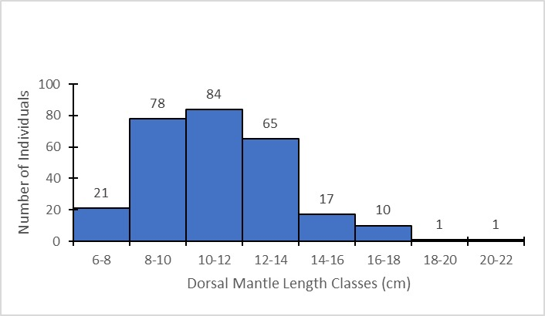 | 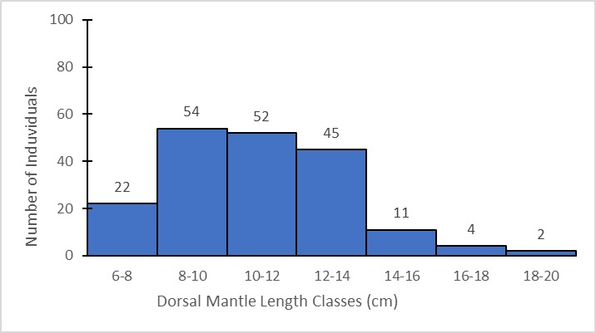
Figure 3. Dorsal Mantle Length Distribution of Female Octopus cyanea | Figure 4. Dorsal Mantle Length Distribution of Male Octopus cyanea

3.2 Body Weight Distribution of Male and Female Octopus cyanea
The body weight distribution of Octopus cyanea in the waters surrounding Seruni Mumbul Village exhibited a similar range and overlapping distribution between males and females, although variation was evident at the extreme values. The minimum body weight recorded for both sexes was 60 g. The maximum weight of males reached 3,876 g, slightly exceeding that of females at 3,600 g. The mean body weight of males was 1,140.6 ± 669.9 g (Figure 5), while females averaged 1,102.38 ± 622.35 g (Figure 6).
Based on weight-class distribution, the population was dominated by medium-sized individuals. The mode for males occurred in the 823–1,077 g class (40 individuals), whereas females showed a modal peak in the 568–823 g class (56 individuals). This difference in modal weight classes indicates variation in size distribution between sexes, although most individuals were concentrated within comparable weight intervals.
Although females exhibited a larger maximum dorsal mantle length, the slightly higher maximum body weight observed in males may reflect individual growth variability or differences in reproductive stage at the time of capture. In cephalopods, females entering or having completed the reproductive phase often undergo changes in body composition due to energy allocation toward egg production and brooding, which may temporarily influence body mass during the reproductive period (Semmens et al., 2004).
Referring to the estimated body weight at first gonadal maturity (Wm) reported by Omar et al. (2020), which is 750 g for males and 900 g for females, a total of 241 individuals (51.6%) were estimated to have reached biological adulthood based on weight criteria. This proportion is substantially higher than the maturity estimate based on dorsal mantle length (DML) (15.8%), suggesting that Octopus cyanea captured in the waters surrounding Seruni Mumbul Village have a relatively faster weight growth rate compared to length growth. This pattern is likely supported by prey abundance within the habitat, enabling individuals to attain critical reproductive weight more rapidly (Diniariwisan et al., 2023). Such conditions are presumed to be influenced by food availability and local oceanographic parameters, as reflected in the variation of gonadal maturity size of Octopus cyanea across different geographic regions (Guard & Mgaya, 2002; Raberinary & Benbow, 2012; Courage, 2013).
The variability in gonadal maturity size further confirms the phenomenon of phenotypic plasticity in octopuses, which is strongly influenced by geographic location. For comparison, male Octopus cyanea in Tanzania reach gonadal maturity at 320 g and females at 600 g (Guard & Mgaya, 2002), whereas in Madagascar the maturity size is considerably larger, reaching 643 g for males and 2,246 g for females (Raberinary & Benbow, 2012). These geographic differences, as explained by Courage (2013) and Semmens et al. (2004), are largely driven by local oceanographic conditions such as temperature and food availability. Optimal water temperature in the coral reef ecosystem of Seruni Mumbul is presumed to enhance metabolic rates, which in turn influence energy allocation for somatic growth and reproductive organ development.

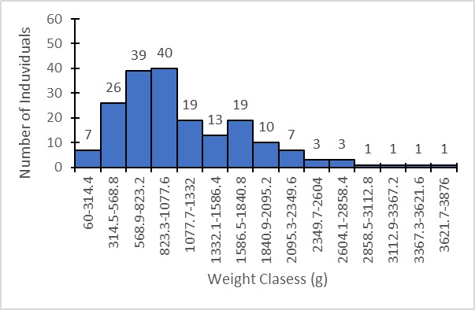 | 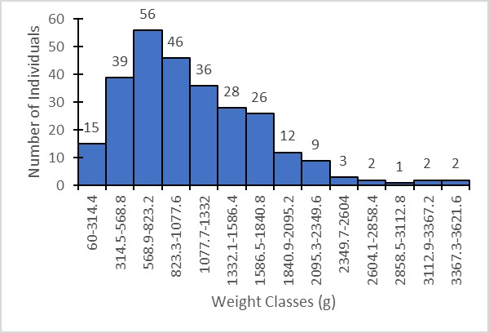
Figure 5. Body Weight Distribution of Male Octopus cyanea | Figure 6. Body Weight Distribution of Female Octopus cyanea

3.3 Growth Patterns of Male and Female Octopus cyanea
Regression analysis showed that both sexes exhibited a similar growth pattern (Figures 7 & Figure 8). In male Octopus cyanea, the relationship between dorsal mantle length (DML) and body weight was expressed as W = 6.6401 (DML)²·⁰⁶⁷⁶ with a coefficient of determination (R²) of 0.6177 (Figure 7). In females, the relationship followed the equation W = 2.8043 (DML)²·³⁸⁷⁵ with an R² value of 0.6742 (Figure 8). The R² values indicate that approximately 61–67% of the variation in body weight can be explained by increases in mantle length, while the remaining variation is likely influenced by other biological factors such as stomach fullness and arm condition. The correlation coefficient (r), derived from the square root of R², indicates a moderately strong positive relationship between mantle length and body weight in both sexes.
The estimated allometric coefficients (b) for both sexes (b_{male} = 2.06; b_{female} = 2.38) were significantly lower than 3 (b < 3), indicating a negative allometric growth pattern in Octopus cyanea. This negative allometry suggests that the population is dominated by individuals still undergoing active somatic growth, in which energy is preferentially allocated to mantle elongation rather than to muscle mass accumulation. These findings are consistent with those reported by Marzuki et al. (2023) and Diniariwisan et al. (2023), who also documented negative allometric growth in octopus populations from Ketapang Beach, East Lombok. The consistency of results across adjacent coastal waters suggests similar habitat characteristics along the eastern Lombok coastline.
Low b values may be influenced by both environmental (external) and biological (internal) factors. According to Amir et al. (2021), variation in b is strongly determined by prey availability and water conditions. From an ecophysiological perspective, Semmens et al. (2004) explained that warm water temperatures, typical of tropical waters such as those of West Nusa Tenggara, may accelerate octopus metabolic rates. As a consequence, energy obtained from food is rapidly expended for activity and linear growth, leaving relatively less energy available for body mass deposition. Furthermore, intensive fishing pressure in the study area (Omar et al., 2020) may increase the risk of growth overfishing, in which individuals are harvested during rapid growth phases before reaching an optimal (isometric) body proportion.

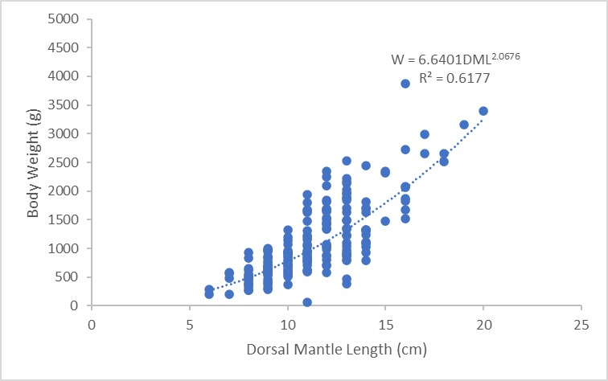 | 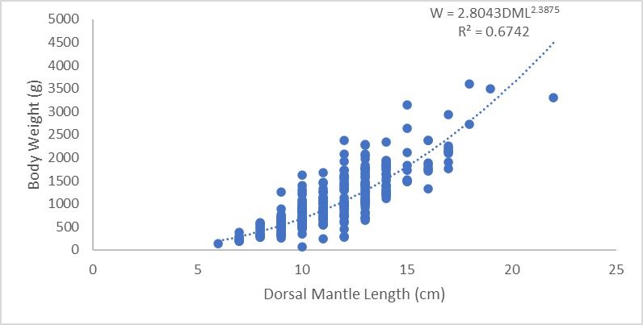
Figure 7. Relationship between Length and Weight of Male Octopus cyanea | Figure 8. Relationship between Length and Weight of Famale Octopus cyanea

4. Conclusion
The Octopus cyanea population in the waters of Seruni Mumbul Village is dominated by medium-sized individuals exhibiting sexual dimorphism, with females attaining greater dorsal mantle length and males reaching higher maximum body weight. Length–weight relationship analysis revealed a negative allometric growth pattern (b < 3), indicating the predominance of individuals in an active somatic growth phase. The proportion of gonadally mature individuals based on mantle length (15.8%) was substantially lower than the estimate based on body weight (51.6%), suggesting phenotypic plasticity in response to local environmental conditions. However, this discrepancy also indicates a potential risk of excessive harvesting of immature (juvenile) individuals.

Disclaimer (Artificial intelligence)

Author(s) hereby declare that NO generative AI technologies such as Large Language Models (ChatGPT, COPILOT, etc.) and text-to-image generators have been used during the writing or editing of this manuscript.

References

- Ahmed, A. S., El-Ganainy, A. A., Osman, M. F., & Khalil, M. T. (2021). Observations on some morphometric characters of the webfoot octopus, Amphioctopus membranaceus (Quoy and Gaimard, 1832) from the Gulf of Suez, Red Sea, Egypt. Egyptian Journal of Aquatic Biology and Fisheries, 25(2), 103 - 115. https://doi.org/10.21608/Ejabf.2021.158705
- Alim, S., Marzuki, M., & Nuryadi, R. (2023). Analysis Existing Conditions of Octopus (Octopus vulgaris) in Pandanan Beach, Malaka Village, North Lombok. Jurnal Biologi Tropis, 23(2), 535–542. https://doi.org/10.29303/jbt.v23i2.5278
- Amir, F., Mallawa, A., & Umar, M. T. (2021). Growth pattern and sex ratio of octopus (Octopus vulgaris) in Bone Bay. Jurnal Ilmiah Agribisnis dan Perikanan, 14(2), 527-532. [In Bahasa Indonesia]. http://pakdosen.unhas.ac.id/storage/dokumen/artikel-1686708162-873-Article%20Text-1636-2-10-20211114.pdf
- Omar, S. B. A., Safitri, A. R. D., Rahmadhani, A., Tresnati, J., Suwarni, S., Umar, M. T., & Kaseng, E. S. (2020). Relative growth of octopus, Octopus cyanea Gray, 1849, in the Makassar Strait and Bone Bay waters. Proceedings of the National Symposium on Marine and Fisheries, 7. [In Bahasa Indonesia].
- Avila-Poveda, O. H., Colin-Flores, R. F., & Rosas, C. (2009). Gonad development during the early life of Octopus maya (Mollusca: Cephalopoda). The Biological Bulletin, 216(1), 94-102. https://doi.org/10.1086/BBLv216n1p94.
- Balansada, A. R., Ompi, M., & Lumoindong, F. (2019). Identification and habitat of octopus (Cephalopoda) from Salibabu waters, Talaud Islands Regency. Jurnal Pesisir dan Laut Tropis, 7(3), 247–255. [In Bahasa Indonesia]. https://doi.org/10.35800/Jplt.7.3.2019.24742.
- Ben‐Hasan, A., Walters, C., Hordyk, A., Christensen, V., & Al‐Husaini, M. (2021). Alleviating growth and recruitment overfishing through simple management changes: insights from an overexploited long‐lived fish. Marine and Coastal Fisheries, 13(2), 87-98. https://doi.org/10.1002/mcf2.10140
- Dinas Kelautan dan Perikanan Provinsi Nusa Tenggara Barat (Dislutkan NTB). (2023). Capture fisheries statistics. Mataram: Dislutkan NTB.
- Diniariwisan, D., Marzuki, M., & Lestariningsih, W. A. (2023). Identification of biological dimensions of octopus in Ketapang Beach, East Lombok, for sustainable fisheries management. Jurnal Ganec Swara, 17(4), 1308-1312. [In Bahasa Indonesia]. https://pdfs.semanticscholar.org/03af/93821928d801023a794c1fb224ac44a4c142.pdf.
- Forum Ilmiah Pengelolaan Perikanan Berkelanjutan Provinsi Nusa Tenggara Barat (FIP2B-NTB). (2022). Ecological database of West Nusa Tenggara Province. FIP2B-NTB.
- Guard, M., & Mgaya, Y. D. (2002). The artisanal fishery for Octopus cyanea Gray in Tanzania. AMBIO: Journal of the Human Environment, 31(7), 528-536. https://doi.org/10.1579/0044-7447-31.7.528.
- Kalih, L. A. T. T. W. S. (2024). Population condition analysis and sustainability of lemuru (Sardinella lemuru) fishery in Awang Bay, Central Lombok Regency. Jurnal Teknologi Perikanan dan Kelautan, 15(1), 1-10. [In Bahasa Indonesia]. https://doi.org/10.24319/jtpk.15.1-10.
- Kartini, S. (2023). Population dynamics of octopus (Octopus cyanea) on Darawa Island, Wakatobi Regency, Southeast Sulawesi (Doctoral dissertation, Universitas Hasanuddin).
- Le Cren, E. D. (1951). The length–weight relationship and seasonal cycle in gonad weight and condition in the perch (Perca fluviatilis). Journal of Animal Ecology, 20(2), 201–219. Https://doi.org/10.2307/1540.
- Lempoy, R., Rondonuwu, A. B., & Bataragoa, N. E. (2020). Size, length–weight relationship, and condition factor of Banggai cardinalfish (Pterapogon kauderni Koumans, 1933) in Lembeh Strait, North Sulawesi. Jurnal Ilmiah Platax, 8(1), 30–36. [In Bahasa Indonesia]. https://doi.org/10.35800/jip.8.1.2020.27599.
- Linung, M. K., Soewarlan, L. C., & Boikh, L. I. (2024). Morphometrics of octopus (Octopus cyanea) in Arubara waters, Tetandara Village, South Ende District, Ende Regency, East Nusa Tenggara Province. Papadak Marine Journal, 5(1), 122–131. https://ejurnal.undana.ac.id/index.php/JBP/article/view/16059
- Marzuki, M., Diniariwisan, D., & Lestariningsih, W. A. (2023). Identification of octopus biology and index values for fisheries management in the Alas Strait, West Nusa Tenggara. Jurnal Penelitian Pendidikan IPA, 9(12), 12149-12154. https://doi.org/10.29303/jppipa.v9i12.5956.
- Mulyani, L. F., Arfiati, D., Widodo, M. S., & Yamindago, A. (2024). Molecular identification of the octopus (Octopus cyanea, Gray 1849) using Mt-DNA COI from Alas Strait Waters, Indonesia. Egyptian Journal of Aquatic Biology & Fisheries, 28(6), 603–615. https://doi.org/10.21608/ejabf.2024.392406.
- Norman, M. D., Finn, J. K., & Hochberg, F. G. (2016). Family Octopodidae. In P. Jereb, C. F. E. Roper, M. D. Norman, & J. K. Finn (Eds.), Cephalopods of the world: An annotated and illustrated catalogue of cephalopod species known to date. Vol. 3: Octopods and vampire squids (pp. 36–215). Rome: Food and Agriculture Organization of the United Nations (FAO).
- Putri, E., & Zuraidah, S. (2022). Production value and marketing of octopus (Octopus sp.) in Tiga Bersaudara, Simeulue Regency, Aceh Province. Journal of Coastal Socio-Economics, 3(2), 10–16. [In Bahasa Indonesia] https://sep.ejournal.unri.ac.id/index.php/jsep/article/view/82
- Raberinary, D., & Benbow, S. (2012). The reproductive cycle of Octopus cyanea in southwest Madagascar and implications for fisheries management. Fisheries Research, 125, 190-197. https://doi.org/10.1016/j.fishres.2012.02.025.
- Rufiati, I., Mahardika, I., & Wijana, M. (2024). Age estimation of octopus (Octopus cyanea) in Pringgabaya and Poto Tano districts using the stylet increment analysis (SIA) method. Ecotrophic 18(2), 144-160. [In Bahasa Indonesia]. https://doi.org/10.24843/EJES.2024.v18.i02.p01.
- Semmens, J. M., Pecl, G. T., Villanueva, R., Jouffre, D., Sobrino, I., Wood, J. B., & Rigby, P. R. (2004). Understanding octopus growth: patterns, variability and physiology. Marine and Freshwater Research, 55(4), 367-377. https://doi.org/10.1071/MF03155.
- Tarigan, D.J, & Simbolon D. (2020). Social and economic characteristics of octopus fishers based on EAFM indicators in Banggai Laut Regency. Indonesian Journal of Maritime, 1(1), 1–10. [In Bahasa Indonesia]. https://doi.org/10.17509/ijom.v1i1.24620
- Taqwa, M. (2020). Distribution map of octopus (Octopus cyanea) fishing grounds in the Maros-Pangkep Geopark area, South Sulawesi (Thesis, Hasanuddin University).
- Walpole, R. E. (1992). Introduction to statistics (3rd ed.). Jakarta: PT Gramedia Pustaka Utama.
- Yunita, L. H., Ramdhani, F., Wulanda, Y., Magwa, R. J., Gelis, E. R. E., & Heltria, S. (2023). Gonad maturity stages of snappers (Lutjanus vitta) landed at TPI Tanjung Pasir, Tangerang Regency. Jurnal Teknologi Perikanan Dan Kelautan, 14(2), 213–219. [In Bahasa Indonesia]. https://doi.org/10.24319/jtpk.14.213-219.

