CIVIC AWARENESS AND PARTICIPATION AMONG LAW STUDENTS: A CASE STUDY OF NUALS

Abstract
Youth are a valuable resource for any country, and among them, lawyers are a very important class of people who play a crucial role in protecting the rights of citizens. However, legal education has been criticised for being too technical and less focused on the needs of society. In this background, the current study focuses on civic education, awareness, and participation among law students. The study was conducted among students at the National University of Advanced Legal Studies (NUALS), Kerala, using descriptive methods with 30 students, proportionate from each year/batch of the 5-year programme, to understand the progress in each batch of students, using a structured questionnaire. A convenient sampling method was adopted for the study. The results show that law students are adequately participating in and engaged with society through their activities, with around 70 per cent of students. They were all well-informed about the rights, duties, and provisions of the Indian Constitution. Additionally, most of the respondents (around 65 per cent) feel that their legal education has enabled them to be civically engaged and participate in society. However, some changes in the education process and curriculum can help law students make a greater impact on society.
Keywords- Civic awareness, civic participation, civic engagement, law students, lawyers, social participation.

INTRODUCTION
Youth constitute one of the nation’s most valuable assets and are widely regarded as key contributors to sustained national development and future progress. Within this demographic, law students and young legal professionals play a particularly significant role in their communities by actively engaging with social and civic issues. Through their academic training and professional orientation, they are often at the forefront of identifying pressing societal challenges and proposing informed, rights-based solutions to address them. The rapid advancement of digital technology has further expanded the opportunities available to law students for acquiring knowledge about civic affairs and political processes. Digital platforms enable them to access diverse sources of information, participate in informed discussions, and remain updated on contemporary socio-political developments. Moreover, technology facilitates interaction with wider communities, encourages meaningful participation in civic life, and enhances their sense of political efficacy and social responsibility. As a result, law students are increasingly positioned to contribute constructively to democratic processes and community development.
Over the last two to three decades, in democratic societies, concerns have been rising about strengthening democratic values and systems, including an emphasis on human rights. Civic responsibility through civic education influences students’ civic engagement and participation. It also helps them to understand the role of the citizens, democratic values, and political views. Civic learning is a factor that affects students’ civic cognition and social participation concerning unfair social problems in societies. Civic expression is another factor that affects their perceptions about political discussions and social engagement in civic issues. Law students use the internet and technology to communicate their political perceptions and their works to engage in their civic affairs. With a better understanding of law students’ civic knowledge, civic value beliefs, and actions, we should be able to work more constructively in promoting their civic awareness and engagement.2
Background- Civic education and responsibilities
The youth population constitutes 65% of the country’s total population. Hence, through education, our youths can develop their competencies, skills, assets, and responsibilities as good citizens, which are vital for nation-building. The responsibility of higher education is to develop responsible citizens and encourage their engagement in the community. Consequently, the relationship between the community and universities is developed.2
A sense of civic responsibility refers to an individual’s personal belief and awareness regarding their obligations and duties towards society and the broader community. It encompasses the recognition that active participation in community affairs is an essential component of responsible citizenship. Individuals who engage in activities aimed at addressing local concerns—such as attending community meetings, participating in voluntary service, raising funds for charitable causes, or expressing opposition to unjust practices—are often regarded as responsible and conscientious members of society. Civic responsibility includes both attitudes and behaviours that support democratic governance and meaningful social participation. It reflects a commitment to collective well-being and the maintenance of social order through active involvement in public life. By advocating for social justice issues or environmental protection, individuals not only demonstrate concern for societal development but also reinforce their attachment to the community and their sense of citizenship responsibility, as noted by Weeks (1998). A 2016 survey by the Annenberg Public Policy Centre revealed that “only a quarter of Americans can name all three branches of government”. Kathleen Hall Jamieson, director of the Annenberg Public Policy Centre, commented that “Lack of basic civics knowledge is worrisome and argued for an increased focus on civics education in the schools”.3 This highlights the necessity of civic education at the basic level for all students.
A sense of civic responsibility may also be understood as an individual’s personal commitment to the well-being of others and to the advancement of society as a whole. Citizens who develop such a sense of responsibility are generally more responsive to, and supportive of, developmental initiatives at both social and political levels. Accordingly, civic responsibility is widely recognised as an essential developmental attribute that contributes to the formation of active, responsible, and productive citizens.

Within this context, lawyers play a significant role in addressing social concerns and safeguarding the legal and constitutional rights of citizens. Through advocacy, legal awareness, and public engagement, members of the legal profession contribute to the cultivation of responsible citizenship. Productive citizens often emerge from the combined efforts of legal professionals and other social stakeholders who promote civic responsibility and encourage a strong sense of belonging within the community.

However, ongoing transformations in social, economic, and technological structures have contributed to a shift in the attitudes and priorities of younger generations of legal professionals. Many young lawyers appear to be less inclined to participate in civic and community activities through traditional forms of engagement. Previous research has shown that higher education institutions not only promote positive academic outcomes but also foster beneficial personal and social attributes, including enhanced self-concept, improved problem-solving abilities, leadership development, cultural awareness, and strong civic orientation. Nevertheless, recent evidence suggests that these civic outcomes have shown a noticeable decline in recent years, raising concerns about the future development of socially responsible professionals. 3 This had been because education is not confined to classroom learning, but rather immersing oneself into society for a better application of one’s learned skills and knowledge for the betterment of society.

Civic Education in Higher Education Institutions
The Evolution of Civic Education in Higher Education by Komives, Lucas, & McMahon (1998) states that civic education in higher education has transformed over the decades to adapt to the current trends and issues in the nation. Definitions of civic responsibility are vast and complicated, with several parts and contradictions. Enrlich (1997) explained the fact that higher education institutions will continue to have a difficult time developing civic education because the aspects of civic responsibility keep changing. It is the responsibility of the judiciary to make proper interpretations of the constitution and related aspects based on the changing environment. A group of researchers advocates for civic engagement to be incorporated into college curricula, making citizenship preparation a priority in teaching. Therefore, lawyers, as the foremost activists in a democratic society, must be trained for civic engagement.
Bole and Gordon (2009) and Malin (2011) have specifically called for educational reform to cultivate and instil citizenship with meaningful opportunities for public engagement by law students. They specifically stated that civic education must be re-examined for how it is being effectively connected to today’s classroom and students. With all these changes and examinations to the higher education curriculum, especially in law education, teachers are the key to understanding how civic education can transition into the online and technology-driven learning environment. As one of the greatest predictors of civic and political engagement, service learning and civic engagement are two of the most successful ways to increase the social responsibility of law graduates.
Service learning has been used predominantly in civic education because of its direct correlation to civic responsibility. It can be described as one of the most well-known teaching methods associated with civic education.7 Service learning emerged in the 1960s to create a teaching method of using civic engagement to thoroughly teach for real-world problems. It is a form of experiential education that “promotes students’ critical thinking and interpersonal skills”. Therefore, it develops the soft skills for the real world. Through service learning, students are said to gain social and personal responsibility that positively affects their academic and personal lives.8 Civic education, when examined for its characteristics, provides a picture of collaboration, motivation, and engagement.
In Major’s (2014) book, Teaching Online: A Research-based Guide to Instructional Change, she examined student engagement to increase retention rates. Major has incorporated concepts of motivation, participation, attention, involvement, and intellectual effort to paint a picture of what student engagement needs to be in the 21st-century educational process. All these concepts can be transitioned into civic education and civic engagement among law students. Guthrie and McCracken (2010) described online education as providing students with the opportunity to compare a range of civic experiences both locally and over great distances. This unique experience could provide interest and motivation that were previously lacking in some web-based courses. The necessary changes in the curriculum of law students are to be made through a comparison with other countries’ law education to make lawyers in India as active as they are in other countries.
“Today's children must become tomorrow's responsible citizens. The attitudes they develop will shape the quality of life for all of us”. Their responsibilities are not confined to their duties alone but also to their rights. All citizens enjoy basic human rights and other constitutional rights guaranteed by the Indian Constitution. The lawyers and other stakeholders in the judiciary help to secure the rights of each citizen.
In the book “The Global Clinical Movement”, Frank Bloch and his co-authors proposed a movement to "transform legal education into justice education". They focus on empowering law students to create a just society through their efforts of active civic participation. If this does not happen, then society might crumble with lots of social issues in the coming years. The five writs in the Indian Constitution help to secure the rights of each citizen. This helps to achieve a welfare society.

Research problem

Although young people are a vital human resource for democratic governance and social change, their involvement in addressing social issues has been steadily declining in recent years. Despite formal education in civic responsibilities, young people, particularly law students, often remain indifferent to social problems affecting large sections of society. This gap is mostly caused by teaching-learning strategies that prioritises rote memorisation and cognitive learning over experiential and application-oriented learning, rather than shortcomings in the curriculum. As a result, students are unable to convert their theoretical understanding into social action.
Although legal education in India has been updated to comply with the Bar Council of India's standards, it still employs traditional teaching methods and places limited emphasis on social justice, community involvement, and political engagement. As a result, law professionals and students are less engaged in civic life, which diminishes their contributions to the country's development. Additionally, judicial activism has declined, and lawyers have become less involved in matters of public importance due to a lack of practical exposure to public interest law and social issues. The role of instructional methods and experiential learning in legal education, as well as their impact on young people's civic engagement and social responsibility, warrants critical examination in this context.

Research questions
- What is the level of civic awareness among law students in India?
- What helps them the most in acquiring and promoting civic awareness?
- How much is the law student’s participation in fulfilling their civic responsibilities?
- What are the attitudes of the law students towards the community and community services?

Objectives of the study
To date, little is known about the extent of the sense of civic responsibility among law students in India. Therefore, it is in the interest of the present study to determine the level of sense of civic responsibility among law students and to identify specific factors that contribute to a sense of civic responsibility, such as curriculum, extracurricular activities, campus climate perception, etc. Based on this general objective above, the study addressed two specific objectives:
1) To identify the level of awareness of civic responsibility among law students.
2) To determine the level of participation among law students in fulfilling their civic responsibilities.
Research Methodology
With an emphasis on civic education among law students, particularly their degrees of civic awareness and civic participation, the current study uses a descriptive research design and quantitative techniques. Kerala state in India was the location of the study. Kerala was chosen because of its high literacy rate and advanced educational metrics, which offer a suitable setting for analysing civic engagement and awareness among educated youth. The participants were undergraduate law students enrolled in the National University for Advanced Legal Studies' (NUALS) five-year integrated LL.B. program, chosen proportionately from all the 5-year batches. The 30 respondents demonstrated that they had gained the academic and practical exposure required to interact with societal issues and legal procedures by completing all required internships and practical training components of the program. A convenience sampling method was employed for participant selection. From each batch of the five-year LL.B. program, five students were chosen, creating a sample that represented various phases of the institution's legal education. A structured questionnaire intended to gauge civic engagement and awareness was used to gather data. The chosen participants received the questionnaire electronically via email. Descriptive statistical methods, such as measures of central tendency, were used to analyse the gathered data. The results were presented and explained using visual aids like pie charts.

Significance of the Study
The current study is significant for legal education as well as for present and future educational practices. It looks at youth development with a focus on law students' civic duty in society. Lawyers are essential in fostering civic awareness, defending rights, and bolstering the rule of law. Civic education is essential to both national development and democratic processes.
By examining how law educators create, implement, and evaluate civic-oriented teaching practices, this study adds to a critical evaluation of how civic education is taught in modern classrooms. The study offers empirical insights into the effectiveness of contemporary pedagogical approaches by examining the connection between teaching strategies and law students' civic attitudes. The results could help academic institutions and law instructors assess how much their methods encourage civic engagement among their students.
Analysis, Interpretations & Discussion

Students and community volunteering
Law students reported higher levels of participation in community volunteering and civic participation. More than two-thirds of the respondents stated that they had worked with groups to address various social problems (see Figure 1), indicating their readiness and active engagement with the community. In contrast, only about 33 per cent of the respondents reported that they had never participated in any community volunteering till now.
Figure 1: Participation in civic or legal activities
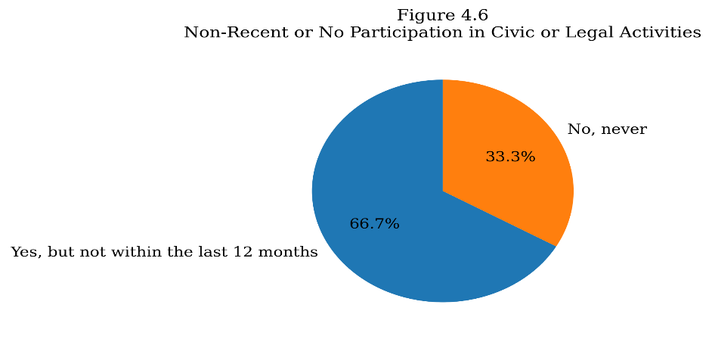
Source: Primary Data, 2025
Similarly, when asked about volunteering without pay, more than three-fifths of the respondents reported that they had volunteered in the community without any remuneration. This reflects their willingness to contribute to community welfare without expecting financial benefits. In contrast, about two-fifths of the respondents stated that they had never engaged in unpaid volunteering. However, their civic engagement appears to be limited to certain forms of civic engagement/ participation. None of the respondents reported contacting or visiting public officials, newspapers, or any form of mass media to express their opinions, indicating a limited role in formal channels of civic and political engagement. Likewise, they had never participated in protests, marches, or public demonstrations. This suggests a tendency to avoid confrontational or publicly visible forms of civic action, rather than necessarily indicating apathy. Furthermore, when asked whether they had ever worked as canvassers, going door to door for a political or social group or candidate, none of the respondents reported having done so, either during their education or at any point in their lives. This points out their limited involvement in direct political mobilisation and public advocacy activities.
When asked about their signing of petitions to solve any social problems, only about 33 per cent of the respondents said that they had signed one in the last 12 months to solve social issues. But the rest had never signed any petitions to solve any social problems in society. Similarly, none of the respondents had ever walked, run or bicycled for a charitable cause. This is different from simply giving money to a charitable society. They do not support many charitable activities by various organisations in society. This might be an indication of their reluctance to take the initiative on a social problem.
Only about 33 per cent of the respondents reported donating money to any group, whether local or national, political or social, labour unions, or other organisations, to support social causes. In contrast, around two-thirds of the respondents had not at all donated any money for such purposes. This suggests a relatively low level of financial contribution among law students towards social causes. However, this reluctance appears to be limited to direct monetary donations and does not extend to other forms of support. All respondents reported that they had helped others raise funds for social causes at some point. Among them, about 33 per cent had engaged in fundraising activities within the last 12 months, while the remaining respondents had done so earlier but not within the past year (see Figure 2). This indicates that although students may be less inclined to donate their own money, they actively support social causes through participation in fundraising efforts and related initiatives.
Figure 2: Fundraising participation
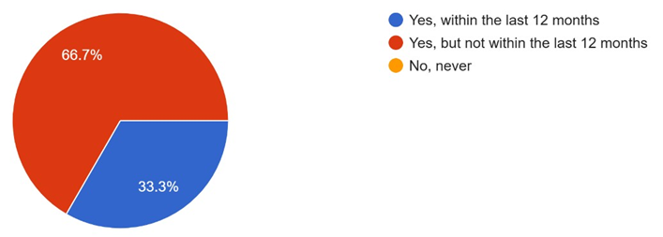
Source: Primary Data, 2025
More than two-thirds of the respondents reported that they regularly vote in local elections to elect candidates for their constituency. This reflects a relatively high level of electoral participation and indicates their awareness of and involvement in the democratic process. However, about 33 per cent of the respondents do not vote regularly in local elections, suggesting comparatively lower participation among a small segment of the students.
In terms of broader electoral involvement, 67 per cent of the respondents reported that they had contested in some form of election at some point in their lives. This demonstrates their willingness to actively engage in the democratic process, take initiative and contribute to community representation. On the other hand, the remaining respondents had never contested in any election and expressed no interest in doing so, indicating variation in the level of political engagement among law students.
When respondents were asked about their civic participation and volunteering in organisations such as community groups, health or social service organisations, religious groups, or organisations focused on children or education, only about one-third reported that they had volunteered in such activities (see Figure 3). This reflects the willingness of a small segment of law students to engage in community-oriented initiatives and contribute to social welfare. In contrast, approximately 66 per cent of the respondents had never volunteered in these types of organisations. This indicates a relatively low level of formal civic volunteering among the majority of respondents, suggesting limited engagement in community service activities.
Figure 3: Civic participation and volunteering
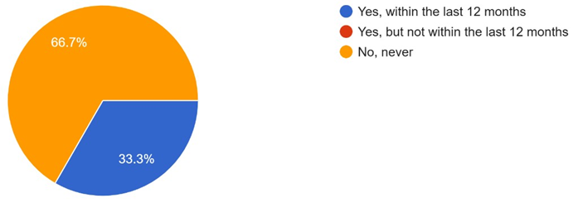
Source: Primary Data, 2025

Civic awareness among the Law students

When asked about their knowledge of Fundamental Rights and Duties and the related constitutional provisions, all respondents reported that they were aware of them, with two-thirds stating that they knew them very well. This indicates a strong level of legal awareness among the students and suggests that they are capable of exercising their rights and fulfilling their duties when required. Similarly, all respondents indicated that they know whom to approach in case their rights are violated, which would enable them to seek appropriate legal remedies in situations of infringement.

With regard to their understanding of the Constitution of India, all respondents reported having fairly good knowledge, and 67 per cent stated that they possessed very good knowledge of it. This reflects a solid grasp of the fundamental laws and principles governing the country. In addition, concerning knowledge of emergency contact numbers, 67 per cent of the respondents reported that they knew them very well, while the remaining respondents indicated that they were aware of them. This demonstrates a general sense of preparedness and alertness in handling potential emergencies.

The education system and civic awareness
When the respondents were asked about the current condition of the education system in incorporating civic awareness among the students, 66 per cent of the respondents agreed that the current curriculum and educational systems are sufficient for the younger generations (see figure 4). Among them, 33.33 per cent strongly agree with it. The remaining 34 per cent remained neutral to it. This is a good indicator of the quality of the current educational system in incorporating civic responsibilities among the younger generation.
Figure 4: Current curriculum and civic education
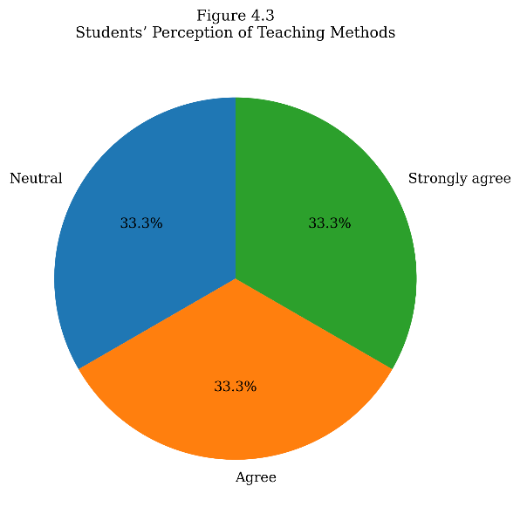
Source: Primary Data, 2025
When it comes to the current educational system, its curriculum and related activities, an essential step for the students to get acquainted with the rights and duties of each student in their respective societies, 67 per cent of the respondents agree that the current curriculum is sufficient in imparting the rights and duties among the law students, indicating a better civic education system in India. However, 33 per cent of the respondents disagree and feel that it is not sufficient in the current challenging times.
When the respondents were asked about the level of political participation in our society, only one-third of the respondents felt that it is fairly good. However, the remaining two-thirds of the respondents felt that it is neither good nor bad. This might be due to the lack of effectiveness of political participation in society.
Therefore, the law students have a comparatively high degree of civic awareness. They demonstrate a thorough understanding of fundamental civic knowledge relevant to daily life and are proficient in applying this knowledge in various settings. In particular, respondents exhibit a high level of awareness regarding emergency and public support systems, legal rights and obligations, and constitutional principles. This shows that law students have a solid understanding of civic duties and structures, which reflects a generally high degree of civic awareness.

Civic attitude among the students
The respondents have mixed responses to various situations presented to them. In certain circumstances, such as helping a person who had met with an accident and was bleeding on the road, all the respondents agreed; however, in other circumstances, such as dealing with a faulty street light or picking up garbage left on the road, it was not preferred by the respondents. They don’t feel the necessity to deal with it. Therefore, their practical application of civic knowledge is limited to their situations and not to the level of civic knowledge they possess.
Therefore, from the responses, it is very clear that law students have a very high civic awareness of their duties and responsibilities, and they feel that the current curriculum for school students is fairly sufficient to impart to them. Similarly, the number of community volunteers among the students is very low, and the current curriculum does not promote it as much. This might hinder their ability to connect with social issues. This adversely affects their community participation in society. This is well reflected through their inconsistencies in responses towards community participation. The attitude of the respondents is poor and varies based on situations. This creates difficulty for the respondents to actively participate in the community to solve social issues.
The findings indicate that law students possess a relatively high level of civic awareness, demonstrated by their sound understanding of essential civic information relevant to everyday life. Law students demonstrate a willingness to address social issues as they emerge and report significant involvement in social activism. Students' degree of civic awareness is strongly correlated with their capacity to recognise, comprehend, and resolve social issues that impact society as a whole, indicating that civic knowledge is crucial in enabling law students to take prompt and informed civic action. But this civic participation and engagement are limited to a few activities like campaigning, donating, etc. They are not taking part in solving the harsh realities of the societies.

Conclusion
The results of this study show that law students have a comparatively high degree of civic awareness, especially when it comes to constitutional principles, legal rights and obligations, and public redress mechanisms. This fundamental understanding is consistent with the idea that young people, particularly those with legal training, are an essential resource for tackling societal issues. The study also shows that although civic awareness is highly developed, there is still little evidence of consistent and long-term civic engagement. This disconnect between information and action is indicative of a larger problem in Kerala, where civic engagement is relatively low but civic education is adequate.
The findings also show that students with greater civic awareness are more likely to participate in social activism and address social issues when necessary. However, rather than being institutionalised or ongoing, such engagement is typically situational. This inconsistency highlights the limitations of a curriculum that prioritises theoretical instruction over experiential learning. Due to the judiciary's crucial role in resolving social issues through procedures like public interest litigation and constitutional remedies, law students' limited practical experience limits their capacity to apply legal tools for the benefit of society.
These results highlight the necessity of curriculum changes that emphasise the real-world implementation of civic obligations and responsibilities through clinical legal education, community involvement, and participatory learning techniques. Enhancing these elements in legal education can help bridge the gap between civic awareness and civic action, empowering future judges and attorneys to engage more effectively with issues that affect significant portions of society. Ultimately, the study concludes that incorporating civic engagement into legal education is essential for achieving the broader social objectives of legal education and translating civic knowledge into effective public service.

Consent
As per international standards or university standards, Participants’ written consent has been collected and preserved by the author(s).

Disclaimer (Artificial intelligence)

Author(s) hereby declare that NO generative AI technologies such as Large Language Models (ChatGPT, COPILOT, etc.) and text-to-image generators have been used during the writing or editing of this manuscript.

References
- Aðalbjarnardóttir, S. (2008). Young people’s civic awareness and engagement: Listening to their voices using thematic and developmental analysis. Í A. Ross (ritstjóri), Reflecting on identities: Research, practice and innovation, 717-727.
- Beaumont, E., & Battistoni, R. M. (2006). Introductory essay: Beyond civics 101: Rethinking what we mean by civic education. Journal of Political Science Education, 2(3), 241-247.
- Bloch, F. (2011). A Global Perspective on Clinical Legal Education. Revista de educación y derecho, (4).
- Colby, A., Ehrlich, T., Beaumont, E., & Stephens, J. (2003). Educating citizens: Preparing America's undergraduates for lives of moral and civic responsibility. John Wiley & Sons.
- Degelman, C. (2000). Fostering Civic Responsibility through Service Learning. Service-Learning Network, 8(1), n1.
- Guthrie, K. L., & McCracken, H. (2010). Teaching and learning social justice through online service-learning courses. The International Review of Research in Open and Distributed Learning, 11(3), 78-94.
- Hillygus, D. S., Nie, N. H., Prewitt, K., & Pals, H. (2006). The hard count: The political and social challenges of census mobilisation. Russell Sage Foundation.
- Kelso, K. C., & Kelso, J. C. (2021). Civic Education and Civil Discourse: A Role for Courts, Judges, and Lawyers. J. App. Prac. & Process, 21, 473.
- Komives, S. R., Lucas, N., & McMahon, T. R. (2009). Exploring leadership: For college students who want to make a difference. John Wiley & Sons.
- Malin, H. (2011). American identity development and citizenship education: A summary of perspectives and call for new research. Applied Developmental Science, 15(2), 111-116.
- Morimoto, S. A., & Friedland, L. A. (2011). The lifeworld of youth in the information society. Youth & Society, 43(2), 549-567.
- Reamey, R. A. A. (2011). Engaged citizenship: The effect of Blackburn Institute participation on post-graduate behaviours and beliefs. The University of Alabama.
- Strait, J., & Sauer, T. (2004). Constructing experiential learning for online courses: The birth of e-service. Educause Quarterly, 27(1), 62-65.
- Thompson, D. F. (2008). Deliberative democratic theory and empirical political science. Annu. Rev. Polit. Sci., 11(1), 497-520.
- Weiss, M. L. (2006). Protest and possibilities: Civil society and coalitions for political change in Malaysia. Stanford University Press.

Thompson, D. F, Deliberative democratic theory and empirical political science, 11(1), Annu. Rev. Polit. Sci., 497-520, (2008).
Aðalbjarnardóttir, S, Young people’s civic awareness and engagement: Listening to their voices using thematic and developmental analysis, Í A. Ross (ritstjóri), Reflecting on identities: Research, practice and innovation, 717-727, (2008).
Kelso, K. C., & Kelso, J. C, Civic Education and Civil Discourse: A Role for Courts, Judges, and Lawyers, 21, J. App. Prac. & Process, 473-74, (2021).
Morimoto, S. A., & Friedland, L. A, The lifeworld of youth in the information society, 43(2), Youth & Society, 549-567, (2011).
Maharg, P. Transforming legal education: learning and teaching the law in the early twenty-first century. Routledge,1-5 (2016).
Weiss, M. L. Protest and possibilities: Civil society and coalitions for political change in Malaysia. Stanford University Press, (2006).
Hillygus, D. S., Nie, N. H., Prewitt, K., & Pals, H. The hard count: The political and social challenges of census mobilisation. Russell Sage Foundation, (2006).
Reamey, R. A. A, Engaged citizenship: The effect of Blackburn Institute participation on post-graduate behaviours and beliefs. The University of Alabama, 7, (2011).
Battistoni, Rick, and Rick Battistoni. "Approaching democratic engagement." Advancing knowledge in service-learning, Research to transform the field (2006).
Guthrie, K. L., & McCracken, H, Teaching and learning social justice through online service-learning courses. 11(3), The International Review of Research in Open and Distributed Learning, 78-94, (2010).
Strait, J., & Sauer, T, Constructing experiential learning for online courses: The birth of e-service. 27(1), Educause Quarterly, 62-65, (2004).
Degelman, C, Fostering Civic Responsibility through Service Learning. 8(1), Service-Learning Network, 1-11, (2000).
Bloch, Frank S., ed, The global clinical movement: Educating lawyers for social justice. Oxford University Press, (2010).

