Cultivating 21st-Century Skills in Araling Panlipunan 9 through Transversal Activities

.
ABSTRACT

This study aimed to develop and validate Supplemental Transversal Skills Activities (TSAs) for Araling Panlipunan 9 to address gaps in the integration of transversal skills within existing instructional materials. Using a descriptive Research and Development (R&D) design, the study was conducted in selected public junior high schools across three school divisions in Ilocos Sur, Philippines, over one academic year. The sample consisted of master teachers, learning resource content validators, an economics expert, and a visual design specialist selected through purposive sampling. Document analysis, expert validation, and descriptive statistical methods were employed to examine existing learning activities, develop supplemental materials aligned with the curriculum, and evaluate their validity in terms of objectives, content, and instructional qualities. Results revealed that while transversal skills were present in the Araling Panlipunan 9 Learner’s Module, their integration was uneven and insufficient across lessons, necessitating targeted instructional support. The developed TSAs, which intentionally embedded six key transversal skill domains across all quarters, were rated as Highly Valid by experts, obtaining an overall composite mean of 3.95, with consistently high ratings for objectives (M = 3.95), content (M = 3.94), and instructional qualities (M = 3.97). These findings indicate that the TSAs are pedagogically sound, curriculum-aligned, learner-centered, and appropriate as supplementary instructional materials. The study concludes that systematically designed supplemental activities can significantly strengthen the integration of transversal skills in Araling Panlipunan 9, supporting holistic learner development in line with national curriculum reforms. It is recommended that the TSAs be pilot-tested in classroom settings, integrated into instructional planning, and considered for broader adoption and further refinement to enhance 21st-century skill development in social studies education.

Keywords: Araling Panlipunan 9, Learners’ Module, Transversal Skills, Supplemental Transversal Skills Activities (TSA)

1. INTRODUCTION

Education systems play a critical role in preparing young people with the knowledge, skills, and values necessary to thrive in an increasingly complex and interconnected world. As societies progress and economies evolve, there is a growing need to emphasize the development of transversal skills, which go beyond traditional academic knowledge to foster holistic development. These skills are essential for cultivating adaptable, innovative, and well-rounded individuals capable of navigating the challenges of the 21st century.
Globally, UNESCO emphasizes that education must equip learners not only with content knowledge but also with the ability to adapt to dynamic social, economic, and technological contexts (Barbara, 2015). In the Asia-Pacific region, including the Philippines, preparing students for the unpredictability of the modern world—ranging from global interconnectedness to rapidly shifting job markets—requires the intentional integration of transversal skills into formal education. Such skills include critical thinking, creativity, collaboration, communication, self-motivation, perseverance, intercultural understanding, and media literacy (Urlanda et al., 2025; Barbara, 2015).
In the Philippine context, the Department of Education (DepEd) has explicitly recognized the importance of 21st-century skills and transversal competencies in shaping learners’ holistic development. DepEd Order No. 024, s. 2022, which adopts the Basic Education Development Plan 2030 (DepEd, 2022), underscores the need for educational programs to foster learner competencies that are adaptive, creative, and globally oriented. Complementing this, DepEd Order No. 10, s. 2024, which outlines the policy guidelines for the implementation of the Matatag Curriculum (DepEd, 2024), highlights the critical role of learner-centered and competency-based approaches that integrate transversal skills across all subject areas, including Araling Panlipunan. These policies collectively reinforce the mandate to equip students with transferable skills that prepare them for lifelong learning, active citizenship, and meaningful participation in society.
Despite these policy directives, research indicates that transversal skills are often underrepresented in existing instructional materials, particularly in Araling Panlipunan 9. In the Economics curriculum, teaching largely focuses on content knowledge, with limited opportunities for students to engage in activities that foster critical thinking, collaboration, problem-solving, and global awareness (DepEd, 2024). This gap underscores the need for instructional interventions that deliberately integrate transversal skills into subject-specific learning experiences.
To address this gap, the present study aims to develop supplemental Transversal Skills Activities (TSAs) for Araling Panlipunan 9, designed to enhance the existing curriculum and empower teachers to cultivate these essential skills. These activities provide learners with opportunities to engage in learning experiences that are both content-rich and skill-enabling, preparing them to respond effectively to real-world challenges. The integration of transversal skills aligns with international and national educational priorities, promoting critical thinking, interpersonal competence, global citizenship, and holistic personal development.
Prior research supports the integration of transversal skills into educational frameworks. Laguna-Sánchez et al. (2020) emphasized the importance of equipping learners with employability and entrepreneurial skills alongside transversal competencies. Similarly, Kim et al. (2019) argued that effective 21st-century teaching necessitates cultivating higher-order thinking skills to prepare learners for global challenges. In the Philippine setting, studies such as Serafico-Reyes et al. (2019) and Garcia-Acojido (2021) highlight the limitations of current Araling Panlipunan instructional resources in promoting transversal skills, emphasizing the need for activities that intentionally foster these competencies. Moreover, Goggin et al. (2019), Ihalon (2022), and Gil (2022) note the potential of differentiated instruction, innovative methodologies, and purposefully designed materials in enhancing learner engagement and transversal skill development.
Aligned with these findings and DepEd policies, this study seeks to develop a validated set of TSAs for Araling Panlipunan 9, with the following objectives:
- To identify the transversal skills reflected in the existing Araling Panlipunan 9 learning module.
- To develop supplemental activities that enhance the current module and integrate transversal skills.
- To evaluate the validity of the developed activities in terms of objectives, content, and instructional quality.
By systematically integrating transversal skills into Araling Panlipunan 9 through supplemental activities, this study aims to support the development of learners who are academically competent, socially responsible, and prepared for the multifaceted demands of the 21st century.

2. methodology

This study utilized a descriptive research design following the Research and Development (R&D) methodology. The R&D approach was chosen as it is systematic and creative, aimed at increasing knowledge, specifically in the context of developing new methodologies and applications for teaching and learning (OECD, 2018). The study progressed in three stages: planning, development, and validation. During the planning stage, the researcher selected and confirmed transversal skills reflected in activities from the learners' module in Araling Panlipunan 9. The development stage focused on creating supplemental activities, ensuring their alignment with educational guidelines. Finally, the validation stage involved expert validation of the developed activities in terms of their objectives, content, and instructional quality.
The study was conducted in public junior high schools from three School Divisions in the province of Ilocos Sur: Vigan City, Candon City, and Ilocos Sur. The selected schools included Ilocos Sur National High School (Vigan City), Candon National High School (Candon City), Santa Maria National High School, Narvacan National High School, San Juan National High School, and Sinait National High School (Ilocos Sur Division), as well as the University of Northern Philippines in Vigan City. These locations provided a diverse setting for collecting data from a range of junior high school teachers and academic experts.
Purposive sampling was employed to select respondents who could provide the most relevant and valid data. The first group included nine (9) master teachers from the selected schools who had experience teaching Araling Panlipunan 9, and a faculty expert from the University of Northern Philippines with at least five years of teaching Economics. This group validated the transversal skills reflected in the Araling Panlipunan 9 module. The second group of respondents, consisting of three (3) content evaluators of learning resources, one (1) economics faculty expert, and one (1) visual graphic artist, was tasked with validating the content and instructional quality of the developed supplemental Transversal Skills Activities (TSAs).
Two research instruments were used: the confirmation survey checklist and the content validation rating scale. The confirmation survey checklist aimed to verify whether the transversal skills identified by the researcher were present in the selected activities of the Araling Panlipunan 9 module. The content validation rating scale, adapted from Lagadan (2022), was used to gather feedback on the developed TSAs. The scale utilized a four-point Likert scale, ranging from 1.00 (Not Valid) to 4.00 (Highly Valid), to measure the validity of the activities in terms of objectives, content, and instructional quality.
Data gathering adhered to ethical guidelines set by the University Research Ethics Board (URERB). After obtaining clearance, the researcher sought permission from the school division superintendents and teachers. The confirmation survey was then administered, followed by the distribution of printed TSAs to the panel of validators. The final version of the TSAs was refined based on feedback from the validators, incorporating revisions where necessary to ensure the activities' relevance and quality.
Data analysis employed descriptive statistical treatment, specifically calculating the weighted mean of responses from the validation survey. The means were interpreted using the following ranges: 3.41-4.00 for "Highly Valid," 2.61-3.40 for "Moderately Valid," 1.81-2.60 for "Slightly Valid," and 1.00-1.80 for "Not Valid." This method ensured that the validity of the developed TSAs was quantified and could be accurately assessed based on expert feedback.

3. results and discussion

3.1 Mapping Transversal Skills in Selected Learning Activities of the Araling Panlipunan 9 Learner’s Module
This section presents the findings of the document analysis conducted on the learners' module for Araling Panlipunan 9, confirming the transversal skills reflected in each activity. The transversal skills identified and validated in the study were categorized by quarter, showcasing their presence in the curriculum's teaching activities. The analysis reveals that Social Studies as a discipline offers a holistic approach to learning, reinforcing the need for transversal skills to be integrated throughout educational materials. These skills are critical for preparing students to navigate an increasingly complex world. As highlighted by Barbara (2015), embedding transversal competencies in all lessons across the curriculum aligns with global educational standards, fostering well-rounded learners who can contribute meaningfully to society.
3.1.1 Quarter I
Araling Panlipunan 9, Quarter 1 focused on the concept of Ekonomiks, covering seven lessons. However, only six learning activities were provided, as Lesson 7 from the learners' module was excluded during the document analysis. The identification of learning activities was based on the Department of Education's most essential learning competencies. The lessons covered in this quarter were as follows: (1) Kahulugan at Kahalagahan ng Ekonomiks, (2) Ang Kakapusan, (3) Pangangailangan at Kagustuhan, (4) Alokasyon, (5) Pagkonsumo, and (6) Produksiyon. Each lesson's activities were carefully examined to identify the transversal skills reflected.
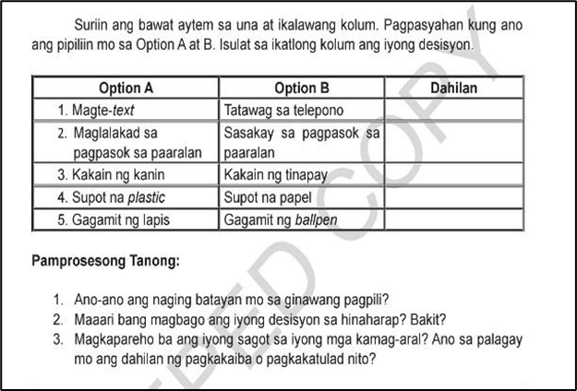
Picture 1. AP 9 Quarter I, Learner’s Module, p. 13.

In Aralin 1: Kahulugan at Kahalagahan ng Ekonomiks, the following transversal skills are reflected in the activity shown in Picture 1: TS2 (Global Citizenship), TS3 (Information and Communication Technology), TS4 (Interpersonal Skills), TS5 (Intrapersonal Skills), and TS6 (Spirituality). These skills are evident in the activity, as the presented items and options enable learners to practice ideal citizenship. Additionally, the activity fosters positive relationships among learners, encouraging them to reflect on their thoughts while considering others' perspectives.

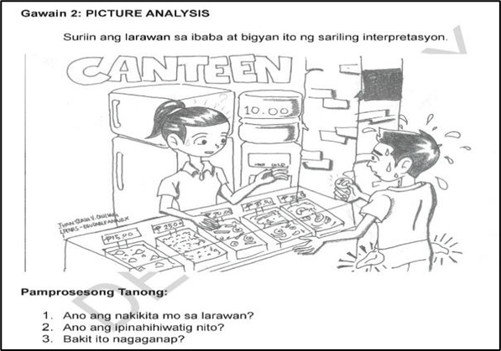
Picture 2. AP 9 Quarter I, Learner’s Module, p. 24.
In Aralin 2: Kakapusan, the following transversal skills are reflected in the activity shown in Picture 2: TS2 (Global Citizenship), TS3 (Information and Communication Technology), TS4 (Interpersonal Skills), TS5 (Intrapersonal Skills), and TS6 (Spirituality). These skills are apparent in the activity because the objectives and processing questions encourage learners to place themselves in real-world situations and reflect on their personal experiences related to scarcity.
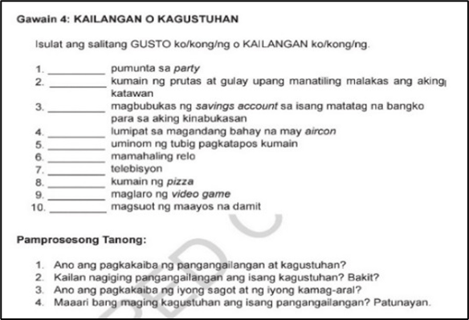
Picture 3. AP 9 Quarter I, Learner’s Module, p. 41.
In Aralin 3: Pangangailangan at Kagustuhan, the following transversal skills are demonstrated in Picture 3: TS3 (Information and Communication Technology), TS4 (Interpersonal Skills), TS5 (Intrapersonal Skills), and TS6 (Spirituality). These skills are clearly evident in the activity, where learners are asked to distinguish between needs and wants based on the given statements, prompting them to critically assess the differences between these two concepts.
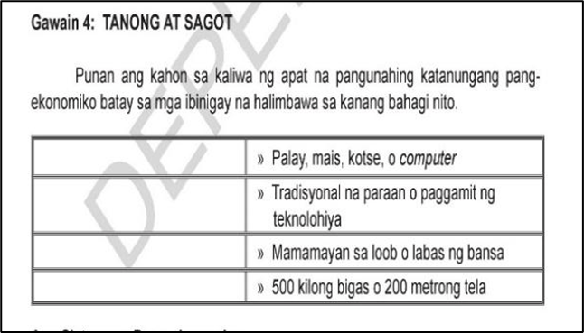
Picture 4. AP 9 Quarter I, Learner’s Module, p. 54.
In Aralin 4: Alokasyon, the following transversal skills are reflected in the activity shown in Picture 4: TS2 (Global Citizenship), TS3 (Information and Communication Technology), TS4 (Intrapersonal Skills), and TS6 (Spirituality). These skills are demonstrated in the activity, where learners critically analyze economic questions by selecting and justifying their choices based on given scenarios, encouraging independent thinking.

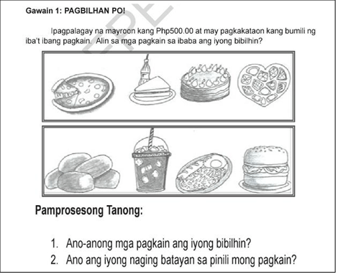
Picture 5. AP 9 Quarter I, Learner’s Module, p. 60.

In Aralin 5: Pagkonsumo, the following transversal skills are reflected in the activity shown in Picture 5: TS1 (Critical and Innovative Thinking), TS2 (Global Citizenship), TS4 (Interpersonal Skills), and TS5 (Intrapersonal Skills). These skills are visible in the activity, where learners are tasked with budgeting a set amount of money. This helps them develop a sense of responsibility and financial management while applying critical thinking.
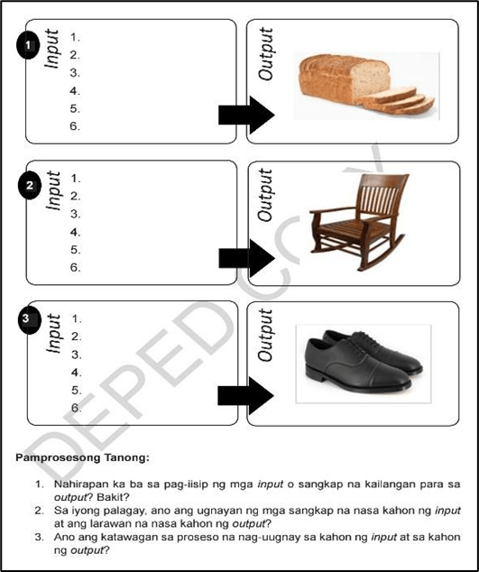
Picture 6. AP 9 Quarter I, Learner’s Module, p. 73.
In Aralin 6: Produksiyon, the following transversal skills are reflected in the activity shown in Picture 6: TS1 (Critical and Innovative Thinking), TS2 (Global Citizenship), TS3 (Information and Communication Technology), TS4 (Interpersonal Skills), and TS5 (Intrapersonal Skills). These skills are highlighted in the worksheet, where learners identify the inputs involved in a production process, fostering critical thinking and the ability to link production processes with inputs and outputs.
3.1.2 Quarter II
Araling Panlipunan 9, Quarter 2 concentrated on Maykroekonomiks, comprising five lessons with accompanying activities. The lessons included: (1) Demand, (2) Supply, (3) Interaksiyon ng Demand at Supply, (4) Ang Pamilihan at ang Istruktura Nito, and (5) Ugnayan ng Pamilihan at Pamahalaan. These activities were carefully reviewed to identify the transversal skills reflected.
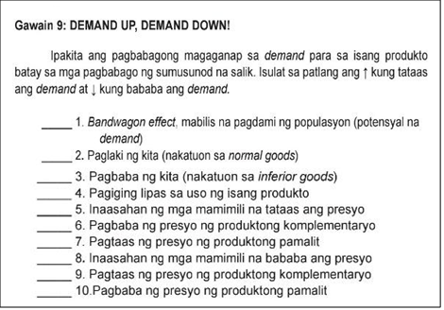
Picture 7. AP 9 Quarter II, Learner’s Module, pp. 123-124
In Aralin 1: Demand, the following transversal skills are reflected in the activity shown in Picture 7: TS2 (Global Citizenship), TS3 (Information and Communication Technology), TS4 (Interpersonal Skills), TS5 (Intrapersonal Skills), and TS6 (Spirituality). These skills are evident as the activity presents the effects of factors influencing demand, encouraging learners to analyze economic situations and navigate global technologies while engaging with their community.
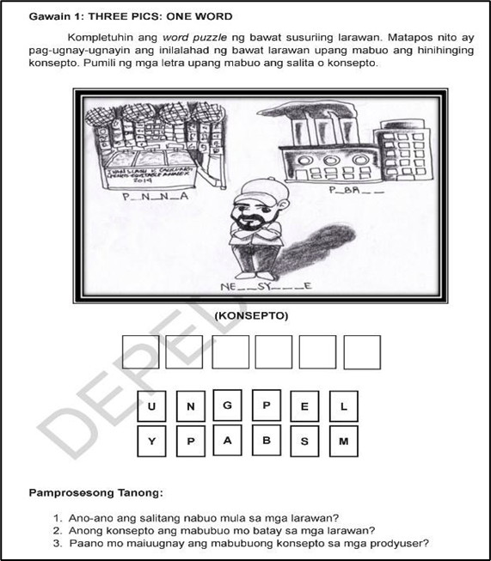
Picture 8. AP 9 Quarter II, Learner’s Module, p. 139
In Aralin 2: Supply, the following transversal skills are reflected in the activity shown in Picture 8: TS1 (Critical and Innovative Thinking), TS2 (Global Citizenship), TS3 (Information and Communication Technology), TS5 (Intrapersonal Skills), and TS6 (Spirituality). These skills emerge as the pictures presented help learners critically analyze the role of producers in the market, emphasizing the importance of producers in meeting everyday needs.
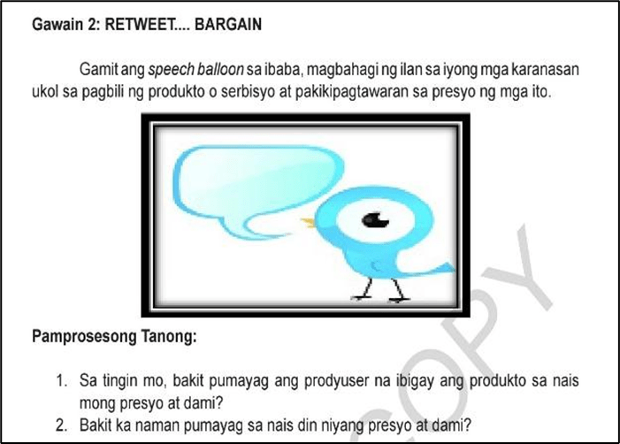
Picture 9. AP 9 Quarter II, Learner’s Module, p. 160
In Aralin 3: Interaksiyon ng Demand at Supply, the following transversal skills are reflected in the activity shown in Picture 9: TS1 (Critical and Innovative Thinking), TS2 (Global Citizenship), TS3 (Information and Communication Technology), and TS5 (Intrapersonal Skills). These skills are reflected as learners are tasked with analyzing and forming thoughts on economic decisions based on their experiences, promoting responsible citizenship.
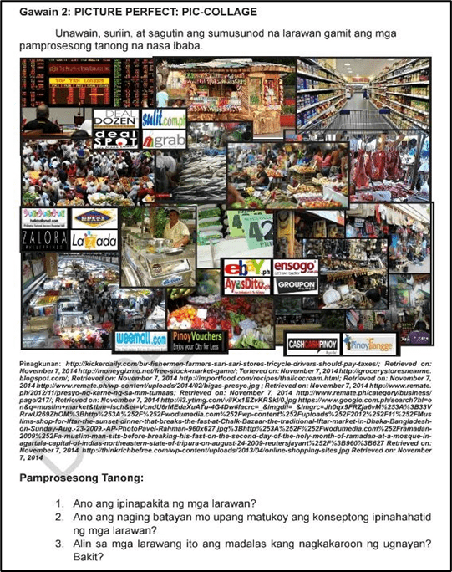
Picture 10. AP 9 Quarter II, Learner’s Module, p. 177
In Aralin 4: Ang Pamilihan at ang Istruktura Nito, the following transversal skills are reflected in the activity shown in Picture 10: TS2 (Global Citizenship), TS3 (Information and Communication Technology), TS5 (Intrapersonal Skills), and TS6 (Spirituality). These skills are demonstrated as learners analyze pictures to understand market structures and their roles in the economy, while the processing questions enhance their understanding of market importance.
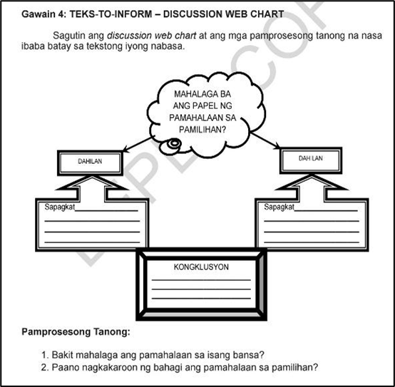
Picture 11. AP 9 Quarter II, Learner’s Module, p. 202
In Aralin 5: Ugnayan ng Pamilihan at Pamahalaan, the following transversal skills are reflected in the activity shown in Picture 11: TS1 (Critical and Innovative Thinking), TS2 (Global Citizenship), TS3 (Information and Communication Technology), TS5 (Intrapersonal Skills), and TS6 (Spirituality). These skills emerge as learners critically assess the role of government in market settings using a graphic organizer to structure their thoughts.
3.1.3 Quarter III
Araling Panlipunan 9, Quarter 3 focused on Makroekonomiks, featuring six lessons, each accompanied by a learning activity. The lessons covered were: (1) Paikot na Daloy ng Ekonomiya, (2) Pambansang Kita, (3) Implasyon, (4) Patakarang Piskal, (5) Patakarang Pananalapi, and (6) Pag-iimpok at Pamumuhunan. These activities were scrutinized for the transversal skills they reflected.
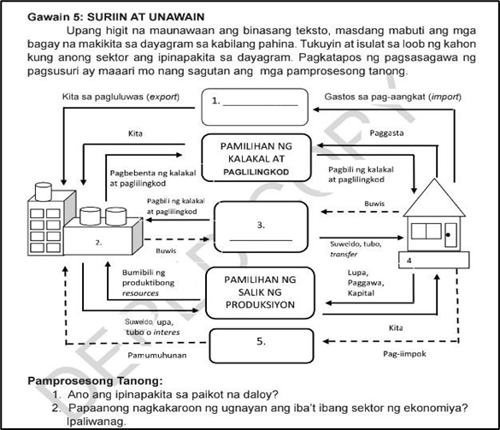
Picture 12. AP 9 Quarter III, Learner’s Module, p. 202
In Aralin 1: Paikot na Daloy ng Ekonomiya, the following transversal skills are reflected in the activity shown in Picture 12: TS1 (Critical and Innovative Thinking), TS2 (Global Citizenship), TS3 (Information and Communication Technology), TS4 (Interpersonal Skills), and TS5 (Intrapersonal Skills). The activity encourages learners to generate and evaluate new ideas, fostering global citizenship by helping them understand the Philippine economy and promoting data-driven decision-making skills.
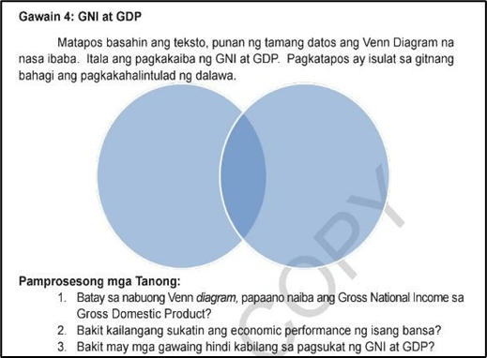
Picture 13. AP 9 Quarter III, Learner’s Module, p. 247
In Aralin 2: Pambansang Kita, the following transversal skills are reflected in Picture 13: TS3 (Information and Communication Technology), TS5 (Intrapersonal Skills), and TS6 (Spirituality). These skills are evident as learners use technology to explore the economic performance of countries, and they reflect on their understanding of GNP and GDP, integrating diverse perspectives on national income.
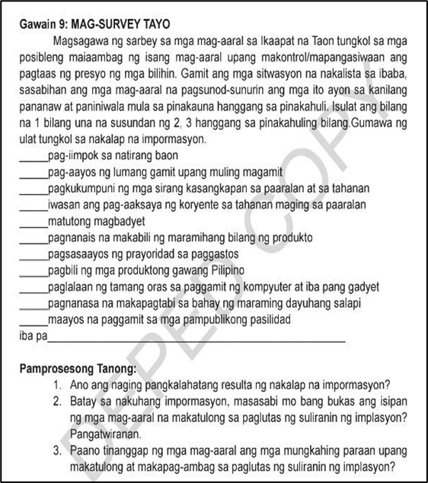
Picture 14. AP 9 Quarter III, Learner’s Module, p. 284
In Aralin 3: Implasyon, the transversal skills reflected in the activity shown in Picture 14 include: TS1 (Critical and Innovative Thinking), TS2 (Global Citizenship), TS3 (Information and Communication Technology), TS5 (Intrapersonal Skills), and TS6 (Spirituality). The activity involves learners analyzing economic situations related to inflation and developing solutions, promoting awareness of economic challenges and critical problem-solving.
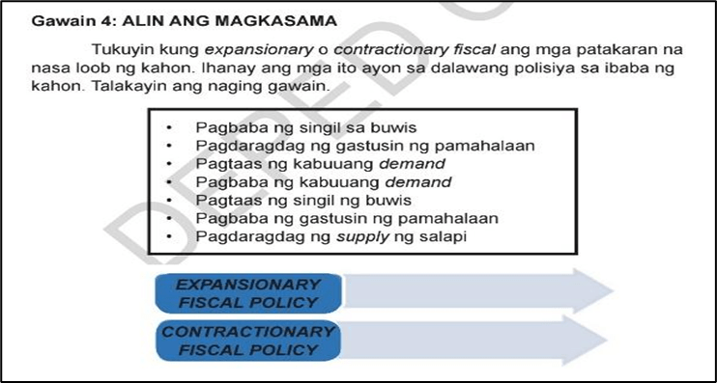
Picture 15. AP 9 Quarter III, Learner’s Module, p. 290
In Aralin 4: Patakarang Piskal, the following transversal skills are reflected in the activity shown in Picture 15: TS1 (Critical and Innovative Thinking), TS3 (Information and Communication Technology), TS5 (Intrapersonal Skills), and TS6 (Spirituality). These skills are evident as learners use technology to research fiscal policies and critically analyze economic scenarios, honing their ability to think through complex policy implications.
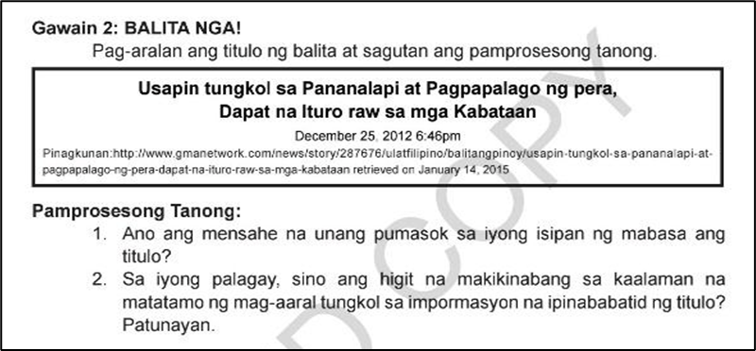
Picture 16. AP 9 Quarter III, Learner’s Module, p. 305
In Aralin 5: Patakarang Pananalapi, the following transversal skills are reflected in the activity shown in Picture 16: TS1 (Critical and Innovative Thinking), TS2 (Global Citizenship), TS3 (Information and Communication Technology), TS4 (Interpersonal Skills), and TS5 (Intrapersonal Skills). These skills emerge as learners engage in news analysis activities that deepen their understanding of monetary policy and its role in the economy, encouraging social awareness and responsible citizenship.
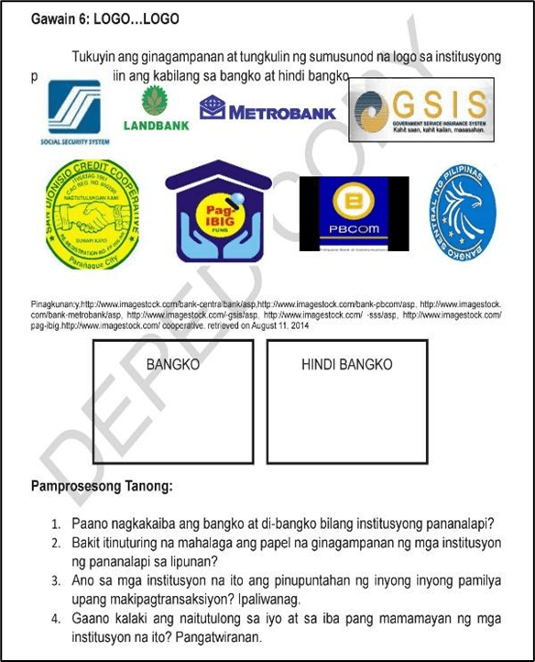
Picture 17. AP 9 Quarter III, Learner’s Module, p. 317
In Aralin 6: Pag-iimpok at Pamumuhunan, the following transversal skills are reflected in the activity shown in Picture 17: TS2 (Global Citizenship), TS3 (Information and Communication Technology), TS5 (Intrapersonal Skills), and TS6 (Spirituality). These skills are highlighted as learners explore the significance of financial institutions and develop reasoning skills while reflecting on the importance of saving and investing in the national economy.
3.1.4 Quarter IV
Araling Panlipunan 9, Quarter 4 focused on Mga Sektor ng Ekonomiya at mga Patakarang Pang-ekonomiya Nito, featuring six lessons and corresponding activities. The lessons were: (1) Konsepto at Palatandaan ng Pambansang Kaunlaran, (2) Sektor ng Agrikultura, (3) Sektor ng Industriya, (4) Sektor ng Paglilingkod, (5) Impormal na Sektor, and (6) Kalakalang Panlabas. These activities were analyzed to identify the transversal skills reflected.
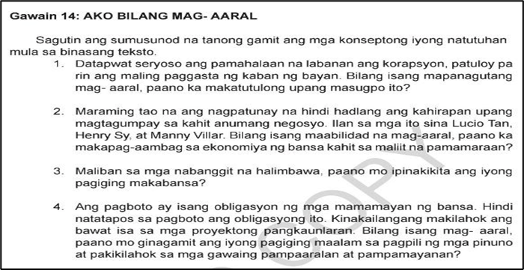
Picture 18. AP 9 Quarter IV, Learner’s Module, p. 355
In Aralin 1: Konsepto at Palatandaan ng Pambansang Kaunlaran, the following transversal skills are reflected in the activity shown in Picture 18: TS1 (Critical and Innovative Thinking), TS2 (Global Citizenship), TS3 (Information and Communication Technology), TS5 (Intrapersonal Skills), and TS6 (Spirituality). These skills are demonstrated as learners engage with questions that prompt them to consider how they can contribute to national development, fostering both civic responsibility and personal reflection.
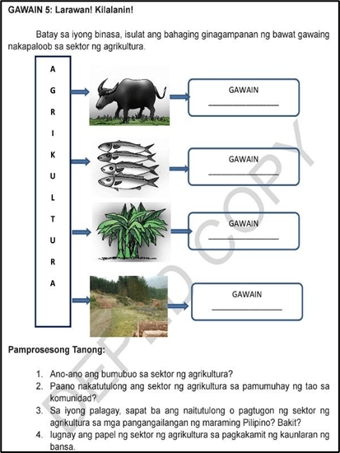
Picture 19. AP 9 Quarter IV, Learner’s Module, p. 370
In Aralin 2: Sektor ng Agrikultura, the following transversal skills are reflected in the activity shown in Picture 19: TS1 (Critical and Innovative Thinking), TS3 (Information and Communication Technology), TS4 (Interpersonal Skills), TS5 (Intrapersonal Skills), and TS6 (Spirituality). These skills are visible as learners critically explore agricultural sectors and their impact on the economy while using technology to enhance their understanding of modern agricultural practices.
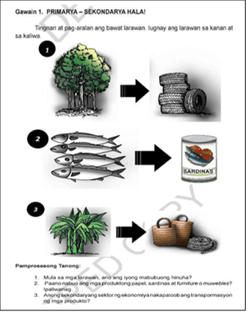
Picture 20. AP 9 Quarter IV, Learner’s Module, p. 386-387
In Aralin 3: Sektor ng Industriya, the following transversal skills are reflected in the activity shown in Picture 20: TS1 (Critical and Innovative Thinking), TS2 (Global Citizenship), TS3 (Information and Communication Technology), TS4 (Interpersonal Skills), and TS5 (Intrapersonal Skills). These skills are demonstrated as learners critically assess how raw materials are transformed into finished products, promoting local industry and encouraging innovation and creativity in product development.
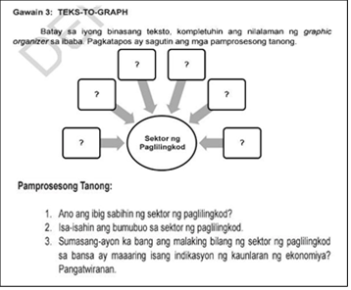
Picture 21. AP 9 Quarter IV, Learner’s Module, p. 413-414
In Aralin 4: Sektor ng Paglilingkod, the following transversal skills are reflected in the activity shown in Picture 21: TS1 (Critical and Innovative Thinking), TS3 (Information and Communication Technology), TS4 (Interpersonal Skills), TS5 (Intrapersonal Skills), and TS6 (Spirituality). These skills are evident as learners engage in an activity that explores the service sector and its future role, fostering collaboration and leadership skills.
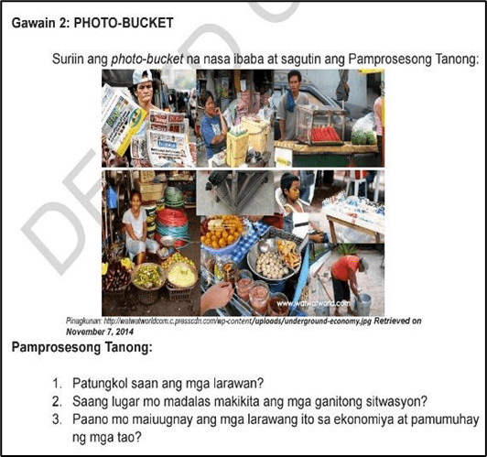
Picture 22. AP 9 Quarter IV, Learner’s Module, p. 431
In Aralin 5: Impormal na Sektor, the following transversal skills are reflected in the activity shown in Picture 22: TS3 (Information and Communication Technology), TS4 (Interpersonal Skills), TS5 (Intrapersonal Skills), and TS6 (Spirituality). These skills are visible as learners analyze the underground economy and reflect on how economic ethics and personal beliefs relate to the broader economy.
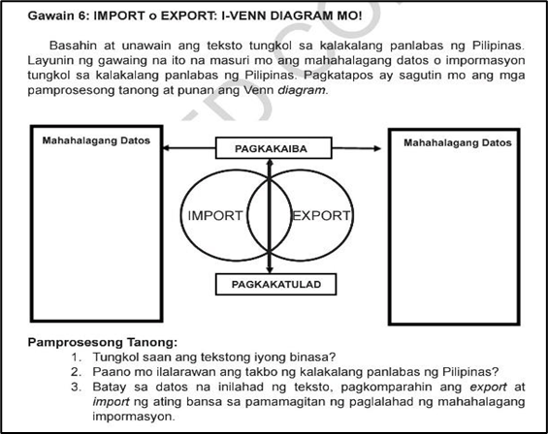
Picture 23. AP 9 Quarter IV, Learner’s Module, p. 445
In Aralin 6: Kalakalang Panlabas, the following transversal skills are reflected in the activity shown in Picture 23: TS1 (Critical and Innovative Thinking), TS2 (Global Citizenship), TS3 (Information and Communication Technology), TS4 (Interpersonal Skills), TS5 (Intrapersonal Skills), and TS6 (Spirituality). These skills are demonstrated as learners critically evaluate the importance of exports and imports, fostering global awareness and economic understanding.
The results of the document analysis indicate that transversal skills (TS) integrated into the learning activities across all quarters of Araling Panlipunan 9 reflect the holistic nature of Social Studies as a discipline. This approach is consistent with the Department of Education’s strategic vision for basic education as articulated in DepEd Order No. 024, s. 2022 (DepEd, 2022), which emphasizes the development of 21st-century skills and competencies as central to the Basic Education Development Plan 2030. The integration of transversal skills aligns with global recommendations, such as those by U Barbara (2015), advocating for the inclusion of these competencies across all subjects, including the social sciences, to prepare students for real-world challenges. Social Studies, by nature, fosters critical awareness of societal dynamics and promotes civic competence, making it an ideal platform for cultivating transversal skills essential for holistic student development (Carvalho & Almeida, 2022).
Consistent with the DepEd’s updated curriculum framework under DepEd Order No. 10, s. 2024 (DepEd, 2024), which implements the Matatag Curriculum, the study underscores the importance of embedding transversal skills within learning activities to equip learners with the competencies necessary for navigating complex and evolving global contexts. The study revealed that activities across Quarters I to IV can be enhanced to foster competencies such as critical thinking, creativity, collaboration, communication, and global citizenship—skills that are increasingly indispensable in contemporary education (Sá & Serpa, 2018; López & Rodríguez-López, 2020).
The findings further suggest that while some transversal skills are currently integrated within the existing Araling Panlipunan 9 curriculum, there is a pronounced need to expand and deepen their integration across all lessons. For example, analysis of the learning activities highlighted gaps in TS1 (Critical and Innovative Thinking), TS2 (Global Citizenship), TS4 (Interpersonal Skills), and TS6 (Spirituality), which, if unaddressed, may limit students’ capacity to adapt, innovate, and collaborate effectively. Belchior-Rocha et al. (2022) emphasize the responsibility of educational systems to ensure learners acquire transversal skills to support employability and lifelong learning. In this context, the Araling Panlipunan 9 curriculum presents a strategic opportunity to cultivate these competencies intentionally, thereby preparing students for both academic success and meaningful participation in society.
Moreover, the study aligns with findings from Biasin and Pacquola (2019), highlighting the positive impact of systematically integrating transversal skills on students’ academic, personal, and professional development. By revising the learning activities to explicitly foster transversal competencies, educators can enhance students’ critical thinking, problem-solving, collaboration, and global awareness, all of which are central to the goals of the Matatag Curriculum (DepEd, 2024). Such integration is essential for equipping learners with the ability to navigate the challenges of the 21st century, fostering resilience, innovation, and adaptability in real-world scenarios.

In summary, the analysis confirms that Araling Panlipunan 9 holds significant potential as a tool for transversal skills development. By strategically redesigning learning activities to integrate TS comprehensively, the curriculum can support the holistic development of students, aligning with the broader vision of modern education as articulated in DepEd policies. The deliberate inclusion of these skills ensures that learners are not only knowledgeable about social, economic, and civic concepts but are also capable of applying their learning creatively, collaboratively, and ethically in diverse and dynamic contexts..
3.2 Supplemental Transversal Skills–Based Activity Package for Araling Panlipunan 9
As revealed by the documentary analysis, several transversal skills were insufficiently represented in the existing learning activities of the Araling Panlipunan 9 Learner’s Module. In response to these gaps, this section presents the Supplemental Transversal Skills Activities (TSAs) designed for each quarter. These activities aim to enrich the existing module while intentionally fostering the development of transversal skills among learners as they engage with economic concepts.
3.2.1 Quarter I
The learning activities in Quarter I were closely examined to determine which transversal skills were inadequately reflected in the Learner’s Module. The lessons analyzed include: (1) Kahulugan at Kahalagahan ng Ekonomiks; (2) Ang Kakapusan; (3) Pangangailangan at Kagustuhan; (4) Alokasyon; (5) Pagkonsumo; and (6) Produksiyon.
In Figure 1, the absence of TS1 (Critical and Innovative Thinking) is evident. The scenario relies heavily on conventional and routine responses, offering limited opportunities for learners to explore alternative solutions or demonstrate creative problem-solving. As a result, learners’ ability to adapt to dynamic economic situations and develop a deeper understanding of economic principles is constrained.
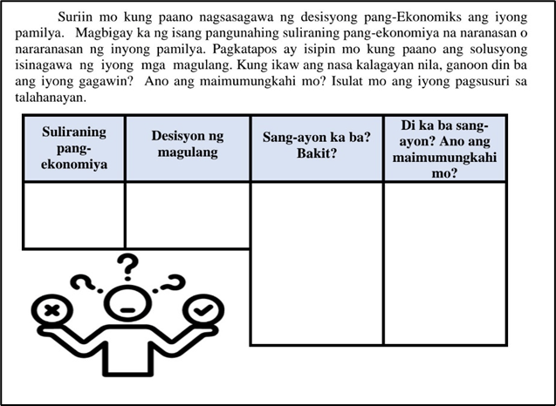
Figure 1. AP9 – Supplemental TSA Yunit I, p. 1
Accordingly, Figure 1 explicitly integrates TS1 (Critical and Innovative Thinking). The activity presents a more dynamic and adaptive economic scenario that encourages learners to explore novel ideas, critically analyze situations, and anticipate possible outcomes. This skill is essential in Economics, as it equips learners with the ability to examine economic conditions critically, generate innovative solutions, and evaluate potential consequences. Through this integration, the activity provides a more comprehensive approach to understanding complex economic realities.
In Figure 2, both TS1 (Critical and Innovative Thinking) and TS4 (Interpersonal Skills) are notably absent. The scenario lacks evidence of collaboration, teamwork, or analytical engagement, resulting in a limited depiction of how interconnected economic factors operate within real-world contexts.
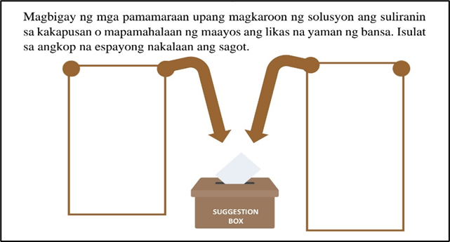
Figure 2. AP9 – Supplemental TSA Yunit I, p. 2
In contrast, Figure 2 effectively demonstrates TS1 and TS4. The activity emphasizes collaborative discussion, allowing learners to share insights and analyze issues related to scarcity collectively. This cooperative learning environment promotes critical thinking and enhances learners’ ability to navigate the complexities of economic systems through shared perspectives and informed dialogue.
In Figure 3, critical transversal skills necessary for understanding the concepts of needs and wants are lacking. Specifically, TS1 (Critical and Innovative Thinking) and TS2 (Global Citizenship) are absent, as the activity does not reflect creative analysis or awareness of broader social and global contexts.
Conversely, Figure 3 addresses these deficiencies by integrating TS1 and TS2. Learners are required to critically analyze the hierarchy of needs while engaging with diverse perspectives. The representation of collaboration among individuals fosters an appreciation of global contexts and cultural diversity, which are essential in understanding economic behavior in a globalized society.

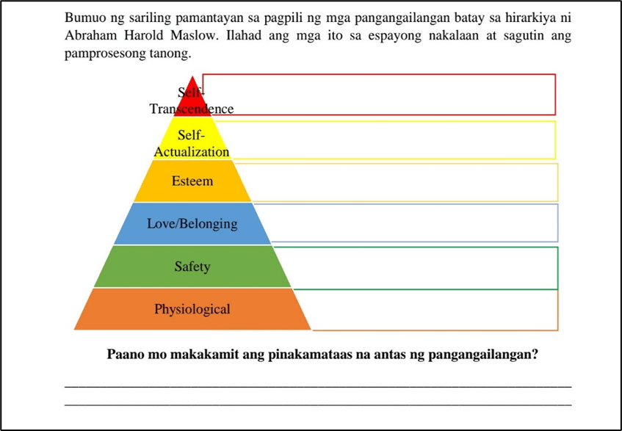
Figure 3. AP9 – Supplemental TSA Yunit I, p. 3
In Figure 4, TS1 (Critical and Innovative Thinking) and TS4 (Interpersonal Skills) are insufficiently represented. The activity focuses primarily on identification rather than analysis, and it does not encourage collaboration or deeper cognitive engagement.
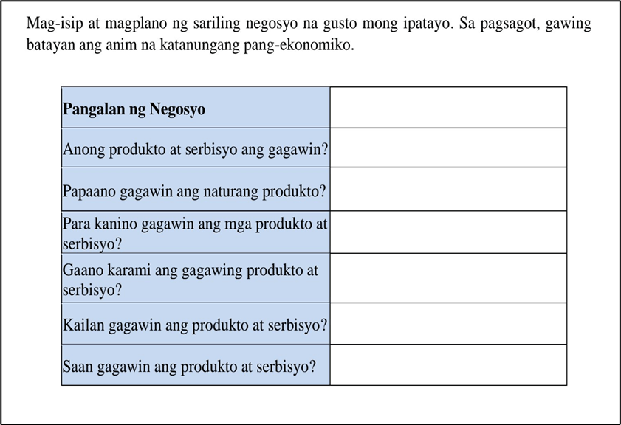
Figure 4. AP9 – Supplemental TSA Yunit I, p. 4
Figure 4, however, integrates both TS1 and TS4 by requiring learners to critically and creatively analyze marketing strategies in relation to the allocation of goods and services. The activity’s structure promotes community collaboration, as learners must interact with others to address the guiding economic questions.
In Figure 5, key transversal skills—particularly TS1 (Critical and Innovative Thinking) and TS5 (Intrapersonal Skills)—are lacking. The activity shows minimal analytical depth and provides limited opportunities for self-reflection or collective engagement in addressing issues related to consumption.
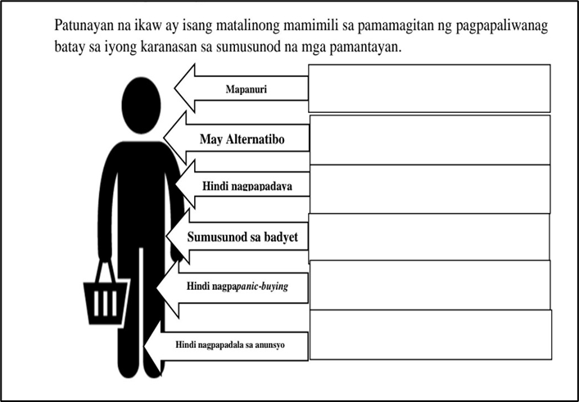
Figure 5. AP9 – Supplemental TSA Yunit I, p. 5
In contrast, Figure 5 effectively integrates these skills. Learners engage in discussions related to consumer rights, encouraging reflection, evaluation of experiences, and synthesis of ideas. This promotes both critical analysis and interpersonal engagement, which are essential in economic decision-making.
In Figure 6, TS6 (Spirituality) is absent, as the activity does not reflect self-discipline, enthusiasm, or appreciation for responsible resource utilization.
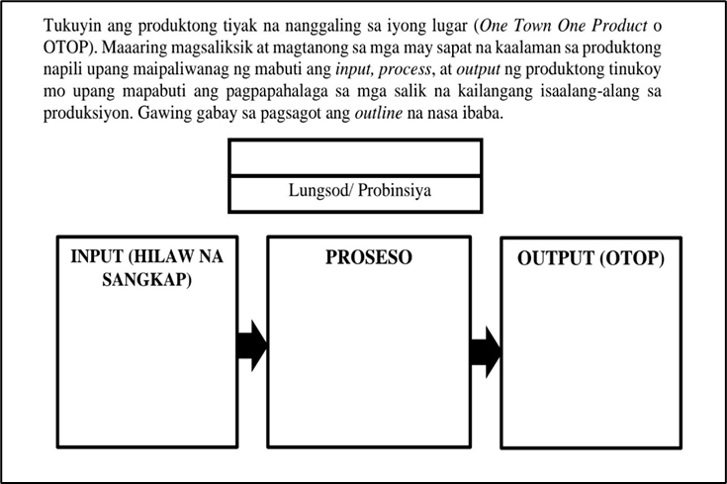
Figure 6. AP9 – Supplemental TSA Yunit I, p. 6
Figure 6 addresses this gap by incorporating TS6 (Spirituality). The activity emphasizes values formation, responsible consumption, and appreciation for the role of production in meeting societal needs. Learners are guided to recognize the ethical dimensions of economic activities and develop self-discipline in consumption practices.
3.2.2 Quarter II
The Quarter II lessons examined include: (1) Demand; (2) Supply; (3) Interaksiyon ng Demand at Supply; (4) Ang Pamilihan at ang Istruktura Nito; and (5) Ugnayan ng Pamilihan at Pamahalaan.
In Figure 7, TS1 (Critical and Innovative Thinking) is insufficiently demonstrated, as the activity fails to illustrate how consumer demand varies in response to price changes.
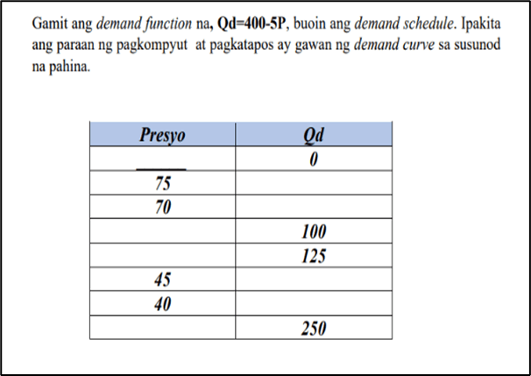
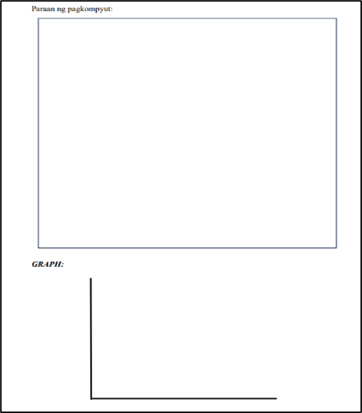
Figure 7. AP9 – Supplemental TSA Yunit II, pp. 7–8
Figure 7 involves computational tasks designed to strengthen learners’ critical thinking and deepen their understanding of the relationship between price and demand. Through this activity, students are able to examine how changes in one variable influence the other, identify the factors that determine demand, and analyze consumer behavior within a market context. As a result, learners gain a clearer understanding of how price fluctuations affect demand patterns.
In contrast, Figure 8 appears to inadequately represent key transversal skills, particularly TS4 (Interpersonal Skills), which are essential in the study of Economics. The scenario presented does not show evidence of collaboration or interaction among individuals, indicating a limited demonstration of teamwork and communication. Given that economic analysis often requires collective problem-solving and the exchange of ideas to understand complex relationships and interdependencies, the absence of these elements suggests an insufficient emphasis on the role of interpersonal skills in addressing economic issues.
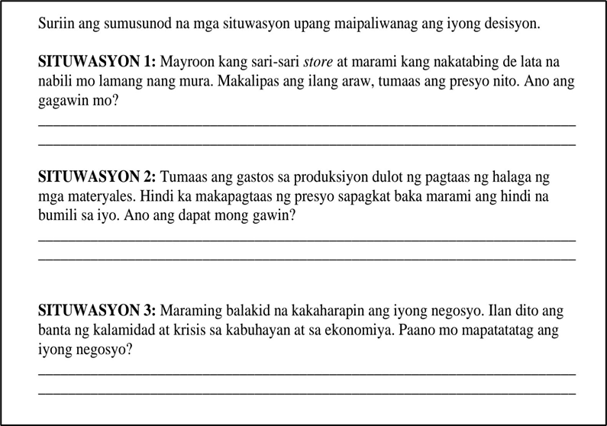
Figure 8. AP9 – Supplemental TSA Yunit II, p. 9
Figure 8 addresses this limitation by promoting group discussions and collaborative analysis of supply-related scenarios, emphasizing the importance of communication and teamwork in economic inquiry.
In contrast, Figure 9 shows limited evidence of TS6 (Spirituality). The lack of enthusiasm and self-discipline suggests a gap in demonstrating reflective decision-making, which is essential in understanding how market equilibrium is achieved within economic contexts.
Figure 9 enables learners to enhance their self-discipline in making decisions that contribute to balancing market conditions. The accompanying processing questions encourage learners to cultivate enthusiasm while deepening their understanding that market equilibrium occurs when the quantity demanded equals the quantity supplied.

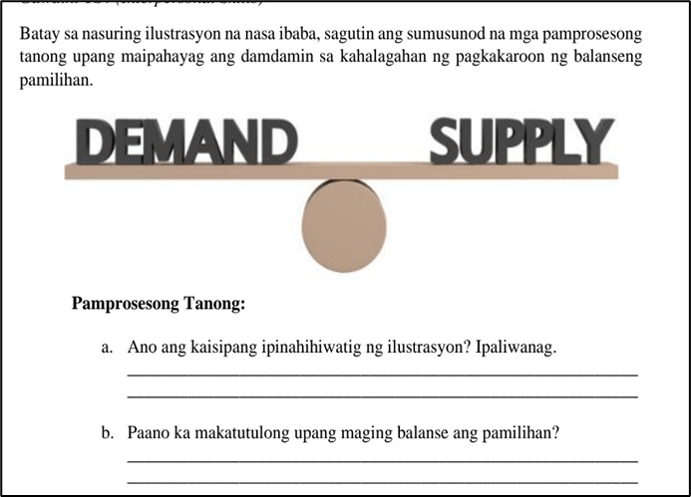
Figure 9. AP9 – Supplemental TSA Yunit II, p. 10
Figure 10 appears to demonstrate a gap in essential transversal skills necessary for learning Economics, particularly TS1 (Critical and Innovative Thinking) and TS4 (Interpersonal Skills). The scenario presented shows little evidence of learners engaging collaboratively or working together to tackle economic challenges. The activity mainly involved responding to questions based on a collage, which did not actively foster the development of critical thinking. Collaboration is especially important in Economics, as addressing complex issues often benefits from multiple perspectives and collective problem-solving. The lack of collaborative engagement in this Picture highlights a potential limitation in cultivating learners’ appreciation for cooperative approaches to understanding and analyzing economic situations.
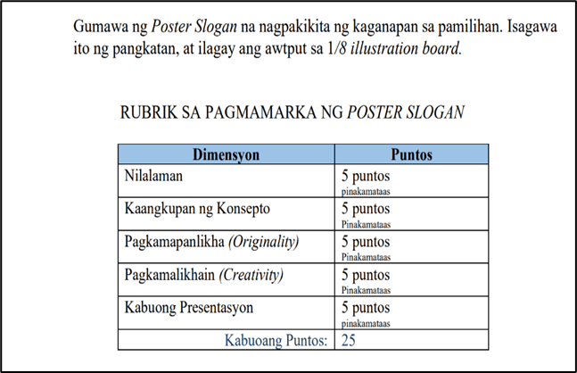
Figure 10. AP9 – Supplemental TSA Yunit II, p. 11
Figure 10 demonstrated a dynamic approach to TS1 (Critical and Innovative Thinking) and TS4 (Interpersonal Skills), as students engaged in discussions and cooperative tasks that mirrored real-market scenarios, highlighting the roles of consumers and producers. This activity effectively fostered problem-solving and critical thinking, illustrating the value of collaboration in understanding market structures and preparing learners for real-world economic complexities. However, TS3 (Information and Communication Technology) was notably absent, limiting the potential for a more engaging, tech-enhanced experience.
In contrast, Figure 11 addressed TS3 by requiring students to access online resources, watch a YouTube video, and analyze news items to understand the concept of price ceilings. This integration of technology provided an interactive means for students to grasp complex economic concepts.
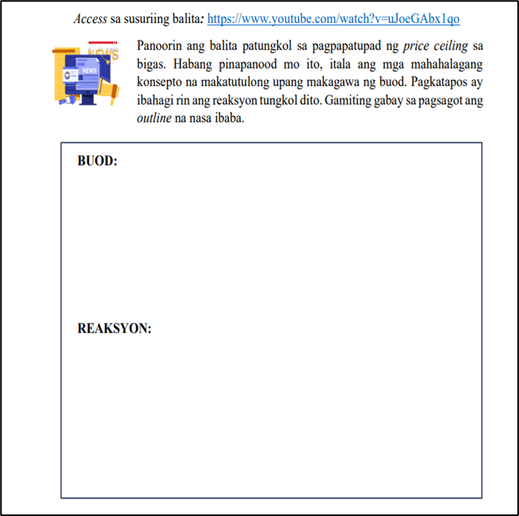
Figure 11. AP9 – Supplemental TSA Yunit II, p. 12
Figure 11 integrates technology by requiring learners to access digital resources, analyze videos, and interpret news related to price ceilings, thereby enhancing engagement and conceptual understanding.
The persistent absence of TS1 and TS4 in Quarter II suggests a systemic concern that extends beyond isolated lessons or activities. This pattern warrants closer examination of curriculum design, teacher preparation, and underlying educational philosophies to determine why these transversal skills are not being adequately addressed. It points to the need for more deliberate and explicit integration of activities that cultivate critical thinking and interpersonal skills across the entire module. Addressing this issue may involve reflective teaching practices, feedback from learners and peers, and the adoption of innovative pedagogical approaches. Targeted professional development can further support teachers in designing strategies that engage students meaningfully, while a collaborative culture among educators may facilitate the sharing of best practices and collective problem-solving to strengthen the integration of transversal skills in Araling Panlipunan 9.
3.2.3 Quarter III
The activities in each lesson were examined to identify transversal skills that were not reflected in the Araling Panlipunan 9 learner’s module. The lessons analyzed included: (1) Paikot na Daloy ng Ekonomiya; (2) Pambansang Kita; (3) Implasyon; (4) Patakarang Piskal; (5) Patakarang Pananalapi; and (6) Pag-iimpok at Pamumuhunan.
Figure 12 showed limited evidence of TS6 (Spirituality). The absence of enthusiasm and self-discipline suggests a constrained understanding of economic functions, particularly in valuing the flow of resources, goods, services, and money in relation to decision-making.
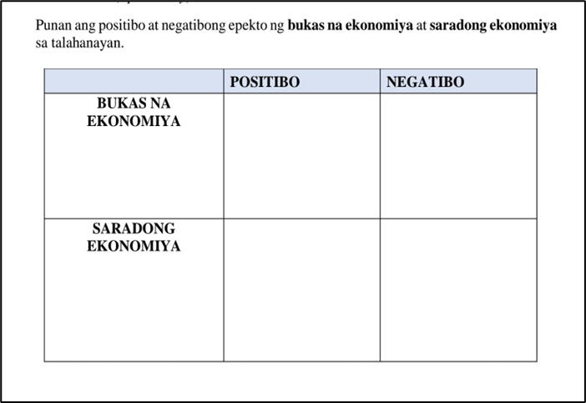
Figure 12. AP9 – Supplemental TSA Yunit III, p. 13
Figure 12 enabled learners to strengthen self-discipline through informed budgeting decisions involving saving, spending, and investing. By examining the positive and negative economic effects of these choices, the activity fostered enthusiasm for the roles of primary economic sectors and deepened understanding of the circular flow of the economy.
Figure 13 inadequately highlighted TS1 (Critical and Innovative Thinking), TS2 (Global Citizenship), and TS4 (Interpersonal Skills). The lack of social interaction and global context limited recognition of the interconnected nature of economic systems. Interpersonal and global competencies are essential in Economics, where understanding national performance requires awareness of international linkages and diverse perspectives.
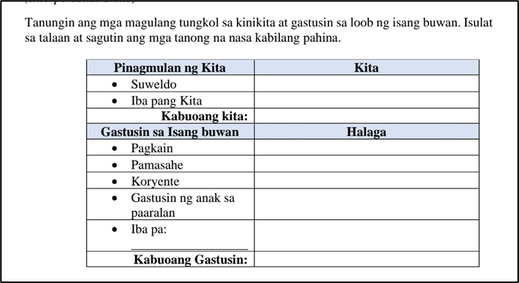
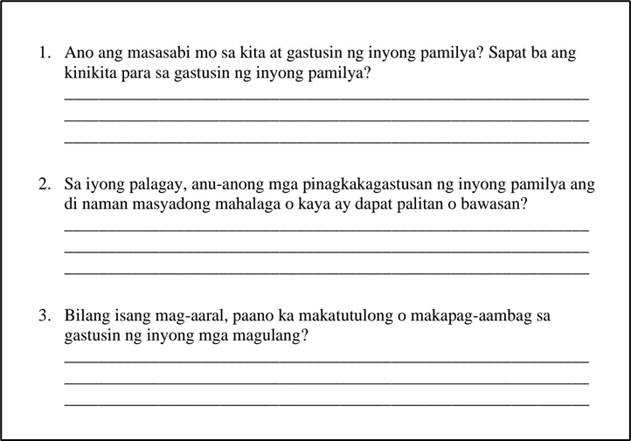
Figure 13. AP9 – Supplemental TSA Yunit III, pp. 14–15
Figure 13 adopted a more comprehensive approach by integrating critical analysis, collaboration, and global awareness. Through situational analysis, learners engaged in economic discussions that reflected the interconnected and global dimensions of economic decision-making.
Picture 14 lacked emphasis on TS4 (Interpersonal Skills), as no communicative or collaborative engagement related to inflation concepts was evident. Effective communication is vital in Economics for articulating ideas, negotiating viewpoints, and solving complex problems.

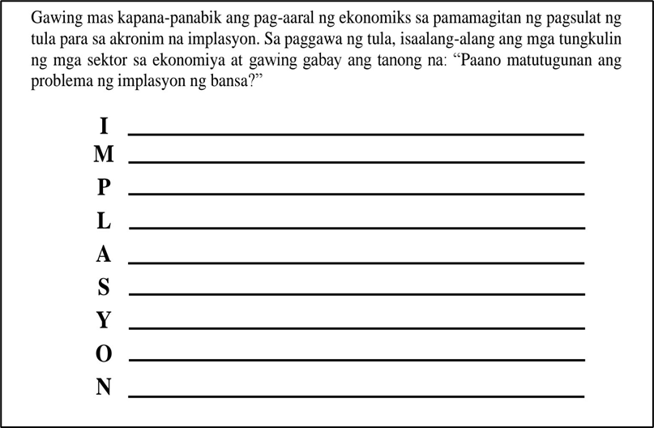
Figure 14. AP9 – Supplemental TSA Yunit III, p. 16
Figure 14 addressed this gap by highlighting interpersonal engagement through discussion and collaboration, reinforcing the role of communication in understanding inflation and economic processes.
Figure 15 fell short in representing TS2 (Global Citizenship) and TS4 (Interpersonal Skills). The absence of intercultural and environmental considerations limited learners’ awareness of the global and ecological implications of economic activities.
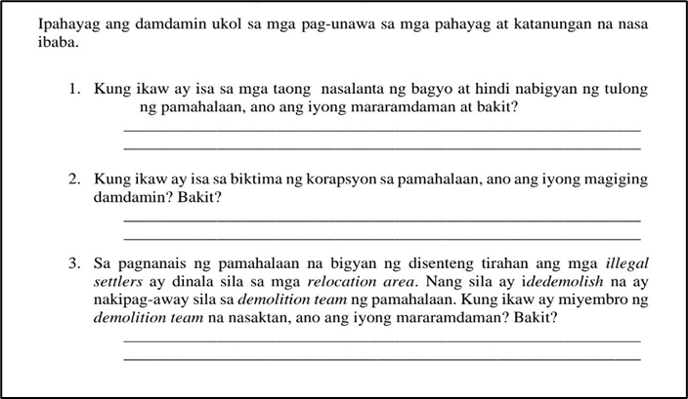
Figure 15. AP9 – Supplemental TSA Yunit III, p. 17
Conversely, Figure 15 presented a more holistic perspective by encouraging consideration of cultural diversity and environmental sustainability, emphasizing the global dimensions of economic decision-making.
Figure 16 showed limited evidence of TS6 (Spirituality), particularly in promoting self-discipline related to managing money supply and supporting economic growth.
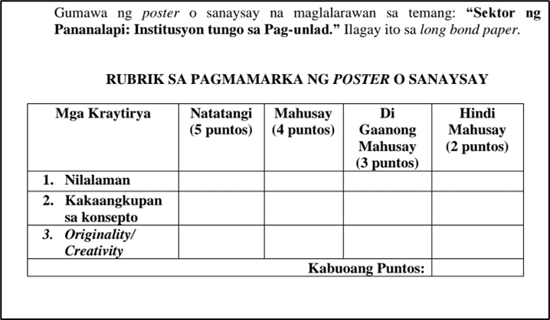
Figure 16. AP9 – Supplemental TSA Yunit III, p. 18
Figure 16 incorporated TS6 by emphasizing responsible monetary management, price stability, and financial awareness. The activity supported learners’ preparedness for real-world financial situations and promoted responsible spending habits.
Figure 17 lacked clear representation of TS1 (Critical and Innovative Thinking) and TS4 (Interpersonal Skills), as collaborative problem-solving and reasoned decision-making were not evident. These skills are essential in Economics, where complex issues require analytical thinking and collective solutions.
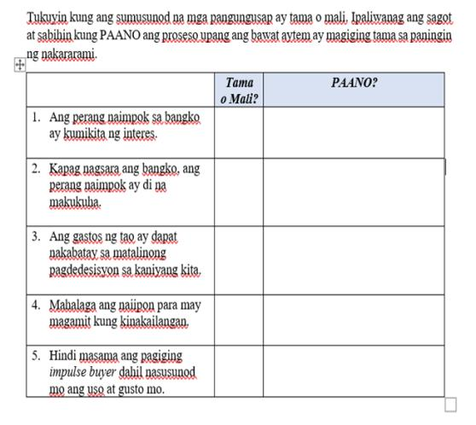
Figure 17. AP9 – Supplemental TSA Yunit III, p. 19
Figure 17 addressed these limitations by promoting group discussions and presentations that encouraged critical analysis and collaboration, aligning with the analytical and cooperative demands of Economics.
The findings highlight the need for a holistic educational approach that extends beyond content mastery to include critical, interpersonal, and global competencies. Identified gaps present opportunities for curriculum enhancement through innovative instructional strategies. Consistent with Bukoye (2021), well-designed instructional materials enhance teaching effectiveness and student performance. Supplemental transversal skills activities therefore make learning more practical, engaging, and meaningful while supporting lifelong skill development and self-actualization among Grade 9 learners.
Research further emphasizes the importance of instructional materials that develop intrapersonal skills such as self-awareness, emotional regulation, and motivation (Miller, 2025). These competencies support academic success and personal growth by fostering self-reflection and learner autonomy (Funa et al., 2021).
Moreover, materials that integrate intrapersonal skills contribute to learners’ holistic development by enhancing resilience, mental well-being, and goal-setting abilities (Sisto et al., 2019). By embedding these skills into instruction, educators create supportive learning environments that promote both academic achievement and emotional intelligence, equipping learners to navigate personal and academic challenges effectively (Laput & Oropa, 2025).
3.2.4 Quarter IV
The activities in each lesson were examined to identify transversal skills that were insufficiently reflected in the Araling Panlipunan 9 learner’s module. The lessons covered were: (1) Konsepto at Palatandaan ng Pambansang Kaunlaran; (2) Sektor ng Agrikultura; (3) Sektor ng Industriya; (4) Sektor ng Paglilingkod; (5) Impormal na Sektor; and (6) Kalakalang Panlabas.
Picture 18 showed limited integration of essential transversal skills, particularly TS4 (Interpersonal Skills). The activity did not provide evidence of collaboration, organized discussion, or presentation of economic concepts. In Economics, effective communication, organization, and teamwork are vital for analyzing data and addressing complex economic issues. The absence of these elements suggests limited preparation for the collaborative and interconnected nature of economic activities.
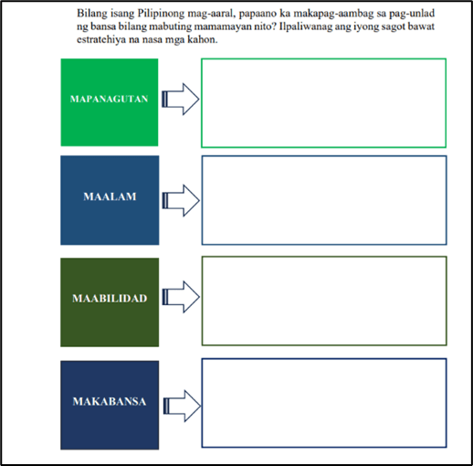
Figure 18. AP9 – Supplemental TSA Yunit IV, p. 20
Figure 18 presented a more comprehensive approach by incorporating TS4. The analysis task encouraged collaboration through structured discussions and presentations, while also strengthening citizenship values such as mapanagutan, maalam, maabilidad, and makabansa. This aligns with the communicative and organizational skills required in economic analysis and collective problem-solving.
Figure 19 lacked representation of TS2 (Global Citizenship), as it did not reflect openness to diverse perspectives or intercultural understanding. Given the global interconnectedness of economic systems, respect for diversity and cultural awareness are essential components of economic education.
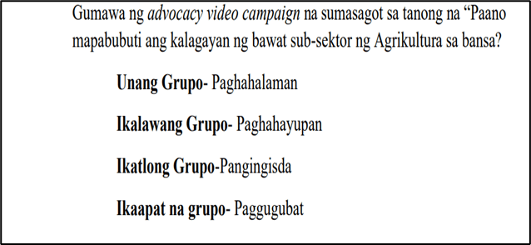
Figure 19. AP9 – Supplemental TSA Yunit IV, p. 21
In contrast, Figure 19 integrated TS2 through an advocacy video campaign that emphasized respect for cultural diversity, particularly within the agricultural sector. This approach reinforced the importance of intercultural understanding in global economic interactions and decision-making.
Figure 20 showed limited integration of TS6 (Spirituality), with no clear indicators of self-discipline, perseverance, or intrinsic motivation. In the study of Economics, particularly within the industrial sector, these traits are necessary for sustained engagement with complex concepts.
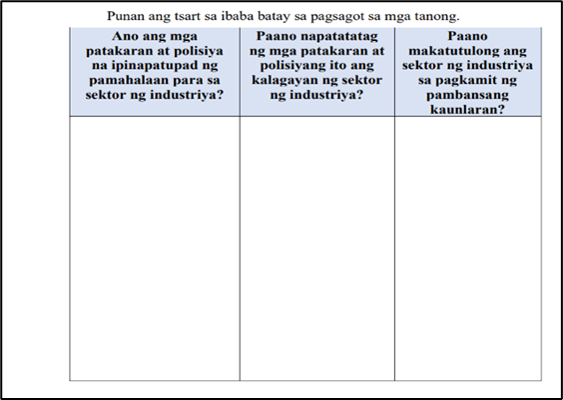
Figure 20. AP9 – Supplemental TSA Yunit IV, p. 22
Figure 20 addressed TS6 by highlighting self-discipline, enthusiasm, perseverance, and self-motivation through a tri-question chart. The activity supported focused learning and deeper understanding of industrial policies, fostering resilience and independent thinking.
Spirituality, understood as cultivating inner awareness and emotional balance, is often overlooked in teaching despite its importance to self-care and ethical decision-making (Wilner, 2014). From a positive psychology perspective, spirituality reflects connectedness and purpose, guiding learners to value and manage resources responsibly (Bożek et al., 2020).
Figure 21 lacked evidence of TS2, particularly in communication, self-discipline, and respect for diversity. These omissions limit learners’ ability to engage effectively with economic concepts that require global awareness and interpersonal competence.
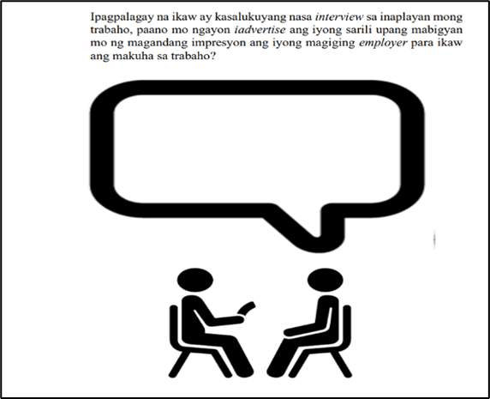
Figure 21. AP9 – Supplemental TSA Yunit IV, p. 23
Figure 21 incorporated TS2 through a job interview simulation that emphasized communication, discipline, and respect for diverse perspectives. This activity aligned with the practical and collaborative demands of economic decision-making.
Figure 22 insufficiently reflected TS1 (Critical and Innovative Thinking) and TS2. The absence of analytical and global perspectives limited learners’ engagement with complex issues such as the underground economy.
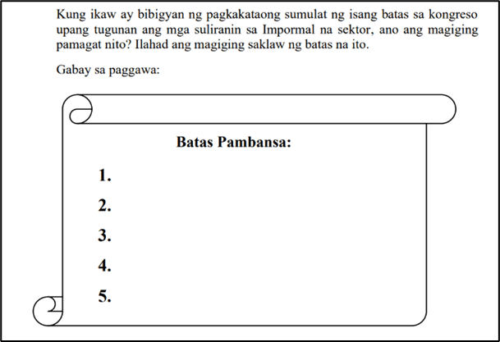
Figure 22. AP9 – Supplemental TSA Yunit IV, p. 24
Figure 22 addressed these gaps by promoting critical analysis, innovative problem-solving, and intercultural awareness through a law-making task. This approach supported deeper understanding of economic issues within a global context.
Figure 23 lacked evidence of TS3 (ICT) and TS6, with no visible use of technology or development of self-discipline and perseverance in understanding export and import concepts.
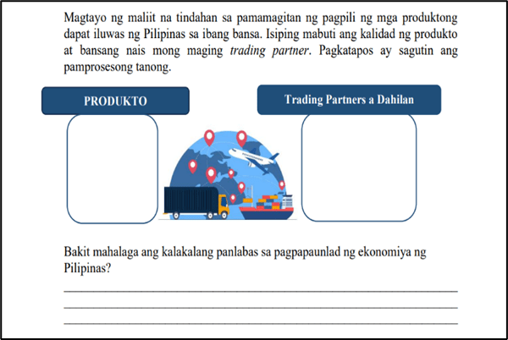
Figure 23. AP9 – Supplemental TSA Yunit IV, p. 25
Figure 23 strengthened self-discipline by engaging learners in entrepreneurial decision-making that emphasized the promotion of quality local products as competitive alternatives to imports.
The recurring gaps in transversal skills across the activities in the Araling Panlipunan 9 learner’s module highlighted the necessity for the development of Supplemental Transversal Skills Activities (TSAs). These activities were intentionally designed to integrate all six transversal skill domains—Critical and Innovative Thinking, Global Citizenship, Information and Communication Technology, Interpersonal Skills, Intrapersonal Skills, and Spirituality—thereby fostering an authentic, immersive, and application-oriented learning environment. By engaging learners in real-world problem scenarios, the TSAs enable the development of higher-order thinking, practical problem-solving, and deeper understanding of economic concepts, which are crucial for preparing learners to navigate the complex demands of the 21st century. This aligns with the Department of Education’s (DepEd) mandate under DepEd Order No. 024, s. 2022, which emphasizes the implementation of the Basic Education Development Plan 2030 to promote learner-centered and competency-based education that equips students with essential knowledge, skills, values, and attitudes for lifelong learning (DepEd, 2022). Additionally, the TSAs support the objectives of DepEd Order No. 10, s. 2024, which provides policy guidelines for the implementation of the Matatag Curriculum that underscores holistic development, critical thinking, and social responsibility among learners (DepEd, 2024).
Consistent with the findings of Kadzera (2006), instructional materials that actively stimulate engagement enhance understanding and retention of concepts. While the existing learner’s module already contains some transversal skill components, the majority of its activities are insufficient in fully developing these competencies, underscoring the need for supplementary activities. Documentary analysis also confirmed teachers’ recognition of the value of TSAs in strengthening critical thinking, communication, global citizenship, and overall appreciation of Economics. Similarly, studies indicate that transversal skills—including collaboration, creativity, adaptability, and resilience—are fundamental to learner success in the 21st century and should be deliberately embedded within instructional materials (Goggin et al., 2019; Guerra-Macías & Tobón, 2024; Laguna-Sánchez et al., 2020; Belchior-Rocha et al., 2022).
The developed TSAs were structured to align with the four-quarter framework of the Araling Panlipunan 9 learner’s module issued by the Department of Education, ensuring that each lesson is enriched with opportunities to apply transversal skills in meaningful contexts. Each TSA comprises a title, learning competencies aligned with the Most Essential Learning Competencies (MELCs), objectives grounded in Bloom’s taxonomy, guided activities with embedded transversal skill tasks, rubrics for evaluating performance where applicable, answer keys, and references. By promoting both individual and collaborative engagement, these activities not only enhance mastery of content but also cultivate transferable skills that prepare learners for academic, personal, and professional growth. In essence, the TSAs operationalize the DepEd’s vision of holistic education by creating an enriched, skills-focused learning experience that integrates cognitive, socio-emotional, and ethical development, ultimately contributing to learners’ well-rounded preparation for real-world economic challenges.
3.3 Validity and Acceptability of Supplemental Transversal Skills Activities for Araling Panlipunan 9
The content validity of the Supplemental Transversal Skills Activities (TSAs) was established through expert evaluation involving learning resource content validators, an Economics professor from a Higher Education Institution (HEI), and a visual graphics design specialist. Overall, the supplemental activities were rated highly valid, obtaining an overall mean of 3.95, indicating that all established criteria were satisfactorily met.
3.3.1 Objective
Table 1 The table presents the validity of the Transversal Skills Activities (TSAs) in terms of their objectives. The results indicate that the objectives were generally rated as Highly Valid (HV), with a composite mean of 3.95 across the twenty-three (23) learning activities. This suggests that the objectives are clearly stated, measurable, learner-centered, and appropriately focused on the domains of knowledge, attitudes, and skills.
Table 1. Mean Rating of TSA in terms of objectives.
Criteria |  | Mean  Rating | Descriptive  Interpretation
A. Objectives
The objectives of the TSAs are:
- clearly stated and measurable. |  | 4.00 | HV
- consistent with the topics/skills found in the AP 9 Curriculum Guide. |  | 4.00 | HV
- focused on knowledge, attitude, and skills development |  | 3.80 | HV
- well defined, organized, and learner-centered |  | 4.00 | HV
Composite Mean |  | 3.95 | HV
Legend: Range of Means Descriptive Interpretation (DI)
3.41 – 4.00 Highly Valid (HV)
2.61 – 3.40 Moderately Valid (MV)
1.81 – 2.60 Slightly Valid (SV)
1.00 – 1.80 Not Valid (NV)
These results support Orr et al. (2022) assertion that learning objectives should clearly describe the expected learner performance rather than instructional processes. Well-written objectives provide direction for instructional design and activity development (Phothongsunan, 2024). Thus, the high rating underscores the importance of clearly articulated objectives in determining the effectiveness of learning materials.
3.3.2 Content
Table 2 presents the results of expert validation regarding the content of the developed TSAs. The findings indicate that the activities are highly valid, with a composite mean of 3.94. This suggests that the activities are relevant to real-life situations, appropriate to students’ developmental levels, free from bias, and supportive of desirable values and transversal skills.
Table 2. Mean Rating of TSA in terms of content.
Criteria |  | Mean  Rating | Descriptive  Interpretation
B. Content
The activities are:
- relevant to real-life situations that makes it more engaging, interesting, and understandable. |  | 4.00 | HV
- suitable to the student's level of development. |  | 4.00 | HV
- focused on development of higher cognitive skills such as critical thinking, creativity, learning by doing, inquiry, problem solving, etc. |  | 4.00 | HV
- free of ideological, cultural, religious, racial, and gender biases and prejudices. |  | 3.60 | HV
- supported with the development of desirable values and traits such as:
- Pride in being a Filipino |  | 4.00 | HV
- Scientific attitude and reasoning |  | 3.60 | HV
- Desire for excellence |  | 4.00 | HV
- Love for country |  | 4.00 | HV
- Helpfulness/Teamwork/ Cooperation |  | 4.00 | HV
- Unity |  | 3.80 | HV
- Desire to learn new things |  | 4.00 | HV
- Honesty and trustworthiness |  | 4.00 | HV
- Ability to know right from wrong |  | 4.00 | HV
- Respect |  | 4.00 | HV
- Critical and Creative Thinking |  | 4.00 | HV
- Productive Work |  | 4.00 | HV
- fit for the development of Transversal Skills |  | 4.00 | HV
Composite Mean |  | 3.94 | HV
Legend: Range of Means Descriptive Interpretation (DI)
3.41 – 4.00 Highly Valid (HV)
2.61 – 3.40 Moderately Valid (MV)
1.81 – 2.60 Slightly Valid (SV)
1.00 – 1.80 Not Valid (NV)

Consistent with Organization for Economic Co-operation and Development [OECD] (2018), effective learning activities should be responsive to learners’ needs and equip them with skills necessary for productive participation in society. The results affirm that the TSAs promote higher-order thinking, values formation, and skills development aligned with the goals of Araling Panlipunan 9.
3.3.3 Instructional Qualities
Table 3 shows that the instructional qualities of the developed TSAs were rated highly valid, with a composite mean of 3.97. This indicates that the materials achieved their intended purpose, used appropriate language, sustained learner interest, employed well-organized visuals, and complied with social content guidelines.
Table 3. Mean Rating of TSA in terms of instructional qualities
Criteria |  | Mean  Rating | Descriptive  Interpretation
C. Instructional Qualities
The material:
- achieves its defined purpose. |  | 4.00 | HV
- is accurate and up to date |  | 3.80 | HV
- uses language that is appropriate to target user level. |  | 4.00 | HV
- arouses interest and sustain attention |  | 4.00 | HV
- has clear organize used of images/ photos, graphics, and illustrations |  | 4.00 | HV
- is compliant with social content guidelines. |  | 4.00 | HV
Composite Mean |  | 3.97 | HV
Legend: Range of Means Descriptive Interpretation (DI)
3.41 – 4.00 Highly Valid (HV)
2.61 – 3.40 Moderately Valid (MV)
1.81 – 2.60 Slightly Valid (SV)
1.00 – 1.80 Not Valid (NV)
These findings align with Belisario and Paglinawan (2025), who emphasized that instructional materials must be carefully planned, organized, and utilized to maximize learning outcomes. Proper selection and organization of content ensure both depth and breadth of learning, thereby enhancing instructional effectiveness.
3.3.4 Overall Validity of the Developed Supplemental Transversal Skills Activities (TSAs)
Table 4 presents the summary of the validation results for the developed Supplemental Transversal Skills Activities (TSAs). The materials were rated highly valid across all criteria, obtaining mean scores of 3.95 for objectives, 3.94 for content, and 3.97 for instructional qualities. These findings resulted in an overall composite mean of 3.95, which was interpreted by the panel of experts as highly valid.
Table 4. Overall validity of the Developed Supplemental TSAs.
Criteria |  | Mean  Rating | Descriptive  Interpretation
A. Objectives |  | 3.95 | HV
B. Content  i |  | 3.94 | HV
C. Instructional Qualities |  | 3.97 | HV
Over-all Mean |  | 3.95 | HV
Legend: Range of Means Descriptive Interpretation (DI)
3.41 – 4.00 Highly Valid (HV)
2.61 – 3.40 Moderately Valid (MV)
1.81 – 2.60 Slightly Valid (SV)
1.00 – 1.80 Not Valid (NV)
Overall, the results indicate that the developed TSAs possess the essential qualities of an acceptable and effective curriculum support material for Araling Panlipunan 9. The consistently high ratings across the three criteria affirm the soundness of the objectives, the relevance and appropriateness of the content, and the effectiveness of the instructional qualities. In addition, the validators provided significant comments, suggestions, and recommendations to further refine and enhance the strategic intervention materials.
“Good content and organized. The author uses graphics that catches the attention of the reader.” – Evaluator A
“The Supplemental Transversal Skills Activities (TSAs) for Araling Panlipunan 9 is relevant to the intended learning outcomes and it focuses on the knowledge, skills, and abilities appropriate to the grade level.” – Evaluator 3.

4. Conclusion

This study examined the extent to which transversal skills are embedded in the Araling Panlipunan 9 Learner’s Module and developed Supplemental Transversal Skills Activities (TSAs) to address identified gaps. The document analysis revealed that while transversal skills are present across all four quarters of the module, their integration is uneven. Skills such as Global Citizenship (TS2), Information and Communication Technology (TS3), Intrapersonal Skills (TS5), and Spirituality (TS6) were more frequently observed, whereas Critical and Innovative Thinking (TS1) and Interpersonal Skills (TS4) were inconsistently represented, particularly in Quarter II and in selected lessons across other quarters. These findings indicate that, although Araling Panlipunan 9 inherently supports holistic learning, the existing activities do not always provide sufficient opportunities for higher-order thinking, collaboration, and meaningful social interaction.
In response, the study developed a set of Supplemental Transversal Skills Activities designed to intentionally and systematically integrate six key transversal skills: critical and innovative thinking, global citizenship, ICT, interpersonal skills, intrapersonal skills, and spirituality. The TSAs were aligned with the Most Essential Learning Competencies (MELCs), grounded in Bloom’s taxonomy, and contextualized within real-life economic situations to promote authentic learning. Expert validation results demonstrated that the developed TSAs were highly valid in terms of objectives, content, and instructional qualities, with an overall mean rating of 3.95. These results affirm that the TSAs are appropriate, relevant, and instructionally sound as curriculum support materials for Araling Panlipunan 9.
Overall, the study concludes that strengthening the integration of transversal skills through well-designed supplemental activities can significantly enhance the teaching and learning of Economics in Araling Panlipunan 9. By deliberately embedding these skills, the TSAs contribute to learners’ holistic development, better preparing them to think critically, collaborate effectively, use technology responsibly, and engage meaningfully with real-world economic and social issues. The findings underscore the importance of curriculum enrichment initiatives that go beyond content mastery and support the broader goals of 21st-century education.

5. RECOMMENDATIONS

Based on the findings of this study, it is recommended that educators and curriculum developers systematically integrate transversal skills into the design of Araling Panlipunan 9 instructional materials, ensuring that activities actively promote critical and innovative thinking, global citizenship, ICT literacy, interpersonal and intrapersonal skills, and spirituality. Teachers should utilize the Supplemental Transversal Skills Activities (TSAs) as complementary tools to enrich existing modules, foster collaborative and reflective learning, and provide learners with authentic, real-world problem-solving experiences. Furthermore, ongoing professional development and training should be provided to equip teachers with strategies for effectively implementing these activities, while periodic reviews and updates of the curriculum and instructional materials are encouraged to maintain alignment with DepEd policies, the Matatag Curriculum, and the evolving needs of 21st-century learners.

Acknowledgements
The researcher extends sincere gratitude to the school administrators for their support, cooperation, and permission to conduct this study. Heartfelt appreciation is also given to colleagues, the mentor, master teachers, learning resource content validators, the economics expert, and the visual design specialist for their invaluable guidance, expertise, constructive feedback, and time, all of which greatly contributed to the development and validation of the study. Their insights and professional commitment significantly enhanced the quality and rigor of this research. Above all, the researcher offers profound thanks to the Almighty God for the wisdom, strength, guidance, and perseverance granted throughout the completion of this academic endeavor.

Author’s Contribution
IKBB designed the study, performed the statistical analysis, gathered the data, wrote the research protocol, and prepared the first draft of the manuscript. JKMR assisted in data analysis, interpretation of results, and the review of related literature. All authors contributed to the refinement of the manuscript and approved the final version for publication.

Consent:
The study strictly adhered to the principles of Free, Prior, and Informed Consent (FPIC), ensuring that participation was voluntary and free from any form of coercion or undue influence. All participants were adequately informed of the study’s objectives, procedures, potential risks and benefits, and their rights as research participants. Written informed consent was obtained prior to data collection, and all signed consent forms were securely and confidentially kept by the researchers.

Ethical Approval:
This study was conducted in accordance with the ethical principles set forth in the 1964 Declaration of Helsinki, with due regard for the rights, dignity, and welfare of all participants. Data gathering adhered to ethical guidelines set by the University Research Ethics Board (URERB). After obtaining clearance, the researcher sought permission from the school division superintendents and teachers. All data were securely stored, and personal identifiers were anonymized to protect participant privacy. The authors affirm that the study fully complied with established ethical standards.
Disclaimer (Artificial Intelligence)
The author(s) declare that generative artificial intelligence (AI) technologies were utilized during the writing and editing of this manuscript. Specifically, ChatGPT (Version: GPT-4; Model: OpenAI GPT-4) was used to review, refine, and improve the language, coherence, and clarity of the text without altering the data, results, or interpretations of the study. In addition, the AI tool assisted in verifying the accuracy of statistical computations to support the reliability of the findings.
All prompts provided to the AI were limited to language enhancement and technical clarification, ensuring that intellectual ownership, methodological decisions, and analytical interpretations remained the sole responsibility of the author(s). The use of AI was conducted in accordance with ethical research and publication standards, and full transparency regarding AI assistance is hereby declared.

References

Barbara, T. (2015). Transversal skills in TVET. https://unesdoc.unesco.org/ark:/48223/pf0000234738
Belchior-Rocha, H., Casquilho-Martins, I., & Simões, E. (2022). Transversal competencies for employability: From higher education to the labour market. Education Sciences, 12(4), 255. https://doi.org/10.3390/educsci12040255
Belisario, J. M., & Paglinawan, J. L. (2025). The Relationship between Instructional Materials Availability and Student Engagement in Science. International Journal of Research and Innovation in Applied Science, X(V), 263–270. https://doi.org/10.51584/ijrias.2025.100500025
Biasin, C., & Pacquola, M. (2019). How to identify and recognize transversal skills: Italian experiences in professional and craft activities. Padua Research Archive (University of Padua). https://doi.org/10.13128/formare-25185
Bożek, A., Nowak, P. F., & Blukacz, M. (2020). The relationship between Spirituality, Health-Related Behavior, and Psychological Well-Being. Frontiers in Psychology, 11, 1997. https://doi.org/10.3389/fpsyg.2020.01997
Bukoye, R. O. (2019). Utilization of Instruction Materials as Tools for Effective Academic Performance of Students: Implications for Counselling. Proceedings of the 2nd Innovative and Creative Education and Teaching International Conference, 1395. https://doi.org/10.3390/proceedings2211395
Carvalho, C., & Almeida, A. C. (2022). The adequacy of accounting education in the development of transversal skills needed to meet market demands. Sustainability, 14(10), 5755. https://doi.org/10.3390/su14105755
Department of Education [DepEd]. (2024, July 23). DepEd Order No. 10, s. 2024: Policy Guidelines on the Implementation of the Matatag Curriculum [Press release]. Retrieved January 11, 2025, from https://www.deped.gov.ph/wp-content/uploads/DO_s2024_010.pdf
Department of Education [DepEd]. (2022). DepEd Order No. 024, s. 2022: Adoption of the Basic Education Development Plan 2030. deped.gov.ph. Retrieved March 27, 2025, from https://www.deped.gov.ph/wp-content/uploads/2022/05/DO_s2022_024.pdf
Funa, A. A., Gabay, R. a. E., & Ricafort, J. D. (2021). Gamification in Genetics: Effects of gamified instructional materials on the STEM students’ intrinsic motivation. https://eric.ed.gov/?id=ED618262
Garcia-Acojido, V. R. (2021). Merits and Demerits of Araling Panlipunan (Social Studies) Teachers in using instructional resources. Studies in Humanities and Education, 2(1), 79–85. https://doi.org/10.48185/she.v2i1.293
Gil, T. O. G., Jr. (2022). Visiting the secondary social studies curriculum in perilous times. Journal of Social Studies, 18(01), 47–62. https://journal.uny.ac.id/index.php/jss/article/download/43667/pdf
Goggin, D., Sheridan, I., Lárusdóttir, F., & Guðmundsdóttir, G. (2019). TOWARDS THE IDENTIFICATION AND ASSESSMENT OF TRANSVERSAL SKILLS. INTED Proceedings, 1, 2513–2519. https://doi.org/10.21125/inted.2019.0686
Guerra-Macías, Y., & Tobón, S. (2024). Development of transversal skills in higher education programs in conjunction with online learning: relationship between learning strategies, project-based pedagogical practices, e-learning platforms, and academic performance. Heliyon, 11(2), e41099. https://doi.org/10.1016/j.heliyon.2024.e41099
Ihalon, E. C. (2022). Differentiated Instruction in Araling Panlipunan 10: Enhanced Learning Activities. International Journal of Trend in Scientific Research and Development, 6(6), 971–986. https://www.ijtsrd.com/papers/ijtsrd51970.pdf
Kim, S., Raza, M., & Seidman, E. (2019). Improving 21st-century teaching skills: The key to effective 21st-century learners. Research in Comparative and International Education, 14(1), 99–117. https://doi.org/10.1177/1745499919829214
Laguna-Sánchez, P., Abad, P., De La Fuente-Cabrero, C., & Calero, R. (2020). A university training programme for acquiring entrepreneurial and transversal employability skills, a students’ assessment. Sustainability, 12(3), 796. https://doi.org/10.3390/su12030796
Laput, M., & Oropa, J. (2025). Beyond Instruction: The role of emotional intelligence competencies in enhancing classroom effectiveness. Journal of Interdisciplinary Perspectives, 3(6). https://doi.org/10.69569/jip.2025.250
López, I. C., & Rodríguez-López, B. (2020). The relevance of transversal competences in vocational education and training: a bibliometric analysis. Empirical Research in Vocational Education and Training, 12(1), 12. https://doi.org/10.1186/s40461-020-00100-0
Miller, K. (2025, July 3). Science of Spirituality (+16 Ways to Become More Spiritual). PositivePsychology.com. https://positivepsychology.com/science-of-spirituality/
Organization for Economic Co-operation and Development [OECD]. (2018). Education At A Glance 2013. In Education at a glance. OECD indicators/Education at a glance. https://doi.org/10.1787/eag-2013-en
Orr, R. B., Csikari, M. M., Freeman, S., & Rodriguez, M. C. (2022). Writing and using learning objectives. CBE—Life Sciences Education, 21(3), fe3. https://doi.org/10.1187/cbe.22-04-0073
Phothongsunan, S. (2024). Learning Objective Writing in English Teaching: Current Insights and Challenges for EFL teachers. International Journal of Religion, 5(11), 7442–7445. https://doi.org/10.61707/wk19fz91
Sá, M. J., & Serpa, S. (2018). Transversal Competences: their importance and learning processes by higher education students. Education Sciences, 8(3), 126. https://doi.org/10.3390/educsci8030126
Serafico-Reyes, N. M. A., Sjamsuddin, H., Wiriaatmadja, R., & Hasan, S. H. (2019). Araling Panlipunan (Social Studies) in the Philippine Makabayan Learning Area: Problems and prospects in articulating social studies as a discipline. Proceedings of the 3rd Asian Education Symposium (AES 2018). https://doi.org/10.2991/aes-18.2019.33
Sisto, A., Vicinanza, F., Campanozzi, L. L., Ricci, G., Tartaglini, D., & Tambone, V. (2019). Towards a Transversal Definition of Psychological Resilience: A Literature review. Medicina, 55(11), 745. https://doi.org/10.3390/medicina55110745
Urlanda, J. a. V., Alarcon, R. D., Modilla, M. R. S., & Modilla, J. D. (2025). A Systematic Review on Integrating Transversal Competencies in Education: Successes and Struggles. PREPRINT (Version 1) Available at Research Square. https://doi.org/10.21203/rs.3.rs-6970306/v1
Wardani, S., Zakiyah, K. A., Prasetya, A. T., & Haryani, S. (2019). Analysis intrapersonal intelligence of student’s post chemistry learning based guided inquiry model on the buffer material. Journal of Physics Conference Series, 1321(2), 022047. https://doi.org/10.1088/1742-6596/1321/2/022047

Definitions
To facilitate a clearer understanding of the study, the following terms are defined according to their usage in this research:
Araling Panlipunan 9. A social science subject that focuses on developing learners’ understanding of microeconomics and macroeconomics, enabling them to apply concepts to real-life situations through creativity, critical thinking, problem-solving, and decision-making.
Learners’ Module. A systematically organized set of instructional contents aligned with the topics and Most Essential Learning Competencies (MELCs) prescribed by the Department of Education for Araling Panlipunan 9 (Economics).
Supplemental Transversal Skills Activities (TSAs). Instructional support materials designed to assist Grade 9 Economics teachers in enhancing learners’ knowledge, skills, and attitudes by promoting critical and creative thinking, initiative-taking, problem-solving, digital tool use, and collaboration.
Transversal Skills. A set of twenty-first-century skills and learning domains that support holistic learner development and are often not directly measured through traditional assessments.
TS1 – Critical and Innovative Thinking. The ability to analyze and evaluate ideas while reflecting throughout the learning process.
TS2 – Global Citizenship. A broad concept encompassing the social, political, environmental, and economic actions of individuals and communities with a global perspective.
TS3 – Information and Communication Technology. A range of technological tools and resources are used to create, store, share, exchange, and communicate information.
TS4 – Interpersonal Skills. Personal attributes and behaviors demonstrated during social interactions with others.
TS5 – Intrapersonal Skills. Internal self-communication involves self-awareness, reflection, and understanding of one’s inner processes.
TS6 – Spirituality. The recognition of a sense or belief in something greater than oneself, reflecting the understanding that human existence extends beyond sensory experience.
Validity. The degree to which the developed Supplemental Transversal Skills Activities for Araling Pan Lipunan 9 are appropriate and acceptable based on the following criteria:
Objectives. The specific, outcomes-based learning targets of the material.
Content. The activities included in the material that integrate transversal skills.
Instructional Qualities. The features of the material, including design, content organization, teaching methods, procedures, and expected integration of information and communication technology.

