Spatial Distribution of Land Degradation in Jamui District, Bihar, India: A Geospatial Analysis

Abstract
Land degradation has emerged as a critical environmental problem that affects agricultural productivity and rural livelihoods in many parts of India. The present study examines the spatial distribution of land degradation in Jamui district of Bihar using geospatial techniques. Satellite imagery, digital elevation models (DEM), and secondary data were integrated in a GIS environment to identify their spatial patterns. The results indicate that land degradation is unevenly distributed across the district. Results show that southern and south-western part of the district have high concentration of land degradation in comparison to other parts. The result shows that the high concentration of degraded land is strongly associated with terrain characteristics of the study area. It has been found that areas with steep slopes and sparse vegetation cover show higher levels of degradation. On the other hand, areas with plains demonstrate comparatively lower degradation levels. Moderate sheet erosion is most widespread problem in the Jamui district. Southern and south-western parts needs better management plans because topography is more uneven here and it is severely affected by soil & gully erosion. The study highlights the role of geospatial technology in monitoring land degradation. Present study will help policy makers and stakeholders in implementing sustainable developments projects.
Keywords: Land degradation, spatial distribution, GIS, remote sensing, Jamui district, Bihar.

1. Introduction
Land degradation has emerged as one of the most serious environmental challenges affecting the agricultural productivity across the world. It refers to the reduction in the biological productivity of land caused by various natural, human activities and improper land management practices (FAO, 1999; UNCCD, 1993). Land degradation leads to the fall in soil quality and reduction in agricultural productivity, thereby threatening food security (Zhao et al. 2013; Ahmad and Pandey 2018). Soil erosion caused by water and windhas been found most widespread and destructive processes worldwide. Soil erosion removes the fertile topsoil layer, resulting in declining soil productivity over time (Scholten & Seitz, 2019). This process is often intensified by factors such as heavy rainfall, steep slopes, sparse vegetation cover, and unsustainable agricultural practices (Romshoo, 2021). Studies have shown that climate variability and increasing human pressure on land resources further accelerate erosion processes (Hurni et al., 2016; Seifu & Elias, 2018).
In developing countries like India, land degradation has become a major concern due to rapid population growth and increasing pressure on natural resources (Radda, and Pathak, 2021; Verma and Sur, 2024). These factors have significantly altered land use and land cover patterns, leading to soil erosion and declining agricultural productivity in many regions (Marchetti et al. 2012; Gaur et al. 2025). Improper land management practices and overexploitation of marginal lands, further worsen the degradation process.
Spatial analysis of land degradation using geospatial technologies such as Geographic Information Systems (GIS) and remote sensing has become an effective approach for understanding the land degradation (Barman et al. 2020; Gupta et al. 1998). These technologies enable researchers to analyze terrain characteristics and environmental factors influencing degradation processes (Malav et al. 2022). The present study aims to analyze the spatial distribution of land degradation in Jamui district of Bihar and identify the major types of degradation affecting the region. Understanding the spatial pattern of degradation is essential for designing appropriate soil conservation strategies in the district (Parmar et al. 2021).

2. Study Area
The present study area is Jamui district, which is located in the southern part of the state of Bihar in eastern India. The district lies between approximately 24°55′ N to 25°25′ N latitude and 86°05′ E to 86°45′ E longitude (Fig 1). Jamui district forms part of the transitional zone between the fertile Gangetic plains and the uplands of the Chotanagpur Plateau. This physiographic setting results in significant variations in topography, soil characteristics, and land use patterns across the district.Jamui district is bounded by Munger district in the north, Banka district in the east, Giridih district in the south, and Lakhisarai district in the west. The district covers an area of approximately 3,098 square kilometresand consists of several administrative blocks including Chakai, Jhajha, Khaira, Sono, Jamui, Gidhaur, Sikandara, Barhat, Laxmipur, and Islamnagar.
The physiography of the district is characterized by a combination of undulating uplands, hills, and plains. The southern part of the district, particularly the blocks of Chakai and Jhajha, is dominated by hilly and forested terrain.It is northern extension of the Chotanagpur plateau. In contrast, the northern and central parts of the district consist mainly of relatively flat alluvial plains suitable for agricultural activities. The climate of the district is tropical monsoon type, characterized by hot summers, moderate winters, and a distinct rainy season. The average annual rainfall ranges between 1000 mm and 1200 mm, most of which occurs during the southwest monsoon season. Heavy rainfall during the monsoon often leads to increased surface runoff, which contributes to soil erosion and land degradation in sloping areas.
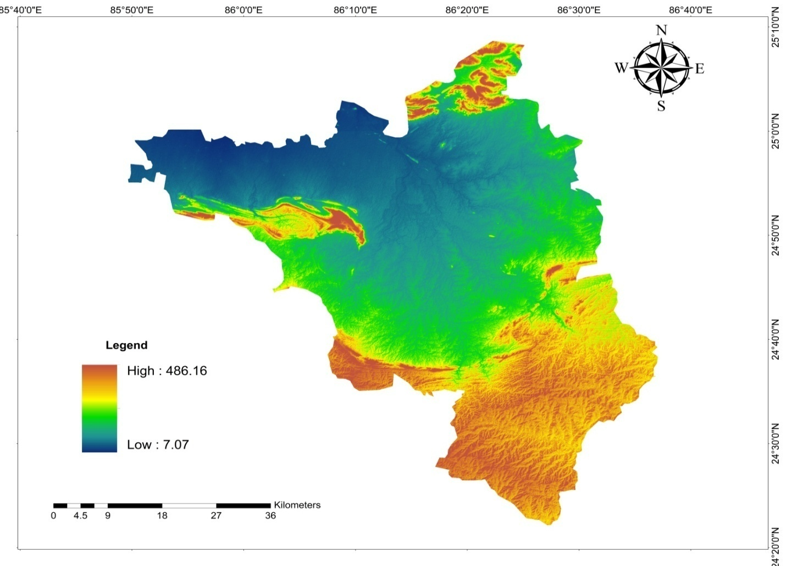
Fig. 1 Study area (Jamui District) DEM
Agriculture is the primary occupation of the population in the district. Major crops grown include rice, wheat, maize, and pulses. However, large parts of the district, particularly in the southern blocks, are affected by various forms of land degradation such as sheet erosion, gully erosion, barren rocky land, and seasonal waterlogging. These degradation processes are influenced by factors such as terrain slope, rainfall intensity, deforestation, and unsustainable land use practices. Due to its varied topography and environmental conditions, Jamui district provides an important setting for studying the spatial patterns and causes of land degradation and for identifying priority areas for soil conservation and sustainable land management.

3. Methodology
The present study aims to analyze the spatial distribution of land degradation in Jamui district using geospatial techniques (Rajand, 2024) . The methodology involves the collection of secondary data, spatial processing using GIS tools, and statistical analysis for interpretation.

3.1 Data Sources
The spatial datasets used in this study were obtained from reliable national geospatial data repositories. Land degradation data for the study area were acquired from the National Remote Sensing Centre (NRSC), which operates under the Indian Space Research Organisation. The dataset was downloaded from the NRSC portal and used in raster format for spatial analysis and mapping of degraded land categories within the study area. Additionally, Digital Elevation Model (DEM) data were obtained from the Bhuvan Bhoonidhi Portal maintained by the National Remote Sensing Centre. The DEM dataset was derived from the Cartosat-1 mission and provides high-resolution elevation information. This DEM data were used to analyze the topographic characteristics of the study area, including elevation and terrain variations (Kaliraj et al. 2026). All spatial datasets were processed and analyzed using ArcGIS for clipping, projection, and spatial analysis according to the boundary of the study area. Administrative boundary shapefiles of Jamui district and its blocks (blocks) were collected from soi and used for spatial analysis and mapping.

3.2 GIS Processing
The spatial analysis was carried out using ArcGIS. The downloaded raster data representing land degradation categories were imported into the GIS environment. The district and block boundary shapefiles were also added to the project.The raster data were clipped to the boundary of Jamui district using the extraction tools available in the GIS software. This ensured that only the land degradation information relevant to the study area was retained for further analysis.After clipping the dataset, the raster data were overlaid with the block-level shapefile. Using spatial analysis tools, the area under different categories of land degradation was calculated for each block. The area values were then converted into square kilometers for comparison.
To understand the spatial variation of degradation, the total degraded area for each block was calculated. The percentage of degraded land in each block was also computed to show the relative intensity of degradation across the district. The calculation of area was performed within the GIS environment, while percentage values were derived using standard statistical formulas based on the total degraded land area. Digital Elevation Model (DEM) data were also used to examine the elevation characteristics of the district. The DEM raster was processed in Arc-Map to generate an elevation map of the study area. The elevation values were classified into different categories to understand terrain variation across the district. The DEM analysis helped to explain the relationship between elevation, slope, and land degradation processes. Areas with higher elevation and steeper slopes, particularly in the southern part of the district, were found to be more prone to soil erosion and land degradation.

4. Results and Discussion
The stacked bar graph illustrates the distribution of different categories of land degradation across the blocks of Jamui district. sheet erosion—particularly moderate sheet erosion—is the dominant form of land degradation across most blocks. Among the blocks, Chakai records the highest degraded land area, followed by Jhajha, Khaira, and Sono (Fig. 2). The high values in these regions can be attributed to several geographical and environmental factors. These blocks lie in the transitional zone between the Gangetic plains and the Chotanagpur plateau fringe. The terrain in these areas is comparatively undulating with moderate to steep slopes, which accelerates the process of surface runoff during the monsoon season. As a result, topsoil is easily removed, leading to widespread sheet erosion.
Another major reason for the high degradation levels is vegetation loss. In many upland areas, natural vegetation has been reduced due to fuelwood collection, agricultural expansion, and grazing activities. The absence of protective vegetation cover increases soil exposure and enhances erosion intensity.
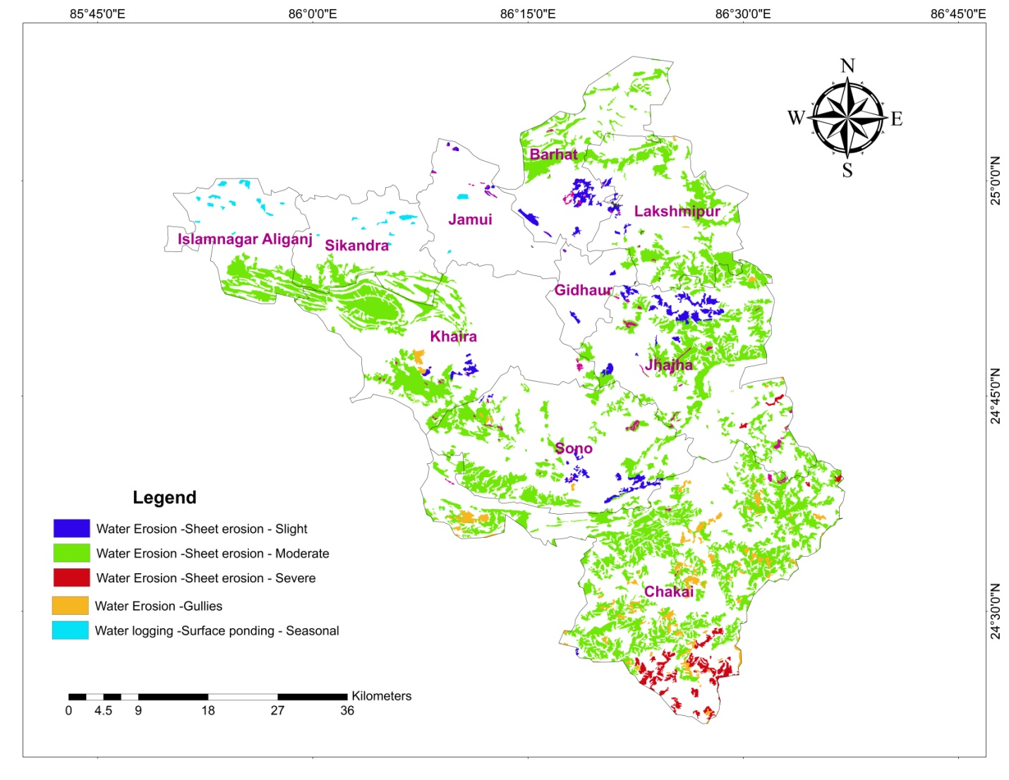
Fig. 2 Spatial distribution of land degradation in Jamui district
The presence of gully erosion in Chakai, indicating that erosion has progressed from sheet erosion to more advanced stages of land degradation in certain areas. Gullies generally develop when runoff water becomes concentrated in channels that cuts deep into the soil surface.

Fig. 3 Distribution of land degradation across sub-districts (blocks) of Jamui district
In contrast, blocks such as Jamui and Gidhaur exhibit relatively smaller degraded areas (Fig. 3). These regions are located in relatively flat terrains which help maintain soil stability.
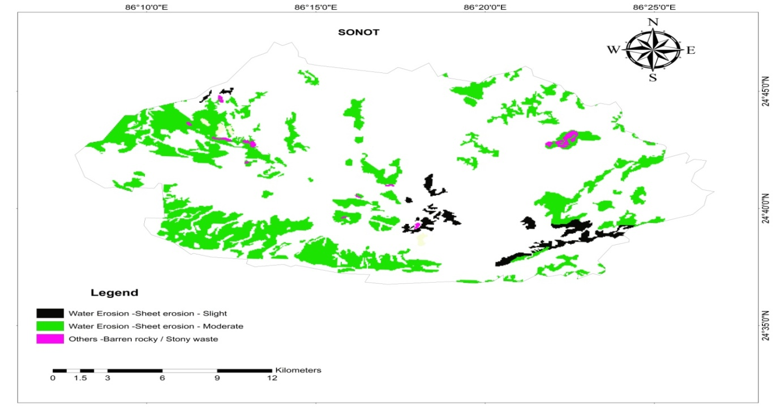
Fig. 4 Distribution of land degradation across Sonot block
Analysis clearly shows that moderate sheet erosion constitutes the largest share of degraded land, accounting for the overwhelming majority of the total degraded area (Fig 5).This dominance of moderate sheet erosion suggests that surface runoff is the primary driver of land degradation in the district. Intense rainfall during the monsoon season generates strong overland flow that gradually removes the upper soil layer. The smaller proportions of severe sheet erosion, gullies, barren rocky land, and seasonal waterlogging indicate that these degradation processes are localized. Severe sheet erosion occurs mainly in upland areas where slopes are steeper and vegetation cover is poor. Similarly, gullies are found in areas where runoff water concentrates along drainage channels.
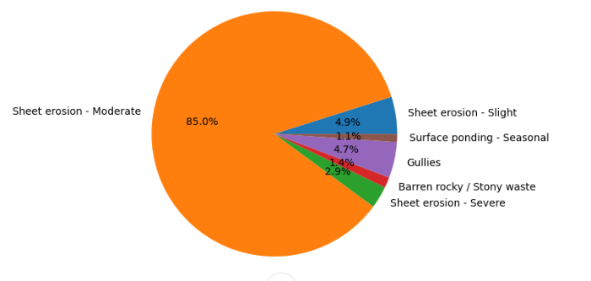
Fig. 5 Percentage distribution of land degradation across various land degradation types
Barren rocky land represents areas where soil depth has been drastically reduced due to prolonged erosion. On the other hand, seasonal waterlogging occurs in low-lying areas, particularly in blocks like Sikandara and Islamnagar (Table 1). In these areas, poor drainage and accumulation of rainwater during the monsoon lead to temporary water stagnation. Study found that sheet erosion remains the most widespread and dominant process, indicating the urgent need for soil conservation measures.Results show that the priority areas for soil conservation and land restoration measures, particularly in the southern upland blocks of the district.

Land Degradation Types | CHAKAI  (Area sq.km) | KHAIRA  (Area sq.km) | SONOT  (Area sq.km) | JHAJHA  (Area sq.km) | GIDHAUR  (Area sq.km) | LAKSHMIPUR  (Area sq.km) | BARHAT  (Area sq.km) | JAMUI  (Area sq.km) | SIKANDARA  (Area sq.km) | ISLAMNAGAR  (Area sq.km)
Sheet erosion - Slight | 0.26 | 2.80 | 6.86 | 12.53 | 1.03 | 1.90 | 7.68 | 0.82 | Nil | Nil
Sheet erosion - Moderate | 207.15 | 78.49 | 69.64 | 98.94 | 1.73 | 57.67 | 30.69 | 0.03 | 20.42 | 23.73
Sheet erosion - Severe | 18.98 | Nil | Nil | 1.17 | Nil | Nil | Nil | Nil | Nil | Nil
Stony waste | 1.14 | 1.10 | 1.47 | 3.47 | 0.22 | 0.25 | 1.28 | 0.72 | Nil | Nil
Gullies | 28.66 | 2.19 | 0.88 | 0.66 | Nil | 0.29 | Nil | Nil | Nil | Nil
Surface ponding - Seasonal | 0.03 | Nil | Nil | 0.03 | 0.08 | Nil | 0.14 | 0.87 | 2.40 | 3.87

Table. 1 Total land degradation area across various block of Jamui district
The study reveals that land degradation in Jamui district is spatially uneven and strongly influenced by terrain and land use practices. The dominance of moderate sheet erosion indicates that surface runoff plays a major role in soil loss across the district. Southern blocks such as Chakai, Jhajha, and Khaira are the most vulnerable areas due to their undulating topography and declining vegetation cover. In contrast, the northern plains show relatively lower degradation levels but are occasionally affected by seasonal waterlogging. These findings emphasize the need for sustainable land management practices including afforestation, contour farming and improved drainage systems.

5. Conclusion
The present study examined the spatial distribution of land degradation in Jamui district using geospatial datasets and GIS-based analysis. The results reveal that water-induced sheet erosion is the most dominant form of land degradation in the district. It was found thatmoderate sheet erosion accounts for the largest share of the degraded land area. This indicates that soil erosion caused by rainfall and surface runoffs are the major environmental problem affecting land. The spatial analysis further shows that degradation is not uniformly distributed across the district. Blocks located in the southern part of the district, such as Chakai and Jhajha, exhibit relatively higher degraded land areas compared to blocks situated in the northern plains.
The analysis of Digital Elevation Model (DEM) data also highlights the influence of terrain characteristics on land degradation. Areas with higher elevation and undulating topography are more vulnerable to soil erosion due to increased runoff velocity. In contrast, relatively flat regions exhibit lower levels of erosion but may experience other issues such as seasonal waterlogging. Therefore, topography, rainfall and land use practices collectively influence the intensity of degradation processes in the district.The findings of this study emphasize the importance of sustainable land management and soil conservation measures to reduce the impact of land degradation. Practices such as afforestation, and watershed management, can significantly help in controlling soil erosion. The use of geospatial technologies provides an effective approach for monitoring land degradation.Overall, the study highlights that geospatial analysis plays a crucial role in identifying vulnerable areas and understanding the spatial dynamics of land degradation. Such information is essential for policymakers and planners to develop appropriate strategies for sustainable land resource management in Jamui district.
Disclaimer (Artificial intelligence)
Author(s) hereby declare that NO generative AI technologies such as Large Language Models (ChatGPT, COPILOT, etc.) and text-to-image generators have been used during the writing or editing of this manuscript.

References

Ahmad, N., & Pandey, P. (2018). Assessment and monitoring of land degradation using geospatial technology in Bathinda district, Punjab, India. Solid Earth, 9, 75–90. https://doi.org/10.5194/se-9-75-2018
Barman, A., Basak, N., Narjary, B., & Mitran, T. (2020). Land degradation assessment using geospatial techniques. In Digital Technologies for Agriculture and Rural Development (pp. 233–251). Springer. https://doi.org/10.1007/978-981-15-6864-0_12
Blaikie, P., & Brookfield, H. (1987). Land degradation and society. London: Methuen.
Food and Agriculture Organization (FAO). (1999). Land degradation assessment in drylands. Rome: FAO.
Gupta, S. K., Hussain, M., Ahmed, M., & Pandey, A. S. (1998). Inventory of degraded lands of Palamau district, Bihar—A remote sensing approach. Journal of the Indian Society of Remote Sensing, 26(1–2), 47–55. https://doi.org/10.1007/BF02990794
Gaur, M. K., Feng, H., & Squires, V. R. (2025). Degradation status and land productivity assessment in drylands using remote sensing and ground survey: Experiences from India and China. Journal of Rangeland Science, 15(2), 95–110. http://oiccpress.com/jrs/article/view/17470
Hurni, H., Berhe, W., Chadhokar, P., Daniel, D., Gete, Z., Grunder, M., & Kassaye, G. (2016). Soil erosion and sustainable land management. Environmental Systems Research, 5(1), 1–20.
Kaliraj, S., Jerin Joe, R. J., Pitchaimani, V. S., Abishek, S. R., & Karuppannan, S. (2026). GIS-based assessment of land degradation vulnerability and environmental indices as ecological indicators in the Western agro-climatic zone of Tamil Nadu, India. Scientific Reports, 16, 4944. https://doi.org/10.1038/s41598-026-35211-3
Malav, L. C., Yadav, B., Tailor, B. L., Pattanayak, S., Singh, S. V., Kumar, N., Reddy, G. P. O., Mina, B. L., Dwivedi, B. S., & Jha, P. K. (2022). Mapping of land degradation vulnerability in the semi-arid watershed of Rajasthan, India. Sustainability, 14(16), 10198. https://doi.org/10.3390/su141610198
Marchetti, A., Piccini, C., Francaviglia, R., & Mabit, L. (2012). Spatial distribution of soil organic matter using geostatistics: A key indicator to assess soil degradation status in central Italy. Pedosphere, 22(2), 230-242.
Parmar, M., Bhawsar, Z., Kotecha, M., Shukla, A., & Rajawat, A. S. (2021). Assessment of land degradation vulnerability using geospatial technique: A case study of Kachchh district of Gujarat, India. Journal of the Indian Society of Remote Sensing, 49, 1661–1675. https://doi.org/10.1007/s12524-021-01349-y
Radda, I. A., Kumar, B. M., & Pathak, P. (2021). Land degradation in Bihar, India: An assessment using rain-use efficiency and residual trend analysis. Agricultural Research, 10(4), 623–635. https://doi.org/10.1007/s40003-020-00514-y
Raj, R., Saharia, M., & Chakma, S. (2024). Geospatial modeling and mapping of soil erosion in India. Catena, 234, 107487
Romshoo, S. A. (2021). Desertification and land degradation atlas of India: Assessment and analysis of changes over 15 years based on remote sensing. Space Applications Centre, ISRO.
Scholten, T., & Seitz, S. (2019). Soil erosion and land degradation. Soil Systems, 3(4), 68. https://doi.org/10.3390/soilsystems3040068
Seifu, A., & Elias, E. (2018). Soil erosion and land degradation in Ethiopia: A review. Environmental Systems Research, 7(1), 1–14.
United Nations Convention to Combat Desertification (UNCCD). (1993). Land degradation definition and framework. United Nations.
Verma, V. K., & Sur, K. S. (2024). Monitoring vegetation degradation using remote sensing and machine learning over India: A multi-sensor, multi-temporal and multi-scale approach. Frontiers in Forests and Global Change, 7. https://doi.org/10.3389/ffgc.2024.1382557
Zhao, X., Dai, J., & Wang, J. (2013). GIS-based evaluation and spatial distribution characteristics of land degradation in Bijiang watershed. SpringerPlus, 2(Suppl 1), S8

