Rural–Urban Differences in Odonata Diversity and Population Dynamics across Agricultural Landscapes of the Eastern Gangetic Plains

ABSTRACT
Odonates are sensitive indicators of ecological condition because their life cycle depends on the integrity of both aquatic and terrestrial habitats. Here, we compared odonate diversity, assemblage composition and seasonal population dynamics across rural and urban agricultural landscapes in the Eastern Gangetic Plains. Weekly visual surveys of adult odonates were conducted from March 2022 to February 2024 in the agricultural areas of Manpur (rural) and Gaya city (urban), spanning fields of food grains, vegetables, pulses and oilseeds. Community structure was analysed using relative abundance, species richness, Shannon diversity, evenness, dominance, Sørensen similarity, one-way ANOVA and principal component analysis. The rural landscape supported 24 species, compared with 17 in the urban landscape, and the two assemblages showed only moderate similarity (SSI = 0.571). Food-grain fields showed the strongest association with odonate community structure and had the highest richness (S = 21), abundance (N = 2239) and Shannon diversity (H′ = 2.734). Seasonal effects were significant in both landscapes, with abundance peaking during the monsoon; this seasonal dependence was slightly stronger in the urban landscape (ICC = 0.426) than in the rural landscape (ICC = 0.368). These findings show that habitat heterogeneity, crop mosaics and monsoon-linked aquatic microhabitats are key determinants of odonate persistence in agricultural landscapes of the Gaya region.
Keywords: Odonata; rural–urban agricultural landscapes; species diversity; seasonal population dynamics; habitat heterogeneity; agroecosystems; Eastern Gangetic Plains
1. INTRODUCTION
Agricultural landscapes are not only food-production systems but also ecological matrices that can support substantial biodiversity when crop fields, bunds, irrigation channels, temporary wetlands, and non-crop vegetation occur as a heterogeneous mosaic (Benton et al., 2003; Tscharntke et al., 2012; Priyadarshana et al., 2024). In the Indo-Gangetic region, such habitat complexity can be especially important because cultivated fields are frequently linked to seasonal water retention, canal irrigation, and fallow patches that generate fine-scale ecological variation within otherwise human-dominated landscapes. By contrast, simplification of crop structure, urban expansion, and fragmentation often reduce habitat continuity and weaken the capacity of agricultural systems to sustain diverse insect communities (McKinney, 2008; Priyadarshana et al., 2024).
Members of the order Odonata (dragonflies and damselflies) are particularly informative in this context because they occupy both aquatic and terrestrial environments during their life cycle and respond quickly to changes in hydroperiod, vegetation structure, land cover, and water quality (Kalkman et al., 2008; Clausnitzer et al., 2009; Simaika & Samways, 2010; Cheri & Finn, 2023). Odonates are also functionally important predators of mosquitoes and other soft-bodied insects, so their persistence in cultivated landscapes may contribute to ecological regulation within agroecosystems (Sharma & Yadav, 2019). Their sensitivity, visibility, and relative ease of field identification make them useful for landscape-level monitoring in both natural and managed ecosystems (Thomas, 2005; Batista et al., 2021).
India supports a rich odonate fauna, and recent regional checklists continue to demonstrate the scale of this diversity and the need for better documentation outside the better-studied biodiversity hotspots (Subramanian et al., 2018; Kalkman et al., 2020; Subramanian & Babu, 2024). However, much of the published Indian literature remains concentrated in the Western Ghats, Himalayan foothills, forested wetlands, and protected areas, whereas intensively used agricultural landscapes of the Eastern Gangetic Plains remain less explored. This is an important gap because the plains contain extensive irrigation networks, floodplain remnants, and rural-urban agricultural interfaces that may shape odonate assemblages in distinctive ways.
The present study therefore compares odonate diversity and population dynamics between two contrasting agricultural landscapes of Gaya district, Bihar: rural Manpur and the urban agricultural matrix of Gaya city. Specifically, the study examines (i) differences in richness and assemblage composition between the two landscapes, (ii) the influence of crop type on community structure, and (iii) seasonal changes in abundance across pre-monsoon, monsoon, and post-monsoon periods. By combining reported community metrics with ecological interpretation, the revised manuscript aims to clarify how landscape context, crop mosaics, and seasonality jointly influence odonate communities in working agroecosystems.
2. MATERIALS AND METHODS
2.1 Study area
The study was carried out in Gaya district, Bihar, India, which covers approximately 4,976 km² and lies between 24°30' N and 25°06' N latitude and 84°24' E and 85°30' E longitude. The district is located in the Punpun sub-basin of the Ganga river system and is traversed by the Morhar, Phalgu, Paimar, and Dhadhar rivers. Two agricultural landscapes were selected for comparison: Manpur, representing a predominantly rural agrarian landscape with relatively continuous habitat structure, and Gaya city, representing fragmented agricultural patches embedded within an urban matrix. The local farming calendar includes rain-fed Kharif crops such as rice and maize and irrigated Rabi crops such as wheat, legumes, and mustard. For analysis, survey sites were stratified across fields growing food grains, vegetables, pulses, and oilseeds.
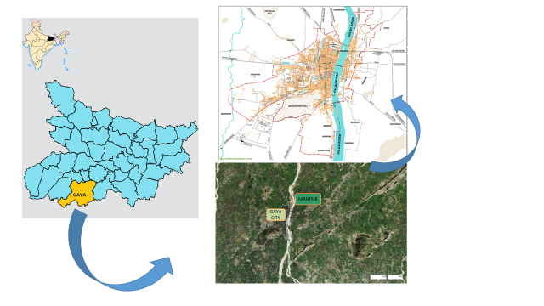
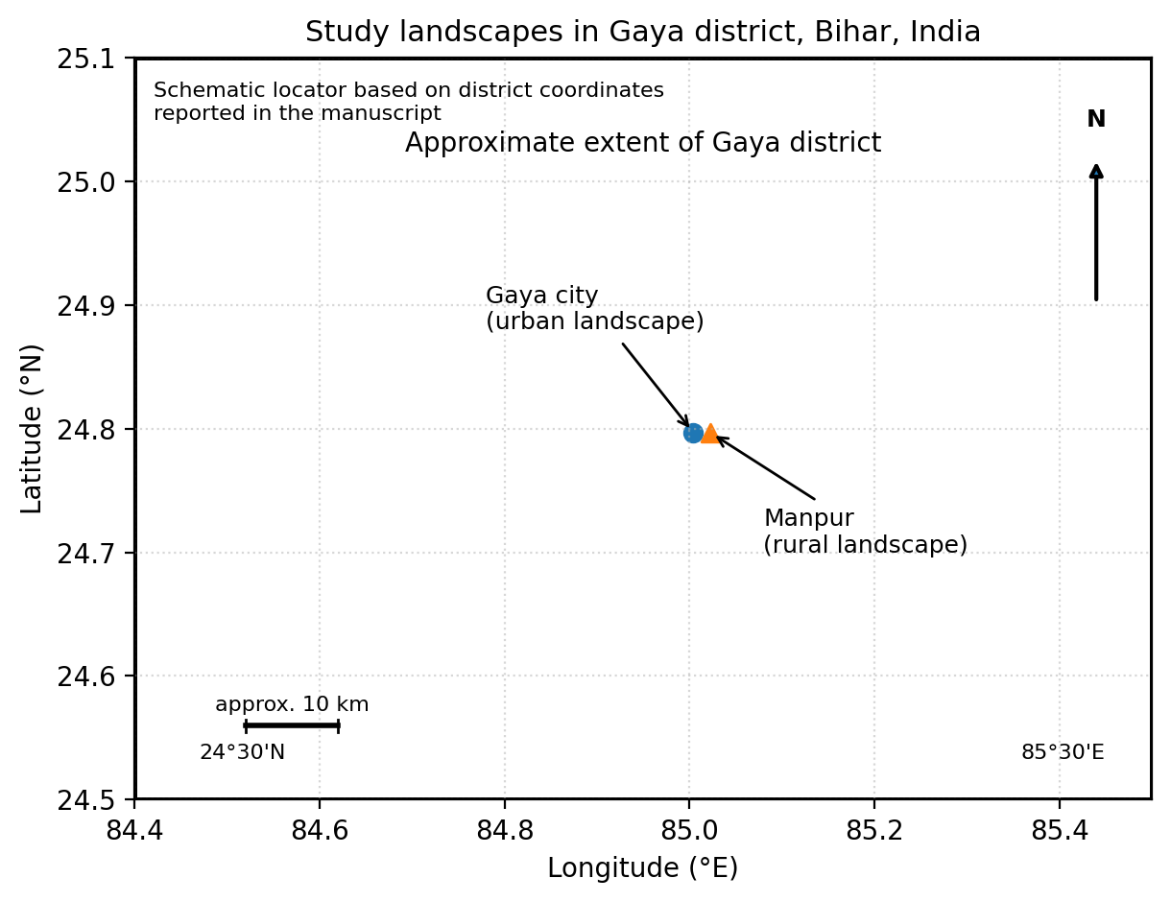
Figure 1. Schematic location of the two study landscapes within Gaya district, Bihar, India, based on the district coordinate range and the reported positions of Gaya city and Manpur.
2.2 Sampling design and field observations
A systematic field survey was conducted from March 2022 to February 2024 to monitor adult odonate abundance and composition. Adult-based visual surveys are widely used in odonate research because they provide efficient estimates of site occupancy and community composition when repeated under fixed observation conditions (Thomas, 2005; Jere et al., 2020; Batista et al., 2021; Darshetkar et al., 2023). In the present study, a fixed-point count design was used to suit narrow agricultural plots and field margins where linear transects were not always practical.
At each landscape, adult free-flying odonates were recorded at twenty fixed locations within each microhabitat. A minimum spacing of 10 m was maintained between successive points. Although highly mobile species may occasionally move across neighbouring points, this spacing, together with the small observation radius, reduced repeated counts within the same microhabitat patch and therefore minimized pseudo-replication as far as field conditions allowed. Observations were restricted to a radius of approximately 3 m around each point and were made weekly during peak flight periods between 09:00 and 12:00 h and again between 15:00 and 16:00 h.
Surveys were conducted in agricultural lands where food grains, vegetables, pulses, and oilseeds were grown, rather than on crop types as abstract categories. Species were identified in the field using direct observation, high-resolution photographs, and standard regional taxonomic resources (Subramanian, 2005; Kalkman et al., 2020; Subramanian & Babu, 2024). Scientific names are presented in italics throughout the manuscript.
2.3 Data analysis
Preliminary data summaries were prepared in Microsoft Excel and the statistical analyses were conducted in R. Relative abundance (RA%) was calculated for each recorded species. Community structure was evaluated using the Shannon-Wiener diversity index (H'), Menhinick's richness index (d), Pielou's evenness index (J'), and Berger-Parker dominance index (D). Beta diversity between the rural and urban landscapes was estimated using Sørensen's similarity index, Cs = 2C/(A + B), where C is the number of shared species and A and B are the total species recorded at each site. Differences in diversity metrics between the two landscapes were examined using one-way analysis of variance (ANOVA), with statistical significance considered at P < .05. Principal component analysis (PCA) was applied to log-transformed abundance data [log(x + 1)] to explore the relationships between species assemblages and habitat variables, especially crop type, vegetation heterogeneity, and disturbance level.
3. RESULTS AND DISCUSSION
3.1 Landscape-level diversity and assemblage differentiation
The rural agricultural landscape of Manpur supported greater odonate diversity than the urban agricultural landscape of Gaya city. A total of 24 species were recorded in Manpur, compared with 17 species in Gaya. Sørensen's similarity index (0.571) indicated only moderate overlap between the two assemblages, which suggests that the landscapes shared part of a regional species pool but also maintained habitat-specific components. This difference is ecologically meaningful because both landscapes belong to the same district and climatic region; the observed variation is therefore more plausibly linked to local habitat structure and land-use context than to broad biogeographic differences.
Taxonomic composition also differed between the two settings. In Manpur, Anisoptera represented 77% of the recorded odonate population, whereas the urban landscape showed stronger representation of Zygoptera (75%). The rural site hosted 13 species not recorded in the urban landscape, including Anaciaeschna jaspidea and Acisoma panorpoides, while the urban landscape contained six exclusive species such as Anax guttatus and Agriocnemis kalinga. The presence of exclusive species in both landscapes indicates that urban agricultural patches should not be treated as entirely depauperate; instead, they contain a filtered subset of the regional fauna plus a few habitat-tolerant or matrix-adapted taxa.
The higher richness of rural Manpur is consistent with the habitat heterogeneity hypothesis and with broader work showing that odonate communities respond strongly to vegetation complexity, shoreline structure, and the availability of adjacent aquatic habitat (Perron et al., 2021; Pires et al., 2022; Vilenica et al., 2024). In the present study, irrigation channels, temporary wet patches, mixed crop architecture, and lower structural disturbance in Manpur probably created a broader array of breeding, perching, and foraging opportunities. By contrast, the urban matrix of Gaya appears to have favoured more disturbance-tolerant and seasonally opportunistic species. Comparable urban studies have shown that some city wetlands can retain distinctive odonate assemblages, but the quality of vegetation and the connectivity of aquatic patches strongly influence whether urban habitats function as refugia or ecological filters (Husband & McIntyre, 2021; Richmond et al., 2024; Vilenica et al., 2024).
The moderate similarity index is therefore important. It suggests that rural and urban agricultural landscapes in Gaya should be viewed as complementary rather than interchangeable from a conservation perspective. Protecting only one landscape type would not conserve the full assemblage observed across the study region.
Metric | Rural (Manpur) | Urban (Gaya)
Species richness (S) | 24 | 17
Exclusive species | 13 | 6
Dominant suborder | Anisoptera (77%) | Zygoptera (75%)
Seasonal ANOVA | F = 14.41, P < .001 | F = 12.88, P < .001
Seasonal ICC | 0.368 | 0.426
Table 1. Comparative summary of reported odonate community metrics for rural and urban agricultural landscapes.
Note: Shared community statistic: Sørensen's similarity index (SSI) = 0.571.
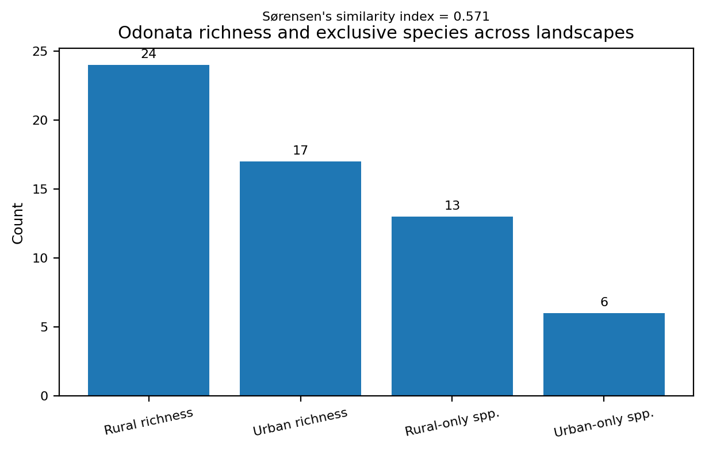
Figure 2. Species richness and exclusive species counts across rural and urban landscapes.
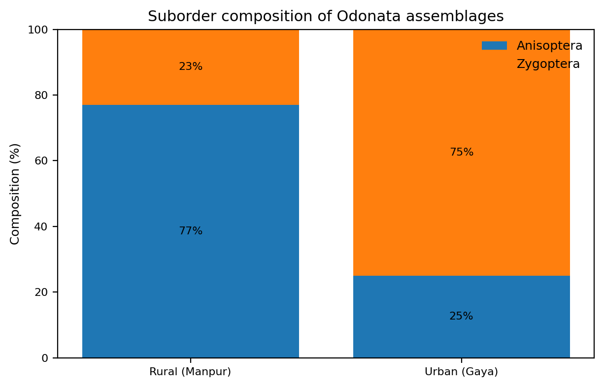
Figure 3. Suborder composition of Odonata assemblages in rural and urban agricultural landscapes.
3.2 Crop composition as a driver of community structure
Principal component analysis showed that crop composition was a major determinant of community structure. PC1 explained 75.25% of the total variance and PC2 explained an additional 16.15%, together accounting for more than 91% of the observed variation. The strongest positive loading on PC1 was associated with food grains (0.757), followed by vegetables (0.519), indicating that these crop categories were the major axes along which odonate assemblages differentiated.
Food-grain habitats supported the highest richness (S = 21), the highest abundance (N = 2239), and the highest Shannon diversity (H' = 2.734). Species such as Neurothemis fulvia, Orthetrum sabina, and Pantala flavescens were closely associated with these habitats. Vegetable fields formed a second important cluster, with Diplacodes trivialis and Ceriagrion coromandelianum showing close affinity. In contrast, pulse fields supported the lowest richness (S = 9) and the lowest abundance (N = 677), whereas oilseed habitats showed comparatively high evenness (J' = 0.91), indicating a smaller but more evenly distributed assemblage.
Ecologically, the strong performance of food-grain systems can be explained by their structural and hydrological characteristics. Rice-based and other food-grain fields often retain water for longer periods, develop emergent or marginal vegetation, and create shallow microhabitats resembling temporary wetlands. Such conditions are known to favour odonates by increasing breeding opportunities and providing more diverse adult perching and hunting substrates (Vilenica et al., 2022; Perron et al., 2021). The result also agrees with recent synthesis work showing that crop and landscape heterogeneity generally increase biodiversity in agricultural systems by broadening the range of microhabitats and resource conditions available to insects (Priyadarshana et al., 2024).
The lower richness in pulse fields may reflect simpler canopy structure, shorter periods of soil moisture retention, and fewer semi-aquatic margins. By contrast, the relatively high evenness in oilseeds suggests that these habitats supported fewer strongly dominant species, perhaps because environmental conditions were intermediate rather than highly favourable for a small number of taxa. Similar landscape-level responses have been reported in agricultural settings where odonate heterogeneity decreases with land-use simplification and increases where aquatic vegetation, non-crop margins, and habitat patchiness are retained (Pires et al., 2022).
Taken together, the PCA results show that not all crop categories contribute equally to odonate conservation. In the Gaya region, food-grain and vegetable systems appear to function as the major biodiversity-supporting components of the agricultural mosaic.
Crop / metric | Reported value | Interpretation for Odonata community | Source in manuscript
Food grains: PC1 loading | 0.757 | Strong positive association with the major axis of community differentiation | Results 3.2
Vegetables: PC1 loading | 0.519 | Secondary positive association with PC1 | Results 3.2
Food grains: PC2 loading | -0.649 | Negative separation along PC2 | Results 3.2
Vegetables: PC2 loading | 0.576 | Positive separation along PC2 | Results 3.2
Food grains: abundance | N = 2239 | Highest abundance among reported crop categories | Results 3.2
Food grains: richness | S = 21 | Highest richness among reported crop categories | Results 3.2
Food grains: Shannon diversity | H' = 2.734 | Indicates a complex and stable community | Results 3.2
Pulses: abundance | N = 677 | Lowest reported abundance | Results 3.2
Pulses: richness | S = 9 | Lowest reported richness | Results 3.2
Oilseeds: evenness | J' = 0.91 | Highest evenness among reported crop groups | Results 3.2
Table 2. Crop-associated community metrics and PCA interpretation.
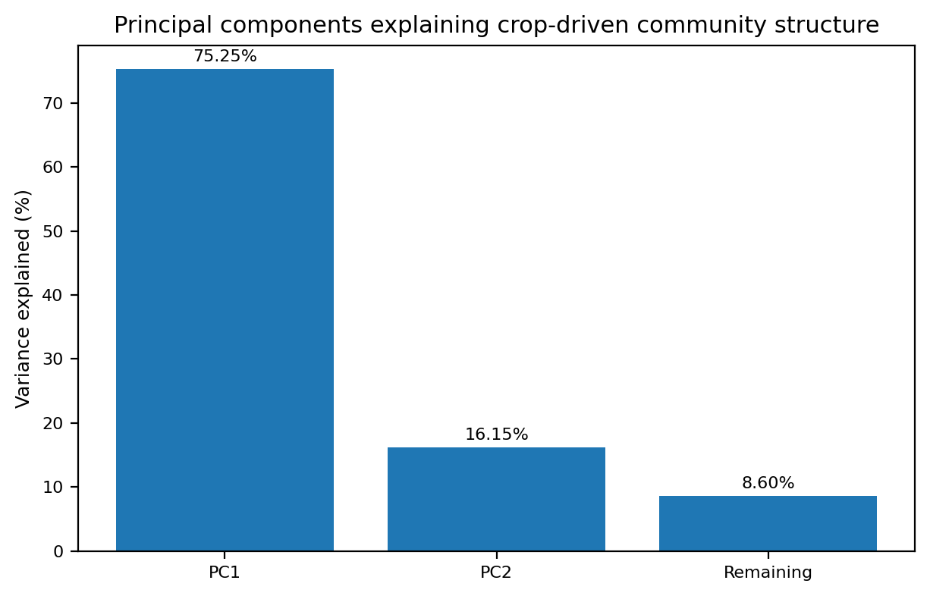
Figure 4. Percentage of variance explained by principal components of crop-driven community structure.
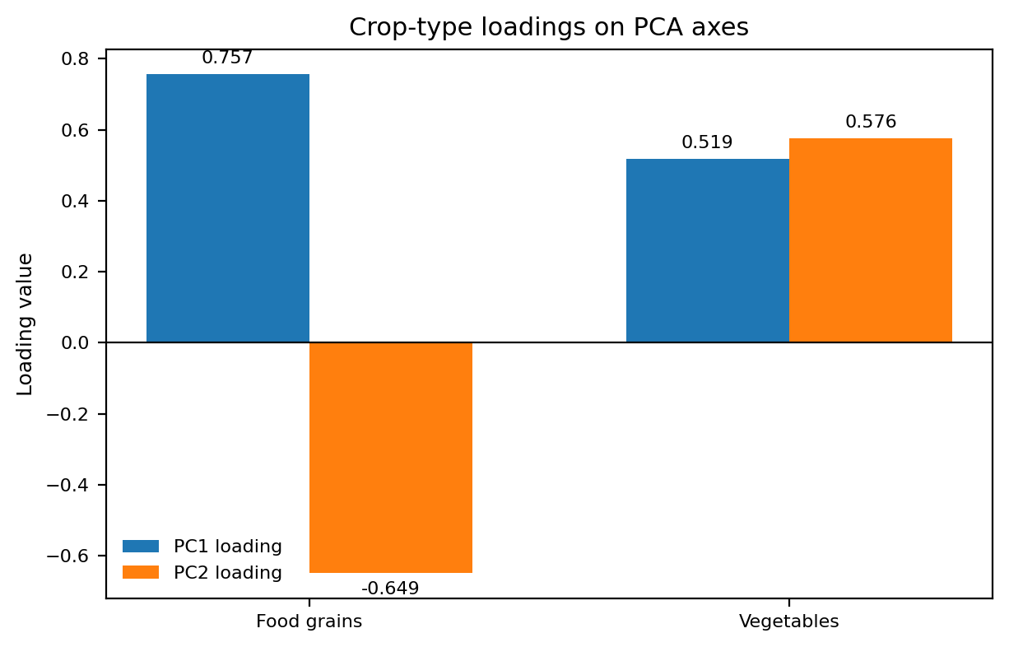
Figure 5. PCA loadings showing the relative influence of food grains and vegetables on PC1 and PC2.
3.3 Seasonal abundance and population dynamics
Seasonality had a significant effect on odonate abundance in both landscapes. One-way ANOVA showed highly significant differences among pre-monsoon, monsoon, and post-monsoon periods for both rural and urban sites (P < .001). In both landscapes, abundance peaked during the monsoon and declined afterwards. These findings indicate that seasonal water availability is a central organizing force in the odonate communities of the study area.
In Manpur, seasonal variation explained 36.8% of total abundance variance (ICC = 0.368). Pantala flavescens and Orthetrum sabina showed especially strong monsoon increases, with reported monsoon mean counts of 80.5 ± 7.29 and 49.25 ± 7.11, respectively. In urban Gaya, seasonal dependence was even stronger (ICC = 0.426), and Brachythemis contaminata reached a monsoon mean count of 51.75 ± 1.08. These species-level peaks indicate that rainfall-driven habitat pulses supported both widespread migratory species and disturbance-tolerant urban taxa.
The somewhat stronger seasonal dependence in the urban landscape suggests that odonates there relied more heavily on short-lived rain-fed habitat windows than did the rural assemblage. This is ecologically plausible because urban agricultural patches generally contain fewer persistent wet margins, less continuous aquatic connectivity, and more abrupt transitions between cultivated land and built surfaces. Recent work on human-modified odonate habitats similarly emphasizes the importance of hydroperiod, vegetation quality, and pond connectivity in determining whether urban habitats can support stable populations or only seasonal surges (Husband & McIntyre, 2021; Richmond et al., 2024).
From a population perspective, the monsoon peak likely reflects multiple linked processes: greater larval habitat availability, improved moisture in surrounding vegetation, increased emergence opportunities, and enhanced adult foraging conditions. Climatic and hydrological controls on odonate phenology have been documented elsewhere, including changes in emergence timing, abundance, and flight morphology under altered environmental conditions (McCauley et al., 2015). In the present study, the seasonal signal appears strong enough to warrant inclusion of monsoon-linked habitat management in agricultural biodiversity planning.
Species | Landscape | Reported monsoon mean count | Reported dispersion
Pantala flavescens | Rural (Manpur) | 80.5 | ± 7.29
Orthetrum sabina | Rural (Manpur) | 49.25 | ± 7.11
Brachythemis contaminata | Urban (Gaya) | 51.75 | ± 1.08
Table 3. Reported monsoon peaks of representative Odonata species recorded in the study.
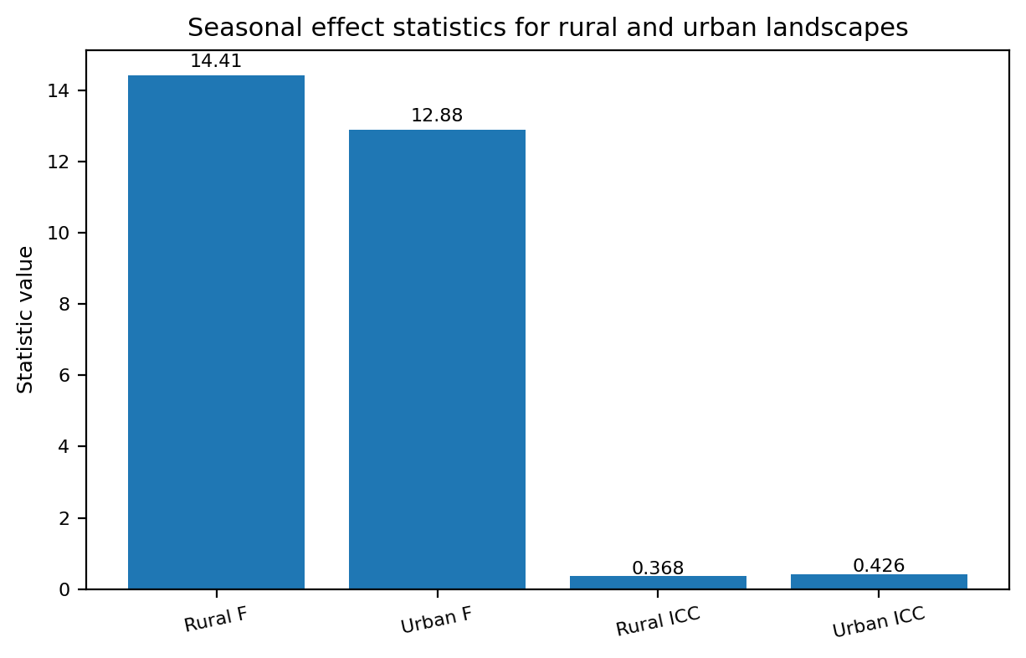
Figure 6. Comparison of seasonal effect statistics reported for rural and urban landscapes. Figure 6 of the original submission was removed because it duplicated the information already summarized in Table 3.
3.4 Management implications for biodiversity-friendly agriculture
When the reported results are viewed together, three management messages emerge. First, rural agricultural landscapes with mixed crop architecture, irrigation-linked wet patches, and lower fragmentation can retain richer odonate assemblages than urban agricultural patches. Second, crop identity matters: food-grain and vegetable systems contributed disproportionately to community structure, while simplified crop categories supported smaller or more seasonally restricted assemblages. Third, monsoon-linked habitat availability remains essential in both settings, particularly in urban landscapes where seasonal water may be the main trigger of population expansion.
These findings support a practical agroecological approach rather than a strict separation of production and biodiversity goals. Maintaining small water bodies, vegetated field margins, irrigation edges, and crop mosaics is likely to benefit odonates while remaining compatible with farm production. Recent large-scale synthesis has likewise shown that crop and landscape heterogeneity generally enhance biodiversity in agricultural landscapes, especially where structurally distinct field types and semi-natural habitat elements are retained (Priyadarshana et al., 2024).
The results are also relevant to urban agriculture. Urban fields are often treated as residual spaces, yet the present data show that they can still support a distinct set of odonate species. Their conservation value would probably increase if drainage channels, ponds, and field-edge vegetation were planned as connected habitat elements rather than isolated fragments. Evidence from stormwater ponds and urban semi-natural wetlands indicates that connectivity and vegetation quality can substantially improve urban odonate richness and abundance (Perron et al., 2021; Richmond et al., 2024; Vilenica et al., 2024).
Odonates therefore provide a useful bridge between agricultural management and freshwater conservation. Because they respond to both terrestrial and aquatic habitat conditions, they can serve as practical indicators for monitoring the ecological performance of multifunctional agricultural landscapes in the Eastern Gangetic Plains.
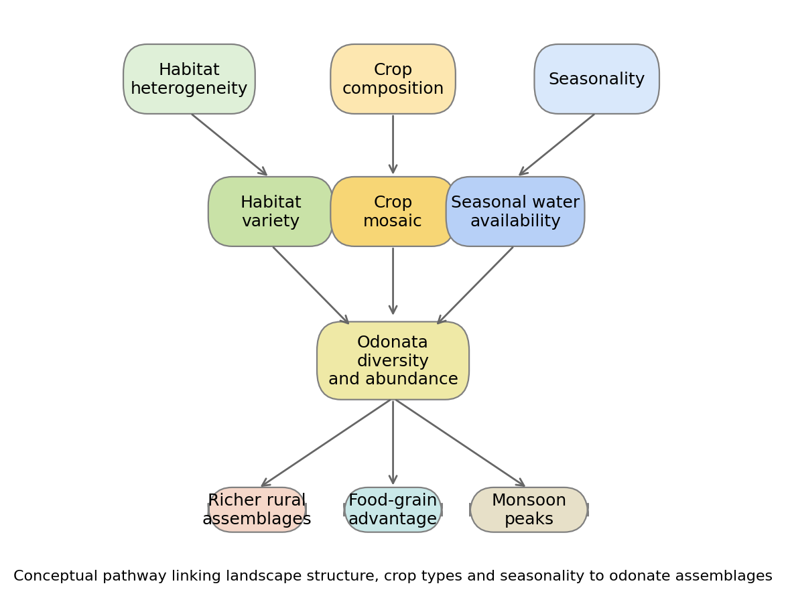
Figure 7. Conceptual framework summarizing how habitat heterogeneity, crop composition, and seasonality shape odonate diversity in the study landscapes.
4. CONCLUSION
The study demonstrates that odonate assemblages in the agricultural landscapes of Gaya are shaped by the combined effects of landscape context, crop composition, and seasonality. Rural Manpur retained a richer and more distinctive assemblage than the urban agricultural matrix of Gaya city, indicating that continuity of habitat structure remains important even within highly modified agroecosystems. Among the crop categories examined, food-grain systems appear to be particularly important because they provide the hydrological and structural conditions that favour higher richness and abundance. The strong monsoon signal across both landscapes further shows that temporary aquatic microhabitats are critical components of odonate persistence. Accordingly, biodiversity-friendly agricultural planning in the Eastern Gangetic Plains should prioritize crop mosaics, vegetated field margins, and conservation of small seasonal and permanent water bodies. Such measures would help maintain odonates both as indicators of environmental quality and as ecologically important predators within farmed landscapes.
Disclaimer (Artificial intelligence)
Author(s) hereby declare that NO generative AI technologies such as Large Language Models (ChatGPT, COPILOT, etc.) and text-to-image generators have been used during the writing or editing of this manuscript.
REFERENCES
- Batista, J.D., Ferreira, V.R.S., Cabette, H.S.R., de Castro, L.A., De Marco, P., & Juen, L. (2021). Sampling efficiency of a protocol to measure Odonata diversity in tropical streams. PLoS ONE, 16(3), e0248216. https://doi.org/10.1371/journal.pone.0248216
- Benton, T.G., Vickery, J.A., & Wilson, J.D. (2003). Farmland biodiversity: Is habitat heterogeneity the key? Trends in Ecology & Evolution, 18(4), 182-188.
- Cheri, C.R., & Finn, D.S. (2023). Odonata as indicators? Dragonflies and damselflies respond to riparian conditions along Ozark spring streams. Hydrobiology, 2(1), 260-276. https://doi.org/10.3390/hydrobiology2010017
- Clausnitzer, V., Kalkman, V.J., Ram, M., Collen, B., Baillie, J.E.M., Bedjanič, M., et al. (2009). Odonata enter the biodiversity crisis debate: The first global assessment of an insect group. Biological Conservation, 142(8), 1864-1869.
- Darshetkar, A., Patwardhan, A., & Koparde, P. (2023). A comparison of four sampling techniques for assessing species richness of adult odonates at riverbanks. Journal of Threatened Taxa, 15(1), 22471-22478. https://doi.org/10.11609/jott.7259.15.1.22471-22478
- Husband, D.M., & McIntyre, N.E. (2021). Urban areas create refugia for odonates in a semi-arid region. Insects, 12(5), 431. https://doi.org/10.3390/insects12050431
- Jere, A., Darshetkar, A., Patwardhan, A., & Koparde, P. (2020). Assessing the response of odonates (dragonflies and damselflies) to a tropical urbanization gradient. Journal of Urban Ecology, 6(1), juaa029. https://doi.org/10.1093/jue/juaa029
- Kalkman, V.J., Clausnitzer, V., Dijkstra, K.-D.B., Orr, A.G., Paulson, D.R., & van Tol, J. (2008). Global diversity of dragonflies (Odonata) in freshwater. Hydrobiologia, 595(1), 351-363.
- Kalkman, V.J., Babu, R., Bedjanič, M., Conniff, K., Gyeltshen, T., Khan, M.K., Subramanian, K.A., Zia, A., & Orr, A.G. (2020). Checklist of the dragonflies and damselflies (Insecta: Odonata) of Bangladesh, Bhutan, India, Nepal, Pakistan and Sri Lanka. Zootaxa, 4849(1), 1-84. https://doi.org/10.11646/zootaxa.4849.1.1
- McCauley, S.J., Hammond, J.I., & Mabry, K.E. (2015). Simulated climate change increases larval mortality, alters phenology, and affects flight morphology of a dragonfly. Ecosphere, 6(10), 1-12.
- McKinney, M.L. (2008). Effects of urbanization on species richness: A review of plants and animals. Urban Ecosystems, 11, 161-176.
- Perron, M.A.C., Richmond, I.C., & Pick, F.R. (2021). Plants, water quality and land cover as drivers of Odonata assemblages in urban ponds. Science of the Total Environment, 773, 145467. https://doi.org/10.1016/j.scitotenv.2021.145467
- Pires, M.M., Sahlén, G., & Périco, E. (2022). Agricultural land use affects the heterogeneity of Odonata communities in the Brazilian Pampa. Journal of Insect Conservation, 26(3), 503-514. https://doi.org/10.1007/s10841-021-00349-0
- Priyadarshana, T.S., Martin, E.A., Sirami, C., et al. (2024). Crop and landscape heterogeneity increase biodiversity in agricultural landscapes: A global review and meta-analysis. Ecology Letters, 27(3), e14412. https://doi.org/10.1111/ele.14412
- Richmond, I.C., Perron, M.A.C., Boyle, S.P., & Pick, F.R. (2024). Connectivity of stormwater ponds impacts Odonata abundance and species richness. Landscape Ecology, 39(3), 63. https://doi.org/10.1007/s10980-024-01817-z
- Sharma, R., & Yadav, S. (2019). Odonata as biological pest control agents: An overview. Agricultural Reviews, 40(2), 123-129.
- Simaika, J.P., & Samways, M.J. (2010). Comparative assessment of indices of freshwater habitat conditions using different bioindicator groups. Ecological Indicators, 10(2), 456-465.
- Subramanian, K.A. (2005). Dragonflies and Damselflies of Peninsular India: A field guide. Centre for Ecological Sciences, Indian Institute of Science and Indian Academy of Sciences, Bangalore.
- Subramanian, K.A., Babu, R., & Tiple, A.D. (2018). The status and distribution of dragonflies and damselflies (Odonata) of India. Journal of Threatened Taxa, 10(3), 11503-11518.
- Subramanian, K.A., & Babu, R. (2024). Fauna of India checklist: Arthropoda: Insecta: Odonata. Version 1.0. Zoological Survey of India. https://doi.org/10.26515/Fauna/1/2023/Arthropoda:Insecta:Odonata
- Thomas, J.A. (2005). Monitoring change in the abundance and distribution of insects using butterflies and other indicator groups. Philosophical Transactions of the Royal Society B: Biological Sciences, 360(1454), 339-357.
- Tscharntke, T., Clough, Y., Wanger, T.C., Jackson, L., Motzke, I., Perfecto, I., et al. (2012). Global food security, biodiversity conservation and the future of agricultural intensification. Biological Conservation, 151(1), 53-59.
- Vilenica, M., Rebrina, F., Matoničkin Kepčija, R., Šegota, V., Rumišek, M., Ružanović, L., & Brigić, A. (2022). Aquatic macrophyte vegetation promotes taxonomic and functional diversity of Odonata assemblages in intermittent karst rivers in the Mediterranean. Diversity, 14(1), 31. https://doi.org/10.3390/d14010031
- Vilenica, M., Brigić, A., Štih Koren, A., Koren, T., Sertić Perić, M., Schmidt, B., Bužan, T., & Gottstein, S. (2024). Odonata assemblages in urban semi-natural wetlands. Insects, 15(3), 207. https://doi.org/10.3390/insects15030207

