Assessing Household Carbon Footprints and Climate Change Vulnerability across Settlement Types in Maharashtra, India

.
ABSTRACT

This study examines the relationship between household carbon emissions and climate change vulnerability across different settlement types in Maharashtra, India. A stratified household survey covering 1000 households across 123 villages and cities was conducted between August 2022 and March 2023. Household carbon footprints were estimated using activity-based emission factors and converted to carbon dioxide equivalents (CO₂e). The results reveal clear regional disparities in emissions and vulnerability. Metropolitan households recorded the highest emissions, mainly from electricity (42%) and transportation (37%), while urban households showed major contributions from transport (40%) and electricity (30%). In contrast, rural and tribal households generated lower overall emissions but experienced significantly higher economic losses due to climate-related events such as floods, droughts, and erratic rainfall. Biomass consumption accounted for 37% of emissions in rural areas and 57% in tribal households. The findings highlight an inverse relationship between carbon emissions and climate vulnerability, where communities contributing the least to greenhouse gas emissions face the greatest economic risks. The study provides empirical evidence to support region-specific climate mitigation and adaptation policies aimed at promoting climate justice and sustainable development in Maharashtra.

Keywords: Climate Change, Household Carbon Footprint, Climate Justice, Climate Vulnerability, Maharashtra

1. INTRODUCTION

Climate change refers to long term shifts in temperature and weather patterns across the globe, largely triggered by anthropogenic activities (Shivanna, 2022). Uncontrolled sources like transportation, fossil fuel combustion, industrial emissions, and deforestation are major contributors, releasing greenhouse gases (GHGs) that drive climate change (Kumar et al., 2021). These GHGs can be tracked through carbon footprint, which (Engström et al., 2024) defined as “A measure of the total emission of carbon dioxide (and other greenhouse gases such as nitrous oxide and methane) caused by a particular product throughout its life cycle.” Measuring carbon footprint helps identify how GHGs are produced through human activities (Fitzpatrick et al., 2015). Global studies have examined how climate change affects social, economic, and environmental systems (Clemens et al., 2022). Events like droughts, floods, and rising sea levels have led to crop failures, inflation, and disruptions in livelihoods (Kabir et al., 2023). Individual lifestyle choices also contribute significantly. (Koide et al., 2021) found that household consumption patterns are linked to unsustainable living and high GHG emissions. In India, (Ahmad et al., 2015) household GHG emissions are influenced by income, family size, and consumption of services like water, electricity, and LPG. Many rural families, however, still rely on solid fuels such as wood and coal due to income disparities (Sharma & Dash, 2022). States with high urbanization and economic activity contribute more to India’s carbon footprint, prompting the question who is more responsible and vulnerable? (Halder et al., 2012) highlighted that underdeveloped region, where people depend on agriculture and forests, are highly exposed. Urban centers like Mumbai and Chennai also face severe effects, including intense monsoons and rising sea levels (Yenneti et al., 2016). Central Indian cities report increased heatwaves and shifting rainfall patterns (Subramanian et al., 2023). Maharashtra, India’s richest state and home to Mumbai, spans 720 km of coastline and features diverse topographies across regions like Western Maharashtra, Konkan, Khandesh, Vidarbha, and Marathwada (Kelkar et al., 2020). According to the India GHG Platform, Uttar Pradesh leads in total emissions, followed by Maharashtra and Gujarat. Odisha tops energy sector emissions, while Gujarat leads in industrial emissions. Uttar Pradesh ranks highest in agriculture and forestry emissions, with Maharashtra sixth. In the waste sector, Maharashtra holds the second position.

Climate change has already emerged as a major environmental challenge in South Asia, with increasing temperature variability, extreme rainfall events, and livelihood risks. Estimating household carbon footprints is therefore important for understanding local contributions to global emissions. International carbon accounting frameworks recommended by the United Nations Framework Convention on Climate Change apply standardized emission factors to ensure comparability across studies. However, regional energy systems often differ in fuel mix and efficiency. In Maharashtra, electricity generation is still dominated by coal-based thermal power plants, which influences the carbon intensity of electricity consumption. Therefore, comparing commonly used emission factors with regional grid emission factors helps improve the accuracy of household carbon footprint estimation in the state.

This study focuses on understanding the impact of climate change across tribal, rural, urban, and metropolitan areas of Maharashtra by analysing major sources of household carbon emissions, estimating and comparing carbon footprints based on lifestyle differences, and assessing the economic impacts on livelihoods. Awareness of carbon footprints enables people to understand how their choices affect the environment and promotes a shift toward sustainability (Ramachandra et al., 2014).

Despite growing research on climate change and carbon emissions in India, limited studies have explored the relationship between household-level carbon footprints and socioeconomic vulnerability within a single state. In particular, the interaction between emissions from everyday household activities and the economic impacts of climate-related disasters remains poorly documented for Maharashtra. Therefore, this study aims to: (1) estimate household carbon footprints across tribal, rural, urban, and metropolitan settlements, (2) compare major sources of emissions among different settlement types, and (3) examine the relationship between household emissions and climate-induced economic vulnerability. By linking emission patterns with livelihood risks, the study contributes to the broader discussion on climate justice and equitable climate policy.

2. methodology

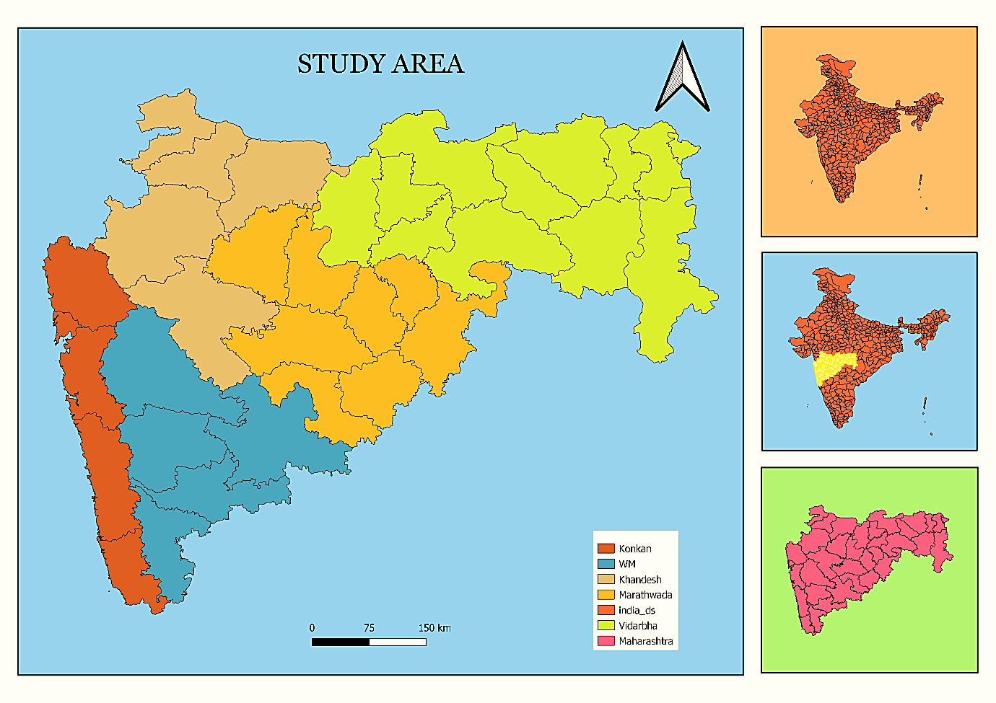Maharashtra (Fig. 1), located between 15.59°N to 22.05°N latitude and 72.68°E to 80.88°E longitude, exhibits diverse geographical and climatic conditions influencing household consumption patterns and their contribution to greenhouse gas (GHG) emissions. This study employed a randomized survey approach, conducting door-to-door interviews using a structured questionnaire to assess these patterns (Bhoyar et al., 2014). Data were collected from 1000 households across 123 villages and cities in Maharashtra between August 2022 and March 2023 (Fig. 2). The survey was stratified by settlement type, with 200 responses per region and 50 per category - tribal, rural, urban, and metropolitan areas. To strengthen the analysis, secondary data from government sources, academic journals, and relevant articles were also incorporated. The methodological framework of this study strategically categorized the diverse human settlements of Maharashtra into four distinct types: Tribal areas, encompassing nomadic and scheduled tribe populations; Rural areas, defined as villages exclusive of the aforementioned tribal groups; Urban areas, including towns and cities with populations under one million, represented by Nagar Panchayats, Nagar Parishads, and smaller Mahanagar Palikas, and Metropolitan cities, characterized by populations ranging from one to five million. To ensure comprehensive geographical representation, data collection was conducted across the five principal geographical divisions of Maharashtra: Konkan, Western Maharashtra, Khandesh, Marathwada, and Vidarbha, thereby capturing the socio economic and ecological variations inherent within the state. This stratified site selection aimed to provide a nuanced understanding of carbon footprints and climate change impacts across a spectrum of settlement characteristics and regional contexts.
Fig. 1. Map Showing the Study Sites of Maharashtra
Fig. 2. Map Showing the Study Area of Maharashtra
2.1 Carbon Footprint Calculation

Household carbon footprints were estimated using an activity-based emission accounting approach widely applied in greenhouse gas inventory studies. Total emissions were calculated using the relationship:
$GHG emission= Activity data × Emission factor$
Activity data represent household consumption patterns collected through the survey, including electricity use, transportation fuel consumption, cooking fuels, and selected food items. Each activity was multiplied by a corresponding emission factor in order to convert consumption quantities into greenhouse gas emissions expressed as carbon dioxide equivalents (CO₂e).
The estimation procedure follows internationally recognized carbon accounting guidelines developed by the Intergovernmental Panel on Climate Change (IPCC, 2006; IPCC, 2019 Refinement) reported by the International Energy Agency (IEA, 2021). Emission factors used in the study were obtained from established datasets including the India GHG Program emission factor database, national greenhouse gas inventory reports, and peer-reviewed studies such as Bhoyar et al. and Bhattacharya et al. These sources provide emission factors for commonly used fuels such as petrol, diesel, LPG, biomass, as well as transport modes and selected food products.
Where possible, emission factors were compared with regional reference values for Maharashtra. For electricity consumption, the emission factor used in the analysis is consistent with values reported in national greenhouse gas inventories and with grid emission factors published by the Central Electricity Authority for the Indian power sector. Using nationally and regionally relevant emission factors improves the reliability of household emission estimates and reflects the carbon intensity of energy consumption patterns in Maharashtra.

2.2 CO₂ Equivalent Emission Factors

Emission factors used in the study were derived from multiple established sources including the India GHG Program emission factor database, national greenhouse gas inventory reports, and previous studies on energy and food related emissions (Bhoyar et al.; Bhattacharya et al.).

Greenhouse gas (GHG) emissions were converted to CO₂-equivalent (CO₂e) using Global Warming Potential (GWP). Emission factors were sourced from peer reviewed literature and government database (Table 1).

Table 1. CO₂ Equivalent Emission Factors for Various Sources

Source Type | Source | CO₂e Emission Factor | Unit | Reference
Liquid Fuels | Petrol | 2.27193 | kg CO₂e/L | India GHG Program
 | Diesel | 2.6444 | kg CO₂e/L | India GHG Program
Other Fuels | LPG | 2.985 | kg CO₂e/kg | Bhoyar et al.,
 | Biomass Burning | 1.597 | kg CO₂e/kg | Bhattacharya et al.,
Travel | Air travel | 0.121 | kg CO₂e/passenger-km | India GHG Program
 | Bus travel | 0.0151 | kg CO₂e/passenger-km | India GHG Program
Energy | Grid electricity | 0.91 | kg CO₂e/kWh | GHG Inventory Report
Food | Rice | 1.220 | kg CO₂e/kg | Bhoyar et al.,
 | Wheat | 0.12 | kg CO₂e/kg | Bhoyar et al.,
 | Non-vegetarian food | 0.78 | kg CO₂e/kg | Bhoyar et al.,
Table 1 presents the emission factors applied for estimating household greenhouse gas emissions across energy, transport, and food consumption categories.

2.3 Monetary Impact Calculation

This study evaluates the monetary impact of extreme climatic events cyclones, floods, droughts, erratic rainfall, unseasonal rainfall, and hailstorms on agriculture, livelihoods, businesses, and household income in Maharashtra (2018-2023). Using primary survey data, economic losses are quantified using normalized units of 0.5/10,000. Adapting the framework of Singh et al., (2012), the study examines both direct and indirect economic effects. Normalized losses are compared with carbon footprint metrics, highlighting regional disparities in climate vulnerability and the link between emissions and economic impacts.

2.4 Limitations of Study

This study is primarily based on primary data collected through household interviews, which introduces certain limitations due to incomplete or inconsistent information provided by respondents. Emissions related to workplaces or occupational activities were not considered, as assessing them involves complex variations across different work environments and job profiles. Additionally, lifecycle emissions from housing infrastructure, household waste generation, and household appliances were excluded from the scope of this study.

3. results and discussion

While global emission factors provide a standardized approach for estimating emissions, regional variations in energy mix influence the final carbon footprint values. In maharashtra, electricity generation and household fuel use patterns differ slightly from global averages, which may affect the magnitude of estimated household emissions. Therefore, localized interpretations of emission factors are important for more accurate climate policy insights. Table 2 summarizes the distribution of household carbon emissions across settlement types in Maharashtra. Urban settlements contribute the largest share of emissions, accounting for 4.32 tCO₂e/year, which represents 26.02% of the total emissions in the sample. Metropolitan areas follow with 4.19 tCO₂e/year, contributing 25.21% of total emissions. Tribal settlements account for 4.13 tCO₂e/year, representing 24.88% of the total, while rural settlements show the lowest contribution with 3.97 tCO₂e/year, corresponding to 23.89% of total emissions.

Table 2. Summary table for emissions by Settlement Types
Settlement Type | Emissions  (t CO₂e/year) | Share of Emissions (%) | Ranks | Comment
Metropolitan | 4.186317484 | 25.2104236 | 2 | Moderate
Urban | 4.320819337 | 26.02040724 | 1 | Highest
Rural | 3.966814624 | 23.88855536 | 4 | Lowest
Tribal | 4.131550911 | 24.8806138 | 3 | Low

Table 2 presents the summary of household carbon emissions across different settlement types in Maharashtra.

Table 3 presents the regional summary of household carbon emissions across different regions in Maharashtra. Urban areas record the highest total emissions at 4.32 tCO₂e/year, followed by metropolitan areas (4.19 tCO₂e/year) and tribal settlements (4.13 tCO₂e/year), while rural areas show the lowest emissions at 3.97 tCO₂e/year. The composition of emissions varies significantly across settlement types. In metropolitan and urban areas, electricity consumption and transportation dominate the carbon footprint, reflecting higher energy demand, mobility, and appliance use associated with urban lifestyles. In contrast, biomass contributes the largest share of emissions in rural (1.49 tCO₂e/year) and tribal regions (2.37 tCO₂e/year), indicating continued reliance on traditional cooking.

Table 3. Summary table emissions by regions
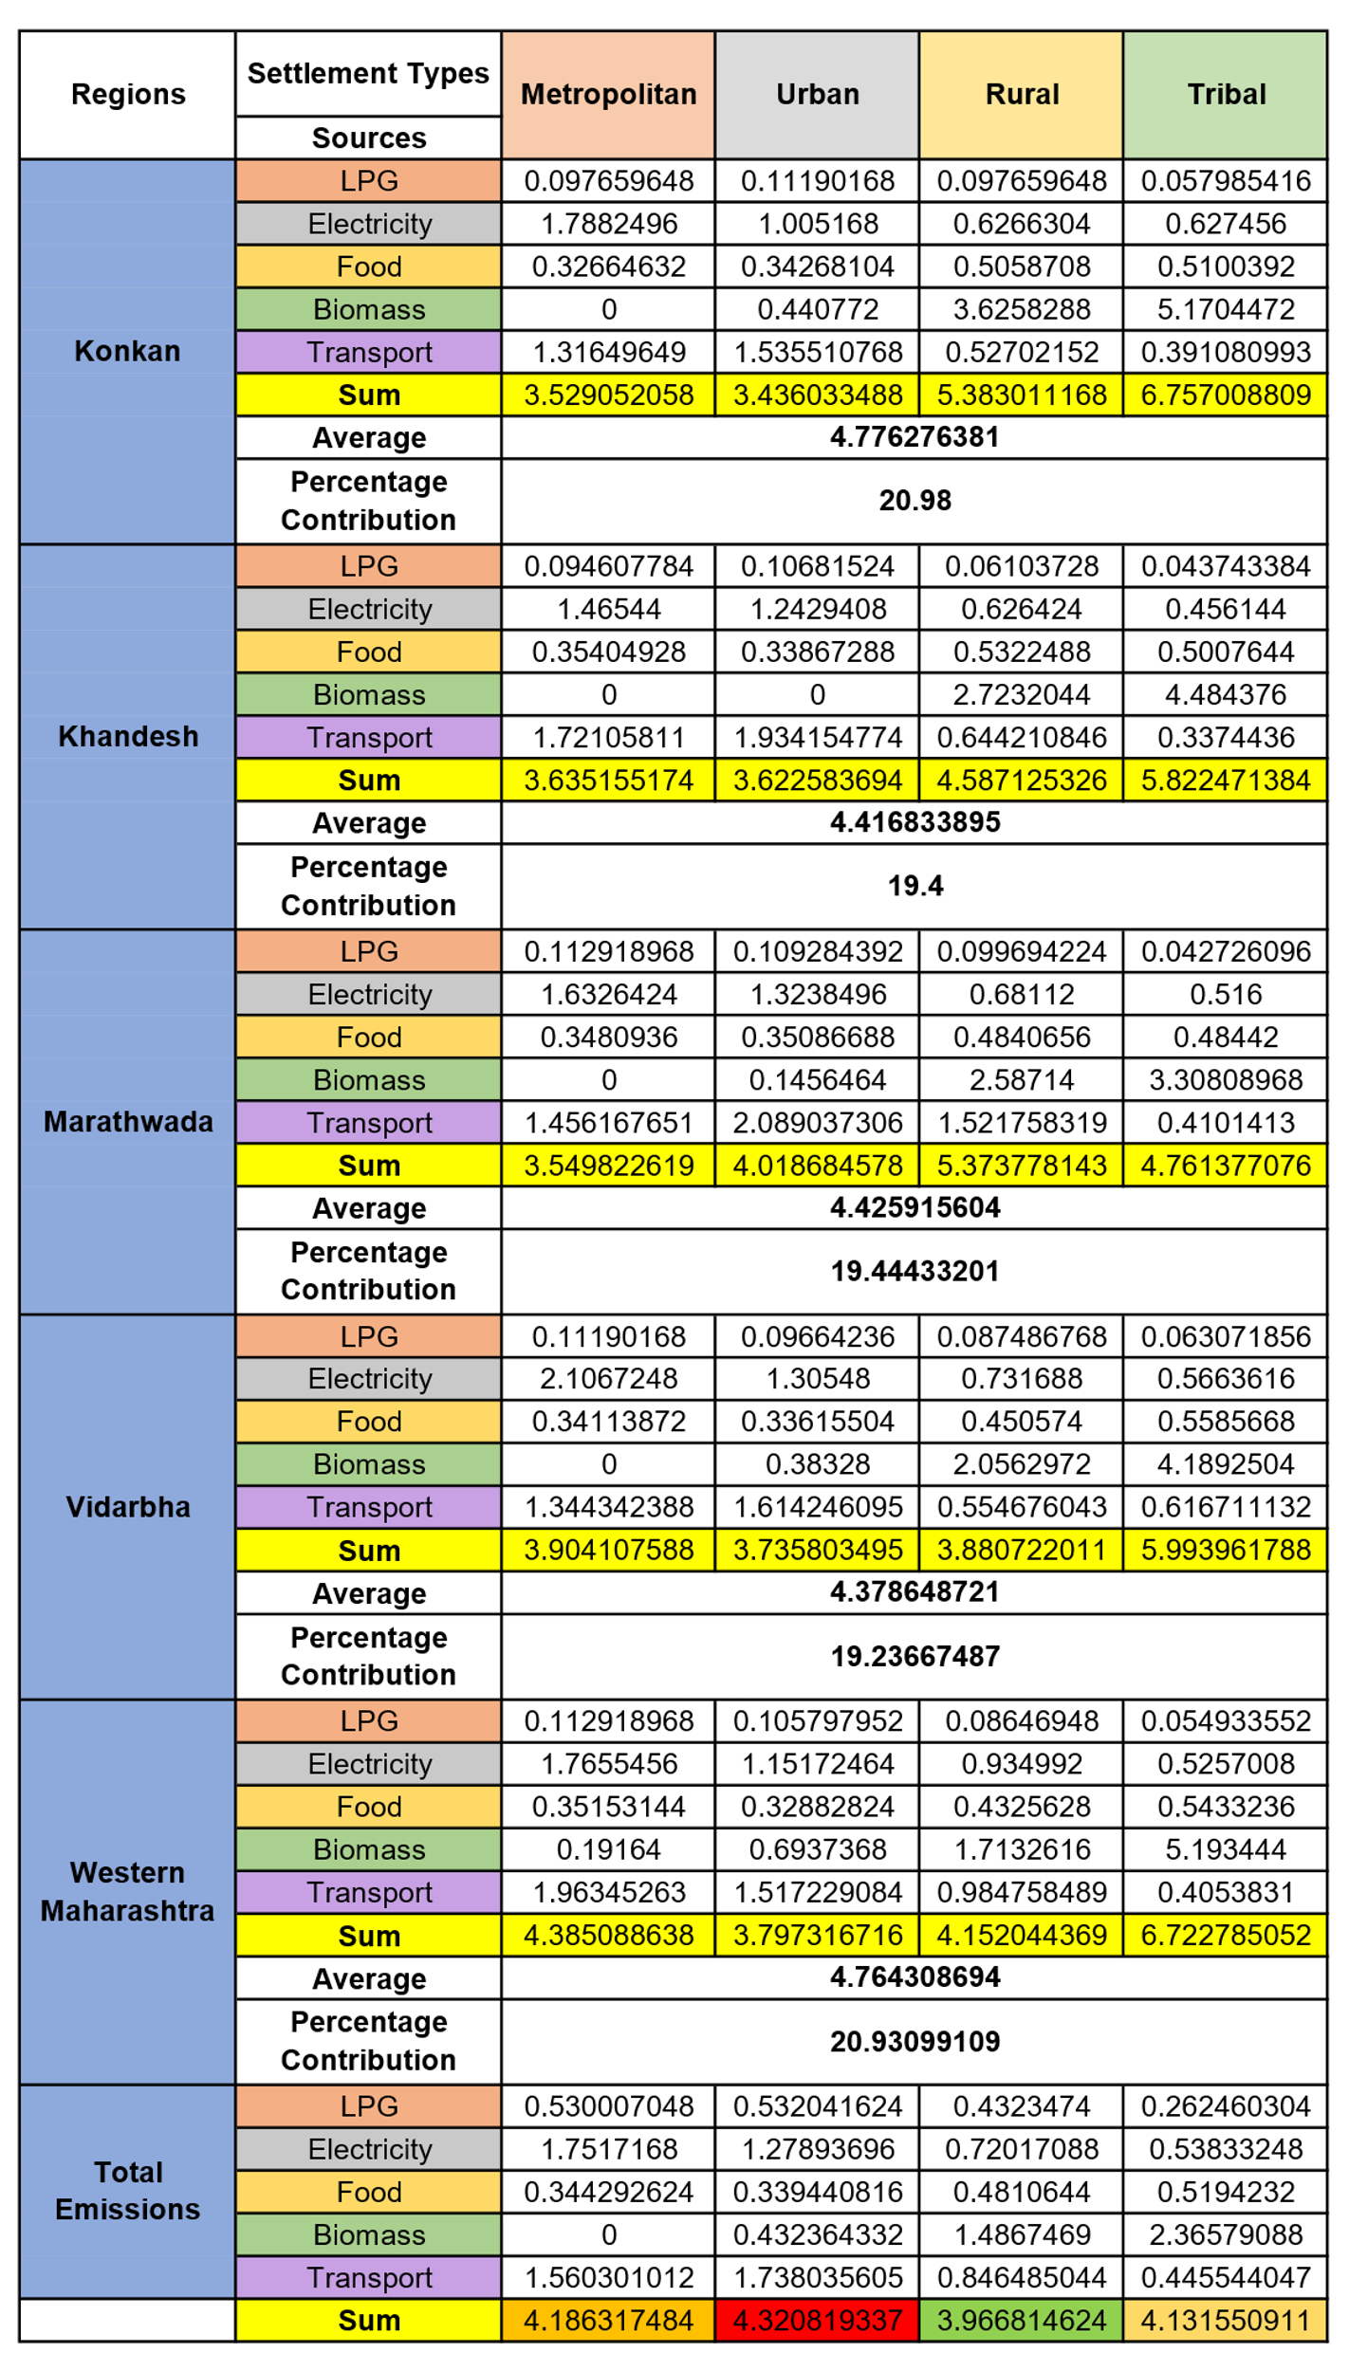
3.1 Metro Cities: Moderate Carbon Footprint, Low Economic Vulnerability.

Metropolitan households recorded a moderate carbon footprint, largely driven by electricity consumption (42%), transportation (37%), LPG use (13%), and food consumption (8%) (Figure 4A). High reliance on electrical appliances, air-conditioning, and private vehicles increases household energy demand in metropolitan areas. Similar patterns have been reported in global urban energy assessments, which show that higher income and consumption levels in cities are associated with increased greenhouse gas emissions (IEA, 2023). Maharashtra’s metropolitan centers such as Mumbai and Pune function as major economic hubs with dense populations, high mobility, and continuous energy demand for residential and commercial activities. Empirical studies across Indian districts also report higher per capita emissions in metropolitan regions compared with rural and semi-urban areas, reflecting the strong link between economic growth and consumption intensity (Lee et al., 2021). Urban infrastructure, high-rise housing, personal vehicle ownership, and widespread use of electronic appliances further increase household energy demand (Kaul et al., 2020). In addition, urban expansion and the loss of vegetated surfaces contribute to the urban heat island effect, increasing cooling requirements and electricity use (Rizwan et al., 2008). Despite relatively higher emissions, metropolitan households reported lower economic losses from climate-induced events (Figure 3A). This lower vulnerability is associated with diversified income sources, stronger infrastructure, and reduced dependence on climate-sensitive sectors such as agriculture. Access to insurance, early warning systems, and emergency response mechanisms further reduces direct economic impacts. Nevertheless, localized vulnerabilities remain in flood-prone urban areas where inadequate drainage and unplanned construction intensify the impacts of extreme rainfall. Household survey responses from Mumbai and Pune indicate recurring losses due to urban flooding, including damage to electrical equipment, temporary displacement, and short-term income disruption. This pattern reflects a broader climate inequality in which urban populations contribute higher emissions while possessing greater adaptive capacity to manage climate risks (Hallegatte et al., 2013).

3.2 Urban Areas: Highest Carbon Footprint, Moderate Economic Vulnerability

Urban households recorded the highest carbon footprint among the settlement categories, with transportation (40%) and electricity (30%) contributing the largest shares, followed by LPG (12%), biomass (10%), and food consumption (8%) (Figure 4B). High dependence on private vehicles and limited efficiency of public transportation systems significantly increase urban emissions. Similar patterns have been observed in global assessments where rapid motorization and mobility demand are identified as major drivers of urban greenhouse gas emissions (Sims et al., 2014). Despite these high emissions, urban households experience moderate economic vulnerability to climate impacts. Severe flooding events in Maharashtra, particularly in Sangli and Kolhapur during 2019 and 2021, caused considerable economic losses through infrastructure damage, temporary business closures, and residential property losses (Economic Survey of Maharashtra, 2021–2022; Down To Earth, 2019). Flood-related disruptions to transport and communication networks further amplify these economic impacts. Studies on climate adaptation and disaster risk management in Maharashtra also indicate that increasing frequency of extreme rainfall and flood events is becoming a major challenge for urban economic systems (TERI, 2014).

3.3 Rural Areas: Lowest Carbon Footprint, High Economic Vulnerability

Rural households recorded the lowest carbon footprint among the settlement categories, primarily due to lower electricity consumption. Biomass fuel used for cooking contributed the largest share of emissions (38%), followed by transportation (21%), electricity (18%), food consumption (12%), and LPG use (11%) (Figure 4C). The continued dependence on traditional biomass reflects typical rural energy consumption patterns observed in developing regions (Smith et al., 2014). Despite relatively low emissions, rural households showed the highest economic vulnerability due to strong dependence on agriculture and climate-sensitive livelihoods. Extreme climate events including droughts, floods, cyclones, and unseasonal rainfall frequently disrupt crop production, damage agricultural infrastructure, and reduce farm income (Figure 3C). Agricultural monocropping practices further increase climate risk by reducing biodiversity and limiting farmers’ ability to adapt to weather variability (Altieri, 1999; Bera et al., 2022). Previous studies also indicate that increasing rainfall variability, groundwater depletion, and rising drought frequency across regions such as Marathwada and Vidarbha intensify rural livelihood vulnerability under changing climate conditions (Kuchimanchi et al., 2019; Bhagawat et al., 2021). These findings highlight the strong link between climate variability and economic instability in agriculture-dependent rural communities.

3.4 Tribal Areas: Low Carbon Footprint, High Economic Vulnerability

Tribal households recorded a relatively low carbon footprint compared with urban settlements, although biomass burning accounted for the largest share of emissions (57%), followed by electricity and food consumption (13% each), transportation (11%), and LPG use (6%) (Figure 4D). The continued dependence on traditional biomass reflects limited access to reliable clean energy infrastructure in remote regions and is consistent with earlier findings on energy use in marginalized communities (IEA, 2022). Despite diversified livelihood activities such as non-timber forest product collection, handicrafts, and subsistence farming, tribal communities remain highly vulnerable to climate-induced economic losses. Limited healthcare access, weak infrastructure, and recurrent damage to homes and livestock during extreme weather events contribute to persistent economic instability (Figure 3D). Survey responses further indicated that many households had received LPG connections under the PM Ujjwala Scheme but continued to rely on biomass due to the absence of nearby refilling facilities, often located 30–40 km away. This logistical barrier limits the effective transition to cleaner fuels and sustains dependence on traditional energy sources in tribal regions (Ellis, 2000).
Fig. 3. (A) Metropolitan Area
Fig. 3. (C) Rural Area
Fig. 3. (D) Tribal Area
Fig. 3. (B) Urban Area

Fig. 3. Economic vulnerability due to climate-related events across different settlement types in Maharashtra
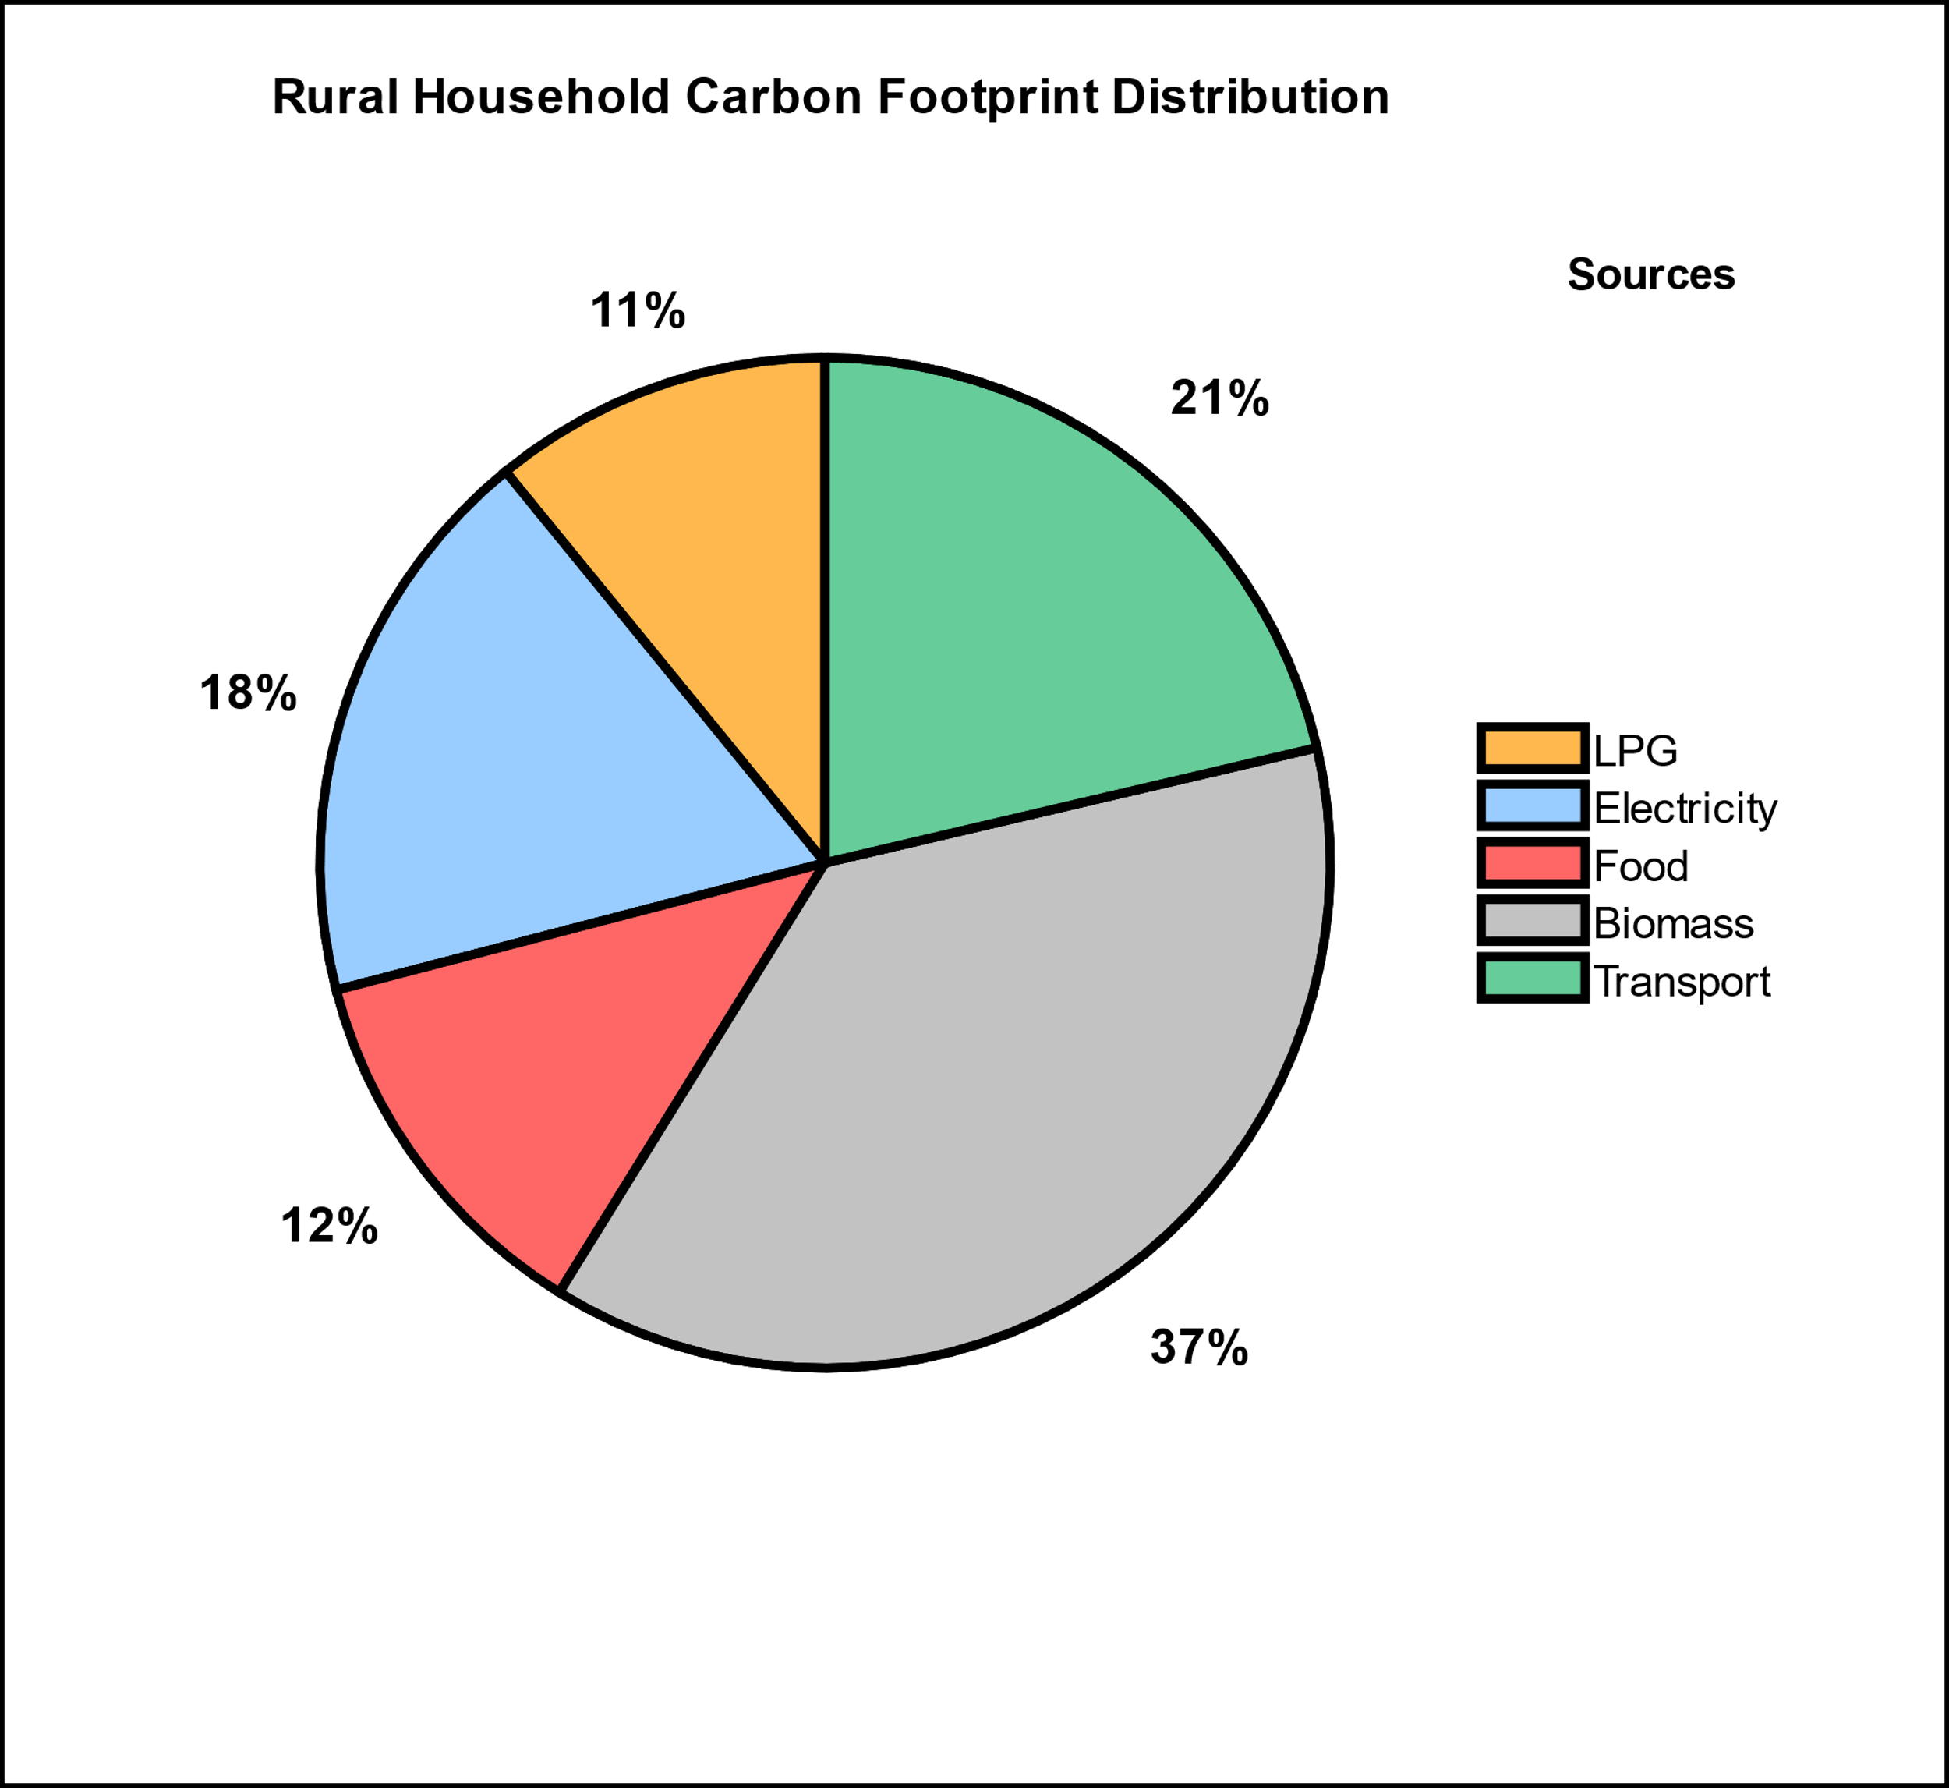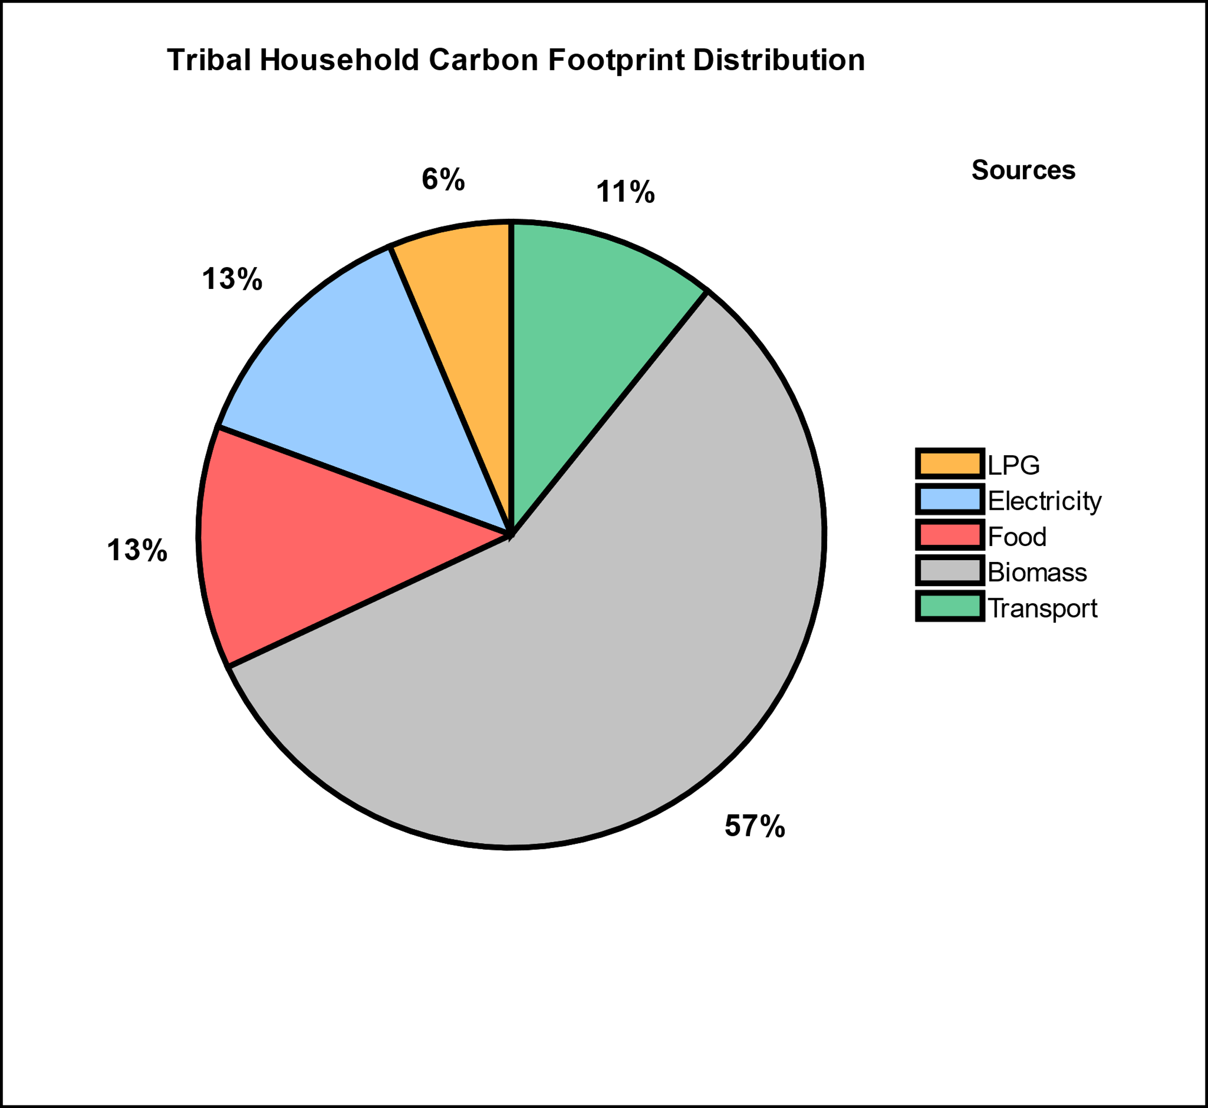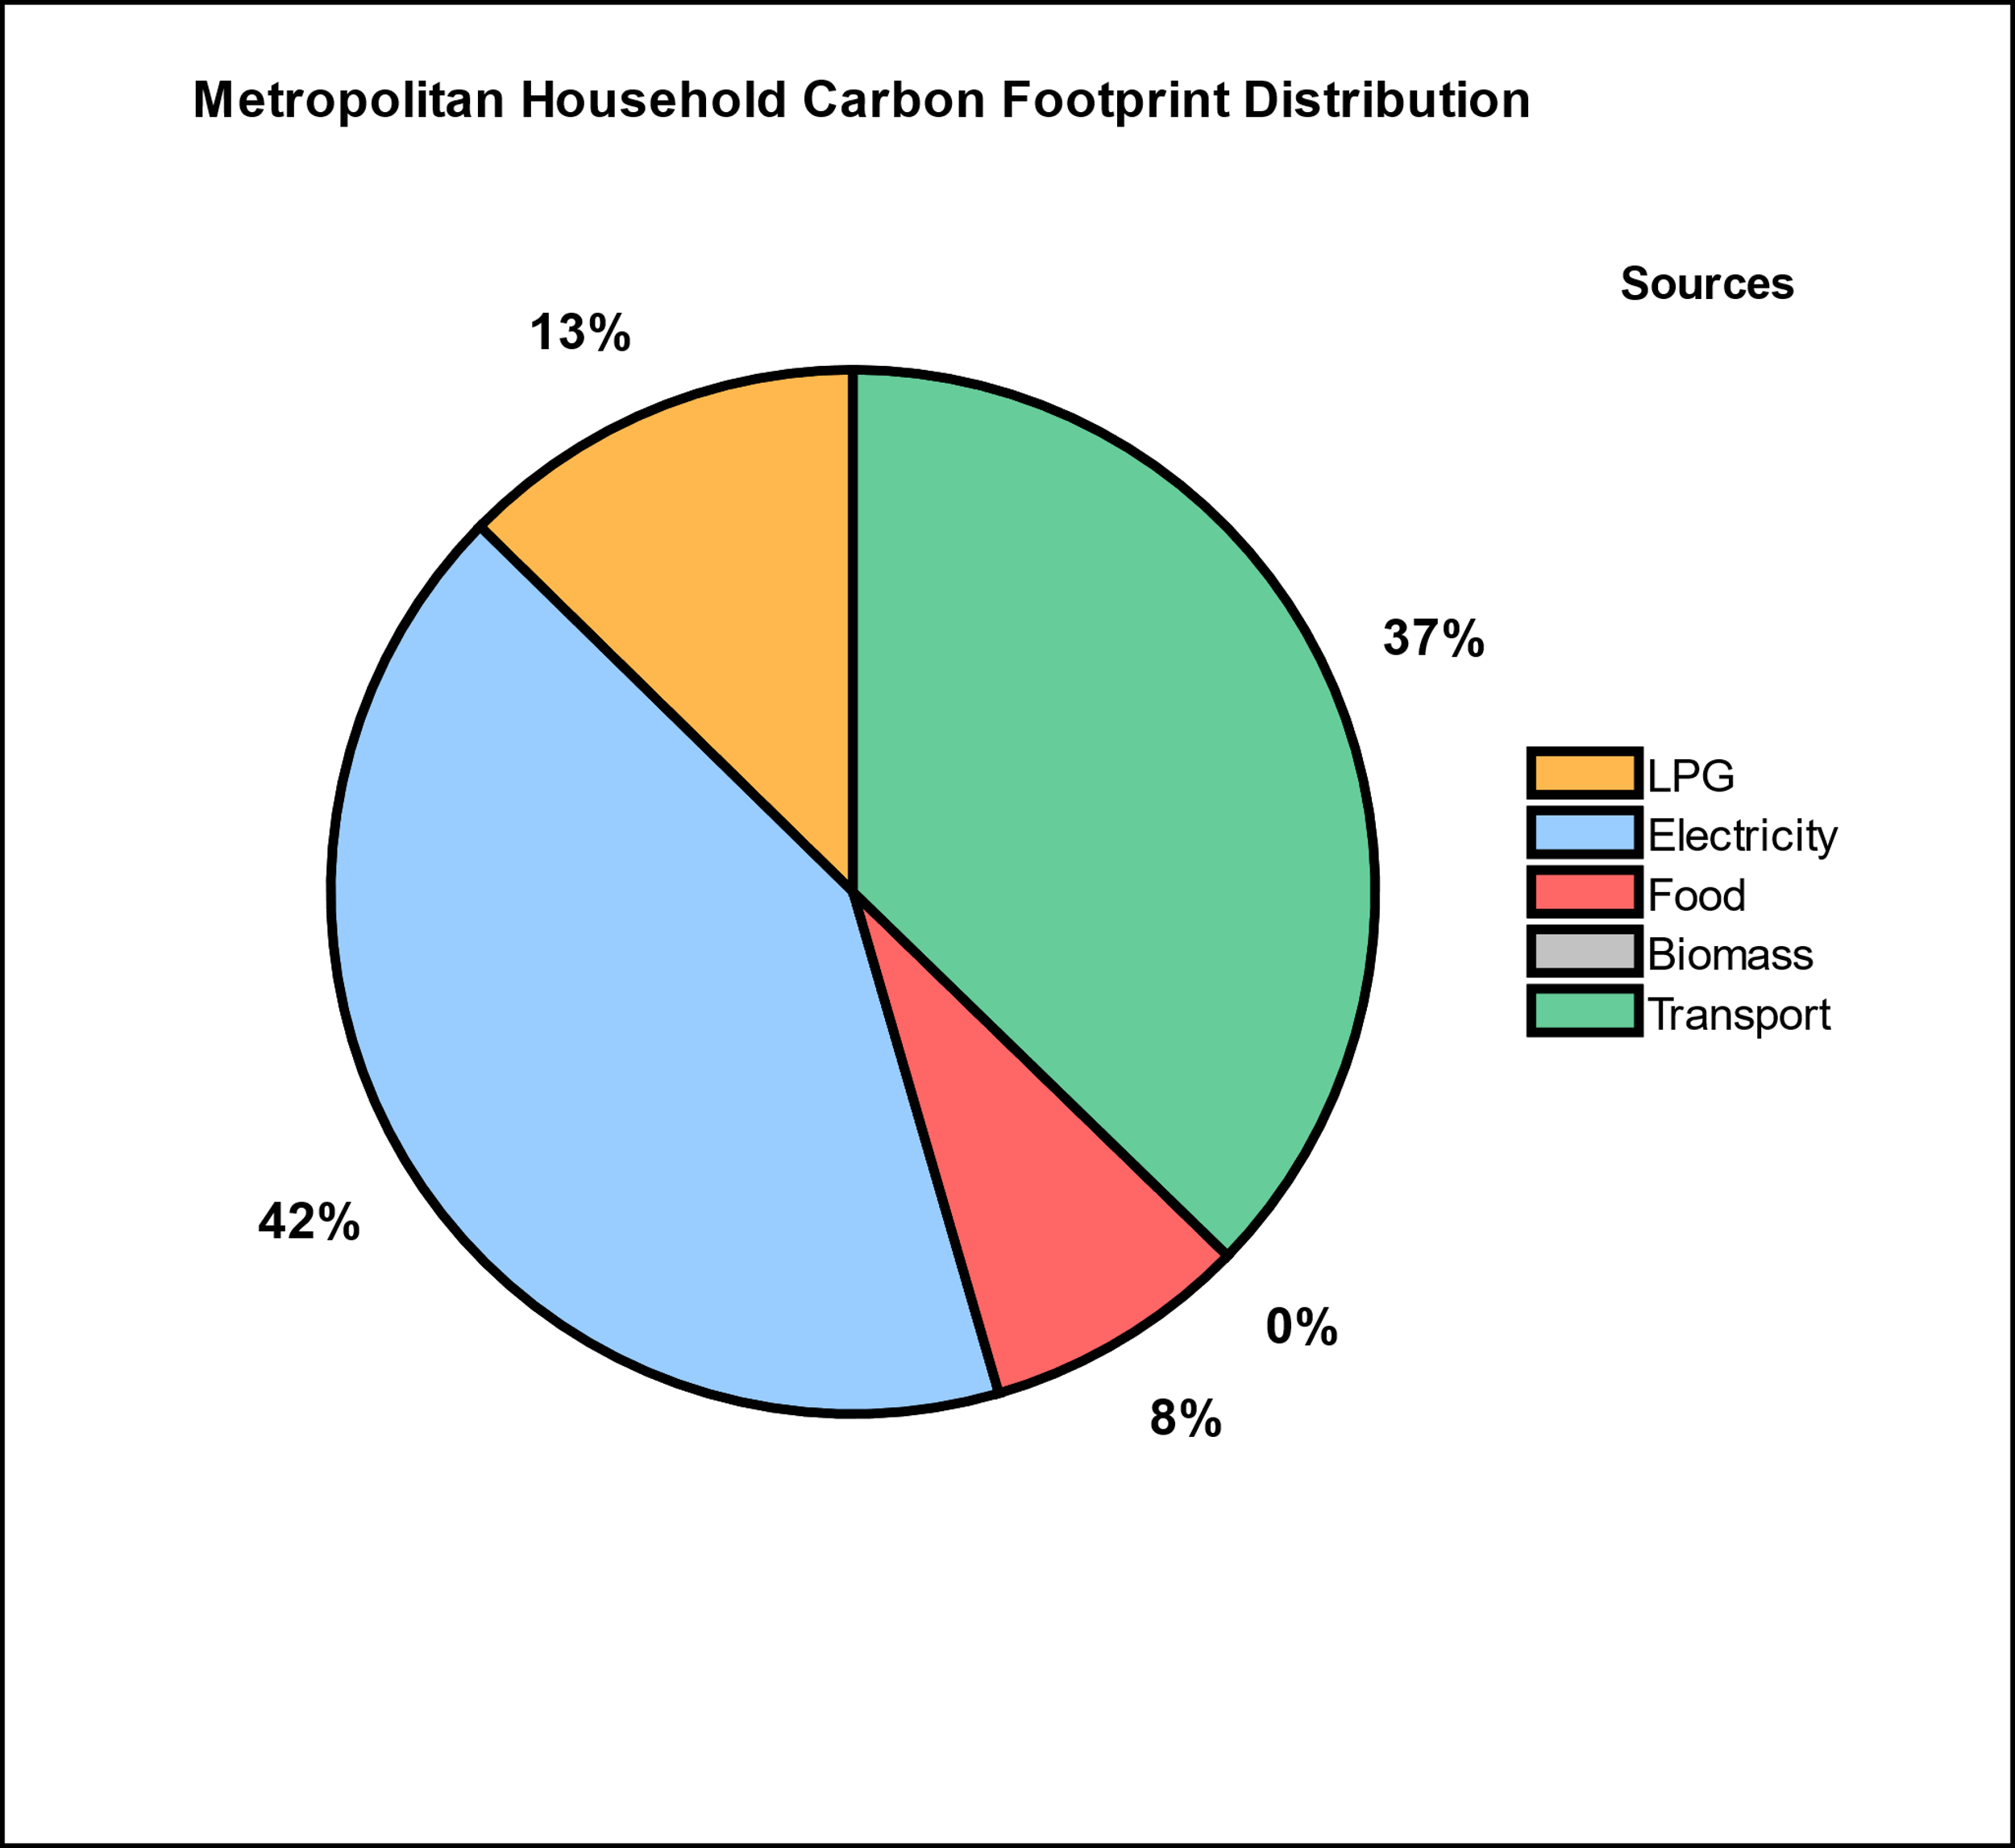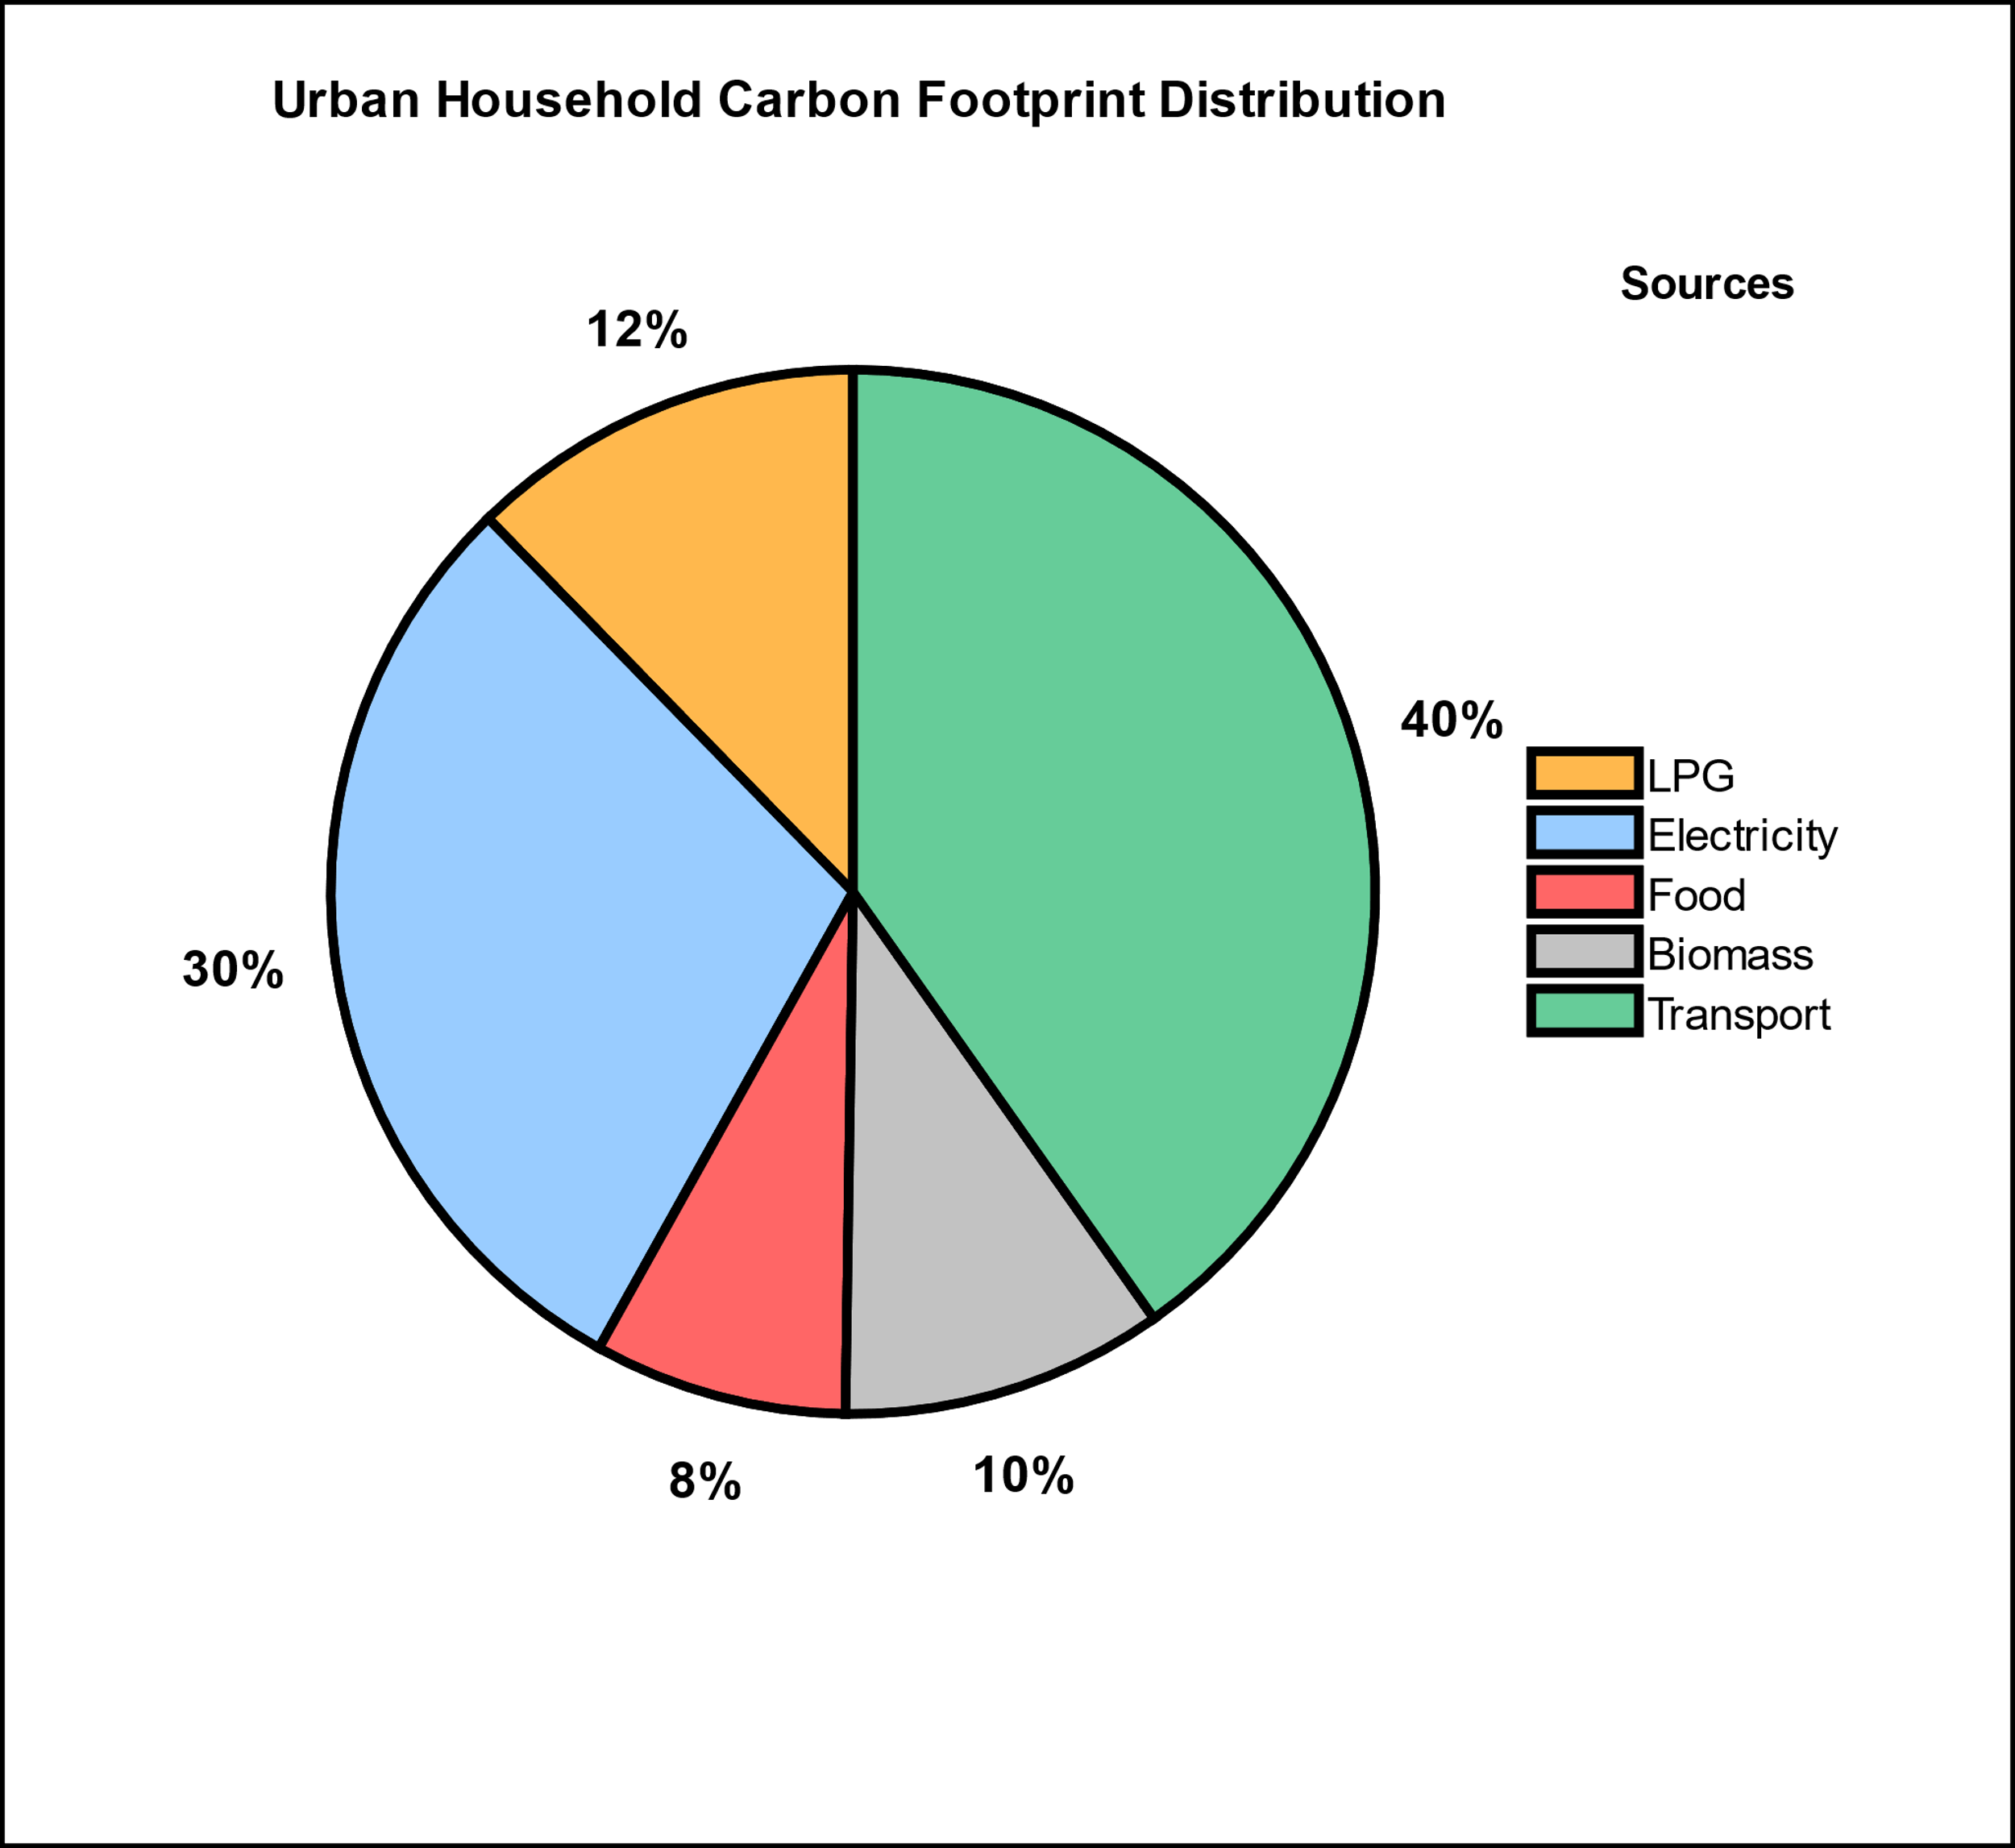
Fig. 4. Distribution of CO₂e emissions from major household activities across metropolitan, urban, rural, and tribal settlements.
Fig. 4. (C) Rural Area
Fig. 4. (D) Tribal Area
Fig. 4. (A) Metropolitan Area
Fig. 4. (B) Urban Area

4. CONCLUSION

This study examines the distribution of household carbon footprints and climate-induced economic vulnerability across tribal, rural, urban, and metropolitan settlements in Maharashtra. Urban and metropolitan households show relatively higher carbon emissions, largely associated with electricity consumption, transportation, and energy-intensive lifestyles. In contrast, rural and tribal households contribute comparatively lower emissions, reflecting dependence on traditional biomass and subsistence-based livelihoods. Despite lower carbon contributions, these communities experience greater economic vulnerability to climate impacts due to agricultural dependence, limited infrastructure, and restricted access to adaptive resources. The findings therefore indicate an inverse relationship between carbon responsibility and climate vulnerability across settlement types. Urban areas possess stronger economic resilience, while rural and tribal regions remain more exposed to climate-related losses. These results highlight the need for region-specific strategies that simultaneously address emission mitigation and adaptive capacity, particularly through improved energy access and climate-resilient agricultural systems. Integrating such considerations into regional development planning is essential to reduce emerging inequalities associated with climate change across Maharashtra.

Consent:
Before beginning the experiments described in this article, the authors obtained informed consent from all human participants.
Disclaimer (Artificial intelligence):
The authors further declare that no generative artificial intelligence tools, including Large Language Models such as ChatGPT, Copilot, or similar systems, and no text-to-image generation technologies were used in the writing, preparation, or editing of this manuscript.

Definitions, Acronyms, Abbreviations
CO₂: Carbon Dioxide
CO₂e: Carbon Dioxide Equivalent
GHG: Greenhouse Gases
GWP: Global Warming Potential
LPG: Liquefied Petroleum Gas
NTFP: Non-Timber Forest Products

References

- Ahmad, S., Baiocchi, G., & Creutzig, F. (2015). CO₂ emissions from direct energy use of urban households in India. Environmental Science & Technology, 49(19), 11312–11320.
- Altieri, M. A. (1995). Agroecology: The science of sustainable agriculture. Boulder, CO: Westview Press.
- Bera, M., Bose, P., & Nag, P. K. (2022). Household carbon footprint: Rural and urban community. Journal of Ecology and Natural Resources, 6(2).
- Bhagawat, C. (2021). Climate change impacts on Maharashtra agriculture. Institute for Sustainable Communities.
- Bhattacharya, S. C., Albina, D. O., & Salam, P. A. (2002). Emission factors of wood and charcoal-fired cookstoves. Biomass and Bioenergy, 23(6), 453–469.
- Bhoyar, S. P., Dusad, S., Shrivastava, R., Mishra, S., Gupta, N., & Rao, A. B. (2014). Understanding the impact of lifestyle on individual carbon footprint. Procedia – Social and Behavioral Sciences, 133, 47–60.
- Central Electricity Authority. (2024). CO₂ Baseline Database for the Indian Power Sector (Version 20). Ministry of Power, Government of India.
- Clemens, V., von Hirschhausen, E., & Fegert, J. M. (2022). Report of the Intergovernmental Panel on Climate Change: Implications for the mental health policy of children and adolescents in Europe. European Child & Adolescent Psychiatry, 31(5), 701–713.
- Creutzig, F., Roy, J., Lamb, W.F., Azevedo, I.M.L., de Bruin, W.B., Dalkmann, H., Edelenbosch, O.Y., Geels, F.W., Grubler, A., Hepburn, C. and Hertwich, E., 2022. Demand-side solutions to climate change mitigation consistent with high levels of well-being. Nature Climate Change, 12, pp.36–46.
- Ellis, F. (2000). Rural livelihoods and diversity in developing countries. Oxford: Oxford University Press.
- Engström, E., Lewis, A. N., Moberg, Å., Vanhuyse, F., Dawkins, E., Lambe, F., Sendlhofer, T., & Ran, Y. (2024). Using labels to support climate-friendly lunch purchases: An in-store study. Cleaner and Responsible Consumption, 15, 100239.
- Fitzpatrick, J.J., McCarthy, S. and Byrne, E.P., 2015. Sustainability insights and reflections from a personal carbon footprint study: the need for quantitative and qualitative change. Sustainable Production and Consumption, 1, pp.34–46.
- Fong, W.K., Kuramochi, T., Roelfsema, M., et al., 2014. Global protocol for community-scale greenhouse gas emission inventories (GPC). World Resources Institute, C40 Cities Climate Leadership Group and ICLEI.
- Halder, P., Sharma, R. and Alam, A., 2012. Local perceptions of and responses to climate change: experiences from natural resource-dependent communities in India. Regional Environmental Change, 12, pp.665–673.
- Hallegatte, S., 2016. Shock Waves: Managing the Impacts of Climate Change on Poverty. Washington, DC: World Bank Publications.
- IEA, 2023. World Energy Outlook 2023. International Energy Agency, Paris.
- IPCC, 2019. 2019 Refinement to the 2006 IPCC Guidelines for National Greenhouse Gas Inventories. Intergovernmental Panel on Climate Change, Geneva.
- IPCC, 2021. Climate Change 2021: The Physical Science Basis. Contribution of Working Group I to the Sixth Assessment Report of the Intergovernmental Panel on Climate Change. Cambridge: Cambridge University Press.
- International Energy Agency (IEA), 2022. World Energy Outlook 2022. Paris: IEA.
- Kabir, M., Habiba, U.E., Khan, W., Shah, A., Rahim, S., De los Rios-Escalante, P.R., Farooqi, Z.U.R., Ali, L. and Shafiq, M., 2023. Climate change due to increasing concentration of carbon dioxide and its impacts on environment in the 21st century: a mini review. Journal of King Saud University – Science, 35(5), 102693.
- Kaul, M., Kulkarni, S. and Chunekar, A., 2020. Energy Consumption Patterns in Indian Households. New Delhi: Prayas Energy Group.
- Kelkar, S.M., Kulkarni, A. and Rao, K.K., 2020. Impact of climate variability and change on crop production in Maharashtra, India. Current Science, 118(8), pp.1235–1245.
- Koide, R., Lettenmeier, M., Akenji, L., Toivio, V., Amellina, A., Khodke, A., Watabe, A. and Kojima, S., 2021. Lifestyle carbon footprints and changes in lifestyles to limit global warming to 1.5 °C and ways forward for related research. Sustainability Science, 16(6), pp.2087–2099.
- Kuchimanchi, B.R., Nazareth, D., Bendapudi, R., Awasthi, S. and D’Souza, M., 2019. Assessing differential vulnerability of communities in the agrarian context in two districts of Maharashtra, India. Climate and Development, 11(10), pp.918–929.
- Kumar, V., Ranjan, D. and Verma, K., 2021. Global climate change: the loop between cause and impact. In: Kumar, V. (ed.), Global Climate Change. Elsevier, pp.187–211.
- Lee, J., Taherzadeh, O. and Kanemoto, K., 2021. The scale and drivers of carbon footprints in households, cities and regions across India. Global Environmental Change, 66, 102205.
- Porter, J., Xie, L., Challinor, A.J., Howden, M., Iqbal, M.M., Lobell, D.B. and Travasso, M.I., 2014. Food security and food production systems. In: Field, C.B. et al. (eds.), Climate Change 2014: Impacts, Adaptation, and Vulnerability. Part A: Global and Sectoral Aspects. Cambridge: Cambridge University Press, pp.485–533.
- Ramachandra, T.V., 2012. Decentralised carbon footprint analysis for opting climate change mitigation strategies in India. Renewable and Sustainable Energy Reviews, 16(8), pp.5820–5833.
- Ramachandra, T.V., Sreejith, K. and Bharath, H.A., 2014. Sector-wise assessment of carbon footprint across major cities in India. In: Muthu, S.S. (ed.), Assessment of Carbon Footprint in Different Industrial Sectors, Volume 2. Singapore: Springer, pp.207–267.
- Sharma, V. and Dash, M., 2022. Household energy use pattern in rural India: a path towards sustainable development. Environmental Challenges, 6, 100404.
- Shivanna, K.R., 2022. Climate change and its impact on biodiversity and human welfare. Proceedings of the Indian National Science Academy, 88(2), pp.160–171.
- Singh, A., Patwardhan, A., Abhyankar, A. and Sarda, N.L., 2011. Extreme Weather Events in India: A Preliminary Analysis of Impacts. Mumbai: Indian Institute of Technology Bombay.
- Smith, P., Bustamante, M., Ahammad, H., Clark, H., Dong, H., Elsiddig, E.A., Haberl, H., Harper, R., House, J., Jafari, M. and Masera, O., 2014. Agriculture, forestry and other land use (AFOLU). In: Edenhofer, O. et al. (eds.), Climate Change 2014: Mitigation of Climate Change. Cambridge: Cambridge University Press, pp.811–922.
- Subramanian, A., Nagarajan, A.M., Vinod, S., Chakraborty, S., Sivagami, K., Theodore, T., Sathyanarayanan, S.S., Tamizhdurai, P. and Mangesh, V.L., 2023. Long-term impacts of climate change on coastal and transitional ecosystems in India: an overview of its current status, future projections, solutions and policies. RSC Advances, 13(18), pp.12204–12228.
- TERI, 2014. Assessing Climate Change Vulnerability and Adaptation Strategies for Maharashtra. Maharashtra State Adaptation Action Plan on Climate Change (MSAAPCC). New Delhi: The Energy and Resources Institute.
- UNEP, 2022. Emissions Gap Report 2022: The Closing Window. United Nations Environment Programme, Nairobi.
- Yenneti, K., Tripathi, S., Wei, Y.D., Chen, W. and Joshi, G., 2016. The truly disadvantaged? Assessing social vulnerability to climate change in urban India. Habitat International, 56, pp.124–135.

