Groundwater Quality Assessment using Geospatial tools for Domestic and Irrigation purposes for Lower Papagni river basin in Chikkaballapura district, Karnataka, India

Abstract

Groundwater is the principal source of freshwater for domestic and agricultural needs in semi-arid regions of peninsular India. The present study evaluates the groundwater quality of the Lower Papagni River Basin in Chikkaballapura District, Karnataka, with special emphasis on its suitability for drinking and irrigation purposes. A total of 45 Post monsoon season groundwater samples were collected from bore wells (Fig. 2) and open wells and analyzed for major physico-chemical parameters such as pH, Electrical Conductivity (EC), Total Dissolved Solids (TDS), major cations (Ca²⁺, Mg²⁺, Na⁺, K⁺) and anions (HCO₃⁻, Cl⁻, SO₄²⁻, NO₃⁻, and F⁻) following standard laboratory procedures. Groundwater occurs mainly in weathered and fractured zones and is vulnerable to both geogenic and anthropogenic contamination. Fluoride enrichment, commonly associated with the dissolution of fluoride-bearing minerals in granitic terrains, has been widely reported in Karnataka. Field measurements of pH, Electrical Conductivity (EC), and Total Dissolved Solids (TDS) were recorded using portable meters, while major cations and anions were analyzed in the laboratory following standard procedures. The dominance of rock-weathering processes in the Gibbs diagram aligns with these elevated TDS values and indicates that the major ions originate from natural geogenic sources rather than anthropogenic pollution. Overall, the Gibbs plots confirm that groundwater chemistry is controlled primarily by geochemical weathering, and while most samples meet BIS and WHO permissible limits, a significant proportion exceeds desirable limits, requiring consideration for domestic suitability. A smaller portion, around 10–15%, plots toward the precipitation dominance zone, reflecting recharge from rainfall with comparatively low mineral content. Only about 2–5% of samples show trends toward the evaporation dominance zone, suggesting minimal influence of evaporative concentration in the region.

Keyworsds: Groundwater, Groundwater quality, Gibbs energy, groundwater chemistry; anthropogenic contamination

INTRODUCTION
Groundwater is the primary source of freshwater in semi-arid hard rock regions of peninsular India, where surface water availability is limited and seasonal. Increasing demand for domestic and agricultural purposes has intensified pressure on crystalline aquifers, making systematic evaluation of groundwater quality essential. In granitic and gneissic terrains, groundwater chemistry is largely governed by rock water interaction processes such as silicate weathering, mineral dissolution, and ion exchange reactions. The Lower Papagni River Basin in Chikkaballapura District, Karnataka, is underlain predominantly by granites and granitic gneisses of the Peninsular Gneissic Complex . Groundwater occurs mainly in weathered and fractured zones and is vulnerable to both geogenic and anthropogenic contamination. Fluoride enrichment, commonly associated with the dissolution of fluoride-bearing minerals in granitic terrains, has been widely reported in Karnataka. In addition, nitrate contamination resulting from agricultural activities and improper waste disposal poses significant health concerns. The present study was carried out in the Lower Papagni River Basin located in Karnataka, India. The study area falls within Chikkaballapura district and forms part of the Pennar River drainage system. Geographically, the basin is situated between approximately 77°45′E to 78°10′E longitudes and 13°25′N to 13°40′N latitudes, covering several rural settlements including Dibbur, Tekalhalli, Ganjikunte, Kancharlahalli, Siddepalli and surrounding villages. The Papagni River, a tributary of the Pennar River, flows through the district and plays a significant role in sustaining agriculture and domestic water supply. The drainage pattern in the basin is predominantly dendritic to sub-dendritic, indicating homogeneous lithological conditions and structural control in certain segments. The area is well connected by a network of rural roads, and agriculture constitutes the primary land use. Physiographically, the Lower Papagni River Basin forms part of the southern granitic terrain of the Peninsular Gneissic Complex, representing a stable cratonic region of the Indian shield. The terrain is characterized by undulating plains interspersed with isolated rocky hills and pediplain. Elevation gradually decreases from northwest to southeast following the regional slope of the basin.
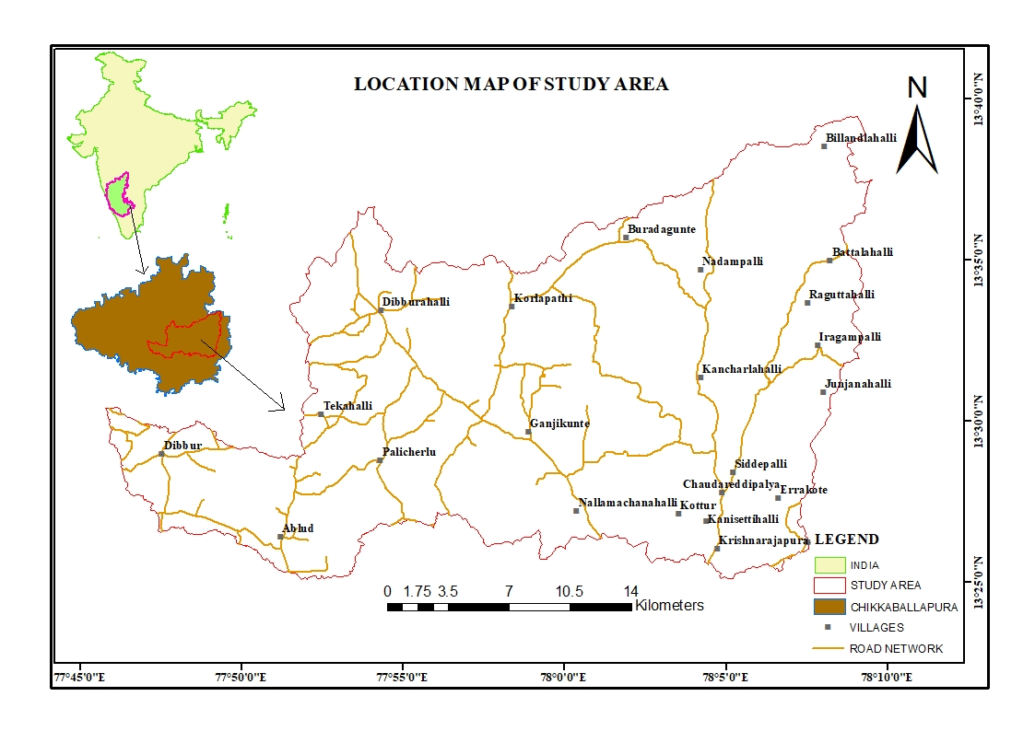
Fig. 1. Study area map.

Methodology
Groundwater quality assessment in the Lower Papagni River Basin was carried out through systematic sampling, laboratory analysis, and geospatial evaluation. Representative 45 Post monsoon season groundwater samples from borewells were collected for the year of 2023 covering different hydrogeomorphic units to ensure spatial variability. Field measurements of pH, Electrical Conductivity (EC), and Total Dissolved Solids (TDS) were recorded using portable meters, while major cations and anions were analyzed in the laboratory following standard procedures recommended by the American Public Health Association (APHA, 2017). Analytical accuracy was verified through ionic balance error within ±5%, as suggested by hydrochemical studies (Hem, 1985). The suitability of groundwater for domestic purposes was evaluated based on drinking water standards prescribed by the Bureau of Indian Standards, IS 10500:2012. Major parameters such as Ca²⁺, Mg²⁺, Na⁺, K⁺, Cl⁻, HCO₃⁻, SO₄²⁻, NO₃⁻, Fluoride, and Total Hardness were compared with acceptable and permissible limits. To provide an integrated evaluation, the Water Quality Index (WQI) was computed using the weighted arithmetic method (Brown, 1972), which has been widely adopted in groundwater quality studies (Ramakrishnaiah, 2009). For irrigation suitability assessment, hydrochemical indices including Sodium Adsorption Ratio (SAR), Residual Sodium Carbonate (RSC), Percent Sodium (%Na), and Permeability Index (PI) were calculated following the classification proposed by Richards (1954) and Wilcox (1955). These indices help evaluate sodium hazard, alkalinity risk, and potential impacts on soil permeability and crop yield. The integration of hydrochemical analysis with GIS-based spatial modeling provides a reliable framework for groundwater quality zonation and sustainable resource management (Jha, 2007).

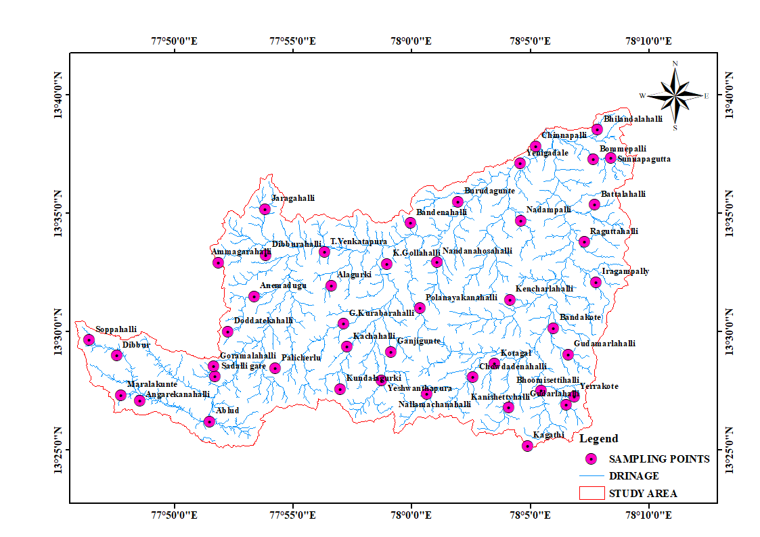
Fig. 2. Sampling locations of study area.

RESULTS AND Discussion

Geogenic Activity
The groundwater chemistry of the Lower Papagni River Basin in Chikkaballapura District, Karnataka, is predominantly controlled by geogenic proecesses associated with the weathering of crystalline rocks of the Peninsular Gneissic Complex. The basin is underlain mainly by granites, granitic gneisses, and migmatites belonging to the Archean crystalline basement. In hard rock terrains, groundwater occurs within weathered mantles and fractured zones, and its chemical composition is largely governed by rock water interaction (i) TDS versus Cl⁻/(Cl⁻ + HCO₃⁻) and (ii) TDS versus Na⁺/(Na⁺ + Ca²⁺), following the conceptual model proposed by R. J. Gibbs (1970). (Hem, 1985). Fluoride enrichment in groundwater, commonly observed in granitic terrains of Karnataka, is attributed to the dissolution of fluoride-bearing minerals such as fluorite, apatite, and biotite present in the basement rocks (Handa, 1975). Similarly, elevated nitrate concentrations in certain locations may partly result from natural soil nitrification processes, though anthropogenic inputs can also contribute. The presence of lineaments and fracture zones facilitates deeper circulation of groundwater, intensifying water–rock interaction and influencing ionic concentration (Ramakrishnaia, 2009).

Anthropogenic Influences
In addition to geogenic controls, groundwater quality in the Lower Papagni River Basin is significantly influenced by anthropogenic activities associated with agriculture, domestic settlements, and land use changes. Rapid expansion of irrigated agriculture in parts of Study area has led to increased application of chemical fertilizers and pesticides, which contribute to elevated concentrations of nitrate (NO₃⁻), chloride (Cl⁻), and other dissolved constituents in groundwater through leaching processes (Subba Rao, 2006). Nitrate contamination is particularly common in semi-arid agricultural regions where intensive cultivation and improper fertilizer management prevail. Unregulated groundwater extraction for irrigation and domestic use has also altered the natural hydrochemical regime of the aquifer. Over-exploitation increases groundwater residence time and enhances water–rock interaction, which may lead to higher salinity and hardness levels (Todd and Mays, 2005). Declining water levels can further concentrate dissolved ions, affecting both drinking and irrigation suitability.
Groundwater Quality Assessment for Drinking Use

Hydrochemical Characteristics
The analytical results of groundwater samples from the Lower Papagni River Basin reveal significant spatial variability in physico-chemical parameters, reflecting the combined influence of lithological control, weathering intensity, climatic conditions, and anthropogenic activities. The measured parameters were evaluated against the drinking water standards prescribed by the Bureau of Indian Standards (BIS 10500:2012). The pH values range from 5.94 to 7.94, with a mean of 7.40, indicating predominantly neutral to slightly alkaline groundwater (Hem, J. D. (1985). Most samples fall within the acceptable range (6.5–8.5), suggesting that acidification processes are minimal in the basin. The slightly alkaline character of groundwater is typical of crystalline hard rock terrains and is attributed to prolonged silicate weathering and buffering reactions (Hem, 1985; Appelo and Postma, 2005). Electrical Conductivity (EC) varies from 103.5 to 2336 µS/cm (mean: 1056.12 µS/cm), while Total Dissolved Solids (TDS) range between 65 and 1550 mg/L (mean: 679.96 mg/L). Approximately 45% of samples exceed the desirable limit of 500 mg/L but remain within the permissible limit (2000 mg/L). Elevated TDS values indicate moderate mineralization and reflect enhanced rock–water interaction, evapoconcentration under semi-arid conditions, and longer groundwater residence times (Freeze and Cherry, 1979). Total Hardness (TH) ranges from 26 to 608 mg/L, with an average of 358.16 mg/L, classifying the majority of samples as hard to very hard water. The high hardness is primarily due to elevated concentrations of calcium (6.01–166.30 mg/L; mean: 71.87 mg/L) and magnesium (2.67–90.41 mg/L; mean: 43.30 mg/L). In granitic–gneissic terrains, dissolution of feldspars, ferromagnesian minerals, and secondary carbonates contributes significantly to hardness development (Todd and Mays, 2005). Though not a serious health hazard, high hardness affects domestic usability due to scaling and soap inefficiency. Chloride concentrations vary between 13.94 and 348 mg/L (mean: 124.35 mg/L). Most samples remain within acceptable limits; however, localized enrichment indicates evaporative concentration and possible anthropogenic inputs such as return irrigation flow and domestic wastewater infiltration. Sulphate concentrations range from 7.03 to 364.20 mg/L (mean: 94.26 mg/L), remaining largely within permissible limits and suggesting limited sulphide oxidation or evaporite dissolution in the study area. Nitrate concentrations exhibit wide variation from 0.24 to 301.40 mg/L (mean: 39.68 mg/L). Several samples exceed the permissible limit of 45 mg/L, particularly in intensively cultivated zones. Elevated nitrate levels are strongly associated with agricultural practices, including excessive fertilizer application, livestock waste disposal, and leaching from septic systems. The shallow weathered aquifer system and absence of protective confining layers enhance vulnerability to surface-derived contamination. Similar nitrate enrichment patterns in hard rock aquifers have been reported in semi-arid agricultural regions (Subba Rao, 2006).The spatial correlation between high nitrate concentrations and cultivated land use supports the inference of anthropogenic origin. Persistent nitrate contamination poses health risks such as methemoglobinemia in infants and therefore requires immediate management attention. Fluoride concentrations range from 0.21 to 2.52 mg/L (mean: 1.36 mg/L), with several samples exceeding the permissible limit of 1.5 mg/L. The elevated fluoride is primarily geogenic in origin and attributed to the dissolution of fluoride-bearing minerals such as fluorite, apatite, and biotite within granitic formations. Alkaline pH conditions and high bicarbonate concentrations enhance fluoride mobilization through ion exchange mechanisms and desorption processes (Appelo and Postma, 2005). The association of high fluoride with elevated TDS further indicates prolonged residence time and intensified water rock interaction. Chronic exposure to fluoride-rich groundwater may lead to dental and skeletal fluorosis, a well-documented issue in many parts of peninsular India.

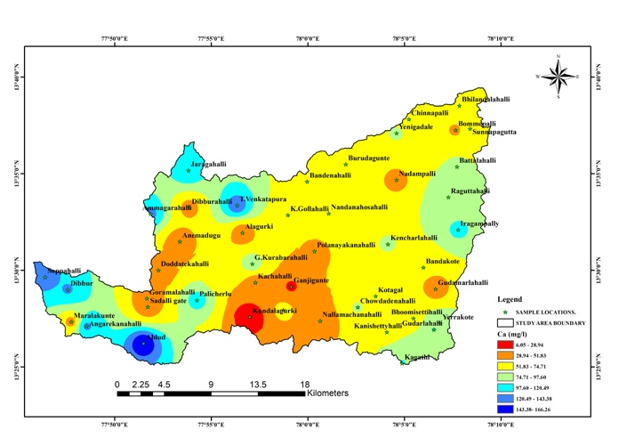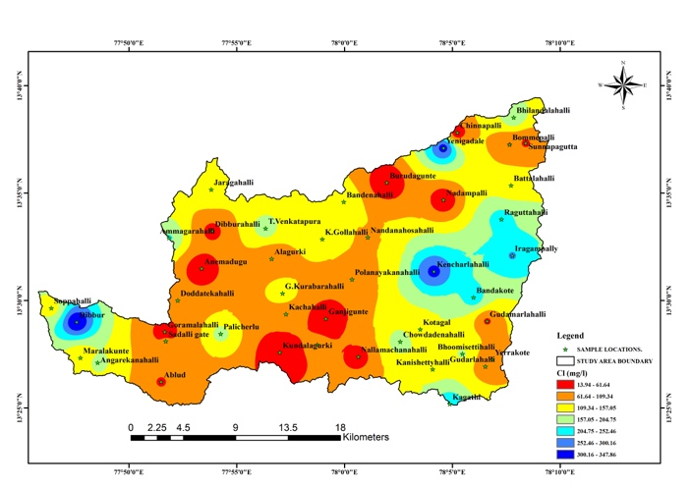
3(a) 3(b)
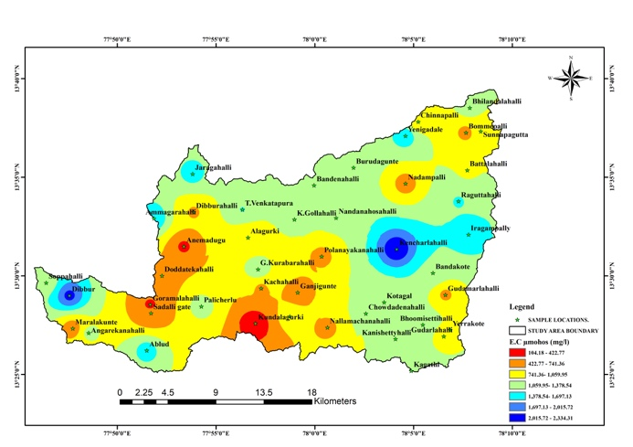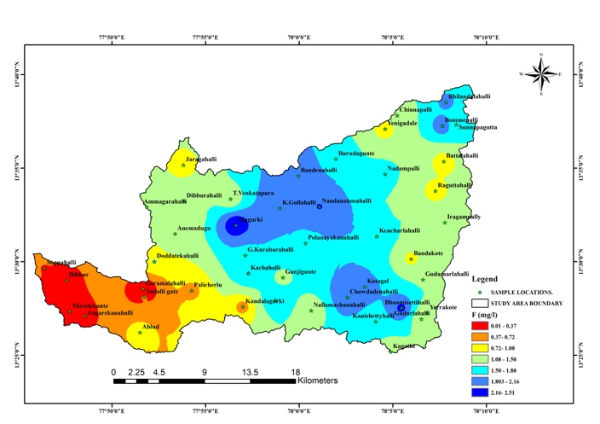
3(c) 3(d)
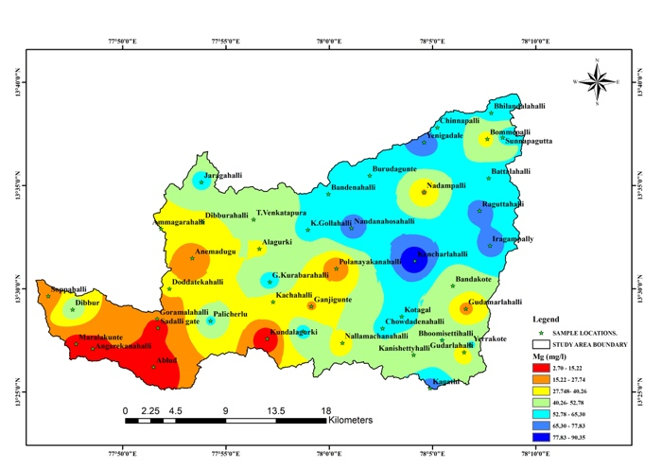
3(e) 3(f)
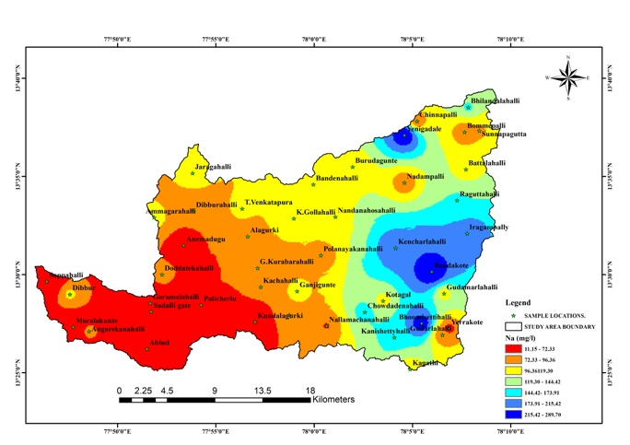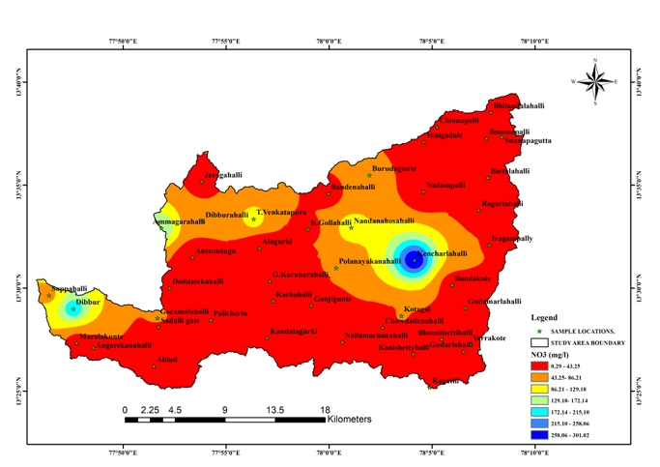3(g) 3(h)
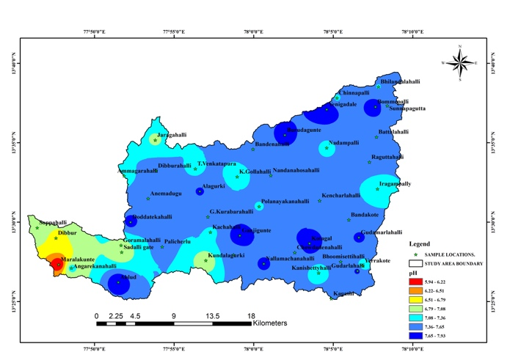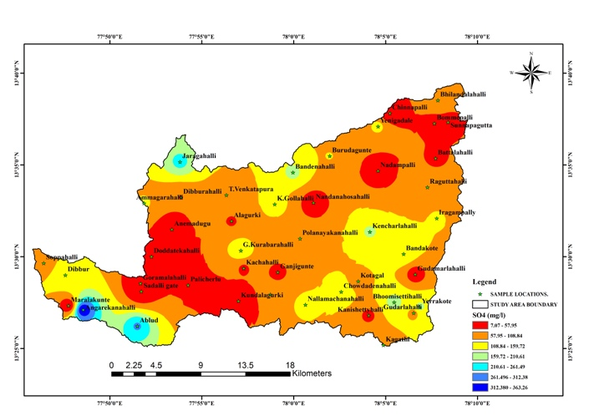
3(i) 3(j)
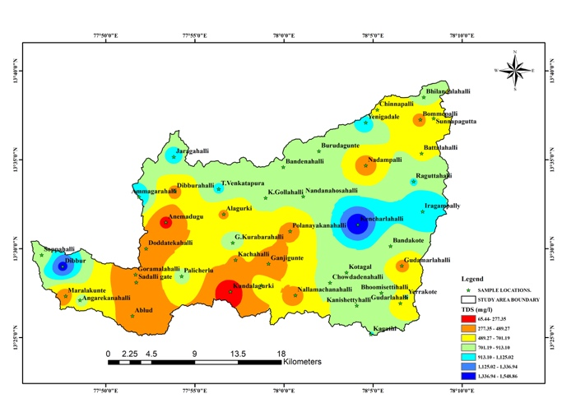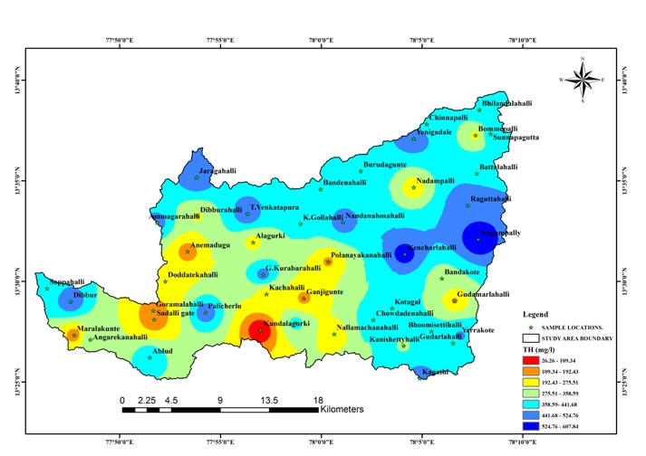
3(k) 3(l)
Fig. 3. Spatial distribution maps of Post monsoon season Physicochemical parameters: Ca (a), Cl(b), EC(c), F(d), K(e), Mg(f), Na(g), NO3(h), pH(i), SO4(j), TDS(k), TH(l).
Table. 1.Physicochemical parameters of groundwater of the study area.
SL.No | Sample Locations | pH | E.C µmohos (mg/l) | TDS  (mg/l) | Ca (mg/l) | Mg (mg/l) | Na (mg/l) | K (mg/l) | HCO₃  (mg/l) | Cl (mg/l) | SO₄ (mg/l) | NO₃ (mg/l) | TH (mg/l) | F (mg/l)
1 | SOPPAHALLI | 7.04 | 1190.00 | 790.00 | 134.00 | 18.40 | 15.89 | 3.34 | 145.18 | 141.00 | 83.40 | 79.80 | 412.00 | 0.37
2 | DIBBUR | 6.73 | 2120.00 | 1410.00 | 122.64 | 50.55 | 101.10 | 43.30 | 12.02 | 348.00 | 144.20 | 200.30 | 514.00 | 0.29
3 | MARALAKUNTE | 5.94 | 518.00 | 340.00 | 43.28 | 10.93 | 41.50 | 2.56 | 20.74 | 110.00 | 7.03 | 24.11 | 153.00 | 0.21
4 | ANGARAKANAHALLI | 7.16 | 1126.00 | 750.00 | 125.04 | 10.69 | 76.63 | 3.48 | 147.62 | 167.00 | 364.20 | 27.03 | 356.00 | 0.33
5 | ABLUD | 7.92 | 1526.00 | 453.00 | 166.30 | 4.37 | 70.18 | 2.17 | 95.16 | 60.00 | 269.00 | 3.43 | 434.00 | 0.88
6 | TATAHALLI | 6.84 | 470.00 | 290.00 | 34.86 | 12.39 | 42.40 | 2.57 | 86.62 | 66.50 | 11.64 | 19.83 | 138.00 | 0.39
7 | GORAMALAHALLI | 7.03 | 369.00 | 310.00 | 38.47 | 15.31 | 30.02 | 3.10 | 53.07 | 41.50 | 7.53 | 60.10 | 159.00 | <0.1
8 | PALICHERLI | 7.45 | 1231.00 | 775.00 | 109.01 | 54.44 | 69.74 | 2.87 | 170.80 | 171.00 | 46.94 | 27.79 | 496.00 | 0.66
9 | DODDA TEKAHALLI | 7.74 | 634.00 | 365.00 | 35.27 | 29.40 | 82.18 | 3.48 | 121.40 | 67.50 | 44.42 | 5.31 | 209.00 | 1.10
10 | ANEMADUGU | 7.63 | 359.00 | 220.00 | 34.06 | 16.52 | 48.39 | 0.96 | 90.89 | 25.49 | 17.27 | 0.79 | 153.00 | 1.21
11 | AMMAGARAHALLI | 7.28 | 1657.00 | 1100.00 | 126.65 | 38.40 | 107.10 | 5.41 | 173.24 | 207.93 | 114.30 | 171.20 | 474.00 | 1.49
12 | JARAGAHALLI | 7.52 | 704.00 | 450.00 | 42.48 | 39.37 | 79.41 | 2.81 | 134.81 | 49.48 | 57.20 | 49.50 | 268.00 | 1.25
13 | DIBBURALLI | 7.04 | 1476.00 | 960.00 | 117.03 | 54.92 | 108.10 | 4.48 | 225.70 | 141.95 | 225.70 | 27.58 | 518.00 | 0.92
14 | T.VENKATAPURAM | 7.68 | 678.00 | 450.00 | 31.26 | 38.40 | 71.25 | 1.57 | 141.52 | 46.98 | 126.70 | 1.64 | 236.00 | 1.23
15 | ALAGURKI | 7.87 | 628.00 | 380.00 | 25.65 | 26.24 | 103.10 | 1.86 | 178.73 | 25.65 | 48.59 | 8.54 | 172.00 | 1.42
16 | G. KURUBARALLI | 7.54 | 871.00 | 560.00 | 59.31 | 57.84 | 96.13 | 1.93 | 212.28 | 70.97 | 69.30 | 9.62 | 386.00 | 1.80
17 | ONGENAHALLI | 6.82 | 103.50 | 65.00 | 6.01 | 2.67 | 11.09 | 0.25 | 14.03 | 14.99 | 11.55 | 2.50 | 26.00 | 0.62
18 | KUNDLAGURKI | 7.30 | 697.00 | 440.00 | 38.07 | 32.08 | 83.61 | 1.66 | 133.00 | 67.97 | 51.40 | 37.85 | 227.00 | 1.81
19 | GANJIKUNTE | 7.61 | 1325.00 | 880.00 | 91.38 | 60.76 | 86.10 | 2.96 | 223.26 | 147.95 | 159.70 | 29.52 | 478.00 | 1.76
20 | YESWANTPURA | 7.68 | 744.00 | 460.00 | 34.46 | 39.30 | 86.87 | 2.61 | 172.02 | 62.48 | 52.90 | 0.79 | 248.00 | 2.52
21 | NALLAMACHANAHALLI | 7.30 | 1387.00 | 950.00 | 137.87 | 40.83 | 100.65 | 1.76 | 179.34 | 180.94 | 91.30 | 106.00 | 512.00 | 1.27
22 | KAGATHI | 7.52 | 1377.00 | 920.00 | 98.55 | 72.42 | 101.10 | 4.53 | 245.22 | 243.92 | 77.70 | 7.69 | 494.00 | 1.22
23 | GUDARALAHALLI | 7.71 | 896.00 | 590.00 | 98.59 | 28.67 | 76.21 | 2.62 | 190.32 | 82.97 | 90.90 | 11.15 | 364.00 | 1.32
24 | ERRAKOTE | 7.22 | 1064.00 | 710.00 | 89.77 | 55.90 | 62.62 | 2.95 | 162.26 | 66.97 | 173.80 | 22.05 | 464.00 | 1.28
25 | BHUMESHETTIHALLI | 7.44 | 1351.00 | 850.00 | 61.72 | 52.98 | 253.90 | 5.28 | 208.62 | 160.95 | 186.60 | 23.48 | 372.00 | 2.25
26 | KANISHETTYHALLI | 7.21 | 1116.00 | 710.00 | 70.54 | 42.77 | 155.80 | 1.37 | 236.68 | 147.95 | 43.94 | 11.90 | 352.00 | 1.67
27 | CHOUDENAHALLI | 7.53 | 1231.00 | 810.00 | 76.95 | 54.44 | 154.10 | 3.46 | 174.46 | 173.94 | 143.90 | 11.70 | 416.00 | 2.12
28 | KOTAGAL | 7.88 | 1079.00 | 710.00 | 58.51 | 57.84 | 109.20 | 2.84 | 192.76 | 132.95 | 87.70 | 45.40 | 384.00 | 1.94
29 | KANCHARALAHALLI | 7.42 | 2336.00 | 1550.00 | 76.95 | 90.41 | 206.30 | 1.92 | 191.54 | 311.90 | 165.90 | 301.40 | 564.00 | 1.80
30 | NANDANAHOSAHALLI | 7.54 | 1135.00 | 750.00 | 74.54 | 72.42 | 109.20 | 2.84 | 225.70 | 105.96 | 18.20 | 108.20 | 484.00 | 2.17
31 | POLANAYAKANALLI | 7.35 | 632.00 | 410.00 | 45.29 | 16.52 | 83.84 | 0.86 | 84.79 | 62.48 | 66.70 | 49.46 | 181.00 | 1.65
32 | K.GOLLAHALLI | 7.22 | 1229.00 | 780.00 | 62.52 | 56.39 | 113.70 | 2.01 | 244.06 | 148.95 | 129.70 | 31.15 | 388.00 | 2.07
33 | BANDERAHALLI | 7.46 | 1254.00 | 830.00 | 60.92 | 58.82 | 111.20 | 2.74 | 235.46 | 133.95 | 172.10 | 25.54 | 394.00 | 2.11
34 | BURUDAGUNTE | 7.74 | 1288.00 | 860.00 | 65.73 | 65.14 | 97.95 | 4.56 | 184.22 | 13.94 | 109.50 | 65.10 | 432.00 | 1.67
35 | NADAMPALLI | 7.31 | 585.00 | 350.00 | 43.28 | 26.98 | 78.98 | 3.62 | 185.44 | 27.99 | 18.86 | 4.11 | 219.00 | 1.63
36 | YENAGADALLE | 7.94 | 1596.00 | 1060.00 | 76.95 | 73.89 | 265.20 | 3.62 | 185.44 | 315.89 | 120.50 | 4.40 | 496.00 | 0.93
37 | CHINNAPALLI | 7.34 | 770.00 | 500.00 | 65.73 | 61.73 | 74.47 | 1.27 | 237.90 | 35.98 | 14.00 | 3.25 | 418.00 | 1.29
38 | BOMMEPALLI | 7.36 | 1230.00 | 820.00 | 68.93 | 55.90 | 147.60 | 3.64 | 176.90 | 197.93 | 89.70 | 30.15 | 402.00 | 1.85
39 | BILLANDALAHALLI | 7.86 | 625.00 | 400.00 | 46.49 | 33.05 | 74.03 | 1.31 | 129.93 | 60.48 | 46.30 | 13.49 | 252.00 | 1.99
40 | SUNAPAGUTTA | 7.42 | 939.00 | 620.00 | 73.74 | 55.42 | 93.68 | 1.45 | 279.38 | 56.98 | 48.10 | 9.00 | 412.00 | 1.63
41 | BATTALAHALLI | 7.43 | 1012.00 | 670.00 | 78.55 | 57.35 | 106.80 | 2.02 | 196.42 | 135.95 | 49.90 | 16.53 | 432.00 | 0.92
42 | RAGUTTAHALLI | 7.54 | 1397.00 | 920.00 | 95.39 | 69.51 | 146.70 | 1.21 | 185.44 | 221.93 | 92.30 | 29.60 | 524.00 | 0.99
43 | IRAGAMPALLI | 7.16 | 1576.00 | 1120.00 | 102.60 | 69.51 | 199.40 | 5.28 | 257.42 | 254.92 | 111.60 | 42.50 | 608.00 | 1.28
44 | BANDAKOTTE | 7.47 | 1335.00 | 860.00 | 53.70 | 43.26 | 289.80 | 3.76 | 140.30 | 228.92 | 156.60 | 25.02 | 312.00 | 0.99
45 | GUDAMARALAHALLI | 7.70 | 659.00 | 400.00 | 35.27 | 23.33 | 108.90 | 1.32 | 162.87 | 56.48 | 22.93 | 0.24 | 184.00 | 1.49
MAX |  | 7.94 | 2336.00 | 1550.00 | 166.30 | 90.41 | 289.80 | 43.30 | 279.38 | 348.00 | 364.20 | 301.40 | 608.00 | 2.52
MIN |  | 5.94 | 103.50 | 65.00 | 6.01 | 2.67 | 11.09 | 0.25 | 12.02 | 13.94 | 7.03 | 0.24 | 26.00 | 0.21
AVERAGE |  | 7.40 | 1056.12 | 679.96 | 71.87 | 43.30 | 105.16 | 3.59 | 165.44 | 124.35 | 94.26 | 39.68 | 358.16 | 1.36

Irrigation Suitability

Hydrochemical Facies (Piper Diagram)
Piper diagram was plotted in accordance of major anion and cation groundwater samples fall in the mixed Ca–Mg–Cl facies, representing chemically evolved water where alkaline earths dominate over alkali metals and strong acids (Cl + SO₄) dominate over weak acids (HCO₃). A few samples plot toward the Ca–Mg–HCO₃ field, indicating relatively fresh recharge conditions. Overall, the Piper diagram suggests a transition from fresh bicarbonate-type water to more mineralized chloride-rich water, controlled by rock–water interaction, residence time, and localized geochemical processes, which collectively influence groundwater suitability for drinking and irrigation.
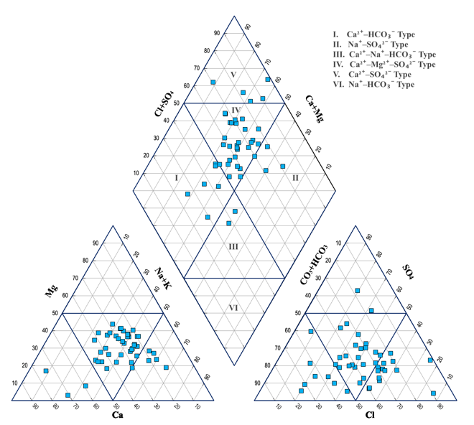
Fig. 4. Piper Trilinear diagram showing variation in hydrochemical facies.

Water Quality Index (WQI)
The Water Quality Index (WQI) for the 45 groundwater sampling sites varies from a low of 55.61 to a high of 106.86, with an average WQI of 81.96. The analysis shows that none of the samples are classified as Excellent (0–25) or Good (26–50), indicating a lack of high-quality groundwater in the area. Twelve samples, accounting for 26.67%, fall into the Poor water quality category (WQI 51–75), suggesting moderate contamination levels that make the water unsuitable for direct consumption without treatment. Most of the groundwater samples, totalling 30 and representing 66.67%, are categorized as Very Poor (WQI 76–100), indicating significant water quality degradation due to high concentrations of chemical substances. Additionally, three samples, or 6.67%, have a WQI value exceeding 100 and are deemed Unfit for Consumption, underscoring severe contamination that could pose health risks if consumed without extensive treatment.
Table. 2. Water quality index range and types of water classification(Brown et al., 1972)
WQ Index Range | Water Quality Status | No. of Samples | Percentage (%)
0–25 | Excellent | - | -
26–50 | Good | - | -
51–75 | Poor | 25 | 55.55
76–100 | Very Poor | 20 | 44.44
>100 | Unfit for Consumption | - | -

SAR (Sodium Hazard)
The Sodium Adsorption Ratio (SAR) classification, as per BIS and USSL standards, reveals that most groundwater samples are categorized as S2 (10–18), comprising 42.22% of the total, indicating a moderate sodium hazard and general suitability for irrigation with standard soil and water management. A notable 20% of samples fall into the S1 category (<10), signifying excellent water quality with minimal sodium risk and no negative effects on soil permeability. However, 24.44% of the samples are classified as S3 (18–26), suggesting a high sodium hazard, where extended use could harm soil structure unless amendments like gypsum are used. Furthermore, 13.33% of the samples are in the S4 category (>26), indicating a very high sodium hazard, making the water unsuitable for irrigation due to significant risks of soil dispersion and decreased infiltration. Overall, the SAR–EC evaluation indicates that while most groundwater in the study area is suitable to moderately suitable for irrigation, certain areas show increased sodium hazard that requires careful management.
${[Na}^{2+}]$
SAR = —————
$\frac{\sqrt{{[Ca}^{2+}+[{[Mg}^{2+}}}{2}$

Table. 3. The Sodium Absorption Ratio (SAR)

SAR Range | Sodium Hazard Class | Irrigation Suitability | Number of Samples | Percentage (%)
< 10 | S1 – Low sodium hazard | Excellent; safe for all soils | 9 | 20
10 – 18 | S2 – Medium sodium hazard | Good; suitable with normal management | 19 | 42.22
18 – 26 | S3 – High sodium hazard | Doubtful; requires soil amendments | 11 | 24.44
> 26 | S4 – Very high sodium hazard | Unsuitable for irrigation | 6 | 13.33
Total | — | — | 45 | 100

EC

Electrical Conductivity (EC) varies from 103.5 to 2336 µS/cm (mean: 1056.12 µS/cm), The results indicate that the majority of groundwater samples (30%) fall under the C2–S1 category, suggesting moderate salinity with low sodium hazard. About 60% of the samples belong to the C3–S1 class, indicating higher salinity but still low sodium risk. A small fraction (10%) occurs in the C3–S2 class, reflecting high salinity with moderate sodium hazard With appropriate soil management practices, the groundwater can be effectively utilized for sustainable irrigation. The groundwater is generally suitable to moderately suitable for irrigation, particularly for semi-arid agricultural regions.

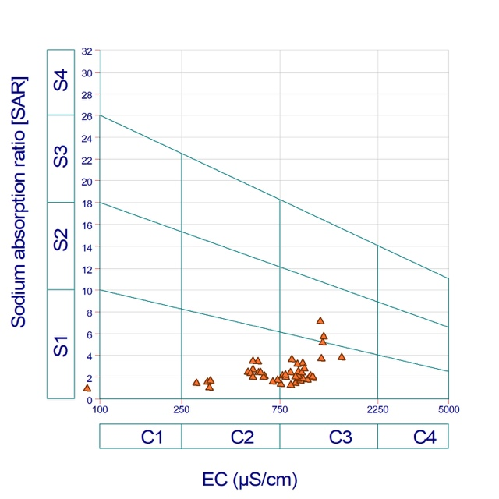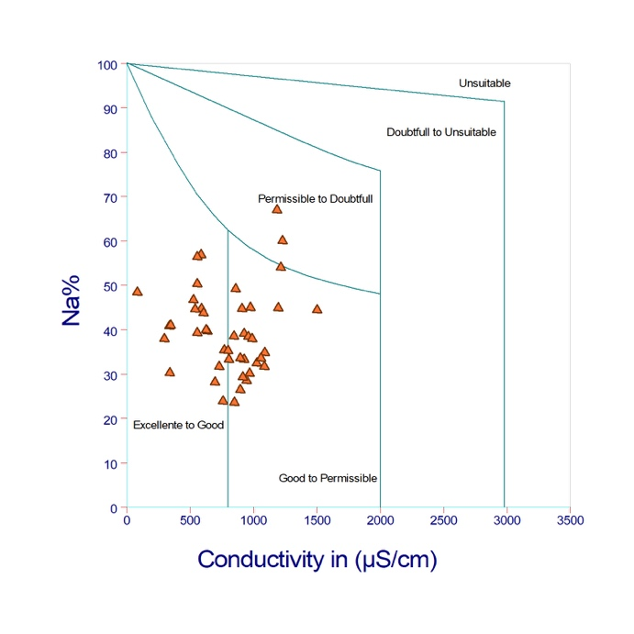
Fig. 5. U.S. Salinity hazard diagram Fig. 6. Percent sodium vs EC plot (after Richards, 1954). (after wilcox, 1995)

Wilcox Classification
The evaluation of groundwater samples for irrigation purposes in the study area was conducted using the Wilcox classification diagram, which links the percentage of sodium (Na%) with electrical conductivity (EC). This method is widely employed to determine the combined effects of sodicity and salinity on soil permeability, structure, and crop productivity. The analysis of the Wilcox diagram (Figure 3) reveals that approximately 48.88% of the groundwater samples are categorized as "Good to Permissible." These waters exhibit moderate salinity and sodium levels, making them generally suitable for irrigation under typical agricultural conditions. However, prolonged use may necessitate occasional leaching and proper drainage to avoid salt accumulation in the root zone. A smaller fraction, about 46.66% of the samples, falls into the "Excellent to Good" category. These samples have low Na% and EC, indicating minimal risks from salinity and sodium. This water is highly appropriate for irrigation and can be used safely for most crops without significant restrictions or management challenges. Around 4.44% of the samples are classified as "Permissible to Doubtful," indicating relatively higher sodium percentages along with moderate-to-high EC values. Using this water for irrigation could adversely affect soil infiltration and permeability, particularly in clay-rich soils. Therefore, its use requires careful management, including selecting crops that tolerate salinity, controlled irrigation scheduling, and regular monitoring of soil salinity and sodicity.
Kelley’s Ratio (KR)
Kelley’s Ratio (KR) serves as a crucial index for assessing irrigation water quality, specifically focusing on the prevalence of sodium (Na⁺) compared to calcium (Ca²⁺) and magnesium (Mg²⁺). As per Kelley (1963), a KR value less than 1 signifies water that is appropriate for irrigation, whereas a value greater than 1 suggests unsuitability due to sodium-related risks.
$$\frac{{[Na}^{2+}]}{{[Ca}^{2+}]+[{Mg}^{2+}]}$$
Although the WHO and BIS drinking-water guidelines do not explicitly define KR limits, they recognize the Kelley (1963) classification as the standard for irrigation studies. The KR values of groundwater samples in the study area vary significantly, ranging from about 0.10 to 2.99, indicating a wide range of sodium hazards. Approximately 66.7% of the samples have KR values below 1, indicating they are suitable for irrigation, while 33.3% exceed the acceptable limit, pointing to potential unsuitability due to sodium dominance. High KR values suggest possible negative impacts on soil structure, decreased permeability, and long-term alkalinity risks. Consequently, even though most groundwater is deemed suitable for irrigation, areas with elevated KR values need careful management and regular monitoring to prevent soil degradation, ensuring the water samples meet the BIS/WHO-accepted standards for irrigation.
The Permeability Index (PI)
The Permeability Index (PI) values of the groundwater samples range from 11.50 to 75.82%, indicating significant variability in irrigation suitability. Based on WHO and BIS irrigation-water classifications, the majority of samples (93.33%) fall within Class II (25–75%), suggesting that groundwater is permissible and moderately suitable for irrigation across most of the study area. Only 4.44% of samples fall under Class I (>75%), representing excellent-quality water with minimal impact on soil permeability. A very small proportion (2.22%) belongs to Class III (<25%), indicating unsuitable water that may adversely affect soil structure through reduced permeability. Overall, the PI analysis confirms that groundwater in the region is predominantly safe and suitable for irrigation, with only isolated locations requiring caution.
Some samples show marginal issues, but most are within permissible limits.
Table. 4. The Permeability Index (PI)
PI Range (%) | Water Class | Irrigation Suitability | Number of Samples | Percentage of Samples (%)
> 75 | Class I | Excellent / Good – Highly Suitable | 2 | 4.44
25 – 75 | Class II | Permissible – Moderately Suitable | 42 | 93.33
< 25 | Class III | Unsuitable for Irrigation | 1 | 2.22
Gibbs diagram
The Gibbs diagrams illustrate the mechanisms controlling groundwater chemistry in the study area using the ratios Na⁺/(Na⁺ + Ca²⁺) and Cl⁻/(Cl⁻ + HCO₃⁻) plotted against TDS. Interpretation of the plots shows that approximately 82–88% of groundwater samples fall within the rock-dominance field, indicating that water rock interaction mainly dissolution of silicate, carbonate, and feldspar minerals is the primary process governing groundwater quality. A smaller portion, around 10–15%, plots toward the precipitation dominance zone, reflecting recharge from rainfall with comparatively low mineral content. Only about 2–5% of samples show trends toward the evaporation dominance zone, suggesting minimal influence of evaporative concentration in the region.
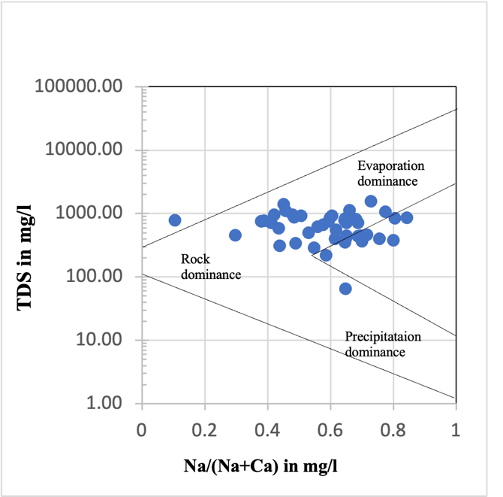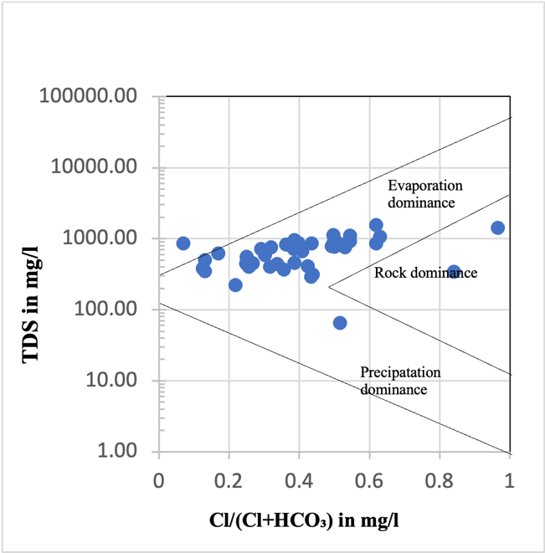
Fig. 7. Plotting in Gibbs diagram for cations and anions vs TDS

When compared with drinking-water standards, around 65–70% of the samples exhibit TDS values above the desirable BIS limit of 500 mg/L, but all samples remain within the BIS permissible limit of 2000 mg/L. Under WHO (2012) guidelines, approximately 30–35% of samples exceed 1000 mg/L, which may slightly affect taste but does not pose direct health concerns. The dominance of rock-weathering processes in the Gibbs diagram aligns with these elevated TDS values and indicates that the major ions originate from natural geogenic sources rather than anthropogenic pollution. Overall, the Gibbs plots confirm that groundwater chemistry is controlled primarily by geochemical weathering, and while most samples meet BIS and WHO permissible limits, a significant proportion exceeds desirable limits, requiring consideration for domestic suitability.
Conclusion
The hydrochemical assessment of Groundwater quality in the Lower Papagni Basin is primarily governed by rock–water interaction processes (9,12). Based on the analytical results, several groundwater samples exhibit nitrate concentrations exceeding the permissible limit of 45 mg/L, with maximum values reaching 301.40 mg/L, while fluoride concentrations reach 2.52 mg/L, exceeding the WHO and BIS drinking water guideline value of 1.5 mg/L. These elevated concentrations pose potential health risks to rural populations relying on untreated groundwater for drinking purposes, particularly in villages such as Kancharalahalli, Nallamachanahalli, and Dibbur where higher chemical concentrations were recorded. Long-term consumption of nitrate-contaminated water which can result in significant health issues such as methemoglobinemia, also known as blue baby syndrome, in infants. High nitrate concentrations are often associated with the excessive use of nitrogen fertilizers, animal waste, and seepage from septic systems in agricultural areas. Whereas excessive fluoride intake can cause dental and skeletal fluorosis, which has been widely reported in granitic terrains of southern India. Although groundwater is generally suitable to moderately suitable for irrigation, its potability is compromised in nitrate affected zones. GIS-based spatial modelling effectively delineates contamination zones and supports decision-making for groundwater management. Regular monitoring, artificial recharge, controlled fertilizer use, and community-level fluoride mitigation measures are strongly recommended. Total Dissolved Solids (TDS) levels reach up to 1550 mg/L, surpassing the recommended limit of 500 mg/L, which suggests a moderate to high mineral content in the groundwater. Elevated TDS levels can affect the palatability of drinking water and may cause gastrointestinal discomfort if consumed over prolonged periods. Furthermore, Total Hardness (TH) values in the region reach 608 mg/L, indicating conditions ranging from hard to very hard water. Although hardness is not directly detrimental to health, it can lead to scaling in pipes and household appliances and reduce the efficacy of soap.
In the context of agriculture, the presence of high levels of dissolved ions such as sodium, sulfate, and nitrate can adversely affect soil quality and crop productivity. Excessive sodium can result in soil sodicity, which reduces the soil's capacity to absorb and retain water, while elevated salinity levels can hinder plant development and decrease crop yields. Therefore, it is essential to regularly assess groundwater quality and implement sustainable irrigation practices to mitigate the potential adverse effects on human health and the sustainability of agriculture in the study region.
Spatial analysis of the hydrochemical parameters and Water Quality Index (WQI) indicates that groundwater quality degradation is not uniform across the basin. Approximately 66.67% of samples fall in the “very poor” category and 26.67% in the “poor” category, suggesting that a large portion of the basin is affected by moderate to severe water quality deterioration
Disclaimer (Artificial intelligence)
Author(s) hereby declaring that no generative Artificial Intelligence (AI) technologies, including Large Language Models such as ChatGPT, Copilot, or any text-to-image generation tools, were used in the writing, editing, analysis, or preparation of this manuscript. The entire content of the manuscript has been prepared, reviewed, and finalized solely by the author(s).

6. References
- American Public Health Association (APHA). (2017). Standard methods for the examination of water and wastewater (23rd ed.). American Public Health Association, Washington, DC.
- Appelo, C. A. J., & Postma, D. (2005). Geochemistry, groundwater and pollution (2nd ed.). A.A. Balkema Publishers.
- Babu, R. R. (2025). Geochemistry of Fluoride Rich Groundwater in Kolar and Tumkur Districts of Karnataka, India. Environmental Earth Sciences, v.61, pp.131–142.
- Bahri, D., Dasarathy, A. K. and Krishna, G. (2025). Assessment of groundwater quality in Bangalore Rural district: A decadal analysis (2015–2024). Pure and Applied Chemistry, v.97, pp.1125–1140.
- Brown, R. M., McClelland, N. I., Deininger, R. A., & Tozer, R. G. (1972). A water quality index – Do we dare? Water and Sewage Works, 117(10), 339–343.
- Bureau of Indian Standards (BIS). (2012). Indian standard drinking water specification (IS 10500:2012). Bureau of Indian Standards, New Delhi.
- Central Ground Water Board (CGWB). (2024). Dynamic Ground Water Resources and Ground Water Quality of Karnataka (CGWB Report).
- Freeze, R. A., & Cherry, J. A. (1979). Groundwater. Prentice Hall, Englewood Cliffs, New Jersey.
- Gibbs, R. J. (1970). Mechanisms controlling world water chemistry. Science, 170(3962), 1088–1090. https://doi.org/10.1126/science.170.3962.1088
- Gulgundi, M. S. and Shetty, A. (2018). Groundwater quality assessment of urban Bengaluru using multivariate statistical techniques. Applied Water Science, 8, Article 43, pp.1–14. https://doi.org/10.7007/s13201-018-0684-z
- Handa, B. K. (1975). Geochemistry and genesis of fluoride-containing groundwater in India. Groundwater, 13(3), 275–281. https://doi.org/10.1111/j.1745-6584.1975.tb03086.x
- Hem, J. D. (1985). Study and interpretation of the chemical characteristics of natural water (3rd ed.). U.S. Geological Survey Water-Supply Paper 2254.
- IJRET. (2016). Evaluation of Suitability of Ground Water for Drinking and Its Quality Assessment in Chikkaballapur District, Karnataka. International Journal of Research in Engineering and Technology, 05(Special Issue: 18), pp.58–63.
- India Water Portal. (2012). Influence of Anthropogenic Contamination on Fluoride Concentration in Groundwater: A Study of Mulbagal Town, Kolar District, Karnataka. International Journal of Economic and Environment Geology, v.3(1), pp.24–33.
- Jha, M. K., Chowdhury, A., Chowdary, V. M., & Peiffer, S. (2007). Groundwater management and development by integrated remote sensing and geographic information systems: Prospects and constraints. Water Resources Management, 21(2), 427–467. https://doi.org/10.1007/s11269-006-9024-4
- Kelley, W. P. (1963). Use of saline irrigation water. Soil Science Society of America.
- Khayum, A. (2025). Assessment of drinking water quality in Bangalore South. NEPT Journal, v.32(25), pp.55–63.
- Khayum, A. and Chandrashekar, J. S. (2011). Assessment of drinking water quality of Bangalore West Zone, India – a case study. Society for Environment and Development, v.1, pp.28–35.
- Krishnappa, S. M., Sadashivaiah, C. and Ananda, K. D. (2023). Evaluation of Groundwater Suitability for Drinking Purposes Using GIS and WQI in Chikkaballapura Taluk, Karnataka, India. Asian Journal of Water, Environment and Pollution, v.20(6), pp.19–27. https://doi.org/10.3233/AJW230075
- P. Ravi Kumar, S., Srinivasa Gowd. and C. Krupavathi, C. (2024) Groundwater quality evaluation using water quality index and geospatial techniques in parts of Anantapur District, Andhra Pradesh, South India. HydroResearch, v.7, pp.86-98.
- P. Ravikumar, R. K., Somashekar. and Prakash, K. L. (2015) Suitability Assessment of Deep Groundwater for Drinking and Irrigation Use in the Parts of Hoskote and Malur Taluks, Karnataka (India). Environmental Research, Engineering and Management, v.71(1), pp.15-26.
- Piper, A. M. (1944). A graphical procedure in the geochemical interpretation of water analysis. Transactions of the American Geophysical Union, v.25, pp.914–928.
- Ramakrishnaiah, C. R., Sadashivaiah, C., & Ranganna, G. (2009). Assessment of water quality index for the groundwater in Tumkur Taluk, Karnataka State, India. E-Journal of Chemistry, 6(2), 523–530. https://doi.org/10.1155/2009/757424
- Richards, L. A. (Ed.). (1954). Diagnosis and improvement of saline and alkali soils. U.S. Department of Agriculture, Agriculture Handbook 60.
- Richards, L.A. (1954). Diagnosis and Improvement of Saline and Alkali Soils.
- Shankar, B. S., Nandini, N., Chandrashekar, J. S., and Durgesh, R. (2017). Impact of industrialization on groundwater quality in Peenya industrial area, Bangalore, India. International Journal of Environmental Sciences, 3(4), 221–230.
- Shivaprasad, H., Ravichandra, K., Prasanna Kumar, G. R., Kedarraya Mallanna. and Savita Kubakaddi. (2015) An Assessment of Groundwater Quality Index in Bommasandra, Bengaluru City, Karnataka State, India. International Journal of Engineering Research & Technology, ISSN: 2278-0181
- Singh, A.K. and Kumar, S.R. (2014). Quality Assessment of Groundwater for Drinking and Irrigation use in-urban area of Tripura, India. Ecology, Environment and Conservation. v,21(1), pp.97-108.
- Sridhara M. K., Sadashivaiah, C. and Kiran, D. A. (2022). Spatial Variation and Fluoride Contamination of Drinking Water Using GIS in the Bagepalli Taluk of Chikkaballapura District, Karnataka. International Journal of Scientific Research in Science, Engineering and Technology, v.9(9), pp.807–813.
- Sridhara M. K., Sadashivaiah, C., Devendra H., Kiran D. A. and Aparna P. M. (2024). Evaluating Health Risks Associated With Fluoride and Nitrate Contaminants in Drinking Water to Residents Living in Chikkaballapur Taluk of Karnataka, India. IIHS Knowledge Gateway.
- Subba Rao, N. (2006). Seasonal variation of groundwater quality in a part of Guntur district, Andhra Pradesh, India. Environmental Geology, 49(3), 413–429. https://doi.org/10.1007/s00254-005-0099-7
- Todd, D. K., & Mays, L. W. (2005). Groundwater hydrology (3rd ed.). John Wiley & Sons.
- United States Salinity Laboratory Staff. (1954). Diagnosis and Improvement of Saline and Alkali Soils. USDA Agriculture Handbook No. 60. U.S. Government Printing Office.
- WHO Scientific Group (1989). Health guidelines for the use of wastewater in agriculture and aquaculture: Report of a WHO scientific group (WHO Technical Report Series No. 778). Geneva: World Health Organization. ISBN 9241207787.
- Wilcox, L. V. (1955). Classification and use of irrigation waters. U.S. Department of Agriculture Circular 969. U.S. Department of Agriculture.
- World Health Organization (WHO). (2012). Guidelines for drinking-water quality (4th ed.). World Health Organization, Geneva.

