First Record of Brachyponera Obscurans (Walker, 1859) (Hymenoptera-Formicidae) From Southern India

ABSTRACT
This paper presents the first record of Brachyponera obscurans (Walker, 1859) from southern India, specifically from the Kolli Hills in Namakkal District, Tamil Nadu. This record expands the known distribution of the species beyond the northern states of Himachal Pradesh, Punjab, and Uttar Pradesh to the Eastern Ghats of southern India. Previously found in tropical and subtropical East Asia and Sri Lanka, this Ponerinae ant is now known to occur in an underrepresented area of southern India.

Key words: Brachyponera obscurans, Hymenoptera, Formicidae, Ponerinae ants, new record, Southern India.

INTRODUCTION
The genus Brachyponera Emery, 1900, was initially established as a subgenus of Euponera but was subsequently elevated to full generic status by Bingham, C. T. in 1903. It is classified within the tribe Ponerini. These ants are small to medium in size, usually measuring around 3 to 7 mm in length (Eyer et al., 2018). They mainly exhibit carnivorous or scavenging habits, they build their nests in soil or in piece of dead wood (Leong, C. M. 2017; Menchetti et al., 2022). This genus found in many places including Africa, parts of Asia, and Australia. The greatest number of their species are found in Southeast Asia (Schmidt, C.A. & Shattuck, S.O. 2014). Currently there are 28 known species and subspecies are recognized worldwide and six of them are found in India (Bharti, H., Guénard, B., Bharti, M., Economo. E. P., 2016) and (Rameshkumar et. al. 2025).

MATERIALS AND METHODS
Ant samples were collected from Kolli Hills, Solakkadu (11.3096° N, 78.3494° E) in Namakkal District, Tamil Nadu, India. They were collected by hand-picking methods from small areas in the ecosystem, like soil and under rocks (Guénard et al., 2018). The collected specimens were preserved in 70% ethanol to maintain structural integrity. Following comprehensive morphological analysis using a stereo zoom microscope, the specimens were curated at the Marine Biology Regional Centre, Zoological Survey of India, Chennai, Tamil Nadu, India.

RESULTS AND DISCUSSIONS
In this study, we provide a complete overview of Brachyponera obscurans, with new record to southern India. We include detailed descriptions and key morphological characters for the species identification. These new records extend the known range of Brachyponera obscurans southward, highlighting potential gaps in prior surveys and underscoring the need for continued ant biodiversity assessments in the region.

Key to the Indian Brachyponera species based on the worker caste:
The distinction between the six Indian Brachyponera species is principally based on Karavaiev, V. 1925, Bingham, C. T. 1903 and Chen, C., Yu, Y., Yi, C. 2025.

- Head shorter and squarer; the eyes are very much smaller and located in front of the lateral margin of the head; body color reddish brown-B. jerdonii (Forel).

- The head is longer than it is broad, with medium-sized eyes positioned anterior to the lateral margins. The body is dark brown, while the mandibles, flagellar segments, and legs are deep yellowish-brown-B. obscurans (Walker).

- The first and second flagellar segments are as long as they are broad, or broader than long. The body is black, whereas the mandibles, antennae, flagellum, tibiae, tarsi, and the distal portion of the gaster are reddish-brown-B. luteipes (Mayr).

- The flagellar segments gradually enlarge towards the distal end. The body is dark brown, while the mandibles, flagellar segments, and legs are deep yellowish-brown-B. obscurans (Walker).

- High dome-shaped epinotum in lateral view; with the petiole scale broader above and less ovoid; Coloration Yellowish rust-brown, occasionally matching the light tones of antennae, mandibles, and legs-B. luteipes continentalis (Karavaiev).

- The propodeum is nearly straight with a sloping profile. The petiolar node is flattened and oval in shape. The overall body colour is dark brown, while the mandibles, flagellar segments, and legs are deep yellowish-brown-B. obscurans (Walker).

- The petiolar node is crescent-shaped. The mesosoma is predominantly smooth, with the pronotum finely punctate and the propodeum exhibiting fine rugosity. The body is black, whereas the appendages are yellowish-brown-B. nigrita (Emery).

- The petiolar node is flattened and oval in shape. The mesosoma, petiole, and gaster are finely punctate. The general body coloration is dark brown, whereas the mandibles, flagellar segments, and legs are deep yellowish-brown -B. obscurans (Walker).

- The posterior margin of the head, when viewed in full-face aspect, is strongly concave. The eyes are relatively large. The petiole forms a high and robust node with a straight profile. The body colour ranges from dark brown to blackish-brown, while the antennae, tibiae, and tarsi are reddish-B. sennaarensis (Mayr).

- The posterior margin of the head, observed in full-face view, is generally weakly concave. The eyes are of medium size. The petiolar node exhibits a flattened oval shape. The overall body colour is dark brown, whereas the mandibles, flagellar segments, and legs are deep yellowish-brown. -B. obscurans (Walker).

Brachyponera obscurans (Walker, 1859)

Materials examined: No. Exs: 6 worker ants, Date of Collection: 28.xii.2024, Location: Solakkadu (11.3096° N, 78.3494° E), Kolli Hills, Namakkal District, Tamil Nadu, India, Collected by: D. Nagarajan., ZSI Regd. No. ANT/INS/021.

Worker Diagnosis: The body is dark brown in colour, with the mandibles and legs yellowish. In frontal view, the head is longer than broad and appears trapezoidal in shape, with the posterolateral corners narrowly rounded. The mandibles are triangular, bearing nine teeth and lacking elongated attenuated teeth. The antennae are composed of 12 segments; the first segment (scape) extends beyond the posterolateral corner of the head, and the flagellar segments gradually increase in size towards the apex. The eyes are of medium size and situated along the lateral margin of the head. The mesosomal profile is uneven or discontinuous, with the metanotal groove clearly developed. The dorsal surface of the propodeum is almost straight and longer than the descending posterior slope, and the posterodorsal corner of the propodeum is broadly rounded. The petiolar node is approximately as high as the propodeum, erect and nearly trapezoidal in shape; the subpetiolar process forms a wedge, while in dorsal view the petiolar node appears flat and oval. The mandibles and head are densely punctate, whereas the mesosoma, petiole, and gaster are finely punctate. The dorsal surface of the body bears abundant erect setae together with dense sub-decumbent hairs, and the upper region of the propodeum is covered with dense sub-decumbent hairs.

The mesosomal profile is discontinuous, with a strongly developed metanotal groove. The dorsal surface of the propodeum is nearly straight and longer than the descending posterior slope, while the posterodorsal corner of the propodeum is broadly rounded. The petiolar node is approximately as high as the propodeum, erect and nearly trapezoidal in shape; the subpetiolar process forms a wedge, and in dorsal view the petiolar node appears flat and oval. The mandibles are densely punctate, and the head also exhibits dense punctation. The mesosoma, petiole, and gaster are finely punctate. The dorsal surface of the body bears abundant erect setae together with dense sub-decumbent hairs, whereas the upper region of the propodeum is covered with dense, appressed hairs.

Queen: unknown
Male: Unknown

The discovery of Brachyponera obscurans (Fig. 1 & Fig. 2) in Kolli Hills, Namakkal District, Tamil Nadu, marks the first confirmed record of this species in southern India. This extends its known range by more than 2,000 km southward from previous reports in northern regions like Himachal Pradesh, Punjab, and Uttar Pradesh (Fig. 3). Earlier checklists up to Bharti, et. al., 2016 only documented these northern locations, likely due to biased sampling in northern India and under-explored southern biodiversity hotspots like the Eastern Ghats. This finding indicates the adaptability of Brachyponera obscurans to varied elevations and microhabitats, ranging from the northern plains to the southern forested hills at approximately 1,000 m, consistent with its tropical East Asian origin.

CONCLUSION
This study documents the first record of Brachyponera obscurans from southern India, specifically the Kolli Hills (Eastern Ghats, Tamil Nadu), extending its known range over 2,000 km southward from previous northern records in Himachal Pradesh, Punjab, and Uttar Pradesh. This discovery fills a critical gap in ant biodiversity documentation for India's under-surveyed southern hotspots, highlighting B. obscurans adaptability to diverse elevations (northern plains to ~1,000 m forested hills) and microhabitats like soil and under rocks, consistent with its carnivorous/scavenging habits and tropical East Asian origins.

The detailed morphological diagnosis and dichotomous key distinguish it from other Indian Brachyponera species (B. jerdonii, B. luteipes, B. nigrita, B. sennaarensis), aiding future identifications amid the genus's 28 global species (6 in India). Ecologically, this range expansion suggests climate/habitat suitability in the Eastern Ghats, potentially driven by warming trends or human-mediated dispersal, mirroring invasive patterns in related species like B. chinensis (Chen, C., Yu, Y., Yi, C. 2025). These findings underscore the need for targeted ant surveys in southern India to refine distribution maps, monitor biodiversity shifts, and support conservation in megadiverse regions.

Disclaimer (Artificial intelligence)
Author(s) hereby declare that NO generative AI technologies such as Large Language Models (ChatGPT, COPILOT, etc.) and text-to-image generators have been used during the writing or editing of this manuscript.
ACKNOWLEDGEMENT
Authors are grateful to the Director, Zoological Survey of India, Kolkata and the Officer in Charge, Marine Biology Regional Centre, Zoological Survey of India, Chennai for providing necessary laboratory facilities to carry out this study. Also, our thanks to Dr. N. Kumaresan a Head Master, Government Higher Secondary School, Kolli Hills for his help and support during the collection of specimens.

REFERENCES
- Bharti, H., Guénard, B., Bharti, M., Economo. E. P., 2016. An updated checklist of the ants of India with their specific distributions in Indian states (Hymenoptera, Formicidae). ZooKeys, 551, 1-83.

- Bingham, C. T. 1903. The fauna of British India, including Ceylon and Burma. Hymenoptera, Vol. II. Ants and Cuckoo-wasps. London: Taylor and Francis, 506 pp.

- Chen, C., Yu, Y., Yi, C. 2025. Revision of the Chinese species of the genus Brachyponera Emery, 1900 (Hymenoptera, Formicidae), with a key to the world species of the genus. ZooKeys 1230: 247-286.

- Karavaiev, V. (1925) Ponerinen (Fam. Formicidae) aus dem Indo-Australischen Gebiet. (Fortsetzung). Konowia, 4, 115–131.

- Leong, C. M. 2017. Biological notes on the colony of Brachyponera obscurans (Hymenoptera: Formicidae) in Macau. Taiwanese Journal of Entomological Studies. 2(1):10-12.

- Rameshkumar, A, S. Sheela, P. Girish Kumar, Rajmohana, K, S. Sardar, P.C. Mazumdar, A. Barua, D. Ghosh, B. Majumder, N. Anand, S. Dey, B. Chattopadhyay, P. Mandal, N. Basak, A. Mandi, R. Debnath, S. Patra and Theertha, PV. (2025). Checklist of Fauna of India: Arthropoda: Insecta: Hymenoptera. Version 2.0. Zoological Survey of India.

- Schmidt, C.A. & Shattuck, S.O. 2014. The higher classification of the ant subfamily Ponerinae (Hymenoptera: Formicidae), with a review of ponerine ecology and behavior. Zootaxa 3817, 1–242.

- Menchetti, M., Schifani, E., Gentile, V., & Vila, R. (2022). The worrying arrival of the invasive Asian needle ant Brachyponera chinensis in Europe (Hymenoptera: Formicidae). Zootaxa, 5115(1), 146-150.

- Eyer, P. A., Matsuura, K., Vargo, E. L., Kobayashi, K., Yashiro, T., Suehiro, W., ... & Tsuji, K. (2018). Inbreeding tolerance as a pre‐adapted trait for invasion success in the invasive ant Brachyponera chinensis. Molecular Ecology, 27(23), 4711-4724.

- Guénard, B., Wetterer, J. K., & MacGown, J. A. (2018). Global and temporal spread of a taxonomically challenging invasive ant, Brachyponera chinensis (Hymenoptera: Formicidae). Florida Entomologist, 101(4), 649-656.

Fig. 1. B. obscurans worker (Head, Frontal view) Fig. 2. B. obscurans worker (Profile view)

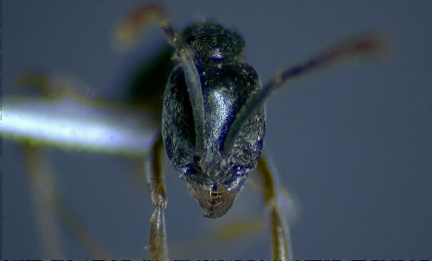

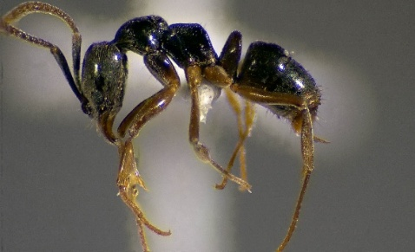

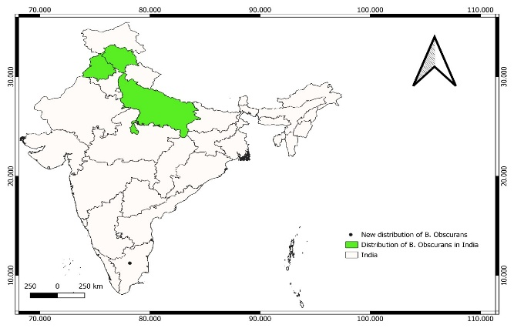
Fig. 3: Distribution Map of Brachyponera obscurans (Walker, 1859) in Kolli Hills, Namakkal District, Tamil Nadu (Bharti, H., Guénard, B., Bharti, M., Economo. E. P., 2016), and locality of specimens examined for this study.

