Short Communication

FIRST RECORD OF BRACHYPONERA OBSCURANS (WALKER, 1859) (HYMENOPTERA-FORMICIDAE) FROM SOUTHERN INDIA

ABSTRACT
This paper presents the first record of Brachyponera obscurans (Walker, 1859) from southern India, specifically from the Kolli Hills in Namakkal District, Tamil Nadu. This record expands the known distribution of the species beyond the northern states of Himachal Pradesh, Punjab, and Uttar Pradesh to the Eastern Ghats of southern India. Previously found in tropical and subtropical East Asia and Sri Lanka, this Ponerinae ant is now known to occur in an underrepresented area of southern India.

Key words: Brachyponera obscurans, Hymenoptera, Formicidae, Ponerinae ants, new record, Southern India.

INTRODUCTION
The genus Brachyponera Emery, 1900, was first created as a subgenus of Euponera but was later made into its own separate generic status by Bingham, C. T. 1903, it belongs to the Ponerini tribe. These ants are small to medium in size, usually measuring around 3 to 7 mm in length. They mainly exhibit carnivorous or scavenging habits, they build their nests in soil or in piece of dead wood (Leong, C. M. 2017). This genus found in many places including Africa, parts of Asia, and Australia. The greatest number of their species are found in Southeast Asia (Schmidt, C.A. & Shattuck, S.O. 2014). Currently there are 28 known species and subspecies are recognized worldwide and six of them are found in India (Bharti, H., Guénard, B., Bharti, M., Economo. E. P., 2016) and (Rameshkumar et. al. 2025).

MATERIALS AND METHODS
Ant samples were collected from Kolli Hills, Solakkadu (11.3096° N, 78.3494° E) in Namakkal District, Tamil Nadu, India. They were collected by hand-picking methods from small areas in the ecosystem, like soil and under rocks. The collected specimens were preserved in 70% ethanol to maintain structural integrity. After detailed morphological examination under a stereo zoom microscope, the specimens were deposited in the Marine Biology Regional Centre, Zoological Survey of India, Chennai, Tamil Nadu, India.

RESULTS AND DISCUSSIONS
In this study, we provide a complete overview of Brachyponera obscurans, with new record to southern India. We include detailed descriptions and key morphological characters for the species identification. These new records extend the known range of Brachyponera obscurans southward, highlighting potential gaps in prior surveys and underscoring the need for continued ant biodiversity assessments in the region.

Key to the Indian Brachyponera species based on the worker caste:
The distinction between the six Indian Brachyponera species is principally based on Karavaiev, V. 1925, Bingham, C. T. 1903 and Chen, C., Yu, Y., Yi, C. 2025.

- Head shorter and squarer; the eyes are very much smaller and located in front of the lateral margin of the head; body color reddish brown-B. jerdonii (Forel).

- Head longer than broad; Eye medium and located in front of lateral margin of head; body color dark brown, mandible, flagella segments, and legs deep yellowish brown-B. obscurans (Walker).

- Flagella segment 1 and 2 as long as broad or broader than long; Body black and mandible, antennae flagellum, tibiae, tarsus, end of gaster reddish brown-B. luteipes (Mayr).

- Flagella segments gradually increase in size toward the end; body color dark brown, mandible, flagella segments, and legs deep yellowish brown-B. obscurans (Walker).

- High dome-shaped epinotum in lateral view; with the petiole scale broader above and less ovoid; Coloration Yellowish rust-brown, occasionally matching the light tones of antennae, mandibles, and legs-B. luteipes continentalis (Karavaiev).

- Propodeum nearly straight and slope; Petiolar node flat oval; body color dark brown, mandible, flagella segments, and legs deep yellowish brown-B. obscurans (Walker).

- Petiolar node crescent-shaped; mesosoma smooth, pronotum finely punctate, and propodeum finely rugose; Body black, appendages yellowish brown-B. nigrita (Emery).

- Petiolar node flat oval; mesosoma, petiole and gaster finely punctate; body color dark brown, mandible, flagella segments, and legs deep yellowish brown-B. obscurans (Walker).

- Posterior margin of head in full-face view strongly concave; eye relatively large; petiole a high and thick node with a straight; Dark brown to blackish brown, antennae, tibiae and tarsi reddish-B. sennaarensis (Mayr).

- Posterior margin of the head in full-face view is typically weakly concave; Eye medium; Petiolar node flat oval; body color dark brown, mandible, flagella segments, and legs deep yellowish brown-B. obscurans (Walker).

Brachyponera obscurans (Walker, 1859)

Materials examined: No. Exs: 6 worker ants, Date of Collection: 28.xii.2024, Location: Solakkadu (11.3096° N, 78.3494° E), Kolli Hills, Namakkal District, Tamil Nadu, India, Collected by: D. Nagarajan., ZSI Regd. No. ANT/INS/021.

Worker Diagnosis: body color is dark brown, with the mandibles and legs being yellowish. When viewed from the front, of the head is longer and broader, shaped like a trapezoid, with the posterolateral corners of head narrowly rounded. The Mandible is triangular with nine teeth and without long attenuated teeth. The Antenna has 12 segments, with the first segment (scape) exceeds posterolateral corner; the flagellar segments gradually increase in size toward the end. The Eye is medium size and present in lateral margin of the head. The Mesosomal profile uneven or discontinuous, and the Metanotal groove clearly visible. The Dorsum of propodeum almost straight, longer than the downward slope, and the posterodorsal corner of propodeum broadly rounded. The Petiolar node as high as propodeum, upright and nearly trapezoid-shaped; the subpetiolar process forms a wedge and the dorsal view of petiolar node flat and oval. The Mandible and head have many small pits or densely punctate, and the mesosoma, petiole and gaster fine pits or finely punctate. Dorsum of body with abundant standing hairs and densely sub-decumbent hairs; upper part of propodeum with densely sub-decumbent hairs

Mesosomal profile discontinuous, Metanotal groove strongly developed. Dorsum of propodeum nearly straight and longer than downward slope, posterodorsal corner of propodeum broadly rounded. Petiolar node as high as propodeum, upright, nearly trapezoidal; subpetiolar process forms a wedge and dorsal view petiolar node flat and oval. Mandible densely punctate; head densely punctate; mesosoma, petiole and gaster finely punctate. Dorsum of the body with abundant standing hairs and densely sub-decumbent hairs, and the upper part of the propodeum has dense, lying-down hairs.

Queen: unknown
Male: Unknown

The discovery of Brachyponera obscurans (Fig. 1 & Fig. 2) in Kolli Hills, Namakkal District, Tamil Nadu, marks the first confirmed record of this species in southern India. This extends its known range by more than 2,000 km southward from previous reports in northern regions like Himachal Pradesh, Punjab, and Uttar Pradesh (Fig. 3). Earlier checklists up to Bharti, et. al., 2016 only documented these northern locations, likely due to biased sampling in northern India and under-explored southern biodiversity hotspots like the Eastern Ghats. This finding indicates the adaptability of Brachyponera obscurans to varied elevations and microhabitats, ranging from the northern plains to the southern forested hills at approximately 1,000 m, consistent with its tropical East Asian origin.

CONCLUSION
This study documents the first record of Brachyponera obscurans from southern India, specifically the Kolli Hills (Eastern Ghats, Tamil Nadu), extending its known range over 2,000 km southward from previous northern records in Himachal Pradesh, Punjab, and Uttar Pradesh. This discovery fills a critical gap in ant biodiversity documentation for India's under-surveyed southern hotspots, highlighting B. obscurans adaptability to diverse elevations (northern plains to ~1,000 m forested hills) and microhabitats like soil and under rocks, consistent with its carnivorous/scavenging habits and tropical East Asian origins.

The detailed morphological diagnosis and dichotomous key distinguish it from other Indian Brachyponera species (B. jerdonii, B. luteipes, B. nigrita, B. sennaarensis), aiding future identifications amid the genus's 28 global species (6 in India). Ecologically, this range expansion suggests climate/habitat suitability in the Eastern Ghats, potentially driven by warming trends or human-mediated dispersal, mirroring invasive patterns in related species like B. chinensis (Chen, C., Yu, Y., Yi, C. 2025). These findings underscore the need for targeted ant surveys in southern India to refine distribution maps, monitor biodiversity shifts, and support conservation in megadiverse regions.

ACKNOWLEDGEMENT
Authors are grateful to the Director, Zoological Survey of India, Kolkata and the Officer in Charge, Marine Biology Regional Centre, Zoological Survey of India, Chennai for providing necessary laboratory facilities to carry out this study. Also, our thanks to Dr. N. Kumaresan a Head Master, Government Higher Secondary School, Kolli Hills for his help and support during the collection of specimens.

REFERENCES
Bharti, H., Guénard, B., Bharti, M., Economo. E. P., 2016. An updated checklist of the ants of India with their specific distributions in Indian states (Hymenoptera, Formicidae). ZooKeys, 551, 1-83.

Bingham, C. T. 1903. The fauna of British India, including Ceylon and Burma. Hymenoptera, Vol. II. Ants and Cuckoo-wasps. London: Taylor and Francis, 506 pp.

Chen, C., Yu, Y., Yi, C. 2025. Revision of the Chinese species of the genus Brachyponera Emery, 1900 (Hymenoptera, Formicidae), with a key to the world species of the genus. ZooKeys 1230: 247-286.

Karavaiev, V. (1925) Ponerinen (Fam. Formicidae) aus dem Indo-Australischen Gebiet. (Fortsetzung). Konowia, 4, 115–131.

Leong, C. M. 2017. Biological notes on the colony of Brachyponera obscurans (Hymenoptera: Formicidae) in Macau. Taiwanese Journal of Entomological Studies. 2(1):10-12.

Rameshkumar, A, S. Sheela, P. Girish Kumar, Rajmohana, K, S. Sardar, P.C. Mazumdar, A. Barua, D. Ghosh, B. Majumder, N. Anand, S. Dey, B. Chattopadhyay, P. Mandal, N. Basak, A. Mandi, R. Debnath, S. Patra and Theertha, PV. (2025). Checklist of Fauna of India: Arthropoda: Insecta: Hymenoptera. Version 2.0. Zoological Survey of India.

Schmidt, C.A. & Shattuck, S.O. 2014. The higher classification of the ant subfamily Ponerinae (Hymenoptera: Formicidae), with a review of ponerine ecology and behavior. Zootaxa 3817, 1–242.

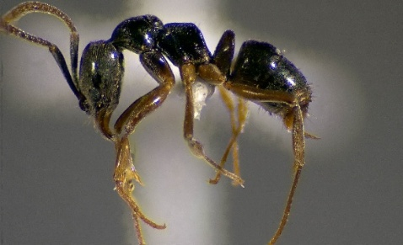
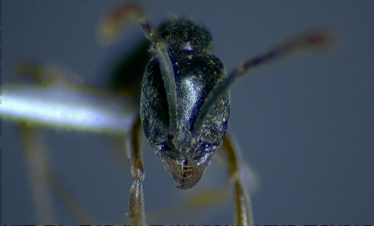
Fig. 1. B. obscurans worker (Head, Frontal view) Fig. 2. B. obscurans worker (Profile view)

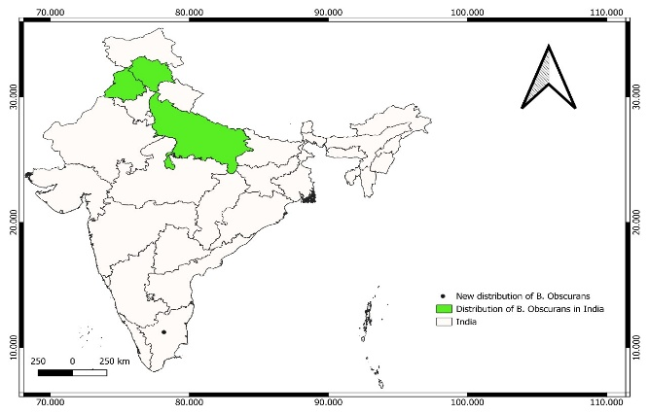

Fig. 3: Distribution Map of Brachyponera obscurans (Walker, 1859) in India (Bharti, H., Guénard, B., Bharti, M., Economo. E. P., 2016), and locality of specimens examined for this study.

