Salinity-Mediated Structuring and Marine–Estuarine Connectivity of Penaeid Shrimp Assemblages in Ashtamudi Wetland, India

ABSTRACT
Salinity gradients play a critical role in structuring penaeid shrimp assemblages in tropical estuaries. The present study aimed to evaluate salinity-driven spatial segregation, diversity structure, and marine-estuarine connectivity of penaeid shrimps in Ashtamudi Lake, a Ramsar-designated wetland in Kerala, India. A comparative cross-sectional ecological research design was adopted, involving short-term field sampling conducted in January 2024 across two ecologically distinct salinity zones: the marine-dominated Neendakara sector and the marine-brackish Puthenthuruth sector. Specimens were collected using standardized fishing gears and analyzed through quantitative community assessment methods, including species richness estimation, Shannon–Wiener and Simpson diversity indices, Sørensen similarity index, K-dominance curves, habitat-based functional classification, and hierarchical cluster analysis. A total of 23 species were recorded from the marine zone and 17 species from the brackish zone, with overall abundance markedly higher in the marine sector and deep-sea taxa absent in the lower salinity area. Diversity indices indicated greater community stability in Neendakara (H′ = 3.031; 1-D = 0.948) compared to Puthenthuruth (H′ = 2.511; 1-D = 0.900). Despite reduced richness, species overlap between zones remained high (Sørensen index = 0.85), reflecting strong ecological connectivity. Migratory marine-estuarine penaeids constituted 26.1% of total species diversity, highlighting the nursery function of the estuarine sector. The findings confirm salinity as a primary ecological filter regulating penaeid community assembly and emphasize the need to maintain hydrological integrity for sustainable fisheries and biodiversity conservation.
Keywords: Salinity gradient, Penaeid shrimps, Estuarine nursery, Diversity indices, Marine-estuarine connectivity
1. INTRODUCTION
Estuaries represent dynamic transition zones between marine and freshwater environments and are widely recognized as critical habitats for Penaeid shrimps due to their role in recruitment, growth, and survival of juvenile stages (Dall et al., 1990; Rothlisberg, 1983; Minello & Zimmerman, 1991). Salinity gradients in particular function as major ecological regulators influencing distribution, abundance, growth performance, and osmoregulatory capacity of penaeids (Brito et al., 2000; Jackson, 2017; Zink et al., 2017). Numerous studies across tropical estuaries have demonstrated that penaeid assemblages exhibit spatial zonation patterns driven by environmental filtering, habitat complexity, and hydrological variability (Kenyon et al., 1997; Howe et al., 1999; Pérez-Castañeda et al., 2009). These gradients often structure communities into marine, estuarine-dependent, and strictly marine components, reflecting ontogenetic migration and estuarine-marine connectivity (Pillay & Yousuf, 1999; Smith & Wu, 2011).
Ashtamudi Lake, a Ramsar-designated tropical estuary on the southwest coast of India, supports diverse aquatic bioresources and sustains economically important shrimp fisheries (Nair et al., 1980; Vimal Raj et al., 2014). The lake functions as a brackish water system influenced by tidal exchange with the Arabian Sea and freshwater inflow from riverine sources, creating pronounced spatial salinity gradients (Alexander, 2025). Previous taxonomic accounts and regional faunal surveys have documented penaeid diversity in Indian waters (Reddy, 1995; Isabel & Kensley, 1997; Dholakia, 2010). However, quantitative assessments linking salinity-driven zonation with community-level diversity, dominance patterns, and functional migratory roles within Ashtamudi remain limited. Despite the long-standing recognition of its fisheries importance, systematic evaluation of marine-estuarine connectivity at the assemblage scale is comparatively underexplored.
Understanding how salinity gradients regulate shrimp community assembly is essential for predicting recruitment variability and ensuring sustainable fisheries management under changing climatic and hydrological regimes (Zink et al., 2017). Salinity was selected as the primary environmental variable because it is widely recognized as a dominant ecological regulator influencing penaeid shrimp distribution, recruitment, and community assembly in estuarine systems (Dall et al., 1990; Rothlisberg, 1983; Jackson, 2017), and pronounced salinity zonation exists within Ashtamudi Lake. However, region-specific quantitative studies linking salinity gradients with penaeid species richness and assemblage structure in Ashtamudi are limited. Therefore, the present study aims to evaluate salinity-driven spatial segregation, diversity structure, and migratory connectivity of Penaeid shrimps across two ecologically distinct sectors of Ashtamudi Wetland. By combining quantitative community analysis with functional habitat interpretation, this study addresses an important regional knowledge gap and contributes to ecosystem-based management of tropical estuarine fisheries.
2. METHODOLOGY
2.1. Study Area and Research Design
Ashtamudi Wetland, a Ramsar-designated tropical estuarine system located along the southwest coast of India (Kerala), represents a dynamic marine-estuarine interface influenced by tidal influx from the Arabian Sea and freshwater discharge from riverine inputs. The present study was conducted during January 2024 across two ecologically contrasting ecosites representing distinct salinity regimes: Neendakara (marine zone; 08°56′7.2″N, 76°32′24.0″E) with a salinity of 35.69%, and Puthenthuruth (marine-brackish tidal zone; 08°55′55.6″N, 76°33′10.1″E) with a salinity of 26.70%. These sites were selected to represent the outer marine-influenced sector and the inner estuarine transitional sector of the wetland, enabling evaluation of salinity-driven spatial structuring of Penaeid shrimp assemblages (Fig. 1). A comparative cross-sectional ecological research design was adopted in this study, wherein shrimp assemblages from two distinct salinity zones were sampled and quantitatively compared at a single time point to evaluate salinity-driven variations in community structure and marine-estuarine connectivity.
Figure 1. Location of Sampling Stations in Ashtamudi Lake Showing Salinity (%) Gradient

2.2. Sampling Procedure and Species Identification
Shrimp sampling was conducted between 9:00 AM and 3:00 PM using standardized traditional fishing gears including gill nets, cast nets, and drag nets, in collaboration with local fishermen to ensure representative and sustainable collection (Fig. 2).
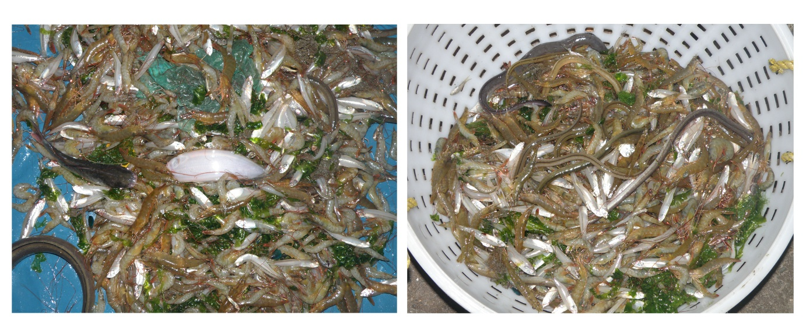
Figure 2. Field Sampling and Collection of Penaeid Shrimps in Ashtamudi Lake (Collected Samples before Segregation)
Specimens were initially sorted and morphologically identified in situ, followed by detailed laboratory examination using stereomicroscopy for taxonomic confirmation (Fig 3). Species identification was carried out using standard taxonomic keys and regional monographs (Reddy, 1995; Isabel & Kensley, 1997; Dholakia, 2010). Species were further categorized into functional habitat groups (deep-sea marine, marine, and marine-estuarine dependent) based on ecological affinity.
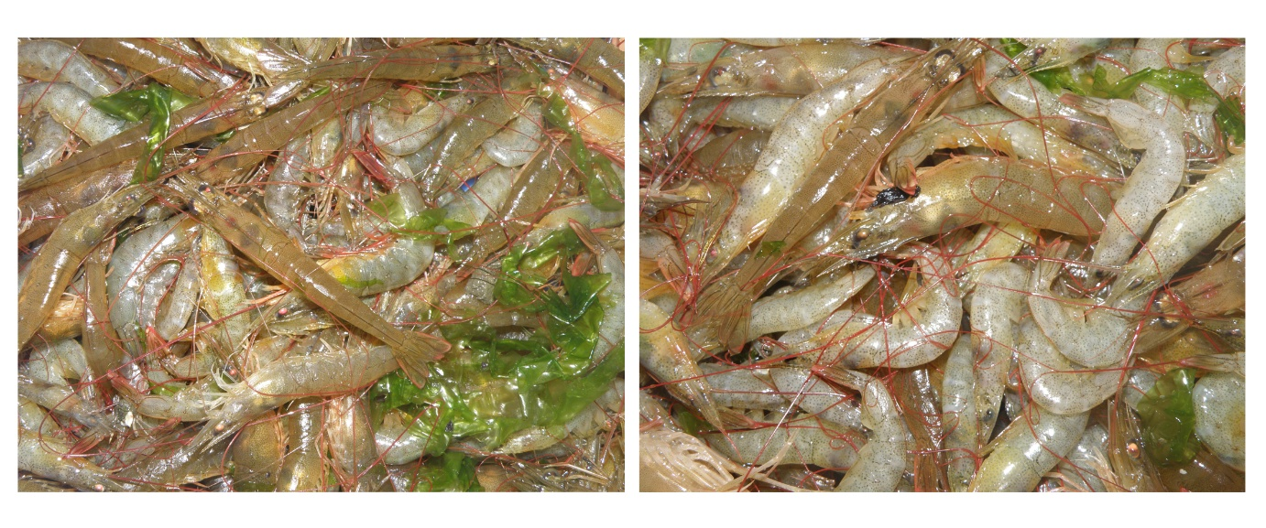
Figure 3. Morphologically Identified Penaeid Shrimp Specimens (Collected samples after segregation)
2.3. Quantitative Data Analysis and Statistical Indices
All quantitative variables were expressed with appropriate measurement units, where salinity was recorded in parts per thousand (%) and abundance as number of individuals, while diversity and similarity indices were dimensionless. Species richness (S) was calculated as the total number of species recorded in each salinity zone. Community diversity was assessed using the Shannon-Wiener diversity index (H′ = –∑pi ln pi) and Simpson’s dominance index (1–D = 1 – ∑pi²), where pi represents the proportional abundance of each species. Community similarity between zones was determined using the Sørensen similarity index (Cs = 2C / (S₁ + S₂)), where C is the number of shared species. Species evenness and dominance patterns were evaluated through K-dominance curves based on cumulative relative abundance. The proportional contribution of marine-estuarine migratory species was calculated as a percentage of total recorded diversity. Hierarchical cluster analysis using Euclidean distance and Ward’s linkage method was performed to examine compositional segregation between salinity zones. All graphical representations, including species abundance bar charts, habitat composition pie charts, K-dominance curves, and hierarchical cluster dendrograms, were generated using species abundance data in PAST version 4.3, following standard ecological plotting procedures to visually interpret diversity structure, functional composition, dominance patterns, and assemblage segregation across salinity zones.
3. RESULTS
3.1. Salinity-Driven Spatial Segregation and Marine-Estuarine Migration Patterns of Shrimp Assemblages
The comparative analysis of shrimp assemblages between the high-salinity marine zone of Neendakara and the relatively lower-salinity marine-brackish zone of Puthenthuruth reveals clear spatial segregation driven by salinity gradients (Table 1). Overall abundance was markedly higher in Neendakara, where all 23 recorded species were present, including deep-sea marine taxa such as Aristeus alcoki and A. semidentatum, which were completely absent in Puthenthuruth. In contrast, the brackish zone showed reduced species counts and abundance but relatively stronger representation of marine-estuarine dependent penaeids, notably Penaeus monodon, Metapenaeus affinis, M. ensis, Fenneropenaeus indicus and Parapenaeopsis coromandelica (Fig. 4). Strictly marine species exhibited sharp declines in abundance toward the lower salinity zone, indicating osmotic constraints and habitat preference. The absence of deep-sea elements and the persistence of estuarine-tolerant penaeids in Puthenthuruth suggest functional habitat partitioning and support the concept of ontogenetic migration, wherein estuarine sectors serve as transitional nursery grounds for commercially important shrimp species. Some
Table 1. Species Composition and Abundance (Number of individuals) of Penaeid Shrimps Across Two Salinity (%) Zones of Ashtamudi Lake
Sl No. | Shrimp species | Family | Habitat | Distribution
 |  |  |  | Neendakara | Puthenthuruth
1 | Solenocera choprai | Solenceridae | Marine | 31 | 4
2 | Solenocera hextii | Solenceridae | Marine | 57 | 2
3 | Aristeus alcoki | Aristeidae | Deep-sea marine | 13 | 0
4 | Aristeus semidentatum | Aristeidae | Deep-sea marine | 21 | 0
5 | Fenneropenaeus indicus | Penaedae | Marine-Estuarine | 49 | 14
6 | Metapenaeopsis stridulans | Penaedae | Marine (occasionally estuarine) | 28 | 9
7 | Metapenaeopsis toloensis | Penaedae | marine | 51 | 11
8 | Metapenaeopsis andamanensis | Penaedae | marine | 33 | 3
9 | Metapenaeus affinis | Penaedae | Marine-Estuarine | 62 | 19
10 | Metapenaeus dobani | Penaedae | Marine | 43 | 4
11 | Metapenaeus ensis | Penaedae | Marine–Estuarine | 55 | 13
12 | Metapenaeus monocerus | Penaedae | Marine-Estuarine | 69 | 7
13 | Metapenaeus moyebi | Penaedae | Marine | 22 | 0
14 | Parapenaeopsis acclimiratus | Penaedae | Marine | 19 | 1
15 | Parapenaeopsis cormuta | Penaedae | Marine | 37 | 3
16 | Parapenaeopsis coromandelica | Penaedae | Marine-Estuarine | 60 | 12
17 | Parapenaeopsis maxillipedo | Penaedae | Marine | 45 | 7
18 | Parapenaeopsis stylierc | Penaedae | Marine | 28 | 2
19 | Parapenaeus longipes | Penaedae | Marine | 16 | 0
20 | Melicertus canaliculatum | Penaedae | Marine | 21 | 0
21 | Penaeus semisulcatus | Penaedae | Marine (occasionally estuarine juvenile) | 25 | 2
22 | Penaeus monodon | Penaedae | Marine-Estuarine | 59 | 27
23 | Trachysalambria curvirostris | Penaedae | Marine | 18 | 0

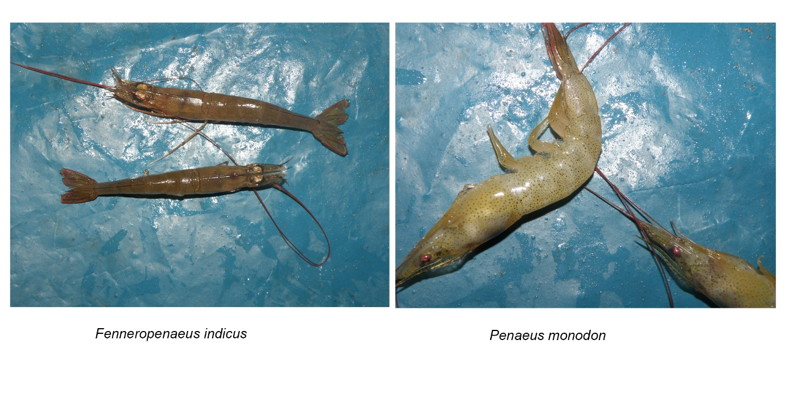
Figure 4. Representative Penaeid Shrimp Species Recorded from the Study Area
The bar graph in figure 5 clearly illustrates the dominance of shrimp abundance in the high-salinity marine zone (Neendakara) compared to the relatively lower-salinity brackish zone (Puthenthuruth). Deep-sea marine species such as Aristeus alcoki and A. semidentatum are entirely absent from the brackish sector, reinforcing their strict marine affinity. Conversely, marine-estuarine dependent species including Penaeus monodon, Metapenaeus affinis, M. ensis, and Parapenaeopsis coromandelica exhibit measurable representation in both zones, with comparatively higher proportional persistence in Puthenthuruth. The overall reduction in abundance across most strictly marine taxa toward the brackish zone highlights salinity-mediated habitat filtering and supports the hypothesis of estuarine utilization as transitional nursery grounds by migratory penaeids within the Ashtamudi estuarine continuum.
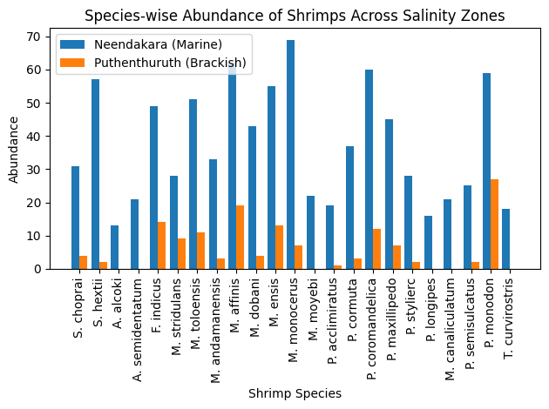
Figure. 5. Species-wise Abundance (Individuals) of Penaeid Shrimps Across the Salinity (%) Gradient
3.2. Species Richness and Habitat Composition
The species richness comparison indicates a clear decline in diversity from the high-salinity marine zone to the lower-salinity brackish zone. Neendakara supported all 23 recorded shrimp species, including deep-sea marine taxa, reflecting its strong marine influence (Table 2). In contrast, Puthenthuruth exhibited reduced richness with only 17 species, as six strictly marine or deep-sea species were absent. The loss of deep-sea taxa and reduced occurrence of several marine species in the brackish zone suggest the role of salinity as an ecological filter shaping community structure. However, the continued presence of marine-estuarine dependent penaeids in both zones highlights their adaptive tolerance and migratory connectivity within the estuarine region.
Table 2: Species Richness and Habitat-Based Functional Classification in Marine and Marine-Brackish Zones
Parameter | Neendakara  (Marine Zone) | Puthenthuruth  (Marine–Brackish Zone)
Total Species Recorded | 23 | 17
Total Species Absent | 0 | 6
Deep-sea Marine Species | 2 | 0
Marine Species | Present (High dominance) | Reduced representation
Marine–Estuarine Species | Present | Present (Relatively persistent)
The pie chart in Figure 6 demonstrates that the shrimp assemblage is predominantly composed of strictly marine species (65.2%), followed by marine-estuarine dependent taxa (26.1%), while deep-sea marine species constitute only a small fraction (8.7%) of the total recorded diversity. This habitat composition indicates strong marine influence within the study region, while the considerable proportion of marine-estuarine species highlights the functional role of the estuarine sector as a transitional nursery and migratory corridor linking offshore spawning populations with brackish growth habitats in the Ashtamudi ecosystem.
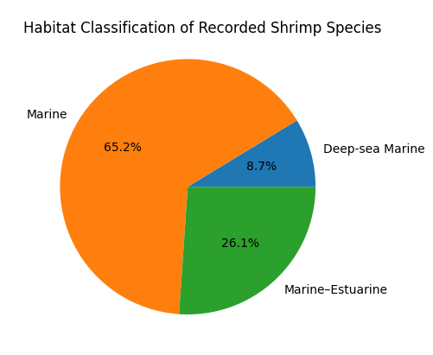
Figure 6. Functional Habitat Composition of Shrimp Assemblages
3.3. Diversity and Evenness Structure
The diversity indices indicate higher species diversity and evenness in the marine-dominated Neendakara zone compared to the brackish Puthenthuruth sector (Table 3). The Shannon index (H’) was markedly higher in Neendakara (3.031), reflecting greater species richness and more balanced abundance distribution. Similarly, the Simpson index (1-D) value of 0.948 suggests lower dominance and higher community stability in the marine zone. In contrast, the reduced Shannon (2.511) and Simpson (0.900) values in Puthenthuruth indicate comparatively lower diversity and greater dominance by a few estuarine-tolerant species. These patterns also support the significance of salinity as a structuring ecological factor influencing shrimp community composition along the Ashtamudi estuarine gradient.
Table 3. Diversity Indices of Shrimp Assemblages Across Salinity (%) Zones
Zone | Shannon Index (H’) | Simpson Index (1-D)
Neendakara (Marine) | 3.031 | 0.948
Puthenthuruth (Brackish) | 2.511 | 0.900

The K-dominance curve demonstrates a steeper and more rapidly rising cumulative dominance pattern in the Puthenthuruth (brackish) zone compared to the Neendakara (marine) zone (Fig. 7). The sharper ascent in the brackish sector indicates higher dominance by fewer species, reflecting reduced evenness and greater ecological filtering under lower salinity conditions. In contrast, the more gradual slope observed in the marine zone suggests a more evenly distributed community structure with lower dominance and higher diversity. This pattern further supports the influence of salinity as a regulating factor shaping shrimp assemblage organization along the Ashtamudi estuarine gradient.
Figure 7. K-Dominance Curves of Shrimp Assemblages in Marine and Marine–Brackish Zones

3.4. Community Similarity and Assemblage Segregation
The Sørensen similarity index of 0.85 indicates a high level of species overlap between the marine-dominated Neendakara and the marine-brackish Puthenthuruth zones (Table 4). Although species richness declined in the lower salinity sector, the majority of shrimp species recorded in Puthenthuruth were also present in Neendakara, reflecting strong ecological connectivity along the estuarine gradient. The absence of certain strictly marine and deep-sea taxa in the brackish zone slightly reduced similarity, but overall, the high index value supports the concept of marine-estuarine migration and habitat linkage within the Ashtamudi wetland system.
Table 4. Sørensen Similarity Index Between Marine and Marine–Brackish Shrimp Assemblages
Parameter | Value
Total species in Neendakara (S₁) | 23
Total species in Puthenthuruth (S₂) | 17
Shared species (C) | 17
Sørensen Similarity Index (2C / S₁+S₂) | 0.85

The hierarchical cluster analysis based on species abundance data shows clear segregation between the marine-dominated Neendakara zone and the marine-brackish Puthenthuruth zone (Fig. 8). The relatively high Euclidean Distance (based on abundance data) between the two clusters indicates distinct community structures shaped primarily by salinity differences. Although the Sørensen similarity index suggested strong species overlap, the dendrogram reveals quantitative divergence in abundance patterns, particularly due to the dominance of strictly marine and deep-sea taxa in the high-salinity zone and reduced representation in the brackish sector. This clustering pattern strengthens the role of salinity as a key environmental filter structuring shrimp assemblage.
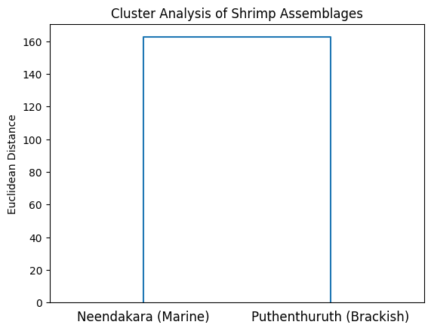
Figure 8. Hierarchical Cluster Dendrogram Showing Assemblage Segregation Between Salinity Zones
3.5. Functional Contribution of Migratory Species
The donut chart illustrates the migratory (marine-estuarine) shrimps constitute 26.1% of total recorded diversity, whereas strictly marine and deep-sea taxa contribute 73.9%. This representation effectively communicates the ecological significance of migratory penaeids in maintaining marine-estuarine connectivity within the Ashtamudi wetland system (Fig. 9).
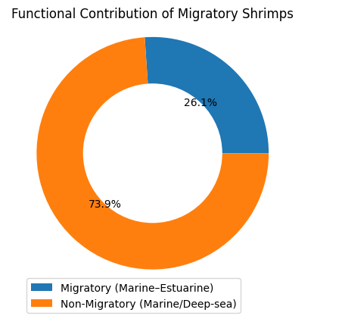
Figure 9. Proportional Contribution of Marine–Estuarine Migratory Species to Total Diversity
The present study demonstrates that shrimp assemblages in Ashtamudi are structured by a salinity-mediated environmental filter operating within a functionally connected marine-estuarine metacommunity. The clear segregation of deep-sea taxa and persistence of migratory penaeids highlight the ecological significance of estuarine nursery sectors in sustaining offshore spawning populations. Protecting hydrological integrity and salinity gradients is therefore critical not only for biodiversity conservation but also for long-term fisheries resilience under changing climatic conditions.
4. DISCUSSION
The present study demonstrates that shrimp assemblages in Ashtamudi Lake are strongly structured by salinity gradients, as evidenced by reduced species richness, lower Shannon diversity, higher dominance patterns, and quantitative segregation in cluster analysis within the marine–brackish sector. The absence of deep-sea marine taxa and the proportional persistence of marine–estuarine penaeids in the lower salinity zone indicate that salinity acts as a primary environmental filter regulating species distribution and abundance. Similar salinity-mediated structuring of penaeid communities has been widely documented in tropical estuaries and coastal lagoons (Jackson, 2017; Zink et al., 2017; Pérez-Castañeda et al., 2009). Experimental studies have further shown that growth performance, survival, and osmotic regulation of juvenile penaeids are strongly influenced by salinity regimes (Brito et al., 2000; Smith & Wu, 2011), supporting the ecological mechanisms underlying the observed spatial segregation in Ashtamudi.
The high Sørensen similarity index (0.85) coupled with distinct abundance-based clustering suggests that while species composition remains broadly connected between zones, population structure and dominance patterns vary substantially along the gradient. This reflects classical estuarine-marine dependency described for penaeids, where offshore spawning stocks recruit into estuarine nursery habitats before returning to marine waters (Rothlisberg, 1983; Dall et al., 1990; Pillay & Yousuf, 1999). Estuarine sectors function as growth and survival hotspots for juveniles, offering refuge and enhanced productivity (Minello & Zimmerman, 1991; Howe et al., 1999; Kenyon et al., 1997). Comparable zonation patterns have been reported in Mexican biosphere reserves and tropical lagoons, where penaeid density and size structure vary predictably across salinity-defined sub habitats (Pérez-Castañeda & Defeo, 2001, 2003; May-Kú & Ordóñez-López, 2006). The dominance of commercially important migratory taxa such as Penaeus monodon and Metapenaeus spp. further underscores the functional connectivity between marine and estuarine compartments.
From a regional perspective, Ashtamudi Lake represents a historically important brackish water prawn resource (Nair et al., 1980) and supports rich aquatic bioresources within its Ramsar-designated ecosystem (Vimal Raj et al., 2014). The present findings reinforce the concept of a salinity-structured metacommunity in which dispersal-driven connectivity and environmental filtering jointly regulate Penaeid assemblages. Any alteration in freshwater inflow, tidal exchange, or climate-driven salinity shifts may disrupt ontogenetic migration pathways and recruitment success, thereby affecting fisheries sustainability. Conservation of hydrological integrity and estuarine-marine linkages is therefore essential to maintain biodiversity stability and long-term shrimp fishery resilience in tropical coastal wetlands (Jackson, 2017; Zink et al., 2017; Dall et al., 1990).
Limitation of the Study: This study was based on short-term sampling conducted over two days during a single season (January 2024) and focused exclusively on penaeid shrimp assemblages. As penaeids exhibit seasonal and interannual variability influenced by monsoonal inflow, tidal exchange, and reproductive cycles, the results may not fully represent temporal dynamics in distribution and recruitment. Other shrimp genera observed in the area were not included in the analysis, and key environmental variables such as temperature, dissolved oxygen, and sediment characteristics were not incorporated. Long-term, multi-seasonal studies integrating broader ecological parameters would provide a more comprehensive understanding of penaeid community structuring and marine-estuarine connectivity.
5. CONCLUSION
The present study confirms that shrimp assemblages in Ashtamudi Lake are structured by a pronounced salinity gradient that functions as an ecological filter regulating species richness, dominance patterns, and community composition. The clear segregation of deep-sea marine taxa to the high-salinity marine zone, coupled with the persistence and relative prominence of marine-estuarine dependent penaeids in the brackish sector, highlights the lake’s role as a functionally connected marine-estuarine metacommunity. High species similarity alongside quantitative divergence in abundance patterns further supports the concept of ontogenetic migration and estuarine nursery utilization by commercially important shrimps. These findings underscore the ecological and fisheries significance of maintaining hydrological integrity and salinity balance within the Ramsar-designated Ashtamudi Wetland, particularly under increasing anthropogenic pressure and climate-driven alterations in freshwater inflow, to sustain biodiversity stability and long-term shrimp fishery resilience.
Disclaimer (Artificial intelligence)
Author(s) hereby declare that NO generative AI technologies such as Large Language Models (ChatGPT, COPILOT, etc.) and text-to-image generators have been used during the writing or editing of this manuscript.

References
- Alexander T. (2025). Ecological Distribution and Trophic Dynamics of Carnivorous Fishes across Salinity Gradient in Ashtamudi Lake, Southwest India. Asian Journal of Fisheries and Aquatic Research. 27 (12):152-162. https://doi.org/10.9734/ajfar/2025/v27i121046
- Brito, R.; Chimal, M.E.; Rosas, C. (2000). Effect of salinity in survival, growth, and osmotic capacity of early juveniles of Farfantepenaeus brasiliensis (decapoda: penaeidae). J. Exp. Mar. Biol. Ecol., 244, 253–263.
- Dall W, Hill B J, Rothlisberg P C, Staples DJ (1990). The biology of the Penaeidae. In: Blaxter JHS, Southward AJ (eds) Advances in marine biology, Vol 27, Academic Press, London, p 1–489
- Dholakia A D. (2010). Identification of prawns/shrimps of India and their culture. Daya Publishing House. New Delhi, India.
- Howe J C, Wallace R K, Rikard F S (1999). Habitat utilization by postlarval and juvenile penaeid shrimps in Mobile Bay, Alabama. Estuaries 22: 971–979
- Isabel P F, Kensley B F. (1997). Penaeids and Sergestoid shrimps and prawns of the world: keys and diagnoses for the families and genera. Paris: Muséum national d’Histoire naturelle.
- Jackson, S. M. (2017). Salinity effects on abundance, growth, and distribution of penaeid shrimps: A review. Estuarine, Coastal and Shelf Science, 198, 1–12. https://www.sciencedirect.com/science/article/abs/pii/S1470160X17303011?utm_source=chatgpt.com
- Kenyon R A, Loneragan N R, Hughes J M, Staples D J (1997). Habitat type influences the microhabitat preference of juvenile tiger prawns (Penaeus esculentus Haswell and Penaeus semisulcatus De Haan). Estuarine, Coastal and Shelf Science, 45: 393–403
- López-González, C. A., & Rocha-Olivares, A. (2014). Environmental factors influencing penaeid shrimp distribution in the Soto la Marina River estuary. Retrieved from https://www.preprints.org/frontend/manuscript/663b37f567aea05a11dbb9744ddcfff0/download_pub?utm_source=chatgpt.com
- May-Kú, M.A., Ordóñez-López, U. (2006). Spatial patterns of density and size structure of penaeid shrimps Farfantepenaeus brasiliensis and Farfantepenaeus notialis in a hypersaline lagoon in the Yucatan Peninsula, Mexico. Bull. Mar. Sci., 79, 259–271.
- Minello T J, Zimmerman R J (1991). The role of estuarine habitats in regulating growth and survival of juvenile penaeid shrimp. In: Deloach PF, Dougherty WJ, Davidson MA (eds) Frontiers of shrimp research. Elsevier, Amsterdam, p 1–16
- Pérez-Castañeda R, Defeo O (2001) Population variability of four sympatric penaeid shrimps (Farfantepenaeus spp.) in a tropical coastal lagoon of Mexico. Estuar. Coast. Shelf Sci. 52:631–641
- Pérez-Castañeda R, Defeo O (2003) Influence of estuarine zonation on exploited shrimp populations in a Mexican biosphere reserve: a feature for management and conservation. J. Mar. Biol. Assoc. UK 83:781–784
- Pérez-Castañeda, R., Ceballos-Vázquez, B. P., & López-Uriarte, E. C. (2009). Spatial distribution and structure along ecological gradients: Penaeid shrimps in a tropical estuarine habitat of Mexico. Journal of Sea Research. https://www.researchgate.net/publication/240809260_Spatial_distribution_and_structure_along_ecological_gradients_Penaeid_shrimps_in_a_tropical_estuarine_habitat_of_Mexico
- Pillay, K. K., & Yousuf, A. R. (1999). Migration in prawns with reference to salinity and estuarine recruitment. Indian Journal of Fisheries. Retrieved from https://connectjournals.com/file_full_text/1820201H_33-48.pdf?utm_source=chatgpt.com
- Reddy KN. (1995). Crustacea: Decapoda. Zool. Surv. India, Wetland Ecosystem Series 1: fauna of Chilika Lake. 367–389. Edited by The Director, Zoological Survey of India, Kolkata, India.
- Rothlisberg, P. C. (1983). Estuarine–marine dependency in penaeid shrimps. Journal of Marine Research, 41(2), 371–389. Retrieved from https://elischolar.library.yale.edu/cgi/viewcontent.cgi?article=2691&context=journal_of_marine_research&utm_source=chatgpt.com
- Smith, D. L., & Wu, R. S. S. (2011). Variation in penaeid shrimp growth rates along an estuarine salinity gradient. Journal of Experimental Marine Biology and Ecology, 409, 10–18. Retrieved from https://www.sciencedirect.com/science/article/abs/pii/S0022098110004946?utm_source=chatgpt.com
- Zink, I.C, Browder, J.A, Lirman, D., Serafy, J.E. (2017). Review of salinity effects on abundance, growth, and survival of nearshore life stages of pink shrimp (Farfantepenaeus duorarum). Ecol. Indic., 81, 1–17
- Nair, P.V., Piḷḷai, N.N., Pillai, V.K., Pillai, P.P., Mathew, K.J., Gopinathan, C.P., Balachandran, V., & Vincent, D. (1980). Brackishwater prawn farming in the Ashtamudi Lake area (S.W. coast of India) under a demonstration project. Its prospects and problems. Indian Journal of Fisheries, 27(1–2), 1–16.
- Vimal Raj, R. V., Binushma Raju, Soumya, W., Shibu, A., Lekshmi, S., Shibu Vardhanan, Y., Sruthi, S., & Radhakrishnan, T. (2014). Aquatic bioresources of Ashtamudi Lake, Ramsar site, Kerala. Journal of Aquatic Biology & Fisheries, 2(1): 297–303. https://keralamarinelife.in/Journals/Vol2-1/39%20Vimal%20Raj%20R%20V.pdf

