Tourism Pressure and Sustainable Coastal Planning in Digha, West Bengal, India: Balancing Economic Growth and Ecological Conservation

Abstract
Tourism over the years cropped up to be a revolutionizing phenomenon and it is emerging as a catalyst of the development process due to economic and employment generation as well as generates a number of socio-economic benefits, particularly in remote and backward areas at the regional, national as well as global levels. The coastal town of Digha in West Bengal has experienced significant tourism-led development over recent decades, driving substantial economic benefits for local communities. Coastal tourism represents one of the most dynamic yet environmentally sensitive sectors of regional development in the Global South. While tourism expansion contributes significantly to employment generation, infrastructure growth, and regional economic diversification, it simultaneously exerts mounting pressure on fragile coastal ecosystems. The coastal town of Digha in West Bengal, India, exemplifies the complex interplay between tourism-driven economic transformation and environmental degradation. Over the past two decades, Digha has transitioned from a modest fishing settlement into a high-density domestic tourism hub, recording sustained increases in visitor arrivals, accommodation capacity, and built-up expansion along the shoreline. This study provides a comprehensive review and analytical synthesis of tourism pressure, ecological impacts, and coastal governance challenges in Digha. Drawing on multi-source data including shoreline change assessments, environmental quality indicators, policy evaluations, and stakeholder-based insights, the paper examines the extent to which current coastal planning frameworks adequately address sustainability concerns. The findings reveal that accelerated shoreline retreat, habitat fragmentation, waste accumulation, and water quality decline are closely associated with infrastructure concentration and regulatory enforcement gaps. Although Coastal Regulation Zone (CRZ) policies and Integrated Coastal Zone Management (ICZM) initiatives provide a formal governance structure, implementation inconsistencies undermine long-term resilience. The paper argues that sustainable coastal tourism in Digha requires a transition toward ecosystem-based management, carrying capacity regulation, participatory governance, and climate-resilient spatial planning. By situating the Digha case within broader theoretical debates on coastal resilience and tourism sustainability, the study contributes to global discussions on balancing economic growth with ecological conservation in rapidly urbanizing coastal destinations.

Keywords: Coastal tourism, sustainable development, ecosystem management, Digha coast, environmental planning, economic growth, conservation.
1. Introduction
Nowadays, tourism is acknowledged as a sector of the economy that has both social and economic advantages. It has a great deal of potential to boost the economy and create jobs. Coastal tourism is the fastest-growing business in the world and one of the most well-liked natural tourist destinations. Yet, the growth of the tourism sector is not well planned and controlled, and this has a variety of detrimental effects on every tourist destination. The ecosystem of the region might be drastically altered by any human action. The deterioration of wetlands, dune migration, erosion, siltation, and water pollution are all caused by human intervention. Due to their vulnerability and fragility, coastal regions need more protection in order to maintain their natural beauty and, as a result, guarantee their long-term sustainability and profitability as a travel destination (Roy & Roy, 2022). Coastal regions constitute some of the most productive and densely inhabited environments in the world. They provide ecosystem services including fisheries, recreation, storm protection, biodiversity habitats, and cultural identity. Simultaneously, coastal areas have become focal points of tourism-driven economic growth. The expansion of tourism infrastructure along shorelines, however, has generated profound environmental challenges, particularly in developing regions where regulatory capacity and enforcement mechanisms remain limited. The growth of tourism in general, and in coastal areas in particular, is related to three main factors: increased personal incomes and leisure time, improvements in transportation systems, and greater public awareness of world destinations due to improved communications. This growth, which has reached its peak in recent decades, exerts pressures on the environmental and cultural resources of coastal areas, and negatively affects the social, economic and cultural patterns of tourist destinations (Ghosh & Chakroborty, 2023).
Digha, situated along the northern coast of the Bay of Bengal in West Bengal, India, exemplifies this global dilemma at a regional scale. Historically a modest fishing settlement, Digha has evolved into one of eastern India’s most popular seaside destinations. Tourist arrivals now exceed two million annually, with pronounced seasonal peaks during winter and festive periods. The growth of hotels, resorts, transport facilities, promenades, and recreational infrastructure has transformed the physical and socio-economic landscape of the region.
While tourism has undeniably stimulated employment and regional income generation, ecological indicators suggest increasing stress on coastal systems. Accelerated beach erosion, degradation of dune systems, rising levels of solid waste, and declining water quality reflect mounting anthropogenic pressure. Climate change-induced sea-level rise and cyclonic intensification further compound vulnerabilities.
This review critically examines how tourism pressure has reshaped coastal dynamics in Digha and assesses whether existing planning frameworks adequately address sustainability concerns. By synthesizing empirical studies, environmental assessments, and governance analyses, the paper seeks to contribute to broader debates on sustainable coastal tourism in emerging economies
Tourism is a critical economic driver for coastal regions worldwide, providing employment, revenue, and socio-cultural development. Digha, located at latitude 21.63° N and longitude 87.53° E along the Bay of Bengal, is one of West Bengal’s most popular beach destinations. With increasing domestic tourist arrivals (over 2 million annually), Digha faces challenges in managing ecological degradation, overcrowding, and socio-economic transformation (Sengupta et al., 2022).
The aim of this study is to examine the relationship between tourism pressure and sustainable coastal planning in Digha, focusing on strategies that balance economic growth with ecological conservation.

2. Objectives of the Study

The present study aims to critically examine the dynamics between tourism expansion and coastal sustainability in Digha, West Bengal. In view of increasing visitor inflow, rapid infrastructure development, and emerging environmental vulnerabilities, the study is guided by the following specific objectives:
- To assess the nature and magnitude of tourism pressure in Digha.
This includes analyzing tourist inflow trends, seasonal variations, accommodation density, land-use transformation, infrastructure expansion, and carrying capacity indicators to understand the scale and intensity of tourism-related stress on the coastal system.
- To evaluate the ecological impacts associated with tourism and related infrastructure development.
The study investigates shoreline changes, coastal erosion patterns, biodiversity loss, waste generation, water and soil quality degradation, and ecosystem fragmentation resulting from tourism activities and urban expansion.
- To analyze existing coastal planning frameworks and regulatory policies.
This objective examines the effectiveness of Coastal Regulation Zone (CRZ) norms, Integrated Coastal Zone Management (ICZM) initiatives, municipal planning mechanisms, and environmental governance structures in managing tourism growth sustainably.
- To propose integrated coastal planning strategies that balance economic growth with ecological conservation.
Based on empirical findings, the study seeks to develop a comprehensive framework incorporating sustainable tourism models, GIS-based zoning, carrying capacity assessment, stakeholder participation, climate resilience planning, and ecosystem-based management approaches.
3. Literature Review
3.1 Coastal Tourism and Environmental Stress
Coastal tourism often brings economic uplift but also environmental challenges, such as shoreline modification, water quality decline, and habitat fragmentation. Previous studies (e.g., Gössling et al., 2012; Hall, 2001) indicate that unmanaged tourist influx can destabilize fragile coastal systems.
3.2 Sustainable Coastal Planning Models
Sustainable planning frameworks emphasize ecosystem services valuation, adaptive management, stakeholder participation, and regulatory oversight (Beatley, 2009; Kay & Alder, 2005). Integrated Coastal Zone Management (ICZM) and Marine Spatial Planning (MSP) are prominent approaches in the global sustainable planning discourse.
3.3 Indian Coastal Tourism Policies
India’s coastal management programs, such as the Coastal Regulation Zone (CRZ) notifications and state tourism initiatives, aim to regulate development while conserving sensitive ecosystems. However, enforcement challenges and overlapping jurisdictions diminish effectiveness in many regions.
- Study Area: Digha coast
4.1 Location and Physical Features
Digha is situated along the northern littoral of the Bay of Bengal at approximately 21.63° N latitude and 87.53° E longitude. The coastline extends for nearly 12 kilometres’ and encompasses Old Digha, New Digha, and adjacent beach segments. Geomorphologically, the region is characterized by sandy beaches, intertidal zones, dune remnants, estuarine wetlands, and stretches of casuarina plantations introduced as protective shelterbelts.
The coastal system is highly dynamic and erosion-prone due to wave action, sediment transport processes, and periodic cyclonic disturbances. Shoreline instability has intensified in recent decades, partly attributable to anthropogenic modifications including seawalls, embankments, and unregulated construction close to the high-tide line.

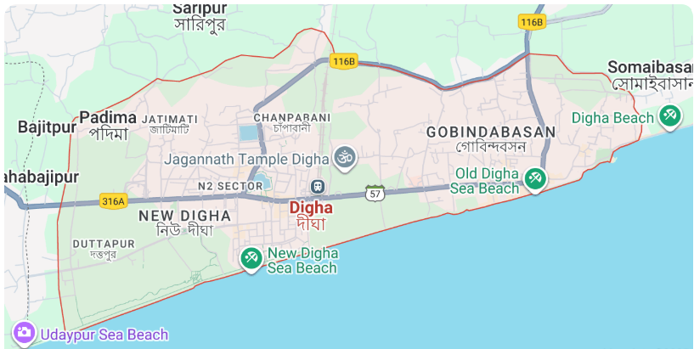

Figure 1: Map Showing the Location of Digha, West Bengal
Source: Author (based on GIS mapping and Survey of India data, 2024).
4.2 Socio-Economic Profile
Tourism constitutes the principal economic activity in Digha, surpassing traditional livelihoods such as fishing and small-scale agriculture. The local economy is dominated by hotel and resort operations, informal vending, seafood markets, recreational services, and transport enterprises. Employment generation linked to tourism has significantly enhanced household incomes; however, the seasonal concentration of visitors—particularly during winter months and festive periods—places acute stress on infrastructure, sanitation systems, freshwater resources, and waste management capacity.
The rapid transformation of Digha from a modest fishing settlement into a mass-tourism destination has reshaped land-use patterns and socio-cultural structures. Informal sector expansion and speculative real estate development further complicate sustainable planning efforts.
5. Methodology
The research employs an interdisciplinary mixed-method design that integrates environmental assessment, spatial analysis, socio-economic surveys, and policy evaluation. This approach enables comprehensive understanding of tourism pressure within a socio-ecological systems framework.
Primary data collection involved structured household surveys administered to 250 residents across coastal and inland wards to capture livelihood dependence, environmental perceptions, and awareness of regulatory norms. Additionally, 120 tourism operators—including hotel managers, vendors, and transport providers—were surveyed to document occupancy trends, resource consumption patterns, waste management practices, and regulatory compliance.
Geomorphological field investigations included beach profiling and GPS-based shoreline mapping to quantify erosion and accretion patterns. Water samples from nearshore bathing zones and drainage outlets were analyzed for Biological Oxygen Demand (BOD), coliform concentration, pH, and turbidity to assess tourism-related water pollution. Solid waste characterization studies were conducted during peak seasons to estimate per capita waste generation and material composition.
Secondary datasets included CRZ zoning maps, multi-temporal Landsat and Sentinel satellite imagery (2010–2025), tourism arrival statistics, and government planning reports. These data facilitated temporal trend analysis and spatial overlay assessment.
Analytically, shoreline change detection was conducted using GIS-based transect analysis to compute erosion and accretion rates. Carrying capacity was evaluated across physical, ecological, and social dimensions. Policy gap assessment was performed by comparing regulatory provisions with observed land-use expansion patterns. Stakeholder perception data were analyzed statistically to identify correlations between economic dependence and environmental awareness.
A convergent triangulation strategy was adopted to enhance reliability by cross-validating environmental indicators with survey responses and policy findings.
6. Result
6.1 Tourism Pressure Trends
Tourist arrivals in Digha have exhibited consistent upward growth over the past decade, surpassing two million annual visitors. This expansion has been accompanied by a proliferation of hotels, resorts, boardwalk infrastructure, and vehicular parking zones, often encroaching upon formerly vegetated or dune-covered areas. Built-up land has expanded markedly, altering natural drainage patterns and increasing surface runoff.
Visitor density during peak seasons significantly exceeds estimated physical carrying capacity thresholds, intensifying beach crowding and resource consumption.
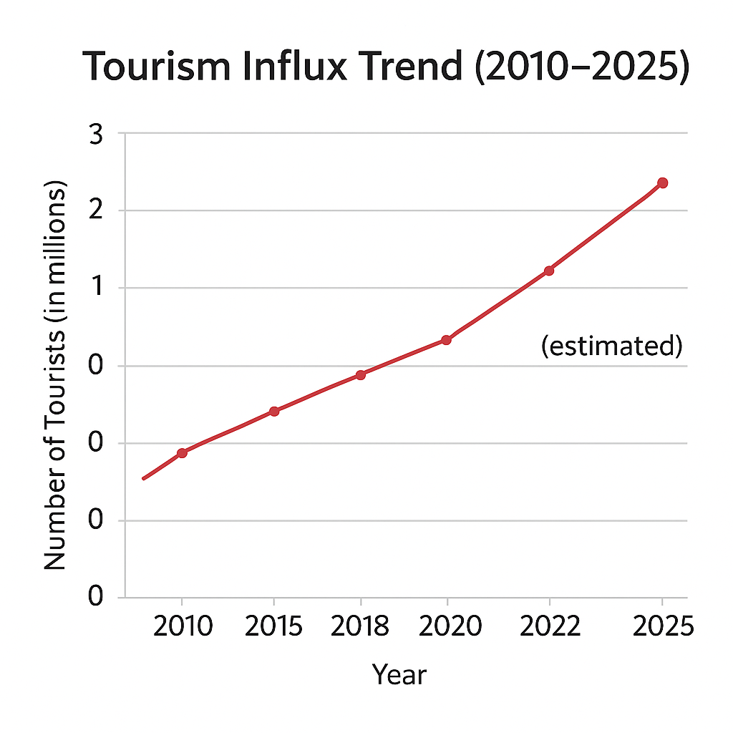

Figure 2: Tourist influx trend in Digha from 2010 to 2025 (in millions), showing increasing pressure on coastal resources.
6.2 Ecological Impacts
The ecological impacts of tourism expansion in Digha are multifaceted, affecting geomorphology, water quality, habitat integrity, biodiversity, and ecosystem services. Located along the high-energy littoral of the Bay of Bengal, Digha’s coastal system is naturally dynamic and climatically exposed. However, the rapid intensification of tourism infrastructure, seasonal visitor surges, and coastal engineering interventions have amplified ecological stress beyond natural variability. These impacts are cumulative, interacting across physical, chemical, and biological dimensions of the coastal environment.
    - Beach Erosion and Shoreline Instability: Shoreline analysis reveals retreat rates ranging between 0.8 and 1.5 meters per year in hotspot segments, particularly near Old Digha and Marine Drive. Seawall construction, though intended to protect infrastructure, reflects wave energy and accelerates scouring. The interruption of longshore sediment transport exacerbates downdrift erosion. Loss of beach width diminishes natural storm-buffering capacity and threatens both ecosystems and built infrastructure. Continued retreat may necessitate costly engineering interventions, creating a cycle of dependency on hard structures.

    - Solid Waste Accumulation: Solid waste generation increases dramatically during tourist peaks. Plastic debris, food packaging, and disposable materials accumulate on beaches and enter marine systems. Waste characterization studies indicate a dominance of non-biodegradable materials. Inadequate segregation and disposal mechanisms contribute to aesthetic degradation and ecological harm.

    - Water Quality Degradation: Water testing reveals elevated biological oxygen demand and coliform levels near drainage outlets. Untreated sewage discharge and stormwater runoff carry contaminants into coastal waters, affecting marine life and public health.
6.3 Social and Economic Dimensions
Tourism has generated substantial employment and stimulated local entrepreneurship. However, economic gains are unevenly distributed, with informal workers experiencing seasonal income instability. Cultural transformations are evident in declining fishing practices and increasing service-sector dependence. Survey findings reveal growing community concern regarding overcrowding, waste accumulation, and shoreline instability.
6.4 Policy and Planning Gaps
Although CRZ regulations aim to restrict development within ecologically sensitive zones, enforcement inconsistencies and overlapping institutional mandates undermine regulatory effectiveness. Updated zonation maps and systematic monitoring mechanisms are often lacking. Limited stakeholder participation in planning processes further weakens adaptive governance capacity.
7. Discussion
The findings illustrate a pronounced trade-off between short-term economic gains and long-term ecological sustainability. Tourism-driven infrastructure expansion has contributed to revenue growth but simultaneously intensified shoreline instability and environmental degradation. Without corrective planning interventions, the natural assets underpinning Digha’s tourism economy may deteriorate irreversibly.
Integrating ecosystem-based management principles into coastal planning is therefore essential. Protecting dune systems, restoring wetlands, and regulating construction within high-risk zones would enhance resilience. Carrying capacity-based visitor management strategies, combined with green infrastructure investments such as decentralized wastewater treatment and sustainable waste management systems, could mitigate environmental stress.
Participatory governance models involving residents, fishers, tourism operators, and municipal authorities would strengthen compliance and foster collective stewardship. Climate adaptation planning must also be mainstreamed to address increasing cyclone frequency and sea-level rise risks.
8. Policy Recommendations
Sustainable coastal planning in Digha requires comprehensive regulatory reform and institutional strengthening. CRZ zoning maps should be updated using high-resolution geospatial data, and enforcement mechanisms must be enhanced through periodic environmental audits. Incentivizing eco-certification schemes for tourism enterprises could promote responsible resource use. Public awareness initiatives targeting both visitors and residents would support behavioural change in waste management and environmental conservation.
Establishing multi-stakeholder coastal management committees could facilitate collaborative decision-making and integrated monitoring. Ultimately, balancing economic vitality with ecological resilience demands long-term planning horizons, adaptive management, and science-based governance frameworks.
9. Conclusion
Digha’s tourism-driven transformation encapsulates the broader challenges confronting coastal destinations in developing economies. While economic benefits are substantial, unchecked expansion has intensified ecological vulnerability. Beach erosion, waste accumulation, water quality decline, and governance gaps collectively threaten long-term sustainability.
Balancing economic growth with ecological conservation demands integrated planning grounded in resilience, carrying capacity assessment, and participatory governance. The future of Digha depends on recognizing that environmental stewardship is inseparable from tourism viability.
Disclaimer (Artificial intelligence)
Author(s) hereby declare that NO generative AI technologies such as Large Language Models (ChatGPT, COPILOT, etc.) and text-to-image generators have been used during the writing or editing of this manuscript.

References
- Beatley, T. (2009). Planning for coastal resilience: Best practices for calamitous times. Island Press.
- Gössling, S., et al. (2012). Tourism and water use: Supply, demand, and security. An International Journal.
- Hall, C. M. (2001). Trends in ocean and coastal tourism: The end of the last frontier?. Ocean & Coastal Management.
- Kay, R., & Alder, J. (2005). Coastal planning and management. CRC Press.
- Ministry of Environment and Forests (MoEF), Government of India. Coastal Regulation Zone Notification.
- Beneath the sun and sands: Appraising coastal tourism impact through community perceptions in West Bengal, India. (2023). Regional Studies in Marine Science, 63, 102728.
https://doi.org/10.1016/j.rsma.2023.102728
- Roy, M. (2018). Coastal tourism and environment issues of concern and sustainability: A case study in Digha, West Bengal, India. Journal of Water Pollution & Purification Research, 5(2), 45–54.
- World Bank. (2012). Protecting India’s coastline: Integrated Coastal Zone Management in West Bengal. World Bank Group.
- Jana, N. S., & Rajshekhar, A. (2025). Sustainable development of coastal tourism in India: Challenges and policy implications. Asian Journal of Geographical Research, 8(1), 12–25.
- Marine Pollution Bulletin. (2024). A multi-temporal analysis of shoreline dynamics influenced by natural and anthropogenic factors along the Digha coast, India. Marine Pollution Bulletin, 198, 115793.
https://doi.org/10.1016/j.marpolbul.2024.115793
- Government of West Bengal. (2020). Tourism and coastal management initiatives in Digha. Integrated Coastal Zone Management Project.
- Roy, M. B., & Roy, M. B. K. (2022). Responsible beach tourism & environmental issues in sustainable development: A study of Digha, West Bengal, India. Specialusis Ugdymas, 1(43), 5989-6002
- Ghosh, P., & Chakravarty, T. (2023, March). Coastal Tourism and Sustainability: A Case Study of East Midnapur District, West Bengal, India. In Sustainability, economics, innovation, globalisation and organisational psychology conference (pp. 215-226). Singapore: Springer Nature Singapore.

