Determinants of Investment Intention: Evidence from Investors in Surabaya Capital Market Using a TPB Framework

.
ABSTRACT

Background: Investment intentions are often influenced by personality traits or a person's way of acting when deciding something. Personality traits are a person's way of acting which is shown or applied in an attitude, character, belief, and so on. The small ratio of the number of investors to the population in Indonesia raises the question of what motivates the entry of new investors in the Indonesian capital market.
Aims: This research is conducted by testing and analyzing the variables of financial attitude, subjective norms, financial self-efficacy, and financial knowledge on investment intention.
Study design: This research type is comparative causal research. The population was all investors in Surabaya City.
Place and Duration of Study: The sampling technique used was accidental sampling. The analysis technique used is structural equation modeling (SEM) with Amos 24 software.
Methodology: These tests and analyzes are carried out directly and indirectly or through mediated relationships through financial attitude and financial self-efficacy. The sample size for analysis using Structural equation modeling (SEM) which uses the Maximum Likelihood Estimation (MLE) model is 100 – 200 samples. The researcher's sample size was determined as 135 respondents and has entered the size range that can be used in SEM analysis. SEM evaluation is used to test model fit which can be assessed based on testing various fit indices obtained from AMOS based on evaluating the fulfillment of SEM assumptions, namely normality assumptions, outlier assumptions, and multicollinearity and singularity assumptions.
Results: The conclusion is that financial attitude has a positive and significant effect on investment intentions. Subjective norms have a positive and insignificant effect on investment intentions in the capital market. Financial self-efficacy has a positive and insignificant effect on investment intentions in the capital market. Financial knowledge has a positive and significant effect on investment intentions in the capital market. Financial knowledge has a positive and significant effect on financial attitude in the capital market. Personality traits have a positive and insignificant effect on investment intentions in the capital market. Personality traits have a positive and significant effect on financial self-efficacy. Financial knowledge on investment intention mediated by financial attitude has a significant relationship. Personality traits on investment intention mediated by financial self-efficacy are not significant.
Conclusion: The contributions of this research are expected to facilitate further understanding of the factors that influence investment intentions, especially in Surabaya, and enrich the financial behavior literature with adjustments and additional variables in the Theory of Planned Behavior (TPB) framework.

Keywords: Financial Attitude;,Financial Self-efficacy;Financial Knowledge;Investment Intentions;Personality Traits.

1. INTRODUCTION

The development of well-functioning and robust stock markets is a critical component for strengthening the financial systems of developing countries. Efficient stock markets facilitate capital mobilisation by enabling firms to access long-term funding, improve the allocation of financial resources, and provide diverse investment opportunities for both domestic and international investors. Beyond their role in capital formation, developed stock markets contribute to financial deepening, enhance market transparency, and support the efficient pricing of risk. Empirical evidence from a range of economies consistently demonstrates a positive association between stock market development and economic growth. By promoting investment, encouraging entrepreneurship, and improving the efficiency of resource allocation, well-developed equity markets can act as catalysts for broader economic expansion, industrial development, and sustainable wealth creation in developing nations (Eshpulatov et al., 2025).

Stock investments have gained considerable popularity in the capital market due to their potential to generate substantial long-term gains. A deeper understanding of the factors influencing stock investment intentions can provide better insights for investors, financial institutions, and capital market regulators. In this way, stakeholders within a company can develop more effective strategies to increase public participation in the capital market and provide information that can support investors in making wiser investment decisions (Putri et al., 2025). Indonesian capital market investors grew 89.58% to 7.3 million SID. This number is the consolidated number of SIDs consisting of investors in shares, debt securities, mutual funds, government securities (SBN) and other types of securities registered at KSEI, with a composition of 3.4 million SIDs that have stock assets, 6.7 million SIDs have mutual fund assets and 607 thousand SIDs have SBN assets. The demographic data for investors in Indonesia is currently dominated by 62.55% men, 59.84% under 30 years old, 32.88% private employees, 58.33% undergraduate graduates, 36.25% earning 10-100 million/month and 69.84% live on the island of Java (KSEI, 2021).
Graph 1.The Number of Capital Market Investors in Indonesia
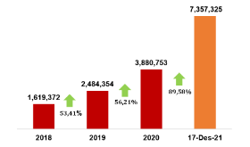
Source: (KSEI, 2021)
There are many reasons for the increase in the number of capital market investors in Indonesia. Firstly, the capital market offers the possibility of "additional income" and getting a return on invested capital. Second, the flexibility of capital market instruments means that one can quickly liquidate the funds they have invested. Lastly is diversity, which means that investors can find assets that suit their investment goals, among the various financial assets available. In addition, there is an increasing trend towards managing one's own pension funds (Clark-Murphy & Soutar, 2004). However, this increase is still far from the total population of Indonesia; the total population in Indonesia, the latest data recorded by the Central Statistics Agency (BPS) in 2021 amounted to 272,682.5 thousand people. So, if we calculate the percentage ratio between the number of investors and the population in Indonesia, we only get 2.70%. The small ratio of the number of investors to the population in Indonesia raises the question of what motivates the entry of new investors in the Indonesian capital market.
Investment intentions, which underpin subsequent decision-making in capital markets, have long been recognised as a complex and challenging area of study. Formulating sound investment decisions requires careful deliberation, analytical reasoning, and a rational appraisal of both market conditions and individual objectives (Rubaltelli et al., 2010). Investors must weigh expected returns against associated risks, consider behavioural and cognitive biases, and integrate available financial information to arrive at informed choices. Consequently, understanding the determinants of investment intentions is critical for explaining investor behaviour and predicting capital market outcomes. According to the Global Survey of Individual Investors (NATIXIS, 2016) survey, it is stated that around 32 percent of investors generally fail to understand their investment goals and around 30 percent of investors are entangled between their views and the advice of their financial advisor. Additionally, individual investors are misinformed, confused and conflicted between what they want and what they can actually get. Previous studies have shown that individual investors fail to align expected returns with risk tolerance (Hoffmann & Post, 2017) and approximately 30 percent of investors believe they can make the right decisions but fail to achieve their investment goals (NATIXIS, 2016). Therefore, investment intentions require special analytical knowledge, in this case, financial knowledge, to be confident about the performance of the shares that will be selected in overall stock investment (Baker et al., 2020).
Investment intentions are frequently shaped by individual personality traits, which influence the ways in which a person approaches decision-making in financial contexts. Personality traits reflect consistent patterns of thought, behaviour, and emotional response, and are expressed through attitudes, character, beliefs, and habitual actions (Subiaktono, 2013). In the context of investment, these traits can affect risk tolerance, information processing, and decision-making style, thereby playing a pivotal role in shaping both the formation and execution of investment intentions. Understanding the interplay between personality and investment behaviour is therefore essential for explaining variations in investor choices and market participation. A person will be better at carrying out financial planning the better the personality traits they have (Triyonowati, 2022). So, personality traits are one of the factors originating from a person's personality that can influence the way they plan their finances. Personality traits are needed by an individual in determining the need to organize good management methods. The personality traits possessed are Preference for Innovation (PI) and risk-taking propensity to enable individuals to have positive confidence in their ability to manage their finances.
Investment intentions also sometimes come from invitations from friends or family. This invitation is also known as Subjective Norms. Subjective norms are social encouragement from individuals/society to carry out certain actions (Ajzen, 1991). An individual who has an understanding in the financial sector who has invested in shares, then tells his friends about the profits he has obtained, this will also encourage the investment intentions of these friends (Phan & Zhou, 2014). The logical thinking is that an individual or investor will have high investment intentions when he or she has social encouragement or subjective norms to carry out investment activities. This encouragement can come from friends, family, or lecturers who teach courses on investing. This social encouragement is obtained when someone tells about their success in investing, making profits and reducing risks, then that individual will be encouraged to invest in the capital market. The state of mind of friends who are influenced by opinions and assessments about finances in depth by one individual is the definition of financial attitude (Klontz et al., 2011).
Apart from that, individuals with high levels of financial attitude and financial knowledge will tend to have a positive financial attitude towards planning in managing finances (Mindra & Moya, 2017). These financial attitudes include saving, borrowing, using insurance products, influencing financial inclusion, and investing. Therefore, if someone has a favorable attitude towards investment intentions, there is a possibility that they will develop a positive financial attitude towards carrying out these investment intentions. The majority of research has illustrated that financial attitude has a positive and significant impact on investment intentions (Gopi & Ramayah, 2007; Phan & Zhou, 2014). An individual's financial attitude also plays an important role in developing the intention to invest, in achieving the desired level of financial stability (Ali, 2011).
Beliefs about financial management also have a strong impact on goals and achievements by influencing our personal choices, motivations and emotional reactions to investment intentions. For example, if we tend to avoid risk, then our ability is limited to investment choices that have low risk and vice versa. The level of effort and persistence shown by a person in determining their investment intentions is called financial self-efficacy. Previous research shows that financial self-efficacy can improve the way finances are managed, so that financial satisfaction can be felt (Sina, 2013). In fact, financial self-efficacy also has an influence on decisions taken in managing teenagers' finances (Danes & Haberman, 2007).
On the other hand, financial knowledge also has a relationship with finances in everyday life. Financial knowledge is not only able to make someone use money wisely, but can also provide benefits to the economy. A person with a high level of financial knowledge will be better able to make good decisions for their family, and thus be in a position to increase their economic security and well-being. In addition, someone who has a high level of financial knowledge can also make informed choices that are very important for their financial goals. Someone with a high level of financial knowledge will also understand financial matters better and be wiser in terms of their financial behavior (Ilahiyah et al., 2021). So, the better the knowledge about finance, the more it triggers someone to make investment intentions. Financial knowledge can be acquired if someone applies financial skills and starts using financial tools. Financial skills are a technique for making decisions regarding financial management, for example preparing a financial budget, weighing and choosing investments, establishing insurance plans, and using credit. Meanwhile, financial tools are tools used when making financial management decisions, for example, credit cards, checks, e-money, etc. (Dwinta, 2010).
An individual who wants to avoid financial problems must be willing to increase their level of financial knowledge. Financial ignorance can have fatal consequences, such as having larger debts and higher loan interest rates than one's financial capabilities (Lusardi & Scheresberg, 2013; Lusardi & Tufano, 2015). Increasing financial knowledge can also help achieve a quality standard of living and avoid financial problems, provided that it is based on good financial knowledge in every decision-making such as increasing financial literacy (Mindra & Moya, 2017). So, by having financial knowledge an individual can have a good financial attitude. According to (Klapper et al., 2011), individuals with knowledge of four basic financial concepts, namely, numeracy, risk diversification, inflation and compound interest, are said to be financially literate.
The majority of the Indonesian population or around 68% want a better old age (retirement), which is in accordance with the results of the survey, The Future of Retirement: Bridging the Gap (HSBC, 2019). However, this must be planned carefully from early on. Unfortunately, this awareness usually arises when someone is approaching retirement. Even, in fact, only a small portion of the Indonesian population invests, where the average investor in Indonesia has not yet reached 1 percent of the total population, so it is necessary to conduct further studies regarding investment intentions in Indonesia. Therefore, this research was carried out by testing and analyzing the variables financial attitude, subjective norms, financial self-efficacy, and financial knowledge on investment intentions. This test and analysis is carried out directly and indirectly or through a mediated relationship through financial attitude and financial self-efficacy. This research focuses on analysing investment intentions within the framework of the Theory of Planned Behavior (TPB). So, we will also explore how variables such as financial attitude, financial self-efficacy, subjective norms, financial knowledge, and personality traits influence investment intentions. It is hoped that the contribution of this research will facilitate further understanding of the factors that influence investment intentions, especially in Surabaya, as well as enrich the financial behaviour literature by adjusting and adding variables within the TPB framework. Apart from that, it is also hoped that it can provide a clear view of the parameters and limitations applied in research regarding investment intentions. Therefore, a hypothesis is formulated as follows:
H1: Financial Attitude has a significant influence on Investment Intentions
H2: Subjective Norms have a significant influence on Investment Intentions
H3: Financial self-efficacy has a significant influence on investment intentions
H4: Financial Knowledge has a significant influence on Investment Intentions
H5: Financial Knowledge has a significant influence on Financial Attitude
H6: Personality Traits Have a Significant Influence on Investment Intentions
H7: Personality Traits have a significant influence on financial self-efficacy
H8: Financial Knowledge has a significant influence on Investment Intentions which is mediated by Financial Attitude
H9: Personality Traits have a significant influence on investment intentions which are mediated by financial self-efficacy

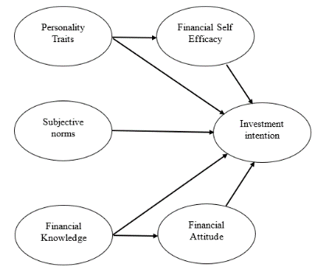
Figure 1 Conceptual Framework of Research
2.METHODS
The type of research used in this research is comparative causal research in the form of a cause-and-effect relationship between two or more variables. The population in this research is all investors in the city of Surabaya, whose number is unlimited. The selection of investors as a population is because they understand the concept of investment and have invested in the Indonesian capital market, so that the data collected will not cause bias in the results of this research data test. Meanwhile, the sampling technique used in this research is Accidental Sampling. Accidental Sampling is a technique for determining samples that coincidentally meet researchers and can be used as samples, if it is deemed that the person they meet by chance is suitable as a data source (Sugiyono, 2018). Sampling was carried out by visiting investors' gathering places during investor forum activities at the IDX East Java representative office or at the Stock Exchange Investment Gallery in the Surabaya City area and then by chance meeting investors at the forum, with the following respondent criteria:
  - Respondents who already have a Single Investor Identification (SID) because they have invested in the Indonesian capital market
  - Respondents who have attended the Capital Market Seminar > 1 time
Researchers chose a minimum sample size for time efficiency in research. Choosing the minimum amount is permissible because it complies with (Hair et al., 1998). The sample size for analysis using Structural equation modeling (SEM) which uses the Maximum Likelihood Estimation (MLE) model is 100 – 200 samples (Hair et al., 1998). The researcher's sample size was determined as 135 respondents and this size falls within the range that can be used in SEM analysis.
The data collected in this research is primary data. The research instrument used in this research was a questionnaire. The questionnaire requires a measurement scale. In this research, the scale used to measure the research variables is the Likert scale. The questionnaire design in this research is as follows.
Table 1. Research questionnaire design
Variable | Indicator | Source | Keywords
Personality Traits | Creative | (Akhtar & Das, 2019) | Creative activity
Personality Traits | Intelligent | (Akhtar & Das, 2019) | Avoid plagiarism
Personality Traits | Productive | (Akhtar & Das, 2019) | Try and find new activities
Personality Traits | Be alert and careful | (Akhtar & Das, 2019) | Stick to company fundamentals
Personality Traits | Brave and not careful | (Akhtar & Das, 2019) | Speculative
Personality Traits | Conservative | (Akhtar & Das, 2019) | Investment activities have meaning for me
Financial Knowledge | Risk diversification | (Klapper et al., 2010) | Has several investment products
Financial Knowledge | Inflation | (Klapper et al., 2010) | Understand the concept of Inflation
Financial Knowledge | Flower | (Klapper et al., 2010) | Understand the concept of interest
Financial Knowledge | Compound Interest | (Klapper et al., 2010) | Understand the concept of Compound Interest
Attitude | Practical wealth development | (Seni & Ratnadi, 2023) | Investing is the same as getting rich
Attitude | Advantages over other instruments | (Seni & Ratnadi, 2023) | Comparing investment returns with other instruments
Attitude | Pension | (Seni & Ratnadi, 2023) | Old age insurance
Attitude | Unpredictable and difficult to understand | (Seni & Ratnadi, 2023) | Investment risk
Subjective norms | Friend | (Seni & Ratnadi, 2023) | Invite a friend
Subjective norms | Parent | (Seni & Ratnadi, 2023) | Invite parents
Subjective norms | You | (Seni & Ratnadi, 2023) | Invite me
Subjective norms | InfluencersShare | (Seni & Ratnadi, 2023) | Invite Influencers to Share Shares on Social Media
FSE | Stick to a spending plan | (Lown, 2011) | Consistent
FSE | Progress towards goals | (Lown, 2011) | Focus on objectives
FSE | Use credit for unexpected expenses | (Lown, 2011) | Credit for emergency funds
FSE | Dealing with unexpected financial events | (Lown, 2011) | Ability to face financial difficulties
FSE | Lack of confidence in managing finances | (Lown, 2011) | Believe in yourself
FSE | Worried about retirement money | (Lown, 2011) | Pension funds
Investment Intentions | Interest | (Bakhri et al., 2020) | Enjoy studying capital markets
Investment Intentions | Desire | (Bakhri et al., 2020) | Want to invest in the capital market
Investment Intentions | Confidence | (Bakhri et al., 2020) | Convinced that investing in the capital market provides benefits
The analysis technique used in this research is structural equation modeling (SEM) using the Amos 24 software program. The steps used in SEM modeling are as follows:
- Step 1 = Path Diagram Construction and Mathematical Conversion
Researchers identify or develop a model that is supported by strong theoretical justification. Then the theoretical model that the researcher has built is described ina path diagram (path diagram) to make it easier to see causal relationships between exogenous variables and endogenous variables.
- Step 2 = Confirmatory Factor Analysis (CFA)
One of the main benefits of CFA is the ability to assess the construct validity of the proposed measurement theory. Construct validity measures the extent to which the indicator size is able to reflect its theoretical latent construct. So construct validity provides confidence that the indicators taken from the sample describe the actual scores in the population (Ghozali, 2008). There are two measures of construct validity, namely: Convergent Validity and Construct Reliability. Convergent Validity to measure construct validity can be seen from the factor loading value. The criteria used to demonstrate high construct validity or Convergent Validity are that the factor loading must be significant and the standardized loading estimate value ≥ 0.50. Meanwhile, Reliability is an indicator of Convergent Validity. Many use Cronch Alpha (CA) as a measure of reliability, but in reality, CA provides lower reliability (under estimate) compared to construct reliability. The amount of good construct reliability is above 0.70, while the reliability of 0.60 – 0.70 is still acceptable, provided that the validity of the indicators in the model is good (Ghozali, 2008).
- Step 3 = SEM Evaluation
SEM evaluation is used to test model fit, which can be assessed based on testing various fit indices obtained from AMOS by evaluating the fulfilment of SEM assumptions, namely normality assumptions, outlier assumptions, and multicollinearity and singularity assumptions.
- Step 4 = Evaluate the Feasibility of the Goodness of Fit Model
Table 2.Goodness of Fit Statistics
Statistics | Fit Criteria
X2 Chi Square | Expected to be small
Significant probability | ≥ 0.05
Root mean square error approximation (RMSEA) | ≤ 0.08
Goodness of fit index (GFI) | ≥ 0.90
Adjusted goodness of fit index(AGFI) | ≥ 0.90
Tucker Lewis Index (TLI) | ≥ 0.90
Source: (Ghozali, 2008).
- Step 5 = Hypothesis Test
To test hypotheses 1 (one) to 7 (seven) use the Casuallity Test which aims to see the relationship between variables which can be seen in the Standardize Reg column. Weight (λ) which provides the regression coefficient value (β), as well as the basis for decision making by looking at the P value (Probability of significance) (Ghozali, 2008) on the AMOS 24 output as follows:
  - If the P value ≤ 0.05, then the hypothesis is accepted.
  - If the P value > 0.05, then the hypothesis is rejected.
Meanwhile, testing hypotheses 8 (eight) and 9 (nine) uses the Sobel Test which aims to test intervening relationships. The test method is the Sobel Test which uses the direct path coefficient that has been obtained in the structural equation modeling analysis technique used in this research. The formula for testing intervening relationships is as follows:
$z-value= \frac{ab}{\sqrt{b^{2}{Sa}^{2}+a^{2}{Sb}^{2}+{Sa}^{2}{Sb}^{2}}}$
Information:
- Z-Value is the significance of the indirect influence of the independent variable on the dependent variable through the intervening variable
- a is the coefficient of the relationship between the independent variable and the dependent variable
- b is the coefficient of the relationship between the intervening variable and the dependent variable
- Sa is the standard error of path a
- Sb is the standard error of path b
The results of calculations using the Sobel Test formula will produce a Z count value. The Z count value is used as a basis for seeing the significance level of the intervening relationship being tested. In this research, researchers used an online calculator so that to test the Sobel Test, it was enough to look at the P value (Probability of Significance) with the following criteria:
- If the P value ≤ 0.05, then the hypothesis is accepted.
- If the P value > 0.05, then the hypothesis is rejected.

3.RESULTS AND DISCUSSIONS
Results
The following are the results of the analysis of the characteristics of investor respondents in Surabaya based on gender as follows:
Table 3.Characteristics Based on Gender
Gender | Amount | Percentage
Man | 70 people | 51.85%
Woman | 65 people | 48.15%
Total | 135 | 100%

Table 4. Characteristics Based on Age
Age | Amount | Percentage
17 – 25 Years | 49 | 36.3%
26 – 30 Years | 32 | 23.7%
31- 35 Years | 30 | 22.2%
> 36 Years | 24 | 17.8%
Total | 135 | 100%
Source: Test Data, 2024.
From tables 3 and 4, data was obtained for 135 respondents with composition based on gender, namely 70 respondents or 51.85% were male and 65 respondents or 48.15% were female. Respondents were also divided into four age categories, namely 17-25 years old, 26-30 years old, 31-35 years old, and over 36 years old. Of the 135 respondents obtained, the composition of respondents based on age was explained as follows: 49 respondents or 36.3% were aged 17-25 years, 32 respondents or23.7%aged 26-30 years, 30 respondents or22.2%aged 31-35 years and aged over 36 years there were 24 respondents or 17.8%.
- Path Diagram Construction Results and Mathematical Conversion
The results of the Path Diagram Construction and Mathematical Conversion of research variables consisting of Exogenous variables and Endogenous variables are conceptualized into the research model, as follows.
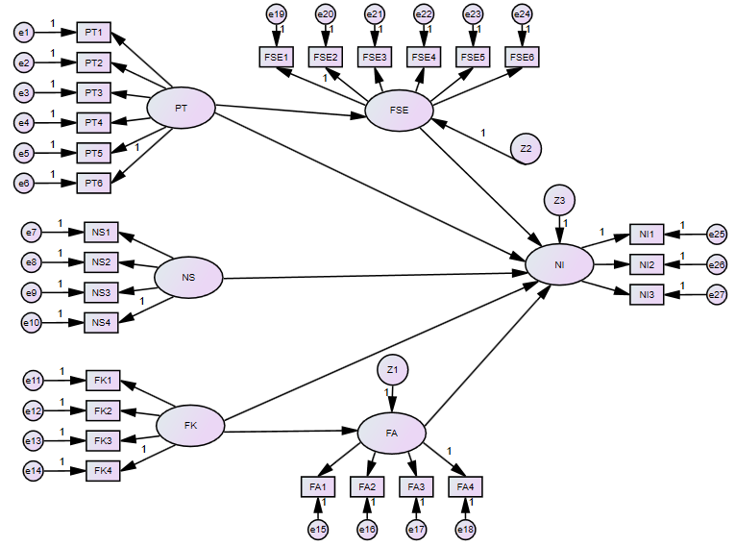
Figure 2. Research Structural Model
This model describes the relationship between exogenous variables, namely personality traits, financial knowledge, and subjective norms, and endogenous variables, namely financial self-efficacy, financial attitude, and investment intentions. Based on the path diagram construct above, change the path diagram into a structural equation and measurement model. The structural equations of this path diagram model are expressed in 3 groups as follows:
- Group 1 describes the Variables
FSE = β1 PT + z1
- Group 2 describes the Variables
NI = β1 PT + β1 FSE + β1 NS + β1 FK + β1 FA + z2
- Group 3 describes the Variables
FA = β1 FK + z3
Information:
- NI = Investment Intention
- PT =Personality Traits
- FSE =Financial self-efficacy
- NS = Norm Subjective
- FK =Financial Knowledge
- F.A =Financial Attitude
- z1,2,3 =Error
Meanwhile, the specifications for the measurement model are as follows:
- The Exogenous Construct of Personality Traits
PT1 = λ1PT + e1
PT2 = λ2PT + e2
PT3 = λ3PT + e3
PT4 = λ4PT + e4
PT5 = λ5PT + e5
PT6 = λ6PT + e6
- The Exogenous Construct of Subjective Norms
NS1 = λ1NS + e7
NS2 = λ2NS + e8
NS3 = λ3NS + e9
NS4 = λ4NS + e10
- Exogenous Construct of Financial Knowledge
FK1 = λ1FK + e11
FK2 = λ2FK + e12
FK3 = λ3FK + e13
FK4 = λ4FK + e14
- Endogenous Construct of Financial Attitude
FA1 = λ1FA + e15
FA2 = λ2FA + e16
FA3 = λ3FA + e17
FA4 = λ4FA + e18
- The Endogenous Construct of Financial Self-Efficacy
FSE1 = λ1FSE + e19
FSE2 = λ2FSE + e20
FSE3 = λ3FSE + e21
FES4 = λ4FSE + e22
FSE5 = λ5FSE + e23
FSE6 = λ6FSE + e24
- The Endogenous Construct of Investment Intentions
NI1 = λ1NI + e25
NI2 = λ2NI + e26
NI3 = λ3NI + e27

- ResultsConfirmatory Factor Analysis (CFA)
The second stage is Confirmatory Factor Analysis. CFA was conducted to assess the construct validity of the proposed measurement theory. There are two measures of construct validity, namely Convergent Validity with standardized loading estimate criteria ≥ 0.50 and Construct Reliability with Cronbach Alpha (CA) criteria ≥ 0.70. The following are the CFA test results for each variable.
- CFA Personality Traits
Table 5.Validity of CFA Personality Traits
Indicator | CFA PT |  |  | CFA PT (elimination)
Indicator | Loading | Loading2 | error | Loading | Loading2 | error
PT6 | 0.491 | 0.241 | 0.759
PT5 | 0.589 | 0.347 | 0.653 | 0.521 | 0.271 | 0.729
PT4 | 0.708 | 0.501 | 0.499 | 0.766 | 0.587 | 0.413
PT3 | 0.784 | 0.615 | 0.385 | 0.793 | 0.629 | 0.371
PT2 | 0.437 | 0.191 | 0.809
PT1 | 0.265 | 0.070 | 0.930
Sum of Std Loading | 3,274 |  |  | 2.08
Sum of Std Loading2 |  | 1,965 |  |  | 1,487
Sum error |  |  | 4.03488 |  |  | 1.51295
Construct Reliability | 0.727 |  |  | 0.741
Source: Data test results, 2024.
In Table 5 it can be seen that the initial indicators still have loading factors with a value of <0.5, namely the PT6 indicator is 0.491, PT2 is 0.437 and PT1 is 0.265. These indicators will be eliminated so that all indicators have a loading factor value of > 0.5. So, it can be concluded that all indicators are valid. Furthermore, the Reliability test was obtained at 0.741. This value is greater than 0.70, which means that the variable is consistent.

- CFA Subjective Norms
Table 6.Validity of CFA Subjective Norms
Indicator | CFA NS |  |  | CFA NS (elimination)
Indicator | Loading | Loading2 | error | Loading | Loading2 | error
NS4 | 0.415 | 0.172 | 0.828
NS3 | 0.652 | 0.425 | 0.575 | 0.616 | 0.379 | 0.621
NS2 | 0.672 | 0.452 | 0.548 | 0.667 | 0.445 | 0.555
NS1 | 0.754 | 0.569 | 0.431 | 0.791 | 0.626 | 0.374
Sum of Std Loading | 2,493 |  |  | 2,074
Sum of Std Loading2 |  | 1,617 |  |  | 1,450
Sum error |  |  | 2.38257 |  |  | 1.54997
Construct Reliability | 0.723 |  |  | 0.735
Source: Data test results, 2024.
In Table 6 it can be seen that the initial indicator still has a loading factor with a value of <0.5, namely the NS4 indicator is 0.415. These indicators will also be eliminated so that all indicators have a loading factor value of > 0.5. So, it can be concluded that all indicators are valid. Furthermore, the Reliability test was obtained at 0.735. This value is greater than 0.70, which means that the variable is consistent.

- CFA Financial Knowledge
Table 7.Validity of CFA Financial Knowledge
Indicator | CFA FK
Indicator | Loading | Loading2 | error
FK4 | 0.722 | 0.521 | 0.479
FK3 | 0.975 | 0.951 | 0.049
FK2 | 0.586 | 0.343 | 0.657
FK1 | 0.751 | 0.564 | 0.436
Sum of Std Loading | 3,034
Sum of Std Loading2 |  | 2,379
Sum error |  |  | 1.62069
Construct Reliability | 0.850
Source: Data test results, 2024.
In Table 7 it can be seen that all indicators obtained have a loading factor value of > 0.5. So it can be concluded that all indicators are valid. Furthermore, the Reliability test was obtained at 0.850. This value is greater than 0.70, which means that the variable is consistent.

- CFA Financial Attitude
Table 8.Validity of CFA Financial Attitude
Indicator | CFA FA
Indicator | Loading | Loading2 | error
FA4 | 0.631 | 0.398 | 0.602
FA3 | 0.708 | 0.501 | 0.499
FA2 | 0.577 | 0.333 | 0.667
FA1 | 0.533 | 0.284 | 0.716
Sum of Std Loading | 2,449
Sum of Std Loading2 |  | 1,516
Sum error |  |  | 2.48356
Construct Reliability | 0.707
Source: Data test results, 2024.
In Table 8 it can be seen that all indicators obtained have a loading factor value of > 0.5. So it can be concluded that all indicators are valid. Furthermore, the Reliability test was obtained at 0.707. This value is greater than 0.70, which means that the variable is consistent.

- CFA Financial Self-Efficacy
Table 9.Validity of CFA Financial Self-Efficacy
Indicator | CFA FSE |  |  | CFA FSE (elimination)
Indicator | Loading | Loading2 | error | Loading | Loading2 | error
FSE1 | 0.262 | 0.069 | 0.931
FSE2 | 0.815 | 0.664 | 0.336 | 0.833 | 0.694 | 0.306
FSE3 | 0.849 | 0.721 | 0.279 | 0.874 | 0.764 | 0.236
FSE4 | 0.458 | 0.210 | 0.790
FSE5 | 0.574 | 0.329 | 0.671 | 0.539 | 0.291 | 0.709
FSE6 | 0.640 | 0.410 | 0.590 | 0.591 | 0.349 | 0.651
Sum of Std Loading | 3,598 |  |  | 2,837
Sum of Std Loading2 |  | 2,403 |  |  | 2,098
Sum error |  |  | 3.59749 |  |  | 1.90243
Construct Reliability | 0.783 |  |  | 0.809
Source: Data test results, 2024.
In Table 9 it can be seen that the initial indicators still have loading factors with a value of <0.5, namely the FSE1 indicator is 0.262 and FSE4 is 0.458. These indicators must be eliminated so that all indicators have a loading factor value of > 0.5. So, it can be concluded that all indicators are valid. Furthermore, the Reliability test was obtained at 0.809. This value is greater than 0.70, which means that the variable is consistent.

- Investment Intention CFA
Table 10.Validity of Investment Intention CFA
Indicator | CFA NI
Indicator | Loading | Loading2 | error
NI1 | 0.693 | 0.480 | 0.520
NI2 | 0.836 | 0.699 | 0.301
NI3 | 0.769 | 0.591 | 0.409
Sum of Std Loading | 2,298
Sum of Std Loading2 |  | 1,771
Sum error |  |  | 1.22949
Construct Reliability | 0.811
Source: Data test results, 2024.
In Table 10 it can be seen that all indicators obtained have a loading factor value of > 0.5. So, it can be concluded that all indicators are valid. Furthermore, the Reliability test was obtained at 0.811. This value is greater than 0.70, which means that the variable is consistent.

- SEM Evaluation Results
- Assumption of Normality
Univariate normality testing by observing the skewness value of the data used, if the CR value for data skewness is between -2.58 ≤ CR ≤ 2.58 at a significance level of 0.01, then the research data used can be said to be normal. The results of the multivariate normality test of the data after modification are as follows:
Table 11.Assessment Of Normality
Variables | min | max | skew | cr | kurtosis | cr
NI3 | 2,000 | 5,000 | -,922 | -4,375 | ,281 | ,667
NI2 | 2,000 | 5,000 | -,635 | -3,012 | ,130 | ,308
NI1 | 3,000 | 5,000 | -,367 | -1,742 | -,680 | -1,612
FSE6 | 2,000 | 5,000 | -,355 | -1,684 | -,595 | -1,411
FSE5 | 2,000 | 5,000 | -,412 | -1,954 | -.025 | -,058
FSE3 | 1,000 | 5,000 | -,556 | -2,638 | ,584 | 1,385
FSE2 | 1,000 | 5,000 | -,687 | -3,258 | ,752 | 1,784
FA1 | 1,000 | 5,000 | -,713 | -3,384 | ,734 | 1,741
FA2 | 1,000 | 5,000 | -,550 | -2,607 | ,393 | ,932
FA3 | 2,000 | 5,000 | -,170 | -,808 | -,299 | -,708
FA4 | 3,000 | 5,000 | ,142 | ,676 | -,694 | -1,646
FK1 | 3,000 | 5,000 | -,439 | -2,082 | -,670 | -1,589
FK2 | 2,000 | 5,000 | -,241 | -1,143 | -,603 | -1,431
FK3 | 2,000 | 5,000 | -1,036 | -4,916 | 1,646 | 3,904
FK4 | 3,000 | 5,000 | -,498 | -2,361 | -,674 | -1,598
NS1 | 1,000 | 5,000 | -,882 | -4,181 | 1,143 | 2,710
NS2 | 1,000 | 5,000 | -,581 | -2,756 | ,152 | ,360
NS3 | 2,000 | 5,000 | -,122 | -,580 | -,448 | -1,063
PT3 | 2,000 | 5,000 | -,200 | -,947 | -,502 | -1,190
PT4 | 2,000 | 5,000 | -,197 | -,934 | -,431 | -1,021
PT5 | 2,000 | 5,000 | -,194 | -,921 | -,306 | -,725
Multivariate |  |  |  |  | 16,510 | 3,086
Source: Data test results, 2024.
In Table 11 it can be seen that the value for multivariate normal is 3.086. This value is still outside the range -2.58 ≤ cr ≤ 2.58, so it can be indicated that the data still does not meet the assumption of normal multivariate, so elimination must be carried out for several indicators, namely FK3 and FSE2, so that the following results are obtained.
Table 12.Assessment Of Normality After Elimination
Variables | min | max | skew | cr | kurtosis | cr
NI3 | 2,000 | 5,000 | -,922 | -4,375 | ,281 | ,667
NI2 | 2,000 | 5,000 | -,635 | -3,012 | ,130 | ,308
NI1 | 3,000 | 5,000 | -,367 | -1,742 | -,680 | -1,612
FSE6 | 2,000 | 5,000 | -,355 | -1,684 | -,595 | -1,411
FSE5 | 2,000 | 5,000 | -,412 | -1,954 | -.025 | -,058
FSE3 | 1,000 | 5,000 | -,556 | -2,638 | ,584 | 1,385
FA1 | 1,000 | 5,000 | -,713 | -3,384 | ,734 | 1,741
FA2 | 1,000 | 5,000 | -,550 | -2,607 | ,393 | ,932
FA3 | 2,000 | 5,000 | -,170 | -,808 | -,299 | -,708
FA4 | 3,000 | 5,000 | ,142 | ,676 | -,694 | -1,646
FK1 | 3,000 | 5,000 | -,439 | -2,082 | -,670 | -1,589
FK2 | 2,000 | 5,000 | -,241 | -1,143 | -,603 | -1,431
FK4 | 3,000 | 5,000 | -,498 | -2,361 | -,674 | -1,598
NS1 | 1,000 | 5,000 | -,882 | -4,181 | 1,143 | 2,710
NS2 | 1,000 | 5,000 | -,581 | -2,756 | ,152 | ,360
NS3 | 2,000 | 5,000 | -,122 | -,580 | -,448 | -1,063
PT3 | 2,000 | 5,000 | -,200 | -,947 | -,502 | -1,190
PT4 | 2,000 | 5,000 | -,197 | -,934 | -,431 | -1,021
PT5 | 2,000 | 5,000 | -,194 | -,921 | -,306 | -,725
Multivariate |  |  |  |  | 10,973 | 2,257
Source: Data test results, 2024.
In table 12 it can be seen that the value for multivariate normal is 2.257. This value is in the range -2.58 ≤ cr ≤ 2.58, so it can be indicated that the data meets the normal multivariate assumptions.

- Outlier Assumption
Detection of multivariate outliers is carried out by paying attention to the mahalanobis distance value. If there is something greater than the Chi-Square value in the degrees of freedom equal to the number of variables and at a significance level of 0.001 then the data indicates the existence of Multivariate Outliers and vice versa. The following are the results of the outlier assumption.
Table 13.Multivariate Evaluation of Outliers
Observation number | Mahalanobis d-squared | p1 | p2
79 | 45,089 | ,001 | ,086
103 | 37,358 | ,007 | ,252
91 | 34,488 | ,016 | ,370
41 | 33,172 | ,023 | ,375
34 | 31,804 | ,033 | ,458
120 | 31,002 | ,040 | ,464
67 | 29,795 | ,054 | ,607
104 | 29,205 | ,063 | ,618
2 | 28,417 | ,076 | ,701
63 | 28,233 | ,079 | ,631
25 | 28,208 | ,080 | ,512
119 | 28,134 | ,081 | ,411
96 | 27,564 | ,092 | ,477
5 | 27,482 | ,094 | ,390
36 | 27,405 | ,096 | ,309
95 | 27,251 | ,099 | ,261
68 | 26,986 | ,105 | ,250
51 | 26,464 | ,118 | ,324
118 | 25,827 | ,135 | ,461
64 | 25,528 | ,144 | ,481
86 | 25,508 | ,144 | ,393
114 | 25,473 | ,146 | ,318
20 | 25,050 | ,159 | ,393
21 | 25,020 | ,160 | ,319
61 | 25,011 | ,160 | ,245
102 | 24,585 | ,175 | ,324
8 | 24,126 | ,191 | ,434
74 | 24,047 | ,194 | ,384
39 | 23,843 | ,202 | ,391
3 | 23,807 | ,204 | ,328
84 | 23,663 | ,209 | ,313
53 | 23,535 | ,215 | ,293
19 | 23,249 | ,227 | ,341
93 | 22,893 | ,242 | ,428
47 | 22,842 | ,244 | ,375
30 | 22,819 | ,245 | ,313
85 | 22,630 | ,254 | ,327
71 | 22,528 | ,259 | ,303
62 | 22,418 | ,264 | ,284
56 | 21,951 | ,287 | ,435
112 | 21,898 | ,289 | ,388
116 | 21,775 | ,296 | ,378
134 | 21,668 | ,301 | ,360
31 | 21,626 | ,303 | ,313
69 | 21,484 | ,311 | ,314
54 | 21,438 | ,313 | ,272
1 | 20,960 | ,339 | ,443
59 | 20,875 | ,344 | ,418
77 | 20,698 | ,354 | ,443
88 | 20,635 | ,357 | ,407
82 | 20,317 | ,376 | ,513
52 | 20,287 | ,378 | ,459
13 | 20,109 | ,388 | ,489
126 | 20,023 | ,393 | ,468
9 | 19,842 | ,404 | ,502
43 | 19,825 | ,405 | ,442
55 | 19,758 | ,409 | ,411
49 | 19,587 | ,420 | ,441
94 | 19,483 | ,426 | ,432
22 | 19,459 | ,428 | ,379
129 | 19,148 | ,447 | ,492
89 | 19,144 | ,448 | ,426
35 | 19,039 | ,454 | ,419
108 | 18,992 | ,457 | ,380
73 | 18,948 | ,460 | ,340
70 | 18,895 | ,464 | ,307
33 | 18,642 | ,480 | ,385
92 | 18,601 | ,483 | ,343
26 | 18,586 | ,484 | ,290
58 | 18,498 | ,489 | ,277
107 | 18,447 | ,493 | ,247
45 | 18,344 | ,500 | ,242
117 | 17,989 | ,523 | ,374
115 | 17,797 | ,536 | ,423
23 | 17,719 | ,541 | ,403
24 | 17,525 | ,554 | ,456
6 | 17,515 | ,555 | ,394
42 | 17,325 | ,568 | ,443
105 | 17,286 | ,571 | ,400
18 | 17,277 | ,571 | ,339
17 | 17,162 | ,579 | ,343
100 | 17,112 | ,582 | ,308
27 | 17,046 | ,587 | ,284
65 | 17,000 | ,590 | ,250
83 | 16,802 | ,603 | ,297
16 | 16,532 | ,622 | ,391
37 | 16,403 | ,630 | ,403
123 | 16,275 | ,639 | ,414
101 | 16,275 | ,639 | ,346
14 | 16,194 | ,644 | ,328
15 | 16,067 | ,653 | ,337
98 | 16,066 | ,653 | ,274
127 | 15,907 | ,663 | ,299
44 | 15,441 | ,694 | ,521
78 | 15,273 | ,705 | ,557
81 | 15,259 | ,706 | ,491
12 | 14,581 | ,749 | ,820
75 | 14,266 | ,768 | ,894
125 | 14,186 | ,773 | ,883
131 | 13,896 | ,790 | ,931
Source: Data test results, 2024.
Table 13 shows data with probability (p), namely p1 or p2, whose value is more than 0.05 with the largest Mahalanobis distance being 45.089. This value is less than the table chi square value (19; 0.001) = 98.32423, so it can be indicated that there is no case. outliers in the data.

- Multicollinearity and Singularity Assumptions
The results of data processing determine the determinant value of the sample covariance matrix which is 0.0000000. This shows that there is multicollinearity in the data, so a composite variable must be created. After creating composite variables, the results showed that there was an increase in the Determinant of sample covariance matrix value, namely 0.00609, so it could be indicated that there were no cases of multicollinearity in the variables.
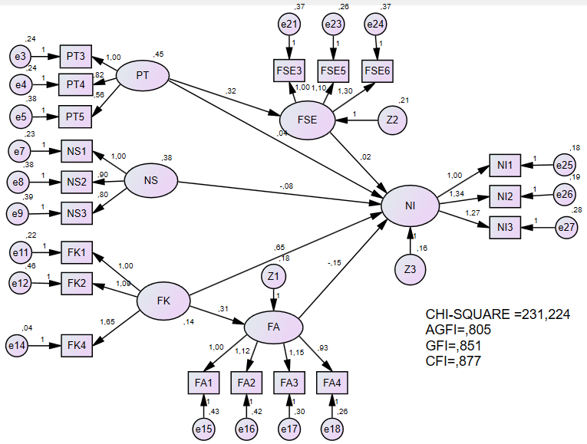
Figure 3.Structural Model Before Making a Composite Model
The process of making composites is carried out by simplifying latent variables that have several indicators into one composite indicator, then calculating them. Then, each composite indicator will produce one composite factor loading value (𝛌c) and error variance composite (𝞗c). Next, these values ​​will be used as constraints for each composite indicator, below are the results.

Table 14Composite factor loading value and composite variance error
Variable | PT | NS | FK | F.A | FSE | NI
Loading Factor Composite | 0.527 | 0.482 | 0.319 | 0.326 | 0.382 | 0.374
Error Variance Composite | 0.05 | 0.05 | 0.0017 | 0.005 | 0.0012 | 0.0017
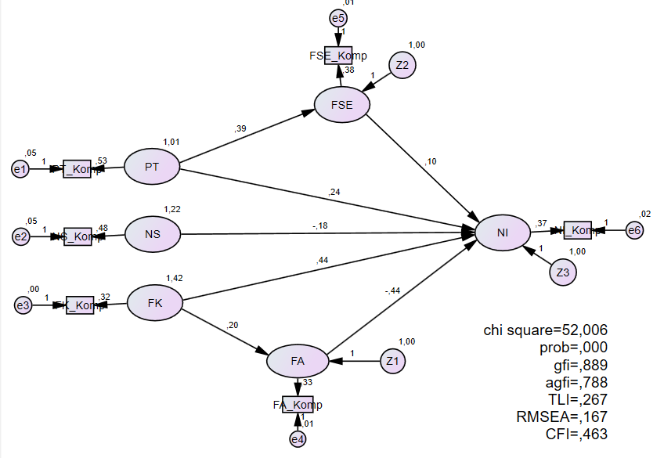
Figure 4.Composite Model Before Modification
- Results of the Goodness of Fit Model Feasibility Evaluation
The results of the data processing analysis after the composite model was carried out showed that all the constructs used to form a research model, in the full SEM model analysis process, did not meet the goodness of fit criteria that had been determined as shown in the following table:
Table 15. Goodness of Fit Statistics of Composite Models
Statistics | Fit Criteria | Analysis Results | Model Evaluation
X2 Chi Square | Expected to be small | 52,006 | Unfulfilled
Significant probability | ≥ 0.05 | 0,000 | Unfulfilled
RMSEA | ≤ 0.08 | 0.167 | Unfulfilled
GFI | ≥ 0.90 | 0.889 | Unfulfilled
AGFI | ≥ 0.90 | 0.788 | Unfulfilled
TLI | ≥ 0.90 | 0.267 | Unfulfilled
Source: Data test results, 2024.
Based on table 15, the composite model does not meet the goodness of fit criteria so modifications must be made to the model. Modifications are carried out by making correlations at the highest Modification Indicator values, so that the following model is obtained.
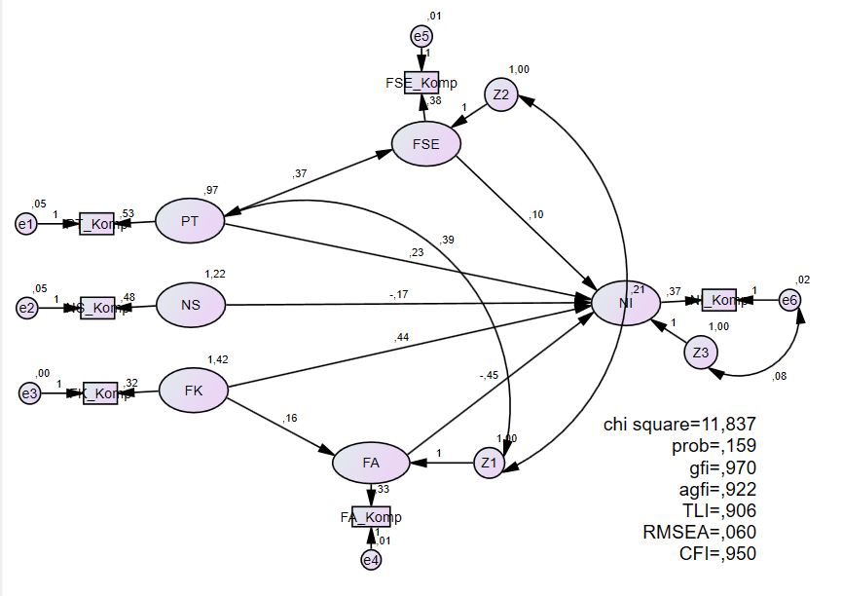
Figure 5.Composite Model After Modification

Table 16. Goodness of Fit Statistics Modification
Statistics | Fit Criteria | Analysis Results | Model Evaluation
X2 Chi Square | Expected to be small | 11,837 | Fulfilled
Significant probability | ≥ 0.05 | 0.159 | Fulfilled
RMSEA | ≤ 0.08 | 0.060 | Fulfilled
GFI | ≥ 0.90 | 0.970 | Fulfilled
AGFI | ≥ 0.90 | 0.922 | Fulfilled
TLI | ≥ 0.90 | 0.906 | Fulfilled
Source: Data test results, 2024.

- Hypothesis Testing Results
The hypothesis test carried out in this research used AMOS 24 software by looking at the output results of standardized regression weights based on the Probability (P) value. If the probability value is ≤ 0.05, then the hypothesis is accepted; conversely, if the probability value is > 0.05 then the hypothesis is rejected.
Table 17. Standardized Regression Weights
Influence | Estimate | S.E | CR | P | Information
FA → NI | 0.447 | 0.128 | 3,508 | *** | Significant
NS → NI | -0.168 | 0.107 | -1,568 | 0.117 | Not significant
FSE → NI | 0.105 | 0.118 | 0.891 | 0.373 | Not significant
FK → NI | 0.441 | 0.094 | 4,677 | *** | Significant
FK → FA | 0.161 | 0.068 | 2,383 | 0.017 | Significant
PT → NI | 0.231 | 0.139 | 1,665 | 0.096 | Not significant
PT → FSE | 0.367 | 0.100 | 3,674 | *** | Significant
Source: Data test results, 2024.
The results of the 1st Hypothesis test show that the financial attitude variable has a significant effect on investment intentions, with a probability value of 0.000 < 0.05. Thus hypothesis 1 is accepted. The results of the 2nd Hypothesis test show that the subjective norm variable has no significant effect on investment intentions with a probability value of 0.117 > 0.05. These results show that subjective norms have a negative and insignificant effect on investment intentions. Thus hypothesis 2 is rejected. The results of the 3rd Hypothesis test show that financial self-efficacy does not have a significant effect on investment intentions. with a probability value of 0.373 > 0.05. These results state that hypothesis 3 is rejected. The results of the 4th Hypothesis test show that financial knowledge has a significant effect on investment intentions. With a probability value of 0.017 <0.05. These results state that hypothesis 4 is accepted. The results of the 5th Hypothesis test show that financial knowledge has a significant effect on financial attitude with a probability value of 0.000 < 0.05. Thus, hypothesis 5 is declared accepted. The results of the 6th Hypothesis test show that personality traits have no effect spirit is significant for investment intentions, with a probability value of 0.096 > 0.05. These results indicate that hypothesis 6 is rejected. The results of the 7th Hypothesis test show that personality traits have a significant influence on financial self-efficacy with a probability value of 0.000 < 0.05. These results conclude that hypothesis 7 is accepted.
Meanwhile, testing the 8th and 9th hypotheses in this study used sobel test analysis. Sobel test analysis is used to determine the influence of financial knowledge on investment intentions, which is mediated by financial attitude (Sobel test 1) and the influence of personality traits on investment intentions, which is mediated by financial self-efficacy (Sobel test 2), using an online calculator. The results of the sobel test that has been carried out appear in table 18 and table 19 as follows.
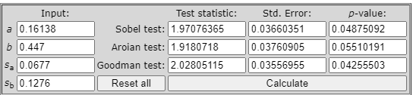
Table 18.Sobel Test 1

In table 18, it is found that the significance level or probability value for Sobel Test 1 is 0.0487 < 0.05. This result means that financial attitude can mediate the influence of financial knowledge on investment intentions. Thus hypothesis 8 is accepted.
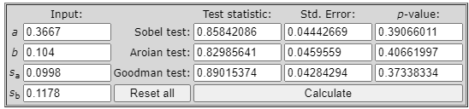
Table 19.Sobel Test 2
In table 19, it is found that the significance level or probability value for Sobel Test 2 is 0.3906 > 0.05. This result means that financial self-efficacy traits cannot mediate the influence of personality on investment intentions. Thus hypothesis 9 is rejected.

Discussion
The results of the first test show that financial attitude has a positive and significant effect on investment intentions. These results reflect that the higher the financial attitude, the greater the intention to invest in the capital market. These results are in line with research conducted by (Akhtar & Das, 2019; Gopi & Ramayah, 2007). The research results are also not in line with (Jensen et al., 2016) which states that financial attitude has a negative influence on investment intentions.
Financial attitudeis a person's assessment, opinion, or state of mind regarding finances which is applied to his or her attitude (Klontz et al., 2011). When an individual is obsessed with money, the individual will think about how to get money and how to use the money they have. With this positive outlook, it will encourage individual investment intentions to have a perception of their finances in the future. The better an individual's attitude towards their personal finances, the better the individual will be at carrying out financial management. So, when making investments, individuals will be careful because they must have different preferences based on return and risk to minimize failure or loss in terms of finances in order to get maximum profits. Obtaining maximum profits will make individuals have greater investment intentions.
The results of the second test show that subjective norms have a negative and insignificant effect on investment intentions in the capital market. This condition shows that the higher the level of subjective norms, the lower the investment intention in the stock market. Subjective Norms are factors originating from outside the individual which contain a person's perception of whether other people will approve or disapprove of a behavior displayed. If an investor's attitude towards decision making does not have support from friends or relatives or other associates, then the individual's investment intentions can change in a contradictory way. On the other hand, currently individuals can also easily use technology to carry out analysis, resulting in a high level of caution regarding investment intentions. Although, many stock influencers create content that contains many invitations to buy certain shares with the promise that these shares will rise, individuals are now smarter not to easily believe these invitations. This is what causes subjective norms to have a negative and insignificant effect on investment intentions.
The results of the third test show that the effect is not significant, indicating that whether someone is strong or weak in their ability to manage their finances does not influence their investment intentions, because in investing a person needs a lot of information related to investment instruments. These results are not in line with research conducted by.
The results of the fourth test show that financial knowledge has a significant positive effect on investment intentions in the capital market. This condition reflects that the higher the level of financial knowledge, the greater the investment intention. This means that the more knowledge related to finance, the better the financial decisions made, so it is more likely that they will demonstrate responsible financial management behavior (Jaya, 2019). Someone with higher financial knowledge is able to make good decisions for their family, and thus is in a position to increase their economic security and well-being, someone who has high financial knowledge can also make informed choices that are very important for their financial goals. The research results are in line with (Akhtar & Das, 2019).
The results of the fifth test show that financial knowledge has a significant positive effect on financial attitude. This condition also reflects that the higher the level of financial knowledge, the more the financial attitude will improve. Individuals with a high level of financial attitude are more likely to have a positive attitude towards planning in managing finances (Mindra & Moya, 2017). So, by having financial knowledge, an individual can have a good financial attitude. This results in individuals becoming more aware of the benefits and risks in the capital market, thereby reducing negative views, which means that the individual's financial attitude has improved. The research results are in line with (Sandi Kemal et al., 2020).
The results of the sixth test show that personality traits have a positive and insignificant effect on investment intentions in the capital market. This means that a person's personality is not enough to increase investment intentions in the capital market and an analysis process is needed first. So, according to research results, personality traits have no significant effect on investment intentions. The results of this research are in line with (Akhtar & Das, 2019; Jensen et al., 2016).
The results of the seventh test show that personality traits have a positive and significant effect on financial self-efficacy in the capital market. This condition indicates that the higher the personality traits, the more financial self-efficacy will increase. This is because people who like innovation and risk have trust or confidence in their ability to achieve their financial goals, so they have great opportunities in the capital market by managing minimal risks and innovation to move money into shares that have a better chance of getting maximum profits. This condition can certainly increase investment intentions. The research results are in line with (Akhtar & Das, 2019) who stated that personality traits have a significant effect on financial self-efficacy in the capital market.
The results of the eighth test show that the financial attitude variable can mediate the relationship between financial knowledge and investment intentions. Financial knowledge possessed by a person can be a tool in making decisions related to finance, so that it becomes quite important for their life (Klapper et al., 2011). These people are also more likely to diversify risks by spreading their funds across different financial assets (Abreu & Mendes, 2010). The more knowledge related to finance, the better the financial decisions made, so it is likely that a person's financial attitude will become more responsible. Individuals with a high level of financial attitude are more likely to have a positive attitude towards planning in managing finances (Mindra & Moya, 2017). A person with high financial knowledge also has a tendency to organize, manage and know the risks that will be faced in investing by having a good financial attitude, namely a positive state of mind, opinions and judgments about finances. So, having a better plan for managing finances will increase investment intentions in the capital market. The research results are in line with (Akhtar & Das, 2019). The results of the ninth test show that financial self-efficacy cannot mediate the relationship between personality traits and investment intentions. This means that a person's personality is different, so it cannot encourage individuals to take opportunities in decision-making situations in the capital market (Akhtar & Das, 2019).

5.CONCLUSION
Based on the analysis and discussion that has been carried out, the conclusion of this research is that financial attitude has a positive and significant effect on investment intentions. Subjective norms have a positive and insignificant effect on investment intentions in the capital market. Financial self-efficacy has a positive and insignificant effect on investment intentions in the capital market. Financial knowledge has a positive and significant effect on investment intentions in the capital market. Financial knowledge has a positive and significant effect on financial attitude in the capital market. Personality traits have a positive and insignificant effect on investment intentions in the capital market. Personality traits have a positive and significant effect on financial self-efficacy. There is a significant relationship between financial knowledge and investment intentions, mediated by financial attitude. The relationship between personality traits and investment intentions, mediated by financial self-efficacy, is not significant.
This research is far from perfect, and has limitations, including hThe results of this research cannot be directly generalized to the investor population outside Surabaya, considering that the research focus is only on respondents in the Surabaya area. There is dependency on subjective responses, including dependency on respondents' subjective responses, which can be influenced by factors such as honesty and self-perception. The capital market context is frequently changing, where rapid changes are also influenced by economic conditions and the capital market. Thus, it can affect the validity and relevance of research results over time. Therefore, it is recommended for future researchers to conduct further research and apply these findings to support an in-depth understanding of investment behavior. As well as adding other variables such as demographic factors to get more representative results. Meanwhile, suggestions to the government and capital market regulators are to consider developing policies that support potential new investors through financial education to provide support to motivate greater participation in the capital market.
Disclaimer (Artificial intelligence)
Author(s) hereby declare that NO generative AI technologies such as Large Language Models (ChatGPT, COPILOT, etc.) and text-to-image generators have been used during the writing or editing of this manuscript.

6.REFERENCES
Abreu, M., & Mendes, V. (2010). Financial literacy and portfolio diversification. Quantitative Finance, 10(5), 515–528. https://doi.org/10.1080/14697680902878105
Ajzen, I. (1991). ATTITUDES, PERSONALITY AND BEHAIOR. In Open University Press (Vol. 13, Issue 4). https://doi.org/10.3109/01421599109089905
Akhtar, F., & Das, N. (2019). Predictors of investment intention in Indian stock markets: Extending the theory of planned behaviour. International Journal of Bank Marketing, 37(1), 97–119. https://doi.org/10.1108/IJBM-08-2017-0167
Ali, A. (2011). Predicting individual investors’ intention to invest: An experimental analysis of attitude as a mediator. World Academy of Science, Engineering and Technology, 50(February), 994–1001.
Baker, H. K., Nofsinger, J. R., & Puttonen, V. (2020). Other Frauds and Scams that Lure Unsuspecting Investors. The Savvy Investor’s Guide to Avoiding Pitfalls, Frauds, and Scams, 149–177. https://doi.org/10.1108/978-1-78973-559-820201010
Bakhri, S., Aziz, A., & Sarinah, R. (2020). Pengetahuan dan Motivasi untuk Menumbuhkan Minat Berinvestasi pada Mahasiswa. Value : Jurnal Manajemen Dan Akuntansi, 15(2), 60–73. https://doi.org/10.32534/jv.v15i2.1175
Citra, M., & Rahmat, S. (2015). Using Theory of Planned Behavior in Predicting Intention to Invest : Case of Indonesia. International Academic Research Journal of Business and Technology 1(2) 2015 Page 137-141, 1(2), 137–141. http://s3.amazonaws.com/academia.edu.documents/45973157/IBTC2015-p137-141.pdf?AWSAccessKeyId=AKIAJ56TQJRTWSMTNPEA&Expires=1473238789&Signature=LOnYcRcmKt39IuoYbkq2d5KpZRA%3D&response-content-disposition=inline%3B filename%3DUsing_Theory_of_Planned_Behavior_in_Pred.pdf
Clark-Murphy, M., & Soutar, G. N. (2004). What individual investors value: Some Australian evidence. Journal of Economic Psychology, 25(4), 539–555. https://doi.org/10.1016/S0167-4870(03)00056-4
Danes, S. M., & Haberman, H. R. (2007). Teen financial knowledge, self-efficacy, and behavior: A gendered view. Journal of Financial Counseling and Planning, 18(2), 48–60.
Dwinta, I. dan C. Y. (2010). Pengaruh Locus Of Control, Financial Knowledge, Income Terhadap Financial Management Behavior. Jurnal Bisnis Dan Akuntansi, 12(3), 131–144.
Ghozali, I. (2008). Structural Equation Modelling (II). Universitas Diponegoro Semarang.
Gopi, M., & Ramayah, T. (2007). Applicability of theory of planned behavior in predicting intention to trade online: Some evidence from a developing country. International Journal of Emerging Markets, 2(4), 348–360. https://doi.org/10.1108/17468800710824509
Hair, J. F., Black, W. C., Babin, B. J., Anderson, R. E., & Tatham, R. L. (1998). Multivariate Data Analysis. Prentice Hall, Upper Saddle River., 5(3), 207–219.
Hoffmann, A. O. I., & Post, T. (2017). How return and risk experiences shape investor beliefs and preferences. Accounting and Finance, 57(3), 759–788. https://doi.org/10.1111/acfi.12169
HSBC. (2019). Sebanyak 9 dari 10 orang Indonesia Belum Siap Menjadi Crazy Rich Retiree. https://www.about.hsbc.co.id/-/media/indonesia/id/news-and-media/190212-crazy-rich-retiree-id.pdf
Ilahiyah, M. E., Soewarno, N., & Jaya, I. M. L. M. (2021). The Effect of Intellectual Capital and Financial Services Knowledge on Financial Inclusion. Journal of Asian Finance, Economics and Business, 8(1), 247–255. https://doi.org/10.13106/jafeb.2021.vol8.no1.247
Jaya, I. M. L. M. (2019). The Impact of Financial Inclusion on Public Financial Services Education through Financial Technology in Sleman Regency, Indonesia. Esensi: Jurnal Bisnis Dan Manajemen, 9(2), 155–174. https://doi.org/10.15408/ess.v9i2.13576
Jensen, C., Huynh, R., & Sandberg, P. (2016). “Doing good while doing well” : An investigation of Generation Y’s intention to invest socially responsibly.
Klapper, L., Amit, R., & Guillen, M. F. (2010). International Differences in Entreprenuership: Enterpreneurship and firm formation across countries. In National Bureau of Economic Research (Issue May). http://www.nber.org/chapters/c8820
Klapper, L., Lusardi, A., & Oudheusden, P. van. (2011). Financial literacy around the world: An overview. Journal of Pension Economics and Finance, 10(4), 497–508. https://doi.org/10.1017/S1474747211000448
Klontz, B., Britt, S. L., Mentzer, J., & Klontz, T. (2011). Money Beliefs and Financial Behaviors: Development of the Klontz Money Script Inventory. Journal of Financial Therapy, 2(1). https://doi.org/10.4148/jft.v2i1.451
KSEI. (2021). Bertepatan Dengan Usia 24 Tahun , KSEI Raih Gelar Kustodian Sentral Terbaik dan Sub Registry Terbaik.
Laurency, J. S., & Arifin, A. Z. (2022). Pengaruh Financial Attitude, Financial Self-Efficacy, dan Risk Perception terhadap Investment Intention. Jurnal Manajerial Dan Kewirausahaan, 4(3), 617–626. https://doi.org/10.24912/jmk.v4i3.19694
Lown, J. M. (2011). Conference paper: Development and validation of a Financial Self-Efficacy Scale. Journal of Financial Counseling and Planning, 22(2), 54–63.
Lusardi, A., & Scheresberg, C. de B. (2013). Financial lteracy and high-cost borrowing in the united states. National Bureau of Economic Research, 1–41. https://www.nber.org/papers/w18969
Lusardi, A., & Tufano, P. (2015). Debt literacy, financial experiences, and overindebtedness. In Journal of Pension Economics and Finance (Vol. 14, Issue 4). https://doi.org/10.1017/S1474747215000232
Mindra, R., & Moya, M. (2017). Financial self-efficacy: A mediator in advancing financial inclusion. Equality, Diversity and Inclusion, 36(2), 128–149. https://doi.org/10.1108/EDI-05-2016-0040
Phan, K. C., & Zhou, J. (2014). Vietnamese Individual Investors’ Behavior in the Stock Market: An Exploratory Study. Research Journal of Social Science & Management, 03(12), 46–54.
Rubaltelli, E., Pasini, G., Rumiati, R., Olsen, R. A., & Slovic, P. (2010). The Influence of Affective Reactions on Investment Decisions. Journal of Behavioral Finance, 11(3), 168–176. https://doi.org/10.1080/15427560.2010.507409
Sandi Kemal, Saparila Worokinasih, & Ari Darmawan. (2020). Pengaruh Financial Knowledge dan Financial Attitude Terhadap Financial Behavior Pada Youth Entrepreneur Kota Malang. Jurnal Administrasi Bisnis, 140–150. https://profit.ub.ac.id
Seni, N. N. A., & Ratnadi, N. M. D. (2023). THEORY OF PLANNED BEHAVIOR UNTUK MEMPREDIKSI NIAT BERINVESTASI. Ekonomis: Journal of Economics and Business, 7(1), 226. https://doi.org/10.33087/ekonomis.v7i1.818
Sina, P. G. (2013). Financial Efficacy and Financial Satisfaction : Ditinjau dari Perbedaan Gender. Jurnal Manajemen Maranatha, 12(2), 173–184. https://journal.maranatha.edu/index.php/jmm/article/view/164
Subiaktono. (2013). PENGARUH PERSONALITY TRAITS TERHADAP PERENCANAAN KEUANGAN KELUARGA. Jurnal Dinamika Manajemen, 4(2), 150–163.
Sugiyono. (2018). Metode Penelitian Kuantitatif, Kualitatif, dan R&D. Alfabeta.
Triyonowati. (2022). Manajemen Keuangan 2 (Lanjutan) (W. Kurniawadi (ed.)). Wawasan Ilmu.
Eshpulatov, D., Berdiev, G., & Artemenkov, A. (2025). Modeling the Determinants of Stock Market Investment Intention and Behavior Among Studying Adults: Evidence from University Students Using PLS-SEM. International Journal of Financial Studies, 13(3), 138. https://doi.org/10.3390/ijfs13030138
Putri, D. M., Trisnawati, N., Putri, S. F., & Kurniawati, S. (2025). Applying the Theory of Planned Behavior: Determinants of Stock Investment Intentions Among Individual Investors in East Java. Electronic Journal of Education, Social Economics and Technology, 6(1), 1201-1210.

